[Arti](https://doi.org/10.1016/j.aiig.2022.02.003)fi[cial Intelligence in Geosciences 2 (2021) 171](https://doi.org/10.1016/j.aiig.2022.02.003)–[178](https://doi.org/10.1016/j.aiig.2022.02.003)





Contents lists available at [ScienceDirect](http://www.sciencedirect.com/science/journal/26665441)

Artificial Intelligence in Geosciences

journal homepage: [www.keaipublishing.com/en/journals/artificial-intelligence-in-geosciences](http://www.keaipublishing.com/en/journals/artificial-intelligence-in-geosciences)

[](http://crossmark.crossref.org/dialog/?doi=10.1016/j.aiig.2022.02.003&domain=pdf)Arriving at estimates of a rate and state fault friction model parameter using Bayesian inference and Markov chain Monte Carlo

Saumik Dana a,*, Karthik Reddy Lyathakula b

a *University of Southern California, Los Angeles, 90007, CA, USA*

b *North Carolina State University, Raleigh, 27607, NC, USA*

A R T I C L E I N F O

*Keywords:*

Fault friction

Rate and state model Critical slip distance Bayesian inference

Markov chain Monte Carlo

A B S T R A C T

The critical slip distance in rate and state model for fault friction in the study of potential earthquakes can vary wildly from micrometers to few me-ters depending on the length scale of the critically stressed fault. This makes it incredibly important to construct an inversion framework that provides good estimates of the critical slip distance purely based on the observed ac-celeration at the seismogram. To eventually construct a frame- work that takes noisy seismogram acceleration data as input and spits out robust estimates of critical slip distance as the output, we first present the performance of the framework for synthetic data. The framework is based on Bayesian inference and Markov chain Monte Carlo methods. The synthetic data is generated by adding noise to the acceleration output of spring-slider-damper idealization of the rate and state model as the forward model.

1. Introduction

Inversion of seismogram data to infer subsurface properties is one of the most critical aspects of geophysics research. In a nutshell, the ac- tivity at and around discontinuities called faults in the subsurface spawn off seismic waves which are recorded at the surface on a seis-

mogram. Some of these recordings are too weak to enable any inference

between the physics of what happens around the fault and what hap- pens at the fault is achieved using the rate- and state- model for friction evolution, which is considered the gold standard for modeling earth- quake cycles on faults (Ruina, 1983; Scholz, 1989; Marone, 1998; Meng and Shi, 2021; Jia et al., 2021; Zhu et al., 2020)

*μ* = *μ* + *A*ln *V*  + *B*ln *V*0 *θ* ;

of subsurface properties, while some are too rich in terms in seismic signatures. The field of waveform inversion deals with the aspects of inference for the latter. The core set of mathematical operations for waveform inversion are going back and forth between the time domain

0 *V*0 *dc*

*θ*_ = 1 — *θV* ;

*dc*

(1)

and the frequency domain. To the naked eye, these operations and al- gorithms to implement them can get a little complicated to the com- munity of researchers who do not have a firm background in inversion geophysics. Over the past few years, Bayesian methods to infer prop- erties from seismogram data have become popular because of the advent of high performance computing and the ability to construct reduced order models of the high fidelity physics using deep learning. At the heart of the Bayesian inversion framework lies the feasibility to perform a lot of fast forward simulations to eventually arrive at robust estimates of the model parameter. Before stepping into any inversion framework, two questions are critical (1) What is the forward model? and (2) What are we infering? In the geophysics realm, the connection

where *V* = |*d*_ | is the slip rate magnitude, *a* = *V*_ which we hypothesize

is of the same order as recorded by seismograph, *μ*0 is the steady-state friction coefficient at the reference slip rate *V*0, *A* and *B* are empirical dimensionless constants, *θ* is the macroscopic variable characterizing state of the surface and *dc* is a critical slip distance over which a fault loses or regains its frictional strength after a perturbation in the loading conditions (Palmer and Rice, 1591). In principle, it determines the maximum slip acceleration and radiated energy to such an extent that it influences the magnitude and time scale of the associated stress breakdown process (Scholz, 2019). Regardless of the importance, it is paradoxical that the values of *dc* reported in the literature range from a few to tens of microns as determined in typical laboratory experiments

* Corresponding author.

*E-mail address:* [saumik@utexas.edu](mailto:saumik@utexas.edu) (S. Dana).

<https://doi.org/10.1016/j.aiig.2022.02.003>

Received 8 December 2021; Received in revised form 25 January 2022; Accepted 23 February 2022

Available online 16 March 2022

2666-5441/© 2022 The Authors. Publishing Services by Elsevier B.V. on behalf of KeAi Communications Co. Ltd. This is an open access article under the CC BY-NC-ND license (<http://creativecommons.org/licenses/by-nc-nd/4.0/>).

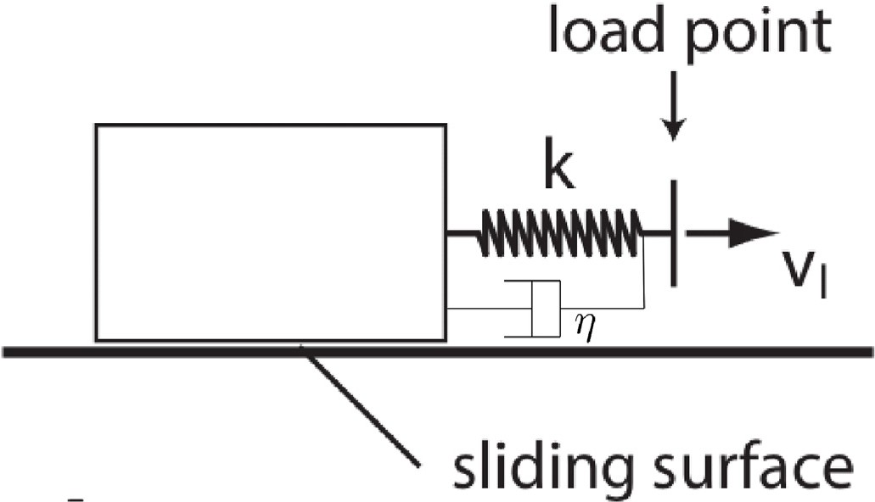estimation of critical slip distance. In section 4, we present the results from our investigation. In section 5, we present conclusions and outlook for future work.

1. Forward model for rate and state friction

We first rewrite Eq. (1) as

*V* = *V* exp 1 *μ* — *μ* — *B*ln *V*0 *θ* ;

0 *A* 0 *dc*

*θ*_ 1 *θV dc*

= —

(2)

Fig. 1. Spring slider damper idealization of fault behavior. *Vl* is velocity of load point and *V* is velocity of the block against the slider surface.

As shown in Fig. 1, we model a fault by a slider spring system (Rice and Gu, 1983; Gu et al., 1984; Dieterich, 1992). The friction coefficient of the block is given by

# *τ*

*μ* = *σ* =

*τl* — *kδ* — *ηV*

# *σ*

(3)

(Scholz, 2019), to 0.1 5 *m* as determined in numerical and seis-

—

mological estimates based on geophysical observations (Kaneko et al., 2017), and further to several meters as determined in high velocity laboratory experiments (Niemeijer et al., 2011). Understanding the physics that controls the critical slip distance and explains the gap between observations from experimental and natural faults is thus one of the crucial problems in both the seismology and laboratory com- munities (Ohnaka, 2003). With that in mind, we provide a framework

where *σ* is the normal stress, *τ* the shear stress on the interface, *τl* is the remotely applied stress acting on the fault in the absence of slip, -*kδ* is the stress relaxation due to fault slip and *η* is the radiation damping coeffi- cient (Kanamori and E Brodsky, 2004; McClure and Horne, 2011). We consider the case of a constant stressing rate *τ*_*l kVl* where *Vl* is the load point velocity. The stiffness is a function of the fault length *l* and elastic modulus *E* as *k* ≈ *E*. With *k*' = *E* , from Eqs. (3) and (2), we get the time

in which synthetic earthquake data is used to quantify uncertainty in critical slip distance. While the resolution and coupled flow and poromechanics (Dana and Wheeler, 2018a; Dana and Wheeler, 2018b; Dana et al., 2018; Dana et al., 2021; DanaJoel Ita and Wheeler, 2020; Dana et al., 2020; Dana, 2018; Dana and Reddy, 2021; Dana and Reddy Lyathakula, 2021) associated with subsurface activity in the realm of energy technologies and concomitant earthquake quantifi- cation is a hot topic, in this work, we focus on the effect of a standard trigonometric perturbation with exponentially decreasing amplitude.

=

*l*

*lσ*

derivative of friction coefficient as

*μ*_ ≈ *k*' (*Vl* — *V* )— *k*''*V*_

= *k*' *V* — *V* exp 1 *μ* — *μ* — *B*ln *V*0 *θ* — *k*''*V*_

*l* 0 *A* 0 *dc*

where *k*'' = *η*. We then get acceleration time series as *a* Ξ *V*_ as,

*σ*

*V*_ = *μ*_ — *θ*_

*V B*

(4)

In section 2, we explain the spring slider damper idealization to infer the influence of critical slip distance on RSF without recourse to

*c*

*A θ*

*V*0 1

*V*0 *θ*

*c*

*B* *θV*

(5)

complicated elastodynamic equations. In section 3, we explain the Bayesian inference framework to inversely quantify uncertainty in the

= *A* exp *A*

*μ* — *μ*0 — *B*ln *d*

× *μ*_ — *θ*

1 — *d*

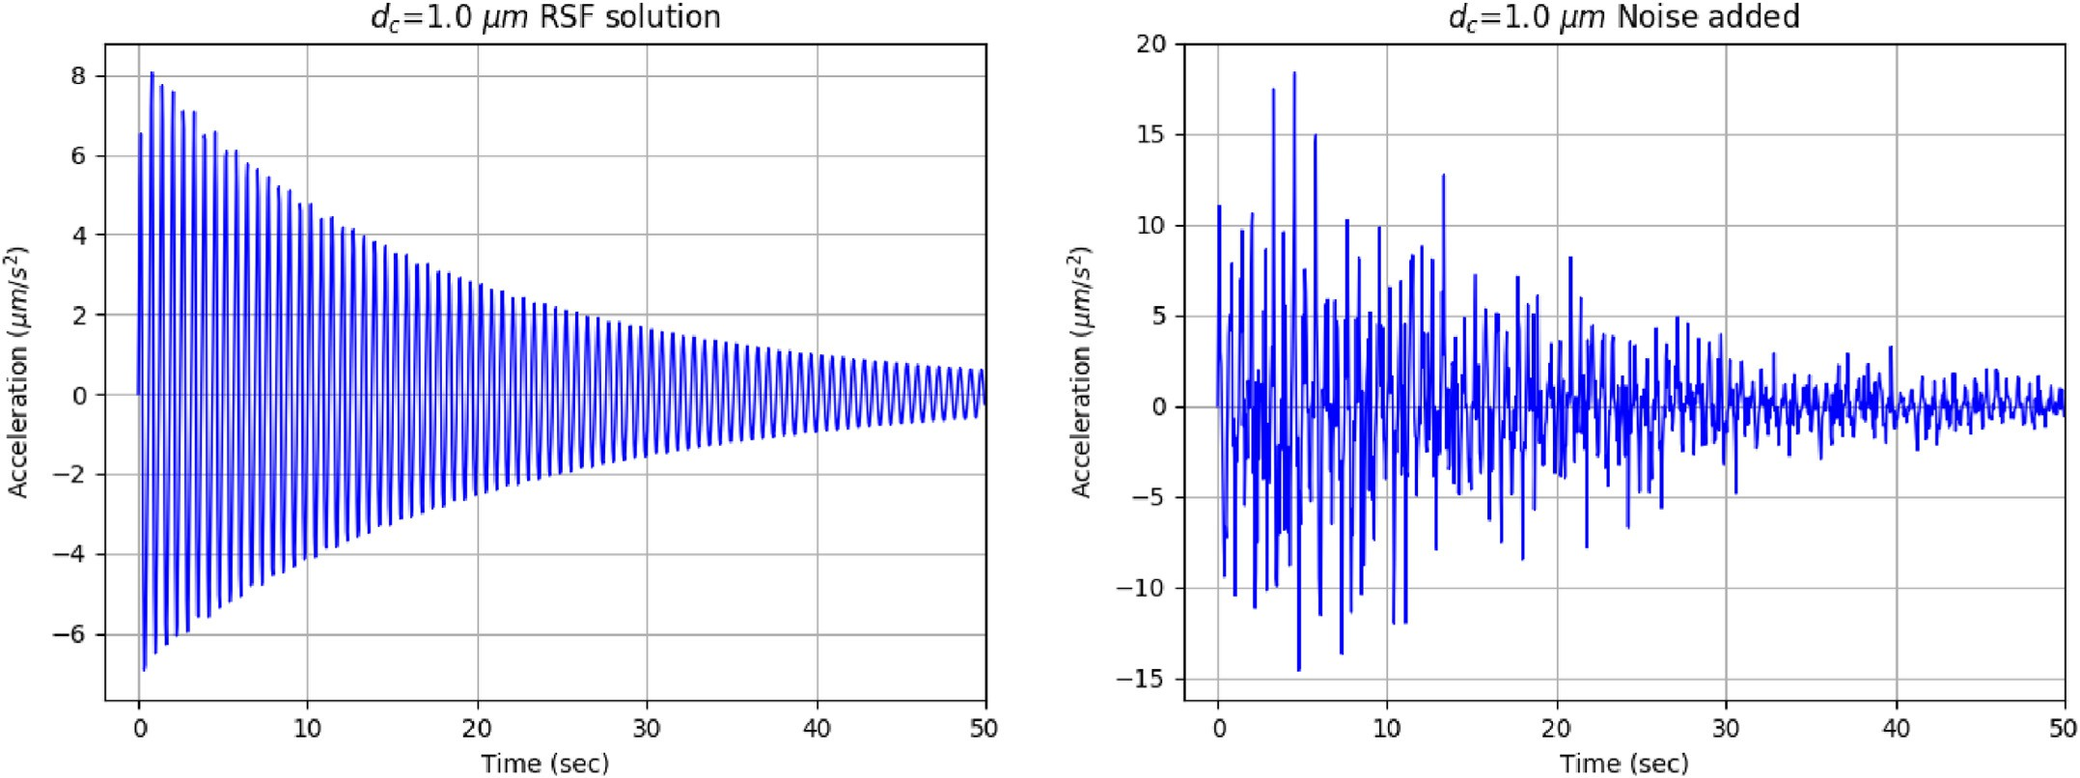

Fig. 2. System response. Before feeding the data to the Bayesian inference framework, we add synthetic noise to the data, because we would always expect some noise to come with the data in a real scenario, and we would want to test the robustness of the inference framework to provide good estimates in such a realistic scenario.

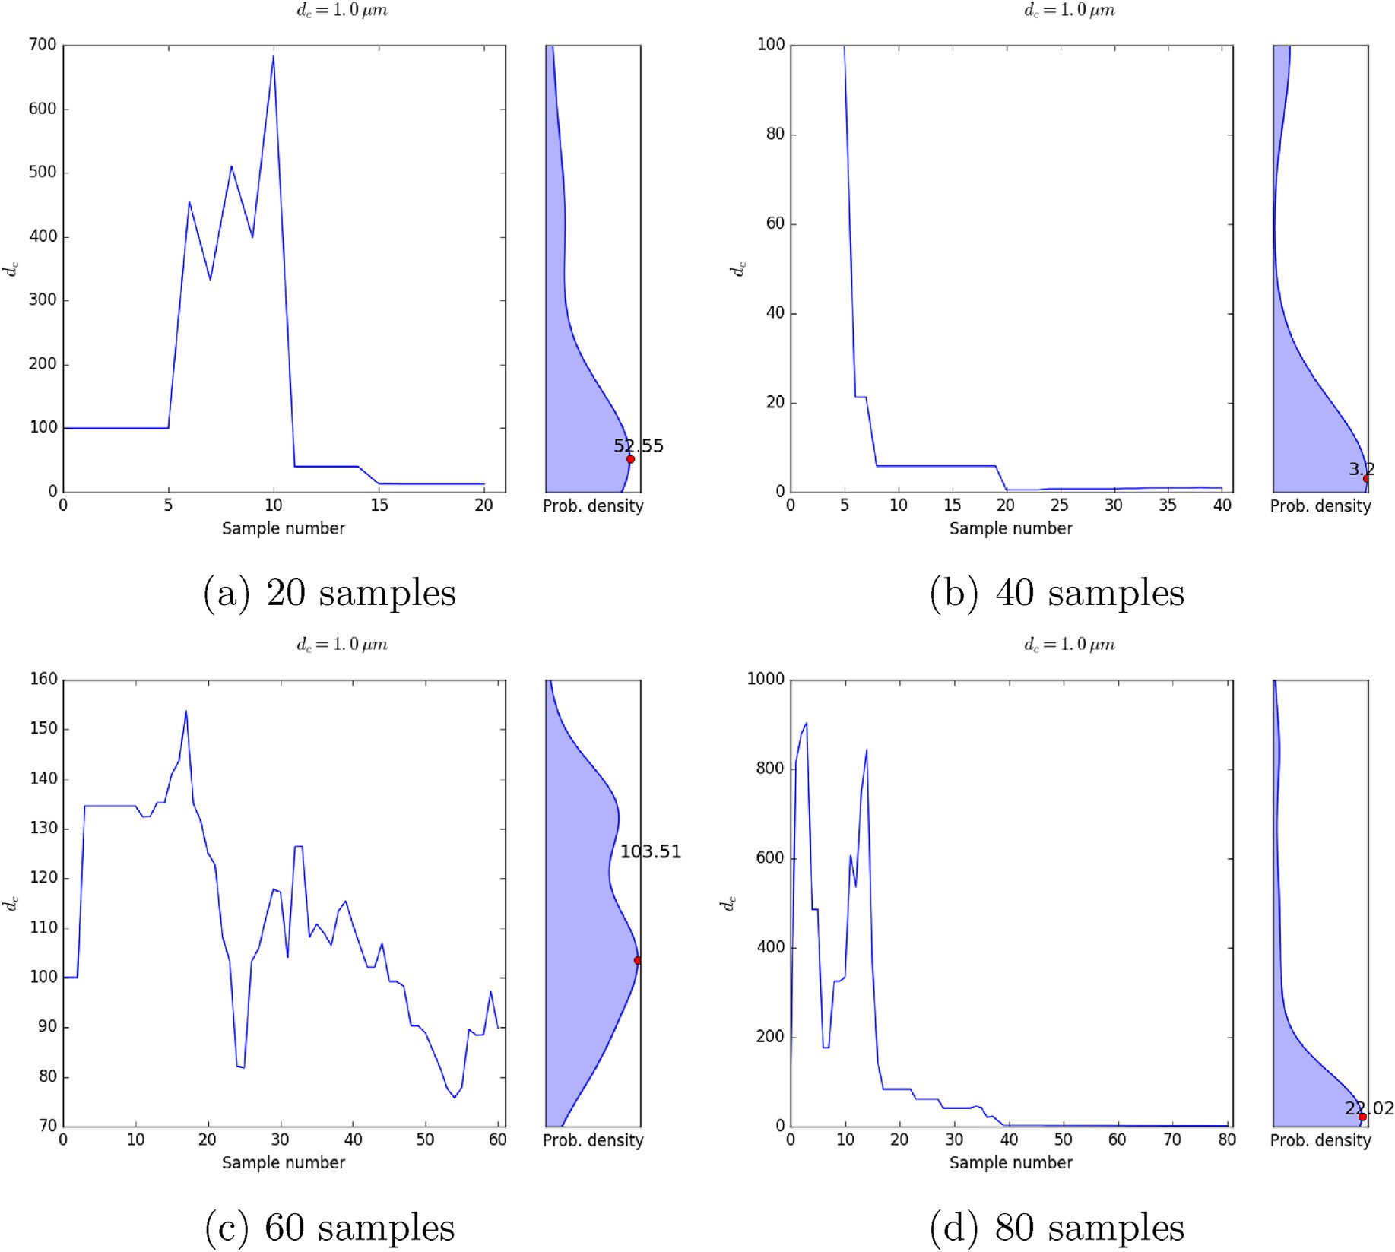

Fig. 3. Output of the Bayesian MCMC framework for model parameter for different sample numbers with true value of *dc* = 1 μm and an initial guess of 100 μm.

Ð

The ballpark values are: *E* = 5 × 1010 *Pa*, *l* = 3 × 10—2 *m*, *σ* = 200 ×

106 *Pa*, *η* = 20 × 106 *Pa*/(*m*/*s*), *A* = 0.011, *B* = 0.014, *V*0 = 1 μm/s, *θ*0 =

0.6, *μ*0 *μ*0 0.6, *tstart* 0, *tend* 50 *s*, *dt* 0.1 *s*, from which the effective stiffness and damping are obtained as *k*' 10—2(*μm*)—1 and *k*'' 10—7 *s*/ *μm*. The influence of critical slip distance on system response to a load point perturbation of the form

≈ =

= = = = =

uncovering a distribution centered around the true value and starts off with an initial guess for the distribution also called “prior” to eventually get to the most accurate distribution possible also called “posterior” through a likelihood . The Bayes theorem in a nutshell is:

*Vl* = *V*0(1 + exp(—*t* / 20) *sin*(10*t*)) (6)

Ð×S

t S

Ð×S

t = R

(7)

is shown in Fig. 2. Before feeding the data to the Bayesian inference framework, we add synthetic noise to the data, because we would al- ways expect some noise to come with the data in a real scenario, and we would want to test the robustness of the inference framework to provide good estimates in such a realistic scenario. The reason for choosing *Vl* to be varying in time as a sinusoid with an exponentially decreasing magnitude to best replicate the quality of the seismogram velocity reading in *V*.

1. The formalism of Bayesian inference with Markov chain Monte Carlo sampling

The Bayesian inference framework works on the basic tent of

The prior is typically taken to be a Gaussian distribution and the likelihood carries information about the forward model. The quantity that makes evaluation of the posterior difficult is the integral term in the denominator. Since direct evaluation of the integral using quad- rature rules is expensive, sampling methods like Markov chain Monte Carlo (MCMC) (Shapiro, 2003; Keith Hastings, 1970; Haario et al., 2001; Mueller, 2010) are used. To put it mathematically, if we were evaluating an integral, then the sampling would apply to points at which we know the value of integrand, and then proceed to evaluate the integral. But if the integrand at each of those points is a distri- bution rather than a value, it makes the sampling and subsequent averaging significantly more complicated. By constructing a Markov chain that has the desired distribution as its equilibrium distribution,

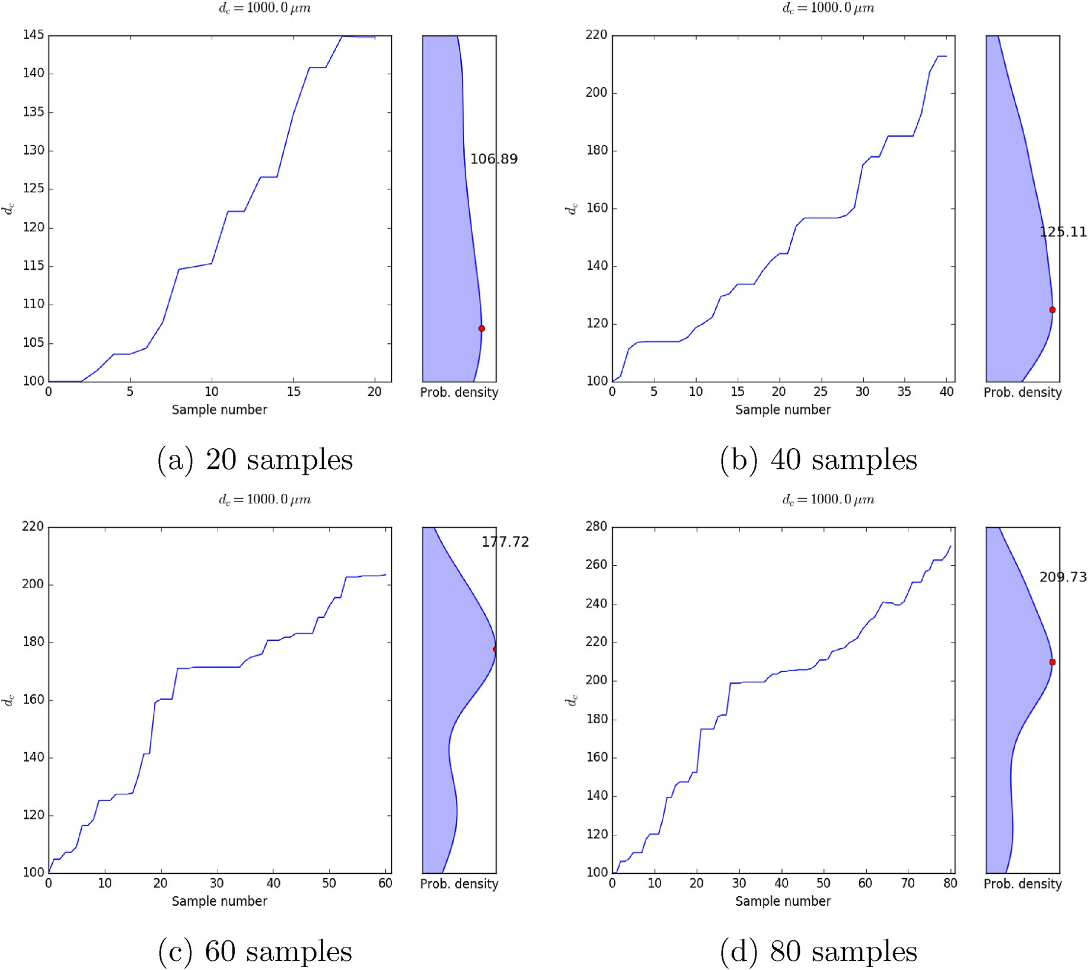

Fig. 4. Output of the Bayesian MCMC framework for model parameter for different sample numbers with true value of *dc* = 1000 μm and an initial guess of 100 μm.

one can obtain a sample of the desired distribution by recording states from the chain. The more steps are included, the more closely the distribution of the sample matches the actual desired distribution.

*π*(*dc*|*a*(*t*1); …; *a*(*tn*)) = R

*π*(*a*(*t*1); …; *a*(*tn*)|*dc*)*π*0(*dc*)

*dc π*(*a*(*t*1); …; *a*(*tn*)|*dc*)*π*0(*dc*)*ddc*

(9)

* 1. *Applied to our problem*

where *π*0(*dc*) is the prior distribution and *π*(*a*(*t*1), …, *a*(*tn*)|*dc*) is the likelihood given by

2

In this particular inverse problem, the acceleration response of the

1

*π a*(*t* ); …; *a*(*t* )|*d* )=

*n*

*π*(*a*(*t* )|*d* )=

*n*

1

2

*e*

*σ*

Y Y —

*a*(*ti* )—*f* (*V* ;*ti* ;*θ*;*μ*;*A*;*B*;*dc* )

model is known and the goal is to find the critical slip distance parameter ( 1

*dc*. To formalize the problem, consider the relationship between accel- eration *a*(*t*) and the model response by the following statistical model

*n c i*=1 *i c*

*i*=1 *σ*,2ﬃﬃﬃ*π*ﬃﬃ

(10)

*a*(*t*)= *f* (*t*; *θ*; *μ*; *A*; *B*; *dc*)+ *ε* (8)

where *ε* is the noise. Assuming the *ε* ~ *N*(0, *σ*2) as unbiased, independent and identical normal distribution with standard deviation *σ* allows us to conveniently generate the synthetic data as shown in Fig. 2. The goal of

* 1. *Adaptive metropolis algorithm*

The adaptive Metropolis algorithm (Haario et al., 2001) explores the parameter space with specified limits ranging from a high of *du* to a low

*c*

of *dl* and starts from a random initial guess of the model parameter *dm*,

*c c*

the inverse problem is to determine the model parameter distribution as follows

where *m* is the iteration number. The initial covariance matrix in the adaptive Metropolis algorithm is constructed using the initial parameter

*dm*=0. At each iteration, the steps are

*c*

* A random parameter sample *d*\* is generated from the proposal distribution

*c*

* If *d*\* is not within the specified limits, *d*\* /∈ (*dl* ; *du*), the iteration is

*c*

*c*

*c*

*c*

1. Results

Figs. 3 and 4 show a gradual improvement in the estimated model parameter as the number of samples is increased. It is evident that the framework has a lot more difficulty converging to the true value if the

initial guess is far away from the true value. In reality, it is not really

passed without moving to the next steps, and the previous sample is considered as the new sample, *dm*+1 = *dm*

*c*

*c*

* If *d*\* is within the specified limits, *d*\* ∈ (*dl* ; *du*), a new value of stan- dard deviation associated with *d*\* is generated using the inverse-

*c*

*c*

*c*

*c*

*c*

gamma distribution

* *d*\* is accepted as the new sample *dm*+1 = *d*\* if a criterion which in- volves the standard devation is met

*c c c*

* The covariance matrix is updated if the iteration number is an exact multiple of *m*0 using the previous *m*0 model parameters (Smith, 2013)

The simulation is repeated for *n* iterations and the parameter samples resulting from all these iterations represent the parameter posterior distribution. The construction of the *d*\* is only based on the current parameter, *dm*, which is the Markov process. The computational time of

*c*

*c*

the MCMC sampling method is proportional to the number of generated samples *n*. To put it more succinctly, the algorithm is elucidated in Al- gorithm 1.

known what the true value is, and arbitrary initial guesses will lend a solution that is way off target regardless of the number of sampling points. We observe from Fig. 3 that the response is not necessarily monotonic, in the sense that the estimated value with the maximum probability does not necessarily monotonically converge to the true value as the number of sampling points is increased. In all of the simulations, we observe in all the simulations that the Bayesian framework does an excellent job of dropping to the ballpark of the expected true value within the first few samples.

* 1. *With burn-in*

As an MCMC algorithm is rarely initialized from its invariant distri- bution, there might be some concern that its initial values might bias results even if it does approach this equilibrium distribution later on. To compensate for this, a burn-in period is often implemented: the first N samples being discarded, with N being chosen to be large enough that the chain has reached its stationary regime by this time. We take that burn-in

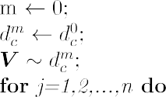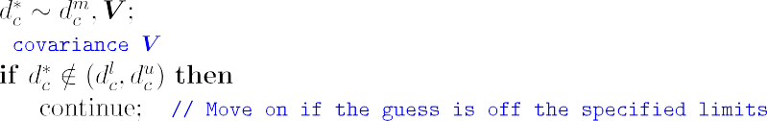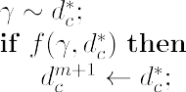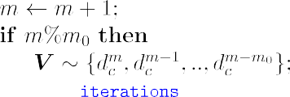

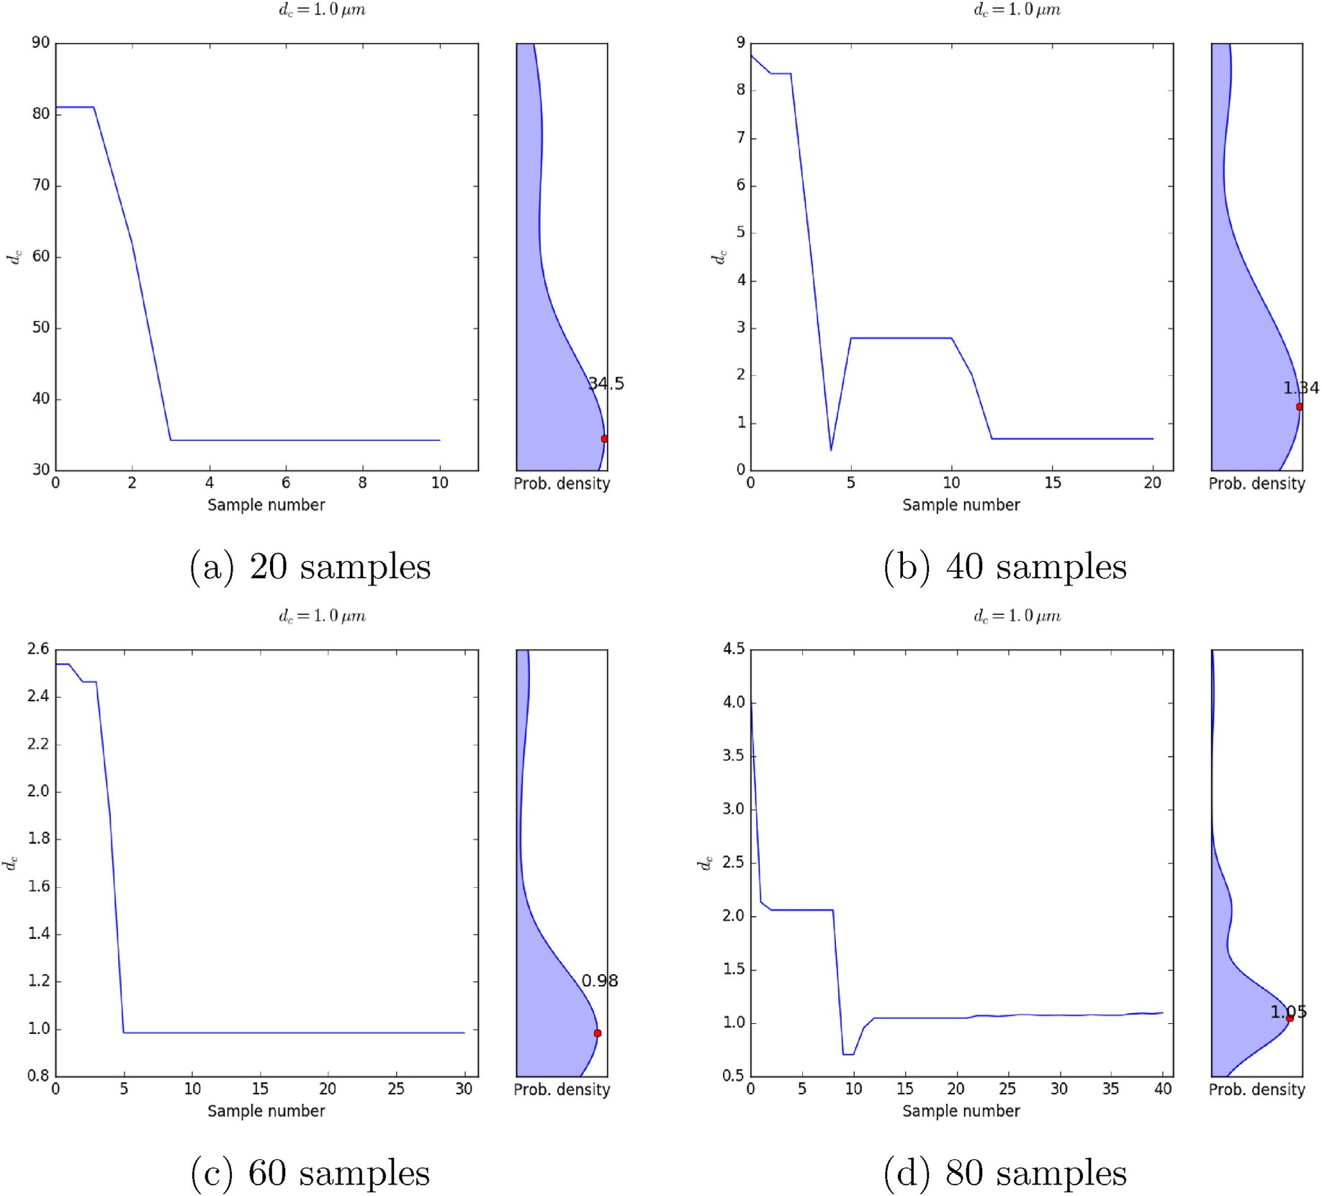

Fig. 5. Output of the Bayesian MCMC framework for model parameter for different sample numbers with true value of *dc* = 1 μm and an initial guess of 100 μm with half the number of samples burnt-in.

number to be half the number of samples. A comparison between Figs. 3 and 5 as well as Figs. 4 and 6 clearly demonstrates the improved accuracy of the estimate when a certain number of samples are burnt-in.

1. Conclusions and outlook

The rate and state model for fault friction evolution is a piece of the puzzle in which forward simulations are used to arrive at the seismic impact of fault slip on earthquake activity. Typically, the earthquakes are measured with seismograms and geophones on the surface as P-waves and S-waves, and then these readings are used to calibrate the seismic activity for constant monitoring. The acceleration field around the fault slip activity translates to these waves recorded on the surface, and for- ward simulations with wave propagation bridge that gap. That being said, a seismic recording on the surface cannot easily be backtraced to acceleration around the fault, and finally to the source of the fault slip. That is precisely inverse modeling, and the Bayesian framework coupled with MCMC allows us to put such a framework in place. The accelerations are field quantities, and the inverse estimation of the field around the fault from the time series at the seismogram and/or geophone is not a

trivial task. With that in mind, we test the robustness of the Bayesian/ MCMC framework to inversely estimate a value instead of a field. The thing is that any inversion framework works on data as the input, and since subsurface data is not available other the sensors at the wells, the forward simulations are used to generate this data with all the compu- tational physics put in place. This generated data is then used to inversely estimate the acceleration field from the data at the surface. Although such forward simulations to generate data are infeasible in real-time scenarios where we need estimates of what is happening in the subsur- face from the reading on the surface almost immediately, the framework robustness would eventually lend itself to that scenario. The scenario is that the recording at the seismogram and/or geophone would be fed into the Bayesian/MCMC fraemwork as an input, and the framework would provide an estimate of the acceleration field around the fault as the output. In this work, we work on arriving at estimates of critical slip distance in the rate and state model by running a spring-slider-damper as the forward model instead of using a full-fledged forward simulator. In the future, we will be deploying the coupled flow and geomechanics simulator as the forward model, and gradually arrive at the aforemen- tioned scenario.

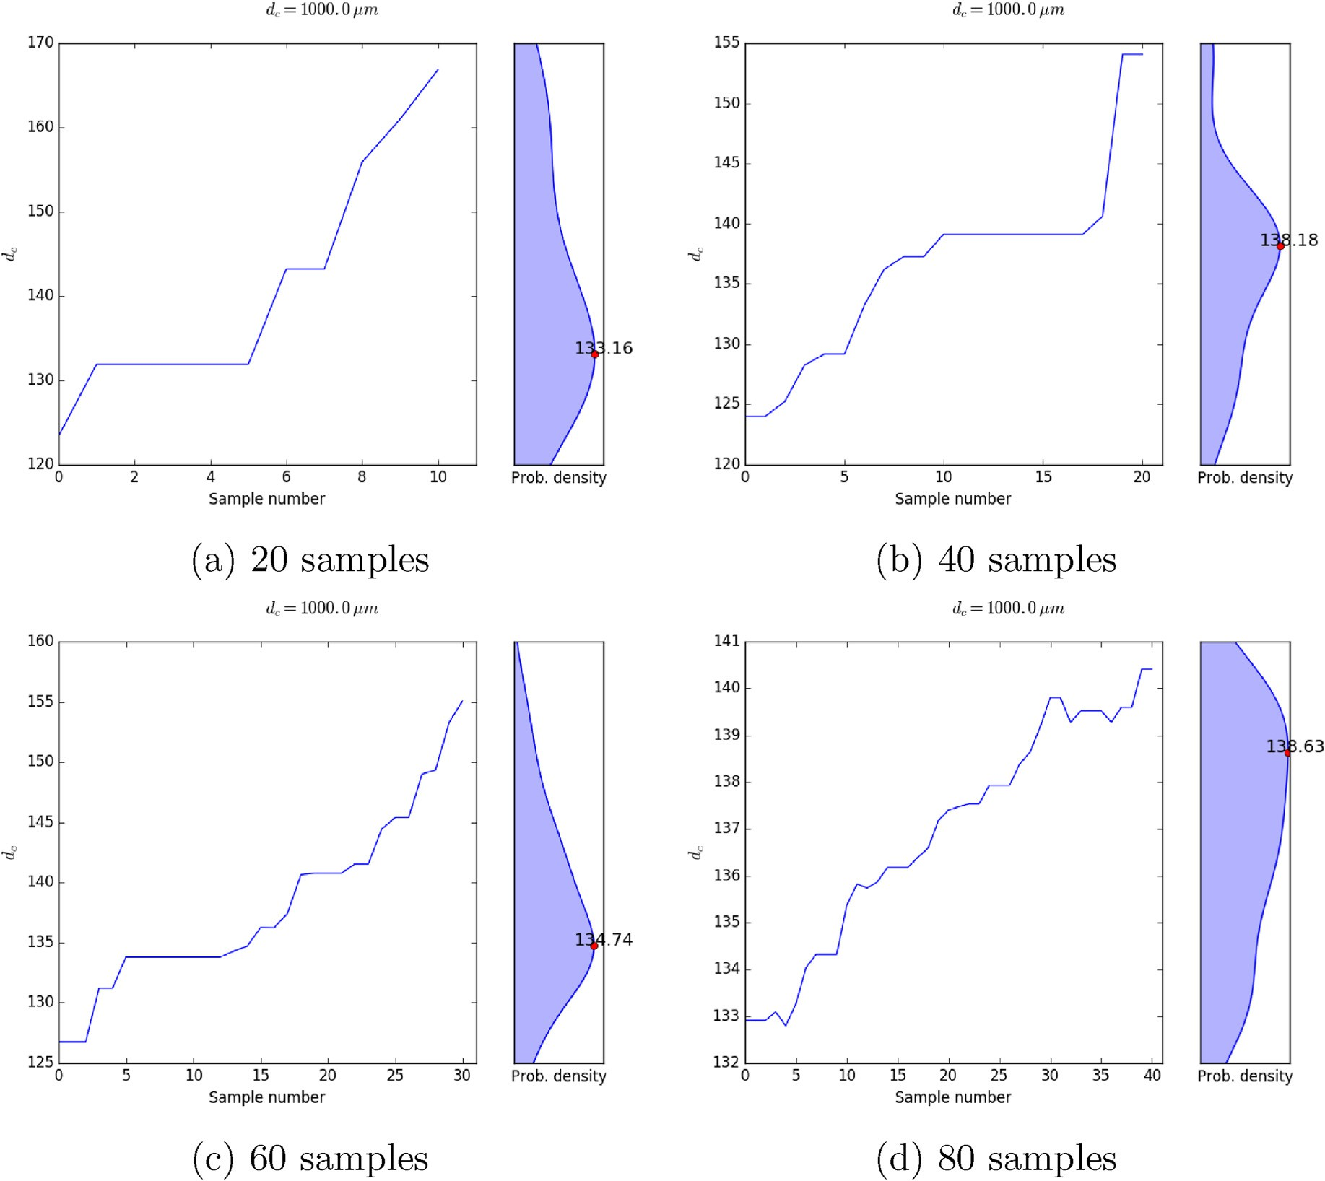

Fig. 6. Output of the Bayesian MCMC framework for model parameter for different sample numbers with true value of *dc* = 1000 μm and an initial guess of 100 μm with half the number of samples burnt-in.

Declaration of competing interest

The authors declare that they have no known competing financial interests or personal relationships that could have appeared to influence the work reported in this paper.

References

[Dana, S., 2018. Addressing Challenges in Modeling of Coupled Flow and Poromechanics](http://refhub.elsevier.com/S2666-5441(22)00003-X/sref1) [in Deep Subsurface Reservoirs. PhD thesis. The University of Texas at Austin](http://refhub.elsevier.com/S2666-5441(22)00003-X/sref1).

[Dana, Saumik, Reddy, Karthik, 2021. Bayesian Inference and Markov Chain Monte Carlo](http://refhub.elsevier.com/S2666-5441(22)00003-X/sref2) [Based Estimation of a Geoscience Model Parameter. *arXiv preprint arXiv:2201.01868*](http://refhub.elsevier.com/S2666-5441(22)00003-X/sref2).

[Dana, Saumik, Reddy Lyathakula, Karthik, 2021. Uncertainty quantification in friction](http://refhub.elsevier.com/S2666-5441(22)00003-X/sref3) [model for earthquakes using bayesian inference. *arXiv preprint arXiv:2104.11156*](http://refhub.elsevier.com/S2666-5441(22)00003-X/sref3).

[Dana, S., Wheeler, M.F., 2018a. Convergence analysis of fixed stress split iterative scheme](http://refhub.elsevier.com/S2666-5441(22)00003-X/sref4) [for anisotropic poroelasticity with tensor biot parameter. Comput. Geosci. 22 (5),](http://refhub.elsevier.com/S2666-5441(22)00003-X/sref4) [1219](http://refhub.elsevier.com/S2666-5441(22)00003-X/sref4)–[1230](http://refhub.elsevier.com/S2666-5441(22)00003-X/sref4).

[Dana, S., Wheeler, M.F., 2018b. Convergence analysis of two-grid fixed stress split](http://refhub.elsevier.com/S2666-5441(22)00003-X/sref5) [iterative scheme for coupled](http://refhub.elsevier.com/S2666-5441(22)00003-X/sref5) fl[ow and deformation in heterogeneous poroelastic](http://refhub.elsevier.com/S2666-5441(22)00003-X/sref5) [media. Comput. Methods Appl. Mech. Eng. 341, 788](http://refhub.elsevier.com/S2666-5441(22)00003-X/sref5)–[806](http://refhub.elsevier.com/S2666-5441(22)00003-X/sref5).

[Dana, Saumik, Ganis, Benjamin, Wheeler, Mary F., 2018. A multiscale](http://refhub.elsevier.com/S2666-5441(22)00003-X/sref6) fi[xed stress split](http://refhub.elsevier.com/S2666-5441(22)00003-X/sref6) [iterative scheme for coupled](http://refhub.elsevier.com/S2666-5441(22)00003-X/sref6) fl[ow and poromechanics in deep subsurface reservoirs.](http://refhub.elsevier.com/S2666-5441(22)00003-X/sref6)

[J. Comput. Phys. 352 (1](http://refhub.elsevier.com/S2666-5441(22)00003-X/sref6)–[22)](http://refhub.elsevier.com/S2666-5441(22)00003-X/sref6).

[Dana, Saumik, Srinivasan, Shriram, Karra, Satish, Makedonska, Nataliia, Hyman, Jeffrey](http://refhub.elsevier.com/S2666-5441(22)00003-X/sref7) [D., O'Malley, Daniel, Viswanathan, Hari, Srinivasan, Gowri, 2020. Towards real-time](http://refhub.elsevier.com/S2666-5441(22)00003-X/sref7) [forecasting of natural gas production by harnessing graph theory for stochastic](http://refhub.elsevier.com/S2666-5441(22)00003-X/sref7) [discrete fracture networks. J. Petrol. Sci. Eng. 195, 107791](http://refhub.elsevier.com/S2666-5441(22)00003-X/sref7).

[Dana, Saumik, Jammoul, Mohamad, Wheeler, Mary F., 2021. Performance studies of the](http://refhub.elsevier.com/S2666-5441(22)00003-X/sref8) fi[xed stress split algorithm for immiscible two-phase](http://refhub.elsevier.com/S2666-5441(22)00003-X/sref8) fl[ow coupled with linear](http://refhub.elsevier.com/S2666-5441(22)00003-X/sref8) [poromechanics. Comput. Geosci. 1](http://refhub.elsevier.com/S2666-5441(22)00003-X/sref8)–[15](http://refhub.elsevier.com/S2666-5441(22)00003-X/sref8).

[Dana, Saumik, Joel Ita, Wheeler, Mary F., 2020. The correspondence between voigt and](http://refhub.elsevier.com/S2666-5441(22)00003-X/sref9) [reuss bounds and the decoupling constraint in a two-grid staggered algorithm for](http://refhub.elsevier.com/S2666-5441(22)00003-X/sref9) [consolidation in heterogeneous porous media. Multiscale Model. Simul. 18 (1),](http://refhub.elsevier.com/S2666-5441(22)00003-X/sref9) [221](http://refhub.elsevier.com/S2666-5441(22)00003-X/sref9)–[239](http://refhub.elsevier.com/S2666-5441(22)00003-X/sref9).

[Dieterich, James H., 1992. Earthquake nucleation on faults with rate-and state-dependent](http://refhub.elsevier.com/S2666-5441(22)00003-X/sref10) [strength. Tectonophysics 211 (1](http://refhub.elsevier.com/S2666-5441(22)00003-X/sref10)–[4), 115](http://refhub.elsevier.com/S2666-5441(22)00003-X/sref10)–[134](http://refhub.elsevier.com/S2666-5441(22)00003-X/sref10).

[Gu, Ji-Cheng, Rice, James R., Ruina, Andy L., Tse Simon, T., 1984. Slip motion and](http://refhub.elsevier.com/S2666-5441(22)00003-X/sref11) [stability of a single degree of freedom elastic system with rate and state dependent](http://refhub.elsevier.com/S2666-5441(22)00003-X/sref11) [friction. J. Mech. Phys. Solid. 32 (3), 167](http://refhub.elsevier.com/S2666-5441(22)00003-X/sref11)–[196](http://refhub.elsevier.com/S2666-5441(22)00003-X/sref11).

[Haario, Heikki, Saksman, Eero, Tamminen, Johanna, 2001. An Adaptive Metropolis](http://refhub.elsevier.com/S2666-5441(22)00003-X/sref12) [Algorithm. Bernoulli, pp. 223](http://refhub.elsevier.com/S2666-5441(22)00003-X/sref12)–[242](http://refhub.elsevier.com/S2666-5441(22)00003-X/sref12).

[Jia, Yunzhong, Tang, Jiren, Lu, Yiyu, Lu, Zhaohui, 2021. The effect of fluid pressure on](http://refhub.elsevier.com/S2666-5441(22)00003-X/sref13) [frictional stability transition from velocity strengthening to velocity weakening and](http://refhub.elsevier.com/S2666-5441(22)00003-X/sref13) [critical slip distance evolution in shale reservoirs. Geomechanics and Geophysics for](http://refhub.elsevier.com/S2666-5441(22)00003-X/sref13) [Geo-Energy and Geo-Resources 7 (1), 1](http://refhub.elsevier.com/S2666-5441(22)00003-X/sref13)–[13](http://refhub.elsevier.com/S2666-5441(22)00003-X/sref13).

[Kanamori, Hiroo, E Brodsky, Emily, 2004. The physics of earthquakes. Rep. Prog. Phys.](http://refhub.elsevier.com/S2666-5441(22)00003-X/sref14)

[67 (8), 1429](http://refhub.elsevier.com/S2666-5441(22)00003-X/sref14).

[Kaneko, Yoshihiro, Fukuyama, Eiichi, James Hamling, Ian, 2017. Slip-weakening distance](http://refhub.elsevier.com/S2666-5441(22)00003-X/sref15) [and energy budget inferred from near-fault ground deformation during the 2016](http://refhub.elsevier.com/S2666-5441(22)00003-X/sref15) [mw7. 8 kaikōura earthquake. Geophys. Res. Lett. 44 (10), 4765](http://refhub.elsevier.com/S2666-5441(22)00003-X/sref15)–[4773](http://refhub.elsevier.com/S2666-5441(22)00003-X/sref15).

[Keith Hastings, W., 1970. Monte Carlo Sampling Methods Using Markov Chains and Their](http://refhub.elsevier.com/S2666-5441(22)00003-X/sref16) [Applications](http://refhub.elsevier.com/S2666-5441(22)00003-X/sref16).

[Marone, C., 1998. Laboratory-derived friction laws and their application to seismic](http://refhub.elsevier.com/S2666-5441(22)00003-X/sref17) [faulting. Annu. Rev. Earth Planet Sci. 26, 643](http://refhub.elsevier.com/S2666-5441(22)00003-X/sref17)–[696](http://refhub.elsevier.com/S2666-5441(22)00003-X/sref17).

[McClure, Mark W., Horne, Roland N., 2011. Investigation of injection-induced seismicity](http://refhub.elsevier.com/S2666-5441(22)00003-X/sref18) [using a coupled fluid flow and rate/state friction model. Geophysics 76 (6),](http://refhub.elsevier.com/S2666-5441(22)00003-X/sref18) [WC181](http://refhub.elsevier.com/S2666-5441(22)00003-X/sref18)–[WC198](http://refhub.elsevier.com/S2666-5441(22)00003-X/sref18).

[Meng, Wei, Shi, Pengcheng, 2021. Synchronization of earthquake cycles of adjacent](http://refhub.elsevier.com/S2666-5441(22)00003-X/sref19) [segments on oceanic transform faults revealed by numerical simulation in the](http://refhub.elsevier.com/S2666-5441(22)00003-X/sref19) [framework of rate-and-state friction. J. Geophys. Res. Solid Earth 126 (1),](http://refhub.elsevier.com/S2666-5441(22)00003-X/sref19) [e2020JB020231](http://refhub.elsevier.com/S2666-5441(22)00003-X/sref19).

[Mueller, Christian Lorenz, 2010. Exploring the common concepts of adaptive mcmc and](http://refhub.elsevier.com/S2666-5441(22)00003-X/sref20) [covariance matrix adaptation schemes. In: *Dagstuhl Seminar Proceedings*. Schloss](http://refhub.elsevier.com/S2666-5441(22)00003-X/sref20)

[Dagstuhl-Leibniz-Zentrum f](http://refhub.elsevier.com/S2666-5441(22)00003-X/sref20)A~ [1/4r Informatik](http://refhub.elsevier.com/S2666-5441(22)00003-X/sref20).

[Niemeijer, Andr´](http://refhub.elsevier.com/S2666-5441(22)00003-X/sref21)e, [Di Toro, Giulio, Nielsen, Stefan, Di Felice, Fabio, 2011. Frictional](http://refhub.elsevier.com/S2666-5441(22)00003-X/sref21) [melting of gabbro under extreme experimental conditions of normal stress,](http://refhub.elsevier.com/S2666-5441(22)00003-X/sref21) [acceleration, and sliding velocity. J. Geophys. Res. Solid Earth 116 (B7)](http://refhub.elsevier.com/S2666-5441(22)00003-X/sref21).

[Ohnaka, Mitiyasu, 2003. A constitutive scaling law and a uni](http://refhub.elsevier.com/S2666-5441(22)00003-X/sref22)fi[ed comprehension for](http://refhub.elsevier.com/S2666-5441(22)00003-X/sref22) [frictional slip failure, shear fracture of intact rock, and earthquake rupture.](http://refhub.elsevier.com/S2666-5441(22)00003-X/sref22)

[J. Geophys. Res. Solid Earth 108 (B2)](http://refhub.elsevier.com/S2666-5441(22)00003-X/sref22).

[Palmer, Andrew Clennel, Rice, James Robert, 1591. The growth of slip surfaces in the](http://refhub.elsevier.com/S2666-5441(22)00003-X/sref23) [progressive failure of over-consolidated clay. Proc. Roy. Soc. Lond. A. Math. Phys. Sci.](http://refhub.elsevier.com/S2666-5441(22)00003-X/sref23) [332, 527](http://refhub.elsevier.com/S2666-5441(22)00003-X/sref23)–[548, 1973](http://refhub.elsevier.com/S2666-5441(22)00003-X/sref23).

[Rice, James R., Gu, Ji-cheng, 1983. Earthquake aftereffects and triggered seismic](http://refhub.elsevier.com/S2666-5441(22)00003-X/sref24) [phenomena. Pure Appl. Geophys. 121 (2), 187](http://refhub.elsevier.com/S2666-5441(22)00003-X/sref24)–[219](http://refhub.elsevier.com/S2666-5441(22)00003-X/sref24).

[Ruina, A.L., 1983. Slip instability and state variable friction laws. Geophys. Res. Lett. 88,](http://refhub.elsevier.com/S2666-5441(22)00003-X/sref25) [359](http://refhub.elsevier.com/S2666-5441(22)00003-X/sref25)–[370](http://refhub.elsevier.com/S2666-5441(22)00003-X/sref25).

[Scholz, C.H., 1989. Mechanics of faulting. Annu. Rev. Earth Planet Sci. 17, 309](http://refhub.elsevier.com/S2666-5441(22)00003-X/sref26)–[334](http://refhub.elsevier.com/S2666-5441(22)00003-X/sref26).

[Scholz, Christopher H., 2019. The Mechanics of Earthquakes and Faulting. Cambridge](http://refhub.elsevier.com/S2666-5441(22)00003-X/sref27) [university press](http://refhub.elsevier.com/S2666-5441(22)00003-X/sref27).

[Shapiro, Alexander, 2003. Monte Carlo sampling methods. Handb. Oper. Res. Manag. Sci.](http://refhub.elsevier.com/S2666-5441(22)00003-X/sref28)

[10, 353](http://refhub.elsevier.com/S2666-5441(22)00003-X/sref28)–[425](http://refhub.elsevier.com/S2666-5441(22)00003-X/sref28).

[Smith, Ralph C., 2013. Uncertainty Quanti](http://refhub.elsevier.com/S2666-5441(22)00003-X/sref29)fi[cation: Theory, Implementation, and](http://refhub.elsevier.com/S2666-5441(22)00003-X/sref29) [Applications, vol. 12. Siam](http://refhub.elsevier.com/S2666-5441(22)00003-X/sref29).

[Zhu, Weiqiang, Allison, Kali, Dunham, Eric, Yang, Yuyun, 09 2020. Fault valving and pore](http://refhub.elsevier.com/S2666-5441(22)00003-X/sref30) [pressure evolution in simulations of earthquake sequences and aseismic slip. Nat.](http://refhub.elsevier.com/S2666-5441(22)00003-X/sref30) [Commun. 11, 4833](http://refhub.elsevier.com/S2666-5441(22)00003-X/sref30).