[Array 17 (2023) 100266](https://doi.org/10.1016/j.array.2022.100266)

Contents lists available at [ScienceDirect](http://www.sciencedirect.com/science/journal/25900056)

Array

journal homepage: [www.sciencedirect.com/journal/array](https://www.sciencedirect.com/journal/array)

Automatic optimization model of transmission line based on GIS and genetic algorithm

Yuancun Qin a,1, Zhaozheng Li b,1, Jieyu Ding c, Fei Zhao d,*, Ming Meng d

a *Yunnan Appraisal Center for Ecological and Environmental Engineering, Kunming 650228, China*

b *Institute of International Rivers and Eco-Security, Yunnan University, Kunming 650500, China*

c *School of Resources and Environmental Science, Wuhan University, Wuhan 430079, China*

d *School of Earth Sciences, Yunnan University, Kunming 650500, China*

A R T I C L E I N F O

*Keywords:* Transmission line Path optimization GIS

Genetic algorithm

A B S T R A C T

At present, the planning of transmission lines mainly relies on human decision-making and lacks intelligence. This paper combines the advantages of GIS in processing spatial data with the advantages of genetic algorithm to explore the optimization method of transmission line planning. The combination of GIS and genetic algorithm can minimize the interference of human factors and quickly solve the path planning problem of transmission lines. According to the theoretical model of genetic algorithm, this study constructs the transmission line opti- mization model based on genetic algorithm, and realizes the Add-ins plug-in development of the transmission line planning model based on genetic algorithm with the help of C # language. Taking 500 kV overhead

transmission line about 150 km from Jiantang Substation (starting point) in Shangri-La County to Tai’ an Substation (ending point) in Lijiang as an example, two groups of experiments are designed under the conditions

of considering traffic single factor and comprehensive multi-factor respectively. It is obtained that the path optimization effect of genetic algorithm is the best under the condition of comprehensive multi-factor, which proves the rationality and superiority of the model constructed in this study.

# Introduction

Genetic algorithm is a method to search the optimal solution by simulating the natural evolution process. This algorithm converts the solving process of the problem into the process of crossover and muta- tion of chromosome genes in similar biological evolution, and can quickly obtain better optimization results when solving complex combinatorial optimization problems. Therefore, it is widely used in optimal transmission, path planning and other fields.

The current transmission line planning mainly relies on experienced professionals through map data and field survey, which requires a lot of time and material costs. GIS can obtain and analyze the data related to the region such as topography, meteorological environment and land use types, which is helpful to solve the problems such as location se-

lection and path optimization [1–6]. But it lacks intelligence and needs leadership and decision-making.

The combination of GIS and genetic algorithm can minimize the interference of human factors and quickly solve the path planning

problem of transmission lines. At present, there are few studies on this problem [7–10]. It is representative that the improved ant colony al- gorithm is combined with GIS, and the distance unit is taken as the cost

condition of transmission line construction, which automatically gives the reasonable planning of power grid transmission lines in short dis- tance [11]. The grid value searched by this scheme is converted from the cost index, which will change with the change of geographical and time conditions, and is uncertain, so there are shortcomings. This study will consider the geographical conditions of natural formation (such as topography, rivers and lakes, nature reserves, floating ice, meteorology, seismic belt, etc.) and social conditions of artificial formation (such as transportation, land use types, regional planning, etc.). These factors determine the difficulty of reasonable planning of power grid path and the construction cost of transmission lines. The shortest path is not necessarily the most reasonable path, and seeking the most reasonable path is the purpose of this study.

In this paper, the geographical factors and human factors that affect the transmission line planning are graded and quantified, and then

* Corresponding author.

*E-mail address:* [vwobai@163.com](mailto:vwobai@163.com) (F. Zhao).

1 Yuancun Qin and Zhaozheng Li as co-first authors，These authors contributed equally to this work.

<https://doi.org/10.1016/j.array.2022.100266>

Received 21 November 2022; Accepted 5 December 2022

Available online 7 December 2022

2590-0056/© 2022 The Authors. Published by Elsevier Inc. This is an open access article under the CC BY license (<http://creativecommons.org/licenses/by/4.0/>).

weighted according to the importance, and then transformed into the grid cost value. The genetic algorithm is used to construct the path optimization model that conforms to the characteristics of power grid transmission line planning. Combined with GIS, the Add-ins plug-in module is developed by C# and ArcObjects components on ArcGIS platform. Taking the whole process of about 150 km 500 kV trans- mission line planning from Jiantang substation in Shangri-La to Tai ’ an

substation in Lijiang as an example, two groups of conditions and two

algorithms of power grid line planning experiments are carried out. One group only considers the single factor cost of traffic. The other group considers the comprehensive cost after the superposition of multiple influencing factors, and uses the genetic algorithm model constructed in this paper and Dijkstra algorithm in ArcGIS to plan the transmission line path. It is concluded that the path optimized by genetic algorithm is the best when considering various factors.

# Transmission line optimization model based on genetic algorithm

The optimization model is divided into two parts (Fig. 1). The first part is the establishment of the evaluation index system and the deter- mination of the weight. Then, the genetic algorithm is used to develop the Add-ins plug-in of the transmission line planning model, and the plug-in is used for actual planning.

* 1. *Evaluation index system of transmission line planning*
     1. *Establishment of index system*

Transmission line path planning area is divided into grids. In the area, the influence factors involved are transformed into cost to repre- sent, and the influence degree of each influence factor is determined. After superposition, the cost value falls into each grid, so that all grids in the planning area have grid values.

Transmission path planning needs to be fully considered, and strive to maximize the economic benefits of the scheme. At the same time, it also needs to consider the safety and stability of the line, the conve- nience of engineering construction and maintenance and the environ- mental friendliness. Therefore, it is necessary to comprehensively consider the topographic and geological conditions, traffic, land use, disaster points, mining areas, military areas, important facilities, nature reserves, scenic spots and urban planning areas and other factors, and classify and quantify the factors and indicators affecting the line plan- ning. In this paper, 500 kV overhead transmission line planning as an example, according to the ⟪100 kV–750 kV overhead transmission line

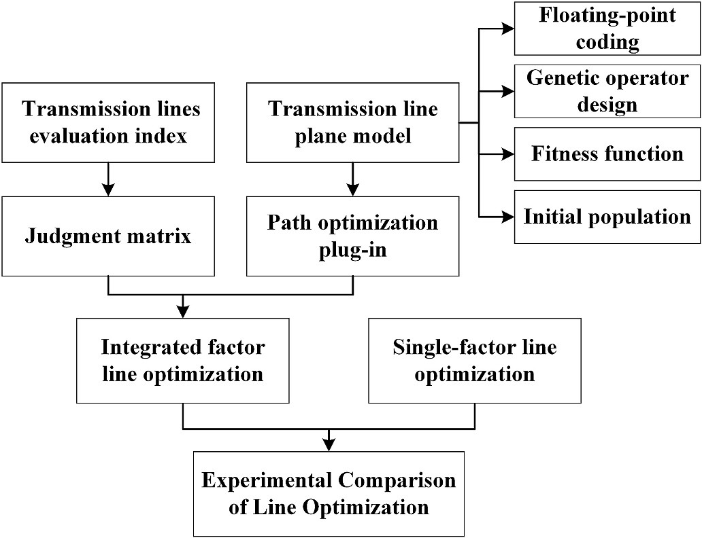

**Fig. 1.** Experiment process.

design specification⟫ [12], combined with the regional characteristics of Yunnan design index system as shown in Table 1.

* + 1. *Determination of index weights by analytic hierarchy process*

Analytic Hierarchy Process (AHP) is a comprehensive evaluation method combining qualitative and quantitative analysis of influencing factors. According to the opinions of power grid experts, the judgment matrix of each factor is obtained, and the importance weights of different target schemes or factors are obtained, as shown in Table 2.

* 1. *Transmission line planning model based on genetic algorithm*

Genetic Algorithm (GA) embodies the ’ survival of the fittest, sur- vival of the fittest ’ evolutionary rules in the algorithm [13], the popu- lation iteration based on genetic selection, crossover, mutation

operation, from each generation update to obtain better groups, and finally get the optimal solution to meet the requirements. Transmission line planning is to find an optimal path or the closest optimal solution. The optimal solution here is the problem that requires solutions in theory or in the equation. Refer to the existing transmission line selec- tion method [14].The idea is as follows:

The first step is to encode the path for genetic operation;

In the second step, generate the path initial solution, each initial solution represents a planning line, get a set of initial population, so that the algorithm began to search;

The third step, combined with the requirements of transmission line selection, considering its target requirements, scientific design fitness function;

The fourth step is to design genetic operators that are convenient for solving and optimizing transmission lines;

The last step, output the optimal path.

* + 1. *Coding strategy*

The transmission line is simplified as a line segment composed of a series of points, which are located on the vertical lines perpendicular to the SE of the line segment. The solution required for the transmission line planning is a line that knows the optimal starting and ending points. Therefore, the coordinates of each point (xS, yS), (X1, Y1), (X2, Y2) …

(Xn, Yn), (xE, yE) can be used as linear genes. The lines composed of

these genes are chromosomes or individuals to be solved. Due to the complex conditions and large amount of calculation involved in solving transmission lines, the genetic operator will be designed by a knowledge-based operator. The operator is not only a numerical expression but also carries spatial and attribute information, so the floating-point coding method is used to encode genes. Floating-point coding is easy to design knowledge-based genetic operators for special problems, and can deal with decision variables with complex con- straints. It can represent a larger number, obtain higher precision values, and improve the efficiency of the algorithm.

* + 1. *Generation of initial populations*

When the genetic algorithm is applied to the optimization of trans- mission lines, it is first necessary to construct individuals with alleles, so as to construct the plane linear model of transmission lines suitable for solving (Fig. 2).

The study area is divided by a regular grid of a certain size. It is assumed that point S (XS, YS) is the starting point of the line and point E (XE, YE) is the end point of the line. It is assumed that the generation of the line does not produce a backturning curve. Connect the line segment SE, and divide the line segment SE into N equal parts at a certain dis-

tance, (x1, y1). (x2, y2), …, (xn, yn) are equally spaced points on the line. Make the vertical lines L1、L2 ….Ln of SE through the equally spaced points. Thus, the line optimization process of the transmission

line is transformed into finding the location of the intersection points with the line on each vertical line. For example, randomly select points (X1, Y1), (X2, Y2) …, (Xn, Yn), connect these points successively from

**Table 1**

500 kV transmission line path selection index system.

500 kV transmission Avoid factors habitation, adverse geological zone, disaster hotspots, mining area, protected areas, scenic spot and so on

line selection

The indicator

influence

index factor Indicator factor grading score

|  |  |  |  |  |  |  |
| --- | --- | --- | --- | --- | --- | --- |
| index system system of non- | factor | 1 | 2 | 3 | 4 | 5 |
| avoidance factor | terrain | Elevation (1/ 1000–1500 m | 1500m–3500 m | 3500m–5000 m | >5000 m |  |
|  |  | 3) |  |  |  |  |
|  |  | altitude 0–20 m | 20–150 m | More than 150 m |  |  |
|  |  | difference |  |  |  |  |
|  |  | (1/3) |  |  |  |  |
|  |  | Slope (1/3) 0–5◦ | 5–15◦ | 15–25◦ | 25–35◦ | More than |
|  |  |  |  |  |  | 35◦ |
|  | land use | land-use type Unused | grassland, garden | woodland | residential land, | water area |
|  |  | wasteland |  |  | cultivated land |  |
|  | Traffic | Distance 40–3000 m | 3000–6000 m | 6000–9000 m | 9000–12000 m | ≤40 m or |
|  |  | from road |  |  |  | ≥12000 m |
|  | Icing | Icing hazard Slightly ice- | Lightly ice- | Moderately ice | Heavy icing |  |
|  |  | level covered areas | covered areas | covered areas (6–9 | areas (>9 mm) |  |
|  |  | (0–3 mm) | (3–6 mm) | mm) |  |  |
|  | Filthy | Pollution I | II | III | IV |  |
|  |  | hazard level |  |  |  |  |
|  | seismic | Seismic ≤VI | VII | VIII | ≥IX |  |
|  | intensity | intensity |  |  |  |  |
|  |  | grade |  |  |  |  |

Note: The score is 0 when the icing danger level is free icing areas (0 mm).

**Table 2**

Impact factor weight judgment matrix.

|  |  |  |  |  |  |  |  |
| --- | --- | --- | --- | --- | --- | --- | --- |
| Factor | tearrain | land use | Traffic | Filthy | Icing | seismic intensity | weight |
| Terrain | 1 | 3 | 1 | 3 | 3 | 3 | 0.291 |
| land use | 1/3 | 1 | 1/4 | 1/2 | 3 | 1/2 | 0.088 |
| Traffic | 1 | 4 | 1 | 4 | 3 | 3 | 0.320 |
| Filthy | 1/3 | 2 | 1/4 | 1 | 1 | 1/2 | 0.092 |
| Icing | 1/3 | 1/3 | 1/3 | 1 | 1 | 1/2 | 0.072 |
| seismic intensity | 1/3 | 2 | 1/3 | 2 | 2 | 1 | 0.137 |

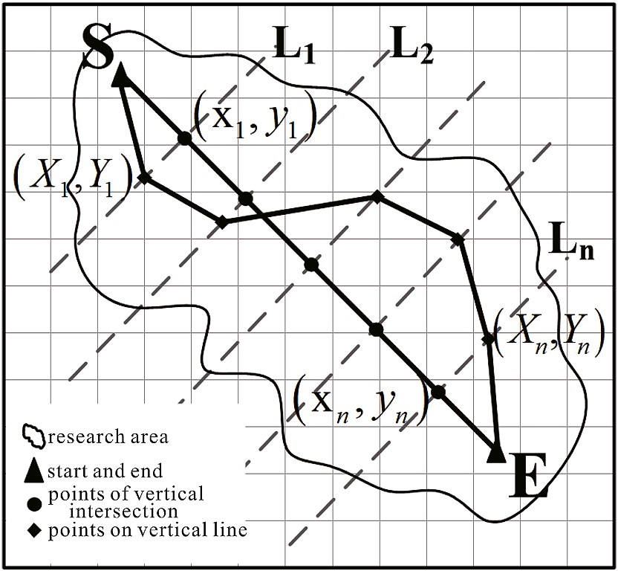

**Fig. 2.** Transmission line plane model.

the starting point (xS, yS) to the end point (xE, yE) to form an initial line. Initial population is composed of a series of initial routes, let λ be a route composed of a set of points, P(0) is the initial population, n is the

number of equally spaced points, m is the population size, then the initial population can be expressed as

*P*(0) = (*λ*1, *λ*, ⋯, *λm*)

*n* ∈ [1, 2, ⋯, *n*], *m* ∈ [1, 2, ⋯, *m*] (1)

The selection of random points on the vertical line is the key to

generate lines. According to the basic requirements of transmission line selection, this model is not in the avoidance area, as shown in Fig. 3 (a). The initial line generation method is as follows: Firstly, connect the stop point S and E to generate the line segment SE between the two points,

and take the equidistant point set (x1, y1), (x2, y2), …, (xn, yn) on the line segment according to a certain distance dm, then generate the

vertical line L1, L2, …, Ln of the line segment through the equidistant point, and finally take any point in the value range of the vertical line,

which cannot be in the avoidance zone. The value range of the vertical line segment can be determined by the research range or by setting the corridor range of a certain distance. Combining the point sets and the starting and ending points on each vertical line is an initial individual

λ1=(XS, YS), (X11, Y11), (X21, Y21), …, (Xn1, Yn1), (XE, YE). Similarly,

an initial population P(0) is generated according to this process which

composed of m individuals λ1,λ2, …,λm.

* + 1. *Construction of fitness function*

The fitness function plays a decisive role in the evolution of genetic algorithm and finding the optimal solution. Theoretically, it is consid- ered that the shortest line segment between two points is the optimal, as shown in the SE line segment in Fig. 3. However, the planning and se- lection of transmission lines cannot only consider the goal of the shortest line, because the complex terrain makes it difficult to construct and maintain the lines between two points, and it is also possible to cross the terrain of ecologically sensitive areas, lakes or cliffs. In this way, the

[(*xS*, *yS*), (*x*11, *y*11), (*x*21, *y*21), ⋯, (*xn*1, *yn*1), (*xE*, *yE*)],

⎧⎪⎨

= [(*xS*, *yS*), (*x*12, *y*12), (*x*22, *y*22), ⋯, (*xn*2, *yn*2), (*xE*, *yE*)],

⋯,

⎫⎪⎬

planned lines will be more expensive or impossible to construct in terms

of construction and maintenance. The optimization problem in this study is to find the optimal transmission line. Since the line is composed

⎪⎩ [(*xS*, *yS*), (*x*1m, *y*1*m*), (*x*2*m*, *y*2*m*), ⋯, (*xnm*, *ynm*), (*xE*, *yE*)], ⎪⎭

of points, the points can be regarded as the set of the best points found on

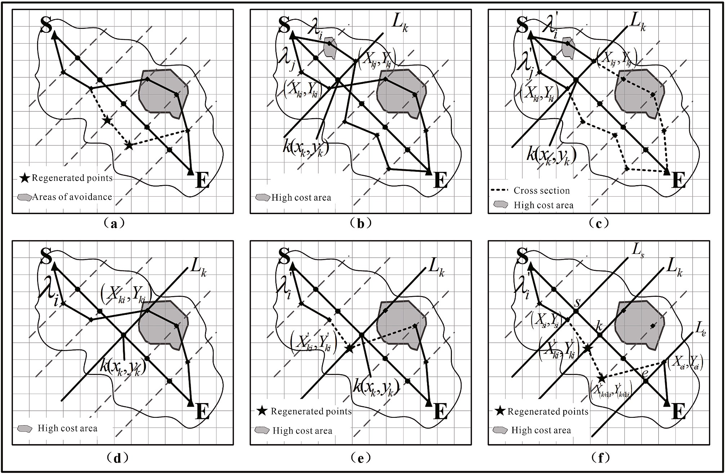

**Fig. 3.** Genetic model,(a) Initial line generation,(b) Parent individuals before crossover,(c) Subbands generated after a sigle crossover,(d) Parent individuals before mutation,(e) Subbands generated after a sigle mutation,(f) Generate new individuals after improving mutation.

the L1, L2, …, Ln vertical lines passing through the equidistant points on SE. The optimization problem of transmission line planning is regarded

as the problem of minimizing the total cost of the line, and the influence factors involved are transformed into cost to represent. The cost value is dropped into each grid, and the points along the line are selected ac- cording to a certain accuracy (the model is selected according to the grid size of the layer) to obtain the cost value of the grid corresponding to the point. The grid cost value carried by these points is the grid cost passed by the line, and the sum of points is the total cost of the line. The lower the total cost of the line, the better the target. According to the principle of the lowest total line cost, the fitness function is defined as:

lines λi, λj in the group, and compare their fitness values. The higher fitness value F is retained and then the subsequent genetic operation is

carried out, and the lower is directly eliminated.

(2) Cross

The design of the crossover operator is similar to that in binary coding, The superior genes are retained to the offspring through cross- over. In transmission line planning, that is to say, the lines passing through the low cost segments are retained while the high cost regional segments are abandoned. The operation of single-point crossing is

shown in Fig. 3(b) and (c). Randomly select two linear individuals in the

*N*

/ ∑

F = 1

1

*value* *xg*, *yg*)

(2)

population λi and λj to obtain the coding of their linear point sets,

*λi* = [(*xS*, *yS*), (X1*i*, *Y*1*i*), (X2*i*, *Y*2*i*)…(Xn*i*, *Yni*), (*xE*, *yE*)]

In the formula, N = [l/D], g∈[1,2 … N], l is the length of λ of the

transmission line, D is the size of the grid, and N is the number of points

along the route. Value (xg,yg) is the raster cost value corresponding to the point taken along the road.

* + 1. *Genetic operator design*

(1) Selection

*λj* = (*xS*, *yS*), X1*j*, *Y*1*j* , X2*j*, *Y*2*j* … Xnj, *Ynj* , (*xE*, *yE*) (3) Random generation of a mutation point k = random[1,n], Genes from the two fathers are then swapped at the point of mutation to create

a new individual:

[ ) ) ) ]

*λ*′ =[(*x* ,*y* ),(X ,*Y* ),(X ,*Y* )…(X ,*Y* ), X ,*Y* )… X ,*Y* ),(*x* ,*y* )]

*i*

*S*

*S*

1*i*

1*i*

2*i*

2*i*

*ki*

*ki*

(*k*+1)*j*

(*k*+1)*j*

nj

*nj*

*E*

*E*

*λ*′ = [(*x* , *y* ), X , *Y* ), X , *Y* )… X , *Y* ), X , *Y* )…(X , *Y* ),

In this paper, the selection strategy of random competition is adop-

*j*

*S*

*S*

1*j*

1*j*

2*j*

2*j*

*kj*

*kj*

(*k*+1)*i*

(*k*+1)*i*

n*i*

*ni*

ted. A pair of individuals are randomly selected at each time, and then the two individuals are allowed to compete. The better individuals enter the next generation, and the inferior individuals are directly eliminated. This not only ensures that the better individual can be inherited, but also retains the diversity of the population, and it is easier to evolve to the

(*xE*, *yE*)]

(3) Variation

(4)

optimal solution. In this model, the individual fitness value F is used for random competitive selection. The operation is to randomly select two

Mutation operation is to change the value of the gene site. The mu-

tation operator design of transmission line profile is similar to binary code mutation, which regards the point set that constitutes the profile as gene, and the mutation operation is to carry out mutation on these point sets. Mutation not only increases the diversity of the population, but also evolves to produce individuals that avoid high cost zones. Fig. 3 (d)–(c)

is the schematic of linear single-point variation. The idea is to randomly

point k = random[1,n] with a mutation location on the individual. On select a parent individual in the population and randomly generate a the vertical line Lk that the random point k(xk,yk) passes through, a

point (x’ki,y’ki) that is not in the avoidance area is randomly generated. Then change the point (xki,yki) on the original mutation site to the changed point (x’ki,y’ki). Thus the mutation operation is completed to obtain a new individual:

*λ*′ = [(*x* , *y* ), (X , *Y* ), (X , *Y* ′ *Y*′ )…(X , *Y* ), (*x* , *y* )] (5)

*i*

*S*

*S*

1*i*

1*i*

2*i*

2*i*)… X*ki* ,

*ki*

n*i*

*ni*

*E*

*E*

influence factor obtained after preprocessing. According to the existing research, when the DEM resolution is 150 m, the calculation time effi- ciency is higher and the loss of terrain information is less [15]. There- fore, the grid resolution of each layer is set to 150 m.

* 1. *Experiment and analysis of transmission line path optimization based on genetic algorithm*

In order to explore the robustness of the genetic algorithm model constructed in this paper, as well as the selection and optimization of the overhead transmission line path, two algorithms are selected for path optimization experiments under different conditions. The starting point of the experimental line is Jiantang substation, and the end point is Tai’an substation. The genetic algorithm and Dijkstra algorithm are used

to carry out two groups of experiments considering the single factor

However, the mutation of a single point is often unable to generate a new individual line that completely bypasses the high-cost region, and the mutation position is very abrupt, which makes it difficult for genetic operation to search for the optimal solution. Therefore, in order to make the algorithm converge to the optimal solution better, this paper im- proves the mutation operation, as shown in Fig. 3 (f). The improved

mutation operator design is to randomly generate two points S = random[k-r,k] and E = random[k,k + r] on both sides of the mutation bit k with a certain step size in the range of r (the points here are calculated

the range of the inclusion of R value, then S = random[1,k], E = random [k,k + d]; Connect the point (Xsi,Ysi) on the vertical line Ls over S to the as equally spaced points). If the starting and ending points S and E are in point (X’ki,Y’ki) after mutation, A new individual λ′i is formed by connecting the constructed line point (Xei,Yei) on the vertical line Le

over the point e and the mutated point (X’ki,Y’ki),

influence and multi-factor comprehensive influence of traffic. ArcGIS is

10.2 version.

* + 1. *Experiment 1: consider only traffic path optimization*

① Optimization of transmission line path by genetic algorithm.

When only the traffic factor is considered, the pre-processed road

map is assigned as “9999′′ to facilitate genetic operation. The probability score needs to be processed again. The avoidance area in the road score of crossover and mutation is set by referring to literature [16], and the

parameter setting is shown in Table 3.

② Dijkstra algorithm is used to optimize the path of transmission lines.

*λ*′ = [(*x* , *y* ), (X , *Y* ), (X , *Y* ), ⋯, (X , *Y* ), (*X*′ , *Y*′ ),

*i*

*S*

*S*

1*i*

1*i*

2*i*

2*i*

*si*

*si*

(*s*+1)*i*

(*s*+1)*i*

The path analysis function of ArcGIS is realized based on Dijkstra

⋯, *X*′ , *Y*′ ), ⋯, (*X*′ , *Y*′ ), (X , *Y* ), ⋯, (X , *Y* )(*x* , *y* )] (6)

algorithm. Therefore, referring to the technical route of existing

*ki*

*ki*

(*e*—1)*i*

(*e*—1)*i*

*ei*

*ei*

*ni*

*ni*

*E*

*E*

research literature [17,18], we can directly optimize the cost path

analysis in ArcGIS.

The line formed in this way is relatively flat, and can better avoid the high cost area.

# Example experiment analysis

* 1. *Overview of the study area*

The study area is concentrated in the northwest of Yunnan Province, which shows the terrain characteristics of Yunnan Province. The area is less suitable for planning ultra-high voltage transmission lines and has typical characteristics. The planning object is about 150 km 500 kV overhead transmission line from Jiantang substation (starting point) to Taian substation (ending point) in Shangri-La county.

* 1. *The implementation of the model algorithm*

In this study, the ArcGIS desktop application program of ESRI Cor- poration was adopted as the host program of the plug-in, combined with its ArcObjects object-oriented component library, using C# as the development language, and developed the Add-Ins plug-in of the transmission line path planning model of genetic algorithm under the Windows operating system.

* 1. *Data preprocessing*

The main work of data preprocessing includes: raster data correction, thematic electronic map data and satellite image data preparation, unified coordinate system, etc. According to Table 1, the impact factors were reclassified and assigned according to scores of 0, 1, 2, 3, 4, and 5. Fig. 4 series is the grid layer of 500 kV transmission line path

* + 1. *Experiment 2: path optimization considering synthesis factors*

On the basis of Table 1, the weight value of each influencing factor is obtained by analytic hierarchy process, and the path optimization under the comprehensive factor is carried out after the comprehensive cost is calculated by grid superposition.

① The path optimization of the genetic algorithm takes into account the comprehensive cost, and the parameters are set according to

Table 4.

② Dijkstra algorithm considers the path optimization of compre- hensive cost, which is consistent with the method ② in Experi- ment 1, and finally obtains the optimization path of

comprehensive cost.

After considering the comprehensive cost, the transmission line path optimized by the two algorithms is shown in Fig. 5. From the graph, it can be seen that the two paths bypass the avoidance area and distribute in the low cost area. It shows that the designed genetic algorithm model is reasonable and feasible and has robustness.

* 1. *Result analysis of optimization path*
     1. *Results and data analysis*

Fig. 6 shows the comparison between the four optimized paths and the established lines. Set the constructed path as scheme I, the optimized path of the genetic algorithm and Dijkstra algorithm considering the comprehensive cost are respectively the II and the III, and the optimized path of the genetic algorithm and Dijkstra algorithm considering the traffic factor are respectively the IV and the V.

Comparison results of the five schemes are shown in Table 5. The

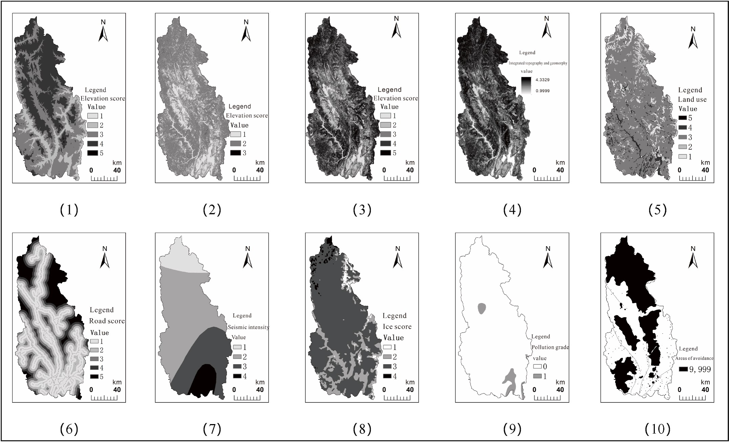

**Fig. 4.** Study area impact factor rating value map (1) Elevation value map,(2) High difference value map,(3) Slope value map,(4) Topographic features value map,(5) Landuse value map,(6) Road value map,(7) Seismic intensity value map,(8) Ice value map,(9) Pullution rating value map,(10) Avoidance area distribution map.

**Table 3**

Parameter setting for genetic algorithm operation considering traffic factor.

|  |  |  |  |  |  |  |
| --- | --- | --- | --- | --- | --- | --- |
| Cost grid | Corridor width (m) | Interval (m) | Number of lines Genetic algebra | Crossover probability | Mutation probability | Mutation step (m) |
| Road score chart.Tif | 10000 | 500 | 200 100 | 0.5 | 0.1 | 30 |

**Table 4**

Parameter setting for genetic algorithm operation considering integrated cost.

|  |  |  |  |  |  |  |  |
| --- | --- | --- | --- | --- | --- | --- | --- |
| Cost grid | Corridor width (m) | Interval (m) | Number of lines | Genetic algebra | Crossover probability | Mutation probability | Mutation step (m) |
| cost.Tif | 10000 | 500 | 200 | 100 | 0.5 | 0.1 | 30 |

“line comprehensive cost value” refers to the total cost value (dimen-

sionless) obtained from starting point to end point by summing up the line length of each scheme in ArcGIS10.2 according to the program of “element to raster” → “raster to point” → “value extraction to point” on

the comprehensive cost layer. This value is used to uniformly measure

the cost value of each line in the comprehensive cost. The function of

“Comprehensive cost value of the line after removing the contained

with the collision avoidance zone grid value set as “9999′′, so as to collision avoidance zone grid” is to remove the large-value grid value facilitate the comparison of the comprehensive cost difference of the line

without the collision avoidance zone.

According to the result table of the path scheme in Table 5, it can be seen that:

1. Comparing the total length of each path: II < IV < V < III < I, it can be seen that the path length optimized by the two algorithms is shorter than that of the built line, and the path length obtained by Scheme II is the shortest.
2. Comparing the comprehensive cost value of the line: III < IV < II < V

< I, it can be seen that after the algorithm optimization, the comprehensive cost value of the path decreases significantly, which is far lower than the initial cost value.

1. By comparing the number of grids in the avoidance area (one): III <

IV < II < V < I, it shows that the existing path is unreasonable in planning. After genetic algorithm optimization, the path can well bypass the avoidance area, while the optimization results of Dijkstra algorithm have certain defects and cannot well bypass the avoidance area.

1. The comprehensive cost values of the lines after removing the grid of the avoidance zone in the lines are compared: III < V < IV < II < I. Except III, the comprehensive cost values of other schemes are similar, indicating that the genetic algorithm is intelligent.

In summary, we can make the following judgments:

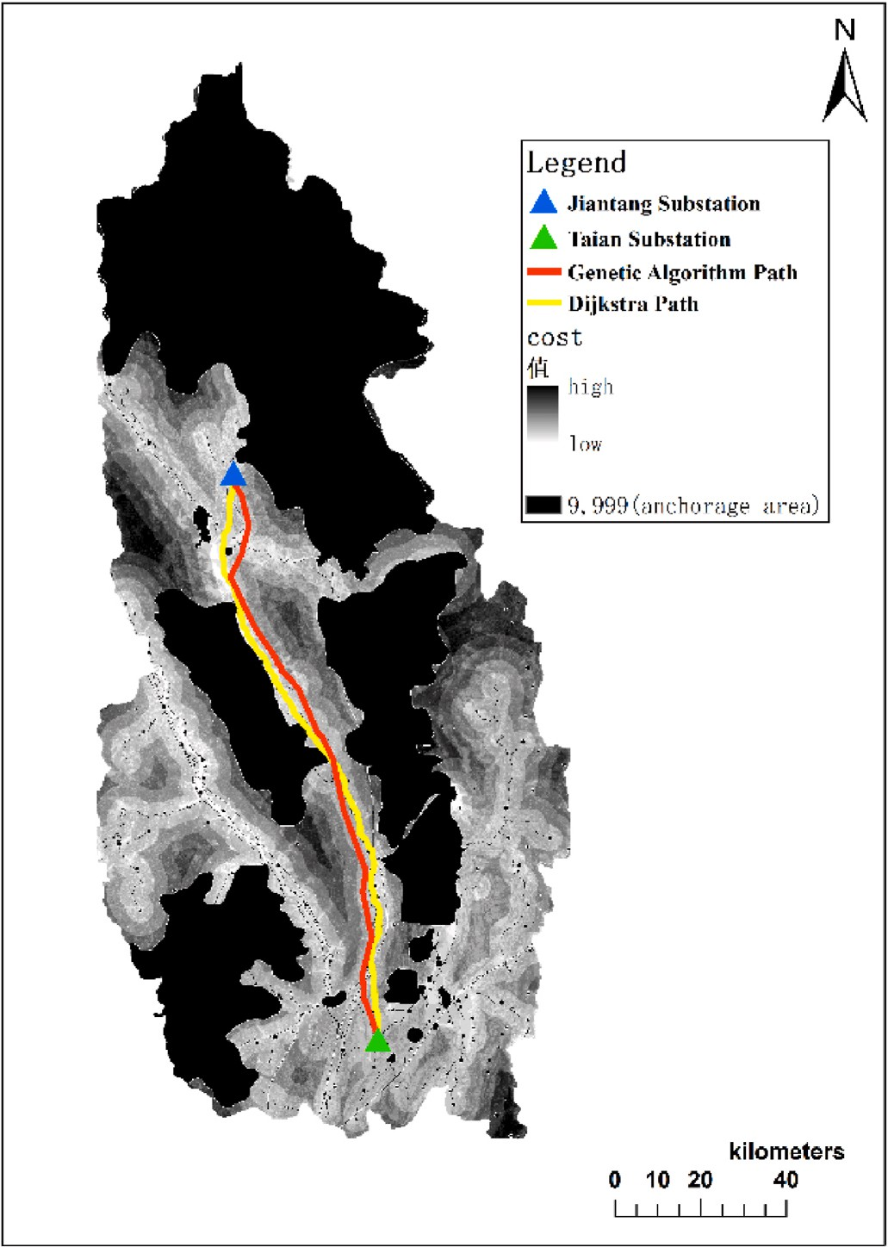 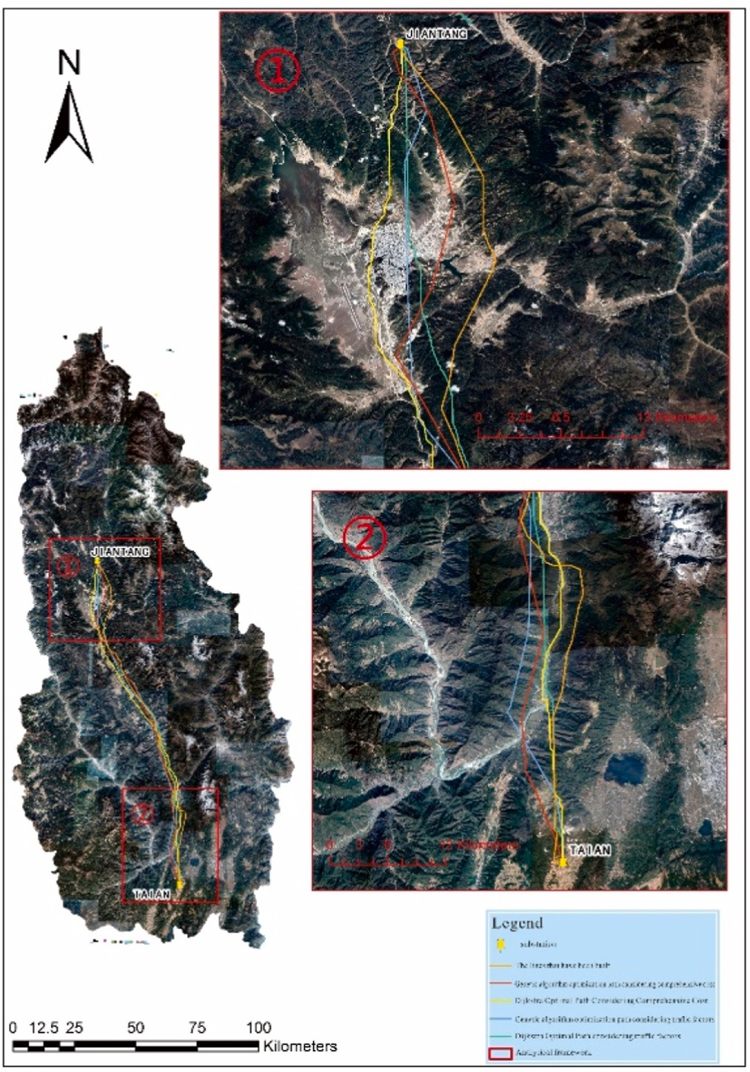

**Fig. 5.** Optimization path considering comprehensive cost. **Fig. 6.** Comparison diagram of test results and built path.

1. There are some unreasonable places in the planning of the built lines, such as passing through more shelter zones, which will affect the surrounding environment; the path length and cost are too high,

|  |  |  |  |  |  |  |
| --- | --- | --- | --- | --- | --- | --- |
| resulting in unnecessary waste. | Comparative | I | II | III | IV | V |
| When the genetic algorithm constructed in this study is used to | length (m) | 147904 | 143112 | 147930 | 143382 | 144645 |
| optimize the transmission line path, it can effectively bypass the | Cost | 251790 | 31736 | 11429 | 21694 | 121662 |
| shelter areas such as residential areas, disaster points, nature re- | Number of avoidance | 25 | 3 | 1 | 2 | 12 |
| serves, scenic spots and ecologically sensitive areas, making the | zones |  |  |  |  |  |

**Table 5**

Comparison table of path plan results.

2)

power grid path more reasonable, reducing the impact on human life and ecological environment, and helping people and nature coexist harmoniously. However, the Dijkstra algorithm cannot achieve the above results.

1. The optimization of genetic algorithm can shorten the length of power grid path, reduce the comprehensive cost, improve the economy and practicability of transmission lines, and reduce un- necessary waste of human and material resources.
2. When only the single factor of traffic is considered, the results ob- tained by either genetic algorithm or Dijkstra algorithm are not ideal. Therefore, we need to establish a comprehensive and objective evaluation system. Under the premise of synthesizing many factors, the algorithm is applied to optimize, so as to obtain the reasonable results as far as possible.
   * 1. *Combined image analysis*
3. The overall trend of the four optimized lines is similar to that of the

existing lines, and the differences are mainly concentrated in local areas, such as ①② area in Fig. 6.

Cost (no-avoidance zone) 1815 1739 1430 1696 1674

1. It can be seen from the ① area that the path optimized by genetic algorithm (scheme II) chooses to cross the mountain, completely

bypassing the urban area and considering the development trend of the town; as far as possible to avoid human activity areas, the impact on the lives of local residents will be minimized and planning is reasonable; III basically bypasses the town, but the planning path through the flat area, waste a lot of land for development, unfavor- able for the future development of the town, the lack of long-term vision; both programmes IV and V chose to cross directly through urban areas, which affected the daily lives of the local population and resulted in unnecessary cost increases and lack of rationality.

1. It can be seen from region ② that the main difference between the

four optimized lines and the built lines is the selection of river

crossing points (Jinsha River). The lines optimized by genetic algo- rithm cross the river near Tai ‘an substation (which is reasonable in theory). The river crossing point of Dijkstra optimization path is in the north of II, and the river crossing point of the built line is the furthest from Tai ‘an substation. The selection of river crossing points needs to consider the river width and certain engineering

construction requirements. According to the actual situation, the river crossing point of I is reasonable.

According to the comprehensive calculation data results and the image analysis of the path, the path chosen by this experiment scheme II is the optimal one in theory, it can effectively bypass the avoidance zone, can search a path with the shortest length and can weigh the factors that have an impact on the transmission line planning, and it is relatively scientific and reasonable.

# Conclusion

In order to realize automatic power grid path optimization, this study combines genetic algorithm with GIS, and designs a transmission line optimization model based on genetic algorithm by analyzing the application of GIS and artificial intelligence in the field of power grid path optimization. At the same time, the Add-ins plug-in development of transmission line planning model based on genetic algorithm is realized by C # language. Taking 500 kV overhead transmission line about 150

km from Jiantang Substation (starting point) to Tai ’an Substation (ending point) in Shangri-La County as the planning object, the model is

verified and discussed, and the rationality and superiority of the model are finally proved.

Due to the lack of knowledge about power grid erection, there may be omissions in considering the cost problem, so the evaluation index system of transmission lines can be further discussed. At the same time, because the analytic hierarchy process depends on expert opinions to determine the weight, the next step can refer to the idea of multi- objective genetic algorithm to optimize, reduce the influence of human subjectivity on the experiment, improve intelligence.

Finally, the following results are obtained:

1. The transmission line optimization model based on genetic al- gorithm is designed. According to the structural characteristics of genetic algorithm, the floating-point coding method is used to design the appropriate genetic operator, and the planar linear model of transmission line is constructed after considering the generation mode of initial population and the fitness function. Develop the Add-ins plug-in. With the help of C # language, a plug-in that can realize the optimization function of genetic al- gorithm is developed.
2. The superiority of genetic algorithm in power grid path optimi- zation is discussed with examples. Taking 500 kV overhead transmission line about 150 km from Jiantang Substation (start-

ing point) in Shangri-La County to Tai’ an Substation (ending point) in Lijiang as an example, two groups of experiments are

designed under the conditions of considering traffic single factor and comprehensive multi-factor respectively. It is obtained that the path optimization effect of genetic algorithm is the best under the condition of comprehensive multi-factor, which proves the rationality and superiority of the model constructed in this study.

# Declaration of competing interest

The authors declare that they have no known competing financial interests or personal relationships that could have appeared to influence the work reported in this paper.

# Data availability

Data will be made available on request.

# Acknowledgements

This work was supported by the National Natural Science Foundation of China [grant number 51467022], the Yunnan Fundamental Research

Projects [grant number 202001BB050030].

# References

1. [Sun Hong. Path optimization of ultra-high voltage transmission lines based on GIS](http://refhub.elsevier.com/S2590-0056(22)00099-6/sref1) [technologys. Hohhot: Inner Mongolia Normal University; 2010](http://refhub.elsevier.com/S2590-0056(22)00099-6/sref1).
2. [Singh S, Behera SN. Development of GIS-based optimization method for selection](http://refhub.elsevier.com/S2590-0056(22)00099-6/sref2)

[of transportation routes in municipal solid waste management. Adv Waste Manag](http://refhub.elsevier.com/S2590-0056(22)00099-6/sref2) [2019 pp 319–331](http://refhub.elsevier.com/S2590-0056(22)00099-6/sref2).

1. [Du P, Hu H. Optimization of tourism route planning algo-rithm for forest wetland](http://refhub.elsevier.com/S2590-0056(22)00099-6/sref3)

[based on GIS. J Discrete Math Sci Cryptogr 2018;21(2):283–8](http://refhub.elsevier.com/S2590-0056(22)00099-6/sref3).

1. [Yuan Shaoxiong, Huang Guangqing, Chen Wenyin, et al. Site-scale constructed](http://refhub.elsevier.com/S2590-0056(22)00099-6/sref4) [wetland site selection based on GIS spatial analysis. Geospat Inf 2018;105(5). 9,54-](http://refhub.elsevier.com/S2590-0056(22)00099-6/sref4) [57,66](http://refhub.elsevier.com/S2590-0056(22)00099-6/sref4).
2. [Liu Xiaolin, Wen Chengjie, Zhang Jiangshui. Analysis of spatial location selection](http://refhub.elsevier.com/S2590-0056(22)00099-6/sref5) [using GIS. Geomat Spatial Inf Technol 2010;33(4):19–21](http://refhub.elsevier.com/S2590-0056(22)00099-6/sref5).
3. [Yang Jia. Research on road route optimization system based on GIS platform.](http://refhub.elsevier.com/S2590-0056(22)00099-6/sref6)

[Chongqing: Chongqing Jiaotong University; 2008](http://refhub.elsevier.com/S2590-0056(22)00099-6/sref6).

1. [Xu Ting, Sheng Ming, Lou Cairong. Logistics distribution center’s allocation based](http://refhub.elsevier.com/S2590-0056(22)00099-6/sref7) [on GIS and ant colony algorithm. Sci Surv Mapp 2010;33(4):19–21](http://refhub.elsevier.com/S2590-0056(22)00099-6/sref7).
2. [Li Xiaobao, Yang Kuo, Hu Mengjin. Evaluation of transmission line path scheme](http://refhub.elsevier.com/S2590-0056(22)00099-6/sref8) [based on GIS and fuzzy analytic hierarchy process. Electr Eng Abstr 2017;(3):26–9](http://refhub.elsevier.com/S2590-0056(22)00099-6/sref8).
3. [Torre TDL, Feltes JW, Roman TGS, et al. De-regulation, privatization, and](http://refhub.elsevier.com/S2590-0056(22)00099-6/sref9)

[competition: transmission planning under uncertainty. IEEE Trans Power Syst](http://refhub.elsevier.com/S2590-0056(22)00099-6/sref9) [2002;14(2):460–5](http://refhub.elsevier.com/S2590-0056(22)00099-6/sref9).

1. [Ye Yali. Research and development of highway intelligent line selection and](http://refhub.elsevier.com/S2590-0056(22)00099-6/sref10)

[decision support system. Xian: Chang’an University; 2010](http://refhub.elsevier.com/S2590-0056(22)00099-6/sref10).

1. [Su Haifeng, Yang Kuo, Liang Zhirui. Automatic route planning of transmission lines](http://refhub.elsevier.com/S2590-0056(22)00099-6/sref11) [based on improved ant colony algorithm. Electr Power Automat Equipm 2016;36](http://refhub.elsevier.com/S2590-0056(22)00099-6/sref11)

[(12):109–14](http://refhub.elsevier.com/S2590-0056(22)00099-6/sref11).

1. [Code for design of 110kV~750kV overhead transmission line: GB50545-2010.](http://refhub.elsevier.com/S2590-0056(22)00099-6/sref12) [Beijing: China Planning Press; 2010](http://refhub.elsevier.com/S2590-0056(22)00099-6/sref12).
2. [Aventze T. Intelligent GIS: location decisions and strategic planning. J Retailing](http://refhub.elsevier.com/S2590-0056(22)00099-6/sref13) [Consum Serv 1998;50(5):257–8](http://refhub.elsevier.com/S2590-0056(22)00099-6/sref13).
3. Chen Zhongwei, Peng Kangbo, Huang Lai, Wang Yichao, Wu Xiaozhong, Xie Jiang,

Hou Yiling, Xiao Zhenfeng, Civilization transmission line selection methods and systems [P].Beijing : CN107480373B, 2020-11-06.

1. [Xie Fei. Research on the relationship between integrated terrain complexity and](http://refhub.elsevier.com/S2590-0056(22)00099-6/sref15) [grid resolution based on DEM. Kuming: Yunnan University; 2017](http://refhub.elsevier.com/S2590-0056(22)00099-6/sref15).
2. [Dijk SV, Thierens D, Berg MD. Using genetic algorithms for solving hard problems](http://refhub.elsevier.com/S2590-0056(22)00099-6/sref16) [in GIS. GeoInformatica 2002;6(4):381–413](http://refhub.elsevier.com/S2590-0056(22)00099-6/sref16).
3. [Zhou Qinfang. Research on the selection of 500kV transmission line path based on](http://refhub.elsevier.com/S2590-0056(22)00099-6/sref17)

[GIS-Tuoba hydropower station to Taian substation as example. Kuming: Yunnan](http://refhub.elsevier.com/S2590-0056(22)00099-6/sref17) [University; 2012](http://refhub.elsevier.com/S2590-0056(22)00099-6/sref17).

1. Zhang Chao, Li Xin, Zhao Xiangwei. Transmission line path planning based on improved Dijkstra algorithm [J].Power Surv Design, 2022 (02): 1-5.DOI : 10.13500/j.dlkcsj.issn1671-9913.2022.02.001.

Yuancun Qin received a M.S. degree from Yunnan University, Kunming, China, in 2018. She is currently an engineer in Yunnan Appraisal Center for Ecological and Environmental Engineering, Kunming, China. Her main research interests include geospatial information applications and intelligent GIS. Email: [qycynkm@163.com](mailto:qycynkm@163.com)

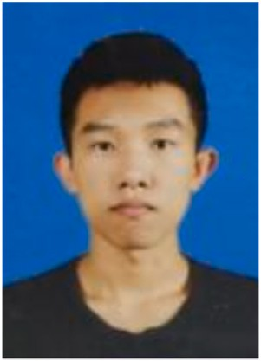Zhaozheng Li received a B.S. degree from Yunnan University, Kunming, China, in 2021. He is currently pursuing an M.S. degree at School of International Institute of River and Ecological Security, Yunnan University, Kunming, China. His main research interests include spatial data matching and pattern recognition. Email: [a769268749@163.com](mailto:a769268749@163.com)

JieYu Ding received a B.S. degree from Yunnan University, Kunming, China, in 2020. She is currently pursuing an M.S. degree in cartography and geography information system at Wuhan University, Wuhan, China. Her research interests include geographic information visualization. Email: [jadeding@whu.edu.cn](mailto:jadeding@whu.edu.cn)

Fei Zhao received a Ph.D. from Wuhan University, Wuhan, China, in 2012. He is currently an associate professor in the School of Earth Sciences, Yunnan University, Kunming, China. His main research interests include cartography and spatial analysis. Email: [vwobai@163.com](mailto:vwobai@163.com)

Ming Meng is currently a professor in the School of Earth Sci- ences, Yunnan University, Kunming, China. His main research interests include spatial information visualization, intelligent geographic information system and intelligent map. E-mail: [mengming586@sina.com](mailto:mengming586@sina.com)