[](Journal%20logo)[Artificial Intelligence in Agriculture 4 (2020) 209–218](https://doi.org/10.1016/j.aiia.2020.10.001)

Contents lists available at [ScienceDirect](http://www.sciencedirect.com/science/journal/25897217)

Artificial Intelligence in Agriculture

journal homepage: [http://www.keaipublishing.com/en/journa ls/artificial- intelligence- in-agriculture/](http://www.keaipublishing.com/en/journals/artificial-intelligence-in-agriculture/)

[](http://crossmark.crossref.org/dialog/?doi=10.1016/j.aiia.2020.10.001&domain=pdf)Benchmark of an intelligent fuzzy calculator for admissible estimation of drawbar pull supplied by mechanical front wheel drive tractor

S.M. Shafaei ⁎, M. Loghavi, S. Kamgar

*Department of Biosystems Engineering, School of Agriculture, Shiraz University, Shiraz 71441-65186, Iran*

a r t i c l e i n f o

*Article history:*

Received 1 July 2020

Received in revised form 23 August 2020 Accepted 1 October 2020

Available online 5 October 2020

*Keywords:* Drawbar power Drawbar pull Power efficiency Wheel slip

Gross traction force

a b s t r a c t

This paper proposes a calculator for estimation of drawbar pull supplied by mechanical front wheel drive tractor based on nominal input variable of tractor driving mode in two-wheel drive (2WD) and four-wheel drive (4WD), and numeral input variables of tractor weight (53.04–78.45 kN) and slip of driving wheels (1.4–15.1%) utilizing intelligent fuzzy systems. The systems were developed by means of various input membership functions, output membership functions, defuzzification methods, and training cycles. The prominent developed system for esti- mation of the drawbar pull yielded a user-friendly intelligent fuzzy calculator with admissible accuracy (coeffi- cient of determination = 0.993). Data obtained from the calculator revealed increasing nonlinear trend of the drawbar pull in range of 12.9–57.5 kN as concurrent augment of slip of the wheels and tractor weight, for 2WD mode. In case of the 4WD mode, it nonlinearly raised from 12.8 to 77.7 kN. Therefore, effect of the slip and weight on the drawbar pull was found synergetic. Moreover, the drawbar pull ranges elucidated that the drawbar pull proliferated as the 4WD mode was employed rather than the 2WD mode. Generally, benchmark of the prominent developed intelligent fuzzy system, not only provide simple calculator with the widest applica- bility for different tractor models, but also produces added values in enrichment of realization level in domain of tractor drawbar pull concepts.

© 2020 The Authors. Production and hosting by Elsevier B.V. on behalf of KeAi Communications Co., Ltd. This is an open access article under the CC BY license (<http://creativecommons.org/licenses/by/4.0/>).

1. Introduction

Investigation on drawbar pull supplied by off road driving wheels has been interest for researchers from six decades ago. Available pub- lished documents indicate that, for the first time, Forrest et al. (1962) attempted to ascertain effect of various parameters on the drawbar pull. This attempt was followed afterwards by other agricultural engi- neers in time periods of sixties and seventies of the twentieth century (McLeod et al., 1966; Zombori, 1967; Burt et al., 1974; Burt et al., 1979; Raghavan and McKyes, 1979). These researches have been con- tinued until recent years (Bailey and Burt, 1981; Burt and Bailey, 1982; Burt et al., 1984; Foda, 1991; Taghavifar and Mardani, 2015; Kumar et al., 2019). In the mentioned research works, for specific soil conditions, main influential factors affecting the drawbar pull were re- ported as dynamic weight, slip, and dimensions of the wheel.

Parallel to these researches in the sixties, army engineers of the United States of America in Waterways Experiment Station started their efforts for studying drawbar pull of off road driving wheels.

*Abbreviations:* MFWD, mechanical front wheel drive; NTTL, Nebraska Tractor Test Laboratory; OECD, Organisation for Economic Co-operation and Development; 2WD, two-wheel drive; 4WD, four-wheel drive.

* Corresponding author.

*E-mail address:* [smshafaei@shirazu.ac.ir](mailto:smshafaei@shirazu.ac.ir) (S.M. Shafaei).

Outcome of their efforts led to presentation of a new engineering pa- rameter for wheel size and soil characteristics. The parameter has been called wheel mobility number (Freitag, 1966; Freitag, 1968). The parameter was subsequently employed by engineers (Wismer and Luth, 1973; Wismer and Luth, 1974) in technical center of Deere & Com- pany in order to develop mathematical model for estimation of gross traction force and the drawbar pull of the wheel. The model proposed by the engineers estimates the gross traction force and drawbar pull based on dynamic weight, slip, and dimensions of the wheel. This ap- proach of mathematical modeling has been followed by other re- searchers (Gee-Clough, 1980; Wulfsohn et al., 1988; Sharma and Pandey, 1998; Srivastava et al., 2006; Maclaurin, 2014; Mason et al., 2018) based on the main mentioned influential factors. However, some miscellaneous mathematical models have been yet developed by other researchers (Hayes and Ligon, 1981; Ashmore et al., 1987; Upadhyaya et al., 1989; Evans et al., 1991; Vechinski et al., 1998; Sharma and Pandey, 2001; Rosca et al., 2014).

Since some agricultural engineers (Southwell, 1964; Steinbruegge and Larsen, 1966; Kliefoth, 1966; Southwell, 1967; Domier and Persson, 1968; Domier and Friesen, 1969; Wang et al., 1989) in the sixties and seventies of the twentieth century tended to ascertain draw- bar pull supplied by tractor in various processes, the aforementioned re- searchers who concerned with development of mathematical models suggested utilization of the models for estimation of tractor drawbar

<https://doi.org/10.1016/j.aiia.2020.10.001>

2589-7217/© 2020 The Authors. Production and hosting by Elsevier B.V. on behalf of KeAi Communications Co., Ltd. This is an open access article under the CC BY license ([http://](http://creativecommons.org/licenses/by/4.0/) [creativecommons.org/licenses/by/4.0/](http://creativecommons.org/licenses/by/4.0/)).

Nomenclature

AFS actual forward speed (km/h) CNU coefficient of non-uniformity (%) CV coefficient of variation (%)

DPi ith drawbar pull (kN)

DPactave average of actual drawbar pull (kN)

DPact,i DPest,i DPmax DPmin M MAVEE MRDM N

R2 RMSE

Sdw SD TFS

ith actual drawbar pull (kN)

ith estimated drawbar pull (kN) maximum value of drawbar pull (kN) minimum value of drawbar pull (kN) mean of drawbar pull (kN)

mean of absolute values of estimation errors (kN) mean relative deviation modulus (%)

number of used data coefficient of determination root mean square error (kN) slip of driving wheels (%)

standard deviation of drawbar pull (kN) theoretical forward speed (km/h)

pull. The utilization can be performed by summation of drawbar pull provided by each driving wheel. Main drawback of this method is attrib- uted to model conditions which are established for specific tire type (bias and radial ply), soil texture (silt, clay, and sandy), slip value, tested surface and environment (Tiwari et al., 2010; Keen et al., 2013; Sunusi et al., 2020). Another drawback of the method is related to its applica- tion for the MFWD tractors. Front and rear driving wheels of the MFWD tractors have different dimensions, dynamic weight, and tire in- flation pressure. Thus, utilization of the mathematical models for esti- mation of drawbar pull of the MFWD tractors in specific conditions results in frequently consequent calculations. These calculations can be partly decreased by employment of new parameter of tractor mobil- ity number (tractor vehicle number). Concept of the tractor vehicle number was initially introduced by Grisso et al. (1992) and completed by Taylor et al. (1995), afterward. However, this scheme was also not a drastic effort for presenting a method for direct estimation of the drawbar pull. Hence, development of a general model for estimation of drawbar pull supplied by the MFWD tractor based on some major tractor parameters is a highlight topic for researchers, undoubtedly.

Notable progress of computer simulation tools for multivariate esti- mations of phenomena leads to worldwide application of the tools in engineering and scientific works. Literature screening process proved this fact for attempts conducted by researchers (Battiato and Diserens, 2013; Battiato and Diserens, 2017) in case of estimation of drawbar pull supplied by the MFWD tractor. In the cited works, the researchers developed a computer program for estimation of the tractor drawbar pull as function of several input parameters (weight of front and rear axles, soil mechanical characterizations, tire specifications, tractor ge- ometry, and slip of driving wheels). The developed program was fed with constant soil characterizations for the front and rear wheels. How- ever, bulk density and cone index of soil are proliferated after passage of front wheels (Rush, 1969; Holm, 1969; Bashford et al., 1988; Abebe et al., 1989; Srivastava et al., 2006; Lyasko, 2010; Taghavifar and Mardani, 2014a). Thus, the rear wheels encounter with higher cone index and bulk density of soil. This deficiency in assumptions results in decrement of confidence level of the program for accurate estimation of the drawbar pull. From another point of view, although estimation of the tractor drawbar pull by the developed program is relatively appro- priate for broad spectrum of conditions, high numbers of prerequisite input parameters of the program prevent the widest employment of the program by engineers, researchers, and associated managers. There- fore, it is indispensable to take a drastic effort for development of

general computer simulation system working like simple calculator for estimation of the drawbar pull based on minimum major input pa- rameters of the MFWD tractor.

Among several computer simulation systems, intelligent types are simulation workspaces typically worked through predetermined se- quential calculations for foundation of correlation between output and input data. These types are well known simulation systems due to their capability for intelligent simulation of multiple input and output parameters with self-training algorithm for nonlinear and uncertain phenomena. These outstanding capabilities result in applying intelli- gent simulation systems in field of Biosystems Engineering researches in recent years in case of two well-known types of the simulation sys- tems (neural and fuzzy systems). Details of development and validation of neural simulation systems in these researches can be found in some published documents (Taghavifar and Mardani, 2014b; Shafaei et al., 2016a; Taghavifar and Mardani, 2017; Shafaei et al., 2018a; Shafaei et al., 2019a). Furthermore, there are some documents in literature for successful application of fuzzy simulation systems in these researches (Khoshnevisan et al., 2014; Daneshmand et al., 2015; Shafaei et al., 2018b; Elijah et al., 2020). Analysis of the literature for performance of intelligent neural and fuzzy simulation systems approved that the fuzzy systems can estimate phenomena with higher accuracy than neu- ral systems. This fact has been remarkably publicized by the same au- thors (Shafaei et al., 2015; Shafaei et al., 2018c; Shafaei et al., 2019b; Shafaei et al., 2019c; Shafaei et al., 2019d) in case of compound effect of nominal and numeral input parameter on output target.

According to dearth of information in the published works for offer- ing general computer simulation system for estimation of drawbar pull supplied by the MFWD tractor and reliability of fuzzy simulation sys- tems for multivariate estimation of nominal and numeral input vari- ables, proved in the literature, this study was intended to develop fuzzy simulation systems for estimation of the drawbar pull on the basis of combined major nominal input variable of tractor driving mode (2WD and 4WD) and numeral input variables of tractor weight, and slip of driving wheels. In this regard, it was expected to provide prominent simulation system with user-friendly environment which works like a simple calculator.

1. Research methodology
   1. *Specifications of tractors*

Eleven MFWD models of New Holland tractors were considered in this study. The New Holland type was selected because it is a popular tractor that is frequently sold and supported in Iran. The models in con- junction with some engineering specifications are tabulated in Table 1.

* 1. *Drawbar pull tests*

The NTTL has spearhead for testing tractors and reported source of reliable data. These data have been arranged for fuel consumption, wheel slip, engine speed, forward speed, drawbar pull, drawbar power, and hydraulic oil temperature of tested tractor. The hydraulic oil temperature was measured and monitored to verify steady state op- erating conditions of the tractor and data collection procedure (Roeber et al., 2017).

From 1986, the NTTL has tested performance of tractors based on of- ficial procedure described by the OECD standard (Kocher et al., 2011). Currently, the OECD standard Code 2 was devoted for official testing of performance of agricultural and forestry tractors under steady state controlled conditions (OECD, 2020). According to the standard, the tests must be conducted on concrete flat surface in order to eliminate ef- fect of soil characteristics on tractor performance. During the tests, the tractor was loaded by a load car. The load car controlled the loads ap- plied to the tractor. The load car was a Caterpillar articulated dump truck. The load car was outfitted with two load cell transducers

Table 1

Some engineering specifications of the MFWD tractors considered in this study.

|  |  |  |  |  |  |
| --- | --- | --- | --- | --- | --- |
| Model | Total tested weight (kN) | Type of front tires | Type of rear tires | Inflation pressure of the tires (kPa) | Height of drawbar (m) |
| TM115 | 53.044 | 14.9R28 | 18.4R38 | 83 | 0.425 |
| TM120 | 53.358 | 14.9R28 | 18.4R38 | 95 | 0.500 |
| TM125 | 53.074 | 14.9R28 | 18.4R38 | 83 | 0.430 |
| TM130 | 53.740 | 14.9R28 | 18.4R38 | 95 | 0.510 |
| TM135 | 60.860 | 16.9R28 | 20.8R38 | 83 | 0.470 |
| TM140 | 58.281 | 16.9R28 | 20.8R38 | 90 | 0.545 |
| TM150 | 62.841 | 16.9R28 | 20.8R38 | 83 | 0.470 |
| TM155 | 58.203 | 16.9R28 | 20.8R38 | 90 | 0.540 |
| TM165 | 65.038 | 16.9R28 | 20.8R38 | 83 | 0.465 |
| TM175 | 71.000 | 540/65R30 | 650/65R42 | 85 | 0.475 |
| TM190 | 78.453 | 540/65R30 | 650/65R42 | 85 | 0.560 |

(1232ALD-100-K-B, Scottsdale, Ariz) connected together in series form and attached to tested tractor hitch to measure drawbar pull supplied by the tractor. The drawbar pull was initially measured in the first load cell transducer, while the second one was employed to confirm measured load by the first one (Roeber et al., 2017). Moreover, the load car was equipped with two controllers for data acquisition with collection rate of 1 kHz and load control. The exterior-mounted control- ler was a NI CRIO 9073 and the controller inside the cab was a NI PIX1042Q. Software interface was LabVIEW version 12.0F3 (Kocher et al., 2017). Actual forward speed was also measured using a non- driving fifth wheel traveled under the load car. Meanwhile, forward speed of rear wheels of the tested tractor was measured as theoretical forward speed (Howard et al., 2013). Therefore, slip values of the tested tractor wheels were ascertained and logged in the data acquisition based on Eq. (1) (Muro and O'Brien, 2004; Andreev et al., 2010; Maclaurin, 2018).

* 1. *Development of intelligent fuzzy systems*

Intelligent fuzzy systems were developed to estimate drawbar pull supplied by the MFWD tractor, based on three independent input vari- ables of slip of driving wheels, tractor weight, and tractor driving mode. The intelligent fuzzy system has five layers comprising various nodes in each layer. These five layers are called fuzzification, normalization, fuzzy rule, defuzzification, and output layer, respectively. The intelli- gent fuzzy estimation is accomplished through passing data sets in these five layers. The estimation scenario is explained in following paragraph.

When input data sets are imported into the system in the first layer nodes, they are graded between zero and one by input membership functions (trapezium, triangular, sigmoid, constant, generalized bell (Gbell) and Gaussian). The graded data are transferred to the second layer nodes as input data. The numerical weights are assigned to the data in the second layer. Additionally, the second layer normalizes the weighted input data. The weighted input data are shifted to the third layer nodes as input data of fuzzy rules. These rules are defined based on the IF and THEN structure through self-training algorithm. These def- initions are intelligently tuned regarding relationships between input and output data. Output data obtained by the rules are collected and ag- gregated to one output value in the fourth layer nodes. This value is con- verted to anticipate output target by defuzzification method (weighted sum and weighted average). Output membership functions (constant and linear) are used for this task. The desired output target is ultimately achieved in the fifth layer node.

In the fuzzy workspace of Matlab R2016b software, data sets obtained from the official NTTL reports were randomly shuffled and classified into three clusters. The clusters including 70% (202 data sets), 15% (43 data sets) and 15% (43 data sets) for training, validating and testing, respec- tively, of each developed system. To estimate the drawbar pull (12.9–57.5 kN) based on input variables of tractor weight (53.04–78.45 kN), slip of driving wheels (1.4–15.1%), and tractor driving mode

*Sdw*

*TFS*−*AFS*

= *TFS* × 100 (1)

The data collecting procedures were carried out twice over approx-

(2WD and 4WD), the ranges of the tractor weight and slip of driving wheels were directly defined in the workspace and integers 2 and 4 were assigned for the 2WD and 4WD, respectively. Development process was frequently accomplished until the best structure of the system with the highest estimation accuracy was reached. The process was finalized

imately 61 m length of straightaway. If similar results were achieved for two tests, next load set point was applied. If the results were not sim- ilar, more data were collected until two tests showed similar results. De- tails for test track with concrete flat surface were fully explained by Howard et al. (2013). The test data sets (288 sets) considered in this study for all eleven MFWD models of New Holland tractor were col- lected at the NTTL from 2000 to 2004.

* 1. *Statistical descriptions*

To describe behavior of drawbar pull supplied by the MFWD tractor, some statistical indices were calculated by means of following Eqs. (2)–

(5) (Shafaei and Kamgar, 2017).

*i*=*N*

∑ *DPi*

utilizing different types of input membership functions (trapezium, tri- angular, sigmoid, constant, generalized bell (Gbell) and Gaussian), the numbers of input membership functions, types of output membership functions (constant and linear), training cycles, and defuzzification methods (weighted sum and weighted average). To avoid prolongation of the paper, equation descriptions of input membership functions, out- put membership functions, and defuzzification methods are referred to Jang (1993). Operational flowchart for selection of the prominent system is depicted in Fig. 1.

* 1. *Performance appraisal of developed intelligent fuzzy systems*

To apprise performance of developed intelligent fuzzy systems for estimation of drawbar pull supplied by the MFWD tractor, suitability criteria of regression coefficient of determination was calculated based

*M* = *i*=1

*N*

sﬃ*i*=ﬃﬃﬃ*N*ﬃﬃﬃﬃﬃﬃﬃﬃﬃﬃﬃﬃﬃﬃﬃﬃﬃﬃﬃﬃﬃﬃﬃ2ﬃﬃ

∑ (*DPi*−*M*)

(2)

on Eq. (6) (Shafaei et al., 2016b). Moreover, absolute and relative errors of estimation were ascertained by Eqs. (7) and (8), respectively (Shafaei et al., 2017a). Mean of absolute values of estimation errors was also cal- culated by Eq. (9). The highest values of coefficient of determination and

the lowest values of absolute and relative errors of estimation indicated

*SD* =

*i*=1

*N*

(3)

the best system for estimation of the drawbar pull.

*CV* = *SD* × 100 (4)

*i*=*N*

*i*=*N*

*CNU* =

*M*

*DP*max−*DP*min

*M*

× 100 (5)

∑(*DPacti*−*DPactave* )− ∑(*DPacti*−*DPesti* )

*R*2 = *i*=1 *i*=1

*i*=*N*

∑(*DPacti*−*DPactave* )

*i*=1

(6)

[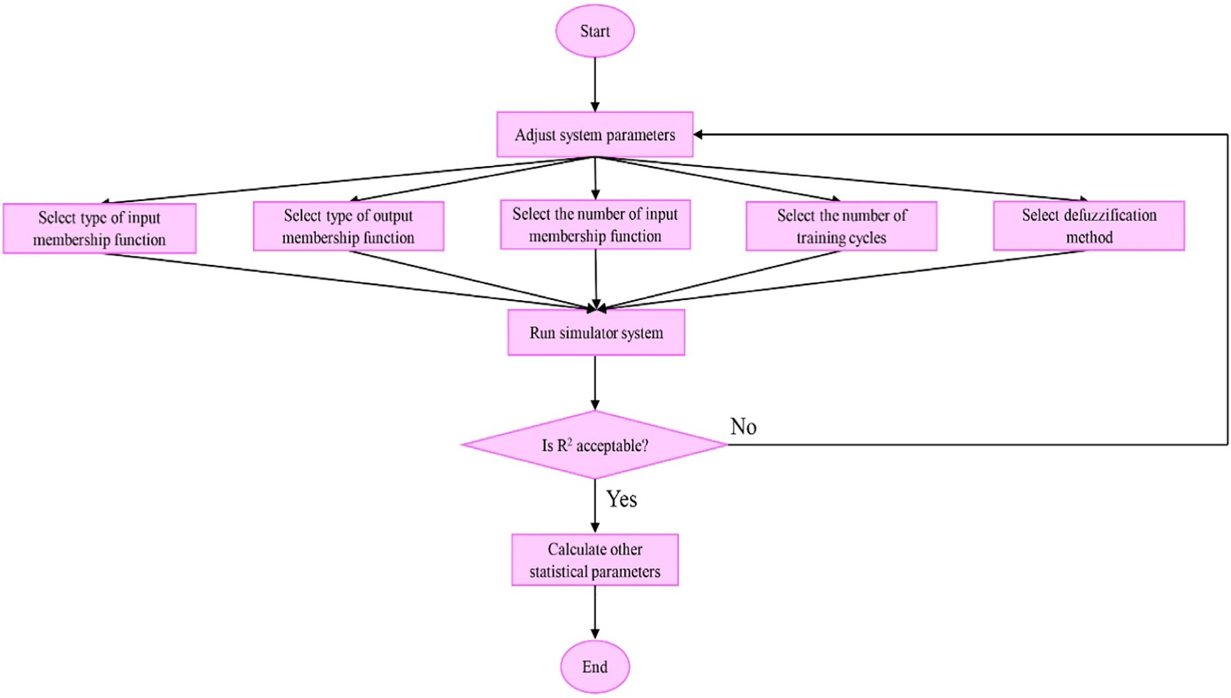](Image%20of%20Fig.%201)

Fig. 1. Operational flowchart for selection of prominent intelligent fuzzy system developed to estimate drawbar pull supplied by the MFWD tractors.

*RMSE* =

*MRDM*

sﬃ1ﬃﬃﬃﬃ*i*ﬃ=ﬃﬃ*N*ﬃﬃﬃﬃﬃﬃﬃﬃﬃﬃﬃﬃﬃﬃﬃﬃﬃﬃﬃﬃﬃﬃﬃﬃﬃﬃﬃﬃﬃﬃﬃﬃﬃﬃﬃ2ﬃﬃ

*i*=1

100 *i*=*N* ∣*DPesti*−*DPacti*∣

*N* ∑ (*DPesti* −*DPacti* )

(7)

8

1. Results and discussion
   1. *Statistical descriptions*

Table 2 lists values of statistical descriptor indices obtained for draw- bar pull supplied by the MFWD tractor. The minimum and maximum

=

*N*

*MAVEE*

∑

*i*=1

1 *i*=*N*

*DPacti*

( )

values of the drawbar pull for each tractor model in the Table 2 were found in the lowest and highest slip values of driving wheels, respec-

tively, for the both 2WD and 4WD modes. This result for the tested trac-

=  ∑ ∣*DPesti*−*DPacti*∣ (9)

*N*

*i*=1

tors is consistent with the results for tested wheels in soil bin facility

Table 2

Statistical descriptor indices obtained for drawbar pull supplied by the MFWD tractors.

|  |  |  |  |  |  |  |  |
| --- | --- | --- | --- | --- | --- | --- | --- |
| Tractor model | Driving mode | Mean (kN) | Standard deviation (kN) | Minimum (kN) | Maximum (kN) | Coefficient of variation (%) | Coefficient of non-uniformity (%) |
| TM115 | 2WD | 28.20 | 7.95 | 12.90 | 35.60 | 28.19 | 84.04 |
|  | 4WD | 35.24 | 14.22 | 12.80 | 52 | 40.35 | 111.24 |
| TM120 | 2WD | 32.39 | 9.28 | 16.30 | 40.30 | 28.65 | 74.10 |
|  | 4WD | 38.46 | 14.15 | 16.10 | 54.80 | 36.79 | 100.62 |
| TM125 | 2WD | 29.85 | 7.09 | 15.90 | 36.50 | 23.75 | 69.01 |
|  | 4WD | 37.85 | 13.82 | 15.80 | 52.80 | 36.51 | 97.75 |
| TM130 | 2WD | 34.11 | 10.52 | 15.60 | 43.50 | 30.84 | 81.79 |
|  | 4WD | 39.19 | 15.27 | 15.60 | 55.80 | 38.96 | 102.58 |
| TM135 | 2WD | 36.45 | 10.39 | 17.50 | 44.70 | 28.51 | 74.62 |
|  | 4WD | 42.08 | 15.64 | 17.30 | 59.50 | 37.17 | 100.29 |
| TM140 | 2WD | 38.59 | 11.43 | 18.20 | 49.40 | 29.62 | 80.85 |
|  | 4WD | 44 | 16.63 | 17.60 | 61.80 | 37.80 | 100.46 |
| TM150 | 2WD | 38.45 | 8.58 | 21.20 | 45.70 | 22.31 | 63.72 |
|  | 4WD | 48.99 | 15.58 | 22.30 | 64.20 | 31.80 | 85.53 |
| TM155 | 2WD | 38.62 | 10.31 | 19.40 | 47.90 | 26.70 | 73.80 |
|  | 4WD | 45.57 | 16.52 | 18.50 | 61.90 | 36.25 | 95.24 |
| TM165 | 2WD | 42.41 | 10.31 | 21.20 | 50 | 24.31 | 67.91 |
|  | 4WD | 49.75 | 16.44 | 20.20 | 65 | 33.05 | 91.90 |
| TM175 | 2WD | 49.63 | 9.54 | 29.10 | 57.50 | 19.22 | 57.22 |
|  | 4WD | 59.06 | 16.26 | 28.60 | 73.20 | 27.53 | 75.52 |
| TM190 | 2WD | 48.42 | 8.60 | 29.50 | 55.10 | 17.76 | 52.87 |
|  | 4WD | 61.51 | 18.15 | 29.40 | 77.70 | 29.51 | 78.52 |

[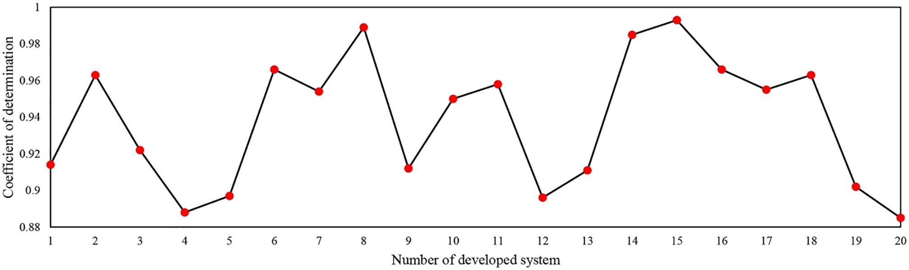](Image%20of%20Fig.%202)

Fig. 2. Variation of coefficient of determination for twenty intelligent fuzzy systems developed to benchmark calculator for estimation of drawbar pull supplied by the MFWD tractors.

[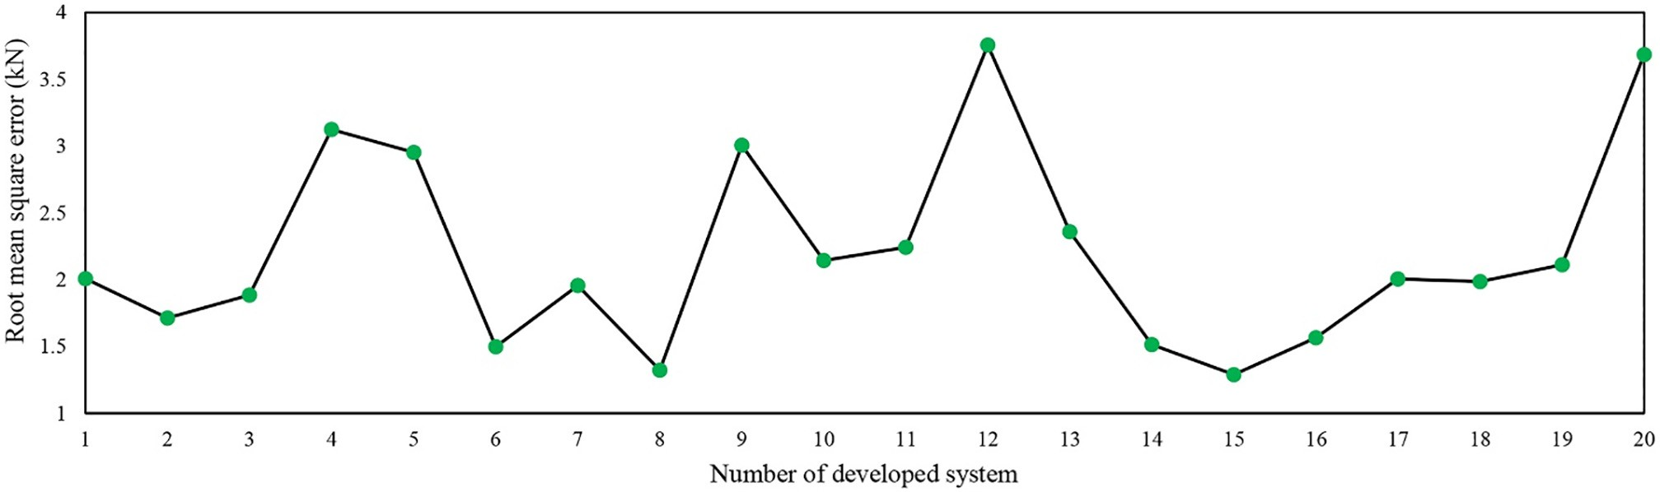](Image%20of%20Fig.%203)

Fig. 3. Variation of root mean square error for twenty intelligent fuzzy systems developed to benchmark calculator for estimation of drawbar pull supplied by the MFWD tractors.

published by previous researchers (Taylor et al., 1967; Shinone et al., 2010).

In the Table 2, the standard deviation values with low fluctuation range (7.09–18.15 kN) for measured drawbar pull confirmed high accu- racy of the NTTL instrumentation system. Moreover, taking note from the Table 2 demonstrates relatively high values were obtained for coef- ficient of variation and coefficient of non-uniformity of the drawbar pull. These high values indicated noteworthy changes of the drawbar pull as affected by slip of driving wheels and tractor weight.

* 1. *Performance appraisal of intelligent fuzzy systems*

Figs. 2–4 show variation of coefficient of determination, root mean square error, and mean relative deviation modulus, respectively, for twenty intelligent fuzzy systems developed to benchmark calculator for estimation of drawbar pull supplied by the MFWD tractors. As it is obvious in the Figs. 2–4, the developed system number 15 yielded max- imum value of coefficient of determination (0.993) and minimum values of root mean square error (1.289 kN) and mean relative

[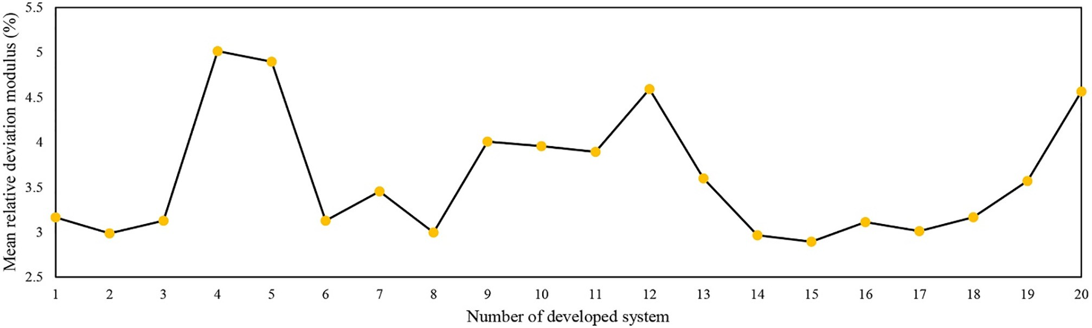](Image%20of%20Fig.%204)

Fig. 4. Variation of mean relative deviation modulus for twenty intelligent fuzzy systems developed to benchmark calculator for estimation of drawbar pull supplied by the MFWD tractors.

Table 3

Structures of selected twenty intelligent fuzzy systems developed to estimate drawbar pull supplied by the MFWD tractors.

|  |  |  |  |  |  |
| --- | --- | --- | --- | --- | --- |
| System number | The number of training cycles | The number of input membership functions | Membership | function | Defuzzification method |
|  |  |  | Input | Output |  |
| 1 | 125 | 2,3,3 | Gbell | linear | weighted sum |
| 2 | 56 | 2,2,3 | sigmoid | linear | weighted average |
| 3 | 111 | 2,3,3 | Gaussian | constant | weighted sum |
| 4 | 74 | 2,2,3 | sigmoid | linear | weighted sum |
| 5 | 99 | 2,4,3 | Gaussian | linear | weighted average |
| 6 | 43 | 2,2,3 | sigmoid | linear | weighted average |
| 7 | 89 | 2,3,3 | Gaussian | constant | weighted sum |
| 8 | 56 | 2,3,3 | Gbell | constant | weighted sum |
| 9 | 111 | 2,3,3 | sigmoid | constant | weighted sum |
| 10 | 40 | 2,2,3 | trapezium | constant | weighted average |
| 11 | 44 | 2,3,3 | gaussian | linear | weighted average |
| 12 | 100 | 2,3,3 | sigmoid | linear | weighted average |
| 13 | 56 | 2,3,3 | trapezium | linear | weighted sum |
| 14 | 111 | 2,2,3 | Gbell | constant | weighted sum |
| 15 | 174 | 2,3,3 | Gaussian | linear | weighted average |
| 16 | 99 | 2,4,3 | Gbell | constant | weighted average |
| 17 | 43 | 2,2,3 | sigmoid | linear | weighted sum |
| 18 | 89 | 2,3,3 | trapezium | linear | weighted average |
| 19 | 96 | 2,3,3 | Gaussian | constant | weighted average |
| 20 | 53 | 2,3,3 | Gaussian | constant | weighted average |

The boldfaced line represents prominent simulation system.

deviation modulus (2.893%). Structure of the developed system number 15 in accordance with other 19 developed systems are tabulated in Table 3. The Table 3 implies that structure of the developed system number 15 comprised 174 training cycles, 3 input membership func- tions for slip of driving wheels and tractor weight, and 2 input member- ship functions for tractor driving mode, Gaussian and linear function for input and output, respectively, and weighted average defuzzification method.

Graphical demonstration of superior value of coefficient of determi- nation as depicted in Fig. 5 shows that the estimated and actual values of the drawbar pull were appropriately clustered close to 1:1 line which indicate excellent correlation between the estimated and actual values. Additionally, scattered distribution of estimation error in Fig. 6 obvi- ously shows that no specific pattern was recognizable in the errors for the prominent system and distribution of the error values was ran- domly scattered. Mean of absolute values of estimation errors was found to be 1.043 kN. Fig. 7 exhibits frequency of estimation error which is shown low ranges of percentage of the errors. Therefore, it can be concluded that estimation error of the prominent system was not sensitive to actual data and consequently, it is inferred that the

system was appropriately matched to actual data. Similar to this result, the previous authors (Sefeedpari et al., 2016; Shafaei et al., 2017b; Shafaei et al., 2018d; Kaveh et al., 2018) in their Biosystems Engineering researches have positively reported adequacy of intelligent fuzzy sys- tem for estimation of desired variables.

According to the observed results, it is found that the drawbar pull was acceptably estimated by the prominent system developed in this research. The prominent system yielded a user-friendly intelligent fuzzy calculator. User interface of the calculator is illustrated in Fig. 8. The calculator can be simply employed based on importing values of tractor driving mode, tractor weight, and slip of driving wheels in allow- able range in predetermined place (bottom red bold framework in the Fig. 8). Consequently, tractor drawbar pull can be also observed in predetermined place (top red bold framework in the Fig. 8).

* 1. *Ascertainment of drawbar pull trend*

To ascertain trend of drawbar pull supplied by the MFWD tractors, three-dimensional surface plots have been drawn in Fig. 9 based on out- put data from the calculator. The Fig. 9 elucidates how the drawbar pull

[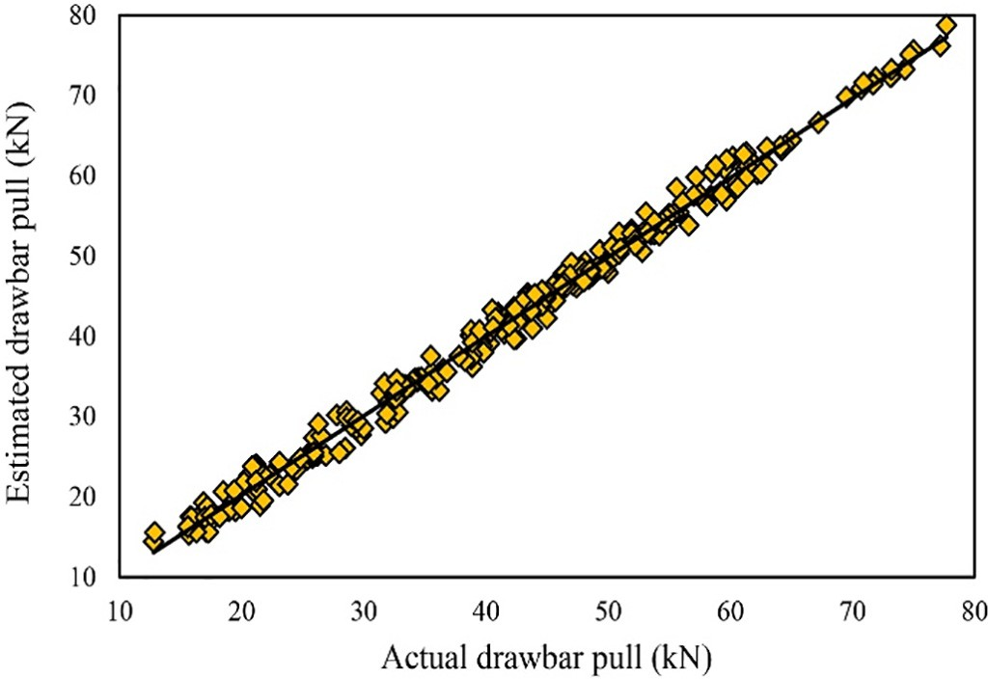](Image%20of%20Fig.%205) [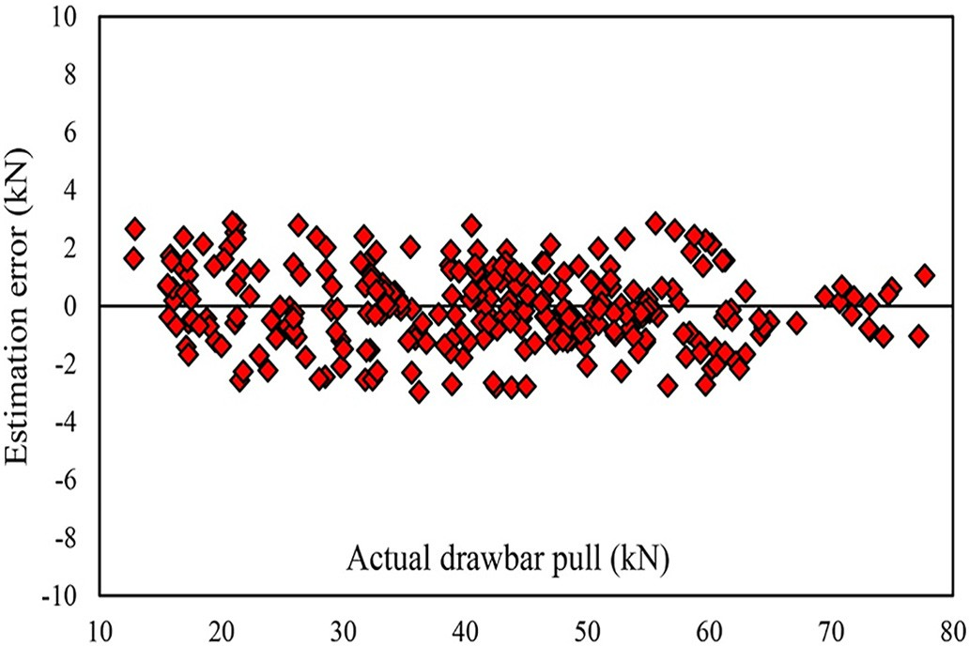](Image%20of%20Fig.%206)

Fig. 5. Relation between estimated and actual values of drawbar pull supplied by the

MFWD tractors. Fig. 6. Distribution of estimation error of drawbar pull supplied by the MFWD tractors.

[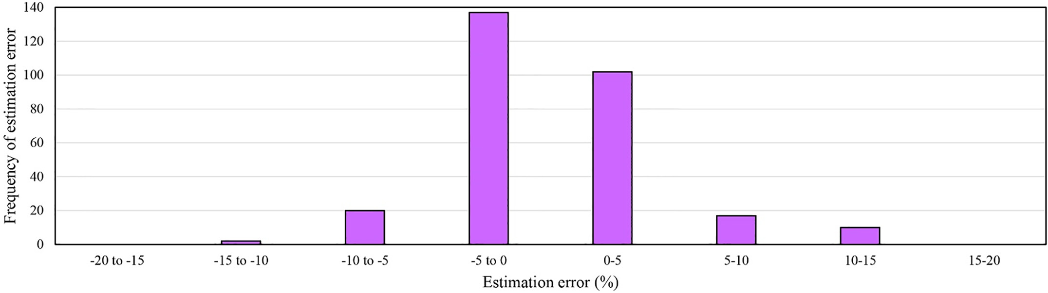](Image%20of%20Fig.%207)

Fig. 7. Frequency of estimation error of drawbar pull supplied by the MFWD tractors.

changed as slip of driving wheels and tractor weight varied. Physical perception obtained from the Fig. 9 indicates that the drawbar pull nonlinearly proliferated as slip of driving wheels and tractor weight in- creased in ranges of 1.4–15.1% and 53.04–78.45 kN, respectively, for both tractor driving modes of the 2WD and 4WD. These results have been obtained for the drawbar pull of the tractors tested in the NTTL on concrete flat surface. For the drawbar pull augmentation of tractors working on soil surface, some interpretations have been addressed by previous authors as mentioned in following paragraph.

When tractor weight augments, weight of its wheels increases, de- terministically. As weight of driving wheels ascends, greater soil volume between tire lugs is trapped which is led to increase resistive shear forces of soil volume. This task reinforces interaction of soil and tire, and consequently results in proliferation of net traction force (Taghavifar and Mardani, 2015; Taghavifar et al., 2015). When net trac- tion force developed by the driving wheels augments, obtained drawbar pull of the tractor increases. Meanwhile, the drawbar pull augmentation with wheel slip increment could be attributed to rise of resistive tangen- tial forces of deformable soil layers compacted by the wheel, as the slip

increases and thereby results in increment of net traction force (Taghavifar and Mardani, 2014c; Taghavifar and Mardani, 2014d; Taghavifar and Mardani, 2015). When net traction force generated by driving wheels increases, obtained drawbar pull for the tractor rises. The same results for increase of the tractor drawbar pull as a result of in- crement of slip of driving wheels and tractor weight have been found by Richardson and Cooper (1970) and Rasool and Raheman (2018).

It must be spotlighted that slip of driving wheels have indirect rela- tion with inflation pressure, dynamic load, and tire type (bias and radial ply). Tire types of the New Holland tractors in this study were radial ply. Radial ply tires develop higher gross traction force than bias ply ones (VandenBerg and Reed, 1962; Forrest et al., 1962; Taylor et al., 1976; Gee-Clough et al., 1977; Wulfsohn et al., 1988; Kumar et al., 2019). Moreover, the radial ply tires have lower slip (Cegnar and Fausti, 1961; Worthington, 1962; Coates, 1985) and rolling resistance force

(Thaden, 1962; McAllister, 1983; Kurjenluoma et al., 2009; Kumar et al., 2019) in comparison with the bias ply tires in the same conditions of tire and soil. These facts are corresponded to footprint of radial ply tire on soil than that of the bias ply tires (Thaden, 1962; Kumar et al.,

[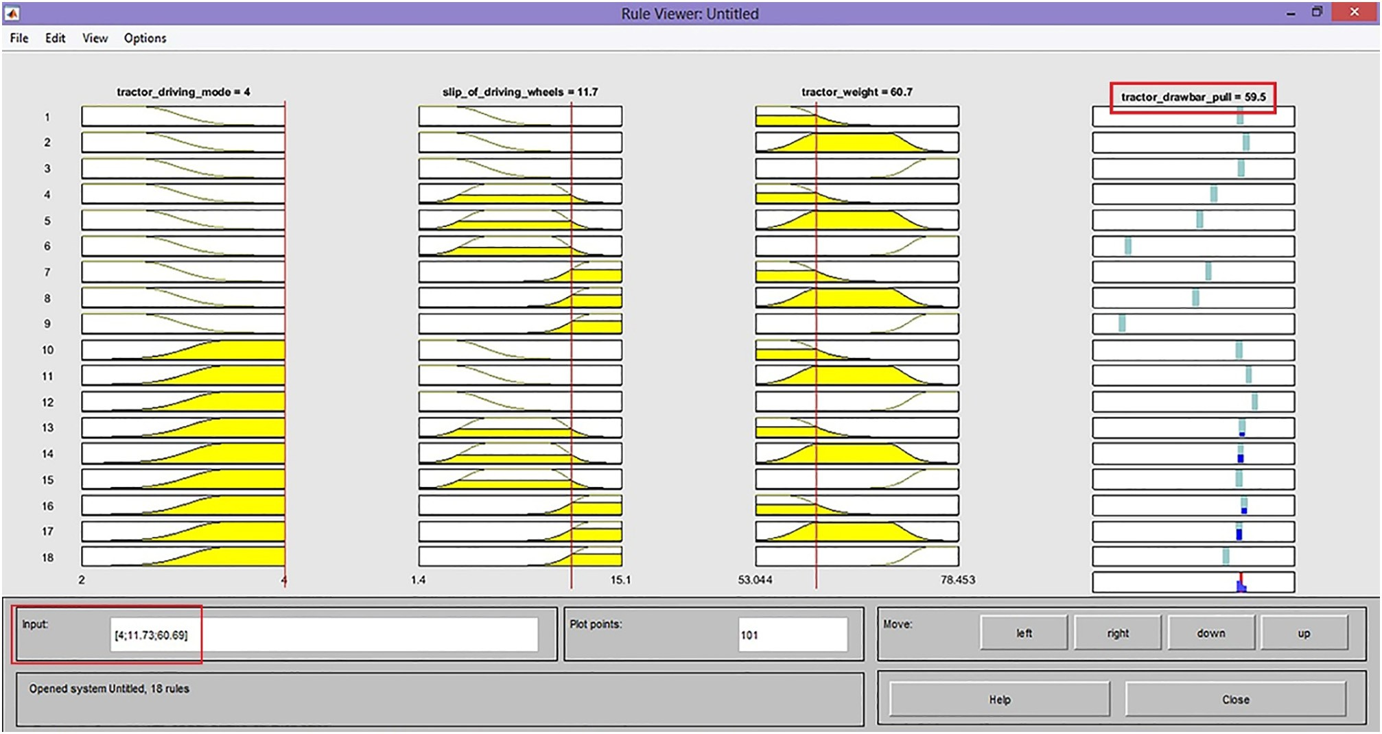](Image%20of%20Fig.%208)

Fig. 8. User interface of intelligent fuzzy calculator for estimation of drawbar pull supplied by the MFWD tractors.

[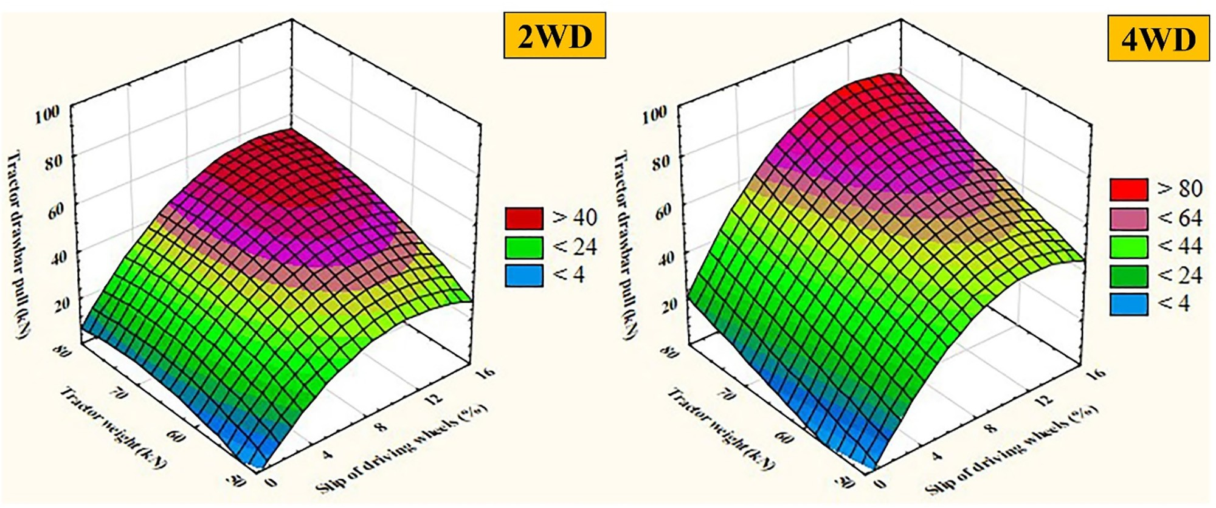](Image%20of%20Fig.%209)

Fig. 9. Three-dimensional surface plots obtained from intelligent fuzzy calculator for estimation of drawbar pull supplied by the MFWD tractors.

2018). The higher footprint with narrower and longer shape (Cegnar and Fausti, 1961; VandenBerg and Reed, 1962; Taylor et al., 1976) dis- tributes uniform ground contact pressure and decreases rolling resis- tance force, and finally leads to lower slip and higher gross traction force (Cegnar and Fausti, 1961). Therefore, in the same conditions of soil and wheels, employment of radial ply tire rather than bias ply tire type could be an effective way for increment of net traction force gener- ated by driving wheel as well as the tractor drawbar pull.

To more clearly inspect trend of variations of the drawbar pull as af- fected by the variables, dual effect of slip of driving wheels and tractor weight on the drawbar pull should be considered. To do this, projected area of the three-dimensional surfaces on horizontal plane are mani- fested in Fig. 10. The projected areas in the Fig. 10 clarify that the dual effect of slip of driving wheels and tractor weight on the drawbar pull was increasingly synergistic. It is plausible in the 2WD projected area that the drawbar pull proliferated from the lowest bound (<10kN) to the highest bound (>50 kN) as congruent increment of slip of driving wheels and tractor weight from 0 to 16% and 50 to 80 kN, respectively. In case of the 4WD, it proliferated from the lowest bound (<10 kN) to the highest bound (>80 kN). According to these bounds, it was found that the drawbar pull of the 4WD was changed in higher bound (average bound = 45.45 kN) than that of the 2WD (average bound = 37.92 kN). This fact could be attributed to employment of four driving wheels of the 4WD tractor than two driving wheels of the 2WD tractor

which is resulted in higher total net traction force produced by driving wheels. Consequently, drawbar pull supplied by the 4WD mode is higher than that of the 2WD mode. This result is compatible with that of statistical reports obtained from the Table 2.

* 1. *Application restrictions of developed calculator*

In this study, the intelligent fuzzy system of developed calculator has been trained based on the drawbar pull data sets of some tractors tested in the NTTL. It must be acknowledged that drawbar pull tests in the NTTL have been commonly performed on concrete flat surface. There- fore, the calculator in this form can be used for construction and indus- trial environments with concrete flat surface and it cannot be employed for various soil conditions and types of the MFWD tractor. This restric- tion implies necessity of adoption of the calculator for different models of the MFWD tractors and soil conditions in future research works by retraining the intelligent system of the calculator with more specific data sets. Another inherent drawback of the calculator is regarded to workspace of its user interface. Since the calculator has been developed in fuzzy workspace of the Matlab software, dependency of its user inter- face on the software restricts its broad employment. Therefore, this re- striction dictates necessity of a drastic effort for development of spreadsheet graphical user interface for the calculator like ones sug- gested by some previous researchers (Al-Hamed and Al-Janobi, 2001;

[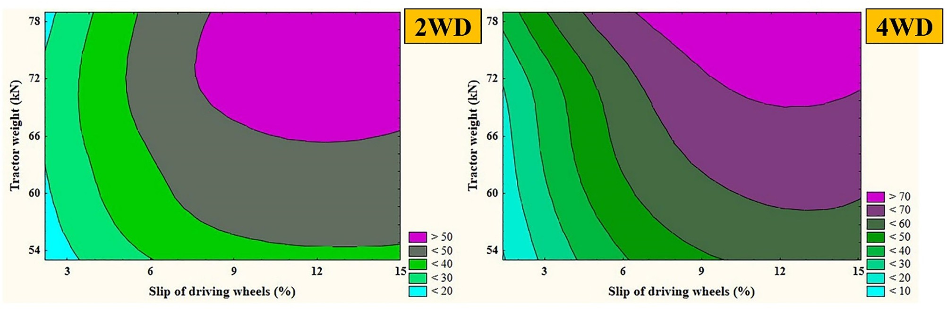](Image%20of%20Fig.%2010)

Fig. 10. Projected area of the three-dimensional surfaces on horizontal plane obtained from intelligent fuzzy calculator for estimation of drawbar pull supplied by the MFWD tractors.

Sahu and Raheman, 2008; Pranav and Pandey, 2008; Catalan et al., 2008; Kumar and Pandey, 2009; Al-Hamed et al., 2010; Mehta et al., 2011; Pranav et al., 2012; AI-Hamed et al., 2014; Kumar and Pandey, 2015; Aboukarima, 2016; Kumar et al., 2017).

1. Summary and conclusion

This paper deals with benchmark of a simple calculator for admissi- ble estimation of drawbar pull supplied by the MFWD tractors. To do this, different intelligent fuzzy systems were developed and appraised based on nominal input variable of tractor driving mode (2WD and 4WD), and numeral input variables of tractor weight (53.04–78.45 kN) and slip of driving wheels (1.4–15.1%). The prominent developed system yielded a user-friendly intelligent fuzzy calculator with admissi- ble accuracy (coefficient of determination = 0.993, root mean square error = 1.289 kN, mean relative deviation modulus = 2.893% and mean of absolute values of estimation errors = 1.043 kN). Hence, it can be asserted that problematic challenge of estimation of tractor drawbar pull by frequent employments of mathematical models for each tractor driving wheels was obviated and thereby, improvement of state of the art was achieved in this realm. Moreover, physical percep- tion obtained from calculator data emphasized that the drawbar pull was augmented as slip of driving wheels and tractor weight increased. Meanwhile, higher capability in supply of drawbar pull for the 4WD compared to the 2WD mode of the MFWD tractor was approved. There- fore, it can be finally concluded that the calculator is beneficial for trac- tor manufacturers and researchers to study and compare the drawbar pull of the MFWD tractors.

Declaration of Competing Interest

The authors declare that they have no known competing financial interests or personal relationships that could have appeared to influ- ence the work reported in this paper.

Acknowledgment

The authors would like to appreciate expert views of four anony- mous reviewers who meticulously revised the manuscript and further enriched content of the paper.

References

Abebe, A.T., Tanaka, T., Yamazaki, M., 1989. [Soil compaction by multiple passes of a rigid](http://refhub.elsevier.com/S2589-7217(20)30028-3/rf0005) [wheel relevant for optimization of traffic. J. Terrramech. 26 (2), 139–14](http://refhub.elsevier.com/S2589-7217(20)30028-3/rf0005)8.

Aboukarima, A.M., 2016. [Interactive computer application for predicting performance in-](http://refhub.elsevier.com/S2589-7217(20)30028-3/rf0010) [dicators of a tractors-chisel plow system in C-sharp environment. Misr J. Ag. Eng. 33](http://refhub.elsevier.com/S2589-7217(20)30028-3/rf0010) [(3), 751–78](http://refhub.elsevier.com/S2589-7217(20)30028-3/rf0010)8.

AI-Hamed, S., Wahby, M., Aboukarima, A., Ahmed, K., 2014. [Development of a computer](http://refhub.elsevier.com/S2589-7217(20)30028-3/rf0015) [program using visual basic for predicting performance parameters of tillage imple-](http://refhub.elsevier.com/S2589-7217(20)30028-3/rf0015) [ments. Misr J. Ag. Eng. 31 (3), 1157–1190](http://refhub.elsevier.com/S2589-7217(20)30028-3/rf0015).

Al-Hamed, S.A., Al-Janobi, A.A., 2001. [A program for predicting tractor performance in](http://refhub.elsevier.com/S2589-7217(20)30028-3/rf0020) [Visual C++. Comput. Electron. Agric. 31 (2), 137–149.](http://refhub.elsevier.com/S2589-7217(20)30028-3/rf0020)

Al-Hamed, S.A., Al-Suhaibani, S.A., Mohammad, F.S., Wahby, M.F.I., 2010. [Development of](http://refhub.elsevier.com/S2589-7217(20)30028-3/rf0025) [a comprehensive computer program for predicting farm energy. Am. J. Agric. Biol. Sci.](http://refhub.elsevier.com/S2589-7217(20)30028-3/rf0025) [5 (1), 89–10](http://refhub.elsevier.com/S2589-7217(20)30028-3/rf0025)1.

Andreev, A.F., Kabanau, V.I., Vantsevich, V.V., 2010. [Driveline Systems of Ground Vehicles.](http://refhub.elsevier.com/S2589-7217(20)30028-3/rf0030)

[1st ed. CRC Press, United States](http://refhub.elsevier.com/S2589-7217(20)30028-3/rf0030).

Ashmore, C., Burt, E.C., Turner, J.L., 1987. [An empirical equation for predicting tractive per-](http://refhub.elsevier.com/S2589-7217(20)30028-3/rf0035) [formance of log-skidder tires. Trans. ASAE 30 (5), 1231–1236](http://refhub.elsevier.com/S2589-7217(20)30028-3/rf0035).

Bailey, A.C., Burt, E.C., 1981. [Performance of tandem, dual, and single tires. Trans. ASAE 24](http://refhub.elsevier.com/S2589-7217(20)30028-3/rf0040) [(5), 1103–1107.](http://refhub.elsevier.com/S2589-7217(20)30028-3/rf0040)

Bashford, L.L., Jones, A.J., Mielke, L.N., 1988. [Comparison of bulk density beneath a belt](http://refhub.elsevier.com/S2589-7217(20)30028-3/rf0045) [track and tire. Appl. Eng. Agric. 4 (2), 122–12](http://refhub.elsevier.com/S2589-7217(20)30028-3/rf0045)5.

Battiato, A., Diserens, E., 2013. [Influence of tyre inflation pressure and wheel load on the](http://refhub.elsevier.com/S2589-7217(20)30028-3/rf0050) [traction performance of a 65 kW MFWD tractor on a cohesive soil. J. Agric. Sci. 5 (8),](http://refhub.elsevier.com/S2589-7217(20)30028-3/rf0050) [197–215](http://refhub.elsevier.com/S2589-7217(20)30028-3/rf0050).

Battiato, A., Diserens, E., 2017. [Tractor traction performance simulation on differently tex-](http://refhub.elsevier.com/S2589-7217(20)30028-3/rf0055) [tured soils and validation: a basic study to make traction and energy requirements](http://refhub.elsevier.com/S2589-7217(20)30028-3/rf0055) [accessible to the practice. Soil Till. Res. 166 (1), 18–32](http://refhub.elsevier.com/S2589-7217(20)30028-3/rf0055).

Burt, E.C., Bailey, A.C., 1982. [Load and inflation pressure effects on tires. Trans. ASAE 25](http://refhub.elsevier.com/S2589-7217(20)30028-3/rf0060) [(4), 881–88](http://refhub.elsevier.com/S2589-7217(20)30028-3/rf0060)4.

Burt, E.C., Schafer, R.L., Taylor, J.H., 1974. [Similitude of a model traction device: part I- pre-](http://refhub.elsevier.com/S2589-7217(20)30028-3/rf0065) [diction of the dynamic traction ratio. Trans. ASAE 17 (4), 658–66](http://refhub.elsevier.com/S2589-7217(20)30028-3/rf0065)1.

Burt, E.C., Bailey, A.C., Patterson, R.M., Taylor, J.H., 1979. [Combined effects of dynamic load](http://refhub.elsevier.com/S2589-7217(20)30028-3/rf0070) [and travel reduction on tire performance. Trans. ASAE 22 (1), 40–45](http://refhub.elsevier.com/S2589-7217(20)30028-3/rf0070).

Burt, E.C., Koger, J.L., Taylor, J.H., Bailey, A.C., 1984. [Performance of log-skidder tires. Trans.](http://refhub.elsevier.com/S2589-7217(20)30028-3/rf0075)

[ASAE 27 (3), 670–673](http://refhub.elsevier.com/S2589-7217(20)30028-3/rf0075).

Catalan, H., Linares, P., Mendez, V., 2008. [Tractor PT: a traction prediction software for ag-](http://refhub.elsevier.com/S2589-7217(20)30028-3/rf0080) [ricultural tractors. Comput. Electron. Agric. 60 (2), 289–295](http://refhub.elsevier.com/S2589-7217(20)30028-3/rf0080).

Cegnar, A., Fausti, F., 1961. [Movements under the contact area of radial and conventional](http://refhub.elsevier.com/S2589-7217(20)30028-3/rf0085) [tires. Trans. ASAE 4 (2), 224–22](http://refhub.elsevier.com/S2589-7217(20)30028-3/rf0085)5.

Coates, W., 1985. [Comparison of bias and radial tractor tires on a soft soil. Trans. ASAE 28](http://refhub.elsevier.com/S2589-7217(20)30028-3/rf0090) [(4), 1090–1093](http://refhub.elsevier.com/S2589-7217(20)30028-3/rf0090).

Daneshmand, H., Tavousi, T., Khosravi, M., Tavakoli, S., 2015. [Modeling minimum temper-](http://refhub.elsevier.com/S2589-7217(20)30028-3/rf0095) [ature using adaptive neuro-fuzzy inference system based on spectral analysis of cli-](http://refhub.elsevier.com/S2589-7217(20)30028-3/rf0095) [mate indices: a case study in Iran. J. Saudi Soc. Agric. Sci. 14 (1), 33–40](http://refhub.elsevier.com/S2589-7217(20)30028-3/rf0095).

Domier, K.W., Friesen, O.H., 1969. [Performance parameters of tractors equipped with sin-](http://refhub.elsevier.com/S2589-7217(20)30028-3/rf0100) [gles, duals and four wheel drive. Can. Agric. Eng. 11 (1), 16–19](http://refhub.elsevier.com/S2589-7217(20)30028-3/rf0100).

Domier, K.W., Persson, S.P.E., 1968. [Comparison of predicted and measured drawbar per-](http://refhub.elsevier.com/S2589-7217(20)30028-3/rf0105) [formance of tractors on agricultural soils. Can. Agric. Eng. 10 (1), 29–32](http://refhub.elsevier.com/S2589-7217(20)30028-3/rf0105).

Elijah, O.C., Philomena, K.I., Joseph, T.N., Charles, O.N., Paschal, E.O., 2020. [Evaluation of](http://refhub.elsevier.com/S2589-7217(20)30028-3/rf0110) [optimization techniques in predicting optimum moisture content reduction in drying](http://refhub.elsevier.com/S2589-7217(20)30028-3/rf0110) [potato slices. Artif. Intell. Agr. 4 (1), 39–47](http://refhub.elsevier.com/S2589-7217(20)30028-3/rf0110).

Evans, M.D., Clark, R.L., Manor, G., 1991. [An improved traction model for ballast selection.](http://refhub.elsevier.com/S2589-7217(20)30028-3/rf0115)

[Trans. ASAE 34 (3), 773–78](http://refhub.elsevier.com/S2589-7217(20)30028-3/rf0115)0.

Foda, M.A., 1991. [On the prediction of drawbar pull-normal slip relationship for a pneu-](http://refhub.elsevier.com/S2589-7217(20)30028-3/rf0120) [matic tyre moving on soft soil. J. Terrramech. 28 (4), 383–39](http://refhub.elsevier.com/S2589-7217(20)30028-3/rf0120)2.

Forrest, P.J., Reed, I.F., Constantakis, G.V., 1962. [Tractive characteristics of radial-ply tires.](http://refhub.elsevier.com/S2589-7217(20)30028-3/rf0125)

[Trans. ASAE 5 (2), 108–11](http://refhub.elsevier.com/S2589-7217(20)30028-3/rf0125)5.

Freitag, R.D., 1966. [A dimensional analysis of the performance of pneumatic tires on clay.](http://refhub.elsevier.com/S2589-7217(20)30028-3/rf0130)

[J. Terrramech. 3 (3), 51–68](http://refhub.elsevier.com/S2589-7217(20)30028-3/rf0130).

Freitag, R.D., 1968. [Dimensional analysis of performance of pneumatic tires on sand.](http://refhub.elsevier.com/S2589-7217(20)30028-3/rf0135)

[Trans. ASAE 11 (5), 669–67](http://refhub.elsevier.com/S2589-7217(20)30028-3/rf0135)2.

Gee-Clough, D., 1980. [Selection of tyre sizes for agricultural vehicles. J. Agric. Eng. Res. 25](http://refhub.elsevier.com/S2589-7217(20)30028-3/rf0140) [(3), 261–27](http://refhub.elsevier.com/S2589-7217(20)30028-3/rf0140)8.

Gee-Clough, D., McAllister, M., Evernden, D.W., 1977. [Tractive performance of tractor](http://refhub.elsevier.com/S2589-7217(20)30028-3/rf0145) [drive tyres: II. A comparison of radial and cross-ply carcass construction. J. Agric.](http://refhub.elsevier.com/S2589-7217(20)30028-3/rf0145) [Eng. Res. 22 (4), 385–395](http://refhub.elsevier.com/S2589-7217(20)30028-3/rf0145).

Grisso, R.D., Al-Hamed, S.A., Taylor, R.K., Zoz, F.M., 1992. [Demonstrating tractor perfor-](http://refhub.elsevier.com/S2589-7217(20)30028-3/rf0150) [mance rends using lotus templates. Appl. Eng. Agric. 8 (6), 733–73](http://refhub.elsevier.com/S2589-7217(20)30028-3/rf0150)8.

Hayes, J.C., Ligon, J.T., 1981. [Traction prediction using soil physical properties. Trans. ASAE](http://refhub.elsevier.com/S2589-7217(20)30028-3/rf0155) [24 (6), 1420–1425.](http://refhub.elsevier.com/S2589-7217(20)30028-3/rf0155)

Holm, I.C., 1969. [Multi-pass behaviour of pneumatic tires. J. Terrramech. 6 (3), 47–71](http://refhub.elsevier.com/S2589-7217(20)30028-3/rf0160).

Howard, C.N., Kocher, M.F., Hoy, R.M., Blankenship, E.E., 2013. [Testing fuel efficiency of](http://refhub.elsevier.com/S2589-7217(20)30028-3/rf0165) [tractors with both continuously variable and standard geared transmissions. Trans.](http://refhub.elsevier.com/S2589-7217(20)30028-3/rf0165) [ASABE 56 (3), 869–879](http://refhub.elsevier.com/S2589-7217(20)30028-3/rf0165).

Jang, J., 1993. [ANFIS: adaptive-network-based fuzzy inference system. IEEE Trans. Syst.](http://refhub.elsevier.com/S2589-7217(20)30028-3/rf0170)

[Man. Cybern. Syst. 23 (3), 665–68](http://refhub.elsevier.com/S2589-7217(20)30028-3/rf0170)5.

Kaveh, M., Sharabiani, V.R., Chayjan, R.A., Taghinezhad, E., Abbaspour-Gilandeh, Y., Golpour, I., 2018. [ANFIS and ANNs model for prediction of moisture diffusivity and](http://refhub.elsevier.com/S2589-7217(20)30028-3/rf0175) [specific energy consumption potato, garlic and cantaloupe drying under convective](http://refhub.elsevier.com/S2589-7217(20)30028-3/rf0175) [hot air dryer. Info. Proc. Agri. 5 (3), 372–38](http://refhub.elsevier.com/S2589-7217(20)30028-3/rf0175)7.

Keen, A., Hall, N., Soni, P., Gholkar, M.D., Cooper, S., Ferdous, J., 2013. [A review of the trac-](http://refhub.elsevier.com/S2589-7217(20)30028-3/rf0180) [tive performance of wheeled tractors and soil management in lowland intensive rice](http://refhub.elsevier.com/S2589-7217(20)30028-3/rf0180) [production. J. Terrramech. 50 (1), 45–62](http://refhub.elsevier.com/S2589-7217(20)30028-3/rf0180).

Khoshnevisan, B., Rafiee, S., Omid, M., Mousazadeh, H., 2014. [Development of an intelli-](http://refhub.elsevier.com/S2589-7217(20)30028-3/rf0185) [gent system based on ANFIS for predicting wheat grain yield on the basis of energy](http://refhub.elsevier.com/S2589-7217(20)30028-3/rf0185) [inputs. Info. Proc. Agri. 1 (1), 14–22](http://refhub.elsevier.com/S2589-7217(20)30028-3/rf0185).

Kliefoth, F., 1966. [The determination of traction-coefficient curves for synthetic farm trac-](http://refhub.elsevier.com/S2589-7217(20)30028-3/rf0190) [tor field tests. J. Terrramech. 3 (2), 71–84](http://refhub.elsevier.com/S2589-7217(20)30028-3/rf0190).

Kocher, M.F., Adamchuk, V.I., Smith, J.A., Hoy, R.M., 2011. [Verifying power claims of high-](http://refhub.elsevier.com/S2589-7217(20)30028-3/rf0195) [power agricultural tractors without a PTO to sell in Nebraska. Appl. Eng. Agric. 27 (5),](http://refhub.elsevier.com/S2589-7217(20)30028-3/rf0195) [711–715](http://refhub.elsevier.com/S2589-7217(20)30028-3/rf0195).

Kocher, M.F., Smith, B.J., Hoy, R.M., Woldstad, J.C., Pitla, S.K., 2017. [Fuel consumption](http://refhub.elsevier.com/S2589-7217(20)30028-3/rf0200) [models for tractor test reports. Trans. ASABE 60 (3), 693–70](http://refhub.elsevier.com/S2589-7217(20)30028-3/rf0200)1.

Kumar, A.A., Tewari, V.K., Gupta, C., Kumar, N., 2017. [A visual basic program and instru-](http://refhub.elsevier.com/S2589-7217(20)30028-3/rf0205) [mentation system for power and energy mapping of tractor implement. Eng. Agric.](http://refhub.elsevier.com/S2589-7217(20)30028-3/rf0205) [Environ. Food 10 (2), 121–13](http://refhub.elsevier.com/S2589-7217(20)30028-3/rf0205)2.

Kumar, N., Pandey, K.P., 2015. [A visual basic program for predicting optimum gear and](http://refhub.elsevier.com/S2589-7217(20)30028-3/rf0210) [throttle position for best fuel economy for 32 kW tractor. Comput. Electron. Agric.](http://refhub.elsevier.com/S2589-7217(20)30028-3/rf0210) [119 (1), 217–22](http://refhub.elsevier.com/S2589-7217(20)30028-3/rf0210)7.

Kumar, R., Pandey, K.P., 2009. [A program in Visual Basic for predicting haulage and field](http://refhub.elsevier.com/S2589-7217(20)30028-3/rf0215) [performance of 2WD tractors. Comput. Electron. Agric. 67 (1–2), 18–26](http://refhub.elsevier.com/S2589-7217(20)30028-3/rf0215).

Kumar, S., Pandey, K.P., Kumar, R., Kumar, A.A., 2018. [Effect of ballasting on performance](http://refhub.elsevier.com/S2589-7217(20)30028-3/rf0220) [characteristics of bias and radial ply tyres with zero sinkage. Measurement 121 (1),](http://refhub.elsevier.com/S2589-7217(20)30028-3/rf0220) [218–224](http://refhub.elsevier.com/S2589-7217(20)30028-3/rf0220).

Kumar, S., Noori, M.T., Pandey, K.P., 2019. [Performance characteristics of mode of ballast](http://refhub.elsevier.com/S2589-7217(20)30028-3/rf0225) [on energy efficiency indices of agricultural tyre in different terrain condition in con-](http://refhub.elsevier.com/S2589-7217(20)30028-3/rf0225) [trolled soil bin environment. Energy 182 (1), 48–56](http://refhub.elsevier.com/S2589-7217(20)30028-3/rf0225).

Kurjenluoma, J., Alakukku, L., Ahokas, J., 2009. [Rolling resistance and rut formation by im-](http://refhub.elsevier.com/S2589-7217(20)30028-3/rf0230) [plement tyres on tilled clay soil. J. Terrramech. 46 (6), 267–275](http://refhub.elsevier.com/S2589-7217(20)30028-3/rf0230).

Lyasko, M., 2010. [Multi-pass effect on off-road vehicle tractive performance.](http://refhub.elsevier.com/S2589-7217(20)30028-3/rf0235)

[J. Terrramech. 47 (5), 275–29](http://refhub.elsevier.com/S2589-7217(20)30028-3/rf0235)4.

Maclaurin, B., 2014. [Using a modified version of the Magic formula to describe the traction/](http://refhub.elsevier.com/S2589-7217(20)30028-3/rf0240) [slip relationships of tyres in soft cohesive soils. J. Terrramech. 52 (1), 1–](http://refhub.elsevier.com/S2589-7217(20)30028-3/rf0240)7.

Maclaurin, B., 2018. [High Speed off-Road Vehicles. 1st ed. Wiley Publisher, United States](http://refhub.elsevier.com/S2589-7217(20)30028-3/rf0245).

Mason, G.L., Williams, J.M., Vahedifard, F., Priddy, J.D., 2018. [A unified equation for](http://refhub.elsevier.com/S2589-7217(20)30028-3/rf0250) [predicting traction for wheels on sand over a range of braked, towed, and powered](http://refhub.elsevier.com/S2589-7217(20)30028-3/rf0250) [operations. J. Terrramech. 79 (1), 33–40](http://refhub.elsevier.com/S2589-7217(20)30028-3/rf0250).

McAllister, M., 1983. [Reduction in the rolling resistance of tyres for trailed agricultural](http://refhub.elsevier.com/S2589-7217(20)30028-3/rf0255) [machinery. J. Agric. Eng. Res. 28 (2), 127–13](http://refhub.elsevier.com/S2589-7217(20)30028-3/rf0255)7.

McLeod, H.E., Reed, I.F., Johnson, W.H., Gill, W.R., 1966. [Draft, power efficiency, and soil-](http://refhub.elsevier.com/S2589-7217(20)30028-3/rf0260) [compaction characteristics of single, dual and low-pressure tires. Trans. ASAE 9 (1),](http://refhub.elsevier.com/S2589-7217(20)30028-3/rf0260) [41–44](http://refhub.elsevier.com/S2589-7217(20)30028-3/rf0260).

Mehta, C.R., Singh, K., Selvan, M.M., 2011. [A decision support system for selection of](http://refhub.elsevier.com/S2589-7217(20)30028-3/rf0265) [tractor-implement system used on Indian farms. J. Terrramech. 48 (1), 65–73](http://refhub.elsevier.com/S2589-7217(20)30028-3/rf0265).

Muro, T., O'Brien, J., 2004. [Terramechanics: Land Locomotion Mechanics. 1st ed. CRC](http://refhub.elsevier.com/S2589-7217(20)30028-3/rf0270) [Press, United States](http://refhub.elsevier.com/S2589-7217(20)30028-3/rf0270).

OECD, 2020. [Code 2, OECD Standard Code for the Official Testing of Agricultural and For-](http://refhub.elsevier.com/S2589-7217(20)30028-3/rf0275) [estry Tractor Performance. Organization for Economic Cooperation and Development,](http://refhub.elsevier.com/S2589-7217(20)30028-3/rf0275) [Paris, France](http://refhub.elsevier.com/S2589-7217(20)30028-3/rf0275).

Pranav, P.K., Pandey, K.P., 2008. [Computer simulation of ballast management for agricul-](http://refhub.elsevier.com/S2589-7217(20)30028-3/rf0280) [tural tractors. J. Terrramech. 45 (6), 185–19](http://refhub.elsevier.com/S2589-7217(20)30028-3/rf0280)2.

Pranav, P.K., Patel, T., Rathore, M., Sonowal, A.J., Tapang, T., Laji, S., 2012. [Computer simu-](http://refhub.elsevier.com/S2589-7217(20)30028-3/rf0285) [lation for haulage performance of power tiller. Int. J. Comput. Appl. 58 (5), 19–25](http://refhub.elsevier.com/S2589-7217(20)30028-3/rf0285).

Raghavan, G.S.V., McKyes, E., 1979. [Performance of traction wheels in a clay soil. Trans.](http://refhub.elsevier.com/S2589-7217(20)30028-3/rf0290)

[ASAE 22 (2), 229–232](http://refhub.elsevier.com/S2589-7217(20)30028-3/rf0290).

Rasool, S., Raheman, H., 2018. [Improving the tractive performance of walking tractors](http://refhub.elsevier.com/S2589-7217(20)30028-3/rf0295) [using rubber tracks. Biosyst. Eng. 167 (1), 51–62](http://refhub.elsevier.com/S2589-7217(20)30028-3/rf0295).

Richardson, B.Y., Cooper, A.W., 1970. [Effects of articulated steering on tractive perfor-](http://refhub.elsevier.com/S2589-7217(20)30028-3/rf0300) [mance of a rubber-tired logging tractor. Trans. ASAE 13 (5), 633–63](http://refhub.elsevier.com/S2589-7217(20)30028-3/rf0300)5.

Roeber, J.B.W., Pitla, S.K., Hoy, R.M., Luck, J.D., Kocher, M.F., 2017. [Development and vali-](http://refhub.elsevier.com/S2589-7217(20)30028-3/rf0305) [dation of a tractor drawbar force measurement and data acquisition system (DAQ).](http://refhub.elsevier.com/S2589-7217(20)30028-3/rf0305) [Appl. Eng. Agric. 33 (6), 781–78](http://refhub.elsevier.com/S2589-7217(20)30028-3/rf0305)9.

Rosca, R., Carlescu, P., Tenu, I., 2014. [A semi-empirical traction prediction model for an ag-](http://refhub.elsevier.com/S2589-7217(20)30028-3/rf0310) [ricultural tyre, based on the super ellipse shape of the contact surface. Soil Till. Res.](http://refhub.elsevier.com/S2589-7217(20)30028-3/rf0310) [141 (1), 10–18](http://refhub.elsevier.com/S2589-7217(20)30028-3/rf0310).

Rush, E.S., 1969. [Soft-soil performance of a four-wheel-drive log skidder. Trans. ASAE 12](http://refhub.elsevier.com/S2589-7217(20)30028-3/rf0315) [(4), 546–54](http://refhub.elsevier.com/S2589-7217(20)30028-3/rf0315)9.

Sahu, R.K., Raheman, H., 2008. [A decision support system on matching and field perfor-](http://refhub.elsevier.com/S2589-7217(20)30028-3/rf0320) [mance prediction of tractor-implement system. Comput. Electron. Agric. 60 (1),](http://refhub.elsevier.com/S2589-7217(20)30028-3/rf0320) [76–86](http://refhub.elsevier.com/S2589-7217(20)30028-3/rf0320).

Sefeedpari, P., Rafiee, S., Akram, A., Chau, K., Pishgar-Komleh, S.H., 2016. [Prophesying egg](http://refhub.elsevier.com/S2589-7217(20)30028-3/rf0325) [production based on energy consumption using multi-layered adaptive neural fuzzy](http://refhub.elsevier.com/S2589-7217(20)30028-3/rf0325) [inference system approach. Comput. Electron. Agric. 131 (1), 10–19](http://refhub.elsevier.com/S2589-7217(20)30028-3/rf0325).

Shafaei, S.M., Kamgar, S., 2017. [A comprehensive investigation on static and dynamic fric-](http://refhub.elsevier.com/S2589-7217(20)30028-3/rf0330) [tion coefficients of wheat grain with the adoption of statistical analysis. J. Adv. Res. 8](http://refhub.elsevier.com/S2589-7217(20)30028-3/rf0330) [(4), 351–36](http://refhub.elsevier.com/S2589-7217(20)30028-3/rf0330)1.

Shafaei, S.M., Heydari, A.R., Masoumi, A.A., Sadeghi, M., 2015. [Determining and modeling](http://refhub.elsevier.com/S2589-7217(20)30028-3/rf0335) [of static friction coefficient of some agricultural seeds. Jordan J. Agric. Sci. 11 (4),](http://refhub.elsevier.com/S2589-7217(20)30028-3/rf0335) [1007–1019](http://refhub.elsevier.com/S2589-7217(20)30028-3/rf0335).

Shafaei, S.M., Loghavi, M., Kamgar, S., 2019d. [Reliable execution of a robust soft computing](http://refhub.elsevier.com/S2589-7217(20)30028-3/rf0395) [workplace found on multiple neuro-fuzzy inference systems coupled with multiple](http://refhub.elsevier.com/S2589-7217(20)30028-3/rf0395) [nonlinear equations for exhaustive perception of tractor-implement performance in](http://refhub.elsevier.com/S2589-7217(20)30028-3/rf0395) [plowing process. Artif. Intell. Agr. 2 (1), 38–84](http://refhub.elsevier.com/S2589-7217(20)30028-3/rf0395).

Shafaei, S.M., Loghavi, M., Kamgar, S., Raoufat, M.H., 2018b. [Potential assessment of neuro-](http://refhub.elsevier.com/S2589-7217(20)30028-3/rf0365) [fuzzy strategy in prognostication of draft parameters of primary tillage implement.](http://refhub.elsevier.com/S2589-7217(20)30028-3/rf0365) [Ann. Agric. Sci. 16 (3), 257–266](http://refhub.elsevier.com/S2589-7217(20)30028-3/rf0365).

Shafaei, S.M., Masoumi, A.A., Roshan, H., 2016b. [Analysis of water absorption of bean and](http://refhub.elsevier.com/S2589-7217(20)30028-3/rf0345) [chickpea during soaking using Peleg model. J. Saudi Soc. Agric. Sci. 15 (2), 135–14](http://refhub.elsevier.com/S2589-7217(20)30028-3/rf0345)4. Shafaei, S.M., Nourmohamadi-Moghadami, A., Kamgar, S., 2016a. [Development of artifi-](http://refhub.elsevier.com/S2589-7217(20)30028-3/rf0340) [cial intelligence based systems for prediction of hydration characteristics of wheat.](http://refhub.elsevier.com/S2589-7217(20)30028-3/rf0340)

[Comput. Electron. Agric. 128 (1), 34–45](http://refhub.elsevier.com/S2589-7217(20)30028-3/rf0340).

Shafaei, S.M., Loghavi, M., Kamgar, S., 2017b. [Appraisal of Takagi-Sugeno-Kang type of](http://refhub.elsevier.com/S2589-7217(20)30028-3/rf0355) [adaptive neuro-fuzzy inference system for draft force prediction of chisel plow im-](http://refhub.elsevier.com/S2589-7217(20)30028-3/rf0355) [plement. Comput. Electron. Agric. 142 (1), 406–41](http://refhub.elsevier.com/S2589-7217(20)30028-3/rf0355)5.

Shafaei, S.M., Loghavi, M., Kamgar, S., 2018a. [A comparative study between mathematical](http://refhub.elsevier.com/S2589-7217(20)30028-3/rf0360) [models and the ANN data mining technique in draft force prediction of disk plow im-](http://refhub.elsevier.com/S2589-7217(20)30028-3/rf0360) [plement in clay loam soil. Agric. Eng. Int. CIGR J. 20 (2), 71–79](http://refhub.elsevier.com/S2589-7217(20)30028-3/rf0360).

Shafaei, S.M., Loghavi, M., Kamgar, S., 2018c. [An extensive validation of computer simula-](http://refhub.elsevier.com/S2589-7217(20)30028-3/rf0370) [tion frameworks for neural prognostication of tractor tractive efficiency. Comput.](http://refhub.elsevier.com/S2589-7217(20)30028-3/rf0370) [Electron. Agric. 155 (1), 283–29](http://refhub.elsevier.com/S2589-7217(20)30028-3/rf0370)7.

Shafaei, S.M., Loghavi, M., Kamgar, S., 2018d. [On the neurocomputing based intelligent](http://refhub.elsevier.com/S2589-7217(20)30028-3/rf0375) [simulation of tractor fuel efficiency parameters. Info. Proc. Agri. 5 (2), 205–22](http://refhub.elsevier.com/S2589-7217(20)30028-3/rf0375)3.

Shafaei, S.M., Loghavi, M., Kamgar, S., 2019a. [Prognostication of energy indices of tractor-](http://refhub.elsevier.com/S2589-7217(20)30028-3/rf0380) [implement utilizing soft computing techniques. Info. Proc. Agri. 6 (1), 132–14](http://refhub.elsevier.com/S2589-7217(20)30028-3/rf0380)9.

Shafaei, S.M., Loghavi, M., Kamgar, S., 2019c. [Feasibility of implementation of intelligent](http://refhub.elsevier.com/S2589-7217(20)30028-3/rf0390) [simulation configurations based on data mining methodologies for prediction of trac-](http://refhub.elsevier.com/S2589-7217(20)30028-3/rf0390) [tor wheel slip. Info. Proc. Agri. 6 (2), 183–19](http://refhub.elsevier.com/S2589-7217(20)30028-3/rf0390)9.

Shafaei, S.M., Nourmohamadi-Moghadami, A., Kamgar, S., 2017a. [Experimental analysis](http://refhub.elsevier.com/S2589-7217(20)30028-3/rf0350) [and modeling of frictional behavior of lavender flowers (*Lavandula stoechas* L.). J.](http://refhub.elsevier.com/S2589-7217(20)30028-3/rf0350) [Appl. Res. Med. Aroma. 4 (1), 5–11](http://refhub.elsevier.com/S2589-7217(20)30028-3/rf0350).

Shafaei, S.M., Nourmohamadi-Moghadami, A., Rahmanian-Koushkaki, H., Kamgar, S., 2019b. [Neural computing efforts for integrated simulation of ultrasound-assisted hy-](http://refhub.elsevier.com/S2589-7217(20)30028-3/rf0385) [dration kinetics of wheat. Info. Proc. Agri. 6 (3), 357–374](http://refhub.elsevier.com/S2589-7217(20)30028-3/rf0385).

Sharma, A.K., Pandey, K.P., 1998. [Traction data analysis in reference to a unique zero con-](http://refhub.elsevier.com/S2589-7217(20)30028-3/rf0405) [dition. J. Terrramech. 35 (3), 179–18](http://refhub.elsevier.com/S2589-7217(20)30028-3/rf0405)8.

Sharma, A.K., Pandey, K.P., 2001. [Matching tyre size to weight, speed and power available](http://refhub.elsevier.com/S2589-7217(20)30028-3/rf0410) [for maximising pulling ability of agricultural tractors. J. Terrramech. 38 (2), 89–97](http://refhub.elsevier.com/S2589-7217(20)30028-3/rf0410).

Shinone, H., Nakashima, H., Takatsu, Y., Kasetani, T., Matsukawa, H., Shimizu, H., Miyasaka, J., Ohdoi, K., 2010. [Experimental analysis of tread pattern effects on tire tractive per-](http://refhub.elsevier.com/S2589-7217(20)30028-3/rf0415) [formance on sand using an indoor traction measurement system with forced-slip](http://refhub.elsevier.com/S2589-7217(20)30028-3/rf0415) [mechanism. Eng. Agric. Environ. Food 3 (2), 61–66](http://refhub.elsevier.com/S2589-7217(20)30028-3/rf0415).

Southwell, P.H., 1964. [An investigation of traction and traction aids. Trans. ASAE 7 (2),](http://refhub.elsevier.com/S2589-7217(20)30028-3/rf0420) [190–193](http://refhub.elsevier.com/S2589-7217(20)30028-3/rf0420).

Southwell, P.H., 1967. [An investigation of four-wheel-drive and tandem-tractor arrange-](http://refhub.elsevier.com/S2589-7217(20)30028-3/rf0425) [ment. Trans. ASAE 10 (2), 284–288](http://refhub.elsevier.com/S2589-7217(20)30028-3/rf0425).

Srivastava, A.K., Goering, C.E., Rohrbach, R.P., Buckmaster, D.R., 2006. [Engineering Princi-](http://refhub.elsevier.com/S2589-7217(20)30028-3/rf0430) [ples of Agricultural Machines. 2nd ed. ASAE Publisher, United States](http://refhub.elsevier.com/S2589-7217(20)30028-3/rf0430).

Steinbruegge, G.W., Larsen, L.F., 1966. [Determining drawbar-performance characteristics](http://refhub.elsevier.com/S2589-7217(20)30028-3/rf0435) [of new tractors. Trans. ASAE 9 (2), 225–22](http://refhub.elsevier.com/S2589-7217(20)30028-3/rf0435)8.

Sunusi, I.I., Zhou, J., Wang, Z.Z., Sun, C., Ibrahim, I.E., Opiyo, S., Korohou, T., Soomro, S.A., Sale, N.A., Olanrewaju, T.O., 2020. [Intelligent tractors: review of online traction con-](http://refhub.elsevier.com/S2589-7217(20)30028-3/rf0440) [trol process. Comput. Electron. Agric. 170 (1), 105176](http://refhub.elsevier.com/S2589-7217(20)30028-3/rf0440).

Taghavifar, H., Mardani, A., 2014a. [Effect of velocity, wheel load and multipass on soil](http://refhub.elsevier.com/S2589-7217(20)30028-3/rf0445) [compaction. J. Saudi Soc. Agric. Sci. 13 (1), 57–66](http://refhub.elsevier.com/S2589-7217(20)30028-3/rf0445).

Taghavifar, H., Mardani, A., 2014b. [Wavelet neural network applied for prognostication of](http://refhub.elsevier.com/S2589-7217(20)30028-3/rf0450) [contact pressure between soil and driving wheel. Info. Proc. Agri. 1 (1), 51–56](http://refhub.elsevier.com/S2589-7217(20)30028-3/rf0450).

Taghavifar, H., Mardani, A., 2014c. [On the modeling of energy efficiency indices of agricul-](http://refhub.elsevier.com/S2589-7217(20)30028-3/rf0455) [tural tractor driving wheels applying adaptive neuro-fuzzy inference system.](http://refhub.elsevier.com/S2589-7217(20)30028-3/rf0455)

[J. Terrramech. 56 (1), 37–47](http://refhub.elsevier.com/S2589-7217(20)30028-3/rf0455).

Taghavifar, H., Mardani, A., 2014d. [Applying a supervised ANN (artificial neural network)](http://refhub.elsevier.com/S2589-7217(20)30028-3/rf0460) [approach to the prognostication of driven wheel energy efficiency indices. Energy 68](http://refhub.elsevier.com/S2589-7217(20)30028-3/rf0460) [(1), 651–65](http://refhub.elsevier.com/S2589-7217(20)30028-3/rf0460)7.

Taghavifar, H., Mardani, A., 2015. [Net traction of a driven wheel as affected by slippage,](http://refhub.elsevier.com/S2589-7217(20)30028-3/rf0465) [velocity and wheel load. J. Saudi Soc. Agric. Sci. 14 (2), 167–171](http://refhub.elsevier.com/S2589-7217(20)30028-3/rf0465).

Taghavifar, H., Mardani, A., 2017. [Off-Road Vehicle Dynamics. 1st ed. Springer Publisher,](http://refhub.elsevier.com/S2589-7217(20)30028-3/rf0470) [Switzerland](http://refhub.elsevier.com/S2589-7217(20)30028-3/rf0470).

Taghavifar, H., Mardani, A., Hosseinloo, A.H., 2015. [Appraisal of artificial neural network-](http://refhub.elsevier.com/S2589-7217(20)30028-3/rf0475) [genetic algorithm based model for prediction of the power provided by the agricul-](http://refhub.elsevier.com/S2589-7217(20)30028-3/rf0475) [tural tractors. Energy 93 (1), 1704–1710](http://refhub.elsevier.com/S2589-7217(20)30028-3/rf0475).

Taylor, J.H., Berg, G.E.V., Reed, I.F., 1967. [Effect of diameter on performance of powered](http://refhub.elsevier.com/S2589-7217(20)30028-3/rf0480) [tractor wheels. Trans. ASAE 10 (6), 838–84](http://refhub.elsevier.com/S2589-7217(20)30028-3/rf0480)2.

Taylor, J.H., Burt, E.C., Bailey, A.C., 1976. [Radial tire performance in firm and soft soils.](http://refhub.elsevier.com/S2589-7217(20)30028-3/rf0485)

[Trans. ASAE 19 (6), 1062–1064](http://refhub.elsevier.com/S2589-7217(20)30028-3/rf0485).

Taylor, R.K., Schrock, M.D., Grisso, R.D., 1995. [A vehicle number to predict tractive perfor-](http://refhub.elsevier.com/S2589-7217(20)30028-3/rf0490) [mance. Appl. Eng. Agric. 11 (4), 495–49](http://refhub.elsevier.com/S2589-7217(20)30028-3/rf0490)8.

Thaden, T.J., 1962. [Operating characteristics of radial-ply tractor tires. Trans. ASAE 5 (2),](http://refhub.elsevier.com/S2589-7217(20)30028-3/rf0495) [109–110](http://refhub.elsevier.com/S2589-7217(20)30028-3/rf0495).

Tiwari, V.K., Pandey, K.P., Pranav, P.K., 2010. [A review on traction prediction equations.](http://refhub.elsevier.com/S2589-7217(20)30028-3/rf0500)

[J. Terrramech. 47 (3), 191–19](http://refhub.elsevier.com/S2589-7217(20)30028-3/rf0500)9.

Upadhyaya, S.K., Wulfsohn, D., Jubbal, G., 1989. [Traction prediction equations for radial](http://refhub.elsevier.com/S2589-7217(20)30028-3/rf0505) [ply tyres. J. Terrramech. 26 (2), 149–17](http://refhub.elsevier.com/S2589-7217(20)30028-3/rf0505)5.

VandenBerg, G.E., Reed, I.F., 1962. [Tractive performance of radial-ply and conventional](http://refhub.elsevier.com/S2589-7217(20)30028-3/rf0510) [tractor tires. Trans. ASAE 5 (2), 126–13](http://refhub.elsevier.com/S2589-7217(20)30028-3/rf0510)2.

Vechinski, C.R., Johnson, C.E., Raper, R.L., 1998. [Evaluation of an empirical traction equa-](http://refhub.elsevier.com/S2589-7217(20)30028-3/rf0515) [tion for forestry tires. J. Terrramech. 35 (1), 55–67](http://refhub.elsevier.com/S2589-7217(20)30028-3/rf0515).

Wang, G., Kushwaha, R.L., Zoerb, G.C., 1989. [Traction performance of a model 4WD trac-](http://refhub.elsevier.com/S2589-7217(20)30028-3/rf0520) [tor. Can. Agric. Eng. 31 (2), 125–12](http://refhub.elsevier.com/S2589-7217(20)30028-3/rf0520)9.

Wismer, R.D., Luth, H.J., 1973. [Off-road traction prediction for wheeled vehicles.](http://refhub.elsevier.com/S2589-7217(20)30028-3/rf0525)

[J. Terrramech. 10 (2), 49–61](http://refhub.elsevier.com/S2589-7217(20)30028-3/rf0525).

Wismer, R.D., Luth, H.J., 1974. [Off-road traction prediction for wheeled vehicles. Trans.](http://refhub.elsevier.com/S2589-7217(20)30028-3/rf0530)

[ASAE 17 (1), 8–10](http://refhub.elsevier.com/S2589-7217(20)30028-3/rf0530).

Worthington, W.H., 1962. [A discussion of performance characteristics of radial-ply tractor](http://refhub.elsevier.com/S2589-7217(20)30028-3/rf0535) [tires. Trans. ASAE 5 (2), 113-113](http://refhub.elsevier.com/S2589-7217(20)30028-3/rf0535).

Wulfsohn, D., Upadhyaya, S.K., Chancellor, W.J., 1988. [Tractive characteristics of radial ply](http://refhub.elsevier.com/S2589-7217(20)30028-3/rf0540) [and bias ply tyres in a California soil. J. Terrramech. 25 (2), 111–13](http://refhub.elsevier.com/S2589-7217(20)30028-3/rf0540)4.

Zombori, J., 1967. [Drawbar pull tests of various traction devices on sandy soils.](http://refhub.elsevier.com/S2589-7217(20)30028-3/rf0545)

[J. Terrramech. 4 (1), 9–17](http://refhub.elsevier.com/S2589-7217(20)30028-3/rf0545).