[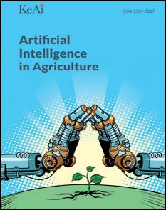](Journal%20logo)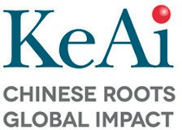[Artificial Intelligence in Agriculture 4 (2020) 153–161](https://doi.org/10.1016/j.aiia.2020.08.002)

Contents lists available at [ScienceDirect](http://www.sciencedirect.com/science/journal/)

Artificial Intelligence in Agriculture

journal homepage: [http://www.keaipublishing.com/en/j ournals/artificial-](http://www.keaipublishing.com/en/journals/artificial-) intelligence-in-agriculture/

[](http://crossmark.crossref.org/dialog/?doi=10.1016/j.aiia.2020.08.002&domain=pdf)Blockchain: A new safeguard for agri-foods

Jie Xu a,⁎, Shuang Guo b,c, David Xie d, Yaxuan Yan e

a *Department of Food Science and Technology, The Ohio State University, Columbus, OH 43210, USA*

b *GXChain, Hangzhou, China*

c *Innovhope Inc. MA, USA*

d *Walmart China, Shenzhen, China*

e *College of Engineering, Nanjing Agricultural University, Nanjing, Jiangsu, China*

# a r t i c l e i n f o

*Article history:*

Received 15 July 2020

Received in revised form 15 August 2020

Accepted 15 August 2020

Available online 21 August 2020

*Keywords:*

Blockchain

Food and agriculture Food safety

Food supply chain Traceability Transparency

# a b s t r a c t

Blockchain implementation in agriculture has begun. Blockchain is recognized as an emerging technology in the agri-foods industry which may provide an efficient and robust mechanism for enhancing food traceability and a transparent and reliable way to validate quality, safety, and sustainability, of agri-foods. However, the technology is in its nascency, therefore, this review was written to foster discussion and encourage the application of blockchain technology, especially in the agri-food industry. In this review, the working principle of blockchain for data recording and tracking is briefly described. The collaboration models for the current blockchain applica- tions on agri-foods are summarized. Furthermore, the specific utilization of blockchain to enhance safety and quality of agri-foods is discussed in four aspects: enhance the data transparency, realize data traceability, improve the food safety and quality monitoring, and reduce the cost of financial transactions. A case study on a Walmart pork traceability system has been provided to demonstrate how blockchain may be used to enhance the food traceability. Finally, challenges and future trends of blockchain technology in agri-foods concerning data/cost management, data security, and data integration are discussed. Blockchain technology reveals a promising approach to foster a future of agri-foods system in a way that is safer, healthier, more sustainable, and reliable.

© 2020 The Authors. Publishing services by Elsevier B.V. on behalf of KeAi Communications Co. Ltd. This is an open access article under the CC BY-NC-ND license (<http://creativecommons.org/licenses/by-nc-nd/4.0/>).

1. Introduction

Blockchain technology, also referred to as distributed ledger tech- nology, is a type of public bookkeeping protocol executed by a network of computing systems. The networked computing systems execute a pre-determined protocol to maintain a record of transactions, which are stored in “blocks.” Each block of the blockchain includes data (e.g., one or more records/transactions), a hash value of the immedi- ately preceding block, and a hash value of the contents of the current block. Blockchain is different from a normal database in that there are specific rules about how data is added to the blockchain. First, the data added to the blockchain cannot conflict with other data that is already on the blockchain, thus data stored on a blockchain must be consistent. Second, data may only be appended to a blockchain (e.g., new data can- not be inserted into a previously recorded block), and thus data stored on a blockchain is immutable. Third, every computing system executing the blockchain protocol must agree on what the state of the data stored on the blockchain is (e.g., the blockchains stored in each computing sys- tem operating the blockchain protocol must be the same). Finally, a public blockchain is not owned by a central party, and thus no single

* Corresponding author.

*E-mail address:* [xu.4037@osu.edu](mailto:xu.4037@osu.edu) (J. Xu).

entity can unilaterally modify the state of the blockchain. Blockchain is capable of providing immutable data records and traceable transaction history, which provides great potential to enhance efficiency, transpar- ency, and traceability (Tripoli and Schmidhuber, 2018). Blockchain is a rapidly evolving technology, and with broad applicability, it appears set to change many areas of public and private life. In the food and agri- culture industry, drastic efforts have been made to consolidate the data traceability of blockchain technology to improve the safety/quality of the global food supply chain and international distribution (Steiner et al., 2016; Tian, 2016; Kamath, 2018; Lin et al., 2018).

The safety of agri-foods is of paramount importance for global food distribution. Safety issues may arise for agri-foods during the pre/ post-harvest processing and production (Lin et al., 2018). For example, during pre/post-harvesting, the quality/safety of agri-foods may be compromised by, excessive use of pesticides, fertilizers with additive chemicals, or heavy metal residues caused by irrigating with wastewa- ter (Tse et al., 2017). During production, the quality/safety of agri-foods may be compromised by, the adulteration of inferior products, inten- tionally mislabeling the origin of a food product, mislabeling the production and/or expiration date, and the like. Most often, these safety issues are caused by the lack of an efficient monitoring or tracking sys- tem and pose a great threat to the health of human beings. We are not guaranteeing that blockchain technology is a panacea for all these

<https://doi.org/10.1016/j.aiia.2020.08.002>

2589-7217/© 2020 The Authors. Publishing services by Elsevier B.V. on behalf of KeAi Communications Co. Ltd. This is an open access article under the CC BY-NC-ND license ([http://](http://creativecommons.org/licenses/by-nc-nd/4.0/) [creativecommons.org/licenses/by-nc-nd/4.0/](http://creativecommons.org/licenses/by-nc-nd/4.0/)).

issues, but it can provide one approach for better monitoring of agri- foods from farm to table, as well as a mechanism to more closely con- nect the participants of the food supply chain and regulators. The data transparency and inclusivity of blockchain technology may significantly reduce the related food safety risks underlying deliberate fraud, poor management, and lack of regulation.

Blockchain represents an emerging technology in the field of agri- foods, which may improve the safety and quality of agri-foods and transform many aspects of the agricultural industry. This review seeks to define blockchain technology and provides a comprehensive analysis of blockchain technology applications in the agriculture-foods area. The current model for implementing blockchain in the agri-foods industry is summarized, case-studies representing diverse applications of blockchain technology are discussed, and the opportunities and chal- lenges of blockchain in the food industry are presented. The information presented in this study would contribute a better understanding of how blockchain technology could be implemented in agri-foods to realize a better performance of food safety, quality, and sustainability.

1. Related works
   1. *Working principle of blockchain*

The name Blockchain was first introduced in 2008 to describe the distributed ledger technology underlying Bitcoin. Briefly, Bitcoin is a type of virtual currency for digital transections, which bypasses the need for intermediaries (e.g. banks, payment gateways, etc.) (Tripoli and Schmidhuber, 2018). The main problem solved by Blockchain tech- nology is bypassing the need for trusted third parties (e.g., banks, insur- ance companies, etc.) by building a trustless decentralized ledger which enables secure peer-to-peer (P2P) transactions based on cryptographi- cally secure methods such as Hash functions (Steiner et al., 2016).

The working principle of blockchain is briefly elucidated in Fig. 1. A hash value is very much likea fingerprint and the hash algorithm is con- structed so that the smallest change in the source (e.g., the data contained in a block) produces a completely different and unpredictable hash value. In the blockchain system, every time a transaction occurs, a

unique hash value (consisting of a string of numbers and letters) is assigned to the transaction. At the same time, the validity of each trans- action must be approved or checked by other computing systems exe- cuting the blockchain protocol (also referred to as nodes), and if a transaction is changed, the nodes are able to detect the change by read- ing the hash value. Once approved, the transactions can be stored in a block of the blockchain. As each block includes both a hash value for its contents, as well as the hash value of the immediately preceding block, a chain of blocks is thus formed, and a change in the contents of any previously recorded block would change the associated hash value for the block and thus break the chain. The contents of blocks are no longer changeable once they are uploaded to the blockchain. However, new blocks can be appended to the blockchain to incorporate further transactions since blockchain can update itself periodically (e.g., every 10 min).

The decentralized and distributed nature of the data maintained by a blockchain ensures a high level of integrity and security, without relying on a trusted third party. Blockchains provide a high degree of transpar- ency, since it is based on a P2P communication protocol, and the con- tents of the blockchain can be viewed by anyone. That means, every node has access to the contents of the entire blockchain and can search the record of previously recorded transactions. All the records in the blockchain are immutable and the system can detect any change to the recorded data during the addition of each new block. Each node can exchange data autonomously and securely and thus, the security of the whole network is guaranteed.

* 1. *Collaboration model of blockchain technology in agri-foods*

The current cooperation model is built on the partnership of a food company and a blockchain company. The food company is responsible for providing information related to agri-foods, and the blockchain com- pany is responsible for providing technical support, such as platform build-up and database maintenance, etc.

Numerous companies are developing blockchain technology glob- ally, including Coinbase, Chronicled, Facebook, Circle, Binance, SALT Lending, Ripple, Steem, etc. Most of them are in the field of finance,

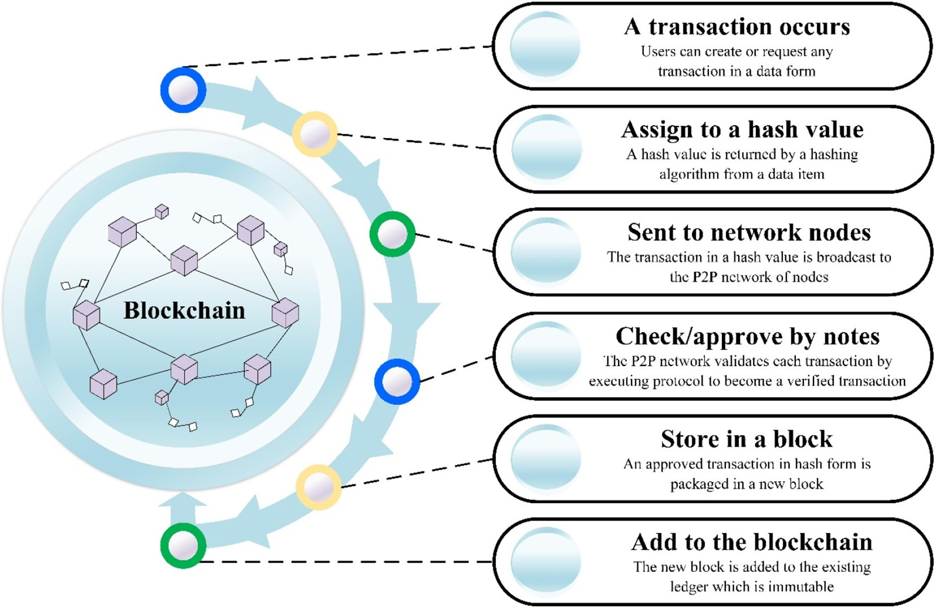

Fig. 1. Schematic diagram of the blockchain working principle.

Table 1

Examples of blockchain foods and agriculture startups and the official website.

|  |  |  |
| --- | --- | --- |
| Name | Website | Application |
| Transparent Path | https://xparent.io/ | Farm-to-distributor traceability |
| IBM Food Trust | <https://www.ibm.com/blockchain/solutions/food-trust> | Track-and-trace |
| Ripe.io | <https://www.ripe.io/> | Transparent digital food supply chain |
| Greenfence | <https://origin.greenfence.com/> | Food traceability |
| Hungry Coin | <http://hungrycoin.net/> | Restaurants, traceable tokens |
| AgriChain | <https://agrichain.com/> | Enabling peer-to-peer agricultural transactions |
| AgriDigital | <https://www.agridigital.io/> | Process complex agricultural transactions through smart contracts |
| AgriLedger | <http://www.agriledger.io/> | Supporting farmers in tracing food origins, transactions |
| TE-FOOD | <https://tefoodint.com/> | Identification tools, farm-to-table food traceability |
| Mixing Bowl | <http://mixingbowlhub.com/the-blockchain-of-food/> | Food supply chain management |
| Provenance | <https://www.provenance.org/> | Transparency traceability |
| OriginTrail | <https://origintrail.io/> | supply chains data sharing |
| Avenews = GT | <https://www.avenews-gt.com/> | supply chain transparency |
| Owlchain | <https://www.owlting.com/obs> | A tracing system for pork |
| Ambrosus | <https://ambrosus.com/#features> | Customized combination of robust sensors, biosensors and food tracers |
| Foodcoin | <https://fcegroup.ch/> | Smart contracts |
| Lokaal Market | <https://lokaal.market/> | Traceability regulations |
| FoodLogiQ | <https://www.foodlogiq.com/> | Food supply chain management |

such as fundraising, cryptocurrency exchange, digital assets, loans, and cross-border payment, which will not be discussed in this review. Some companies working to incorporate blockchain technology into the agricultural-food industry include IBM, Ripe.io, Transparent Path, Greenfence, OpenSC, Hungry Coin, FoodlogIQ, and the like. These com- panies are summarized in Table 1.

The specific applications that the listed businesses are developing are included but not limited to:

* Setting up agri-food supply chain traceability systems for fresh fruits, vegetables, and meats (Tian, 2016);
* Providing a lower price for consumers by removing retailers and en- abling consumers to purchase groceries directly from manufacturers (Hay, 2018);
* Enhancing the traceability of seafoods to decrease seafood fraud and

mislabeling.

Table 2 provides several examples of current collaboration models using blockchain to bring transparency and traceability of agri-foods to global food supply chains. The different food industries and foods involved are also listed.

IBM has been recognized as the leading enterprise blockchain pro- vider. IBM Food Trust program has been exploring ways to utilize blockchain technology to create a secure, shared, and permissioned digital record of agri-food data, which enables participants on the network to access tools and data to improve food safety and become a

proactive contributors to bettering the food system as a whole (Trust). IBM has built specialized modules for particular use cases. The Trace module provides the ability for supply chain participants to trace food products from upstream sources to downstream destinations. The de- tailed tracking information provided by the trace module gives consumers and partners access to a history of agri-foods products' origin and destination. The Data Entry and Access modules provide the ability to upload, manage, and access data to the blockchain. The Certification module provides an easy way to manage the entire supply chain. All the modules can strengthen brand trust, increase supply chain effi- ciency, and improve food safety. Moreover, blockchain technology may enable instant food recalls by designating the original contamina- tion in the food supply chain, which could result in greater consumer confidence in the quality and safety of food products (IBM, 2019).

Many food companies have collaborated with IBM to increase food safety by developing tracing systems. Each step in the life of a food prod- uct, including where a particular food product was produced and where/how the food product was processed, may be recorded via blockchain, enabling the consumers to be better informed regarding the food products they consume, as well as preventing unsafe foods from being consumed. The companies currently developing such systems are generally large-scale enterprises or raw ingredient supply companies, such as Walmart, Carrefour, Nestle, Tyson Foods, Kelloggs, Raw Seafood Inc., etc. (Armonk, 2017).

Start with an example, Farmer connect is an industry-driven initia- tive that uses digital identity and blockchain to drive digital connectivity

Table 2

Examples of collaboration models using blockchain technology in agri-foods area.

|  |  |  |  |  |
| --- | --- | --- | --- | --- |
| Blockchain Company | Food Company Partners | Food Products | Country | References |
| IBM  SAP | Walmart, Carrefour, Nestle, Unilever, Farmer Connect, Tyson, Foods, Raw Seafoods Inc. Cermaq salmon and Labeyrie, El Ordeño  Target, Kelloggs, Tate & Lyle, Johnsonville, Natura & | Mousseline purée, scallop, pork, lettuce, mango slices, infant nutrition, line chicken, coffee beans, seafoods (shrimps and claims)  yellowfin tuna, | US, China, UK, France, Ecuador US | Armonk (2017), IBM  (2019), IBM (2020)  Kamath (2018)  Lawton (2019) |
| FoodlogIQ | Co and Maple Leaf, Bumble Bee  Tyson Foods, Subway, UK's Food Standards Agency, | Tomato, coffee, | US | Jones (2018a), Jones |
| SIM | Testo, AgBiome Innovations,  Refresco, Albert Heijn | Orange juice | Dutch | (2018b)  Hejin (2018) |
| JD.com | InterAgri | Pure Black Angus Beef | Australia, | JD.com (2018) |
| OpenSC | *Nestlé* | Milk and palm oil | China  Switzerland, | Nestlé (2019) |
| OriginTrail&TagItSmart | Plantaze | Grape, wine, | New Zealand  Montenegro, | OriginTrail (2018) |
| BloomBloc | Malaysian Palm Oil Council (MPOC) | Palm oil | China  Malaysia | Bernama (2020) |

from the farm to the consumer. Farmer Connect and IBM have devel- oped a new consumer-facing mobile application named “Thank My Farmer”, which allows consumers to trace coffee through the supply chain back to its origin. Blockchain technology has been used in this system to connect the different contributors in the global supply chain of coffee, which includes farmers, exporters, shippers, importers, roasters, retailers, distributors, and consumers (IBM, 2019). Traceability provides the ability for consumers or other interested parties to deter- mine if coffee was sourced responsibly and sustainably. Consumers can choose to patronize or support food suppliers who employ sustain- able practices.

1. Blockchain technology for agri-food applications
   1. *Data transparency*

Traditionally, the food supply chain management and interactions are unidirectional. Most of the participants in the supply chain can only connect with entities immediately downstream, which means up- stream agents can communicate with downstream agents, e.g., a manu- facturer can communicate with a restaurant, but the restaurant cannot communicate with the manufacturer (Tse et al., 2017). The usage of blockchain can make the agri-foods supply chain management more re- liable and efficient. Blockchain can link all aspects of the food supply chain with a traceable and immutable data system (Fig. 2).

For example, if a consumer purchased an item from a retailer, and the expiration data indicated the food was still safe to consume, but after consuming the food the consumer got diarrhea, the first reaction that the consumer might take would be to contact the retailer. After- ward, if the retailer wants to determine the cause of the issue, the retailer might ask help from the local regulator, since the regulator acts as the central controller that is able to connect with multiple

participants of the supply chain, such as farmers, processors, manufac- turers, retailers, and restaurants. However, the number of regulated participants is quite limited, and the source of the issue may be a non- regulated entity, such as the distributor, packer, trader, etc. Also, tracing the origin of an issue is normally difficult in conventional systems, since no single entity possesses all of the information, and some information is obfuscated because of trade secrets. Therefore, in current supply chains, the process of tracing the origin of an issue may be time- consuming, labor-intensive, inefficient, and sometimes inconclusive. Because of this, many food safety issues are ignored or under-reported since consumers might hesitate to attempt to determine the source of a particular issue, since the process is so lengthy and often inconclusive. Blockchain technology may be able to address the above issues, by leveraging the decentralized-distributed P2P communication described in Section 2.1. From Fig. 3, it is clear to see that all the participants are connected in the blockchain system and the communication model is interactive and bidirectional. Every participant can be regarded as a node and each node has access to all the information recorded in the blockchain. That means, for the same example that we used, the con- sumer does not need a middleman (regulator) to find the source of the issue, but can track all the information on the purchased item through the entire supply chain, since the consumer has direct connec- tions to all the participants. This is a vivid example of using blockchain

for data transparency.

For agri-foods supply chain management, the real advantage is the reliability of the data maintained on the blockchain combined with the fact that it acts as a central location to store all aspects of data related to the life cycle of a food. For regulators, the advantages over conven- tional supply chain models are obvious. The same data-sharing system can be utilized by the regulators to simply access supply chain informa- tion by cell phone or other computing devices, as opposed to going to different locations physically to perform an audit of each step in the

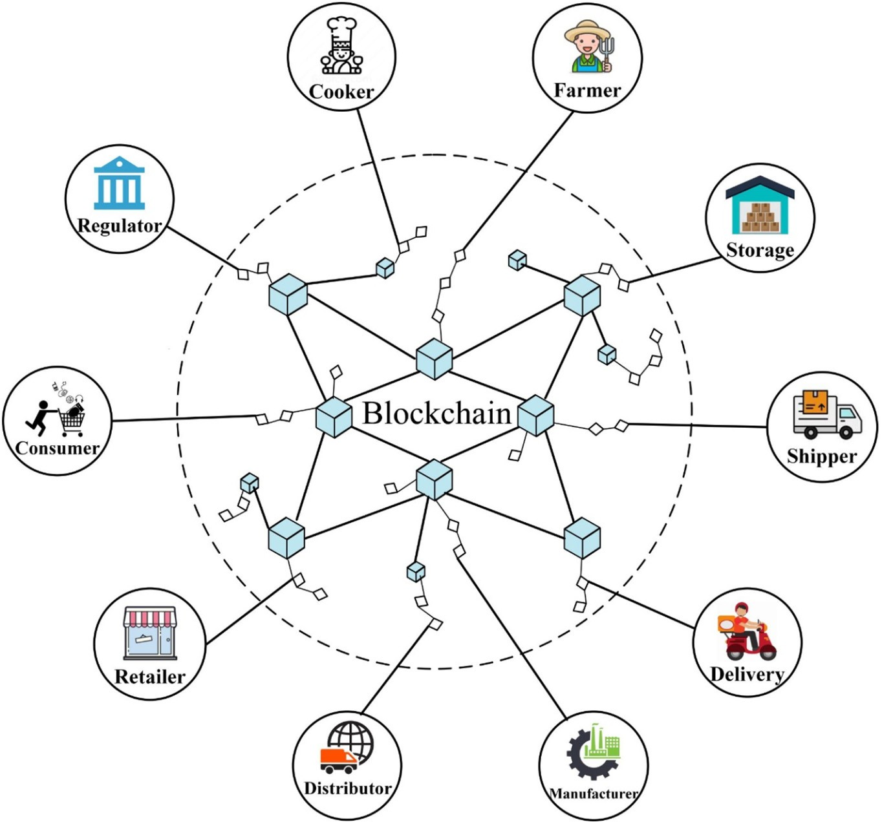

Fig. 2. Blockchain can connect multiple participants in the food supply chain.

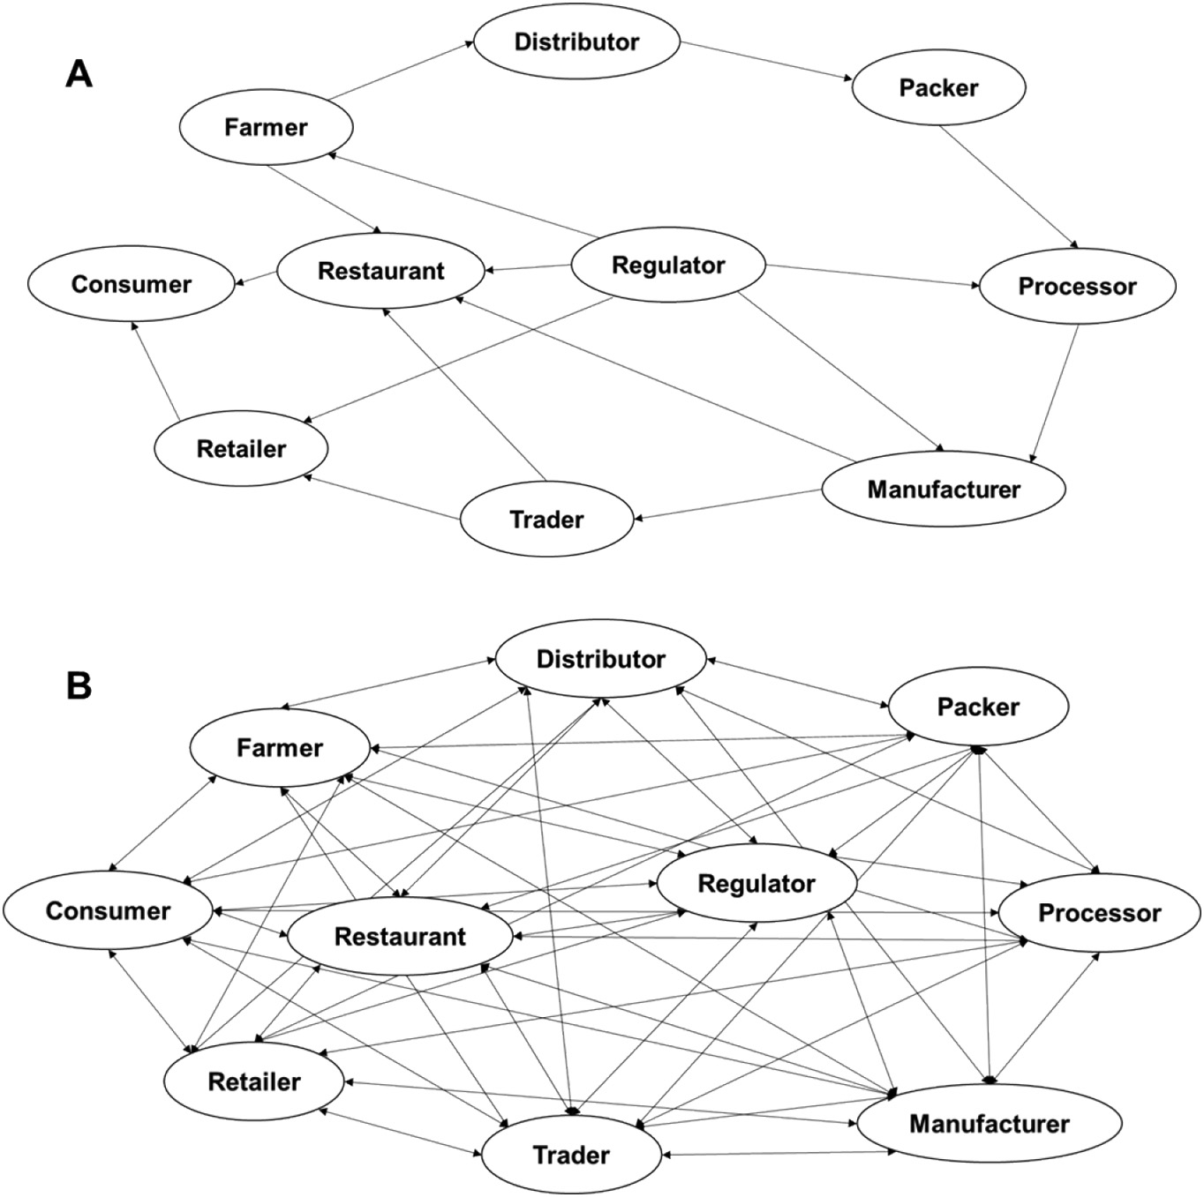

Fig. 3. Comparison of (A) traditional and (B) decentralized food supply chain models.

supply chain of the food item. Some published reviews on using blockchain for food supply chain management can be referred (Kshetri, 2018).

* 1. *Data traceability*

Blockchain can be used as a node database, which can track the dig- ital data for each food item passed through different participants in the food supply chain, e.g. farmers, food processors, packers, distributors, and eventually store shelves. Currently, data traceability implemented by blockchain has been realized in many agri-foods, such as wine (Lakhani and Iansiti, 2017), plant food (Galvez et al., 2018; Matzembacher et al., 2018), poultry (Peters, 2017), etc. With blockchain, supply chain managers can seamlessly track everything remotely in a distributed ledger, from expiration dates to warehouse temperatures (Kaye, 2016). In contrast with the traditional methods which rely on information supervision centers to transfer and share the information, all the information uploaded in the blockchain system is provided by first-hand sources, such as farms, markets, warehouse centers, transport vehicles, consumers, etc. Data acquisition is the first step to realize data traceability, and there are several approaches for data acquisition, such as sensor-RFID, cameras, etc. The parameters that can be traced from different blockchain participants are included in Fig. 4.

For data from the farms, radio-frequency identification technology (RFID) has been used to track the movement of livestock (Tse et al., 2017). The information on the farm location, soil and fertilizer informa- tion, etc. can be recorded and uploaded manually. The data during pack- ing can be uploaded manually by the packer, such as the quantity of the items packed, package conditions, and packing time and date. For data in the manufacturing facilities, cameras can be utilized to monitor the entire process lines in the slaughterhouse, all the processing data, such

as temperature, time, relative humidity, are recorded automatically via sensors. The worker needs to manually enter the product information and other relevant information, such as production date, time, location, and packaging information and food safety data, such as temperature, grade assigned by an inspector, or any other lab results. During the transportation, all the vehicles are installed with sensors that can test temperature and relative humidity during shipment, the alarm system will help to correct if conditions exceed established thresholds. The change of locations and shipping details have been monitored by global position systems (GPS). Similarly, geographic information systems (GIS) have been successfully applied to tracing crops (Qu et al., 2007).

Tracking food products through each step of the supply chain was accomplished using smart-tagged bar codes. Bar codes are used for packaged products. The system creates a unique ID for the specific food type. Initially, the unique ID links to a null record since no informa- tion is recorded in the system or associated with this ID. Then, the ID will be assigned to a unique bar code and physically given to the workers in the form of a tag. When the products are cut and packaged, the bar codes created by the system will be added to the blockchain. The workers are responsible for applying the tags to the products and scanning the barcode, this adding the ID to the blockchain. The devices used to scan the bar codes may be a smartphone, or portable device such as an intelligent bar code reader, or a computer. All the data input will be uploaded automatically to the blockchain system. Also, the blockchain ensures all related data was uploaded and remotely moni- tored by related managers.

* 1. *Food safety and quality monitoring*

Real-time food tracing systems built on blockchain technology pro- vide an information platform enabling all the supply chain members

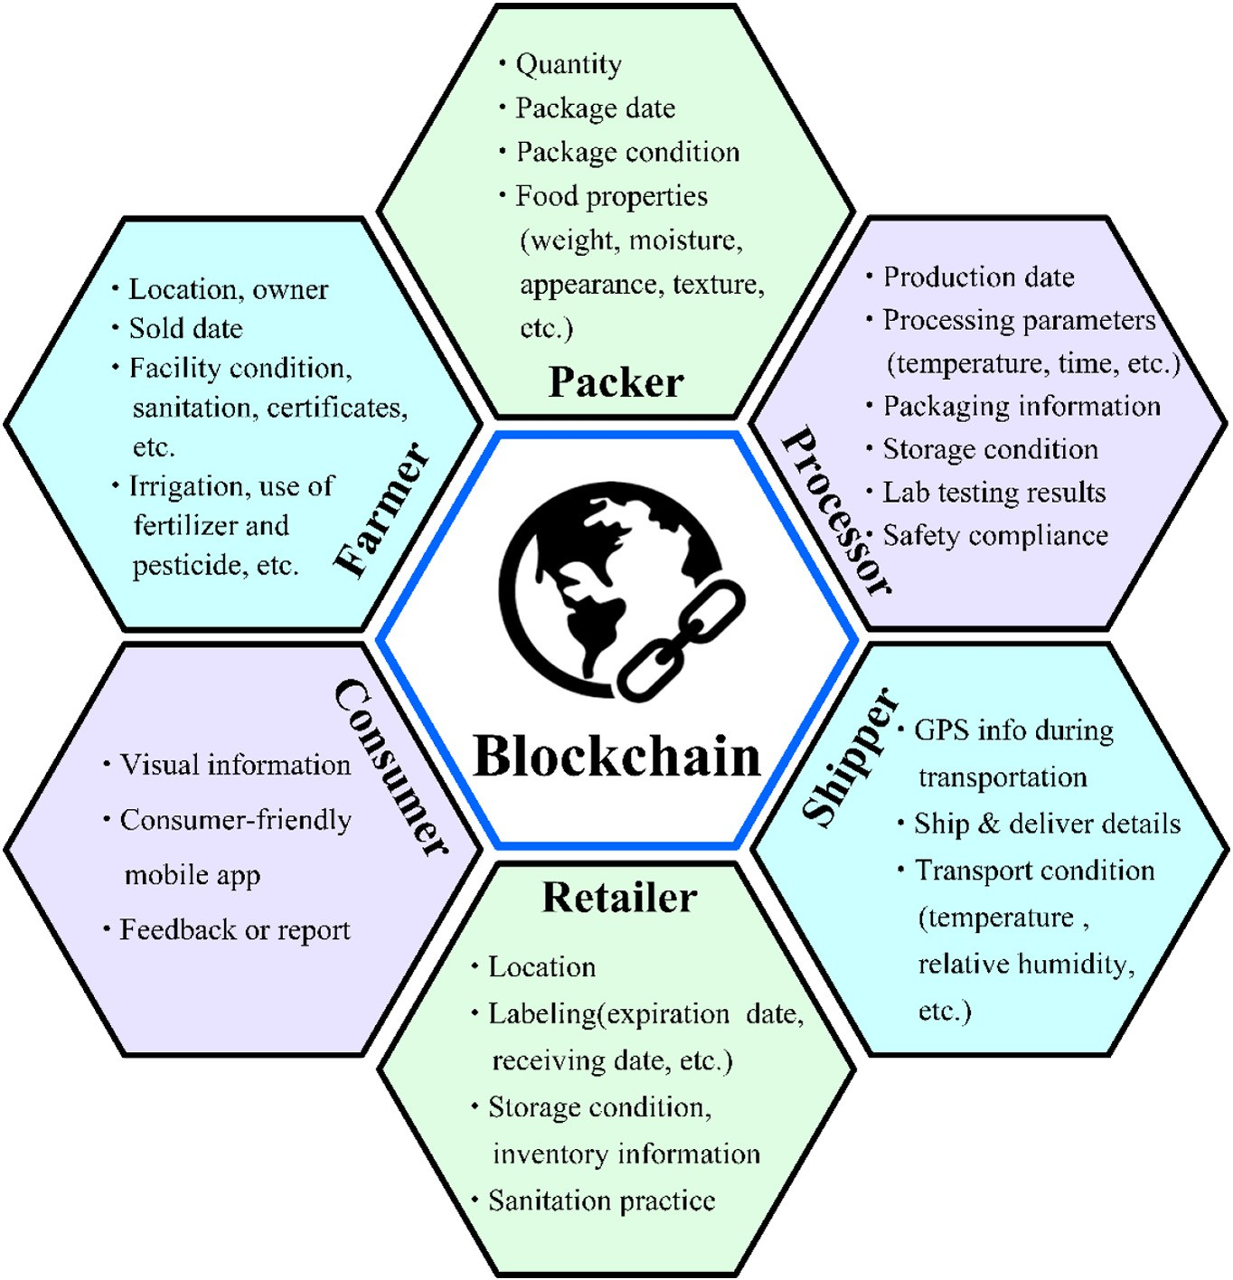

Fig. 4. Potential traced data by the blockchain system for different participants.

to access all information associated with a particular food item, provid- ing openness, transparency, neutrality, reliability, and security, to food supply chains (Tian, 2017). The information that can be monitored by blockchain technology that is related with food safety and quality are summarized in Table 3 (Zhang et al., 2014; Lin et al., 2018; Gao et al., 2020; Talaviya et al., 2020).

For global supply chains, food safety is essential to prevent cross- contamination and food pathogen outbreaks, which may be caused by worldwide shipment, and which may have a multi-national impact. Other safety issues associated with food production and processing in- clude, improper sanitation procedures, failure of processing to eliminate pathogens, improper storage conditions, cross-contamination of han- dlers, etc. (Scott et al., 2009; Xu, 2019; Sokołowska and Nasiłowska, 2020). If all the information regarding the origin and handling of food items can be tracked and monitored by the blockchain, the above-

Table 3

Food properties for safety and quality assessment.

Properties for safety assessment Properties for quality assessment

indicated risks will be significantly reduced or potentially eradicated and, thus improving the safety of agri-foods.

One example of how blockchain technology may beneficially impact food quality is provided by the mango pilot program in the United States. The mango pilot program monitors the quality or maturity of mango slices during international transportation from Mexico using blockchain technology (Kamath, 2018). This can be applied to other fresh fruits that have perishability issues during production and trans- portation. The environmental factors (temperature, moisture), and the quality-related characteristics, such as appearance (color, size, etc.), physical damages (bruise, etc.) or biological damages (worms, etc.) will be critical for monitoring or estimating the quality of supply.

Applications of blockchain technology to agriculture are only just be- ginning, thus the properties listed in Table 3 that are currently able to be tracked via blockchain are quite limited. Currently, tracking the provenance of agri-foods is the most popular application of blockchain to supply chain tracing, while tracking other properties related to food safety-quality is becoming more popular (Tama et al., 2017; Feng et al., 2020). Tracking additional food properties beyond those related to food origin and food quality-safety needs more systematic study and research on using blockchain technology.

Internal factor

External factor

Initial microbial flora, pesticide residuals, artificial colorant, food pathogen contamination, food allergen, toxin, heavy metal contamination, sick poultry and livestock, abuse use of food additives & chemicals, etc.

Temperature, relative humidity, sanitation procedure, CIP,

shelf-life, etc.

Appearance (color, shape, size, shape), surface defect (bruise, worm) texture, ripeness, nutrient (sugar, water content, etc.), flavor, volatile, provenance, falsification, inferior, etc.

Temperature, relative humidity, light, gas concentration, etc.

* 1. *Agriculture finance*

Agricultural finances normally involve cross-border payments be- tween different countries and participants, including farmers, sellers, buyers, traders, etc. The traditional payment model is complex and in- volves lots of paper-heavy settlement processes, significantly reducing the efficiency of the transactions.

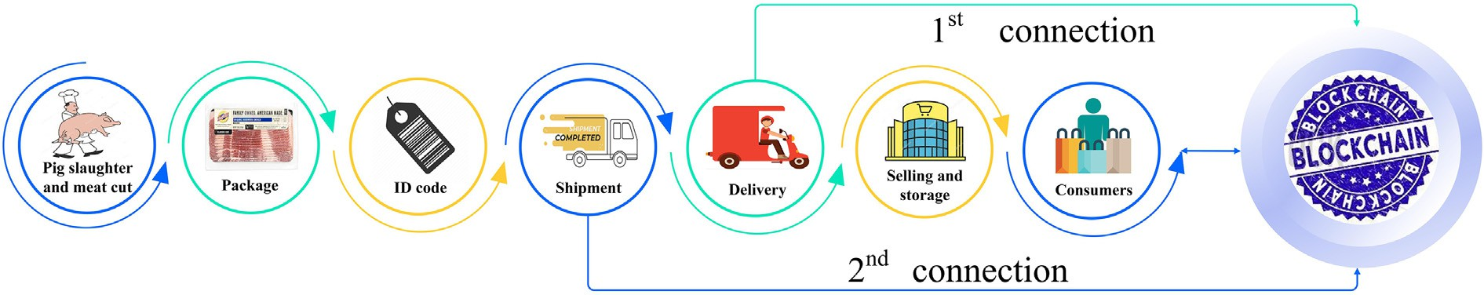

Fig. 5. Flow chart of Walmart pork traceability system by blockchain

Blockchain technology can realize rapid and real-time payments for agricultural financial services, and thus, reduce the transaction costs and risks while increasing cash flow and working capital (Tripoli and Schmidhuber, 2018). Blockchain technology, such as Ripple, can be used to solve the problem of cross border payments. Since Ripple uses virtual currency, such as Bitcoin and Ethereum for financial transactions, Ripple has drawn much attention from both investors and developers in the past 10 years. The use of cryptocurrency on a blockchain network as a uni- versal currency for use in the agri-foods supply chain can greatly reduce exchange fees among different currencies, transaction fees, and time.

Blockchain technology allows fast and safe payments at a reduced cost. The traditional payment approach normally takes 3–5 days, and some time passes through several banks acting as middlemen, resulting in high transaction fees, placing a great burden on agri-food workers, es- pecially those in developing countries. In contrast, payments made via blockchain could reduce the cost to less than $2, regardless of the trans- action amount. The payments made via blockchain could be settled in less than 10 min. No bank approval would be required, and no inspec- tions needed. More efficient supply chains and agricultural financial transactions would lead to greater financial inclusion and stronger busi- ness development.

1. Case study
   1. *Pork traceability system by Walmart*

In 2016, the retail giant Walmart established the Walmart Food Safety Center in Beijing and invested $25 million to build global food safety using IBM's blockchain solution (Kamath, 2018). Proof of concept (POC) and blockchain pilots have been established for two products: mango slices, and fresh-cut pork products, in the U.S. and China, respec- tively (IBM, 2017). Because of the differences between these two coun- tries, different information is used in each system. One difference between the pork pilot and mango pilot is that the pork pilot focuses more on product traceability within the nationwide. In the mango pilot, the product traceability is international due to the transitional transpor- tation of mango products between Mexico and the United States, also, the quality or maturity of the mango slices is the focus. While in China, Chinese consumers are more interested in the source of the products, and thus the location for pork production is recorded. In this review, we will discuss the Walmart pork traceability system in China.

China is the world's largest pork importer and producer, with an an- nual pork consumption of 12.7 million tons (Gale, 2017). Several scan- dals have occurred in China, challenging the public's perception of the quality and reliability or indicated origin of the pork products, such as water-injected pork, or pork products contaminated with clenbuterol, a banned drug that causes pigs to shed fat (Leng et al., 2019). For these reasons, Chinese consumers are eager to know the provenance of the meat products, and the inspection information during the pro- cessing steps. However, due to the lack of regulation and quality inspec- tions, the source and the quality of most pork products are not easy to monitor. Therefore, there is an urgent need to increase meat quality and safety during the pork production process. Blockchain technology

has the potential to improve pork safety by increasing the transparency of the pork supply chain.

The current pork traceability system implemented in China has been validated using fresh-cut pork products. A diagram illustrating the cur- rent pork traceability system is shown in Fig. 5. The detailed description of the main steps is summarized below:

1. Tracking factor identification: the first step is to identify the factor for traceability. This is likely to the critical control point in Hazard analysis and critical control point (HACCP). At this early stage, the source of the products or the inspection information during the pork processing line is the tracking identification point.
2. Training: a special training has been provided by IT support to the employees of the manufacturers in the pork pilot plant. This step tells the employees how to use the app or portable detection device, which includes data uploading, data scanning, data collecting, data proofing, etc.
3. Pork processing: at this step, pigs in the slaughterhouse are slaughtered. The inspection information is collected from the pig providers at this stage. Then, the pigs are cut into different parts and pre-packaged into different products for end-user consumption.
4. ID build-up: the geographical location information can be collected by creating a vendor ID. For each item, the specific item number should be created, which is linked with product information, such as production data and time, location, source, inspection data, etc. The amount of the same item is also recorded by applying the same amount of code segment. In this case, each item will have a dif- ferent barcode number for tracking.
5. First-connection to blockchain: then, when the products are proc- essed and ready for shipment, the barcode number for each product is recorded and linked with the vehicle. This step is the first time at which product information is uploaded to the blockchain, which provides the location of the shipping information. In this case, the origin or the source of the product is recorded.
6. Second connection to blockchain: when the products are delivered to the grocery stores, the location of the receiving stores will be recorded automatically by GPS. This is the second time that the information is uploaded to the blockchain system, which will provide the receiving store, the number of items delivered, and the delivery time.
7. Selling and storage: the delivered pork is put in the storage room and labeled for price. A special bar code is attached with each item en- abling the consumer to access all product information stored on the blockchain including processing and transportation information.
8. Consumers: when the consumers purchased the pork, they can scan the barcode on the item and access the product information via mo- bile device.
9. Challenges
   1. *How to manage the agriculture supply chain as a whole?*

The whole supply chain includes many participants and building a good connection between all of them is very challenging using

conventional systems. Currently, the successful model built by Walmart has received much attention and is being further developed. More work is needed before sufficient connectivity between supply chain partici- pants is achieved. In this case, an international community should be built to monitor or manage the participants and provide policies or guidance on the proper usage of blockchain technology.

Another issue is the blockchain system built by different companies or countries might not be compatible for data sharing with other dis- tinct blockchains. This will raise a challenge if a certain product has been transported between countries using separate blockchains. Thus, issues exist regarding which country or company's blockchain system should be adopted as the central blockchain, or how information may be transmitted between blockchains. Thus, how to make the whole blockchain accessible for all sectors is hard to solve.

* 1. *How to ensure the data sets are accurate, open, and safe?*

The blockchain itself is trustless, however, the information that gets recorded on the blockchain could be falsified, so how the data that gets incorporated into the blockchain is ensured to be accurate is of critical importance. Currently, most of the data uploaded in the blockchain is manually uploaded. However, there are very lim- ited measures in place to ensure this manually reported information is valid.

Currently, the data stored by blockchain is not completely open to the consumers. In this case, the use of blockchain to track products is more like a supplier self-inspection tool. That means, when out- breaks occur, the suppliers can use the data as a proof to provide to the inspectors or governmental regulators. In this case, consumer- friendly scan systems should be created to make the data more ac- cessible to consumers. The consumer can use the scan function of their cell phone to trace the source of products of interest. No special devices are needed to get the origin or transportation data from the consumer end.

Concern of the manufactures. Once the data has been uploaded to the blockchain, there is no way to change it. The consumers can check the information through the number stored in the blockchain. It de- pends on how the manufactures would like to be open to the con- sumers. For some big companies with sufficient regulations and management, it might be easy, but for some small-scale industries, which do not have good manufacturing practices, they might not be willing to share all the information to the consumers.

Moreover, the safety of transactions using capital currencies (e.g., non-crypto currencies) is still a major challenge. The system might be hacked by someone. Since there are no regulators or super- vision systems for blockchain system management, more work is needed to improve the safety of the blockchain transaction system in general.

* 1. *How to benefit more agri-foods?*

The current challenge facing blockchain systems is how to extend these use cases to benefit other products. Since different products have different properties, and concerns of the consumers may be differ- ent for each distinct product. For example, for fresh fruits and vegeta- bles, the consumers might care more about the pesticide residues instead of their origin; for frozen seafoods, the consumers care more about their authenticity and provenance, and if they have been thawed or re-frozen during transportation; for high-quality fresh-cut meat, such as Kobe beef, or high-value fruits, such as jackfruit or dragon fruits, the quality change during shipment is of great concern. In this case, more tracking factors should be identified according to the product types. Monitoring each of these different parameters will provide a challenge for the data uploader as well as the blockchain system. Training and technical issues might occur when dealing with other food properties.

* 1. *How to deal with pre-existing data?*

How to use the blockchain system to combine with the pre-existing data is another challenge. Currently, each manufacture has their own data system, which have large volumes of information on the details of the products. The current challenge for blockchain technology is how to bridge the gap between local farms or manufacturers and upload the pre-existing data to the blockchain or cloud to create a larger data set.

Another benefit of blockchain technology is its potential to transfer the gathered data to government regulatory platforms. This will help the government regulatory agencies perform a better job tracking, mon- itoring, and auditing the entirety of the food supply chain (Tse et al., 2017). However, how can systems be built to ensure the manufacturers report cases to the governmental systems or regulation systems by using the blockchain system? This is even more challenging if the food safety regulation systems are different between local governments, or between local and national governments. The application programming interface (API) should be built into the blockchain system to connect the pre-existing data from food providers and should be configured to con- nect or report all the data into the governmental systems. In this case, once the centralized data storage system has been built by the food sup- pliers, the API can connect to the different local governmental systems. Then, the different data from different suppliers can be linked together by blockchain. In this case, the food suppliers or manufacturers do not have to report the case to the local government, since the blockchain can behave like a middleman to transfer the data from food suppliers to the government.

* 1. *How to manage the extra cost?*

The core of the blockchain system is data collection and acquisition. Currently, the special ID code built for item identification will increase the cost of packaging. The price of barcode labels can be various and if the cost is too high, for some low-price products, it will be challenging to scale-up applications to all food products. The labeling machine might need to be modified or re-installed to fit the special need of the barcode tag. For production lines without automation, the labor cost for attaching tags on products will be high. Also, the labor cost of man- ually scanning and recording barcodes, or the cost of automated scan- ning equipment and IT staff to support said equipment, may also increase the cost. The cost of the sensors for temperature, humidity, or oxygen is quite expensive and this will increase the expenses as well. The blockchain system should be further developed based on different manufacturing systems and the extra cost will surely arise, such as link build-up, speed and capacity of transactions, etc. The good news is that the blockchain system developed by Walmart has been applied successfully in a nut production line in Vietnam. The blockchain system can be applied in the canning and sealing sys- tem for tag attachment, without the need for buying new specialized equipment. All relevant product information is stored in the Vechain blockchain.

1. Conclusions and future trends

There is much excitement surrounding blockchain technology in both the public and private sectors. Recently, there have been efforts to adopt blockchain technologies in the agri-foods area, yet there is still a great deal of unrealized potential. Decentralized, distributed blockchain technology enables better agri-foods management with bet- ter traceability and transparency. Digitally tracking products from farm to consumer presents an opportunity for companies to then apply blockchain technologies to improve food safety and quality. However, many challenges, both technical and regulatory, remain to be solved be- fore more large-scale adoption of blockchain technology for a diverse range of agri-foods is realized.

CRediT authorship contribution statement

Jie Xu: writing the original draft, reviewing, and editing Shuang Guo: consulting and editing

David Xie: consulting and editing Yaxuan Yan: drawing figures

Acknowledgment

No financial support is used in this review. The authors declared that no conflict exists.

References

Armonk, N.Y., 2017. [IBM Announces Major Blockchain Collaboration with Dole, Driscoll’s,](http://refhub.elsevier.com/S2589-7217(20)30023-4/rf0005) [Golden State Foods, Kroger, McCormick and Company, McLane Company, Nestlé,](http://refhub.elsevier.com/S2589-7217(20)30023-4/rf0005) [Tyson Foods, Unilever and Walmart to Address Food Safety Worldwid](http://refhub.elsevier.com/S2589-7217(20)30023-4/rf0005)e.

Bernama (2020). "Blockchain, direct to consumer communication can help uplift palm oil's image." from [https://www.theedgemarkets.com/article/blockchain-direct-con-](https://www.theedgemarkets.com/article/blockchain-direct-consumer-communication-can-help-uplift-palm-oils-image) [sumer-communication-can-help-uplift-palm-oils-image](https://www.theedgemarkets.com/article/blockchain-direct-consumer-communication-can-help-uplift-palm-oils-image).

Feng, H., et al., 2020. [Applying blockchain technology to improve agri-food traceability: a](http://refhub.elsevier.com/S2589-7217(20)30023-4/rf0010) [review of development methods, benefits and challenges. J. Clean. Prod. 12103](http://refhub.elsevier.com/S2589-7217(20)30023-4/rf0010)1.

Gale, F., 2017. [China’s Pork Imports Rise along with Production Costs (United States De-](http://refhub.elsevier.com/S2589-7217(20)30023-4/rf0015) [partment of Agriculture)](http://refhub.elsevier.com/S2589-7217(20)30023-4/rf0015).

Galvez, J.F., et al., 2018. [Future challenges on the use of blockchain for food traceability](http://refhub.elsevier.com/S2589-7217(20)30023-4/rf0020) [analysis. TrAC Trends Anal. Chem. 107, 222–232](http://refhub.elsevier.com/S2589-7217(20)30023-4/rf0020).

Gao, Z., et al., 2020. [Real-time hyperspectral imaging for the in-field estimation of straw-](http://refhub.elsevier.com/S2589-7217(20)30023-4/rf0025) [berry ripeness with deep learning. Artificial Intelligence in Agriculture 4, 31–38](http://refhub.elsevier.com/S2589-7217(20)30023-4/rf0025).

Hay, D., 2018. [INS Ecosystem (INS) Overview: Blockchain for the Grocery Supply Chain](http://refhub.elsevier.com/S2589-7217(20)30023-4/rf0030). Hejin, A., 2018. [Albert Heijn and Refresco Make Orange Juice Chain Transparent](http://refhub.elsevier.com/S2589-7217(20)30023-4/rf0035).

IBM, 2017. Maersk and IBM Unveil First Industry-Wide Cross-Border Supply Chain Solu- tion on Blockchain. press release,IBM.com, March 5. [www-03.ibm.com/press/us/](http://www-03.ibm.com/press/us/en/pressrelease/51712.wss) [en/pressrelease/51712.wss](http://www-03.ibm.com/press/us/en/pressrelease/51712.wss).

IBM (2019). "IBM, Raw Seafoods Collaborate to Use Blockchain to Help Improve Seafood Traceability and Sustainability While Addressing Fraud.".

IBM (2020). "Farmer Connect Uses IBM Blockchain to Bridge the Gap Between Consumers and Smallholder Coffee Farmers." from [https://newsroom.ibm.com/2020-01-06-](https://newsroom.ibm.com/2020-01-06-Farmer-Connect-Uses-IBM-Blockchain-to-Bridge-the-Gap-Between-Consumers-and-Smallholder-Coffee-Farmers) [Farmer-Connect-Uses-IBM-Blockchain-to-Bridge-the-Gap-Between-Consumers-](https://newsroom.ibm.com/2020-01-06-Farmer-Connect-Uses-IBM-Blockchain-to-Bridge-the-Gap-Between-Consumers-and-Smallholder-Coffee-Farmers) [and-Smallholder-Coffee-Farmers](https://newsroom.ibm.com/2020-01-06-Farmer-Connect-Uses-IBM-Blockchain-to-Bridge-the-Gap-Between-Consumers-and-Smallholder-Coffee-Farmers).

JD.com (2018). "JD Ramps up Australian Imports with InterAgri Partnership on Pure Black Angus Beef.".

Jones, K., 2018a. [FoodLogiQ Announces Blockchain Pilot Alongside Industry Leaders](http://refhub.elsevier.com/S2589-7217(20)30023-4/rf0040). Jones, K., 2018b. [FoodLogiQ, Subway®/IPC, and GS1 US Join Forces to Present on](http://refhub.elsevier.com/S2589-7217(20)30023-4/rf0045)

[Blockchain at National Restaurant Association’s (NRA) Restaurant Innovation Summit](http://refhub.elsevier.com/S2589-7217(20)30023-4/rf0045) [in Dallas](http://refhub.elsevier.com/S2589-7217(20)30023-4/rf0045).

Kamath, R., 2018. [Food traceability on blockchain: Walmart’s pork and mango pilots with](http://refhub.elsevier.com/S2589-7217(20)30023-4/rf0050) [IBM. The Journal of the British Blockchain Association 1 (1), 3712](http://refhub.elsevier.com/S2589-7217(20)30023-4/rf0050).

Kaye, L., 2016. "Responding to food safety concerns, Walmart invests $25 million in China." from. [http://www.triplepundit.com/story/2016/responding-food-safety-con-](http://www.triplepundit.com/story/2016/responding-food-safety-concerns-walmart-invests-25-million-china/21896/) [cerns-walmart-invests-25-million-china/21896/](http://www.triplepundit.com/story/2016/responding-food-safety-concerns-walmart-invests-25-million-china/21896/).

Kshetri, N., 2018. [1 Blockchain’s roles in meeting key supply chain management objec-](http://refhub.elsevier.com/S2589-7217(20)30023-4/rf0060) [tives. Int. J. Inf. Manag. 39, 80–89](http://refhub.elsevier.com/S2589-7217(20)30023-4/rf0060).

Lakhani, K., Iansiti, M., 2017. [The truth about blockchain. Harv. Bus. Rev. 95 (1), 119–127](http://refhub.elsevier.com/S2589-7217(20)30023-4/rf0065). Lawton, G., 2019. [How Bumble Bee Is Using SAP Blockchain for Food Traceabilit](http://refhub.elsevier.com/S2589-7217(20)30023-4/rf0070)y.

Leng, Y., et al., 2019. [A method to detect water-injected pork based on bioelectrical im-](http://refhub.elsevier.com/S2589-7217(20)30023-4/rf0075) [pedance technique. Journal of Food Measurement and Characterization 13 (2),](http://refhub.elsevier.com/S2589-7217(20)30023-4/rf0075) [1341–1348](http://refhub.elsevier.com/S2589-7217(20)30023-4/rf0075).

Lin, J., et al., 2018. [Blockchain and IoT based food traceability for smart agriculture. Pro-](http://refhub.elsevier.com/S2589-7217(20)30023-4/rf0080) [ceedings of the 3rd International Conference on Crowd Science and Engineerin](http://refhub.elsevier.com/S2589-7217(20)30023-4/rf0080)g.

Matzembacher, D.E., et al., 2018. [An integration of traceability elements and their impact](http://refhub.elsevier.com/S2589-7217(20)30023-4/rf0085) [in consumer’s trust. Food Control 92, 420–429](http://refhub.elsevier.com/S2589-7217(20)30023-4/rf0085).

Nestlé (2019). "Nestlé breaks new ground with open blockchain pilot.".

OriginTrail (2018). "Utilizing Smart Sensors to Prevent Wine Fraud — OriginTrail's Pilot With TagItSmart.".

Peters, A., 2017. [In China, you Can Track your Chicken on-you Guessedit-the Blockchai](http://refhub.elsevier.com/S2589-7217(20)30023-4/rf0090)n. Qu, X.-H., et al., 2007. [Studies on GIS based tracing and traceability of safe crop product in](http://refhub.elsevier.com/S2589-7217(20)30023-4/rf0095)

[China. Agric. Sci. China 6 (6), 724–73](http://refhub.elsevier.com/S2589-7217(20)30023-4/rf0095)1.

Scott, V.N., et al., 2009. [Control of *Salmonella* in low-moisture foods I: minimizing entry of](http://refhub.elsevier.com/S2589-7217(20)30023-4/rf0100)

[*Salmonella* into a processing facility. Food Prot. Trends 29 (6), 342–35](http://refhub.elsevier.com/S2589-7217(20)30023-4/rf0100)3.

Sokołowska, B., Nasiłowska, J., 2020. [Controlling Spoilage and Pathogenic Microorganisms](http://refhub.elsevier.com/S2589-7217(20)30023-4/rf0105) [in Beetroot (*Beta vulgaris*) Juice by High Hydrostatic Pressure. Elsevier, Safety Issues](http://refhub.elsevier.com/S2589-7217(20)30023-4/rf0105) [in Beverage Production, pp. 79–10](http://refhub.elsevier.com/S2589-7217(20)30023-4/rf0105)4.

Steiner, J., et al., 2016. [Blockchain: The Solution for Transparent in Product Supply Chains.](http://refhub.elsevier.com/S2589-7217(20)30023-4/rf0110)

[A white paper was written by Project Provenance Ltd.](http://refhub.elsevier.com/S2589-7217(20)30023-4/rf0110)

Talaviya, T., et al., 2020. [Implementation of Artificial Intelligence in Agriculture for Opti-](http://refhub.elsevier.com/S2589-7217(20)30023-4/rf0115) [misation of Irrigation and Application of Pesticides and Herbicides (Artificial Intelli-](http://refhub.elsevier.com/S2589-7217(20)30023-4/rf0115) [gence in Agriculture)](http://refhub.elsevier.com/S2589-7217(20)30023-4/rf0115).

Tama, B. A., et al. (2017). A critical review of blockchain and its current applications. 2017 international conference on electrical engineering and computer science (ICECOS), IEEE.

Tian, F. (2016). An agri-food supply chain traceability system for China based on RFID & blockchain technology. 2016 13th international conference on service systems and service management (ICSSSM), IEEE.

Tian, F., 2017. [A supply chain traceability system for food safety based on HACCP,](http://refhub.elsevier.com/S2589-7217(20)30023-4/rf0120) [blockchain & internet of things. 2017 International Conference on Service Systems](http://refhub.elsevier.com/S2589-7217(20)30023-4/rf0120) [and Service Management, IEEE](http://refhub.elsevier.com/S2589-7217(20)30023-4/rf0120).

Tripoli, M., Schmidhuber, J., 2018. [Emerging opportunities for the application of](http://refhub.elsevier.com/S2589-7217(20)30023-4/rf0125) [blockchain in the agri-food industry. FAO and ICTSD: Rome and Geneva. Licence:](http://refhub.elsevier.com/S2589-7217(20)30023-4/rf0125) [CC BY-NC-SA](http://refhub.elsevier.com/S2589-7217(20)30023-4/rf0125) 3.

Trust, I. F. "IBM Food Trust. A new era for the world's food supply.". from [https://www.](https://www.ibm.com/blockchain/solutions/food-trust) [ibm.com/blockchain/solutions/food-trust](https://www.ibm.com/blockchain/solutions/food-trust).

Tse, D., et al., 2017. [Blockchain application in food supply information security. 2017 IEEE](http://refhub.elsevier.com/S2589-7217(20)30023-4/rf0130) [International Conference on Industrial Engineering and Engineering Management](http://refhub.elsevier.com/S2589-7217(20)30023-4/rf0130) [(IEEM), IEEE](http://refhub.elsevier.com/S2589-7217(20)30023-4/rf0130).

Xu, J., 2019. [Control of *Salmonella* in Low-Moisture Foods: Thermal Death Kinetics and Mi-](http://refhub.elsevier.com/S2589-7217(20)30023-4/rf0135) [crobial Validation of Radio-Frequency Processes Washington State University](http://refhub.elsevier.com/S2589-7217(20)30023-4/rf0135).

Zhang, B., et al., 2014. [Principles, developments and applications of computer vision for](http://refhub.elsevier.com/S2589-7217(20)30023-4/rf0140) [external quality inspection of fruits and vegetables: a review. Food Res. Int. 62,](http://refhub.elsevier.com/S2589-7217(20)30023-4/rf0140) [326–34](http://refhub.elsevier.com/S2589-7217(20)30023-4/rf0140)3.