[Artificial Intelligence in the Life Sciences 1 (2021) 100018](https://doi.org/10.1016/j.ailsci.2021.100018)

 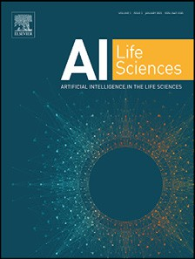

Contents lists available at [ScienceDirect](http://www.ScienceDirect.com/)

Artificial Intelligence in the Life Sciences

journal homepage: [www.elsevier.com/locate/ailsci](http://www.elsevier.com/locate/ailsci)

Review

Can deep learning revolutionize clinical understanding and diagnosis of optic neuropathy?

Mohana Devi Subramaniam a,∗, Abishek Kumar Ba, Ruth Bright Chirayath a, Aswathy P Nair a,

Mahalaxmi Iyer b, Balachandar Vellingiri c

a *SN ONGC Department of Genetics and Molecular Biology, Vision Research Foundation, Sankara Nethralaya, Chennai, Tamil Nadu 600 006, India*

b *Livestock Farming and Bioresource Technology, Tamil Nadu, India*

c *Department of Human Genetics and Molecular Biology, Bharathiar University, Coimbatore 641 046, India*

a r t i c l e i n f o a b s t r a c t

*Keywords:*

Artificial intelligence Deep learning Ophthalmology

Leber’s hereditary optic neuropathy Diagnosis

Artificial intelligence (AI) based on deep learning (DL) has sparked tremendous global interest in recent years. Deep Learning has been widely adopted in speech and image recognition, natural language processing which has an impact on healthcare. In the recent decade, the application of DL has exponentially grown in the field of Ophthalmology. The fundoscopy, slit lamp photography, optical coherence tomography (OCT), and magnetic resonance imaging (MRI) were employed for clinical examination of various ocular conditions. These data served as a perfect platform for the development of DL models in Ophthalmology. Currently, the application of DL in oc- ular disorders is majorly studied in Diabetic retinopathy (DR), age-related macular degeneration (AMD), macular oedema, retinopathy of prematurity (ROP), glaucoma, and cataract. In Ophthalmology, DL models are gradually expanding their scope in optic neuropathies. Glaucoma and optic neuritis are optic nerve disorders, where DL models are currently studied for clinical applications. For further expansion of DL application in inherited optic neuropathies, we discussed the recent observational studies revealing the pathophysiological changes at the optic nerve in Leber’s hereditary optic neuropathy (LHON). LHON is an inherited optic neuropathy leading to bilateral loss of vision in early age groups. Hence for early management, further footsteps in the application of DL in LHON will benefit both ophthalmologists and patients. In this review, we discuss the recent advancements of AI in the Ophthalmology and prospective of applying DL models in LHON for clinical precision and timely diagnosis.

# Introduction

Artificial intelligence (AI) has taken over healthcare by playing a ma- jor part in revolutionizing diagnosis in the present era. Any complexity in healthcare precision, the AI model finds its application. In diagnosis, AI aced in mimicking human behaviour through machine learning (ML) technology to increase eﬃciency. AI comprehend machine learning pro- vides techniques or algorithms that empowers computers to make effec- tive predictions or judgement using available input data. It requires a large number of training data to build an exact model [1]. Deep learn- ing (DL) is a subgroup of ML which has significant accuracy in many domains including natural language processing, recommender systems, sound recognition, and image recognition. It can also recognize com- plex, unstructured, and interconnected data with fair accuracy [2].

Gulshan et al. [3] first introduced the algorithm of DL in diabetic retinopathy (DR). Soon after the development of DL in DR, researchers were interested to work on different algorithms and successfully devel- oped DL models, that could detect and moderate ocular conditions like

∗ Corresponding author.

*E-mail address:* [geneticmohana@gmail.com](mailto:geneticmohana@gmail.com) (M.D. Subramaniam).

Age-related macular degeneration (AMD), glaucoma, retinopathy of pre- maturity (ROP), and cataract [4]. To date, two complete algorithms have been successfully approved by the FDA. Amongst them, IDx-DR is a dig- ital diagnosis system for DR. The other one is Viz.AI, which analyses im- ages indicating a stroke. These devices are termed “Locked algorithms” [5]. These algorithms for ML have the potential to evolve continuously and are highly adaptive in the application of other fields.

Artificial Intelligence in neuro-ophthalmology is an emerging field and AI algorithms have shown high accuracy in detecting neuro- ophthalmic diseases in papilledema and glaucoma. Algorithms in AI are developed for detecting neuro-ophthalmic diseases through moni- toring retinal nerve fibre layer (RNFL) thickness and optic disc alter- ations using fundus and OCT images [6]. This emerging technology in neuro Ophthalmology further signifies insight to expand its applica- tion in inherited optic neuropathy especially LHON. This review dis- cusses the current application and recent innovations of AI in Oph- thalmology, and the possible role of AI-based models in inherited optic neuropathy.

<https://doi.org/10.1016/j.ailsci.2021.100018>

Received 30 June 2021; Received in revised form 18 November 2021; Accepted 18 November 2021

Available online 21 November 2021

2667-3185/© 2021 The Authors. Published by Elsevier B.V. This is an open access article under the CC BY-NC-ND license (<http://creativecommons.org/licenses/by-nc-nd/4.0/>)

# Potential of AI in healthcare

The major reason for the exponential growth of AI worldwide is due to demand in big data processing and to enhance human work in health- care diagnostics [7]. At present, tremendous growth in diagnostics and imaging is benefiting radiologists, ophthalmologists, and other treat- ment managing sectors (Fig. 4). Therefore, AI models in the field of Ophthalmology are rapidly increasing [8]. Deep Learning is employed in several medical imaging of disease conditions like tuberculosis from chest X-rays [9], malignant melanoma on skin photography [10], lymph node metastases to breast cancer from tissue sections [11], lung cancer using chest images [12], cardiovascular risk using computer CT [13], Pulmonary embolism using CT angiography [14], polyps using virtual colonoscopy [15], glioma using MRI [16], Alzheimer’s disease detection using functional MRI [17].

Ophthalmology involves the latest electrical, acoustic, mechanical, and optical imaging techniques. Therefore, the application of AI in Oph- thalmology is widely implemented and accepted. Using advanced DL models, AI classifies images based on pattern recognition [8]. In collab- oration with the optic system, different models of DL algorithms like neural networking are successfully applied in various disease diagnoses and it’s progression [18]. In DR, continuous monitoring is required to observe the disease progression. However, the introduction of AI has made it possible to image the fundus of patients with early DR eﬃ- ciently. In the future, requirements for continuous monitoring of DR patients may be compromised, as AI can demonstrate the development and progression of the disease [19].

# AI algorithms for diagnosis

In ophthalmology, ML requires algorithms with huge input data to train for predicting ocular conditions and to standardize its perfor- mance. Building a structured algorithm in ML is a crucial step for de- veloping AI models for diagnosis. Fundus images of the optic conditions serve as the major database for building an AI algorithm in Ophthal- mology [20]. Other than traditional fundus photography, optical co- herence tomography (OCT) scans can also be used for developing al- gorithms [21]. Combing both the 2-dimensional fundus images and 3- dimensional OCT can improve the sensitivity and specificity of the AI algorithm. These databases are fed into systems with applied logarithms for decision-making through AI [22].

The two forms of AI are supervised learning and unsupervised learn- ing. Supervised learning is the traditional ML method. In traditional ML, expert knowledge is utilized to label the clinical features and progno- sis of ophthalmic conditions. The sorted images representing the clin- ical severity are then used for classification by trained ML models. To build a precise ML model, a larger number of labelled data by experts should be fed to train and validate the algorithm [23]. Some of the pop- ular AI algorithms used for ML in Ophthalmology include decision tree, Bayesian classifiers, random forests, support vector machines, k-means, k-nearest neighbors, discriminate analysis, and neural networks [19]. In unsupervised learning, DL is applied which enables to skip the step involving the supervision of the expert. In DL the authorized input data from clinical diagnosis are extracted from secondary sources like pub- lished data, medical records, etc. for self-learning and to classify the ophthalmic conditions based on the diagnosis and severity [22]. The two powerful DL Classification system for identification includes con- volutional neural network (CNN) and massive-training artificial neural network (MTANN) [23]. The characteristics of the AI system in Oph- thalmology are presented in Fig. 1.

For building AI algorithms for Ophthalmology, the raw image data

must be sorted, validated, and pre-processed. These steps involve human intelligence to validate an algorithm and it also reflects on the sensitiv- ity and specificity of the AI system. Pre-processing of the image includes noise reduction, integration, and selection of the most relevant data. This will improve the eﬃciency of image processing for the outcome.

After processing the data, a large number of inputs are fed to achieve maximum test eﬃciency. The test should be cross-validated before ap- plication. For cross-validation, test data should be compared with the training sets involving different variables. K-fold cross-validation is the commonly used method for validation. After validation of algorithms, the sensitivity and specificity of the performance are calculated using the receiver operating characteristic (ROC) curve [19].

# Role and application of AI in the ophthalmology

The AI has revolutionized healthcare diagnostics by enabling ML applications to aid physicians with more precision and to reduce turnaround time. The scope of AI is extending exponentially and in the recent decade, ML is practiced in Ophthalmology. Numerous dig- ital imaging data including OCT, MRI, colour fundoscopy, and comput- erized visual field for manual prediction in the clinical investigation, makes Ophthalmology an ideal field for the application of AI. The errors are common in the manual interpretation of the slit lamp or fundus or OCT images by an ophthalmologist, and it is more subjective. The ML identifies the images as measurable data and enables precision in the recognition. Hence the AI application is well established in Ophthal- mology [24,25]. The current research in applying AI in various fields of Ophthalmology is represented in Fig. 2. amongst ocular disorders, DR is the widely studied area in AI serving as a hotspot for ML appli- cation. DR is the leading cause of blindness, and all diabetic patients require timely retinal screening for early-stage detection of DR which will help for treatment and management [26]. The progression of DR with pathological changes like cotton-wool spots, microaneurysm, hem- orrhages, hard exudates, and neovascularization enable the ideal appli- cation of DL for characterization of DR [27]. In DR, the application of DL not only detects the condition but also categorizes them into pro- liferative DR, non-proliferative DR, and diabetic macular oedema [28]. The recent innovation in neural networks and precision in DL enabled to classify them based on the severity gradings such as mild, moderate, or severe [3]. Wong et al. proposed a three-layer feed-forward neural network based on identifying microaneurysms and hemorrhages [29]. The morphological component analysis (MCA) technique was developed to detect oedema and hemorrhages [30]. Yazid et al. identified hard exudates and optic disc pathologies using inverse surface thresholding and lattice neural network [31]. Another study has detected optic disc changes from fundus images by using keypoint detection, texture anal- ysis, and visual dictionary techniques [32]. The specificity and sensitiv- ity of these studies ranged from 75% to 94.7%. Other than using fundus images, ElTanboly et al. introduced DL based system to detect DR us- ing another imaging modality through 52 OCT images and reported an AUC of 0.98 [33]. The AI in DR is found to be more reliable, and the test sensitivity of DL models is 97%, whereas the manual interpretation by ophthalmologists is only 8.3% [34]. A major milestone in prospective assessment of AI was the United States Food and Drug Administration approval of IDx-DR. The first complete autonomous AI-based DR diag- nostic system for detecting more than mild DR and diabetic macular oedema [35]. Recently a study has evaluated an oﬄine AI on a Remidio Fundus-on Phone and it displays high sensitivity (93%) and high speci- ficity (92.5%) [36,37]. Oﬄine AI facilities would make this technology more reachable in areas having poor network connectivity. The intelli- gent retinal imaging system is another breakthrough in the field of AI in Ophthalmology. This tele retinal DR screening program compares non- mydriatic fundus retinal images with a standard set of images from early DR study, to recommend referral in cases of severe non-proliferative DR (NPDR) or advanced DR [38].

AMD is an irreversible macular disease, caused due to various ge-

netic and epigenetic changes affecting people above the age of 50 years [39]. Advances in image recognition and classification had enabled the recognition of retinal pigment changes, choroidal neovascularization, drusen, haemorrhage, exudation, and atrophy [23]. Colour fundus im- ages are used as data for interpretation in DL. Although the results of

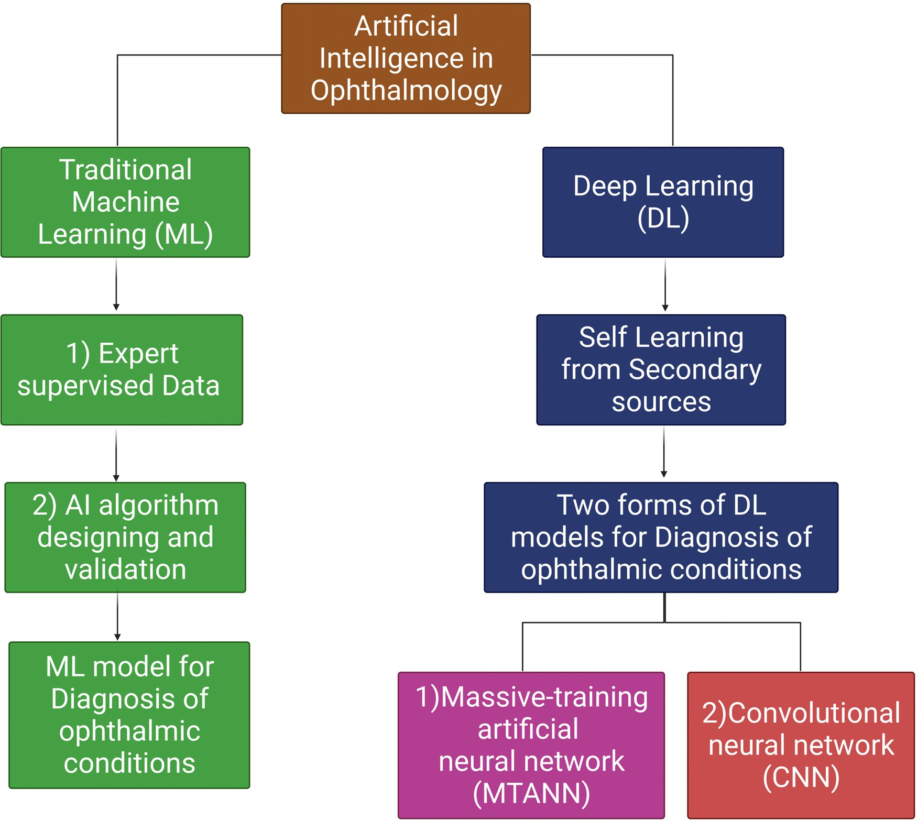

**Fig. 1.** AI algorithms in the traditional ML and DL models for the diagnosis in Ophthalmology.

DL application in the AMD are preliminary, many studies and clinical trials with greater study groups are ongoing for successful application [40,41]. From the observed studies, the test sensitivity of DL in AMD is

*>* 87% [42]. But the application of OCT images of AMD in the DL model

increased sensitivity, specificity, and accuracy [43]. The OCT enables

the DL to detect the variations in morphology, intraretinal or subretinal fluid accumulations. The recent evaluation of OCT images obtained from the larger patient groups to develop the CNN platform in the DL model for diagnosis has shown accuracy greater than 90% [44,45]. Bogunovic et al. tested an algorithm to observe the anti-VEGF treatment respon- ders using OCT images [46]. Incorporating ML in OCT images predicts the possibility of retreatment and it achieves significant performance in predicting low and high retreatment requirements [47]. Another study reported a deep convolution neural network (DCNN) using OCT images for decision making on anti-VEGF injection [48] and these studies are important in the image-guided prediction of treatment intervals in the management of AMD. Recently, scientists created and validated an AI model for AMD screening and predicting late dry and wet AMD progres- sion. This model has 99.2% accuracy for AMD screening [49].

Cataract causes opacification of the lens in the eye with a promi- nent cloudy appearance. The early diagnosis of cataracts is crucial for management, which is a challenging task through clinical observation. Hence the DL finds the application in cataracts by the development of CNN algorithms for slit-lamp images for diagnosis of the early stage of cataract. The performance of the DL model in cataracts compared to the traditional clinical grading was achieved only 70% [50]. Another DL

model developed for paediatric cataracts, enabled automatic localiza- tion of the region of interest in the lens for identification using CNN. The pre-processing of images has enhanced the sensitivity and specificity of the DL model up to 97% and enabled the classification and grading of cataracts [51]. Another study has reported risk prediction for posterior capsule opacification (PCO) using AI with 87% accuracy [52].

Glaucoma is caused due to increased intraocular pressure that dam- ages the optic nerve. The early management of glaucoma is necessary to avoid irreversible compilations, but technical challenges are attributed to the clinical diagnosis of early glaucoma [53]. In the face of glaucoma diagnosis in the clinics, measurement of intraocular pressure, optic disc cupping, visual fields & OCT for RNFL and ganglion cell layer (GCL) thickness is examined [54]. Algorithms of ML were developed for the identification of glaucoma by optic disc thickness using OCT. The neural networks enabled quantitatively OCT images to classify glaucoma based on severity [55]. In the fundus images, few studies targeted cup disc ra- tio to apply CNN for DL [56]. The thickness of the RNF through OCT examination in glaucoma was studied in 102 patients. The DL model using CNN for the classification of glaucoma has an accuracy of over 87% [57]. The studies based on the RNF and optic disc thickness open a broad scope for future application of AI in optic neuropathy, espe- cially in LHON, where the RNF layer and optic nerve vary upon the disease progression. Martin et al. used 24 prospective clinical trial data of a contact lens sensor for IOP monitoring using a random forest model [58]. Omodaka et al. developed an algorithm for the parameter such as optic disc cupping, neuroretinal rim thickness, and ganglion cell thick-

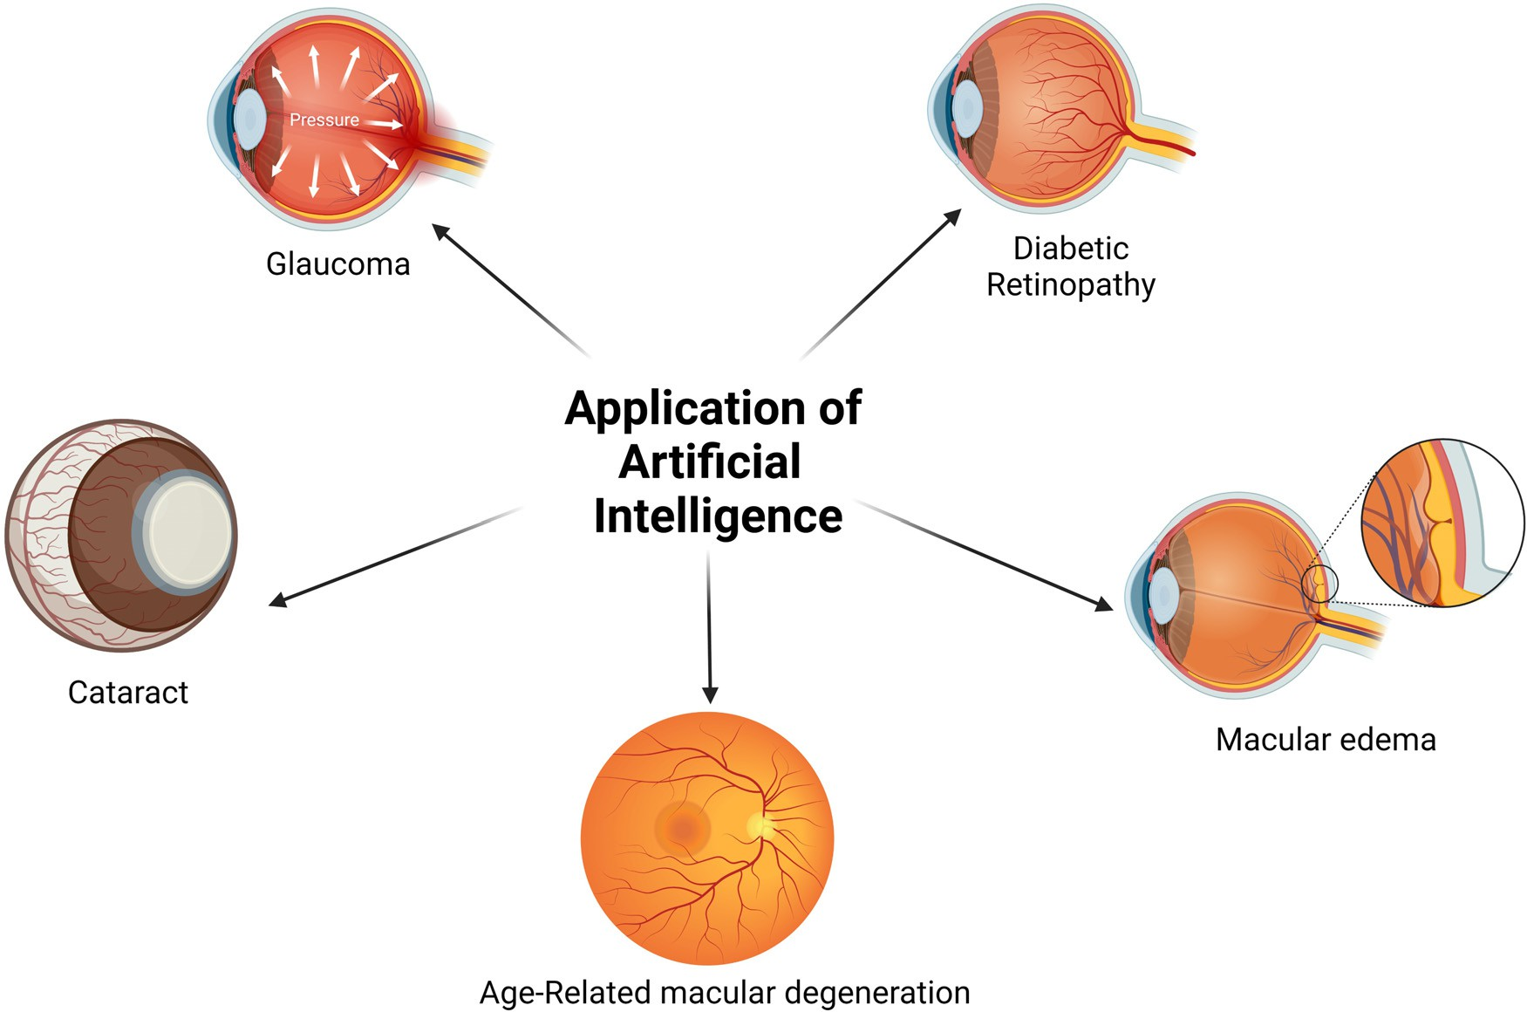

**Fig. 2.** The major areas of application of AI models in Ophthalmology.

ness based on segmentation technique using OCT images and it showed 87% accuracy [55]. Another study designed a fully automated model to classify angle-closure glaucoma using OCT scans and it reported 89.2% accuracy [59]. Studies have evaluated the DL algorithm to detect glauco- matous optic disc changes using fundus images and it shows high sensi- tivity and specificity [60,61]. Visual fields are very diﬃcult to interpret and AI in the interpretation of visual field have been reported using a feed-forward neural network to identify pre-perimetric visual fields [62,63].

In other ocular diseases, Ohsugi et al. developed DL which can de- tect rhegmatogenous retinal detachment from ultra-wide-field fundus images with high sensitivity and specificity [64]. Xu et al. designed a dual-stage DL system to identify pigment epithelial detachment in polypoidal choroid vasculopathy (PCV) from OCT images [65]. Another study from retinitis pigmentosa and Leber congenital amaurosis patients has employed an ML-based approach to predict perimetry from OCT im- ages [66]. The ML decision tree model has been introduced to predict the complexity of reconstructive surgery after the excision of periocular basal cell carcinoma [67]. In Ophthalmology, AI holds many advantages like corneal topography, IOL power prediction, predicting the outcome of the treatment, screening, and diagnostics. Artificial Intelligence has not only proven to be eﬃcient and structured but also cost-effective when compared to high-end screening and diagnostic techniques [68].

# Current status of AI in the diagnosis of optic neuropathy

Optic neuropathy occurs when the optic nerve is damaged causing structural changes in the eye and variations in the blood flow [69]. In most cases, optic neuropathy leads to vision loss starting with fading of vision, loss of colour vision, blurriness, peripheral vision loss, and clouding. It is important to detect optic nerve damage early and treat it. Researchers are trying to study various methods to derive better and quick diagnoses using AI. [70]. Currently, some studies support the use of AI in various diseases related to optic neuropathy. Recent studies on ML system attempts in detecting optic disc abnormalities through reti- nal fundus, focusing on optic disc atrophy and papilledema. The com-

bination of DL systems along with new innovative hardware solutions could bring revolution in the neuro-ophthalmic conditions and health- care [71].

Recently, A study reported an unsupervised data-driven technique to quantify measurement of RNFL structure covering a large region using swept-source optical coherence tomography(SS-OCT) images for detec- tion of glaucoma and to predict future glaucomatous progression [72]. In another study, using RNFL thickness spatial patterns were used for predicting visual field loss in glaucoma [73]. Mariotonni et al. devel- oped a novel segmentation-free DL algorithm that can measure accu- rate RNFL thickness on spectral-domain optical coherence tomography (SDOCT), without requiring segmentation of retinal layers [74]. Another scientist modified the ResNet-152 DCNN system to determine the op- tic disc laterality, to characterize between right and left optic discs in presence of neuro-ophthalmic pathologies [75]. Al-Aswad et al. evalu- ated the performance of the DL system for the identification of glauco- matous optic neuropathy using colour fundus photographs and its high sensitivity makes it a valuable tool for screening this disease [61]. One of the DL systems can diagnose optic nerve abnormalities specifically for papilledema from fundus photographs with dilated pupils differen- tiate amongst optic disc with papilledema, normal disc, and disc with non-papilledema abnormality [76]. Machine Learning techniques can be combined with fundus images as an effective approach to distinguish between Pseudopappiledema (PPE) and elevated optic disc associated with optic neuropathies [77]. AI-based DL algorithm for detecting op- tic disc abnormalities showed significant performance in differentiating non-glaucomatous optic neuropathy and glaucomatous optic neuropa- thy using colour fundus photographs [78].

# Pathophysiological changes observed in LHON

LHON is an inherited optic neuropathy caused due to mitochondrial dysfunction. The point mutations *MT-ND1, MT-ND4,* and *MT-ND6* in the mitochondrial DNA (mtDNA) affect the respiratory complex I subunits [79]. The mutation impairs NADH-ubiquinone oxidoreductase chains and increases reactive oxygen species (ROS) leading to oxidative dam-

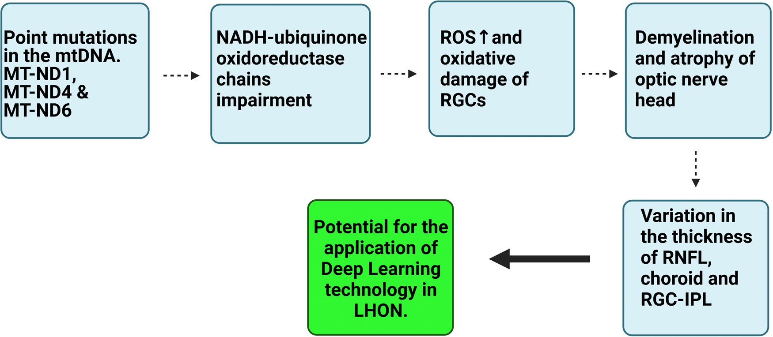

**Fig. 3.** Stepwise pathophysiological changes in LHON from mtDNA mutation level to optic nerve atrophy for understanding DL application.

age of the cells [80]. As the nerve cells are vulnerable to mitochondrial dysfunction, the retinal ganglion cells (RGC) in the axonal region of the optic nerve disc degenerates due to apoptosis [81,82]. This causes optic neuropathy and affects the visual pathway for image perception. The following events contribute to bilateral visual loss in the individual and pathological changes observed at the optic nerve. The pathophysi- ological changes at the optic nerve disc include demyelination and at- rophy. In the acute stage, the RNFL swells in the area surrounding the optic nerve head. It is then followed by persistent thinning of these lay- ers due to compensatory response in the chronic LHON. These changes were studied in OCT imaging [83]. Few studies suggested that, in acute LHON, both RNFL and choroidal thickening were observed. On the other hand, in chronic LHON, both RNFL and choroidal become thin [84]. The pathological changes in the RGCs affect the vascularity of the reti- nal ganglion cell-inner plexiform layer (RGC-IPL). Both the macular and peripapillary choroid thinning in progressed LHON correlates with the RGC-IPL thickness [85]. Evaluation of retinal vasculature in acute LHON using OCT angiography (OCT-A) outlines the marked vascular dilatation and tortuosity clinically. In fundus examination after dilation, peripapil- lary telangiectasias with hyperaemic optic nerve are observed and serve for clinical diagnosis of LHON. In the chronic stage, optic atrophy is seen at the nerve head [83]. To exclude the other causes of demyeli- nation and compressive lesions from LHON, Magnetic resonance imag- ing (MRI) aids to narrow down the differential diagnosis. In LHON, in- creased T2 signals are noted in the chiasm and optic nerve tract. Optic nerve and chiasmal enhancements mimic optic neuritis in MR. Follow- ing pathological changes observed on LHON in comparison with the healthy individual and it may serve as a tool for the application of DL in face of LHON diagnosis (Fig. 3).

# Potential of DL in the diagnosis of LHON

Currently, DL models are widely used only in the diagnosis of DR, AMD, cataract, and glaucoma [86,87]. Its application is not yet inves- tigated in LHON. Although the demand for the data exists to train the DL models, since LHON is a rare disease, a targeted multi-centric study can provide enough information to feed the DL system. Successful ap- plication of DL in LHON will revolutionize the diagnosis and precision in neuro-ophthalmology. In recent years, DL technology is well estab- lished especially in the DR, and enables the classification of them based on the types and severity [88]. In DR, fundus examination shows micro- aneurysms, dot hemorrhages, intraretinal microvascular abnormalities, neovascularization which serves as an essential tool for clinical diag- nosis [89]. The colour fundus images displaying these peculiar changes in DR are taken into consideration by the DL algorithm to form CNN

and can classify them into proliferative or non-proliferative DR or mac- ular oedema and mild, moderate, the severe scale of severity [3]. Simi- larly, in LHON, OCT examination revealed changes in the width of the RNFL, choroid, and RGC-IPL due to demyelination and atrophy. The thickness of RNFL and choroid studied were found to progress along with the severity of LHON. In acute LHON, these layers appear thick and after progression of LHON to the chronic stage, it gets significantly thin [84,85]. These changes were examined through many observational studies for enabling ophthalmologists to diagnose LHON and its progno- sis. But considering the minor observational changes through OCT, MRI, and fundoscopy and its non-specificity, it remains diﬃcult for manual interpretation. Conditions like optic neuritis and other sources of in- flammation in the optic nerve tract mimic the optic nerve pathology of LHON and lead to many other differential diagnoses, hindering the ophthalmologist to decide on genetic testing and counselling for LHON. Hence the DL model with black box algorithm can create neural net- works for accurate identification of width and other structural changes observed in the OCT. For more precision in the clinical picture of LHON, DL can augment ophthalmologists to decide on further proceedings.

# Virtual assessment of LHON by various AI techniques

Many observational studies in LHON are currently focused on un- derstanding optic nerve pathology, as it causes loss of central vision in most cases [90]. Here, we discuss how AI systems can potentially help the virtual assessment of LHON. In recent years, researchers worked on different ways of visualizing the white matter tracts like optic radia- tion and optic tract using diffusion tensor imagining (DTI) [91]. After this discovery, understanding morphometric changes near the subcor- tical area of the brain has increased. This would help the clinicians to correlate how the subcortical area could be associated with the prog- nosis of LHON. For observation of subcortical area in optic neuropathy, ultra-high-field imaging data requires 7T magnetic resonance. Artificial Intelligence DL system running on various installed algorithms, takes the core control and made it possible for high-resolution visualization of the cortical area [91].

The size of the optic nerve head can be useful in LHON [92]. The size of the optical disc can be captured in the image using AI/DL system. Var- ious algorithms were designed to work on the pedigree of an individual by exploring the genetic history of their family. This makes it easier for clinicians to understand the background of the patient, their family, and their genetic capabilities to accept and increase the rate of early diag- nosis of inherited genetic disorders like LHON [93]. Not much has been explored using AI in treating and understanding LHON; nevertheless, there is a great potential in quantitative analysis in combination with *in*

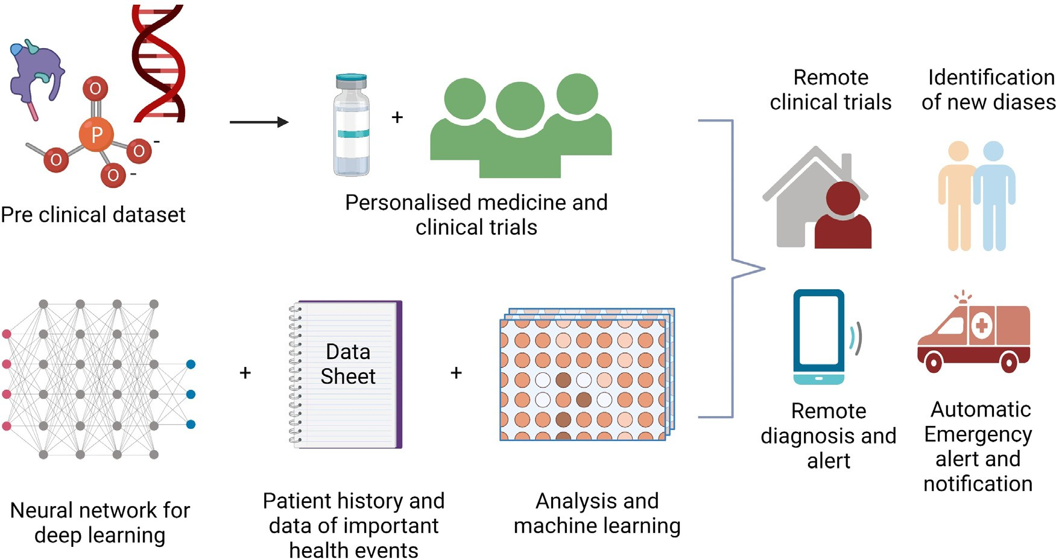

**Fig. 4.** Remote assessment in Ophthalmology. Telemedicine employing AI technology as a prospective for longitudinal diagnosis of ocular conditions.

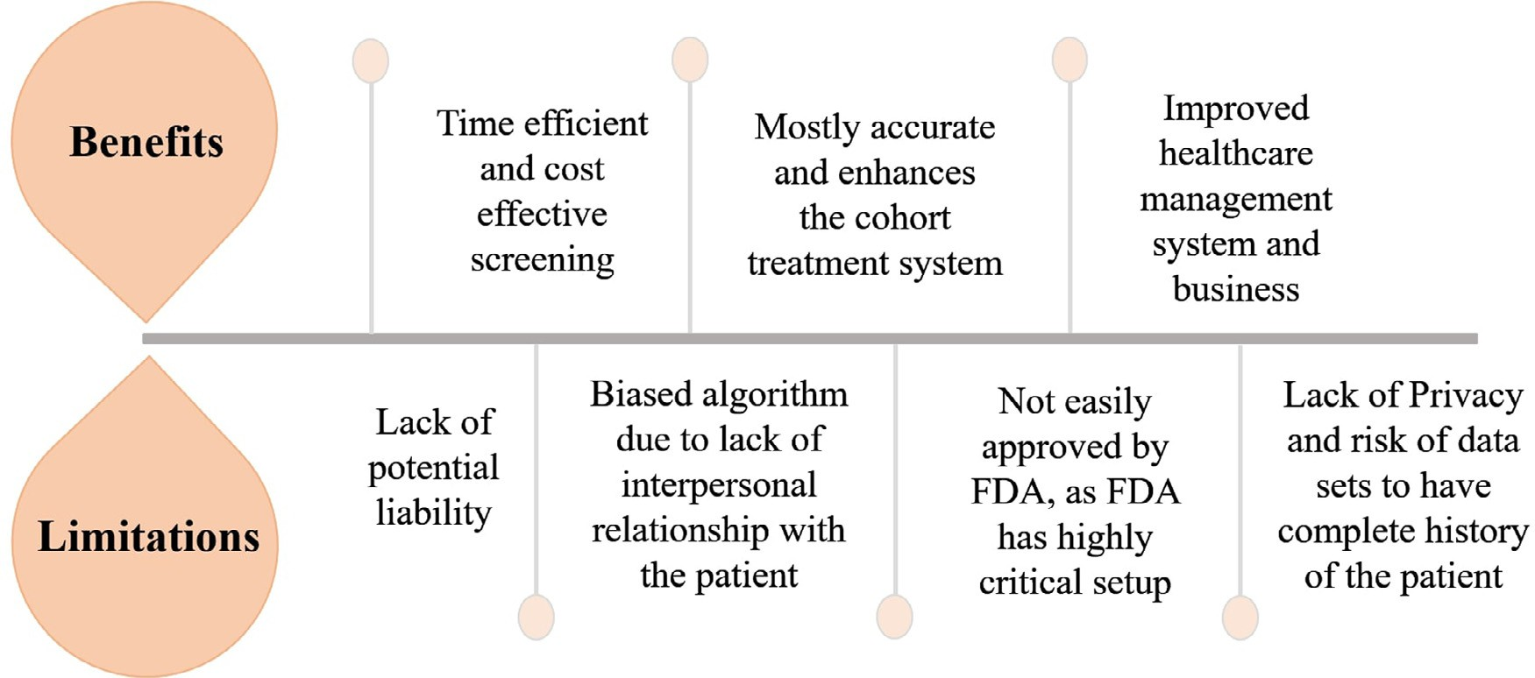

**Fig. 5.** This figure depicts the major benefits and limitations of AI in healthcare.

*vitro* studies to track down the morphological changes, progression, and understanding of LHON.

# Advantages of employing telemedicine in Ophthalmology

Trials are ongoing to expand AI platforms via digital innovations in the internet of things, 5th generation telecommunication networks, and the creation of an ecosystem that is self-dependant and provides the prospect to advance the latest models related to Ophthalmology ad- dressing various challenges [94]. One of the major advantages of using telemedicine is that it made possible for clinicians to evaluate the pa- tient from any given location. Replicating routine clinical examination, AI and telemedicine are improvising to be better by incorporating vast information about the progression of diseases, longitudinal data usage, and real-time calculation of incidences in the real-world [95,96]. The application of AI can make data collection possible and store big data of patients. Many digital innovations run from diagnostics to helping in the treatment of eye diseases. Screening of eye diseases was majorly carried with the help of AI. Tele-screening through AI has expanded its applica- tion towards ophthalmological issues like DR, ROP, glaucoma, myopia,

cataract, and AMD [23]. It can help in capturing the ocular conditions and make remote screening possible in Ophthalmology. Incorporating telemedicine for screening and understanding genetic diseases would be of great advantage (Fig. 4). Research has proven the use of AI in various genetically inherited diseases and similarly, this theory could successfully be applied for patients diagnosed with LHON. Genotypic and phenotypic correlation in LHON is a bit challenging task, but it is important clinically to decide on the treatment.

# Limitations of AI

In the face of technology, AI has a major contribution towards diag- nosis, assisting surgery, biomedical research, and biomedical informa- tion processing [97]. We have discussed the important role of AI in rev- olutionizing the future, however, it has several drawbacks in medicine and diagnosis [98]. The most challenging work involving the AI sys- tems would be studying the intrinsic aspects of ML, concerning diseases with several possibilities and outcomes. To begin with, the regulation of various algorithms is a tedious task. AI is widely accepted, yet doesn’t easily receive approval from FDA [99]. Few assistive algorithms have

been approved by the FDA, which has critical acceptance criteria for the majority of the systems including clinical trials and transparency.

There are slight chances that AI commits minor errors which may be a hindrance in the process of operations and disease diagnosis con- siderably [99]. To originate various ways for gathering data as well as analysing them considering the legal formality is one amongst the prin- cipal challenges to be confronted by the upcoming AI system. Artificial Intelligence uses different approaches to assign ground labels which are AI reference standards, and they are subjected to human error. With evidence, it can be easily stated that there is a high risk of AI system producing biased assessment by the methodological index for nonran- domized studies (MINORS), which is yet to be used completely as an application due to testing [100]. Every new system and algorithm must go through a large amount of testing and trials which is time-consuming as it must cross many approvals, as the whole system is dependant on a trial-and-error procedure.

Neural networking in DL, also known as AI paradigms, trains dataset depending on the input fed. In some cases, the variability may occur in the output data which is termed as a black-box problem [101]. The AI would eﬃciently work only if the database has all the suﬃcient infor- mation to understand the particular condition [102]. The biased algo- rithm is not a very common mistake of AI but occurs in three differ- ent forms of components namely Model variance (Insuﬃcient dataset), Model bias (selected majority and under-represented groups), and out- come noise (Interaction through model predictions unaffected by sub- population) [99]. Despite various challenges and risks, AI/DL system is still changing the face of the healthcare ecosystem universally (Fig. 5).

# Conclusion

Accurate and eﬃcient image interpretation and satisfactory prelim- inary outcome of AI have a significant impact on Ophthalmology. The fusion of automatic diagnostics through AI with the traditional system of Ophthalmology would help ophthalmologists in understanding the pathophysiology of ocular conditions. Diagnosis of LHON requires com- plex genetic tastings which is time-consuming. Therefore, the applica- tion of AI in the observation of clinical images increases precision in the provisional diagnosis and helps in the early management.

# Declaration of Competing Interest

The authors declare that there are no conflicts of interest.

# Acknowledgements

The authors would like to thank the Science and Engineering Research Board (SERB) for providing Early Career Research Award (ECR/2018/000718), India to complete this article successfully.

# References

1. Lee A, Taylor P, Kalpathy-Cramer J, Tufail A. Machine learning has arrived!. Oph- thalmology 2017;124:1726–8. doi:[10.1016/j.ophtha.2017.08.046](https://doi.org/10.1016/j.ophtha.2017.08.046).
2. LeCun Y, Bengio Y, Hinton G. Deep learning. Nature 2015;521:436–44. doi:[10.1038/nature14539](https://doi.org/10.1038/nature14539).
3. Gulshan V, Peng L, Coram M, Stumpe MC, Wu D, Narayanaswamy A, et al. Development and validation of a deep learning algorithm for detection of di- abetic retinopathy in retinal fundus photographs. JAMA 2016;316:2402–10. doi:[10.1001/jama.2016.17216](https://doi.org/10.1001/jama.2016.17216).
4. Ting DSW, Cheung CYL, Lim G, Tan GSW, Quang ND, Gan A, et al. Development and validation of a deep learning system for diabetic retinopathy and related eye diseases using retinal images from multiethnic populations with diabetes. JAMA 2017;318:2211–23. doi:[10.1001/jama.2017.18152](https://doi.org/10.1001/jama.2017.18152).
5. [Milea D, Singhal S, Najjar RP. Artificial intelligence for detection of optic disc ab- normalities. Curr Opin Neurol 2020:33.](http://refhub.elsevier.com/S2667-3185(21)00018-0/sbref0005)
6. Mayro EL, Wang M, Elze T, Pasquale LR. The impact of artificial intelli- gence in the diagnosis and management of glaucoma. Eye (Lond) 2020;34:1–11. doi:[10.1038/s41433-019-0577-x](https://doi.org/10.1038/s41433-019-0577-x).
7. Bohr A, Memarzadeh K. The rise of artificial intelligence in healthcare applications. Artif Intell Healthc 2020:25–60. doi:[10.1016/B978-0-12-818438-7.00002-2](https://doi.org/10.1016/B978-0-12-818438-7.00002-2).
8. Girard MJA, Schmetterer L. Chapter 3 - Artificial intelligence and deep learning in glaucoma: current state and future prospects. In: Bagetta G, Nucci CBTP, editors. Glaucoma a neurodegener. dis. retin. beyond - Part B. Elsevier; 2020. p. 37–64. vol. 257. doi:[10.1016/bs.pbr.2020.07.002](https://doi.org/10.1016/bs.pbr.2020.07.002).
9. Lakhani P, Sundaram B. Deep learning at chest radiography: automated classifica- tion of pulmonary tuberculosis by using convolutional neural networks. Radiology 2017;284:574–82. doi:[10.1148/radiol.2017162326](https://doi.org/10.1148/radiol.2017162326).
10. Esteva A, Kuprel B, Novoa RA, Ko J, Swetter SM, Blau HM, et al. Dermatologist-level classification of skin cancer with deep neural networks. Nature 2017;542:115–18. doi:[10.1038/nature21056](https://doi.org/10.1038/nature21056).
11. Liu Y, Kohlberger T, Norouzi M, Dahl GE, Smith JL, Mohtashamian A, et al. Artificial intelligence–based breast cancer nodal metastasis detection: insights into the black box for pathologists. Arch Pathol Lab Med 2018;143:859–68. doi:[10.5858/arpa.2018-0147-OA](https://doi.org/10.5858/arpa.2018-0147-OA).
12. van Ginneken B. Fifty years of computer analysis in chest imaging: rule- based, machine learning, deep learning. Radiol Phys Technol 2017;10:23–32. doi:[10.1007/s12194-017-0394-5](https://doi.org/10.1007/s12194-017-0394-5).
13. [Weng SF, Reps J, Kai J, Garibaldi JM, Qureshi N. Can machine-learning im- prove cardiovascular risk prediction using routine clinical data? PLoS ONE 2017;12:e0174944.](http://refhub.elsevier.com/S2667-3185(21)00018-0/sbref0013)
14. [Schoepf UJ, Schneider AC, Das M, Wood SA, Cheema JI, Costello P. Pulmonary embolism: computer-aided detection at multidetector row spiral computed tomog- raphy. J Thorac Imaging 2007;22:319–23.](http://refhub.elsevier.com/S2667-3185(21)00018-0/sbref0014)
15. Komeda Y, Handa H, Watanabe T, Nomura T, Kitahashi M, Sakurai T, et al. Computer-aided diagnosis based on convolutional neural network system for colorectal polyp classification: preliminary experience. Oncology 2017;93:30–4. doi:[10.1159/000481227](https://doi.org/10.1159/000481227).
16. Li Z, Wang Y, Yu J, Guo Y, Cao W. Deep Learning based Radiomics (DLR) and its usage in noninvasive IDH1 prediction for low grade glioma. Sci Rep 2017;7:5467. doi:[10.1038/s41598-017-05848-2](https://doi.org/10.1038/s41598-017-05848-2).
17. [Jo T, Nho K, Saykin AJ. Deep learning in Alzheimer’s disease: diagnostic classifi- cation and prognostic prediction using neuroimaging data. Front Aging Neurosci 2019;11:220.](http://refhub.elsevier.com/S2667-3185(21)00018-0/sbref0017)
18. Xu J, Xue K, Zhang K. Current status and future trends of clinical di- agnoses via image-based deep learning. Theranostics 2019;9:7556–65. doi:[10.7150/thno.38065](https://doi.org/10.7150/thno.38065).
19. Lu W, Tong Y, Yu Y, Xing Y, Chen C, Shen Y. Applications of artificial intelli- gence in ophthalmology: general overview. J Ophthalmol 2018;2018:5278196. doi:[10.1155/2018/5278196](https://doi.org/10.1155/2018/5278196).
20. Cavichini M, An C, Bartsch DUG, Jhingan M, Amador-Patarroyo MJ, Long CP, et al. Artificial intelligence for automated overlay of fundus camera and scanning laser ophthalmoscope images. Transl Vis Sci Technol 2020;9:56. doi:[10.1167/tvst.9.2.56](https://doi.org/10.1167/tvst.9.2.56).
21. Dahrouj M, Miller JB. Artificial intelligence (AI) and retinal opti- cal coherence tomography (OCT). Semin Ophthalmol 2021;36:341–5. doi:[10.1080/08820538.2021.1901123](https://doi.org/10.1080/08820538.2021.1901123).
22. [Gunasekeran DV, Wong TY. Artificial intelligence in ophthalmology in 2020: a technology on the cusp for translation and implementation. Asia Pac J Ophthalmol 2020;9:61–6.](http://refhub.elsevier.com/S2667-3185(21)00018-0/sbref0022)
23. Du XL, Li WB, Hu BJ. Application of artificial intelligence in ophthalmology. Int J Ophthalmol 2018;11:1555–61. doi:[10.18240/ijo.2018.09.21](https://doi.org/10.18240/ijo.2018.09.21).
24. Akkara J, Kuriakose A. Role of artificial intelligence and machine learning in oph- thalmology. Kerala J Ophthalmol 2019;31:150–60. doi:[10.4103/kjo.kjo_54_19](https://doi.org/10.4103/kjo.kjo_54_19).
25. Keskinbora K, Güven F. Artificial Intelligence and Ophthalmology. Turkish J Oph- thalmol 2020;50:37–43. doi:[10.4274/tjo.galenos.2020.78989](https://doi.org/10.4274/tjo.galenos.2020.78989).
26. Cheung N, Mitchell P, Wong TY. Diabetic retinopathy. Lancet 2010;376:124–36. doi:[10.1016/S0140-6736(09)62124-3](https://doi.org/10.1016/S0140-6736(09)62124-3).
27. Dutt S, Sivaraman A, Savoy F, Rajalakshmi R. Insights into the growing popularity of artificial intelligence in ophthalmology. Indian J Ophthalmol 2020;68:1339–46. doi:[10.4103/ijo.IJO_1754_19](https://doi.org/10.4103/ijo.IJO_1754_19).
28. Ting DSW, Cheung CYL, Lim G, Tan GSW, Quang ND, Gan A, et al. Development and validation of a deep learning system for diabetic retinopathy and related eye diseases using retinal images from multiethnic populations with diabetes. JAMA 2017;318:2211–23. doi:[10.1001/jama.2017.18152](https://doi.org/10.1001/jama.2017.18152).
29. Yun WL, Rajendra Acharya U, Venkatesh YV, Chee C, Min LC, Ng EYK. Identifica- tion of different stages of diabetic retinopathy using retinal optical images. Inf Sci (NY) 2008;178:106–21. doi:[10.1016/j.ins.2007.07.020](https://doi.org/10.1016/j.ins.2007.07.020).
30. Imani E, Pourreza HR, Banaee T. Fully automated diabetic retinopathy screen- ing using morphological component analysis. Comput Med Imaging Graph 2015;43:78–88. doi:[10.1016/j.compmedimag.2015.03.004](https://doi.org/10.1016/j.compmedimag.2015.03.004).
31. Yazid H, Arof H, Isa HM. Automated identification of exudates and optic disc based on inverse surface thresholding. J Med Syst 2012;36:1997–2004. doi:[10.1007/s10916-011-9659-4](https://doi.org/10.1007/s10916-011-9659-4).
32. Akyol K, Şen B, Bayır Ş. Automatic detection of optic disc in retinal image by us- ing keypoint detection, texture analysis, and visual dictionary techniques. Comput Math Methods Med 2016;2016:6814791. doi:[10.1155/2016/6814791](https://doi.org/10.1155/2016/6814791).
33. ElTanboly A, Ismail M, Shalaby A, Switala A, El-Baz A, Schaal S, et al. A computer- aided diagnostic system for detecting diabetic retinopathy in optical coherence tomography images. Med Phys 2017;44:914–23. doi:[10.1002/mp.12071](https://doi.org/10.1002/mp.12071).
34. Krause J, Gulshan V, Rahimy E, Karth P, Widner K, Corrado GS, et al. Grader variability and the importance of reference standards for evaluating machine learning models for diabetic retinopathy. Ophthalmology 2018;125:1264–72. doi:[10.1016/j.ophtha.2018.01.034](https://doi.org/10.1016/j.ophtha.2018.01.034).
35. Abràmoff MD, Lavin PT, Birch M, Shah N, Folk JC. Pivotal trial of an autonomous AI-based diagnostic system for detection of diabetic retinopathy in primary care oﬃces. Npj Digit Med 2018;1:39. doi:[10.1038/s41746-018-0040-6](https://doi.org/10.1038/s41746-018-0040-6).
36. Sosale B, Aravind SR, Murthy H, Narayana S, Sharma U, Gowda SG V, et al. Simple, mobile-based artificial intelligence algorithm in the detection of dia- betic retinopathy (SMART) study. BMJ Open Diabetes Res Care 2020;8:e000892. doi:[10.1136/bmjdrc-2019-000892](https://doi.org/10.1136/bmjdrc-2019-000892).
37. Sosale B, Sosale AR, Murthy H, Narayana S, Sharma U, Gowda SGV, et al. 51- OR: medios-a smartphone-based artificial intelligence algorithm in screening for diabetic retinopathy. Diabetes 2019;68:51 -OR. doi:[10.2337/db19-51-OR](https://doi.org/10.2337/db19-51-OR).
38. Huemer J, Wagner SK, Sim DA. The evolution of diabetic retinopathy screening programmes: a chronology of retinal photography from 35 mm slides to artificial intelligence. Clin Ophthalmol 2020;14:2021–35. doi:[10.2147/OPTH.S261629](https://doi.org/10.2147/OPTH.S261629).
39. Mohana Devi S, Mahalaxmi I, Kaavya J, Chinnkulandhai V, Balachandar V. Does epigenetics have a role in age related macular degeneration and diabetic retinopa- thy? Genes Dis 2021;8:279–86. doi:[10.1016/j.gendis.2020.01.003](https://doi.org/10.1016/j.gendis.2020.01.003).
40. Grassmann F, Mengelkamp J, Brandl C, Harsch S, Zimmermann ME, Linkohr B, et al. A deep learning algorithm for prediction of age-related eye disease study severity scale for age-related macular degeneration from color fundus photography. Ophthalmology 2018;125:1410–20. doi:[10.1016/j.ophtha.2018.02.037](https://doi.org/10.1016/j.ophtha.2018.02.037).
41. Yan Q, Weeks DE, Xin H, Swaroop A, Chew EY, Huang H, et al. Deep-learning- based prediction of late age-related macular degeneration progression. Nat Mach Intell 2020;2:141–50. doi:[10.1038/s42256-020-0154-9](https://doi.org/10.1038/s42256-020-0154-9).
42. Burlina P, Pacheco KD, Joshi N, Freund DE, Bressler NM. Comparing humans and deep learning performance for grading AMD: a study in using universal deep features and transfer learning for automated AMD analysis. Comput Biol Med 2017;82:80–6. doi:[10.1016/j.compbiomed.2017.01.018](https://doi.org/10.1016/j.compbiomed.2017.01.018).
43. Treder M, Lauermann JL, Eter N. Automated detection of exudative age- related macular degeneration in spectral domain optical coherence tomogra- phy using deep learning. Graefe’s. Arch Clin Exp Ophthalmol 2018;256:259–65. doi:[10.1007/s00417-017-3850-3](https://doi.org/10.1007/s00417-017-3850-3).
44. Schlegl T, Waldstein SM, Bogunovic H, Endstraßer F, Sadeghipour A, Philip AM, et al. Fully automated detection and quantification of mac- ular fluid in OCT using deep learning. Ophthalmology 2018;125:549–58. doi:[10.1016/j.ophtha.2017.10.031](https://doi.org/10.1016/j.ophtha.2017.10.031).
45. Hwang DK, Hsu CC, Chang KJ, Chao D, Sun CH, Jheng YC, et al. Artificial intelligence-based decision-making for age-related macular degeneration. Thera- nostics 2019;9:232–45. doi:[10.7150/thno.28447](https://doi.org/10.7150/thno.28447).
46. Bogunović H, Waldstein SM, Schlegl T, Langs G, Sadeghipour A, Liu X, et al. Prediction of anti-VEGF treatment requirements in neovascular AMD us- ing a machine learning approach. Invest Ophthalmol Vis Sci 2017;58:3240–8. doi:[10.1167/iovs.16-21053](https://doi.org/10.1167/iovs.16-21053).
47. Kvannli L, Krohn J. Switching from pro re nata to treat-and-extend regimen im- proves visual acuity in patients with neovascular age-related macular degeneration. Acta Ophthalmol 2017;95:678–82. doi:[10.1111/aos.13356](https://doi.org/10.1111/aos.13356).
48. Prahs P, Radeck V, Mayer C, Cvetkov Y, Cvetkova N, Helbig H, et al. OCT-based deep learning algorithm for the evaluation of treatment indication with anti- vascular endothelial growth factor medications. Graefe’s Arch Clin Exp Ophthalmol 2018;256:91–8. doi:[10.1007/s00417-017-3839-y](https://doi.org/10.1007/s00417-017-3839-y).
49. Bhuiyan A, Wong TY, Ting DSW, Govindaiah A, Souied EH, Smith RT. Artifi- cial intelligence to stratify severity of age-related macular degeneration (AMD) and predict risk of progression to late AMD. Transl Vis Sci Technol 2020;9:25. doi:[10.1167/tvst.9.2.25](https://doi.org/10.1167/tvst.9.2.25).
50. Gao X, Lin S, Wong TY. Automatic feature learning to grade nuclear cataracts based on deep learning. IEEE Trans Biomed Eng 2015;62:2693–701. doi:[10.1109/TBME.2015.2444389](https://doi.org/10.1109/TBME.2015.2444389).
51. Liu X, Jiang J, Zhang K, Long E, Cui J, Zhu M, et al. Localization and diagnosis framework for pediatric cataracts based on slit-lamp images using deep features of [a convolutional neural network. PLoS ONE 2017;12:e0168606. doi:10.1371/jour- nal.pone.0168606.](https://doi.org/10.1371/journal.pone.0168606)
52. [Mohammadi SF, Sabbaghi M, Z-Mehrjardi H, Hashemi H, Alizadeh S, Ma-](http://refhub.elsevier.com/S2667-3185(21)00018-0/sbref0052) [jdi M, et al. Using artificial intelligence to predict the risk for posterior cap- sule opacification after phacoemulsification. J Cataract Refract Surg 2012;38:403– 408.](http://refhub.elsevier.com/S2667-3185(21)00018-0/sbref0052)
53. Öhnell H, Heijl A, Brenner L, Anderson H, Bengtsson B. Structural and functional progression in the early manifest glaucoma trial. Ophthalmology 2016;123:1173–

80. doi:[10.1016/j.ophtha.2016.01.039](https://doi.org/10.1016/j.ophtha.2016.01.039).

1. Kapoor R, Whigham BT, Al-Aswad LA. The role of artificial intelligence in the diagnosis and management of glaucoma. Curr Ophthalmol Rep 2019;7:136–42. doi:[10.1007/s40135-019-00209-w](https://doi.org/10.1007/s40135-019-00209-w).
2. Omodaka K, An G, Tsuda S, Shiga Y, Takada N, Kikawa T, et al. Classification of optic disc shape in glaucoma using machine learning based on quantified ocular parameters. PLoS ONE 2017;12:e0190012. doi:[10.1371/journal.pone.0190012](https://doi.org/10.1371/journal.pone.0190012).
3. Cerentini A, Welfer D, d’Ornellas MC, Haygert CJP, Dotto GN. Automatic identi- fication of glaucoma using deep learning methods. Stud Health Technol Inform 2017;245:318–21. doi:[10.3233/978-1-61499-830-3-318](https://doi.org/10.3233/978-1-61499-830-3-318).
4. Muhammad H, Fuchs TJ, De Cuir N, De Moraes CG, Blumberg DM, Liebmann JM, et al. Hybrid deep learning on single wide-field optical coherence tomogra- phy scans accurately classifies glaucoma suspects. J Glaucoma 2017;26:1086–94. doi:[10.1097/IJG.0000000000000765](https://doi.org/10.1097/IJG.0000000000000765).
5. Martin KR, Mansouri K, Weinreb RN, Wasilewicz R, Gisler C, Hennebert J, et al. Use of machine learning on contact lens sensor–derived parameters for the di- agnosis of primary open-angle glaucoma. Am J Ophthalmol 2018;194:46–53. doi:[10.1016/j.ajo.2018.07.005](https://doi.org/10.1016/j.ajo.2018.07.005).
6. Niwas SI, Lin W, Bai X, Kwoh CK, Jay Kuo CC, Sng CC, et al. Auto- mated anterior segment OCT image analysis for Angle Closure Glaucoma mechanisms classification. Comput Methods Programs Biomed 2016;130:65–75. doi:[10.1016/j.cmpb.2016.03.018](https://doi.org/10.1016/j.cmpb.2016.03.018).
7. Li Z, He Y, Keel S, Meng W, Chang RT, He M. Eﬃcacy of a deep learning system for detecting glaucomatous optic neuropathy based on color fundus photographs. Ophthalmology 2018;125:1199–206. doi:[10.1016/j.ophtha.2018.01.023](https://doi.org/10.1016/j.ophtha.2018.01.023).
8. [Al-Aswad LA, Kapoor R, Chu CK, Walters S, Gong D, Garg A, et al. Evaluation of a deep learning system for identifying glaucomatous optic neuropathy based on color fundus photographs. J Glaucoma 2019;28:1029–34.](http://refhub.elsevier.com/S2667-3185(21)00018-0/sbref0061)
9. Asaoka R, Murata H, Iwase A, Araie M. Detecting preperimetric glaucoma with standard automated perimetry using a deep learning classifier. Ophthalmology 2016;123:1974–80. doi:[10.1016/j.ophtha.2016.05.029](https://doi.org/10.1016/j.ophtha.2016.05.029).
10. Andersson S, Heijl A, Bizios D, Bengtsson B. Comparison of clinicians and an ar- tificial neural network regarding accuracy and certainty in performance of visual field assessment for the diagnosis of glaucoma. Acta Ophthalmol 2013;91:413–17. doi:[10.1111/j.1755-3768.2012.02435.x](https://doi.org/10.1111/j.1755-3768.2012.02435.x).
11. Ohsugi H, Tabuchi H, Enno H, Ishitobi N. Accuracy of deep learning, a machine-learning technology, using ultra–wide-field fundus ophthalmoscopy for detecting rhegmatogenous retinal detachment. Sci Rep 2017;7:9425. doi:[10.1038/s41598-017-09891-x](https://doi.org/10.1038/s41598-017-09891-x).
12. Xu Y, Yan K, Kim J, Wang X, Li C, Su L, et al. Dual-stage deep learning framework for pigment epithelium detachment segmentation in polypoidal choroidal vascu- lopathy. Biomed Opt Express 2017;8:4061–76. doi:[10.1364/BOE.8.004061](https://doi.org/10.1364/BOE.8.004061).
13. Sumaroka A, Garafalo AV, Semenov EP, Sheplock R, Krishnan AK, Roman AJ, et al. Treatment potential for macular cone vision in leber congenital amaurosis due to CEP290 or NPHP5 mutations: predictions from artificial intelligence. Invest Oph- thalmol Vis Sci 2019;60:2551–62. doi:[10.1167/iovs.19-27156](https://doi.org/10.1167/iovs.19-27156).
14. Tan E, Lin F, Sheck L, Salmon P, Ng S. A practical decision-tree model to predict complexity of reconstructive surgery after periocular basal cell carcinoma excision. J Eur Acad Dermatol Venereol 2017;31:717–23. doi:[10.1111/jdv.14012](https://doi.org/10.1111/jdv.14012).
15. Amisha Malik P, Pathania M, Rathaur VK. Overview of artificial intelligence in medicine. J Fam Med Prim Care 2019;8:2328–31. doi:[10.4103/jfmpc.jfmpc_440_19](https://doi.org/10.4103/jfmpc.jfmpc_440_19).
16. DeBusk A, Moster ML. Gene therapy in optic nerve disease. Curr Opin Ophthalmol 2018;29:234–8. doi:[10.1097/ICU.0000000000000473](https://doi.org/10.1097/ICU.0000000000000473).
17. Carelli V, Ross-Cisneros FN, Sadun AA. Mitochondrial dysfunction as a cause of op- tic neuropathies. Prog Retin Eye Res 2004. doi:[10.1016/j.preteyeres.2003.10.003](https://doi.org/10.1016/j.preteyeres.2003.10.003).
18. Mohana Devi S, Mahalaxmi I, Aswathy NP, Dhivya V, Balachandar V. Does retina play a role in Parkinson’s disease? Acta Neurol Belg 2020;120:257–65. doi:[10.1007/s13760-020-01274-w](https://doi.org/10.1007/s13760-020-01274-w).
19. Christopher M, Belghith A, Weinreb RN, Bowd C, Goldbaum MH, Saunders LJ, et al. Retinal nerve fiber layer features identified by unsupervised machine learn- ing on optical coherence tomography scans predict glaucoma progression. Invest Ophthalmol Vis Sci 2018;59:2748–56. doi:[10.1167/iovs.17-23387](https://doi.org/10.1167/iovs.17-23387).
20. Wang M, Shen LQ, Pasquale LR, Wang H, Li D, Choi EY, et al. An artificial intelli- gence approach to assess spatial patterns of retinal nerve fiber layer thickness maps in glaucoma. Transl Vis Sci Technol 2020;9:41. doi:[10.1167/tvst.9.9.41](https://doi.org/10.1167/tvst.9.9.41).
21. Mariottoni EB, Jammal AA, Urata CN, Berchuck SI, Thompson AC, Estrela T, et al. Quantification of retinal nerve fibre layer thickness on optical coherence tomog- raphy with a deep learning segmentation-free approach. Sci Rep 2020;10:402. doi:[10.1038/s41598-019-57196-y](https://doi.org/10.1038/s41598-019-57196-y).
22. [Liu TYA, Ting DSW, Yi PH, Wei J, Zhu H, Subramanian PS, et al. Deep learning and transfer learning for optic disc laterality detection: implications for machine learning in neuro-ophthalmology. J Neuro-Ophthalmology 2020;40:178–84.](http://refhub.elsevier.com/S2667-3185(21)00018-0/sbref0075)
23. Milea D, Najjar RP, Jiang Z, Ting D, Vasseneix C, Xu X, et al. Artificial intelligence to detect papilledema from ocular fundus photographs. N Engl J Med 2020;382:1687–

95. doi:[10.1056/NEJMoa1917130](https://doi.org/10.1056/NEJMoa1917130).

1. Ahn JM, Kim S, Ahn K-S, Cho S-H, US Kim. Accuracy of machine learning for dif- ferentiation between optic neuropathies and pseudopapilledema. BMC Ophthalmol 2019;19:178. doi:[10.1186/s12886-019-1184-0](https://doi.org/10.1186/s12886-019-1184-0).
2. Yang HK, Kim YJ, Sung JY, Kim DH, Kim KG, Hwang JM. Eﬃcacy for differentiat- ing nonglaucomatous versus glaucomatous optic neuropathy using deep learning systems. Am J Ophthalmol 2020;216:140–6. doi:[10.1016/j.ajo.2020.03.035](https://doi.org/10.1016/j.ajo.2020.03.035).
3. Mohana Devi S, Abishek Kumar B, Mahalaxmi I, Balachandar V. Leber’s hereditary optic neuropathy: current approaches and future perspectives on Mesenchymal stem cell-mediated rescue. Mitochondrion 2021;60:201–18. doi:[10.1016/j.mito.2021.08.013](https://doi.org/10.1016/j.mito.2021.08.013).
4. Subramaniam MD, Iyer M, Nair AP, Venkatesan D, Mathavan S, Eruppakotte N, et al. Oxidative stress and mitochondrial transfer: a new dimension towards ocular diseases. Genes Dis 2020. doi:[10.1016/j.gendis.2020.11.020](https://doi.org/10.1016/j.gendis.2020.11.020).
5. Howell N. Leber hereditary optic neuropathy: respiratory chain dysfunc- tion and degeneration of the optic nerve. Vision Res 1998;38:1495–504. doi:[10.1016/S0042-6989(97)00444-6](https://doi.org/10.1016/S0042-6989(97)00444-6).
6. S Mohana Devi, Nair Aswathy P, Mahalaxmi I, Balachandar V. Mitochondrial func- tion and epigenetic outlook in Leber’s hereditary optic neuropathy (LHON). Neurol Perspect 2021. doi:[10.1016/j.neurop.2021.07.003](https://doi.org/10.1016/j.neurop.2021.07.003).
7. [Jurkute N, Yu-Wai-Man P. Leber hereditary optic neuropathy: bridging the trans- lational gap. Curr Opin Ophthalmol 2017;28:403–9.](http://refhub.elsevier.com/S2667-3185(21)00018-0/sbref0083)
8. Borrelli E, Triolo G, Cascavilla ML, La Morgia C, Rizzo G, Savini G, et al. Changes in choroidal thickness follow the RNFL changes in Leber’s. Hereditary Optic Neu- ropathy. Sci Rep 2016;6:37332. doi:[10.1038/srep37332](https://doi.org/10.1038/srep37332).
9. Darvizeh F, Asanad S, Falavarjani KG, Wu J, Tian JJ, Bandello F, et al. Choroidal thickness and the retinal ganglion cell complex in chronic Leberʼs hereditary optic neuropathy: a prospective study using swept-source optical coherence tomography. Eye 2020;34:1624–30. doi:[10.1038/s41433-019-0695-5](https://doi.org/10.1038/s41433-019-0695-5).
10. Ting DSW, Pasquale LR, Peng L, Campbell JP, Lee AY, Raman R, et al. Artificial intelligence and deep learning in ophthalmology. Br J Ophthalmol 2019;103:167–

75. doi:[10.1136/bjophthalmol-2018-313173](https://doi.org/10.1136/bjophthalmol-2018-313173).

1. Zapata MA, Royo-Fibla D, Font O, Vela JI, Marcantonio I, Moya-Sanchez EU, et al. Artificial intelligence to identify retinal fundus images, quality validation, lateral- ity evaluation, macular degeneration, and suspected glaucoma. Clin Ophthalmol 2020;14:419–29. doi:[10.2147/OPTH.S235751](https://doi.org/10.2147/OPTH.S235751).
2. Bellemo V, Lim G, Rim TH, Tan GSW, Cheung CY, Sadda S, et al. Artificial intelli- gence screening for diabetic retinopathy: the real-world emerging application. Curr Diab Rep 2019;19:72. doi:[10.1007/s11892-019-1189-3](https://doi.org/10.1007/s11892-019-1189-3).
3. [Viswanath K, McGavin DDM. Diabetic retinopathy: clinical findings and manage- ment. Community Eye Heal 2003;16:21–4.](http://refhub.elsevier.com/S2667-3185(21)00018-0/sbref0089)
4. Theodorou-Kanakari A, Karampitianis S, Karageorgou V, Kampourelli E, Ka- pasakis E, Theodossiadis P, et al. Current and emerging treatment modalities for Leber’s hereditary optic neuropathy: a review of the literature. Adv Ther 2018;35:1510–18. doi:[10.1007/s12325-018-0776-z](https://doi.org/10.1007/s12325-018-0776-z).
5. Jonak K, Krukow P, Symms M, Maciejewski R, Grochowski C. Neuroanatomical changes in Leber’s hereditary optic neuropathy: clinical application of 7T MRI sub- millimeter morphometry. Brain Sci 2020;10:359. doi:[10.3390/brainsci10060359](https://doi.org/10.3390/brainsci10060359).
6. Ramos C do VF, Bellusci C, Savini G, Carbonelli M, Berezovsky A, Tamaki C, et al. Association of optic disc size with development and prognosis of Leber’s hereditary optic neuropathy. Invest Ophthalmol Vis Sci 2009;50:1666–74. doi:[10.1167/iovs.08-2695](https://doi.org/10.1167/iovs.08-2695).
7. Grochowski C, Jonak K, Maciejewski M, Stępniewski A, Rahnama-Hezavah M. Al- teration within the hippocampal volume in patients with LHON disease-7 tesla MRI study. J Clin Med 2021;10. doi:[10.3390/jcm10010014](https://doi.org/10.3390/jcm10010014).
8. Li JPO, Liu H, Ting DSJ, Jeon S, Chan RVP, Kim JE, et al. Digital technology, tele- medicine and artificial intelligence in ophthalmology: a global perspective. Prog Retin Eye Res 2020:100900. doi:[10.1016/j.preteyeres.2020.100900](https://doi.org/10.1016/j.preteyeres.2020.100900).
9. Zahlmann G, Mertz M, Fabian E, Holle R, Kaatz H, Neubauer L, et al. Perioperative cataract OP management by means of teleconsultation. Graefe’s. Arch Clin Exp Ophthalmol 2002;240:17–20. doi:[10.1007/s00417-001-0396-0](https://doi.org/10.1007/s00417-001-0396-0).
10. Khan AA, Mustafa MZ, Sanders R. Improving patient access to prevent sight loss: ophthalmic electronic referrals and communication (Scotland). Public Health 2015;129:117–23. doi:[10.1016/j.puhe.2014.10.010](https://doi.org/10.1016/j.puhe.2014.10.010).
11. [Chowdhury M, Sadek AW. Advantages and limitations of artificial intelligence. Ar- tificial Intelligence Applications to Critical Transportation Issues, 6, Transportation Research Circular 2012:E-C168.](http://refhub.elsevier.com/S2667-3185(21)00018-0/sbref0097)
12. Edelkamp S. Memory limitations in artificial intelligence bt - algorithms for memory hierarchies: advanced lectures. Berlin, Heidelberg: Springer Berlin Heidelberg; 2003. p. 233–50. In: Meyer U, Sanders P, Sibeyn J, editors.. doi:[10.1007/3-540-36574-5_11](https://doi.org/10.1007/3-540-36574-5_11).
13. Kelly CJ, Karthikesalingam A, Suleyman M, Corrado G, King D. Key challenges for delivering clinical impact with artificial intelligence. BMC Med 2019;17:195. doi:[10.1186/s12916-019-1426-2](https://doi.org/10.1186/s12916-019-1426-2).
14. Langerhuizen DWG, Janssen SJ, Mallee WH, van den Bekerom MPJ, Ring D, Kerkhoffs GMMJ, et al. What are the applications and limitations of artifi- cial intelligence for fracture detection and classification in orthopaedic trauma imaging? A systematic review. Clin Orthop Relat Res 2019;477:2482–91. doi:[10.1097/CORR.0000000000000848](https://doi.org/10.1097/CORR.0000000000000848).
15. Zednik C. Solving the black box problem: a normative framework for explainable artificial intelligence. Philos Technol 2019. doi:[10.1007/s13347-019-00382-7](https://doi.org/10.1007/s13347-019-00382-7).
16. Dias R, Torkamani A. Artificial intelligence in clinical and genomic diagnostics. Genome Med 2019;11:70. doi:[10.1186/s13073-019-0689-8](https://doi.org/10.1186/s13073-019-0689-8).