[Array 17 (2023) 100271](https://doi.org/10.1016/j.array.2022.100271)

Contents lists available at [ScienceDirect](http://www.sciencedirect.com/science/journal/25900056)

Array

journal homepage: [www.sciencedirect.com/journal/array](https://www.sciencedirect.com/journal/array)

Combating Covid-19 using machine learning and deep learning: Applications, challenges, and future perspectives

Showmick Guha Paul a, Arpa Saha a, Al Amin Biswas a,*, Md. Sabab Zulfiker a, Mohammad Shamsul Arefin a,b, Md. Mahfujur Rahman a, Ahmed Wasif Reza c

a *Department of Computer Science and Engineering, Daffodil International University, Dhaka, Bangladesh*

b *Department of Computer Science and Engineering, Chittagong University of Engineering and Technology, Chittagong, Bangladesh*

c *Department of Computer Science and Engineering, East West University, Dhaka, Bangladesh*

A R T I C L E I N F O

*Keywords:* Machine learning Deep learning

Artificial intelligence Pandemic

COVID-19

A B S T R A C T

COVID-19, a worldwide pandemic that has affected many people and thousands of individuals have died due to COVID-19, during the last two years. Due to the benefits of Artificial Intelligence (AI) in X-ray image interpre- tation, sound analysis, diagnosis, patient monitoring, and CT image identification, it has been further researched in the area of medical science during the period of COVID-19. This study has assessed the performance and investigated different machine learning (ML), deep learning (DL), and combinations of various ML, DL, and AI approaches that have been employed in recent studies with diverse data formats to combat the problems that have arisen due to the COVID-19 pandemic. Finally, this study shows the comparison among the stand-alone ML and DL-based research works regarding the COVID-19 issues with the combinations of ML, DL, and AI-based research works. After in-depth analysis and comparison, this study responds to the proposed research ques- tions and presents the future research directions in this context. This review work will guide different research groups to develop viable applications based on ML, DL, and AI models, and will also guide healthcare institutes, researchers, and governments by showing them how these techniques can ease the process of tackling the COVID- 19.

# Introduction

COVID-19, a new coronavirus, emerged in December 2019 as a cluster of deadly serious illnesses in Wuhan, China, and rapidly expanded as an outbreak [1]. The illness is driven by the virus SARS-CoV-2, referred to as COVID-19. WHO labeled COVID-19 a worldwide epidemic on March 11th, 2020 [2]. Therefore, as an outcome of this pandemic, more than six million people have died throughout the world [3]. The COVID-19 pandemic spread worldwide, infecting mil- lions of people. Fig. 1 depicts a worldwide heat map of COVID-19 epidemic deaths.

The most typical signs of the COVID-19 infection include terrible cough, failure of flavor and aroma, migraine, exhaustion, and lung ail- ments such as breathing problems [5,6]. However, medical images such as Chest X-ray (CXR), ultrasonography, computerized tomography (CT), and other imaging techniques have become significant options for diagnosing COVID-19 infection. Because of the extreme contagiousness

of this virus, a rapid and precise diagnosis approach is unquestionably essential for combating this pandemic. Many coronavirus diseases like SARS and MERS can persist in a host species without any symptoms. Contagiousness of this virus, a rapid and precise diagnosis approach is unquestionably essential for combating this pandemic. Sometimes these diseases create extremely weak and non-characteristic signs in the infected individuals. Fig. 2 shows the growth pattern of the COVID-19 spread. It can be found that the growth is exponential. Therefore, it may be possible to predict the upcoming COVID-19 wave and be pre- pared early for it, saving thousands of lives, making prompt detection and treatment of these infections[7].

Since the outbreak of the COVID-19, governments of different countries have implemented strict lockdowns in large cities and urban areas to avoid large gatherings of people and reduce the infection’s

impact. COVID-19 has various clinical signs in its early stages, including

malaise, migraine, headache, difficulty in breathing, muscle pain, dry mouth, backache, vomiting, and stomach cramps [8,9]. The most

* Corresponding author.

*E-mail addresses:* [showmick.cse@gmail.com](mailto:showmick.cse@gmail.com) (S.G. Paul), [arpasaha.cse@gmail.com](mailto:arpasaha.cse@gmail.com) (A. Saha), [alaminbiswas.cse@gmail.com](mailto:alaminbiswas.cse@gmail.com) (A.A. Biswas), [sabab.rumc@gmail.](mailto:sabab.rumc@gmail.com) [com](mailto:sabab.rumc@gmail.com) (Md.S. Zulfiker), [sarefin@cuet.ac.bd](mailto:sarefin@cuet.ac.bd) (M.S. Arefin), [mrrajuiit@gmail.com](mailto:mrrajuiit@gmail.com) (Md.M. Rahman), [wasif@ewubd.edu](mailto:wasif@ewubd.edu) (A.W. Reza).

<https://doi.org/10.1016/j.array.2022.100271>

Received 28 October 2022; Received in revised form 5 December 2022; Accepted 7 December 2022

Available online 10 December 2022

2590-0056/© 2022 The Authors. Published by Elsevier Inc. This is an open access article under the CC BY-NC-ND license ([http://creativecommons.org/licenses/by-](http://creativecommons.org/licenses/by-nc-nd/4.0/) [nc-nd/4.0/](http://creativecommons.org/licenses/by-nc-nd/4.0/)).

prevalent signs for COVID-19 are lack of flavor and aroma [10]. Gov- ernments and regulatory organizations throughout the world have implemented a no-compromise lockdown to preserve social isolation and so limit the epidemic as daily notifications of new breakouts have been flooding in at an unprecedented rate. The most impacted nations have closed their borders to transit and travel to stop the spread of COVID-19. In this global health emergency, the health sector is actively searching for new technology and strategies to monitor and manage the spread of the coronavirus epidemic. AI is currently one of the most effective technology since it can monitor the spread of the Coronavirus, assess its danger and severity, and measure its development rate.

AI is a vast field with several sub-fields that may be used to address difficult issues in our daily lives. Learning, planning, representing in- formation, and seeking are some of these sub-areas. The RT-PCR is currently most widely utilized approaches for COVID-19 detection. Using various data types with different AI-based methods, multiple ap- plications have been developed that can now be used as a replacement for traditional RT-PCR tests. Utilizing different AI-based applications, patient management is becoming more effective, as these applications

can efficiently predict patients’ conditions and needs for hospitalization. The identifying and detecting COVID-19 by AI using CXR can early

detect the disease and can be automated as a replacement for RT-PCR. AI has been used in forecasting the upcoming waves of the COVID-19 outbreak. By employing different ML, DL, and AI-based models, senti- ment analysis of the public opinions regarding the pandemic has been performed. Also, these models have been used to identify hoax or fake information regarding the COVID-19 pandemic. Which eventually hel- ped to raise public awareness against the pandemic. The ML, DL, and AI- based classification and screening techniques have been used to fine- tune and explore new methods that can more adequately classify and improve the accuracy of detecting the COVID-19 disease. Thus these

techniques can be helpful for COVID-19 management. The widespread use of various techniques of AI for different purposes is driving the way to manage and combat of COVID-19 more efficiently.

Therefore, we have taken the initiative to analyze and explore studies that utilized various techniques in the field of AI to combat COVID-19-related challenges. The following are some of the contribu- tions of our review study:

* Various techniques currently utilized in the field of AI have been explored, and the optimal and most utilized techniques with respect to various data types have been filtered.
* This study outlines future research directions and challenges to the researchers who wants to pursue study in the related field.
* The proposed six state-of-the-art questionnaires that tend to uncover issues, future perspectives, and analysis of the current studies to manage COVID-19 have been addressed.

The organization of the remaining sections is as follows: the review methodology used to conduct the study is discussed in section 2. Section 3 of this study presents the analysis and findings. Section 4 of this study presents finding and analysis of the proposed research questions. Section 5 discusses the challenges and the potential scopes for future research to combat COVID-19. Finally, the study is concluded in section 6.

# Review methodology

As shown by Brereton et al. [11], a review of studies is a technique of discovering, analyzing, and interpreting every accessible material on a particular study topic or topic of attention.

In this study, a comprehensive literature search has been carried out in response to a collection of research queries. Besides, a safe, robust,

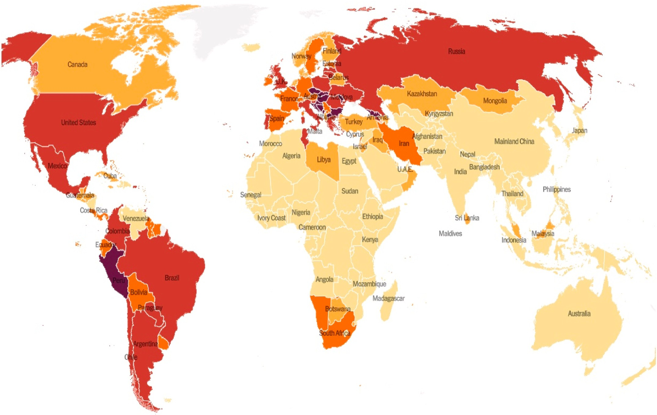

and quantifiable procedure has been utilized to provide the answer to those concerns.

* 1. *Search strategy*

Multiple online academic search engines such as Scopus, Web of Science, ERIC, PubMed, Science Direct, IEEE Xplore, DOAJ, and Google Scholar were utilized to obtain related studies. Table 1 summarizes the keywords that have been applied to extract the relevant works. Relevant studies were mostly chosen by manually using these keywords in various combinations. Some samples of the combinations are (‘COVID-19′ or

’coronavirus’ or ‘CoV2′ and ‘machine learning’), (‘coronavirus’ or

‘CoV2′ or ‘COVID-19′ and ‘deep learning’), (‘COVID-19′ or ’coronavirus’

or ‘CoV2′, ‘machine learning’, and ‘prediction’), etc.

* 1. *Inclusion and exclusion criteria*

In this study, only the relevant works published in the English lan- guage have been considered. The inclusion and exclusion criteria for considering the related works are as followings:

Inclusion criteria:

* + 1. Papers that propose at least one ML, DL, or combinations of ML/ DL/AI models.
    2. Studies that discuss at least one of the COVID-19 issues.
    3. Studies performing experimental works on different datasets related to COVID-19.

Exclusion criteria:

1. Research works published before 2020.
2. AI, ML, and DL-based techniques mentioned in research articles which are not associated with the COVID-19 epidemic.
3. COVID-19 issues mentioned in a research work that does not employ ML, DL, or combinations of ML/DL/AI approaches.
4. Theoretical research with no practical applicability, survey pa- pers, and review papers.
   1. *Selection of the study*

The process of study selection based on the inclusion and exclusion criteria is presented in Fig. 3

In this step, the primary relevant works were selected based on the search strategy discussed earlier. By applying the aforementioned search strategy, 600 studies were identified and selected initially. The duplicate records or studies were then removed in the next phase. After removing the duplicate studies, a total of 512 works remained. 382 studies were

excluded during the screening process. Abstract analysis, dataset anal- ysis, and inclusion and exclusion criteria were used to filter the studies. A total of 130 research works became eligible for full-text analysis through the screening process. Later, these 130 research works were reviewed, and 26 of them were eliminated. In the last stage, a total of 104 studies remained to be checked for their methodological qualities. Among those studies, a total of 16 studies were then excluded based on the methodological quality. After completing all these procedures, only

88 studies remained for the systematic review. Among the selected studies, 29 studies are from the Elsevier journals, 16 studies are from the Springer journals, 11 studies are from the MDPI journals, 10 studies are from various journals referred to as "Others Journal", and 6 studies are from the Nature journals. On the other hand, equal numbers of studies have been collected from the Hindawi and the Wiley journals. From each of these two publishers, 3 studies have been considered. The least number of studies have been collected from the IOP science journals. Only 2 studies have been considered from the journals of this publisher. The remaining 8 studies are conference papers.

* 1. *Extraction of the data*

After selecting the studies, data extraction is very much important to analyze and interpret the studies properly. A general structure is required for the extraction of data from studies to obtain meaningful findings. As a response, tables with some preset attributes were devel- oped, and various data from the studies were added to the tables. The

first attribute of the tables, “References and Year,” contains the authors’ name and the publication year. The second attribute defines the pur-

poses of the studies. The third and the fourth attributes describe the data types used in the studies and the sample size of the studies, respectively. The fifth attribute specifies the major techniques applied in the studies. Finally, the last attribute mentions the best performing model with its performance.

* 1. *Research questions (RQs)*

This comprehensive and in-depth review mainly focuses on summing up, evaluating, and synthesizing different research works where several ML, DL, and combinations of ML, DL, and AI-based techniques have been considered. The primary goal of this study is to acquire the answers to the subsequent six research questions and to have a profound as well as a comprehensive understanding of the responses to these questions.

**RQ 1**. What ML, DL, and combinations of ML, DL, and AI-based mechanisms are widely used in the studies related to COVID-19?

**RQ 2**. Until now, are there any standard datasets that are publicly available and may be used to analyze different ML, DL, and

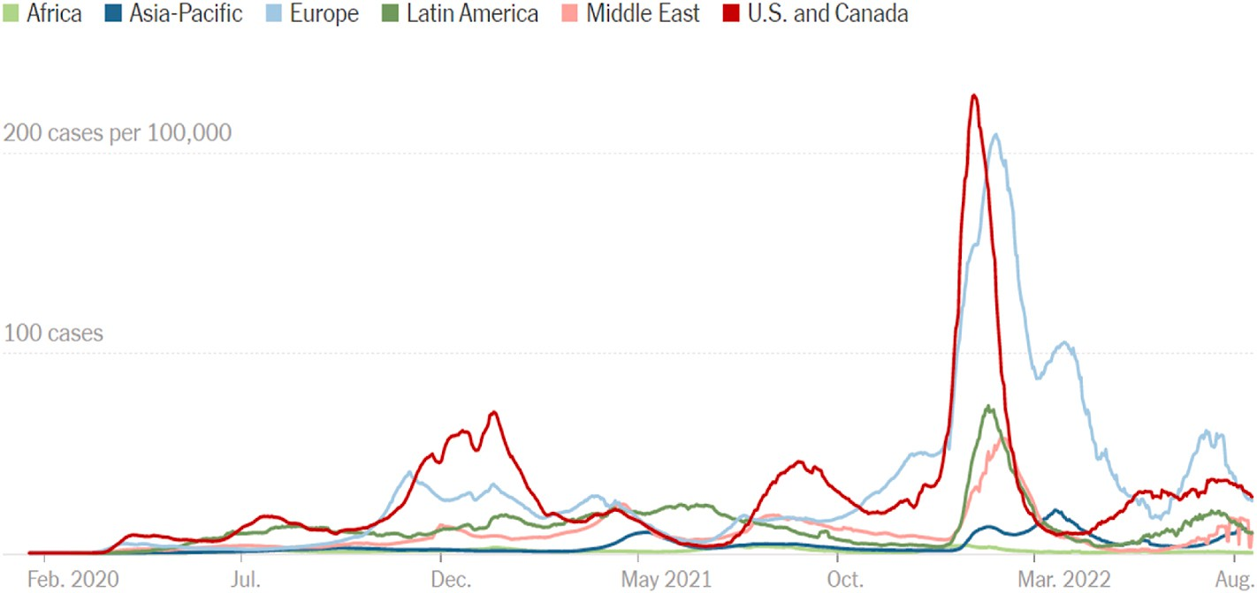

combinations of ML, DL, and AI-based techniques?

**RQ 3**. Are there any End-to-End Solutions (E2ES) available for COVID- 19 diagnosis?

**RQ 4**. Which countries performed the most research relating COVID- 19 by involving ML, DL, and combinations of ML, DL, and AI-based techniques?

**RQ 5**. What are the most widely utilized criteria for assessing various works already in existence related to COVID-19 using ML, DL, or com- binations of ML, DL, and AI-based techniques? Are those criteria enough that have been employed in most of these studies?

**RQ 6**. What are the biggest challenges for the researchers who are currently planning to do research on COVID-19 using ML, DL, or com- binations of ML, DL, and AI-based techniques?

# Analysis and findings

Multiple studies have analyzed the application of ML, DL, and AI methods in COVID-19-related studies. Dogan et al. [12] have analyzed

**Table 1**

Applied keyword

’machine learning’ ’artificial intelligence’, ’deep learning’, ’coronavirus’, ’prediction’, ’classification’, ’detection’,

’diagnosis’, ’identification’, ’pandemic’, ’sentiment analysis’, ’CoV2’, ’covid-19’, ’ML’,

’combination’, ’DL’, ’AI’

and reviewed the studies related to the uses of AI and ML mechanisms in the context of various COVID-19-related tasks. In that review study, various studies related to COVID-19 transmission prediction, diagnosis, and detection, and drug/vaccine development have been analyzed, and six predefined questions have been explored. However, the entire context of the COVID-19 pandemic and the application of DL techniques have not been explored in the study.

In another study, Islam et al. [13] reviewed various studies that have employed various AI and ML mechanisms in the process of fighting against the COVID-19 pandemic. Based on the objectives, the studies have been categorized into four groups such as disease detection, epidemic forecasting, sustainable development, and disease diagnosis.

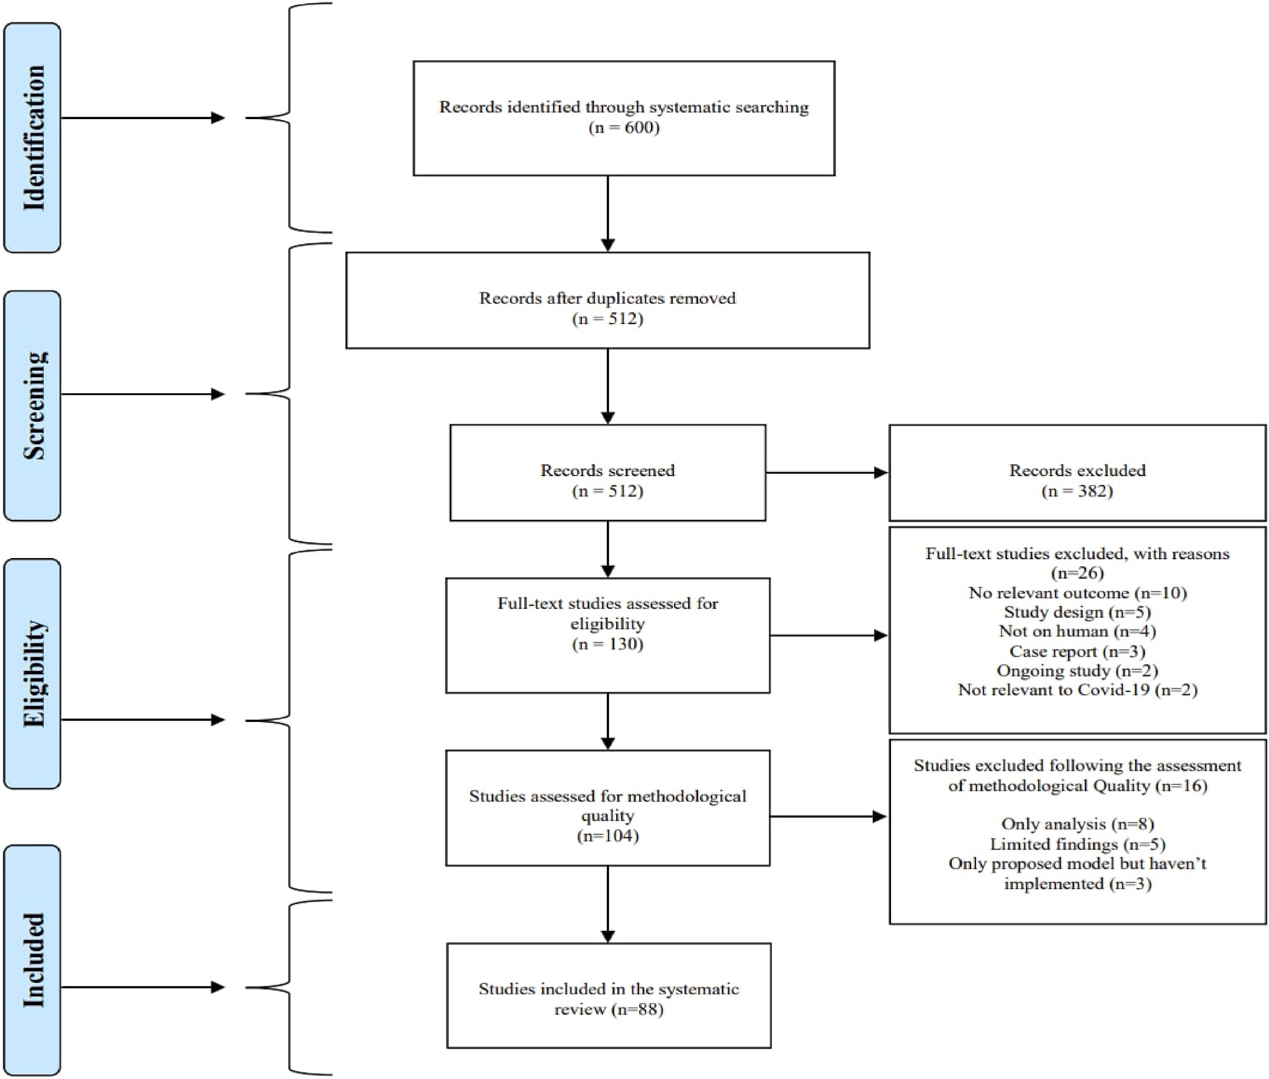

**Fig. 3.** Prisma flow diagram of the selection process of the study based on inclusion and exclusion criteria.

The application of various models has been reviewed and summarized. Furthermore, six research opportunities have been identified and sum- marized in the study. However, other objectives (sentiment analysis, vaccine development, etc.) and the application of DL techniques have not been explored.

A comprehensive review of the role of AI, drones, blockchain, and 5G to manage the COVID-19 pandemic has been performed by Chamola et al. [14]. The study explored the use of current technologies to combat the epidemic as well as its effect on the global economy. The role of Unmanned Aerial Vehicles (UAVs), blockchain, AI, and 5G, among others, in mitigating the effects of the COVID-19 outbreak has been explored and discussed in the studies.

Alballa et al. [15] reviewed recent reports on ML algorithms used in relation to the COVID-19 pandemic. In the study, the applications of ML for diagnosis and predicting patient mortality risk and severity were analyzed. The review includes studies published between January 2020 and January 2021. By assessing the studies, a small number of real-time E2E systems and a selection bias due to imbalanced data were identified. Despite analyzing the ML models for diagnosis and prediction, other COVID-19-related objectives such as detection, epidemic forecasting, etc. have not been considered.

Alafif et al. [16] review the studies conducted on the uses of ML and DL towards COVID-19 diagnosis and treatment. The review study pro- vides a summary of the AI-based ML and DL procedures, the available datasets, performance, and currently available tools. By performing a comprehensive analysis of the current ML and DL approaches used to diagnose COVID-19, obstacles to conducting the studies have been highlighted. In addition, the study made some directions for future work. Although the study analyzed the uses of ML and DL approaches only for the diagnosis and treatment of COVID-19, other perspectives on the probable combination of ML, DL, and the COVID-19 pandemic were not covered.

Although various studies have been conducted to review the works related to the use of ML, DL, and AI-based techniques for COVID-19 management. Very few studies have explored the uses of the possible combination of ML, DL, and AI mechanisms. Moreover, this study explored diverse perspectives on the COVID-19 pandemic, utilizing a variety of data types and combinations of data types. In addition, most recent studies conducted on ML, DL, and the combination of ML, DL, and AI-based mechanisms have been included, as well as some earlier rele- vant studies.

* 1. *Distribution and context of the study*

Among all the considered works, 92% of studies have been collected from different journals, and 8% of studies have been collected from different conferences. From Fig. 4, it can be found that 96% of studies using ML models have been published in different journals, while the rest 4% of studies have been published in different conferences. The percentages of studies employing DL techniques published in journals

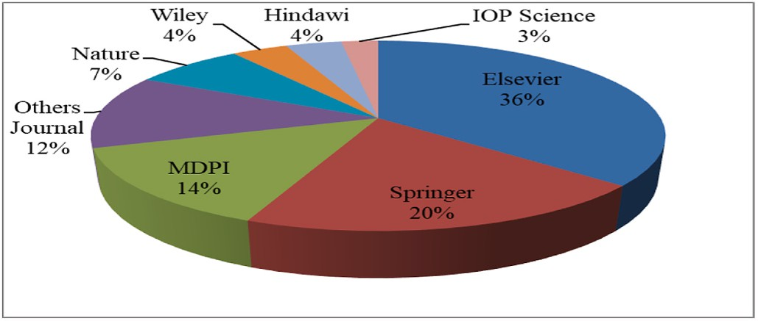

**Fig. 5.** Percentage of the Journal paper collected from different publishers.

and conferences are 80% and 20%, respectively. In terms of applying the combination of ML, DL, and AI-based techniques, 97% of the considered studies are journal papers. The remaining 3% of studies are conference papers.

Among the studies collected from the journals, 36% of the studies are from Elsevier, 20% are from Springer, 14% are from MDPI, 7% are from Nature, 4% are from Hindawi, 4% are from Wiley, 3% are from IOP Science, and 12% are from other journals according to Fig. 5.

The yearly distribution of the studies that were chosen for analysis is shown in Fig. 6. In terms of the publication year, a total of 41 studies were published in 2022. On the other hand, 39 studies were included from 2021. Only 8 studies were included from 2020. In 2022, the studies using the combination of ML, DL, and AI-based models have the highest frequency. The majority of the included studies applying ML techniques were published in 2021. Only a limited numbers of studies employing ML and DL techniques were performed in 2020. Furthermore, no studies applying the combination of ML, DL, and AI-based techniques were included from 2020.

Fig. 7 shows the types of data that were used in various studies. The majority of the studies utilized datasets in image formats. Studies employing datasets in image formats used mainly MRI, CT, CXR, ECG, and X-ray images. The studies that used non-image datasets had mainly worked with different clinical, time-series, textual, and audio data. 54%

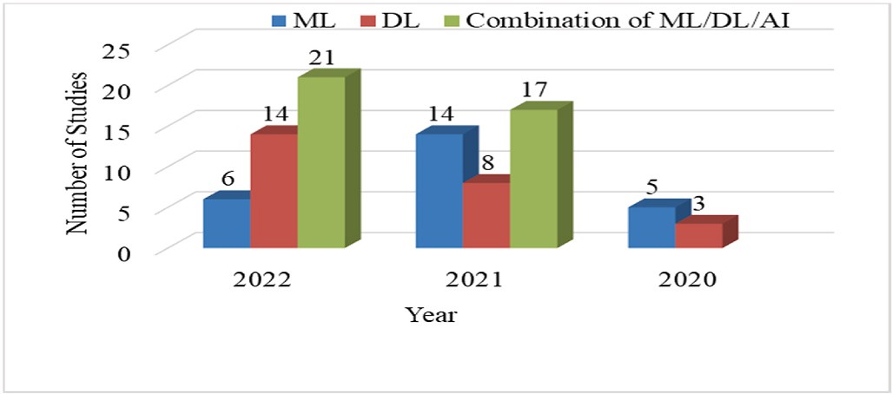

**Fig. 6.** Year-wise distribution of the final selected studies.

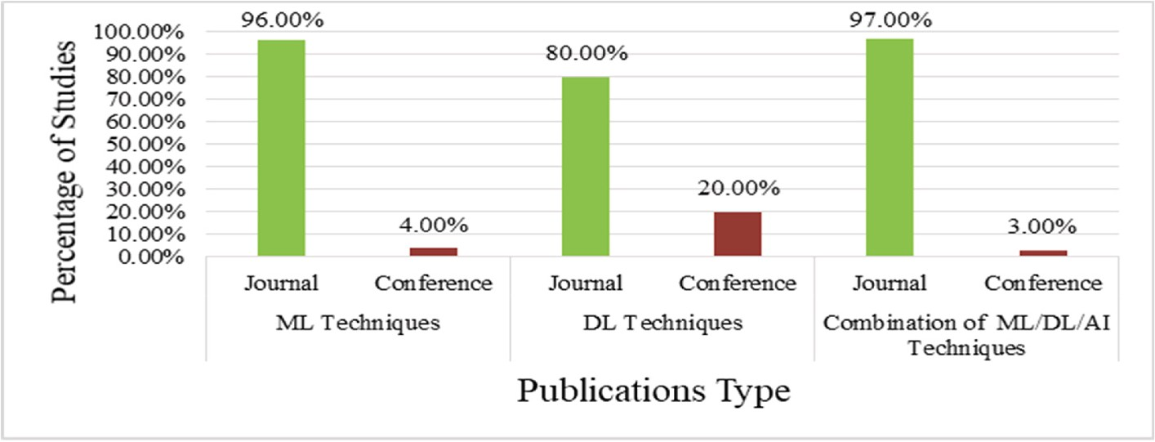

**Fig. 4.** Percentage of studies from different Journal & Conferences.

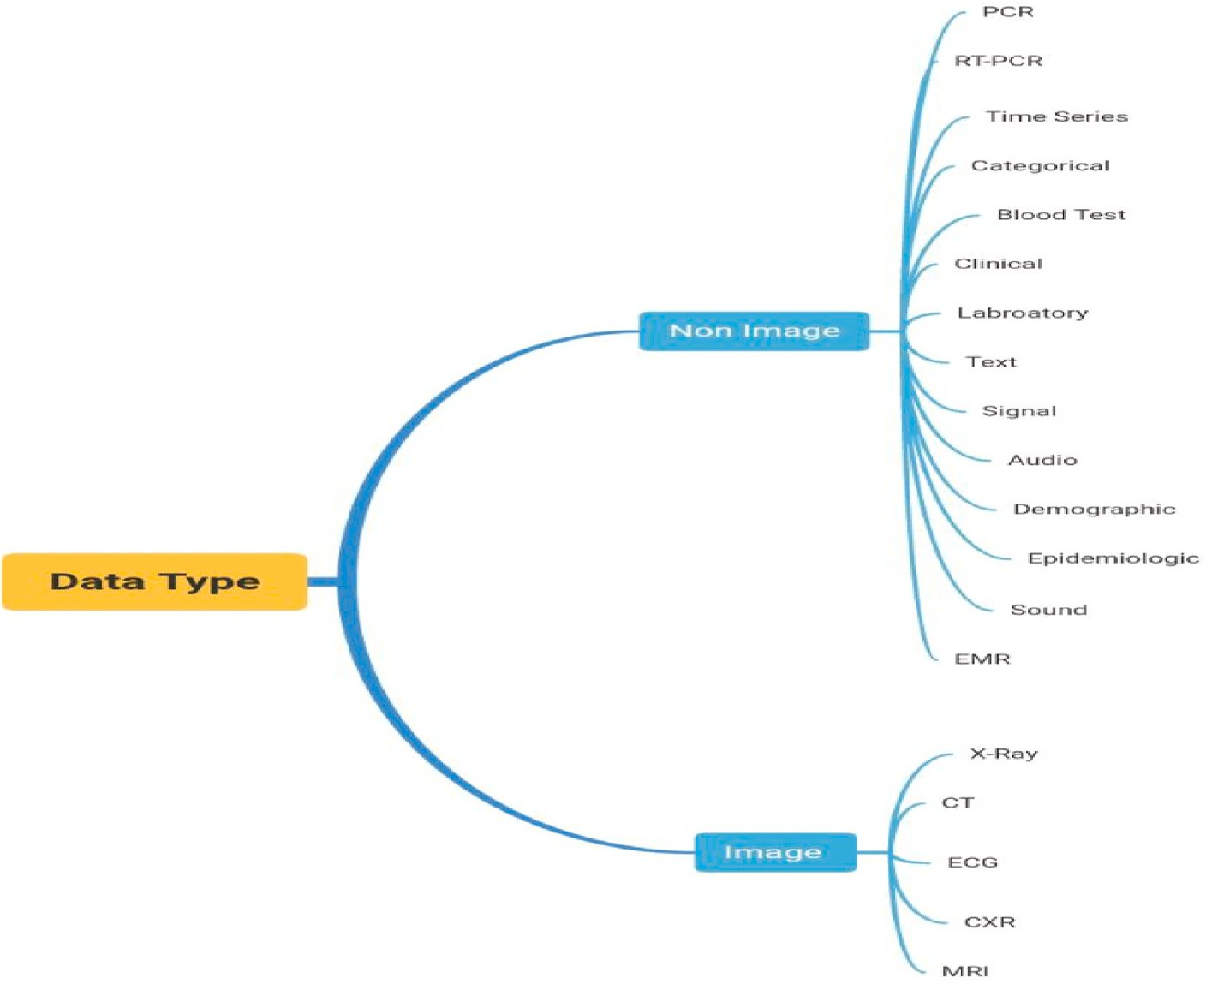

**Fig. 7.** Different types of data used in various studies.

of the total studies employed datasets of image format, the rest 46% studies used non-image datasets.

Among the image data types, CXR has the most significant percent- age, with a percentage of 57%, followed by CT images with a percentage of 28%. X-rays and other images make up the remaining 15% of the data types.

Among the non-image data types, clinical data is the most frequently utilized data format, representing 41% of all the non-image data, fol- lowed by laboratory data, which represents 12% of all the non-image data. 11% data of the non-image data are in time series format. On the other hand, 9% data of the non-image data are in text format. Furthermore, the percentages of audio-sound data, blood test data, and RT-PCR data are 8%, 5%, and 3%, respectively. 11% of the non-image data are of other different data formats.

* 1. *Applications of machine learning to combat COVID-19*

ML is the area of AI that mainly focuses on building systems that are capable of learning without explicit programming to do so. At the beginning of the COVID-19 pandemic, ML algorithms were primarily utilized. Initially, these algorithms were utilized exclusively for geographical and area-wise COVID-19 spread analysis. These algorithms are now being used for various purposes in combating COVID-19. Currently, ML approaches not only can predict COVID-19 by using clinical and laboratory data but also can be used to derive much more complicated aspects of COVID-19. ML approaches show significant performance in the diagnostic process of COVID-19 by utilizing diverse data such as blood images, X-rays, ECG, CT scans, etc. Due to the usage of ML methods for extracting features from images, signals, and audio

data, COVID-19’s classification is improving day by day. As ML models achieve more desirable outcomes, they are increasingly being combined

with other approaches. The use of several ML methods to address different COVID-19-related problems has been reviewed and presented in this section. Table 2 shows the summary of various studies employing ML models to combat COVID-19.

Fig. 8 shows the frequency of different ML models that have been

used in the considered studies. The most frequently used ML model is RF in the considered works. The SVM model has achieved the second- highest position, followed by the LR model with the third-highest po- sition. Models like NB, DT, XGB, KNN, and NN have also been used frequently on the other hand.

Fig. 9 shows the percentage of studies by different countries employing ML models to combat COVID-19. The majority of the studies come from the United States. 20% of the studies were conducted in the United States. Each of the countries such as Bangladesh, Iran, and Italy contributed 8% of the studies. However, the remaining 14 countries provided significantly fewer studies using ML models to work on COVID- 19-related issues.

From Table 2, it is observed that, various types of data have been used to perform the various studies. According to our in-depth analysis and observations, in the majority of studies for classification purposes, the RF and XGB classification models performed most optimally with the clinical data type. Moreover, regardless of data type or study objective, XGB, RF, and NN models consistently outperform other machine learning algorithms.

* 1. *Applications of deep learning to combat COVID-19*

DL is a branch of ML that utilizes representation learning to tackle complicated problems. DL-based models, such as CNN, proposed Custom CNN, DCNN, and other methods have lately been used for COVID-19 classification, diagnostics, and detection, by researchers to combat the COVID-19 outbreak. This study has reviewed the application of various DL approaches for combating the COVID-19 epidemic as well as per- formed comparisons between them. Table 3 shows the summary of the studies employing DL techniques relating to COVID-19 issues.

Fig. 10 represents the applied DL models. Among different DL models, the custom models have the highest frequency of 14, followed by the RESNET50 with the count of 12. Various versions of EFFI- CIENTNET, which are referred to as EFFICIENTNET(X) algorithms, have achieved the third highest position with a number of 11. Among the next-most used DL models, VGG-16 and VGG-19 have been applied in 10

**Table 2**

A summary of different machine learning-related studies for COVID-19.

|  |  |  |  |  |  |
| --- | --- | --- | --- | --- | --- |
| References and Year | Purposes | Data Type | Sample Size | Model | Best Model with Performance |
| Abdulkareem et al. [17], | Classification | Laboratory | 600 | RF, BERNOULLI NB, SVM | SVM(Accuracy 95%) |

(2021)

Callejon-Leblic et al. [18], (2021)

Prediction RT-PCR 777 LR, RF, SVM SVM(Mean Sensitivity of 80.74%)

Faisal et al. [19], (2021) Prediction Time Series,

Categorical

92,400 LR, KNN, RBFK-SVM,

PK-SVM, ADB, NB, DT, RF, GB, QDA, ANN

DT(Accuracy 90%)

Cabitza et al. [20],(2020) Detection Blood Test,

Clinical

3 datasets (1624 patients)

LR, NB, KNN, SVM CBC dataset(RF Accuracy 93%), COVID-19 dataset

(KNN Accuracy 90%), CBC dataset (KNN Accuracy 90%)

Guan et al. [21],(2020) Prediction Clinical 1270 LASSO R, XGB XGB(Sensitivity 85%)

Alves et al. [22],(2021) Classification RT-PCR,

Laboratory

5644 LR, RF, XGB, SVM, MLP, ENSEMBLE

RF(Accuracy 88%)

Kukar et al. [23],(2021) Diagnosis Blood test,

Clinical

5333 RF, SVM, NN, XGB XGB(Sensitivity 81.9%)

Muhammad et al. [24], (2020)

Zargari Khuzani et al. [25],(2021)

Statsenko et al. [26], (2021)

Prediction Clinical 263,007 DT, LR, NB, SVM, ANN DT(Accuracy 94.99%) Classification X-ray 420 PCA, NN NN(Accuracy 94%)

Prediction Clinical 560 GB, ADB, ET,RF, NN,LR NN(with top value AUC 0.86, With all value AUC 0.90)

Tran et al. [27],(2021) Detection Clinical 226 MILO MILO(Accuracy of 98.3%)

Rezaeijo et al. [28],(2021) Classification X-ray 178 ADB, BAG, GNB, DT, GBDT,

KNN, RF, L-SVM, LR,RFE,MNB

RFE + KNN(AUC 0.997)

Jimenez-Solem et al. [29], (2021)

Prediction Clinical 5594 RF RF(ROC-AUC of ICU admission 0.802, ventilator treatment 0.815,and death 0.902)

Hassan et al. [30],(2021) Prediction Time Series Jan 22- Feb 13 NN, SVM, BN, PR NN(R-Square score Confirmed Cases 0.989086182,

Recoveries Cases 0.989356735, Deaths Cases 0.932880987)

Saadatmand et al. [31], (2022)

Prediction PCR, Clinical 398 LR, RF, XGB, C 5.0, NN LR, and NNs achieved the highest Accuracy (86.42%)

|  |  |  |  |  |  |
| --- | --- | --- | --- | --- | --- |
| Rehman et al. [32],(2021) | Prediction | X-ray, Clinical | 646 | DT, KNN, NB, ET, RF, SVM | RF(Recall 96.00%) |
| Guerrero-Romero et al. | Identification | Clinical, | 1064 | LR | LR(Sensitivity 83%) |
| [33],(2022) |  | Laboratory |  |  |  |
| Debjit et al. [34],(2022) | Prediction | Clinical, | 1,023,426 | HHOXGB, HHOLGB, HHOCAT, | HHOXGB(Accuracy 92.23%) |
|  |  | Laboratory |  | HHORF, HHOSVC |  |
| Almustafa [35],(2021) | Prediction | Laboratory | 200,000 | NB, SGD, J48, RF, KNN | J48(Accuracy 94.41%) |
| Erdog˘an and Narin [36], | Classification | Signal | 1187 records | ENSEMBLE, BT, SVM-LINEAR, | Ensemble-BT(Recall 90.54%) |
| (2022) |  |  |  | LR, LDA, MKNN |  |
| Sciavicco et al. [37], | Classification | Audio | 9986 | TRF, TDT | TRF(Accuracy 99.4%) |

(2022)

Pourhomayoun and Shakibi [38],(2020)

Prediction Clinical 2,670,000 SVM, NN, RF, DT, LR,KNN NN(Accuracy 89.98%)

|  |  |  |  |  |  |
| --- | --- | --- | --- | --- | --- |
| Li et al. [39],(2020) | Diagnosis | Clinical | 413 | XGB | XGB(Sensitivity 92.5%) |
| Bayat et al. [40],(2021) | Diagnosis | Clinical, | 75,991 | XGB | XGB(Accuracy 86.4%) |
|  |  | Laboratory |  |  |  |
| Hussain et al. [41],(2022) | Prediction | Clinical | 1085 | SVM, DT, RF, LR | RF(Accuracy 99.24%) |

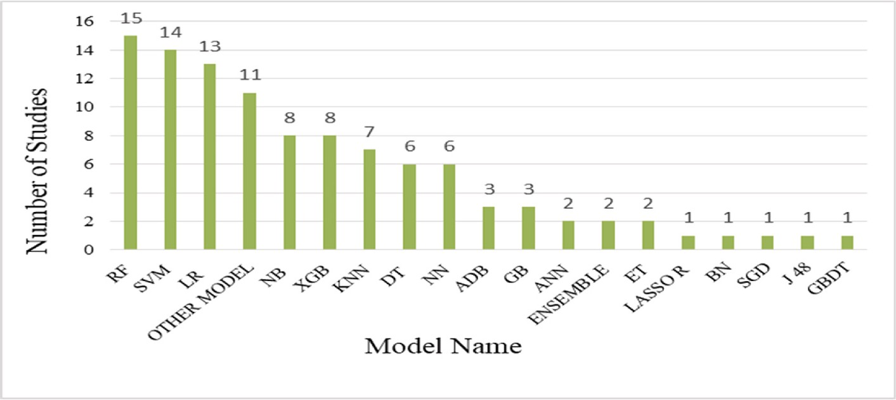

**Fig. 8.** Applied ML models.

and 9 studies, respectively. Other models that consist of various DL models such as (NASNET, COVIDNet, INCEPTIONREST, LSTM,

SQUEEZENET, etc.) have achieved the next position with a frequency of 8, followed by MOBILENET(X) with count of 7. Xception, InceptionV3,

and DENSENET(X) have achieved the next position. Each of these models have been used in 5 research works. Besides, various versions of RESNET, referred to as RESNET(X) have been used in studies with a count of 4.

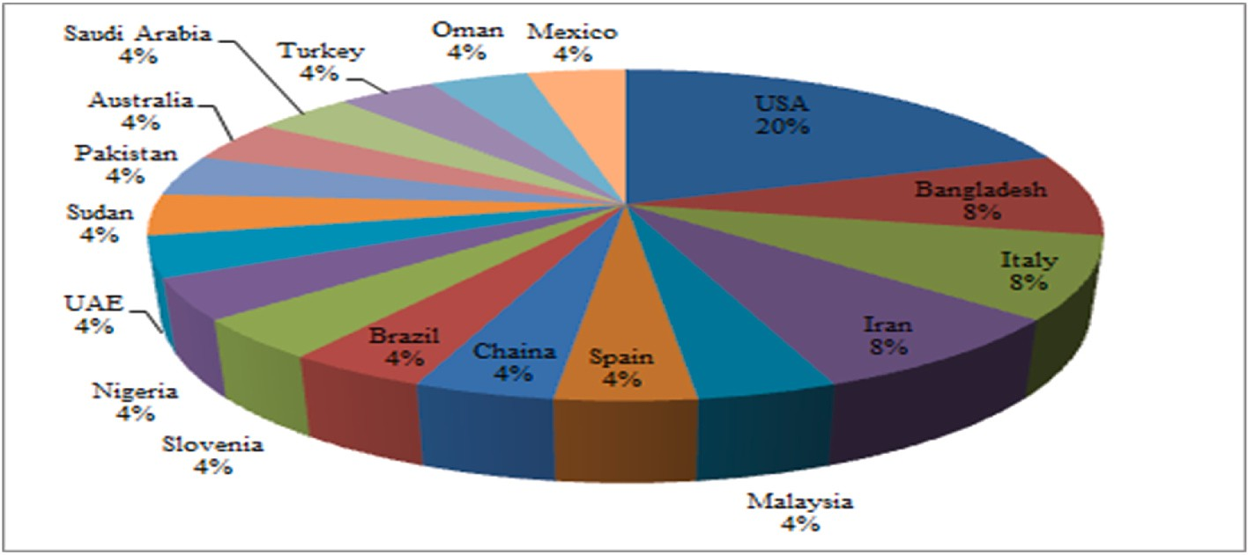

**Fig. 9.** Country-wise percentage of studies using ML Techniques.

From Table 3, it is observed that despite extensive uses of transfer- learning-based models, in the majority of the studies, custom models have outperformed the transfer-learning-based model. From our anal- ysis and observation, for COVID-19 detection-based works with CXR data type, proposed custom CNN models have outperformed the transfer-learning-based CNN models. However, irrespective of the study’s purpose and utilized data type in the uses of transfer-learning-

based models, RESNET and DENSENET architecture-based models

consisting of various versions have performed best in the majority of the studies. However, regardless of the type of image data used in deep learning-based research work, the usage of custom models may improve performance.

The country-wise percentage of the studies employing DL models is shown in Fig. 11. In terms of using DL models to combat COVID-19, the majority of the research works were performed in India with a per- centage of 44%. 8% of the research works were conducted in each of the following countries: Indonesia and Saudi Arabia. On the other hand, countries such as Algeria, Australia, Turkey, Switzerland, and all other countries have ranked in third place in terms of the number of research works employing DL methods.

* 1. *Application of combination of ML/DL/AI to combat COVID-19*

The combinations of ML, DL, and AI-based techniques are crucial in better understanding and dealing with the COVID-19 situation. The combinations of these methods are rapidly being used since these ap- proaches can open up new avenues for various forms of diagnosis, sentiment analysis, public surveillance, and illness prevention. Several COVID-19 diagnostic approaches based on images aided by DL and AI- based techniques have been developed, and their association with RT- PCR has been evaluated. Image and non-image types of data are inte- grated by the combination of ML, DL, and AI-based methods to inves- tigate several new alternatives to combat COVID-19.

The study demonstrates the combination of ML, DL, and AI meth- odologies and applications for combating COVID-19. Table 4 shows the summary of the combination of ML, DL, and AI-based techniques to combat COVID-19.

Fig. 12 shows that among the ML techniques, SVM has been the most frequently used model in the studies that utilized the combination of ML, DL, and AI-based and it has been used in twenty-three studies. Other ML models like ARIMA, LRG, GB, Total Boost, etc., models have been used in 15 studies. Among the other ML models, RF, DT, KNN, LR, NB, and XGB models have been used in 13, 12, 10, 9, 8 and 7 studies, respectively. The ADB model has been used less frequently among the ML techniques.

Various AI techniques have been used most frequently in the studies. In Fig. 12, for AI technique, we have counted only the numbers of different AI technique instead of showing the number of studies that have employed these techniques. Different DL models such as

ATTENTION RESNET-50, DBN, IPCNN, DECNN, DEEPLABV3, SGAN,

etc., models have appeared in 19 different studies in total. CNN has been used in 14 studies. Various versions of RESNET, referred to as RESNET

(X) has been used in 12 studies. Furthermore, LSTM is the next most frequently used model, followed by various versions of DENSENET and INCEPTION, which have been referred to as DENSENET(X) and INCEPTION(X).

From Fig. 12, it is observed that there is a trend to use custom models among the studies, which outperformed other DL models in terms of usage in different studies. However, various transfer learning DL models have been used frequently.

From Table 4, it is observed that there are diverse patterns or com- binations of mechanisms that have been used to perform the studies. In studies using ML in combination with other techniques, the SVM (ML model) has been utilized and tends to perform better compared to other ML models. Therefore, to construct mechanisms combining the ML model with other techniques, researchers might consider using the SVM model. Furthermore, to perform the study on the amalgam of the various data types, it is important to combine techniques from various domains and examine the performance.

Fig. 13 Depicts the country-wise percentages of the studies employ- ing the combination of ML, DL, and AI models. In India, 18% of the studies were conducted. Saudi Arabia carried out 13% of the studies. China, Bangladesh, and Turkey each conducted 11% of the studies. 8% of the studies conducted in the United States, whereas 5% were per- formed in Iran. The remaining 3% of the studies were conducted in other regions of the world.

* 1. *Evaluation procedure for different study*

Evaluation is studying a system, an initiative to determine how effectively a system fulfills its objectives. Evaluations assist in deter- mining what works effectively and where improvements can be made in a program.

According to Fig. 14, accuracy is the most used evaluation metric, followed by sensitivity/recall and AUC. Other metrics have been employed in a limited number of studies. Accuracy has been applied most frequently in the combination of ML, DL, and AI-based studies, while in ML and DL studies, accuracy metrics have been used equally. The sensitivity/recall metric has been mostly used in the studies employing the combination of ML, DL, and AI-based techniques fol- lowed by DL and ML-models-based studies. AUC metric has been used in all these three types of studies.

Specificity and R-Square have been only used in ML models-based and combinations of ML, DL, and AI models-based studies. ML-based studies haven’t used the Dice scores. F1 score, precision, MAPE, and

RMSE have been only employed in the combination of ML, DL, and AI

models-based studies.

**Table 3**

A summary of different deep learning-related studies for COVID-19.

|  |  |  |  |  |  |
| --- | --- | --- | --- | --- | --- |
| References and Year | Purposes | Data Type | Sample Size | Model | Best Model with Performance |
| Ferroukhi [42], | Diagnosis | CT | 4708 | VGG16, RESNET 50, MOBILENET, | RESNET 50(Accuracy 90%) |
| (2022) |  |  |  | GOOGLENET, XCEPTION, DENSENET121 |  |
| Sitaula and | Classification | CXR | Three datasets of(1125, | VGG16, VGG19, PROPOSED(ATTENTION- | ATTENTION-BASED VGG-16(Accuracy |
| Hossain [43], |  |  | 1638, 2138 image per | BASED VGG-16) | (79.58%, 85.43%, 87.49%)) |
| (2020) |  |  | dataset) |  |  |
| Gour and Jain | Classification | CXR | Three datasets includes | VGG19, RESNET-152, XCEPTION, | UA-ConvNet(Sensitivity multiclass = |
| [44], (2021) |  |  | (3040,627,2905) CXR | DENSENET-169, MOBILENET, NASNET | 98.02%, binary = 99.16%) |
|  |  |  |  | LARGE, INCEPTION-V3, EFFICIENTNET, |  |
|  |  |  |  | PROPOSED(UA-CONVNET) |  |
| Khan et al. [45], | Diagnosis | Clinical, | 270 | DEEP CNN, FFNN, EFFICIENTNETB7, | Fusion model (Recall 98.6%) |
| (2022) |  | Demographic, |  | FUSION MODEL |  |
|  |  | CXR |  |  |  |
| Irmak [46],(2022) | Classification | ECG Trace | 1937 | CNN, RESNET-101, VGG-19, DENSENET, | CNN-proposed model(Accuracy of |
|  |  |  |  | RESNET-50, VGG-16, INCEPTIONV3 | 98.57%, 93.20%, 96.74%) |
| Shiri et al. [47], | Detection | CT | 2558 | COLI-NET | COLI-Net(mean Dice coefficients 0.98 and |
| (2021) |  |  |  |  | 0.91 l for lung and lesions segmentation) |
| Malik et al. [48], | Classification | CT | 660 | RESNET-50, BDCNET, VGG-16, INCEPTION | BDCNet(Recall of 98.31%) |
| (2021) |  |  |  | V3,VGG-19, |  |
| Kumar et al. [49], | Detection | CXR | 13,975 | VGG-16, VGG-19, RESNET18, | SARS-Net(Sensitivity 92.90%) |
| (2021) |  |  |  | ALEXNET, RESNET-50, SARS-NET |  |
|  |  |  |  | CNN, SARS-NET |  |
| Mousavi et al. | Detection | CXR | 12,931 | PROPOSED(CNN-LSTM), | CNN-LSTM(Accuracy 90% all scenarios) |
| [50],(2022) |  |  |  | XCEPTION, RESNET50, INCEPTION, VGG 19 |  |
| Kavya et al. [51], | Detection | CXR | 15,153 | VGG16, RESNET50 | ResNet50(Accuracy 91.39%) |
| (2022) |  |  |  |  |  |
| Sundaram et al. | Classification | CXR | 4050 | RSQZ-SEGNET | RSqz-SegNet(Accuracy 99.69% binary |
| [52],(2021) |  |  |  |  | 99.48% three class) |
| Luz et al. [53], | Detection | CXR | 13,800 | EFFICIENTNET B0-X, EFFICIENTNET B1-X | Approach Flat EfficientNet B3-X( |
| (2021) |  |  |  | , EFFICIENTNET B2-X, EFFICIENTNET B3-X | Sensitivity of 96.8%) |
|  |  |  |  | , EFFICIENTNET B4-X, EFFICIENTNET B5-X |  |
|  |  |  |  | , MOBILENET, MOBILE NET V2, RESNET50, |  |
|  |  |  |  | VGG-16, VGG-19 |  |
| Djuniadi et al. | Detection | Images | 4095 | MOBILENET V2 | MobileNet V2(Accuracy 99%) |
| [54],(2022) |  |  |  |  |  |
| Chaudhary et al. | Detection | CXR | 14,000 | EFFICIENTNET-B1, VGG-19, RESNET-50, | EFFICIENTNet-B1(Accuracy 95%) |
| [55],(2020) |  |  |  | COVIDNET |  |
| Kogilavani et al. | Detection | CT | 3873 | VGG16, DESENET121, MOBILENET | VGG16(Accuracy 97.68%) |
| [56],(2022) |  |  |  | , NASNET, XCEPTION, EFFICIENTNET |  |
| Muralidharan | Detection | CXR | D1 contains 1225 | MULTISCALE DCNN | Multiscale DCNN(dataset A(multiclass |
| et al. [57], |  |  | images, D2 contains |  | and binary accuracy of 96% and100%), |
| (2022) |  |  | 9000 images. |  | dataset B(multiclass and binary accuracy |
|  |  |  |  |  | of 97.17% and 96.06%)) |
| Haghanifar et al. | Detection | CXR | 9600 | CHEXNET, COVID-CXNET. | COVID-CXNet(Accuracy 87.88%) |
| [58],(2022) |  |  |  |  |  |
| Nassif et al. [59], | Detection | CXR, Audio | 1159 sound samples, | LSTM, VGG16, VGG19, DENSNET201, | LSTM (Accuracy of 98%), VGG16 |
| (2022) |  |  | 13,808 CXR Image | RESNET50, INCEPTIONV3, | (Accuracy 89.64%), InceptionResNetV2 |
|  |  |  |  | INCEPTIONRESNETV2, XCEPTION | (Accuracy 82.22%) |
| Nayak et al. [60], | Detection | CXR | 406 | ALEXNET, VGG16, GOOGLENET, MOBILE | ResNet-34(Accuracy 98.33%). |
| (2020) |  |  |  | NET-V2, SQUEEZENET, RESNET-34, |  |
|  |  |  |  | RESNET-50, INCEPTION-V3 |  |
| Verma et al. [61], | Detection | CT | 63,849 | RESNET50 V2, EFFICIENTNET B0 | EfficientNet B0(Sensitivity 99.69%) |
| (2022) |  |  |  |  |  |
| Sim et al. [62], | Detection | CXR | 5717 | DENSENET121 | DenseNet121(Sensitivity 95%) |
| (2022) |  |  |  |  |  |
| Srivastava and | Detection | CXR, CT | 4271 | DEEPCOVX, DEEPCOVCT | DeepCovX(Sensitivity 100%), DeepCovCT |
| Ruchilekha |  |  |  |  | (Sensitivity 97.06%) |
| [63],(2022) |  |  |  |  |  |
| Muljo [64],(2022) | Detection | CXR | 133,280 | DENSENET121 | DenseNet121(AUC average of 0.82, best |
|  |  |  |  |  | AUC 0.99) |
| Panwar et al. [65], | Classification | CXR | 4563 | CNN, ALEXNET | CNN(Accuracy 98%) |
| (2021) |  |  |  |  |  |
| Nasser et al. [66], | Detection | CXR | 6000 | RESNET50 | ResNet50(Sensitivity 97.3%) |
| (2021) |  |  |  |  |  |

From Fig. 14 it is obvious that all three approaches use accuracy as the primary evaluation metric. Despite sensitivity/Recall being the second most utilized metric, ML and DL-based studies have used this metric less frequently compared to accuracy. As misclassification of the COVID-19 disease can threaten the patient and their family’s lives in

addition to complicating COVID-19’s spread control. Therefore, it is

necessary to emphasize the sensitivity/recall metric more for evaluating the model’s performance.

# Finding and analysis of proposed research questions

In this section, the predefined research questions have been dis- cussed. For each of the research questions, we have discussed the sig- nificance of the question as well as the findings based on the question that has been explored via the analysis of the studies. In addition, we have provided directions and some precautions for the researchers who aspire to conduct COVID-19 pandemic-related studies.

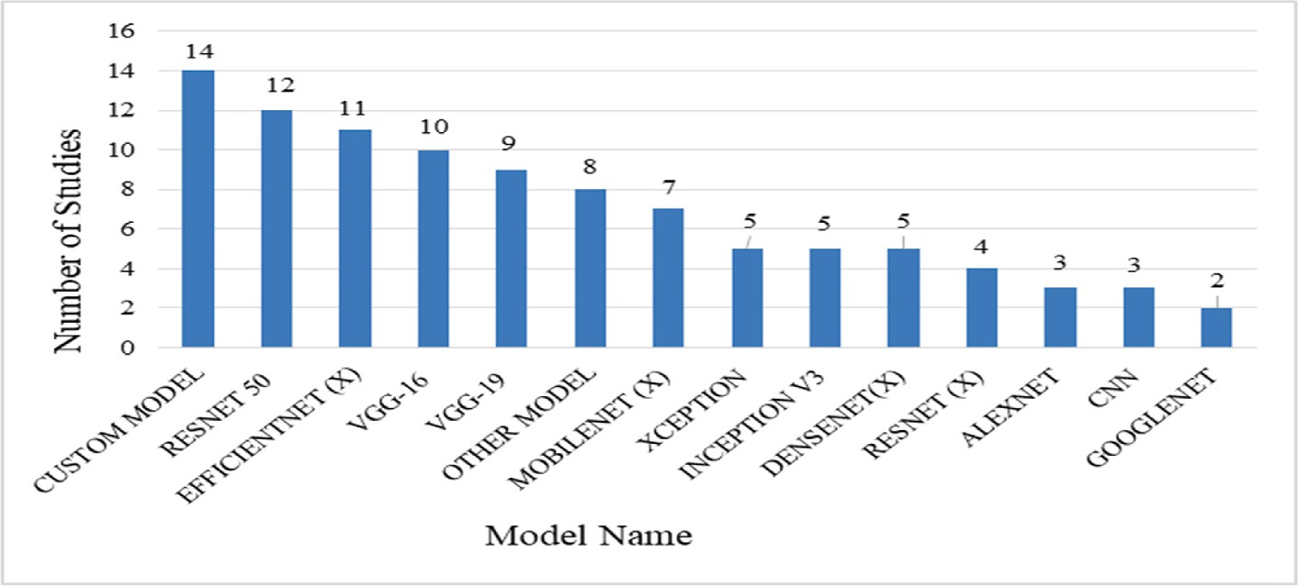

**Fig. 10.** Applied DL models.

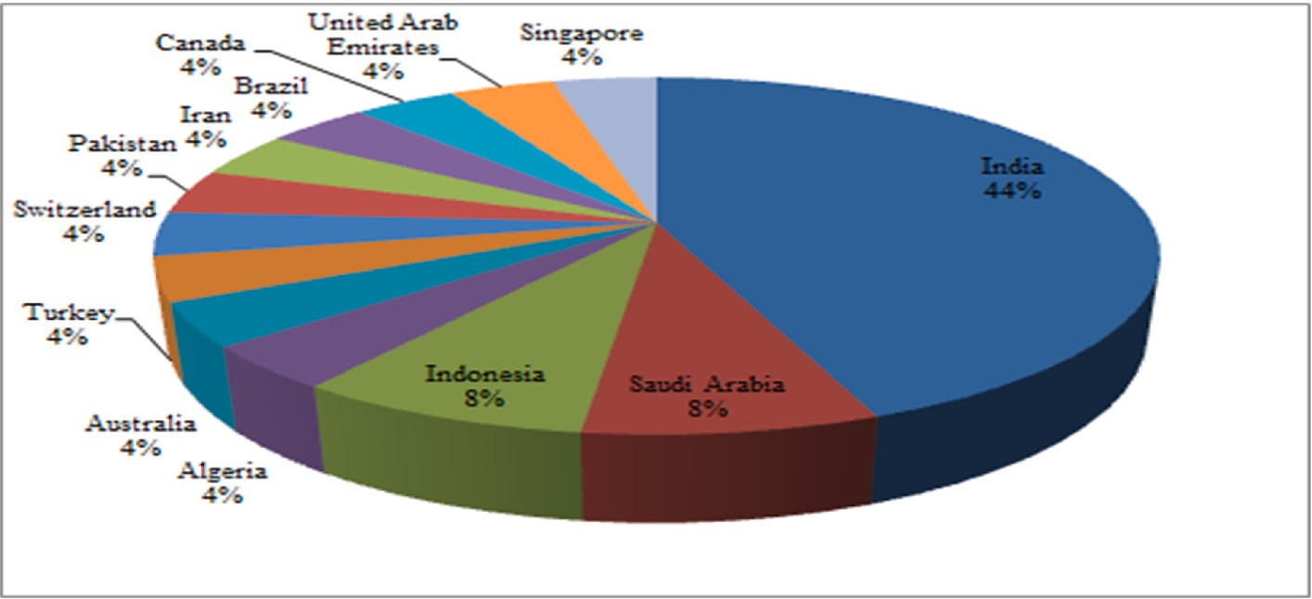

**Fig. 11.** Country-wise percentage of studies using DL models.

RQ 1: In the domain of AI, there are different types of algorithms, each with its own set of advantages and disadvantages. Many factors influence the model’s performance in a positive or negative manner,

resulting in less optimum performance and complicating the task of

finding ways to combat COVID-19. As a result, it is necessary to identify widely used specific ML, DL, and AI mechanisms so that model selection for a certain purpose becomes simple and effective.

Various models have been applied in the application of the ML model in COVID-19-related tasks. The majority of the studies employed mul- tiple ML models and compared the results. Therefore, the finding of some top-utilized models can be very beneficial. RF, SVM, LR, NB, XGB, and KNN are some of the most frequently used models. In addition to the use of specific ML models, various diversified but not widely used models have also been applied.

Analyzing the studies, it can be observed that XGB has performed as the best model among utilized ML mechanisms, followed by RF and NN. Therefore, while using the ML model for prediction, classification, detection, and diagnosis, XGB, RF, and NN models can be considered, which may aid in achieving the best possible result.

Many studies have developed custom models and compared them to other existing mechanisms in the use of DL relevant to the COVID-19 study. In the use of specific DL models, RESTNET50, EFFICIENTNET, VGG-16, VGG-19, and MOBIELNET have been the most widely applied models. Analyzing the studies, it can be shown that custom models performed the best among the used DL mechanisms, followed by ResNet-

(X) referring to various versions of ResNet particularly ResNet-50.

In the application of the combination of ML, DL, and AI techniques related to the COVID-19 study, many studies applied the combination of diverse mechanisms and analyzed the performance, limitations, and

potentiality of those mechanisms. Among the mechanisms, various AI techniques, SVM (ML model), custom models, diverse but not widely used DL models, CNN (DL model), and RF (ML model) are some of the widely applied mechanisms in the studies. Analyzing the studies and the best model, it can be found that the majority of the studies employed Al methods with ML or DL models and emphasize increasing the performance.

By analyzing the studies, we have observed that there is a significant association between model’s performance and the pattern of data used in the studies. This is discovered by analyzing and observing the results

of studies with a similar type of data that applied a variety of techniques. As a result, it is essential for the researcher to choose standard dataset and select the suitable model according to the data type. To perform a study with the usage of ML models in COVID-19-related work, the researcher might consider XGB, RF, and NN models since they have outperformed other models and are widely used too. For performing a DL-based study, researchers should concentrate on constructing custom CNN models since they outperform transfer-learning-based DL algo- rithms most of the time. However, in the uses of the combination of ML, DL, and AI-based techniques, various studies have been used a diverse amalgam of techniques. Therefore, while conducting a study based on a combination of several techniques, it is essential to select and analyze possible combinations of techniques by reviewing previously conducted related work.

RQ 2: A dataset is one of the main defining parts of any study. Therefore, the dataset used in the studies needs to be trustworthy and standard. As the COVID-19 virus can mutate quickly, collecting virus- specific data is very challenging. To stop the spread and identify any mutated COVID-19, data should be collected in a short span of time. For

**Table 4**

A summary of different combination of ML/DL/AI related studies for COVID-19.

|  |  |  |  |  |  |
| --- | --- | --- | --- | --- | --- |
| References and Year | Purposes | Data Type | Sample Size | Model | Best Model with Performance |
| Tariq et al. [67], | Prediction | EMR, Clinical | 3194 | FM, LR, LASSO R, XGB, RF, CNN | FM(F1-score 84%) |
| (2021) |  |  |  |  |  |
| Wang et al. [68], | Classification | CT | 1418 | V-NET, 3D U-NET++, DPN-92, RESNET-50, | ResNet-50 with 3D U-Net++ |
| (2021) |  |  |  | RESNET, FCN–8S, U-NET, INCEPTION NET- | (Sensitivity 97.4%) |
|  |  |  |  | WORKS, ATTENTION RESNET-50 |  |
| Chung et al. [69], | Prediction | Clinical | 5601 | ADB, RF, XGB, DNN | DNN(Sensitivity 90.2%) |
| (2021) |  |  |  |  |  |

Afshar et al. [70], (2022)

Sheela and Arun [71], (2022)

Diagnosis CT, Clinical 160 MLP, DNN Two-stage time-distributed capsule network(Sensitivity of 94.3%)

Identification MRI 200 HYBRID PSO-SVM, SVM, PSO, DBN, SAE Hybrid PSO-SVM (Sensitivity 95.6%)

Babaei Rikan [72],

(2021)

Diagnosis Laboratory, Blood Tests

D1 279,D2 1624, D3 600

SVM, NB, ET, RF,LR, KNN, DT, XGB, DNN, CNN, LSTM, RNN

DNN(D1 (accuracy 92.11%), D2 (Accuracy 93.16%), D3 (Accuracy 93.16%)

Yildirim et al. [73], (2022)

Classification CXR 15,470 ALEXNET, RESNET50, GOOGLENET,

DENSENET201, DARKNET53, MOBILENETV2, EFCIENTNETB0, INCEPTIONV3, NCA, DT, DA, NB, SVM, KNN, SE

Darknet53 + NCA + SVM(Accuracy 99.05 and 97.1%)

De Falco et al. [74], (2021)

Lella and Pja [75], (2021)

Hipolito Canario

et al. [76],(2022)

Classification CXR 13,808 BN, NB, RBF, SVM, AB, OR, DEREX RBF(Average Accuracy 79.60%),

DEREx(Best Accuracy 80.67%) Diagnosis Sound,Clinical 18,000 DAE, GFCC, IMFCC,DCNN, VGG NET, SVM DCNN(Accuracy 95.45%)

Identification CXR 722 M-QXR M-qXR(Identify pulmonary opacities Sensitivity 94%), detecting pulmonary opacities Sensitivity 94%), Identify pulmonary consolidation Sensitivity 91%), PPV 89.7%, and NPV 80.4%

Kini et al. [77], (2022)

Screening CT 12,146 JLM, AGGDF, WSDL, DECNN, DLCRD, PARL,

GCNN, GOOGLENET, IPCNN, RESNET152V2, DENSENET201, IRNV2, ENSEMBLE DL (PROPOSED)

Proposed(Recall 98.58%)

Messaoud et al. [78],(2022)

Detection Clinical, X-ray, CT

270 patient,2251 and

746 image

LR, KNN, SVM, VGG19 VGG19(Accuracy 90%)

Liang et al. [79], (2022)

Diagnosis CT 1,552,988 RESNET-18, RESNEXT50, GRU, DCNN, SVM,

LK, PK, RBF KERNEL, DEEPLABV3, DENSENET121, GPR, FL FRAMEWORK

Boosting (AUC 0.98), DL + FL(Dice’s

coefficient of 0.77)

Tan et al. [80], (2022)

Classification CXR, CT Covid-19 1394, Pneumonia 11,712,

Negative 20,431

COVID-NET, MULTI-MODAL Multi-modal(AUC 0.93)

Chen et al. [81], (2022)

Diagnosis Sounds 1486 KNN, CNN, MFCCS CNN(Accuracy 97%)

Alkhaldi et al. [82], (2022)

Sentiment Analysis

Text 2750 TF-IDF, CRNN, RNN, RF, XGB, SVM, ET, DT, SFO, SFODLD-SAC

SFODLD-SAC(Accuracy 99.65%)

Mahbub et al. [83], (2022)

Screening CXR C1: COVID-191,200,

C2: Pneumonia 3,875,

C3:Tuberculoss 3,500,

C4: Healthy 6182

RESNET50, RESNET152V2, PROPOSED DNN (COVTBPNNET), INCEPTIONNETV3, MOBILENETV2

CovTbPnNet Accuracy (healthy CXR Screening(99.87% on COVID-19,

99.55% on Pneumonia versus, for TB versus 99.76%), non–healthy CXR Screening(98.89% on COVID-19 versus

Pneumonia, 98.99% on COVID-19 versus TB, and Pneumonia versus TB 100%))

Koç and Türkog˘lu

[84],(2021)

Elharrouss et al. [85],(2021)

Loey et al. [86], (2022)

Shastri et al. [87], (2021)

Zhang et al. [88], (2022)

Forecasting Time Series 77-day DEEP LSTM NETWORK, ADAM, LSTM,

ARIMA, SVM, DT, LR

Segmentation CT 100 U-NET,ATTENTION-UNET, GATED-UNET, DENSE-UNET, U-NET++, SEMI–INF–NET, MULTI-CLASS U-NET, DEEPLABV3+, FC8S,

PROPOSED METHOD (MULTI-TASK DL METHOD)

Detection CXR 10,848 PROPOSED MODEL (BAYESIAN-BASED

OPTIMIZED DEEP LEARNING MODEL)

Forecasting Time Series 421-days LSTM, BI-LSTM, CONVLSTM, COBID-NET

ENSEMBLE

Classification Time Series, Text 11,303,850 FINE-TUNING BERT, LRG, TF-IDF, KNN, SVM,

DPCNN, EXPERT SYSTEM

The Deep LSTM network(beds, respiratory equipment, and cases number yielded MAPE values of (2.89%, 3.29%, and 4.80%) and R

Squared values (99.90%, 99.85%, and

99.72%), respectively)

Proposed Method (78.6% Dice Score, 71.1% Sensitivity, 99.3% Specificity,

85.6% Precision, 0.062 Mean Average Error metric)

Proposed Model(Accuracy 96%)

CoBiD-Net ensemble model(Accuracy 98.10–99.13%)

Fine-tuning BERT(Recall 99%)

Tavakolian et al. [89],(2022)

Choudrie et al. [90], (2021)

Screening Clinical 5,435,996 LR, RF, XGB, SGAN SGAN (Accuracy 99.2%, 99.6% for COVID-19 and H1N1)

Classification Text 143 SVM, DT, RF, SGD, LSTM, CNN DT (Accuracy 86.7%, Sensitivity

88.89%)

Diagnosis 4600

(*continued on next page*)

|  |  |  |  |  |  |
| --- | --- | --- | --- | --- | --- |
| **Table 4** (*continued* ) |  |  |  |  |  |
| References and Year | Purposes | Data Type | Sample Size | Model | Best Model with Performance |
| Saha et al. [91], |  |  |  | EMCNET, CNN, RF, SVM, DT, ADB, | EMCNet(Accuracy 98.91%, Precision |
| (2021) |  | CXR |  | ENSEMBLING | 100%) |
| Zulfiker et al. [92], | Sentiment | Text | 1075 | LSTM, 1D-CNN, BI-LSTM, TCN, DT, GB, SVM, | Bi-LSTM with word2vec embedding |
| (2022) | Analysis |  |  | LDA | (Sensitivity 88.52%) |
| Shiri et al. [93], | Classification | CT | 14,339 | CNN, LR, LASSO, LDA, RF, ADB, NB, MLP, | ANOVA feature selector, and RF |
| (2021) |  |  |  | ANOVA, KW, RFE, RELIEF | classifier(Sensitivity 81%) |
| Aslan et al. [94], | Classification | CXR | 2905 | ALEXNET, INCEPTIONV3, RESNET18, SVM, | DenseNet201 and SVM(Sensitivity |
| (2022) |  |  |  | RESNET50, ANN, DT, NB, DENSENET201, | 96.42%) |
|  |  |  |  | INCEPTIONRESNETV2, MOBILENETV2, |  |
|  |  |  |  | GOOGLENET, KNN |  |
| Goel et al. [95], | CXR | 2700 | 2700 | DT, KNN, SVM, NB, RF, CNN, SE,RESNET50, | Multi-COVID-Net(Sensitivity 99.63%) |
| (2021) |  |  |  | INCEPTIONV3,EDLN, |  |
|  |  |  |  | PROPOSED(MULTI-COVID-NET) |  |
| Kanwal et al. [96], | Detection | CXR | 18,394 | DNN, CNN, 2DCNN, BI-LSTM, SVM LINEAR, | COVID-opt-aiNet(Accuracy of SVM |
| (2021) |  |  |  | SVM RBF, | 98%–99%, Accuracy of CNN |
|  |  |  |  | SVM POLYNOMIAL, LR, COVID-OPT-AINET | 70.85%–71% ,Accuracy of DNN 96%– |
|  |  |  |  |  | 97% ) |
| Bhattacharyya et al. | Detection | CXR | 247 | C-GAN, VGG-19, SCNN, DENSENET-169, | VGG-19 with BRISK(Accuracy 96.6%) |
| [97],(2021) |  |  |  | VGG-16, DENSENET-201, SOFTMAX, SVM, |  |
|  |  |  |  | RF, XGB, SIFT, BRISK |  |
| Davazdahemami | Prediction | Clinical, Time | 27,215 | RF, GA, DNN, SHAP | GA with DNN(AUC 0.883) |
| et al. [98],(2022) |  | Series |  |  |  |
| Karim et al. [99], | Detection | CXR | 27,605 | CNN, NB, SVM, SOFTMAX, KNN, DT | NB + Ant Lion Optimization + CNN |
| (2022) |  |  |  |  | (98.31% Accuracy, 100% Precision) |
| Khan et al. [100], | Prediction | Epidemiological | 2,676,311 | DT, LR, RF, XGB, KNN, DNN | DNN(Sensitivity 97%) |
| (2021) |  |  |  |  |  |
| Dhruv et al. [101], | Diagnosis | CT | 17,104 | INRFNET AND INNET, DENSENET-121, | InRFNet Sensitivity(94.48%) |
| (2022) |  |  |  | RESIDUAL |  |
|  |  |  |  | ATTENTION, ENSEMBLE WITH FC, |  |
|  |  |  |  | ENSEMBLE WITH FC + SVM |  |
| Janbi and Elnazer | Diagnosis | CXR | 6308 | SVM-LINEAR, SVM-POLYNOMIAL, SVM-RBF, | RESNET50(Recall 99.49%) |
| [102], (2021) |  |  |  | VGG-16, INCEPTIONV3, XCEPTION, |  |
|  |  |  |  | RESNET50, CCGAN, |  |
| Islam and | Detection | X-ray | 2482 | GNB, SVM, DT, LR, RF, CNN, ENSEMBLE | Ensemble(Recall 99.73%) |
| Nahiduzzaman |  |  |  |  |  |
| [103], (2022) |  |  |  |  |  |
| Alabrah et al. [104], | Sentiment | Text | 464 records | LSTM, SVM, FINE-KNN, ENSEMBLE, BOOST, | Fine-KNN and Ensemble boost |
| (2022) | Analysis |  |  | TOTAL BOOST | (Accuracy 94.01%) |

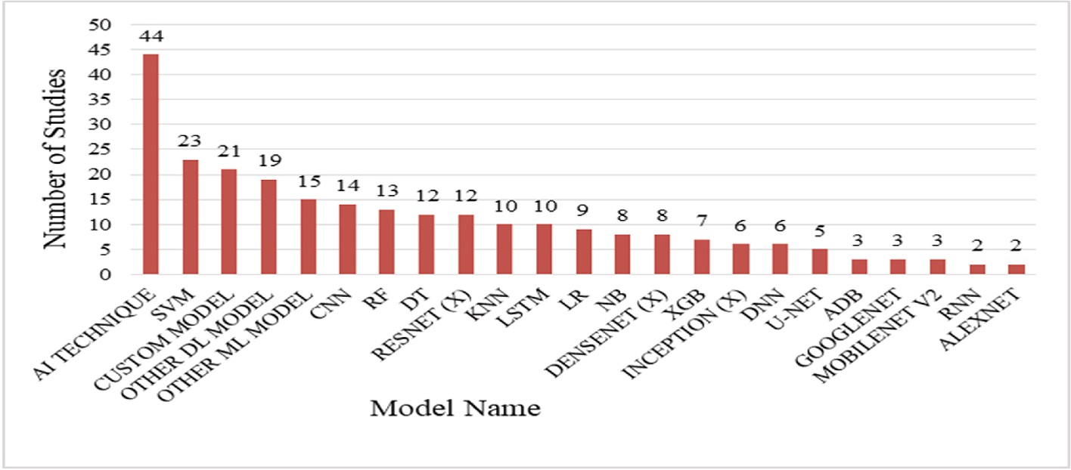

**Fig. 12.** Applied combination of ML/DL/AI models.

this reason, sometimes there could be some lagging in the data collection procedure, which can create imbalanced and nonstandard data. There- fore, creating a standard dataset is important. Comparing the study re- sults with the standard dataset is also important.

As COVID-19 is a global pandemic, many governments and NGOs have released open-access COVID-19 datasets, which mostly involve vaccination-related and spread-related datasets. But to identify the COVID-19 virus in the human body, an image type dataset is needed. Due to various constraints, there is a shortage of publicly available image datasets at the beginning of the period. Now there are some in- dividual studies that have given open access to their dataset. But most of the individual datasets have some limitations, such as being imbalanced,

lacking representative data samples, biased, and so on. Due to the data sample size quantity, some balanced datasets can’t be categorized as standard datasets. Therefore, there is still storage of the global standard

dataset, which can be used to reevaluate studies applying model per- formance. Furthermore, there is a lack of standard datasets related to sound and audio types of data for the COVID-19 disease. Also, there are very limited open-access sound-related standard datasets.

As there are shortages and limitations of data regarding COVID-19, the researchers have to check the quality and limitations of the data- set before conducting the research work. In addition, the collection procedure for research datasets should be standard, and the privacy of volunteers should be protected.

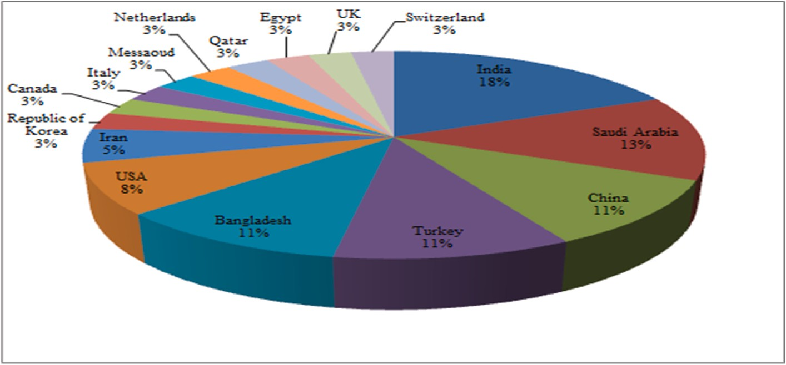

**Fig. 13.** Country-wise percentage of studies using combination of ML/DL/AI models.

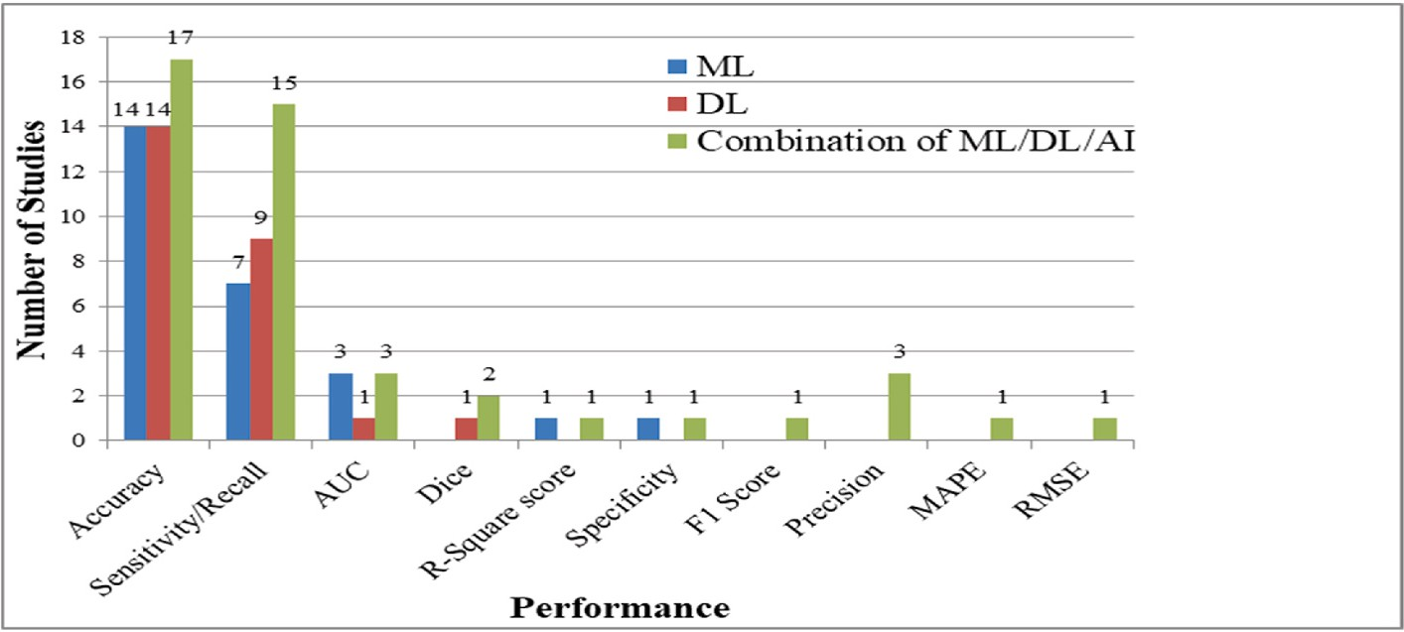

**Fig. 14.** Performance evaluation metrics used in various studies.

RQ 3: RT-PCR is the traditional method used to detect COVID-19 disease in the human body. Patients must physically visit a hospital to give samples for testing the suspected COVID-19 present in their bodies while using the traditional testing method. However, between the waves of the COVID-19 pandemic, visiting the hospital is a risky step. Because visiting the hospital in the middle of the COVID-19 wave can affect healthy people, who can further act as hosts and further spread the disease. Therefore, it is important to find some End-to-End solution based on AI, which can remotely and effectively diagnose COVID-19 in a suspected person.

But most of the studies have not emphasized building an End to End solution for diagnosis. Despite that, many studies have been conducted in order to develop an application for an End-to-End diagnosis solution [61,81]. Most studies consider image data types such as X-ray, CT, MRI, etc. to build COVID-19 diagnosis E2ES. As a result, using those appli- cations, the patient’s standard form of X-ray, CT, and MRI data sample is

needed, which must be primarily obtained from the clinic or hospital.

Therefore, the E2ES hardly solves the problem of remote E2ES systems. Some studies have considered using sound and audio data to build E2ES for the COVID-19 diagnosis system, which can diagnose COVID-19 remotely. However, low sound-quality recording devices and environ- mental noise can downgrade the quality of captured audio and sound data, which may affect the performance of the application. Furthermore, these studies and applications have some certain circumscribed. Therefore, there is still a lack of standard and reliable E2ES for the diagnosis of COVID-19.

As there is a lack of E2E systems regarding various COVID-19-related work. The researchers should more focus on the issue and develop more E2E systems. Furthermore, the researcher should concentrate on

removing the issues that users encounter when using the E2E system and improve quality (noise reduction, low-quality images handling). The system should be available and compatible with the maximum possible number of devices and platforms. In addition, researchers must promote campaign of the E2E system so that the wider populace can utilize the resource.

RQ 4: As COVID-19 spread as a global pandemic, the virus’s devas- tation was felt throughout the country and regions. Therefore, the ma-

jority of the country’s governmental and non-governmental organizations and NGOs have taken COVID-19-fighting measures, such

as allocating funds, encouraging researchers, providing data, applaud- ing researchers, and so on. These steps and opportunities have aided in the local and global combat of the COVID-19 pandemic by encouraging researchers to work on the issue of the COVID-19 pandemic. As a result, determining which country contributes the most to combating COVID- 19 by conducting more research is a useful step toward appreciating their contribution. Furthermore, identifying countries with less signifi- cant contributions to research work is important so that those countries can be encouraged and financially aided so that as human civilizations, we can advance equally. Identifying the countries contributing to the COVID-19 pandemic, on the other hand, is a broad perfective work that requires dedicated research work, which may include research type, the technology used, and the discovery of performed studies.

Analyzing the studies considered in this research work reveals that India has conducted the most studies using ML, DL, and combinations of ML, DL, and AI-based techniques, followed by Saudi Arabia and the USA. Other developed countries as well as developing countries have contributed less in conducting research work regarding combating the COVID-19 pandemic.

RQ 5: For combating the COVID-19 pandemic, many studies have been conducted for various purposes and using various mechanisms. Various domains of AI have been used with diverse modifications and combinations. Furthermore, various types of data and a mixture of data types have been used to perform studies. Therefore, there is a need to evaluate the studies with a standard form of evaluationmetrics. Addi- tionally, there is a need to identify the criteria that have been used in those studies to evaluate the trustworthiness of the studies. Most of the studies have used some of the evaluation metrics such as accuracy,

sensitivity/recall, precision, F1 score, AUC-ROC curve, etc. From analyzing the studies’ utilized metrics, the accuracy metric has been used in most of the studies, followed by sensitivity and recall. Other

evaluation metrics have been used less frequently in the related studies. However, the researchers should focus on the True Positive Rate instead of accuracy.

As COVID-19 is a pandemic and can transmit from person to person very rapidly, the top priority is to stop the spread. Therefore, it is crucial not to misidentify an infected person rather than misidentify a healthy person. Therefore, the researchers should prioritize the True Positive Rate or recall value rather than accuracy, as recall value focuses on capturing all true positives, even if it increases false positive rate.

RQ 6: Due to the COVID-19 pandemic, there have been instanced number of research works conducted to manage and to combat the pandemic by the use of ML, DL, and combinations of ML, DL, and AI- based techniques. Those research works have been analyzed and iden- tified various factors and purposes associated with COVID-19 using ML, DL, and combinations of ML, DL, and AI-based techniques. However, from those studies, some common challenges and limitations can be outlined. Identifying those challenges can be beneficial for the re- searchers who are planning to do research by applying the ML, DL, and AI methods as they can study those challenges to overcome in their study or can make their study particularly based on finding the solution to those challenges.

Selection of an effective model from the variety of models available from various domains of ML, DL, and AI is a challenging and time- consuming task. Some traditional ML, DL, and AI methods have already been extensively researched. However, there is still scope for improvements, but it will be challenging. Additionally, finding an effective combination of ML, DL, and AI is a challenging task that re- quires a significant amount of time and expertise. The scarcity of stan- dards and enough sample data is one of the fundamental challenges when it comes to working with COVID-19. These are the two most fundamental challenges for researchers who intend to conduct research using ML, DL, or combinations of ML, DL, and AI-based techniques.

# Challenges and future research opportunities

Many ML, DL, and other AI approaches depend on massive training data, such as clinical data, medical images, and other types of medical data. Large-scale training data is scarce and unavailable. It should be noted that determining the best models for COVID-19 diagnosis is challenging because of the scarcity of data. Further research is required to solve this issue. Moreover, a benchmark dataset is required for diagnosing COVID-19.

Since the COVID-19 virus’s arrival, various variants have appeared

due to mutations. Gathering data for different variants in a short period is complex, and there is always a shortage of COVID-19-related updated datasets. A combined and effective data gathering strategy is required to address this issue. Furthermore, a change in the variant might alter the performance of a model, which has been trained by a different variant previously. Hence, more research works are needed to investigate the performance of the previous studies on the new variants of COVID-19. COVID-19 samples have a low count of CT, MRI, and X-ray images compared to pneumonia infection and healthy human case samples. Data argumentation tries to generate new image sample from the existing samples by flipping, rotating, zooming, adding random noise in

the existing images. Further studies are needed to measure the perfor- mance of this strategy and its limitations.

Using imbalanced datasets is an obvious shortcoming of recent studies. Data balancing is required for handling imbalanced datasets. The performances of the different models before and after balancing the datasets need to be compared.

Similarly, there are many potential combinations of various sorts of data type, namely demographics, MRI, X-ray and CT images, sound/ audio data, and clinical, laboratory, and blood test data. However, combining multiple types of datasets (organized and unstructured) for various purposes of COVID-19 is needed for additional investigation.

Furthermore, some factors in COVID-19 research impede AI-based ML and DL applications. Some of these factors are as follows.

* Slow Legislation process
* Security equipment and resource
* Lack of large-scale data.
* Vast rumors and noisy data.
* The researchers have limited expertise at the intersection of com- puter science and medical science.
* Data security and privacy issues in collecting data.

For tackling COVID-19, one of the necessary steps is to coordinate the participation of specialists who belong to other sectors and to include data from several studies. Most researchers’ backgrounds are in com-

puter science. However, a strong specialty in bioinformatics and various

other relevant domains is needed for applying ML and DL to include additional knowledge of medical science in the COVID-19-related studies.

In the middle of a pandemic wave, using the traditional diagnosis method to identify COVID-19 is a dangerous process. Because visiting a

hospital for a COVID-19 test can spread the virus to others who haven’t

already been exposed to the virus. Therefore, a remote COVID-19 End-to End diagnosis solution must be established in order to resolve the problem. In the future, it will be necessary to examine the problem by overcoming constraints and developing reliable and accurate End-to- End diagnosis solutions.

Remote video diagnostics and consultations are available nowadays in different clinics and hospitals. In the future, by combining AI and NLP-based technologies, remote video diagnostic programs can be

developed to replace the COVID-19 patients’ primary visits to the hospital.

In ML, DL, and AI-based systems, various simulations may be utilized to examine how different social approaches affect the spread of disease. Furthermore, this technique may be applied to verify the trustworthi- ness and explore scientific methods for the control and prevention of disease among citizens.

AI-powered ML, DL, and other systems can create social networks and knowledge graphs to keep an eye on and follow the traits of in- dividuals living next to COVID-19-affected patients, precisely antici- pating and monitoring the disease’s spread.

Intelligent robots can be utilized in initiatives such as, product dis-

tribution programs and medical treatment where human resources can be replaced. Taking those initiatives may halt the propagation of the COVID-19 epidemic.

# Conclusion

This study focuses on ML, DL, and combinations of ML, DL, and AI- based studies that may help fighting the COVID-19 pandemic. The pri- mary objective of this study is to outline prior research works and how these works have been used to fight COVID-19. For that purpose, mul- tiple academic search engines have been searched by using various keywords to find relevant studies. Those studies are filtered by using the defined criteria. Based on the abstract analysis, dataset analysis, inclu- sion and exclusion criteria, and methodological quality, a final selection

of 88 studies has been made. Among these studies, 25 studies employed ML techniques, 25 studies employed DL techniques, and the rest 38 studies utilized the combination of ML, DL, and AI-based methods. This study has analyzed the prior research works by summarizing the applied methods in those works, comparing the performance of different models used and identifying the purpose of those works.

92% of these studies are from different journals, and the rest 8% of these studies are conference papers. Most of the studies analyzed in this work are from 2022. USA conducted the maximum number of research works employing ML methods. On the other hand, the maximum num- ber of works utilizing DL methods and the combination of ML, DL, and AI-based methods have been performed in India. RF model has been used most frequently in studies employing ML models, whereas different custom models have the highest frequency in DL-based studies. A variety of AI-based techniques have the highest frequency in the studies utiliz- ing the combination of ML, Dl, and AI-based methods. In the evaluation process, most studies have emphasized accuracy to evaluate the per- formance of the proposed models.

The significant information discovered, investigated, and reported in this study are contemporary and up-to-date regarding COVID-19. For the appropriate content, we utilized precise keywords. These search terms yielded valuable results to achieve the aim of this study, though there is a chance we may have missed significant resources that are not shown by these terms. Some data might have been missed during the extraction of data from the selected studies.

Various ML, DL, and combinations of ML, DL, and AI-based methods have emerged in recent years. In future, more combinations of different methods and complicated approaches can be analyzed for fighting against COVID-19. Future research works can consider combining a variety of data formats to precisely identify COVID-19.

# Declaration of competing interest

The authors declare that they have no known competing financial interests or personal relationships that could have appeared to influence the work reported in this paper.

# Data availability

No data was used for the research described in the article.

# Nomenclature

SVM Support Vector Machine BERNOULLI INB Bernoulli Naive Bayes RF Random Forest

LR Logistic Regression KNN K-Nearest Neighbor DT Decision Tree

RBFK-SVM Radial Basis Function SVM RNN Recurrent Neural Network ANN Artificial Neural Network ADB Adaboost

NB Naive Bayes

GB Gradient Boosting

QDA Qualitative Data Analysis

RFE Recursive Feature Elimination LASSO R Lasso Regression

XGB Xgboost

MLP Multilayer Perceptron

NCA Necessary Condition Analysis

DEREx Differential-Evolution-based Rule Extractor DAE De-noising Auto Encoder

LASSO Least Absolute Shrinkage and Selection Operator ConvLSTM Convolutional Long Short Term Memory IMFCC Improved Multi-frequency Cepstral Coefficients

CRNN Cascaded Recurrent Neural Network LDA Latent Dirichlet Allocation Model LDA Linear Discriminant Analysis

GFCC Gamma-tone Frequency Cepstral Coefficients KW Kruskal-Wallis

EDLN Ensemble Deep Learning Network DBN Deep Belief Network

BN Bayesian Network SAE Stacked Auto-Encoder DCNN Deep Cnn

PK Polynomial Kernel

FM Fusion Model

SWEM Semantic Word Embedding Models LGBM LightGBM

LK Linear Kernel

ARIMA Autoregressive Integrated Moving Average RBF Radial Basis Function

OR One Rule

RBF KERNEL Radial Basis Function (Gaussian) Kernel PCA Principal Component Analysis

GPR Gaussian Process Regression FR-CNN Faster RCNN

CAPS Net Capsule Neural Network DTL Duplication Transfer Loss ET ExtraTrees

GRAD-CAM Gradient Weighted Class Activation Mapping MFCCs Mel Frequency Cepstral Coefficients

SGAN Semi-Supervised Gan BD-LSTM Bi-directional LSTM

SHAP Shapley Additive exPlanations NN Neural Network

SGD Stochastic Gradient Descent LSTM Long Short-Term Memory CNN Convolutional Neural Network MNB Multinomial Naive Bayes

MLIO Machine Intelligence Learning Optimizer GBDT Gradient Boosted Decision Trees

LDA Latent Dirichlet Allocation

TCN Temporal Convolutional Network

L-SVM Lagrangian Support Vector Machines LRG Linear Regression

GBM Gradient Boosting Machine PR Polynomial Regression

ET Extremely Randomized Trees HHOSVC HHO-Based Support Vector Classifier HHOLGB HHO-Based Light Gradient Boosting

BSOA Bayesian Search Derived Optimal Architecture HHORF HHO-Based Random Forest

GNB Gaussian Naive Bayes BT Bagged Trees

HHOXGB HHO-Based EXtreme Gradient Boosting MKNN Medium Knn

ANOVA Analysis of Variance DTL Deep Transfer Learning

HHOCAT HHO-Based Categorical Boosting GA Genetic Algorithm

TDT Temporal Decision Trees TRF Temporal Random Forests FFNN Feed-Forward Networks DNN Deep Neural Network

PSO Particle Swarm Optimization JLM Joint Learning Model

WSDL Weakly Supervised Deep Learning Model

IPCNN Iteratively Pruned Ensemble Convolutional Neural Network DECNN Dense CNN Models

ED-LSTM Encoder-decoder LSTM

PARL Prior-attention Residual Learning

AGGDF Adaptive Feature Selection Guided Deep Forest GCNN Genetic CNN

GRU Gated Recurrent Unit

TF-IDF Term Frequency–Inverse Document Frequency SCNN Self-Customized Simple CNN

SIFT Scale-Invariant Feature Transform

BRISK Binary Robust Invariant Scalable Key-Points

CCGA Continuous Conditional Generative Adversarial Network DLCRD Deep Learning-based Chest Radiograph Diagnosis ADAM Adaptive Moment Estimation

PK-SVM Polynomial Kernel Support Vector Machines BAG Bagging

MERS Middle East Respiratory Syndrome AI Artificial Intelligence

CXR Chest X-ray

MRI Magnetic Resonance Imaging

SARS Severe Acute Respiratory Syndrome CT Computerized Tomography

RT-PCR Reverse Transcription-Polymerase Chain Reaction ECG Electrocardiogram

ML Machine Learning

SARS-CoV-2 Severe Acute Respiratory Syndrome Coronavirus 2 DL Deep Learning

WHO The World Health Organization NLP Natural Language Processing MAPE Mean Absolute Percentage Error DOAJ Directory of Open Access Journals RMSE Root Mean Square Error

# References

1. Wu Y-C, et al. The outbreak of COVID-19: an overview. J Chin Med Assoc Mar. 2020;83(3):217–20. <https://doi.org/10.1097/JCMA.0000000000000270>.
2. WHO Director-General’s opening remarks at the media briefing on COVID-19 - 11

March 2020. Available: [https://www.who.int/director-general/speeches/detail](https://www.who.int/director-general/speeches/detail/who-director-general-s-opening-remarks-at-the-media-briefing-on-covid-19---11-march-2020)

[/who-director-general-s-opening-remarks-at-the-media-briefing-on-covid-19—](https://www.who.int/director-general/speeches/detail/who-director-general-s-opening-remarks-at-the-media-briefing-on-covid-19---11-march-2020) [11-march-2020](https://www.who.int/director-general/speeches/detail/who-director-general-s-opening-remarks-at-the-media-briefing-on-covid-19---11-march-2020) [Accessed 26 June 2022].

1. Worldometer: COVID-19 Coronavirus Pandemic. Available: [https://www.wor](https://www.worldometers.info/coronavirus/) [ldometers.info/coronavirus/](https://www.worldometers.info/coronavirus/) [Accessed 26 June 2022].
2. Coronavirus World Map: Tracking the Global Outbreak. Available:[https://www.](https://www.nytimes.com/interactive/2021/world/covid-cases.html) [nytimes.com/interactive/2021/world/covid-cases.html](https://www.nytimes.com/interactive/2021/world/covid-cases.html) [Accessed 26 June 2022].
3. Jalaber C, et al. Chest CT in COVID-19 pneumonia: a review of current knowledge. Diagnostic and Interventional Imaging 2020;101(7–8):431–7. <https://doi.org/10.1016/j.diii.2020.06.001>.
4. Ibrahim NK. Epidemiologic surveillance for controlling Covid-19 pandemic: types, challenges and implications. Journal of Infection and Public Health 2020;

13(11):1630–1638, Nov. <https://doi.org/10.1016/j.jiph.2020.07.019>.

1. Oran DP, Topol EJ. Prevalence of asymptomatic SARS-CoV-2 infection: a narrative review. Ann Intern Med 2020;173(5):362–7. [https://doi.org/10.7326/](https://doi.org/10.7326/M20-3012) [M20-3012](https://doi.org/10.7326/M20-3012).
2. Wu Z, McGoogan JM. Characteristics of and important lessons from the coronavirus disease 2019 (COVID-19) outbreak in China: summary of a report of 72 314 cases from the Chinese center for disease control and prevention. JAMA 2020;323(13). <https://doi.org/10.1001/jama.2020.2648>.
3. Pang KW, et al. Frequency and clinical utility of olfactory dysfunction in COVID- 19: a systematic review and meta-analysis. Curr Allergy Asthma Rep 2020;20

(12):76. <https://doi.org/10.1007/s11882-020-00972-y>.

1. Rocke J, et al. Is loss of sense of smell a diagnostic marker in COVID-19: a systematic review and meta-analysis. Clin Otolaryngol Nov. 2020;45(6):914–22. <https://doi.org/10.1111/coa.13620>.
2. Brereton P, et al. Lessons from applying the systematic literature review process within the software engineering domain. J Syst Software 2007;80(4):571–83. <https://doi.org/10.1016/j.jss.2006.07.009>.
3. Dogan O, Tiwari S, Jabbar MA, Guggari S. A systematic review on AI/ML approaches against COVID-19 outbreak. Complex Intell. Syst. 2021;7(5):

2655–78. <https://doi.org/10.1007/s40747-021-00424-8>.

1. Islam MN, Inan TT, Rafi S, Akter SS, Sarker IH, Islam AKMN. A systematic review on the use of AI and ML for fighting the COVID-19 pandemic. IEEE Trans. Artif.

Intell. Dec. 2020;1(3):258–70. <https://doi.org/10.1109/TAI.2021.3062771>.

1. Chamola V, Hassija V, Gupta V, Guizani M. A comprehensive review of the

COVID-19 pandemic and the role of IoT, drones, AI, blockchain, and 5G in managing its impact. IEEE Access 2020;8:90225–65. [https://doi.org/10.1109/](https://doi.org/10.1109/ACCESS.2020.2992341) [ACCESS.2020.2992341](https://doi.org/10.1109/ACCESS.2020.2992341).

1. Alballa N, Al-Turaiki I. Machine learning approaches in COVID-19 diagnosis, mortality, and severity risk prediction: a review. Inform Med Unlocked 2021;24: 100564. <https://doi.org/10.1016/j.imu.2021.100564>.
2. Alafif T, Tehame AM, Bajaba S, Barnawi A, Zia S. Machine and deep learning towards COVID-19 diagnosis and treatment: survey, challenges, and future directions. IJERPH 2021;18(3). <https://doi.org/10.3390/ijerph18031117>.
3. Abdulkareem KH, et al. Realizing an effective COVID-19 diagnosis system based on machine learning and IoT in smart hospital environment. IEEE Internet Things

J 2021;8(21):15919–28. <https://doi.org/10.1109/JIOT.2021.3050775>.

1. Callejon-Leblic MA, et al. Loss of smell and taste can accurately predict COVID-19 infection: a machine-learning approach. JCM Feb. 2021;10(4):570. [https://doi.](https://doi.org/10.3390/jcm10040570) [org/10.3390/jcm10040570](https://doi.org/10.3390/jcm10040570).
2. Faisal F, et al. Covid-19 and its impact on school closures: a predictive analysis using machine learning algorithms. In: 2021 international conference on science

& contemporary technologies (ICSCT), dhaka, Bangladesh; Aug. 2021. p. 1–6. <https://doi.org/10.1109/ICSCT53883.2021.9642617>.

1. Cabitza F, et al. Development, evaluation, and validation of machine learning models for COVID-19 detection based on routine blood tests. Clin Chem Lab Med Feb. 2021;59(2):421–31. <https://doi.org/10.1515/cclm-2020-1294>.
2. Guan X, et al. Clinical and inflammatory features based machine learning model

for fatal risk prediction of hospitalized COVID-19 patients: results from a retrospective cohort study. Ann Med Jan. 2021;53(1):257–66. [https://doi.org/](https://doi.org/10.1080/07853890.2020.1868564) [10.1080/07853890.2020.1868564](https://doi.org/10.1080/07853890.2020.1868564).

1. Alves MA, et al. Explaining machine learning based diagnosis of COVID-19 from routine blood tests with decision trees and criteria graphs. Comput Biol Med May 2021;132:104335. <https://doi.org/10.1016/j.compbiomed.2021.104335>.
2. Kukar M, et al. COVID-19 diagnosis by routine blood tests using machine learning. Sci Rep 2021;11(1):10738. [https://doi.org/10.1038/s41598-021-](https://doi.org/10.1038/s41598-021-90265-9) [90265-9](https://doi.org/10.1038/s41598-021-90265-9).
3. Muhammad LJ, et al. Supervised machine learning models for prediction of COVID-19 infection using epidemiology dataset. SN COMPUT. SCI. 2021;2(1):11. <https://doi.org/10.1007/s42979-020-00394-7>.
4. Zargari Khuzani A, et al. COVID-Classifier: an automated machine learning model to assist in the diagnosis of COVID-19 infection in chest X-ray images. Sci Rep 2021;11(1):9887. <https://doi.org/10.1038/s41598-021-88807-2>.
5. Statsenko Y, et al. Prediction of COVID-19 severity using laboratory findings on admission: informative values, thresholds, ML model performance. BMJ Open 2021;11(2):e044500. <https://doi.org/10.1136/bmjopen-2020-044500>.
6. Tran NK, et al. Novel application of automated machine learning with MALDI- TOF-MS for rapid high-throughput screening of COVID-19: a proof of concept. Sci Rep 2021, Dec;11(1):8219. <https://doi.org/10.1038/s41598-021-87463-w>.
7. Rezaeijo SM, et al. Screening of COVID-19 based on the extracted radiomics features from chest CT images. XST Mar. 2021;29(2):229–43. [https://doi.org/](https://doi.org/10.3233/XST-200831) [10.3233/XST-200831](https://doi.org/10.3233/XST-200831).
8. Jimenez-Solem E, et al. Developing and validating COVID-19 adverse outcome risk prediction models from a bi-national European cohort of 5594 patients. Sci Rep 2021;11(1):3246. <https://doi.org/10.1038/s41598-021-81844-x>.
9. Faculty of Engineering, University Mashreq, North Khartoum, Sudan A H M Hassan, et al. Visualization & prediction of COVID-19 future outbreak by using

machine learning. IJITCS Jun. 2021;13(3):16–32. [https://doi.org/10.5815/](https://doi.org/10.5815/ijitcs.2021.03.02) [ijitcs.2021.03.02](https://doi.org/10.5815/ijitcs.2021.03.02).

1. Saadatmand S, et al. Predicting the necessity of oxygen therapy in the early stage of COVID-19 using machine learning. Med Biol Eng Comput 2022;60(4):957–68. <https://doi.org/10.1007/s11517-022-02519-x>.
2. Rehman MU, et al. Future forecasting of COVID-19: a supervised learning approach. Sensors 2021;21(10):3322. <https://doi.org/10.3390/s21103322>.
3. Guerrero-Romero F, et al. Magnesium-to-Calcium ratio and mortality from COVID-19. Nutrients 2022;14(9). <https://doi.org/10.3390/nu14091686>.
4. Debjit K, et al. An improved machine-learning approach for COVID-19 prediction using harris hawks optimization and feature analysis using SHAP. Diagnostics 2022;12(5):1023. <https://doi.org/10.3390/diagnostics12051023>.
5. Almustafa KM. Covid19-Mexican-Patients’ dataset (Covid19MPD) classification and prediction using feature importance. Concurrency and Computation 2022;34

(4). <https://doi.org/10.1002/cpe.6675>.

1. Erdog˘an YE, Narin A. Comparison of classification algorithms for COVID19 detection using cough acoustic signals. 2022. [https://doi.org/10.48550/](https://doi.org/10.48550/ARXIV.2201.04872) [ARXIV.2201.04872](https://doi.org/10.48550/ARXIV.2201.04872).
2. Sciavicco G, et al. The voice of COVID19: breath and cough recording classification with temporal decision trees and random Forests. SSRN Journal 2022. <https://doi.org/10.2139/ssrn.4102488>.
3. Pourhomayoun M, Shakibi M. Predicting mortality risk in patients with COVID-19 using machine learning to help medical decision-making. Smart Health 2021;20: 100178. <https://doi.org/10.1016/j.smhl.2020.100178>.
4. Li WT, et al. Using machine learning of clinical data to diagnose COVID-19: a systematic review and meta-analysis. BMC Med Inf Decis Making 2020;20(1):247. <https://doi.org/10.1186/s12911-020-01266-z>.
5. Bayat V, et al. A severe acute respiratory syndrome coronavirus 2 (SARS-CoV-2) prediction model from standard laboratory tests. Clin Infect Dis 2021;73(9):

e2901–7. <https://doi.org/10.1093/cid/ciaa1175>.

1. Hussain SA, et al. Prediction and evaluation of healthy and unhealthy status of COVID-19 patients using wearable device prototype data. MethodsX 2022;9: 101618. <https://doi.org/10.1016/j.mex.2022.101618>.
2. Ferroukhi M. Automatic diagnosis of COVID-19 using deep learning. In: 2022 7th

international conference on image and signal processing and their applications (ISPA), mostaganem, Algeria; May 2022. p. 1–6. [https://doi.org/10.1109/](https://doi.org/10.1109/ISPA54004.2022.9786357) [ISPA54004.2022.9786357](https://doi.org/10.1109/ISPA54004.2022.9786357).

1. Sitaula C, Hossain MB. Attention-based VGG-16 model for COVID-19 chest X-ray image classification. Appl Intell May 2021;51(5):2850–63. [https://doi.org/](https://doi.org/10.1007/s10489-020-02055-x) [10.1007/s10489-020-02055-x](https://doi.org/10.1007/s10489-020-02055-x).
2. Gour M, Jain S. Uncertainty-aware convolutional neural network for COVID-19 X- ray images classification. Comput Biol Med 2022;140:105047. [https://doi.org/](https://doi.org/10.1016/j.compbiomed.2021.105047) [10.1016/j.compbiomed.2021.105047](https://doi.org/10.1016/j.compbiomed.2021.105047).
3. Khan IU, et al. Using a deep learning model to explore the impact of clinical data on COVID-19 diagnosis using chest X-ray. Sensors Jan. 2022;22(2):669. [https://](https://doi.org/10.3390/s22020669) [doi.org/10.3390/s22020669](https://doi.org/10.3390/s22020669).
4. Irmak E. COVID-19 disease diagnosis from paper-based ECG trace image data using a novel convolutional neural network model. Phys Eng Sci Med Mar. 2022;

45(1):167–79. <https://doi.org/10.1007/s13246-022-01102-w>.

1. Shiri I, et al. COLI-Net : deep learning-assisted fully automated COVID -19 lung

and infection pneumonia lesion detection and segmentation from chest computed tomography images. Int J Imag Syst Technol Jan. 2022;32(1):12–25. [https://doi.](https://doi.org/10.1002/ima.22672) [org/10.1002/ima.22672](https://doi.org/10.1002/ima.22672).

1. Malik H, et al. BDCNet: multi-classification convolutional neural network model for classification of COVID-19, pneumonia, and lung cancer from chest

radiographs. Multimed Syst Jun. 2022;28(3):815–29. [https://doi.org/10.1007/](https://doi.org/10.1007/s00530-021-00878-3) [s00530-021-00878-3](https://doi.org/10.1007/s00530-021-00878-3).

1. A. Kumar at al. “SARS-Net. COVID-19 detection from chest x-rays by combining graph convolutional network and convolutional neural network. Pattern Recogn

2022;122:108255. <https://doi.org/10.1016/j.patcog.2021.108255>.

1. Mousavi Z, et al. COVID-19 detection using chest X-ray images based on a developed deep neural network. SLAS Technology Feb. 2022;27(1):63–75. <https://doi.org/10.1016/j.slast.2021.10.011>.
2. Sri Kavya N, et al. Detecting Covid19 and pneumonia from chest X-ray images using deep convolutional neural networks. Mater Today Proc 2022;64:737–43. <https://doi.org/10.1016/j.matpr.2022.05.199>.
3. Sundaram SG, et al. Deep transfer learning based unified framework for COVID19

classification and infection detection from chest X-ray images. Arabian J Sci Eng 2022;47(2):1675–1692, Feb. <https://doi.org/10.1007/s13369-021-05958-0>.

1. Luz E, et al. Towards an effective and efficient deep learning model for COVID-19

patterns detection in X-ray images. Res. Biomed. Eng. Mar. 2022;38(1):149–62. <https://doi.org/10.1007/s42600-021-00151-6>.

1. Djuniadi, et al. Face mask detection services of Covid19 monitoring system to maintain a safe environment using deep learning method. IOP Conf Ser Earth Environ Sci 2022;969(1). <https://doi.org/10.1088/1755-1315/969/1/012016>. 012016.
2. Chaudhary Y, et al. Efficient-CovidNet: deep learning based COVID-19 detection from chest X-ray images. In: 2020 IEEE international conference on E-health networking, application & services (HEALTHCOM). Shenzhen, China: Mar.; 2021.

p. 1–6. <https://doi.org/10.1109/HEALTHCOM49281.2021.9398980>.

1. Kogilavani SV, et al. COVID-19 detection based on lung ct scan using deep learning techniques. Comput Math Methods Med 2022:1–13. [https://doi.org/](https://doi.org/10.1155/2022/7672196) [10.1155/2022/7672196](https://doi.org/10.1155/2022/7672196).
2. Muralidharan N, et al. Detection of COVID19 from X-ray images using multiscale deep convolutional neural network. Appl Soft Comput 2022;119:108610. [https://](https://doi.org/10.1016/j.asoc.2022.108610) [doi.org/10.1016/j.asoc.2022.108610](https://doi.org/10.1016/j.asoc.2022.108610).
3. Haghanifar A, et al. COVID-CXNet: detecting COVID-19 in frontal chest X-ray images using deep learning. Multimed Tools Appl; 2022. [https://doi.org/](https://doi.org/10.1007/s11042-022-12156-z) [10.1007/s11042-022-12156-z](https://doi.org/10.1007/s11042-022-12156-z).
4. Nassif AB, et al. COVID-19 detection systems using deep-learning algorithms based on speech and image data. Mathematics 2022;10(4):564. [https://doi.org/](https://doi.org/10.3390/math10040564) [10.3390/math10040564](https://doi.org/10.3390/math10040564).
5. Nayak SR, et al. Application of deep learning techniques for detection of COVID- 19 cases using chest X-ray images: a comprehensive study. Biomed Signal Process Control 2021;64:102365. <https://doi.org/10.1016/j.bspc.2020.102365>.
6. Verma A, et al. Detecting COVID-19 from chest computed tomography scans using AI-driven android application. Comput Biol Med 2022;143:105298. <https://doi.org/10.1016/j.compbiomed.2022.105298>.
7. Sim JZT, et al. Diagnostic performance of a deep learning model deployed at a national COVID-19 screening facility for detection of pneumonia on frontal chest radiographs. Healthcare Jan. 2022;10(1):175. [https://doi.org/10.3390/](https://doi.org/10.3390/healthcare10010175) [healthcare10010175](https://doi.org/10.3390/healthcare10010175).
8. Srivastava V, Ruchilekha. Diagnosing covid-19 using AI based medical image

analysis. In: 5th joint international conference on data science & management of data (9th ACM IKDD CODS and 27th COMAD); Jan. 2022. p. 204–12. [https://doi.](https://doi.org/10.1145/3493700.3493730) [org/10.1145/3493700.3493730](https://doi.org/10.1145/3493700.3493730). Bangalore India.

1. Improving lung disease detection by joint learning with COVID-19 radiography database. Commun. Math. Biol. Neurosci. 2022. [https://doi.org/10.28919/](https://doi.org/10.28919/cmbn/6838) [cmbn/6838](https://doi.org/10.28919/cmbn/6838).
2. Panwar A, et al. COVID 19, pneumonia and other disease classification using

chest X-ray images. In: 2021 2nd international conference for emerging technology (INCET); May 2021. p. 1–4. [https://doi.org/10.1109/](https://doi.org/10.1109/INCET51464.2021.9456192) [INCET51464.2021.9456192](https://doi.org/10.1109/INCET51464.2021.9456192). Belagavi, India.

1. Nasser N, et al. A deep learning-based system for detecting COVID-19 patients. In: ICC 2021 - IEEE international conference on communications. Montreal, QC:

Canada; Jun. 2021. p. 1–6. <https://doi.org/10.1109/ICC42927.2021.9500460>.

1. Taeiq A, et al. Patient-specific COVID-19 resource utilization prediction using fusion AI model. npj Digit. Med. 2021;4(1):94. [https://doi.org/10.1038/s41746-](https://doi.org/10.1038/s41746-021-00461-0) [021-00461-0](https://doi.org/10.1038/s41746-021-00461-0).
2. Wang B, et al. AI-assisted CT imaging analysis for COVID-19 screening: building and deploying a medical AI system. Appl Soft Comput 2021;98:106897. [https://](https://doi.org/10.1016/j.asoc.2020.106897) [doi.org/10.1016/j.asoc.2020.106897](https://doi.org/10.1016/j.asoc.2020.106897).
3. Chung H, et al. Prediction and feature importance analysis for severity of COVID- 19 in South Korea using artificial intelligence: model development and validation. J Med Internet Res 2021;23(4):e27060. <https://doi.org/10.2196/27060>.
4. Afshar P, et al. Human-level COVID-19 diagnosis from low-dose CT scans using a two-stage time-distributed capsule network. Sci Rep 2022;12(1):4827. [https://](https://doi.org/10.1038/s41598-022-08796-8) [doi.org/10.1038/s41598-022-08796-8](https://doi.org/10.1038/s41598-022-08796-8).
5. Sheela MS, Arun CA. Hybrid PSO–SVM algorithm for Covid-19 screening and quantification. Int. j. inf. tecnol. 2022;14(4):2049–56. [https://doi.org/10.1007/](https://doi.org/10.1007/s41870-021-00856-y) [s41870-021-00856-y](https://doi.org/10.1007/s41870-021-00856-y).
6. Babaei Rikan S, et al. COVID-19 diagnosis from routine blood tests using artificial intelligence techniques. Biomed Signal Process Control 2022;72:103263. [https://](https://doi.org/10.1016/j.bspc.2021.103263) [doi.org/10.1016/j.bspc.2021.103263](https://doi.org/10.1016/j.bspc.2021.103263).
7. Yildirim M, et al. COVID-19 detection on chest X-ray images with the proposed model using artificial intelligence and classifiers. New Generat Comput May 2022. <https://doi.org/10.1007/s00354-022-00172-4>.
8. De Falco I, et al. Classification of Covid-19 chest X-ray images by means of an interpretable evolutionary rule-based approach. Neural Comput & Applic; 2022. <https://doi.org/10.1007/s00521-021-06806-w>.
9. Lella KK, Pja A. Automatic diagnosis of COVID-19 disease using deep convolutional neural network with multi-feature channel from respiratory sound

data: cough, voice, and breath. Alex Eng J 2022;61(2):1319–34. [https://doi.org/](https://doi.org/10.1016/j.aej.2021.06.024) [10.1016/j.aej.2021.06.024](https://doi.org/10.1016/j.aej.2021.06.024).

1. Canario DAH, et al. Using artificial intelligence to risk stratify COVID-19 patients based on chest X-ray findings. Intelligence-Based Medicine 2022;6:100049. <https://doi.org/10.1016/j.ibmed.2022.100049>.
2. Kini AS, et al. Ensemble deep learning and internet of things-based automated COVID-19 diagnosis framework. Contrast Media & Molecular Imaging; 2022.

p. 1–10. <https://doi.org/10.1155/2022/7377502>.

1. Messaoud S, et al. Virtual healthcare center for COVID-19 patient detection based on artificial intelligence approaches. Can J Infect Dis Med Microbiol 2022:1–15. <https://doi.org/10.1155/2022/6786203>. Jan. 2022.
2. Liang H, et al. Artificial intelligence for stepwise diagnosis and monitoring of COVID-19. Eur Radiol 2022;32(4):2235–2245, Apr. [https://doi.org/10.1007/](https://doi.org/10.1007/s00330-021-08334-6) [s00330-021-08334-6](https://doi.org/10.1007/s00330-021-08334-6).
3. Tan T, et al. Multi-modal trained artificial intelligence solution to triage chest X-

ray for COVID-19 using pristine ground-truth, versus radiologists. Neurocomputing May 2022;485:36–46. [https://doi.org/10.1016/j.](https://doi.org/10.1016/j.neucom.2022.02.040) [neucom.2022.02.040](https://doi.org/10.1016/j.neucom.2022.02.040).

1. Chen Z, et al. Diagnosis of COVID-19 via acoustic analysis and artificial intelligence by monitoring breath sounds on smartphones. J Biomed Inf 2022; 130:104078. <https://doi.org/10.1016/j.jbi.2022.104078>.
2. Alkhaldi NA, et al. Leveraging tweets for artificial intelligence driven sentiment analysis on the COVID-19 pandemic. Healthcare 2022;10(5):910. [https://doi.](https://doi.org/10.3390/healthcare10050910) [org/10.3390/healthcare10050910](https://doi.org/10.3390/healthcare10050910).
3. Mahbub Md K, et al. Deep features to detect pulmonary abnormalities in chest X- rays due to infectious diseaseX: covid-19, pneumonia, and tuberculosis, vol. 592.

Information Sciences; May 2022. p. 389–401. [https://doi.org/10.1016/j.](https://doi.org/10.1016/j.ins.2022.01.062) [ins.2022.01.062](https://doi.org/10.1016/j.ins.2022.01.062).

1. Koç E, Türkog˘lu M. Forecasting of medical equipment demand and outbreak

spreading based on deep long short-term memory network: the COVID-19 pandemic in Turkey. SIViP 2022;16(3):613–21. [https://doi.org/10.1007/s11760-](https://doi.org/10.1007/s11760-020-01847-5) [020-01847-5](https://doi.org/10.1007/s11760-020-01847-5).

1. Elharrouss O, et al. An encoder–decoder-based method for segmentation of COVID-19 lung infection in CT images. SN COMPUT. SCI. 2022;3(1):13. [https://](https://doi.org/10.1007/s42979-021-00874-4) [doi.org/10.1007/s42979-021-00874-4](https://doi.org/10.1007/s42979-021-00874-4).
2. Loey M, et al. Bayesian-based optimized deep learning model to detect COVID-19 patients using chest X-ray image data. Comput Biol Med 2022;142:105213. <https://doi.org/10.1016/j.compbiomed.2022.105213>.
3. Shastri S, et al. CoBiD-net: a tailored deep learning ensemble model for time series forecasting of covid-19. Spat. Inf. Res. Feb. 2022;30(1):9–22. [https://doi.](https://doi.org/10.1007/s41324-021-00408-3) [org/10.1007/s41324-021-00408-3](https://doi.org/10.1007/s41324-021-00408-3).
4. Zhang Y, et al. An intelligent early warning system of analyzing Twitter data using machine learning on COVID-19 surveillance in the US. Expert Syst Appl 2022;198:116882. <https://doi.org/10.1016/j.eswa.2022.116882>.
5. Tavakolian A, et al. Fast COVID-19 versus H1N1 screening using optimized parallel inception. Expert Syst Appl 2022;204:117551. [https://doi.org/10.1016/](https://doi.org/10.1016/j.eswa.2022.117551) [j.eswa.2022.117551](https://doi.org/10.1016/j.eswa.2022.117551).
6. Choudrie J, et al. Machine learning techniques and older adults processing of online information and misinformation: a covid 19 study. Comput Hum Behav 2021;119:106716. <https://doi.org/10.1016/j.chb.2021.106716>.
7. Saha P, et al. EMCNet: automated COVID-19 diagnosis from X-ray images using convolutional neural network and ensemble of machine learning classifiers. Inform Med Unlocked 2021;22:100505. [https://doi.org/10.1016/j.](https://doi.org/10.1016/j.imu.2020.100505) [imu.2020.100505](https://doi.org/10.1016/j.imu.2020.100505).
8. Zulfiker Md S, et al. Analyzing the public sentiment on COVID-19 vaccination in social media: Bangladesh context. Array 2022;15:100204. [https://doi.org/](https://doi.org/10.1016/j.array.2022.100204) [10.1016/j.array.2022.100204](https://doi.org/10.1016/j.array.2022.100204).
9. Shiri I, et al. COVID-19 prognostic modeling using CT radiomic features and machine learning algorithms: analysis of a multi-institutional dataset of 14,339 patients. Comput Biol Med 2022;145:105467. [https://doi.org/10.1016/j.](https://doi.org/10.1016/j.compbiomed.2022.105467) [compbiomed.2022.105467](https://doi.org/10.1016/j.compbiomed.2022.105467).
10. Aslan MF, et al. COVID-19 diagnosis using state-of-the-art CNN architecture features and Bayesian Optimization. Comput Biol Med 2022;142:105244. [https://](https://doi.org/10.1016/j.compbiomed.2022.105244) [doi.org/10.1016/j.compbiomed.2022.105244](https://doi.org/10.1016/j.compbiomed.2022.105244).
11. Goel T, et al. Multi-COVID-Net: multi-objective optimized network for COVID-19 diagnosis from chest X-ray images. Appl Soft Comput 2022;115:108250. [https://](https://doi.org/10.1016/j.asoc.2021.108250) [doi.org/10.1016/j.asoc.2021.108250](https://doi.org/10.1016/j.asoc.2021.108250).
12. Kanwal S, et al. COVID-opt-aiNet : a clinical decision support system for COVID

-19 detection. Int J Imag Syst Technol Mar. 2022;32(2):444–61. [https://doi.org/](https://doi.org/10.1002/ima.22695) [10.1002/ima.22695](https://doi.org/10.1002/ima.22695).

1. Bhattacharyya A, et al. A deep learning based approach for automatic detection of COVID-19 cases using chest X-ray images. Biomed Signal Process Control 2022; 71:103182. <https://doi.org/10.1016/j.bspc.2021.103182>.
2. Davazdahemami B, et al. An explanatory machine learning framework for studying pandemics: the case of COVID-19 emergency department readmissions,” Decision Support Systems. 2022. p. 113730. [https://doi.org/10.1016/j.](https://doi.org/10.1016/j.dss.2022.113730)

[dss.2022.113730](https://doi.org/10.1016/j.dss.2022.113730).

1. Karim AM, et al. New optimized deep learning application for COVID-19 detection in chest X-ray images. Symmetry May 2022;14(5):1003. [https://doi.](https://doi.org/10.3390/sym14051003) [org/10.3390/sym14051003](https://doi.org/10.3390/sym14051003).
2. Khan IU, et al. Computational intelligence-based model for mortality rate prediction in COVID-19 patients. IJERPH 2021, Jun;18(12):6429. [https://doi.](https://doi.org/10.3390/ijerph18126429) [org/10.3390/ijerph18126429](https://doi.org/10.3390/ijerph18126429).
3. Dhruv M, et al. InRFNet: involution receptive field network for COVID-19 diagnosis. J Phys: Conf. Ser. 2022;2161(1). [https://doi.org/10.1088/1742-6596/](https://doi.org/10.1088/1742-6596/2161/1/012064) [2161/1/012064](https://doi.org/10.1088/1742-6596/2161/1/012064). 012064.
4. Janbi J, Elnazer S. Comparing ML and DL approaches to diagnosis COVID-19 from CCGAN augmented CTX dataset. In: 2021 national computing colleges conference

(NCCC). Taif, Saudi Arabia; 2021. p. 1–6. [https://doi.org/10.1109/](https://doi.org/10.1109/NCCC49330.2021.9428800) [NCCC49330.2021.9428800](https://doi.org/10.1109/NCCC49330.2021.9428800).

1. Islam Md R, Nahiduzzaman Md. Complex features extraction with deep learning model for the detection of COVID19 from CT scan images using ensemble based machine learning approach. Expert Syst Appl 2022;195:116554. [https://doi.org/](https://doi.org/10.1016/j.eswa.2022.116554) [10.1016/j.eswa.2022.116554](https://doi.org/10.1016/j.eswa.2022.116554).
2. Alabrah A, et al. Gulf countries’ citizens’ acceptance of COVID-19 vaccines—a

machine learning approach. Mathematics Jan. 2022;10(3):467. [https://doi.org/](https://doi.org/10.3390/math10030467) [10.3390/math10030467](https://doi.org/10.3390/math10030467).