Available online at [www.sciencedirect.com](http://www.sciencedirect.com/)



AASRI Procedia 2 (2012) 275 – 281

AASRI

Procedia

[www.elsevier.com/locate/procedia](http://www.elsevier.com/locate/procedia)

2012 AASRI Conference on Power and Energy Systems

# Comparison of the Performance of DTC of Induction Generator in Wind Energy Conversion System with PI and Neural Controllers

Yerra Sreenivasa Raoa, Dr. A. Jaya Laxmib

a *Associate Professor*, *MIC College of Technology, Vijayawada, INDIA*

*b Associate Professor*, *JNTUCEH, Hyderabad, INDIA*

Abstract

The Direct Torque Control (DTC) method is basically a performance enhanced scalar control method. The main features of DTC are direct control of flux and torque by the selection of optimum inverter switching vector, indirect control of stator current and voltages, approximately sinusoidal stator flux and stator currents and high dynamic performance even at standstill. The advantages of DTC are minimal torque response time, absence of coordinate transformations and absence of separate voltage modulation block which is required in vector controlled drives.

© 2012 Published by Elsevier B.V. Selection and/or peer review under responsibility of American Applied Science Research Institute

The main objective of direct torque control of squirrel-cage induction generator is to control the speed of the machine and the torque given by wind turbine and this control has to be rigid and accurate without any time delay. A feed forward neural network is designed with inputs as the rotor flux, stator current to estimate the actual speed of machine. The performance of DTC of Squirrel-Cage Induction Generator (SCIG) in wind energy conversion system is compared with PI and Neural controllers. The controlling scheme is explained and the modeling of the complete system is done in MATLAB/ Simulink.

© 2012 Published by Elsevier B.V. Selection and/or peer review under responsibility of American Applied Science Research Institute

© 2012 Published by Elsevier B.V.

Selection and/or peer review under responsibility of American Applied Science Research Institute

Open access under [CC BY-NC-ND license.](http://creativecommons.org/licenses/by-nc-nd/3.0/)

*Keywords: Scig; Vscf; Cscf; Wecs*

1. Introduction to Direct Torque Control

The Direct Torque Control (DTC) method is basically a performance enhanced scalar control method. The main features of DTC are direct control of flux and torque by the selection of optimum inverter switching vector, indirect control of stator currents and voltages, approximately sinusoidal stator flux and stator currents and high dynamic performance even at standstill. The advantages of DTC are minimal torque response time, absence of coordinate transformations which are required in most of vector controlled drive implementation

and absence of separate voltage modulation block which is required in vector controlled drives. The

2212-6716 © 2012 Published by Elsevier B.V. Selection and/or peer review under responsibility of American Applied Science Research Institute

Open access under [CC BY-NC-ND license.](http://creativecommons.org/licenses/by-nc-nd/3.0/) doi:10.1016/j.aasri.2012.09.046

disadvantages of DTC are inherent torque and stator flux ripple and requirement for flux and torque estimators implying the consequent parameters identification.[1]

The complete block diagram of DTC is shown in Fig. 1. There are two hysteresis control loops, one for the control of torque and the other for the control of flux. The flux controller controls the machine operating flux to maintain the magnitude of the operating flux at the rated value till the rated speed and at a value decided by the field weakening block for speeds above the rated speeds. Torque control loop maintains the torque value at the torque demand. The output of these controllers together with the instantaneous position of flux vector selects a proper voltage vector. So it is very important to estimate the stator flux and motor torque accurately.[1]

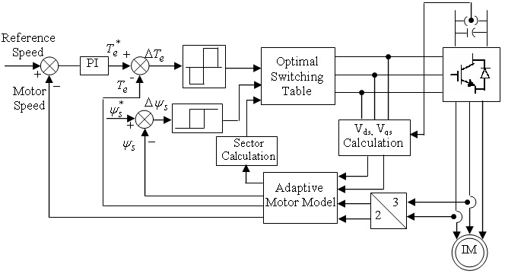

Fig. 1 Block diagram of DTC

1. Optimal Switching Logic

Processing of the torque status output and the flux status output is handled by the optimal switching logic. The function of the optimal switching logic is to select the appropriate stator voltage vector that will satisfy both the torque status output and the flux status output. In reality, there are only six active voltage vectors and two zero voltage vectors that a voltage-source inverter can produce [6, 8, 10].These are shown in Fig. 2. By using switching functions Sa, Sb and Sc of whose value is either 1 or 0, the primary voltage vector v(Sa, Sb, Sc) can be defined as in equation 1.

 ( 2** )  ( 4** )

  3  

2

*Z*

V(Sa,Sb,Sc)=

(*Vdc* )[*Sa*  *Sbe*   *Sc e* 3 ]

(1)

Where Vdc is DC link voltage.

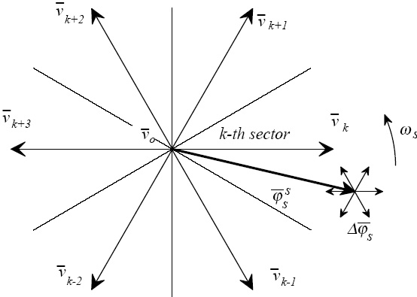

Fig. 2 Inverter output voltages

1. Design of Neural Network Controller

The drawback of conventional DTC with PI controller is more amount of ripples are observed in torque produced by generator. To reduce the amount of torque ripples, PI controller is replaced by an artificial neural network. A feed forward neural network is designed to estimate the actual speed of machine with rotor fluxes and stator currents as inputs. The subsystem of neural controller block is shown in Fig. 3. x{1} is the input to the neural network and y{1} is the output of the neural network and chosen neural network is two layer self learning weighed Neural Network.

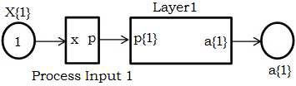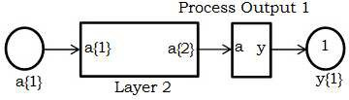

Fig.3 Subsystem for neural network.

Fig. 4 shows the process input subsystem, which is used to convert the given system with current and flux inputs to weighing function derivative. The block diagram representation of layer 1 of ANN function is shown in Fig. 5.

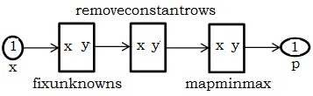

Fig.4 Process input subsystem.

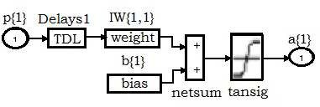

Fig. 5 Block diagram representation of Layer1 ANN system

The parameters with weighing function, dot-product and transformed function are shown in Fig 6. Based

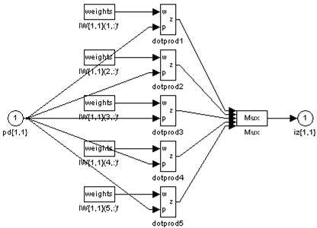

Fig. 6 MATLAB design of layers and weighing function

on the weighing function and other respective parameters, the first intermediate layer of the ANN system is obtained.. As the ANN system is bounded within the weighing function, the system will be stable and is a self learning mechanism. Similarly, the weighing functions to the second layer are also programmed to get the desired reference torque. The block diagram representation of layer 2 of ANN function is shown in Fig. 7. Purelin, Transig are the linear transfer function blocks and bias is a constant with value 2.316110024977692.

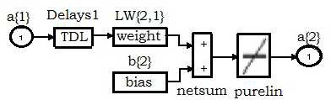

Fig. 7 Block diagram representation of Layer 2 ANN system

1. DTC of SCIG in WECS

The direct torque control of SCIG in wind Energy conversion system with PI controller and Neural controller is implemented in MATLAB/ Simulink. The wind energy conversion system consists of five main important blocks. They are constant pitch and variable speed wind turbine, induction generator, three-phase inverter, DTC controller and PI Controller / Neural controller (speed controller). Wind turbine acts as a prime mover to the induction generator. Wind turbine pitch angle is 45 degrees (constant) and wind velocity is varied between 0 to 20 m/sec randomly..

1. Simulation Results with neural controller

Initially the generator reference speed is zero; the reference speed is changed to 500 rpm at 0.01 sec, 1000

rpm at 1 sec and 500 rpm at 2.5 sec. The stator d-axis and q- axis currents trajectory revolving at synchronous speed with PI and Neural controllers are shown in Fig. 8.

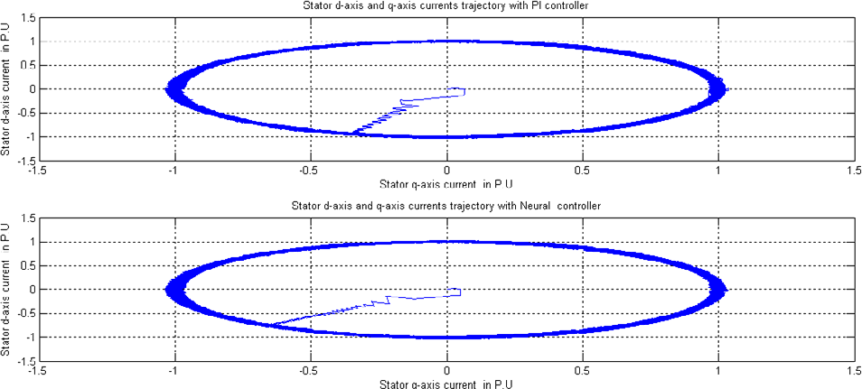

Fig. 8 Stator d-axis and q-axis currents trajectory

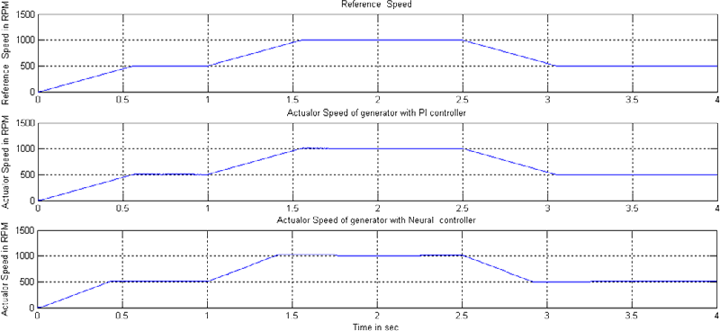At the time instants at which the reference speed changes there will be sudden variations in stator d-axis and q-axis currents. The stator d-axis and q- axis currents are used in estimating the stator flux. Fig. 9 shows the tracking of actual generator speed to the reference generator speed with with PI and Neural controllers.

Fig. 9 Reference generator speed and actual generator speed

The Torque developed by the wind turbine and induction generator with PI and Neural controllers are shown in Fig. 10 and Fig. 11 respectively.

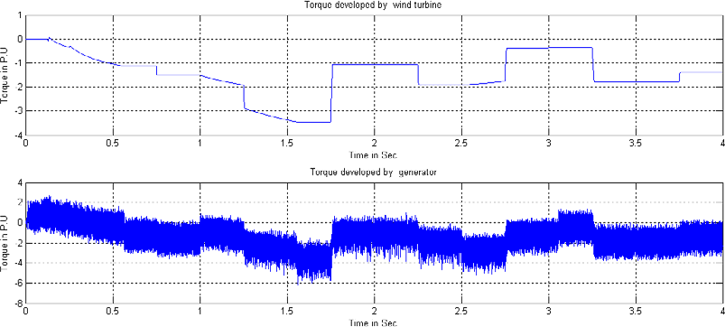

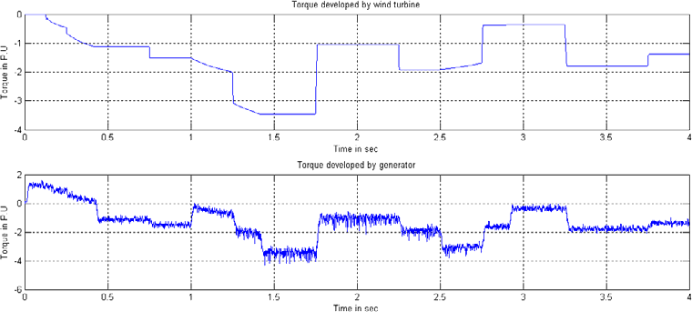Fig. 10 Torques developed by wind turbine and generator with PI Controller

Fig. 11 Torque developed by wind turbine and generator with Neural Controller

Torque ripples are observed in the torque developed by induction generator and the amount of torque ripples depends on the switching frequency of the inverter which is determined by the torque and flux band. In Fig.

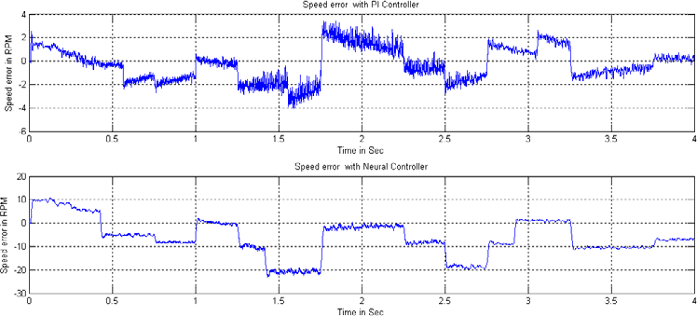10. The response of electro-magnetic torque follows the reference values with a very small delay of 0.02 seconds and also the torque ripples are minimum with Neural controller compared to PI controller. The speed error between the reference and actual speeds is shown in Fig. 12. The speed error between the reference and actual speeds varies from -4 to 3 rpm with PI Controller where as with Neural controller the speed error varies from -22 rpm to 10 rpm.

Fig. 12 Speed error with PI and Neural Controllers

1. Comparison of the Performance of DTC of SCIG with PI and Neural Controllers

The Comparison of the Performance of direct torque control of induction generator with PI and neural controllers in wind energy conversion system is given in Table 1.

Table 1 Comparison of the Performance of DTC of SCIG with PI and Neural Controllers

|  |  |  |
| --- | --- | --- |
| Performance Criterion | PI Controller | Neural Controller |
| Computational Complexity | Low | High |
| Computational time | Less | More |
| Torque Ripples | More | Less |
| Range of speed error | -4 to 3 rpm | -22 to 10 rpm |

The advantage of neural controller over PI controller is the less amount of ripple in torque produced by generator whereas the main disadvantage of neural controller is more variations in speed of generator than PI controller.

1. Conclusions

The direct torque control combines the benefits of vector control and direct self-control into a sensor-less variable-frequency drive that does not require a PWM modulator. In steady state, there is a ripple in the torque. This ripple depends on the switching frequency of the inverter which is determined by the torque and flux band. The switching frequency of the inverter varies over a wide range because of using hysteresis controllers. The magnitude of the stator flux can be maintained constant and several bright spots show the points where stator flux halts.

DTC implementation using ANN system is very accurate and the neural network is self learning mechanism. From the analysis and simulations, a command flux optimization scheme has been proposed to reduce the speed and torque ripples.

References

1. I. Takahashi and Y. Ohmori, “ High performance direct torque control of an induction motor,” IEEE Transactions on Industrial Applicaions.,vol.25, pp.257–264, Mar./Apr. 1989.
2. LAMCHICH Moulay Tahar, LACHGUER Nora, “Direct Torque control based multi-level inverter and Artificial intelligence techniques of induction machine,” pp.29-50.
3. Domenico Casadei, Giovanni Serra, &Angelo Tani, “The Use of Matrix Converters in Direct Torque Control of Induction Machines,” IEEE Transactions on Industrial Electronics, vol. 48, no. 6, December 2001 .
4. Si Zhe Chen, Norbert C. Cheung, Ka Chung Wong, and Jie Wu “Integral Sliding-Mode Direct Torque Control of Doubly-Fed Induction Generators Under Unbalanced Grid Voltage,” IEEE transactions on energy conversion, vol. 25, no. 2, June 2010.
5. B. B. Pimple, V. Y. Vekhande and B. G. Fernandes,“ New Direct Torque Control of DFIG under Balanced and Unbalanced Grid Voltage,” TENCON-2010, pp.2154-2158, IEEE-2010.
6. Alfeu J. Sguarezi Filho and Ernesto Ruppert,“ Modeling and Designing a Deadbeat Power Control for Doubly-Fed Induction Generator,” Wind Energy Management, pp. 113-128.
7. L. Xu and W. Cheng, “Torque and reactive power control of a doubly fed Induction Machine by position sensor less scheme,” IEEE Transactions on Industrial Applicaions, vol.31, May/June 1995, pp.636–642.