Available online at [www.sciencedirect.com](http://www.sciencedirect.com/)



**ScienceDirect**

AASRI Procedia 7 (2014) 38 – 44

2013 2nd AASRI Conference on Power and Energy Systems

Coordinating Control of Reactive Power Optimization in Distribution Power System with Distributed Wind Energy

Qingfeng Tang a, Jianhua Zhang a, Linze Huang b

*aState Key Laboratory of Alternate Electrical Power System with Renewable Energy Sources (North China Electric Power University), Changpin District, Beijing 102206, China*

*bGuangzhou Power Supply Bureau, China Southern Power Grid, Tianhe District, Guangzhou 510075, China Tang Qingfeng.*

*Tel.: +86-15810551063.*

*E-mail address:* [*tangqingfeng523@163.com.*](mailto:tangqingfeng523@163.com)

**Abstract**

Distributed generation (DG) systems are considered an integral part in future distribution power system. The reactive power injections from DG units, are seen as a cost-effective solution for distribution system voltage support, energy saving, and reliability improvement. This paper proposes a coordinating control method of reactive power optimization in distribution power system with distributed wind energy. The reactive capability limits of doubly fed induction generator (DFIG) are included in the optimization model. The problem of reactive power output/absorb of adjustable compensating capacitor and wind turbine (WT) is formulated as constrained conditions; differential evolution algorithm (DE) integrating depth-first search is developed to effectively obtain optimal solutions. The proposed algorithm is applied to a practical test system and results are compared and presented.

© 2014 The Authors. Published by Elsevier B. V. This is an open access article under the CC BY-NC-ND license ([http://creativecommons.org/licenses/by-nc-nd/3.0/).](http://creativecommons.org/licenses/by-nc-nd/3.0/))

© 2013 Tang Qingfeng, Zhang Jianhua, Huang Linze .Published by Elsevier B.V.

Selection and/or peer review under responsibility of American Applied Science Research Institute

Peer-review under responsibility of Scientific Committee of American Applied Science Research Institute

*Keywords:* Wind energy, reactive power optimization, distribution power system

# Introduction

Distributed generation is the direction of future power industry. Wind energy is the most widely used clean renewable energy. Distributed wind turbines(WT) are connected to the grid as distributed power sources and have brought significant impact on the system power flow distribution, voltage level and transmission loss.

2212-6716 © 2014 The Authors. Published by Elsevier B. V. This is an open access article under the CC BY-NC-ND license ([http://creativecommons.org/licenses/by-nc-nd/3.0/).](http://creativecommons.org/licenses/by-nc-nd/3.0/))

Peer-review under responsibility of Scientific Committee of American Applied Science Research Institute doi:10.1016/j.aasri.2014.05.026

Adequate voltage stability margin needs to be obtained through the appropriate scheduling of the reactive power resources [1].

Asynchronous wind turbines have simple structure and easy interconnection, but need to absorb reactive power from system in running state, there is no excitation device and capability of voltage regulation[2]. Currently, the most common technology used is the doubly fed induction generator (DFIG), which is able to provide reactive power support. A large variety of control strategies can be used in the operation of DFIG

The author in [3] has proposed a wind turbine control strategy in which the converters of grid side and rotor side are reserves of each other. In [4], a method to calculate the reactive power limit of system with DFIG considering grid-side converter reactive power limit is proposed, and the DFIG wind farm are used for reactive power compensation. [5] focused on including the reactive power capability of the DFIG turbines directly in the optimization formulation, and proposed a multiobjective reactive power planning strategy for WF and transmission system devices.

In this paper, we focus on the reactive power optimization of distributed system with distributed wind power, asynchronous wind turbines, adjustable compensating capacitor and DFIG technology is considered, and the reactive power capability of converter also taking into consideration.

**Nomenclature**

*U*˙*s*

*I*˙

*s*

*Rs xs xm*

*Ps Qs*

the rotor side voltage the stator side current the stator resistance

the rotor side leakage reactance

the excitation reactance

cos*φ*

*I*˙

*r*

*Rr xr s*

the power factor the rotor current

the rotor side resistance

the rotor side leakage reactance the slip ratio

the active power and reactive power generated or absorbed by stator side

*Pr Qr* the active power and reactive power generated or absorbed by rotor side

*Qg* the reactive power of DFIG emits to system *QAsy* the reactive power output of asynchronous WT

*Pc*

*P*

*x*1

*Qc* the active power and reactive power of GSC input from system

the active power output of asynchronous WT

the stator leakage reactance

*V* the output voltage of asynchronous WT

*x*2 the rotor leakage reactance

# Mathematic model of wind turbine generator

* 1. *Mathematic model of Variable Speed Constant Frequency Wind Turbine Generator*

The DFIG has two set of windings including rotor winding and stator winding. The stator winding is connected directly to the grid through grid-side converter, GSC. The DC side voltage is controlled by GSC, and the power factor is adjusted according to the demand of grid.

The value is set to positive when rotor and stator generating active power and inductive reactive power into grid. Then the power injected to the system by DFIG can be written as:

*Pe*  *Ps*  *Pr*

*Qe*  *Qs*  *Qr*

(1)

(2)

There are two main operating mode for DFIG: Constant power factor and constant voltage. Where *Qr* can be neglected, then we have *Qe*  *Qs* . When the stator side voltage of wind turbine is constant, its reactive power adjustment range is influenced by the thermal limit current of stator winding and rotor winding, and the

maximum current of converter. The maximum current of converter is the main impact factor. The rotor

current range is determined by the converter current range. Let the maximum converter current be *I* , which

*r* max

is usually 150% of the rated current[6], then we have:

*U*˙

*s*

2

*P*2  (*Q*  )2 

*U*˙ 2 *x*2 *I* 2

*s m r* max

(3)

*s s* 2

*X X*

*ss ss*

The stator side reactive power range can be obtained from (3):

*Qs* min

  

2 *X*

3 *U*

2

*s*

(2 *Xm U*

3 *X*

*s r* max *s*

*I* )2  *P*2

*s*

*Qs* max

*s*

  

3 *U*

2

*s*

(2 *Xm U*

3 *X*

*s r* max *s*

*I* )2  *P*2

*s*

2 *X*

(4)

*s*

* 1. *Reactive power limit of GSC*

The essence of GSC is a voltage type PWM rectifier, the AC side has the unique characteristics of a controlled current source, it can run in four quadrant. The GSC usually run in unit power factor condition, if

*Pc* and *Qc* are active power and reactive power of GSC input from system, then *Qc*  0 , capacity selection of

GSC only need to consider the maximum slip-active power of DFIG.

According to the wind power system with the maximum slip-active power to design power size of GSC, line loss and breaker loss are taking into consideration. If *Pc* max is the maximum active power of GSC, the reactive power of it emits or absorbs calculate as equation (5)-(6):

*Qc* min

*Qc* max

2 2 2

*c c c* max

*P*  *Q*  *P*

 

*P*2

*c* max

[*s* / (1 *s*)]2 *P*2

*mec*



*P*2

*c* max

[*s* / (1 *s*)]2 *P*2

*mec*

(5)

(6)

* 1. *Asynchronous wind turbine model*

The active-reactive power relationship of asynchronous WT system showed in (7)

*V* 2

   *x*

*QAsy f* (*V* )

*m*

 *V* 2 

*V* 4  4*P*2 *x*2

2*x*

(7)

Where *P* is the active power output, *V* is output voltage, *x*  *x*1  *x*2 .

# The reactive power optimization model of power distribution system with distributed wind turbines

* 1. *Mathematical model*

The objective of reactive power optimization model is to reduce the loss of system, reactive power optimization is defined as the minimization of reactive power losses by controlling a number of control variables:

24



min *Qloss*

*i* 1

(8)

*h*(*u*, *x*)  0, *k*  1, 2,..., *n*

*s*.*t*.*g*(*u*, *x*)  0, *k*  1, 2,..., *n*



(9)

Where *h* is equality constraint, namely power flow equation, *g* is inequality constraints, including the branch power restriction, the node voltage constraints and upper and lower limits of control variables; *u* and *x* represent control variables and state variables respectively.

* 1. *Power flow model of distribution power system based on depth search*

The benefit of the power flow calculation methods based on depth search is that could ignore the specific network in radial topology, only need to know the base information of the node structure and the branch structure. In this paper, choose the voltage deviation as the termination condition of power flow calculation:

max( *U j*  *U j*1 )  *ε*

*i i*

(10)

Where *ε* is constant, *ε* =10-5. Then compute injection current of non-end nodes piecewise according to the level attribute, more details in [7]. Nodal attributes including:

inf*i*  {*i*, *pi* , *qi* , *l*, *l*max , *a*}

(11)

Where *i* is node number,

*pi* is nodal active power, *qi*

is nodal reactive power, *l* is hierarchy number,

*l*max

is the maximum hierarchy number, *a* is node type.

* 1. *Solution procedure based on differential evolution algorithm*

Classic differential evolution involves two stages: initialization and evolution. Initialization generates an

initial population *P*0 . Then *P*0 evolves to *P*1 , *P*1 evolves to *P*2 , … ,until the termination conditions are

fulfilled. While evolving from *Pn* to *Pn*1 , the three evolutionary operations, namely, differential mutation, crossover and selection are executed in sequence.

*Qloss*

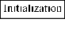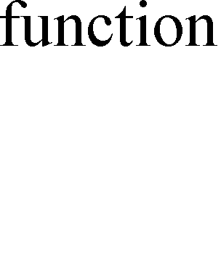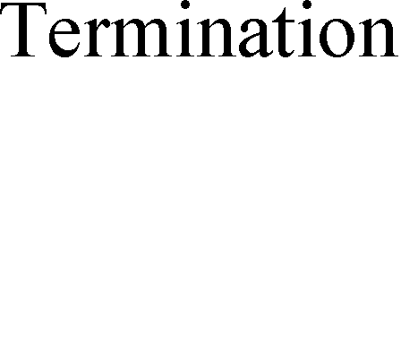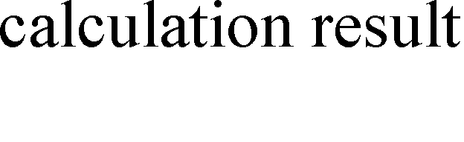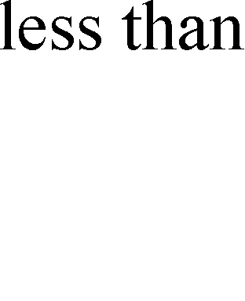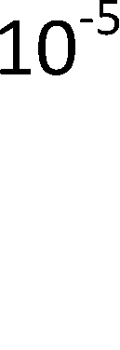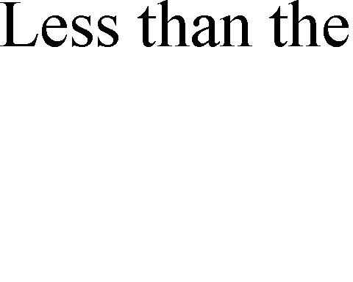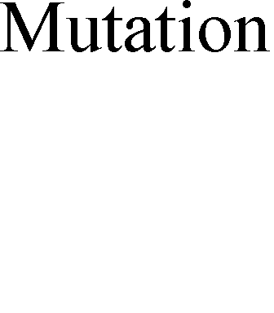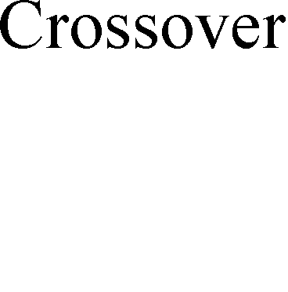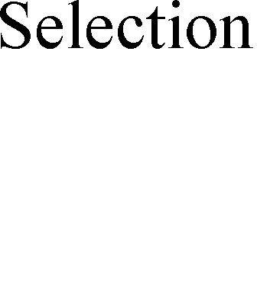

Fig 1 Coordinating control method of reactive power optimization with distributed wind energy

Termination conditions: when

*Qloss* less than the threshold, algorithm terminates. The whole solution

procedure is given in Fig.1. The threshold of reactive power loss employ the average reactive power loss of network without WT, and considering the termination condition can not be satisfied, set the maximum number of iterations to avoid endless loop, maximum number is 500.

# Reactive Power Optimization and Verification With Distribution WT

* 1. *Access form of distribution WT*

In this paper, chose a distribution power system as test case, bus voltage is 1.05(p.u.), reference power is 100 MVA, reference voltage is 10 KV. The chosen network is radial topology including three lines contain

424 nodes, which the line 1 has 224 nodes, the line 2 has 119 nodes and the line 3 has 81 nodes.

There are 6 access points which all in frontier nodes, shown in Table 1. Because the WT output power fluctuate, given the wind speed random in the case, according to the wind power characteristic curve to ensure the WT output.

Table 1. WT access points

|  |  |  |
| --- | --- | --- |
| Access points of DFIG | Combined access points | Line |
| 109 | 139 | 1 |
| 232 | 239 | 2 |
| 355 | 359 | 3 |

* 1. *Coordinating control of reactive power optimization in distribution power system with distributed wind energy*

The node of 1 to 244 belongs to line 1, 225-343 belongs to line 2, 344-424 belongs to line 3, Fig.2(a) shows the total network voltage level without distributed wind energy and Fig.2(b) shows the nodal voltage state after reactive power optimization.

1

0.98

0.96

0.94

0.92

0.9

225 344

1.015

1.01

1.005

1

0.995

0.99

0.985

0.98

0.975

0 50 100 150 200 250 300 350 400 450

Fig 2(a) Voltage level without distributed wind energy Fig 2(b) Voltage level without distributed wind energy

The figures above show that nodal voltage of line 1 are in low state, line 2 and 3 are higher simultaneously when there is no reactive power compensation and wind energy access. The reactive power optimization efficiency considering the reactive power limit of WT shows in Fig.(3)-(5) , the left is the access point voltage state before optimization, and the right is after optimization.

0.96

0.94

0.92

0.9

0.88

0.86

0 5 10 15 20 25

1.02

1

0.98

0.96

0.94

0.92

0.9

0 5 10 15 20 25

Fig 3 Voltage state of node 109

1 1.005

0.995 1

0.99 0.995

0.985 0.99

0.98 0.985

0.975

0 5 10 15 20 25

0.98

0 5 10 15 20 25

Fig 4 Voltage state of node 232

1

0.998

0.996

0.994

1.015

1.01

1.005

1

0.992 0.995

0.99

0 5 10 15 20 25

0.99

0 5 10 15 20 25

Fig 5 Voltage state of node 355

In line 1, node voltage level increased significantly, all of nodes with low voltage rise within the allowable range. Fig.(3)-(5) show the voltage variation in 24 hours between WT accessed and the day before access. After WT accessed, voltage of total access points improved, where node 109 is the most significant. The switch time optimization result of adjustable compensating capacitor shows in Table 2, and the total reactive power loss decreased from 1.951MWh to 1.678MWh.

Table 2. Switch time optimization result of adjustable compensating capacitor

|  |  |  |  |  |
| --- | --- | --- | --- | --- |
| Adjustable compensating capacitor | Access point | Line | Time of switch on | Time of switch off |
| 1 | 139 | 1 | 5 | 13 |
| 2 | 239 | 2 | 7 | 15 |
| 3 | 359 | 3 | 10 | 22 |
| **5. Conclusion** |  |  |  |  |

This paper has presented a optimization method for reactive power optimization of distribution system with incorporating DFIG reactive capability and asynchronous WT. The reactive capabilities of DFIG including the reactive power limit of GSC have been emphasized in this paper.

# Acknowledgements

This work was financially supported by the National Natural Science Foundation (51277067).

# References

1. Alizadeh Mousavi O, Bozorg M, Cherkaoui R. Preventive reactive power management for improving voltage stability margin[J]. Electric Power Systems Research, 2013, 96: 36-46.
2. Chen J, Chen H, Duan X. Multi-period dynamic optimal power flow in wind power integrated system[J]. PROCEEDINGS-CHINESE SOCIETY OF ELECTRICAL ENGINEERING, 2006, 26(3): 31.
3. Jia J, Liu J, Zhang Y. Novel Reactive Power Optimization Control Strategy for Doubly Fed Induction Wind Power Generation System[J]. Proceedings of the CSEE, 2010, 30: 015.
4. Lang Y Q, Zhang X G, Xu D G, et al. Reactive Power Analysis and Control of Doubly Fed Induction Generator Wind Farm[C] Proceedings of the Chinese Society of Electrical Engineering. 2007, 27(9): 77-82.
5. Alonso M, Amaris H, Alvarez-Ortega C. A multiobjective approach for reactive power planning in networks with wind power generation [J]. Renewable Energy, 2012, 37(1): 180-191.
6. Shen H, Wang W S, Dai H Z. REACTIVE POWER LIMIT OF VARIABLESPEED CONSTANTFREQUENCY WIND TURBINE [J][J]. Power system technology, 2003, 11: 013.
7. Lu X Q, Wu C N. Modified power flow calculation method of distribution grid with DGs[J]. Power System Protection and Control, 2012, 40(21): 48-51.