[](Journal%20logo)[Artificial Intelligence in Agriculture 4 (2020) 262–271](https://doi.org/10.1016/j.aiia.2020.11.001)

Contents lists available at [ScienceDirect](http://www.sciencedirect.com/science/journal/25897217)

Artificial Intelligence in Agriculture

journal homepage: [http://www.keaipublishing.com/en/journa ls/artificial- intelligence- in-agriculture/](http://www.keaipublishing.com/en/journals/artificial-intelligence-in-agriculture/)

[](http://crossmark.crossref.org/dialog/?doi=10.1016/j.aiia.2020.11.001&domain=pdf)Crop plant signaling for real-time plant identification in smart farm:

A systematic review and new concept in artificial intelligence for automated weed control

Wen-Hao Su a,b,⁎

a *China Agricultural University, College of Engineering, 17 Qinghua East Road, Haidian, Beijing 100083, China*

b *University of California-Davis, Department of Biological and Agricultural Engineering, One Shields Avenue, Davis, CA 95616, USA*

a r t i c l e i n f o

*Article history:*

Received 28 October 2020

Received in revised form 19 November 2020 Accepted 22 November 2020

Available online 27 November 2020

*Keywords:*

Crop plant signaling Robot-plant interaction Fluorescent compound Weed control

a b s t r a c t

The continued emergence of herbicide-resistant weeds and the increasing labor costs are threatening the ability of growers to manage weeds and maintain profits. The smart farm with the advantage of non-invasive and high-efficiency operation plays an important role in increasing the sustainability of agricultural system as it can optimize crop inputs such as herbicides while preserving resources including soil and water. An automatic weed control system requires a sensing subsystem capable of detecting and distinguishing crop plants from weeds. The overlapping plants remain a challenge for successful detection of weeds. Crop plant signaling is a new robot-plant interaction technique that allows the visualization of exogenous fluorescent signals applied to crop plants for crop/weed identification. Based on all published articles in the leading edge of knowledge, a com- prehensive review of the mushrooming crop plant signaling for discriminations of weeds and crops is highlighted. The discussion outlines the significant progress that has been made in developing new and more ro- bust automated systems along with the current challenges and future prospects. This paper details the promise of crop plant signaling for accurate and automated plant recognitions in cropping systems. There is no doubt that this review is of great significance to scholars in related research field to study the solutions to real-time weed control.

© 2020 The Authors. Publishing services by Elsevier B.V. on behalf of KeAi Communications Co. Ltd. This is an open access article under the CC BY-NC-ND license (<http://creativecommons.org/licenses/by-nc-nd/4.0/>).

Contents

1. Introduction 263
2. Limitations of existing sensing methods for plant detection 263
3. Crop plant signaling 264
   1. Physical markers 264
   2. Biological markers 264
   3. Chemical markers 265
      1. Systemic crop signaling compounds 265
      2. Topical markers 268
4. Discussions 269
   1. Advantages of crop plant signaling 269
   2. Disadvantages and future potentials of crop plant signaling for on line applications 269
5. Conclusions 270

Declaration of Competing Interest 270

References 270

* Corresponding author at: China Agricultural University, College of Engineering, 17 Qinghua East Road, Haidian, Beijing 100083, China.

*E-mail address:* [whssu@ucdavis.edu](mailto:whssu@ucdavis.edu).

<https://doi.org/10.1016/j.aiia.2020.11.001>

2589-7217/© 2020 The Authors. Publishing services by Elsevier B.V. on behalf of KeAi Communications Co. Ltd. This is an open access article under the CC BY-NC-ND license ([http://](http://creativecommons.org/licenses/by-nc-nd/4.0/) [creativecommons.org/licenses/by-nc-nd/4.0/](http://creativecommons.org/licenses/by-nc-nd/4.0/)).

1. Introduction

Due to the limited selection of herbicides, the lack of labor, high costs for manual weeding, and the increasing demand for organic foods, the development of automated weed control systems to meet the real- time plant care in the field has received increasing attention (Fennimore and Boyd, 2018; Fennimore and Cutulle, 2019; Fennimore and Tourte, 2019). Herbicides are widely used to control weeds in agri- culture. However, this poses a risk of poisoning to people who operate and use them (Pateiro-Moure et al., 2013). The overuse of herbicides can cause pollution to the air, water, and soil, and their residues may be present in foods (Hildebrandt et al., 2008). Also, labelling new herbi- cide for each crop group is an onerous process. There is evidence that there have been more than 40 years since the last valuable herbicide in crops such as lettuce was made (Fennimore and Tourte, 2019). Her- bicides are strictly regulated by the government and face more public scrutiny. The vulnerability of liability claims makes the labeling of new herbicides cumbersome. For example, the registrant would be liable for $1700 ha−1 if the maize in Iowa was damaged by an herbicide and the yield was lost by 100% (Plastina, 2019). In any case, the use of herbi- cides will inevitably cause certain species to become resistance to the herbicide. With few new herbicides released and more herbicide- resistant weeds, the risk of weed management through herbicides is in- creasing (Davis and Frisvold, 2017). Additionally, labor shortages, inef- ficiencies, and rising wages limit manual weeding as a viable option for long-term weeding. Large-scale cultivation needs cost-effective and labor-saving techniques for rapid and efficient removal of various weeds in crops. Automatic weeding is an effective operation to ensure the sustainability of crop production system. Recently, commercial ma- chines for automatic thinning of lettuce have been developed to thin let- tuce plants to the expected final crop density. A small number of commercial robotic weed control machines are available to farmers for purchase (Su et al., 2019a). However, the current state of the art is unable to distinguish between crops and weed plants under conditions such as those found in organic production of direct sown crops, where visual occlusion from plant leaves can be severe (Slaughter, 2014).

A modern technology called crop plant signaling has been proposed

for crop/weed differentiation. Crop plant signaling is a new concept de- fined as any communication process that governs basic interactions be- tween sensors and exogenous fluorescent signals applied to crop plants. This new technology was first created by Nguyen et al. (2017) in 2017 as a novel solution to automated weed control in vegetable crops. In their study, the crop plants marked at planting in the field generated a unique optical signature, which ensured the differentiation task. After, Su et al. (2019b) updated this technology using systemic fluorescent markers that effectively discriminated snap bean plants from different weeds. By applying the systemic fluorescent compound to seeds or transplants, Su et al. (2020a) successfully created sensor-readable crop plants with a unique optical appearance for real-time plant care. The fluorescent tracer in plants has significant fluorescence emission upon excitation light. This systemic crop signaling technique allows the crop to indicate its presence using fluorescence signals of extraneous substances applied to plants. In addition, crop signaling methods developed using plant la- bels, topical markers, or fluorescent proteins (FPs) were successfully used for crop/weed detection (Raja et al., 2019). The properties of sig- naling methods for an automatic weeding system has to feature:

(i) the signal compound has a unique fluorescence signal, (ii) the optical filter combined with the excitation light can filter out the fluorescence signal, (iii) a small amount of fluorescent tracer can produce strong sig- nal, (iv) the signaling compound can be safely used for crop plants, and

(v) it is cost-effective to be used. When weed control is needed, ma- chine vision systems will be deployed to detect the unique optical sig- nals produced by crop plants and develop high spatial resolution maps involving crops and weed plants to accurately locate all plants in real- time. The crop/weed map will be used by a high spatial resolution

weed destruction mechanism that selectively takes lethal action against individual weed plants without damaging the crop plants. Such a recog- nition system does not require prior knowledge of the plant to identify high-density weeds.

The feasibility of crop signaling techniques has been investigated by scientists during past few years. Up to now, no review on crop signaling technology has been published for plant identification. This paper first provides an introduction of the new concept on crop planting signaling. Challenges of existing noncontact methods including spectroscopy and imaging techniques (such as hyperspectral imaging and multispectral imaging) for discriminations of crops and weeds have been presented in Section 2. In Section 3, an emphasis has been given to the studies of recent years in advanced crop plant signaling using physical, biological and chemical markers to simplify and ensure the success of the crop and weed detection. The discussions are given on the advantages, chal- lenges and future prospects of crop planting signaling for real time applications.

1. Limitations of existing sensing methods for plant detection

Automatic detections of weeds in agricultural fields usually involves sensing the weeds against the backgrounds of soil, plant residue, and crops. Noncontact approaches for weed detection mainly require the ac- quisition of plants involving sensing from satellites or airborne vehicles, and ground-based vehicles or robotics (Su, 2020). Spectroscopy is a rapid technique commonly used to sense the difference between crop plants and weeds (Jurado-Expósito et al., 2003). Besides their spectral features, the spatial attributes should also be incorporate in analysis since they already are part of the measurement (Elstone et al., 2020; Su and Sun, 2016). Such methods depend reflectance, absorbance, or emission of an inherent signal or feature from a plant to be received by non-imaging sensors (Jurado-Expósito et al., 2003) or imaging sen- sors such as color imaging (El-Faki et al., 2000), hyperspectral imaging (Okamoto et al., 2007; Su et al., 2018; Su and Sun, 2016a, 2016b, 2016c, 2017a, 2017b), and multispectral imaging (Piron et al., 2009).

These sensing techniques coupled with machine learning algorithms such as Bayesian classifiers and convolutional neural network (CNN) have been widely used for rapid crop/weed discrimination (Su, 2020). Specifically, visible/near infrared (VIS/NIR) spectroscopy studies the in- teraction between the object to be measured and radiation intensity as a function of wavelength (Su et al., 2017a). Support vector machine (SVM) algorithm based on three characteristic variables in the red edge (RD) region achieved a high accuracy of 97% for recognition of sil- ver beet and maize plants (Akbarzadeh et al., 2018). Borregaard et al. (2000) used the spectral reflectance of 694 nm and 970 nm to achieve an accuracy of up to 90% for classification of crops (including sugar beet) and weeds (including black bindweed, fools parsley, and fat-hen). The non-imaging spectroscopy only generates spectral infor- mation from very small points or local parts without providing spatial information of the entire object (Su et al., 2019; Su and Sun, 2019). Color imaging can capture whole image data within red, green, and blue wavelength ranges. CNN-based classification systems using RGB data can run easily on mobile hardware with a processing time below 30 milliseconds (Santos et al., 2019). The color image-based RF classifier had an overall accuracy rate of about 95% in the classification of early growing weeds in maize fields (Gao et al., 2018).

Hyperspectral imaging differs from non-imaging spectroscopy and color imaging in that it takes numerous narrow-band images from a continuous spectral region, generating the spectra of all pixels in an image (Su et al., 2017b). Hyperspectral models using the absorbance in the region of 1700 to 2320 nm achieved over 99% classification rates for discriminating nightshade weed from tomato plant (Slaughter et al., 2004). Based on ground-based hyperspectral imaging (400–1000 nm), Bayesian classifiers and artificial neural network (ANN) were examined to discriminate crops such as lettuce, field pea,

canola and tomato from different weeds grown under various sunlight intensities with high accuracies (88% to 94%) (Eddy et al., 2014; Slaughter et al., 2008; Staab et al., 2009). However, it takes a lot of time and effort to effectively remove the large amount of redundant in- formation contained in the full wavelength range to simplify the model (Su et al., 2020) and improve the speed of on-line detection (Su, 2020; Su et al., 2019, 2020).

As a successor of hyperspectral imaging technique, multispectral im- aging only captures images in several discrete spectral bands within the full wavelength region (Lara et al., 2020; Su and Sun, 2018). The RF algo- rithm based on the selected multi-spectral images obtained an accuracy of more than 93% for the classification of weeds in three soybean varie- ties (Fletcher and Reddy, 2016). However, weeds in complex natural scenarios (e.g. high weed densities) are difficult to be distinguished (Westwood et al., 2018). Instead of acquiring reflectance or absorbance spectra, chlorophyll fluorescence imaging can capture the fluorescence emission of plant chlorophyll, but it is hard to classify healthy crop plants from the weeds using this technique, because the fluorescence peaks of chlorophyll of these green plants are identical (Hilton, 2000). Overall, the widely used sensors are based on plant inherent features (such as chlorophyll and nitrogen) (Clevers and Kooistra, 2011; Ustin et al., 2009). In addition, these methods require sufficient learning of the characteristics of a large number of weeds or crops to establish a ro- bust machine learning model before performing operations of plant identification (Zhang et al., 2012).

1. Crop plant signaling

Crop plant signaling is a new robot-plant interaction technique that allows weed/crop differentiation based on photographing of a machine- readable fluorescence signal applied to crop plants rather than the weed (Su et al., 2019b). Fig. 1 shows a schematic diagram illustrating the prin- ciple of the crop plant signaling technology. Fluorescent compounds in the plant at very low doses contain fluorophores that can generate very strong fluorescent emissions when excited by specific wave- lengths. The fluorescent signals can be then captured by a fluorescence macroscope. According to the attributes of labels, signaling approaches can be divided into three categories: physical markers (such as plant la- bels), biological markers (such as FPs), and chemical markers (such as systemic crop signaling compounds and topical markers). The current published studies of this technology have been summarized in Table 1.

The following are the examples of their applications for automated identification of the location of target plants.

* 1. *Physical markers*

Physical markers refer to the use of inexpensive and biodegradable plant labels made from polylactic acid or maize-based plastic. The plant labels painted with orange, green, or pink fluorescent paints were placed next to seedling stems to provide a unique signal used to localize the crop plants. Because of the fluorescent signal of the plant label under ultraviolet (UV) excitation light, the crop signaling system equipped with a camera was able to detect the occluded and non- occluded crops (including tomato and lettuce) with an accuracy of 97.8% at travel speeds up to 3.2 km h−1 in fields with a high density of weeds (Raja et al., 2020a). As shown in Fig. 2, the system mainly consists of a camera at the top, two sets of three mirrors, two sets of six UV lights, and a pneumatic-powered weed knife. The top view of the target plant along with mirror images from six view angles allow the location of the plant to be calculated according to the geometric appearance of the plant label (Fig. 3). Based on the position of the plant label, the weeding blade receives commands to perform the weeding operation. The tech- nique allows for universal weed control rather than classification of dif- ferent weeds, because the temporary fluorescent signal is only applied to the crops and not the weeds, allowing it to rapidly distinguish the dif- ferent weeds from the crop plants. Results showed that over 90% weeds (including edroot pigweed, barnyardgrass, yellow nutsedge, prostrate pigweed, lambsquarters, black nightshade, and purslane) and 66% weeds (including burning nettle and purslane) were classified and re- moved from the tomato and the lettuce without reducing yields (Kennedy et al., 2019). The error was mainly due to the failure of the plant label to adhere to the crop plants. Also, it is difficult to avoid re- moval of labels by irrigation. Although this system has potential to con- trol the universal weeds in crops, this crop plant signaling using plant labels are inefficient as it takes a lot time to mark each vegetable seed- ling manually.

* 1. *Biological markers*

Biological markers are widely used as indicators to measure certain biological conditions. FP is a very efficient genetically encoded biological marker for imaging living cells and tissues (Dixit et al., 2006; Xian et al.,

[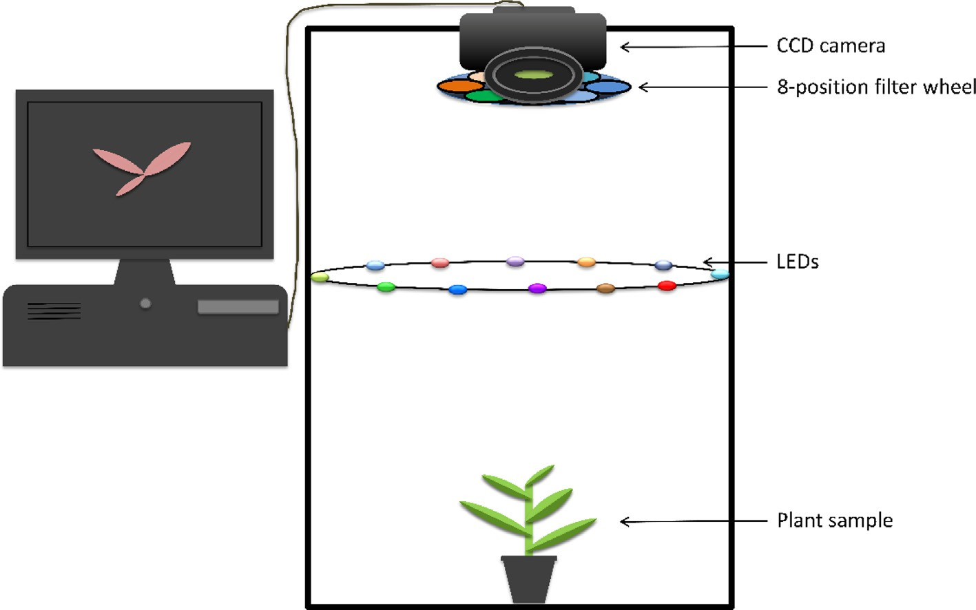](Image%20of%20Fig.%201)

Fig. 1. A schematic diagram illustrating the principle of the crop plant signaling technology.

Table 1

The current published studies with cop plant signaling approaches.

|  |  |  |  |  |
| --- | --- | --- | --- | --- |
| Signaling approach | Plant | Excitation light | Fluorescence emission | Reference |
| Physical markers | Tomato, lettuce | UV | Green to pink | (Kennedy et al., 2019; Nguyen et al., 2017; Raja et al., 2020a) |
| Biological markers  Chemical markers | Tomato Potato  Snap bean | Blue  UV to orange UV, green | Bright green Blue to red  Yellow to orange | (Raja et al., 2019) (Rigoulot et al., 2019)  (Su et al., 2019a, 2019b, 2020a) |
|  | Celery Tomato  Lettuce | Green Green  UV | Yellow to orange Yellow to orange  Red | (Su et al., 2020c) (Su et al., 2020b)  (Kennedy et al., 2019; Raja et al., 2020b) |

1999). The most common categories are red, green, cyan, yellow, and green-to-red FPs (Chudakov et al., 2010; Hao et al., 2007). Monitoring plants based on fluorescent markers is not a completely new method as it has been proposed for detecting transgenic plants (Stewart Jr, 2005). For instance, the fluorescence of green FP was used to indicate the characterization of protein synthesis in transgenic plants (Richards et al., 2003). The FP produced specific colors was used to screen diseased plants (Wang et al., 2007). Also, FPs expressed in plants can generate a specific signal for classification of crops from weeds. Results showed that the fluorescence generated from green FP under blue (470 nm) ex- citation light extensively appeared in plant leaves, which helped to identify crops from weeds (Raja et al., 2019). Rigoulot et al. (2019) de- veloped a fluorescence-based platform for imaging of plant canopies that expressed multiple FP genes in leaves. The excitation lights for FPs ranged from UV to orange (395–578 nm) with fluorescence emis- sions from blue to red (454–611 nm). Of the 20 fluorescent proteins screened, the fluorescence of the four proteins (mEmerald, mTagBFP2, mScarlet-I, and TurboRFP) was clearly detected on the entire leaves of the plant (Fig. 4). In the future, the iterative version of the system is ex- pected to be used for automated crop/weed screening.

* 1. *Chemical markers*
     1. *Systemic crop signaling compounds*

Systemic crop signaling compounds are applied to the seedling roots of transplanted crops or through the seed coat to crop seeds that can be sown directly prior to planting, then they are transported systematically to the stem or the foliage of a plant for detection (Su et al., 2020a). Lappartient et al. (1999) found that sulfate can move up into leaves after being absorbed by plant roots. The lipophile property of a com- pound expressed in terms of the log *K*ow affects its mode of action and absorption in plants (Salanenka and Taylor, 2006). Molecules with log *K*ow between 0 and 2 are considered to move more readily in plants (Hsu et al., 1990). The fluorescent tracers mainly originate from chemi- cal families including arylmethane dye, azine dye, coumarins and xan- thenes (Wang et al., 2020). Such markers for agricultural use should be cost effective and safe. As an inexpensive xanthene fluorescent com- pound, the use of Rhodamine B (Rh\\B) (no more than 60 ppm on the treated seed) does not have a negative impact on the environment or public health based on the statement U.S. Environmental Protection Agency (EPA) (Su, 2020). Studies have shown that Rh\\B (Log *K*ow =

[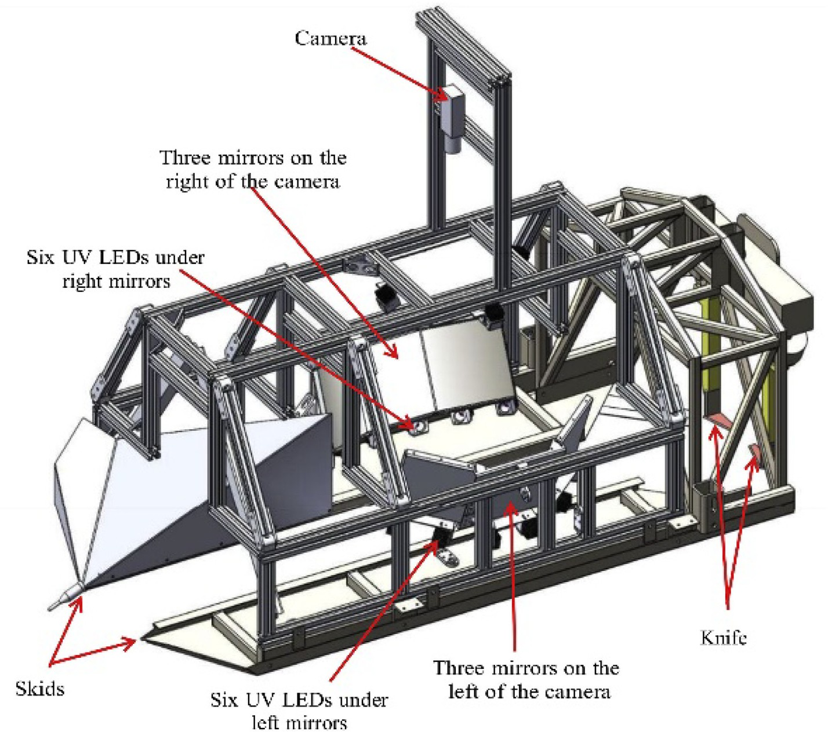](Image%20of%20Fig.%202)

Fig. 2. Mechanical structure of the crop signaling system for automated weeding (Raja et al., 2020a).

[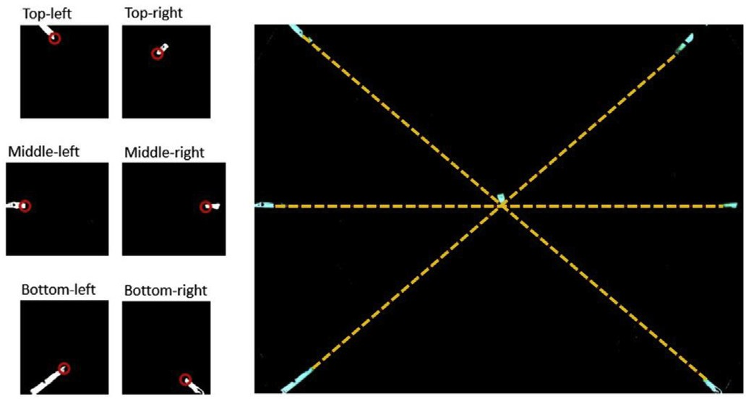](Image%20of%20Fig.%203)

Fig. 3. Determination of actual signal soil-entry location by connecting six lowest points (in red circles) of the plant label using three pairs of dashed lines (Raja et al., 2020a).

1.5) was more easily absorbed by broad bean leaves rather than hydro- philic dyes such as Oregon Green 488 (Liu and Gaskin, 2004).

The seed coats of lettuce and tomato are non-permeable to the sys- temic Rh\\B dye, but the snap bean seed coat is permeable to this marker (Salanenka and Taylor, 2011). Rh\\B has been successfully used as a systemic crop signaling compound excited under UV light to distinguish snap bean plants from three weeds including burning nettle, barley and groundsel with 100% accuracy (Su et al., 2019a). In their

study, the Rh\\B signal in crops was created by soaking the snap bean seeds with Rh\\B liquid dye for 24 h before sowing. After the seedlings grow up, this systemic signaling compound was deposited in the plant stem following the seed pathway (Su et al., 2019b). Besides snap bean, soybean (a large-seeded legume) had the very similar seed coat perme- ability (Taylor and Salanenka, 2012; Yang et al., 2018). After investiga- tion of 32 fluorescent tracers, the systemic Rh\\B was finally selected as the optimal tracer for systemic soybean seed uptake (Wang et al., 2020). The Rh\\B was detected from the roots and hypocotyl, while lim- ited contents were measured from soybean epicotyl and true leaves (Fig. 5). Although the Rh\\B has less translocation beyond the stem tis- sue and into the leaves, the function of the systemic compound using seed pathway is equivalent to the plant labels. Previous studies demon- strated that in addition to UV light, green light was also able to excite the systemic Rh\\B producing the same emission signal (Han et al., 2003). For a clearer understanding of concentration effects on seed uptake, Su et al. (2020a) developed a system based on the green light at 523 nm to detect snap beans containing various doses of Rh\\B tracer using the seed pathway. They found that the seeds with 100 ppm of Rh\\B presented the highest fluorescence intensity (Fig. 6 (a, b)). After the signal of the control samples was filtered, it was found that the emission of Rh−B was mainly concentrated in the stem (hypocotyl and epicotyl) of the plant (Fig. 6(c, d)).

Rh\\B tracers were easily taken up into bean and celery leaves fol- lowing the root pathway (Su et al., 2020a; Su et al., 2020c). Fig. 7

[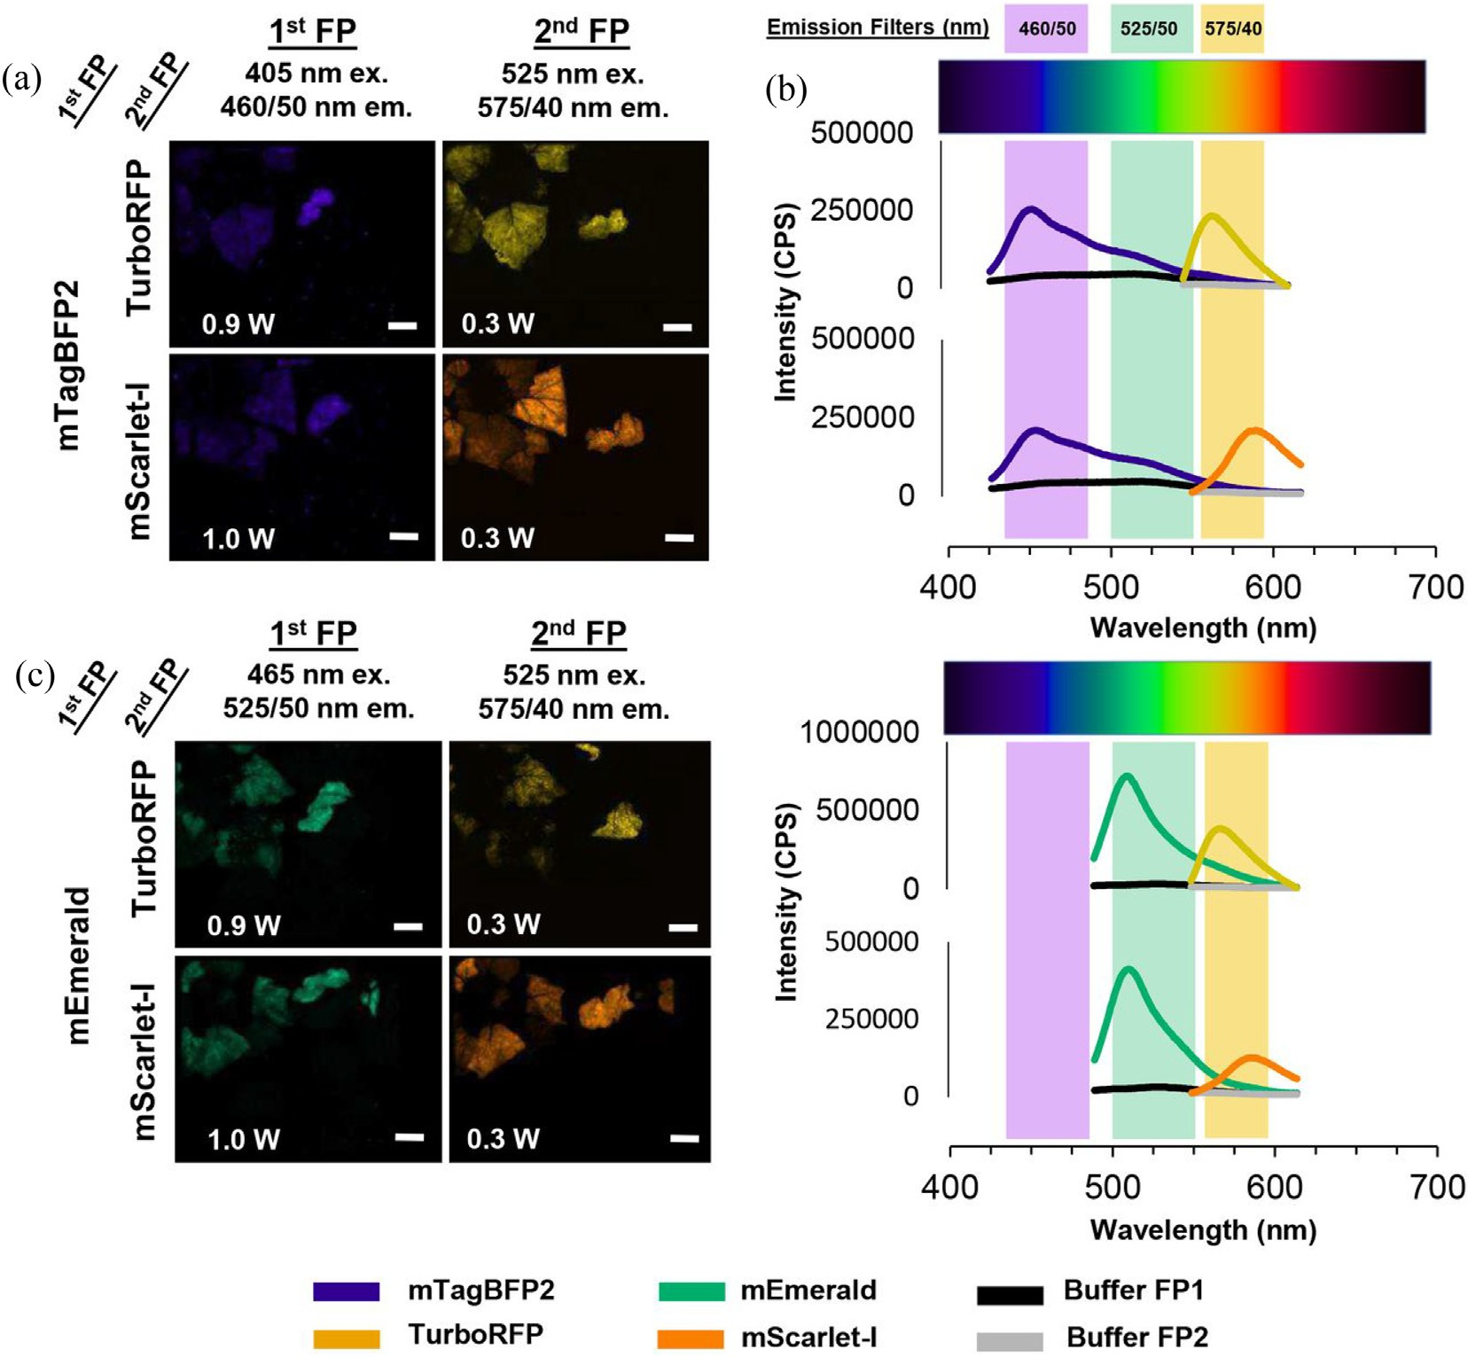](Image%20of%20Fig.%204)

Fig. 4. Fluorescence measurements of co-expressed fluorescent proteins in plant leaves. (a) visualization of co-expression of mTagBFP2 with mScarlet-I or TurboRFP under 405 or 525 nm excitation light, (b) emission spectra of corresponding proteins based on 465 or 575 nm emission filter (c) visualization of co-expression of mEmerald with mScarlet-I or TurboRFP under 465 or 525 excitation light, (d) emission spectra of corresponding proteins based on 525 or 575 nm emission filter (Rigoulot et al., 2019).

[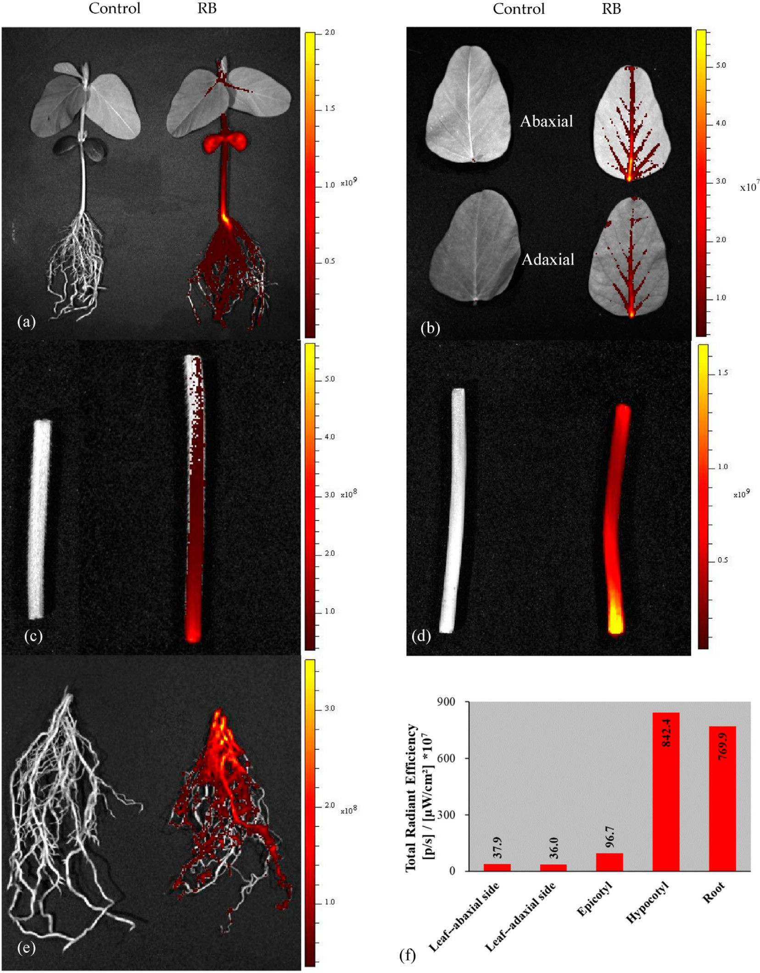](Image%20of%20Fig.%205)

Fig. 5. Imaging of Rh\\B (or RB) in soybean seedlings based on seed treatment: (a) whole plant, (b) leaf, (c) epicotyl, (d) hypocotyl, (e) root, and (f) fluorescence intensity in different parts of soybean seedling (Wang et al., 2020).

shows the distribution of Rh\\B absorbed by celery roots via plant xylem upward to foliage. Stronger fluorescence signal was observed in the plant stem, followed by the leaf midvein, secondary vein, and apex (Su et al., 2020c). Fluorescent compounds generally undergo photodegradation under the radiation of UV and visible light, and sys- temic Rh\\B tracers are no exception (Watanabe et al., 1977). Thus, evaluation of the photobleaching of Rh\\B markers in crops under sun- light is indispensable. Also, the Rh\\B marker on plant health and vigor should be assessed due to the cytotoxicity of this fluorescent compound at higher dose (O'brien et al., 2000). Su et al. (2020b) proved that sys- temic Rh\\B dye in treated celery was photostable for about 4 weeks (Fig. 8) and the celery was tolerant to the 60 ppm Rh\\B. In addition,

the combination of green excitation light and the bandpass emission fil- ter centered at 579 nm showed higher performance than that using the UV light and other filters for plant identifications (Su et al., 2020a). Al- though UV induced fluorescence spectroscopy (400–490 nm) has been utilized to differentiate maize crop from weeds with classification accuracy of over 80% (Panneton et al., 2010; Panneton et al., 2011), such spectroscopic methods using the full wavelength ranges cannot provide image information of target objects, and was not yet suitable for auto- mated online applications. In addition, it was possible to distinguish dif- ferent plants including barley and peas based on the relative intensities at 685 and 735 nm, this fluorescence ratio based on the concentration of chlorophyll had limited ability for plant discriminations (Hilton, 2000).

[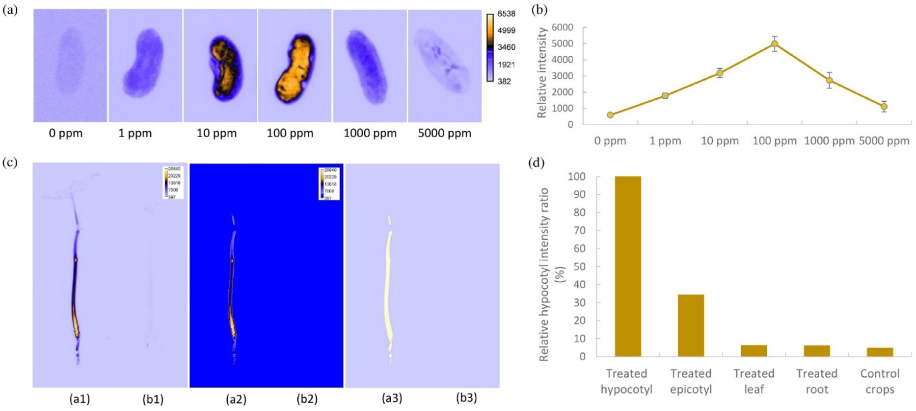](Image%20of%20Fig.%206)

Fig. 6. (a) Pseudo color images of treated snap bean seeds with different dosages of Rh\\B based on a 579 nm emission filter and 523 nm light illumination, (b) Intensity of snap bean seeds treated by different concentrations of Rh\\B based on 579 nm emission filter and 523 nm light illumination, (c) Pseudo-color images of 100 ppm Rh\\B treated (a1, a2, and a3) and control (b1, b2, and b3) bean plants, (d) intensity ratio of different parts of snap bean plants based on 523 nm light excitation and 579 nm emission filter (Su et al., 2020a).

[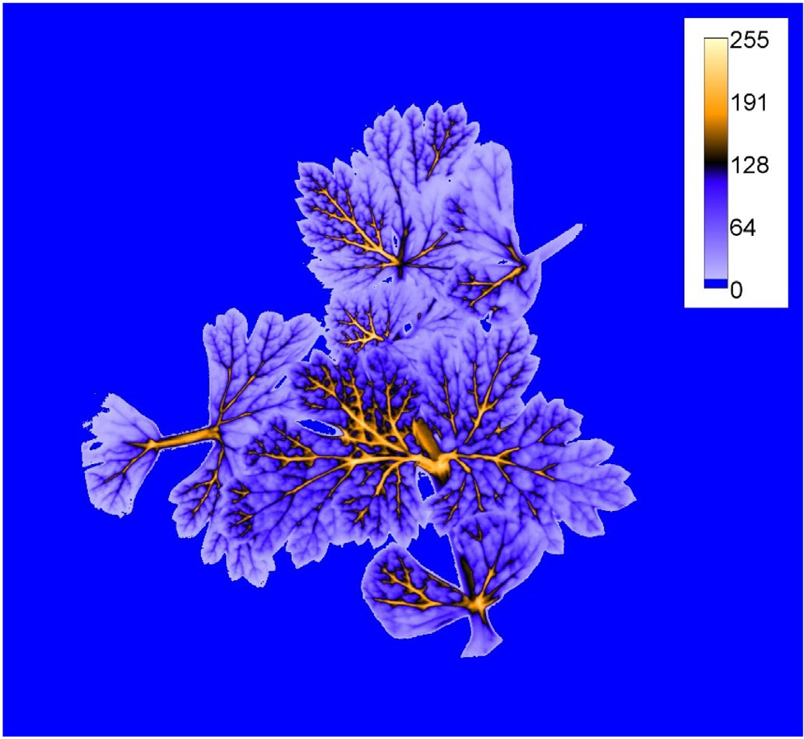](Image%20of%20Fig.%207)

Fig. 7. Pseudo color image of 60 ppm Rh\\B in celery plant following root pathway (Su et al., 2020c).

* + 1. *Topical markers*

Topical markers (water-based latex fluorescent paints) were applied to the plant stems or foliage of crop seedlings by a real-time spray sys- tem during transplanting. The spray system was modified from a stan- dard row crop transplanter, which could accurately target the paint to seedlings. Compared with plant labels, topical markers are automati- cally applied to plant seedlings in the field, making the marking process faster and easier. More information about this spray system can be found elsewhere (Vuong et al., 2017). When the signaling compound was excited using UV light 3 weeks after seedling transplanting, its fluo- rescent signal was still machine-readable. The amount of topical marker applied to the foliage of crop seedling is very limited as an excessive amount of marker may affect the photosynthesis of the leaves and

[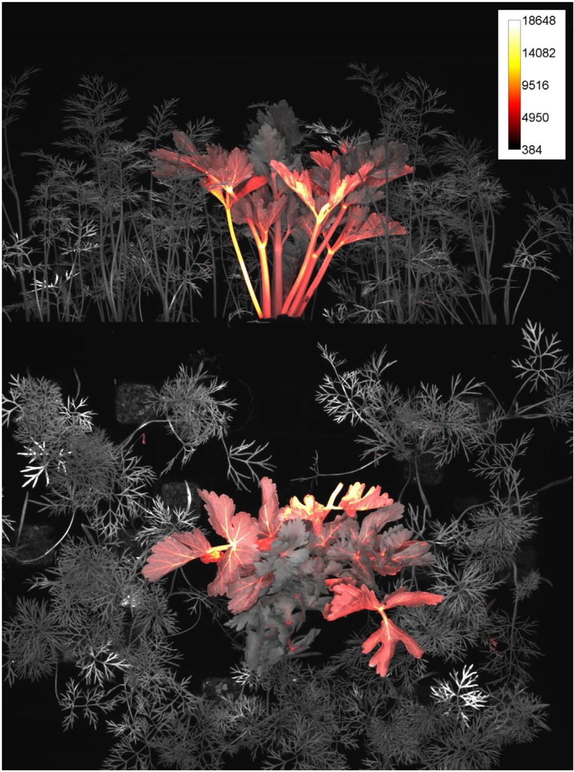](Image%20of%20Fig.%208)Fig. 8. Fluorescence images of carrot weeds and Rh\\B treated celery grown under sunlight for about 4 weeks (Su et al., 2020b).

slow down the growth of plants. Based on topical markers applied to plant stems, this crop signaling system combined with a micro-jet herbicide-spraying device (Fig. 9) achieved an identification accuracy

[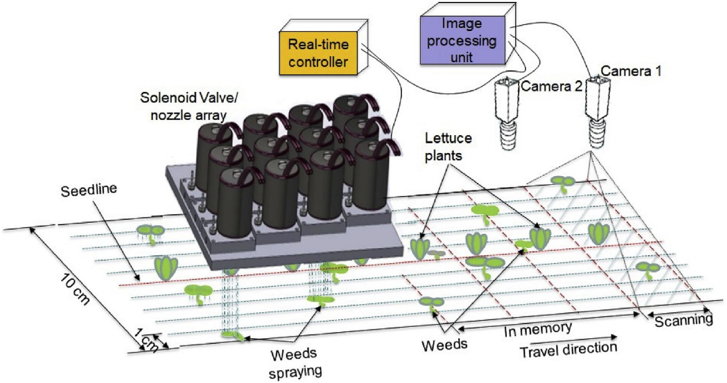](Image%20of%20Fig.%209)

Fig. 9. The design of a micro-jet spraying device detecting weeds in lettuce field (Raja et al., 2020b).

of more than 99.75% of the lettuce plants and 98.11% of sprayable weeds in an outdoor experiment (Raja et al., 2020b). Based on this technology, manual weeding time per hectare can be reduced by up to 48% for veg- etable crops (Kennedy et al., 2019). Overall, topical markers produced a unique fluorescent signal during the first few weeks of the critical weeding season, which is enough to distinguish lettuce plants from weeds. If the marker on the crop stems cannot be detected, it will lead to false identifications. This error may be caused by the occlusion of the leaves, which prevented the fluorescence of the paint on the stem from being received by the camera.

1. Discussions
   1. *Advantages of crop plant signaling*

The development of advanced technology for universal weeding is a difficult but realistic task. Crop plant signaling technology, which gov- erns the basic interaction between crop plants and sensors, has great potential in intelligent crop recognition. The feasibility of the technol- ogy for discriminations of crops and weeds has been illustrated by em- pirical studies. The application of chemical markers was easier compared to physical labels. The extra workload of using physical marker can be compensated for by the advantages of this technology. Systemic crop signaling compounds are not subject to climatic and field conditions as the markers exist inside the crop plants (Su et al., 2020c). The function of systemic markers that translocate from the seed coat to the crop stem is the same as physical markers, but the time and labor needed in the process of seed preparation are very less. Systematic markers based on root treatment can move from the root into the stem and leaves, and their function is the same as the FPs and topical markers used. The signaling methods mentioned in this article are applicable to transplanted crops, but only systemic compounds based on seed treatment are feasible for seeded crops. In addition, crop signaling using systemic markers and FPs requires less labor and is more reliable and feasible. Thus, crop plants marked with systemic signaling compounds (e.g. Rh\\B) based on seed or root pathway were more effectively identified than those with physical or other chemical markers (e.g. plant labels and topical markers) placed on or near the crops. This indicates that this systemic plant signaling method is the easiest and most promising technique for real-time weed control in fields.

Sunlight can cause a fluorescent signal to gradually weaken with

time until it disappears (Song et al., 1995). For all signaling approaches,

the fluorescent marker was photostable for several weeks in small plants, which was significant enough for the routine use of the crop sig- naling technique during the critical period (3 to 5 weeks) of weed re- moval. Plant signaling is best suited in an application context with high weed densities without having to learn plant characteristics. An advantage of this crop plant signaling over conventional sensing tech- niques is that it does not require prior knowledge of the features of weeds or crops. Also, the poor visual appearance of the plants does not compromise system performance. Compared with gene-altered crops, consumer acceptance of crop signaling will be stronger since the small amount of fluorescent tracer disappeared after a period of time under sunlight. Also, their applications to plants and seeds are allowed by federal regulatory agencies. The crop signaling materials proposed are easy to detect, environmentally friendly and cost effective as well as simple to apply, which provided a new breakthrough for au- tomatic plant segmentations.

* 1. *Disadvantages and future potentials of crop plant signaling for on line applications*

The success of crop plant signaling depends on the identification of effective compounds for use on the farm and the development of a safe delivery approach that generates sufficient signal strength to achieve plant identification. Disadvantages to weed/crop differentiation in the field include variable lighting conditions, the ability to robustly control the illumination of the scene with pulsed high-intensity lighting, and the need for high speed plant capture and processing capabilities. The robustness, signal strength, and visibility of fluorescent compounds are critical. Crops in the field are particularly vulnerable to competition from weeds at the seedling stage (about 3 to 5 weeks) (Su, 2020). The time interval of 3 weeks may be not enough for weeding, but more re- search is needed to investigate the alternative new signaling marker that has longer fluorescent lifetime in the future. In a recent study, it was found that the signaling compound showed great photostability in celery plants for 5 weeks (Su et al., 2020c). After 3 to 5 weeks when the crops have survived and grew large, the weeds will not be a big problem. The presence of camera and computer hardware solutions, such as image intensifiers and graphics processing units (GPUs), can mitigate some of the potential signal problems. The rapid development of advanced GPU and camera will bring new imaging sensors with higher resolution at lower cost. High-tech companies that develop intel- ligent weeding technologies are relatively small, but they will likely

become the main source of new weed control technologies instead of traditional pesticide companies in the future.

As a novel technology and concept, although crop plant signaling is not mature enough, the review on plant identification based on a unique fluorescent marker summarized the work of many authors over the span of 4 years. Also, this technology is very promising for real-time and accurate identification of crops in fields. According to the presented literature, crop plant signaling has not yet reached the performance of vision systems based on RGB (and often NIR) cameras, but has shown the great potential to develop the automatic weeding ro- bots comparable to the human eye in crop/weed identification. This paper will be of great significance for the scholars in this field to carry out further related research. In the future, an intelligent control system that integrates the crop plant signaling technology and the intra-row cultivators or sprayers is expected to remove most of the weeds in crops. Nevertheless, as the interaction between crop and weed is a com- plex process, more practical research should be carried out in the field. Further research is planned to determine whether these markers will contaminate field soil or post-harvest agricultural products. After assessing the impact of different doses of Rh\\B on seedling growth, it was found that 60 ppm of Rh\\B was safe for celery but higher concen- trations of the dye were harmful to plant health (Su et al., 2020c). Al- though the marking chemicals from the US EPA list are classified as having no adverse public health effects, it would be good to investigate the yield and nutrition value for at least three crop plants with the chemical markers using crop signaling and compare it with the tradi- tional methods in future. Based on the huge progress of artificial intelli- gence, it appears that the future of crop plant signaling in automated weed control will be very promising.

1. Conclusions

In recent years, much attention has been paid to the development and application of crop plant signaling technology for robotic weed con- trol. This article has highlighted the current research status and pros- pects of crop plant signaling using different markers applied to crop plants for the automatic differentiation of crops and weeds. The fluores- cence of the markers generated under excitation lights was used to indi- cate the specific location of the crop in the field. Three types of signaling methods including physical markers (plant labels), biological markers (FPs), and chemical markers (systemic crop signaling compounds and topical markers) were investigated and summarized. The approach of using physical markers is to place a plant label together with a crop seedling during transplanting. Based on a FP in plants, a characteristic fluorescence was generated under excitation light to distinguish the crops from weeds. Systemic crop signaling is to label the crop plants by applying a signaling compound to the seeds or the roots of crop seed- lings. Topical marker is a more direct method by applying the com- pound directly to the stems or leaves of crops. The results showed that the accuracy of distinguishing weeds/crops using crop plant signaling was very promising. The intelligent system developed for automatic weed control improved the recognition of crops from weeds. Such ap- plication results demonstrated that crop plant signaling has great po- tential to enable precise weeding on a commercial scale.

Declaration of Competing Interest

None.

References

Akbarzadeh, S., Paap, A., Ahderom, S., Apopei, B., Alameh, K., 2018. [Plant discrimination by](http://refhub.elsevier.com/S2589-7217(20)30032-5/rf0005) [support vector machine classifier based on spectral reflectance. Comput. Electron.](http://refhub.elsevier.com/S2589-7217(20)30032-5/rf0005) [Agric. 148, 250–258](http://refhub.elsevier.com/S2589-7217(20)30032-5/rf0005).

Borregaard, T., Nielsen, H., Nørgaard, L., Have, H., 2000. [Crop–weed discrimination by line](http://refhub.elsevier.com/S2589-7217(20)30032-5/rf0010) [imaging spectroscopy. J. Agric. Eng. Res. 75, 389–40](http://refhub.elsevier.com/S2589-7217(20)30032-5/rf0010)0.

Chudakov, D.M., Matz, M.V., Lukyanov, S., Lukyanov, K.A., 2010. [Fluorescent proteins and](http://refhub.elsevier.com/S2589-7217(20)30032-5/rf0015) [their applications in imaging living cells and tissues. Physiol. Rev. 90 (3), 1103–1163](http://refhub.elsevier.com/S2589-7217(20)30032-5/rf0015). Clevers, J.G., Kooistra, L., 2011. [Using hyperspectral remote sensing data for retrieving](http://refhub.elsevier.com/S2589-7217(20)30032-5/rf0020) [canopy chlorophyll and nitrogen content. IEEE J. Select. Topics Appl. Earth Observ.](http://refhub.elsevier.com/S2589-7217(20)30032-5/rf0020)

[Remote Sens. 5, 574–58](http://refhub.elsevier.com/S2589-7217(20)30032-5/rf0020)3.

Davis, A.S., Frisvold, G.B., 2017. [Are herbicides a once in a century method of weed](http://refhub.elsevier.com/S2589-7217(20)30032-5/rf0025) [control? Pest Manag. Sci. 73, 2209–222](http://refhub.elsevier.com/S2589-7217(20)30032-5/rf0025)0.

Dixit, R., Cyr, R., Gilroy, S., 2006. [Using intrinsically fluorescent proteins for plant cell](http://refhub.elsevier.com/S2589-7217(20)30032-5/rf0030) [imaging. Plant J. 45, 599–61](http://refhub.elsevier.com/S2589-7217(20)30032-5/rf0030)5.

Eddy, P., Smith, A., Hill, B., Peddle, D., Coburn, C., Blackshaw, R., 2014. [Weed and crop dis-](http://refhub.elsevier.com/S2589-7217(20)30032-5/rf0035) [crimination using hyperspectral image data and reduced bandsets. Can. J. Remote.](http://refhub.elsevier.com/S2589-7217(20)30032-5/rf0035) [Sens. 39, 481–49](http://refhub.elsevier.com/S2589-7217(20)30032-5/rf0035)0.

El-Faki, M.S., Zhang, N., Peterson, D., 2000. [Weed detection using color machine vision.](http://refhub.elsevier.com/S2589-7217(20)30032-5/rf0040)

[Trans. ASAE 43, 196](http://refhub.elsevier.com/S2589-7217(20)30032-5/rf0040)9.

Elstone, L., How, K.Y., Brodie, S., Ghazali, M.Z., Heath, W.P., Grieve, B., 2020. [High speed](http://refhub.elsevier.com/S2589-7217(20)30032-5/rf0045) [crop and weed identification in lettuce fields for precision weeding. Sensors 20, 455](http://refhub.elsevier.com/S2589-7217(20)30032-5/rf0045). Fennimore, S.A., Boyd, N.S., 2018. [Sustainable Weed Control in Strawberry. Weed Control:](http://refhub.elsevier.com/S2589-7217(20)30032-5/rf0050)

[Sustainability, Hazards, and Risks in Cropping Systems Worldwide. p. 38](http://refhub.elsevier.com/S2589-7217(20)30032-5/rf0050)3.

Fennimore, S.A., Cutulle, M., 2019. [Robotic weeders can improve weed control options for](http://refhub.elsevier.com/S2589-7217(20)30032-5/rf0055) [specialty crops. Pest Manag. Sci. 75, 1767–1774](http://refhub.elsevier.com/S2589-7217(20)30032-5/rf0055).

Fennimore, S.A., Tourte, L., 2019. [Regulatory burdens on development of automated](http://refhub.elsevier.com/S2589-7217(20)30032-5/rf0060) [weeding machines and herbicides are different. Outlooks Pest Manag. 30, 147–15](http://refhub.elsevier.com/S2589-7217(20)30032-5/rf0060)1.

Fletcher, R.S., Reddy, K.N., 2016. [Random forest and leaf multispectral reflectance data to](http://refhub.elsevier.com/S2589-7217(20)30032-5/rf0065) [differentiate three soybean varieties from two pigweeds. Comput. Electron. Agric.](http://refhub.elsevier.com/S2589-7217(20)30032-5/rf0065) [128, 199–20](http://refhub.elsevier.com/S2589-7217(20)30032-5/rf0065)6.

Gao, J., Liao, W., Nuyttens, D., Lootens, P., Vangeyte, J., Pižurica, A., He, Y., Pieters, J.G., 2018. [Fusion of pixel and object-based features for weed mapping using unmanned aerial](http://refhub.elsevier.com/S2589-7217(20)30032-5/rf0070) [vehicle imagery. Int. J. Appl. Earth Obs. Geoinf. 67, 43–53](http://refhub.elsevier.com/S2589-7217(20)30032-5/rf0070).

Han, X., Lin, J., Xing, R., Fu, J., Wang, S., 2003. [Patterning and optical properties rhodamine](http://refhub.elsevier.com/S2589-7217(20)30032-5/rf0075) [B-doped organic–inorganic silica films fabricated by sol–gel soft lithography. Mater.](http://refhub.elsevier.com/S2589-7217(20)30032-5/rf0075) [Lett. 57, 1355–1360.](http://refhub.elsevier.com/S2589-7217(20)30032-5/rf0075)

Hao, L., Liu, X., Zhou, X., Li, J., Suo, X., 2007. [Transient transfection of Eimeria tenella using](http://refhub.elsevier.com/S2589-7217(20)30032-5/rf0080) [yellow or red fluorescent protein as a marker. Mol. Biochem. Parasitol. 153, 213–21](http://refhub.elsevier.com/S2589-7217(20)30032-5/rf0080)5. Hildebrandt, A., Guillamón, M., Lacorte, S., Tauler, R., Barceló, D., 2008. [Impact of pesticides](http://refhub.elsevier.com/S2589-7217(20)30032-5/rf0085) [used in agriculture and vineyards to surface and groundwater quality (North Spain).](http://refhub.elsevier.com/S2589-7217(20)30032-5/rf0085)

[Water Res. 42, 3315–332](http://refhub.elsevier.com/S2589-7217(20)30032-5/rf0085)6.

Hilton, P.J., 2000. [Laser-induced fluorescence for discrimination of crops and weeds. High-](http://refhub.elsevier.com/S2589-7217(20)30032-5/rf0090) [Resolution Wavefront Control: Methods, Devices, and Applications II. International](http://refhub.elsevier.com/S2589-7217(20)30032-5/rf0090) [Society for Optics and Photonics, pp. 223–231](http://refhub.elsevier.com/S2589-7217(20)30032-5/rf0090).

Hsu, F.C., Marxmiller, R.L., Yang, A.Y., 1990. [Study of root uptake and xylem translocation](http://refhub.elsevier.com/S2589-7217(20)30032-5/rf0095) [of cinmethylin and related compounds in detopped soybean roots using a pressure](http://refhub.elsevier.com/S2589-7217(20)30032-5/rf0095) [chamber technique. Plant Physiol. 93, 1573–157](http://refhub.elsevier.com/S2589-7217(20)30032-5/rf0095)8.

Jurado-Expósito, M., López-Granados, F., Atenciano, S., Garcıa-Torres, L., González- Andújar, J.L., 2003. [Discrimination of weed seedlings, wheat (*Triticum aestivum*) stub-](http://refhub.elsevier.com/S2589-7217(20)30032-5/rf0100) [ble and sunflower (*Helianthus annuus*) by near-infrared reflectance spectroscopy](http://refhub.elsevier.com/S2589-7217(20)30032-5/rf0100) [(NIRS). Crop Prot. 22, 1177–118](http://refhub.elsevier.com/S2589-7217(20)30032-5/rf0100)0.

Kennedy, H., Fennimore, S.A., Slaughter, D.C., Nguyen, T.T., Vuong, V.L., Raja, R., Smith, R.F., 2019. [Crop signal markers facilitate crop detection and weed removal from lettuce](http://refhub.elsevier.com/S2589-7217(20)30032-5/rf0105) [and tomato by an intelligent cultivator. Weed Technol. 1–32](http://refhub.elsevier.com/S2589-7217(20)30032-5/rf0105).

Lappartient, A.G., Vidmar, J.J., Leustek, T., Glass, A.D., Touraine, B., 1999. [Inter-organ signal-](http://refhub.elsevier.com/S2589-7217(20)30032-5/rf0110) [ing in plants: regulation of ATP sulfurylase and sulfate transporter genes expression](http://refhub.elsevier.com/S2589-7217(20)30032-5/rf0110) [in roots mediated by phloem-translocated compound. Plant J. 18, 89–95](http://refhub.elsevier.com/S2589-7217(20)30032-5/rf0110).

Lara, A.E.P., Pedraza, C., Jamaica-Tenjo, D.A., 2020. [Weed Estimation on Lettuce Crops](http://refhub.elsevier.com/S2589-7217(20)30032-5/rf0115) [Using Histograms of Oriented Gradients and Multispectral Images, Pattern Recogni-](http://refhub.elsevier.com/S2589-7217(20)30032-5/rf0115) [tion Applications in Engineering. IGI Global, pp. 204–22](http://refhub.elsevier.com/S2589-7217(20)30032-5/rf0115)8.

Liu, Z., Gaskin, R.E., 2004. [Visualisation of the uptake of two model xenobiotics into bean](http://refhub.elsevier.com/S2589-7217(20)30032-5/rf0120) [leaves by confocal laser scanning microscopy: diffusion pathways and implication in](http://refhub.elsevier.com/S2589-7217(20)30032-5/rf0120) [phloem translocation. Pest Manag. Sci. Form. Pesticide Sci. 60, 434–43](http://refhub.elsevier.com/S2589-7217(20)30032-5/rf0120)9.

Nguyen, T.T., Slaughter, D.C., Fennimore, S.A., Vuong, V.L., 2017. [Designing and evaluating](http://refhub.elsevier.com/S2589-7217(20)30032-5/rf0125) [the use of crop signaling markers for fully automated and robust weed control tech-](http://refhub.elsevier.com/S2589-7217(20)30032-5/rf0125) [nology. 2017 ASABE Annual International Meeting. ASABE, St. Joseph, MI, p. 1](http://refhub.elsevier.com/S2589-7217(20)30032-5/rf0125).

O’brien, J., Wilson, I., Orton, T., Pognan, F., 2000. [Investigation of the Alamar Blue](http://refhub.elsevier.com/S2589-7217(20)30032-5/rf0130) [(resazurin) fluorescent dye for the assessment of mammalian cell cytotoxicity. Eur.](http://refhub.elsevier.com/S2589-7217(20)30032-5/rf0130)

[J. Biochem. 267, 5421–5426](http://refhub.elsevier.com/S2589-7217(20)30032-5/rf0130).

Okamoto, H., Murata, T., Kataoka, T., HATA, S.I., 2007. [Plant classification for weed detec-](http://refhub.elsevier.com/S2589-7217(20)30032-5/rf0135) [tion using hyperspectral imaging with wavelet analysis. Weed Biol. Manag. 7, 31–37](http://refhub.elsevier.com/S2589-7217(20)30032-5/rf0135). Panneton, B., Guillaume, S., Roger, J.-M., Samson, G., 2010. [Improved discrimination be-](http://refhub.elsevier.com/S2589-7217(20)30032-5/rf0140) [tween monocotyledonous and dicotyledonous plants for weed control based on the](http://refhub.elsevier.com/S2589-7217(20)30032-5/rf0140) [blue-green region of ultraviolet-induced fluorescence spectra. Appl. Spectrosc. 64,](http://refhub.elsevier.com/S2589-7217(20)30032-5/rf0140)

[30–36](http://refhub.elsevier.com/S2589-7217(20)30032-5/rf0140).

Panneton, B., Guillaume, S., Samson, G., Roger, J.-M., 2011. [Discrimination of corn from](http://refhub.elsevier.com/S2589-7217(20)30032-5/rf0145) [monocotyledonous weeds with ultraviolet (UV) induced fluorescence. Appl.](http://refhub.elsevier.com/S2589-7217(20)30032-5/rf0145) [Spectrosc. 65, 10–19](http://refhub.elsevier.com/S2589-7217(20)30032-5/rf0145).

Pateiro-Moure, M., Arias-Estévez, M., Simal-Gándara, J.s., 2013. [Critical review on the en-](http://refhub.elsevier.com/S2589-7217(20)30032-5/rf0150) [vironmental fate of quaternary ammonium herbicides in soils devoted to vineyards.](http://refhub.elsevier.com/S2589-7217(20)30032-5/rf0150) [Environ. Sci. Technol. 47, 4984–499](http://refhub.elsevier.com/S2589-7217(20)30032-5/rf0150)8.

Piron, A., Leemans, V., Lebeau, F., Destain, M.-F., 2009. [Improving in-row weed detection](http://refhub.elsevier.com/S2589-7217(20)30032-5/rf0155) [in multispectral stereoscopic images. Comput. Electron. Agric. 69, 73–79](http://refhub.elsevier.com/S2589-7217(20)30032-5/rf0155).

Plastina, A., 2019. [Estimated Costs of Crop Production in Iowa-201](http://refhub.elsevier.com/S2589-7217(20)30032-5/rf0160)9.

Raja, R., Slaughter, D.C., Fennimore, S.A., Nguyen, T.T., Vuong, V.L., Sinha, N., Tourte, L., Smith, R.F., Siemens, M.C., 2019. [Crop signalling: a novel crop recognition technique](http://refhub.elsevier.com/S2589-7217(20)30032-5/rf0165) [for robotic weed control. Biosyst. Eng. 187, 278–29](http://refhub.elsevier.com/S2589-7217(20)30032-5/rf0165)1.

Raja, R., Nguyen, T.T., Slaughter, D.C., Fennimore, S.A., 2020a. [Real-time robotic weed knife](http://refhub.elsevier.com/S2589-7217(20)30032-5/rf0170) [control system for tomato and lettuce based on geometric appearance of plant labels.](http://refhub.elsevier.com/S2589-7217(20)30032-5/rf0170) [Biosyst. Eng. 194, 152–16](http://refhub.elsevier.com/S2589-7217(20)30032-5/rf0170)4.

Raja, R., Nguyen, T.T., Slaughter, D.C., Fennimore, S.A., 2020b. [Real-time weed-crop classi-](http://refhub.elsevier.com/S2589-7217(20)30032-5/rf0175) [fication and localisation technique for robotic weed control in lettuce. Biosyst. Eng.](http://refhub.elsevier.com/S2589-7217(20)30032-5/rf0175) [192, 257–274](http://refhub.elsevier.com/S2589-7217(20)30032-5/rf0175).

Richards, H., Halfhill, M., Millwood, R., Stewart, C., 2003. [Quantitative GFP fluorescence as](http://refhub.elsevier.com/S2589-7217(20)30032-5/rf0180) [an indicator of recombinant protein synthesis in transgenic plants. Plant Cell Rep. 22,](http://refhub.elsevier.com/S2589-7217(20)30032-5/rf0180) [117–121](http://refhub.elsevier.com/S2589-7217(20)30032-5/rf0180).

Rigoulot, S.B., Schimel, T.M., Lee, J., Brabazon, H., Meier, K.A., Schmid, M.J., Seaberry, E.M., Poindexter, M.R., Layton, J.S., Brabazon, J.W., 2019. [Fluorescence-based whole plant](http://refhub.elsevier.com/S2589-7217(20)30032-5/rf0185) [imaging and phenomics. bioRxiv 865428](http://refhub.elsevier.com/S2589-7217(20)30032-5/rf0185).

Salanenka, Y.A., Taylor, A.G., 2006. [Seed coat permeability and uptake of applied systemic](http://refhub.elsevier.com/S2589-7217(20)30032-5/rf0190) [compounds. IV International Symposium on Seed, Transplant and Stand Establish-](http://refhub.elsevier.com/S2589-7217(20)30032-5/rf0190) [ment of Horticultural Crops; Translating Seed and Seedling 782, pp. 151–154](http://refhub.elsevier.com/S2589-7217(20)30032-5/rf0190).

Salanenka, Y.A., Taylor, A.G., 2011. [Seedcoat permeability: uptake and post-germination](http://refhub.elsevier.com/S2589-7217(20)30032-5/rf0195) [transport of applied model tracer compounds. HortScience 46, 622–626](http://refhub.elsevier.com/S2589-7217(20)30032-5/rf0195).

Santos, A.A.D., Marcato Junior, J., Araújo, M.S., Di Martini, D.R., Tetila, E.C., Siqueira, H.L., Aoki, C., Eltner, A., Matsubara, E.T., Pistori, H., Feitosa, R.Q., Liesenberg, V., Gonçalves, W.N., 2019. [Assessment of CNN-based methods for individual tree detec-](http://refhub.elsevier.com/S2589-7217(20)30032-5/rf0200) [tion on images captured by RGB cameras attached to UAVs. Sensors 19, 359](http://refhub.elsevier.com/S2589-7217(20)30032-5/rf0200)5.

Slaughter, D.C., 2014. [The biological engineer: sensing the difference between crops and](http://refhub.elsevier.com/S2589-7217(20)30032-5/rf0205) [weeds. Automation: The Future of Weed Control in Cropping Systems. Springer,](http://refhub.elsevier.com/S2589-7217(20)30032-5/rf0205)

[pp. 71–95](http://refhub.elsevier.com/S2589-7217(20)30032-5/rf0205).

Slaughter, D., Lanini, W., Giles, D., 2004. [Discriminating weeds from processing tomato](http://refhub.elsevier.com/S2589-7217(20)30032-5/rf0210) [plants using visible and near-infrared spectroscopy. Trans. ASAE 47, 1907](http://refhub.elsevier.com/S2589-7217(20)30032-5/rf0210).

Slaughter, D.C., Giles, D.K., Fennimore, S.A., Smith, R.F., 2008. [Multispectral machine vision](http://refhub.elsevier.com/S2589-7217(20)30032-5/rf0215) [identification of lettuce and weed seedlings for automated weed control. Weed](http://refhub.elsevier.com/S2589-7217(20)30032-5/rf0215) [Technol. 22, 378–38](http://refhub.elsevier.com/S2589-7217(20)30032-5/rf0215)4.

Song, L., Hennink, E., Young, I.T., Tanke, H.J., 1995. [Photobleaching kinetics of fluorescein](http://refhub.elsevier.com/S2589-7217(20)30032-5/rf0220) [in quantitative fluorescence microscopy. Biophys. J. 68, 2588–2600](http://refhub.elsevier.com/S2589-7217(20)30032-5/rf0220).

Staab, E., Slaughter, D., Zhang, Y., Giles, D., 2009. [Hyperspectral imaging system for preci-](http://refhub.elsevier.com/S2589-7217(20)30032-5/rf0225) [sion weed control in processing tomato. 2009 Reno, Nevada, June 21-June 24, 2009.](http://refhub.elsevier.com/S2589-7217(20)30032-5/rf0225) [American Society of Agricultural and Biological Engineers, p. 1](http://refhub.elsevier.com/S2589-7217(20)30032-5/rf0225).

Stewart Jr., C.N., 2005. [Monitoring the presence and expression of transgenes in living](http://refhub.elsevier.com/S2589-7217(20)30032-5/rf0230) [plants. Trends Plant Sci. 10, 390–39](http://refhub.elsevier.com/S2589-7217(20)30032-5/rf0230)6.

Su, W.-H., 2020. [Advanced machine learning in point spectroscopy, RGB- and](http://refhub.elsevier.com/S2589-7217(20)30032-5/rf0235) [hyperspectral-imaging for automatic discriminations of crops and weeds: a review.](http://refhub.elsevier.com/S2589-7217(20)30032-5/rf0235) [Smart Cities 3, 767–792](http://refhub.elsevier.com/S2589-7217(20)30032-5/rf0235).

Su, W.-H., Sun, D.-W., 2016. [Comparative assessment of feature-wavelength eligibility for](http://refhub.elsevier.com/S2589-7217(20)30032-5/rf0240) [measurement of water binding capacity and specific gravity of tuber using diverse](http://refhub.elsevier.com/S2589-7217(20)30032-5/rf0240) [spectral indices stemmed from hyperspectral images. Comput. Electron. Agric. 130,](http://refhub.elsevier.com/S2589-7217(20)30032-5/rf0240) [69–82](http://refhub.elsevier.com/S2589-7217(20)30032-5/rf0240).

Su, W.-H., Sun, D.-W., 2016. [Facilitated wavelength selection and model development for](http://refhub.elsevier.com/S2589-7217(20)30032-5/rf4001) [rapid determination of the purity of organic spelt (Triticum spelta L.) flour using](http://refhub.elsevier.com/S2589-7217(20)30032-5/rf4001) [spectral imaging. Talanta 155, 347–35](http://refhub.elsevier.com/S2589-7217(20)30032-5/rf4001)7.

Su, W.-H., Sun, D.-W., 2016. [Multivariate analysis of hyper/multi-spectra for determining](http://refhub.elsevier.com/S2589-7217(20)30032-5/rf4002) [volatile compounds and visualizing cooking degree during low-temperature baking](http://refhub.elsevier.com/S2589-7217(20)30032-5/rf4002) [of tubers. Comput. Electron. Agric. 127, 561–57](http://refhub.elsevier.com/S2589-7217(20)30032-5/rf4002)1.

Su, W.-H., Sun, D.-W., 2016. [Potential of hyperspectral imaging for visual authentication of](http://refhub.elsevier.com/S2589-7217(20)30032-5/rf4003) [sliced organic potatoes from potato and sweet potato tubers and rapid grading of the](http://refhub.elsevier.com/S2589-7217(20)30032-5/rf4003) [tubers according to moisture proportion. Comput. Electron. Agric. 125, 113–124](http://refhub.elsevier.com/S2589-7217(20)30032-5/rf4003).

Su, W.-H., Sun, D.-w., 2017. [Evaluation of spectral imaging for inspection of adulterants in](http://refhub.elsevier.com/S2589-7217(20)30032-5/rf4004) [terms of common wheat flour, cassava flour and corn flour in organic Avatar wheat](http://refhub.elsevier.com/S2589-7217(20)30032-5/rf4004) [(Triticum spp.) flour. J. Food Eng. 200, 59–69](http://refhub.elsevier.com/S2589-7217(20)30032-5/rf4004).

Su, W.-H., Sun, D.-W., 2017. [Chemical imaging for measuring the time series variations of](http://refhub.elsevier.com/S2589-7217(20)30032-5/rf4006) [tuber dry matter and starch concentration. Comput. Electron. Agric. 140, 361–37](http://refhub.elsevier.com/S2589-7217(20)30032-5/rf4006)3.

Su, W.H., Sun, D.W., 2018. [Multispectral imaging for plant food quality analysis and visu-](http://refhub.elsevier.com/S2589-7217(20)30032-5/rf0245) [alization. Compr. Rev. Food Sci. Food Saf. 17, 220–23](http://refhub.elsevier.com/S2589-7217(20)30032-5/rf0245)9.

Su, W.-H., He, H.-J., Sun, D.-W., 2017a. [Non-destructive and rapid evaluation of staple](http://refhub.elsevier.com/S2589-7217(20)30032-5/rf0250) [foods quality by using spectroscopic techniques: a review. Crit. Rev. Food Sci. Nutr.](http://refhub.elsevier.com/S2589-7217(20)30032-5/rf0250) [57, 1039–105](http://refhub.elsevier.com/S2589-7217(20)30032-5/rf0250)1.

Su, W.-H., Sun, D.-W., 2019. [Mid-infrared (MIR) spectroscopy for quality analysis of liquid](http://refhub.elsevier.com/S2589-7217(20)30032-5/rf4007) [foods. Food Eng. Rev. 11 (3), 142–15](http://refhub.elsevier.com/S2589-7217(20)30032-5/rf4007)8.

Su, W.-H., Sun, D.-W., He, J.-G., Zhang, L.-B., 2017b. [Variation analysis in spectral indices of](http://refhub.elsevier.com/S2589-7217(20)30032-5/rf0255) [volatile chlorpyrifos and non-volatile imidacloprid in jujube (*Ziziphus jujuba* mill.)](http://refhub.elsevier.com/S2589-7217(20)30032-5/rf0255) [using near-infrared hyperspectral imaging (NIR-HSI) and gas chromatograph-mass](http://refhub.elsevier.com/S2589-7217(20)30032-5/rf0255) [spectrometry (GC–MS). Comput. Electron. Agric. 139, 41–55](http://refhub.elsevier.com/S2589-7217(20)30032-5/rf0255).

Su, W.-H., 2020. [Systemic crop signaling for automatic recognition of transplanted lettuce](http://refhub.elsevier.com/S2589-7217(20)30032-5/rf4008) [and tomato under different levels of sunlight for early season weed control. Chal-](http://refhub.elsevier.com/S2589-7217(20)30032-5/rf4008) [lenges 11 (2), 1–13](http://refhub.elsevier.com/S2589-7217(20)30032-5/rf4008).

Su, W.-H., Bakalis, S., Sun, D.-W., 2018. [Fourier transform mid-infrared-attenuated total](http://refhub.elsevier.com/S2589-7217(20)30032-5/rf4009) [reflectance (FTMIR-ATR) microspectroscopy for determining textural property of mi-](http://refhub.elsevier.com/S2589-7217(20)30032-5/rf4009) [crowave baked tuber. J. Food Eng. 218, 1–13](http://refhub.elsevier.com/S2589-7217(20)30032-5/rf4009).

Su, W.-H., Bakalis, S., Sun, D.-W., 2019. [Fingerprinting study of tuber ultimate compressive](http://refhub.elsevier.com/S2589-7217(20)30032-5/rf4011) [strength at different microwave drying times using mid-infrared imaging spectros-](http://refhub.elsevier.com/S2589-7217(20)30032-5/rf4011) [copy. Drying Technol. 37 (9), 1113–1130.](http://refhub.elsevier.com/S2589-7217(20)30032-5/rf4011)

Su, W.-H., Bakalis, S., Sun, D.-W., 2019. [Chemometrics in tandem with near infrared (NIR)](http://refhub.elsevier.com/S2589-7217(20)30032-5/rf4012) [hyperspectral imaging and Fourier transform mid infrared (FT-MIR)](http://refhub.elsevier.com/S2589-7217(20)30032-5/rf4012) [microspectroscopy for variety identification and cooking loss determination of](http://refhub.elsevier.com/S2589-7217(20)30032-5/rf4012) [sweet potato. Biosyst. Eng. 180, 70–86](http://refhub.elsevier.com/S2589-7217(20)30032-5/rf4012).

Su, W.-H, Bakalis, S., Sun, D.-W., 2020. [Chemometric determination of time series mois-](http://refhub.elsevier.com/S2589-7217(20)30032-5/rf4013) [ture in both potato and sweet potato tubers during hot air and microwave drying](http://refhub.elsevier.com/S2589-7217(20)30032-5/rf4013) [using near/mid-infrared (NIR/MIR) hyperspectral techniques. Drying Technol. 38](http://refhub.elsevier.com/S2589-7217(20)30032-5/rf4013) [(5–6), 806–823](http://refhub.elsevier.com/S2589-7217(20)30032-5/rf4013).

Su, W.-H., Fennimore, S.A., Slaughter, D.C., 2019a. [Computer Vision Technology for Iden-](http://refhub.elsevier.com/S2589-7217(20)30032-5/rf0260) [tification of Snap Bean Crops using Systemic Rhodamine B, 2019 ASABE Annual Inter-](http://refhub.elsevier.com/S2589-7217(20)30032-5/rf0260) [national Meeting. American Society of Agricultural and Biological Engineers, p. 1](http://refhub.elsevier.com/S2589-7217(20)30032-5/rf0260).

Su, W.-H., Fennimore, S.A., Slaughter, D.C., 2019b. [Fluorescence imaging for rapid moni-](http://refhub.elsevier.com/S2589-7217(20)30032-5/rf0265) [toring of translocation behaviour of systemic markers in snap beans for automated](http://refhub.elsevier.com/S2589-7217(20)30032-5/rf0265) [crop/weed discrimination. Biosyst. Eng. 186, 156–167](http://refhub.elsevier.com/S2589-7217(20)30032-5/rf0265).

Su, W.-H., Fennimore, S.A., Slaughter, D.C., 2020a. [Development of a systemic crop signal-](http://refhub.elsevier.com/S2589-7217(20)30032-5/rf0270) [ling system for automated real-time plant care in vegetable crops. Biosyst. Eng. 193,](http://refhub.elsevier.com/S2589-7217(20)30032-5/rf0270) [62–74](http://refhub.elsevier.com/S2589-7217(20)30032-5/rf0270).

Su, W.-H., Fennimore, S.A., Slaughter, D.C., 2020b. [Evaluation of Photostability of Rhoda-](http://refhub.elsevier.com/S2589-7217(20)30032-5/rf0275) [mine B for Automatic Recognition of Tomato Plants, 2020 ASABE Annual Interna-](http://refhub.elsevier.com/S2589-7217(20)30032-5/rf0275) [tional Virtual Meeting. ASABE, St. Joseph, MI, pp. 1–](http://refhub.elsevier.com/S2589-7217(20)30032-5/rf0275)4.

Su, W.-H., Slaughter, D.C., Fennimore, S.A., 2020c. [Non-destructive evaluation of](http://refhub.elsevier.com/S2589-7217(20)30032-5/rf0280) [photostability of crop signaling compounds and dose effects on celery vigor for pre-](http://refhub.elsevier.com/S2589-7217(20)30032-5/rf0280) [cision plant identification using computer vision. Comput. Electron. Agric. 168,](http://refhub.elsevier.com/S2589-7217(20)30032-5/rf0280) [10515](http://refhub.elsevier.com/S2589-7217(20)30032-5/rf0280)5.

Su, W.-H., Yang, C., Dong, Y., Johnson, R., Page, R., Szinyei, T., Hirsch, C.D., Steffenson, B.J., 2020. [Hyperspectral imaging and improved feature variable selection for automated](http://refhub.elsevier.com/S2589-7217(20)30032-5/rf4014) [determination of deoxynivalenol in various genetic lines of barley kernels for resis-](http://refhub.elsevier.com/S2589-7217(20)30032-5/rf4014) [tance screening. Food Chem. 128507](http://refhub.elsevier.com/S2589-7217(20)30032-5/rf4014).

Taylor, A., Salanenka, Y., 2012. [Seed treatments: phytotoxicity amelioration and tracer up-](http://refhub.elsevier.com/S2589-7217(20)30032-5/rf0285) [take. Seed Sci. Res. 22, S86–S90](http://refhub.elsevier.com/S2589-7217(20)30032-5/rf0285).

Ustin, S.L., Gitelson, A.A., Jacquemoud, S., Schaepman, M., Asner, G.P., Gamon, J.A., Zarco- Tejada, P., 2009. [Retrieval of foliar information about plant pigment systems from](http://refhub.elsevier.com/S2589-7217(20)30032-5/rf0290) [high resolution spectroscopy. Remote Sens. Environ. 113, S67–S7](http://refhub.elsevier.com/S2589-7217(20)30032-5/rf0290)7.

Vuong, V.L., Slaughter, D.C., Nguyen, T.T., Fennimore, S.A., Giles, D.K., 2017. [An Automated](http://refhub.elsevier.com/S2589-7217(20)30032-5/rf0295) [System for Crop Signaling and Robotic Weed Control in Processing Tomatoes, 2017](http://refhub.elsevier.com/S2589-7217(20)30032-5/rf0295) [ASABE Annual International Meeting. American Society of Agricultural and Biological](http://refhub.elsevier.com/S2589-7217(20)30032-5/rf0295) [Engineers, p.](http://refhub.elsevier.com/S2589-7217(20)30032-5/rf0295) 1.

Wang, K., Kang, L., Anand, A., Lazarovits, G., Mysore, K.S., 2007. [Monitoring in planta bac-](http://refhub.elsevier.com/S2589-7217(20)30032-5/rf0300) [terial infection at both cellular and whole-plant levels using the green fluorescent](http://refhub.elsevier.com/S2589-7217(20)30032-5/rf0300) [protein variant GFPuv. New Phytol. 174, 212–223](http://refhub.elsevier.com/S2589-7217(20)30032-5/rf0300).

Wang, Z., Amirkhani, M., Avelar, S.A.G., Yang, D., Taylor, A.G., 2020. [Systemic uptake of](http://refhub.elsevier.com/S2589-7217(20)30032-5/rf0305) [fluorescent tracers by soybean (*Glycine max* (L.) Merr.) seed and seedlings. Agricul-](http://refhub.elsevier.com/S2589-7217(20)30032-5/rf0305) [ture 10, 248](http://refhub.elsevier.com/S2589-7217(20)30032-5/rf0305).

Watanabe, T., Takizawa, T., Honda, K., 1977. [Photocatalysis through excitation of adsor-](http://refhub.elsevier.com/S2589-7217(20)30032-5/rf0310) [bates. 1. Highly efficient N-deethylation of rhodamine B adsorbed to cadmium sul-](http://refhub.elsevier.com/S2589-7217(20)30032-5/rf0310) [fide. J. Phys. Chem. 81, 1845–1851](http://refhub.elsevier.com/S2589-7217(20)30032-5/rf0310).

Westwood, J.H., Charudattan, R., Duke, S.O., Fennimore, S.A., Marrone, P., Slaughter, D.C., Swanton, C., Zollinger, R., 2018. [Weed management in 2050: perspectives on the fu-](http://refhub.elsevier.com/S2589-7217(20)30032-5/rf0315) [ture of weed science. Weed Sci. 66, 275–28](http://refhub.elsevier.com/S2589-7217(20)30032-5/rf0315)5.

Xian, M., Honbo, N., Zhang, J., Liew, C.-C., Karliner, J.S., Lau, Y.-F.C., 1999. [The green fluores-](http://refhub.elsevier.com/S2589-7217(20)30032-5/rf0320) [cent protein is an efficient biological marker for cardiac myocytes. J. Mol. Cell. Cardiol.](http://refhub.elsevier.com/S2589-7217(20)30032-5/rf0320) [31, 2155–2165](http://refhub.elsevier.com/S2589-7217(20)30032-5/rf0320).

Yang, D., Donovan, S., Black, B.C., Cheng, L., Taylor, A.G., 2018. [Relationships between com-](http://refhub.elsevier.com/S2589-7217(20)30032-5/rf0325) [pound lipophilicity on seed coat permeability and embryo uptake by soybean and](http://refhub.elsevier.com/S2589-7217(20)30032-5/rf0325) [corn. Seed Sci. Res. 28, 229–23](http://refhub.elsevier.com/S2589-7217(20)30032-5/rf0325)5.

Zhang, Y., Slaughter, D.C., Staab, E.S., 2012. [Robust hyperspectral vision-based classifica-](http://refhub.elsevier.com/S2589-7217(20)30032-5/rf0330) [tion for multi-season weed mapping. ISPRS J. Photogramm. Remote Sens. 69, 65–73](http://refhub.elsevier.com/S2589-7217(20)30032-5/rf0330).