[Artificial Intelligence in Agriculture 6 (2022) 47–54](https://doi.org/10.1016/j.aiia.2022.01.002)

Contents lists available at [ScienceDirect](http://www.sciencedirect.com/science/journal/)

Artificial Intelligence in Agriculture

journal homepage: [http://www.keaipublishing.com/en/journa ls/artificial- intelligence- in-agriculture/](http://www.keaipublishing.com/en/journals/artificial-intelligence-in-agriculture/)

[](http://crossmark.crossref.org/dialog/?doi=10.1016/j.aiia.2022.01.002&domain=pdf)Deep convolutional neural network models for weed detection in polyhouse grown bell peppers

A. Subeesh ⁎, S. Bhole, K. Singh, N.S. Chandel, Y.A. Rajwade, K.V.R. Rao, S.P. Kumar, D. Jat

*ICAR-Central Institute of Agricultural Engineering (CIAE), Bhopal, Madhya Pradesh, India*

# a r t i c l e i n f o

*Article history:*

Received 30 October 2021

Received in revised form 18 January 2022 Accepted 27 January 2022

Available online 10 February 2022

*Keywords:*

Bell pepper Computer vision

Convolutional neural networks Deep learning

Weed identification

# a b s t r a c t

Conventional weed management approaches are inefficient and non-suitable for integration with smart agricul- tural machinery. Automatic identification and classification of weeds can play a vital role in weed management contributing to better crop yields. Intelligent and smart spot-spraying system's efficiency relies on the accuracy of the computer vision based detectors for autonomous weed control. In the present study, feasibility of deep learning based techniques (Alexnet, GoogLeNet, InceptionV3, Xception) were evaluated in weed identification from RGB images of bell pepper field. The models were trained with different values of epochs (10, 20,30), batch sizes (16, 32), and hyperparameters were tuned to get optimal performance. The overall accuracy of the selected models varied from 94.5 to 97.7%. Among the models, InceptionV3 exhibited superior performance at 30-epoch and 16-batch size with a 97.7% accuracy, 98.5% precision, and 97.8% recall. For this Inception3 model, the type 1 error was obtained as 1.4% and type II error was 0.9%. The effectiveness of the deep learning model presents a clear path towards integrating them with image-based herbicide applicators for precise weed management.

© 2022 The Authors. Publishing services by Elsevier B.V. on behalf of KeAi Communications Co., Ltd. This is an open access article under the CC BY-NC-ND license (<http://creativecommons.org/licenses/by-nc-nd/4.0/>).

1. Introduction

Bell pepper (*Capsicum annum L*.) is an important crop cultivated all over the world owing to its commercial value and medicinal uses (De, 2003; Gonzalez-Diaz et al., 2009). Bell pepper is also known as ‘sweet pepper’, ‘pepper’ or ‘capsicum’ and is cultivated for its fruit. India con- tributes one-fourth of the world's production of bell peppers with an av- erage annual production of 0.9 MT from an area of 0.885 million hectares (Kumar et al., 2016). Like any other crop, bell peppers are sub- ject to biotic and abiotic factors that negatively affect the yield, weed being the major biotic factor (Chandel et al., 2021b). Being a poor com- petitor with weeds, immediately after transplanting, the supply of irri- gation for the crop may stimulate weed growth leading to yield loss up to 97% (Amador-Ramírez, 2002; Campiglia et al., 2012). Pepper pro- ductivity has decreased over the period in open fields compared to polyhouse due to frequent pests and diseases (Jat et al., 2020).

Polyhouse cultivation in India needs to be enhanced in terms of tech- nological intervention and reduction of operating costs (Singh et al., 2019). Weeds not only cause a reduction in yield but also lower crop quality, act as a reservoir for pests and diseases, and reduction in human efficiency. This issue requires the utilization of a weed detection

* Corresponding author.

*E-mail address:* [subeesh18@gmail.com](mailto:subeesh18@gmail.com) (A. Subeesh).

framework (Hasan et al., 2021). Weeds are persistent problems in polyhouses and detract from the perceived quality of crops being grown. Herbicides are a means to control weed growth, but they have several negative consequences for the environment and human health (Bah et al., 2018). The adoption of chemical and cultural control mea- sures might have negative environmental consequences, when not ap- propriately controlled. As most of the countries are facing labour shortages and increased labour costs, automation of weed control sys- tems is a need of the hour (Liu and Bruch, 2020; Subeesh and Mehta, 2021). Weed management in covered structures like polyhouses needs much precision as the vapours from the chemicals can be trapped in closed structures, resulting in damage to both workers as well as the crop.

Weed recognition is one of those essential that requires digitization and automation. Therefore, data-driven and image processing-based techniques using Internet of things and variable rate application of in- puts for real-time automation of system needs to be developed (Mehta et al., 2021). Weed detection in crops is an inherently challeng- ing problem to solve using digital technologies especially, using tradi- tional image processing techniques (Wang et al., 2019). This is due to the shapes and textures of both weed and crop. Varying illuminating condition is another major challenge, when traditional image process- ing techniques have been applied to solve this problem. If weeds are identified at an earlier stage it leads to reduced cost of herbicides (Espejo-Garcia et al., 2020). A typical weed identification system follows

<https://doi.org/10.1016/j.aiia.2022.01.002>

2589-7217/© 2022 The Authors. Publishing services by Elsevier B.V. on behalf of KeAi Communications Co., Ltd. This is an open access article under the CC BY-NC-ND license ([http://](http://creativecommons.org/licenses/by-nc-nd/4.0/) [creativecommons.org/licenses/by-nc-nd/4.0/](http://creativecommons.org/licenses/by-nc-nd/4.0/)).

four key steps: image data collection, pre-processing of images, feature extraction and classification (Shanmugam et al., 2020). Different ad- vanced technologies are in vogue to execute these steps. The most vital part of these steps is weed identification and classification. For the last few years, Artficial Intelligence (AI) and deep learning strategies have been utilized for weed management with progressions in innova- tion replacing the traditional approaches (Sharpe et al., 2019, 2020; Su, 2020).

In recent years, numerous studies have been carried for the automa- tion of the process of identification and classification of weeds. Deep learning based image processing in lettuce crops, three methods for weed estimation were proposed by Osorio et al. (2020), which included machine learning and deep learning models such as Support Vector Ma- chines (SVM), YOLO and Mask R-CNN. The models achieved an F1 score of 88%, 94%, and 94%, respectively for the crop detection. The SVM in this study used histograms of oriented gradients (HOG) as feature descrip- tors and YOLOV3 for object detection and Mask R-CNN for instance seg- mentation. SVM also found to be successful in identifying aquatic weeds (Pereira et al., 2012) and classification of chilli and weeds in images taken from single plants (Ahmed et al., 2012). Yu et al. (2019) reported the efficiency of several deep convolutional neural network (DCNN) models such as VGGNet, GoogLeNet and DetectNet for detection of weeds in bermudagrass. The major finding was that DetectNet exhib- ited high performance for detection of weeds while growing in dormant bermudagrass, with F1 score of 0.99. There were numerous attempts were made by researchers in identifying weeds in rice (Ashraf and Khan, 2020; Barrero et al., 2016; Cheng and Matson, 2015), wheat (Golzarian and Frick, 2011; Hameed and Amin, 2018), onion (Kim et al., 2018; Parico and Ahamed, 2020; Sanchez et al., 2021), etc. Hu et al. (2020) proposed a novel graph-based ‘Graph Weeds Net’ architec- ture to recognize various types of weeds from RGB images collected from complex rangelands and the model achieved good performance with 98.1% accuracy. In the present study, we investigated the feasibility of use of DCNN models such as Alexnet, GoogLeNet, InceptionV3 and Xception in detecting weeds in the bell pepper cultivation.

1. Materials and methods
   1. *Image acquisition*

The images were collected at ICAR-Central Institute of Agricultural Engineering, Bhopal, Madhya Pradesh (longitude — 77°24′11.28″E and latitude — 23°18′35.67”N). A hybrid variety of bell pepper known as ‘Indra’ was cultivated on raised beds according to standard package of practices (Jat et al., 2020). The images were captured between 9 AM to 5 PM inside a polyhouse under varying lighting conditions with a dig- ital camera (Xiaomi Mi 11× mobile device's rear camera, which has a

triple camera setup with 48 MP, f/1.8, 26 mm (wide), 1/2“, 0.8μm, PDAF 8 MP, f/2.2, 119° (ultrawide) 5 MP, f/2.4, 50mm (macro), 1/5.0”,

1.12 μm) at a ratio of 4:3, with a resolution of 4000 × 3000 pixels. A total of 1106 individual images were collected from the polyhouse, with 685 images of bell pepper and 421 images of various weeds. The collected images were grouped into weed and crop categories. The noise and lighting variations have been removed while pre-processing the images. Further, data augmentation has been applied over the dataset to enhance the size and quality of training datasets and prevent overfitting (Shorten and Khoshgoftaar, 2019). The presence of weeds in bell pepper grown in polyhouse is shown in Fig. 1.

The images from the dataset were further divided into training, test- ing and validation. The modeling was performed with 80% of the images for training, 10% for testing and 10% for validation from the total cap- tured images.

* 1. *Deep learning and CNN models*

In the initial years, artificial intelligenceheavily relied on the rule- based engines that can make predictions based on the fixed and predefined rule sets generated by a human expert. However, as the data got massive, a more data driven approach was required and ma- chine learning was into the action. Machine learning is a collection of al- gorithms and tools by which machines can understand patterns within the data and perform reasoning about a specific task. Machine learning has the capability to extract meaningful information from the data using various algorithms. Deep learning (DL) can be considered as a next fron- tier of machine learning; it is a subset of machine learning that makes extensive use of neural networks. The advent of deep learning has brought a revolution in the area of image analysis and computer vision (Chandel et al., 2021a; Hemanth and Estrela, 2017).

Deep learning techniques applied to digital photographs can help distinguish between crops and weeds beyond the limitations of conven- tional image processing. A deep convolutional neural network (DCNN) is a type of artificial intelligence that is extensively utilized in recent years. In the initial days, the most that CNN could do was recognize handwritten digits. At present, DCNN models are the most eccentric ap- paratus in computer vision capable of analysing huge complex datasets, having high computational limits. Numerous DL architectures exist for image classification like AlexNet (Krizhevsky et al., 2012), DenseNet (Huang et al., 2017), EfficientNet (Tan and Le, 2020), GoogLeNet (Szegedy et al., 2015), InceptionNet (Szegedy et al., 2016), NASNet/ PNASNet/ENASNet (Adam and Lorraine, 2019), ResNeXt (Xie et al., 2017), ResNet50 (He et al., 2016), XceptionNet (Chollet, 2017), SENet (Hu et al., 2018), VGGNet (Simonyan and Zisserman, 2015) and ZFNet (Howard et al., 2017). In this study for identifying weeds, the perfor- mance of four different CNN architectures AlexNet, GoogleNet,

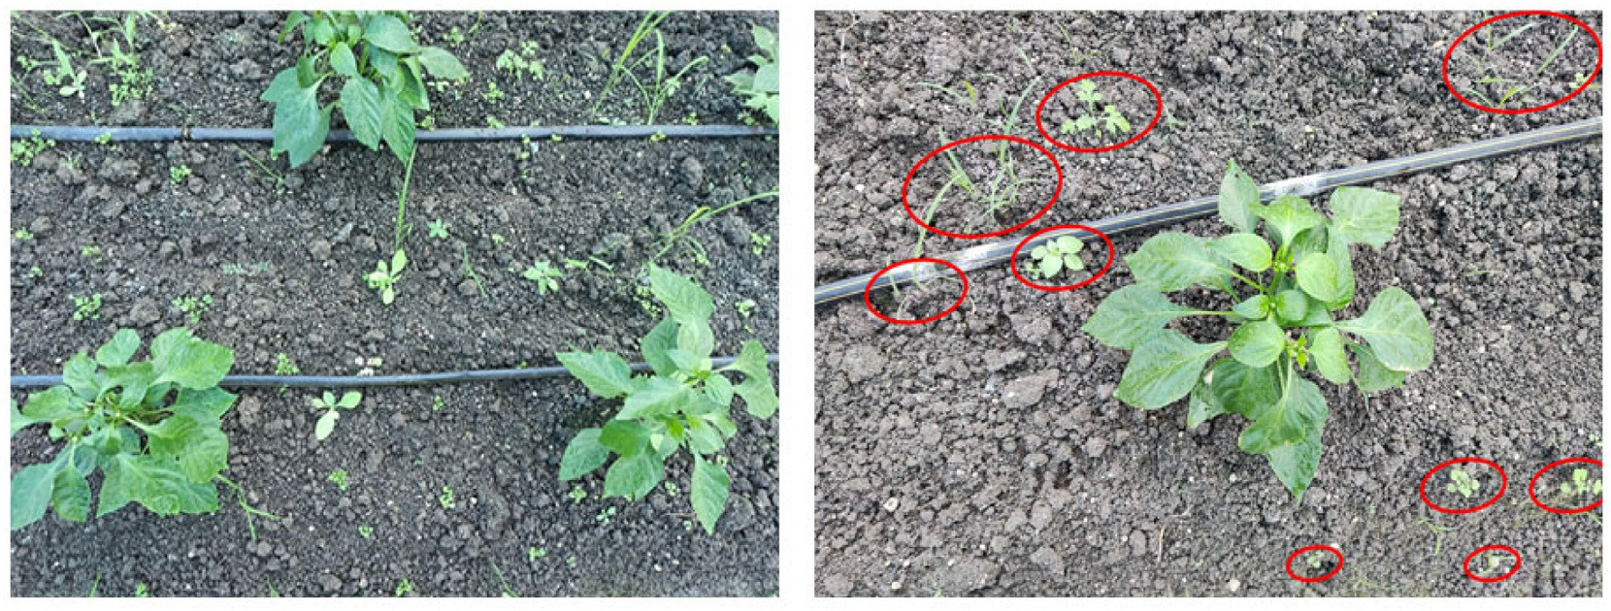

Fig. 1. Presence of weeds in bell pepper grown in polyhouse.

Table 1

Architectural characteristics of selected Convolutional Neural Network (CNN) models.

|  |  |  |  |  |
| --- | --- | --- | --- | --- |
| Model | Parameters (in millions) | Depth | Image input size | Model characteristics |
| AlexNet | 61.0 | 8 | 227 × 227 | Simple architecture with 5 Convolutional layers and 3 Fully connected layers |
| GoogLeNet | 7.0 | 22 | 224 × 224 | Use of auxiliary classifiers, Going deeper with convolutions |
| InceptionV3 | 23.9 | 48 | 299 × 299 | Extended network of GoogLeNet, Reduced computational complexity |
| Xception | 22.9 | 71 | 299 × 299 | Linear stack of depthwise separable convolutions and residual connections, Modular architecture |

InceptionV3 and Xception are investigated. The models were selected based on the complexity and computational cost. AlexNet being the rel- atively simplest models and InceptionV3 (48 layers) and GoogleNet, are of moderate complexity and Xception with high complexity and depth. Table 1 shows the architectural characteristics of these models.

AlexNet is an 8-layer CNN that outperformed all other models in a large margin and won the ImageNet large scale visual recognition chal- lenge held in 2012 (Krizhevsky et al., 2012). Although LeNet (LeCun et al., 1995) had achieved decent results on early datasets of smaller size, the performance while training CNNs on larger datasets were not that impressive. AlexNet has achieved huge improvement over LeNet and it was the first architecture to adopt consecutive convolutional

layers with kernel sizes of (11 × 11), (5 × 5), and (3 × 3). VGG16 Model (Simonyan and Zisserman, 2015), which achieved 92.7% top-5 test accuracy in ImageNet Large-Scale Visual Recognition Challenge. It was submitted to ILSVRC in 2014 where it became one of the popular models. VGG16 showed improved performance over AlexNet by replac- ing large kernel-sized filters (11 and 15 sizes present in AlexNet) with a number of 3 × 3 sized kernels. The introduction of inception networks has made a significant impact in the field of neural networks. The first version of inception model i.e. inceptionV1 is termed as GoogLeNet. This had set a new state of the art for both classification and object de- tection problems. The GoogLeNet Architecture has a depth of 22 layers with 27 pooling layers and 9 inception modules stacked in total

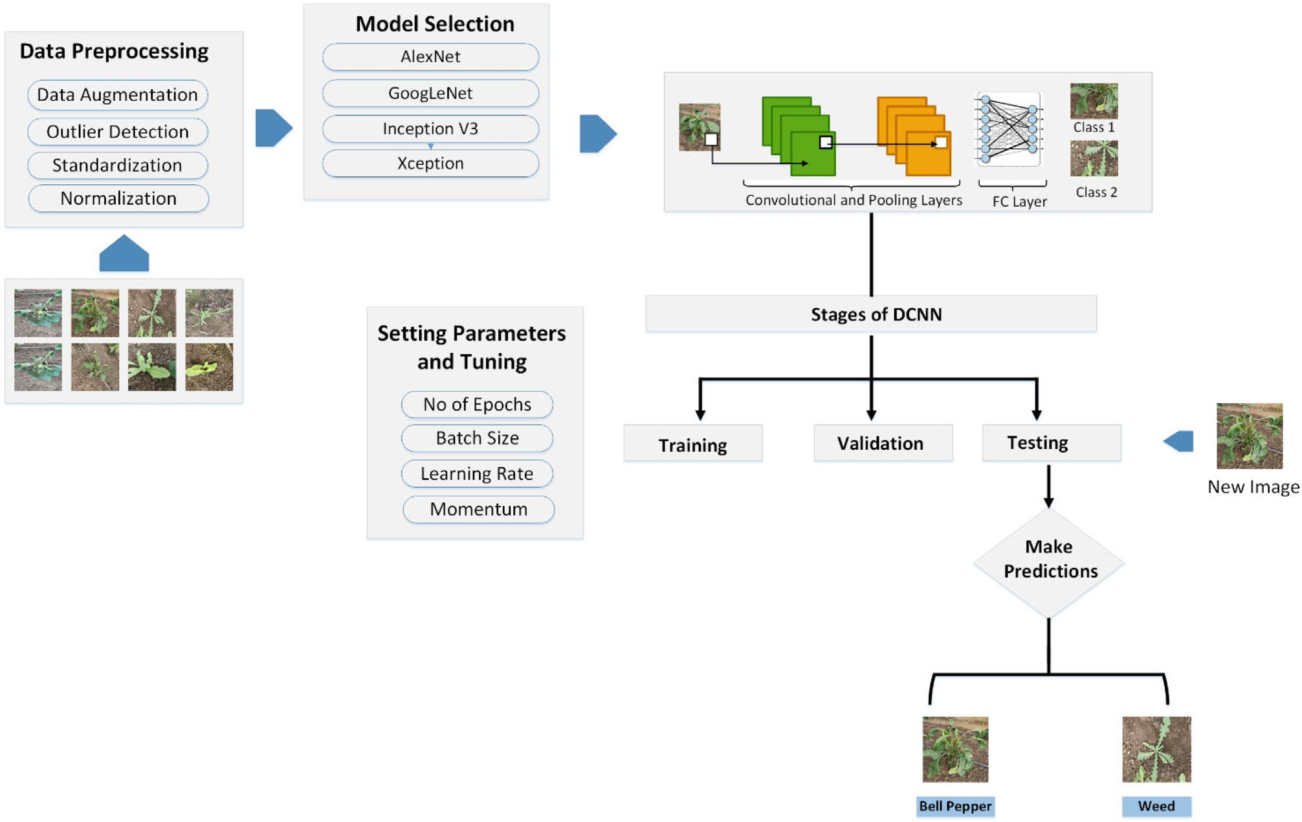

Fig. 2. Deep Learning based Image classification pipeline used for weed identification.

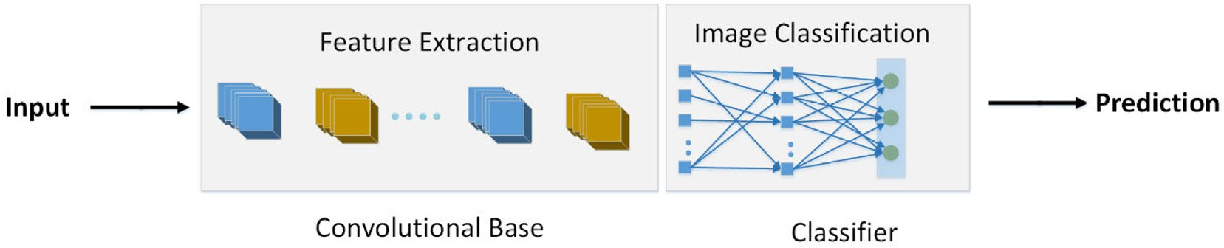

Fig. 3. Components of Image classification using DCNN.

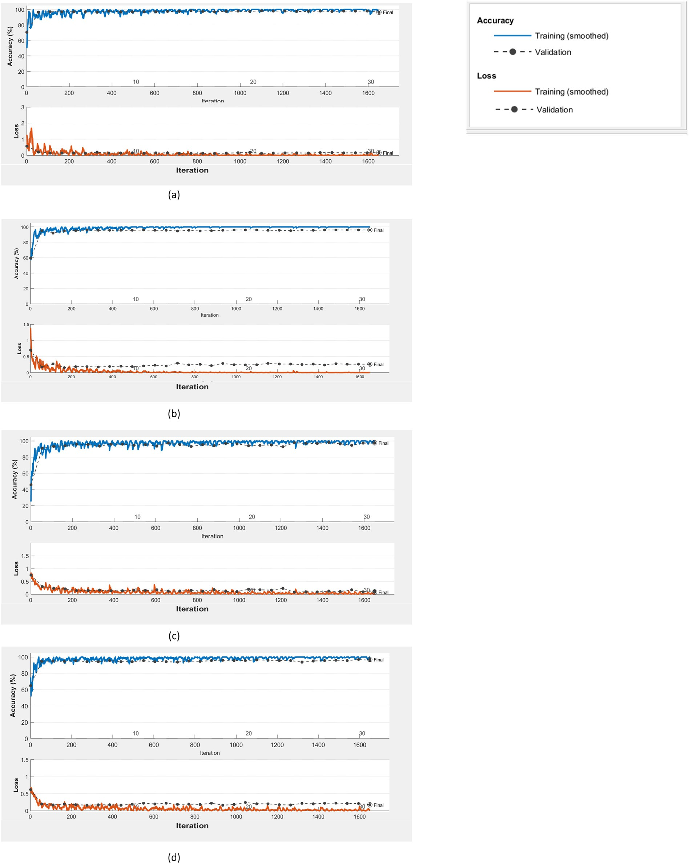

Fig. 4. Accuracy and loss function plots (trained with epoch =30, batch size =16) a) AlexNet, b) GoogLeNet, c) InceptionV3, d) Xception.

(Szegedy et al., 2015). GoogLeNet had achieved a top-5 error rate of 6.67% in ILSVRC, which is very close to the human level performance. In comparison to the AlexNet and GoogLeNet, InceptionV3 model focuses on consuming less computational power. InceptionV3 model optimizes the network with the help of factorized convolution, dimen- sionality reduction, regularization and parallelized computations (Szegedy et al., 2016). Xception is an extreme version of the inception. Depth wise separable convolutional layers make Xception different

from the rest of the models and it follows a modular architecture (Chollet, 2017).

* 1. *Deep learning based image classification framework for weed identification*

The image classification for weed detection began with the image data collection. The data has been collected from the precision farming

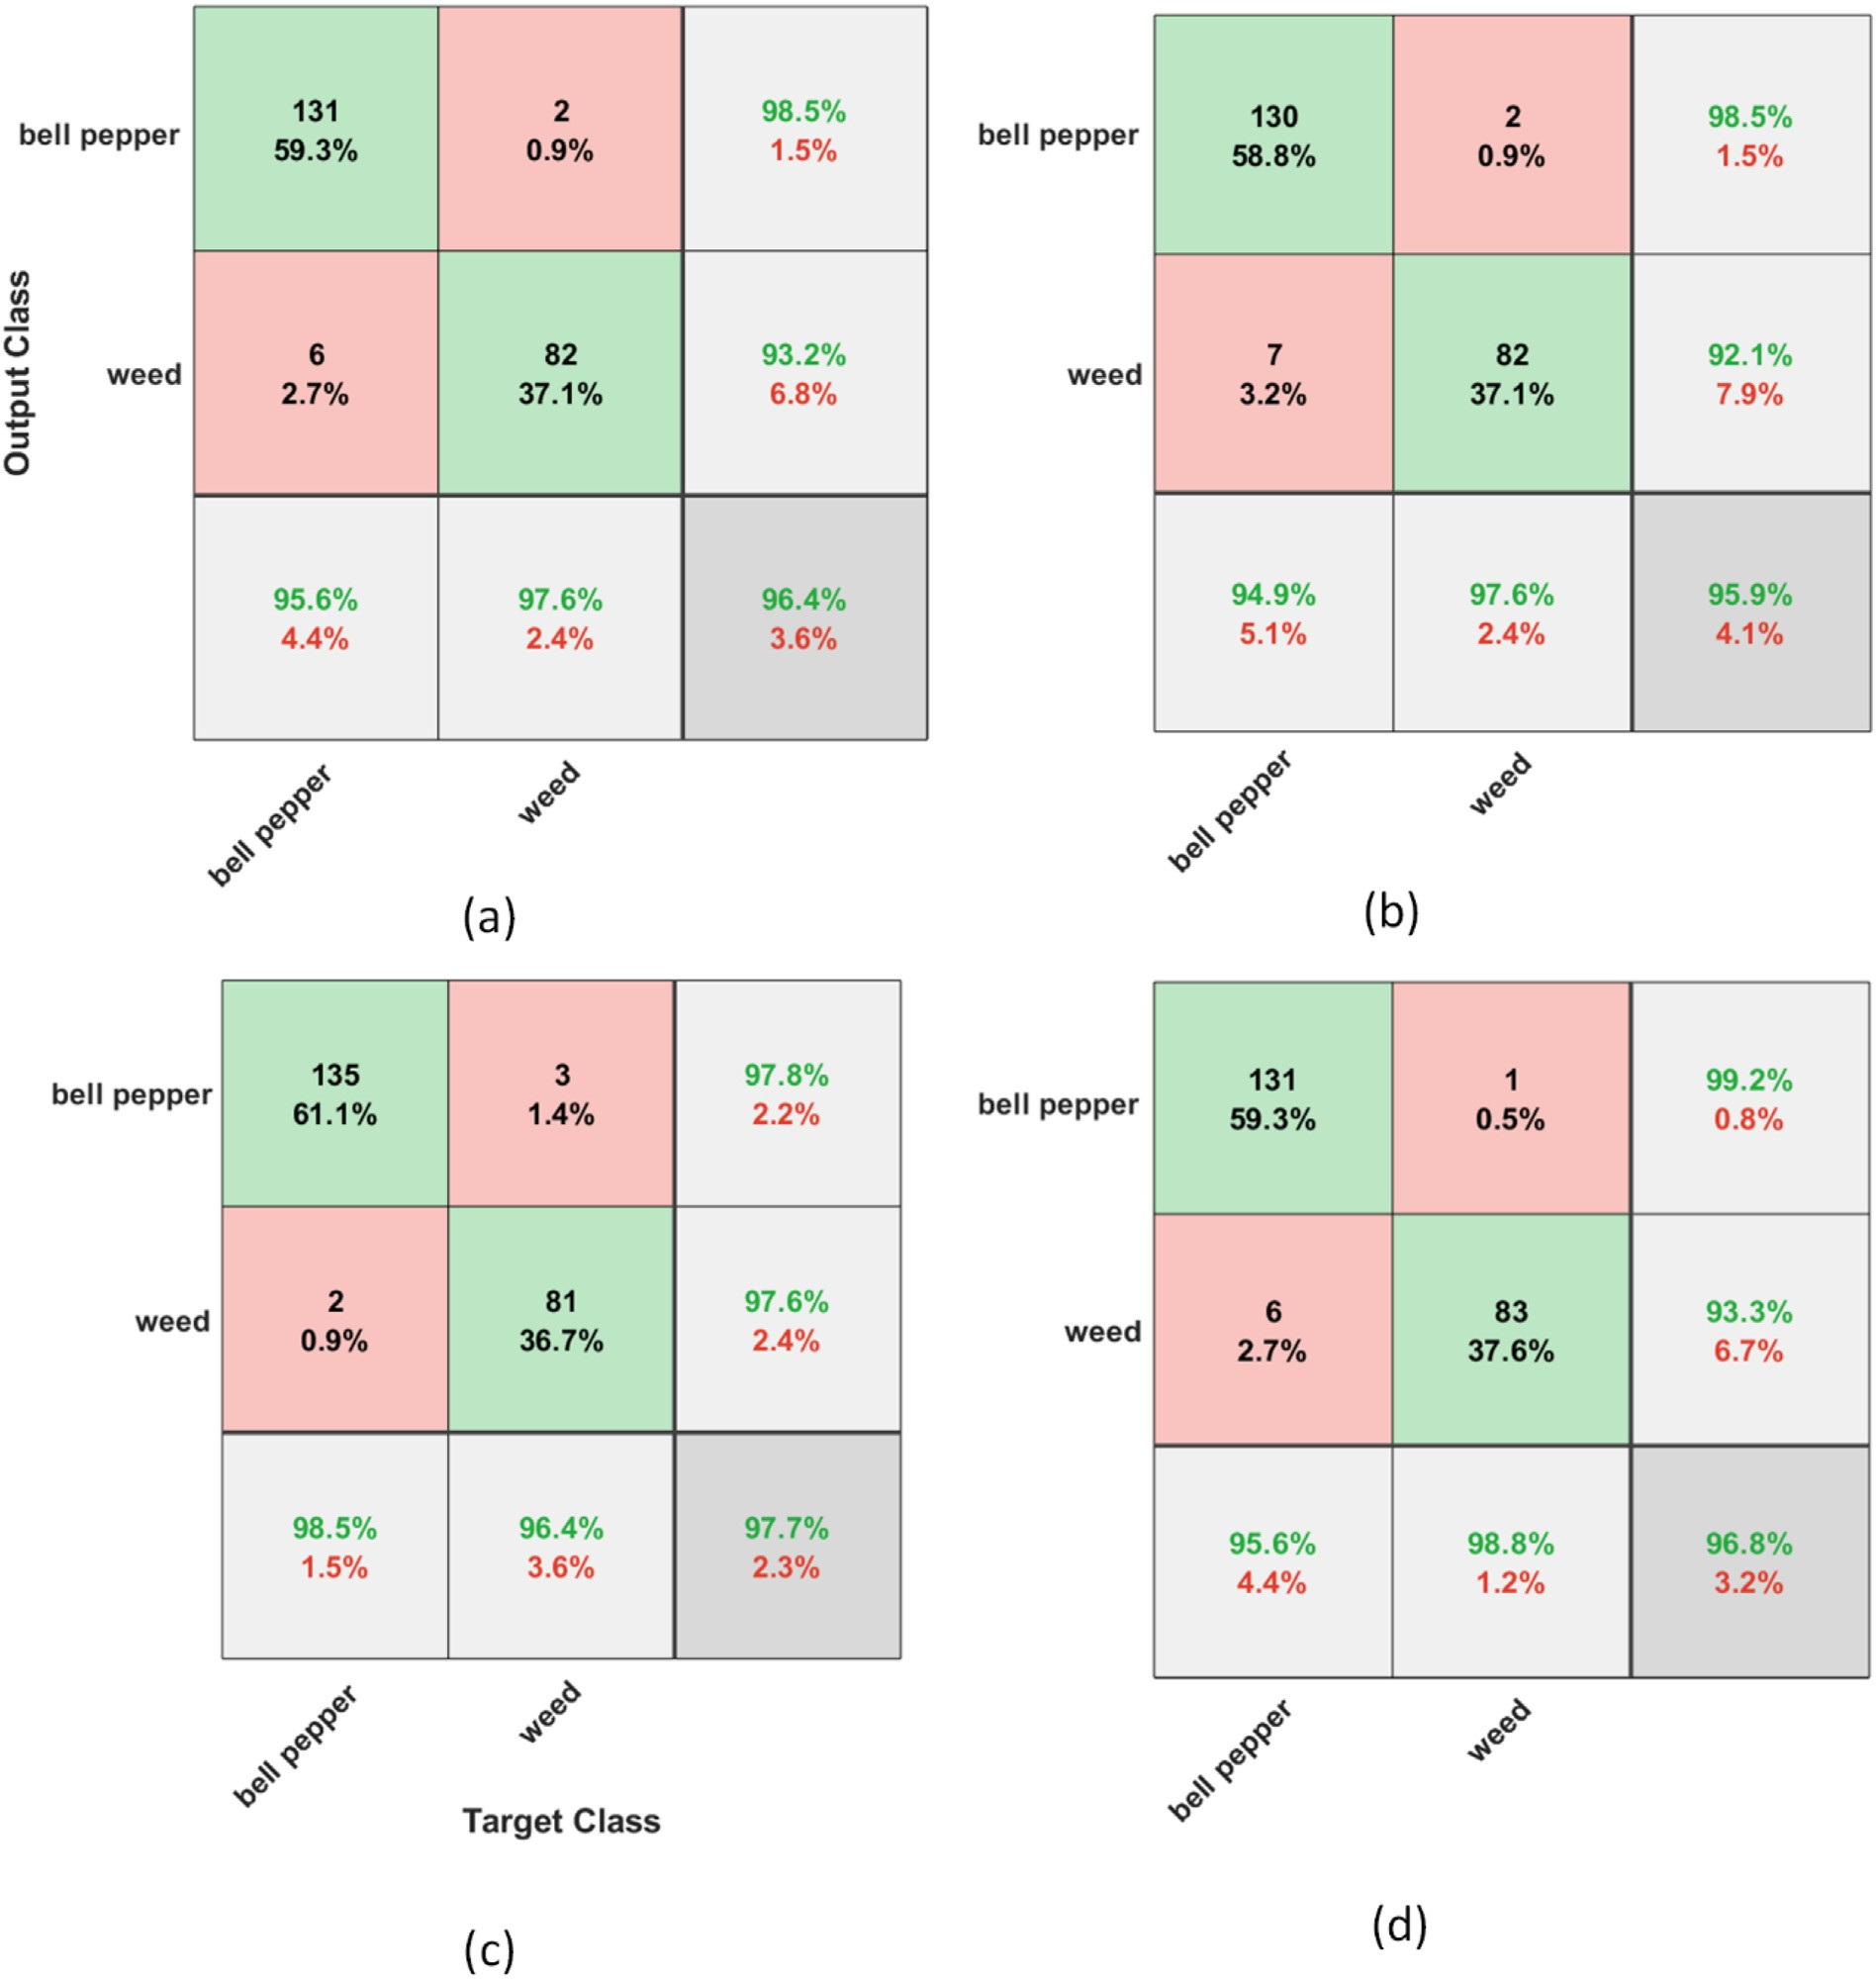

Fig. 5. Confusion Matrices indicating the performance of the selected models (trained on epoch = 30, batch size = 16) a) AlexNet, b)GoogLeNet, c) InceptionNet, d) Xception.

development centre located at ICAR – Central Institute of Agricultural Engineering Bhopal, India.

The images collected have been pre-processed before handing over to the classification task (Fig. 2). The labels for each image have been de- fined and a binary classification was performed in the experiment. The models AlexNet, GoogLeNet, InceptionV3, and Xception models were

Table 2

Performance of inceptionV3 model.

Epoch Batch size Precision (%) Recall (%) F1 score (%) Accuracy (%)

|  |  |  |  |  |  |
| --- | --- | --- | --- | --- | --- |
| 10 | 16 | 92.0 | 99.2 | 95.5 | 94.6 |
|  | 32 | 93.4 | 99.2 | 96.2 | 95.5 |
| 20 | 16 | 94.9 | 99.2 | 97.0 | 96.4 |
|  | 32 | 97.8 | 97.8 | 97.8 | 97.3 |
| 30 | 16 | 98.5 | 97.8 | 98.1 | 97.7 |
|  | 32 | 96.4 | 99.2 | 97.8 | 97.3 |

chosen for identifying the bell pepper and weed. The pre-trained models specified here for image classification are generally composed of two components: a convolutional base and a classifier (Fig. 3). The convolutional base is responsible for the feature extraction and the clas- sifier classifies the input image based on the features extracted by the convolutional base. In the classifier part, the standard approach is to use fully connected layers followed by an activation layer, which is gen- erally a softmax activation. The softmax layer generates the output indi- cating the probability of each class. The most probable class is chosen as the predicted class.

The model was trained with the help of training data and before the training got started, the model parameters like number of epochs, batch size, learning rate, etc. were set. Validation set was used for unbiased evaluation of the model. This helped to optimize the hyperparameters of the model. After identifying the right parameters, the model was

trained again by setting these parameters. Once the model was

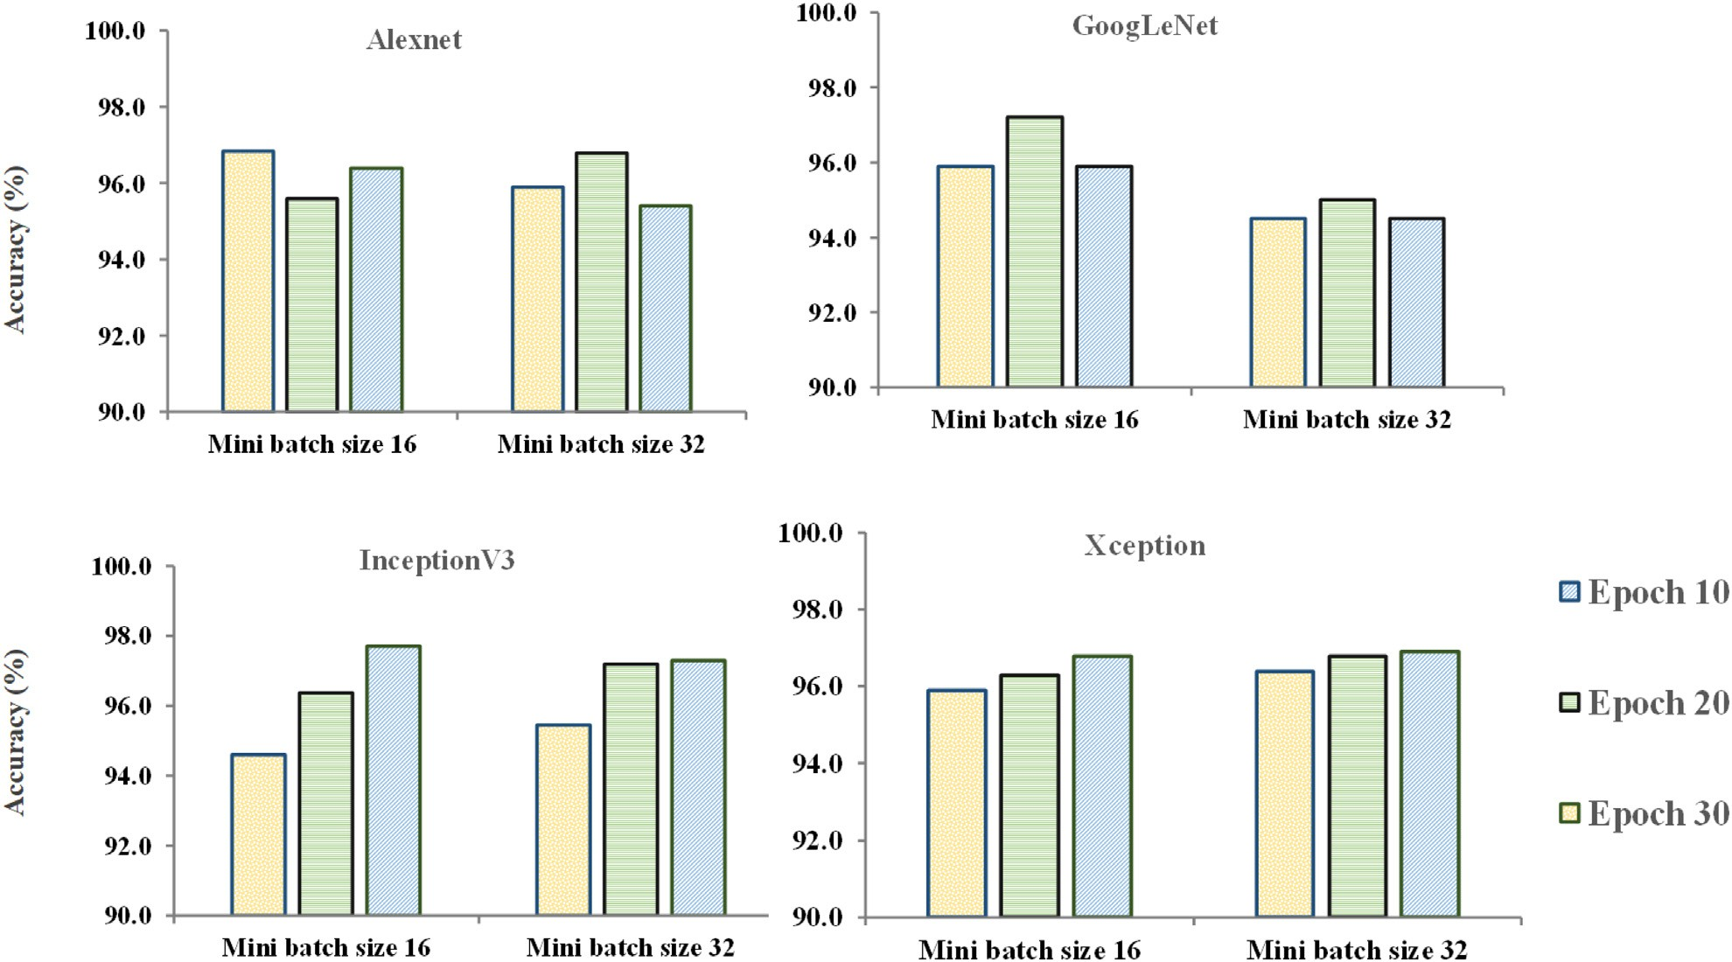

Fig. 6. Performance of Deep Learning Models with respect to parameters epoch and batch size.

completely trained, test set was used to provide a final real-world check of the unseen data points to confirm the proper functioning of the model.

Accuracy = TP + TN (1)

TP + TN + FP + FN

* 1. *Training, validation and testing*

Precision = TP

TP + FP

Sensitivity TP

(2)

The images were pre-processed and trained using AlexNet,

/Recall = TP + FN (3)

GoogLeNet, Xception and Inception V3. During the training phase, the model automatically extracts the relevant features of ‘bell pepper’ plant and ‘weed’ in general. This process can be applied directly to the

F1 Score = 2∗Precision∗Recall

Precision + Recall

(4)

image captured from the fields, which are unseen to the model, and the model can produce an accurate classification. During the training process, the loss function was set to stochastic gradient descent algo- rithm and batch sizes were set to 16 and 32. The initial learning rate was set to 0.001 and momentum to 0.9000. For all these models, epoch and batch size were varied and performance across the models were compared. The validation data used to validate our model that helps in adjusting and tuning the hyperparameters. The main reason for using the validation data is to prevent the model from overfitting. Confusion matrix is effective in estimating the performance of the ma- chine learning classification models. In this study, we have a binary clas- sification problem and each input sample was assigned to one of the classes ‘weed’ or ‘bell pepper’. The row of the confusion matrix denotes the predicted class and the column represents the actual class of the in- stances.

Table 3

Performance of models AlexNet, GoogLeNet, InceptionV3 and Xception (Epoch = 30, batch size = 16).

Model Precision (%) Recall (%) F1 Score (%) Accuracy (%)

|  |  |  |  |  |
| --- | --- | --- | --- | --- |
| AlexNet | 95.6 | 98.5 | 97.0 | 96.4 |
| GoogleNet | 94.9 | 98.5 | 96.7 | 95.9 |
| InceptionV3 | 98.5 | 97.8 | 98.1 | 97.7 |
| Xception | 95.6 | 99.2 | 97.4 | 96.8 |

Accuracy, precision, recall and F1 score matrices are used for evalu- ating the model performance (Eqs. (1)–(4)). Here, TP denotes the True Positive, indicating the number/percentage of instances of bell peppers accurately predicted by the model, FP denotes the Fall Posi- tive/type I error that shows the percentage of bell peppers misclassified as weeds. FN or False Negative denotes the Type II error that shows the number/percentage of weed images classified as bell pepper. TN or True Negative indicates the number percentage of weed images that are accurately predicted by the model.

1. Results and discussion

In this study, the performances of various deep learning models were evaluated for identifying the weeds among the bell peppers. The results indicated that all the models have performed satisfactorily with an overall accuracy varying between 94.5 and 97.7%. The experi- ment has been repeated with a number of epochs 10, 20, 30 and signif- icant improvement has been observed in the accuracy. The number of batch size should be a power of 2, to take the complete advantage of the GPU processing (Kandel and Castelli, 2020). Two different values of batch size 16 and 32 were selected for training the model. Fig. 4 shows the accuracy and loss function variation when the model is trained with 30 epochs and 16 batch size. The plots indicate the loss function for all the models has started converging from early epochs without having large fluctuations. There were no overfitting or

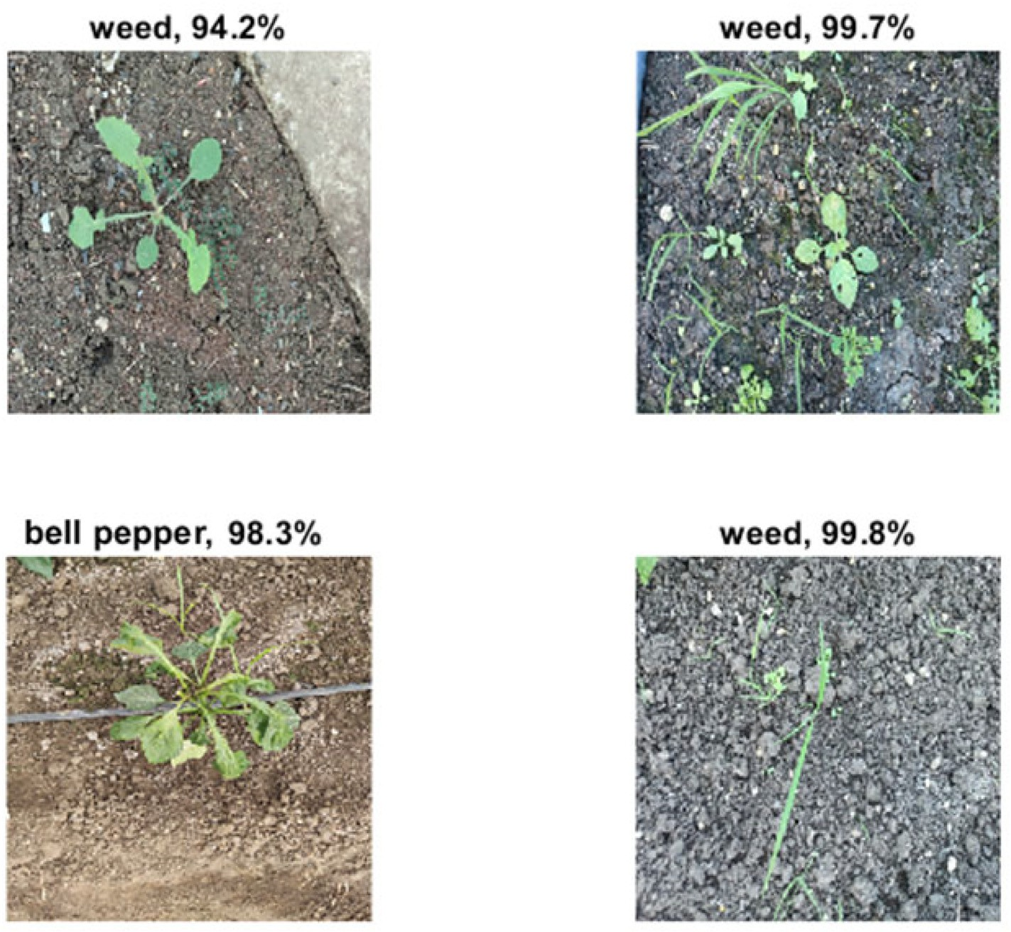

Fig. 7. Predictions and accuracy of InceptionV3 model (trained on epoch = 30, batch size =16) on the test images (The percentage in the figurehead represents the confidence of the model in predicting the specific class).

underfitting observed in AlexNet, GoogLeNet, InceptionV3, and Xception models.

In AlexNet, for a mini batch size of 16, the accuracy obtained for 10, 20, and 30 epochs were 96.8%, 95.6%, and 96.4% respectively. With mini batch size 32, the accuracies for the model were 95.9%, 96.8%, 95.4% re- spectively. Thus there was no steady improvement is observed while in- creasing the number of epochs as well as the batch size for Alexnet. The overall accuracies in alexnet were varied between 95.4% and 96.8%. For GoogLeNet, the highest accuracy of 97.2% was obtained at 20 epochs and batch size 16. In the Xception model, there is a slight improvement in accuracy has been observed after increasing the number of epochs from 10 to 30. The accuracies of Xception were varied between 95.9 and 96.9%.

The confusion matrices for weed and bell pepper identification using the selected deep learning models have been shown in Fig. 5. The diag- onal values indicate the true estimations. The highest accuracy observed was 97.7% for InceptionV3 when it was trained for 30 epochs with a batch size of 16. For these hyperparameter values of batch size 16, with epoch 30, the inceptionV3 model was able to successfully classify 135 bell pepper images out of 138 bell pepper images and only 3 images of bell pepper were misclassified. Also, the model successfully identified 81 weed images out of 83 weed images and only 2 weed images were misclassified. InceptionV3 model showed a steady rise in the accuracy on increasing the number of epochs. The accuracies observed for InceptionV3 for mini batch size 16 and epochs 10, 20, 30 were 94.6,

96.4 and 97.7%, respectively (Table 2). This improved performance of InceptionV3 over other models is due to factorization into smaller con- volutions and the use of auxiliary classifiers as regularizes. InceptionV3 architecture has made major improvements over the GoogLeNet archi- tecture without compromising on the performance. Even though there is an increase, the same trend of steady increase was not observed in

batch size 32 and the accuracies were 95.5, 97.2, and 97.3 respectively. There was no further improvement in accuracy after increasing the epochs from 20 to 30 (Fig. 6).

Table 3 compares the precision, recall, F1 scores of all the models with the best performing which was trained with 30 epochs and a batch size of 16. The recall was very high for Xception, which indi- cated that the model was highly capable of making correct positive predictions. The precision, accuracy, and F1 score of inceptionV3 at

30 epochs and 16 batch size are higher than the other models and found to be the most effective model for weed and crop iden- tification. The Type I error for inceptionV3 at these parameters setting was 1.4% and Type II error was observed as 0.9%. The same inceptionV3 model was tested with random testing images and the results are as shown in Fig. 7. The obtained results show that the model is able to successfully identify the weed among the bell pepper with very high confidence.

1. Conclusion

Deep convolutional neural network-based weed detection is prom- ising and supports automation of agricultural operations. This work demonstrated the capability of using DCNN models for weed identifica- tion in bell pepper field. In this study, four deep learning models (Alexnet, GoogLeNet, InceptionV3, Xception) have been applied for the identification of weeds present among the bell pepper field. InceptionV3 outperformed others in terms of precision, accuracy, and recall. The potential future work includes detection of crop and weed in real-time and execution of the weeding action by intelligent weeders and/or site-specific herbicide applicators based on the decision made by the DCNN models.

Credit author statement

A. Subeesh: Conceptualization, Data curation, Methodology, Formal analysis, Writing – original draft. Sameer Bhole: Investigation, Data curation, Validation, Writing-original draft. Karan Singh: Software, Su- pervision, Writing - review & editing. NS Chandel: Data curation, Meth- odology, Validation, Writing - original draft, Writing - review & editing. YA Rajwade: Data curation, Methodology, Writing - original draft, Writ- ing - review & editing. K.V.R Rao – Investigation, Resources, Supervision, Validation, Writing - review & editing. SP Kumar - Validation, Writing - review & editing. Dilip Jat: Data curation, Writing - review & editing.

Declaration of Competing Interest

The authors declare that they have no known competing financial interests or personal relationships that could have appeared to influ- ence the work reported in this paper.

References

Adam, G., Lorraine, J., 2019. [Understanding Neural Architecture Search Techniques](http://refhub.elsevier.com/S2589-7217(22)00003-4/rf0005) [ArXiv190400438 Cs Stat](http://refhub.elsevier.com/S2589-7217(22)00003-4/rf0005).

Ahmed, F., Al-Mamun, H.A., Bari, A.S.M.H., Hossain, E., Kwan, P., 2012. Classification of crops and weeds from digital images: a support vector machine approach. Crop Prot. 40, 98–104. <https://doi.org/10.1016/j.cropro.2012.04.024>.

Amador-Ramírez, M.D., 2002. Critical period of weed control in transplanted chilli pepper.

Weed Res. 42, 203–209. <https://doi.org/10.1046/j.1365-3180.2002.00278.x>.

Ashraf, T., Khan, Y.N., 2020. Weed density classification in rice crop using computer vision. Comput. Electron. Agric. 175, 105590. [https://doi.org/10.1016/j.compag.2020.](https://doi.org/10.1016/j.compag.2020.105590)

[105590](https://doi.org/10.1016/j.compag.2020.105590).

Bah, M.D., Hafiane, A., Canals, R., 2018. Deep learning with unsupervised data labeling for weed detection in line crops in UAV images. Remote Sens. 10, 1690. [https://doi.org/](https://doi.org/10.3390/rs10111690) [10.3390/rs10111690](https://doi.org/10.3390/rs10111690).

Barrero, O., Rojas, D., Gonzalez, C., Perdomo, S., 2016. Weed detection in rice fields using aerial images and neural networks. 2016 XXI Symposium on Signal Processing, Im- ages and Artificial Vision (STSIVA), pp. 1–4 [https://doi.org/10.1109/STSIVA.2016.](https://doi.org/10.1109/STSIVA.2016.7743317) [7743317](https://doi.org/10.1109/STSIVA.2016.7743317).

Campiglia, E., Radicetti, E., Mancinelli, R., 2012. Weed control strategies and yield re- sponse in a pepper crop (Capsicum annuum L.) mulched with hairy vetch (Vicia villosa Roth.) and oat (Avena sativa L.) residues. Crop Prot. 33, 65–73. [https://doi.](https://doi.org/10.1016/j.cropro.2011.09.016) [org/10.1016/j.cropro.2011.09.016](https://doi.org/10.1016/j.cropro.2011.09.016).

Chandel, N., Chakraborty, S., Rajwade, Y., Dubey, K., Tiwari, M.K., Jat, D., 2021a. Identifying crop water stress using deep learning models. Neural Comput. Applic. 33. [https://doi.](https://doi.org/10.1007/s00521-020-05325-4) [org/10.1007/s00521-020-05325-4](https://doi.org/10.1007/s00521-020-05325-4).

Chandel, N.S., Chandel, A.K., Roul, A.K., Solanke, K.R., Mehta, C.R., 2021b. An integrated inter- and intra-row weeding system for row crops. Crop Prot. 145, 105642. <https://doi.org/10.1016/j.cropro.2021.105642>.

Cheng, B., Matson, E.T., 2015. A feature-based machine learning agent for automatic Rice and weed discrimination. In: Rutkowski, L., Korytkowski, M., Scherer, R., Tadeusiewicz, R., Zadeh, L.A., Zurada, J.M. (Eds.), Artificial Intelligence and Soft Com- puting. Lecture Notes in Computer Science. Springer International Publishing, Cham,

pp. 517–527 <https://doi.org/10.1007/978-3-319-19324-3_46>.

Chollet, F., 2017. Xception: deep learning with depthwise separable convolutions. 2017 IEEE Conference on Computer Vision and Pattern Recognition (CVPR),

pp. 1800–1807 <https://doi.org/10.1109/CVPR.2017.195>. De, A.K., 2003. [Capsicum: The Genus Capsicum. CRC Press](http://refhub.elsevier.com/S2589-7217(22)00003-4/rf0060).

Espejo-Garcia, B., Mylonas, N., Athanasakos, L., Fountas, S., 2020. Improving weeds identi- fication with a repository of agricultural pre-trained deep neural networks. Comput. Electron. Agric. 175, 105593. <https://doi.org/10.1016/j.compag.2020.105593>.

Golzarian, M.R., Frick, R.A., 2011. Classification of images of wheat, ryegrass and brome grass species at early growth stages using principal component analysis. Plant Methods 7, 28. <https://doi.org/10.1186/1746-4811-7-28>.

Gonzalez-Diaz, L., Martinez Jimenez, M.P., Bastida, F., Gonzalez-Andujar, J., 2009. Decision support system for integrated plant protection in pepper. Expert Syst. Appl. 36, 8975–8979. <https://doi.org/10.1016/j.eswa.2008.11.038>.

Hameed, S., Amin, I., 2018. Detection of weed and wheat using image processing. 2018 IEEE 5th International Conference on Engineering Technologies and Applied Sciences (ICETAS), pp. 1–5 <https://doi.org/10.1109/ICETAS.2018.8629137>.

Hasan, A.S.M.M., Sohel, F., Diepeveen, D., Laga, H., Jones, M.G.K., 2021. A survey of deep learning techniques for weed detection from images. Comput. Electron. Agric. 184, 106067. <https://doi.org/10.1016/j.compag.2021.106067>.

He, K., Zhang, X., Ren, S., Sun, J., 2016. Deep residual learning for image recognition. 2016 IEEE Conference on Computer Vision and Pattern Recognition (CVPR), pp. 770–778 <https://doi.org/10.1109/CVPR.2016.90>.

Hemanth, D.J., Estrela, V.V., 2017. [Deep Learning for Image Processing Applications. IOS](http://refhub.elsevier.com/S2589-7217(22)00003-4/rf0095) [Pres](http://refhub.elsevier.com/S2589-7217(22)00003-4/rf0095)s.

Howard, A.G., Zhu, M., Chen, B., Kalenichenko, D., Wang, W., Weyand, T., Andreetto, M., Adam, H., 2017. [MobileNets: Efficient Convolutional Neural Networks for Mobile](http://refhub.elsevier.com/S2589-7217(22)00003-4/rf0100) [Vision Applications ArXiv170404861 Cs](http://refhub.elsevier.com/S2589-7217(22)00003-4/rf0100).

Hu, J., Shen, L., Sun, G., 2018. Squeeze-and-excitation networks. 2018 IEEE/CVF Confer- ence on Computer Vision and Pattern Recognition, pp. 7132–7141 [https://doi.org/](https://doi.org/10.1109/CVPR.2018.00745) [10.1109/CVPR.2018.00745](https://doi.org/10.1109/CVPR.2018.00745).

Hu, K., Coleman, G., Zeng, S., Wang, Z., Walsh, M., 2020. Graph weeds net: a graph-based deep learning method for weed recognition. Comput. Electron. Agric. 174, 105520. <https://doi.org/10.1016/j.compag.2020.105520>.

Huang, G., Liu, Z., Van Der Maaten, L., Weinberger, K.Q., 2017. Densely connected convolutional networks. 2017 IEEE Conference on Computer Vision and Pattern Rec- ognition (CVPR), pp. 2261–2269 <https://doi.org/10.1109/CVPR.2017.243>.

Jat, D., Rajwade, Y.A., Chandel, N.S., Dubey, K., Rao, K.V.R., 2020. [Embedded system for reg-](http://refhub.elsevier.com/S2589-7217(22)00003-4/rf0120) [ulating abiotic parameters for Capsicum cultivation in a polyhouse with comparison](http://refhub.elsevier.com/S2589-7217(22)00003-4/rf0120) [to open-field cultivation. Int. J. Veg. Sci. 26, 487–49](http://refhub.elsevier.com/S2589-7217(22)00003-4/rf0120)7.

Kandel, I., Castelli, M., 2020. The effect of batch size on the generalizability of the convolutional neural networks on a histopathology dataset. ICT Express 6, 312–315. <https://doi.org/10.1016/j.icte.2020.04.010>.

Kim, S., Lee, J.S., Kim, H.S., 2018. Deep learning-based automatic weed detection on onion

field. Smart Media J. 7, 16–21. <https://doi.org/10.30693/SMJ.2018.7.3.16>.

Krizhevsky, A., Sutskever, I., Hinton, G.E., 2012. [ImageNet classification with deep](http://refhub.elsevier.com/S2589-7217(22)00003-4/rf0135) [convolutional neural networks. Advances in Neural Information Processing Systems.](http://refhub.elsevier.com/S2589-7217(22)00003-4/rf0135) [Curran Associates, Inc](http://refhub.elsevier.com/S2589-7217(22)00003-4/rf0135).

Kumar, P., Chauhan, R.S., Grover, R.K., 2016. [Economic analysis of capsicum cultivation](http://refhub.elsevier.com/S2589-7217(22)00003-4/rf0140) [under polyhouse and open field conditions in Haryana. Int. J. Farm Sci. 6, 96–100](http://refhub.elsevier.com/S2589-7217(22)00003-4/rf0140).

LeCun, Y., Jackel, L.D., Bottou, L., Brunot, A., Cortes, C., Denker, J., Drucker, H., Guyon, I., Muller, U.A., Sackinger, E., 1995. [Comparison of learning algorithms for handwritten](http://refhub.elsevier.com/S2589-7217(22)00003-4/rf0145) [digit recognition. International Conference on Artificial Neural Networks. Perth,](http://refhub.elsevier.com/S2589-7217(22)00003-4/rf0145) [Australia, pp. 53–60](http://refhub.elsevier.com/S2589-7217(22)00003-4/rf0145).

Liu, B., Bruch, R., 2020. Weed detection for selective spraying: a review. Curr. Robot. Rep.

1, 19–26. <https://doi.org/10.1007/s43154-020-00001-w>.

Mehta, C.R., Chandel, N.S., Rajwade, Y., 2021. [Smart farm mechanization for sustainable](http://refhub.elsevier.com/S2589-7217(22)00003-4/rf0155) [Indian agriculture. Ama Agric. Mech. Asia Afr. Lat. Am. 50, 99–10](http://refhub.elsevier.com/S2589-7217(22)00003-4/rf0155)5.

Osorio, K., Puerto, A., Pedraza, C., Jamaica, D., Rodríguez, L., 2020. A deep learning ap- proach for weed detection in lettuce crops using multispectral images. AgriEngineering 2, 471–488. <https://doi.org/10.3390/agriengineering2030032>.

Parico, A.I.B., Ahamed, T., 2020. An aerial weed detection system for green onion crops using the you only look once (YOLOv3) deep learning algorithm. Eng. Agric. Environ. Food 13, 42–48. <https://doi.org/10.37221/eaef.13.2_42>.

Pereira, L.A.M., Nakamura, R.Y.M., de Souza, G.F.S., Martins, D., Papa, J.P., 2012. [Aquatic](http://refhub.elsevier.com/S2589-7217(22)00003-4/rf0170) [Weed Automatic Classification Using Machine Learning Techniques](http://refhub.elsevier.com/S2589-7217(22)00003-4/rf0170).

Sanchez, P.R., Zhang, H., Ho, S.-S., De Padua, E., 2021. Comparison of one-stage object de- tection models for weed detection in mulched onions. 2021 IEEE International Con- ference on Imaging Systems and Techniques (IST), pp. 1–6 [https://doi.org/10.1109/](https://doi.org/10.1109/IST50367.2021.9651352) [IST50367.2021.9651352](https://doi.org/10.1109/IST50367.2021.9651352).

Shanmugam, S., Assunção, E., Mesquita, R., Veiros, A., Gaspar, P.D., 2020. [Automated weed](http://refhub.elsevier.com/S2589-7217(22)00003-4/rf0180) [detection systems: a review. KnE Eng. 271–28](http://refhub.elsevier.com/S2589-7217(22)00003-4/rf0180)4.

Sharpe, S.M., Schumann, A.W., Boyd, N.S., 2019. Detection of Carolina Geranium (Gera- nium carolinianum) growing in competition with strawberry using convolutional neural networks. Weed Sci. 67, 239–245. <https://doi.org/10.1017/wsc.2018.66>.

Sharpe, S.M., Schumann, A.W., Boyd, N.S., 2020. Goosegrass detection in strawberry and tomato using a convolutional neural network. Sci. Rep. 10, 9548. [https://doi.org/10.](https://doi.org/10.1038/s41598-020-66505-9) [1038/s41598-020-66505-9](https://doi.org/10.1038/s41598-020-66505-9).

Shorten, C., Khoshgoftaar, T.M., 2019. A survey on image data augmentation for deep learning. J. Big Data 6, 60. <https://doi.org/10.1186/s40537-019-0197-0>.

Simonyan, K., Zisserman, A., 2015. [Very Deep Convolutional Networks for Large-Scale](http://refhub.elsevier.com/S2589-7217(22)00003-4/rf0200) [Image Recognition ArXiv14091556 Cs](http://refhub.elsevier.com/S2589-7217(22)00003-4/rf0200).

Singh, M.C., Singh, G.K., Singh, J.P., 2019. [Nutrient and water use efficiency of cucumbers](http://refhub.elsevier.com/S2589-7217(22)00003-4/rf0205) [grown in soilless media under a naturally ventilated greenhouse. J. Agric. Sci. Technol.](http://refhub.elsevier.com/S2589-7217(22)00003-4/rf0205) [21, 193–207](http://refhub.elsevier.com/S2589-7217(22)00003-4/rf0205).

Su, W.-H., 2020. Advanced machine learning in point spectroscopy, RGB- and hyperspectral-imaging for automatic discriminations of crops and weeds: a review. Smart Cities 3, 767–792. <https://doi.org/10.3390/smartcities3030039>.

Subeesh, A., Mehta, C.R., 2021. Automation and digitization of agriculture using artificial intelligence and internet of things. Artif. Intell. Agric. 5, 278–291. [https://doi.org/10.](https://doi.org/10.1016/j.aiia.2021.11.004) [1016/j.aiia.2021.11.004](https://doi.org/10.1016/j.aiia.2021.11.004).

Szegedy, C., Liu, W., Jia, Y., Sermanet, P., Reed, S., Anguelov, D., Erhan, D., Vanhoucke, V., Rabinovich, A., 2015. Going deeper with convolutions. 2015 IEEE Conference on Com- puter Vision and Pattern Recognition (CVPR), pp. 1–9 [https://doi.org/10.1109/CVPR.](https://doi.org/10.1109/CVPR.2015.7298594) [2015.7298594](https://doi.org/10.1109/CVPR.2015.7298594).

Szegedy, C., Ioffe, S., Vanhoucke, V., Alemi, A., 2016. [Inception-v4, Inception-ResNet and](http://refhub.elsevier.com/S2589-7217(22)00003-4/rf0230) [the Impact of Residual Connections on Learning ArXiv160207261 Cs](http://refhub.elsevier.com/S2589-7217(22)00003-4/rf0230).

Tan, M., Le, Q.V., 2020. [EfficientNet: Rethinking Model Scaling for Convolutional Neural](http://refhub.elsevier.com/S2589-7217(22)00003-4/rf0235) [Networks ArXiv190511946 Cs Stat](http://refhub.elsevier.com/S2589-7217(22)00003-4/rf0235).

Wang, A., Zhang, W., Wei, X., 2019. A review on weed detection using ground-based ma- chine vision and image processing techniques. Comput. Electron. Agric. 158, 226–240. <https://doi.org/10.1016/j.compag.2019.02.005>.

Xie, S., Girshick, R., Dollár, P., Tu, Z., He, K., 2017. [Aggregated Residual Transformations for](http://refhub.elsevier.com/S2589-7217(22)00003-4/rf0245) [Deep Neural Networks ArXiv161105431 Cs](http://refhub.elsevier.com/S2589-7217(22)00003-4/rf0245).

Yu, J., Sharpe, S.M., Schumann, A.W., Boyd, N.S., 2019. Deep learning for image-based weed detection in turfgrass. Eur. J. Agron. 104, 78–84. [https://doi.org/10.1016/j.eja.](https://doi.org/10.1016/j.eja.2019.01.004) [2019.01.004](https://doi.org/10.1016/j.eja.2019.01.004).