[](http://crossmark.crossref.org/dialog/?doi=10.1016/j.aiia.2020.03.001&domain=pdf)[](Journal%20logo)Deep learning approach for recognition and classification of yield affecting paddy crop stresses using field images

Contents lists available at [ScienceDirect](http://www.sciencedirect.com/science/journal/25897217)

Artificial Intelligence in Agriculture

journal homepage: [http://www.keaipublishing.com/en/j ournals/artificial- intelligence-in-agriculture/](http://www.keaipublishing.com/en/journals/artificial-intelligence-in-agriculture/)

Basavaraj S. Anami a,d, Naveen N. Malvade b,d,⁎, Surendra Palaiah c

a *Department of Computer Science and Engineering, K. L. E. Institute of Technology, Hubballi 580030, Karnataka, India*

b *Department of Information Science and Engineering, K. L. E. Institute of Technology, Hubballi 580030, Karnataka, India*

c *Department of Genetics and Plant Breeding, University of Agricultural Sciences, Dharwar 580002, Karnataka, India*

d *Visvesvaraya Technological University, Belagavi 590018, Karnataka, India*

# a r t i c l e i n f o

*Article history:*

Received 15 July 2019

Received in revised form 20 March 2020

Accepted 20 March 2020

Available online 3 April 2020

*Keywords:*

Paddy crop

Biotic and abiotic stress CNN

VGG-16

# a b s t r a c t

On-time recognition and early control of the stresses in the paddy crops at the booting growth stage is the key to prevent qualitative and quantitative loss of agricultural yield. The conventional paddy crop stress recognition and classification activities invariably rely on human experts identifying visual symptoms as a means of categoriza- tion. This process is admittedly subjective and error-prone, which in turn can lead to incorrect actions being taken in stress management decisions. The work presented in this paper aims to design a deep convolutional neural network (DCNN) framework for automatic recognition and classification of various biotic and abiotic paddy crop stresses using the field images. The work has adopted the pre-trained VGG-16 CNN model for the au- tomatic classification of stressed paddy crop images captured during the booting growth stage. The trained models achieve an average accuracy of 92.89% on the held-out dataset, demonstrating the technical feasibility of using the deep learning approach utilizing 30,000 field images of 5 different paddy crop varieties with 12 dif- ferent stress categories (including healthy/normal). The proposed work finds applications in developing the de- cision support systems and mobile applications for automating the field crop and resource management practices.

© 2020 The Authors. Publishing services by Elsevier B.V. on behalf of KeAi Communications Co. Ltd. This is an open access article under the CC BY-NC-ND license (<http://creativecommons.org/licenses/by-nc-nd/4.0/>).

1. Introduction

The paddy crop cultivation is an integral part of Indian agricultural economy ranking first in the area of cultivation with 43.92 million hect- ares with the production of 111.50 million tons (Anonymous, 2018). Al- though the overall numbers are impressive, the rice production has come under increased pressure in Asia due to population growth and changing socio-economic factors. The major paddy producing belts in Asia regions achieves only 40% of total production efficiency due to damage caused by drought, diseases, and pests. A more integrated ap- proach involving optimum crop improvement and resource manage- ment practices such as nutrient management, irrigation regime, and other agronomic management factors for paddy crop with the existing farmers' practices is a potential option for minimizing the crop yield gap (Nutan et al., 2020; Alam et al., 2013).

* Corresponding author at: Department of Information Science and Engineering, K. L. E. Institute of Technology, Hubballi 580030, Karnataka, India.

*E-mail addresses:* [anami_basu@hotmail.com](mailto:anami_basu@hotmail.com) (B.S. Anami), [naveen.malvade@gmail.com](mailto:naveen.malvade@gmail.com) (N.N. Malvade), [surendrap@uasd.in](mailto:surendrap@uasd.in) (S. Palaiah).

The paddy crops are exposed to various types of stresses, both biotic and abiotic as they grow in a wide range of environments characterized by different temperatures, climates, and soil-water conditions, whose combined effect can adversely affect crop performance and survival. It is generally believed that the stresses are considered as a serious threat to sustainable paddy production. Among these stresses, pathogen, drought, over-irrigation or submergence, nutrient deficiency, toxicity due to over-feeding of fertilizers, and high salinity stress factors have a huge impact on the world agriculture and they reduce average yield by more than 50%. The plans have evolved and developed specific mechanisms to respond to complex stress conditions. The plant re- sponses to the individual stress vary depending on the nature and se- verity of the stress involved, the age of the plant at which the stress is encountered, and inherent stress tolerant nature of the plants. The on- time monitoring and recognition of these stresses, the supply of ade- quate farm inputs and rapid morphological diagnoses can reduce the adverse effects of stresses on the crops. The paddy crops under stress show obvious symptoms in the color, shape and texture of the leaves (Mew et al., 2018). It is difficult to capture and quantify these micro- symptoms using manual visual observation. The sample field images of normal and stressed paddy crops are shown in Fig. 1.

<https://doi.org/10.1016/j.aiia.2020.03.001>

2589-7217/© 2020 The Authors. Publishing services by Elsevier B.V. on behalf of KeAi Communications Co. Ltd. This is an open access article under the CC BY-NC-ND license ([http://](http://creativecommons.org/licenses/by-nc-nd/4.0/) [creativecommons.org/licenses/by-nc-nd/4.0/](http://creativecommons.org/licenses/by-nc-nd/4.0/)).

[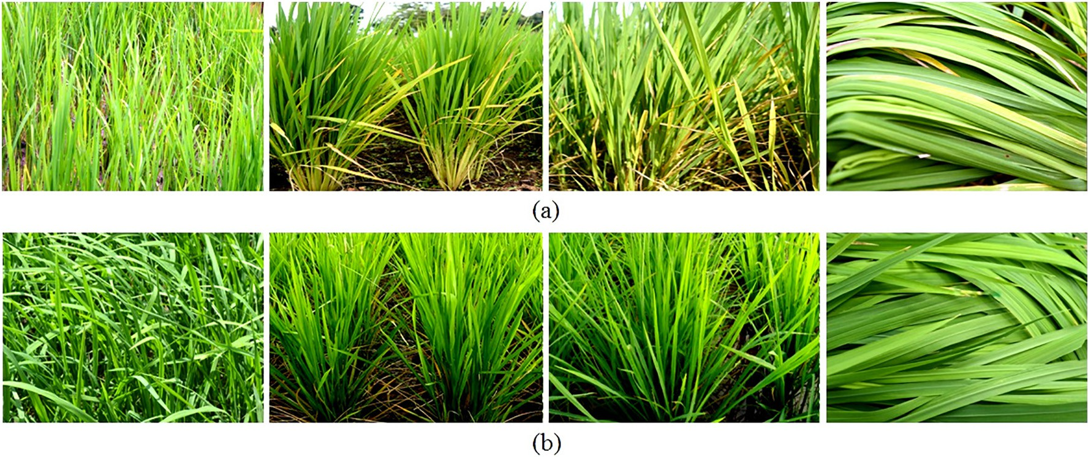](Image%20of%20Fig.%201)

Fig. 1. Sample field images of (a) normal and (b) stressed paddy crops.

The leaf injury and leaf color variation are the two visual scoring symptoms used in the classification and determination of the stress cat- egories. The trained personnel visually observe these symptoms as a qualitative assessment to determine the stress types. This visual inspec- tion of an individual leaf is subjective, time-consuming, destructive sometimes, and tedious by nature. For identification of plant Nitrogen

(N) nutrient deficiency, two easy decision instruments, namely Leaf Color Chart (LCC) and Chlorophyll Meter (SPAD) are used (Ali et al., 2017). As a plant N status indicator, the LCC measures the greenness of the paddy crop leaf. In LCC, the accuracy is not guaranteed, especially for different lighting conditions as the approach is based on visual in- spection of leaf color. Fig. 2 shows the determination of paddy plant Ni- trogen (N) demand using the chlorophyll meter (SPAD) and Leaf Color Chart (LCC). An objective and rapid stress identification system would be beneficial to the potential farmers and researchers for timely inter- vention and mitigation of the problems by applying the proper crop management strategies that can effectively boost the crop yields. Sev- eral research works have proposed to detect and classify plant stresses using image processing and machine learning techniques (Sun et al., 2018; Latte et al., 2017; Yuan et al., 2016; Mohan et al., 2016; Yang et al., 2015; Chen et al., 2014; Phadikar et al., 2012; Pugoy and Mariano, 2011; Bock et al., 2010; Sanyal et al., 2007). These approaches have attempted to build image classifiers using the handcrafted shape, color, and texture features extracted from the individual crop leaf

images and the classifier dependency on the handcrafted features causes lack of automation. In recent years, the deep convolutional neu- ral networks (DCNN) have shown the impressive results in many image classification tasks without using an expert designed or handcrafted features (Singh et al., 2018; Mohanty et al., 2016). This brings the desire of adopting deep learning in computer vision to develop a comprehen- sive paddy plant stress recognition system which could be used as an ef- fective tool in constructing crop management strategies. To know the state-of-the-art in automation of paddy and allied crop stress recogni- tion and classification using a deep learning approach, a survey is made and the gist of a survey is given as under.

1. Literature survey

Sambuddha et al. (2018) have proposed a deep machine vision- based approach for identification, classification, and quantification of eight soybean plant stresses, including both biotic and abiotic using 25,000 images of stressed and healthy leaflets in the fields. The overall classification accuracy of 94.13% is achieved by the developed deep CNN model. Konstantinos (2018) has developed five different deep CNN models which include AlexNet, AlexNetOWTBn, GoogLeNet, Overfeat and VGG for the identification of plant disease combinations using the simple leaves images of healthy and diseased plants. The image dataset comprises 87,848 individual leaf images from 58 different

[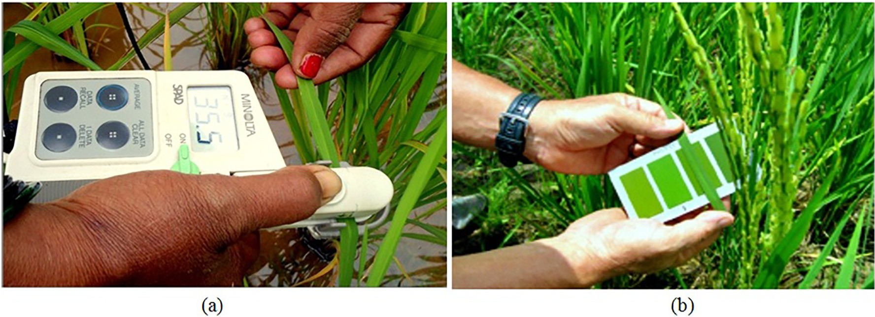](Image%20of%20Fig.%202)

Fig. 2. Real time tools for determining Nitrogen (N) demand of paddy crop. (a) Chlorophyll meter (SPAD) (b) Leaf Color Chart (LCC).

classes of plant-disease combinations of 25 different plant species. The highest classification accuracy of 99.53% is achieved using the VGG- CNN model. Jiang Lu et al. (2017) have developed an in-field automatic wheat disease diagnosis system using the supervised deep learning framework. The image dataset comprises 50,000 labeled images of healthy and infected leaves of wheat crops. In the work, four different CNN models have been developed to perform the recognition of 7 wheat disease classes and the VGG-16 model with fully connected layers has given the maximum average recognition accuracy of 97.95%. Yang Lu et al. (2017) have presented a paddy crop disease iden- tification method using deep learning techniques. The image dataset comprises 500 images of healthy and diseased rice leaves and stems. The developed CNN model is inspired by LeNet-5 and AlexNet CNN ar- chitectures. The work has considered 10 common paddy crop diseases and an average recognition accuracy of 95.48% is obtained using the trained CNN model. The work has also shown that the stochastic pooling enhances the generalization ability of the CNN model and prevents over-fitting.

The literature survey has revealed that the researchers have exten- sively used the deep learning techniques for plant or crop disease recog- nition and classification. In all the works, individual plant leaf images have been used for the disease or stress recognition and classification. But, the diseases or stresses can occur in all parts of the plants apart from the leaves. Moreover, there has not been any comprehensive study and referable results on recognition and classification of paddy crop biotic and abiotic stresses using field images yet. It is also under- stood from the field experts and the survey that the paddy crops are more susceptible to different stresses during the booting growth stage and the severe stress at this growth stage can cause irrecoverable dam- age to the plants resulting in reduced yield. This brings the desire of de- veloping a sophisticated deep learning framework for paddy plant stress recognition and classification system which could be used as an effective tool in implementing crop management strategies.

In consultation with the agricultural experts and plant pathologists, the present work considers 11 different types of stresses (including both biotic and abiotic stresses) in paddy crops, namely, bacterial blight, fungal blast, drought, submerged, Nitrogen deficiency, Phosphorus

deficiency, Potassium deficiency, Boron deficiency, Zinc deficiency, Iron deficiency, and chemical injury. The stress classification tree is shown in Fig. 3.

1. Proposed methodology

To deal with the stated challenges, a deep learning-based approach has been introduced to recognize and classify the paddy crop stresses. The proposed methodology consists of two main stages, namely, image dataset preparation and deep learning-based classification. The block diagram illustrating the stages involved in the proposed method- ology is shown in Fig. 4.

* 1. *Study area and site description*

The experimental paddy fields are situated at All India Co-ordinate Rice Improvement Project (AICRIP), Mugad, University of Agricultural Sciences, Dharwad, India. The study area is categorized as the dry zone with the annual rainfall ranges between 464.5 and 785.7 mm. The soil is medium to deep black clay in larger areas and sandy loam in a small portion with high organic matter content. Sixty experimental farmlands were considered for the individual paddy crop stress analysis.

* 1. *Crop sample preparation*

In consultation with the University of Agricultural Sciences, Dharwad, Karnataka State, India, five certified and popular paddy varie- ties, namely, Jaya, Abhilasha, Mugad Suganda, Mugad 101 and Mugad Siri are selected as experimental grain samples. The grain samples are having 100% physical and genetic purity. The collected paddy grains were sown separately in a raised bed nursery (direct seeding) as per the standard guidelines. All the necessary precautions were taken to maintain a uniform plant population of each variety and the plants were grown under controlled nutrient conditions. These paddy crop va- rieties were challenged by all the considered 11 stress types and the ob- servations were carried out under conditions favoring normal growth and expression of all the crop stress symptoms to fulfill the objectives

[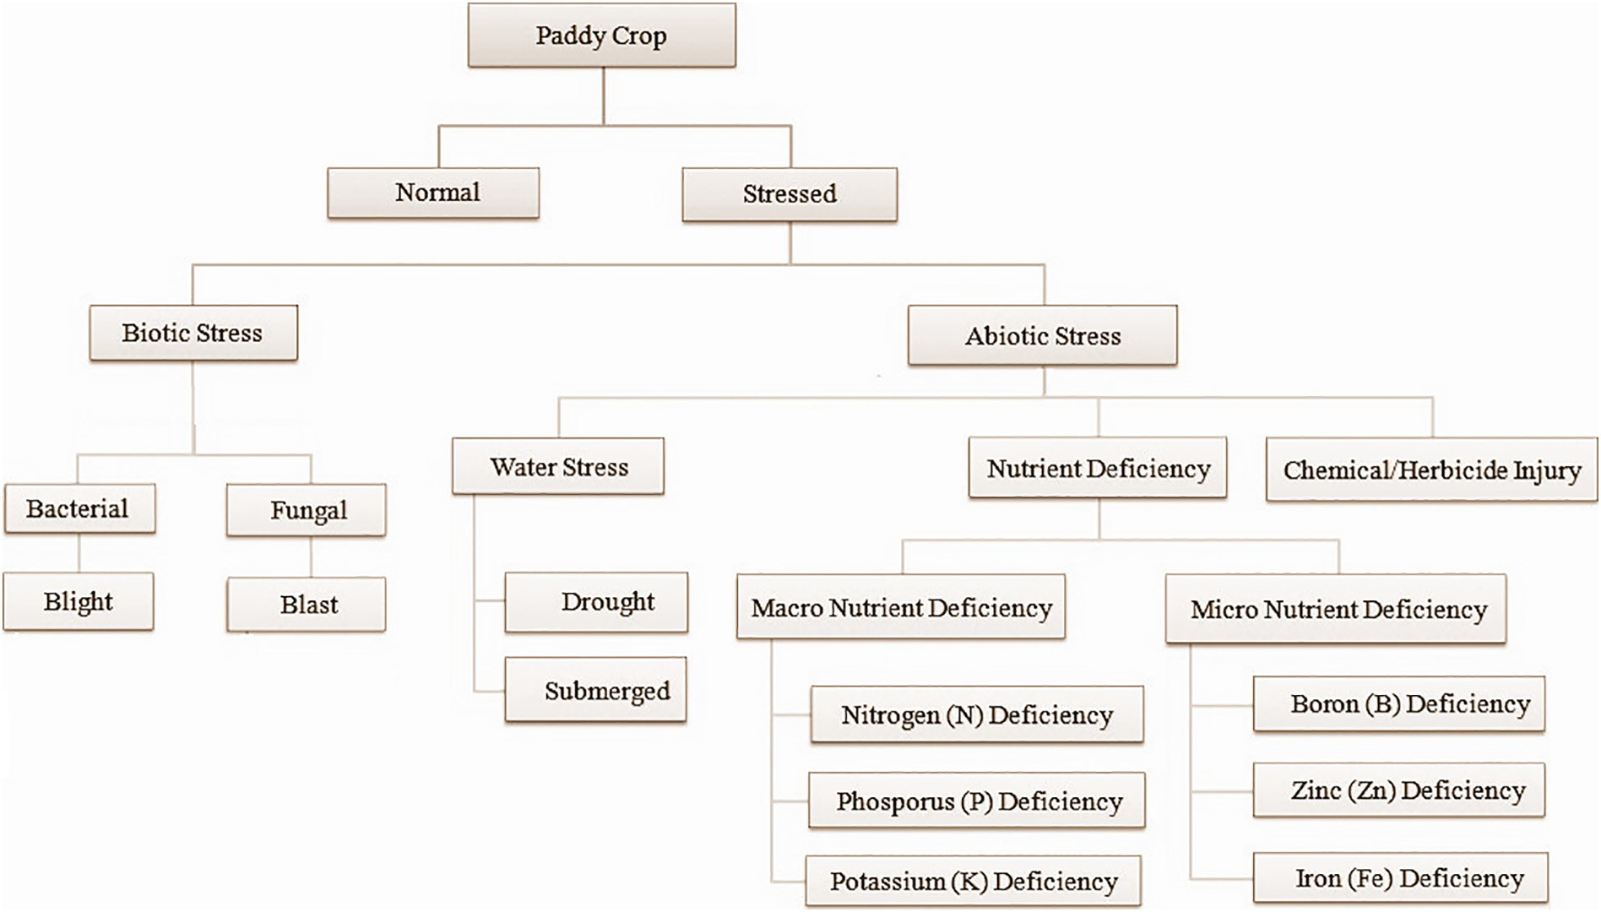](Image%20of%20Fig.%203)

Fig. 3. Paddy crop stress classification tree.

[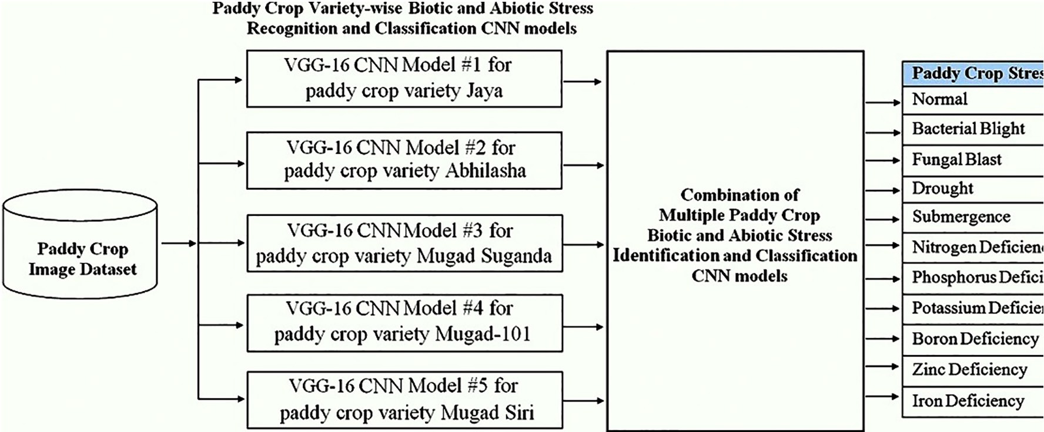](Image%20of%20Fig.%204)

Fig. 4. Proposed methodology.

[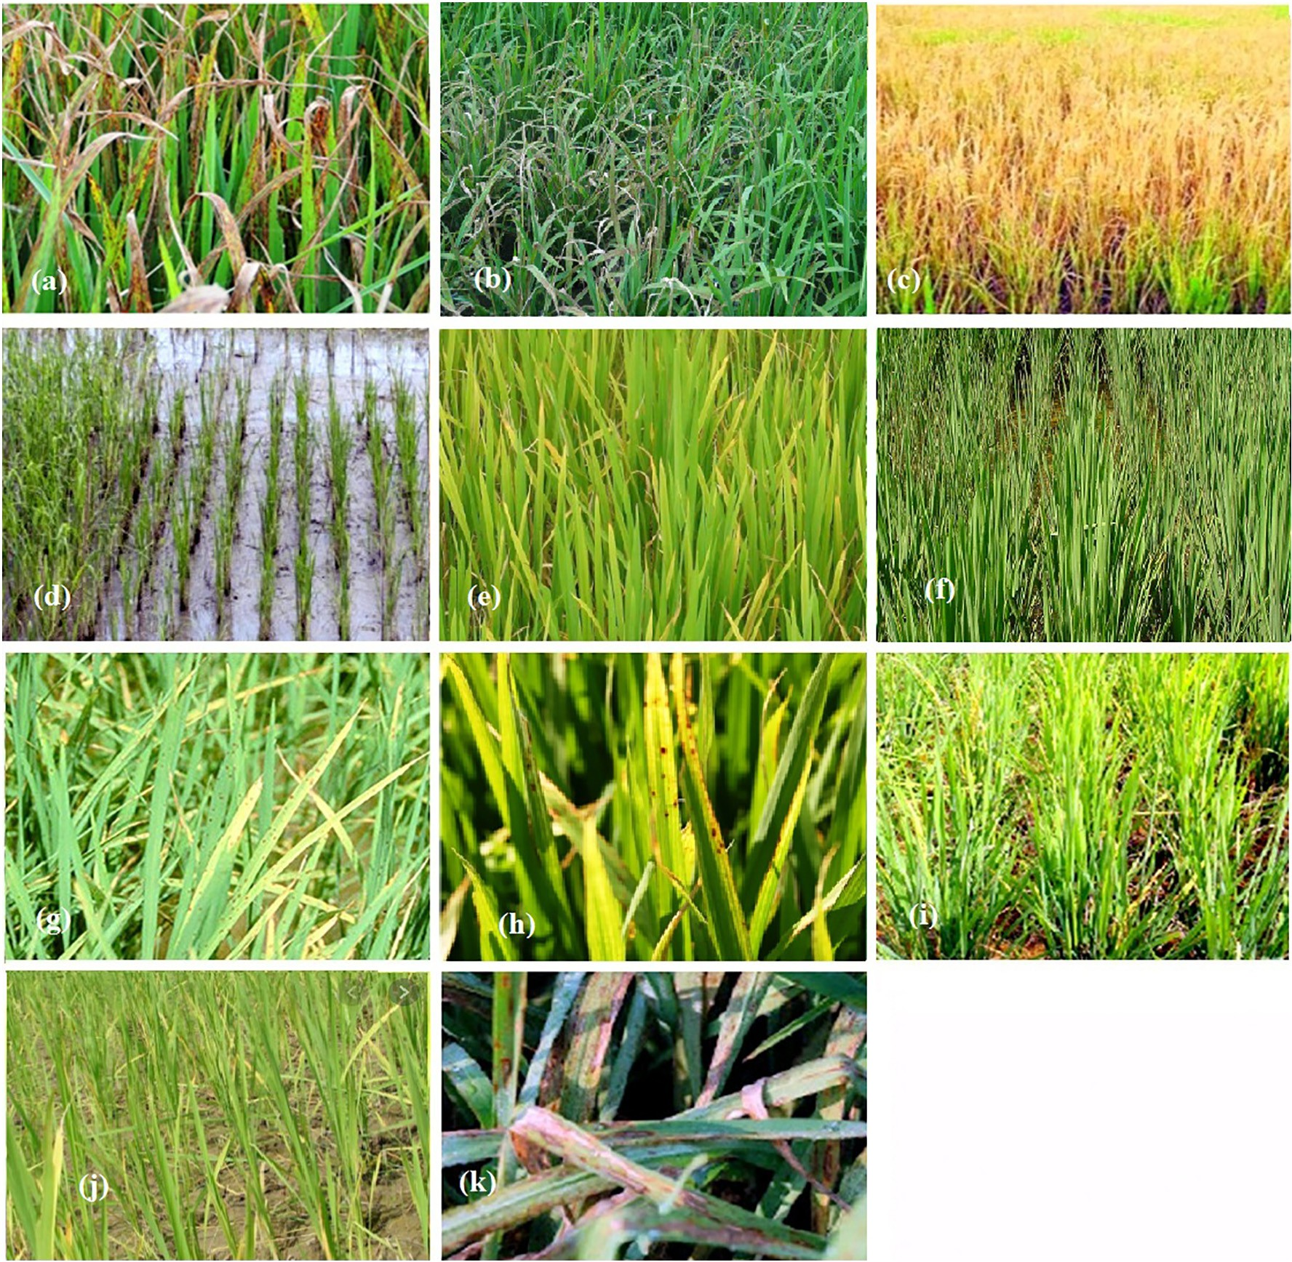](Image%20of%20Fig.%205)

Fig. 5. Sample field images of Jaya paddy crop under various stress conditions. (a) Bacterial blight, (b) Fungal blast, (c) Drought, (d) Submergence, (e) Nitrogen deficit, (f) Phosphorus deficit, (g) Potassium deficit, (h) Boron deficit, (i) Zink deficit, (j) Iron deficit, (k) Chemical injury.

of the study. The field tests were conducted during the Kharif season of 2018.

* 1. *Image acquisition*

The study considers the impact of 11 different stress classes on the 5 different selected paddy crop varieties. From each of the paddy crop va- rieties, a total of 6000 images, considering 500 images per stress class are acquired. A total of 500 healthy field images per paddy crop variety along with the stressed paddy field images have been included in the dataset. The stress identities were confirmed by the experts. The stresses such as bacterial blight and fungal blast were present at low to a medium severity. Each image in this dataset is associated with an expert marked label indicating a stress class. The images were captured in the field under natural light condition near solar noon which is the period with the most stable illumination at the top of the atmosphere using a Nikon D3300 Digital SLR camera having a resolution of 24 megapixels. The camera parameters, such as the ISO, shutter speed, and aperture were set to 400, 1/500, and f/32, respectively. In order to provide a rigid and stable support and easy movement, the camera was mounted on a tripod stand. The angle between the camera lens and the object axis was maintained at approximately 45°. The images were taken keeping the object distance of 2.5 m from the imaged crops. A white foam board was used as a reflector to bounce and inten- sify natural light in the opposite direction to fill the shadows.

Over 30,000 labeled images are collected to create the experimental

dataset of paddy field images from healthy crops and the crops exhibiting different stresses. As a part of the dataset preparation, the ac- quired images of size 1920 × 1080 pixels are manually cropped to a fixed size of 150 × 150 pixels with the assistance of agricultural experts and rice scientists. The sample field images of Jaya paddy crop under various stress conditions are shown in Fig. 5.

* 1. *CNN model configuration and architecture*

The proposed work has employed the pre-trained VGG-16 CNN model for the classification of normal and stressed paddy crop im- ages because of its state-of-the-art performance in the image classi- fication tasks (Simonyan and Zisserman, 2015, Wang et al., 2017, Kamilaris and Prenafeta-Boldú, 2018). The model is an extremely ho- mogeneous architecture that only performs 3 × 3 convolutions and 2 × 2 pooling from the beginning to the end. The model is imple- mented using a higher level Python library Keras which runs over an open source deep learning framework TensorFlow as a backend to classify the stressed paddy crop field images. The image dimen- sion is set to 150 × 150 pixels with depth 3 (RGB channels) and the images are passed through the stack of convolutional layers with the convolution filter size 3 × 3 and convolution strides in x and y di- rections (1,1) pixels. The spatial size is preserved after convolution using hyper parameter padding 1. The spatial pooling is carried out by using five max pooling layers with the pooling size 2 × 2 pixels. The activation function ‘ReLu’ has been considered in all the hidden layers and the ‘softmax’ function is applied to the final layer to en- sure the predicted probability output values are in the range of 0 and 1. The network uses 20 epochs and a batch size of 12. The net- work has been optimized using the gradient descent optimization al- gorithm with categorical cross entropy logarithmic loss function.

The model receives the paddy crop images of size 150 × 150 pixels as input. Then it has a sequence of two convolutional and pooling layers as feature extractors, followed by a fully connected layer to interpret the features and an output layer. The output layer has 12 neurons, which correspond to the number of stress classes in which the input image need to be classified. The schematic structure of the network model layers is shown in Fig. 6.

[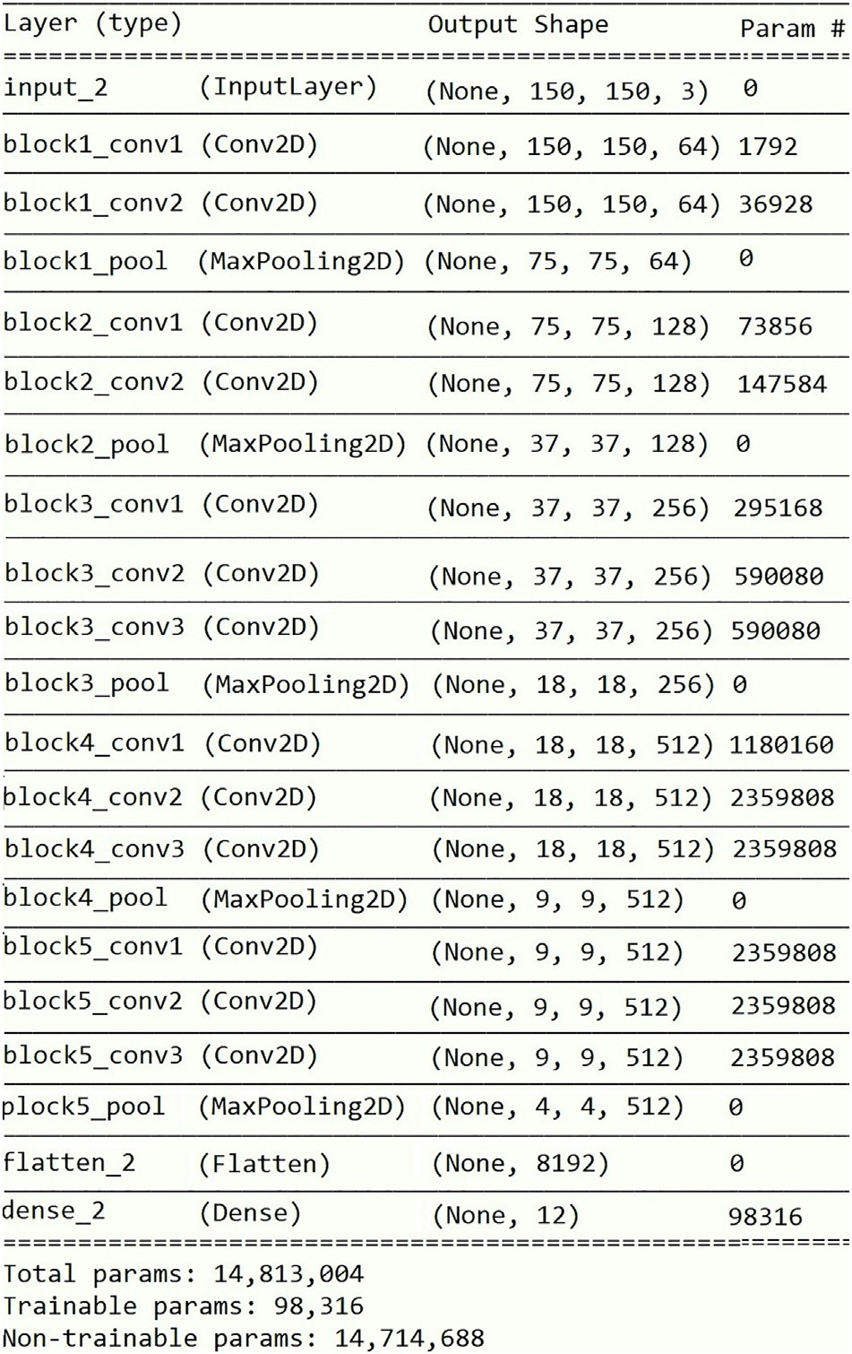](Image%20of%20Fig.%206)

Fig. 6. Schematic structure of the VGG-16 CNN model layers.

1. Experimental results and discussion

The experimental classification model consists of five separate VGG- 16 CNN models, considering one for each of the paddy crop varieties as shown in Fig. 6.8. In each paddy crop variety, there have been twelve classes to distinguish. In order to improve the performance of the CNN models, the original field image dataset with 12,000 images has been enhanced to 30,000 labeled images (considering 6000 images per paddy crop variety) using various image augmentation techniques such as random rescaling, perturbations to brightness, shear transform, vertical flip, horizontal flip, and skewing. All the augmented images show remarkable variation with the original images. The enhanced image set has been split into 60% training (3600 images per paddy crop variety) and 40% testing (2400 images per paddy crop variety) to evaluate the accuracy of the individual CNN model. The 10% of the test dataset has been used as the validation set.

The models have been executed on a desktop computer configured with an Intel Core i5-4210U processor, 8 GB of RAM and one GeForce NVIDIA 1070 GPU. The models have been trained and tested using the respective paddy crop variety images by considering the pre-trained weights provided by the Oxford group in all the layers until conver- gence. The confusion matrices are generated from all the individual models to reveal the erroneous predictions and they are shown in Fig. 7. The performance measures, namely, precision, recall, and mean classification accuracy of each stress class are computed from the confu- sion matrices and they are listed in Table 1. The graphical representation of the average stress classification accuracy results for each paddy crop variety is shown in Fig. 8. From Fig. 8, the maximum and minimum

[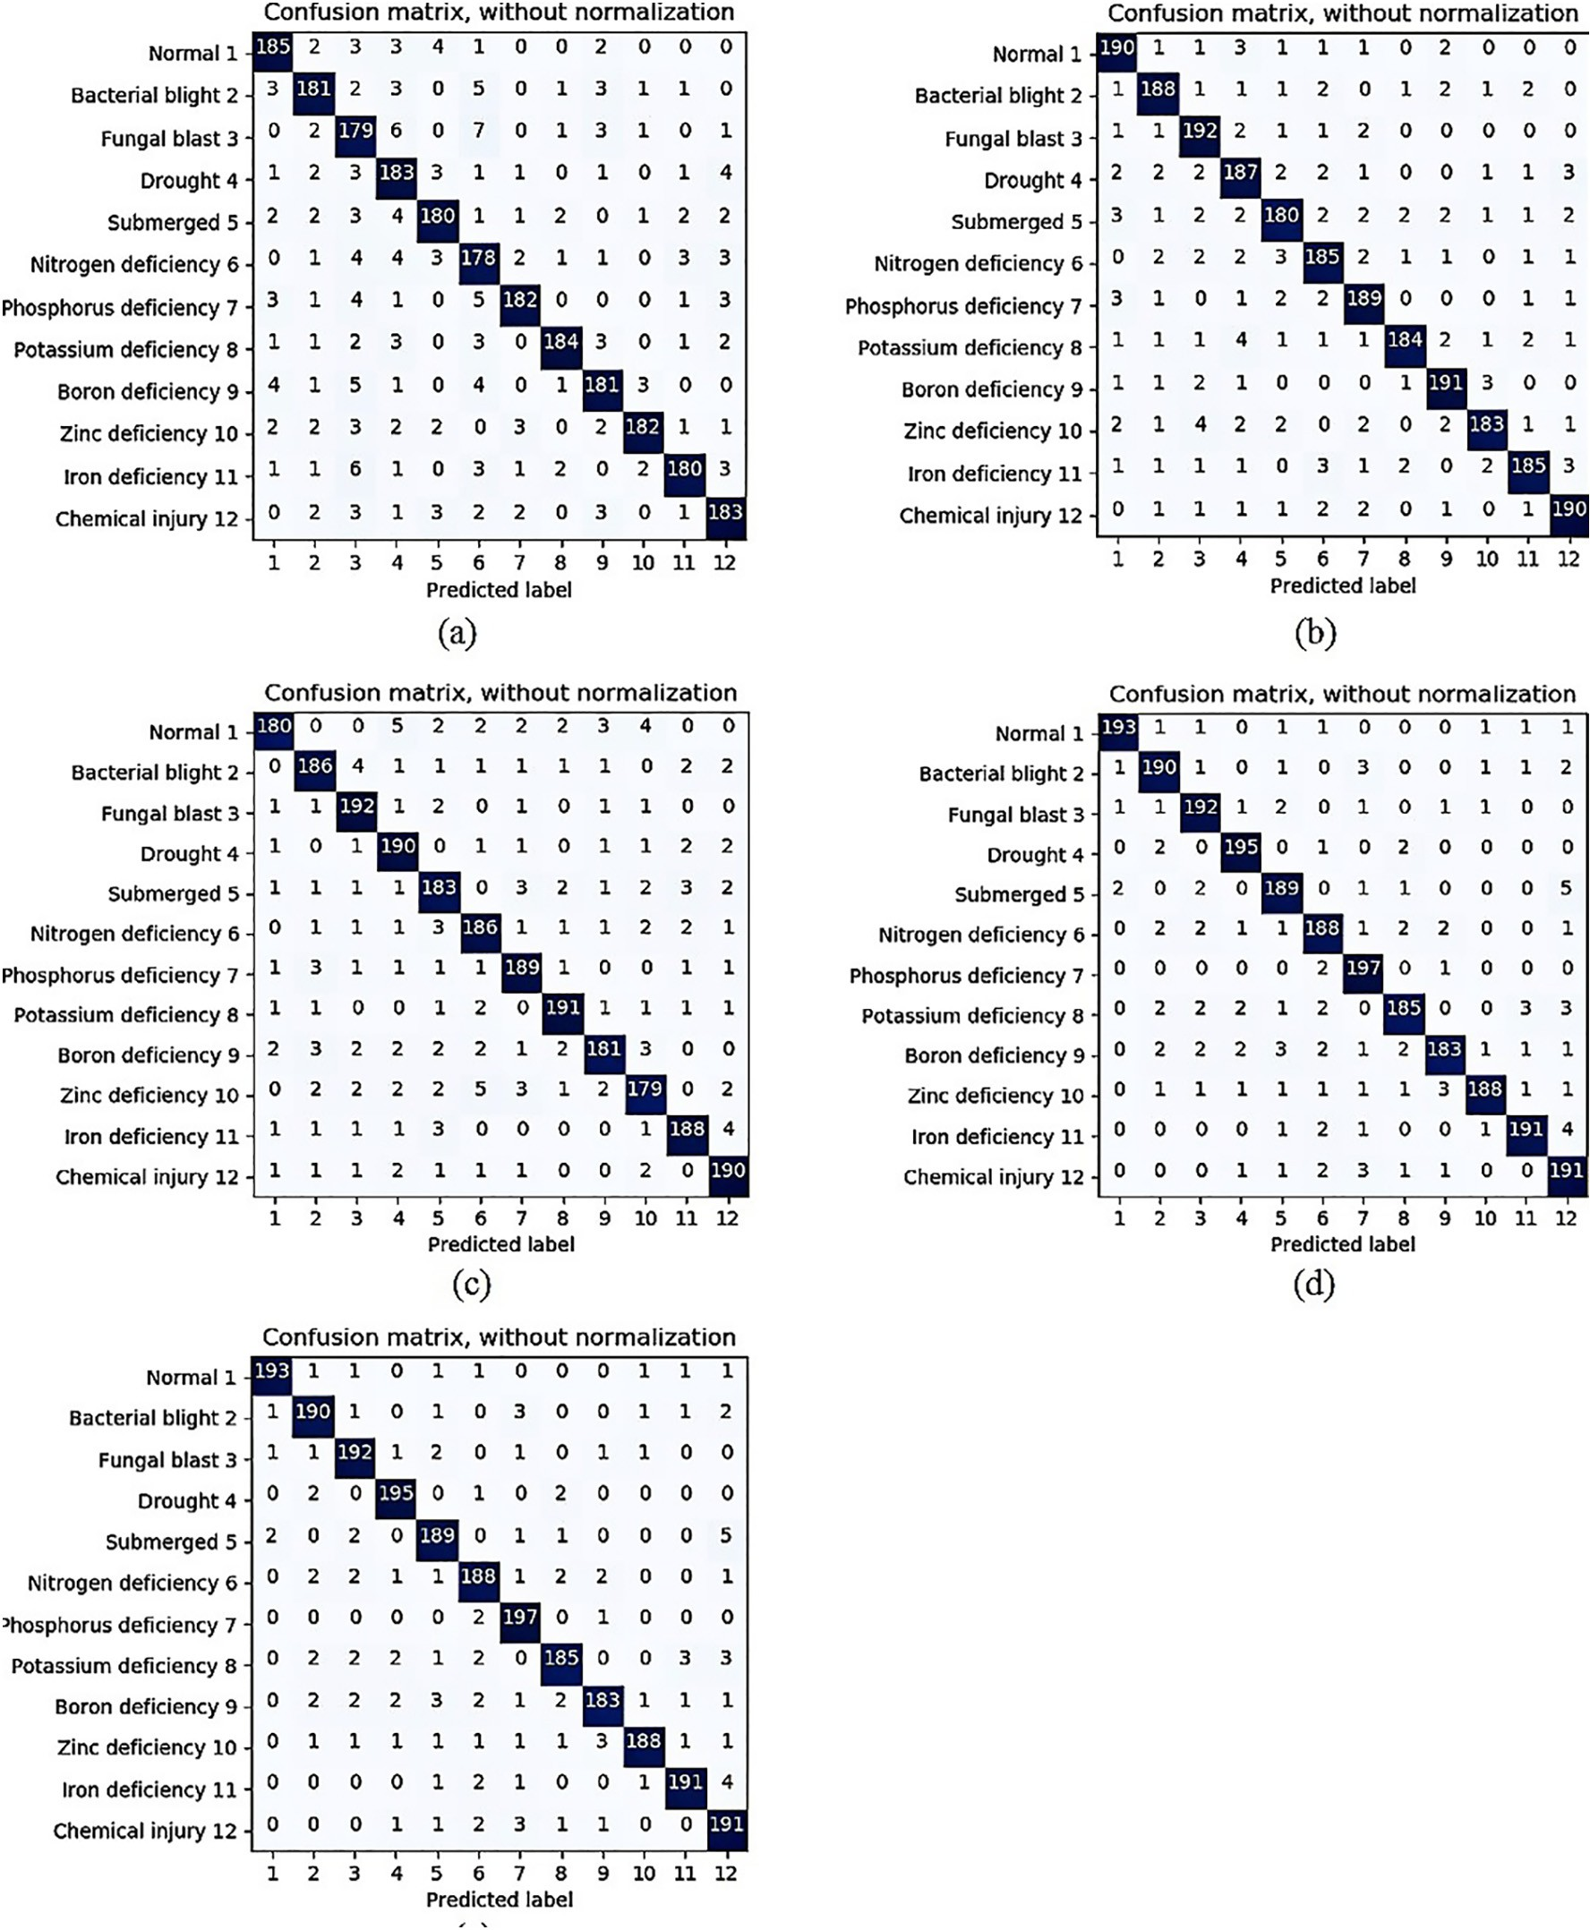](Image%20of%20Fig.%207)

Fig. 7. Confusion matrices for the paddy crop stress images classification using the pre-trained VGG-16 CNN model (a) Jaya, (b) Abhilasha, (c) Mugad Suganda, (d) Mugad 101, (e) Mugad Siri.

average stress classification accuracies of 95.08% and 90.75% are ob- tained for the paddy crop varieties Mugad 101 and Jaya, respectively. The trained models achieve an average stress classification accuracy of 92.89% on the held-out dataset, demonstrating the technical feasibility of using the deep learning approach utilizing 30,000 field images of five different paddy crop varieties with twelve different stress catego- ries (including healthy/normal).

* 1. *Comparison of BPNN and VGG-16 CNN classification results*

The classification results of the present VGG-16 CNN model are corroborated with the developed Backpropagation Neural

Network (BPNN) classification model (Anami et al., 2019). The BPNN classifier is trained with three lower order color statistics, namely mean, variance and skew, and two color descriptors de- fined by the MPEG-7 standard, namely Dominant Color Descriptor (DCD) and Color Layout Descriptor (CLD) to express the color distribution and variations in the field images of paddy crops under various stresses. Table 2 depicts the average stress classifi- cation comparison results between VGG-16 CNN and BPNN classi- fication models across twelve stress classes from five paddy crop varieties considered. From Table 2, it is observed that the perfor- mance of VGG-16 CNN model is slightly better than the BPNN classifier.

Table 1

Paddy crop stress classification results.

|  |  |  |  |  |  |
| --- | --- | --- | --- | --- | --- |
| Sl. no. | Paddy crop variety | Stress class | Precision | Recall | Mean stress classification accuracy (%) |
| 1 | Jaya | Normal | 0.92 | 0.93 | 90.75 |
|  |  | Bacterial blight | 0.91 | 0.91 |  |
|  |  | Fungal blast | 0.82 | 0.90 |  |
|  |  | Drought | 0.86 | 0.92 |  |
|  |  | Submergence | 0.92 | 0.90 |  |
|  |  | Nitrogen deficiency | 0.85 | 0.89 |  |
|  |  | Phosphorus deficiency | 0.95 | 0.91 |  |
|  |  | Potassium deficiency | 0.96 | 0.92 |  |
|  |  | Boron deficiency | 0.91 | 0.91 |  |
|  |  | Zinc deficiency | 0.96 | 0.91 |  |
|  |  | Iron deficiency | 0.94 | 0.90 |  |
|  |  | Chemical injury | 0.91 | 0.92 |  |
| 2 | Abhilasha | Normal | 0.93 | 0.95 | 93.38 |
|  |  | Bacterial blight | 0.94 | 0.94 |  |
|  |  | Fungal blast | 0.92 | 0.96 |  |
|  |  | Drought | 0.90 | 0.92 |  |
|  |  | Submergence | 0.93 | 0.90 |  |
|  |  | Nitrogen deficiency | 0.92 | 0.93 |  |
|  |  | Phosphorus deficiency | 0.93 | 0.95 |  |
|  |  | Potassium deficiency | 0.96 | 0.92 |  |
|  |  | Boron deficiency | 0.94 | 0.96 |  |
|  |  | Zinc deficiency | 0.95 | 0.92 |  |
|  |  | Iron deficiency | 0.95 | 0.93 |  |
|  |  | Chemical injury | 0.94 | 0.95 |  |
| 3 | Mugad Suganda | Normal | 0.95 | 0.90 | 93.13 |
|  |  | Bacterial blight | 0.93 | 0.93 |  |
|  |  | Fungal blast | 0.93 | 0.96 |  |
|  |  | Drought | 0.92 | 0.95 |  |
|  |  | Submergence | 0.91 | 0.92 |  |
|  |  | Nitrogen deficiency | 0.93 | 0.93 |  |
|  |  | Phosphorus deficiency | 0.93 | 0.95 |  |
|  |  | Potassium deficiency | 0.95 | 0.96 |  |
|  |  | Boron deficiency | 0.94 | 0.91 |  |
|  |  | Zinc deficiency | 0.91 | 0.90 |  |
|  |  | Iron deficiency | 0.94 | 0.94 |  |
|  |  | Chemical injury | 0.93 | 0.95 |  |
| 4 | Mugad 101 | Normal | 0.98 | 0.97 | 95.08 |
|  |  | Bacterial blight | 0.95 | 0.95 |  |
|  |  | Fungal blast | 0.95 | 0.96 |  |
|  |  | Drought | 0.96 | 0.98 |  |
|  |  | Submergence | 0.94 | 0.95 |  |
|  |  | Nitrogen deficiency | 0.94 | 0.94 |  |
|  |  | Phosphorus deficiency | 0.94 | 0.99 |  |
|  |  | Potassium deficiency | 0.95 | 0.93 |  |
|  |  | Boron deficiency | 0.96 | 0.92 |  |
|  |  | Zinc deficiency | 0.97 | 0.94 |  |
|  |  | Iron deficiency | 0.96 | 0.96 |  |
|  |  | Chemical injury | 0.91 | 0.96 |  |
| 5 | Mugad Siri | Normal | 0.89 | 0.94 | 92.13 |
|  |  | Bacterial blight | 0.90 | 0.92 |  |
|  |  | Fungal blast | 0.92 | 0.95 |  |
|  |  | Drought | 0.95 | 0.89 |  |
|  |  | Submergence | 0.93 | 0.90 |  |
|  |  | Nitrogen deficiency | 0.90 | 0.92 |  |
|  |  | Phosphorus deficiency | 0.92 | 0.92 |  |
|  |  | Potassium deficiency | 0.93 | 0.95 |  |
|  |  | Boron deficiency | 0.93 | 0.91 |  |
|  |  | Zinc deficiency | 0.92 | 0.93 |  |
|  |  | Iron deficiency | 0.95 | 0.95 |  |
|  |  | Chemical injury | 0.95 | 0.90 |  |

1. Conclusion and future scope

In the present work, an attempt has been made to automate the rec- ognition and classification of paddy crop stresses using the on field im- ages and it has been successfully demonstrated by employing the deep learning techniques. The approach presented is applicable to 11 classes of biotic and abiotic stresses from 5 different paddy crop varieties. The best performing pre-trained deep learning model VGG-16 has been used in the classification task. The maximum average stress classifica- tion accuracy of 95.08% has been achieved using the VGG-16 by learning over 6000 images of Mugad 101 paddy crop variety. The results

obtained are encouraging as the work considers more number of paddy crop stress classes and the varieties than in the reported works. But still, there is a scope for improvement. The stress classification per- formance of the VGG-16 model will be compared with the similar state- of-the-art models such as ResNet, GoogLeNet, Inception-v3, and LeNet as a future scope. The work carried out is challenging in terms of high ir- regularity in an outdoor environment. The generality of the proposed approach can make it applicable to a wide range of field crops, such as wheat, maize, barley, soybean etc. The effects of environmental condi- tions such as extreme temperatures and soil factors, the presence of combinatorial stresses, the quantification of stresses, and the prediction

[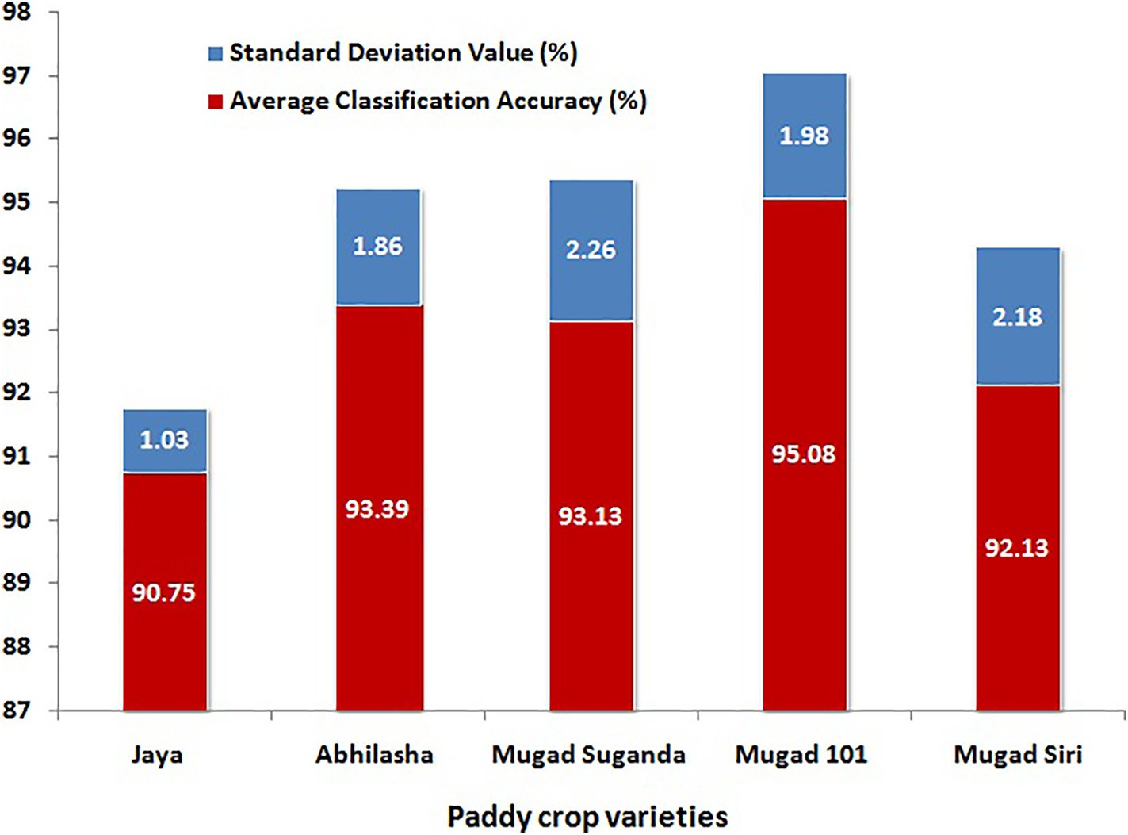](Image%20of%20Fig.%208)

Fig. 8. Graphical representation of VGG-16 model based paddy crop stress classification results.

Table 2

Classification efficiency comparison between VGG-16 CNN and BPNN classification models.

Sl. no. Paddy crop variety Average stress classification accuracies per paddy crop variety (%)

VGG ‐− 16 CNN BPNN

1. Jaya 90.75 88.00`
2. Abhilasha 93.38 89.67
3. Mugad Suganda 93.13 90.67
4. Mugad 101 95.08 87.92
5. Mugad Siri 92.13 89.33

Bock, C.H., Poole, G.H., Parker, P.E., Gottwald, T.R., 2010. [Plant disease severity estimated](http://refhub.elsevier.com/S2589-7217(20)30010-6/rf0025) [visually, by digital photography and image analysis, and by hyperspectral imaging.](http://refhub.elsevier.com/S2589-7217(20)30010-6/rf0025) [Crit. Rev. Plant Sci. 29 (2), 59–107](http://refhub.elsevier.com/S2589-7217(20)30010-6/rf0025).

Chen, L., Lin, L., Cai, G., Sun, Y., Huang, T., Wang, K., Deng, J., 2014. [Identification of nitro-](http://refhub.elsevier.com/S2589-7217(20)30010-6/rf0030) [gen, phosphorus, and potassium deficiencies in rice based on static scanning technol-](http://refhub.elsevier.com/S2589-7217(20)30010-6/rf0030) [ogy and hierarchical identification method. PLoS One 9 (11), e11320](http://refhub.elsevier.com/S2589-7217(20)30010-6/rf0030)0.

Kamilaris, A., Prenafeta-Boldú, F.X., 2018. [Deep learning in agriculture: a survey. Comput.](http://refhub.elsevier.com/S2589-7217(20)30010-6/rf0035)

[Electron. Agric. 147, 70–90](http://refhub.elsevier.com/S2589-7217(20)30010-6/rf0035).

Konstantinos, P. Ferentinos, 2018. [Deep learning models for plant disease detection and](http://refhub.elsevier.com/S2589-7217(20)30010-6/rf0040) [diagnosis. Comput. Electron. Agric. 145, 311–31](http://refhub.elsevier.com/S2589-7217(20)30010-6/rf0040)8.

Latte, M.V., Shidnal, S., Anami, B.S., 2017. [Rule based approach to determine nutrient de-](http://refhub.elsevier.com/S2589-7217(20)30010-6/rf0045)

[ficiency in paddy leaf images. Int. J. Agric. Technol. 13 (2), 227–24](http://refhub.elsevier.com/S2589-7217(20)30010-6/rf0045)5.

Lu, Jiang, Hu, Jie, Zhao, Guannan, Mei, Fenghua, Zhang, Changshui, 2017. [An in-field auto-](http://refhub.elsevier.com/S2589-7217(20)30010-6/rf0050) [matic wheat disease diagnosis system. Comput. Electron. Agric. 142, 369–37](http://refhub.elsevier.com/S2589-7217(20)30010-6/rf0050)9.

Lu, Yang, Yi, Shujuan, Zeng, Nianyin, Liu, Yurong, Zhang, Yong, 2017. [Identification of](http://refhub.elsevier.com/S2589-7217(20)30010-6/rf0055) [rice diseases using deep convolutional neural networks. Neurocomputing 267,](http://refhub.elsevier.com/S2589-7217(20)30010-6/rf0055)

Average stress classification accuracy obtained across the paddy varieties (%)

92.89 89.12

[378–384.](http://refhub.elsevier.com/S2589-7217(20)30010-6/rf0055)

Mew, T.W., Hibino, H., Savary, S., Vera Cruz, C.M., Opulencia, R., Hettel, G.P., 2018. [Rice Dis-](http://refhub.elsevier.com/S2589-7217(20)30010-6/rf0060) [eases: Biology and Selected Management Practices (Eds). International Rice Research](http://refhub.elsevier.com/S2589-7217(20)30010-6/rf0060) [Institute, Los Baños (Philippines)](http://refhub.elsevier.com/S2589-7217(20)30010-6/rf0060).

Mohan, K.J., Balasubramanian, M., Palanivel, S., 2016. [Detection and recognition of dis-](http://refhub.elsevier.com/S2589-7217(20)30010-6/rf0065) [eases from paddy plant leaf images. Int. J. Comput. Appl. 144 (12)](http://refhub.elsevier.com/S2589-7217(20)30010-6/rf0065).

of the gap between yield potential and yield under stress can be the fac- tors for further studies.

Conflict of interest

On behalf of all the authors, the corresponding author declares that there is no conflict of interest to report and received no financial support for the research.

References

Alam, M.M., Karim, Md Rezaul, Ladha, J.K., 2013. [Integrating best management practices](http://refhub.elsevier.com/S2589-7217(20)30010-6/rf0005) [for rice with farmers’ crop management techniques: a potential option for minimiz-](http://refhub.elsevier.com/S2589-7217(20)30010-6/rf0005) [ing rice yield gap. Field Crop Res. 144, 62–68](http://refhub.elsevier.com/S2589-7217(20)30010-6/rf0005).

Ali, M.M., Al-Ani, Ahmed, Derek Eamus, D., Tan, K., 2017. [Leaf nitrogen determination](http://refhub.elsevier.com/S2589-7217(20)30010-6/rf0010) [using non-destructive techniques –a review. J. Plant Nutr. 40 (7), 928–95](http://refhub.elsevier.com/S2589-7217(20)30010-6/rf0010)3.

Anami, B.S., Naveen, N.M., Surendra, P., 2019. Classification of yield affecting biotic and abiotic paddy crop stresses using field images. Information Processing in Agriculture <https://doi.org/10.1016/j.inpa.2019.08.005>.

Anonymous, 2018. USDA foreign agriculture service, India-grain and feed annual. GAIN report number IN8027. Retrieved March 16, 2018, from. [http://www.gain.fas.usda.](http://www.gain.fas.usda.gov/) [gov](http://www.gain.fas.usda.gov/).

Mohanty, S.P., Hughes, D.P., Salathé, M., 2016. [Using deep learning for image-based plant](http://refhub.elsevier.com/S2589-7217(20)30010-6/rf0070) [disease detection. Front. Plant Sci. 7, 1419](http://refhub.elsevier.com/S2589-7217(20)30010-6/rf0070).

Nutan, K.K., Rathore, R.S., Tripathi, A.K., Mishra, M., Pareek, A., Singla-Pareek, S.L., 2020. [In-](http://refhub.elsevier.com/S2589-7217(20)30010-6/rf0075) [tegrating dynamics of yield traits in rice responding to environmental changes. J. Exp.](http://refhub.elsevier.com/S2589-7217(20)30010-6/rf0075) [Bot. 71 (2), 490–50](http://refhub.elsevier.com/S2589-7217(20)30010-6/rf0075)6.

Phadikar, S., Sil, J., Das, A.K., 2012. [Classification of rice leaf diseases based on morpholog-](http://refhub.elsevier.com/S2589-7217(20)30010-6/rf0080) [ical changes. International Journal of Information and Electronics Engineering 2 (3),](http://refhub.elsevier.com/S2589-7217(20)30010-6/rf0080) [46](http://refhub.elsevier.com/S2589-7217(20)30010-6/rf0080)0.

Pugoy, R.A.D., Mariano, V.Y., 2011. [Automated rice leaf disease detection using color](http://refhub.elsevier.com/S2589-7217(20)30010-6/rf0085) [image analysis, in: third international conference on digital image processing](http://refhub.elsevier.com/S2589-7217(20)30010-6/rf0085) [(ICDIP 2011). International Society for Optics and Photonics 8009, 80090F](http://refhub.elsevier.com/S2589-7217(20)30010-6/rf0085).

Sambuddha, Ghosal, Blystone, David, Singh, Asheesh K., Ganapathysubramanian, Baskar, Singh, Arti, Sarkar, Soumik, 2018. [An explainable deep machine vision framework](http://refhub.elsevier.com/S2589-7217(20)30010-6/rf0090) [for plant stress phenotyping. Proc. Natl. Acad. Sci. 115 (18), 4613–4618.](http://refhub.elsevier.com/S2589-7217(20)30010-6/rf0090)

Sanyal, P., Bhattacharya, U., Parui, S.K., Bandyopadhyay, S.K., Patel, S., 2007. [Color texture](http://refhub.elsevier.com/S2589-7217(20)30010-6/rf0095) [analysis of rice leaves diagnosing deficiency in the balance of mineral levels towards](http://refhub.elsevier.com/S2589-7217(20)30010-6/rf0095) [improvement of crop productivity. Information Technology, (ICIT 2007), 10th Inter-](http://refhub.elsevier.com/S2589-7217(20)30010-6/rf0095) [national Conference, IEEE, pp. 85–90](http://refhub.elsevier.com/S2589-7217(20)30010-6/rf0095).

Simonyan, Karen, Zisserman, Andrew, 2015. [Very deep convolutional networks for large-](http://refhub.elsevier.com/S2589-7217(20)30010-6/rf0100) [scale image recognition. arXiv preprint arXiv, pp. 1409–1556 ICLR](http://refhub.elsevier.com/S2589-7217(20)30010-6/rf0100).

Singh, A.K., Ganapathysubramanian, B., Sarkar, S., Singh, A., 2018. [Deep learning for plant](http://refhub.elsevier.com/S2589-7217(20)30010-6/rf0105) [stress phenotyping: trends and future perspectives. Trends Plant Sci. 23 (10),](http://refhub.elsevier.com/S2589-7217(20)30010-6/rf0105) [883–89](http://refhub.elsevier.com/S2589-7217(20)30010-6/rf0105)8.

Sun, Y., Tong, C., He, S., Wang, K., Chen, L., 2018. [Identification of nitrogen, phosphorus,](http://refhub.elsevier.com/S2589-7217(20)30010-6/rf0110) [and potassium deficiencies based on temporal dynamics of leaf morphology and](http://refhub.elsevier.com/S2589-7217(20)30010-6/rf0110) [color. Sustainability 10 (3), 76](http://refhub.elsevier.com/S2589-7217(20)30010-6/rf0110)2.

Wang, G., Sun, Y., Wang, J., 2017. [Automatic image-based plant disease severity estima-](http://refhub.elsevier.com/S2589-7217(20)30010-6/rf0115) [tion using deep learning. Comput. Intell. Neurosci. 2017](http://refhub.elsevier.com/S2589-7217(20)30010-6/rf0115).

Yang, J., Gong, W., Shi, S., Du, L., Sun, J., Ma, Y.Y., Song, S.L., 2015. [Accurate identification of](http://refhub.elsevier.com/S2589-7217(20)30010-6/rf0120) [nitrogen fertilizer application of paddy rice using laser-induced fluorescence com-](http://refhub.elsevier.com/S2589-7217(20)30010-6/rf0120) [bined with support vector machine. Plant Soil Environ. 61 (11), 501–50](http://refhub.elsevier.com/S2589-7217(20)30010-6/rf0120)6.

Yuan, Jianqing, Zhongbin, Su, Jia, Yinjiang, Yu, Zhang, Zhang, Zongxin, 2016. [Identifi-](http://refhub.elsevier.com/S2589-7217(20)30010-6/rf0125) [cation of rice leaf blast and nitrogen deficiency in cold region using](http://refhub.elsevier.com/S2589-7217(20)30010-6/rf0125) [hyperspectral imaging. Transactions of the Chinese Society of Agricultural](http://refhub.elsevier.com/S2589-7217(20)30010-6/rf0125) [Engineering 32 (13), 155–160.](http://refhub.elsevier.com/S2589-7217(20)30010-6/rf0125)