[Artificial Intelligence in Agriculture 6 (2022) 211–229](https://doi.org/10.1016/j.aiia.2022.09.007)

Contents lists available at [ScienceDirect](http://www.sciencedirect.com/science/journal/)

Artificial Intelligence in Agriculture

journal homepage: [http://www.keaipublishing.com/en/journa ls/artificial- intelligence- in-agriculture/](http://www.keaipublishing.com/en/journals/artificial-intelligence-in-agriculture/)

[](http://crossmark.crossref.org/dialog/?doi=10.1016/j.aiia.2022.09.007&domain=pdf)Deep learning based computer vision approaches for smart agricultural applications

V.G. Dhanya a,⁎, A. Subeesh b,⁎⁎, N.L. Kushwaha c, Dinesh Kumar Vishwakarma d, T. Nagesh Kumar e,

G. Ritika c, A.N. Singh a

a *ICAR- Indian Institute of Seed Science, Mau, Uttar Pradesh 275101, India*

b *ICAR- Central Institute of Agricultural Engineering, Bhopal, Madhya Pradesh 462038, India*

c *ICAR- Indian Agricultural Research Institute, New Delhi 110012, India*

d *Govind Ballabh Pant University of Agriculture and Technology, Pantnagar, Uttarakhand 263145, India*

e *ICAR - National Institute of Natural Fibre Engineering and Technology, Kolkata 700040, India*

a r t i c l e i n f o

*Article history:*

Received 2 June 2022

Received in revised form 22 September 2022 Accepted 25 September 2022

Available online 30 September 2022

*Key words:*

Agriculture automation Computer vision

Deep learning Machine learning Smart agriculture Vision transformers

### Contents

a b s t r a c t

### The agriculture industry is undergoing a rapid digital transformation and is growing powerful by the pillars of cutting-edge approaches like artificial intelligence and allied technologies. At the core of artificial intelligence, deep learning-based computer vision enables various agriculture activities to be performed automatically with utmost precision enabling smart agriculture into reality. Computer vision techniques, in conjunction with high-quality image acquisition using remote cameras, enable non-contact and efficient technology-driven solu- tions in agriculture. This review contributes to providing state-of-the-art computer vision technologies based on deep learning that can assist farmers in operations starting from land preparation to harvesting. Recent works in the area of computer vision were analyzed in this paper and categorized into (a) seed quality analysis, (b) soil analysis, (c) irrigation water management, (d) plant health analysis, (e) weed management (f) livestock manage- ment and (g) yield estimation. The paper also discusses recent trends in computer vision such as generative ad- versarial networks (GAN), vision transformers (ViT) and other popular deep learning architectures. Additionally, this study pinpoints the challenges in implementing the solutions in the farmer’s field in real-time. The overall finding indicates that convolutional neural networks are the corner stone of modern computer vision approaches and their various architectures provide high-quality solutions across various agriculture activities in terms of pre- cision and accuracy. However, the success of the computer vision approach lies in building the model on a quality dataset and providing real-time solutions.

### © 2022 The Authors. Publishing services by Elsevier B.V. on behalf of KeAi Communications Co., Ltd. This is an open access article under the CC BY-NC-ND license (<http://creativecommons.org/licenses/by-nc-nd/4.0/>).

### Introduction 212

### Computer vision and deep learning models 213

### Image classification with CNN and Object detection models 214

*Abbreviations:* AI, Artificial Intelligence; ANN, Artificial Neural Network; BP, Back Propagation; C-GAN, Conditional Generative Adversarial Network; CNN, Convolutional Neural Network; COCO, Common Objects in Context; CV, Computer Vision; DCNN, Deep Convolutional Neural Network; DL, Deep Learning; DNA, Deoxyribo Nucleic Acid; RCNN, Region- based Convolutional Networks; FCN, Fully Convolutional Networks; FLDA, Fisher's Linear Discrimination Analysis; GAN, Generative Adversarial Network; GLCM, Grey Level Co- occurrence Matrix; GPU, Graphic Processing Units; HOG, Histogram of Oriented Gradients; KNN, K- Nearest Neighbour; LBP, Local Binary Patterns; LCTF, Liquid Crystal Tunable Filters; LDA, Linear Discriminant Analysis; LIDAR, Light Detection and Ranging; LSTM, Long Short-Term Memory; MHA, Multi Headed Attention; ML, Machine Learning; MLP, Multi-Layer Perceptron; NASNet, Neural Search Architecture Network; NLP, Natural Language Processing; OCR, Optical Character Recognition; PEAT, Progressive Environmental and Agricultural Technologies; PLF, Precision Livestock Farming; ResNet, Residual Network; RF, Random Forest; RGB, Red Green Blue; SegNET, Semantic Segmentation Network; SSD, Single Shot Multibox Detector; SVM, Support Vector Machine; UAV, Unmanned Aerial Vehicle; VGG, Visual Geometry Group; ViT, Vision Transformers; WSN, Wireless Sensor Network; YOLO, You Only Look Once.

* Corresponding author to: V.G Dhanya, ICAR - Indian Institute of Seed Science, Mau, Uttar pradesh 275101, India.

⁎⁎ Corresponding author to: A. Subeesh, ICAR - Central Institute of Agricultural Engineering (CIAE), Bhopal, Madhya Pradesh 462038, India.

*E-mail addresses:* [dhanya.vg@icar.gov.in](mailto:dhanya.vg@icar.gov.in) (V.G. Dhanya), [subeesh.a@icar.gov.in](mailto:subeesh.a@icar.gov.in) (A. Subeesh).

<https://doi.org/10.1016/j.aiia.2022.09.007>

2589-7217/© 2022 The Authors. Publishing services by Elsevier B.V. on behalf of KeAi Communications Co., Ltd. This is an open access article under the CC BY-NC-ND license ([http://](http://creativecommons.org/licenses/by-nc-nd/4.0/) [creativecommons.org/licenses/by-nc-nd/4.0/](http://creativecommons.org/licenses/by-nc-nd/4.0/)).

* 1. Generative adversarial network (GAN) and Vision Transformers (ViT) 214

1. Deep learning driven computer vision – Application areas in agriculture 215
   1. Seed quality analysis 215
   2. Soil analysis 216
   3. Irrigation management 217
   4. Plant health analysis 218
   5. Weed management 219
   6. Livestock management 220
   7. Yield estimation 221
2. Practical implications 221
3. Challenges and way forward 223
4. Conclusions 224

References 224

1. Introduction

The UNDP 2021 report on “leveraging digital technology for sustain- able agriculture” states that global food production needs to be in- creased by 98 percent to feed a burgeoning human population of 9.9 billion by 2050 (Burra et al., 2021). This target needs to be accomplished through the effective utilization of available resources viz land, labor, capital, and technology (Ranganathan et al., 2018). Present status on precision agriculture aims to define the decision support system for farm management by optimizing the output while consecutively pre- serving the resources applied. Constructively pointing out, the emerging trend of food security needs to be handled with data-driven farming that can increase productivity, efficiency, and profits. The key challenges such as food demand, labor shortage, water shortage, climate change (Badrzadeh et al., 2022; Elbeltagi et al., 2022a; Kaack et al., 2022) and in- creasing energy demands lead to the need for technology intervention. The opportunity offered by smart agriculture, which encompasses pre- cision agriculture, digital agriculture as well as modern agricultural practices, needs prime validation at this point. Smart agriculture is pri- marily based on three platforms viz, science, innovation, and ICT (Infor- mation and Communication Technology) (Khanna and Kaur, 2019). The traditionally used information and knowledge management system for collecting and monitoring agricultural data is not only laborious but is also time-consuming and error-prone. Therefore, the technical ad- vancement in remote sensing, digital applications, sensors, advanced imaging systems, cloud data storage along with intelligent data analysis using the decision support systems need to be well utilized in making the farming sector smarter (Fig. 1). Smart agriculture can leverage cutting-edge technologies like the Internet of Things, Machine learning,

Cloud computing, Blockchain, *etc*., and benefit from these opportunities in improving food production and addressing the emerging challenges in this sector (Sami et al., 2022).

Recently, the infiltration of computer/ mobile technology even to the most rural pockets, has provided an inimitable facility in connecting the rural producers with the city-consumers or the international investors, thereby facilitating better investments and knowledge transfer in agri- culture (Aker, 2011; Karim et al., 2013). Artificial intelligence (AI) is a game-changing technology that already has proven track records across various industries, including agriculture (Adnan et al., 2021; Bhagat et al., 2020; Jamei et al., 2022b; Kumar et al., 2019; Subeesh et al., 2019). The use of machine learning, a subset of artificial intelligence, has been covered extensively by researchers in delivering innovative solutions for modelling complex relationships and further, making pre- dictions on agriculture data (Bhavsar and Panchal, 2012; Heramb et al., 2022; Jamei et al., 2022c; Karbasi et al., 2022; Malik et al., 2022a; Rai et al., 2022; Rehman et al., 2019; Tantalaki et al., 2019). Computer vi- sion, a field of artificial intelligence, is making a machine “see”, using the modern technologies involving a camera and computer instead of human vision, empowering extensive automation capabilities to AI sys- tems. Computer vision collects necessary visual data regarding crops, livestock, farm or garden, allowing us to identify, detect and track spe- cific objects using visual elements and comprehend complex visual data for automation tasks. In the past decades, expert and intelligent systems based on computer vision technology have been well utilized for agricultural operations (Foglia and Reina, 2006; Gomes and Leta, 2012; Rico-Fernández et al., 2019). Further, the development of modern technologies and hardware supports like Graphic Processing Units (GPUs) and edge devices have diversified the application of computer

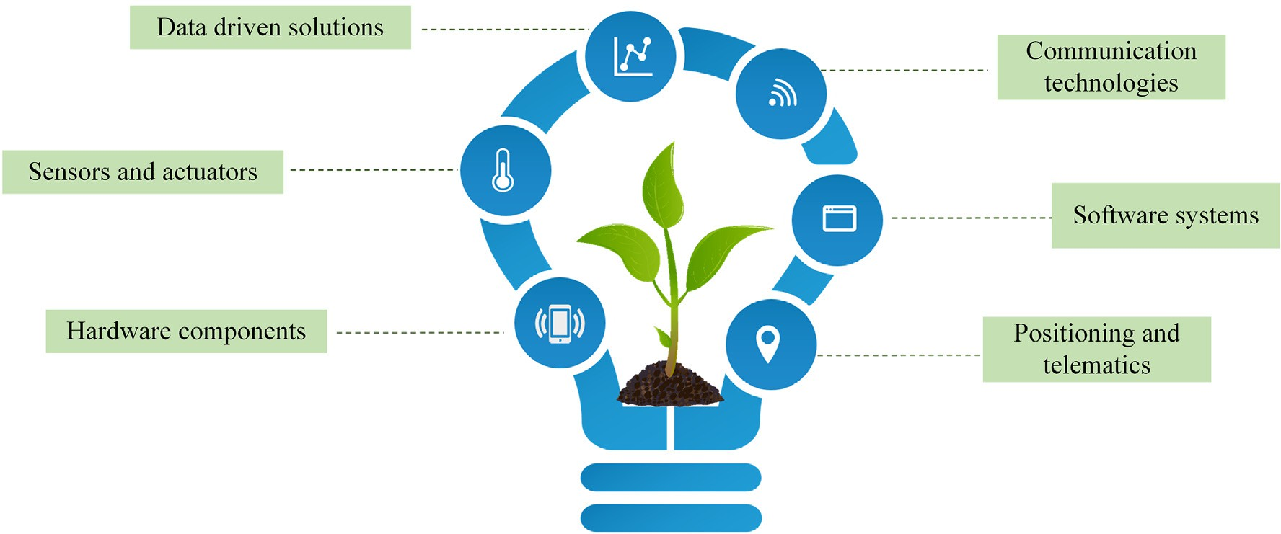

vision, thereby making strands to efficient agricultural production (Li et al., 2019; Mochida et al., 2019; Rehman et al., 2019; Vázquez- Arellano et al., 2016). Modern computer vision techniques can help in the digital quantification of different morphological and physiological plant parameters along with the qualitative assessment of the same and are expected to rapidly improve the accuracy of plant phenotyping (Araus and Cairns, 2014; Ghanem et al., 2015). Further, combining the computer vision techniques with the high throughput molecular meth- odologies of DNA sequencing provides an opportunity for genome-wide exploration of useful genes and molecular modeling of the same to un- derstand the complex traits such as plant yield and productivity, stress tolerance, biotic and abiotic stress management etc (Araus et al., 2018; Shakoor et al., 2017). Thus imaging with computer vision technology aided by various imaging sensors and algorithms can indeed play a major role in precision agriculture and in paving the way for smart ag- riculture (Araus et al., 2018). A data driven precision agriculture system architecture consists of sensors deployed on the fields (sensing layer), network layer that provides connectivity, storage and other services (service layer) and application layer consisting of the end user accessing the services through mobile/web-based applications (Fig. 2). Integrative and multi-mode Artificial Intelligence (AI) models can be deployed to predict crop behaviour under differing field conditions (Shrivastava and Marshall-Colon, 2018; Waldhoff et al., 2017). The yield perfor- mance of major crops in various regions, along with the field conditions for crop production, environmental impact and economic outcome, have been assessed using the algorithms of deep learning and machine learning (Tantalaki et al., 2019). Deep learning permits the computa- tional models with multiple processing layers to indicate the data in multiple levels of abstraction (Schmidhuber, 2015). The main applica- tion of deep learning in the field of agriculture are building models to derive meaningful insights from agriculture data (Jamei et al., 2022a; Malik et al., 2022b), image analysis including classification and object detection, such as the detection of diseases, weed identification, soil

analysis, plant disease detection, etc. (Kamilaris and Prenafeta-Boldú, 2018).

For this study, we have collected more than 100 research papers from scientific databases, including PubMed, Web of Science, and Scopus, in the area of deep learning-based computer vision. Further, we investigated all these works that leveraged deep learning-based computer vision technologies to address key agriculture tasks such as plant health monitoring, disease and weed identification, irrigation management, soil analysis, livestock management, yield estimation, etc. The main objective of this study is to evaluate the penetration of deep learning-based computer vision approaches in key agricultural problems, and this review is intended to be useful to agriculture re- searchers as well as general computer vision researchers who are inter- ested in the application of computer vision solutions to automate and solve potential agricultural problems. The practical implications of these technologies along with major challenges in implementing large-scale applications were also constructively pointed out in this study.

1. Computer vision and deep learning models

Computer vision possesses dual and interrelated goals. In biological science, computer vision aims to represent the human visual system using computational models, and in the engineering perspective, com- puter vision attempts to create autonomous systems that can do tasks that often human visual systems cannot perform (Huang, 1993). Com- puter vision imparts visual capability to machines through cameras, data, models, and algorithms rather than retinas and the visual cortex. Optical character recognition (OCR) technology and intelligent charac- ter recognition were some major tasks that employed computer vision to accomplish tasks such as document and invoice processing, vehicle plate detection, etc. In the early stages of computer vision research, the main focus was to build algorithms to detect edges, curves, corners,

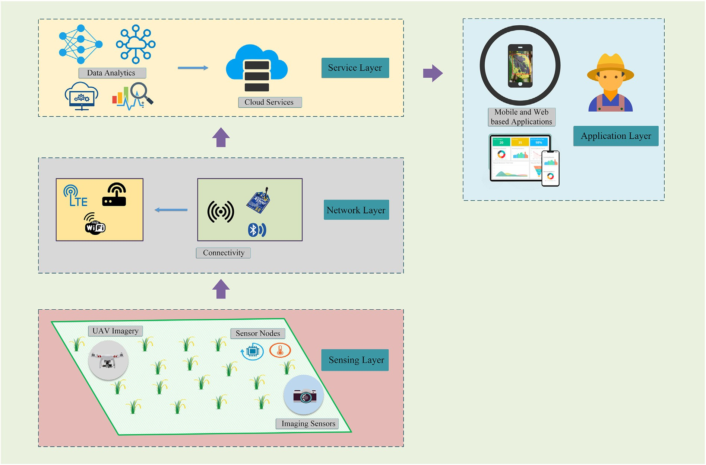

and other basic shapes. Before the era of deep learning, image process- ing relied on gray level segmentation and this approach wasn’t robust enough to represent complex classes. Modern computer vision algo- rithms rely extensively on artificial neural networks that provide a dra- matic improvement in performance and accuracy compared to traditional approaches for image processing. Deep learning-based com- putation models allow multiple processing layers to learn and infer complex patterns mimicking the human brain (O’Mahony et al., 2020; Schmidhuber, 2015; Zhong et al., 2016). It runs and inspects the data over several iterations until it discerns distinctions and identifies or rec- ognizes the features in the images. The recent surge of interest in deep learning is due to the fact that it can handle massive amounts of hetero- geneous data (visual, audio, text, etc.) and is capable of embedding so- lutions into several hardwares. DL allows automatic feature extraction and can be utilized in numerous image processing tasks and is well known for its effectiveness in handling vision-based activities like image classification, object detection, semantic segmentation, etc. In fact, these tasks are the backbone for modeling and automating agricul- tural activities such as disease identification, weed detection, yield esti- mation, etc (Jha et al., 2019; Subeesh and Mehta, 2021; Tian et al., 2020).

* 1. *Image classification with CNN and Object detection models*

Convolutional neural network-based deep learning architectures are popular for computer vision tasks like image classification. A convolutional neural network is a type of neural network architecture that takes input images and extracts relevant features to efficiently identify and classify images. CNN uses labels to perform convolutions and generate feature maps. The introduction of imageNet dataset that contained millions of tagged images had laid a foundation and benchmark for building advanced computer vision-based models (Kriegeskorte and Golan, 2019; Miikkulainen et al., 2019; Yoo, 2015). LeNet-5 was one of the earliest CNN proposed by Yann LeCun (LeCun

et al., 1998), led to the development of various CNN models (Fig. 3). In 2012, AlexNet architecture (Krizhevsky et al., 2012a) was found prom- ising for image recognition, and numerous new architectures such as VGGNet (Simonyan and Zisserman, 2015), ResNet (He et al., 2015), etc. were also introduced by researchers, reducing the error rate and im- proving the performance. Image segmentation approaches are quite useful for understanding what an image consists of, by dividing the im- ages into several segments. Image segmentation creates a pixel- oriented mask for each object present inside the image. This eases the image processing tasks as the important segments alone can be consid- ered for processing tasks.

The image classification mainly identifies the class, a specific image belongs to. The image classification approach is often not successful when there are multiple objects in the same image. Object detection aims to detect the location of objects in the image/video. Object detection task comprises two major components; class information and location in- formation. The location information is described by bounding boxes around the target object. Object detection architectures such as YOLO (You Only Look Once) (Redmon et al., 2016), SSD (Single Shot Multibox Detector) (Liu et al., 2016), Faster-RCNN (Region Convolutional Net- works) (Ren et al., 2016) are widely used for object detection and auto- mation across different domains including agriculture.

## *Generative adversarial network (GAN) and Vision Transformers (ViT)*

A generative adversarial network (GAN) is a special type of neural network used for unsupervised learning. GAN is an approach to genera- tive modeling that can learn to mimic a given distribution of data. These models effectively reduce the data into its fundamental properties or generate new data points with varied properties. The application of GANs has achieved state-of-the-art performance in many image generation tasks, such as text-to-image synthesis (Xu et al., 2017), super-resolution (Ledig et al., 2017), and image-to-image translation

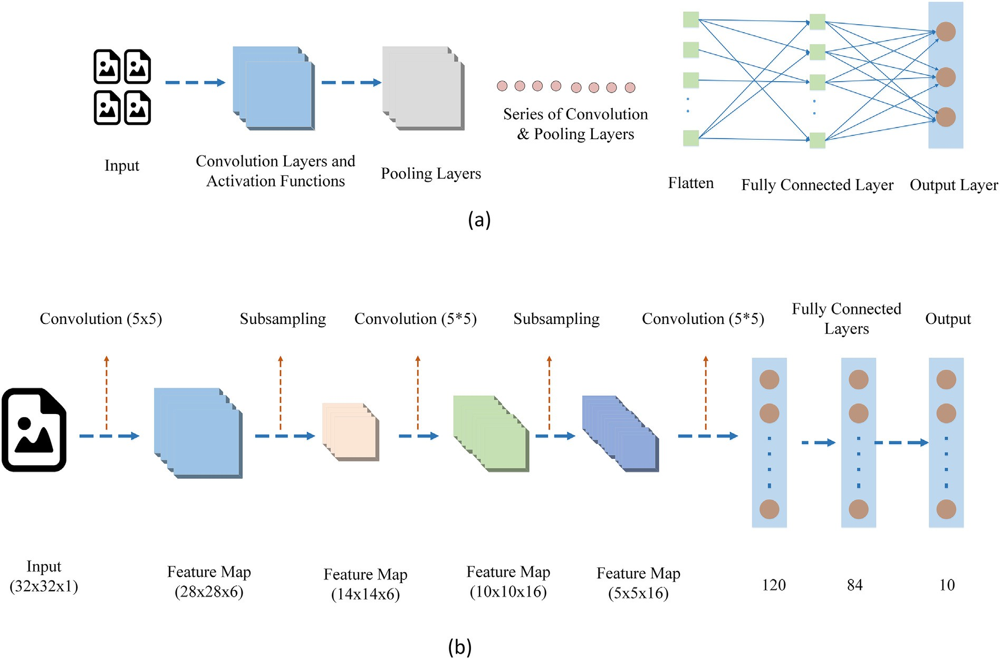

(Zhu et al., 2020b). Generally, GAN has two main building blocks (two neural nets) which compete with each other and are capable of captur- ing, copying and analyzing the variations in a dataset (Fig. 4). The two networks are usually called Generator and Discriminator. The generator neural network helps to generate new instances, while the discrimina- tor neural network evaluates the authenticity of the generated images. The discriminator decides whether or not every instance of the data it evaluates belongs to the actual training set and penalizes the generator for generating implausible outcomes. The loss of the discriminator is used for improving the generator (Reimers and Requena-Mesa, 2020). The discriminator tries to identify the fake data from the real data, and both networks work simultaneously to learn complex data. GANs are a panacea for the data scarcity problem, which is a serious hurdle in de- veloping robust deep neural network models (Hiriyannaiah et al., 2020). The realistic images produced by GAN that are different from the original training data are attractive in data augmentation of DL- computer vision to reduce the model overfitting.

Transformer models have become the de-facto status quo in text processing, and recently, the computer vision community has extended the concept of NLP (Natural Language Processing) transformer to apply to the image domain with slight modification in the implementation to process multiple modalities (*e.g.*, images, videos, etc.) using similar pro- cessing blocks (Dosovitskiy et al., 2021; Khan et al., 2021; Vaswani et al., 2017). Even though the general architecture used in both cases are sim- ilar, ViT uses different approaches for tokenization and embedding (Fig. 5). The overall architecture consists of 3 main components, viz., patch embedding, feature extraction by stacked transformer encoders and the classification head. In ViT, initially, the input image of shape (height, width, channels) is embedded into a feature vector of shape (n+1, d), using a set of transformations. The input image is split into a group of image patches. Later, these groups of image patches are em- bedded into encoded vectors and fed into transformer encoder network. The transformer encoder learns the features from the embedded patches using a stack of transformer encoders (Wu et al., 2021). The en- coder mainly comprises multi-headed attention (MHA) and a 2-layer MLP with layer normalization and residual connections. The final MLP block, called the MLP head is used as an output of the transformer. In the case of image classification, a softmax on the output generates the classification outputs. ViTs are useful in several vision applications such

as image classification, image-to-text, text-to-image generation, image segmentation, object detection, etc (Bazi et al., 2021; Li et al., 2022).

# Deep learning driven computer vision – Application areas in agriculture

## *Seed quality analysis*

The commercial seed industry is focused on the supply of the right quality seeds to the farmers at the right time in the right quantity. Filter- ing out low-quality of seeds from high-quality ones, is not only labori- ous, but it requires sophisticated equipments, infrastructure, and time (Kannur et al., 2011). The testing of seeds for their quality can indeed gain momentum by the use of computer vision technology which can extract the morphological information of different seed lots and grade it according to the internationally prescribed quality standards (Bao and Bambil, 2021). The different seed testing modules are likely to ad- dress their physical purity, genetic purity, seed health, vigour, patterns of deterioration etc., which in general may indeed cover the physical or visually attributable characters such as the seed length, shape, size, visual impairments, and presence of foreign bodies which can indeed be captured by the advanced computer vision technology (Granitto et al., 2005).

Performance issues of traditional computer vision have greatly been improved by deep learning-based computer vision, resulting in larger adoption for seed variety identification. The seed quality evaluation pro- cess using computer vision is shown in Fig. 6. Often, spectral imaging techniques are also merged with these approaches to enhance the accu- racy (Qiu et al., 2018; Zhu et al., 2019). In a study conducted by Zhu et al. (2019), combining spectroscopy and machine learning – CNN models were found to be effective in identifying the seed varieties. The machine learning models showed an accuracy of more than 80% in classifying the cotton seeds based on the feature extracted by the CNN and ResNet models. In another investigation, SeedSortNet built from computer vi- sion CNN models, was found to be promising, with accuracies 97.33% and 99.56% in sorting the maize and sunflower seeds (Li et al., 2021). CNN deep learning was also utilized for cognizing the viable and non-viable seeds and was found to be successful with 90% viability prediction accuracy for naturally aged seeds (Ma et al., 2020).

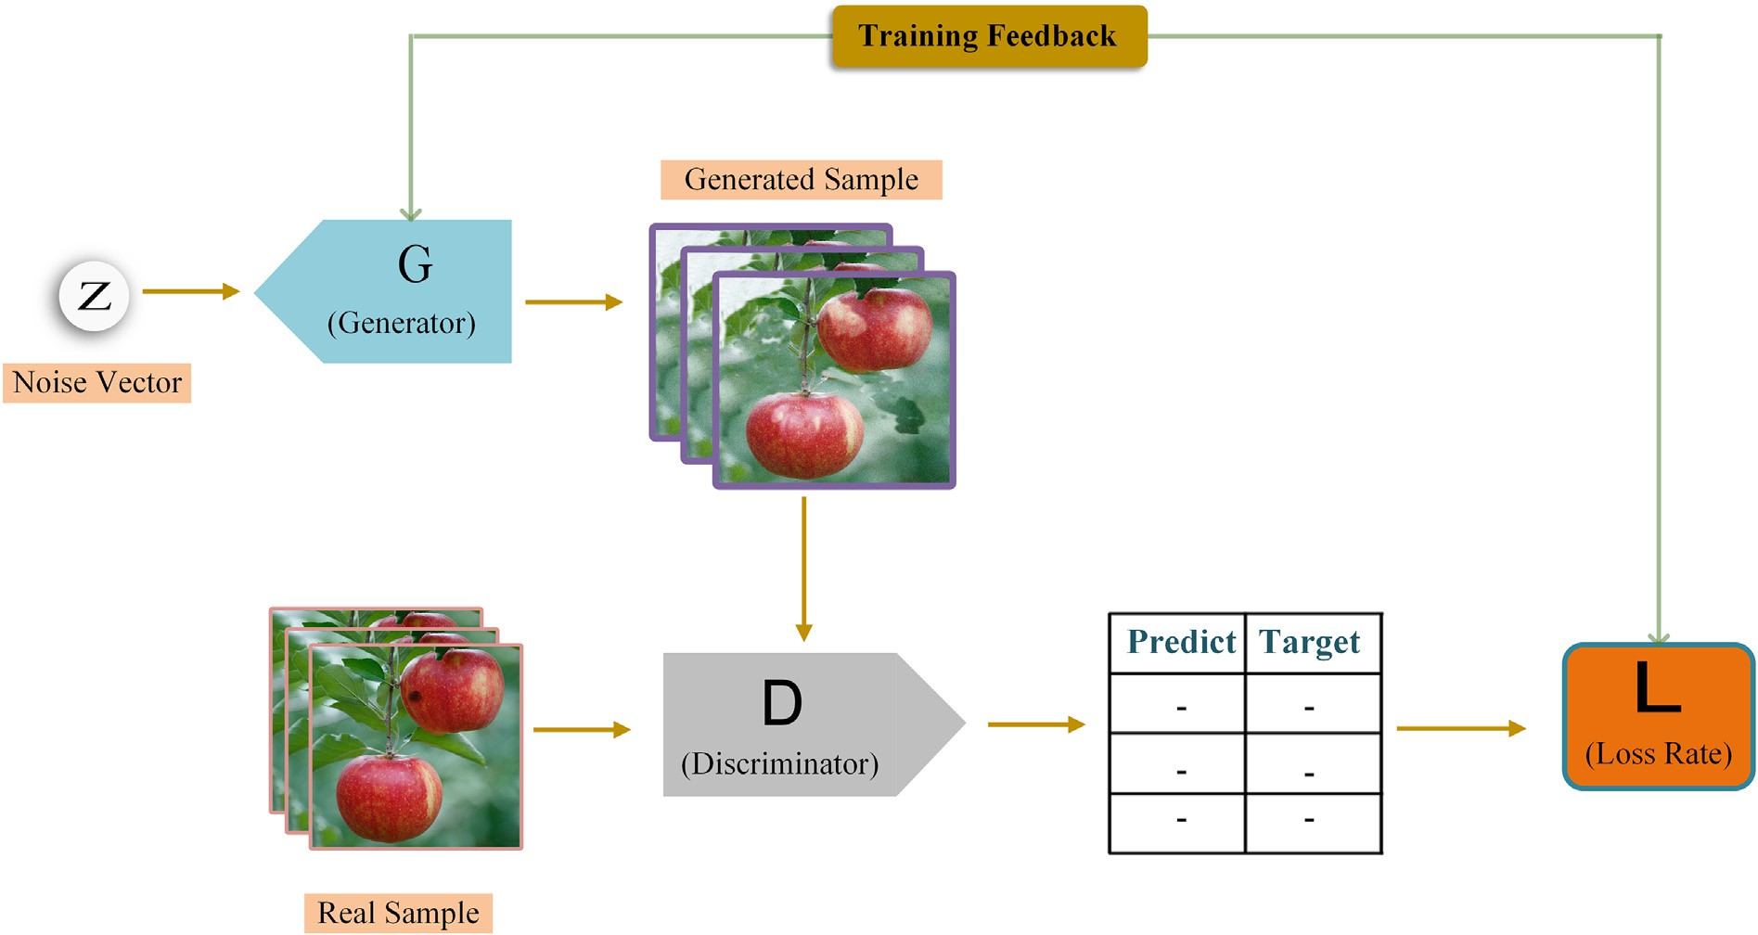

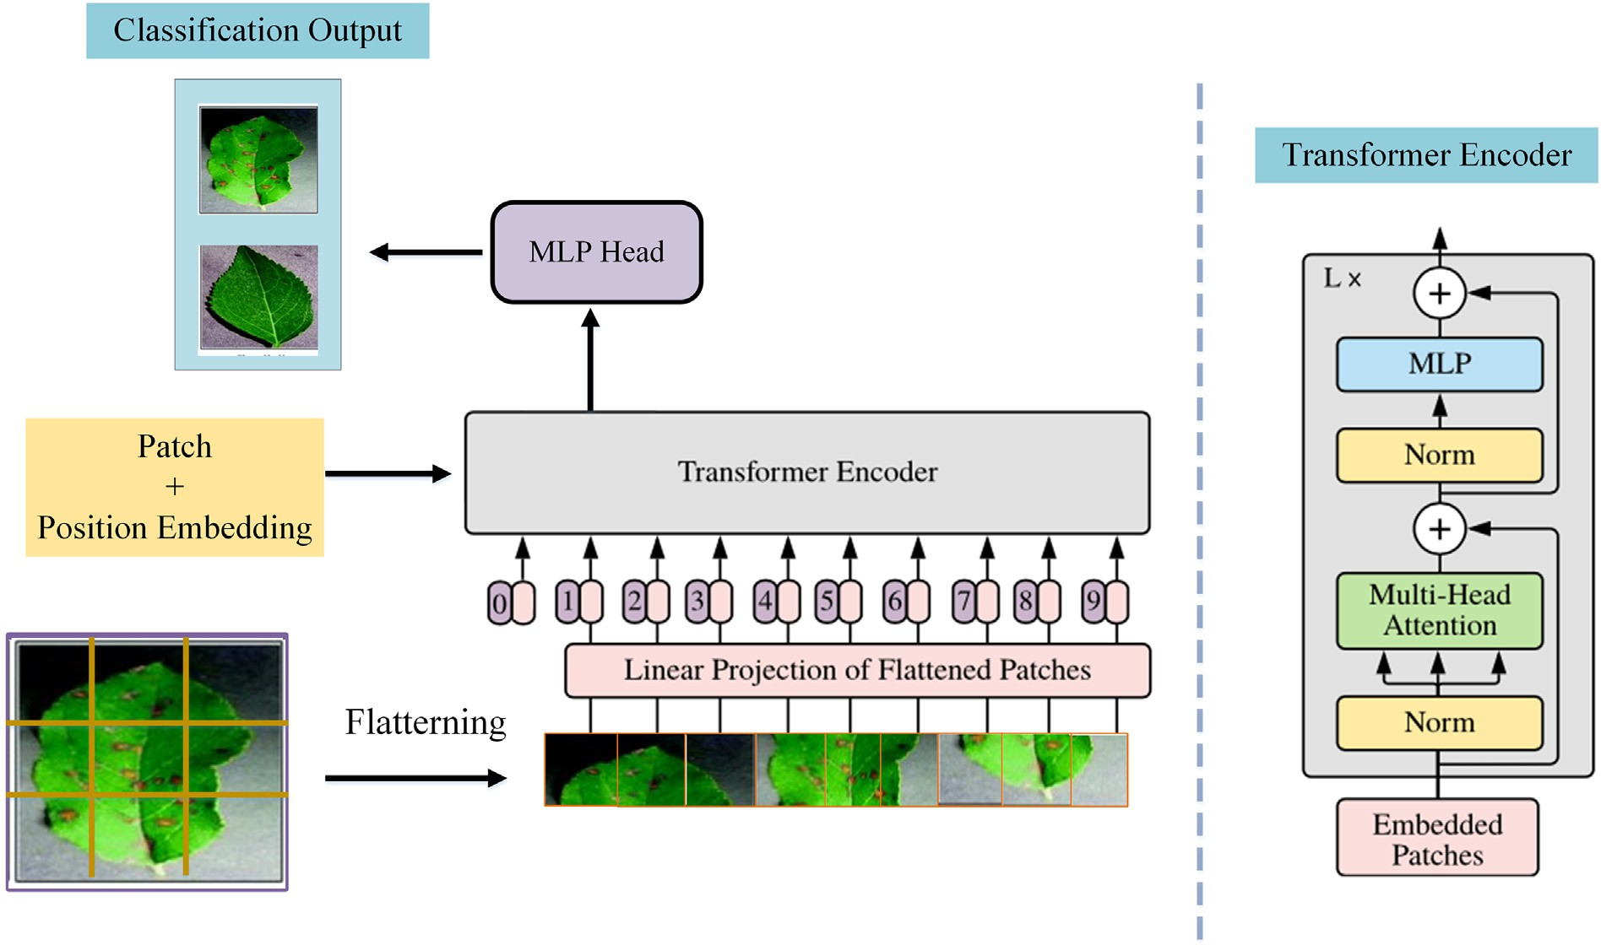

Fig. 5. The architecture of Vision Transformer Model for image classification (Dosovitskiy et al., 2021; Vaswani et al., 2017).

Taheri-Garavand et al. (2021) developed models for automatic identifi- cation of chickpea varieties using seed images in the visible spectrum. A modified VGG16 model was used for the identification purpose. As sorting high-quality seeds are vital for increasing yield in the breeding industry, Zhao et al. (2021) employed seven different computer vision models to accurately detect and identify surface defects. MobileNet-V2 model had shown excellent detection accuracy for the soybean dataset. There are numerous such studies done by various researchers and the seed industry is hugely getting benefited from advanced computer vi- sion models, achieving a higher level of automation capabilities. Some of the studies in this area are precisely summarized Table 1.

## *Soil analysis*

The preservation and improvement of dynamic soil characteristics is the main emphasis of soil management in agriculture for increasing

crop productivity (Kushwaha et al., 2022; Suchithra and Pai, 2020). Tra- ditional soil texture analysis entails taking soil samples and bringing them to a laboratory, where they are dried, crushed, and sieved before being used. For coarse textured or sandy soils, sieving is the most typical laboratory analytical method, while for smaller textured particles, a hy- drometer or pipette approach based on sedimentation theory is used (Kushwaha et al., 2022; Sudarsan et al., 2016).

With the advancement of image processing power and the develop- ment of image acquisition (e.g., cameras) systems in recent years, com- puter vision-based image analysis approaches have gotten a lot of interest in a lot of sectors, including soil science. This method collects soil images (dynamic or static) with cameras and then uses simple com- puter programmes to classify and categorise them (Fig. 7). For example, after matching textural patterns, the size of the soil particles might be estimated straight from the image. In several investigations, various image analysis-based computer vision approaches were tried.

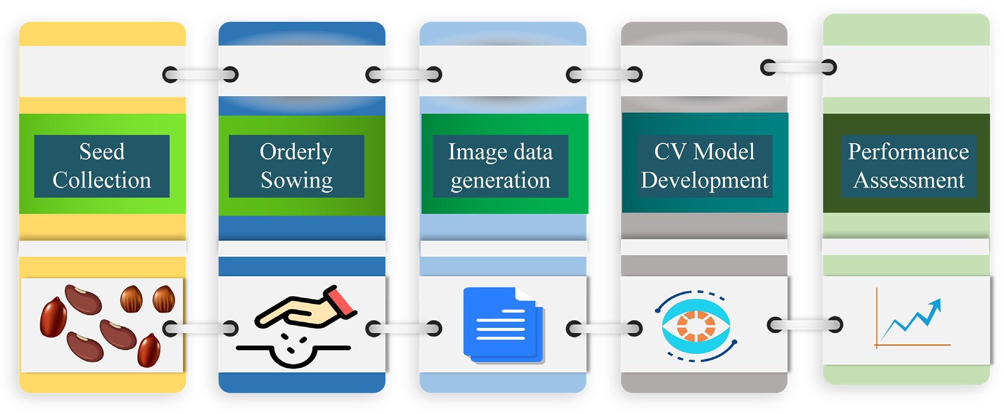

Fig. 6. Seed quality analysis using data-driven models.

Table 1

Previous studies on seed quality analysis through application of computer vision and deep learning.

|  |  |  |  |  |
| --- | --- | --- | --- | --- |
| Reference | Objectives and scenario of application | Methodology | Crop | Results |
| (Javanmardi | Corn variety | CNN as a generic feature extractor. Classification | Corn | CNN ANN classification has a classification accuracy of 98.1%, |
| et al., 2021) | classification using 9 | using ANN, SVM, kNN, boosted tree, bagged tree |  | precision 98.2%, recall 98.1% and F1 score of 98.1%. |
|  | different varieties | and LDA |  |  |
| (Qiu et al., 2018) | Variety identification in | KNN, SVM and CNN models | Rice | CNN outperformed other models with 89.6% accuracy on the |
|  | rice |  |  | training set and 87% accuracy on the testing set. |
| (Gulzar et al., | Seed classification | VGG16 architecture for classification | - | 99.9% accuracy over test set with 234 images |
| 2020) | using 14 types of seeds |  |  |  |
| (Wu et al., 2019) | Variety identification in | DCNN model | Oats | 99.19% accuracy on testing set. |
|  | oats |  |  |  |
| (Gulzar et al., | Seed classification in | CNN model | Maize and | CNN based visual model - SeedSortNet developed with 97.33 |
| 2020) | maize and sunflower |  | Sunflower | percent accuracy on maize and 99.56% accuracy on sunflower |
|  |  |  |  | dataset respectively. |
| (Liu et al., 2015) | Soyabean seed sorting | BP neural network | Soyabean | 97.25% average recognition accuracy over 857 images of soybean |
|  |  |  |  | seeds with pest and insect damage. |
| (Veeramani | Corn seed defect | VGG 19 and GoogleNet | Maize | - |
| et al., 2018) | detection |  |  |  |
| (Dolata and | Varietal identification | CNN | Barley | Increase in average classification accuracy by 0.6% and sensitivity |
| Reiner, 2018) | in barley |  |  | by 2.3% with respect to view point ignorant architecture of the said |
| (Kurtulmuş, | Seed classification in | AlexNet, GoogleNet and ResNet | Sunflower | study.  95% accuracy with GoogleNet algorithm for classification of 4800 |
| 2021) | sunflower |  |  | sunflower seeds. |
| (Ni et al., 2019) | Seed grading in maize | DCNN | Maize | 98.2% prediction accuracy for 408 test images in maize. |

Haralick et al. (1973) attempted to classify images received from an ae- rial or satellite source using entropy and angular moment-based tex- tural classification. Since then, the grey level co-occurrence matrix (GLCM) and its analogues have been used in a variety of remote sensing applications (Dell’Acqua and Gamba, 2003; Kuplich et al., 2005). How- ever, the greatest resolution satellite can only provide a maximum res- olution of 10 m/square pixel, which is insufficient to understand soil particle sizes. Riese and Keller (2019a) implemented three 1- dimensional (1D) convolutional neural networks: the LucasCNN, the LucasResNet and the LucasCoordConv. In addition, for the classification problem at hand, the study tweaks two existing 1D CNN techniques and compares the CNN techniques against a random forest classifier to see how well they do. Thereby, study uses the LUCAS topsoil dataset, which is freely available. The CNN method with the least amount of depth turns out to be the most effective classifier. In terms of average ac- curacy, the LucasCoordConv has the best results.

Similarly, Zhang et al. (Zhang et al., 2003) proposed a soil texture classification system that uses the wavelet transform approach to dis- tinguish between different types of soil. Wavelet transform, which is a strong image and signal analysis method due to its multi-resolution ca- pabilities, is used to extract features. A set of training instances is used to create a maximum likelihood (ML) classifier. This method of ML

parameter estimation produces the best results. At the time of training and classification, the Fisher's Linear Discrimination Analysis (FLDA) is used to optimize and reduce the dimension of the vector. Soil textures such as clay, sand, and silt are employed for training and classification. Clay, sand, and silt have 60 percent, 100 percent, and 100 percent cate- gorization rates, respectively. In instance segmentation, Zhang et al. (Zhang et al., 2020) suggested a mask refined R-CNN for refining object details. The goal is to figure out how semantic segmentation of high- level and low-level features affects instance segmentation. The COCO (common objects in context) and cityscapes datasets were used to col- lect the trial results. This approach is reported to be simple to use and effective. Some of the previous significant studies in soil analysis using DL computer vision have been summarized in Table 2.

## *Irrigation management*

Irrigation water management in agricultural production necessitates considerable effort and is crucial in maintaining hydrological, climato- logical, and agronomic equilibrium. Several studies have thus been un- dertaken in gaining knowledge of the biophysical processes included in the uptake of water through the root zone of the soil and the pro- cesses of transpiration through the plant canopy (Elbeltagi et al.,

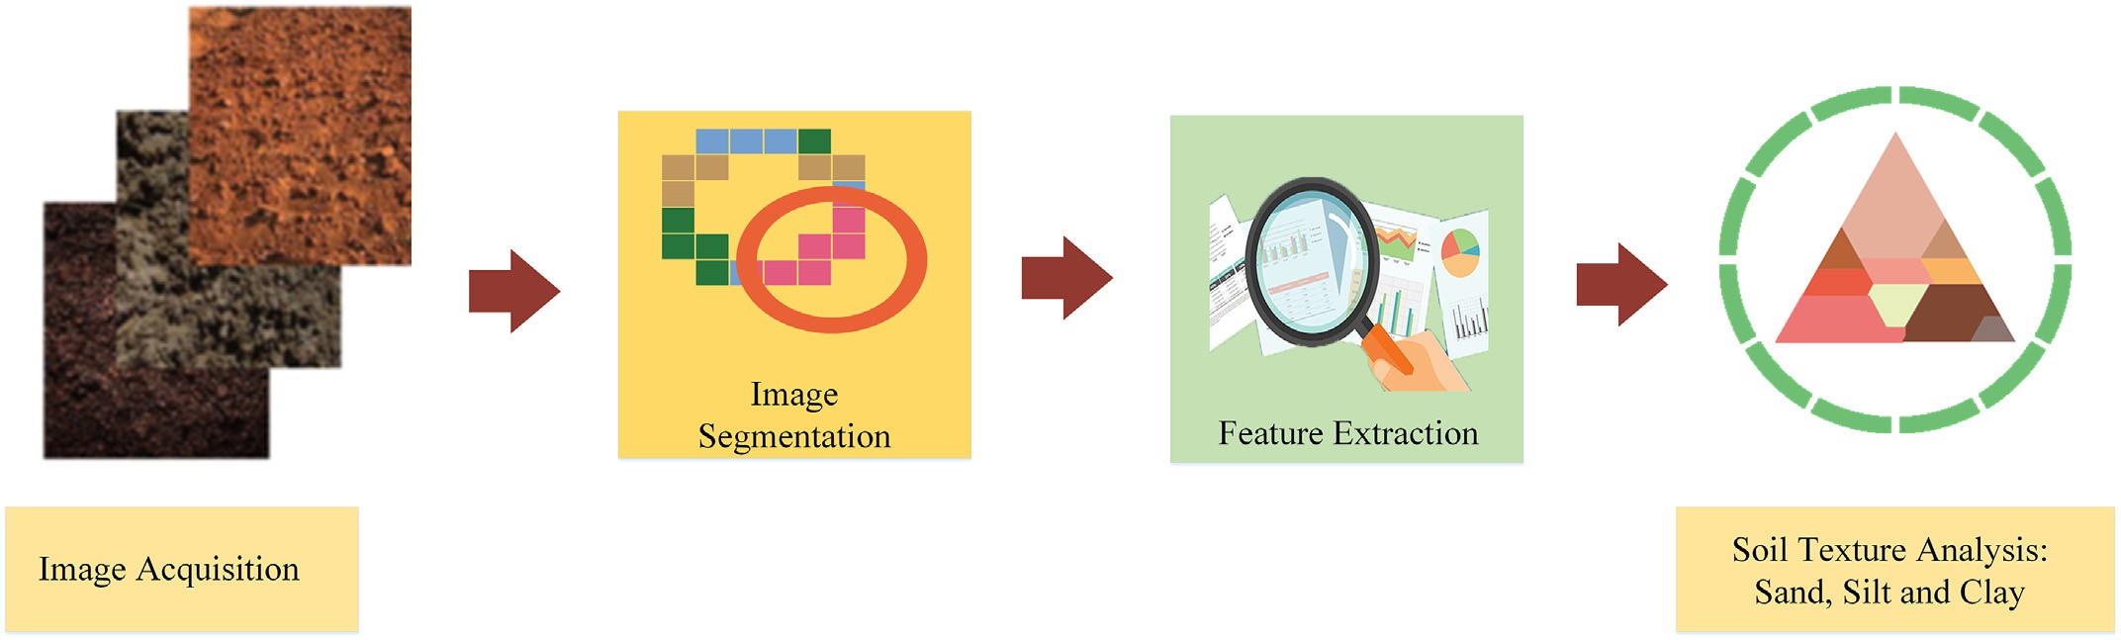

Fig. 7. Soil texture analysis using image processing.

2022b; Kushwaha et al., 2021). For an effective irrigation schedule, it is necessary to know the precise amount of water required by the crop (Kushwaha et al., 2016; Vishwakarma et al., 2022). The application of computer vision technologies, as well as the integration and deploy- ment of automated crop production management, plant irrigation, and yield evaluation, thus become critical. Zhang et al. (Zhang et al., 2018) performed identification and monitoring of centre pivot irrigation sys- tems using a Convolutional Neural Networks (CNNs) approach to the al- location of irrigation water. The CNNs with various structures were built and compared and for data augmentation,training, a sampling strategy was developed. In the testing region, the CNN with the best perfor- mance and the shortest training time was used. To further pinpoint the centre of each centre pivot system, a variance-based technique was presented. The proposed approach performed well in the centre pivot irrigation systems identification challenge, with a precision of 95.85% and a recall of 93.33% of the identification findings.

Similarly, Chang and Lin (Chang and Lin, 2018) developed a compact intelligent agricultural machine which is capable of autonomous weeding and variable watering on the cultivated ground, using a combi- nation of computer vision and multitasking. The system classifies the plants and weeds in real-time so that it can weed and water while main- taining an average herbicidal rate of 90% and a deep soil moisture level of 80%. This strategy has a lot of potential because it allows for not only multitasking integration but also resource utilization in its entirety.

Kamyshova et al. (Kamyshova et al., 2022) proposed a computer vision-based technology for optimizing the watering process of crops utilizing a phyto indication system in low latency mode, the study sug- gested an algorithm-based system for obtaining a maize irrigation map. The system, which comprises 8 IP cameras coupled to a DVR connected to a laptop, can be mounted on a centre pivot irrigation system. There are three steps to the algorithm. Using an integrated excess green and excess red difference (ExGR) index during the image preprocessing stage. The application of the approach that the study chose based on the system's operational conditions is the categorization stage. A neural network trained using the Resilient Propagation method is utilised in the final stage to calculate the rate of watering of plants in the cur- rent sector of the sprinkler site. Plant identification accuracy was up to 93 percent, and growth stages were up to 92 percent. Low- cost cameras are now being used in all sectors of technology, partic- ularly in agricultural applications. The soil water balance may be precisely assessed to enable accurate irrigation planning by acquir- ing relevant information on the growth of horticulture crops through photographs (Koech and Langat, 2018). Table 3 shows the irrigation

water management through the application of computer vision and deep learning technologies.

## *Plant health analysis*

With the advancement in computer vision and deep learning, new promising solutions for identifying overall health status of the plants were introduced. The intelligent decision support system for identifying crop diseases (Fig. 8), water stress, and nutrient deficiencies would lead to timely control of the panic situations and eradicating the huge losses, ultimately leading to improved plant quality.

Plant stress induced by biotic and abiotic factors is expressed in the plant canopy as multiple symptoms. In case of water stress, the plant closes stomata and delays photosynthesis and transpiration activities indicating colour changes in the leaf and temperature (Nilsson, 1995). Similarly, nutrient deficiencies-related symptoms are typically visible in leaves color and texture (Xu et al., 2011). Image analysis can detect these changes in a pattern quite effectively. Deep learning-based com- puter vision approaches are viable solutions in addressing timely dis- ease identification and avoiding consultation of human experts. The availability of a large number of public image datasets such as PlantVillage (Hughes and Salathe, 2016), PlantDoc (Singh et al., 2020) have proliferated the research in the area of disease identification and many works have taken encouraging steps towards disease-free agri- culture (Hassan and Maji, 2022; Ji and Wu, 2022; Nagasubramanian et al., 2019).

The PlantVillage dataset has been extensively utilized by various re- searchers for solving disease identification problems using deep learn- ing (Amara et al., 2017; Brahimi et al., 2017; Ferentinos, 2018; Mohanty et al., 2016). Several studies reveal that pre-trained models quickly and accurately identifying the diseases in terms of precision, re- call and F1 scores (Abbas et al., 2021; Chen et al., 2020b; Coulibaly et al., 2019; Mukti and Biswas, 2019; Thakur et al., 2021). Abbas et al. (Abbas et al., 2021) used synthetic images generated using the Conditional Generative Adversarial Network (C-GAN) to build tomato leaf disease detection. C-GAN can address the issue of data insufficiency and provide more generalization to the models (Mirza and Osindero, 2014). It is worth noting that some investigations were focused on the localization of the disease spots, giving precise information about the diseases (Cen et al., 2016; Liu and Wang, 2020; Mathew and Mahesh, 2022; Son, 2021). Several other studies reported research on DL-computer vision based identification of crop stresses, including water stress and nutrient deficiencies (Abdalla et al., 2021; Anami et al., 2020; Jahagirdar and

Table 2

Previous studies on computer vision and deep learning technologies for soil properties analysis and management.

Reference Objectives and scenario of application

Methodology Results

(Riese and Keller, 2019b)

(Omondiagbe et al., 2022)

Soil texture analysis Soil texture prediction

The CNN architectures LucasCNN, the LucasResNet and theLucasCoordConv Models

Employed automated deep convolutional neural networks and

population-based learning by replacing the random search with a Bayesian Optimization.

The CNN method with the least amount of depth turns out to be the most effective classifier

Results show improvements of 5% to 26% for all three soil properties such as sand, silt and clay.

(Pyo et al., 2020) Estimation of

heavy metal concentration

From the soil reflectance images, CNN with convolutional autoencoders was trained to estimate As, Cu and Pb metals.

The highest accuracies reported for As, Cu, and Pb estimates were with R2 values of 0.86, 0.74, and 0.82.

(Zhong et al., 2021)

Soil properties The DCNN architectures LucasResNet-16 and LucasVGGNet-16 models When compared to a single-task DCNN model, the

performance of a multi-task DCNN model created based on LucasResNet-16 was enhanced.

(Yu et al., 2019) Soil

Classification

Lquid crystal tunable filters (LCTF)-based system and three-dimensional convolutional neural network (3D-CNN) for soil classification

The overall accuracy of 99.59% for 3D-CNN-SD-PCA.

(Azadnia et al., 2022)

(Azadnia et al., 2022)

Texture Analysis Portable smartphone-based machine vision system using CNN was developed. The features were extracted using CNN and classification is performed using ANN, SVM, RF and KNN classifiers.

Texture analysis Deep learning models VggNet16, ResNet50, and Inception-v4 models were used to classify soil aggregates

Model accuracies at distances of 20, 40 and 60 cm were of 99.89, 99.81 and 99.58%,

Overall accuracy obtained for CNN networks was 96.2%, 97.1%, and 98.7%

Previous studies on irrigation water management through application of computer vision and deep learning approaches.

References Objectives and scenario of application Methodology Results

(Albuquerque et al., 2020)

(Chen et al., 2020a)

Identification of malfunctioning in the irrigation systems

Identification of water pollution for agricultural irrigation resources

Mask R-CNN based segmentation on UAV captured images

Shallow CNN model in combination with decision tree algorithm trained on NIR data

Given dataset sizes, the results are satisfactory.

Validation results were 25.47 of RMSEV and 0.914 of Rv.

(Zhang et al., 2018)

Monitoring and identification of canter pivot irrigation system to supply irrigation water

CNN based segmentation on UAV captured images Precision and recall of 95.85% and 93.3 percent,

respectively, were attained.

(Tang et al., 2021) Monitoring the distribution of center pivot

irrigation systems

Lightweight real-time object detection network (PVANET) based on GoogLeNet and Hough transform

Experiments with Sentinel-2 images achieved a precision of 95% and a recall of 95.5%,

(Kumbi and Birje, 2022)

Irrigation efficiency Sun-flower Atom Optimization-based Deep convolution neural network (SFAO-DeepCNN) algorithm

Maximal accuracy of 92%, specificity of 91.2% and sensitivity of 94.1%

(Kim et al., 2022) Water Level Estimation of Irrigation Channel ResNet-50 image classification and U-Net

segmentation models on irrigation canal's CCTV images

The image segmentation model showed a Dice score of 0.998 and predicted water levels showed R2 of 0.97

Budihal, 2021). Table 4 shows the previous studies on deep learning based computer vision technology on plant health analysis.

## *Weed management*

Weeds are among the major factors that affect agricultural produc- tion negatively. With the focus on improving agricultural productivity, it is evident that more and more chemicals are being dumped into the environment with the aim of managing the weed growth. But for im- proving the productivity, it also requires the optimum utilization of re- sources which can only be achieved by the precise spraying on weeds. The traditional robotic weeders generally function by detecting crop row patterns and they do not rely on crop recognition for the weeding operation. If the weed density and population are large, they may ob- scure the row pattern leading to reduced efficiency of the weeders.

Computer vision approaches come to rescue at this point by accurately identifying the objects as precise spraying of weeds depends on the ac- curate identification and location of weeds. Recently, several studies were carried out by researchers on adaptability of computer vision tech- nology for the agronomic classification of plant species at the field level, viz the classification of crops from weeds, off types etc. (Sau and Ucchesu, 2019; Sau et al., 2018; Subeesh et al., 2022). Detailed applica- tion of the same in the automatic identification of plant species based on the leaf recognition pattern has been proposed for preserving and cataloguing plant species (Putzu et al., 2016) along with the botanical characterization of germplasm (Lo Bianco et al., 2017). Methods of achieving weed detection at the field level mainly include the utilization of computer vision technology using the traditional image processing and deep learning. When, the conventional methods of computer vision are used, extracting the different features such as colour, shape, texture

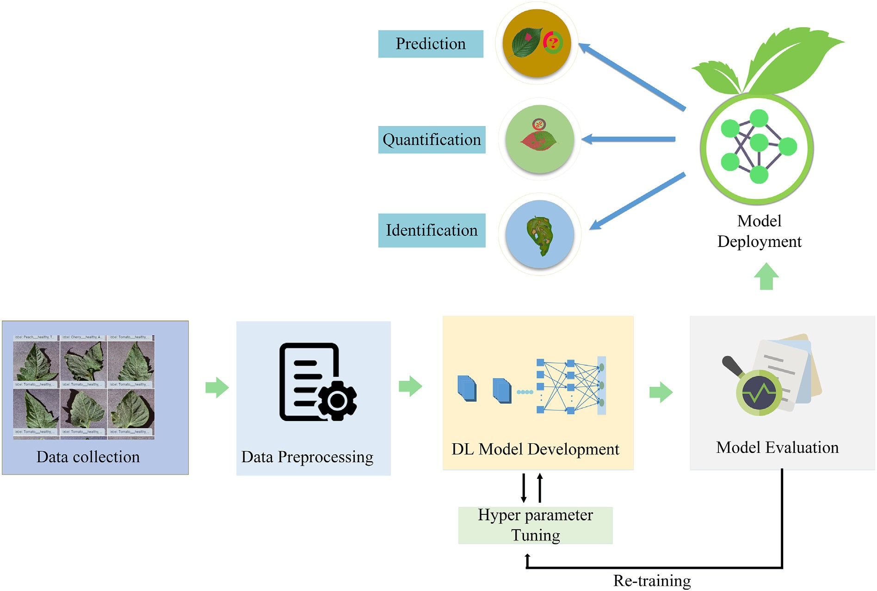

Fig. 8. Deep learning based computer vision approach for plant health analysis.

Table 4

Previous studies on computer vision and deep learning technologies for crop health analysis.

|  |  |  |  |  |
| --- | --- | --- | --- | --- |
| References | Objectives and scenario of application | Methodology | Crop | Results |
| (Hassan and Maji, 2022)  (Hati and Singh, | Plant disease identification  Species Recognition (SR) and | Novel lightweight CNN based on Inception and Residual connections with fewer parameters  Residual network (ResNet) based | Rice, Cassava  12 different | The testing accuracies of the proposed model is 99.39%,99.66% and 76.59% on Plantvillage, Rice, and Cassava dataset  Species identification: Precision 91.84%, Recall 91.67% |
| 2021)  (Ji and Wu, 2022)  (Syed-Ab-Rahman | Identification of Healthy and Infected Leaves (IHIL)  Black measles disease identification in grape  Citrus diseases classification using | convolutional neural network (CNN) architecture  Plant disease evaluation. Image segmentation using DeepLabV3 with ResNet50 backbone  Two-stage deep CNN model | plant species Grape  Citrus | and F191.49%. IHIL : Precision 84%, Recall 83.14% and F1 83.19%  Overall classification accuracy of 97.75% on the hold-out test dataset.  Detection accuracy of 94.37% and an average precision |
| et al., 2022)  (Li and Li, 2022) | leaf images  Leaf disease identification | Vision Transformer-based lightweight | Apple | of 95.8%.  ConvViT achieved an accuracy of 96.85% on the apple |
| (Mkonyi et al., | Early identification of *Tuta absoluta* | apple leaf disease- identification model (ConvViT)  Pre-trained CNN architectures VGG16, | Tomato | leaf disease dataset  VGG16 attained the highest accuracy of 91.9% |
| 2020)  (Azimi et al., | disease  Stress level detection due to nitrogen | VGG19 and ResNet50 Models  Custom Deep learning architecture with 23 | Sorghum | 8.25% better accuracy than traditional machine |
| 2021)  (Joshi et al., 2021) | deficiency  Viral disease diagnosis | layers.  Convolutional neural network - VirLeafNet | Vigna | learning techniques  Accuracies of VirLeafNet-1, VirLeafNet-2, and |
|  |  |  | mungo | VirLeafNet-3 were 91.234%, 96.429%, and 97.403% |
| (Shah et al., 2021) | Plant disease detection | ResTS Architecture with residual | 14 crops | F1-Score: 0.991 |
| (Singh et al., 2021) | Pest and disease detection | connection  2D-CNN model with segmented images | Coconut | Accuracy of 96.94% with a Kappa value 0.91 |
|  |  |  | tree |  |

etc., and combining them with the machine learning methods such as the SVM becomes necessary. But with the improvement in computing power, the deep learning algorithms can beneficially extract multidi- mensional and multi-scale spatial and semantic feature information of weeds through AlexNet, VGGNet, ResNet, etc due to their enhanced ca- pability for image data expression thereby avoiding the disadvantages of traditional methods of feature extraction. The application of deep learning in agronomic classification of plant species has gained momen- tum after the outbreak of CNN and AlexNet (Krizhevsky et al., 2012b). Hall et al. (2015) have utilized the CNN architecture in classifying leaves of 32 species of crops and weeds by capturing nearly 1900 images of the same.

Utilization of CNN architecture in the classification and differentia- tion of weeds from different species of wheat, sugarbeet, corn, soybean, sunflower, etc. has been proposed by Kussul et al. (2017), while the modified version of VGG16 for the classification of barley, grass, oil crops and weeds have been proposed by Mortensen et al. (2016).

Table 5 shows the previously applied computer vision technology for weed management.

## *Livestock management*

Computer vision approaches are leveraged extensively in precision livestock farming (PLF), ensuring optimum output and health of each individual animal. Livestock monitoring systems provide real-time in- formation and assist farmers in making strategic decisions (Fig. 9). The non-invasive computer vision technology has been widely researched for its use in recognition of livestock behaviour over the past few years (Bello et al., 2021; Kumar et al., 2017; Qiao et al., 2019a; Shen et al., 2020). Xiao et al. (2022) employed a modified Mask-RCNN model and trained a fusion of Mask-RCNN and SVM to identify cows in unconstrained barn. Hansen et al. (2018) trained a CNN to recognize pigs via the face using a data set with 1,553 images. The VGG-face model used in this study achieved an accuracy of 96.7%. Some of the

Table 5

Previous studies on computer vision and deep learning technologies for weed management.

|  |  |  |  |  |
| --- | --- | --- | --- | --- |
| References | Objectives and scenario of application | Methodology | Crop | Results |
| (Le et al., 2020) | Weed identification in | Filtered Local Binary Pattern withContour Mask | Canola, corn, | K-FLBPCM method outperformed other state of the |
|  | Canola, corn and raddish | and Coefficient k (k-FLBPCM), VGG-16, | radish | art CNN models. |
|  |  | VGG-19,ResNet-50, Inception-v3 |  |  |
| (Osorio et al., 2020) | Weed detection in lettuce | Compared Mask R-CNN with HOG SVM and YOLO | Lettuce | 98% accuracy for Mask R-CNN |
|  |  | V3 |  |  |
| (Chavan and | Weed identification in paddy | Comapred SegNET with FCN and U-Net | Rice | 92.7% accuracy for SegNet |
| Nandedkar, 2018) | field |  |  |  |
| (Chavan and | Weed classification at field | Comapred Hybrid network with VGGNet and | Maize,wheat, | 98.23% accuracy for Hybrid network |
| Nandedkar, 2018) | level | AlexNet | sugarbeet |  |
| (Fawakherji et al., | Crop/weed segmentation | Synthetic image generation using GAN and | Sugar beet | All models were performed well with synthetic |
| 2020) | using synthetic images | segmentation models (UNET, BONNET,SEGNET, |  | images generated using GAN and IoU increased |
|  |  | UNET-RESNET) |  | drastically using synthetic dataset. |
| (Wang et al., 2020) | Weed detection in sugarbeet | FCN architecture employed | Sugarbeet | Best MIoU value (pixel-wise segmentation) 88.91% |
|  | and oilseeds |  | and oilseeds. | and object-wise segmentation 96.12% |
| (Espejo-Garcia | Detection of balck night | Compared Modified Xception, with Inception - | Tomato and | Combination of fine tuned Densenet and SVM.micro |
| et al., 2020) | shade and velvet leaf in | ResNet, VGG-Net, MobileNet and DenseNet | cotton | F1 score of 99.29%.F1 score ≥ 95% over repeated tests. |
|  | tomato and cotton fileds |  |  |  |
| (Huang et al., 2020) | Weed in rice field | FCN | Rice | Highest accuracy- VGG Net based FCN |
| (Veeranampalayam | Weed in soybean filed | Compared Single-Shot Detector (SSD), Faster | Soybean | Faster RCNN as the best model for weed detection |
| Sivakumar et al., |  | R-CNN |  | performance and inference time |
| 2020) |  |  |  |  |

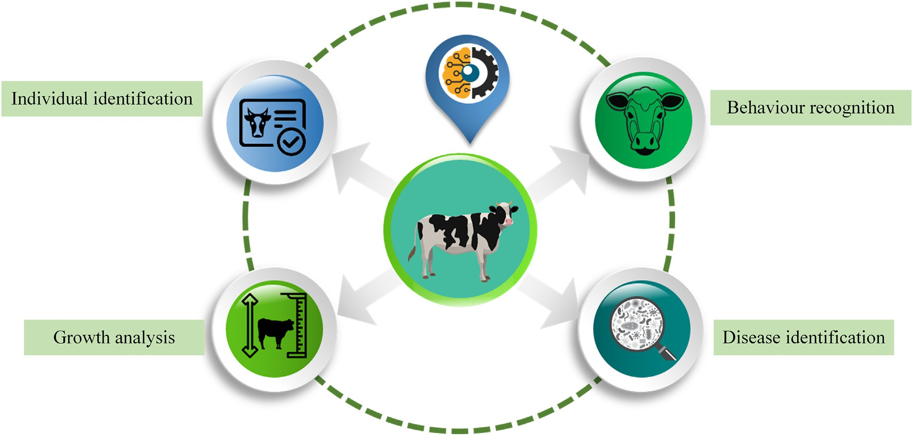

Fig. 9. Major applications of DL-Computer vision for livestock management

investigations relied on data collection using unmanned aerial vehicles to accurately detect and count the cattle (Andrew et al., 2019; Chamoso et al., 2014; Rahnemoonfar et al., 2019; Rivas et al., 2018). Such detection and counting approach problems, in general, have adopted either CNN-based probability heat map generation on the loca- tion of the animals or generation of bounding boxes for detection of the animals. An improved Yolo model called ‘FLYOLOv3’ (FilterLayer YOLOv3) based on Filter layer was introduced by Jiang et al. (2019) to ensure accurate detection of key parts of dairy cows. The performance of this approach was superior to the Faster-RCNN and Yolov3 algorithms.

Daily activity patterns, food intake, and ruminating are some key in- dicators closely bound to the health and productivity of dairy cows (Huzzey et al., 2007; Weary et al., 2009). Some recent studies underline that traditional methods of direct observation and time-lapse video re- cording are slowly getting replaced by computer vision approaches. Yang et al. (2018) used a Faster-RCNN model to identify individual pigs from a group and subsequently assess the feeding area occupation rate to identify their feeding behaviour. To improve the accuracy of feeding behavior analysis, identify and exclude the non-nutritive visits (NNV) to the feeding area, Alameer et al. (2020) developed a GoogLeNet-based approach. The detection of feeding behaviour was highly accurate with 99.4% accuracy. CNN architectures are also found to be promising for early cattle disease detection in the animal hus- bandry farm (Rony et al., 2021). Table 6 shows the previous studies on computer vision technology for livestock management.

## *Yield estimation*

Early and accurate yield estimation is essential for farmers and other stakeholders in making strategic decisions on post-harvest planning, policy-making and crop management (Al-Gaadi et al., 2016; Chlingaryan et al., 2018; Wei et al., 2020). Some of the studies underline that yield estimation using deep learning-based computer vision on ae- rial images is superior to traditional approaches. In a study conducted by Yang et al. (2019) rice grain yield from low-altitude remote sensing data was used to estimate the rice grain yield using convolutional neural net- works. The models were trained on both RGB and multispectral images collected by UAV, and results showed that the CNN trained on these im- ages outperformed the VIs-based traditional regression models for grain yield estimation at the ripening stage.

You et al. (2017) employed a combination of convolutional neural networks and recurrent neural networks based on the remotely sensed images to predict the soybean yield. Another investigation carried out by Russello (2018) utilized satellite images in combination with convolutional neural networks for crop yield prediction. In case of or- chard crops like citrus, computer vision approaches are quite straight- forward (Fig. 10). The yield can be estimated by directly counting the number of flowers or fruits prior to the harvesting stages (Cheng et al., 2017; Dorj et al., 2017; Kanwal et al., 2019). With an objective of esti- mating yield from citrus orchards, Apolo-Apolo et al. (Apolo-Apolo et al., 2020)developed a Faster-RCNN model for the fruit detection. The data collected through UAV was used for the model development. In their study, based on the count, yield from orchards was modelled using the Long Short-Term Memory (LSTM) model. An attempt was made by Zhou et al.(Zhou et al., 2020)to deploy the yield estimation models in smartphones as android applications. In his investigation, four different computer vision models; SSD with MobileNetV2, quan- tized MobileNetV2, InceptionV3, and quantized InceptionV3 were trained and converted to TensorFlow Lite models. As reported by stud- ies, fruit occlusion caused by leaves and twigs and varying illumination conditions are some challenging factors in implementing fruit yield es- timation systems based on computer vision (Maheswari et al., 2021). Table 7 shows the previous studies on computer vision technology for yield estimation.

# Practical implications

Despite being late for digitization, the agriculture sector has finally seen good momentum for the practical implementation of several arti- ficial intelligence applications, including deep learning-based computer vision approaches. Computer vision-powered disease identification ap- plications merge the expertise of genetic resources and artificial intelli- gence, allowing farmers and extension workers to act quickly and rescue the crop. This disease detecting computer vision-enabled soft- ware is also being installed inside greenhouses, drones, and other equipment to identify the issues and provide a faster response in taking preventive measures. Advancement in computer vision technology has been used by agricultural startups for building solutions that assist farmers in harvesting, plant health monitoring, pest-weed control, etc. For pesticide application, blue river technology (Blue river technology) developed a see and spray’ technology that works based on camera

Table 6

Previous studies on computer vision and deep learning technologies for livestock management.

|  |  |  |  |  |
| --- | --- | --- | --- | --- |
| References | Objectives and scenario of application | Methodology | Livestock | Results |
| (Qiao et al., | Cattle Segmentation and Contour | Mask R-CNN based cattle instance | Cattle | Cattle segmentation performance with 0.92 Mean Pixel |
| 2019b) | extraction | segmentation and contour line extraction |  | Accuracy (MPA) |
| (Achour et al., | Identification and feeding | CNN coupled to Support Vector Machine | Cow | Accuracy 97% for individual identification of cows using |
| 2020) | behavior monitoring | (SVM) |  | multi-CNN. |
| (Xu et al., 2020) | Livestock classification and | Mask RCNN based segmentation on UAV | Cattle | Classification Accuracy: 96% and Counting accuracy: 92% |
|  | counting | captured images | and |  |
|  |  |  | Sheep |  |
| (Jung et al., 2021) | Cattle Vocal Classification and | Convolutional neural network (CNN) | Cattle | Accuracy of 81.96% after the sound filtering. |
|  | Livestock Monitoring | based cattle vocal classification |  |  |
| (Qiao et al., 2022) | Behaviour classification | C3D-ConvLSTM based cow behaviour | Cow | Classification accuracy of 90.32% and 86.67% in calf and cow |
|  |  | classification using video data |  | datasets of 30-frame video length |
| (Abu Jwade et al., | Breed Classification | VGG16 model for breed classification | Sheep | Maximum classification accuracy of 95.8% with 1.7 standard |
| 2019) |  |  |  | deviation. |
| (Shojaeipour | Automated Muzzle Detection and | Two-stage YOLOv3-ResNet50 algorithm | Cattle | Muzzle detection accuracy was 99.13% and biometric |
| et al., 2021) | Biometric Identification |  |  | identification of 99.11% testing accuracy |
| (Brand et al., | Pregnancy status prediction from | Genetic algorithm and DenseNet model | Cow | DenseNet was superior over GA with prediction sensitivity 0.89, |
| 2021) | mid-infrared spectroscopy |  |  | specificity of 0.86, and prediction accuracy of 0.88%. |
| (Ayadi et al., | Rumination behavior | Convolutional Neural Networks | Cow | Average accuracy, recall and precision were 95%, 98% and 98% |
| 2020) | identification |  |  | respectively |
| (Riekert et al., | Position and posture detection | Faster R-CNN object detection | Pig | Pig position detection: Average Precision (AP) 87.4% Pig |
| 2020) |  |  |  | position, and pig position and posture: mAPof 80.2%. |

inputs and computer vision algorithms. The algorithm can distinguish weeds from plants and perform targeted pesticide applications. The startup, cromai (Cromai) developed AI-driven land and crop diagnostic information. They provide a technological solution for georeferenced identification of weeds in the sugarcane field using advanced artificial intelligence approaches. Harvesting robots are widely used in open field conditions, integrating with machine visions and achieving im- proved precision. Harvest CROO robotics (Harvest croo robotics) devel- oped a fully autonomous harvester, employing a harvester-mounted LIDAR system to avoid collisions and accurate navigation. The computer vision system scans each berry on the plant and determines the ripeness and health before harvesting. ‘Plantix’, the crop damage diagnosis mo- bile application (Plantix) developed by German startup PEAT (Progres- sive Environmental and Agricultural Technologies), uses deep learning and computer vision to help farmers to combat pests and diseases (Goncharov et al., 2018; Tibbetts, 2018). The application’s functionality enables the end-user to upload crop images and get guidance on the dis- ease affected, symptom descriptions, treatment information, preventive measures, etc. With the same objective of identifying a large number of plant diseases, other applications such as Agrio (Agrio) were also

introduced to the farming community. Several technology-driven solu- tions were introduced into precision livestock farming to ensure opti- mal health and output of animals also. The technology startup Cainthus (Cainthus) offers a computer vision-driven AI system for dairy farmers to monitor their cows and send timely alerts and reports via associated applications. Smart cameras are deployed to watch over the activities of the cows to provide the right amount of feed available on a timely basis. Similar to this, Piguard (Piguard), an innovative live- stock management software, leverages deep learning-based computer vision approach to monitor the health status and behavioral patterns of animals.

Computer vision technology covers a broad spectrum of solutions for farmers, from small AI-enabled mobile apps for decision support, over in-field imaging sensors and remote sensing technologies for data col- lection, and to drones and robots for the automation of processes. Across the globe, farming community has realized the potential of digital tech- nologies and for the past few years, there has been an increase in its adoption. Some of the key factors influencing the transformation of farms into digital farms include farm characteristics, operator characteristics, interactions, institutions, attributes to technology, and

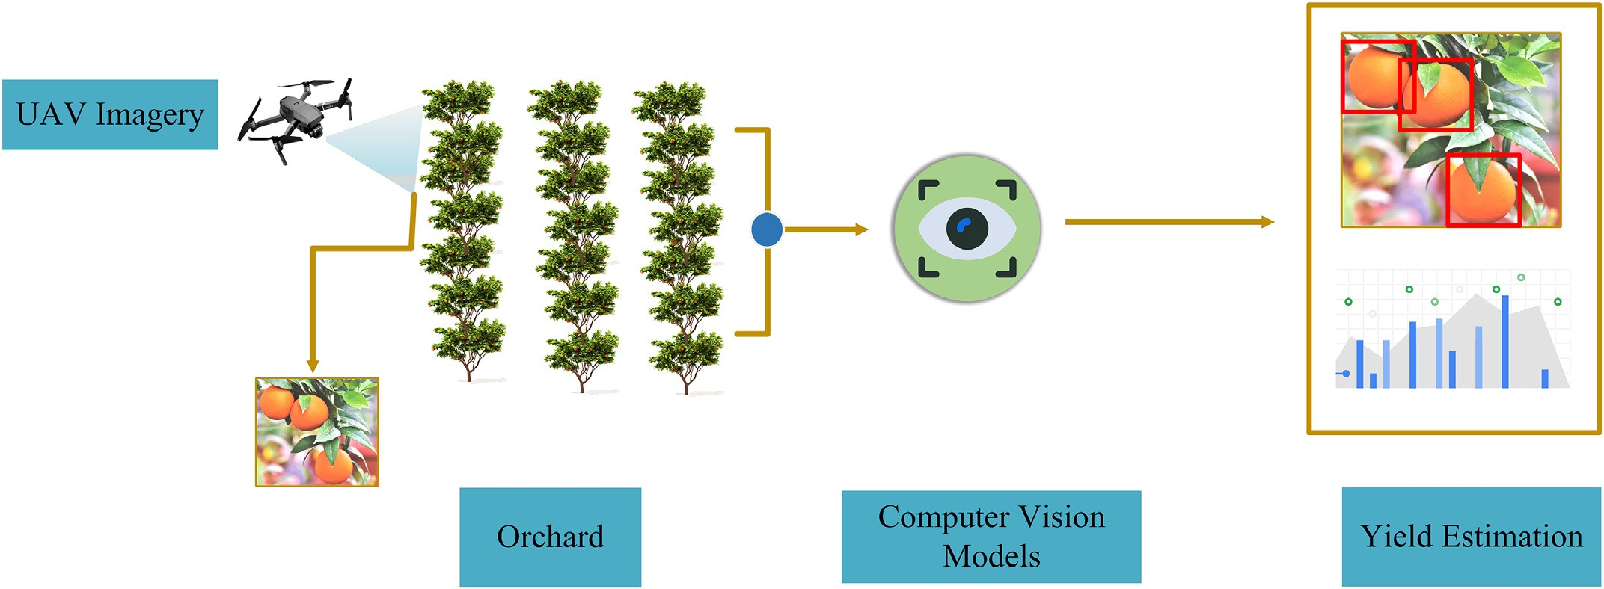

Fig. 10. Orchard yield estimation using computer vision.

Table 7

Previous studies on computer vision and deep learning technologies for yield estimation.

|  |  |  |  |  |
| --- | --- | --- | --- | --- |
| References | Objectives and scenario of application | Methodology | Crop | Results |
| (Khaki et al., 2020)  (Apolo-Apolo | Image-based corn kernel counting and yield estimation  Yield map Generation | Truncated VGGNet backbone and semi supervised deep learning.  Region-CNN (RCNN) Model using UAV | Corn  Apple | MAE and RMSE of 41.36 and 60.27 respectively.  R-squared value: 0.86, MAE: 10.35 and RMSE: 13.56 |
| et al., 2020)  (Palacios et al., | Detection of flower at bloom for | imagery  CNN SegNet architecture with a VGG19 | Grape | A determination coefficient (R2) of 0.91 between the |
| 2020)  (Faisal et al., 2020)  (Yang et al., 2019) | yield estimation  Intelligent harvesting decision system based on date fruit maturity level.  Rice grain yield forecasting using  UAV images | network encoder  VGG-19, Inception-v3, and NASNet Models  CNN models with RGB and multispectral datasets | Date  Rice | actual and detected flowers.  Performance metrics of IHDS were 99.4%, 99.4%, 99.7%, and 99.7% for accuracy, F1 score, sensitivity (recall), and precision, respectively.  Prediction accuracy: MAPE: 20.4%, RMSE: 0.658 and  R-squared: 0.585 |
| (Tedesco-Oliveira et al., 2020)  (Chen et al., | Yield estimation using object detection models  Yield prediction by counting | Faster RCNN, SSD and SSD Lite Models  Faster RCNN model | Cotton  Strawberry | Mean percentage error of 8.84%  The average deep learning counting accuracy was |
| 2019)  (Bargoti and | number of flowers and maturity  analysis, using aerial ortho images Yield Estimation using fruit | CNN and Watershed algorithm | Apple | 84.1% with average occlusion of 13.5%.  The count estimates using CNN and WS with |
| Underwood,  2017) | detection and counting |  |  | R-squared value of 0.826 |
| (Zhou et al., 2020)  (Rahnemoonfar | Real-time fruit detection and yield estimation through smartphones.  Fruit counting based on deep | Single shot Multibox Detector with MobileNetV2, quantized MobileNetV2, InceptionV3, and quantized InceptionV3 Models  Modified version of the Inception-ResNet | Kiwi  Tomato | MobileNetV2, quantized MobileNetV2, InceptionV3, and quantized InceptionV3 obtained TDR of 90.8%, 89.7%, 87.6%, and 72.8%, respectively.  91% average test accuracy on real images and 93% on |
| and Sheppard,  2017) | simulated learning | Model |  | synthetic images |

psychological factors (Shang et al., 2021). Larger farms are more likely to adopt these technologies by taking advantage of economies of scale, and they can afford the higher initial investment cost. Use of comple- mentary technologies can also lead to better adoption of technologies. For example, the variable rate technology and yield mapping are inter- related, and farmers who are using variable rate technologies are more likely to adopt yield mapping technologies. Operator characteristics such as end user’s education level, age, on-farm digital device such as computer usage are also significant (Isgin et al., 2008). Operators having higher education levels and innovativeness could adopt the new tech- nologies faster (Aubert et al., 2012). Isgin et al. (2008) found significant evidence relating to the impact of urban influences on adoption of pre- cision farming technologies in their empirical analysis. Mohr and Kühl (2021) investigated the behavioral factors influencing the acceptance of artificial intelligence technologies using a theoretical framework. The results showed that behavioral control and personal attitude of the farmers are the two most influential factors in the acceptance of artificial intelligence in agriculture.

# Challenges and way forward

Deep learning for computer vision, the spearhead of artificial intelli- gence, is perhaps one of the most promising technologies for meeting the ever-growing food demand. Several intractable problems in agricul- ture are being solved with the support of DL-computer vision. However, high innovation capability always comes along with some challenges. One major challenge in computer vision using deep learning includes the requirement of massive processing power, and most deep learning applications are data-intensive. A possible solution to this is the adop- tion of cloud-based solutions that offer auto-scaling, load balancing, eas- ier maintenance, and high availability features. However, cloud solutions limit real-time processing due to the latency in access and re- trieval of the data from the cloud. The increased cost of immense data processing and privacy issues are also other concerns. Advanced edge devices with accelerators are capable of analyzing real-time video in- puts and providing inferences in near real-time. Deployment of the computer vision solutions in edge devices can reduce the latency limita- tions. Sophisticated computer vision models in a variety of agricultural

use cases often do not perform as expected in the production environ- ment. To ensure that a promising model is not becoming a costly liabil- ity, several aspects like data quality check, code inspection, hyper- parameter tuning, code versioning, setting up the right deployment en- vironment, rigorous training and re-training, etc, need to be closely evaluated.

Quality of data is another major concern for developing efficient data-driven solutions (Cai and Zhu, 2015; Carletto, 2021). Programmat- ically generating synthetic data is one of the approaches for enhancing the data quality in deep learning-based computer vision solutions (Fig. 11). Generative adversarial networks and their variations like CGAN can generate synthetic data for agricultural applications quite ef- fectively (Cui et al., 2021; Olatunji et al., 2020; Zhu et al., 2020a). The performance of a DL-CV model relies heavily on the right hyper- parameter configurations. There are no simple ways to set hyper- parameters such as learning rate, batch size, momentum, weight decay, etc, and it demands expertise and extensive trial and error to achieve the best performance. The process of configuring the hyper- parameter in a high-dimensional space is not a trivial challenge. Com- puter vision problems, more specifically object detection approaches face practical implementation challenges such as viewpoint variation, deformation, occlusion, varying illumination conditions, complex back- grounds, and speed. Viewpoint variation is very common in object de- tection, and segmentation problems, as the object may look at different viewing angles. For e.g., a crop may look different when cap- tured from different angles. The additional complication appears due to the occlusion.

In fruit yield estimation systems, this is a major concern and causes sharp declination in the overall accuracy of the system. Varying illumi- nation conditions and extraction of data from complex overlapped and textured backgrounds also make the computer vision task challeng- ing. In real-time video applications, performance in terms of detection speed and accuracy are crucial for detecting objects in motion. Research in computer vision is growing at a faster pace in the agriculture domain. Building a robust computer vision system requires quality data genera- tion, transfer, and processing. The system should have adequate security to block attacks. Heterogeneity of resources involved in CV solutions in- troduces a lot of security concerns, such as data integrity, privacy issues,

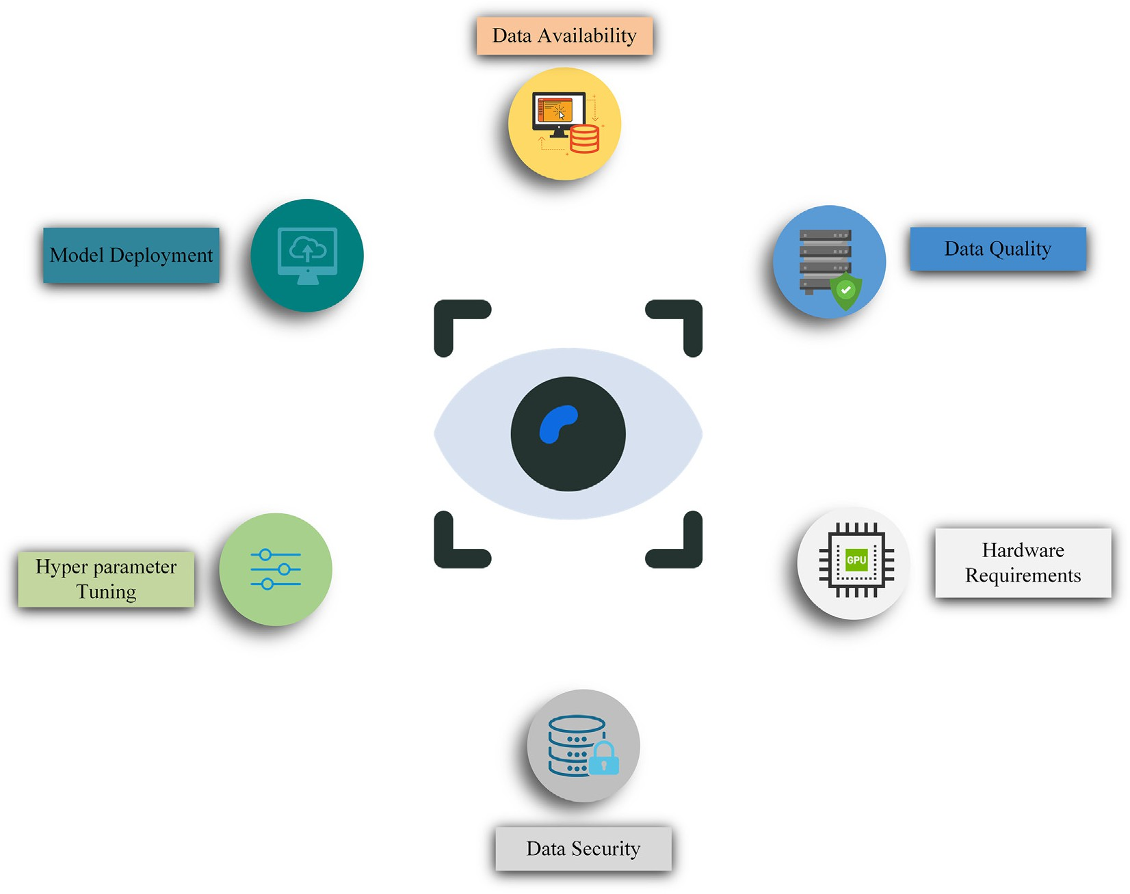

Fig. 11. Challenges in implementation of deep learning based computer vision.

reliability, etc. As these solutions integrate several digital technologies starting from the internet, IoT, cloud computing or edge computing, and wireless sensor networks, the system should accommodate security features for all these technologies and ensure data and device integrity, data accuracy, and availability. From land preparation to harvesting, dif- ferent stakeholders are leveraging new ways to improve the ability to derive insights from images, object detection and tracking, etc. Deep learning - computer vision models will undoubtedly continue to expand and become more innovative and intelligent, handling more complex computations in agriculture with utmost precision. Above all, for obtaining efficient and desirable outputs, strong business cases with the capability to scale on a larger scale is necessary.

# Conclusions

The surge of deep learning coupled with computer vision over the past few years has brought automation capabilities to traditional agri- culture practices. In this paper, we have extensively discussed the role of deep learning-based computer vision in different agriculture applica- tions. More specifically, the paper emphasizes seven different applica- tion areas such as seed quality analysis, soil analysis, irrigation management, plant health analysis, weed management, livestock man- agement, and yield estimation. Review of the application of deep learn- ing particularly, the assessment and planning of water resources revealed that the water sector would continue to embrace deep learning at an accelerated rate, and it will play a significant role in the future of water-related research and the wide range of application areas. Tech- nologies powered by deep learning have created a myriad of application and research opportunities that have the potential to change hydrolog- ical science and workflow. Recent advances in deep learning-assisted

image analysis involving algorithms for image classification, object de- tection, segmentation, etc., have expanded their applications across dif- ferent pre-and post-harvesting activities in agriculture.

The following conclusions can be drawn from the study.

* Deep learning-based computer vision has tremendous automation ca- pabilities across different applications such as automated plant health monitoring, weed detection, irrigation management, livestock man- agement, yield estimation, etc.
* Integration of the deep learning computer vision approaches with the

UAV, and spectral data can help in building advanced-intelligent solu- tions.

* Despite the benefits computer vision and deep learning brought to ag- riculture, significant challenges do remain, especially the data quality issues, the computation power requirement, etc.
* The extensive automation across various agriculture activities will continue to attract the interest of the deep learning research commu- nity in the years to come.

The adoption rate of advanced technologies in agriculture is rela- tively slow, owing to the high initial investment required, lack of techni- cal expertise, and growing concerns about data privacy. However at present, the rate of the adoption of these digital solutions has seen a ris- ing curve, thus suggesting that these would not be concerns in moving forward.

Declaration of Competing Interest

The authors declare that they have no known competing financial interests or personal relationships that could have appeared to influ- ence the work reported in this paper.

# References

Abbas, A., Jain, S., Gour, M., Vankudothu, S., 2021. Tomato plant disease detection using transfer learning with C-GAN synthetic images. Comput. Electron. Agric. 187, 106279. <https://doi.org/10.1016/j.compag.2021.106279>.

Abdalla, A., Cen, H., Wan, L., Mehmood, K., He, Y., 2021. Nutrient Status Diagnosis of Infield Oilseed Rape via Deep Learning-Enabled Dynamic Model. IEEE Trans. Ind. Inform. 17, 4379–4389. <https://doi.org/10.1109/TII.2020.3009736>.

Abu Jwade, S., Guzzomi, A., Mian, A., 2019. On farm automatic sheep breed classification using deep learning. Comput. Electron. Agric. 167, 105055. [https://doi.org/10.1016/j.](https://doi.org/10.1016/j.compag.2019.105055) [compag.2019.105055](https://doi.org/10.1016/j.compag.2019.105055).

Achour, B., Belkadi, M., Filali, I., Laghrouche, M., Lahdir, M., 2020. Image analysis for indi- vidual identification and feeding behaviour monitoring of dairy cows based on Convolutional Neural Networks (CNN). Biosyst. Eng. 198, 31–49. [https://doi.org/10.](https://doi.org/10.1016/j.biosystemseng.2020.07.019) [1016/j.biosystemseng.2020.07.019](https://doi.org/10.1016/j.biosystemseng.2020.07.019).

Adnan, R.M., Mostafa, R.R., Islam, A.R.Md.T., Kisi, O., Kuriqi, A., Heddam, S., 2021. Estimat- ing reference evapotranspiration using hybrid adaptive fuzzy inferencing coupled with heuristic algorithms. Comput. Electron. Agric. 191, 106541. [https://doi.org/10.](https://doi.org/10.1016/j.compag.2021.106541) [1016/j.compag.2021.106541](https://doi.org/10.1016/j.compag.2021.106541).

Agrio, 2022o. Agrio. <https://agrio.app/>. (Accessed 6 July 2022).

Aker, J.C., 2011. Dial “A” for agriculture: a review of information and communication tech- nologies for agricultural extension in developing countries. Agric. Econ. 42, 631–647. <https://doi.org/10.1111/j.1574-0862.2011.00545.x>.

Alameer, A., Kyriazakis, I., Dalton, H.A., Miller, A.L., Bacardit, J., 2020. Automatic recogni- tion of feeding and foraging behaviour in pigs using deep learning. Biosyst. Eng. 197, 91–104. <https://doi.org/10.1016/j.biosystemseng.2020.06.013>.

Albuquerque, C.K.G., Polimante, S., Torre-Neto, A., Prati, R.C., 2020. Water spray detection for smart irrigation systems with Mask R-CNN and UAV footage. 2020 IEEE Interna- tional Workshop on Metrology for Agriculture and Forestry (MetroAgriFor),

pp. 236–240 <https://doi.org/10.1109/MetroAgriFor50201.2020.9277542>.

Al-Gaadi, K.A., Hassaballa, A.A., Tola, E., Kayad, A.G., Madugundu, R., Alblewi, B., Assiri, F., 2016. Prediction of Potato Crop Yield Using Precision Agriculture Techniques. PLOS ONE 11, e0162219. <https://doi.org/10.1371/journal.pone.0162219>.

Amara, J., Bouaziz, B., Algergawy, A., 2017. [A deep learning-based approach for banana](http://refhub.elsevier.com/S2589-7217(22)00017-4/rf0050) [leaf diseases classification. Datenbanksysteme Für Bus. Technol. (Web BTW 2017-](http://refhub.elsevier.com/S2589-7217(22)00017-4/rf0050) [Work](http://refhub.elsevier.com/S2589-7217(22)00017-4/rf0050)).

Anami, B.S., Malvade, N.N., Palaiah, S., 2020. Deep learning approach for recognition and classification of yield affecting paddy crop stresses using field images. Artif. Intell. Agric. 4, 12–20. <https://doi.org/10.1016/j.aiia.2020.03.001>.

Andrew, W., Greatwood, C., Burghardt, T., 2019. Aerial Animal Biometrics: Individual Frie- sian Cattle Recovery and Visual Identification via an Autonomous UAV with Onboard Deep Inference. <https://doi.org/10.48550/arXiv.1907.05310>.

Apolo-Apolo, O.E., Martínez-Guanter, J., Egea, G., Raja, P., Pérez-Ruiz, M., 2020. Deep learn- ing techniques for estimation of the yield and size of citrus fruits using a UAV. Eur.

J. Agron. 115, 126030. <https://doi.org/10.1016/j.eja.2020.126030>.

Araus, J.L., Cairns, J.E., 2014. Field high-throughput phenotyping: the new crop breeding frontier. Trends Plant Sci. 19, 52–61. <https://doi.org/10.1016/j.tplants.2013.09.008>.

Araus, J.L., Kefauver, S.C., Zaman-Allah, M., Olsen, M.S., Cairns, J.E., 2018. Translating High- Throughput Phenotyping into Genetic Gain. Trends Plant Sci. 23, 451–466. [https://](https://doi.org/10.1016/j.tplants.2018.02.001) [doi.org/10.1016/j.tplants.2018.02.001](https://doi.org/10.1016/j.tplants.2018.02.001).

Aubert, B.A., Schroeder, A., Grimaudo, J., 2012. IT as enabler of sustainable farming: An empirical analysis of farmers’ adoption decision of precision agriculture technology. Decis. Support Syst. 54, 510–520. <https://doi.org/10.1016/j.dss.2012.07.002>.

Ayadi, S., Ben Said, A., Jabbar, R., Aloulou, C., Chabbouh, A., Achballah, A.B., 2020. Dairy Cow Rumination Detection: A Deep Learning Approach. In: Jemili, I., Mosbah, M. (Eds.), Distributed Computing for Emerging Smart Networks, Communications in Computer and Information Science. Springer International Publishing, Cham,

pp. 123–139 <https://doi.org/10.1007/978-3-030-65810-6_7>.

Azadnia, R., Jahanbakhshi, A., Rashidi, S., Khajehzadeh, M., Bazyar, P., 2022. Developing an automated monitoring system for fast and accurate prediction of soil texture using an image-based deep learning network and machine vision system. Measurement 190, 110669. <https://doi.org/10.1016/j.measurement.2021.110669>.

Azimi, S., Kaur, T., Gandhi, T.K., 2021. A deep learning approach to measure stress level in plants due to Nitrogen deficiency. Measurement 173, 108650. [https://doi.org/10.](https://doi.org/10.1016/j.measurement.2020.108650) [1016/j.measurement.2020.108650](https://doi.org/10.1016/j.measurement.2020.108650).

Badrzadeh, N., Samani, J.M.V., Mazaheri, M., Kuriqi, A., 2022. Evaluation of management practices on agricultural nonpoint source pollution discharges into the rivers under climate change effects. Sci. Total Environ. 838, 156643. [https://doi.org/10.1016/j.](https://doi.org/10.1016/j.scitotenv.2022.156643) [scitotenv.2022.156643](https://doi.org/10.1016/j.scitotenv.2022.156643).

Bao, F., Bambil, D., 2021. Applicability of computer vision in seed identification: deep learning, random forest, and support vector machine classification algorithms. Acta Bot. Bras. 35, 17–21. <https://doi.org/10.1590/0102-33062020abb0361>.

Bargoti, S., Underwood, J.P., 2017. Image Segmentation for Fruit Detection and Yield Esti- mation in Apple Orchards. J. Field Robot. 34, 1039–1060. [https://doi.org/10.1002/rob.](https://doi.org/10.1002/rob.21699) [21699](https://doi.org/10.1002/rob.21699).

Bazi, Y., Bashmal, L., Rahhal, M.M.A., Dayil, R.A., Ajlan, N.A., 2021. Vision Transformers for Remote Sensing Image Classification. Remote Sens. 13, 516. [https://doi.org/10.3390/](https://doi.org/10.3390/rs13030516) [rs13030516](https://doi.org/10.3390/rs13030516).

Bello, R.-W., Mohamed, A.S.A., Talib, A.Z., 2021. Contour Extraction of Individual Cattle From an Image Using Enhanced Mask R-CNN Instance Segmentation Method. IEEE Access 9, 56984–57000. <https://doi.org/10.1109/ACCESS.2021.3072636>.

Bhagat, M., Kumar, D., Haque, I., Munda, H.S., Bhagat, R., 2020. Plant Leaf Disease Classifi- cation Using Grid Search Based SVM. 2nd International Conference on Data, Engi- neering and Applications (IDEA). Presented at the 2nd International Conference on Data, Engineering and Applications (IDEA), pp. 1–6 [https://doi.org/10.1109/](https://doi.org/10.1109/IDEA49133.2020.9170725) [IDEA49133.2020.9170725](https://doi.org/10.1109/IDEA49133.2020.9170725).

Bhavsar, H., Panchal, M.H., 2012. [A review on support vector machine for data classifica-](http://refhub.elsevier.com/S2589-7217(22)00017-4/rf0130) [tion. Int. J. Adv. Res. Comput. Eng. Technol. IJARCET 1, 185–189](http://refhub.elsevier.com/S2589-7217(22)00017-4/rf0130).

Blue river technology, 2022y. <https://bluerivertechnology.com/>. (Accessed 5 July 2022). Brahimi, M., Boukhalfa, K., Moussaoui, A., 2017. Deep Learning for Tomato Diseases: Clas- sification and Symptoms Visualization. Appl. Artif. Intell. 31, 299–315. [https://doi.org/](https://doi.org/10.1080/08839514.2017.1315516)

[10.1080/08839514.2017.1315516](https://doi.org/10.1080/08839514.2017.1315516).

Brand, W., Wells, A.T., Smith, S.L., Denholm, S.J., Wall, E., Coffey, M.P., 2021. Predicting pregnancy status from mid-infrared spectroscopy in dairy cow milk using deep learn- ing. J. Dairy Sci. 104, 4980–4990. <https://doi.org/10.3168/jds.2020-18367>.

Burra, D.D., Hildebrand, J., Giles, J., Nguyen, T., Hasiner, E., Schroeder, K., Treguer, D., Juergenliemk, A., Horst, A., Jarvis, A., Kropff, W., 2021. [Digital Agriculture Profile:](http://refhub.elsevier.com/S2589-7217(22)00017-4/rf0145) [Viet Nam (Report). Food and Agriculture Organization of the United Nations](http://refhub.elsevier.com/S2589-7217(22)00017-4/rf0145).

Cai, L., Zhu, Y., 2015. The Challenges of Data Quality and Data Quality Assessment in the Big Data Era. Data Sci. J. 14, 2. <https://doi.org/10.5334/dsj-2015-002>.

Cainthus, 2022s. Cainthus. [https://www.cainthus.com](https://www.cainthus.com/). (Accessed 6 July 2022).

Carletto, C., 2021. Better data, higher impact: improving agricultural data systems for so- cietal change. Eur. Rev. Agric. Econ. 48, 719–740. [https://doi.org/10.1093/erae/](https://doi.org/10.1093/erae/jbab030) [jbab030](https://doi.org/10.1093/erae/jbab030).

Cen, H., Lu, R., Zhu, Q., Mendoza, F., 2016. Nondestructive detection of chilling injury in cu- cumber fruit using hyperspectral imaging with feature selection and supervised clas- sification. Postharvest Biol. Technol. 111, 352–361. [https://doi.org/10.1016/j.](https://doi.org/10.1016/j.postharvbio.2015.09.027) [postharvbio.2015.09.027](https://doi.org/10.1016/j.postharvbio.2015.09.027).

Chamoso, P., Raveane, W., Parra, V., González, A., 2014. [UAVs applied to the counting and](http://refhub.elsevier.com/S2589-7217(22)00017-4/rf0165) [monitoring of animals. Ambient Intelligence-Software and Applications. Springer](http://refhub.elsevier.com/S2589-7217(22)00017-4/rf0165) [71–80](http://refhub.elsevier.com/S2589-7217(22)00017-4/rf0165).

Chang, C.-L., Lin, K.-M., 2018. Smart Agricultural Machine with a Computer Vision-Based Weeding and Variable-Rate Irrigation Scheme. Robotics 7, 38. [https://doi.org/10.](https://doi.org/10.3390/robotics7030038) [3390/robotics7030038](https://doi.org/10.3390/robotics7030038).

Chavan, T.R., Nandedkar, A.V., 2018. AgroAVNET for crops and weeds classification: A step forward in automatic farming. Comput. Electron. Agric. 154, 361–372. [https://doi.org/](https://doi.org/10.1016/j.compag.2018.09.021) [10.1016/j.compag.2018.09.021](https://doi.org/10.1016/j.compag.2018.09.021).

Chen, Y., Lee, W.S., Gan, H., Peres, N., Fraisse, C., Zhang, Y., He, Y., 2019. Strawberry Yield Prediction Based on a Deep Neural Network Using High-Resolution Aerial Orthoim- ages. Remote Sens. 11, 1584. <https://doi.org/10.3390/rs11131584>.

Chen, H., Chen, A., Xu, L., Xie, H., Qiao, H., Lin, Q., Cai, K., 2020a. A deep learning CNN ar- chitecture applied in smart near-infrared analysis of water pollution for agricultural irrigation resources. Agric. Water Manag. 240, 106303. [https://doi.org/10.1016/j.](https://doi.org/10.1016/j.agwat.2020.106303) [agwat.2020.106303](https://doi.org/10.1016/j.agwat.2020.106303).

Chen, J., Chen, Jinxiu, Zhang, D., Sun, Y., Nanehkaran, Y.A., 2020b. Using deep transfer learning for image-based plant disease identification. Comput. Electron. Agric. 173, 105393. <https://doi.org/10.1016/j.compag.2020.105393>.

Cheng, H., Damerow, L., Sun, Y., Blanke, M., 2017. Early Yield Prediction Using Image Anal- ysis of Apple Fruit and Tree Canopy Features with Neural Networks. J. Imaging 3, 6. <https://doi.org/10.3390/jimaging3010006>.

Chlingaryan, A., Sukkarieh, S., Whelan, B., 2018. Machine learning approaches for crop yield prediction and nitrogen status estimation in precision agriculture: A review. Comput. Electron. Agric. 151, 61–69. <https://doi.org/10.1016/j.compag.2018.05.012>.

Coulibaly, S., Kamsu-Foguem, B., Kamissoko, D., Traore, D., 2019. Deep neural networks with transfer learning in millet crop images. Comput. Ind. 108, 115–120. [https://](https://doi.org/10.1016/j.compind.2019.02.003) [doi.org/10.1016/j.compind.2019.02.003](https://doi.org/10.1016/j.compind.2019.02.003).

Cromai, 2022i. Cromai. <https://www.cromai.com/>. (Accessed 6 July 2022).

Cui, X., Ying, Y., Chen, Z., 2021. CycleGAN based confusion model for cross-species plant disease image migration. J. Intell. Fuzzy Syst. 41, 6685–6696. [https://doi.org/10.](https://doi.org/10.3233/JIFS-210585) [3233/JIFS-210585](https://doi.org/10.3233/JIFS-210585).

Dell’Acqua, F., Gamba, P., 2003. Texture-based characterization of urban environments on satellite SAR images. IEEE Trans. Geosci. Remote Sens. 41, 153–159. [https://doi.org/](https://doi.org/10.1109/TGRS.2002.807754) [10.1109/TGRS.2002.807754](https://doi.org/10.1109/TGRS.2002.807754).

Dolata, P., Reiner, J., 2018. [Barley Variety Recognition with Viewpoint-Aware Double-](http://refhub.elsevier.com/S2589-7217(22)00017-4/rf0220) [Stream Convolutional Neural Networks. 2018 Federated Conference on Computer](http://refhub.elsevier.com/S2589-7217(22)00017-4/rf0220) [Science and Information Systems (FedCSIS)., pp. 101–105](http://refhub.elsevier.com/S2589-7217(22)00017-4/rf0220)

Dorj, U.-O., Lee, M., Yun, S., 2017. An yield estimation in citrus orchards via fruit detection and counting using image processing. Comput. Electron. Agric. 140, 103–112. [https://](https://doi.org/10.1016/j.compag.2017.05.019) [doi.org/10.1016/j.compag.2017.05.019](https://doi.org/10.1016/j.compag.2017.05.019).

Dosovitskiy, A., Beyer, L., Kolesnikov, A., Weissenborn, D., Zhai, X., Unterthiner, T., Dehghani, M., Minderer, M., Heigold, G., Gelly, S., Uszkoreit, J., Houlsby, N., 2021. An Image is Worth 16x16 Words: Transformers for Image Recognition at Scale. <https://doi.org/10.48550/arXiv.2010.11929>.

Elbeltagi, A., Kumar, M., Kushwaha, N.L., Pande, C.B., Ditthakit, P., Vishwakarma, D.K., Subeesh, A., 2022a. Drought indicator analysis and forecasting using data driven models: case study in Jaisalmer, India. Stoch. Environ. Res. Risk Assess [https://doi.](https://doi.org/10.1007/s00477-022-02277-0) [org/10.1007/s00477-022-02277-0](https://doi.org/10.1007/s00477-022-02277-0).

Elbeltagi, A., Kushwaha, N.L., Rajput, J., Vishwakarma, D.K., Kulimushi, L.C., Kumar, M., Zhang, J., Pande, C.B., Choudhari, P., Meshram, S.G., Pandey, K., Sihag, P., Kumar, N., Abd-Elaty, I., 2022b. Modelling daily reference evapotranspiration based on stacking hybridization of ANN with meta-heuristic algorithms under diverse agro-climatic conditions. Stoch. Environ. Res. Risk Assess. [https://doi.org/10.1007/s00477-022-](https://doi.org/10.1007/s00477-022-02196-0) [02196-0](https://doi.org/10.1007/s00477-022-02196-0).

Espejo-Garcia, B., Mylonas, N., Athanasakos, L., Fountas, S., Vasilakoglou, I., 2020. Towards weeds identification assistance through transfer learning. Comput. Electron. Agric. 171, 105306. <https://doi.org/10.1016/j.compag.2020.105306>.

Faisal, M., Alsulaiman, M., Arafah, M., Mekhtiche, M.A., 2020. IHDS: Intelligent Harvesting Decision System for Date Fruit Based on Maturity Stage Using Deep Learning and Computer Vision. IEEE Access 8, 167985–167997. [https://doi.org/10.1109/ACCESS.](https://doi.org/10.1109/ACCESS.2020.3023894) [2020.3023894](https://doi.org/10.1109/ACCESS.2020.3023894).

Fawakherji, M., Potena, C., Prevedello, I., Pretto, A., Bloisi, D.D., Nardi, D., 2020. Data Aug- mentation Using GANs for Crop/Weed Segmentation in Precision Farming. 2020 IEEE

Conference on Control Technology and Applications (CCTA). Presented at the 2020 IEEE Conference on Control Technology and Applications (CCTA), pp. 279–284 <https://doi.org/10.1109/CCTA41146.2020.9206297>.

Ferentinos, K.P., 2018. Deep learning models for plant disease detection and diagnosis. Comput. Electron. Agric. 145, 311–318. [https://doi.org/10.1016/j.compag.2018.01.](https://doi.org/10.1016/j.compag.2018.01.009)

[009](https://doi.org/10.1016/j.compag.2018.01.009).

Foglia, M.M., Reina, G., 2006. Agricultural robot for radicchio harvesting. J. Field Robot. 23, 363–377. <https://doi.org/10.1002/rob.20131>.

Ghanem, M.E., Marrou, H., Sinclair, T.R., 2015. Physiological phenotyping of plants for crop improvement. Trends Plant Sci. 20, 139–144. [https://doi.org/10.1016/j.tplants.2014.](https://doi.org/10.1016/j.tplants.2014.11.006) [11.006](https://doi.org/10.1016/j.tplants.2014.11.006).

Gomes, J.F.S., Leta, F.R., 2012. Applications of computer vision techniques in the agricul- ture and food industry: a review. Eur. Food Res. Technol. 235, 989–1000. [https://](https://doi.org/10.1007/s00217-012-1844-2) [doi.org/10.1007/s00217-012-1844-2](https://doi.org/10.1007/s00217-012-1844-2).

Goncharov, P, Ososkov, G, Nechaevskiy, A, Uzhinskiy, A, Nestsiarenia, I, 2018. [Disease De-](http://refhub.elsevier.com/S2589-7217(22)00017-4/optIpHAQt3s9g) [tection on the Plant Leaves by Deep Learning. In: Kryzhanovsky, Boris, Dunin-](http://refhub.elsevier.com/S2589-7217(22)00017-4/optIpHAQt3s9g) [Barkowski, Witali, Redko, Vladimir, Tiumentsev, Yury (Eds.), Advances in Neural](http://refhub.elsevier.com/S2589-7217(22)00017-4/optIpHAQt3s9g) [Computation, Machine Learning, and Cognitive Research II. Springer, pp. 151–159](http://refhub.elsevier.com/S2589-7217(22)00017-4/optIpHAQt3s9g).

Granitto, P.M., Verdes, P.F., Ceccatto, H.A., 2005. Large-scale investigation of weed seed identification by machine vision. Comput. Electron. Agric. 47, 15–24. [https://doi.](https://doi.org/10.1016/j.compag.2004.10.003) [org/10.1016/j.compag.2004.10.003](https://doi.org/10.1016/j.compag.2004.10.003).

Gulzar, Y., Hamid, Y., Soomro, A.B., Alwan, A.A., Journaux, L., 2020. A Convolution Neural Network-Based Seed Classification System. Symmetry 12, 2018. [https://doi.org/10.](https://doi.org/10.3390/sym12122018) [3390/sym12122018](https://doi.org/10.3390/sym12122018).

Hall, D., McCool, C., Dayoub, F., Sunderhauf, N., Upcroft, B., 2015. Evaluation of Features for Leaf Classification in Challenging Conditions. 2015 IEEE Winter Conference on Appli- cations of Computer Vision. Presented at the 2015 IEEE Winter Conference on Appli- cations of Computer Vision, pp. 797–804 <https://doi.org/10.1109/WACV.2015.111>.

Hansen, M.F., Smith, M.L., Smith, L.N., Salter, M.G., Baxter, E.M., Farish, M., Grieve, B., 2018. Towards on-farm pig face recognition using convolutional neural networks. Comput. Ind. 98, 145–152. <https://doi.org/10.1016/j.compind.2018.02.016>.

Haralick, R.M., Shanmugam, K., Dinstein, I., 1973. Textural Features for Image Classifica- tion. IEEE Trans. Syst. Man Cybern. SMC-3, 610–621. [https://doi.org/10.1109/TSMC.](https://doi.org/10.1109/TSMC.1973.4309314) [1973.4309314](https://doi.org/10.1109/TSMC.1973.4309314).

Harvest croo robotics, 2022s. Harvest croo robotics. [https://www.harvestcroorobotics.](https://www.harvestcroorobotics.com/technology) [com/technology](https://www.harvestcroorobotics.com/technology). (Accessed 5 July 2022).

Hassan, S.M., Maji, A.K., 2022. Plant Disease Identification Using a Novel Convolutional Neural Network. IEEE Access 10, 5390–5401. [https://doi.org/10.1109/ACCESS.2022.](https://doi.org/10.1109/ACCESS.2022.3141371) [3141371](https://doi.org/10.1109/ACCESS.2022.3141371).

Hati, A.J., Singh, R.R., 2021. Artificial Intelligence in Smart Farms: Plant Phenotyping for Species Recognition and Health Condition Identification Using Deep Learning. AI 2, 274–289. <https://doi.org/10.3390/ai2020017>.

He, K., Zhang, X., Ren, S., Sun, J., 2015. [Deep residual learning for image recognition.](http://refhub.elsevier.com/S2589-7217(22)00017-4/rf0315)

[ArXiv151203385 Cs](http://refhub.elsevier.com/S2589-7217(22)00017-4/rf0315).

Heramb, P., Kumar Singh, P., Ramana Rao, K.V., Subeesh, A., 2022. Modelling reference evapotranspiration using gene expression programming and artificial neural network at Pantnagar. Inf. Process. Agric, India <https://doi.org/10.1016/j.inpa.2022.05.007>.

Hiriyannaiah, S., Srinivas, A.M.D., Shetty, G.K., Srinivasa, K.G., 2020. Chapter 4 - A compu- tationally intelligent agent for detecting fake news using generative adversarial net- works. In: Bhattacharyya, S., Snášel, V., Gupta, D., Khanna, A. (Eds.), Hybrid Computational Intelligence, Hybrid Computational Intelligence for Pattern Analysis. and Understanding. Academic Press, pp. 69–96 [https://doi.org/10.1016/B978-0-12-](https://doi.org/10.1016/B978-0-12-818699-2.00004-4) [818699-2.00004-4](https://doi.org/10.1016/B978-0-12-818699-2.00004-4).

Huang, T., 1993. [Computer vision. Evolution and promise](http://refhub.elsevier.com/S2589-7217(22)00017-4/rf0330). Huang, H., Lan, Y., Yang, A., Zhang, Y., Wen, S., Deng, J., 2020. Deep learning versus Object-

based Image Analysis (OBIA) in weed mapping of UAV imagery. Int. J. Remote Sens. 41, 3446–3479. <https://doi.org/10.1080/01431161.2019.1706112>.

Hughes, D.P., Salathe, M., 2016. [An open access repository of images on plant health to en-](http://refhub.elsevier.com/S2589-7217(22)00017-4/rf0340) [able the development of mobile disease diagnostics. ArXiv151108060 Cs](http://refhub.elsevier.com/S2589-7217(22)00017-4/rf0340).

Huzzey, J.M., Veira, D.M., Weary, D.M., von Keyserlingk, M., 2007. Prepartum behavior and dry matter intake identify dairy cows at risk for metritis. J. Dairy Sci. 90, 3220–3233. <https://doi.org/10.3168/jds.2006-807>.

Isgin, T., Bilgic, A., Forster, D.L., Batte, M.T., 2008. Using count data models to determine the factors affecting farmers’ quantity decisions of precision farming technology adoption. Comput. Electron. Agric. 62, 231–242. [https://doi.org/10.1016/j.compag.](https://doi.org/10.1016/j.compag.2008.01.004) [2008.01.004](https://doi.org/10.1016/j.compag.2008.01.004).

Jahagirdar, P., Budihal, S.V., 2021. Framework to Detect NPK Deficiency in Maize Plants Using CNN. In: Panigrahi, C.R., Pati, B., Mohapatra, P., Buyya, R., Li, K.-C. (Eds.), Prog- ress in Advanced Computing and Intelligent Engineering, Advances in Intelligent Sys- tems and Computing. Springer, Singapore, pp. 366–376 [https://doi.org/10.1007/978-](https://doi.org/10.1007/978-981-15-6353-9_33) [981-15-6353-9_33](https://doi.org/10.1007/978-981-15-6353-9_33).

Jamei, M., Karbasi, M., Malik, A., Abualigah, L., Islam, A.R.M.T., Yaseen, Z.M., 2022a. Compu- tational assessment of groundwater salinity distribution within coastal multi- aquifers of Bangladesh. Sci. Rep. 12, 11165. [https://doi.org/10.1038/s41598-022-](https://doi.org/10.1038/s41598-022-15104-x) [15104-x](https://doi.org/10.1038/s41598-022-15104-x).

Jamei, M., Maroufpoor, S., Aminpour, Y., Karbasi, M., Malik, A., Karimi, B., 2022b. Develop- ing hybrid data-intelligent method using Boruta-random forest optimizer for simula- tion of nitrate distribution pattern. Agric. Water Manag. 270, 107715. [https://doi.org/](https://doi.org/10.1016/j.agwat.2022.107715) [10.1016/j.agwat.2022.107715](https://doi.org/10.1016/j.agwat.2022.107715).

Jamei, Mehdi, Karbasi, M., Malik, A., Jamei, Mozhdeh, Kisi, O., Yaseen, Z.M., 2022c. Long- term multi-step ahead forecasting of root zone soil moisture in different climates: Novel ensemble-based complementary data-intelligent paradigms. Agric. Water Manag. 269, 107679. <https://doi.org/10.1016/j.agwat.2022.107679>.

Javanmardi, S., Miraei Ashtiani, S.-H., Verbeek, F.J., Martynenko, A., 2021. Computer-vision classification of corn seed varieties using deep convolutional neural network. J. Stored Prod. Res. 92, 101800. <https://doi.org/10.1016/j.jspr.2021.101800>.

Jha, K., Doshi, A., Patel, P., Shah, M., 2019. A comprehensive review on automation in ag- riculture using artificial intelligence. Artif. Intell. Agric. 2, 1–12. [https://doi.org/10.](https://doi.org/10.1016/j.aiia.2019.05.004) [1016/j.aiia.2019.05.004](https://doi.org/10.1016/j.aiia.2019.05.004).

Ji, M., Wu, Z., 2022. Automatic detection and severity analysis of grape black measles dis- ease based on deep learning and fuzzy logic. Comput. Electron. Agric. 193, 106718. <https://doi.org/10.1016/j.compag.2022.106718>.

Jiang, B., Wu, Q., Yin, X., Wu, D., Song, H., He, D., 2019. FLYOLOv3 deep learning for key parts of dairy cow body detection. Comput. Electron. Agric. 166, 104982. [https://](https://doi.org/10.1016/j.compag.2019.104982) [doi.org/10.1016/j.compag.2019.104982](https://doi.org/10.1016/j.compag.2019.104982).

Joshi, R.C., Kaushik, M., Dutta, M.K., Srivastava, A., Choudhary, N., 2021. VirLeafNet: Auto- matic analysis and viral disease diagnosis using deep-learning in Vigna mungo plant. Ecol. Inform. 61, 101197. <https://doi.org/10.1016/j.ecoinf.2020.101197>.

Jung, D.-H., Kim, N.Y., Moon, S.H., Jhin, C., Kim, H.-J., Yang, J.-S., Kim, H.S., Lee, T.S., Lee, J.Y.,

Park, S.H., 2021. Deep Learning-Based Cattle Vocal Classification Model and Real- Time Livestock Monitoring System with Noise Filtering. Animals 11, 357. [https://](https://doi.org/10.3390/ani11020357) [doi.org/10.3390/ani11020357](https://doi.org/10.3390/ani11020357).

Kaack, L.H., Donti, P.L., Strubell, E., Kamiya, G., Creutzig, F., Rolnick, D., 2022. Aligning ar- tificial intelligence with climate change mitigation. Nat. Clim. Change 12, 518–527. <https://doi.org/10.1038/s41558-022-01377-7>.

Kamilaris, A., Prenafeta-Boldú, F.X., 2018. Deep learning in agriculture: A survey. Comput.

Electron. Agric. 147, 70–90. <https://doi.org/10.1016/j.compag.2018.02.016>.

Kamyshova, G., Osipov, A., Gataullin, S., Korchagin, S., Ignar, S., Gataullin, T., Terekhova, N., Suvorov, S., 2022. Artificial neural networks and computer vision’s-based phytoindication systems for variable rate irrigation improving. IEEE Access 10, 8577–8589. <https://doi.org/10.1109/ACCESS.2022.3143524>.

Kannur, Anil, Kannur, Asha, Rajpurohit, V.S., 2011. Classification and grading of bulk seeds using artificial neural network. Int. J. Mach. Intell. 3, 62–73. [https://doi.org/10.9735/](https://doi.org/10.9735/0975-2927.3.2.62-73) [0975-2927.3.2.62-73](https://doi.org/10.9735/0975-2927.3.2.62-73).

Kanwal, Z., Basit, A., Jawad, M., Ullah, I., Ali, A., 2019. Overlapped apple fruit yield estima- tion using pixel classification and hough transform. Int. J. Adv. Comput. Sci. Appl. 10. <https://doi.org/10.14569/IJACSA.2019.0100271>.

Karbasi, M., Jamei, M., Ali, M., Malik, A., Yaseen, Z.M., 2022. [Forecasting weekly reference](http://refhub.elsevier.com/S2589-7217(22)00017-4/rf0430) [evapotranspiration using Auto Encoder Decoder Bidirectional LSTM model hybrid-](http://refhub.elsevier.com/S2589-7217(22)00017-4/rf0430) [ized with a Boruta-CatBoost input optimizer. Comput. Electron. Agric. 198, 10712](http://refhub.elsevier.com/S2589-7217(22)00017-4/rf0430)1.

Karim, L., Anpalagan, A., Nasser, N., Almhana, J., 2013. Sensor-based M2M Agriculture Monitoring Systems for Developing Countries. State and Challenges 5. [https://doi.](https://doi.org/10.5296/npa.v5i3.3787) [org/10.5296/npa.v5i3.3787](https://doi.org/10.5296/npa.v5i3.3787).

Khaki, S., Wang, L., Archontoulis, S.V., 2020. A CNN-RNN Framework for Crop Yield Predic- tion. Front. Plant Sci. 10. <https://doi.org/10.3389/fpls.2019.01750>.

Khan, S., Naseer, M., Hayat, M., Zamir, S.W., Khan, F.S., Shah, M., 2021. Transformers in Vi- sion: A Survey. ACM Comput. Surv. <https://doi.org/10.1145/3505244>.

Khanna, A., Kaur, S., 2019. Evolution of Internet of Things (IoT) and its significant impact in the field of Precision Agriculture. Comput. Electron. Agric. 157, 218–231. [https://](https://doi.org/10.1016/j.compag.2018.12.039) [doi.org/10.1016/j.compag.2018.12.039](https://doi.org/10.1016/j.compag.2018.12.039).

Kim, K.-H., Kim, M.-G., Yoon, P.-R., Bang, J.-H., Myoung, W.-H., Choi, J.-Y., Choi, G.-H., 2022.

Application of CCTV Image and Semantic Segmentation Model for Water Level Esti- mation of Irrigation Channel. J. Korean Soc. Agric. Eng. 64, 63–73. [https://doi.org/10.](https://doi.org/10.5389/KSAE.2022.64.3.063) [5389/KSAE.2022.64.3.063](https://doi.org/10.5389/KSAE.2022.64.3.063).

Koech, R., Langat, P., 2018. Improving irrigation water use efficiency: a review of ad- vances, challenges and opportunities in the Australian context. Water 10, 1771. <https://doi.org/10.3390/w10121771>.

Kriegeskorte, N., Golan, T., 2019. Neural network models and deep learning. Curr. Biol. 29, R231–R236. <https://doi.org/10.1016/j.cub.2019.02.034>.

Krizhevsky, A., Sutskever, I., Hinton, G.E., 2012a. [ImageNet classification with deep](http://refhub.elsevier.com/S2589-7217(22)00017-4/rf0470) [convolutional neural networks, in: Proceedings of the 25th International Conference](http://refhub.elsevier.com/S2589-7217(22)00017-4/rf0470) [on Neural Information Processing Systems - Volume 1, NIPS’12. Curran Associates](http://refhub.elsevier.com/S2589-7217(22)00017-4/rf0470) [Inc., Red Hook, NY, USA, pp. 1097–1105](http://refhub.elsevier.com/S2589-7217(22)00017-4/rf0470).

Krizhevsky, A., Sutskever, I., Hinton, G.E., 2012b. [ImageNet Classification with Deep](http://refhub.elsevier.com/S2589-7217(22)00017-4/rf0475) [Convolutional Neural Networks. Advances in Neural Information Processing Systems.](http://refhub.elsevier.com/S2589-7217(22)00017-4/rf0475) [Curran Associates, Inc.](http://refhub.elsevier.com/S2589-7217(22)00017-4/rf0475)

Kumar, S., Singh, S.K., Singh, R., Singh, A.K., 2017. [Recognition of cattle using face images.](http://refhub.elsevier.com/S2589-7217(22)00017-4/rf0480)

[Anim. Biom. 79–11](http://refhub.elsevier.com/S2589-7217(22)00017-4/rf0480)0.

Kumar, A., Sarkar, S., Pradhan, C., 2019. Recommendation System for Crop Identification and Pest Control Technique in Agriculture. 2019 International Conference on Com- munication and Signal Processing (ICCSP). Presented at the 2019 International Con- ference on Communication and Signal Processing (ICCSP), pp. 0185–0189 [https://](https://doi.org/10.1109/ICCSP.2019.8698099) [doi.org/10.1109/ICCSP.2019.8698099](https://doi.org/10.1109/ICCSP.2019.8698099).

Kumbi, A.A., Birje, M.N., 2022. Deep CNN based sunflower atom optimization method for optimal water control in IoT. Wirel. Pers. Commun. 122, 1221–1246. [https://doi.org/](https://doi.org/10.1007/s11277-021-08946-7) [10.1007/s11277-021-08946-7](https://doi.org/10.1007/s11277-021-08946-7).

Kuplich, T.M., Curran, P.J., Atkinson, P.M., 2005. Relating SAR image texture to the biomass of regenerating tropical forests. Int. J. Remote Sens. 26, 4829–4854. [https://doi.org/10.](https://doi.org/10.1080/01431160500239107) [1080/01431160500239107](https://doi.org/10.1080/01431160500239107).

Kurtulmuş, F., 2021. Identification of sunflower seeds with deep convolutional neural net- works. J. Food Meas. Charact. 15, 1024–1033. [https://doi.org/10.1007/s11694-020-](https://doi.org/10.1007/s11694-020-00707-7) [00707-7](https://doi.org/10.1007/s11694-020-00707-7).

Kushwaha, N.L., Bhardwaj, A., Verma, V.K., 2016. [Hydrologic response of Takarla-Ballowal](http://refhub.elsevier.com/S2589-7217(22)00017-4/rf0505) [watershed in Shivalik foot-hills based on morphometric analysis using remote sens-](http://refhub.elsevier.com/S2589-7217(22)00017-4/rf0505) [ing and GIS. J Indian Water Resour Soc 36, 17–25](http://refhub.elsevier.com/S2589-7217(22)00017-4/rf0505).

Kushwaha, N.L., Rajput, J., Elbeltagi, A., Elnaggar, A.Y., Sena, D.R., Vishwakarma, D.K., Mani, I., Hussein, E.E., 2021. Data Intelligence model and meta-heuristic algorithms-based pan evaporation modelling in two different agro-climatic zones: a case study from Northern India. Atmosphere 12, 1654. <https://doi.org/10.3390/atmos12121654>.

Kushwaha, N.L., Elbeltagi, A., Mehan, S., Malik, A., Yousuf, A., 2022. Comparative study on morphometric analysis and RUSLE-based approaches for micro-watershed

prioritization using remote sensing and GIS. Arab. J. Geosci. 15, 564. [https://doi.org/](https://doi.org/10.1007/s12517-022-09837-2) [10.1007/s12517-022-09837-2](https://doi.org/10.1007/s12517-022-09837-2).

Kussul, N., Lavreniuk, M., Skakun, S., Shelestov, A., 2017. Deep learning classification of land cover and crop types using remote sensing data. IEEE Geosci. Remote Sens. Lett. 14, 778–782. <https://doi.org/10.1109/LGRS.2017.2681128>.

Le, V.N.T., Ahderom, S., Alameh, K., 2020. Performances of the LBP Based Algorithm over CNN Models for Detecting Crops and Weeds with Similar Morphologies. Sensors 20, 2193. <https://doi.org/10.3390/s20082193>.

LeCun, Y., Bottou, L., Bengio, Y., Haffner, P., 1998. [Gradient-based learning applied to doc-](http://refhub.elsevier.com/S2589-7217(22)00017-4/rf0530) [ument recognition. Proc. IEEE 86, 2278–2324](http://refhub.elsevier.com/S2589-7217(22)00017-4/rf0530).

Ledig, C., Theis, L., Huszar, F., Caballero, J., Cunningham, A., Acosta, A., Aitken, A., Tejani, A., Totz, J., Wang, Z., Shi, W., 2017. Photo-Realistic Single Image Super-Resolution Using a Generative Adversarial Network. <https://doi.org/10.48550/arXiv.1609.04802>.

Li, X., Li, S., 2022. Transformer Help CNN See Better: A Lightweight Hybrid Apple Disease Identification Model Based on Transformers. Agriculture 12, 884. [https://doi.org/10.](https://doi.org/10.3390/agriculture12060884) [3390/agriculture12060884](https://doi.org/10.3390/agriculture12060884).

Li, Y., Randall, C.J., Van Woesik, R., Ribeiro, E., 2019. Underwater video mosaicing using to- pology and superpixel-based pairwise stitching. Expert Syst. Appl. 119, 171–183. <https://doi.org/10.1016/j.eswa.2018.10.041>.

Li, C., Li, H., Liu, Z., Li, B., Huang, Y., 2021. SeedSortNet: a rapid and highly effificient light- weight CNN based on visual attention for seed sorting. PeerJ Comput. Sci. 7, e639. <https://doi.org/10.7717/peerj-cs.639>.

Li, Y., Wu, C.-Y., Fan, H., Mangalam, K., Xiong, B., Malik, J., Feichtenhofer, C., 2022. [MViTv2:](http://refhub.elsevier.com/S2589-7217(22)00017-4/rf0555) [improved multiscale vision transformers for classification and detection. Presented at](http://refhub.elsevier.com/S2589-7217(22)00017-4/rf0555) [the Proceedings of the IEEE/CVF Conference on Computer Vision and Pattern Recog-](http://refhub.elsevier.com/S2589-7217(22)00017-4/rf0555) [nition, pp. 4804–4814](http://refhub.elsevier.com/S2589-7217(22)00017-4/rf0555).

Liu, J., Wang, X., 2020. [Tomato diseases and pests detection based on improved yolo V3](http://refhub.elsevier.com/S2589-7217(22)00017-4/rf0560) [convolutional neural network. Front. Plant Sci. 11](http://refhub.elsevier.com/S2589-7217(22)00017-4/rf0560).

Liu, D., Ning, X., Li, Z., Yang, D., Li, H., Gao, L., 2015. Discriminating and elimination of dam- aged soybean seeds based on image characteristics. J. Stored Prod. Res. 60, 67–74. <https://doi.org/10.1016/j.jspr.2014.10.001>.

Liu, W., Anguelov, D., Erhan, D., Szegedy, C., Reed, S., Fu, C.-Y., Berg, A.C., 2016. SSD: Single Shot MultiBox Detector. In: Leibe, B., Matas, J., Sebe, N., Welling, M. (Eds.), Computer Vision – ECCV 2016. Lecture Notes in Computer Science. Springer International Pub- lishing, Cham, pp. 21–37 <https://doi.org/10.1007/978-3-319-46448-0_2>.

Lo Bianco, M., Grillo, O., Cañadas, E., Venora, G., Bacchetta, G., 2017. Inter- and intraspecific diversity in Cistus L. (Cistaceae) seeds, analysed with computer vision techniques. Plant Biol. 19, 183–190. <https://doi.org/10.1111/plb.12529>.

Ma, T., Tsuchikawa, S., Inagaki, T., 2020. Rapid and non-destructive seed viability predic- tion using near-infrared hyperspectral imaging coupled with a deep learning ap- proach. Comput. Electron. Agric. 177, 105683. [https://doi.org/10.1016/j.compag.](https://doi.org/10.1016/j.compag.2020.105683) [2020.105683](https://doi.org/10.1016/j.compag.2020.105683).

Maheswari, P., Raja, P., Apolo-Apolo, O.E., Pérez-Ruiz, M., 2021. Intelligent fruit yield esti- mation for orchards using deep learning based semantic segmentation techniques—a review. Front. Plant Sci. 12, 1247. <https://doi.org/10.3389/fpsyg.2020.513474>.

Malik, A., Saggi, M.K., Rehman, S., Sajjad, H., Inyurt, S., Bhatia, A.S., Farooque, A.A., Oudah, A.Y., Yaseen, Z.M., 2022a. Deep learning versus gradient boosting machine for pan evaporation prediction. Eng. Appl. Comput. Fluid Mech. 16, 570–587. [https://doi.](https://doi.org/10.1080/19942060.2022.2027273) [org/10.1080/19942060.2022.2027273](https://doi.org/10.1080/19942060.2022.2027273).

Malik, A., Tikhamarine, Y., Sihag, P., Shahid, S., Jamei, M., Karbasi, M., 2022b. Predicting daily soil temperature at multiple depths using hybrid machine learning models for a semi-arid region in Punjab. Environ. Sci. Pollut. Res, India [https://doi.org/10.1007/](https://doi.org/10.1007/s11356-022-20837-3) [s11356-022-20837-3](https://doi.org/10.1007/s11356-022-20837-3).

Mathew, M.P., Mahesh, T.Y., 2022. Leaf-based disease detection in bell pepper plant using YOLO v5. Signal Image Video Process. 16, 841–847. [https://doi.org/10.1007/s11760-](https://doi.org/10.1007/s11760-021-02024-y) [021-02024-y](https://doi.org/10.1007/s11760-021-02024-y).

Miikkulainen, R., Liang, J., Meyerson, E., Rawal, A., Fink, D., Francon, O., Raju, B., Shahrzad, H., Navruzyan, A., Duffy, N., Hodjat, B., 2019. Chapter 15 - Evolving Deep Neural Net- works. In: Kozma, R., Alippi, C., Choe, Y., Morabito, F.C. (Eds.), Artificial Intelligence in the Age of Neural Networks and Brain Computing. Academic Press, pp. 293–312 <https://doi.org/10.1016/B978-0-12-815480-9.00015-3>.

Mirza, M., Osindero, S., 2014. [Conditional Generative Adversarial Nets. ArXiv14111784 Cs](http://refhub.elsevier.com/S2589-7217(22)00017-4/rf0610) [Stat](http://refhub.elsevier.com/S2589-7217(22)00017-4/rf0610).

Mkonyi, L., Rubanga, D., Richard, M., Zekeya, N., Sawahiko, S., Maiseli, B., Machuve, D., 2020. Early identification of Tuta absoluta in tomato plants using deep learning. Sci. Afr. 10, e00590. <https://doi.org/10.1016/j.sciaf.2020.e00590>.

Mochida, K., Koda, S., Inoue, K., Hirayama, T., Tanaka, S., Nishii, R., Melgani, F., 2019. Com- puter vision-based phenotyping for improvement of plant productivity: a machine learning perspective. GigaScience 8. <https://doi.org/10.1093/gigascience/giy153>.

Mohanty, S.P., Hughes, D.P., Salathé, M., 2016. [Using Deep Learning for Image-Based Plant](http://refhub.elsevier.com/S2589-7217(22)00017-4/rf0625) [Disease Detection. Front. Plant Sci. 7](http://refhub.elsevier.com/S2589-7217(22)00017-4/rf0625).

Mohr, S., Kühl, R., 2021. Acceptance of artificial intelligence in German agriculture: an ap- plication of the technology acceptance model and the theory of planned behavior. Precis. Agric. 22, 1816–1844. <https://doi.org/10.1007/s11119-021-09814-x>.

Mortensen, A.K., Dyrmann, M., Karstoft, H., Nyholm Jørgensen, R., Gislum, R., 2016. [Se-](http://refhub.elsevier.com/S2589-7217(22)00017-4/rf0635) [mantic Segmentation of Mixed Crops using Deep Convolutional Neural Network](http://refhub.elsevier.com/S2589-7217(22)00017-4/rf0635).

Mukti, I.Z., Biswas, D., 2019. Transfer Learning Based Plant Diseases Detection Using ResNet50. 2019 4th Int. Conf. Electr. Inf. Commun. Technol. EICT. [https://doi.org/10.](https://doi.org/10.1109/EICT48899.2019.9068805) [1109/EICT48899.2019.9068805](https://doi.org/10.1109/EICT48899.2019.9068805).

Nagasubramanian, K., Jones, S., Singh, A.K., Sarkar, S., Singh, A., Ganapathysubramanian, B., 2019. Plant disease identification using explainable 3D deep learning on hyperspectral images. Plant Methods 15, 98. [https://doi.org/10.1186/s13007-019-](https://doi.org/10.1186/s13007-019-0479-8) [0479-8](https://doi.org/10.1186/s13007-019-0479-8).

Ni, C., Wang, D., Vinson, R., Holmes, M., Tao, Y., 2019. Automatic inspection machine for maize kernels based on deep convolutional neural networks. Biosyst. Eng. 178, 131–144. <https://doi.org/10.1016/j.biosystemseng.2018.11.010>.

Nilsson, H., 1995. Remote Sensing and Image Analysis in Plant Pathology. Annu. Rev.

Phytopathol. 33, 489–528. <https://doi.org/10.1146/annurev.py.33.090195.002421>.

O’Mahony, N., Campbell, S., Carvalho, A., Harapanahalli, S., Hernandez, G.V., Krpalkova, L., Riordan, D., Walsh, J., 2020. Deep Learning vs. Traditional Computer Vision. In: Arai, K., Kapoor, S. (Eds.), Advances in Computer Vision, Advances in Intelligent Systems and Computing. Springer International Publishing, Cham, pp. 128–144 [https://doi.](https://doi.org/10.1007/978-3-030-17795-9_10) [org/10.1007/978-3-030-17795-9_10](https://doi.org/10.1007/978-3-030-17795-9_10).

Olatunji, J.R., Redding, G.P., Rowe, C.L., East, A.R., 2020. Reconstruction of kiwifruit fruit ge- ometry using a CGAN trained on a synthetic dataset. Comput. Electron. Agric. 177, 105699. <https://doi.org/10.1016/j.compag.2020.105699>.

Omondiagbe, O.P., Lilburne, L., Licorish, S., MacDonell, S., 2022. Soil Texture Prediction with Automated Deep Convolutional Neural Networks and Population Based Learn- ing (SSRN Scholarly Paper No. 4003387). Social Science Research Network, Rochester, NY <https://doi.org/10.2139/ssrn.4003387>.

Osorio, K., Puerto, A., Pedraza, C., Jamaica, D., Rodríguez, L., 2020. A deep learning ap- proach for weed detection in lettuce crops using multispectral images. AgriEngineering 2, 471–488. <https://doi.org/10.3390/agriengineering2030032>.

Palacios, F., Bueno, G., Salido, J., Diago, M.P., Hernández, I., Tardaguila, J., 2020. Automated grapevine flower detection and quantification method based on computer vision and deep learning from on-the-go imaging using a mobile sensing platform under field conditions. Comput. Electron. Agric. 178, 105796. [https://doi.org/10.1016/j.compag.](https://doi.org/10.1016/j.compag.2020.105796) [2020.105796](https://doi.org/10.1016/j.compag.2020.105796).

Piguard, 2022d. Piguard. <https://www.serket-tech.com/Products>. (Accessed 5 July 2022). Plantix, 2022x. Plantix. <https://plantix.net/en/>. (Accessed 5 July 2022).

Putzu, L., Di Ruberto, C., Fenu, G., 2016. A Mobile Application for Leaf Detection in Com- plex Background Using Saliency Maps. In: Blanc-Talon, J., Distante, C., Philips, W., Popescu, D., Scheunders, P. (Eds.), Advanced Concepts for Intelligent Vision Systems. Springer International Publishing, Cham, pp. 570–581 [https://doi.org/10.1007/978-3-](https://doi.org/10.1007/978-3-319-48680-2_50) [319-48680-2_50](https://doi.org/10.1007/978-3-319-48680-2_50).

Pyo, J., Hong, S.M., Kwon, Y.S., Kim, M.S., Cho, K.H., 2020. Estimation of heavy metals using deep neural network with visible and infrared spectroscopy of soil. Sci. Total Environ. 741, 140162. <https://doi.org/10.1016/j.scitotenv.2020.140162>.

Qiao, Y., Su, D., Kong, H., Sukkarieh, S., Lomax, S., Clark, C., 2019. [Individual cattle identifi-](http://refhub.elsevier.com/S2589-7217(22)00017-4/rf0695) [cation using a deep learning based framework. IFAC-Pap. 52, 318–32](http://refhub.elsevier.com/S2589-7217(22)00017-4/rf0695)3.

Qiao, Y., Truman, M., Sukkarieh, S., 2019b. Cattle segmentation and contour extraction based on Mask R-CNN for precision livestock farming. Comput. Electron. Agric. 165, 104958. <https://doi.org/10.1016/j.compag.2019.104958>.

Qiao, Y., Guo, Y., Yu, K., He, D., 2022. C3D-ConvLSTM based cow behaviour classification using video data for precision livestock farming. Comput. Electron. Agric. 193, 106650. <https://doi.org/10.1016/j.compag.2021.106650>.

Qiu, Z., Chen, J., Zhao, Y., Zhu, S., He, Y., Zhang, C., 2018. Variety Identification of Single Rice Seed Using Hyperspectral Imaging Combined with Convolutional Neural Network. Appl. Sci. 8, 212. <https://doi.org/10.3390/app8020212>.

Rahnemoonfar, M., Sheppard, C., 2017. Deep count: fruit counting based on deep simu- lated learning. Sensors 17, 905. <https://doi.org/10.3390/s17040905>.

Rahnemoonfar, M., Dobbs, D., Yari, M., Starek, M.J., 2019. DisCountNet: Discriminating and Counting Network for Real-Time Counting and Localization of Sparse Objects in High- Resolution UAV Imagery. Remote Sens. 11, 1128. [https://doi.org/10.3390/](https://doi.org/10.3390/rs11091128) [rs11091128](https://doi.org/10.3390/rs11091128).

Rai, P., Kumar, P., Al-Ansari, N., Malik, A., 2022. Evaluation of machine learning versus em- pirical models for monthly reference evapotranspiration estimation in Uttar Pradesh and Uttarakhand States. India. Sustainability 14, 5771. [https://doi.org/10.3390/](https://doi.org/10.3390/su14105771) [su14105771](https://doi.org/10.3390/su14105771).

Ranganathan, J., Waite, R., Searchinger, T., Hanson, C., 2018. [How to Sustainably Feed 10](http://refhub.elsevier.com/S2589-7217(22)00017-4/rf0730) [Billion People by 2050, in 21 Charts](http://refhub.elsevier.com/S2589-7217(22)00017-4/rf0730).

Redmon, J., Divvala, S., Girshick, R., Farhadi, A., 2016. You Only Look Once: Unified, Real- Time Object Detection. 2016 IEEE Conference on Computer Vision and Pattern Recog- nition (CVPR), pp. 779–788 <https://doi.org/10.1109/CVPR.2016.91>.

Rehman, T.U., Mahmud, Md.S., Chang, Y.K., Jin, J., Shin, J., 2019. Current and future appli- cations of statistical machine learning algorithms for agricultural machine vision sys- tems. Comput. Electron. Agric. 156, 585–605. [https://doi.org/10.1016/j.compag.2018.](https://doi.org/10.1016/j.compag.2018.12.006) [12.006](https://doi.org/10.1016/j.compag.2018.12.006).

Reimers, C., Requena-Mesa, C., 2020. Chapter 13 - Deep Learning – an Opportunity and a Challenge for Geo- and Astrophysics. In: Škoda, P., Adam, F. (Eds.), Knowledge Dis- covery in Big Data from Astronomy and Earth Observation. Elsevier, pp. 251–265 <https://doi.org/10.1016/B978-0-12-819154-5.00024-2>.

Ren, S., He, K., Girshick, R., Sun, J., 2016. [Faster R-CNN: towards real-time object detection](http://refhub.elsevier.com/S2589-7217(22)00017-4/rf0750) [with region proposal networks. ArXiv150601497 Cs](http://refhub.elsevier.com/S2589-7217(22)00017-4/rf0750).

Rico-Fernández, M.P., Rios-Cabrera, R., Castelán, M., Guerrero-Reyes, H.-I., Juarez- Maldonado, A., 2019. A contextualized approach for segmentation of foliage in differ- ent crop species. Comput. Electron. Agric. 156, 378–386. [https://doi.org/10.1016/j.](https://doi.org/10.1016/j.compag.2018.11.033) [compag.2018.11.033](https://doi.org/10.1016/j.compag.2018.11.033).

Riekert, M., Klein, A., Adrion, F., Hoffmann, C., Gallmann, E., 2020. Automatically detecting pig position and posture by 2D camera imaging and deep learning. Comput. Electron. Agric. 174, 105391. <https://doi.org/10.1016/j.compag.2020.105391>.

Riese, F.M., Keller, S., 2019a. SOIL TEXTURE CLASSIFICATION WITH 1D CONVOLUTIONAL NEURAL NETWORKS BASED ON HYPERSPECTRAL DATA, in: ISPRS Annals of the Pho-

togrammetry, Remote Sensing and Spatial Information Sciences. Presented at the ISPRS Geospatial Week 2019 (Volume IV-2/W5) - 10–14 June 2019. Copernicus GmbH, Enschede, The Netherlands, pp. 615–621 [https://doi.org/10.5194/isprs-an-](https://doi.org/10.5194/isprs-annals-IV-2-W5-615-2019) [nals-IV-2-W5-615-2019](https://doi.org/10.5194/isprs-annals-IV-2-W5-615-2019).

Riese, F.M., Keller, S., 2019b. Soil texture classification with 1D convolutional neural net- works based on hyperspectral data. ISPRS Annals of the Photogrammetry, Remote Sensing and Spatial Information Sciences. Copernicus GmbH, pp. 615–621 [https://](https://doi.org/10.5194/isprs-annals-IV-2-W5-615-2019) [doi.org/10.5194/isprs-annals-IV-2-W5-615-2019](https://doi.org/10.5194/isprs-annals-IV-2-W5-615-2019).

Rivas, A., Chamoso, P., González-Briones, A., Corchado, J.M., 2018. Detection of Cattle Using Drones and Convolutional Neural Networks. Sensors 18, 2048. [https://doi.](https://doi.org/10.3390/s18072048) [org/10.3390/s18072048](https://doi.org/10.3390/s18072048).

Rony, Md., Barai, D., Riad Hasan, Z., 2021. Cattle External Disease Classification Using Deep Learning Techniques. 2021 12th International Conference on Computing Communi- cation and Networking Technologies (ICCCNT), pp. 1–7 [https://doi.org/10.1109/](https://doi.org/10.1109/ICCCNT51525.2021.9579662) [ICCCNT51525.2021.9579662](https://doi.org/10.1109/ICCCNT51525.2021.9579662).

Russello, H., 2018. [Convolutional neural networks for crop yield prediction using satellite](http://refhub.elsevier.com/S2589-7217(22)00017-4/rf0785) [images. IBM Cent. Adv. Stud.](http://refhub.elsevier.com/S2589-7217(22)00017-4/rf0785)

Sami, M., Khan, S.Q., Khurram, M., Farooq, M.U., Anjum, R., Aziz, S., Qureshi, R., Sadak, F., 2022. A Deep Learning-Based Sensor Modeling for Smart Irrigation System. Agron- omy 12, 212. <https://doi.org/10.3390/agronomy12010212>.

Sau, S., Ucchesu, M., D'hallewin, G., Bacchetta, G., 2019. Potential use of seed morpho- colourimetric analysis for Sardinian apple cultivar characterisation. Comput. Electron. Agric. 162, 373–379. <https://doi.org/10.1016/j.compag.2019.04.027>.

Sau, S., Ucchesu, M., Dondini, L., De Franceschi, P., D'hallewin, G., Bacchetta, G., 2018. Seed morphometry is suitable for apple-germplasm diversity-analyses. Comput. Electron. Agric. 151, 118–125. <https://doi.org/10.1016/j.compag.2018.06.002>.

Schmidhuber, J., 2015. Deep learning in neural networks: An overview. Neural Netw. 61, 85–117. <https://doi.org/10.1016/j.neunet.2014.09.003>.

Shah, D., Trivedi, V., Sheth, V., Shah, A., Chauhan, U., 2021. ResTS: Residual Deep interpret- able architecture for plant disease detection. Inf. Process. Agric. [https://doi.org/10.](https://doi.org/10.1016/j.inpa.2021.06.001) [1016/j.inpa.2021.06.001](https://doi.org/10.1016/j.inpa.2021.06.001).

Shakoor, N., Lee, S., Mockler, T.C., 2017. High throughput phenotyping to accelerate crop breeding and monitoring of diseases in the field. Curr. Opin. Plant Biol., 38 Biotic in- teractions 2017. 38, pp. 184–192. <https://doi.org/10.1016/j.pbi.2017.05.006>.

Shang, L., Heckelei, T., Gerullis, M.K., Börner, J., Rasch, S., 2021. Adoption and diffusion of digital farming technologies - integrating farm-level evidence and system interaction. Agric. Syst. 190, 103074. <https://doi.org/10.1016/j.agsy.2021.103074>.

Shen, W., Hu, H., Dai, B., Wei, X., Sun, J., Jiang, L., Sun, Y., 2020. [Individual identification of](http://refhub.elsevier.com/S2589-7217(22)00017-4/rf0825) [dairy cows based on convolutional neural networks. Multimed. Tools Appl. 79,](http://refhub.elsevier.com/S2589-7217(22)00017-4/rf0825) [14711–14724](http://refhub.elsevier.com/S2589-7217(22)00017-4/rf0825).

Shojaeipour, A., Falzon, G., Kwan, P., Hadavi, N., Cowley, F.C., Paul, D., 2021. Automated muzzle detection and biometric identification via few-shot deep transfer learning of mixed breed cattle. Agronomy 11, 2365. [https://doi.org/10.3390/agron-](https://doi.org/10.3390/agronomy11112365) [omy11112365](https://doi.org/10.3390/agronomy11112365).

Shrivastava, S., Marshall-Colon, A., 2018. Big data in agriculture and their analyses. Ency- clopedia of Food Security and Sustainability. Elsevier, pp. 233–237 [https://doi.org/10.](https://doi.org/10.1016/B978-0-08-100596-5.22191-4) [1016/B978-0-08-100596-5.22191-4](https://doi.org/10.1016/B978-0-08-100596-5.22191-4).

Simonyan, K., Zisserman, A., 2015. [Very deep convolutional networks for large-scale](http://refhub.elsevier.com/S2589-7217(22)00017-4/rf0840) [image recognition. ArXiv14091556 Cs](http://refhub.elsevier.com/S2589-7217(22)00017-4/rf0840).

Singh, D., Jain, N., Jain, P., Kayal, P., Kumawat, S., Batra, N., 2020. PlantDoc: a dataset for visual plant disease detection. Proc. 7th ACM IKDD CoDS 25th COMAD,

pp. 249–253 <https://doi.org/10.1145/3371158.3371196>.

Singh, P., Verma, A., Alex, J.S.R., 2021. Disease and pest infection detection in coconut tree through deep learning techniques. Comput. Electron. Agric. 182, 105986. [https://doi.](https://doi.org/10.1016/j.compag.2021.105986) [org/10.1016/j.compag.2021.105986](https://doi.org/10.1016/j.compag.2021.105986).

Son, C.-H., 2021. Leaf spot attention networks based on spot feature encoding for leaf dis- ease identification and detection. Appl. Sci. 11, 7960. [https://doi.org/10.3390/](https://doi.org/10.3390/app11177960) [app11177960](https://doi.org/10.3390/app11177960).

Subeesh, A., Mehta, C.R., 2021. Automation and digitization of agriculture using artificial intelligence and internet of things. Artif. Intell. Agric. 5, 278–291. [https://doi.org/10.](https://doi.org/10.1016/j.aiia.2021.11.004) [1016/j.aiia.2021.11.004](https://doi.org/10.1016/j.aiia.2021.11.004).

Subeesh, A., Kumar, P., Chauhan, N., 2019. [Flood early detection system using internet of](http://refhub.elsevier.com/S2589-7217(22)00017-4/rf0865) [things and artificial neural networks. International Conference on Innovative Com-](http://refhub.elsevier.com/S2589-7217(22)00017-4/rf0865) [puting and Communications. Springer, pp. 297–305](http://refhub.elsevier.com/S2589-7217(22)00017-4/rf0865).

Subeesh, A., Bhole, S., Singh, K., Chandel, N.S., Rajwade, Y.A., Rao, K.V.R., Kumar, S.P., Jat, D., 2022. Deep convolutional neural network models for weed detection in polyhouse grown bell peppers. Artif. Intell. Agric. 6, 47–54. [https://doi.org/10.1016/j.aiia.2022.](https://doi.org/10.1016/j.aiia.2022.01.002) [01.002](https://doi.org/10.1016/j.aiia.2022.01.002).

Suchithra, M.S., Pai, M.L., 2020. Improving the prediction accuracy of soil nutrient classifi- cation by optimizing extreme learning machine parameters. Inf. Process. Agric. 7, 72–82. <https://doi.org/10.1016/j.inpa.2019.05.003>.

Sudarsan, B., Ji, W., Biswas, A., Adamchuk, V., 2016. Microscope-based computer vision to characterize soil texture and soil organic matter. Biosyst. Eng., Proximal Soil Sensing – Sensing Soil Condition and Functions 152, 41–50. [https://doi.org/10.1016/j.](https://doi.org/10.1016/j.biosystemseng.2016.06.006) [biosystemseng.2016.06.006](https://doi.org/10.1016/j.biosystemseng.2016.06.006).

Syed-Ab-Rahman, S.F., Hesamian, M.H., Prasad, M., 2022. Citrus disease detection and classification using end-to-end anchor-based deep learning model. Appl. Intell. 52, 927–938. <https://doi.org/10.1007/s10489-021-02452-w>.

Taheri-Garavand, A., Nasiri, A., Fanourakis, D., Fatahi, S., Omid, M., Nikoloudakis, N., 2021. Automated in situ seed variety identification via deep learning: a case study in chick- pea. Plants 10, 1406. <https://doi.org/10.3390/plants10071406>.

Tang, J., Arvor, D., Corpetti, T., Tang, P., 2021. Mapping Center Pivot Irrigation Systems in the Southern Amazon from Sentinel-2 Images. Water 13, 298. [https://doi.org/10.](https://doi.org/10.3390/w13030298) [3390/w13030298](https://doi.org/10.3390/w13030298).

Tantalaki, N., Souravlas, S., Roumeliotis, M., 2019. Data-driven decision making in preci- sion agriculture: the rise of big data in agricultural systems. J. Agric. Food Inf. 20, 344–380. <https://doi.org/10.1080/10496505.2019.1638264>.

Tedesco-Oliveira, D., Pereira da Silva, R., Maldonado, W., Zerbato, C., 2020. Convolutional neural networks in predicting cotton yield from images of commercial fields. Comput. Electron. Agric. 171, 105307. [https://doi.org/10.1016/j.compag.2020.](https://doi.org/10.1016/j.compag.2020.105307)

[105307](https://doi.org/10.1016/j.compag.2020.105307).

Thakur, P., Chug, A., Singh, A.P., 2021. Plant disease detection of bell pepper plant using transfer learning over different models. 2021 8th International Conference on Signal

Processing and Integrated Networks (SPIN), pp. 384–389 [https://doi.org/10.1109/](https://doi.org/10.1109/SPIN52536.2021.9565945) [SPIN52536.2021.9565945](https://doi.org/10.1109/SPIN52536.2021.9565945).

Tian, H., Wang, T., Liu, Y., Qiao, X., Li, Y., 2020. Computer vision technology in agricultural automation —A review. Inf. Process. Agric. 7, 1–19. [https://doi.org/10.1016/j.inpa.](https://doi.org/10.1016/j.inpa.2019.09.006) [2019.09.006](https://doi.org/10.1016/j.inpa.2019.09.006).

Tibbetts, John, 2018. The Frontiers of Artificial Intelligence: Deep learning brings speed, accuracy to the life sciences. BioScience 68 (1), 5–10. [https://doi.org/10.1093/](https://doi.org/10.1093/biosci/bix136) [biosci/bix136](https://doi.org/10.1093/biosci/bix136).

Vaswani, A., Shazeer, N., Parmar, N., Uszkoreit, J., Jones, L., Gomez, A.N., Kaiser, Ł., Polosukhin, I., 2017. [Attention is All you Need, in: Advances in Neural Information](http://refhub.elsevier.com/S2589-7217(22)00017-4/rf0920) [Processing Systems. Curran Associates, Inc.](http://refhub.elsevier.com/S2589-7217(22)00017-4/rf0920)

Vázquez-Arellano, M., Griepentrog, H.W., Reiser, D., Paraforos, D.S., 2016. 3-D Imaging Systems for Agricultural Applications—A Review. Sensors 16, 618. [https://doi.org/](https://doi.org/10.3390/s16050618) [10.3390/s16050618](https://doi.org/10.3390/s16050618).

Veeramani, B., Raymond, J.W., Chanda, P., 2018. DeepSort: deep convolutional networks for sorting haploid maize seeds. BMC Bioinformatics 19, 289. [https://doi.org/10.](https://doi.org/10.1186/s12859-018-2267-2) [1186/s12859-018-2267-2](https://doi.org/10.1186/s12859-018-2267-2).

Veeranampalayam Sivakumar, A.N., Li, J., Scott, S., Psota, E., Jhala, J., Luck, J.D., Shi, Y., 2020. Comparison of object detection and patch-based classification deep learning models on mid- to late-season weed detection in UAV imagery. Remote Sens. 12, 2136. <https://doi.org/10.3390/rs12132136>.

Vishwakarma, D.K., Pandey, K., Kaur, A., Kushwaha, N.L., Kumar, R., Ali, R., Elbeltagi, A., Kuriqi, A., 2022. Methods to estimate evapotranspiration in humid and subtropical climate conditions. Agric. Water Manag. 261, 107378. [https://doi.org/10.1016/j.](https://doi.org/10.1016/j.agwat.2021.107378) [agwat.2021.107378](https://doi.org/10.1016/j.agwat.2021.107378).

Waldhoff, G., Lussem, U., Bareth, G., 2017. Multi-Data Approach for remote sensing-based regional crop rotation mapping: A case study for the Rur catchment, Germany. Int.

J. Appl. Earth Obs. Geoinformation 61, 55–69. [https://doi.org/10.1016/j.jag.2017.04.](https://doi.org/10.1016/j.jag.2017.04.009) [009](https://doi.org/10.1016/j.jag.2017.04.009).

Wang, A., Xu, Y., Wei, X., Cui, B., 2020. Semantic segmentation of crop and weed using an encoder-decoder network and image enhancement method under uncontrolled out- door illumination. IEEE Access 8, 81724–81734. [https://doi.org/10.1109/ACCESS.](https://doi.org/10.1109/ACCESS.2020.2991354) [2020.2991354](https://doi.org/10.1109/ACCESS.2020.2991354).

Weary, D.M., Huzzey, J.M., von Keyserlingk, M., 2009. Board-invited review: Using behav- ior to predict and identify ill health in animals. J. Anim. Sci. 87, 770–777. [https://doi.](https://doi.org/10.2527/jas.2008-1297) [org/10.2527/jas.2008-1297](https://doi.org/10.2527/jas.2008-1297).

Wei, M.C.F., Maldaner, L.F., Ottoni, P.M.N., Molin, J.P., 2020. Carrot yield mapping: a preci- sion agriculture approach based on machine learning. AI 1, 229–241. [https://doi.org/](https://doi.org/10.3390/ai1020015) [10.3390/ai1020015](https://doi.org/10.3390/ai1020015).

Wu, N., Zhang, Y., Na, R., Mi, C., Zhu, S., He, Y., Zhang, C., 2019. Variety identification of oat seeds using hyperspectral imaging: investigating the representation ability of deep convolutional neural network. RSC Adv. 9, 12635–12644. [https://doi.org/10.1039/](https://doi.org/10.1039/C8RA10335F) [C8RA10335F](https://doi.org/10.1039/C8RA10335F).

Wu, H., Xiao, B., Codella, N., Liu, M., Dai, X., Yuan, L., Zhang, L., 2021. [Cvt: Introducing con-](http://refhub.elsevier.com/S2589-7217(22)00017-4/rf0970) [volutions to vision transformers. Presented at the Proceedings of the IEEE/CVF Inter-](http://refhub.elsevier.com/S2589-7217(22)00017-4/rf0970) [national Conference on Computer Vision, pp. 22–31](http://refhub.elsevier.com/S2589-7217(22)00017-4/rf0970).

Xiao, J., Liu, G., Wang, K., Si, Y., 2022. Cow identification in free-stall barns based on an im- proved Mask R-CNN and an SVM. Comput. Electron. Agric. 194, 106738. [https://doi.](https://doi.org/10.1016/j.compag.2022.106738) [org/10.1016/j.compag.2022.106738](https://doi.org/10.1016/j.compag.2022.106738).

Xu, G., Zhang, F., Shah, S.G., Ye, Y., Mao, H., 2011. Use of leaf color images to identify nitro- gen and potassium deficient tomatoes. Pattern Recognit. Lett. 32, 1584–1590. [https://](https://doi.org/10.1016/j.patrec.2011.04.020) [doi.org/10.1016/j.patrec.2011.04.020](https://doi.org/10.1016/j.patrec.2011.04.020).

Xu, T., Zhang, P., Huang, Q., Zhang, H., Gan, Z., Huang, X., He, X., 2017. AttnGAN: Fine- Grained Text to Image Generation with Attentional Generative Adversarial Networks. <https://doi.org/10.48550/arXiv.1711.10485>.

Xu, B., Wang, W., Falzon, G., Kwan, P., Guo, L., Sun, Z., Li, C., 2020. Livestock classification and counting in quadcopter aerial images using Mask R-CNN. Int. J. Remote Sens. 41, 8121–8142. <https://doi.org/10.1080/01431161.2020.1734245>.

Yang, Q., Xiao, D., Lin, S., 2018. Feeding behavior recognition for group-housed pigs with the Faster R-CNN. Comput. Electron. Agric. 155, 453–460. [https://doi.org/10.1016/j.](https://doi.org/10.1016/j.compag.2018.11.002) [compag.2018.11.002](https://doi.org/10.1016/j.compag.2018.11.002).

Yang, Q., Shi, L., Han, J., Zha, Y., Zhu, P., 2019. Deep convolutional neural networks for rice grain yield estimation at the ripening stage using UAV-based remotely sensed im- ages. Field Crops Res. 235, 142–153. <https://doi.org/10.1016/j.fcr.2019.02.022>.

Yoo, H.-J., 2015. [Deep convolution neural networks in computer vision: a review. IEIE](http://refhub.elsevier.com/S2589-7217(22)00017-4/rf1005) [Trans. Smart Process. Comput. 4, 35–43](http://refhub.elsevier.com/S2589-7217(22)00017-4/rf1005).

You, J., Li, X., Low, M., Lobell, D., Ermon, S., 2017. [Deep Gaussian process for crop yield pre-](http://refhub.elsevier.com/S2589-7217(22)00017-4/rf1010) [diction based on remote sensing data. Proceedings of the Thirty-First AAAI Confer-](http://refhub.elsevier.com/S2589-7217(22)00017-4/rf1010) [ence on Artificial Intelligence, AAAI’17. AAAI Press, San Francisco, California, USA,](http://refhub.elsevier.com/S2589-7217(22)00017-4/rf1010)

[pp. 4559–4565](http://refhub.elsevier.com/S2589-7217(22)00017-4/rf1010).

Yu, Y., Xu, T., Shen, Z., Zhang, Y., Wang, X., 2019. Compressive spectral imaging system for soil classification with three-dimensional convolutional neural network. Opt. Express 27, 23029–23048. <https://doi.org/10.1364/OE.27.023029>.

Zhang, X., Younan, N., King, R., 2003. [Soil texture classification using wavelet transform](http://refhub.elsevier.com/S2589-7217(22)00017-4/rf1020) [and Maximum Likelihood Approach. IGARSS 2003. 2003 IEEE International Geosci-](http://refhub.elsevier.com/S2589-7217(22)00017-4/rf1020) [ence and Remote Sensing Symposium. Proceedings (IEEE Cat. No.03CH37477),](http://refhub.elsevier.com/S2589-7217(22)00017-4/rf1020)

[pp. 2888–2890](http://refhub.elsevier.com/S2589-7217(22)00017-4/rf1020).

Zhang, C., Yue, P., Di, L., Wu, Z., 2018. Automatic identification of center pivot irrigation systems from landsat images using convolutional neural networks. Agriculture 8,

147. <https://doi.org/10.3390/agriculture8100147>. Zhang, Y., Chu, J., Leng, L., Miao, J., 2020. Mask-Refined R-CNN: A Network for Refining Ob-

ject Details in Instance Segmentation. Sensors 20, 1010. [https://doi.org/10.3390/](https://doi.org/10.3390/s20041010) [s20041010](https://doi.org/10.3390/s20041010).

Zhao, G., Quan, L., Li, H., Feng, H., Li, S., Zhang, S., Liu, R., 2021. Real-time recognition sys- tem of soybean seed full-surface defects based on deep learning. Comput. Electron. Agric. 187, 106230. <https://doi.org/10.1016/j.compag.2021.106230>.

Zhong, G., Wang, L.-N., Ling, X., Dong, J., 2016. An overview on data representation learn- ing: From traditional feature learning to recent deep learning. J. Finance Data Sci. 2, 265–278. <https://doi.org/10.1016/j.jfds.2017.05.001>.

Zhong, L., Guo, X., Xu, Z., Ding, M., 2021. Soil properties: Their prediction and feature ex- traction from the LUCAS spectral library using deep convolutional neural networks. Geoderma 402, 115366. <https://doi.org/10.1016/j.geoderma.2021.115366>.

Zhou, Z., Song, Z., Fu, L., Gao, F., Li, R., Cui, Y., 2020. Real-time kiwifruit detection in orchard using deep learning on AndroidTM smartphones for yield estimation. Comput. Elec- tron. Agric. 179, 105856. <https://doi.org/10.1016/j.compag.2020.105856>.

Zhu, S., Zhou, L., Gao, P., Bao, Y., He, Y., Feng, L., 2019. Near-infrared hyperspectral imaging combined with deep learning to identify cotton seed varieties. Molecules 24, 3268. <https://doi.org/10.3390/molecules24183268>.

Zhu, F., He, M., Zheng, Z., 2020a. Data augmentation using improved cDCGAN for plant vigor rating. Comput. Electron. Agric. 175, 105603. [https://doi.org/10.1016/j.](https://doi.org/10.1016/j.compag.2020.105603) [compag.2020.105603](https://doi.org/10.1016/j.compag.2020.105603).

Zhu, J.-Y., Park, T., Isola, P., Efros, A.A., 2020b. Unpaired Image-to-Image Translation using Cycle-Consistent Adversarial Networks. <https://doi.org/10.48550/arXiv.1703.10593>.