Available online at [www.sciencedirect.com](http://www.sciencedirect.com/)



AASRI Procedia 3 (2012) 230 – 235

2012 AASRI Conference on Modeling, Identification and Control

Design and Analysis of Comprehensive Control System for Hydroturbines

Lin Lia, Rujian Maa,*

*a School of Electrical Engineering, University of Jinan, Jinan 250022, China*

Abstract

The control system and the characteristics of the turbine governor are reviewed and the analysis is provided, based on which the combined control method is proposed. The simulation results show that this method enables the turbine to maintain stable work in a smooth state, so as to solve the severe turbine vibrations caused by turbine speed instability. These vibrations are apt to cause damage to the equipment and the recovery system does not work properly and so on. Thus the integrated control mode would keep safe and stable operation of the hydraulic turbine, and then energy recovery systems could run efficiently.

© 2012 The Authors. Published by Elsevier B.V. Open access under [CC BY-NC-ND license.](http://creativecommons.org/licenses/by-nc-nd/3.0/)

© 2012 Published by Elsevier B.V. Selection and/or peer rev[iew under respon](http://creativecommons.org/licenses/by-nc-nd/3.0/)sibility of American Applied Science Research Institute

Selection and/or peer review under responsibility of American Applied Science Research Institute

*Keywords* Hydroturbine; Speed regulation control; Simulation analysis; Single neuron adaptive PID control; combined control

1. Introduction

Hydroturbines have great significance as recycling machinery to reuse the dormant mechanical and kinetic energy in recent years in energy conservation, low-carbon production, such as steelmaking, petroleum, chemical and other heavy industry.

Hydrogenerator converted the water potential energy into electrical energy [1]; it is the basic unit in the hydropower. The energy quality produced by Hydrogenerator is depended on the quality of the adjustment to

*Lin Li. Tel.: 15098723732; .

*E-mail address:* [lilin.ujn@gmail.com.](mailto:lilin.ujn@gmail.com)

2212-6716 © 2012 The Authors. Published by Elsevier B.V. Open access under [CC BY-NC-ND license.](http://creativecommons.org/licenses/by-nc-nd/3.0/) Selection and/or peer review under responsibility of American Applied Science Research Institute doi:10.1016/j.aasri.2012.11.038

it. The task of regulating turbine is done by the turbine governor. Governor change in a degree of opening of the water guide (or nozzle blades) corresponding to the changes of the load[2], thereby changing the moment of the power generated by the flow of turbine, to adjust the active power output of the hydro generator groups, and to maintain the unit speed (frequency ) in the specified range. Turbine governor is an important control equipment to ensure the stable operation of Hydropower Plant, related to the safe and stable operation of the unit directly.

With the development of the power system in recent years, especially the construction and development of a number of large hydropower stations, the degree of automation of turbine regulation system is requested to be higher. Therefore it is significant to research turbine governor system and look for the ideal control system. The PCC controller is used in Hydraulic turbine speed control system, meanwhile a single neuron PID control method is also used in the controller, making the speed frequency stability in certain ideal range of

turbine efficiently and stable operation.

1. System Design

In the energy recovery system, the waste gas with high temperature [3], acting in a state of potential energy in the cylinder, after the steam exhaust the Condenser condensate to the formation of the condensed water. Then, condensed water through the circulation pipeline into the air cooling tower segments for cooling, after cooling, the water return to the condenser, the top of the water by the fan section through the spray pressure head under pressure [4], again vaporized. After cooling of the circulating water backwater returned from the top of the to Condenser entrance process, there is a considerable height of the gap, in order to make full use of this part of the potential energy, the turbine used for power generation is installed in the return pipeline, to recycle energy reserved of waste gas and liquid.

The turbine comprehensive speed control system is designed for making its speed could be stable in a certain range, so that the turbine could reduce vibration, the more effective energy recovery. Comprehensive speed control system is mainly composed of speed measuring mechanism, signal processing circuit, turbine governor system, alarm system, electrical control part[5], mechanical executive part and so on several parts. The structure diagram of Comprehensive control system is shown in Figure 1.

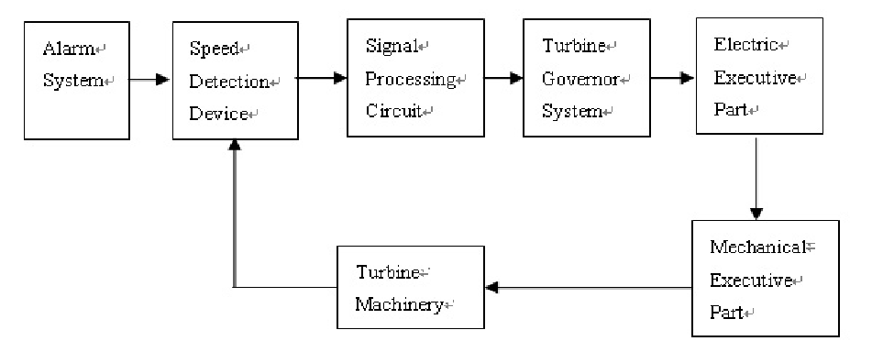

Fig.1.The structure diagram of comprehensive control system

* 1. *Control and regulation system*

Programmable computer controller (PCC) is the selection in the integrated speed control system as the core controller [6]. It is the most effective and most commonly advanced control method used in the turbine

regulation systems. The method can complete the adjustment of the input signal in accordance with the procedures set by the user accurately and automatically, it is indicated, as long as the certain procedures to be set up from the beginning, the related algorithms is also determined at the same time. The judgment and operation will be made by the PCC governor in accordance with the procedures.

PCC control regulator due to its hardware itself has very high reliability [7], generally use the stand-alone structure, should the user's special requirements can also provide double machine. When using stand-alone, an 80 C196 micro manual regulation channel will be provided. The regulator hardware configuration is as follows: PP41 control machine (CPU controller and operation panel integration), a 4-road analog input module AI354, a 10-way switch input module DI138, two 4-channel digital output module DO135, one for and monitoring system for communication RS232 interface module IF311 or RS485 / RS422 interface module IF321 composition. The structure diagram of PCC controller is shown in Figure.2.

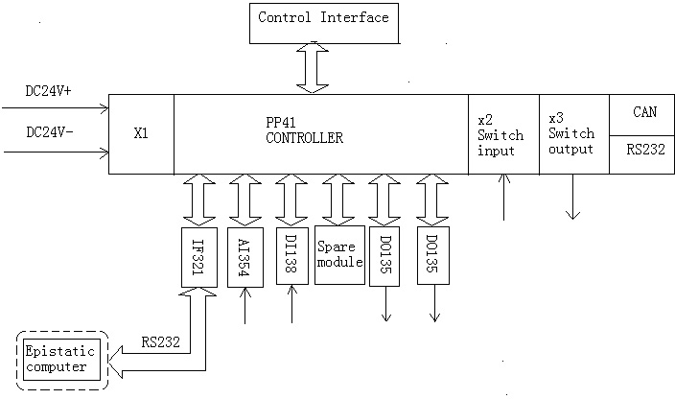

Fig. 2. The structure diagram of PCC controller

* 1. *Alarm system*

When the rotational speed of the turbine exceeds the rating of a certain range (± 130%), or the system detects judgment turbine overspeed, alarm device warns[8], if the system can quickly and effectively adjust the turbine speed, the alarm system will automatically stop the warning. The alarm devices are connected with plc, microcontroller in majority of the existing water turbine control systems. However the speed alarm device is connected to speed measurement system directly in comprehensive system, so that it can alerts more directly and rapidly, which could lead to the console operators could make preliminary action when the system can not make over speed protection promptly.

First, three independent measuring points are chose to increase accurately and reliability of speed measurement system. At the same time, the "3 take 2" overspeed protection function is also set to prevent "coaster". When any two speeds of the three measuring points reach to alarm value, the program [9] will be issued a turbine overspeed instruction, and then the alarm system would take protective action to avoid the damage caused by maloperation of the system. That can effectively avoid unsafe incident, and increase the reliability of the protective action.

* 1. *Signal processing circuit*

The detected speed signal is amplified and filtered through speed measurement system. The noise, vibration and other interference signal is filtered out of the sensor transmission, and the speed signal is further

amplified and strengthened [10] by the signal processing circuit. The following requirements would basically be met by the circuit :(1) low noise (2) low input offset voltage and input offset current (3) low drift (4) stable gain (5) linear characteristic well, high accuracy (6) undistorted amplification transient signal.

1. System Simulation

Computer simulation is often adopted in Comprehensive analysis of turbine regulating system. However the workload of simulation calculation preparation and debug program is very big still, meanwhile the portability of the simulation program is poor, it is difficult to adapt to the hydropower personality characteristics, and the lack of strong graphics output support. MATLAB is now international fashion system simulation software; it is able to overcome the above difficulties.

MATLAB can not only solve the matrix arithmetic problems abound in cybernetics [11], but also provide a powerful toolbox support. The control system is directly related to the popular control strategy toolbox, such as robust control, µ-analysis, synthesis, neural networks, model predictive control, nonlinear control design and fuzzy logic. It can be said that the theory and a wide range of industrial applications and research control algorithm basically can be found in MATLAB.

Single neuron adaptive PID control method is modelled on neurons workflow to adjust the speed of the turbine speed control adjustment [12]. When there is a difference between the rate of the turbine with the given target value, the control system automatically do the difference calculation, if the difference is within the safe range, the system will be determined as the normal system, work safety, regulator not action. But the difference between the two is large, which exceeds the safe range, the system will be maintained need action at this moment ,then the system start regulating aspects[13]. After the single neuron adaptive controller self- organizing, self-correcting action, self-regulating, adaptive, and ultimately, the system to find the optimal working condition, and then, after computing, control servomotor opening adjustment the operation, so that the turbine to maintain the rate, and stability in the best working condition, an adjustment process is over.

The weight coefficient adjustment of single neuron adaptive controller is achieved on the basis of the supervised Hebb learning rule, the system adopt different learning rates in allusion to integral, proportional and derivative ,so that it could adjust by different weight coefficient. K is the neurons proportion coefficient, it is important to choose the right K value. K value is smaller, the smaller the overshoot, but the longer adjustment time. K value is greater [14], the better the rapidity, meanwhile the larger the overshoot which could make the system unstable, at the same time K must be greater than 0. According to this principle, select the appropriate K value, so that the control system to achieve the best effect of the adjustment.

The system linearization model should be established before the turbine simulation, the ideal turbine model is shown in Equation (1).

G1(S) 

1 - TwS

1  0.5TwS

*(1)*

The *Tw* is flow inertial time constant. Ideal model expression is too simple to reflect the real state, which reduces the reference value of the stability calculation results. So the choice is made between accuracy and simplified, controlled object is simplified with high order transfer function, which is shown in Equation (2).

P(S)

Y(S)

 ey - (eqyeh - eqhey )Tw S (TyS  1)(eqh TwS  1)(TaS  en )

*(2)*

*Ta* is the inertial time constant;*Ty* is main relay unit time constant[15];*eh* is transfer coefficient of the turbine head;*ey* is transfer coefficient of the turbine torque on the guide vane opening;*en* is turbine self-adjustment

|  |  |  |  |
| --- | --- | --- | --- |
| factor;*eqy* is the transfer coefficient of Turbine flow to guide vane opening;*eqh* is transfer coefficient of the turbine flow to discharge head.  Selecting a hydropower station turbine as acquisition object, its working parameters are shown in Table 1. | | | |
| Table 1.The turbine working parameters |  |  |  |
|  |  |  |  |
| Model |  | Operating points |  |
| parameters | A | B | C |
| Guide vane opening:a | 22.0 | 25.0 | 25.0 |
| TY | 0.02 | 0.02 | 0.02 |
| TW | 1.27 | 1.27 | 1.27 |
| Ta | 9.06 | 9.06 | 9.06 |
| ey | 1.190 | 1.041 | 0.657 |
| eh | 0.835 | 1.162 | 1.431 |
| eqy | 0.930 | 0.933 | 0.674 |
| eqh | 0.359 | 0.389 | 0.445 |

Choosing SIMULINK software to establish the modelling and simulation on the system, take each parameter value when the guide vane opening is 22.0 mm, en=0.5,the initial value of the improved single neuron adaptive PID algorithm is selected for Ki = 0.2, Kd =0.2, Kp = 0.2, K = 120 , the transfer function of controlled object model is shown in Equation(3).

1.190  0.4436618*s*

*G*(*s*) 

(0.02*s*  1)(0.45593*s*  1)(9.06*s*  0.5)

*(3)*

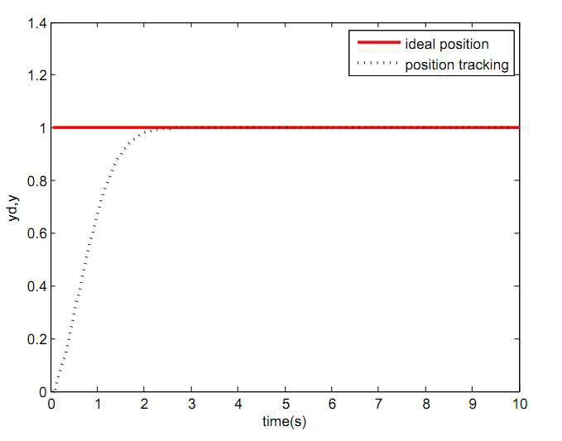

The diagram of simulation results is shown in Figure.3.

Fig.3. The diagram of simulation results

As can be seen from the figure, the integrated control method is able to maintain a short adjustment time of a single neuron adaptive controller, at the same time it would keep short response time, small overshoot, the stability of rise process, good quality advantages of dynamic nonlinear incident object. The method can avoid the rapid adjustment and great volatility phenomenon in regulating the process. So the turbine can be guaranteed to be regulated in a relatively short period of time, steady, accurate, safe for control, in order to achieve the target rate.

1. Conclusions

The speed control and regulation of hydroturbine is very important for the modern industry. A comprehensive turbine governing system is designed in this paper. On the basis of the introduction and analysis of the entire regulatory system, corresponding simulation is established. The simulation result proves that the integrated system could make the hydroturbine work stably in the optimal operation condition and avoid the great volatility and vibration, which means that the comprehensive system can provide great help to the energy recovery and the realization of low-carbon production.

References

1. Wuxiong Xu. A novel control strategy for water turbine governing systems. East China Electric Power.Vol.35 No.3 Mar.2007.
2. Shouping Wei, Ping Luo. Turbine speed control system of PLC evaluation method. Internal Journal Hydroelectric Energy.Vol.18 No.4.Dec.2000 (12).
3. Rennian Li,Congxin Yang, Criterion of aerodynamic performance of large-scale offshore horizontal axis wind turbine. Applied mathematics and mechanics, 2010, 31(1).
4. Xihe Jia, Baoliang Pan,Yingwen Wu. The Evolvenet and Expectation on of Cut-edge Turbine Control Technology of China. Journal of Yangtze River Scientific Research Institute.Vol.24.No.5.Oct.2007.
5. J.G.Wissink. DNS of separating low Reynolds number flow in a turbine cascade with incoming wakes.International Journal of Heat and Fluid Flow, 2003, 24(4).
6. Dianwei Qian, Haigeng Chen. An intelligent control strategy for hydro-turbine regulation system. Advances in Science and Technology of Water Resources.
7. Kyung Nam Lee, Yeong Koo Yeo. Predictive PID Tuning Method Based on the Simplified GPC Control Law. Journal of Chemical Engineering of Japan, 2009, 4(7).
8. Qi Liu, Jiangbin Zhang, Lu Li. Research on Real-time Simulation System for Hydraulic Turbine Regulation System. Large Electric Machine.No.4.2006
9. Jin Zhou, Gangzhu Li. Water turbine speed governing system models suitable for stability calculation of power systems. East China Electric Power.Vol.36.No.7.Jul.2008.
10. Damir Vrancic, Sanko Strmcnik, Jus Kocijan.Improving disturbance rejection of PID controllers by means of the magnitude optimum method. ISA Transactions,2010.
11. X. Z. Gao, S. J. Ovaska. Soft computing methods in motor fault diagnosis.2001.1.
12. Fred Aminzadeh. Applications of AI and soft computing for challenging problems in the oil Industry. Journal of Petroleum Science and Engineering.2005.14.
13. John Zeleznikow, James R. Nolan. Using soft computing to build real world intelligent decision support systems in uncertain domains. Decision Support Systems.2001.(31).
14. Abdulkadir Cevik, Ibranim H.Guzelbey.A soft computing based approach for the prediction of ultimate strength of metal in compression. Engineering Structures.2007.(29).
15. Tianbo Peng. Hydro turbine governing system modeling parameters testing theory and application research. Mechanical and Electrical of Hydropower Station.Vol.31.No.4.Aug.2008