Available online at [www.sciencedirect.com](http://www.sciencedirect.com/)



**ScienceDirect**

AASRI Procedia 7 (2014) 107 – 113

2013 2nd AASRI Conference on Power and Energy Systems

Design and Development of a Mini Custom Power Park

Manitha P.V.1, Jishnu Sankar V.C.2, Anjana P.2, Visal Raveendran2 and Manjula G.Nair2

*Department of Electrical and Electronics Engineering, Amrita VishwaVidyapeetham Amrita school of Engineering, 1Bangalore Campus, 2Amritapuri Campus Corresponding author. Tel.:+914763801280 ext.2308;*

*E-mail* [*address:manjulagnair@am.amrita.edu*](mailto:manjulagnair@am.amrita.edu)

**Abstract**

This paper presents an improved operation of the Custom power park with a newly proposed control algorithm for series active filter. Custom power devices operated for multiple customers in an industrial area form a common platform called custom power park (CPP). CPP delivers high quality high reliable supply than from the utility at different grades. The enhanced operation of CPP is proposed with GTO based static transfer switch, shunt and series active filters.The shunt active filter provides the harmonic and reactive power support for the park while voltage sag/swell and voltage harmonic mitigation is done by means of series active filter with a newly proposed control algorithm. The entire model of CPP is developed and operation is verified using MATLAB/ Simulink model.

© 2014 Elsevier B. V. This is an open access article under the CC BY-NC-ND license ([http://creativecommons.org/licenses/by-nc-nd/3.0/).](http://creativecommons.org/licenses/by-nc-nd/3.0/))

© 2013 Published by Elsevier B.V.

Selection and/or peer review under responsibility of American Applied Science Research Institute

Peer-review under responsibility of Scientific Committee of American Applied Science Research Institute

*Keywords:* Custom power devices; custom power park; static transfer switch; shunt active filter; series active filter.

# I troduction

Good quality power is essential for the proper working of the equipment especially sensitive loads. The reason for the power quality arises due to source unreliability and load side issues. Owing to the dynamic nature of the power system it always addresses number of power quality issues such as interruption, sag, swell etc. Another important concern is on the use of nonlinear loads. The non-linear devices worsens the quality of

the

power by introducing current harmonics in the

system whichitself sometimes constit

tes voltage

harmonics.Most f the power quality issues can be mitigated by use of custom power devices [2]. With the

deregulation policies it is necessary for the utilities to provide the required quality of power to the loads,

2212-6716 © 2014 Elsevier B. V. This is an open access article under the CC BY-NC-ND license ([http://creativecommons.org/licenses/by-nc-nd/3.0/).](http://creativecommons.org/licenses/by-nc-nd/3.0/))

Peer-review under responsibility of Scientific Committee of American Applied Science Research Institute doi:10.1016/j.aasri.2014.05.037

impossible for most situations and now days cannot provide different grades of power. In such a context a custom power park (CPP) can be built and operated so as to provide different grades of power to same ordifferent customers at different tariffs.The different grades are achieved by incorporating different devices in the park which will be discussed in later sections.

The CPP concept is very much applicable to industrial or commercial areas which can account up to few megawatts of loads[2]. Each customer can have different grades of power depending of their load requirements. For example an industry or a shopping mall has critical or noncritical loads. Industries may have very critical loads such as process control, robotic tools etc. which even cannot suffer small variation in the power quality level. The CPP will address such issues.

In this paper the coordinated control scheme is developed to have a control of the connected equipment and loads so as to deliver different grades of power with load and source issues. Another important concern is over the voltage detection scheme. As fast the system can respond to the voltage variations the more effectively the system work. Here abc to dq0 transformation algorithm is used for voltage detection. The shunt active filter achieves the harmonic and reactive compensation through Icos algorithm [5]. The series active filter provides the voltage support and voltage harmonic compensation by a newly proposed algorithm which is very fast and easy to implement. The entire operation of the CPP is verified in MATLAB/Simulink model.

# Operation of the CPP

Custom Power Park has mainly the CPP substation/park to with two incoming feeders’ namely preferred and alternate feeder. The park/substation consists of a STS (static transfer switch), a DG (diesel generator), Shunt active filter(ShAF), and a series active filter(SeAF). The park delivers mainly three different categories of power named as A, AA, AAA. The three different grades of power are supplied as per the customer demand. A category power is delivered to the least critical loads and AA to the next level of priority and AAA to the highly critical loads which cannot tolerate the power failure of even a second. The STS with the help of coordinated control can detect the voltage of the preferred or alternate feeder and switches to the higher voltage feeder. The power is qualified by means of the shunt active filter and series active filter which eliminates harmonics, sags or swells. In case of failure of both the feeders the power to the critical loads such as AA and AAA are provided by the diesel generator. For the time interval where the DG has to start up and synchronised the power to the most critical category which is the AAA are provided by the series active filter.

# Equipment employed in CPP For Power Quality Improvement

The major equipment in the CPP includes

* 1. *Static Transfer Switch*

Static Transfer Switch (STS) is used to transfer the loads of the park from the preferred feeder to the alternate feeder in case of voltage reduction in the preferred feeder. It consists of antiparallel connected thyristors/gate turn off thyristors per phase. The thyristor based STS usually takes few milliseconds to half a cycle [6]. The GTO based switches can achieve a fast transfer [7] because of the turn off capability by applying a reverse current in the gate. As the load transfer is very fast and absence of commutating circuits etc. is indeed advantageous for the park. The only problem is the requirement of a high negative current to turn off the GTO. Another important aspect is the protection of equipment in the park [1].

`

* 1. *Shunt Active Filter.*

The shunt active filter provides the reactive and harmonic power support for the AA and AAA loads. Most of the industrial loads may be harmonically polluting loads such as motor drives etc. The shunt active filter eliminates the harmonics along with the reactive power issues. It consists of a shunt connected voltage source inverter connected to the system through coupling inductor. The algorithm used to implement the shunt active

filter is theIcos algorithm [5].

* 1. *Series Active Filter.*

The series active filter (SeAF) provides the voltage support and voltage harmonic elimination for the AAA loads. At certain time the voltage of both the feeders goes below 90% of the nominal voltage.Such times the series active filter provides voltage support to the AAA loads. In case of increase of the voltage levels it can absorb the excess voltage, provided for values up to 10% of over voltages. Another situation there exists in which the SeAF provides 100% voltage support when both the feeder voltages fall below 60% and during the startup delay of the DG. Thus SeAF should be capable of supporting the entire AAA loads for 3 to 5 seconds

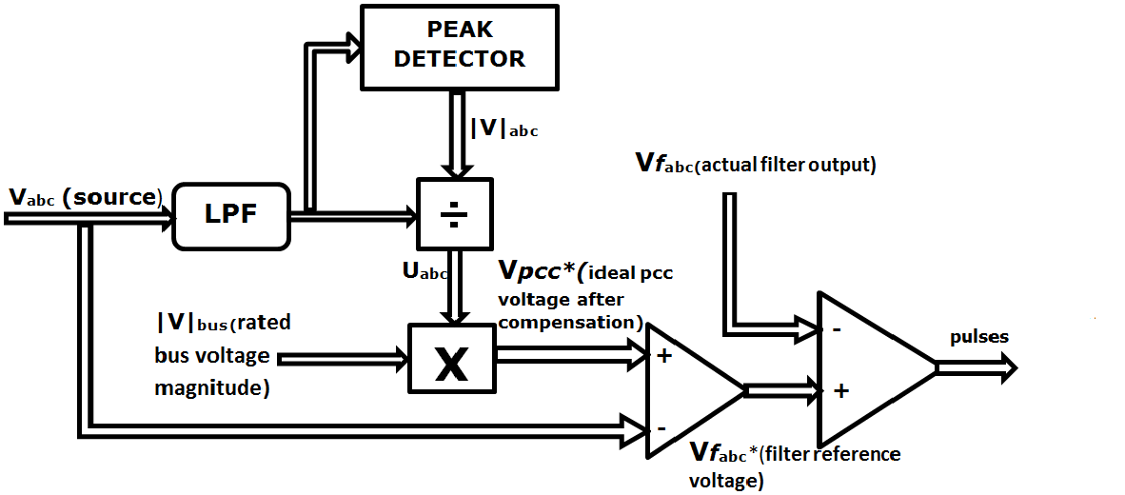

Fig.1. Series Active Filter Controller diagram

(depending on DG startup and synchronization time). It eliminates the voltage harmonics which causes mal operation of process controls, hospital critical loads/ sensitive instruments etc. The algorithm used is a newly proposed one in which fast sag/swell elimination along with elimination of harmonics in the supply voltage are done as shown in Fig.1. The source voltage having harmonics, sag and swell is fed to low pass filter for deriving the fundamental voltage. The magnitude of the filtered voltage is detected by means of a peak detector and it is divided with the fundamental voltage to obtain unit amplitude sine wave (Uabc). It is then multiplied with rated bus voltage magnitude for generating ideal voltage at PCC after compensation (VPCC*). The source voltage is subtrac ed from VPCC* for getting the series filter reference voltage. The pulses are generated by comparing the filter reference voltage and actual filter voltage.

* 1. *Diesel Generator /Renewable Energy Support systems for park back up*

The DG/RES should be capable of providing the entire AA and AAA loads in case of failure of both the preferred and alternate ones. It generally takes some time to start up and synchronization is completed in few seconds. Instead of using DG the renewable power can be supplied to the AA and AAA loads through voltage/ current source inverters which can achieve with no time delay or very small delay.

# Control of CPP

Fig.2. Control diagram flow chart

In order to achieve the different grades of power it is necessary to have proper control of the devices and loads. The control is done by a CPP control center which continuously monitor the preferred and alternate voltages and based on the higher required voltage level, it switches between preferred and alternate feeders. In case of low level of voltages at both the feeders, it isolates both the feeders by controlling the STS. At that time it isolates the A loads and AA loads and control the series active filter to provide required voltage levels to the entire AAA loads and send signals to the DG to start up. After the DG startup it picks up the AAA and AA loads. The control scheme flow chart is shown in Fig.2, which is similar to that of mentioned in [2] and

[3] except the DG turn on and DG ready checking capabilities.Depending on the voltage detection scheme the speed of operation (isolation and switching) will vary.The voltage detection scheme used is the abc to dq0transformation method.The detection scheme is similar to [3]. The measured voltage is converted to dq0 axis with abc to dq0 transformation technique, then passed through a second order mid rejection filter to attenuate the voltage transients and send to the CPP main controller for conditional checking.

# Simulation of CPP Model

The first section of the simulation shows the effectiveness of the controller for the CPP to switch between preferred feeder and alternate feeder so as to maintain a steady voltage at the CPP loads. The second sectionexplains the effectiveness of series active filter to eliminate sag/swells/elimination of voltage, the shunt active filter to eliminate current harmonics and reactive power requirements, so that desired voltage quality and levels are maintained at the AA and AAA loads. The simulation circuit is shown in the Fig.3.The load and system conditions are: Voltage – 415 V, A loads – 10kW, 1 kvar, AA loads - 10kW, 1 kvar, Diode bridge rectifier with R load, AAA loads – 10kW. In order to achieve the variation in the voltage magnitude and voltage harmonic injection, two programmable power supplies are used.Another power supply is used instead of DG. The controller for the entire system is modeled using mat lab function block.

`

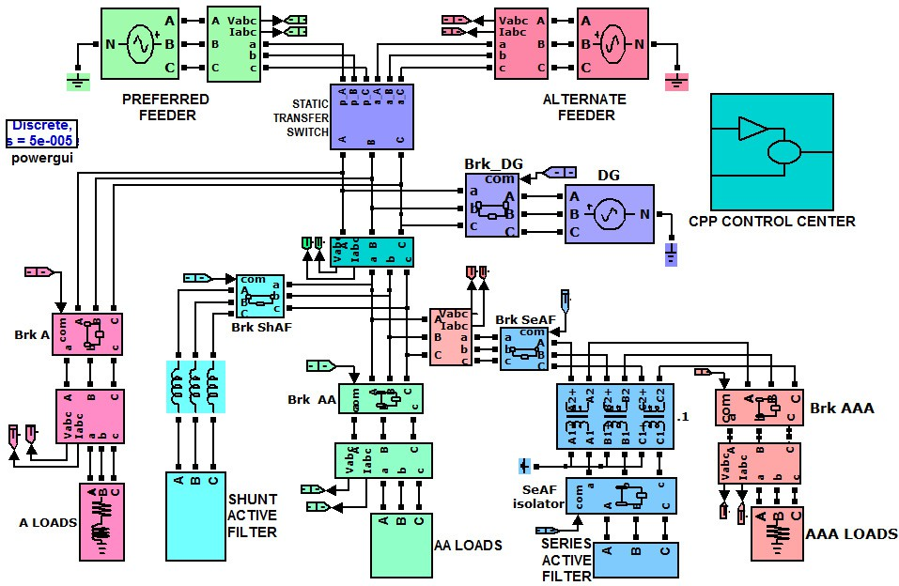

Fig.3. Simulation diagram

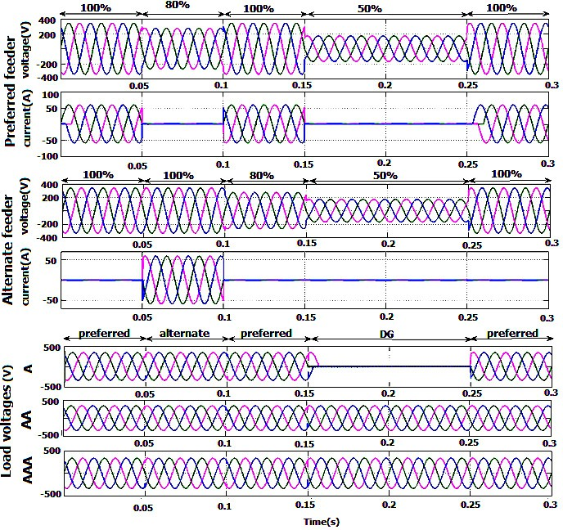

Fig.4 .Voltage and current at preferred and alternate feeders and the available voltages at A, AA, and AAA loads.

The input to this controller is provided through the preferred and alternate feeder detected voltages. It checks the preferred and alternate voltages and switches as per the conditions as shown in flow chart. Up to

0.05 second the preferred and alternate voltages are set to nominal values. From 0.05– 0.1 the preferred voltage is dropped to 80% of nominal value at that instant the load is switched over to the alternate feeder which has nominal voltage. For the time 0.1-0.15 the preferred voltage is restored to nominal voltage and switch back to preferred feeder. At 0.15 second both the feeder voltage dropped to 50%. At this instant the A loads are isolated and AA and AAA loads are taken by the DG set (assuming no delay for startup). At 0.25 second the preferred and alternate voltage is restored and entire loads are switched to the preferred feeder. The various conditions of A, AA, AAA load voltages are shown along with the preferred and alternate feeder voltages in Fig.4. The A loads gets uninterrupted power for all times except at failure of both feeders The AA and AAA loads are able to receive uninterruptable power at all the times as shown in Fig.4.

Fig.5 shows the performance of the series active filter in the park. To evaluate the effectiveness different events have created. The events are assumed to occur at both the feeders simultaneously. So it will affect the A and AA loads. Initially the system or feeder voltage is assumed to be nominal and at 0.05 s system voltage

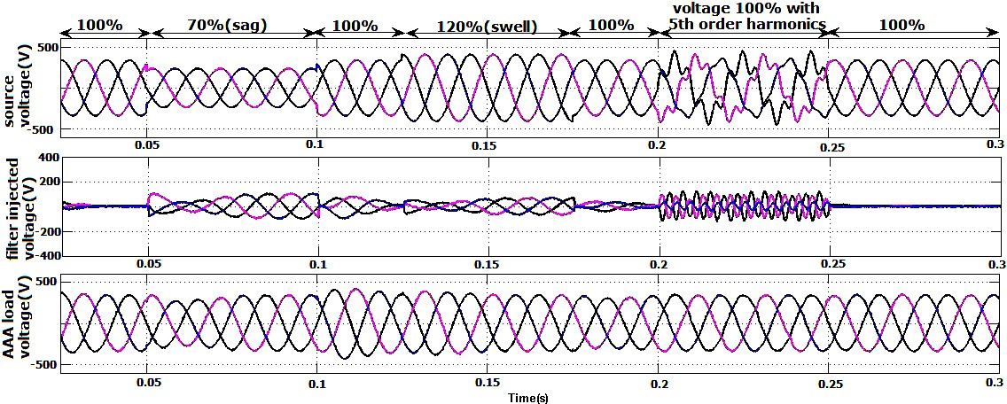

Fig.5. Source voltage, filter injectedvoltage and voltage at AAA load point of the CPP duringvarious events of source feeder sag, swell, voltage harmonics

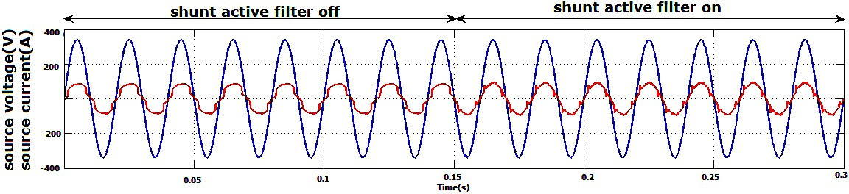

. Fig.6. Voltage and current of phase ‘a’ of the utility supply during shunt filter off and on.

`

has reduced to 70%. The A and AA loads are receiving low voltage same as the feeder voltage whereas AAA voltage is maintained due to the series active filter support. At 0.125s the voltage has increased to120%.At this event also the AAA loads are receiving nominal voltage. At 0.2s harmonics is injected to the system voltage and this has no effect on the AAA load operation due to the voltage harmonic compensation capability of the series active filter. Thus the AAA loads are resistible to feeder voltage issues.

The performance of the shunt active filter in the park is shown in Fig.6. Up to 0.15s the shunt active filter is off and the source current is harmonically distorted. At 0.15s the shunt active filter is switched on, which makes the current drawn from the source in phase and sinusoidal by providing harmonic compensation for the nonlinear loads and reactive compensation for the AA and AAA loads in the park.

# Conclusion

Developed a control scheme for the custom power park and the operation of the CPP is verified through MATLAB Simulink model. The loads of the CPP at various conditions of sag/swell etc. are receiving the nominal available voltage by switching between preferred and alternate feeders. The shunt active filter provides the harmonic and reactive power support to the AA and AAA loads and making the point of common coupling (PCC) current in phase with the PCC voltage. The series active filter eliminates all the voltage side issues to the AAA loads. The current harmonic elimination along with voltage issues suppression ensures the delivery of high quality power to loads. Thus the park is able to deliver high quality power than from a normal utility feeder for A loads and also well-conditioned different qualities of power to AA and AAA loads by utilizing shunt and series filters. This helps the customer to choose any level or multiple levels of power according to the sensitivity and reliability requirements. The effectiveness of the park can be improved by using special voltage detection schemes, operation with dynamic loads etc. which canbe considered as thefuture enhancements to this work.

# References

1. A. Ghosh and A. Joshi, “The concept and operating principles of a mini custom power park,” *IEEE Trans. on Power Delivery*, vol. 19, no. 4, pp. 1766-1774, 2004.
2. N.G. Hingorani, “Overview of custom power applications,” in *IEEE–PES Summer Meeting Panel Session on Application of Custom Power Devices for Enhanced Power Quality*, San Diego, CA, 1998.
3. M.EminMeral, Ahmet Teke, CagatayBayindir, Mehmet Tumay, “Power quality improvement with an extended custom power park”, *Electrical Power Systems Research*, 2009, vol 79, pp1553-1560.
4. Arindam Ghosh, RitwikMajumder, Gerard Ledwich, and FiruzZare, “Power Quality Enhanced Operation and Control of a Microgrid based Custom Power Park”, International Conference on Control and Automation Christchurch, New Zealand, December 9-11, 2009 pp. 1669-1674.

[5]G.Bhuveneswari and ManjulaG.Nair, “Design, Simulation, and Analog Circuit Implementation of a Three- Phase Shunt Active Filter Using the I cos Algorithm,” *IEEE Transactions on power delivery*, vol. 23, no. 2, pp.1222-1235, 2008.

1. M.N. Moschakis and N. D. Hatziargyroiu, A Detailed Model for a Thyristor Based Static Transfer Switch, *IEEE Transactions on Power Delivery*, Volume: 18, Issue: 4, Oct. 2003, pp. 1442 – 1449.
2. Ramesh.Pachar, Harpal Tiwari, “Performance Evaluation of Static Transfer Switch”, *WSEAS Transactions on systems and control,* vol.3, issue 3, pp.137-148, 2008.
3. J.H.Akagi, Y.Kanazawa, and A.Nabae, “Instantaneous reactive power compensators comprising switching devices without energy storage components,” *IEEE Trans. Ind. Appl*., vol. IA-20, no. 3, pp. 625–630, May/Jun. 1984.