Available online at [www.sciencedirect.com](http://www.sciencedirect.com/)



AASRI Procedia 2 (2012) 199 – 204

AASRI

Procedia

[www.elsevier.com/locate/procedia](http://www.elsevier.com/locate/procedia)

2012 AASRI Conference on Power and Energy Systems

# Design and Experimental Test of a Thermomagnetic Motor

M.Trapaneseb,A. Violaa,V.Franzittaa*

*aUniversità di Palermo –Dipartimento di Ricerche Energetiche e Ambientali- Palermo-Italy*

*bUniversità di Palermo – Dipartimento di Ingegneria Elettrica, Elettronica e delle Telecomunicazioni – Palermo – Italy*

Abstract

This paper presents a Thermomagnetic Motor. The design of the motor is based on a thermal-magnetic coupled dynamic model, which is obtained by assuming the use of a ferromagnetic material working at temperatures near the curie point. The motor is modeled in terms of both its magnetic as well thermal properties (magnetic permeability and thermal conductivity) and the thermal processes are supposed to be influenced by the thermal conductivity, the convection and the advection. An analytical expression of the generated torque, which links this quantity to the magnetic, thermal and geometrical parameters of the generated torque is given. A design of a machine, based on this theory is proposed and the related performances are numerically simulated. The motor has been built and its rotor has been manufactured by using Gadolinium. An experimental verification of the performances is reported.

© 2012 Published by Elsevier B.V. Selection and/or peer review under responsibility of American Applied Science Research Institute

© 2012 VVVV. Published by Elsevier B.V.

Selection and/or peer review under responsibility of American Applied Science Research Institute

Open access under [CC BY-NC-ND license.](http://creativecommons.org/licenses/by-nc-nd/3.0/)

*Keywords:*Curie motor; magnetic materials; electrical machines.

1. Introduction

The use of new forms of energy can strongly help to satisfy the constantly increasing demand of energy [1- 4].The purpose of this paper is to show that a Thermomagnetic Motor which can rotate continously and has useful mechanical characteristics is feasible. Such a motor could be coupled to an electric generator to produce electrical energy. A thermomagnetic motor is a motor that directly converts thermal energy into kinetic energy. This kind of motor is also named Curie motor [5- 6].

* Corresponding author. Tel.: +39-091-238 61941; fax: +39-091-484925.

*E-mail* [*address:*franzitta@dream.unipa.it.](mailto:franzitta@dream.unipa.it)

2212-6716 © 2012 Published by Elsevier B.V. Selection and/or peer review under responsibility of American Applied Science Research Institute

Open access under [CC BY-NC-ND license.](http://creativecommons.org/licenses/by-nc-nd/3.0/) doi:10.1016/j.aasri.2012.09.035

In this type of motor the driving force is generated by a thermally induced permeability difference in two areas of the rotor. More precisely, the heating of one side of the rotor modifies locally the permeability of the soft magnetic material in comparison with the cool area of the rotor and this permeability difference can generate a force if the rotor is placed in a magnetic field. This force can be enhanced if the hot side temperature of the rotor is above the Curie's temperature of the magnetic material and the cold side under this temperature. If the geometry and the cooling/heating system of the motor allows to continuously keep the temperature, a continuous driving force is generated.

Unfortunately. the traditional ferromagnetic materials have very high Curie's temperature and therefore their ferromagnetic phase transition cannot be used. As a result Curie motors built by using traditional materials have very poor performances.Experimental realization of the motor has been shown several times [6-7], most of the applications presents a reciprocating motion and in all the experimental applications a relatively low speed and a very low torque have been obtained. The objective of this paper is to show that a rotating Curie motor which presents useful mechanical characteristics is feasible.

1. Principle of operation of curie motor

The principle of operation of the Curie-motor can be explained by fig. 1.

The magnetic field is generated by a fixed permanent magnet. In order to generate a driving force, a area of the rotor is heated and another area is cooled. Because of heat conduction along the armature, the temperature in the gap increases and the magnetic properties change point by point. The cold side of the rotor is kept at a low temperature by a suitable cooling system. If the warm side of the armature is heated above Curie temperature, it behaves magnetically like air or vacuum, on the contrary, if the cold side is at a temperature lower than the Curie temperature, then there the material is ferromagnetic. As a result, a force arises in direction of the higher energy density of the warm side. If the armature is movable, it is drawn into this direction. Under the above mentioned conditions the Curie-motor performs like a conventional magnetic device. In reality however, the Curie-motor will not produce a sharp boundary surface between warm and cold side. However, a sharp difference in the magnetic properties of the rotor are induced in the area at Curie Temperature. This effect allows to define a line of the rotor where the phase transitions takes place. This line is called Phase Transition Line. The dq axis theory of thermomagnetic motor is reported in [4]

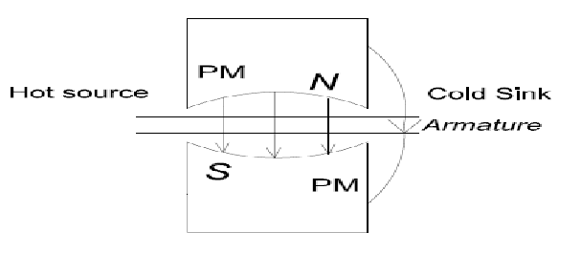

Fig.1.A Curie linear motor, with a soft magnetic, movable armature. The magnetization and temperature varies between the hot and the cold side [4].

1. Design of a thermomagnetic motor

In order to obtain the first design of the thermomagnetic motor the mathematical model above outlined has been used. More particularly, it is combined the required performances with the magnetic characteristics of the material in order to obtain a preliminary design.In particular, must be satisfied:

* 1. a high torque is related to a high heat flow;
  2. the higher the temperature difference between hot and cold spot, the higher the achievable speed;
  3. the higher the permeability difference between hot and cold spot, the higher the achievable torque;
  4. the temperature difference is inversely proportional to the surface perpendicular to heat flow between hot and cold spot

The above said considerations implies that the structure of the machine should be as sketched in fig. 2.

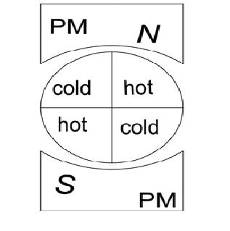

Fig.2 The structure of the rotor of a thermomagnetic machine.

It can be seen from the equations above presented and from fig. 2 the following facts:

1. A hot and a cold side is needed for each pole;
2. The angle between the line which divides the hot and cold sides (i.e. the transition line) and the direct magnetic axis influences the torque;
3. The transition line position does not depend on the rotational speed but does depend on the position of the cold and hot heat source;
4. Torque depends on the permeability difference induced by the temperature difference between hot and cold side and on the position of the heat sources;
5. Temperature difference depends on rotational speed and on the thermal coupling between the heat and cold sources.

The above outlined consideration together with some analytical consideration have produced a preliminary design that has been refined trough a numerical multiphysics analysis.

The main characteristics of this design is that the thermal coupling between the rotor and the heat sources has been maximized, by maximizing the coupling surfaces. As a result, the structure of the rotor is obtained by using several tubes installed along a circumference. The tubes perform to task: they contain the ferromagnetic material which undergoes to the ferromagnetic transition and they allow to maximize the heat exchange.

The machine obtained is shown in fig.3.

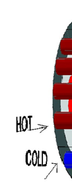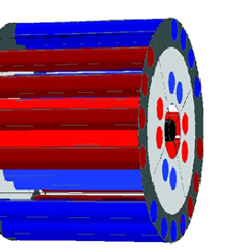

Fig.3 The structure of the rotor of a thermomagnetic machine.

1. The structure of the machine

As already said the structure of the rotor has been designed by using a numerical multiphysics approach.

The stator of the machine is obtained by using the stator of a single pole of a dc machine. The field generated by the stator was equal to 0.9T.

The heat source is guaranteed by an electromagnetic source which emits infrared rays. The heat sink is obtained by using cool water.

The rotor consists of an array of tubes circularly placed (fig.4). The radius of the rotor is 11 cm.

Each tube is able to contain the ferromagnetic material and to guarantee the correct flow of the heat. The external diameter of the tube is 20mm.

The tube consists of two regions separated by two layers: in the inner region is contained the cooling fluid, in the external region the ferromagnetic material, the inner layer is made of aluminum and the external layer of plastic material. The function of the aluminum is to shield the fluid from infrared rays and to let the ferromagnetic material follow the optimum temperature cycle by maximizing the heat exchange and therefore the torque production. In fig. 4 the section of the of the tube is shown.

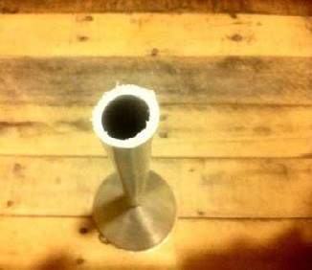

Fig.4Section of a tube.

Inside the tube is placed the ferromagnetic material, which guarantees the torque production. In order to maximize the torque production the ferromagnetic material must undergo to the ferromagnetic phase transition between the hot and the cold side, as a result the choice of the ferromagnetic material sets the operating point of the machine. Unfortunately, the traditional ferromagnetic materials (iron, nickel, etc) have very high Curie temperatures and are not suitable to maximize the torque production. Only one ferromagnetic material, Gadolinium, has a Curie temperature which allows to obtain an easily usable Curie temperature. As a result, Gadolinium has been used as the ferromagnetic material of this motor. Gadolinium powder, was inserted inside the external area of the tube. The Curie's temperature of Gadolinium powder is 293 K. Several calculation have been performed in order to evaluate the temperature distribution.In fig. 5 it is shown the temperature field when a temperature difference of 90[K]is continuosly kept between the hot and cold side. The field temperature has been calculated by using a multiphysics simulation tool.

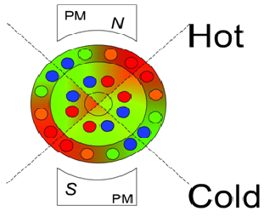

Fig.5 The temperature field for a temperature difference equal to 90 K. Red spots are the hottest point and blue are the coldest points.

The motor rotates in a clock wise way.

In fig. 5 motor rotates clock wise.In fig. 6 it is shown the temperature field when a temperature difference of 10[K] is continuosly kept between the hot and cold side. The field temperature has been calculated by using a multiphysics simulation tool.

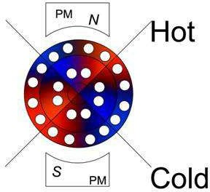

Fig.6 The temperature field for a temprature difference equal to 90 K. Red spots are the hottest point and blue are the coldest points. The motor rotates in a clock wise way.

1. Experimental results

The machine designed has been built. The rotor of the machine has been built by inserting inside the tube GD powder. The hot and cold spots have been obtained by using the heating system described in the previous sectons. Two tests have been performed: the measurement of the stand still torque versus the heat flow and an acceleration curve.

A torque of 1.3N/m has been reached for a temperature difference of 90 K at stand still and in this case a rotational speed of 8.2 rad/sec has been achieved.

Fig. 8 show how the experimental curves agrees with the theoretical curves. The theoretical acceleration curve can be obtained from eqs. 1- 5 reported in[8] as follows. First order approximation of (5) is:

*T*  *k*2 1  *d*

*(1)*

Eq.1 shows that advection causes a reduction of the generated temperature difference (the last term in eq.1) and consequently of Iq and of the generated torque. Formally speaking advection plays the role of the back electromotive force term. By assuming that  is equal to one, equation of motion of rotor is in this case read:

*Mdq Id*

*k* 1 *d*   *I*  *d*

*dt*

2

*(2)*

where I is the inertia of the rotor. Eq. (2) can be analytically. Fig.7 compares the experimental acceleration curve with the solution of eq.2, one can see that the behaviour of the angular speed is correctly described from the theory here presented. However, it must be stressed that the parameters present in eq. 2 has not been calculated from first principles or deducted from numerical tools but have been adapted by a best fit technique on the experimental data.

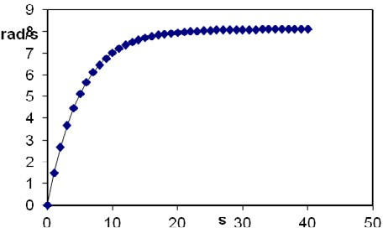

Fig.7 Acceleration experimental comparison with the theoretical curves. Diamonds are the experimental points and continuous line is the theoretical curve.

Conclusion

In this paper a Curie motor has been presented. The mathematical model used to design the motor has been presented and the dq theory of the Curie motor has been explained . It is shown, how the temperature difference plays a fundamental role for torque generation and that the temperature difference is governed by both thermal conduction as well as advection in the rotor. It has been shown that the motor can rotate continuously and that a torque Finally, an experimental validation of the theory has been presented.

Acknowledgment

This work was funded in part by "IMPETUS" program of Italian "Ministerodell'ambiente"

References

1. Franzitta, V., Rizzo, G.. Renewable energy sources: A mediterranean perspective ICBEE 2010 - 2nd International Conference on Chemical, Biological and Environmental Engineering, Proceedings : 48.
2. Bonanno, A., Franzitta, V., Muzio, F.P., Trapanese, M. A multiphysics approach to the design of a seawave energy conversion system. Proceedings of ICEST, Singapore, 2008: 2197.
3. Di Dio, V., Franzitta, V., Muzio, F., Scaccianoce, G., Trapanese, M. The use of sea waves for generation of electrical energy and hydrogen. MTS/IEEE Biloxi - Marine Technology for Our Future: Global and Local Challenges, OCEANS, 2009.
4. Franzitta, V., La Gennusa, M., Peri, G., Rizzo, G., Scaccianoce, G.– A Toward a European Eco-label brand for residential buildings: Holistic or by-components approaches? Energy 2011;36:4 -1884.
5. Tesla N., US Patent number 396121, (1889).
6. Palmy C., "A thermo-magnetic wheel", Europhysicsnews, vol.38, No 3, pp.32-34,2007.
7. Murakami K., Nemoto M. "Some experiments and considerations on the behaviour of thermomagnetic motors", IEEE Trans. Magnetics Mag., vol. 8, pp.387-398, 1972.

[8]M.Trapanese, "A dq axis theory of the magnetic, thermal and mechanical properties of Curie motor” J. of Appl. Phys, Vpl.109, issue 7, Pg. 07E706, pg.1-3, 2011.