[Array 14 (2022) 100129](https://doi.org/10.1016/j.array.2022.100129)



Contents lists available at [ScienceDirect](http://www.elsevier.com/locate/array)

Array

journal homepage: [www.elsevier.com/locate/array](http://www.elsevier.com/locate/array)

Design and implementation of event-based multicast AODV routing protocol for ubiquitous network

Chandrashekhar Pomu Chavan ∗, Pallapa Venkataram

*Protocol Engineering and Technology Unit, Electrical Communication Engineering, Indian Institute of Science, Bangalore, India*

A R T I C L E I N F O A B S T R A C T

*Keywords:*

Vague set

Computational intelligence Multicast tree

Group members Optimal route

We designed and implemented the ECA (Event Condition Action) based Multicast Ad hoc On-demand Distance Vector (ECA-MAODV) routing protocol for the ubiquitous network. The ECA-MADOV protocol plays a predominant role in selecting an efficient route for the creation of an efficient multicast tree and selecting a unique group leader in the multicast group to share and exchange information among group members in an efficient way using a Computational Intelligence (CI) approach. The vague set is a CI that is an enhanced fragment of a fuzzy set. Each element in the Fuzzy set is mapped to [0,1], reflecting its membership grade. We estimated ECA-MAODV’s time and spatial complexity. Besides, we assessed ECA-MAODV performance and compared it with conventional routing protocols such as MAODV and AODV. Finally, simulation results indicate that the ECA scheme proposed is both effective and powerful.

## Introduction

The ubiquitous network is a seamless aggregation of networks that allows many mobile users to view augmented reality content from any smartphone, at any time, with no user intervention. Multicasting in the ubiquitous network [1] is a method of disseminating data packets seamlessly from a transmitter to a group of receivers having similar characteristics located at the heterogeneous network. The group of receivers has a group address called a multicast group address. The transmitter intending to transmit data packets to the group; disseminate them to the multicast group address, as shown in Fig. 1. A standard multicast group is interactive, which means that members of the group will take part and exit the group at any stage. A member of a multicast group might be a participant of more than one multicast group at a time. For data packet transmission, a sender does not need to be a member of a multicast community, but receivers must be members of a specific group. [2–7]. A route to the group has to build before the sender sends data packets to the multicast group, establish a route on- demand whenever a sender wishes to disseminate a data packet to a group of receivers, for which it does not have routing data in routing table. Thus the sender initiates route investigation by the broadcasting route query message. On receipt of the response to the route, the route query packet can only be responded to by the member node by unicasting to the originating node. Disseminating a unicast multicast activation message to the nearest adjacent node to set a route for multicast from the transmitter to the group of receivers to exchange

popular data packets at any time. Multicasting performs the following operations

* Enable node to join: To transfer and swap data packets, every mobile node in the ubiquitous network will participate in a multicast group.
* Provides a reliable path to connect among group members: A

node will link to a multicast path linking group members if it wants to reach a particular multicast group.

* A tree is constructed among group members: To swap data pack-

ets, the group uses a multicast tree that is shared by all partici- pants. [8–13].

* Checks the connectivity of tree: Due to the versatility of the node

or nod’s abandon from the group at any point in time. It is vital to track the connectivity among the group members.

The remaining sections of the paper are organized as follows. In Sec- tion 2, we give a summary of some of the existing works. Section 3 dis- cusses the working of the proposed architecture. In Section 4, The list of ECA-MAODV functions is described. Section 5 includes a list of mem- bership functions. Section 6 depicts time complexity. Section 7 details the protocol’s space complexity. Section 8 discusses the main distinc- tions between MAODV and ECA-MAODV routing protocols. Section 9

∗ Corresponding author.

*E-mail addresses:* [chandrashekh@iisc.ac.in](mailto:chandrashekh@iisc.ac.in) (C.P. Chavan), [pallapa@iisc.ac.in](mailto:pallapa@iisc.ac.in) (P. Venkataram).

<https://doi.org/10.1016/j.array.2022.100129>

Received 14 July 2021; Received in revised form 9 December 2021; Accepted 16 January 2022

Available online 2 February 2022

2590-0056/© 2022 The Authors. Published by Elsevier Inc. This is an open access article under the CC BY-NC-ND license ([http://creativecommons.org/licenses/by-](http://creativecommons.org/licenses/by-nc-nd/4.0/) [nc-nd/4.0/](http://creativecommons.org/licenses/by-nc-nd/4.0/)).

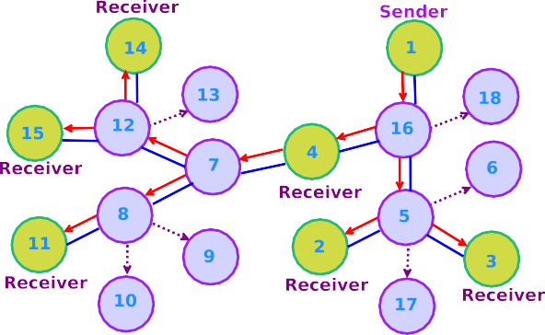

**/ig. 1.** An instance of multicast routing.

contains the directory of events. Section 10 presents the implementa- tion details of ECA-MAODV protocols. Section 11 illustrates the simu- lation environment. Section 12 addresses the results of the simulation. Eventually, the article draws some conclusions in Section 13.

## Related works

Min Ge et al. [14] presented the working of the Application Layer Multicast Algorithm (ALMA), the ALMA routing protocol is decentral- ized and powered by receivers mainly emphasized on creating a logical tree. It has a procedure that makes it easier for the logical tree to be reconfigured in mobility or congestion scenarios. Besides, ALMA provides all of the benefits of an application layer multicast protocol that is the ease of deployment, self-determination from bottom-layer protocols, and the ability to leverage features present at lower layers like TCP reliability. The authors in [15] proposed a protocol based on the multicast operation of the AODV routing protocol, a Reliable and Energy-Aware Multicast Ad-hoc On-demand Distance Vector (REA- MAODV) routing protocol is developed. REA-MAODV routing protocol achieves improved performance over On-Demand Multicast Routing Protocol (ODMRP) and seeks energy-efficient multicast paths to a set of destination nodes from the originating node. Besides, update maximum energy consumption and smaller tree branches, the REA-MAODV pro- tocol can also create a multicast tree with aid branches. REA-MAODV uses 45 percent less energy than the MAODV protocol, and the energy consumption is more balanced. Besides, the REA-MAODV protocol is able to increase the transmission rate of packets by 19 percent and also managed to reduce the latency of end-to-end networks by 21 percent. The authors in [16] presented the working of the On-Demand Multicast Routing Protocol (ODMRP). The ODMRP protocol based on a mesh structure, rather than a traditional tree, which uses the idea of a transferring group; the multicast packets are redirected by only a subset of nodes by a scoped flood. It invokes on-demand subroutines to construct dynamic routes and preserve a multicast group. The ODMRP protocol is best suitable for mobile nodes where limited link bandwidth is available, frequent changes in dynamic network topology, and power restricted nodes. Y. Chawathe et al. [17] decomposed an immense heterogeneous secure multicast session into many clustering multicast data groups of homogeneous respondents. A set of application layer Reliable Multicast proXies (RMXs) agents categorize data sets into a spanning tree employing the TCP link overlay network. Originators disseminate data packets to their localized group, the RMX in the localized group transmit the data packet to the remaining data groups. To respond to the effects of heterogeneity in the domain, RMXs use a comprehensive awareness of implementation semantics. The authors in [18] proposed an algorithm for the generation of a collection of routing trees to maximize the overall cost of the group’s collection of routing trees. Under various network conditions, simulations have been

**/ig. 2.** Proposed architecture for ECA-based efficient path selection.

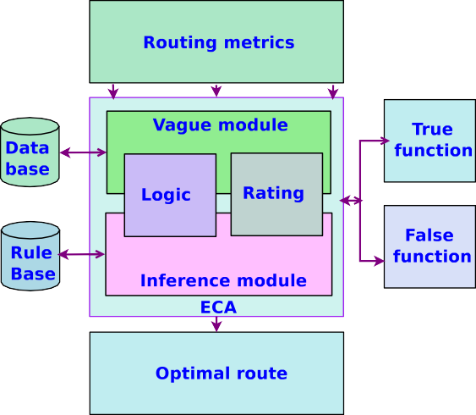performed to equate the proposed algorithm with the conventional approach.

Work in [19] developed a protocol that supports multiple-parameter routing requirements in mobile ad-hoc networks, A new multicast overlay spanning tree protocol that is aware of Quality of Service (QoS) is created. By a QoS link-state protocol, a QoS-aware multicast overlay spanning tree is utilized to enhance admission access, reservation of bandwidth, prevention of congestion, and access. The developed proto- col’s packet distribution ratio is similar to that of Quality of Optimized Link State Routing (QOLSR). The QoS-aware multicast overlay span- ning tree protocol, however, has around 50 percent less E2E average delay than QOLSR. The authors in [20] proposed a secure multicast routing protocol focused on selecting proximity nodes. The nodes with higher reliability set factors are chosen for data packet transmission in contrast to the threshold reliability set factor. Therefore, to establish multicast routes for data packet transmission, only stable neighboring nodes are chosen. The proposed protocol is simulated in many network metrics such as packet propagation ratio, packet propagation latency, and two types of overheads such as routing message overhead and overhead control, and the suggested protocol’s cumulative performance is demonstrated by simulation analysis.

## Proposed architecture for ECA based efficient path selection

The proposed architecture for ECA-based efficient path selection consisting of blocks like routing metrics, logic, route rating, inference module, and optimal route as shown in Fig. 2. The main functions of each block are listed below.

1. Routing metrics: Inputs such as hop count, energy level, pro- cessor speed, bandwidth, throughput, buffer occupancy, battery capacity, and so on are collected by the route metrics module and disseminate to the vague module.
2. Vague module: The vague module is composed of logic and rout- ing rating modules. The logic module converts routing metrics into ambiguous values, while based on ambiguous input, the optimal route rating module calculates good accuracy. Two dif-

ous collection of the discourse domain Y. The first is the *𝜙*VS(y) ferent functions differentiate each of the elements in the ambigu- true membership function; the second is the *𝜓* VS(y) false mem- bership function. This is represented as *𝜙*VS:Y →[0,1] *𝜓* VS:Y

→[0,1] and *𝜙*VS(y) + *𝜓* VS(y)≤ 1. *𝜙*VS(y) is the lower limit on the function of membership of *𝑦* and *𝜓* VS(y) is the lower limit

on the function of membership of the negation of y. The open

interval value *𝑦* is obtained by *𝑦*  *𝑉 𝑎𝑙𝑢𝑒 𝑜𝑓 𝑖𝑛𝑝𝑢𝑡 𝑝𝑎𝑟𝑎𝑚𝑒𝑡𝑒𝑟* . During

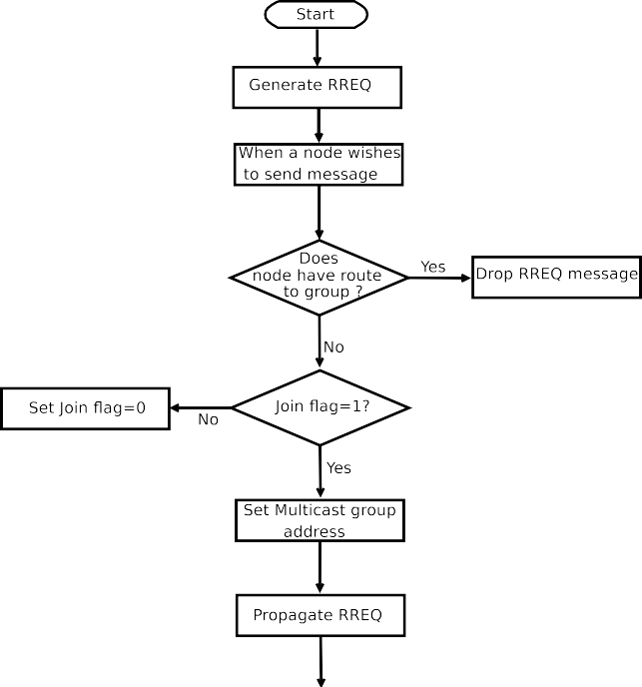

=

*𝑁 𝑢𝑚𝑏𝑒𝑟 𝑜𝑓 𝑙𝑖𝑛𝑔𝑢𝑖𝑠𝑡𝑖𝑐𝑠 𝑙𝑎𝑏𝑒𝑙*

efficient route selection, true membership function *𝜙*VS(y) will be considered and false membership function *𝜓* VS(y) will be

discarded.

1. Vague inference module: ECA scheme is defined to respond to a composite type of events occurring at a random interval of time. Events with significant changes in routing are exemplified in event-driven routing operations. An event can be any routing process functions such as the bandwidth of the link is high, path failure, a node with a high energy level, dissemination of data packet hop-by-hop, etc. The ECA scheme points out how dynamic routing decisions under critical network conditions impact complex routing behavior. The suitable conditions are determined when there is an event with significant changes in the routing happen; if the conditions have been satisfied or the pre-condition criteria have been surpassed, the appropriate runtime multicast routing decision will be made in a stipulated time.

## ECA-MAODV functions

In this section, we explore the concepts such as creating a multicast route query packet, a flowchart for activating a multicast route, gen- erating a multicast route response packet, enabling a multicast group hello packet, a procedure for initiating a new multicast group, joining a new participant in an existing multicast group, and creation of a PET-ECE-IISc multicast research group.

* 1. *Creation of multicast route query packet*

The target of the route query packet is the multicast team address in the span of 224.0.0.0 to 239.255.255.255. Multicast group receivers make a copy of the control and data packets included in the route query packet and pass it to the protocol stack before delivering the route query packet. The flowchart shown in Fig. 3 describes the procedure to create a multicast route query packet.

As and when a mobile node would like to join a dedicated multicast group creates a route query packet and broadcasts it to its adjacent nodes. If mobile nodes know the route to the multicast group may refrain from preparing and broadcasting the route query packet. Let us presume that the mobile node may not be aware of the multicast group and path to the group. It is essential to prepare the route query packet in such a scenario by setting the join flag to 1 and the multicast group address before disseminating it to its neighboring nodes. Multicast AODV protocol offers a quicker adapting to complex network con- straints, limited processing, and minimal network utilization. Multicast AODV protocol produces duplex direction distributed multicast trees that enable us to connect multicast sender and receivers. There are four messages in the multicast AODV routing protocol as follows.

* + - Join-route: A node sends a query to join a specific group uses the join-route.
    - Route reply: Members of the group can send the response back to the soliciting node regarding the route available.
    - Multicast activation: Used to form a multicast tree from which all the group members can connect and share information effectively.
    - Group hello: The hello message will be used to keep track of the connectivity between group members.
  1. *Flowchart of multicast route activation*

The flowchart shown in Fig. 4 describes the procedure to activate the multicast route. Whenever an originating node disseminates a route query packet for a specific multicast group, the originating node frequently receives multiple route responses. The 1-hop node must be chosen as only one of the route responses since each of the route

**/ig. 3.** Flowchart of generating multicast route query packet.

responses sets up a feasible route to the specific multicast tree. When a mobile node receives a route activation message, it saves the multicast address in the destination address. A mobile node that wishes to join a specific multicast group should propagate a unicast packet to the one- hop node and update the information in the routing table. The next-hop multicast route table data shared with the mobile node enables the active flag to 1. The mobile node to which the multicast activation has been sent triggers the route entry for the connection in its multicast route table after getting this post, thus completing the tree branch formation. Every adjacent who does not receive this specific message time out and uninstall the node in their route tables.

* 1. *The procedure to create multicast route reply packet*

Algorithm 1 outlines the procedure to create a route response by the member node whenever it receives a join query message from the non- member node. Non-member nodes broadcast a route query message and wait for route response from the member node of a specific group. Member nodes generate a 32-bit route response message by performing the following functions. Firstly, the member node upgrades its multicast table by adding relevant information about the node, copy the origina- tor IP address and desired destination address into the RREP message. Secondly, initialize route response value to zero before unicasting to the originating node and forward route response message back to the originating node by incrementing hop count. If an originating node receives multiple route responses from the neighboring nodes, it selects the correct route response for building a multicast tree by considering several metrics. The metrics are high bandwidth, high energy level, minimum hop count, and speed of the processor, and so on. As desired, each member node of a particular community shares and transfers data packets through the multicast tree.

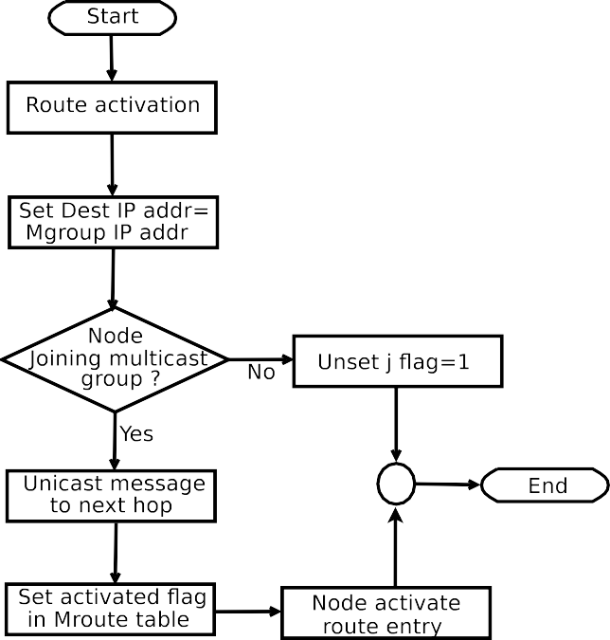**Algorithm 2:** Procedure for generating multicast group hello message using ECA

## begin

**Input:** A 32-bit group hello message **Output:** Send to member nodes Group leader forward hello message

# /* Node is able to rx hello message instantly

*/

**if** *The node receiving hello messages* **then**

Update multicast route table Hop count += 1

**else**

# /* Setting M_flag = 1 */

Set M_flag = 1

**Table 1**

Procedure to create a new multicast group.

Steps Operation

**/ig. 4.** Flowchart of multicast AODV route activation.

**Algorithm 1:** Procedure for generating ECA-MAODV route response message

## begin

**Input:** A 32-bit modified RREP packet format **Output:** Unicast RREP packet back to source node S0 Member node initiate to generate RREP message

# /* Belongs to a particular group */

**if** *Node* ∈ *multicast group G* **then**

Node update its multicast table

RREP message⟵S0 address + D0 address of RREQ message

Initialize RREP⟵0 Unicast RREP to S0 node

## else

1. Service hosting node (shn) will initiate to form a group
2. Add metrics in an s-ad message before propagating
3. The node that wishes to join sends the j-req message
4. The shn unicast a membership using j-rep message

Broadcast service advertisement (s-ad) message in the network.

The metrics including shn address,

service-descriptions, lifetime, and hop count.

The metrics like willing-node-address, shn address, and join flag.

The metrics such as shn address, willing-node-address, and membership status.

# /* Rebroadcast to its neighbors node */

Rebroadcast RREQ packet to adjacent nodes

* 1. *The procedure to create multicast group hello message*

Algorithm 2 illustrates the procedure to create a hello message by the group leader. The group leader generates a group hello message and broadcasts it to all the members of a specific group; upon receiving the hello message member node updates its multicast routing table and increases the hop count to 1 before disseminating.

* 1. *Procedure to create new multicast group*

Table 1 shows the protocol to form a new multicast group. Multicast group comprising of a set of mobile nodes that are randomly created by invoking rand() and srand() functions. The mobile node having some important application service can initiate to form a group by broadcasting service advertisement messages in the network. Node willing to join the specific group can send a join query packet to the group and wait to get a join response from the member node. Fig. 5 demonstrates the procedure to form a new multicast group. Node 7

**/ig. 5.** Example of new multicast group formation.

initiates to create a group by broadcasting the s-ad message; a node that wishes to join the group can send a join query message to the service hosting node and wait to receive a join response message.

* 1. *New member joining an established multicast group*

Fig. 6 shows the procedure for joining a new member in the estab- lished multicast group. In step 1, node-8 transmits the join route query message to the established group, while in step 2, the member node of the tree prepares a route response message and unicast back to node-8. In step 3, node-8 unicasting a multicast activation message to the group member connected via a multicast tree, while in last step 4, a multicast tree is created post joining node-8. When a leaf node wishes to exit the multicast group, it transmits a unicast message to its next-hop node on the tree. The unicast message comprises of P flag set and with the target destination address assign to the address of the specific multicast group address.

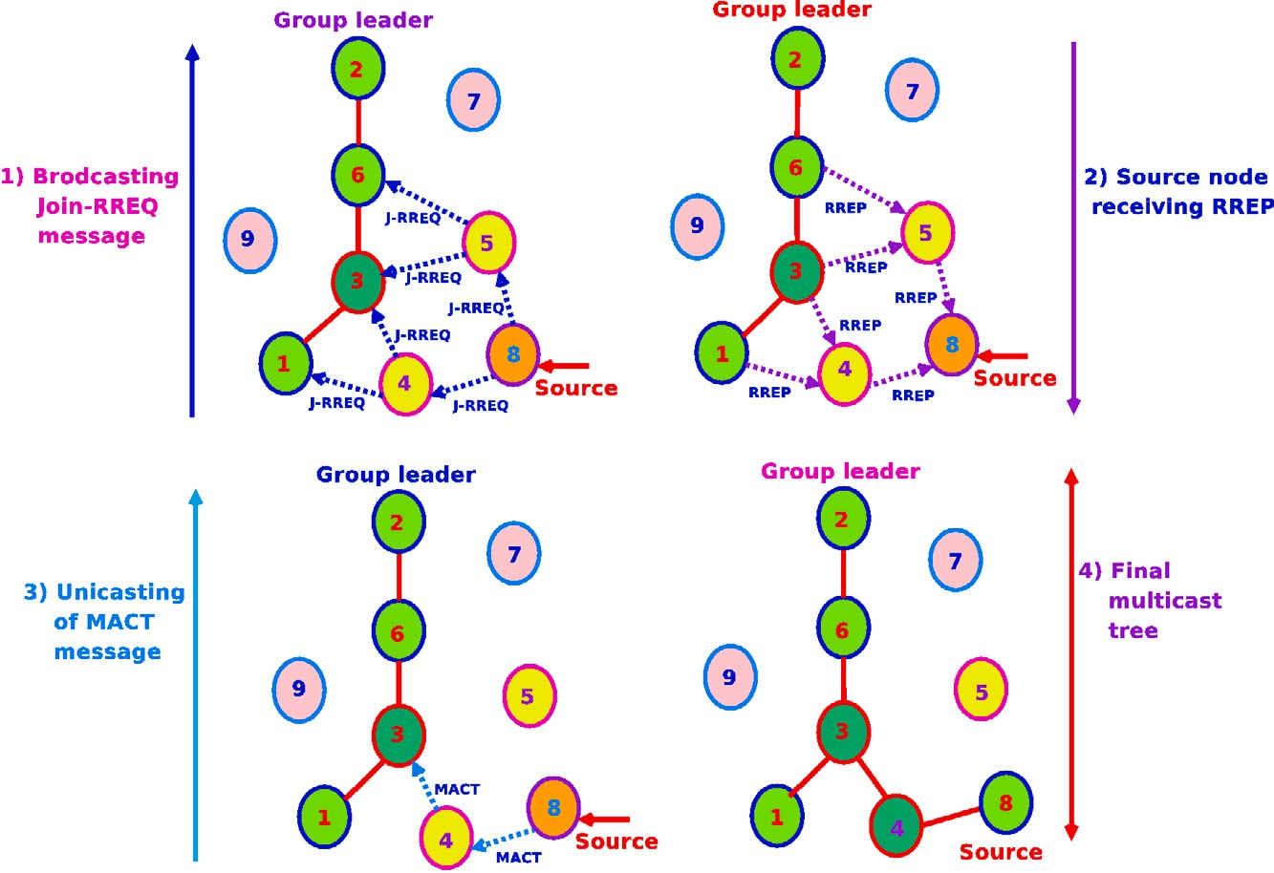

**/ig. 6.** New member joining a multicast group.

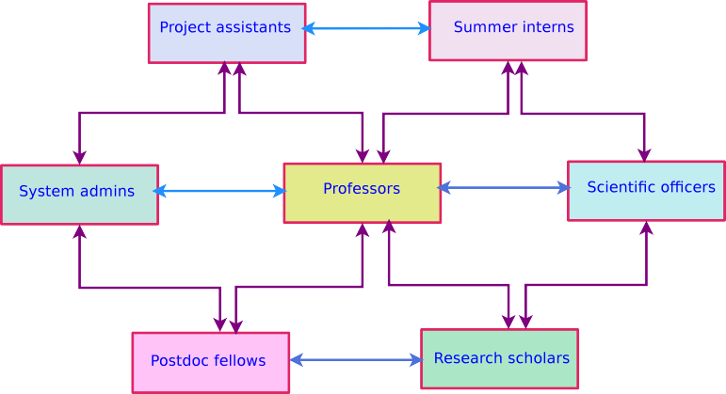

**/ig. 7.** Establishment of PET-ECE-IISc multicast research group.

* 1. *Establishment of PET-ECE-IISc multicast research group*

The objectives of the Protocol Engineering and Technology (PET) multicast research group in the Department of Electrical Communica- tion Engineering (ECE) at IISc, Bangalore are as follows.

* + - PET research group allows members such as research scholars, post-doctoral fellows, system admins, scientific officers, project assistants, and summer interns to interact and exchange ideas about the ongoing research works with the professor.
    - Provide a platform for group members to share information like

research ideas, discussion on a specific topic, course work details, assignments, dissertation, etc.

* + - Enable communication among group members anytime, any-

where on any device seamlessly.

* + - Connect professor to discuss research activity, course teaching, webinar, seminar, group seminar, meeting schedule, Ph.D. status report, projects, etc.

Fig. 7 shows the connectivity among multicast research group members to share and exchange data in an efficient way.

* 1. *Selecting a group leader for the multicast group*

Algorithm 3 discusses the procedure to choose a group leader for the specific multicast group. The initiating node broadcast a join message in the network; if the node does not receive a response even after the maximum route request retries, it will declare itself as a group leader for the dedicated multicast group for effective communication.

## Membership functions

In this section, we incorporate a vague set membership function to create an efficient multicast tree using ECA. The multicast tree connects all the members of the group. The membership function of routing metrics are hop count, bandwidth, buffer capacity, energy, and battery power are given below. Table 2 indicates the membership function for the hop count value of 10.

The following reflects a vague expression of the min, avg, and max hop count value of 10.

*𝜙*(*𝐻𝐶𝑚𝑖𝑛*) + *𝜓* (*𝐻𝐶𝑚𝑖𝑛*) ≤ 1

*𝜙*(*𝐻𝐶𝑎𝑣𝑔* ) + *𝜓* (*𝐻𝐶𝑎𝑣𝑔* ) ≤ 1

*𝜙*(*𝐻𝐶𝑚𝑎𝑥*) + *𝜓* (*𝐻𝐶𝑚𝑎𝑥*) ≤ 1

**Algorithm 3:** Procedure to select a group leader using ECA

## begin

**Input:** Join request message

**Output:** Selection of group leader

Initiating node broadcast join-request message in the network

# /* The node broadcasts join request message instantly */

PTC: **if** *no reply from the node* **then**

Initiator ⟵ ∼(nodes response) Broadcast message ≤ route request retries

Assume that node ∉ the UN

Declare itself as a group leader

## else

Select a group leader based on plentiful resources available at the node

**Table 2**

Membership function for hop count (HC = 10 hops).

Linguistic labels (l) Symbol (s) Open interval (y) *𝜙* 1 − *𝜓 𝜓*

Minimum HC*𝑚𝑖𝑛* 0 *<* y *<* 3.5 0 3.5 −2.5

Average HC*𝑎𝑣𝑔* 3.5 *<* y *<* 6.9 3.5 6.9 −5.9

Maximum HC*𝑚𝑎𝑥* 6.9 *<* y *<* 10 6.9 10 −9

**Table 3**

Membership function for bandwidth (BW = 16 Mbps).

|  |  |  |  |  |  |
| --- | --- | --- | --- | --- | --- |
| Linguistic labels (l) | Symbol (s) | Open interval (y) | *𝜙* | 1 − *𝜓* | *𝜓* |
| Low | BW*𝑙* | 0 *<* y *<* 5.5 | 0 | 5.5 | −4.5 |
| Medium | BW*𝑚* | 5.5 *<* y *<* 10.9 | 5.5 | 10.9 | −9.9 |
| High | BW*ℎ* | 10.9 *<* y *<* 16 | 10.9 | 16 | −15 |

**Table 4**

Membership function for buffer capacity (BC = 6 GB).

|  |  |  |  |  |  |
| --- | --- | --- | --- | --- | --- |
| Linguistic labels (l) | Symbol (s) | Open interval (y) | *𝜙* | 1 − *𝜓* | *𝜓* |
| Low | BC*𝑙* | 0 *<* y *<* 2 | 0 | 2 | −1 |
| Medium | BC*𝑚* | 2 *<* y *<* 4 | 2 | 4 | −3 |
| High | BC*ℎ* | 4 *<* y *<* 6 | 4 | 6 | −5 |

The following expression gives the elements of a vague series of min, avg, and max hop count.

(*𝐻𝐶𝑚𝑖𝑛,* (*𝜙*(*𝐻𝐶𝑚𝑖𝑛*)*,* 1 − *𝜓* (*𝐻𝐶𝑚𝑖𝑛*))) (*𝐻𝐶𝑎𝑣𝑔 ,* (*𝜙*(*𝐻𝐶𝑎𝑣𝑔* )*,* 1 − *𝜓* (*𝐻𝐶𝑎𝑣𝑔* )))

**Table 5**

Membership function for energy (E = 20 Joules).

|  |  |  |  |  |  |
| --- | --- | --- | --- | --- | --- |
| Linguistic labels (l) | Symbol (s) | Open interval (y) | *𝜙* | 1 − *𝜓* | *𝜓* |
| Low | E*𝑙* | 0 *<* y *<* 6.8 | 0 | 6.8 | −5.8 |
| Medium | E*𝑚* | 6.8 *<* y *<* 13.5 | 6.8 | 13.5 | −12.5 |
| High | E*ℎ* | 13.5 *<* y *<* 20 | 13.5 | 20 | −19 |

**Table 6**

Membership function for power (BP = 25 W).

Linguistic labels (l) Symbol (s) Open interval (y) *𝜙* 1 − *𝜓 𝜓*

|  |  |  |  |  |  |
| --- | --- | --- | --- | --- | --- |
| Less | BP*𝑙* | 0 *<* y *<* 8.5 | 0 | 8.5 | −7.5 |
| Medium | BP*𝑚𝑒* | 8.5 *<* y *<* 16.9 | 8.5 | 16.9 | −15.9 |
| More | BP*𝑚𝑜* | 16.9 *<* y *<* 25 | 16.9 | 25 | −24 |

The below reflects a vague expression of the low, medium, and high buffer capacity value of 6 GB.

*𝜙*(*𝐵𝐶𝑙* ) + *𝜓* (*𝐵𝐶𝑙* ) ≤ 1

*𝜙*(*𝐵𝐶𝑚*) + *𝜓* (*𝐵𝐶𝑚*) ≤ 1

*𝜙*(*𝐵𝐶ℎ*) + *𝜓* (*𝐵𝐶ℎ*) ≤ 1

The below expression gives the elements of a vague series of the low, medium, and high buffer capacity.

(*𝐵𝐶𝑙,* (*𝜙*(*𝐵𝐶𝑙* )*,* 1 − *𝜓* (*𝐵𝐶𝑙* ))) (*𝐵𝐶𝑚,* (*𝜙*(*𝐵𝐶𝑚*)*,* 1 − *𝜓* (*𝐵𝐶𝑚*))) (*𝐵𝐶ℎ,* (*𝜙*(*𝐵𝐶ℎ*)*,* 1 − *𝜓* (*𝐵𝐶ℎ*)))

Table 5 demonstrates the membership function for the node energy level of 20 Joules.

The below reflects a vague expression of the low, medium, and high energy value of 20 Joules and it is expressed in the following manner before choosing the desired route.

*𝜙*(*𝐸𝑙* ) + *𝜓* (*𝐸𝑙* ) ≤ 1

*𝜙*(*𝐸𝑚*) + *𝜓* (*𝐸𝑚*) ≤ 1

*𝜙*(*𝐸ℎ*) + *𝜓* (*𝐸ℎ*) ≤ 1

The below expression gives the elements of a vague series of the low, medium, and high energy levels.

(*𝐸𝑙,* (*𝜙*(*𝐸𝑙* )*,* 1 − *𝜓* (*𝐸𝑙* )))

(*𝐸𝑚,* (*𝜙*(*𝐸𝑚*)*,* 1 − *𝜓* (*𝐸𝑚*)))

(*𝐸ℎ,* (*𝜙*(*𝐸ℎ*)*,* 1 − *𝜓* (*𝐸ℎ*)))

Table 6 demonstrates the membership function for the node battery

(*𝐻𝐶*

*𝑚𝑎𝑥*

*,* (*𝜙*(*𝐻𝐶𝑚𝑎𝑥*

)*,* 1 − *𝜓* (*𝐻𝐶𝑚𝑎𝑥*

)))

power of 25 Joules.

The following reflects a vague expression of the less, medium, and

Table 3 demonstrates the membership function for the link bandwidth value of 16 Mbps.

The below reflects a vague expression of the low, medium, and high bandwidth value of 16 Mbps.

*𝜙*(*𝐵𝑊𝑙* ) + *𝜓* (*𝐵𝑊𝑙* ) ≤ 1

*𝜙*(*𝐵𝑊𝑚*) + *𝜓* (*𝐵𝑊𝑚*) ≤ 1

*𝜙*(*𝐵𝑊ℎ*) + *𝜓* (*𝐵𝑊ℎ*) ≤ 1

The below expression gives the elements of a vague series of the low, medium, and high bandwidth.

(*𝐵𝑊𝑙,* (*𝜙*(*𝐵𝑊𝑙* )*,* 1 − *𝜓* (*𝐵𝑊𝑙* ))) (*𝐵𝑊𝑚,* (*𝜙*(*𝐵𝑊𝑚*)*,* 1 − *𝜓* (*𝐵𝑊𝑚*))) (*𝐵𝑊ℎ,* (*𝜙*(*𝐵𝑊ℎ*)*,* 1 − *𝜓* (*𝐵𝑊ℎ*)))

Table 4 demonstrates the membership function for the node buffer capacity value of 6 GB.

more power value of 25 W.

*𝜙*(*𝐵𝑃𝑙* ) + *𝜓* (*𝐵𝑃𝑙* ) ≤ 1

*𝜙*(*𝐵𝑃𝑚𝑒*) + *𝜓* (*𝐵𝑃𝑚𝑒*) ≤ 1

*𝜙*(*𝐵𝑃𝑚𝑜*) + *𝜓* (*𝐵𝑃𝑚𝑜*) ≤ 1

The following expression gives the elements of a vague series of the less, medium, and more power.

(*𝐵𝑃𝑙,* (*𝜙*(*𝐵𝑃𝑙* )*,* 1 − *𝜓* (*𝐵𝑃𝑙* ))) (*𝐵𝑃𝑚𝑒,* (*𝜙*(*𝐵𝑃𝑚𝑒*)*,* 1 − *𝜓* (*𝐵𝑃𝑚𝑒*))) (*𝐵𝑃𝑚𝑜,* (*𝜙*(*𝐵𝑃𝑚𝑜*)*,* 1 − *𝜓* (*𝐵𝑃𝑚𝑜*)))

The Vague Set (VS) such as *𝜙*VS and *𝜓* VS are obtained from the energy

and hop count values.

*𝜙*(*𝐸𝑙* ) ∈ [0*,* 2*.*5]*, 𝜓* (*𝐸𝑙* ) ∈ [2*.*5*,* 6*.*5]

*𝜙*(*𝐸𝑚*) ∈ [6*.*8*,* 10*.*4]*, 𝜓* (*𝐸𝑚*) ∈ [10*.*4*,* 13]

*𝜙*(*𝐸ℎ*) ∈ [13*.*5*,* 15]*, 𝜓* (*𝐸ℎ*) ∈ [15*,* 19]

The time complexity of MAODV routing.

Performance parameters Time complexity

Route investigation O(T x log(T))

Multicast tree maintenance O(T x log(T))

Configuration of route O(T x log(T))

Multicast route postfailure O(T x log(T))

Group hello message O(K x log(K))

Multicast route activity O(K x log(K))

The time complexity of ECA-MAODV routing.

Performance parameters Time complexity

Route investigation O(log k)

Multicast tree maintenance O(log k)

Configuration of route O(log k)

Multicast route postfailure O(log k)

Group hello message O(log m)

Multicast route activity O(log m)

*𝜙*(*𝐻𝐶𝑚𝑖𝑛*) ∈ [0*,* 2]*, 𝜓* (*𝐻𝐶𝑚𝑖𝑛*) ∈ [2*,* 3*.*4]

*𝜙*(*𝐻𝐶𝑎𝑣𝑔* ) ∈ [3*.*5*,* 5]*, 𝜓* (*𝐻𝐶𝑎𝑣𝑔* ) ∈ [5*,* 6*.*8]

*𝜙*(*𝐻𝐶𝑚𝑎𝑥*) ∈ [6*.*9*,* 8]*, 𝜓* (*𝐻𝐶𝑚𝑎𝑥*) ∈ [8*,* 9*.*5]

Based on the value of *𝐸𝐻𝑗𝑘*, the mobile node selects an optimal route

to join the multicast tree. Similarly, we can construct an optimal route

by considering a pair of routing metrics.

*∑ 𝜙*(*𝐸𝑗* )

**Table 9**

The space complexity of MAODV routing.

|  |  |
| --- | --- |
| Type of packet | Packet size (in Bytes) |
| Join-route query | 24 |
| Route response | 20 |
| Activation of route | 16 |
| Group hello message | 16 |
| Total space occupied | 76 |

*𝐸𝐻*

*𝑗𝑘* =

*𝑗*∈*𝑙*

*∑ 𝜙*(*𝐻𝐶𝑘*)

*𝑘*∈*𝑙*

(1)

*6.2. Time complexity of ECA-MAODV routing protocol*

In this subsection, Table 8 discusses the time needed for the ECA-

The expression *𝑃𝑖* decides whether or not to pick a connection for the

creation of a multicast tree.

*⎧*P0 Bad if 0 *< 𝐸𝐻𝑗𝑘 <* 2

*𝑃𝑖* = *⎨⎪*P1 Good if 2 *< 𝐸𝐻𝑗𝑘 <* 8

*⎩*P2 Best if 8 *< 𝐸𝐻𝑗𝑘 <* 15

*⎪*

As and when a member node of a specific multicast group receives multiple responses from the node that wishes to join the group, select the route based on the routing metrics. Based on the value of the optimum parameter, the multicast tree is built.

Path and node status is determined by *𝜎*(*𝑛*) before joining a specific

multicast tree

*⎧⎪𝑛* = 1 if *𝜙*(*𝐵𝑊* = *𝐻 𝑖𝑔ℎ*) ⋅ *𝜙*(*𝐵𝐶* = *𝐿𝑜𝑤*) ⋅ *𝜙*(*𝐵𝑃* = *𝑀𝑒𝑑𝑖𝑢𝑚*)

MAODV routing protocol for the process of route investigation to join a specific group, multicast tree maintenance among the group members, route configuration, route post-failure, group hello message, and multicast route activity. The ubiquitous network is composed of fewer k mobile nodes with a smaller m-diameter. The mobile nodes are randomly created by invoking random functions. The mobile node having vital application services (for instance, IISc research group, virtual meetings, webinars, etc.) wishes to form a specific group by broadcasting service advertisement messages in the ubiquitous net- work. Mobile node wishes to join a particular group can send a route join query message to the group and wait to get a join response from the member node.

## Space complexity

*⎪*

*⎪*

*𝜎*(*𝑛*) = *⎪⎪*

*⎨*

*⎪*

*⎪*

*⎪*

else if *𝜙*(*𝐵𝑊* = *𝐻 𝑖𝑔ℎ*) ⋅ *𝜙*(*𝐵𝐶* = *𝐿𝑜𝑤*) ⋅ *𝜙*(*𝐵𝑃* = *𝑀 𝑜𝑟𝑒*)

else if *𝜙*(*𝐵𝑊* = *𝐻 𝑖𝑔ℎ*) ⋅ *𝜙*(*𝐵𝐶* = *𝑀𝑒𝑑𝑖𝑢𝑚*) ⋅ *𝜙*(*𝐵𝑃* = *𝑀𝑒𝑑𝑖𝑢𝑚*) else if *𝜙*(*𝐵𝑊* = *𝐻 𝑖𝑔ℎ*) ⋅ *𝜙*(*𝐵𝐶* = *𝑀𝑒𝑑𝑖𝑢𝑚*) ⋅ *𝜙*(*𝐵𝑃* = *𝑀 𝑜𝑟𝑒*) else if *𝜙*(*𝐵𝑊* = *𝑀𝑒𝑑𝑖𝑢𝑚*) ⋅ *𝜙*(*𝐵𝐶* = *𝐿𝑜𝑤*) ⋅ *𝜙*(*𝐵𝑃* = *𝑀𝑒𝑑𝑖𝑢𝑚*) else if *𝜙*(*𝐵𝑊* = *𝑀𝑒𝑑𝑖𝑢𝑚*) ⋅ *𝜙*(*𝐵𝐶* = *𝐿𝑜𝑤*) ⋅ *𝜙*(*𝐵𝑃* = *𝑀 𝑜𝑟𝑒*) else if *𝜙*(*𝐵𝑊* = *𝑀𝑒𝑑𝑖𝑢𝑚*) ⋅ *𝜙*(*𝐵𝐶* = *𝑀𝑒𝑑𝑖𝑢𝑚*) ⋅ *𝜙*(*𝐵𝑃* = *𝐿𝑒𝑠𝑠*)

else if *𝜙*(*𝐵𝑊* = *𝑀𝑒𝑑𝑖𝑢𝑚*) ⋅ *𝜙*(*𝐵𝐶* = *𝑀𝑒𝑑𝑖𝑢𝑚*) ⋅ *𝜙*(*𝐵𝑃* = *𝑀𝑜𝑑𝑒𝑟𝑎𝑡𝑒*)

This section emphasizes space complexity that quantifies the amount of memory needed to process the routing packets like join route query, route response, activation of the route, and group hello message.

* 1. *Space complexity of MAODV routing protocol*

In this section, Table 9 displays the total space occupied by the

*⎪⎩𝑛* = 0 else

## Time complexity

In this section, we briefly discuss the time needed by the original MAODV and ECA-MAODV routing protocols.

* 1. *Time complexity of MAODV routing protocol*

In this subsection, Table 7 discusses the time needed for the MAODV routing protocol for the process of route investigation to join a specific group, multicast tree maintenance among the group members, route configuration, route post-failure, group hello message, and multicast route activity. The ubiquitous network is composed of K mobile nodes with a T-diameter. The mobile nodes are randomly created by invoking random functions. The mobile node having vital application services (for instance, audio conferencing, video conferencing, IP telephony, etc.) wishes to form a specific group by broadcasting service advertise- ment messages in the ubiquitous network. Mobile node wishes to join a particular group can send a route join query message to the group and wait to get a join response from the member node.

standard MAODV routing protocol during the join route query, route response, route activation, and group hello message transactions.

mined as follows. MAODV space complexity = sizeof(Join query + The total space needed by the MAODV routing protocol is deter- Route response + Route activation + Group hello) messages. Hence-

forth, the total space required for the MAODV routing protocol is 76 bytes. Therefore MAODV routing protocol does not consume much bandwidth, as the size of the packet is short.

* 1. *Space complexity of ECA-MAODV routing protocol*

Table 10 shows space needed by the ECA-MAODV routing protocol to process the routing packets like join route query, route response, activation of the route, and group hello message.

ECA-MAODV space complexity = sizeof(Join query + Route re-

sponse + Activation of route + Group hello message) packets. There-

fore, the total space required for the ECA-MAODV routing protocol is

76 bytes. Hence space required for ECA-MAODV is the same as that of the conventional MAODV routing protocol. Efficient utilization of the reserved bit fields available in join query and route response packet is another biggest advantage of ECA-MAODV because, with the same size,

**Table 10**

Space complexity of ECA-MAODV routing protocol.

|  |  |
| --- | --- |
| Type of packet | Packet size (in Bytes) |
| Join route query | 24 |
| Route response | 20 |
| Activation of route | 16 |
| Group hello message | 16 |
| Total space occupied | 76 |

**Table 11**

The contrast between MAODV and ECA-MAODV.

|  |  |  |
| --- | --- | --- |
| Parameters | MAODV | ECA-MAODV |
| Time complexity | O(T x log(T)) | O(log k) |
| Space complexity | 76 Bytes | 76 Bytes |
| Dynamic routing decision | No | Yes |
| Route discovery (link fail) | Repeats route discovery | Choose an alternate path |
| Selection of route | Route with minimum hop | Resource rich nodes |
| Delay and throughput | Moderate | Less |
| Congestion | Medium | Less |
| Control packet overhead | Moderate | Low |

it performs better than conventional MAODV by reducing overhead in packets.

## The contrast between MAODV and ECA-MAODV routing proto- cols

This section compares and contrasts conventional MAODV and ECA- MAODV routing protocols by considering a set of metrics, as shown in Table 11.

* Time and space complexity: Time and space are required to perform routing operations.
* Dynamic routing decision: Make runtime routing decisions when an event occurs.
* Link failure and selection of route: If the link is disconnected, then select the alternate path.
* Delay and throughput: The time needed to send the data packet to the desired node.
* Congestion and packet control overhead: Analyze routing control packet overhead.

## Directory of events in multicast AODV routing protocol

In this section, we have listed the different types of events, set of conditions, and related actions for group formation, route activation, and joining a group in multicast AODV routing protocol as shown in Table 12. The directory of events given below.

* A node joining a group (e.g., PET-ECE-IISC research group): A node can broadcast a join request message.
* A node can join the group by setting the join flag to 1: Set the join flag to 1 if a node wishes to join the multicast tree.
* Activate route entry: Used to build a multicast tree from which all community members can easily link and exchange data.
* Member node wishes to generate route reply: Only the member node of a multicast tree will generate a route response message.
* A node receiving and transmitting hello message: To checks the connectivity among the group members.
* Creation of multicast tree: To establish connectivity among group members.

## Implementation of ECA-MAODV routing protocol

In this section, we emphasize on implementation details of the ECA- MAODV routing protocol in the ubiquitous network. The detailed steps

**Table 12**

Directory of events, conditions, and actions in MAODV routing.

|  |  |  |
| --- | --- | --- |
| Event | Condition | Action |
| E1:A node joining a group | C1:if(Node has a route) | A1:Drop join route query |
| E2:A node joining a group | C2:if(Route not exist) | A2:Set j-request flag = 1 |
| E3:Set join flag to 1 | C3:set(Group address) | A3:Propagate route query |
| E4:Activate route entry | C4:is(Info to next hop) | A4:Update mroute table |
| E5:Generates a RREP | C5:is(Node ∈ specific G) | A5:Update multicast table |
| E6:Generates a RREP | C6:is(Node ∉ specific G) | A6:Ignore route reply |
| E7:Receive a hello packet | C7:is(Hop count += 1) | A7:Update multicast table |
| E8:No hello packet | C8:is(Mflag = 1) | A8:Update multicast table |
| E9:Node transmits packet | C9:if(Node ∈ specific G) | A9:Receive a packet |
| E10:Create a mcast tree | C10:is(Sno 1 && min-hc) | A10:Unicast mact packet |

and collection of subroutines used in the ECA-MAODV routing protocol are as follows.

1. Procedure for transferring files from the MAODV directory to the base directory of AODV.
   1. The list of files given below should transfer to the AODV base directory.
      1. AODV header
      2. AODV C++
      3. AODV multicast C++
      4. AODV multicast table auxiliary C++
      5. AODV multicast table auxiliary header
      6. AODV multicast table C++
      7. AODV multicast table C++ header
      8. AODV routing packet header
      9. AODV routing queue C++
      10. AODV routing queue header
      11. AODV routing table C++
      12. AODV routing table header
      13. CMU trace-file C++
      14. Wireless phy C++
      15. Wireless phy header
      16. Node C++
      17. Node header
      18. Network simulator multicast TCL file
   2. Move the selected files of (a) to a specific folder in the ns-3.28 directory
      1. Move files (i) through (xii) to aodv directory
      2. Move file (xiii) to trace directory
      3. Move files (xiv) and (xv) to mac directory
      4. Move files (xvi) and (xvii) to common directory
      5. Eventually move file (xviii) to mcast directory
   3. The following header files need to be set initially in the source code
      1. AODV local repair header: The usage of the header file is to unicast packet simulation at the time of link repair.
      2. AODV link-layer detection: This header file is used for a unicast packet to detect the link.
      3. Improvement: The usage of the header file is only for the transmission of unicast packets for the sec- ond time after the first transmission has collapsed. The packets will be lost when the second transmis- sion ever stalls.
      4. Multicast: Used for multicast configuration and dis- seminate data packet from a sender to a group of receivers.
      5. Prediction: When the route to unicast traffic is proactively maintained, the header file is incorpo- rated.
      6. Upper-level receive: The header file enables an upper-level agent to accept multicast data packets (for instance, UDP agent port number 654). This function is primarily used for group members of the multicast community to transmit and receive multicast traffic to the same port.
      7. MAODV: It is an extension of AODV that supports features like unicast, broadcast, and multicast. Ev- ery file in the MAODV base directory is a reference to other files to execute the code.
   4. *Subroutines in ECA-MAODV routing protocol*

The hello packets are disabled in AODV routing protocol implemen- tation. To allow broadcasting of hello packets in ECA-MAODV routing, comments on the following two segments are present in the AODV C++ file. The first one is AODV connectivity detection, and the second is link-layer detection. Re-compile ns3 by using make clean when a make clean is entered AODV reference directory that comprised of the only main file but not the object file. Executable file using the command

./configure creating make file, make inturn creates o file such as AODV object file, AODV log object, AODV routing queue, and AODV routing table respectively.

* + 1. Routing table management subroutines
       1. void eca_rtable_resolve(packet *pkt)
       2. void eca_rtable_modify(aodv eca_rtable_info *rtable, un- signed_int32_c seq_num, unsigned_int16_c parameter, eca_ns_addr_c, next_hop, double route_time_out)
       3. void eca_rtable_down(aodv_rtable_entry *rtable)
       4. void eca_local_rtable_repair(aodv_rtable_entry *rtable, packet *pkt)

1. timer.manipulate((event*) 0)
2. grouphtimer.manipulate((event*) 0)
3. broadcasttimer.manipulate((event*) 0)
4. local_construction_timer.manipulate((event*) 0)
   1. *File references of AODV C++ and AODV header*

AODV C++ file (see Fig. 8) comprises of cmu trace header file, aodv header file, random header file, and aodv packet header file. The aodv header file (see Fig. 9) consisting of aodv route table header file, aodv multicast table header file, aodv rq header file, and a pre queue header file. The random header file consists of a random number generation header file, configuration header file, and math header file. In addition to the aodv cc file, the aodv header file comprises header files such as agent, ip, god, trace, drop tail, queue, object, packet, scheduler, assert, and system types.

* 1. *Multicast routing evaluation metrics*
* **Bandwidth availability:** Bandwidth is among the most signifi- cant resource is taken into account at the time of dissemination of the data and control packets. A wireless link can propagate the maximum amount of data packet from originating to an ultimate destination node within the stipulated time and is denoted by

=

*𝛽*  *𝑀 𝑒𝑠𝑠𝑎𝑔𝑒 𝑠𝑖𝑧𝑒*

*𝑇 𝑟𝑎𝑛𝑠𝑚𝑖𝑠𝑠𝑖𝑜𝑛 𝑡𝑖𝑚𝑒*

* **Packet processing latency:** Processing latency is the period

taken to interpret the encapsulated packet promptly by a mobile node ‘x’ and is given by the following equation.

*𝑝𝑟𝑜𝑐𝑥* = (*𝜎*11 − *𝜎*12) + *𝜎*13 (2)

*𝑑*

where *𝜎*11 is to verify individual bit, *𝜎*12 is to determine error level, and *𝜎*13 is to evaluate the next destination of the packet. The message propagation delay in a subnetwork between node *𝑥* and node *𝑦* is denoted by *𝑡𝑥*−*𝑦* and is given by

*𝑑𝑒𝑙𝑎𝑦*

1. void eca_rtable_link_failed(packet *pkt)

*𝑥*−*𝑦*

*𝑀 𝑒𝑠𝑠𝑎𝑔𝑒 𝑠𝑖𝑧𝑒*

1. void eca_rtable_expel(void)
2. Neighbors management subroutines
   1. void eca_nb_add(addr_c uid)

*𝑡𝑑𝑒𝑙𝑎𝑦* = *𝑁 𝑒𝑡𝑤𝑜𝑟𝑘 𝑏𝑎𝑛𝑑𝑤𝑖𝑑𝑡ℎ* (3)

The queuing latency of a specific message in the ubiquitous network is given by the following equation

* 1. aodv_proximity* nb_search(addr_c uid)
  2. void nb_remove(addr_c uid)

*𝑞* = 1

*𝑑𝑒𝑙𝑎𝑦 𝜇* − *𝜆*

(4)

1. Broadcast ID information subroutines

The following equation gives the transmission delay between two designated routers in the ubiquitous network

* 1. void eca_uid_add(addr_c uid, unsigned_int32_c bcid)
  2. bool eca_uid_search(addr_c uid, unsigned_int32_c bcid)
  3. void uid_expel(void)

*𝑥*−*𝑦*

*𝑑𝑒𝑙𝑎𝑦*

*𝑝𝑟𝑜𝑝*

= *𝐷𝑖𝑠𝑡𝑎𝑛𝑐𝑒 𝑏𝑒𝑡𝑤𝑒𝑒𝑛 𝑟𝑜𝑢𝑡𝑒𝑟𝑠*

*𝑃 𝑟𝑜𝑝𝑎𝑔𝑎𝑡𝑖𝑜𝑛 𝑠𝑝𝑒𝑒𝑑 𝑜𝑓 𝑡ℎ𝑒 𝑙𝑖𝑛𝑘*

(5)

1. Packet transmission subroutines
   1. void pkt_forward(aodv_rtable_entry *rtable, packet *pkt, double latency)
   2. void transmithello(void)
   3. void sendquery(addr_c destination)
   4. void sendresponse(addr_c ipdstn, unsigned_int32_c hc, addr_c rpdstn, unsigned_int32_c rpseqnumber, unsigned_int32_c lifespan, double time)
2. Packet reception subroutines
   1. eca-maodv::rxaodv(packet *pkt)
   2. eca-maodv::rxquery(packet *pkt)
   3. eca-maodv::rxresponse(packet *pkt)
   4. eca-maodv::rxerror(packet *pkt)
   5. eca-maodv::rxhello(packet *pkt)
3. Timer process subroutine

* **End-to-end latency:** The typical end-to-end latency is the time it takes for data packets to be successfully transmitted from the originator node to the final destination.

*𝐴𝑣𝑒𝑟𝑎𝑔𝑒 𝐸*2*𝐸 𝑑𝑒𝑙𝑎𝑦* = *𝜇*1 − *𝜇*2 (6) where *𝜇*1 is the time at which data packet is received, and *𝜇*2 is

the time at which data packet is sent.

* **Buffer capacity:** Buffer capacity of a node is the amount of memory space available to store the flow of control and data packets. The buffer capacity of a node is determined using the equation

*𝐵𝐶* = *𝛼*1 − [*𝛼*2 − *𝛼*3] (7)

where *𝛼*1 is buffer space, *𝛼*2 is packet received, and *𝛼*3 is a packet

sent successfully.

* **Mobility:** When nodes are mobile, the movement of mobile nodes in an arbitrary direction keeps their position, speed, and acceler- ation altered for a given period. A node’s mobility is measured

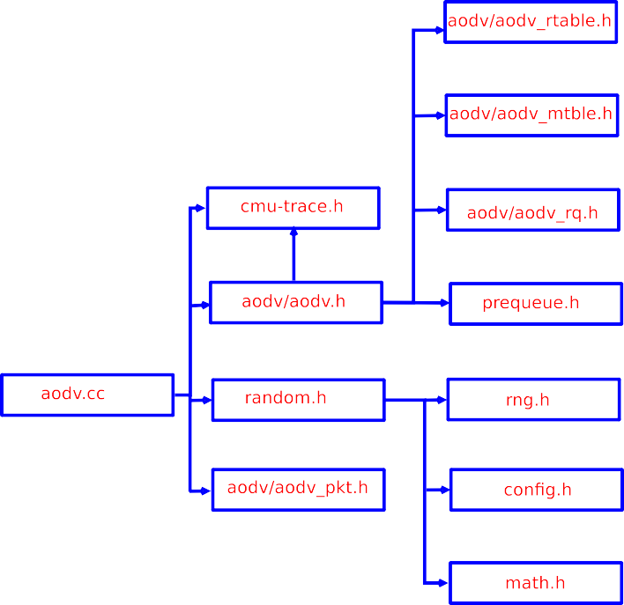

**/ig. 8.** File references of AODV C++ file.

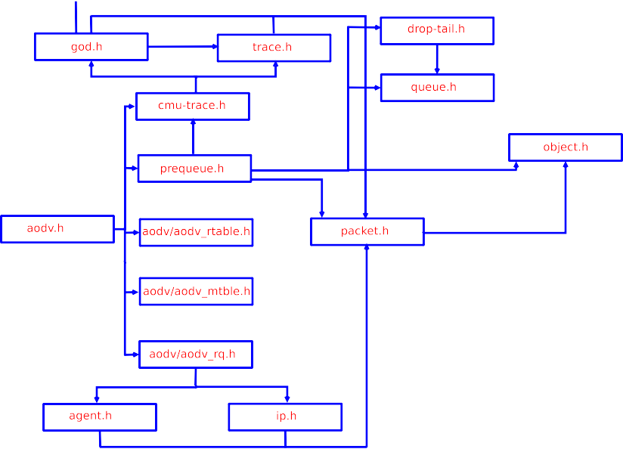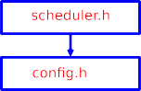

**/ig. 9.** File references of AODV header file.

using an equation the equation.

*𝑀* =

*𝑚*

*𝑜*=1

*∑*

*√(𝑥𝑜* − *𝑥𝑝)*2 − *(𝑦𝑜* − *𝑦𝑝)*2

*𝑡*

(8)

*𝐵𝑃* =

*𝑃𝑖𝑑𝑙𝑒* + *𝑃𝑠𝑙𝑒𝑒𝑝* + *𝑃𝑡𝑥* + *𝑃𝑟𝑥*

*𝑡𝑖𝑚𝑒*

(9)

where t is the time of the simulation. As and when node mobility increases, there is a chance of breakage of the link that leads group members to defer the communication from the multicast tree so that node cannot send the data packet properly to the specific group.

* + **Throughput:** Throughput is the amount of data packets transmit- ted successfully per unit time from the originator to the intended destination node. The equation is given as follows

*𝑅𝑥*

* **Battery power:** The potential of a mobile node to perform spe- cific actions in the network on time, for example, packet transmis-

*𝑇* =

(10)

*𝑇*

sion to its proximity nodes, receiving a packet from the neighbor node, etc. The battery power of a mobile node is determined using

where *𝑅𝑥* is the number of the data packet received successfully

and ‘T’ is time.

**Table 13**



Simulation parameters.

Parameters Values

Number of mobile nodes 200

Type of network simulator NS3

MAC type IEEE 802.11

Multicast routing protocols AODV, MAODV, and ECA-MAODV

Transmission range 40 mts

Simulation time 500 s

Pause time 10 s

Terrain 2000X2000 m

Packet size 512 Bytes

Queue length 50

Packet rate 4 Packets/s

Antenna type Omnidirectional

Radio propagation model 2-Ray ground

Mobility Random



* **Routing Packet Control Overhead (RPCO):** RPCO is the ratio between total control packets generated (such as join route re- quest, route response, activation of the route, and group hello message) to the total amount of data packets received. ECA- MAODV routing protocol minimizes the usage of control packets during the route establishment phase.

**/ig. 10.** Simulation time vs. Throughput.



*𝑅𝑃 𝐶𝑂* = *𝑇 𝑜𝑡𝑎𝑙 𝑐𝑜𝑛𝑡𝑟𝑜𝑙 𝑝𝑎𝑐𝑘𝑒𝑡𝑠 𝑔𝑒𝑛𝑒𝑟𝑎𝑡𝑒𝑑*

*𝑇 𝑜𝑡𝑎𝑙 𝑟𝑒𝑐𝑒𝑖𝑣𝑒𝑑 𝑑𝑎𝑡𝑎 𝑝𝑎𝑐𝑘𝑒𝑡𝑠*

## Simulation environment

(11)

We have created four different subnetworks like PET (Protocol Engineering and Technology) lab, RF (Radio Frequency) lab, ERNET (Education and Research Network) lab, and Photonic lab in the ECE department at IISc. Each subnetwork consisting of 50 mobile nodes col- lectively forms a multicast group named ‘‘Innovative-Research-Group’’ objective of the research group is to discuss the current trends in a wireless network. A node from each subnetwork sends a join route query message to the multicast group to become a member of the research group. Member node sends a route response to join query message, upon receiving a response from the member node, a node may join the multicast group. We develop our NS3 simulation on the operating system of Fedora Core 24 by taking simulation parameters into account, as shown in Table 13. We simulated with 200 nodes uniformly dispersed onto a 2000X2000 m square field. In every four separate subnetworks consisting of 50 nodes are deployed. Whenever a node triggers an event, the node informs its periphery nodes as well as nodes residing in another subnetwork too, and chooses the best path for data transmission.

## Simulation results

The network NS-3 is employed to conduct a simulation of the energy-efficient ECA-MAODV multicast routing protocol. A series of results are obtained, described in the figures below. In Fig. 10, we generated 100 nodes randomly and simulated for 1000 ms better throughput is obtained in ECA-Multicast AODV routing protocol within a specified amount of time. The ECA-MAODV protocol constructs the multicast tree by considering metrics such as link bandwidth, minimal hop count, buffer capacity, energy level, etc. The ECA-MAODV selects the nodes with plentiful resources to proceed with further transactions such as sending join query, the transmission of the data packet, re- ceiving route response from the member nodes, etc. Indeed, traditional routing protocols like multicast AODV and standard AODV do not consider bandwidth as a metric while constructing multicast trees. Therefore Multicast AODV and AODV routing protocols have lower throughput in comparison with the ECA-MAODV routing protocol.

In Fig. 11, we have created 50 nodes randomly by invoking the pseudorand() function. At a certain point, we analyze the time needed



**/ig. 11.** Simulation time vs. Data packet lost.

to propagate data packets from a transmitter to the set of receivers. If the transmitted packet is not getting by the member of the multi- cast group in a stipulated time, we need to assume that packet is a lost packet. Increasing orders, i.e., ECA-MAODV, MAODV, and AODV routing protocols, signify the number of packets missing at the time of delivery. Therefore, we conclude that the packet loss ratio is low in ECA-MAODV while comparing with the other two routing protocols such as MAODV and AODV. When a mobile node suddenly disappears from the network or connection fails on the intended path, a mobile node produces a link error message as and when it encounters path failure. The connectivity of the link among the mobile node is monitors via hello message periodically. The mobile node retransmits a joint route query message to the group members to form a multicast tree whenever the link between the group members is lost. The member node consumes time to establish a multicast tree for the lost connection. Member node of a specific group may not get needed the data packet in a set prescribed time due to a lost link. The mobile node assumes that the packet is lost due to connectivity and waits for some time to receive data packets from the mobile node in the network.

We have considered 40 nodes in Fig. 12, in which we have examined the response time of each set of nodes w.r.t routing protocols such as ECA-MAODV, MAODV, and AODV. ECA-MAODV routing protocol response time is faster than MAODV and AODV routing protocols since it is an event-driven routing protocol that reacts immediately to networking conditions as and when an event occurs.



**/ig. 12.** Number of nodes vs. Average response time.

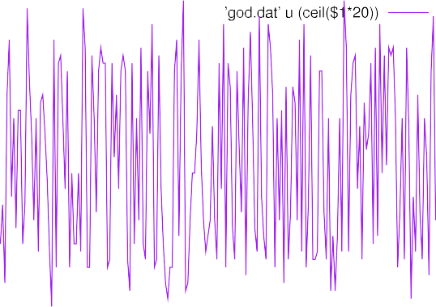

|  |  |  |  |  |  |  |
| --- | --- | --- | --- | --- | --- | --- |
|  | | | | | | |
|  | | | | | | |
|  |  |  |  |  | | |
|  |  |  | | |
|  |  |  |
|  |  |  |  |
|  |
|  |  |  |  |  |  |
|  |
|  |  |  |  |  |
|  |

**/ig. 13.** Number of nodes vs. Average latency.

Fig. 13 shows the average latency of the ECA-MAODV for 150 mobile nodes is low in comparison with MAODV and AODV routing protocols at the time of the dissemination of data and control packets to the intended receivers. The ECA-MAODV routing protocol is, therefore, compelled to adapt rapidly to make dynamic decisions under sensitive network conditions.

We considered an average of 200 mobile nodes in Fig. 14 and observed the time required by a mobile node to process a concurrently occurring series of events. We analyzed the cumulative amount of mobile nodes at a given time versus the total number of processed events.

In Fig. 15, we considered 14 mobile nodes in which their corre- sponding balance of energy w.r.t probability density when the par- ticular event is processed at that particular mobile node. The value of the probability density function at any given set of events in the sample space is interpreted based on the constraints. The relative probability value of the discrete variable is equal to the sequence of events processed.

## Conclusion

In this article, we have incorporated an innovative vague set to choose an optimal path for the creation of a multicast tree in the ubiquitous network. It is an improved part of the fuzzy set. Each element of a fuzzy set is assigned a single value span of [0,1] that reflects its grade of membership. The single value does not cause proof

**/ig. 14.** Average number of nodes vs. Average event processed.





**/ig. 15.** Balance of energy vs. Probability density.

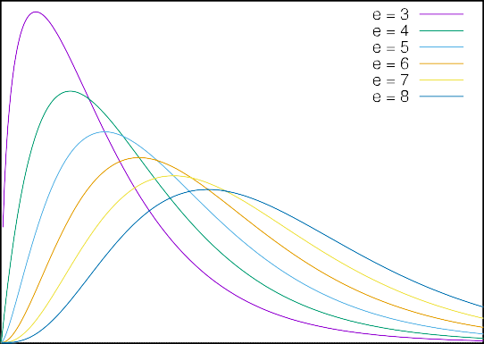

of a degree of membership and evidence against membership to be divided. The vague collection is an interval-based membership in which metrics like the bandwidth of the link, node’s processor speed, buffer capacity, the battery power of a node, and minimal hop count are taken into account to create a multicast tree. Every member node of a specific multicast group establishes the connection via a shared multicast tree to propagate data packets. Eventually, the utility of ECA-MAODV routing protocols using a vague collection has been measured and contrasted. ECA-MAODV outperforms IETF AODV and MAOV routing protocols in terms of the lifespan of the network, better throughput, minimal data packet loss, mean response time, mean latency, and a mean number of events processed. The vague collection outperforms the point-based membership function in terms of the lifetime of the ubiquitous network.

## Declaration of competing interest

The authors declare that they have no known competing finan- cial interests or personal relationships that could have appeared to influence the work reported in this paper.

## Availability of data and material

The authors declare that this manuscript is truthful, authentic, and transparent.

## References

1. Chavan CP, Venkataram P. Designing a routing protocol for ubiquitous networks using ECA scheme. In: Fifth international conference on advances in computing and information technology (acity 2015). Chennai, India; 2015, p. 1–18. [http:](http://dx.doi.org/10.5121/csit.2015.51301)

[//dx.doi.org/10.5121/csit.2015.51301](http://dx.doi.org/10.5121/csit.2015.51301).

1. Internet multicast routing architecture. <https://tools.ietf.org/html/rfc5110>.
2. Huang X, Fang Y. Multiconstrained QoS multipath routing in wireless sensor networks. J Wirel Netw 2008;14(4):465–78. [http://dx.doi.org/10.1007/s11276-](http://dx.doi.org/10.1007/s11276-006-0731-9) [006-0731-9](http://dx.doi.org/10.1007/s11276-006-0731-9).
3. Dhote CA, Pund MA, Mangrulkar R. Hybrid routing protocol with broadcast reply for mobile ad hoc network. Int J Comput Appl 2010;1(10):108–13. [http:](http://dx.doi.org/10.5120/212-360)

[//dx.doi.org/10.5120/212-360](http://dx.doi.org/10.5120/212-360).

1. Routing architecture is accessed from <https://tools.ietf.org/html/rfc6115>.
2. Murthy S, Garcia-Luna-Aceves JJ. An efficient routing protocol for wireless networks. ACM Mob Netw Appl J Spec Issue Routing Mob Commun Netw 1996;1(2):183–97. <http://dx.doi.org/10.1007/BF01193336>.
3. Garcia-Luna-Aceves J, Spohn M. Source-tree adaptive routing in wireless net- works. In: Proceedings of the 7th annual ieee international conference on network protocols. Toronto, Canada; 1999, [http://dx.doi.org/10.1109/ICNP.](http://dx.doi.org/10.1109/ICNP.1999.801950) [1999.801950](http://dx.doi.org/10.1109/ICNP.1999.801950).
4. Toh C. A novel distributed routing protocol to support ad hoc mobile computing. In: IEEE 15th annual international phoenix conference. 1996, p. 480–6. [http:](http://dx.doi.org/10.1109/PCCC.1996.493675)

[//dx.doi.org/10.1109/PCCC.1996.493675](http://dx.doi.org/10.1109/PCCC.1996.493675).

1. Jeni, Jasmine PR, Juliet AV, Parthasarathy R, Bose AM. Performance analysis of DOA and AODV routing protocols with black hole attack in MANET. In: IEEE conference on smart structures and systems (icsss). 2013, p. 178–82. <http://dx.doi.org/10.1109/ICSSS.2013.6623022>.
2. [Bondre, Vipin, Dorle S. Performance analysis of AOMDV and AODV rout-](http://refhub.elsevier.com/S2590-0056(22)00002-9/sb10) [ing protocol for emergency services in VANET. Eur J Adv Eng Technol](http://refhub.elsevier.com/S2590-0056(22)00002-9/sb10) [2017;4(4):242–8.](http://refhub.elsevier.com/S2590-0056(22)00002-9/sb10)
3. Felemban E, Lee C, Ekici E. Multipath multi-speed protocol for QoS guarantee of reliability and timeliness in wireless sensor networks. IEEE Trans Mob Comput 2006;5(6):738–54. <http://dx.doi.org/10.1109/TMC.2006.79>.
4. Working of ad-hoc network is accessed from <https://tools.ietf.org/html/rfc5444>.
5. Internet routing protocol is accessed from <https://tools.ietf.org/html/rfc1264>.
6. Ge M, Krishnamurthy SV, Faloutsos M. Application versus network layer multicasting in ad hoc networks: The ALMA routing protocol. Ad Hoc Netw 2006;4(2):283–300. <http://dx.doi.org/10.1016/j.adhoc.2004.10.002>, Elsevier.
7. Tavizi A, Ghaffari A. Tree-based reliable and energy-aware multicast routing pro- tocol for mobile ad hoc networks. Springer J Supercomput 2018;74(11):6310–32. <http://dx.doi.org/10.1007/s11227-018-2562-8>.
8. Lee S-J, Su W, Gerla M. On-demand multicast routing protocol in multi-hop wireless mobile networks. Mob Netw Appl 2002;441–53. [http://dx.doi.org/10.](http://dx.doi.org/10) 1023/A:1020756600187.
9. Chawathe Y, McCanne S, Brewer E. RMX: Reliable multicast for heterogeneous networks. In: Infocom 2000. Nineteenth annual joint conference of the ieee computer and communications societies, Vol. 2. 2000, p. 795–804. [http://dx.](http://dx.doi.org/10.1109/INFCOM.2000.832254) [doi.org/10.1109/INFCOM.2000.832254](http://dx.doi.org/10.1109/INFCOM.2000.832254).
10. Jia X, Wang L. A group multicast routing algorithm by using multiple minimum steiner trees. Comput Commun 1997;20(9):750–8. [http://dx.doi.org/10.1016/](http://dx.doi.org/10.1016/S0140-3664(97)00081-9) [S0140-3664(97)00081-9](http://dx.doi.org/10.1016/S0140-3664(97)00081-9), Elsevier.
11. Badis H. A QoS-aware multicast routing protocol for multimedia applications in mobile ad hoc networks. In: Proceedings of the 11th acm international symposium on modeling, analysis and simulation of wireless and mobile systems. 2008, p. 244–51. <http://dx.doi.org/10.1145/1454503.1454547>.
12. Yadav AK, Tripathi S. Design of QoS multicast routing protocol using re- liable node selection scheme for MANETs. Springer Peer-to-Peer Netw Appl 2017;10:897–909. <http://dx.doi.org/10.1007/s12083-016-0441-8>.