Available online at [www.sciencedirect.com](http://www.sciencedirect.com/)



AASRI Procedia 2 (2012) 149 – 155

AASRI

Procedia

[www.elsevier.com/locate/procedia](http://www.elsevier.com/locate/procedia)

2012 AASRI Conference on Power and Energy Systems

# Design of PI and Fuzzy Controllers for Dynamic Voltage Restorer (DVR)

K. Sandhyaa*, Dr. A. Jaya Laxmib, Dr. M.P. Sonic

*a*Research Scholar, Department of Electrical and Electronics Engineering, College of Engineering, JNTU Hyderabad , INDIA*

*Email: sandhyakp_msr @yahoo.co.in*

*bDepartment of Electrical and Electronics Engineering, College of Engineering, JNTU Hyderabad, INDIA*

*cDepartment of Electrical and Electronics Engineering, M.J. College of Engineering & Technology, Banjarahills, Hyderabad, INDIA*

Abstract

© 2012 Published by Elsevier B.V. Selection and/or peer review under responsibility of American Applied Science Research Institute

Power quality is one of the major concerns in the present era. It has become important, especially, with the introduction of sophisticated devices, whose performance is very sensitive to the quality of power supply. To solve this problem, custom power devices are used. One of those devices is the Dynamic Voltage Restorer (DVR), which is the most efficient and effective modern custom power device used in power distribution networks. Its appeal includes lower cost, smaller size, and its fast dynamic response to the disturbance. This paper presents modelling, analysis and simulation of a Dynamic Voltage Restorer (DVR) using MATLAB for both PI and FUZZY CONTROLLERS.

© 2012 Published by Elsevier B.V. Selection and/or peer review under responsibility of American Applied Science Research Institute

© 2012 Published by Elsevier B.V. Selection and/or peer review under responsibility of American Applied Science Research Institute

Open access under [CC BY-NC-ND license.](http://creativecommons.org/licenses/by-nc-nd/3.0/)

*Keywords:* Dynamic Voltage Restorer, Custom Power Devices, Dynamic Power Quality, PI, Control Strategy.

*Corresponding author. Tel.: +919704675710

*E-mail* [*address:*sandhyakp_msr@yahoo.co.in](mailto:sandhyakp_msr@yahoo.co.in)

2212-6716 © 2012 Published by Elsevier B.V. Selection and/or peer review under responsibility of American Applied Science Research Institute

Open access under [CC BY-NC-ND license.](http://creativecommons.org/licenses/by-nc-nd/3.0/) doi:10.1016/j.aasri.2012.09.027

1. Introduction

Nowadays, modern industrial applications are mostly based on electronic devices such as programmable logic controllers and electronic drives. The electronic devices are very sensitive to disturbances and become less tolerant to power quality problems such as voltage sags, swells and harmonics. Voltage dips are considered to be one of the most severe disturbances to the industrial equipments. Voltage support at a load can be achieved by reactive power injection at the load point of common coupling. The common method for this is to install mechanically switched shunt capacitors in the primary terminal of the distribution transformer. The disadvantage is that, high speed transients cannot be compensated. Another power electronic solution to the voltage regulation is the use of a custom power device. DVRs are a class of custom power devices for providing reliable distribution power quality.

1. Solutions to Power Quality Problems

There are two approaches to the mitigation of power quality problems. The solution to the power quality can be done from customer side or from utility side. First approach is called load conditioning, which ensures that the equipment is less sensitive to power disturbances and allowing the operation even under significant voltage distortion. The other solution is to install line conditioning systems that suppress or counteracts the power system disturbances. Currently they are based on PWM converters and are connected to low and medium voltage distribution system in shunt or in series. Some of the effective and economic measures identified are Lightening and Surge Arresters, Thyristor Based Static Switches, Energy Storage Systems. Though there are many different methods to mitigate voltage sags and swells, but the use of a custom Power device is considered to be the most efficient method. There are many types of Custom Power devices. Some of these devices include: Active Power Filters (APF), Battery Energy Storage Systems (BESS), Distribution Static Synchronous Compensators (DSTATCOM), Distribution Series Capacitors (DSC), Dynamic Voltage Restorer (DVR), Surge Arresters (SA), Superconducting Magnetic Energy Systems (SMES), Static Electronic Tap Changers (SETC), Solid-State Transfer Switches (SSTS), Solid State Fault Current Limiter (SSFCL), Static VAR Compensator (SVC), Thyristor Switched Capacitors (TSC) and Uninterruptible Power Supplies (UPS). Among these, the DVR is an effective custom power device which is based on the VSC principle that can deal with voltage sags and swells.

1. Dynamic Voltage Restorer (DVR)

Dynamic Voltage Restorer (DVR), is the most efficient and effective modern custom power device used in power distribution networks. DVR is a recently proposed series connected solid state device that injects voltage into the system in order to regulate the load side voltage. It is normally installed in a distribution system between the supply and the critical load feeder at the Point of Common Coupling (PCC). Other than voltage sags and swells compensation, DVR has other features like: line voltage harmonics compensation and reduction of transients in voltage and fault current limitations. The structure of the DVR is shown in fig.1.

An equivalent circuit diagram of the DVR and the principle of series injection for sag/swell compensation is depicted in fig. 2. The load voltage is given by

*VL = VS + Vinj* *(1)*

where VS is the supply voltage and Vinj is the voltage injected by the mitigation device. Under nominal voltage conditions, the load power on each phase is given by

*SL =VL IL* = PL-jQL* *(2)*

where IL is the load current, PL and QL are the real and reactive power taken by the load respectively.

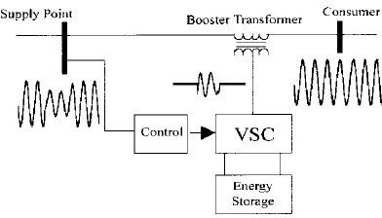 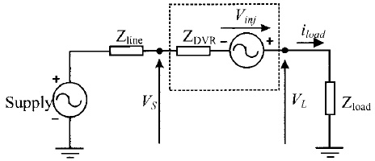

Fig. 1 Structure of DVR Fig. 2 Equivalent circuit of DVR

When the compensating device is active and restores the voltages back to normal, then

SL=PL-jQL= (PSag-jQSag) + (Pinj – jQin) (3)

where the sag subscript refers to the sagged supply quantities, the inject subscript refers to quantities injected by the compensator device (DVR).

1. Control Scheme

The control scheme of DVR is exhibited in Fig.3. In this, Va, Vb, Vc are the three-phase voltages, VRMS is

the Root Mean Square (RMS) voltage. Finally, V* is the three-phase voltage desired at the converter output.

abc

The two controllers analyzed in this paper are shown in fig4 and fig.6, which employs Proportional-Integral (PI) controller and Fuzzy Proportional-Integral (FPI) controller.

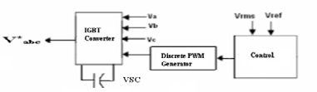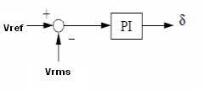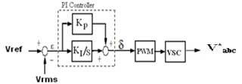

Fig. 3 Control Scheme of DVR Fig. 4 PI Controller Fig. 5 PI Controller with PWM and VSC

* 1. *PI Controller*

The PI controller input is an error signal obtained from the reference voltage and the RMS value of the terminal voltage measured. Such error is processed by a PI controller and the output is the angle which is provided to the PWM signal generator. The PWM generator then generates the pulse signals to the IGBT gates of Voltage Source Converter (VSC). The disadvantage of PI controller is its inability to react to abrupt changes in the error signal, ε, because it is only capable of determining the instantaneous value of the error signal without considering the change of the rise and fall of the error, which in mathematical terms is the derivative of the error signal, denoted as *Δε*.

* 1. *FUZZY PI (FPI) Controller*

To solve this problem and to improve the behaviour of DVR, Fuzzy PI control is proposed. The determination of the output control signal, is done in an inference engine with a rule base having if-then rules in the form of IF *ε* AND *Δε*, THEN *Kp* AND *Ki* . With the rule base, the values of the constants *Kp* and *Ki* are changed according to the value of the error signal, *ε*, and the rate-of-error, ∆ε. The Fuzzy Logic Control (FLC) is based on Mamdani's system.

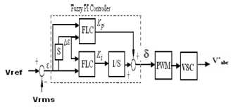 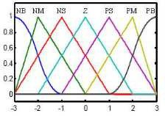 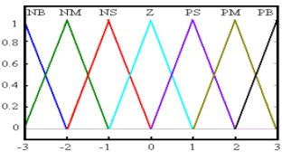

Fig .6 Fuzzy PI Controller Fig.7 Membership function curves of the Fig.8 Membership function curves of the

inputs ε and ∆ε output Kp and Ki

The fuzzy controller has two inputs: (i) the difference between the rms voltage and the reference voltage (ii) the derivation of the error. The fuzzy logic controller consists of three stages: the fuzzification, rule execution, and defuzzification. All the variables i.e., fuzzy subsets for the inputs ε and ∆ε are defined as (NB, NM, NS, Z, PS, PM, PB). Taking into account of the coverage, sensitivity, robustness of universe, the fuzzy subsets of the membership functions use “Z”-shaped membership function in the left, triangular membership function in the middle and “S”-shaped membership function curve in the right .The membership functions and initial universes of the inputs are illustrated in fig. 7. For the output variables *KP* and *KI,* the fuzzy subsets of the membership functions have a triangular shape only as it is illustrated in Figure 8. Tables 1 and 2 illustrate the fuzzy control rules for the output variables *KP* and *KI.*

Table 1. Fuzzy Control Rules for Kp Table 2. Fuzzy Control Rules for KI

|  |  |  |  |  |  |  |  |
| --- | --- | --- | --- | --- | --- | --- | --- |
| e/Δe | NB | NM | NS | Z | PS | PM | PB |
| NB | PB | PB | PM | PM | PS | PS | Z |
| NM | PB | PB | PM | PM | PS | Z | NS |
| NS | PM | PM | PM | PS | Z | NS | NM |
| Z | PM | PS | PS | Z | NS | NM | NM |
| PS | PS | PS | Z | NS | NS | NM | NM |
| PM | PS | Z | NS | NM | NM | NM | NB |
| PB | Z | NS | NS | NM | M | NB | NB |

|  |  |  |  |  |  |  |  |
| --- | --- | --- | --- | --- | --- | --- | --- |
| e/Δe | NB | NM | NS | Z | PS | PM | PB |
| NB | NB | NB | NB | NM | NM | NS | Z |
| NM | NB | NB | NM | NM | NS | Z | PS |
| NS | NM | NM | NS | NS | Z | PS | PS |
| Z | NM | NS | NS | Z | PS | PS | PM |
| PS | NS | NS | Z | PS | PS | PM | PM |
| PM | NS | Z | PS | PM | PM | PB | PB |
| PB | Z | NS | PS | NM | PB | PB | PB |

1. Simulation Results

The system shown in fig.1 with system parameters given in table-3 has been modelled by MATLAB/SIMULINK to study the performance of DVR in enhancing power quality. The results of simulation are shown separately in each case. Both sag and swell are generated from source. The simulation results are shown in the following figures, where the very effective voltage regulation provided by the DVR can be clearly appreciated in all cases.

* 1. *With PI Controller*

Sag and swell of 20% magnitude is generated at source side in one of the phases (sag from t = 100 ms to 200 ms and swell from t = 200 ms to 300 ms) which is shown in fig.9 (a). The PI Controller based DVR is able to mitigate voltage sag and swell and is providing voltage regulation with load side THD of 8.89 %. (Fig. 9(b), (c) and (d))

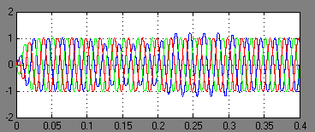 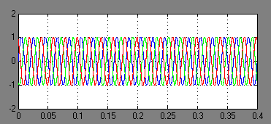

Fig.9 (a) Source Voltage with 20% voltage sag and swell Fig.9 (b) Load Voltage after mitigating voltage sag and swell in phase A with PI Controller

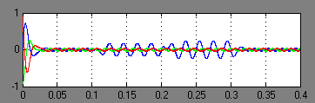 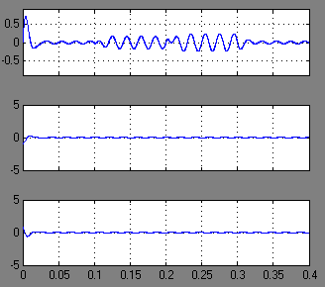

Fig.9(c) DVR injected Voltage with PI Controller Fig.9 (d) Three phases of DVR injected Voltage with PI Controller

* 1. *With Fuzzy PI Controller*

20% sag (from t = 100 ms to 200 ms) and 20% swell (from t = 200 ms to 300 ms) are generated at source side in phase A. The Fuzzy PI Controller based DVR is able to mitigate voltage sag and swell and is providing voltage regulation with load side THD of 4.45% where as the THD with the PI Controller alone was 8.89%. With the Fuzzy PI Controller the THD is reduced to considerable amount and is providing better voltage regulation (Fig. 10(b), (c) and (d)). Table4 gives the comparison of PI Controller with FPI controller.

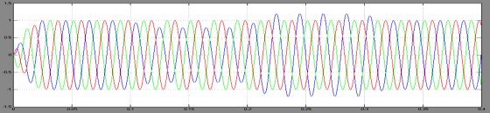 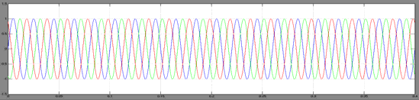

Fig.10 (a) Source Voltage with 20% voltage Fig.10 (b) Load Voltage after mitigating voltage sag and swell sag and swell in phase A with Fuzzy PI Controller

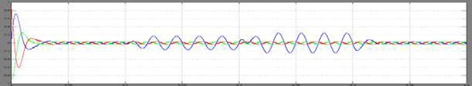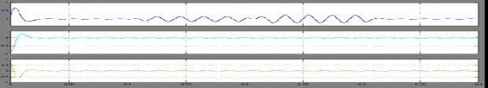

Fig.10(c) DVR injected Voltage with Fuzzy PI Controller Fig. 10(d) Three phases of DVR injected Voltage with

Fuzzy PI Controller

Table 3. System Parameters Table 4. Comparison of PI Controller with FPI Controller

|  |  |
| --- | --- |
| Voltage: 240V | Filter Inductance: 2e- 3H |
| Frequency: 2*pi*50 radians/sec. | Filter Capacitance:  300e-6F |
| Phase: -2*pi*/3 radians | Base Voltage: 240V |
| PWM carrier Frequency:2000Hz | R Load: 40 Ohms |
| PWM sampling time: 2e-3sec. | L Load: 6.41/2*pi*%0  H |
| Linear Transformer: 100MVA | |
| Primary Winding: 960V, 0.002 Ohm, 0.08H | Secondary Winding: 480V, 0.002 Ohm,  0.08H |

|  |  |  |
| --- | --- | --- |
| Factor | With PI DVR | With FPI DVR |
| Sag 20% t(sec.)= 0.1-  0.2 | Mitigated | Mitigated |
| Swell 20% t(sec.)= 0.2-  0.3 | Mitigated | Mitigated |
| Multi mode oscillations | Observed | Not observed |
| Source side THD | 21.73% | 12.07% |
| Load side THD | 8.89% | 4.45% |

1. Conclusion

The paper has presented the power quality problems such as voltage dips and swells. Compensation techniques of custom power electronic devices such as DVR were presented. A PWM-based control scheme was implemented. As opposed to fundamental frequency switching schemes already available in the MATLAB/ SIMULINK, this PWM control scheme only requires voltage measurements. This characteristic makes it ideally suitable for low-voltage custom power applications. PI and FUZZY LOGIC Controllers are developed. The results show that Fuzzy PI Controller is giving better performance results than compared to PI Controllers since the load THD with FPI Controller is found to be 4.45% which is less 5%.(as per IEEE norms)

References

1. N.G. Hingorani, “Introducing Custom Power”, EEE Spectrum Vol. 31, pp .41-48, 1995.
2. E Acha, V.G.Agelidis, O.Anaya-Lara, T.J.Miller, “Power Electronic Control in Electrical Systems”, 1st edition, Newnes, 2002.
3. Anaya-Lara o, Acha E., “Modeling and analysis of custom power Systems by PSCAD/EMTDC”, IEEE Transactions on Power Delivery, Vol.17, Issue: 1, Jan. 2002, Pages: 266-272.
4. Bollen, M.H.J.,“Voltage sags in three-phase systems” Power Engineering Review, IEEE, Vol. 21, Issue: 9, Sept. 2001, pp: 8-11, 15.
5. N.G.Hingorani and L.Gyuyi, “Understanding Facts – Concepts and Technology of Flexible AC Transmission Systems”, 1st Ed: Inst.Elect. Electronic Eng. Press, 1999.
6. Gareth A. Taylor, “Power quality hardware solutions for distribution systems: Custom power”, IEE North Eastern Centre Power Section Symposium, Durham. UK, 1995, pp.11/1-11/9.
7. Ran Cao, Jianfeng Zhao, Weiwei Shi, Ping Ziang, Gouquing Tang, “Series Power Quality Compensator for Voltage Sags, Swells, Harmonics and Unbalance”, IEEE/PES Transmission and Distribution Conference and Exposion, Vol. 1,28 Oct.- Nov., pp. 543-547.
8. Chris Fitzer, Mike Barnes, Peter Green, “Voltage Sag Detection Technique for a Dynamic Voltage Restorer”, IEEE Trans. Power Electronics, Vol. 22, No. 2, Mar. 2007, pp.626-635.
9. Ran Cao, Jianfeng Zhao, Weiwei Shi, Ping Ziang and Gouquing Tang, “Series Power Quality Compensator for Voltage Sags, Swells, Harmonics and Unbalance”, IEEE/PES Transmission and Distribution Conference and Exposion, Vol. 1, 28 Oct.-2 Nov., pp. 543-547.
10. Chris Fitzer, Mike Barnes and Peter Green, “Voltage Sag Detection Technique for a Dynamic Voltage Restorer”, IEEE Trans. Power Electronics, Vol. 22, No.2, Mar. 2007, pp.626-635.
11. Stump, M.D., G.J. Kaene and F.K.S Leong, “Role of custom power products in enhancing power quality at industrial facilities” Int. Conf. Rec. IEEE/EMPD, pp: 507-517.
12. O.Anaya-Lara, E. Acha, “Modeling and Analysis of Custom Power Systems by PSCAD/EMTDC”, IEEE Trans., Power Delivery, PWDR, Vol-17(1), pp. 266-272, 2002.
13. R.Buxton, “Protection from Voltage Dips with Dynamic Voltage Restorer”, in IEE Half day colloquium,(1998).
14. A. Ghosh, G.Ledwich, “Power Quality Enhancement Using Custom Power Devices”, Kluwer Academic Publishers, 2002.

About The Authors

K.Sandhya, obtained B.Tech degree in 2001 and M.Tech in 2007 with specialization in Electrical Power Systems from Jawaharlal Nehru Technological University and pursuing Ph.D. (Power Quality) from Jawaharlal Nehru Technological University, Hyderabad, India. She has 10 years of teaching experience. Her research interests are Power Systems, Power Quality, FACTS and

Custom Power Devices. She has 6 international and national conference papers to her credit. She is a Member of Indian Society of Technical Education (M.I.S.T.E).

Dr. A. Jaya Laxmi completed her B.Tech. (EEE) from Osmania University College of Engineering, Hyderabad in 1991, M. Tech.(Power Systems) from REC Warangal, Andhra Pradesh in 1996 and completed Ph.D.(Power Quality) from Jawaharlal Nehru Technological University

College of Engineering, Hyderabad in 2007. She has five years of Industrial experience and 14 years of teaching experience. She has worked as Visiting Faculty at Osmania University College of Engineering, Hyderabad and is presently working as Associate Professor, Department of Electrical and Electronics Engineering, JNTU College of Engineering, Hyderabad. She has 50 International and 10 National papers published in various conferences held at India and also abroad. She has 20international journal papers and 5 national journals & magazines to her credit. Her research interests are Neural Networks, Power Systems & Power Quality. She was awarded “Best Technical Paper Award” for Electrical Engineering in Institution of Electrical Engineers in the year 2006. Dr. A. Jaya Laxmi is a Member of Institution of Electrical Engineers Calcutta (M.I.E), Member of Indian Society of Technical Education (M.I.S.T.E), Member System Society of India (M.S.S.I), Member IEEE, Member International Accredition Organisation (IAO) and also Member of Institution of Electronics and Telecommunication Engineers (MIETE).

Dr. M. P. Soni, Worked as Addl. General Manager in BHEL (R & D in Transmission and power System Protection. Worked as Senior Research Fellow at I.I.T. Bombay for BARC Sponsored Project titled, ‘Nuclear Power Plant Control’ during the year 1974 - 1977. Presently Working as Professor and Head, Department of Electrical and Electronics Engineering, M.J. College of

Engineering and Technology, Banjarahills, Hyderabad. India. He has undertaken the following projects like “Dynamic Simulation Studies on Power System and Power Plant Equipments”, “Initiated developments in the area of Numerical Relays for Substation Protection”, “Developed Microprocessor based Filter bank protection for National HVDC Project and commissioned at 220 kV Substation s ,MPEB Barsoor and APTRANSCO Lower Sileru, Terminal Stations of the HVDC Project. “Commissioned Numerical Relays and Low cost SCADA System at 132kV, GPX Main Distribution Substation, BHEL Bhopal”. He has 15 international and national conference papers to his credit. His research interests include power System protection and advanced control systems.