[Artificial Intelligence in Agriculture 5 (2021) 240–251](https://doi.org/10.1016/j.aiia.2021.10.003)

Contents lists available at [ScienceDirect](http://www.sciencedirect.com/science/journal/)

Artificial Intelligence in Agriculture

journal homepage: [http://www.keaipublishing.com/en/journa ls/artificial- intelligence- in-agriculture/](http://www.keaipublishing.com/en/journals/artificial-intelligence-in-agriculture/)

[](http://crossmark.crossref.org/dialog/?doi=10.1016/j.aiia.2021.10.003&domain=pdf)Development, evaluation, and optimization of an automated device for quality detection and separation of cowpea seeds

J. Audu a,⁎, A.K. Aremu b

a *Department of Agricultural & Environmental Engineering, University of Agriculture, Makurdi, Nigeria*

b *Department of Agricultural & Environmental Engineering, University of Ibadan, Nigeria.*

a r t i c l e i n f o

*Article history:*

Received 20 March 2021

Received in revised form 10 October 2021 Accepted 10 October 2021

Available online 13 October 2021

*Keywords:* Cowpea Development Automation Optimization

Artificial Intelligence

a b s t r a c t

Automation and Artificial intelligence has been used to solve the world’'s most complex problems. The goal of this study is to develop, evaluate and optimize cowpea seeds quality detection and separating device to meet inter- national export standards. The design of the device was divided into metering, automation, and conveyor belt outlet unit. An evaluation was done using samples made up of good and bad (impurity) portions. Response sur- face methodology was used to evaluate, model and optimize the device performance. The optimized results were validated using regression and prediction interval (PI) analysis test. The separating efficiency, throughput, max- imum capacity, and actual utilization obtained; range from 68.966 ‐ –94.118%, 0.5 – –3 kg/hr, 6–36 kg/12 h, 0.083–0.083(8.3%) respectively. These evaluating parameters were significantly affected by the operational fac- tors at *P* < 0.05. Optimum values obtained are 92%, 2.689 kg/h, 32.781 kg/12 h for impurity separating: efficiency, throughput, and maximum capacity respectively. The prediction interval test shows that the validation experi- mental mean result lies within calculated prediction intervals. Regression analysis shows a 0.9(90%) coefficient of determination between the model predictions and the validation experimental results. The developed device was recommended to always operate at a metering speed of 20 rpm for optimum performance.

© 2021 The Authors. Publishing services by Elsevier B.V. on behalf of KeAi Communications Co., Ltd. This is an open access article under the CC BY-NC-ND license (<http://creativecommons.org/licenses/by-nc-nd/4.0/>).

1. Introduction

Cowpea (*Vigna unguiculata (L.) Walp*) is one of the most ancient human protein food sources and has existed as a crop since Neolithic times. It is used for both consumptions and as industrial raw material for other products. The world produces over 8 million tones of dry cow- pea seed yearly; with 90% percent of the production from Africa and Asia. America and Europe are the largest exporters, though being the least producers. This is because Asia and African producing countries can not meet international export standards (Henshaw, 2008, IITA, 2015, ACB, 2015, Snapp et al., 2018, Rawal and Navarro, 2019, FAOSTAT, 2020, FAO, 2021). This study's goal is to change that trend, by developing an automated cowpea seeds quality detecting and sepa- rating device for less developed producing countries.

Automation is the term used to describe an operation that requires less or no human involvement. In crop processing, a lot of the automa- tion activity involves machine vision. According to tech brief (2019) ma- chine vision automation is bring a never seen before solution to human problems. Machine vision involves the use of image sensors to detect materials and separate them. The use of machine vision to automate

* Corresponding author.

*E-mail addresses:* [audujoh@gmail.com](mailto:audujoh@gmail.com) (J. Audu), [ademolaomooroye@gmail.com](mailto:ademolaomooroye@gmail.com) (A.K. Aremu).

agricultural grains and seed processing operations has been carried out by various researchers. Casady and Paulsen (1989) developed a ma- chine vision automated maize corn positioning system with an error- free of 99%. Georg et al. (1995) developed an automatic machine vision for broken and unbroken wheat kernel separating system with 95.8% accuracy. Wan (2002) developed an automatic image vision grain sorting system with 99% accuracy at 1296 kernels per minute using two cameras. The system was tested with rice, wheat, jobstear, and sor- ghum kernels. Pearson (2009) developed a hardware-based image pro- cessing damaged grain sorting device. It was tested with Maize and wheat kernels with a throughput of 40 kg/h and 8 kg/h, with an accu- racy of 74 and 91% respectively. Pearson (2010) developed a low-cost high-speed machine vision grain damage sorter. The system was tested with wheat, barley, durum, and flax seeds. Its throughput was found to be 25 kg/h with an accuracy ranging from 92 to 96% depending on the grain being sorted. Kirilova et al., 2013 developed prototype image rec- ognition and grading system for damaged maize seeds. The system was tested and found to have sensitivity, specificity, accuracy, and precision of 88.43, 93.88, 90.49, and 94.79%, respectively. Arkadiusz and Andrzej, 2018 developed, a 2D machine vision, automated machine for diseased rice sorting system using the rice shape and color. Injante et al., 2020 de- veloped an automated image processing system for sorting lima beans to meet export standards. Test of the system shows an acceptance and

<https://doi.org/10.1016/j.aiia.2021.10.003>

2589-7217/© 2021 The Authors. Publishing services by Elsevier B.V. on behalf of KeAi Communications Co., Ltd. This is an open access article under the CC BY-NC-ND license ([http://](http://creativecommons.org/licenses/by-nc-nd/4.0/) [creativecommons.org/licenses/by-nc-nd/4.0/](http://creativecommons.org/licenses/by-nc-nd/4.0/)).

rejection efficiency of 96.81 and 95.26% respectively. None of these re- searchers during evaluation used I-optimal experimental design to model and optimize the operational capability of their developments.

Modeling is the representation of concepts and happenings within our natural world, to study and predict future instances. Optimization is part of mathematical modeling (Zeigler et al., 2018). Dantzig (2014) and Al-Baali et al. (2018), define numerical optimization as choosing the best elements or factors among groups of elements considered. These choices must be done considering some sets of constraints or goals set for the selection. In order words, optimization is finding the best available choices under certain conditions. There are different math- ematical approaches to achieve optimization. One of these approaches is Response surface methodology. Response surface methodology (RSM) is a mathematical technique that develops an experimental design that can put together all the independent variables or factors and use the experi- mental outcome or results to produce equations that can be used to re- produce or predict the experimental results or outcome again. Though complex calculations (well-designed regression analysis) are involved, it is one of the efficient ways of achieving optimization. Experimental de- signs developed during response surface optimization include Central Composite Design (CCD); Box-Behnken (BB); Optimal Designs (Stat- Ease, 2018; García and Peña, 2018; Makowski, 2020). The objective of

this study is to develop, evaluate and optimize the operational capability of an automated device for quality detection and separation of cowpea seeds to meet international export standards.

1. Materials and methods
   1. *Design of the automated device*

The design of the automated device was divided into three catego- ries: metering unit, automation (artificial intelligence) unit, and con- veyor belt unit. The detailed design parameters, calculations, and reasons for selections are displayed in Tables S1, S2, S3, and S4 (supple- mentary tables). Written materials consulted during design include (Boumans, 1985, Srivastava et al., 2006, Yalcin, 2007, Fenner Dunlop, 2009, Sharma and Mukesh, 2010, Dunlop, 2016, O'Keefe, 2017, Tech

Briefs, 2019, Habasit Fabric Conveyor Belt Engineering Guide, 2021)

* 1. *Automated device design components*
     1. *Metering unit*

This consists of an 11 kg/s capacity hopper having a 120 mm dia- meter wooden metering disc (with 4 holes bored at equal interval)

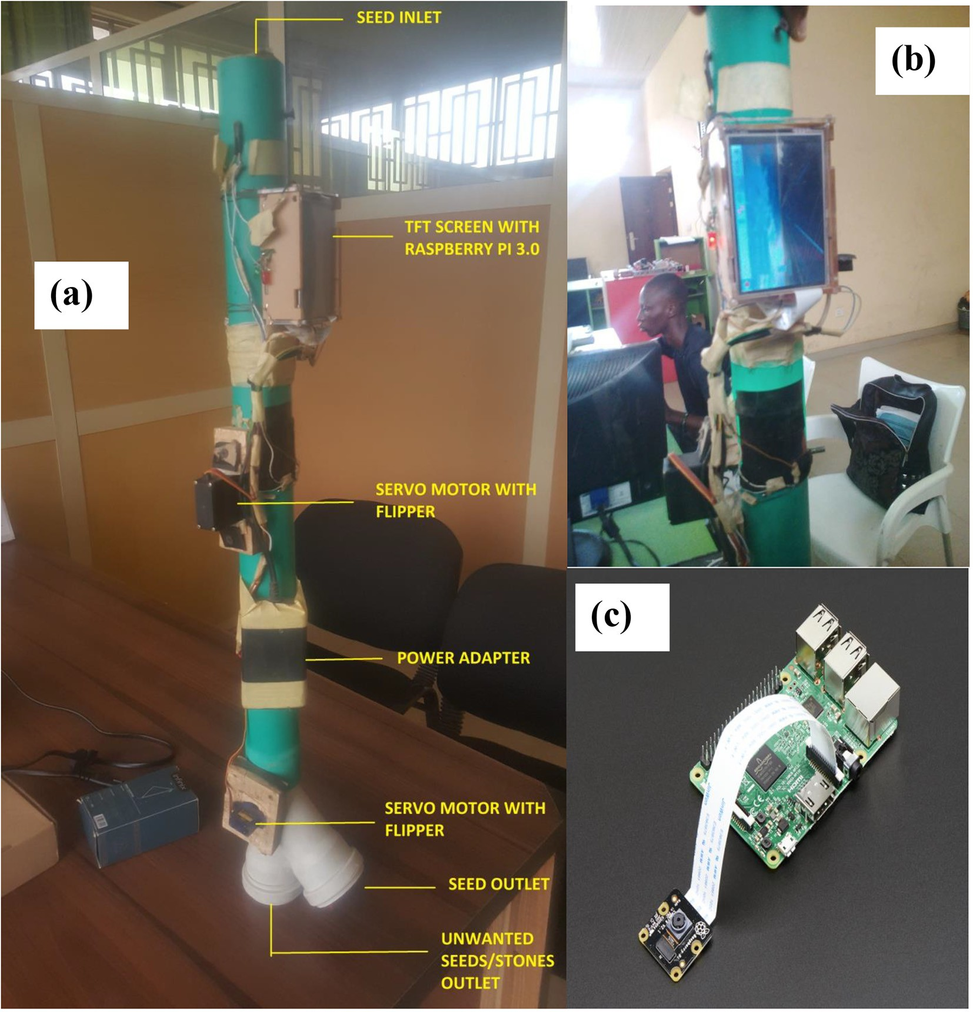

attached at the bottom (fig. S1 in the supplementary document). This metering disc was powered with 2 hp. motor revolving at 1450 rev/ min and link to a reduction gear with ratio 1:80. This reduction gear al- lows the seeds and impurity to be metered one at a time into the auto- mation unit. A 920 mm high standing frame was used to support the entire metering unit (Fig. S1a).

* + 1. *Automation unit*

Fig. 1 displayed the automated unit. This consists of raspberry pi 3 board model B with a Pi camera board attached placed inside a rectangular plastic box (Fig. 1a). This box is covered with a 5 in. TFT screen which was also connected to the raspberry pi board (Fig. 1b and c). The box is then attached to a 90 mm length PVC pipe. The inside of the pipe is divided into two compartments sepa- rated with two circular plastic flippers forming the bases. Theses flippers are attached to two micro servo SG 90 motor which flip them 90o inside the PVC pipe. The inside of the two (primary and secondary) compartments were lit up by LED lights also connected to the raspberry pi board. Adaptor power cable was used to power the raspberry pi board. The PVC pipe had two outlets at its end for rejected and accepted materials.

* + 1. *Conveyor belt outlet unit*

This consists of belt carcass type of PN (polyester and Nylon) plain weave (DIN code EP) with strength range of 315–2000 kN/m (150–400 kn/m/ply). The belt has a carry capacity of 1000 kg/m3,

with length and width of 1300 mm and 250 mm respectively. The belt pulley dimensions are shown in fig. S1b (supplementary docu- ment).

* 1. *Programming of automated unit*

The Raspberry pi board operational system software was downloaded from the Raspberry pi organization website ([https://](https://www.raspberrypi.org/downloads/) [www.raspberrypi.org/downloads/](https://www.raspberrypi.org/downloads/)). The operating system software was installed as instructed by the company. After installation of the operating system, other devices like the Raspberry pi camera and the TFT screen was attached and their application software downloaded from their respective company websites. These appli- cations software were also installed on the Raspberry pi board ac- cording to installation instructions. The Raspberry pi camera was now used to take 150,000 images each for good seeds and impuri- ties (Program S1 in the supplementary document). Some pictures captured by the pi camera used for the automation are displayed in Fig. 2. These captured images was now saved on the Raspberry pi board and then uploaded into a laptop. These images were there- after uploaded into python software. The program (which is the ar- tificial intelligence part) that was developed by the python software; used for comparing incoming image with stored image on the Raspberry pi board are displayed in Program S2 in the sup- plementary document. After developing the python programs, it is then transferred into the Raspberry pi board.

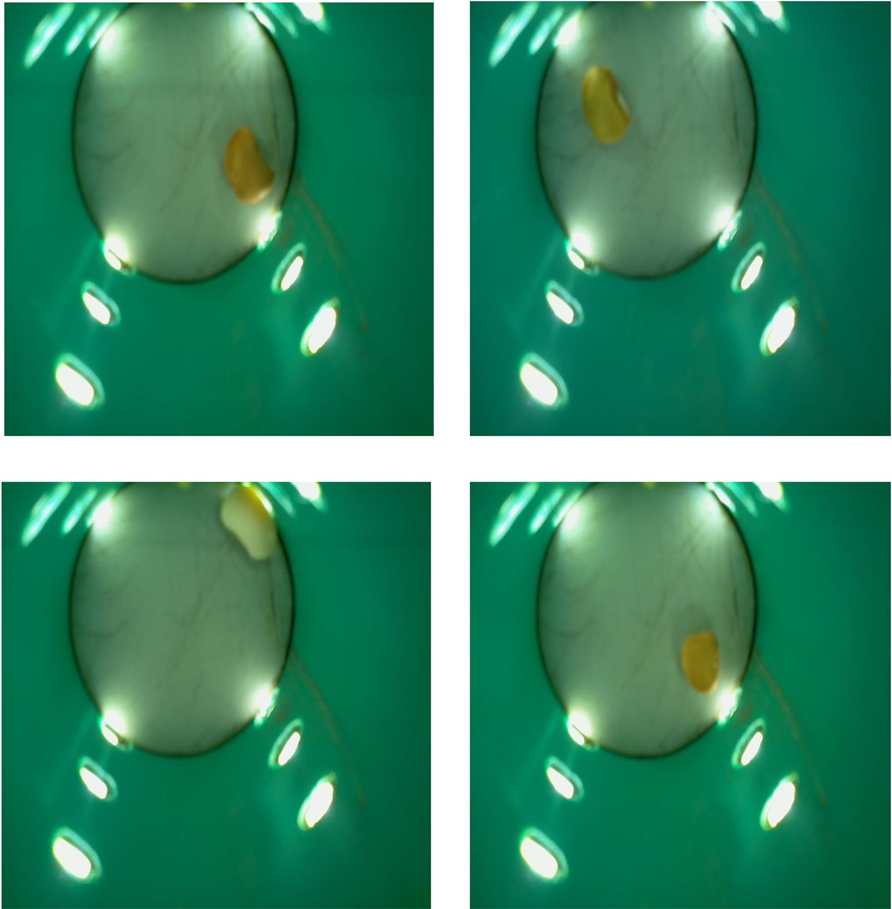

* 1. *Operational procedure of the automated device*

The operational flow diagram of the separating procedures is displayed in Fig. 3. The device was first turned on. Then material to be detected and separated was introduced as input into the metering de- vice hopper. Then metering drum at the end of the hopper, introduced it into the automation unit, one after the other. As the material passed into the automation units, motion and proximity sensors from the Rasp- berry Pi camera board detect its presence. When the material fell into the first detection chamber called the primary grain collector (compart- ment). This primary grain collecting chamber (compartment) was well illuminated by LED light bulbs (Fig. 2). The LED light bulbs were con- nected to the Pi camera board and come on when the automation device is turned on. The image photograph of the material was taken by the pi camera sensors in the primary collection chamber (compartment). This image was sent to the Raspberry pi board to be processed and compared it to previous images loaded into the board memory. The Raspberry pi board then activates the circular bottom plastic flipper (actuator) of the primary collection chamber (compartment) to rotate 90 degrees. This action allowed the material to move to the second chamber (com- partment) called the secondary grain collection chamber (compart- ment). This chamber also was illuminated by LED light bulbs. In the secondary grain chamber (compartment), separation decisions are

made. This decision was made using artificial intelligence program (see programs S1 and S2 in the supplementary material) developed by python program software, inputted into the Raspberry pi board. After comparing the taken image to the stored images, the Raspberry pi board automatically activates the actuator. The actuator here was the circular plastic flipper bottom of the secondary grain collecting chamber (compartment). This circular bottom flipped either flipped 90 degrees to the left or 90 degrees to the right. Each flipping of the bot- tom directs the material to either of the two outlet pipes. The outlet pipes are called the “Accepted and “Rejected” outlets. Materials move from the outlets onto the conveyor belt. These materials either fall to the right or left on the belt. The belt conveys them to another two out- lets at the end of the conveyor belt. A well labeled diagram of the com- plete assembled setup of the cowpea quality detection and separation device is shown in Fig. 4.

* 1. *Evaluation technique*

Three good quality cowpea seed varieties namely: NG/AD/11/08/ 0033, NG/OA/11/08/063, and NGB/OG/0055 samples were obtained at the National Center for Genetic Resources and Biotechnology (NACGRAB), Ibadan, Nigeria. Quality assessment and selection of sam- ple materials used for evaluation were carried out as displayed in

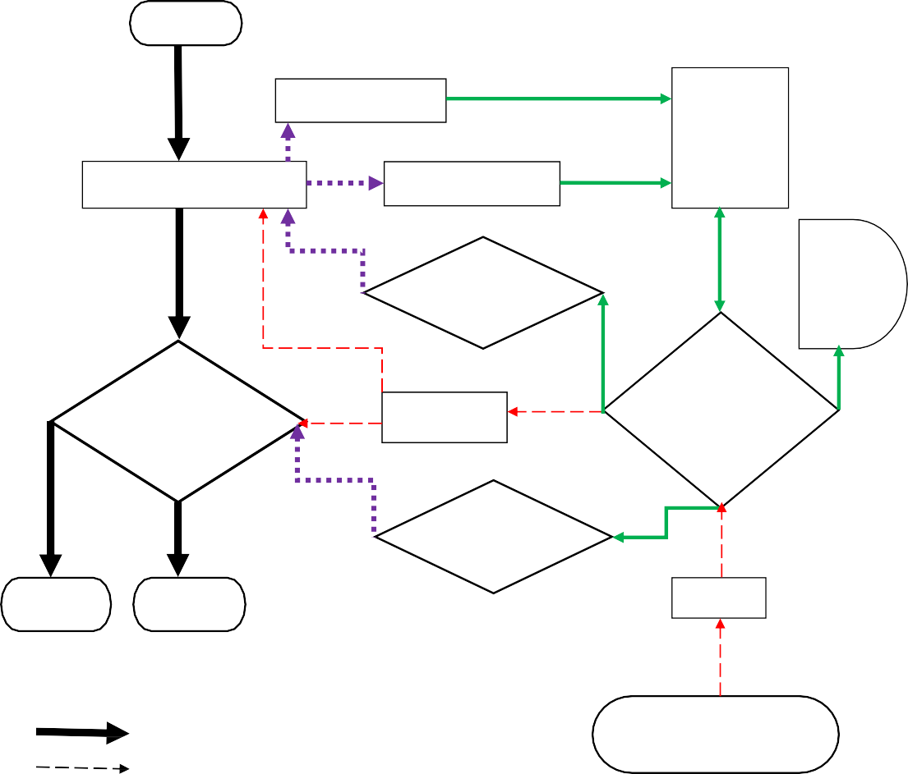

**Input**

**Motion Sensing**

**Primary Seed Collector**

**Image Sensing**

**Camera**

**/motion board with sensors**

**Servo Motor & Flipper 1**

**TFT**

**screen display**

**Secondary Seed Collector**

**LED lights**

**Raspberry Pi Circuit Board**

**Servo Motor & Flipper 2**

**Reject**

**Accept**

**Adaptor**

**Separating Materials Flow**

**PVC Pipe Outline**

**Electric power Source**

### Automation Action Programmed information flow Electrical Current Flow

Fig. 3. Flow Chart of Automation unit of cowpea Seed/Impurity separation.

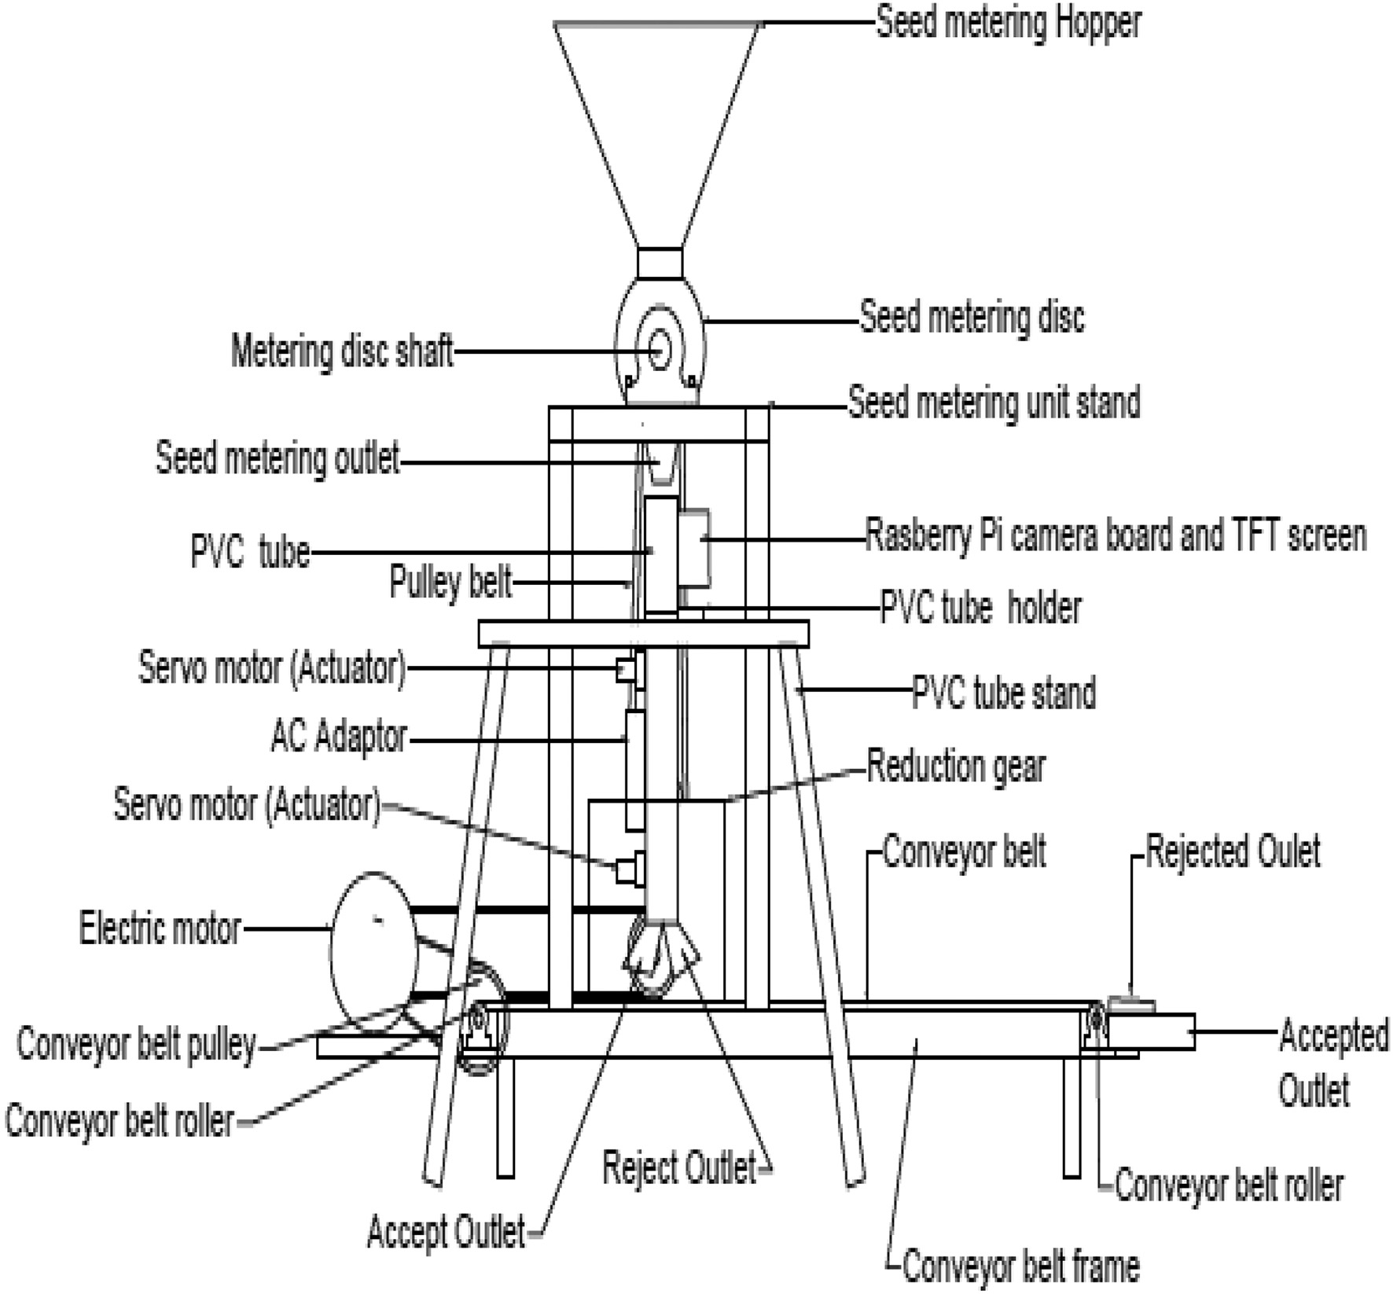

Fig. 4. Labeled diagram of the complete assembled setup of the cowpea quality detection and separation device.

Table 1. Images of impurities (bad portion) used in this study to mix with good seeds (good portion) are displayed in Fig. 5. These impurities are made up of:

Table 1

Quality assessment and selection of materials used for evaluation.

Quality parameters Grade 1 Grade 2 Grade 3

Range of quality parameters limits of cowpea compile from international standards Broken Seeds (%) 2 – 3a,b,c,f,g 3 – 5a,b,c,d,e 6 -7a,b,c,d,e,f

Foreign Body (%) 0.5–0.8a,b,d,e,g,i 1a,b,e,f.g,i 2a,b,c,d,e,f,g.h,i

Damage Seeds (%) 4 – 6a,b,d,e,f,g 7 – 10a,b.c,e,f,g 15a,b,c,d,e,f,g Bad portion (%) 6.5–10.8 11–16 23–24

Good portion (%) 93.5–89.2 89–84 77–76

Total (%) 100 100 100

Quality parameters used for preparing cowpea sample for this study

|  |  |  |  |
| --- | --- | --- | --- |
| Broken Seeds | 3% (0.06 kg) | 5% (0.1 kg) | 7% (0.14 kg) |
| Foreign Body | 0.8% (0.016 kg) | 1% (0.02 kg) | 2% (0.04 kg) |
| Damage Seeds | 6% (0.12 kg) | 10% (0.2 kg) | 15% (0.3 kg) |
| Bad portion | 9.8% (0.196 kg) | 16% (0.32 kg) | 24% (0.48 kg) |
| Good portion | 90.2% (1.804 kg) | 84% (1.68 kg) | 76% (1.52 kg) |
| Total | 100% (2 kg) | 100% (2 kg) | 100% (2 kg) |

Sources: (a) African Standard, 2012; (b) United States Standards for Beans, 2008; (c) Draft

1. Damaged seeds - cowpea seeds exposed to natural environment for six months for it to be both insect and fungal affected (Fig. 5a and b)
2. Broken seeds – Crushed cowpea seeds (Fig. 5c)
3. Foreign body - Stones (ranging from 6 to 10 mm in diameter) (Fig. 5d)

To evaluate the device (machine) performance, a 2 kg of an ex- perimental sample (good + bad portion), made up of different va- rieties and quality grades (percentage of impurity: grade 1, 2, and 3) was poured into the metering hopper. This was metering at speeds of 12, 16, and 20 rpm. Separated samples were collected at the rejected and accepted outlets of the belt conveyor. Both sepa- rated samples that were collected from the outlets at the end of each run (experiment). Were further hand sorted into good seeds, broken seeds, foreign body, and damaged seeds. They were then weighed and recorded. The time for each experimental run was also taken and recorded. Evaluation parameters were calcu- lated as displayed by eqs. (1)–(5):

* 1. The separating efficiency of Automation device (E)(%) is the Impu- rity removal efficiency

Malawi Standard (2015); (d) AHCX Commodities Exchange, 2014; (e) Australian Pulse Standards, 2014/15; (f) EAC, 2010, Codex Standard 171–1989; (g) FDUS EAS 755., 2013

* + 1. Codex Standard 171-1989, n.d.

*E* = *weight of impurity collect at the reject outlet Tatal weight of impurity used for experiment*

*x* 100 (1)

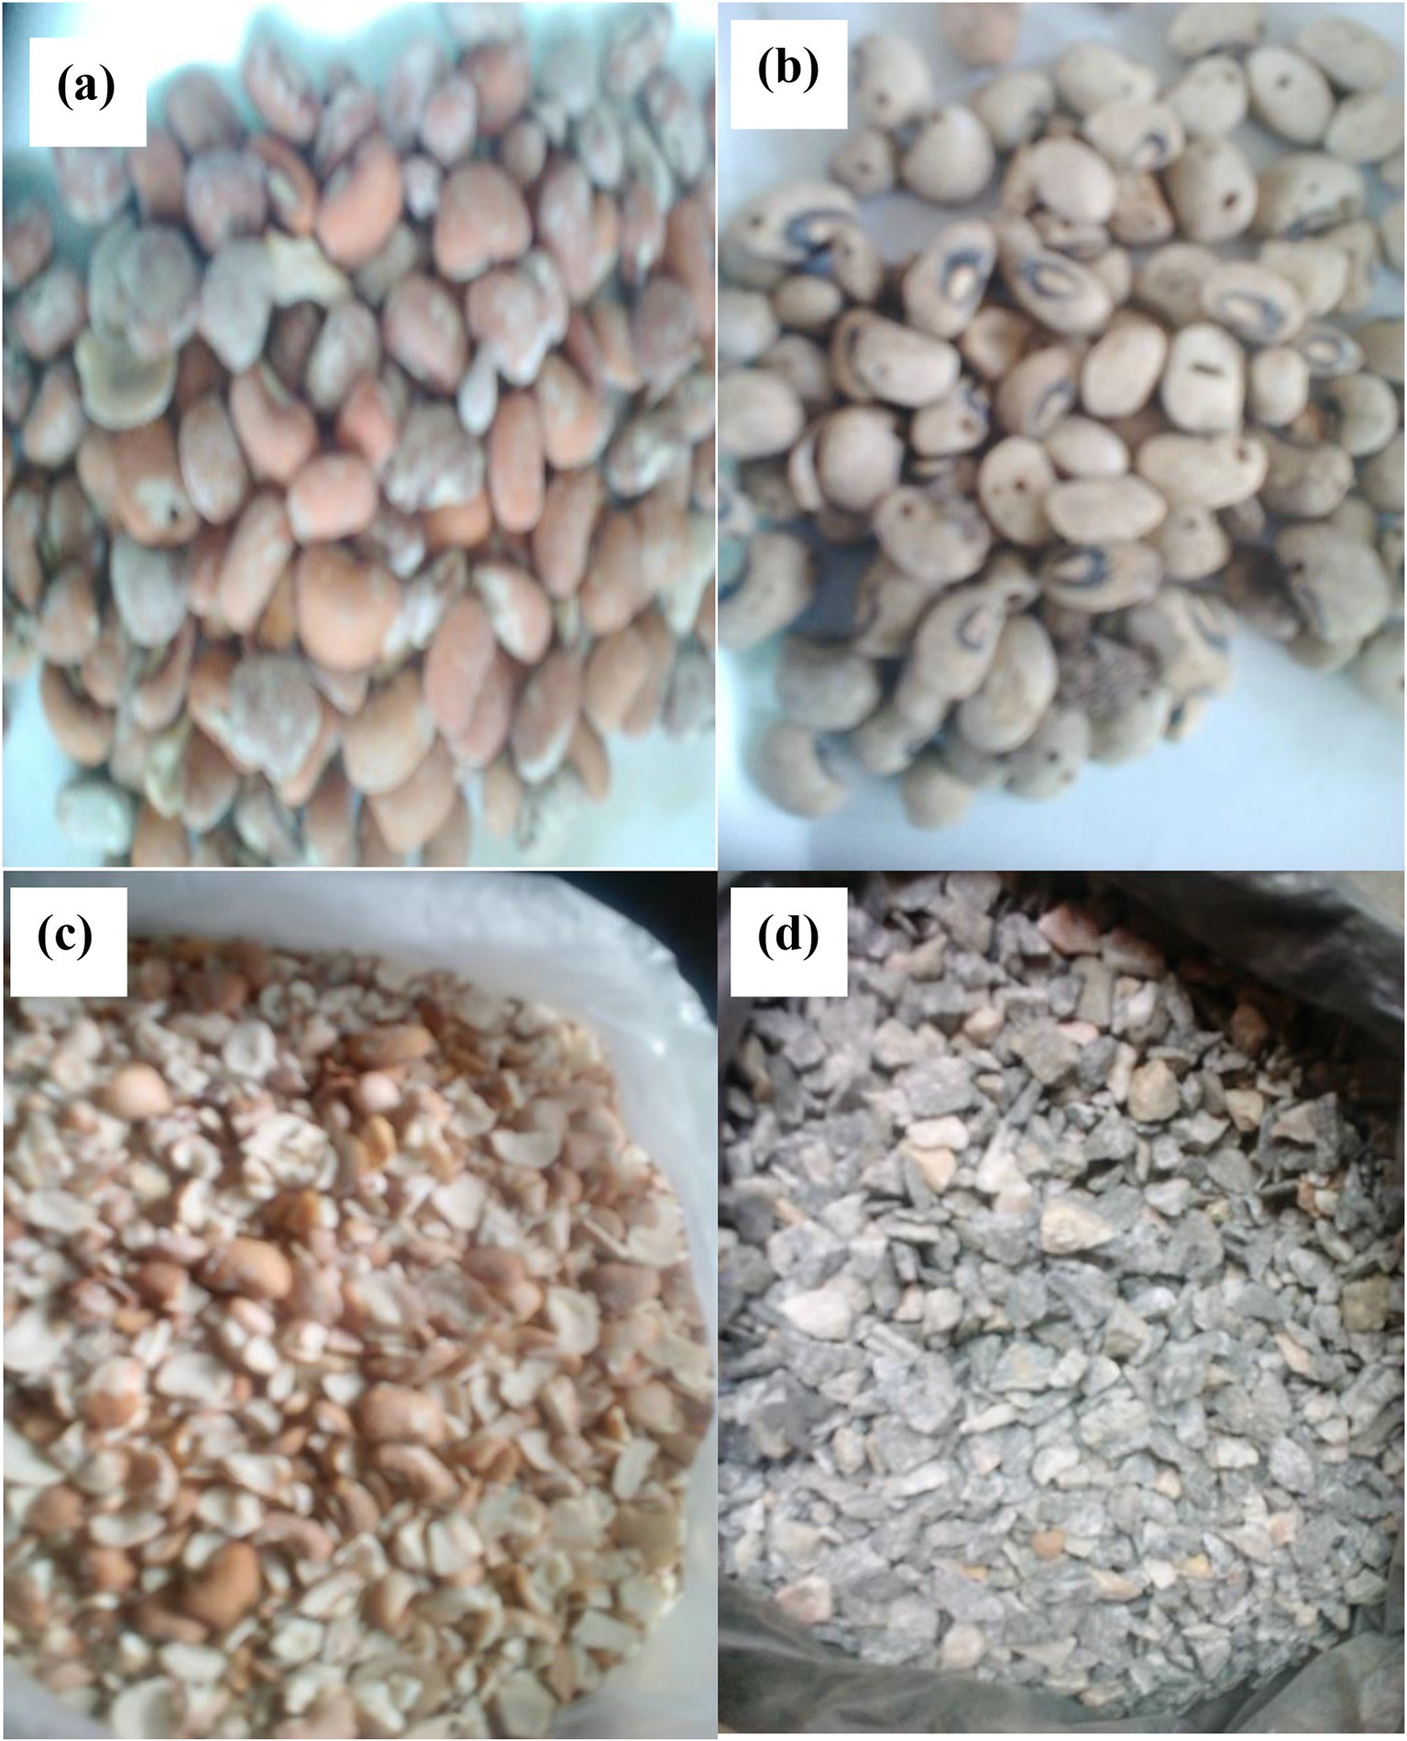

Fig. 5. Pictures of (a) diseased seeds (b) insect infected seeds (c) broken seeds and (d) stones; used for preparing impurity.

Total weight of impurity = weight of (Broken seeds + Foreign

bodies + Damage seeds) (2)

*Actual Utilization* (*AU*) = *Throughput* (*T*)

*Maximum Capacity* (*MC*)

(5)

* 1. Throughput of Automation device (T) (kg/h) is the Impurity removed in one hour

*T* = *weight of impurity coming out of the rejected outlet in one hour*

(3)

* 1. Maximum Capacity of Automation device (MC) (kg/12 h) is the impurity removed in 12 h (assuming the device is only allowed to operate for only 12 h a day)

*MC* = *Throughput rate x operation time* = *T x* 12 *hours* (4)

* 1. Actual utilization of Automation device

Machine utilization is a measure of how intensively a machine is being used. Machine utilization compares the actual machine time (setup and run time) to available time.

Operational factors used for evaluating were speed of metering de- vice, seeds varieties and seed grades.

* 1. *Modeling, optimization, and validation*

The experimental design used for modeling and collection of data was response surface I-optimal design. Software used for both modeling and optimization was “Design Expert” version 10. The goals of the optimization were to achieve device settings that

will produce maximum impurity separation efficiency, throughput, and capacity. Validation on the device was done using two statisti- cal analyses: The regression analysis test and the Prediction interval test.

1. Results and discussion
   1. *Evaluation*

The experimental results obtained during the evaluation are shown in Table 2. Summary of the modeling activity were displayed in Table 3. Impurity separation efficiency obtained during evaluation range from 68.966–94.118% with a mean result of 82.758%. The standard deviation of the experiment was 7.479%. A low standard deviation value of 7.479% shows that majority of the impurity separation efficiency results ob- tained are close to the mean result of 82.752%. This is good, owning to the fact that constant operational high separating efficiency is a desir- able characteristic for a quality control device. Similar separating accu- racies ranges had been achieved by Casady and Paulsen (1989), Georg et al. (1995), Wan (2002), Pearson (2009), Pearson (2010), Kirilova et al. (2013), Arkadiusz and Andrzej (2018) and Injante et al. (2020) for other grains and seeds. Impurity separating throughput results ob- tained range from 0.5–3 kg/h with a mean result of 1.352 kg/h. The stan- dard deviation of the experiment was 0.777 kg/h. A low standard deviation also signifies that the majority of the results obtained do not spread along with the range but concentrate around the mean through- put of 1.352. This is also a good quality for predicting device perfor- mance. Similar throughput results ranges for other grains and seeds were reported by Wan (2002), Pearson (2009), and Pearson (2010). The maximum impurity separation capacity results obtained range from 6 to 36 kg/12 h. The mean value obtained was 16.404 kg/12 h with an experimental mean deviation of 9.473 kg/12 h. A low standard deviation value of 9.473 kg/12 h shows that majority of the maximum impurity separation capacity results obtained are close to the mean re- sult of 16.404 kg/12 h. This knowledge can help the operator schedule his working hours and cost of operation. The actual Utilization capacity results obtain for the device were 0.083 (8.3%) all through the

experiments. This is because a constant sample weight of 2 kg was used throughout the evaluation experiments. 2 kg represent 8.3% of the device material carrying and processing capacity at a time. From this information, this study deduced that the device can carry and pro- cess 24 kg (100% utilization) at a time.

* 1. *Effects of operational factors on evaluation parameters*

The effects of operational factors like speed of metering, variety, and grade of the sample used; on evaluation parameters like separating effi- ciency, throughput, and maximum capacity are displayed graphically in Fig. 6 and 7. A 2D plot of separating efficiency on metering speed shows a quadratic relationship (Fig. 6a). This plot shows that an increase in seed metering speed reduced the separating efficiency to a point. Then further increments start to increase the efficiency. This phenomenon can be attributed, to the image processing time. The programmed image comparing time was set for five second (Program S2). So, increas- ing the speed of seed metering (feed rate) will lead to having more seeds in the separating chambers. This can lead to wrong decision dur- ing comparing acquired image to stored image, therefore reducing sep- aration efficiency. Similar observation was mentioned by Pearson et al., 2008 during his evaluation of a developed color image based sorter for separating red and white wheat. They also notice that increasing the federate affected the sorting accuracy of wheat seeds from its impurity. So therefore, this study recommends that to increase separation effi- ciency the metering speed should be reduced from its design metering speed of 15 rpm. A 3D graph of separating efficiency on variety and grade shows that; NG/AD/11/08/0033 (small white seeds) has the highest separating efficiency and NGB/OG/0055 (red seeds) the lowest (Fig. 7a). This trend can be explained to be caused by the bright white colors and the small sizes of NG/AD/11/08/0033 variety. Its color makes it easier to detect by the pi camera while its size allows it to be metered faster. The NGB/OG/0055 (red seeds) variety color delay dur- ing its detection, which could be due to colour spectrum band differ- ences. Similar condition was reported by Pasikatan and Dowell (2003), during evaluation of a high speed sorter for separating impurity in white and red wheat. The sorting sensitivity and accuracy was less for

Table 2

Automation device evaluation results.

|  |  |  |  |  |  |  |  |  |  |  |  |
| --- | --- | --- | --- | --- | --- | --- | --- | --- | --- | --- | --- |
| Run | Factors |  |  |  | Responses |  | | | | | |
|  | Speed of Metering  rpm | Grade | Variety |  | Separating Efficiency  % |  | Separating Throughput  kg/h |  | Maximum separating capacity  kg/12 h | Actual Utilization |  |
| 1 | 16 | 1 | 33 |  | 91.892 |  | 0.680 |  | 8.160 | 0.083 |  |
| 2 | 16 | 3 | 33 |  | 90.909 |  | 1.818 |  | 21.818 | 0.083 |  |
| 3 | 12 | 2 | 33 |  | 90.615 |  | 0.875 |  | 10.500 | 0.083 |  |
| 4 | 16 | 3 | 55 |  | 72.727 |  | 1.333 |  | 16.000 | 0.083 |  |
| 5 | 20 | 1 | 63 |  | 80.973 |  | 2.257 |  | 30.542 | 0.083 |  |
| 6 | 20 | 2 | 63 |  | 81.579 |  | 2.583 |  | 31.000 | 0.083 |  |
| 7 | 20 | 3 | 63 |  | 81.818 |  | 2.647 |  | 31.765 | 0.083 |  |
| 8 | 16 | 1 | 55 |  | 70.000 |  | 0.784 |  | 11.000 | 0.083 |  |
| 9 | 20 | 2 | 55 |  | 76.923 |  | 3.000 |  | 36.000 | 0.083 |  |
| 10 | 16 | 3 | 63 |  | 82.353 |  | 2.100 |  | 25.200 | 0.083 |  |
| 11 | 12 | 1 | 55 |  | 73.171 |  | 0.500 |  | 6.000 | 0.083 |  |
| 12 | 12 | 3 | 63 |  | 85.739 |  | 1.045 |  | 12.674 | 0.083 |  |
| 13 | 16 | 1 | 33 |  | 91.892 |  | 0.680 |  | 8.160 | 0.083 |  |
| 14 | 16 | 3 | 55 |  | 72.727 |  | 1.333 |  | 16.000 | 0.083 |  |
| 15 | 20 | 3 | 33 |  | 90.000 |  | 2.647 |  | 31.765 | 0.083 |  |
| 16 | 16 | 3 | 33 |  | 90.909 |  | 1.818 |  | 21.818 | 0.083 |  |
| 17 | 20 | 1 | 55 |  | 77.295 |  | 1.231 |  | 14.769 | 0.083 |  |
| 18 | 12 | 2 | 63 |  | 82.143 |  | 0.852 |  | 10.222 | 0.083 |  |
| 19 | 12 | 1 | 63 |  | 80.645 |  | 0.577 |  | 6.923 | 0.083 |  |
| 20 | 12 | 2 | 63 |  | 82.000 |  | 0.810 |  | 10.000 | 0.083 |  |
| 21 | 12 | 1 | 33 |  | 94.118 |  | 0.571 |  | 6.857 | 0.083 |  |
| 22 | 16 | 2 | 33 |  | 89.286 |  | 1.190 |  | 14.286 | 0.083 |  |
| 23 | 12 | 2 | 55 |  | 68.966 |  | 0.606 |  | 7.273 | 0.083 |  |
| 24 | 16 | 1 | 63 |  | 82.353 |  | 0.700 |  | 8.400 | 0.083 |  |
| 25 | 16 | 2 | 33 |  | 87.923 |  | 1.154 |  | 12.978 | 0.083 |  |

Table 3

Summary of modeling of automation device evaluation parameter.

|  |  |  |  |  |  |  |  |  |
| --- | --- | --- | --- | --- | --- | --- | --- | --- |
| Software: Design Expert Version 10  Study Type: Response Surface  Design Type: I-optimal  Subtype: Randomized  Blocks: No Blocks |  | | | | | | | |
| Factor Units Type | Subtype | Mi⁎ | Max⁎ | Coded | Values |  | Mean | Std. Dev.⁎ |
| Speed of Metering rpm Numeric | Discrete | 12 | 20 | 1 = 12 | 1 = 20 |  | 15.68 | 3.038 |
| Grade Categorical | Nominal | 1 | 3 |  | Levels: |  | 3 |  |
| Variety Categorical | Nominal | 055 | 063 |  | Levels: |  | 3 |  |
| Response Units Obs⁎ | Analysis | Min⁎ | Max⁎ | Mean | Std. Dev.⁎ | Ratio | Trans⁎ | Model |
| Separating Efficiency % 25 | Polynomial | 68.966 | 94.118 | 82.758 | 7.479 | 1.365 | None | Quadratic |
| Separating Throughput kg/h 25 | Polynomial | 0.500 | 3.000 | 1.352 | 0.777 | 6 | None | Linear |
| Maximum separating capacity kg/12 h 25 | Polynomial | 6.000 | 36.000 | 16.404 | 9.473 | 6 | None | Linear |
| Actual Utilization 25 | Polynomial | 0.083 | 0.083 | 0.083 | 2.83E-17 | 1 | None | Linear |

⁎Obs is Observation, Min is Minimum, Max is maximum, Trans is Transformation, Std. Dev. is Standard Deviation.

the red wheat blend than for the white. This study had therefore shown that the developed device separate white cowpea better than red. A plot of the device throughput with metering speed shows a linear relation- ship (Fig. 6b). Throughput increases as metering speeds are increased. This behavior can be explained from the point of view that increasing the metering speed increase the number of material introduced into the automated unit in one hour. So therefore, more impurities are likely to be a separation in one hour. Kawusara (2019) and Injante et al. (2020) also reported similar observation during evaluation and testing

of their image processing devices for cowpea and lima beans respec- tively. Although throughput range of 0.5–3 kg/h obtained is low com- pare to that obtained by previous researchers for other grains and seeds. To improve this, then the use of a higher version of the raspberry board with lesser decision time (processing speed) with HD camera is recommends. A 3D plot of throughput on variety and grade shows that; NG/OA/11/08/063 has the highest throughput and NGB/OG/0055 the lowest; grade 3 has the highest throughput and grade 1 the lowest (Fig. 7b). This could be because NG/OA/11/08/063 variety has a very

Design-Expert® Software Factor Coding: Actual Separating Efficiency (%)  Design Points

95% CI Bands

X1 = A: Speed of Metering Actual Factors

B: Grade = 3

C: Variety = 033

100

90

Separating Efficiency (%)

80

70

One Factor

Design-Expert® Software Factor Coding: Actual Separating Throughput (kg/hr)  Design Points

95% CI Bands

X1 = A: Speed of Metering Actual Factors

B: Grade = 3

C: Variety = 033

3

2.5

Separating Throughput (kg/hr)

2

1.5

1

One Factor

Design-Expert® Software Factor Coding: Actual

60

12 14 16 18 20

A: Speed of Metering (rpm)

One Factor

0.5

12 14 16 18 20

Warning! Factor involved in multiple interactions.

2

**(a)**

Prediction 90.0713

2

**(b)**

Prediction 2.45126

A: Speed of Metering (rpm)

Maximum separating capacity (kg/12hr)  Design Points

**(c)**

2

Prediction 29.4055

Maximum separating capacity (kg/12hr)

40

95% CI Bands

X1 = A: Speed of Metering Actual Factors

30

B: Grade = 3

C: Variety = 033

20

10

0

12 14 16 18 20

A: Speed of Metering (rpm)

Fig. 6. 2D graphs on effect of speed of metering on (a) Separating Efficiency (b) Separating Throughput (c) Maximum separating capacity.

Design-Expert® Software Factor Coding: Actual Separating Efficiency (%)

 Design points above predicted value  Design points below predicted value

X1 = B: Grade X2 = C: Variety

Actual Factor

A: Speed of Metering = 20

90.0713

Design-Expert® Software Factor Coding: Actual Separating Throughput (kg/hr)

Design points above predicted value Design points below predicted value

X1 = B: Grade X2 = C: Variety

Actual Factor

A: Speed of Metering = 20

3

Separating Throughput (kg/hr)

2.45126

## (a)

100

90

Separating Efficiency (%)

80

70

60

063

055

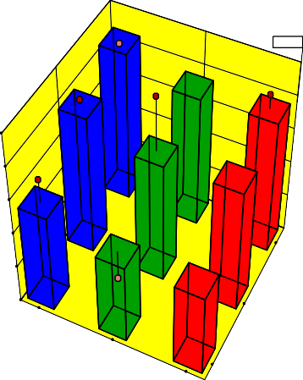033

3

2

B: Grade

1 Design-Expert® Software Factor Coding: Actual

## (b)

2.5

2

1.5

1

0.5

063

055

C: Variety

033

3

2

B: Grade

1

C: Variety

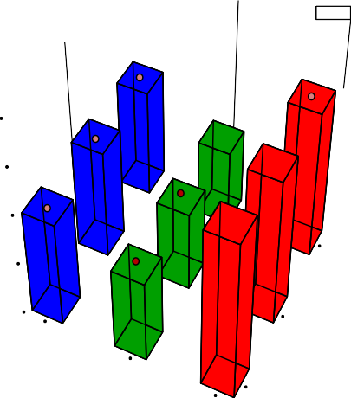

Maximum separating capacity (kg/12hr) Design points above predicted value Design points below predicted value

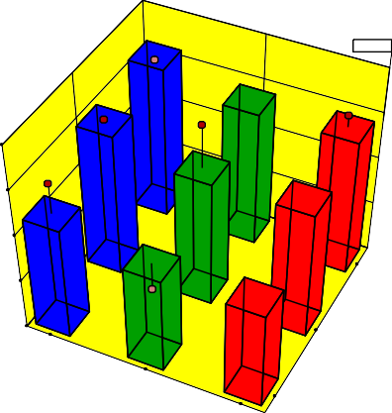X1 = B: Grade X2 = C: Variety

Actual Factor

Maximum separating capacity (kg/12hr)

A: Speed of Metering = 20

40

**(a)** 30

29.4055

20

10 3

0

063

055

C: Variety

033

2

B: Grade

1

Fig. 7. 3D graphs on effect of seed variety and grade On (a) Separating efficiency (b) Separating throughput (c) Maximum separating capacity.

bright white color which is easier to detect than NGB/OG/0055 which has red coloured seeds. Also, grade 3 having more impurity must sepa- rate more impurity per time. Similarly throughput behavior had been

observed by Pearson et al. (2008), Pearson (2009) and Pearson (2010). A graph of maximum capacity plotted on metering speed, be- havior similar to that of throughput graph (Fig. 6c). Also, 3D plot of

Table 4

Optimized results of evaluation of operational performance on automation device.

|  |  |  |  |  |  |  |  |  |  |  |
| --- | --- | --- | --- | --- | --- | --- | --- | --- | --- | --- |
|  | Constraints |  | | | | | | | | |
|  |  |  | Lower |  | Upper | Lower | Upper |  |  |
| Name | Goal |  | Limit |  | Limit | Weight | Weight | Importance |  |
|  | Speed of Metering | In range |  | 12 |  | 20 | 1 | 1 | 3 |  |
|  | Grade | In range |  | 1 |  | 3 | 1 | 1 | 3 |  |
|  | Variety | In range |  | 055 |  | 063 | 1 | 1 | 3 |  |
|  | Efficiency | Maximize |  | 68.966 |  | 94.118 | 1 | 1 | 3 |  |
|  | Throughput | Maximize |  | 0.5 |  | 3 | 1 | 1 | 3 |  |
|  | Maximum capacity | Maximize |  | 6 |  | 36 | 1 | 1 | 3 |  |
|  | Actual Utilization | none |  | 0.083 |  | 0.083 | 1 | 1 | 3 |  |
|  | Solution Number | Speed of Metering | Grade | Variety | Efficiency | Throughput | Maximum capacity | Actual Utilization | Desirability |  |
|  | 1 | 20 | 3 | 033 | 90.071 | 2.451 | 29.405 | 0.083 | 0.799 |  |
|  | 2 | 20 | 2 | 033 | 90.054 | 2.287 | 27.445 | 0.083 | 0.754 |  |
|  | 3 | 20 | 3 | 063 | 81.852 | 2.689 | 32.781 | 0.083 | 0.737 |  |
|  | 4 | 20 | 2 | 063 | 82.183 | 2.525 | 30.821 | 0.083 | 0.706 |  |
|  | 5 | 20 | 1 | 033 | 92.598 | 1.694 | 20.926 | 0.083 | 0.607 |  |
|  | 6 | 20 | 1 | 063 | 81.464 | 1.932 | 24.302 | 0.083 | 0.558 |  |
|  | 7 | 20 | 3 | 055 | 75.484 | 2.413 | 29.185 | 0.083 | 0.535 |  |
|  | 8 | 20 | 2 | 055 | 76.270 | 2.249 | 27.224 | 0.083 | 0.524 |  |
|  | 9 | 20 | 1 | 055 | 76.748 | 1.656 | 20.705 | 0.083 | 0.412 |  |

maximum capacity on variety and grade behaviors similar to that of throughput plot on variety and grade (Fig. 7c). Similar explanations given to throughput graphs can also be used for the maximum capacity.

* 1. *Modeling and optimization*

Five polynomial equations were considered for modeling and opti- mization of evaluation parameters as shown in table S5 (Supplementary table). These equations were: linear, 2 factors interaction (2FI), qua- dratic (2 order polynomial), and cubic (3 order polynomial). A quadratic equation model was chosen for separating efficiency. This choice was base on the fact that among the model equations tested. The quadratic equation had the highest: lack of fit *p*-value (a value that describes whether the equation adequately describes the relationship between the variables); adjusted R-square (how close are the data results close to the regression line adjusted for the predictors) and predicted R- square (how well are predicted values close to the experimental values). Linear equation models were chosen for modeling and optimi- zation of separating throughput and maximum separating capacity. This choice was base on the fact that among the polynomials tested. The lin- ear equation had the highest sequential p-value (the probability that the terms are not modeling noise) and predicted R-square. These two model equations were used to optimize the evaluation parameters, but first the Analysis of Variance (ANOVA) and statistic parameters were calculated. The ANOVA, statistical parameters, and model equation terms for the evaluation parameters are displayed in tables S6, 7, and 8 (supplementary tables). ANOVA shows that all developed models for evaluating parameters were all significant at *P* < 0.05 while their lack fit were not significant at P < 0.05 (table S6). These are good indication of a very good predictive model. Table S7 shows the statistical quality of the developed equations. These statistic range are standard deviations (0–4.306), coefficient of variation (CV) (0–26.249), PRESS (0–654.111), −2 Log Likelihood (9–137.087), R-Squared (0.8–0.985),

Adjusted R-Squared (0.7–0.965), Predicted R-Squared (0.5–0.876), Ad- equate Precision (14–22.924), Bayesian information criterion (BIC) (29–156.401) and Akaike information criterion (AIC) (26–153.754). These modeling statistic ranges show that the developed models can be used to accurately optimize the evaluation parameters of the devel- oped device at 95% confident level. Model equations are displayed in table S8 (supplementary table).

The optimum solutions obtained from optimizing the device opera- tions are displayed in Table 4. The goals of the optimization were to achieve maximum separating: efficiency, throughput, and capacity. This was done within the experimental ranges of metering speed, vari- ety, and grades used in this study. Nine optimum solutions were achieved. The automation device achieved its highest separating effi- ciency (92%) when processing NG/AD/11/08/0033 variety of grade 1 with a metering speed of 20 rpm (solution 5 in Table 4). Maximum

# Separating Efficiency Validation

90.400



R² = 0.8926

**Predicted Validation Mean**

**(%)**

90.300

90.200

90.100

90.000

89.900

89.000 89.500 90.000 90.500 91.000 91.500

**Experimental Validation mean (%)**

# Separating Throughput Validation

2.900



R² = 0.7387

**Predicted Validation Mean**

**(kg/hr)**

2.800

2.700

2.600

2.500

2.200 2.300 2.400 2.500 2.600 2.700

### Experimental Validation mean (kg/hr)

**Mximum Separating Capacity Validation**

40.000



R² = 0.9895

**Predicted Validation Mean**

**(kg/12hrs)**

30.000

20.000

10.000

0.000

27.000 28.000 29.000 30.000 31.000 32.000 33.000

### Experimental Validation mean (kg/12hrs)

Fig. 8. Regression analysis for validation of automation device operation.

separating throughput (2.689 kg/h) was achieved when processing NG/OA/11/08/063 variety of grade 3 with a metering speed of 20 rpm (solution 3 in Table 4). Maximum separating capacity (32.781 kg/ 12 h) was achieved when processing NG/OA/11/08/063 variety of grade 3 with a metering speed of 20 rpm (solution 3 in Table 4). More

Table 5

Validation results for the automation device.

|  |  |  |  |  |  |  |  |  |  |  |  |
| --- | --- | --- | --- | --- | --- | --- | --- | --- | --- | --- | --- |
|  | Two-sided Confidence = 95% |  | | | | | | | | | |
| Factor | Level used for validation | | Low Level | High Level | | | Std. Dev.⁎ | | Coding |  |
|  | Speed of Metering | 20 | | 12 | 20 | | | 0 | | Actual |  |
|  | Grade | 3 | | 1 | 3 | | | N/A | | Actual |  |
|  | Variety | 033 | | 055 | 063 | | | N/A | | Actual |  |
| Response Predicted Validation | | | Predicted Median | Evaluation Data | Std Dev⁎ | N⁎ | Pred Std⁎ | 95% PI⁎ | Validation Experimental | 95% PI⁎ | |
| Mean | | | Validation | Mean |  |  | Error | low | mean | high | |
| Efficiency 90.071 | | | 90.071 | 82.758 | 1.389 | 5 | 1.863 | 85.920 | 90.142 | 94.223 | |
| Throughput 2.451 | | | 2.451 | 1.352 | 0.338 | 5 | 0.378 | 1.659 | 2.752 | 3.244 | |
| Maximum | | |  |  |  |  |  |  |  |  | |
| capacity 29.405 | | | 29.405 | 16.404 | 4.306 | 5 | 4.824 | 19.309 | 32.836 | 39.502 | |
| Actual  Utilization 0.083 | | | 0.083 | 0.083 | 1.36 × 10−17 | 5 | 0 | 0.083 | 0.083 | 0.083 | |

⁎n is Number of Experimental observation, PI is Prediction interval, Std Dev. is Standard Deviation, Pred Std is Predicted standard.

choices can be made from Table 4, depending on operational goals. All optimal results were obtained at a metering speed of 20 rpm. This means that the automated device should not be operated below or above a metering speed of 20 rpm.

* 1. *Validation*

Prediction interval (PI) statistical analysis test was done to validate the prediction ability of the models used; for optimizing separating effi- ciency, separating throughput, and maximum separating capacity. The mean validation results were displayed in Table 5 (full results are displayed in table S9 in supplementary material). The analysis shows that the mean validation experimental results obtained; for separating efficiency, separating throughput, and maximum separating capacity all lay between calculated low 95% prediction intervals (95% PI) and cal- culated high 95% prediction intervals (95% PI). This indicates that the models are predicting within a statistically expected range. Further- more, a regression analysis was also done to validate the predictive abil- ity of the models (Fig. 8). A regression graph between the predicted results was plotted against validation experimental results. This graphs show coefficient of determination (R2) value of 0.892 (89.2%) for sepa- rating efficiency, 0.738 (73.8%) for separating throughput, and 0.989 (98.9%) for maximum separating capacity. These values show that the developed models used for optimization predictions were within the range of 73–93% accurate and precise.

1. Conclusions

An automated (artificially intelligent) quality separating device was developed with three units. These units are the metering, automating, and belt conveying outlet. To evaluate the device; its separating effi- ciency, throughput, and maximum capacity were modeled and opti- mized. An optimal: impurity separating efficiency of 92%, impurity separating throughput of 2.689 kg/h, and maximum impurity separat- ing capacity of 32.781 kg/12 h were achieved. The effects of operating factors like cowpea variety, cowpea export grades, and metering speed on device evaluation parameters like impurity separating: effi- ciency, throughput, and maximum capacity were established. It was also established that the metering speed of the device should not go below or above 20 rpm for optimal impurity separating results. This ar- tificially intelligent (smart) device can also be used in cowpea seeds grading processing line to achieve cowpea seeds export grade quality.

Declaration of Competing Interest

There is no conflict of interest what so ever between co-author and me. This research was not funded by any cooperation or institution. This research was part of my PhD research work.

Appendix A. Supplementary data

Supplementary data to this article can be found online at [https://doi.](https://doi.org/10.1016/j.aiia.2021.10.003) [org/10.1016/j.aiia.2021.10.003](https://doi.org/10.1016/j.aiia.2021.10.003).

References

African Centre for Biodiversity (ACB), 2015. GM and Seed Industry Eye Africa’s Lucrative Cowpea Seed Markets: The Political Economy of Cowpea in Nigeria. Burkina Faso, Ghana. [https://www.acbio.org.za/gm-and-seed-industry-eye-africas-lucrative-](https://www.acbio.org.za/gm-and-seed-industry-eye-africas-lucrative-cowpea-seed-markets-political-economy-cowpea-nigeria) [cowpea-seed-markets-political-economy-cowpea-nigeria](https://www.acbio.org.za/gm-and-seed-industry-eye-africas-lucrative-cowpea-seed-markets-political-economy-cowpea-nigeria).

African Standard, 2012. Cowpeas — Specification. CD-ARS 867. Organization for Standard- ization, African . [www.arso-oran.org](http://www.arso-oran.org/).

AHCX Commodities Exchange, 2014. AHCX Cowpeas Contract. Malawi. [www.](http://www.ahcxmalawi.com/beta/wp-content/.../03/AHCX-Cow-peas-Contract-2014.pdf) [ahcxmalawi.com/beta/wp-content/.../03/AHCX-Cow-peas-Contract-2014.pdf](http://www.ahcxmalawi.com/beta/wp-content/.../03/AHCX-Cow-peas-Contract-2014.pdf) accessed on 24/7/2017.

Al-Baali, M., Grandinetti, L., Purnama, A., 2018. Numerical Analysis and Optimization. Springer Proceedings of the Fourth International Conference on Numerical Analysis and Optimization. Sultan Qaboos University, Muscat, Oman ISBN: 978-3-319- 90026-1 <https://images.springer.com/sgw/books/medium/9783319900254.jpg>.

Arkadiusz, N., Andrzej, S., 2018. Design of an automated rice grain sorting system using a vision system. Proc. SPIE 10808, Photonics Applications in Astronomy, Communica- tions, Industry, and High-energy Physics Experiments, 1080816 [https://doi.org/10.](https://doi.org/10.1117/12.2501658) [1117/12.2501658](https://doi.org/10.1117/12.2501658).

Australian Pulse Standards, 2014/15. [http://www.pulseaus.com.au](http://www.pulseaus.com.au/). Boumans, G., 1985. [Grain handling and storage. Developments in Agricultural Engineering](http://refhub.elsevier.com/S2589-7217(21)00030-1/rf0035)

[4. © Elsevier Science Publishers B.V ISBN 0-444-42439-3 (Vol. 4). ISBN 0-444-41940-](http://refhub.elsevier.com/S2589-7217(21)00030-1/rf0035) [3 (series](http://refhub.elsevier.com/S2589-7217(21)00030-1/rf0035)).

Casady W. W. and Paulsen, M. R., 1989. An automated kernel positioning device for com- puter vision analysis of grain. Trans. ASAE. 32 (5): 1821–1826. DOI: [10.13031/2013.31229](https://doi.org/10.13031/2013.31229).

Codex Standard 171-1989, d. Codex Standard for Certain Pulses [www.fao.org/.../](http://www.fao.org/.../standards/.../CXS_171e.pdf%3Bjsessionid%3D1F97060376D5A130C7F) [standards/.../CXS_171e.pdf%3Bjsessionid=1F97060376D5A130C7F](http://www.fao.org/.../standards/.../CXS_171e.pdf%3Bjsessionid%3D1F97060376D5A130C7F).

Dantzig, B.G., 2014. The Nature of Mathematical Programming. Archived. At the Way Back Machine. Mathematical Programming Glossary, INFORMS Computing Society. [http://](http://glossary.computing.society.informs.org/) [glossary.computing.society.informs.org](http://glossary.computing.society.informs.org/).

Draft Malawi Standard, 2015. Dry Beans – Specification. DMS 245. ICS 67.060 [www.](http://www.mbsmw.org/) [mbsmw.org](http://www.mbsmw.org/).

Dunlop, 2016. Conveyor Belting Technical Manual. Version 2.6. [www.dunlopconveyorbelting.](http://www.dunlopconveyorbelting.com/.../Dunlop_Technical_Manual) [com/.../Dunlop_Technical_Manual](http://www.dunlopconveyorbelting.com/.../Dunlop_Technical_Manual).

Fenner Dunlop, 2009. Convey Handbook. Convey Belting Australia. [www2.hcmuaf.edu.](http://www2.hcmuaf.edu.vn/.../5_Fenner%20Dunlop_%202009_%20Conveyor%20Handb) [vn/.../5_Fenner%20Dunlop_%202009_%20Conveyor%20Handb](http://www2.hcmuaf.edu.vn/.../5_Fenner%20Dunlop_%202009_%20Conveyor%20Handb).

EAC, 2010. East African standards. Cowpeas — Specification and Grading. CD/K/453. ICS

67.060. HS 0713.39.15. [www.each.int](http://www.each.int/).

FAO, IFAD, UNICEF, WFP, WHO, 2021. Transforming food systems for food security, im- proved nutrition and affordable healthy diets for all. The State of Food Security and Nutrition in the World 2021. FAO, Rome, Italy . <https://doi.org/10.4060/cb4474en>.

FAOSTAT, 2020. [http://www.fao.org/faostat/en/#data/QC](http://www.fao.org/faostat/en/%23data/QC) accessed 20 January 2021. FDUS EAS 755. 2013. Final Draft Uganda Standard. Cowpeas — Specification. UNBS. [www.](http://www.nubs.go.ug/)

[nubs.go.ug](http://www.nubs.go.ug/)

García, J., Peña, A., 2018. Robust optimization: concepts and applications. Chapter 2. In Book: Nature-Inspired Methods for Stochastic, Robust and Dynamic Optimization <https://doi.org/10.5772/intechopen.75381>.

Georg, B., Guth, N., Bockisch, F.J., 1995. Machine vision for the automatic measurement of broken grain fractions. IFAC Proceed. 28 (6), 139–142 Ostend. Belgium [https://doi.](https://doi.org/10.1016/S1474-6670(17)47174-6) [org/10.1016/S1474-6670(17)47174-6](https://doi.org/10.1016/S1474-6670(17)47174-6).

Habasit Fabric Conveyor Belt Engineering Guide, 2021. Services media No.6039. [https://](https://www.habasit.com/en/getToolDownloadFile.htm?...2) [www.habasit.com/en/getToolDownloadFile.htm?...2](https://www.habasit.com/en/getToolDownloadFile.htm?...2).

Henshaw, F.O., 2008. Varietal differences in physical characteristics and proximate com- position of cowpea (vigna unguiculata). World J. Agric. Sci. 4 (3), 302–306 ISSN 1817-3047 <https://www.raspberrypi.org/downloads/> accessed on 12/3/2018.

IITA, 2015. Cowpea.[Online]. Available: <http://www.iita.org/cowpea> Accessed in January 2021.

Injante, H., Gutiérrez, E., Vinces, L., 2020. A vibratory conveying system for automatic sorting of lima beans through image processing. IEEE XXVII International Conference on Electronics, Electrical Engineering and Computing (INTERCON), Lima, Peru,

pp. 1–4 <https://doi.org/10.1109/INTERCON50315.2020.9220231>.

Kawusara, N.S., 2019. Cowpea Sorter: An Alternative to the Manual Cowpea Sorting Pro- cess. Published thesisAshesi University. [https://air.ashesi.edu.gh/](https://air.ashesi.edu.gh/handle/20.500.11988/543) [handle/20.500.11988/543](https://air.ashesi.edu.gh/handle/20.500.11988/543).

Kirilova, E., Plamen, D., Tzvetelina, G., Rusin, T., 2013. Recognition and Grading of Sound and Fusarium Damaged Corn Seeds of Different Varieties using Prototype System based on Machine Vision. ICCST Year II, No. 1 [https://www.researchgate.net/profile/](https://www.researchgate.net/profile/Plamen_Daskalov/publication/259757351.pdf) [Plamen_Daskalov/publication/259757351.pdf](https://www.researchgate.net/profile/Plamen_Daskalov/publication/259757351.pdf).

Makowski, P.T., 2020. Optimizing concepts: Conceptual engineering in the field of man- agement. The case of routines research. Acad. Manag. Rev., 9–66 [https://doi.org/10.](https://doi.org/10.5465/amr.2019.0252) [5465/amr.2019.0252](https://doi.org/10.5465/amr.2019.0252).

O'Keefe, P.J., 2017. Engineering Expert Witness Blog: A Pulley Speed Ratio Formula Appli- cation. <http://www.engineeringexpert.net/Engineering-Expert-Witness-Blog/>.

Pasikatan, M.C., Dowell, F.E., 2003. [Evaluation of a high-speed color sorter for segregation](http://refhub.elsevier.com/S2589-7217(21)00030-1/rf0130) [of red and white wheat. Appl. Eng. Agric. 19 (1), 71–76](http://refhub.elsevier.com/S2589-7217(21)00030-1/rf0130).

Pearson, T., 2009. Hardware-based image processing for high-speed inspection of grains. Comput. Electron. Agric. 69, 12–18. <https://doi.org/10.1016/j.compag.2009.06.007>.

Pearson, T., 2010. High-speed sorting of grains by color and surface texture. Applied engineering in agriculture. ASABE 26 (3), 499–505 ISSN 0883-8542 [10.13031/2013.29948](http://10.13031/2013.29948).

Pearson, T., Brabec, D., Haley, S., 2008. Color image based sorter for separating red and white wheat. Sens. & Instrumen. Food Qual. 2, 280–288. [https://doi.org/10.1007/](https://doi.org/10.1007/s11694-008-9062-0) [s11694-008-9062-0](https://doi.org/10.1007/s11694-008-9062-0).

Rawal, V., Navarro, D.K., 2019. The Global Economy of Pulses. FAO, Rome. [http://www.fao.](http://www.fao.org/3/I8300EN/i8300en.pdf) [org/3/I8300EN/i8300en.pdf](http://www.fao.org/3/I8300EN/i8300en.pdf).

Sharma, D.N., Mukesh, S., 2010. Farm Machinery design Principles and Problems. Second edition. Pusa Agri-book Service, IARI, New Delhi. [https://www.google.com/farm-](https://www.google.com/farm-machinery-design-principles-problems-dn-sharma-8183601421-9788183601429) [machinery-design-principles-problems-dn-sharma-8183601421-9788183601429](https://www.google.com/farm-machinery-design-principles-problems-dn-sharma-8183601421-9788183601429).

Snapp, S., Rahmanian, M., Batello, C., 2018. In: Calles, T. (Ed.), Pulse Crops for Sustainable Farms in Sub-saharan Africa Rome, FA <http://www.fao.org/3/i7108en/i7108en.pdf>.

Srivastava, A.K., Goering, C.E., Rohrbach, R.P., Buckmaster, D.R., 2006. [Engineering Princi-](http://refhub.elsevier.com/S2589-7217(21)00030-1/rf0165) [ples of Agricultural Machines. 2nd edition. ASABE.MI 49085-9659 USA.LCCN:](http://refhub.elsevier.com/S2589-7217(21)00030-1/rf0165) [2005937948.ISBN: 1-892769-50-6. ASAE Publication 801M0206](http://refhub.elsevier.com/S2589-7217(21)00030-1/rf0165).

Stat-Ease, 2018. Design-Expert. [www.statease.com](http://www.statease.com/) Accessed on 20/6/2018.

Tech Briefs, 2019. Machine Vision Camera Trends: 2019 and Beyond. [https://www.](https://www.techbriefs.com/component/content/article/tb/supplements/pit/features/articles/35168) [techbriefs.com/component/content/article/tb/supplements/pit/features/](https://www.techbriefs.com/component/content/article/tb/supplements/pit/features/articles/35168) [articles/35168](https://www.techbriefs.com/component/content/article/tb/supplements/pit/features/articles/35168).

United States Standards for Beans, 2008. The United States, Department of Agriculture (USDA). Grain Inspection, Packers and Stockyards Administration. Federal Grain In- spection Service. <https://www.gipsa.usda.gov/fgis/standards/Bean-Standards.pdf>.

Wan, Y.N., 2002. Kernel handling performance of an automatic grain quality inspection system. Trans. ASAE 45 (2), 369–377. <https://doi.org/10.13031/2013.8508>.

Yalcin, I., 2007. Physical properties of cowpea (*Vigna sinensis* L.) seed. J. Food Eng. 79 (1), 57–62. <https://doi.org/10.1016/j.jfoodeng.2006.01.026>.

Zeigler, B.P., Alexandre, M., Ernesto, K., 2018. Introduction to systems modeling concepts. Chapter one. In Book: Theory of Modeling and Simulation [https://doi.org/10.1016/](https://doi.org/10.1016/B978-0-12-813370-5.00009-2) [B978-0-12-813370-5.00009-2](https://doi.org/10.1016/B978-0-12-813370-5.00009-2).

Engr. Dr. John Audu is a lecturer of the department of agricultural and environmental en- gineering, federal university of agriculture, Makurdi, Nigeria. His expertise includes agri- cultural system modeling, simulation, and optimization; design and automation of crop

processing machines; artificial intelligence and robotic in agriculture; application of ma- chine vision and internet of things in agriculture; design of crop processing and storage types of equipment.

Engr. Prof. A. K. Aremu is a lecturer of the department of agricultural and environmental engineering, university of Ibadan, Ibadan, Nigeria. His expertise includes farm power and machinery; design of agricultural processing equipment; environmental and energy stud- ies; design and automation of crop processing machines. He is the current head of the de- partment of agricultural and environmental engineering, university of Ibadan, Ibadan, Nigeria.