Available online at [www.sciencedirect.com](http://www.sciencedirect.com/)



AASRI Procedia 1 (2012) 454 – 462

AASRI

Procedia

[www.elsevier.com/locate/procedia](http://www.elsevier.com/locate/procedia)

2012 AASRI Conference on Computational Intelligence and Bioinformatics

# Development of GIS Server Application for Sharing and Utilizing Biodiversity Survey Database

Ibrahim Djamaluddina,*, Yasuhiro Mitania, Tetsukazu Yaharab

*aKyushu University, Motooka 744, Nishi-Ku, Fukuoka 819-0395, Japan*

*bKyushu University, Hakozaki 6-10-1, Higashi-Ku, Fukuoka 812-8581, Japan*

**Abstract**

In this paper, a GIS server system application has been developed using the ArcGIS technology for supporting biodiversity observation study. Survey database of China as for example has been used to investigate the effectiveness of the GIS server system. As a result, the developed server application is considerably valuable for creating, sharing and utilizing biodiversity information.

2012 Published by Elsevier B.V. Selection and/or peer review under responsibility of American Applied Science Research Institute Open access under [CC BY-NC-ND license.](http://creativecommons.org/licenses/by-nc-nd/3.0/)

*Keywords:* Bioinformatics; Geographical Information Systems (GIS); Server application

## Introduction

Now, biodiversity changes are eminent in Asia where the most serious biodiversity loss in the world is observed (Yahara, 2009). A network of biodiversity observation has been created in Asia as research fields to carry out integrative observations there. Important biodiversity observations are located in China, Indonesia, Cambodia and Japan. In these sites, intensive integrated observations are ongoing under the collaboration of scientists, citizens, and public sectors. Hence, coordinated strategies designed by sharing information and integrating data, play important role in defining interconnections and interdependencies in research as well as in increasing global awareness. In this respect, the objective of our research is to develop Geographic Information System (GIS)-based server system database to improve internal workflows at the field

* Corresponding author. Tel.: +81-92-802-3396; fax: +81-92-802-3396.

*E-mail address:* [ibrahim@doc.kyushu-u.ac.jp.](mailto:ibrahim@doc.kyushu-u.ac.jp)

2212-6716 © 2012 Published by Elsevier Ltd. Open access under [CC BY-NC-ND license.](http://creativecommons.org/licenses/by-nc-nd/3.0/)

doi:10.1016/j.aasri.2012.06.071

observations and to quicker sharing updated information of biodiversity observation data. In this paper, first, the research problems in the biodiversity information using GIS system are discussed. Second, the plan of designing seamless data integration using GIS portal for the comprehensive biodiversity information system is presented. Third, the GIS server system application as a core system is developed by combining the ArcGIS server and the Microsoft Visual Studio 2008 components. Finally, to verify the effectiveness of the GIS server system application, a case study of a biodiversity observation field is currently established for creating, sharing and utilizing biodiversity information, at the currently of our research outcomes.

## Research Challenges

The research groups are attempting to integrate biodiversity observations at many levels. Nevertheless the development of database and data-sharing system becomes difficult when handling enormous GIS datasets, which have complex data structure, complex coding, and complex versioning (Pollock and McLaughlin, 1991). There are also various data types with different volumes (Bradley et al. 1994). Data modeling is also one of the research challenges. It should be done before developing seamless data integration. After assessing the issues related to the present state of the biodiversity information in Asia, the research faces three greatest challenges that need to be tackled as following subsection.

* 1. *Management of huge datasets*

The biodiversity observation is carried out by integrating many systems. Many datasets are being stored by research groups on their local database and servers, so it is not always easy to get the data quickly. The most important task is to store in one of many data repositories of biodiversity observation. This would allow an effective monitoring of workflow processes that take place both within each respective site and throughout the research groups. It also makes the management of Asian biodiversity information easier. Such centralization of all related datasets using GIS server will be beneficial in urgent cases when all the data could easily be downloaded and relocated to off-site locations rather quickly so that there would be no loss of data (John and Donald, 1994).

* 1. *Handling global scale data*

Monitoring biodiversity changes such as using a series of remote sensing data will have an effect on data access performance. Enormous remote sensing data in the form of historical imagery will not easily and efficiently be accessible (Longley et al. 2001). This challenge is to serve the historical and present day raster data in the form of aerial imagery and all of the various remote sensing data. This research would try to apply GIS image server technology to handle large size of the image data and to improve the performance of a data access.

* 1. *Integrating and sharing data on high performance*

The collaboration of scientists, citizen and public sectors are key points for this biodiversity research to succeed. In the biodiversity observation research groups, many scientists are not GIS technicians, but nevertheless need to make a quick map of an area and analyze their field of interest. Citizens will need an easy-to-use application to make queries on GIS data and observe biodiversity changes. The process involved in distributing GIS data out to the general public who is not a technically savvy GIS person in a simple and yet easy way is a difficult task to accomplish.

## Designing Seamless Data Integration

An advanced research will be performed to create and design geodatabases which make full use of the capabilities of GIS application and server. Fig. 1 shows the framework of designing seamless data integration using GIS technology. In this framework, the geodatabases for biodiversity observation is not just another spatial data format that can be used by researcher; it is an integral part of the GIS system. The biodiversity observation data from research groups will be collected to develop datasets, data modeling and databases by utilizing the GIS workflow process and interoperability analysis. By storing datasets from biodiversity research groups, geospatial relationships will be modeled between observation researches data (feature datasets), enabling more advanced analysis. Furthermore, comprehensive geodatabases will be developed to provide additional functionality such as versioning, geodatabases replication and archiving. With comprehensive GIS data model, geospatial modeling capabilities, and scalable architecture, the developed geodatabases become the effective foundation of information infrastructures that enable the assembling of intelligent biodiversity information systems that can be adapted for many other GIS applications for related biodiversity study.

The intensive research on developing GIS server, image server and engine application will advance to build an integrated high performance dynamic data-sharing. Since the biodiversity research groups have variety of observation levels, this research will create applications that consume one or more services available through a GIS portal to provide powerful and intuitive tools. The three-core GIS technologies of server, image server and engine application will be integrated fully to improve efficiency and effectiveness of GIS server system. This strategy integration will give scientists the capability to organize and publish their research to improve knowledge sharing, reduce duplication of effort, direct scientists toward the best available data, and the overall quality of biodiversity data and information.

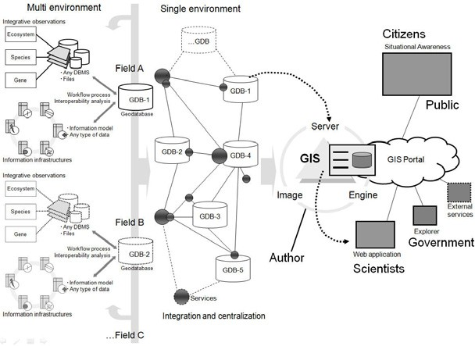

Fig. 1. Plan of designing database integration using GIS server where three-core GIS technologies will be employed in the system

## Application Development Using GIS Server Technology

Nowadays, it is ordinary to observe maps or other geographic information integrated seamlessly into Web sites (Peterson, 2005). ArcGIS-based server can be used to share the GIS resources across an enterprise and

across the Web. GIS resources are the maps, globes, address locators, geodatabases, and tools. The main advantages of sharing GIS resources on a GIS server are the same as sharing any data through any kind of server technology (Goodchild, 1993). ArcGIS Server can display the geographic information of biodiversity data on the Web, whether needs a custom application that simply displays a map or a more sophisticated one that incorporates specialized GIS tools. Access to the GIS server is embedded inside the Web application and typically hidden from the user of the application.

* 1. *GIS server system components*

Fig. 2 shows the architecture of ArcGIS server system based on the latest GIS technology (ESRI, 2007). GIS-based server system is invented of several of the following main components that are: GIS server, web server, clients and data server.

* + - The GIS server hosts the GIS resources and exposes them as services to client applications. The GIS server is composed of two distinct parts that is: the server object manager (SOM) and server object containers (SOC). The SOM manages the services running on the server. When a client application requests the use of a particular service, the SOM provides one for the client to use. The SOM connects to one or more SOC. The SOC machines host the services that the SOM manages. Depending on the configuration, it can be run the SOM and SOC on different machines.
    - The web server hosts web applications and services that use the resources running on the GIS server. Clients are web, mobile, and desktop applications that connect to ArcGIS server internet services or ArcGIS server local services through the intranet.
    - The data server contains the GIS resources that have been published as services on the GIS server. These resources can be map documents, address locators, globe documents, geodatabases, and toolboxes.

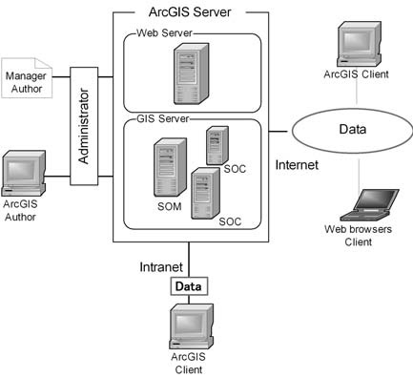

Fig. 2. Server system architecture using ArcGIS technology

## Integrated Application Using GIS Server

The current research is progressing to develop two types of the server applications. First type is a server application by creating web service application with ArcGIS Server Manager. ArcGIS server manager is a wizard for creating web mapping application that uses services. The main steps in creating GIS web

application are shown in Fig. 3. Once GIS resource has been created, it can be published rapidly as a service using ArcGIS server manager. The interface of the web application created by GIS server manager that mainly uses to share information. Web GIS application would be the simple system that would allow public to discover. The web application that created in server manager can be opened and then edited in Microsoft Visual Studio for further customization.

Create a web application

Log in to server manager

Choose the map service

Configuring tasks

Deploying the application

Fig. 3. Main steps in creating web application as service using ArcGIS Server Manager

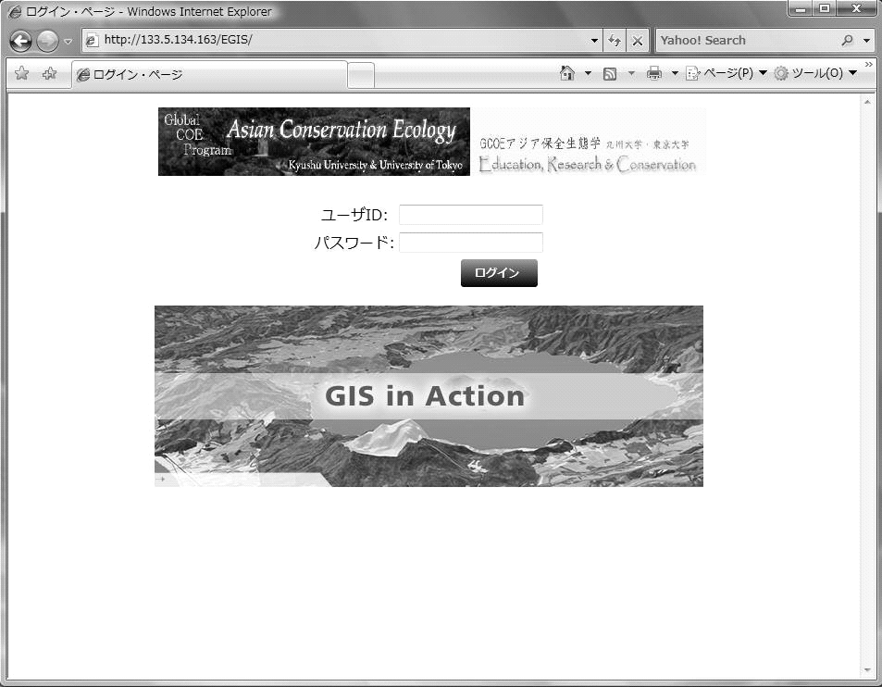

User ID Password

Log in

Fig. 4. Global resource interface of the GIS server integrated application which has been developed in a GIS server using a Microsoft Visual Studio 2008 and ArcObject Server component technology

Master Control

Limitation Setting

Tool

Retrieval

Print

Display

Fig. 5. User interface function compositions for the GIS server integrated application

User function

Manager function

Log output and authority management

Sheet global resource interface

interface

User

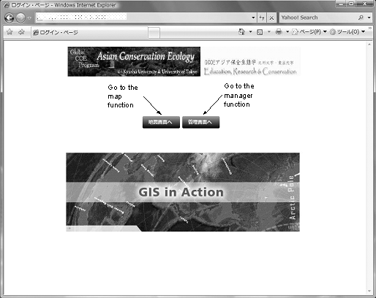

Fig. 6. Log output and authority management interface that shows the map function and manager function buttons

Second type is a server application by developing the integrated application to a production server (Fig. 4). However, circumstances may require that the application be created on a development machine and later moved to a production server. This involves installing and configuring the appropriate software on the production server, as well as setting up the data and services that the production server requires to run the application. Fig. 5 shows the composition functions of the GIS server integrated application in which user can access the application as user function and manager function. The user function and the manager function of the system are the GIS function groups that made it as Active Server Pages (ASP) .NET 2.0 user control. The detail functions are described as following subsection.

* 1. *Common feature function (authority management)*

The log output level is switched by the configuration file. The operation authority is set according to the content of the operation. The user and manager functions are provided as a common feature (Fig. 6). The common feature operates in cooperation with each function of the user function group and the manager function group. It is a common function that operates in the GIS server system.

* 1. *User function*

The user function is variously function for the map and the data examination etc. of a GIS server integrated application that assumes the users uses it in the research groups by way of the network, and achieves in a Web browser. The function groups of the display, the print, the output, the retrieval, the drawing edit, and the tool (measurement, identify, thematic map making, etc.) is provided for user function. A single purpose function is included in each function group. Accessible data and the function are limited by the user account at login.

* 1. *Manager function*

The manager function is variously function to manage a GIS server integrated application that assumes the authors uses the server application as a system administrator and the database manager, and achieves in a web browser (Fig. 7). The manager functions (access authority and data update, etc.) are prepared, and web browser can be used properly according to user roles and the authority. In addition, it is possible to be a new registration by the manager function limitation set up information database used with this system.

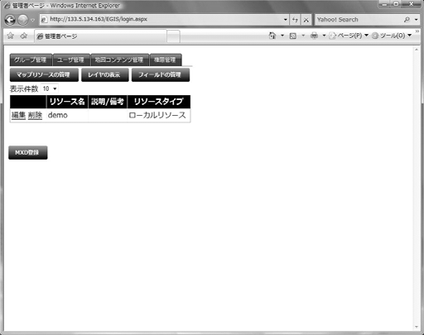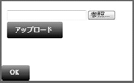

Map manager

The map including data can be upload through Internet

Fig. 7. Manager function interface is used to manage access authority and data update

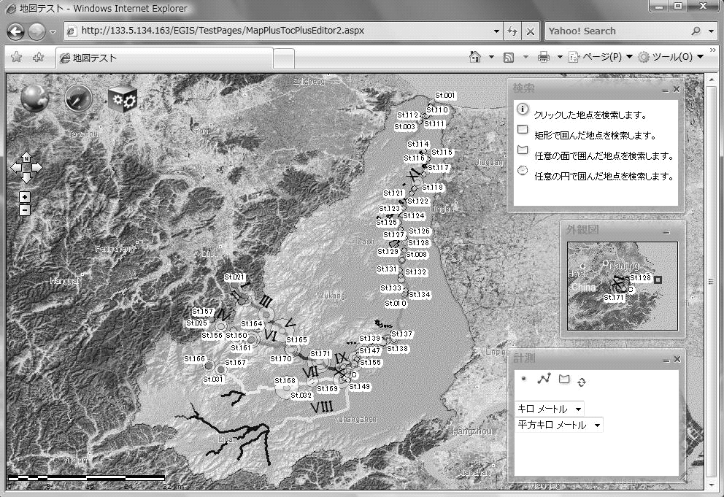

Fig. 8. GIS server integrated application in which users can access this overview map of biodiversity survey datasets

## Case Study

An integrated research survey was performed to assess the river environment and biodiversity in the East Tiaoxi River basin, China. Using many apparatus such as electrofishing, water quality equipment, and Global Positioning System (GPS) logger, an integrated field survey (fishes, plants and water quality) was conducted on the whole of the rivers. A survey database was made from 108 surveyed stations in the East Tiaoxi River. A total of 3531 individual of fishes were sampled during the survey time from November 19th until November 23rd, 2009. For preliminary assessment of the effectiveness of the developed server application, the survey database of the East Tiaoxi River was used to create, share, and utilize biodiversity information. Various environmental data and field observation data are converted using GIS functions, and all databases are managed by the GIS server system application. Fig 8 shows the interface of the GIS server integrated application which is currently developed using a Microsoft Visual Studio and ArcObject Server components.

## Conclusion and Discussions

In this paper, the GIS server application has been developed using the GIS server technology to integrate and share biodiversity information to support biodiversity observation studies. Case study from field observation dataset in the East Tiaoxi River basin of China has been examined to assess the efficiency of the developed GIS server system applications to share biodiversity information data. The advantage of this developed server application that the users easily can integrated and share their observation field data by uploading maps or layers via internet. However, since biodiversity information has complex data structure such as gene and species information which has many relationships data, the use of this server application has currently limited in displaying the spatial relationships information.

## Acknowledgements

This work was supported in part by Global COE Program (Center of excellence for Asian conservation ecology as a basis of human-nature mutualism), MEXT, Japan.

## References

1. Battrick B. The changing earth. ESA Publication Division: The Netherlands; 2006.
2. Letcher T. Climate Change, Observed Impacts on Planet Earth. Elsevier: The Netherlands; 2009.
3. Yahara T. Climate change, biodiversity loss and challenges of the Asian Conservation Ecology program. The 1st International Symposium on Aquatic Environment and Biodiversity Conservation in the Lake Taihu Basin, Shanghai-China; 2009.
4. Pollock RJ, McLaughlin JD. Data-based management system technology and geographic information systems. J of Surveying Engineering 1991; 117(1):9-26.
5. Bradley CR, Thomas RL, Louis TS, Jesslyn FB, James WM, and Donald OO. Designing global land cover databases to maximum utility: The US prototype. Environmental Information Management and Analysis: Ecosystem to Global Scales. Tailor & Francis: London; 1994.
6. John JK, Donald LP. Global environmental characterization: Lessons from the NOAA-EPA Global Ecosystems Database Project*.* Environmental Information Management and Analysis: Ecosystem to Global Scales. Tailor & Francis: London; 1994.
7. Longley PA, Goodchild MF, Maguire DJ, Rhind DW. Geographic information systems and science. John Willey & Sons: New York; 2001.
8. Peterson MP. Maps and the Internet. Elsevier: The Netherlands; 2005.
9. Goodchild MF. Sharing imperfect data, Sharing Geographic Information. New Brunswick: New Jersey; 1993.
10. ESRI (Environmental Systems Research Institute). Geospatial Service-Oriented Architecture (SOA). an ESRI White Paper. Retrieved June 2007 from: <http://www.esri.com/library/whitepapers/pdfs/geospatial-> soa.pdf