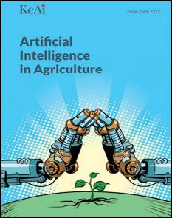[Artificial Intelligence in Agriculture 5 (2021) 52–63](https://doi.org/10.1016/j.aiia.2021.02.001)

Contents lists available at [ScienceDirect](http://www.sciencedirect.com/science/journal/)

Artificial Intelligence in Agriculture

journal homepage: [http://www.keaipublishing.com/en/journa ls/artificial- intelligence- in-agriculture/](http://www.keaipublishing.com/en/journals/artificial-intelligence-in-agriculture/)

[](http://crossmark.crossref.org/dialog/?doi=10.1016/j.aiia.2021.02.001&domain=pdf)Development of a metering mechanism with serial robotic arm for handling paper pot seedlings in a vegetable transplanter

Vikas Paradkar, Hifjur Raheman ⁎, Rahul K.

*Agricultural and Food Engineering Department, Indian Institute of Technology Kharagpur, India*

a r t i c l e i n f o

*Article history:*

Received 15 September 2020

Received in revised form 9 February 2021 Accepted 9 February 2021

Available online 16 February 2021

*Keywords:*

Tomato seedling transplanting Feeding conveyor

Robotic transplantation Seedling sensing system

a b s t r a c t

This paper describes the development of an automated metering mechanism for vegetable transplanter. It consisted of a 3- DOF serial robotic arm and an automatic feeding conveyor. The robotic arm was developed to pick and drop tomato seedlings raised in biodegradable paper pots. The volume of each pot was 50 cm3 (3.5 cm diameter and 5.2 cm height) with a maximum total weight of 47 g including pot mix and seedling. A ma- trix type feeding conveyor was developed to convey the pot seedlings to a predefined position where the robotic arm could pick up these seedlings one by one. LDR (Light Dependent Resistor) - LED (Light Emitting Diode) sens- ing unit was used to perform the intermittent movement of the conveyor. The developed system was evaluated under both laboratory and field conditions. The robotic arm was able to pick and drop 20 seedlings per minute and its effective cycle time per handling one seedling was varying from 2.5 to 3.1 s. Power consumption of the conveyor of the developed system and the robotic arm was 18 W and 16 W, respectively. The conveying, metering and overall efficiency of the developed metering mechanism under laboratory condition were 96.83%, 95.91% and 92.86%, respectively as compared to 94.7%, 93.28% and 88.33%, under field condition. The de- veloped robotic arm based metering mechanism was simple, light in weight and effectively handled the pot seed- lings without damage and would thus help in mechanizing transplanting of vegetable seedlings.

© 2021 The Authors. Publishing services by Elsevier B.V. on behalf of KeAi Communications Co. Ltd. This is an open access article under the CC BY license (<http://creativecommons.org/licenses/by/4.0/>).

1. Introduction

Planting of seed/seedling is an important operation for raising any crop. Vegetable crops like tomato and brinjal give better productivity with transplanting of best-grown seedlings instead of sowing the seeds directly into the agricultural field. Unavailability of suitable vege- table transplanting machinery in developing countries such as India, manual transplanting is opted for cultivating vegetables, which requires considerable manpower, and thus it is expensive. Shortage of labours during the peak transplanting period adversely affects the timeliness of this operation, thereby reduces crop yield (Khadatkar et al., 2018; Vivek et al., 2019). In manual transplanting, seedlings are manually planted in the soil by maintaining a recommended row-to-row and plant-to-plant spacing. Since manual transplanting is more prone to error, it results in non-uniform plant distribution which makes it diffi- cult to operate several other agricultural machinery such as plant pro- tection implements and harvesting implements required for raising the plants (Parish, 2005; Kumar and Raheman, 2008, 2011). Therefore, mechanization in the transplanting of vegetable seedlings becomes es- sential to overcome the shortage of labour and will help to complete

* Corresponding author.

*E-mail address:* [hifjur@agfe.iitkgp.ernet.in](mailto:hifjur@agfe.iitkgp.ernet.in) (H. Raheman).

the transplantation process in less time with good uniformity of plant distribution in the field.

A transplanter generally consists of a metering mechanism i.e., a picking unit and a seedling dropping unit. It is designed based on type of seedlings used (bare root, plug and pot seedlings). Kumar and Raheman (2010) developed paper pot type vegetable seedlings using recycled bio-degradable paper. The paper pots were filled with vermicompost, soil and sand at an optimum proportion to raise seed- lings. Nandede et al. (2014) standardized the potting mix (farmyard manure: sand: soil) for better growth of vegetable seedlings in paper pots and found these seedlings suitable to use in the agricultural field using a transplanter. The main advantages of paper pot seedlings are: individual seedlings have sufficient space, nutrients and conducive con- ditions for better seedling germination and growth (Kumar and Raheman, 2008) and withstand the transplanting shock (Dihingia et al., 2017). The transplanters are commonly classified into two catego- ries a) semi-automatic and b) automatic type. The semi-automatic transplanters require additional workers for feeding and steering oper- ation, while the automatic transplanters require a single operator to carry out transplanting in the field (Tsuga, 2000; Kumar and Raheman, 2011). Tsuga (2000) developed three models of automatic self-propelled vegetable transplanter for plug seedlings and paper pot seedlings. The planting rate of the seedlings in the field was 60 hills/ row/min.

<https://doi.org/10.1016/j.aiia.2021.02.001>

2589-7217/© 2021 The Authors. Publishing services by Elsevier B.V. on behalf of KeAi Communications Co. Ltd. This is an open access article under the CC BY license ([http://](http://creativecommons.org/licenses/by/4.0/) [creativecommons.org/licenses/by/4.0/](http://creativecommons.org/licenses/by/4.0/)).

Nomenclature

DOF

Degree of freedom

DC motor Direct current motor

EEPROM Erasable programmable read-only memory IC Integrated circuit

IC engine Internal combustion engine LDR Light dependent resistance LED Light emitting diode

LOA Line of action

PLC Programmable logic controller PWM Pulse width modulation signal

SCARA Selective compliance assembly robot arm

Automatic mechanical type vegetable transplanters are either self- propelled or tractor-mounted. The performance of the transplanters primarily depends on several parameters such as seedling feeding rate of the pickup unit, seedling row to row spacing and optimal forward speed of the machine (Kumar and Raheman, 2008). These automatic transplanters produce vibration, require high input power and the metering mechanism of mechanical type automatic transplanters are complicated to design and fabricate (Prasanna and Raheman, 2012).

In order to avoid the complexity associated with mechanical trans- planters and to reduce power consumption, researchers have developed electronic-based robotic transplanters for handling plug and pot seedlings. Hwang and Sistler (1986) incorporated robotic manipulator (5 degree of freedom (DOF)) in a commercially available mechanical transplanter for transplanting pepper crop seedlings in the field. This system utilized an 8-bit microcomputer for master control of the robotic movement. The pri- mary purpose of the manipulator was to pick pepper pot seedlings from a horizontal conveyor and place it at a dropping point. This transplanter in- cluded aplant tray, a furrow opener, plant kicker and twopress wheels and its transplanting rate was slightly more than 6 plants per min. Ting et al. (1990a) conducted a study on work cell layouts for transplanting plug seedling using a Selective Compliance Assembly Robot Arm (SCARA). A computer program was developed for analyzing the interactions of the work cell layout, the robot arm motion and the material flow. Ting et al. (1990b) designed a swinging and sliding needle type gripper for picking, holding and placing the plug seedlings. The gripper was attached on a SCARA robot arm with a capacitive proximity type sensor for identifying the plug seedling grasped by the gripper. Ryu et al. (2001) developed a transplanting system based on an image recognition system for bedding plants using a three-axis gantry type robot. This system consisted of an image recognition device, a tray conveyor, a manipulator, and an end- effector. This transplanter was specially developed for greenhouse appli- cations at a transplanting rate of 30 plants per minute. Tian et al. (2010) designed and developed asimple gantry-type arm with a feeding conveyor system to handle plug seedlings. The unit comprised of a programmable logic controller (PLC) based control system, seedling pickup unit anda con- veyor system for plug seedlings. The planting rate was reported as 1800 to 2400 seedlings per hour. Hu et al. (2014) designed and analyzed the di- mensional synthesis and kinematic simulation of a 2-DOF parallel robot arm for transplanting plug seedlings from a 128-hole tray to a 50-hole tray. The transplanting capacity of the developed system was up to 55 plants perminute. Xinetal. (2018) implemented anautomatic mechanism for transplanting plug seedlings. It consisted ofa gear train seedling picking mechanism, a photoelectric sensor (for seedling recognition) and a push- type seedling conveyor. The success rate of the developed system was 88.23% and the leakage rate was 16.46%.

Shamshiri et al. (2018a) described the achievements of the latest ro- botics technology in agriculture such as the importance of incorporating advanced sensing systems, machine vision system (Joseph et al., 2019, Syed et al., 2019a, 2019b) multi-robot collaboration and the latest soft- ware tools. These advanced techniques could help in the efficient

transplanting of seedlings by decreasing the workforce and time taken to complete the operation. Shamshiri et al. (2018b) reviewed various simulating software and virtual environments for the use of digital agriculture. It was found that, with the capability of available software platforms, the performance of the agricultural robotics could be signifi- cantly improved by incorporating the advanced algorithms, sharing the existing workspaces and reusing the materials. Also, the utilization of software platforms for field operations could significantly reduce the cost by reducing the number of real-time experimental errors and opti- maluseoffarmresources. Syedetal.(2019a) investigatedtheapplication of machine vision technology in agriculture and automatic transplanting machine. It was reported in this study that combined use of robot, sensor and machine vision technology in transplanter could improve quality of transplanting, efficiency and reduce the labour requirement. Syed et al. (2019b) proposed a non-destructive method of seedling measurement systemfor its use inautomatictransplanters. Theyhaveused machinevi- sionsystemalongwithadepthcameratoobtaintheseedlingdata. The 3D model of the seedlings was generated from the collected data with the help of a point cloud clustering algorithm. Rahul et al. (2019) developed a 2 DOF parallel robot for transplanting paper pot seedlings. The duty cycle timeof the robot for pick up and placementof each seedling was re- portedas 2.25 swithapower requirementof 22 W. Viveketal.(2019) de- veloped a gripper for vegetable transplanting robot, which was utilized for transplanting plug seedlings and the success rate of the transplanting system was reported as 92.47% and 91.32% for chilli and brinjal, respec- tively. Yung et al. (2019) developed a serial robotic arm for transplanting tomato seedling from a traytoa box. Theaverage cycle time of therobotic armforpickingandplacingoperationwas 2.82 s, andthesuccessofplant- ingwasreportedas 93.86%. Rahul etal.(2020) developedafirmwarethat could be implemented on embedded systems. They tested the controller with a 4 DOF parallel robot arm to transplant pot seedlings. It was re- ported that the developed embedded system reduced the overall cost with the cycle time and success rate of 3.5 s and 93.3%, respectively.

Robotic transplanters utilize an individual unit of power source (motor) for picking the seedlings, which eliminates the need of complex metering mechanism and complex power transmission system re- quired in case of internal combustion (IC) engine operated mechanical transplanter (Ryu et al., 2001; Hu et al., 2014; Rahul et al., 2019, (Rahul et al., 2020)2020). Robotic transplanters require less input power, and they are adjustable to control speed and transplanting rate (Sakaue, 1996; Hu et al., 2014). Robotic transplanters can be equipped with advanced sensors to detect the environmental changes and smart actuators to provide the required torque and forces to the ma- chine components for delicate removal of seedlings from the conveyor and drops into a delivery tube. Hence, there is a need to develop a ro- botic vegetable transplanter equipped with an advanced control system in the metering mechanism that should work well in the actual field condition with a lesser power requirement and easy to operate.

The use of serial robotic arm could be advantageous for use in vege- table transplanters in many ways such as: workspace to robot size ratio is high; the complexity of kinematics computation is simpler along with big workspace and compact size (Pandilov and Dukovski, 2014). These advantages make the serial robotic arm to be more suitable for vegeta- ble transplanting in the field. However, an automatic feeding conveyor with a seedling sensing unit is required to supply pot seedlings contin- uously to the robotic arm of the transplanting system. Therefore, in the present study, an attempt has been made to design and develop a serial robotic arm for handling paper pot seedlings with an automatic feeding conveyor for a vegetable transplanter.

1. Materials and methods
   1. *Raising of pot seedlings*

Old newspapers were used for the preparation of cylindrical shaped paper pots of size 3.5 cm diameter and 5.2 cm height (50 cm3 volume).

These paper pots were filled with the recommended pot mix (vermicompost, sand and soil in the ratio of 1 : 1 1 : 1 1) for the success-

programmed to pick and drop the pot seedlings one by one from the conveyor to the dropping point without any human intervention. The

2 2

ful growth of tomato seedlings as recommended by Kumar and Raheman (2011). Tomato seed was planted into the potting mix of each pot. It was allowed to grow with regular watering for 21 days. The weight of the paper pot along with the potting mix moisture ready for transplanting were 44.0 ± 2.0 g, 46.0 ± 2.0 g and 47.0 ±

2.0 g at moisture content of 6 ± 2%, 9 ± 2% and 12 ± 2% (dry basis), respectively.

* 1. *Conceptual working of robotic arm pickup mechanism and feeding conveyor*

The flow chart for the working of the robotic pickup mechanism and feeding conveyor is shown in Fig. 1. The pot seedlings are initially loaded to the feeding conveyor cells. During operation, the robotic arm was

front row of the feeding conveyor, where the sensing unit could detect the presence of pot seedlings is called the line of action (LOA).

The first row of pot seedlings was positioned at line of action (LOA) by rotatingtheconveyorshaftusingadirectcurrent(DC) motoroperatedin- termittently by using an electronic control circuit. Whenever the seed- lings were detected by the LED (Light Emitting Diode) – LDR (Light Dependent Resistance) sensing unit, the electronic circuit sensed the presence of pot seedlings at the LOA and the DC motor was stopped by providing an appropriate signal to the relay circuit. After positioning the seedlings at LOA, the robotic arm was actuated to pick-up the pot seed- lings present at the robot pick-up position and drop the same at the droppingpoint. Whennoseedlingwasavailableat LOA, theelectroniccir- cuit provided a control signal to actuate the DC motor of the feeding con- veyor to bring the seedlings to the LOA of the robotic arm. This process continued until all pots in the conveyor were emptied by the robotic arm.

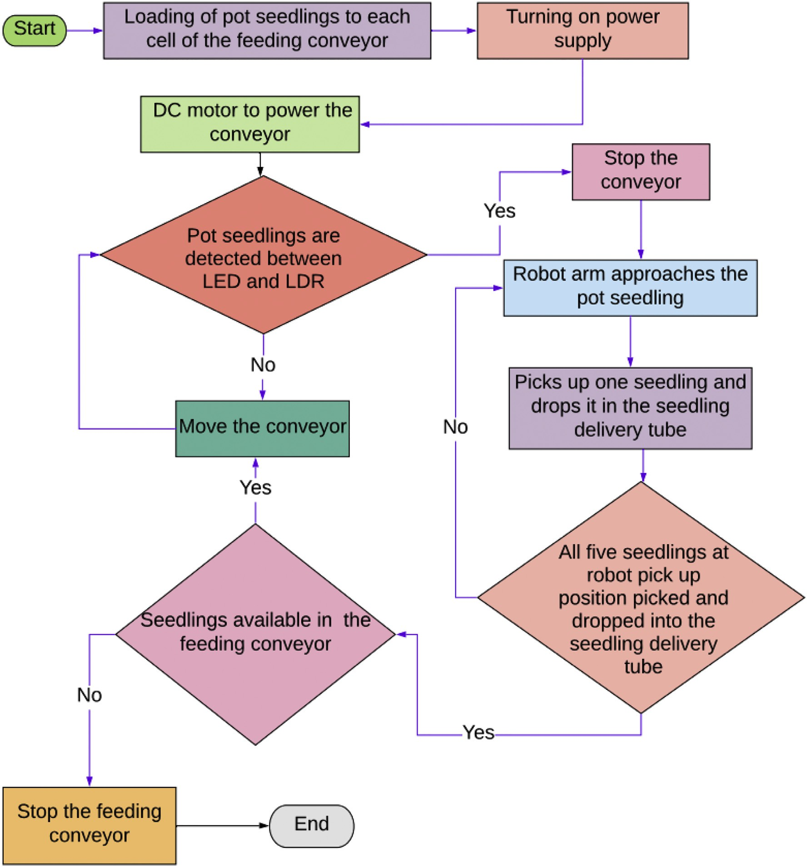

Fig. 1. Process flow chart for handling pot seedlings using a robotic arm.

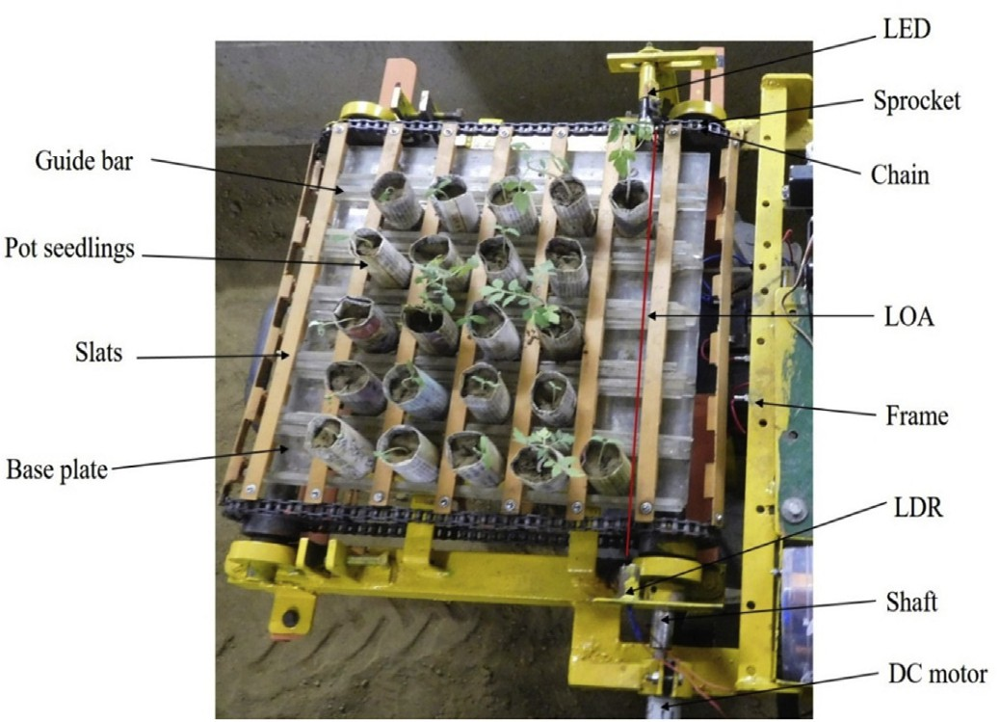

Fig. 2. Image of the developed seedling feeding conveyor.

* 1. *Development of a laboratory model of vegetable transplanter with a robotic arm*

The laboratory model of vegetable transplanter was developed using an automatic feeding conveyor, electronic circuit, robotic arm, and seed- ling delivery tube.

* + 1. *Automatic feeding conveyor*

The purpose of using an automatic feeding conveyor was to carry the pot seedlings in upright orientation towards the LOA of the robotic arm. The seedling feeding conveyor comprised a base plate (360 × 345 × 6 mm acrylic sheet) to hold pot seedlings and it was fixed on a mild steel frame (715 mm × 428 mm). Vertical guide bars were provided on the base plate parallel to each other at an interval of 65 mm. A horizontal slattype chain conveyor wasused topushthe pot seedlings byfixingslats (345 mm × 15 mm × 3 mm each) on the chain at an interval of 60 mm. Thus, the combination of moving slats and fixed bars made cells on the base plate for accommodating pot seedlings in an upright orientation.

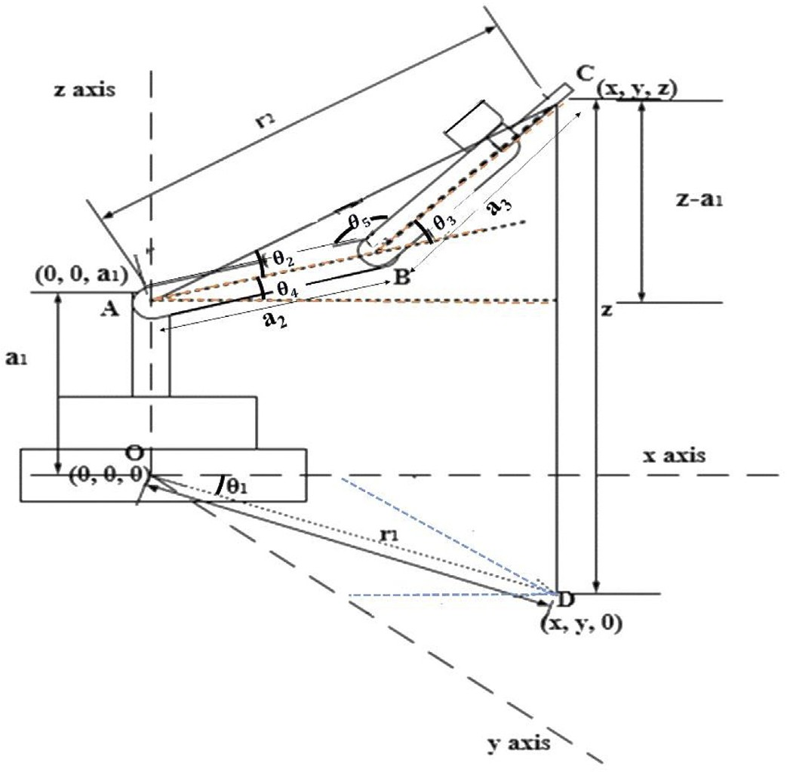

Fig. 3. The geometry of the 3 DOF robotic arm to pick and drop the pot seedlings.

Fig. 4. The workspace of the robotic arm.

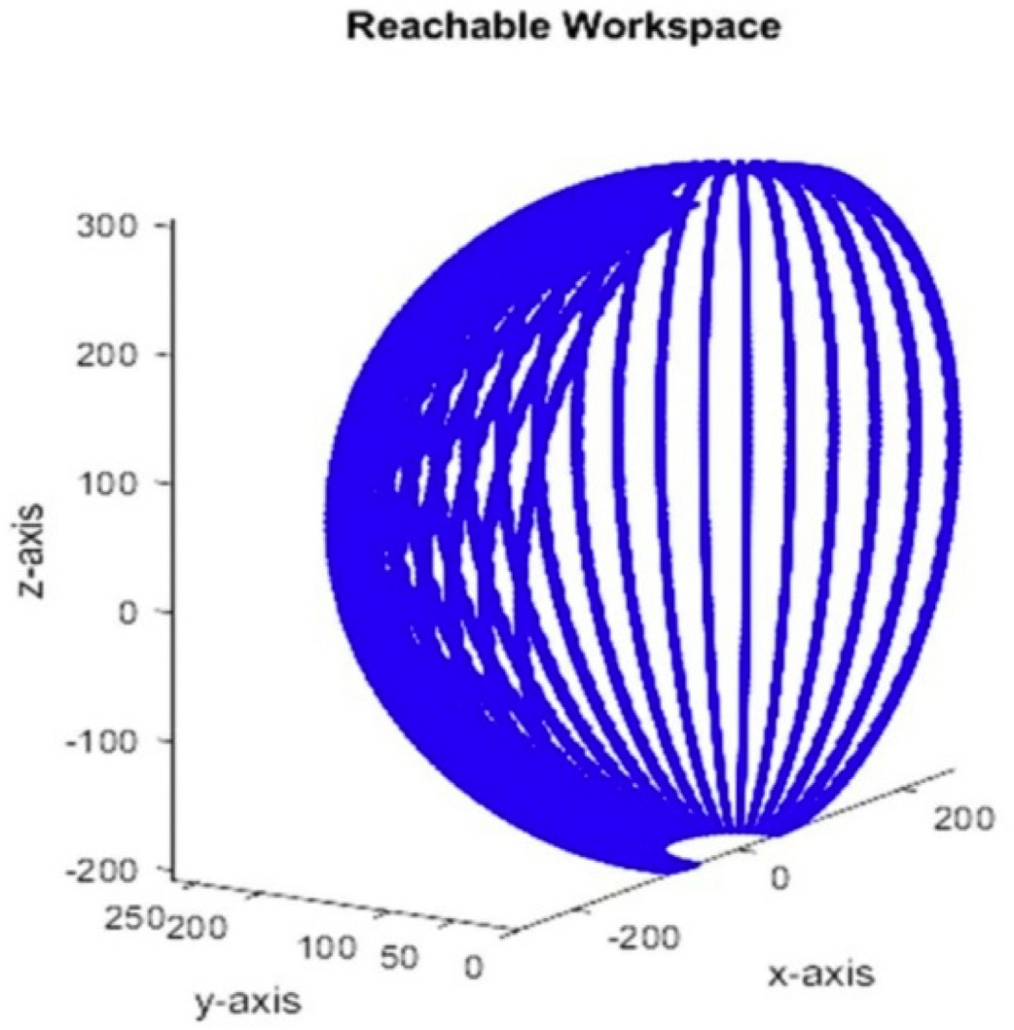By rotating the conveyor chain with the help of a DC motor (12 V and 60 rpm) attached directlytothedrive shaftof theconveyor, theslats present ontheconveyorpushedthepotseedlingstoslideoverthebaseplateupto the robot arm pick up points. The conveyor was designed to carry five- column of pot seedlings at a time. The robotic arm was fixed to the main- frame in front of the conveyor to pick up the pot seedlings one by one and to drop these seedlings into the delivery tube without any interference. The developed feeding conveyor is shown in Fig. 2.

* + - 1. *Electronic circuit for the control of feeding conveyor.* A DC motor was used to power the slat type feeding conveyor. The electronic circuit used for actuating the DC motor by continuously monitoring the output of the LED-LDR sensing unit of the feeding conveyor. The LED was con- nected to a DC power source (+12 V) through a current limiting resistor (100 K) whichproducedapointedlightsource. The LDRwaspositionedin suchawaythatthepointedlightsourcefrom LEDfellonthe LDR'ssensing surface. Thestraight-linelightbeambetweenthe LEDand LDRformedthe LOA of the robotic arm. The resistance of LDR decreased when the light beam fell on the LDR's sensing surface. A comparator (LM741) IC contin- uously compared the voltage across the LDR and a reference voltage be- tween two resistors (R3 and R4). The output voltage of the comparator produced a driving current whenever the voltage difference was high.

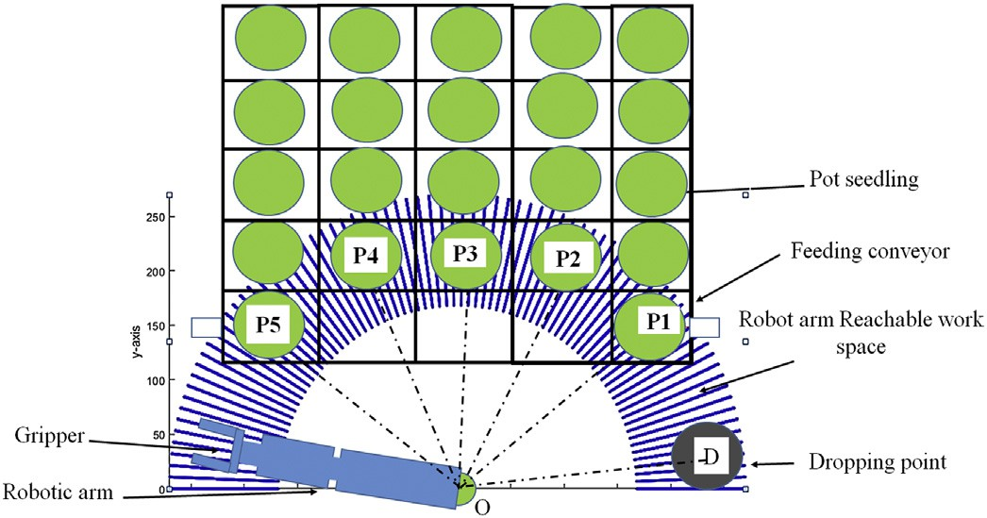

Fig. 5. The workspace of the robotic arm in the XY plane.

This driving current-controlled the switching of the relay to actuate the rotation of the DC motor. A potentiometer was provided to adjust the value of the reference voltage.

* + 1. *Design and development of the robotic arm*

The developed 3 DOF serial robot arm consisted of the three links (*a1, a2* and *a3*) and three jointangles, as shown in Fig. 3. Thejointbetween link(*a1*)andthegroundis ‘O,’ thejointbetweenlink(*a1*) and link (*a2*)is ‘A’ and the joint between link (*a2*) and the link (*a3*) is ‘B’. The orientation of OD with the x-axis is *θ*1, the orientation of AB with XY plane is *θ*4 and, the orientation of BC with AB is *θ*3 and the orientation of AC with AB is *θ*2. The joint angle formed between link (*a2*) and link (*a3*) is *θ*5.

One end of the link (*a3*) was connected to the joint ‘B’, and a gripper C (x, y, z) was attached the to the other end of the link. The reference frame OXYZ is located at the mid-plane of the link (*a1*). Hence, by vary- ing the joint angles at O, A and B, the gripper location, C (x, y, z) could be positioned at a desired point in the Cartesian space. The gripper point C (x, y, z) was projected on XY plane at point D (x, y, 0). Distance between the base of the robot (0,0,0) and point D (x, y, 0) is r1 whereas the dis- tance between joint ‘A’ (0, 0, a1) and gripper point C (x, y, z) is r2.

* + - 1. *Forward kinematic analysis.* The forward kinematic analysis was carried out using the trigonometric concept to obtain both the position and orientation of the end-effector for the given set of input joint angles and link lengths. Px, Py and Pz are the coordinates (x, y, z) of the end effector C.

*Px* = [*a*2 cos *θ*4 + *a*3 cos (*θ*3 + *θ*4)] × cos *θ*1 (1)

*Py* = [*a*2 cos *θ*4 + *a*3 cos (*θ*3 + *θ*4)] × sin *θ*1 (2)

*Pz* = *a*2 *sin θ*4 + *a*3 *sin* (*θ*3 + *θ*4) + *a*1 (3)

* + - 1. *Inverse kinematics.* Inverse kinematics (IK) was used to compute joint angles for the given end-effector position (*x*, *y, z*) and orientation in Cartesian space using a geometric approach. From the geometry (Fig. 3) of the robotic arm, inverse kinematics equations were derived as given below:

*θ*1 = tan −1 *y* (4)

*x*

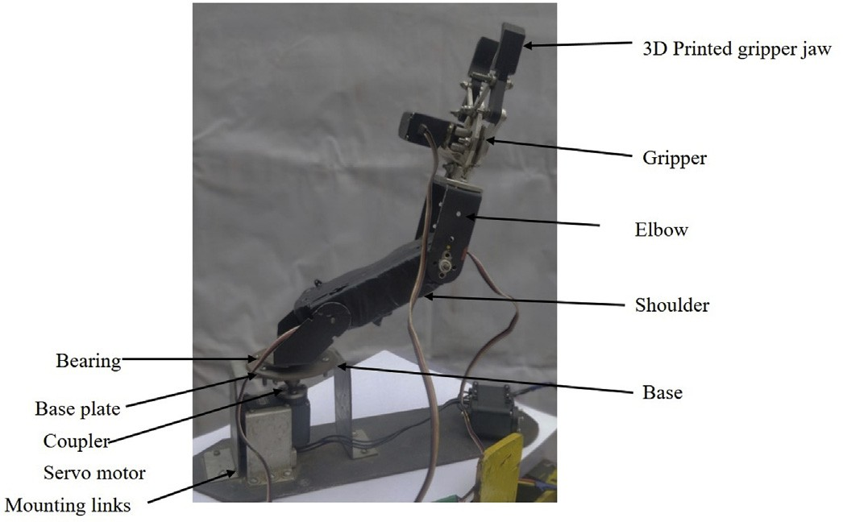

Fig. 6. The developed robotic arm.

Thus, for the known link lengths (*a1,* a2 and *a3*) and at the desired known position of the gripper C (x, y, z), the unknown input angles θ2 and θ4 were decided using the above equations of inverse kinematics.

* + - 1. *Workspace of the robotic arm.* The computation of all the reach- able positions of the gripper of the robotic arm in the Cartesian space is termed as workspace. The workspace was used to decide optimum link lengths for the robotic arm. Based on known link length, suitable ac- tuators for the link joints were selected. The forward kinematic equa- tions were used in MATLAB software for generating workspace, as shown in Fig. 4. The link lengths for the robotic arm considered for the workspace are: a1–50 mm, a2–100 mm and a3–170 mm (including the length of the gripper 80 mm). These link lengths were selected to en- sure that the robotic arm could easily pick up the pot seedlings from dif- ferent positions in the conveyor. For generating maximum reachable workspace, joint angles were provided as given below:

Base joint O: 0 ≤ *θ*1≤ 180° (condition for maximum reachability). Shoulderjoint A:- 60° ≤ *θ*4 ≤ 60°(toavoidcollisionbetweentwolinks). Elbow joint B: - 60° ≤ *θ*3 ≤ 60°.

The designed robotic arm was needed to pick the pot seedlings lo- cated at multiple positions in the feeding conveyor and drop these pot seedlings at the dropping point without making any collision with

other pot seedlings or with the feeding conveyor. The maximum and

*r*1 = q*x*ﬃﬃﬃ2ﬃﬃﬃ+ﬃﬃﬃﬃﬃ*y*ﬃﬃ2ﬃﬃ

From the triangle ABC,

*r*2 = q(ﬃﬃ*z*ﬃﬃﬃ−ﬃﬃﬃﬃ*a*ﬃﬃﬃ1ﬃﬃ)ﬃﬃ2ﬃﬃﬃ+ﬃﬃﬃﬃﬃ*r*ﬃﬃ1ﬃﬃ2ﬃﬃ

(5)

(6)

minimum reachable position of the gripper in the XY plane together with the workspace of the robotic arm superimposed on it is shown in Fig. 5. It can be seen in this figure that the designed robotic arm had to pick seedlings from five positions (P1, P2, P3, P4, and P5) and drop all these seedlings at position D. Distance between the base of the robotic arm to the seedling pickup positions P1, P2, P3, P4 and P5 were 180

*θ*3 + *θ*5 = 180 (7)

*θ*4 + *θ*2 = tan −1 *z*−*a*1 (8)

*r*1

Applying cosine rule

mm, 220 mm, 210 mm, 220 mm and 180 mm, respectively. Positions P1 and P5 belonged to the first row. P2, P3 and P4 belonged to the sec- ond row of the feeding conveyor. The three columns in the middle of the first row were kept empty as these positions were not covered in the workspace of the robotic arm as it had to move in an arc.

*r*2 = *a*2 + *a*2−2*a*2*r*2 *cos θ*5

2 2 3

(9)

* + - 1. *Developed robotic arm.* The mechanical structure of the robotic

arm consisted of three serial links (base-shoulder, shoulder-elbow, and elbow-gripper) whichwereconnected byrevolutejoints. Different serial

*θ* 180− cos −1 *a*2 + *a*2−*r*2 10

3 =

3

2

2

2

(

)

*θ*2 = cos −1

*a*2*r*2

2 2 2 2 2

(*z*−*a* ) + *x* + *y* + *a* −*a* !

1 2 3

2*a*2*r*2

(11)

Table 1

List of electronic devices used.

S. No. Material used Manufacturer Model

*z*−*a* ! (*z*−*a* )2 + *x*2 + *y*2 + *a*2−*a*2!

|  |  |  |
| --- | --- | --- |
| 1 Servo motor | SparkFun | Hi Tech, HS-422, 6 V |
| 2 Servo motor | Robotis | Dynamixel ax-12 |
| 3 Microcontroller | Arduino | Arduino uno |
| 4 Current sensor | Generic | ACS712 |

*θ*4 =

tan −1

1

p*x*ﬃﬃﬃ2ﬃﬃﬃ+ﬃﬃﬃﬃﬃ*y*ﬃﬃ2ﬃﬃ

− cos −1

1

2*a*2*r*2

2 3 (12)

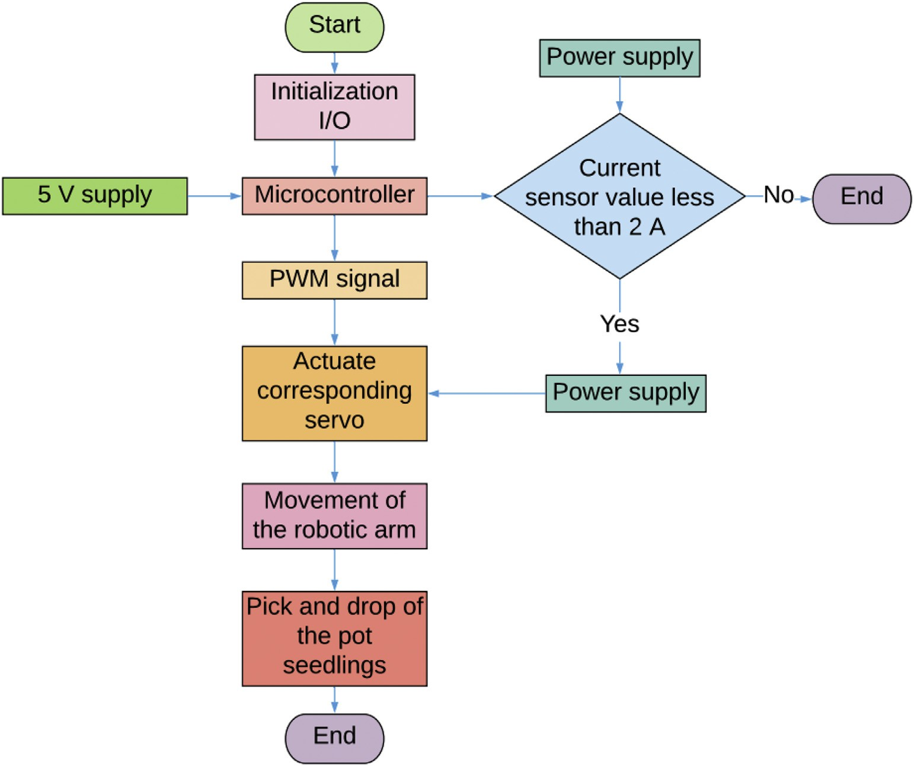

Fig. 7. Flow chart for the working sequence of the robotic arm.

links (shoulder-elbow – 100 mm and elbow-gripper – 170 mm) were made by using 2 mm thick aluminium sheet. The base was the platform on whichtheshoulder, elbowandgripper linkswererested. A basestruc- ture was constructed to avoid direct load on the base servo motor (using mounting links, base plate, bearing (608zz) and coupler (base-shoulder

−50 mm) asshown in Fig.6. All the links wereconnected serially. A bear-

ing was attached to the housing of the base plate to avoid direct load on the base servo motor and to provide smoother movement to the robotic arm. A coupler was used for transferring motion from the base servo motor to the shoulder link. A gripper with two jaws, which opened and closed by the control of a servo motor, was rigidly fixed to the end of the elbow link. Since the pot seedlings were cylindrical in shape having a diameter of 35 mm, a wider width typegripper jawwithcurvedcontact wasfabricatedusing PLA(Polylacticacid) material(3dprinted) asshown in Fig. 6 for increasing the holding ability of the gripper jaw (Yamanobe and Nagata, 2010; Harada et al., 2016).

* + - 1. *Circuit components.* The robotic arm comprised three mechanical link joints which were driven by actuators. Therefore, the accuracy of the movement of the robotic arm was dependent on the precise control of the actuators. Hence, the selection of suitable controller, sensor, elec- tric power converters and actuators were needed. Servo motor, current sensor, microcontroller (Table 1), buffer IC and 12 V battery were used for developing an electronic circuit for the robotic arm.

Four servo motors were selected for the robotic arm out of which three servo motors for the shoulder joint, elbow joint and gripper (Hi- Tec HS-422, 6 V) and one for the base joint (Dynamixel ax-12, 12 V). A microcontroller (Arduino Uno) was used to compute the algorithm and generate a (PWM) pulse width modulation signal. A buffer IC 74LS24 was incorporated for a unit gain amplifier in an integrated cir- cuit for controlling dynamixel motor to provide pass signals or data packets. The voltage converter circuit was designed using LM317T and various components for getting output voltage in the range of 3 V to

12 V. This circuit was used for supplying current with 6 V to the three servo motors and microcontroller. Two current sensors (ACS712) were used as an overload protection device for the robotic arm. When- ever a high current was detected, a relay switch was activated to discon- nect the circuit from the main power supply.

* + - 1. *Working of the robotic arm.* The servo motors were provided with precise angles to ensure proper grasping of the pot seedlings for picking from the pickup positions. There were five pickup positions P1, P2, P3, P4 and P5 (Fig. 5); thus, joint angles were calculated for each of them using inverse kinematics equations. Initially, the gripper was kept at D i.e., the dropping point. In order to achieve collision-free movement of the robotic arm, the sequence of movement was set in the following order: the opening of gripper – upward rotation of elbow – upward rota- tion of shoulder joints – rotation of base joint to move the robotic arm to- wards pick up position – rotation of elbow and shoulder joints to lower the gripper – closing of the gripper. The sequence for dropping the pot seedlings was in the order: rotation of elbow and shoulder joints to lift the gripper (while the pot was held between the gripper jaws) – rotation of base joint to move robotic arm near dropping point – rotation of elbow

Table 2

Robotic arm motion parameters obtained from software simulation.

|  |  |  |  |  |  |
| --- | --- | --- | --- | --- | --- |
| S. No. | Joint rotation sequence | Pickup orientation angle (deg) | Time (s) | Dropping orientation angle (deg) | Cumulative time (s) |
| 1 | Base | −115 | 0.6 | – | 0.6 |
| 2 | Shoulder | −40 | 0.35 | – | 0.95 |
| 3 | Elbow | −30 | 0.4 | – | 1.35 |
| 4 | Elbow | – | 0.4 | 30 | 1.75 |
| 5 | Shoulder | – | 0.35 | 40 | 2.1 |
| 6 | Base | – | 0.6 | 115 | 2.7 |

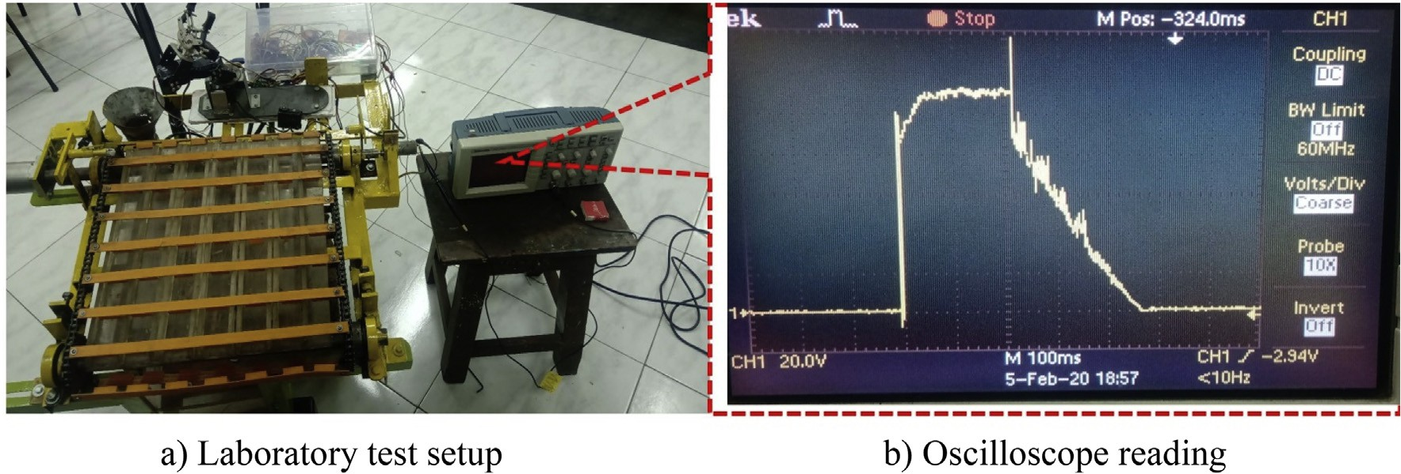

Fig. 8. Laboratory test of the feeding conveyor. a) Laboratory test setup b) Oscilloscope reading.

andshoulderjointstolower thegripper – openingofthegripper. Analgo- rithm was written to perform these tasks using the microcontroller.

The microcontroller was preprogrammed based on the angle of joints and their sequence of movements to reach all picking positions and dropping position. The flow chart of the working sequence of the robotic arm is given in Fig. 7. The robotic arm was initiated by providing a power supply to the input/output pins of the microcontroller. The mi- crocontroller read the pickup and drop locations from EEPROM memory and provided PWM signals to the corresponding servo motor. A current sensor was used to measure current consumption by the servo motor, and this current value was monitored by the microcontroller. When the current value exceeded 2 A, the microcontroller generated a pulse to activate the relay switch to stop power supply.

* + - 1. *Simulation of the robot arm for pick and place of pot seedlings.* The roboticarmpathplanningandtrajectorywerevalidatedbythekinematic simulation carried out using ADAMS multibody simulation software. In order to determine the position and velocity of the robot joints during the pick and drop cycle, a kinematic diagram was constructed by provid- ingtheactuallinkparametersoftheroboticarmandtheperformancewas simulated for the input joint motion for one pick and drop cycle.

A simulation cycle refers to the movement of the manipulator from the initial position to any pickup positions (P1, P2, P3, P4 and P5) in the workspace of the robotic arm, picking up of the seedling and then fi- nally dropping the seedling at the dropping position D. Since the robotic arm could reach multiple pick up positions in a similar way. Hence, any of the pickup and, drop positions was simulated for analysis. The simu- lation analysis presented below is for the complete cycle to fetch the seedling located at position P5, the farthest position among the pick up positions from the dropping point. The motion parameters com- prised the angular rotation of robotic arm joints (‘-‘sign indicates coun- terclockwise rotation) in sequence to perform the pick and drop cycle for seedling P5 located on the feeding conveyor is given in Table 2.

* 1. *Performance evaluation of the feeding conveyor*

The performance of the feeding conveyor was evaluated in terms of run time required for intermittent rotation of the conveyor shaft to move the pot seedlings into the workspace of the robotic arm and the power required to operate the feeding conveyor.

Initially, the developed electronic circuit for the feeding conveyor was tested in terms of time taken to move a group of pot seedlings (five in number) to the workspace of the robotic arm. For this, an oscil- loscope was connected to +ve end of the DC motor and no pot seedling was observed at LOA. Then, the conveyor was powered to run the con- veyor to move the pot seedlings to the workspace of the robotic arm. When the seedlings touched the LOA, the conveyor was stopped. The pulse (V, volt vs time, ms) corresponding to the starting and stopping of the conveyor was detected with an oscilloscope (Fig. 8b).

* 1. *Testing of the developed robotic arm based metering mechanism*

The experiment included testing of the feeding conveyor and the ro- botic arm for measuring power consumption and cycle time required to pick and drop a single pot seedling. In order to test the performance of the designed metering mechanism, experiments were carried out in the laboratory. This system was also evaluated in the field by mounting the metering unit on a propelling vehicle, as shown in Fig. 9.

* + 1. *Experimental procedure for evaluating the developed robotic arm based metering mechanism*

Testing of the developed metering unit was carried out in the labora- tory under the stationary condition and moving condition in the field. The robotic arm was pre-programmed to pick and drop pot seedlings from all five positions of the conveying unit. In this experiment, 21 days old tomato pot seedlings were used for testing. Initially, the pot seedlings were loaded in the cells of the feeding conveyor except for the first row of the feeding conveyor, and then two seedlings were placed at positions P1 and P5 of the first row (Fig. 5). The initially loaded seedlings were noted as Nt. When the conveyor was powered, it pushed the pot seedlings towards the robotic arm pick up positions (in the working space of the ro- botic arm). After that, the robotic arm was actuated to pick the pot seed- lings and drop the same at the dropping point. During the grasping action (pick and drop operation) few seedlings got damaged (Ndam) and were recorded for further analysis. For efficient picking of pot seedlings, pots were required to be placed accurately at robotic arm pick up positions without tilting. The angle of inclination of pot seedlings from the vertical

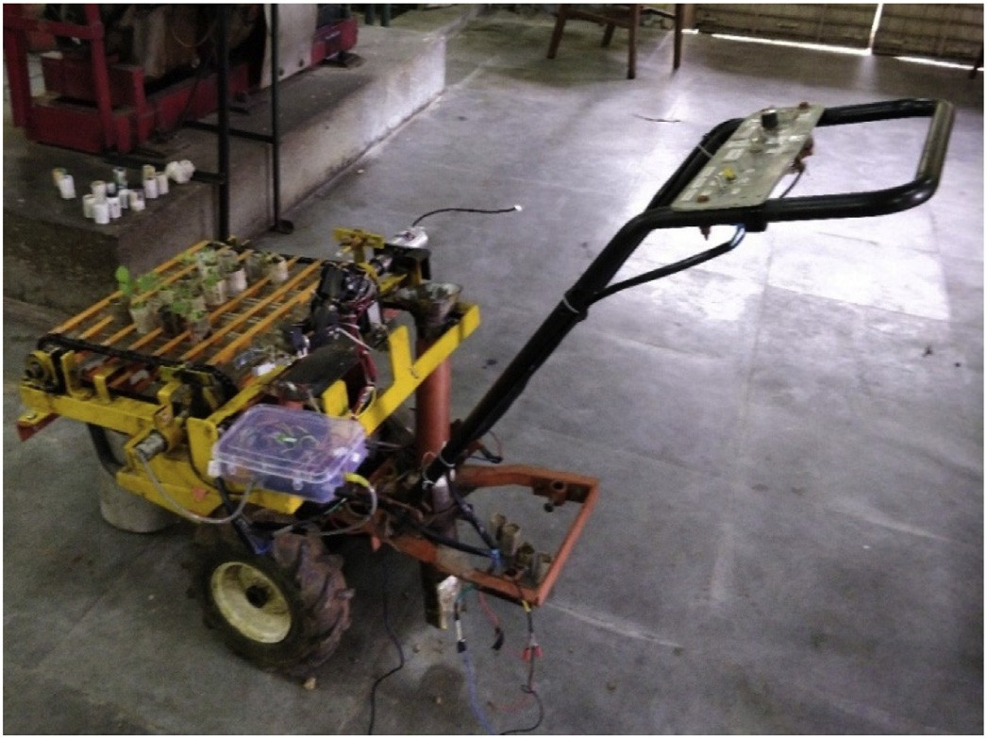

Fig. 9. The developed transplanting unit.

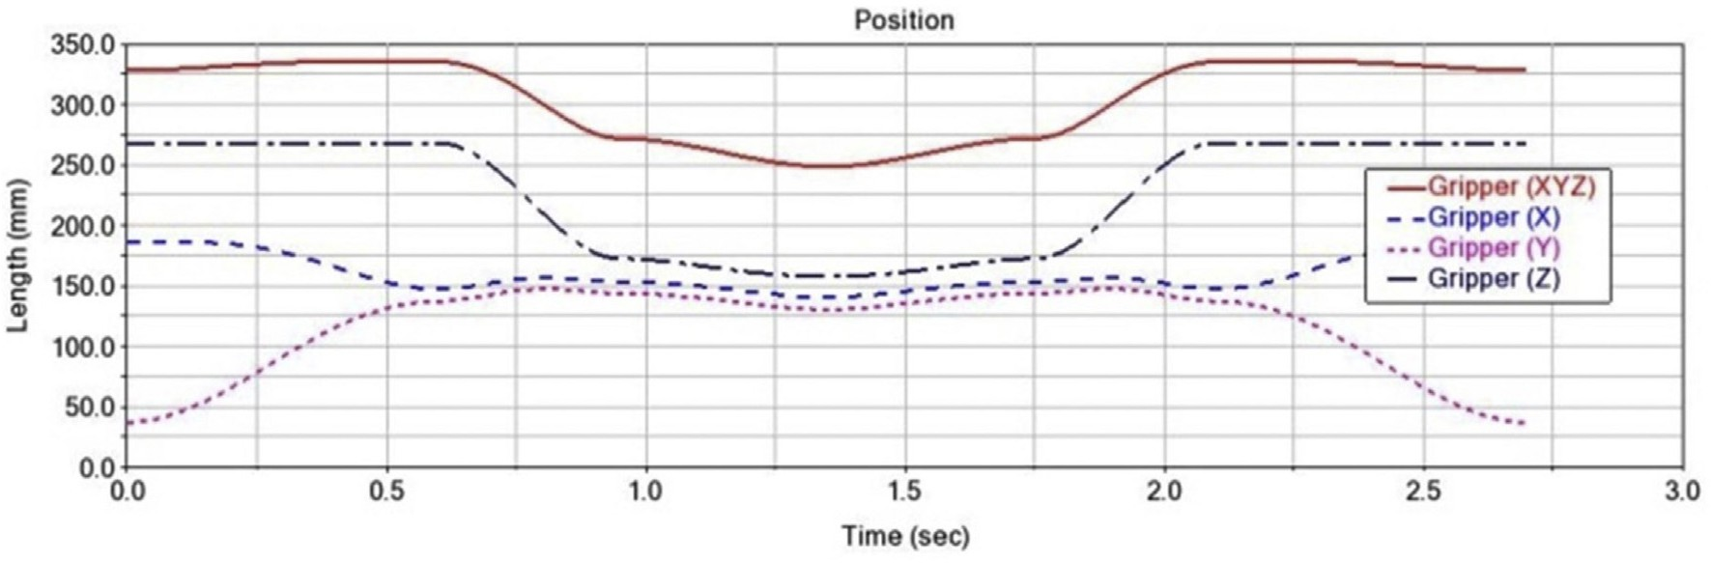

Fig. 10. Gripper position during one cycle time.

wasmeasured atthe pickup positions. The gripper of the robotic arm could not hold the seedlings properly when the pot seedlings were tilted above 250 (considered as the threshold angle) from the vertical of the conveyor base plate. The number of inclined seedlings on the feeding conveyor was noted to determine the conveying efficiency. The seedlings in upright orientation without any significant inclination were only allowed to be handled by the robotic arm. The inclination of seedlings present in the feeding conveyor was closely observed. The significantly inclined seed- lings were removed quickly and counted (Ni). The seedlings were allowed to be picked by the gripper from the pickup positions and to drop the same at the drop position. The dropped seedlings were carefully observed, and the number of damaged pots and seedlings (Ndam) was noted. A total of 21 tomato pot seedlings were placed in the feeding conveyor, and six rep- lications were made (21 × 6 = 126 runs) for laboratory tests. In the field, six replications were made with each plot of size of 15 × 6 m.

* + 1. *Data analysis*

Data on the number of seedlings while feeding, conveying and transplanting operation was noted down. The seedling conveying effi- ciency (CE), metering efficiency (ME) and overall efficiency (OE) were computedusingthefollowingequations(Nandede and Raheman, 2015):

*CE* = *Nt* −*Ni* × 100 (13)

*Nt*

*ME* = *Nt* −*Ni*−*Ndam* × 100 (14)

*Nt*−*Ni*

1. Results and discussion
   1. *Performance of feeding conveyor*

The run time of the conveyor computed from Fig. 8b was found to be 450 ms. Power requirement for operating the feeding conveyor was found out by measuring the current using a multimeter. A con- stant 12 V DC was supplied and the maximum current consumption was measured as 1.5A. The maximum power consumed by the feed- ing conveyor was found to be 18 W (12 V × 1.5 A).

* 1. *Performance of robot arm*
     1. *Based on the simulation study*

From the simulation results, the Cartesian position (X, Y, and Z) of the gripper with respect to time in one cycle is shown in Fig. 10. It was found that the time required to complete one cycle was 2.7 s. The simulated angular velocity profile of all three joints (base, shoul- der and elbow) of the robotic arm for completing a pick and drop cycle is shown in Fig. 11. It can be seen in this figure that the velocity profile initially increased gradually from the rest position to a maxi- mum velocity and then gradually reduced until it reached the desired location. The maximum velocity of the base joint, elbow joint and shoulder joint was 125° s−1, 117.5° s−1 and 173° s−1, respectively. The differences in velocity of active joints were basically to synchro-

*OE* = *CE* × *ME*

100

(15)

nize the input joint motion for reaching the different target angular positions.

where, N = Number of seedlings placed in the conveyor, N = Number

The translational velocity of the gripper for pick and drop of sin-

t i gle pot seedling is shown in Fig. 12. The minimum and maximum ve-

of inclined seedlings at robotic arm pick up position and Ndam = Num- ber of seedlings damaged while picking and placing by the robotic arm

locity of the gripper was found to be 93 and 426 mm s−1, respectively.

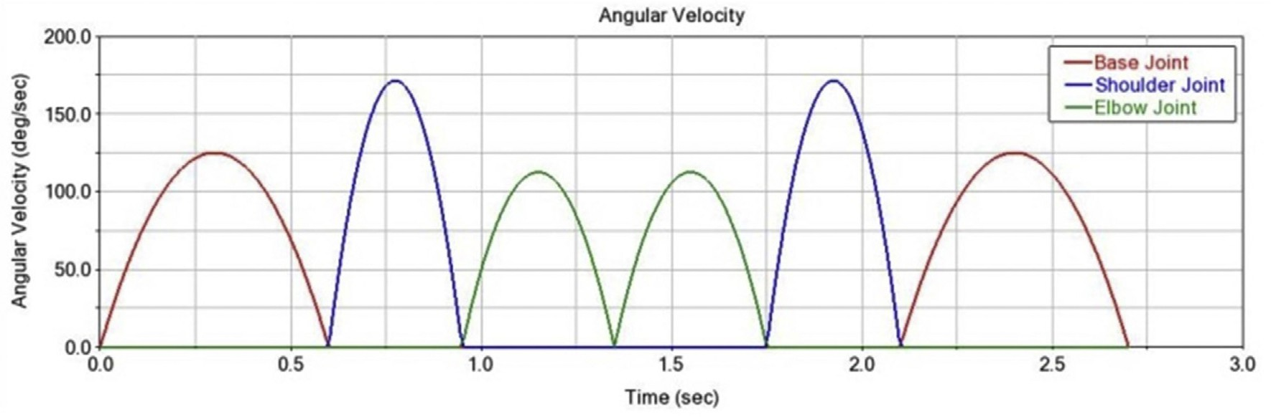

Fig. 11. Joint angular velocity during one cycle time.

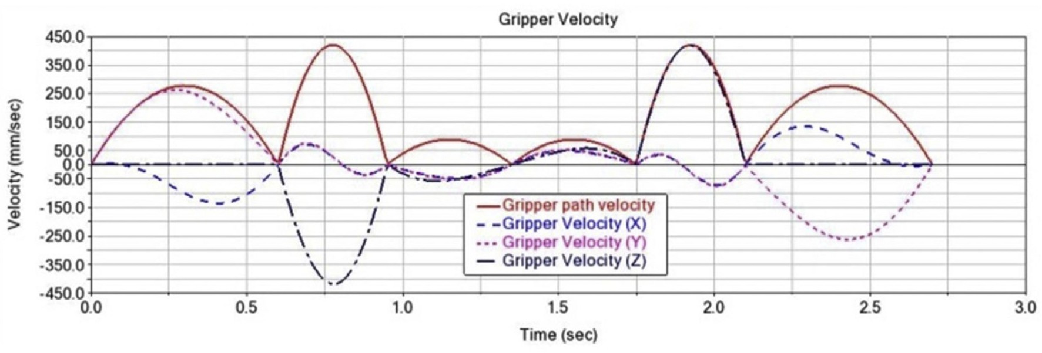

Fig. 12. Gripper velocity during one cycle time.

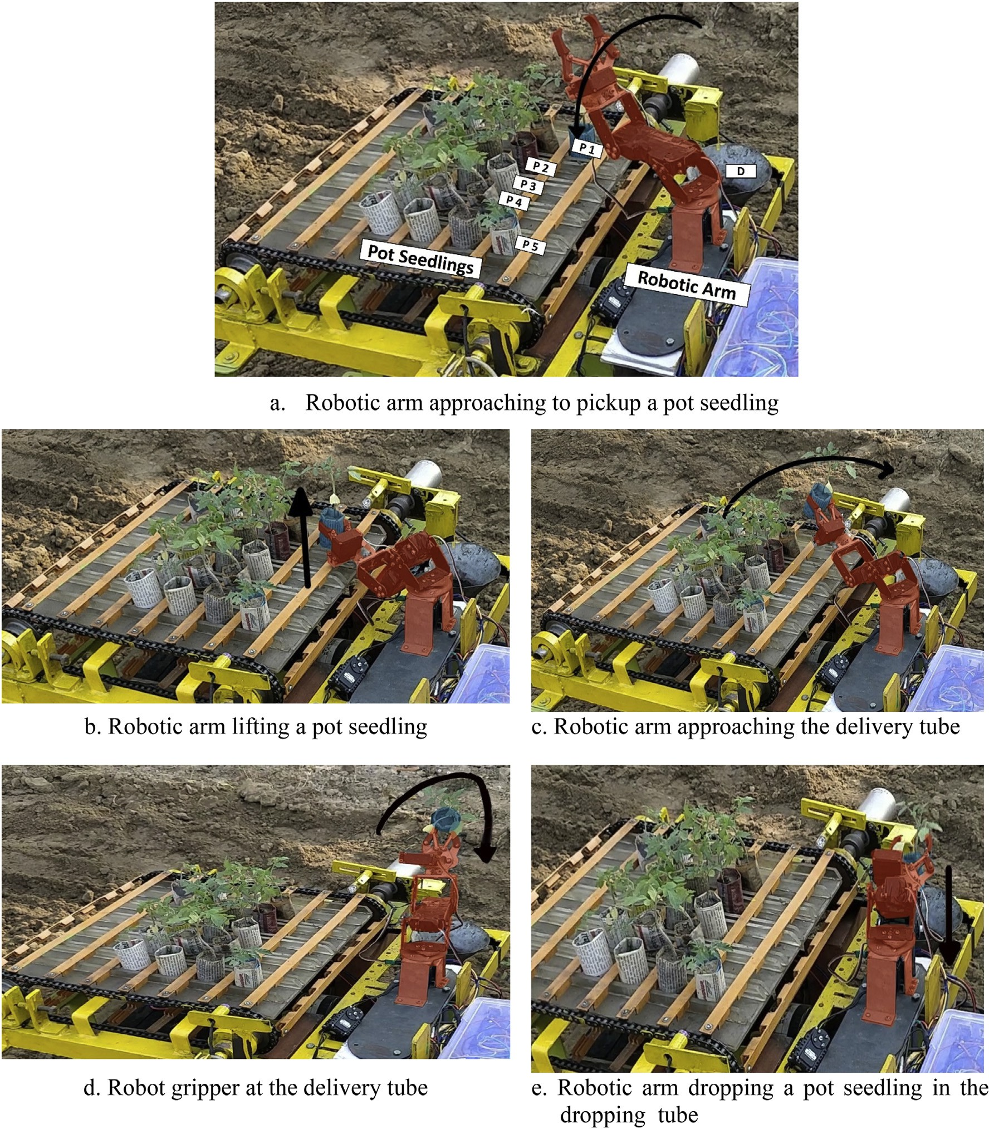

Fig. 13. Sequence of operation made by the robotic arm in handling a paper pot seedling (The arrow marks given in the figures indicate the movement of robotic arm).

Table 3

Performance of the metering unit under laboratory condition.

|  |  |  |  |  |  |  |
| --- | --- | --- | --- | --- | --- | --- |
| S. No | Number of seedlings loaded on the conveyor | Number of inclined seedlings | Number of seedlings damaged by the robotic arm | Conveying efficiency (%) | Metering efficiency (%) | Overall efficiency (%) |
| 1 | 21 | 1 | 1 | 95.24 | 95.00 | 90.48 |
| 2 | 21 | 0 | 1 | 100.00 | 95.24 | 95.24 |
| 3 | 21 | 1 | 1 | 95.24 | 95.00 | 90.48 |
| 4 | 21 | 1 | 0 | 95.24 | 100.00 | 95.24 |
| 5 | 21 | 0 | 1 | 100.00 | 95.24 | 95.24 |
| 6 | 21 | 1 | 1 | 95.24 | 95.00 | 90.48 |
| Average |  |  |  | 96.83 | 95.91 | 92.86 |

* + 1. *Power requirement for operation of the robotic arm*

The power required for operating the robotic arm depends upon the number of joints, the weight of the links and payload (i.e., the weight of pot seedling). The current consumption of the robotic arm was

measured with a multi-meter. By providing a constant DC voltage (12 V), the maximum current required for operating the robotic arm while handling paper pot seedlings was measured to be 1.33 A. Hence, the power requirement of the robotic arm was found to be 16 W.

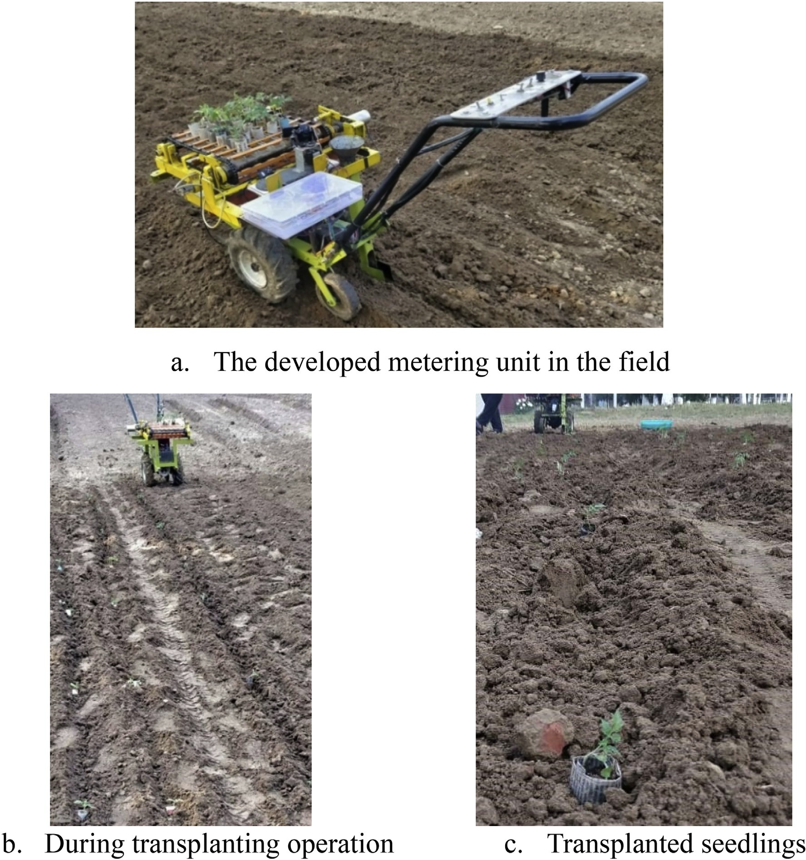

Fig. 14. Testing of the metering unit under field condition.

Table 4

Performance of the metering unit under field condition.

|  |  |  |  |  |  |
| --- | --- | --- | --- | --- | --- |
| S. No. | Parameters | Plot 1 | Plot 2 | Plot 3 | Average |
| 1. | Seedling planting rate, seedlings min−1 | 20 | 20 | 20 | 20 |
| 2. | Percentage missed planting, % | 4.5 | 4 | 4.5 | 4.33 |
| 3. | Percentage tilted planting, % | 4.8 | 5.5 | 6 | 5.43 |
| 4. | Metering efficiency, % | 93.89 | 92.67 | 93.29 | 93.28 |
| 6. | Conveying efficiency (%) | 95.23 | 94.17 | 94.7 | 94.70 |
| 7. | Overall efficiency (%) | 89.41 | 87.27 | 88.35 | 88.33 |

−1

Kumar and Raheman (2011) reported the percentage of missed planting and tilted planting as 4.01% and 5.14%, respectively with a field capacity of 0.026 ha/h for a walk-behind type fully automatic veg- etable transplanter that used pot seedlings. In the present study, aver- age missed plantings and tilted plantings were 4.33% and 5.43%, respectively with an average field capacity of 0.021 ha/h. A little higher missed and tilted planting occurred due to damage of pots during the metering process by the feeding conveyor and robotic arm.

Around 4 to 6% of the total pot seedlings of tomato planted by the de-

8. Average forward speed, km h

|  |  |  |  |  |
| --- | --- | --- | --- | --- |
| 9. Spacing between adjacent seedlings (cm) | 61±3 | 62±4 | 60±5 | 61±4 |
| 10. Field capacity, ha/h | 0.021 | 0.02 | 0.022 | 0.021 |
| 11. Field efficiency, % | 43.7 | 41.66 | 45.83 | 43.73 |

* + 1. *Cycle time of the robotic arm*

0.8 0.8 0.8 0.8

veloped metering mechanism were found tilted after falling into the furrow. Chaudhuri et al. (2002) reported the percentage of tilted plant- ing as 4.00 to 13.43 for the semi-automatic vegetable transplanter due to soil condition prevailed in the field. In the present study, pot seed- lings tilted during transplanting due to partial covering of seedling pots with soil by the furrow closer and failure of pot seedlings to fall in upright orientation through the seedling delivery tube. A close view

The cycle time of the robotic arm to pick and drop seedlings was measured using a stopwatch and found to be varying from 2.5 to 3.1 s (for positions P1 to P5). The deviation in average actual cycle time and simulated cycle time of robotic arm for P5 position was due to friction, gripper opening/closing time and algorithm computation time by the microcontroller. The robotic arm could able to pick and drop 20 seed- lings min−1. The time required to move the next group of pot seedlings to the workspace of the robotic arm in the feeding conveyor was found to be 450 ms. This means by the time the robotic arm dropped the last seedlings from a row from position P5, the conveyor could move the next row of seedlings to the pickup positions. Thus, the robotic arm was able to continuously pick up the pot seedlings from the feeding con- veyor and drop these seedlings into the delivery tube.

* 1. *Performance of the robotic arm with feeding conveyor*

The sequence of operation made by the robotic arm to pick the pot seedlings from position P1 and to drop it at D is shown in Fig. 13a–e. The robotic arm first approached a pot seedling and gripped it by actu- ating the gripper (Fig. 13a). Then the pot seedling was lifted from the conveyor by actuating the shoulder and elbow joint of the robotic arm (Fig. 13b). The seedling was then moved from P1 to D by rotating the base joint (Fig. 13c). Finally, the seedling was dropped at the dropping point, D by opening the gripper (Fig. 13d and e).

* + 1. *Performance of the metering mechanism under the stationary labora- tory condition and moving condition in the field*

The results of the metering unit evaluated under the stationary condition in the laboratory are summarized in Table 3. The convey- ing efficiency of the feeding conveyor refers to successfully placing of seedling at the robot pickup position without tilting, and metering efficiency refers to the successfully picking and dropping of the pot seedlings at the dropping point into the seedling delivery tube without causing any damage to the pots and seedlings. Convey- ing efficiency, metering efficiency and overall efficiency were com- puted using Eqs. (13), (14) and (15), respectively. The average values of the conveying, metering and overall efficiency under labo- ratory conditions were observed to be 96.83%, 95.91% and 92.86%, respectively.

The testing of the metering mechanism in moving conditions in the

field is shown in Fig. 14.

From the field tests, the quality of transplanting as indicated by the seedling planting rate, percent missed planting, percent tilted planting and overall planting efficiency are computed and summarized in Table 4 for the individual plots. From this Table, it can be seen that the developed metering mechanism could drop on an average 20 pot seed- lings per min. The average percentage of missed planting that occurred due to damage of pots within the machine during the metering of pot seedlings was found to be 4.44%.

of the seedlings dropped into the furrow is shown in Fig. 14 (b and c). The average conveying, metering and overall efficiency of the metering unit in the field condition were found to be 94.7%, 93.28% and 88.33%, respectively. The sources of reduced efficiencies from the ideal (100%) are due to: a) inclinations and tilting occurred during con- veying of the seedlings due to friction and operating speed of the con- veyor and b) damage occurring to the seedlings by the robot arm due to higher force of gripping the seedlings. These reductions in efficiency are not so high, hence, the developed robotic arm could be successfully

used to handle pot seedlings in a vegetable transplanter.

1. Conclusions

A 3 DOF serial robotic arm based metering mechanism was devel- oped to automate the vegetable transplantation process using tomato seedlings raised in paper pots weighing 44 to 47 g with a total power consumption of 16 W. An LDR and LED based sensing system was devel- oped to detect the presence of the seedlings on the feeding conveyor. It successfully sensed the presence of pot seedlings at LOA and controlled the movement of the conveyor precisely. The power required for oper- ating the feeding conveyor was 18 W only and it required 450 ms to move a group of pot seedlings into the workspace of the robotic arm.

The developed robotic arm could pick and drop pot seedling from different positions in the conveyor with a cycle time between 2.5 and

3.1 s. These variations were because of variation in the distance of pick- ing positions from the dropping point. The robotic arm could success- fully pick and drop 20 seedlings per min. The average values of the conveying, metering and overall efficiency of the developed metering mechanism were 96.83%, 95.91% and 92.86%, respectively, under labo- ratory conditions as compared to 94.7%, 93.28% and 88.33%, under field condition. The measured efficiencies under field conditions were found to be reduced due to the vibrations produced during the move- ment of the transplanter in the field. It was observed that the developed robotic metering unit could operate at much lesser power input with re- duced size and mechanisms without much difference from the perfor- mance of mechanical type pot seedling transplanter. Thus the use of robotic metering mechanism could increase the feasibility of commer- cializing the transplanters by reducing the overall cost without compromising the performance.

Declaration of competing interest

The authors have no conflict of interest

Acknowledgement

The financial support received from the Indian Council of Agricul- tural Research (ICAR), Ministry of Agriculture, Govt. of India (Agri. Engg.27(4)/2015-AE) to carry out this research work is sincerely acknowledged.

References

Chaudhuri, D., Singh, V.V., Dubey, A.K., 2002. [Refinement and adoption of mechanical veg-](http://refhub.elsevier.com/S2589-7217(21)00013-1/rf0005) [etable transplanters for Indian conditions. Agricult. Eng. Today 26 (5), 11–20](http://refhub.elsevier.com/S2589-7217(21)00013-1/rf0005).

Dihingia, P.C., Kumar, G.V.P., Sarma, P.K., Neog, P., 2017. [Production of soil block seedlings](http://refhub.elsevier.com/S2589-7217(21)00013-1/rf0010) [in plug trays for mechanical transplanting. Int. J. Vegetabl. Sci. 23 (5), 471–485](http://refhub.elsevier.com/S2589-7217(21)00013-1/rf0010).

Harada, K., Nagata, K., Rojas, J., Ramirez, A.I.G., Wan, W., Onda, H., Tsuji, T., 2016. [Proposal](http://refhub.elsevier.com/S2589-7217(21)00013-1/rf0015) [of a shape adaptive gripper for robotic assembly tasks. Adv. Robot. 30 (17–18),](http://refhub.elsevier.com/S2589-7217(21)00013-1/rf0015) [1186–1198](http://refhub.elsevier.com/S2589-7217(21)00013-1/rf0015).

Hu, J., Yan, X., Ma, J., Qi, C., Francis, K., Mao, H., 2014. [Dimensional synthesis and kinemat-](http://refhub.elsevier.com/S2589-7217(21)00013-1/rf0020) [ics simulation of a high-speed plug seedling transplanting robot. Comput. Electron.](http://refhub.elsevier.com/S2589-7217(21)00013-1/rf0020) [Agric. 107, 64–72](http://refhub.elsevier.com/S2589-7217(21)00013-1/rf0020).

Hwang, H., Sistler, F.E., 1986. [A robotic pepper transplanter. Appl. Eng. Agric. 2 (1), 2–](http://refhub.elsevier.com/S2589-7217(21)00013-1/rf0025)5.

Joseph, R.A.N., Sundaram, R., Mahesh, V.G., Zhuang, Z., Simeone, A., 2019. [A multi-sensor](http://refhub.elsevier.com/S2589-7217(21)00013-1/rf0030) [system for silkworm cocoon gender classification via image processing and support](http://refhub.elsevier.com/S2589-7217(21)00013-1/rf0030) [vector machine. Sensors 19 (12), 2656](http://refhub.elsevier.com/S2589-7217(21)00013-1/rf0030).

Khadatkar, A., Mathur, S.M., Gaikwad, B.B., 2018. [Automation in transplanting: a smart](http://refhub.elsevier.com/S2589-7217(21)00013-1/rf0035) [way of vegetable cultivation. Curr. Sci. 115 (10), 1884](http://refhub.elsevier.com/S2589-7217(21)00013-1/rf0035).

Kumar, G.V.P., Raheman, H., 2008. [Vegetable transplanters for use in developing countries](http://refhub.elsevier.com/S2589-7217(21)00013-1/rf0040) [a review. Int. J. Vegetabl. Sci. 14 (3), 232–255](http://refhub.elsevier.com/S2589-7217(21)00013-1/rf0040).

Kumar, G.V.P., Raheman, H., 2010. [Volume of vermicompost-based potting mix for vege-](http://refhub.elsevier.com/S2589-7217(21)00013-1/rf0045) [table transplants determined using fuzzy biomass growth index. Int. J. Vegetabl. Sci.](http://refhub.elsevier.com/S2589-7217(21)00013-1/rf0045) [16 (4), 335–35](http://refhub.elsevier.com/S2589-7217(21)00013-1/rf0045)0.

Kumar, G.V.P., Raheman, H., 2011. [Development of a walk-behind type hand tractor](http://refhub.elsevier.com/S2589-7217(21)00013-1/rf0050) [powered vegetable transplanter for paper pot seedlings. Biosyst. Eng. 110 (2),](http://refhub.elsevier.com/S2589-7217(21)00013-1/rf0050) [189–197](http://refhub.elsevier.com/S2589-7217(21)00013-1/rf0050).

Nandede, B.M., Raheman, H., 2015. [Multi-stage metering mechanism for transplanting of](http://refhub.elsevier.com/S2589-7217(21)00013-1/rf0055) [vegetable seedlings in paper pots. J. Institut. Eng. Ser. A 96 (4), 295–30](http://refhub.elsevier.com/S2589-7217(21)00013-1/rf0055)0.

Nandede, B.M., Raheman, H., Kumar, G.V.P., 2014. [Standardization of potting mix and pot](http://refhub.elsevier.com/S2589-7217(21)00013-1/rf0060) [volume for the production of vegetable seedlings in paper pot. J. Plant Nutr. 37 (8),](http://refhub.elsevier.com/S2589-7217(21)00013-1/rf0060) [1214–1226](http://refhub.elsevier.com/S2589-7217(21)00013-1/rf0060).

Pandilov, Z., Dukovski, V., 2014. [Comparison of the characteristics between serial and par-](http://refhub.elsevier.com/S2589-7217(21)00013-1/rf0065) [allel robots. Bull. Eng. 7 (1), 143–16](http://refhub.elsevier.com/S2589-7217(21)00013-1/rf0065)0.

Parish, R.L., 2005. [Current developments in seeders and transplanters for vegetable crops.](http://refhub.elsevier.com/S2589-7217(21)00013-1/rf0070)

[HortTechnology 15 (2), 346–351](http://refhub.elsevier.com/S2589-7217(21)00013-1/rf0070).

Prasanna, K.G.V., Raheman, H., 2012. [Automatic feeding mechanism of a vegetable trans-](http://refhub.elsevier.com/S2589-7217(21)00013-1/rf0075) [planter. Int. J. Agricult. Biol. Eng. 5 (2), 20–27](http://refhub.elsevier.com/S2589-7217(21)00013-1/rf0075).

Rahul, K., Raheman, H., Paradkar, V., 2019. [Design and development of a 5R 2DOF parallel](http://refhub.elsevier.com/S2589-7217(21)00013-1/rf0080) [robot arm for handling paper pot seedlings in a vegetable transplanter. Comput. Elec-](http://refhub.elsevier.com/S2589-7217(21)00013-1/rf0080) [tron. Agric. 166, 10501](http://refhub.elsevier.com/S2589-7217(21)00013-1/rf0080)4.

Rahul, K., Raheman, H., Paradkar, V., 2020. [Design of a 4 DOF parallel robot arm and the](http://refhub.elsevier.com/S2589-7217(21)00013-1/rf1111) [firmware implementation on embedded system to transplant pot seedlings. Artificial](http://refhub.elsevier.com/S2589-7217(21)00013-1/rf1111) [Intelligence in Agriculture 4, 172–18](http://refhub.elsevier.com/S2589-7217(21)00013-1/rf1111)3.

Ryu, K.H., Kim, G., Han, J.S., 2001. [Automation and emerging technologies: development](http://refhub.elsevier.com/S2589-7217(21)00013-1/rf0085) [of a robotic transplanter for bedding plants. J. Agric. Eng. Res. 78 (2), 141–146](http://refhub.elsevier.com/S2589-7217(21)00013-1/rf0085).

Sakaue, O., 1996. [Development of seeding production robot and automated transplanter](http://refhub.elsevier.com/S2589-7217(21)00013-1/rf0090) [system. Japan Agricult. Res. Q. 30, 221–226](http://refhub.elsevier.com/S2589-7217(21)00013-1/rf0090).

Shamshiri, R., Weltzien, C., Hameed, I.A., Yule, I., Grift, T.E., Balasundram, S.K., Pitonakova, L., Ahmad, D., Chowdhary, G., 2018a. [Research and development in agricultural robot-](http://refhub.elsevier.com/S2589-7217(21)00013-1/rf0095) [ics: a perspective of digital farming. Int. J. Agricult. Biol. Eng. 11 (4), 1–14](http://refhub.elsevier.com/S2589-7217(21)00013-1/rf0095).

Shamshiri, R., Hameed, I.A., Pitonakova, L., Weltzien, C., Balasundram, S.K., Yule, I., Grift, T.E., Chowdhary, G., 2018b. [Simulation software and virtual environments for accel-](http://refhub.elsevier.com/S2589-7217(21)00013-1/rf0100) [eration of agricultural robotics: features highlights and performance comparison.](http://refhub.elsevier.com/S2589-7217(21)00013-1/rf0100) [Int. J. Agricult. Biol. Eng. 11 (4), 15–31](http://refhub.elsevier.com/S2589-7217(21)00013-1/rf0100).

Syed, T.N., Lakhiar, I.A., Chandio, F.A., 2019a. [Machine vision technology in agriculture: a](http://refhub.elsevier.com/S2589-7217(21)00013-1/rf0105) [review on the automatic seedling transplanters. Int. J. Multidiscipl. Res. Devel. 6](http://refhub.elsevier.com/S2589-7217(21)00013-1/rf0105) [(12), 79–88](http://refhub.elsevier.com/S2589-7217(21)00013-1/rf0105).

Syed, T.N., Jizhan, L., Xin, Z., Shengyi, Z., Yan, Y., Mohamed, S.H.A., Lakhiar, I.A., 2019b. [Seedling-lump integrated non-destructive monitoring for automatic transplanting](http://refhub.elsevier.com/S2589-7217(21)00013-1/rf0110) [with Intel RealSense depth camera. Artif. Intellig. Agricult. 3, 18–32](http://refhub.elsevier.com/S2589-7217(21)00013-1/rf0110).

Tian, S., Qiu, L., Kondo, N., Yuan, T., 2010. [Development of automatic transplanter for plug](http://refhub.elsevier.com/S2589-7217(21)00013-1/rf0115) [seedling. IFAC Proc. Vol. 43 (26), 79–82](http://refhub.elsevier.com/S2589-7217(21)00013-1/rf0115).

Ting, K.C., Giacomelli, G.A., Shen, S.J., 1990a. [Robot workcell for transplanting of seedlings](http://refhub.elsevier.com/S2589-7217(21)00013-1/rf0120) [part I-layout and materials flow. Trans. ASAE 33 (3), 1005–1010](http://refhub.elsevier.com/S2589-7217(21)00013-1/rf0120).

Ting, K.C., Giacomelli, G.A., Shen, S.J., Kabala, W.P., 1990b. [Robot workcell for transplanting](http://refhub.elsevier.com/S2589-7217(21)00013-1/rf0125) [of seedlings part II-end-effector development. Trans. ASAE 33 (3), 1013–1017](http://refhub.elsevier.com/S2589-7217(21)00013-1/rf0125).

Tsuga, K., 2000. [Development of fully automatic vegetable transplanter. Japan Agricult.](http://refhub.elsevier.com/S2589-7217(21)00013-1/rf0130)

[Res. Q. 34 (1), 21–28](http://refhub.elsevier.com/S2589-7217(21)00013-1/rf0130).

Vivek, P., Duraisamy, V.M., Kavitha, R., 2019. [Development of a gripper for robotic picking](http://refhub.elsevier.com/S2589-7217(21)00013-1/rf0135) [and transplanting operation of protray grown vegetable seedlings. Innov. Farming 4](http://refhub.elsevier.com/S2589-7217(21)00013-1/rf0135) [(2), 97–10](http://refhub.elsevier.com/S2589-7217(21)00013-1/rf0135)4.

Xin, J., Kaixuan, Z., Jiangtao, J., Xinwu, D., Hao, M., Zhaomei, Q., 2018. [Design and imple-](http://refhub.elsevier.com/S2589-7217(21)00013-1/rf0140) [mentation of intelligent transplanting system based on photoelectric sensor and](http://refhub.elsevier.com/S2589-7217(21)00013-1/rf0140) [PLC. Futur. Gener. Comput. Syst. 88, 127–13](http://refhub.elsevier.com/S2589-7217(21)00013-1/rf0140)9.

Yamanobe, N., Nagata, K., 2010. [Grasp planning for everyday objects based on primitive](http://refhub.elsevier.com/S2589-7217(21)00013-1/rf0145) [shape representation for parallel jaw grippers. IEEE International Conference on Ro-](http://refhub.elsevier.com/S2589-7217(21)00013-1/rf0145) [botics and Biomimetics, pp. 1565–1570](http://refhub.elsevier.com/S2589-7217(21)00013-1/rf0145).

Yung, I., Maccarana, Y., Maroni, G., Previdi, F., 2019. [Partially structured robotic picking for](http://refhub.elsevier.com/S2589-7217(21)00013-1/rf0150) [automation of tomato transplantation. IEEE International Conference on](http://refhub.elsevier.com/S2589-7217(21)00013-1/rf0150) [Mechatronicss (ICM). 1, pp. 640–64](http://refhub.elsevier.com/S2589-7217(21)00013-1/rf0150)5.

Vikas Paradkar is Ph.D Student, Specialization in Farm machinery and Power, Agricultural and Food Engineering Department, Indian Institute of Technology Kharagpur, India. His re- search focus is on implementation of robot in vegetable transplanter.

Hifjur Raheman is a Professor in the Agricultural and Food Engineering Department of Indian Institute of Technology Kharagpur, India. His research areas are use of robotics in agri-machinery, renewable energy operated agricultural machinery, alternate fuels from biomass (Biodiesel, producer gas) and bioelectricity production and tillage and traction improvement in tractors and power tillers.

Rahul K is persuing Master of Science at Indian Institute of Technology Kharagpur in Farm Machinery specialization under Agricultural and Food Engineering Department. His re- search focuses on implementation of robotics and automation in agricultural machinery. He is also interested in artificial intelligence, machine vision and mechatronic system de- sign.