Available online at [www.sciencedirect.com](http://www.sciencedirect.com/)



AASRI Procedia 3 (2012) 270 – 276

2012 AASRI Conference on Modelling, Identification and Control

Direct-drive Bi-Rotary Milling Head Variable Load Thermal Characteristics Analysis*

Shiwei Hua Qingdong Yanga Baoying Pengb Hongzhi Wanga

*a College Of Mechanical Engineering, Beijing Information Science & Technology University, Beijing, 100192,China*

*b College of Mechanical Engineering and Applied Electronics Technology, Beijing University of Technology, Beijing, 100024; China*

**Abstract**

Bi-rotary Milling Head in the machining process take direct cutting force, its thermal properties change on the accuracy of machine tool have an important influence. In this paper a wide range of load change processing conditions direct drive type double pendulum Angle milling head thermal properties condition to carry on the analysis, based on solidworks platform set up Bi-rotary Milling Head of the CAD model, the model into ANSYS platform. Determine the Bi-rotary Milling Head structure heat source, convection boundary conditions and constraints, the motor power changes the Bi- rotary Milling Head temperature field model and digital simulation, the varying load processing conditions, A, C thermal characteristic analysis, get the A, C axis load - temperature - time distribution, for the Bi-rotary Milling Head and structure design of high-grade CNC machine straight drive processing technology led to the development of theory and the technology base.

© 2012 The Authors. Published by Elsevier B.V. Open access under [CC BY-NC-ND license.](http://creativecommons.org/licenses/by-nc-nd/3.0/)

© 2012 Published by Elsevier B.V. Selection and/or peer rev[iew under responsi](http://creativecommons.org/licenses/by-nc-nd/3.0/)bility of American Applied Science Research Institute

Selection and/or peer review under responsibility of American Applied Science Research Institute

*Keywords*: Bi-Rotary Milling Head; Variable load; ANSYS; Thermal analysis ; Torque motor

* *The construction of high-end equipment R & D service center--Advanced direct-drive technology laboratory construction (D11110400260000)

*Corresponding Author:Shiwei Hu/Email:1535825900@qq.com/Tel:15501133133

2212-6716 © 2012 The Authors. Published by Elsevier B.V. Open access under [CC BY-NC-ND license.](http://creativecommons.org/licenses/by-nc-nd/3.0/) Selection and/or peer review under responsibility of American Applied Science Research Institute doi:10.1016/j.aasri.2012.11.044

## Introduction

The Bi-rotary Milling Head is the core component of the axis CNC milling machine, its structure and performance largely determine the performance of the whole machine, and thus become one of the axis CNC machine tools focus of market competition [1].According to transmission double pendulum angle milling head can be divided into mainly mechanical milling head of the worm gear, worm drive and direct drive torque motor direct drive milling head. Mechanical milling head in the country earlier research, the technology is more mature, but the large volume of such milling head positioning accuracy. Direct drive milling head with high-power direct-drive torque motor, eliminating the need for intermediate transmission gear, worm link, the structure has the following advantages [2-4]: 1 Parts small parts, simple structure, compact, small size, light weight; 2 Avoid transmission error of the gap between the transmission member, thereby improving the machining accuracy; 3 Greatly reduce vibration, friction, fatigue, mechanical failure, caused by the high- speed transmission and improve the accuracy of the system of the milling head holding. With the torque motor technology continues to evolve, the mechanical milling head gradually replaced by Direct-drive milling head.

Direct-drive Bi-rotary Milling Head with high precision characteristics, so Bi-rotary Milling Head temperature field distribution of the overall structure of a great influence on machining accuracy, the parts of the surface quality and production efficiency[5]. In recent years, scholars have varying degrees of Bi-rotary Milling Head. In 2009, Liu Lei [6] and other several focus on the worm double swing milling head structure comparison and research, bevel gears and torque motor direct drive double swing milling head institutions, summarizes several double pendulum the advantages and disadvantages of the milling head. In 2010, Lin Jianfeng, [7-8] direct-drive double swing milling head structural units finite element analysis and modal analysis to calculate the radial deformation of the casing and turn round deformation, to find the turn round stiffness of the weakest link - spacer, and then calculate the milling head of the 4-order modes, the axis swing angle milling head structure inherent frequency analysis, and to provide technical support for the design and improvement of class milling head. In 2011, Huo Jun Zhou [9-10] etc. Based on UG platform, the A-axis direct- drive double swing milling head thermal deformation and thermal stress analysis, access to the A-axis maximum thermal deformation and thermal stress position for direct-drive double pendulum mill the structural design of the head and around the motor coolant circulation system designed to provide a design basis.

Based solidworks platform to establish a double pendulum CAD model of the milling head, and imported into the ANSYS platform, determine the boundary conditions, the state of the straight drive double pendulum angle milling machine thermal characteristics in a wide range of load changes in processing conditions analysis to establish the temperature field, direct-drive double swing milling head load - temperature - time distribution, direct drive the development of processing technology for the Bi-rotary Milling Head structure design and high-end CNC machine tools to lay the theoretical and technical basis.

## The finite element model of direct-drive Bi-rotary Milling Head

* 1. *The mechanical structure of direct drive Bi-rotary Milling Head*

Direct-drive Bi-rotary Milling Head the agencies mainly by a spindle around the axis of rotation of the gimbals, the four connected gimbals torque motor and electric spindle. Direct-drive double pendulum the milling head mechanical structure shown in Figure 1 shown:

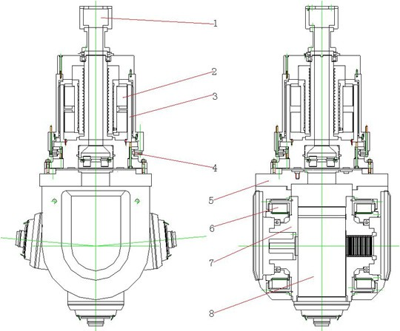

1. Coupler 2. Stator 3.Rotor 4. A/R bearing 5.Gimbals 6.Rotor 7 Spindle sleeve 8. Electric spindle

Fig.1 Direct-drive Bi-rotary Milling Head structure

The gimbals and electric spindle torque motor direct drive. Gimbals driven by the first torque motor, achieve C-axis rotation. The second pair of torque motor through a pair of prongs connected to the gimbals around the C-axis rotation with gimbals, the rotor electric spindle sleeve is connected to the electric spindle, direct drive electric spindle axis A swing. Two pairs torque motors are used in parallel installed.

* 1. *The finite element model of direct-drive Bi-rotary Milling Head*

Milling head components mainly by the A-axis torque motor fixed support frame, the base of the swing com- ponents, electric spindle, motor spindle mounts, C-axis fixed bearing C-axis motor stator bearing components, tor- que motors, bearings, grating and other components, the establishment of a three- dimensional solid model these parts and assembly model of the entire milling head parts. There are a lot of subtle features which in accordance with the physical structure of the finite element analysis, finite element modeling is very difficult, and the establishment of the model is too complex may lead to subsequent finite element meshing difficulties, poor meshing unit mesh density varying degrees, the results are not allowed reasonable shape of the finite element mesh generation unit after so reduce the number of units and the number of nodes, in order to improve the accuracy and reliability of the analysis results, to reduce the computation and improve the computational speed necessary to simplify the equivalent in the finite element model of the actual model should:

* + 1. Modeling process will structure the process characteristics such as chamfers, small boss, casting rounded ignored 
    2. Ignore structure hole for bolt holes, technological holes and positioning holes, etc 
    3. Entity rings instead of bearing to simplify the calculation, the definition of a fixed combination of surface, "Frictional" and "Stiffness" command definitions movable bearing joint surface and can be used in the Workbench "Bonded" command.

Simplified model into finite element software, ANSYS Workbench12, divided by the line grid of the overall mesh model in Figure 2 shows:

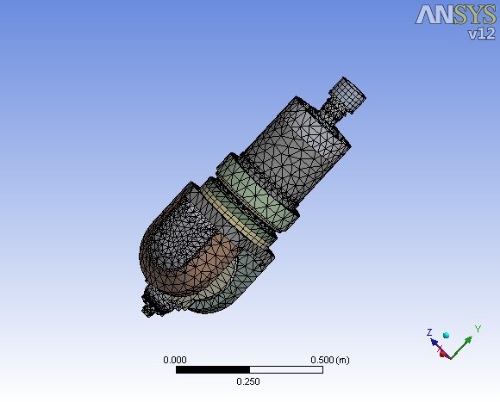

Fig.2 Bi-rotary Milling Head finite element model

## Bi-rotary Milling Head heat source and boundary conditions calculated

* 1. *Heat source analysis*

Direct drive torque motor direct drive Bi-rotary Milling Head, so the main consideration for direct-drive Bi-rotary Milling Head heat source analysis torque motor heating, while ignoring low speed bearing fever.

The heat generated by the torque motor at work that motor power is not converted to mechanical energy of that portion of the heat. That 

*H * *P*(1)

In the formula :P is the motor power  is the efficiency.

* 1. *The calculation of the heat transfer coefficient*

*(1)*

Due to the temperature rise of the motor work process is relatively large, so water cooling are forced on exile thermal tube. According to Nusselt Standards, Calculated as the heat transfer coefficient a is:

*a * *Nu*

/ *L (2)*



size.

Criterion equation for forced on exile thermal   Wherein the formula 3 is in the laminar flow state, the formula 4 is in a turbulent state. 

# *Nu* 0.15 Re0.33 Pr0.43 *Gr*0.1 Pr

Pr*w*

0.25

*k (3)*

# *Nu* 0.021Re0.8 Pr0.43 Pr

Pr*w*

0.25

*k (4)*

In the formula  Pr is the Plaut number of the fluid; Prw wall temperature Plaut number; K correction coefficient; L is characterized by size; v is the kinematic viscosity; Re is the Reynolds number, and its expression is 

Re *w L v*

*(5)*



The heat generating power in accordance with the above formula, the A-axis motor for 414.8w, the heat power of the C-axis motor 376.8w, and the convective heat transfer coefficient of the cooling water to 1500w/(m2. c).

## Thermal Analysis of the temperature results

Direct-drive double swing milling head in the course of work, depending on the load, the power is different from the corresponding heat rate is not the same, different load changes during thermal analysis simulation analysis on the A / C-axis plus cycle transient thermal load, as shown in Figure 3 and 4

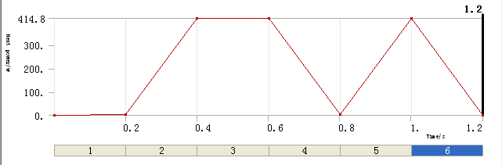

Fig.3 A shaft thermal load

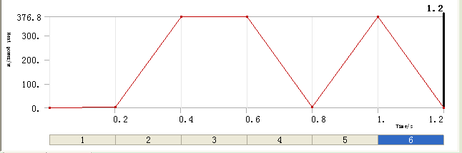

Fig.4 C shaft thermal load

Analysis on the direct-drive Bi-rotary Milling Head to obtain a temperature field in Figure 5 and Figure 6. By the analysis results, the highest temperature appears in the motor coil, out of the A\C-axis moment, 36.5 ° turntable bearing and the electro-spindle lower temperature, which is a lower speed in the work project, so less heat generated, and thus bearing the temperature atlower electric spindle with self-cooling system so the temperature is lower.

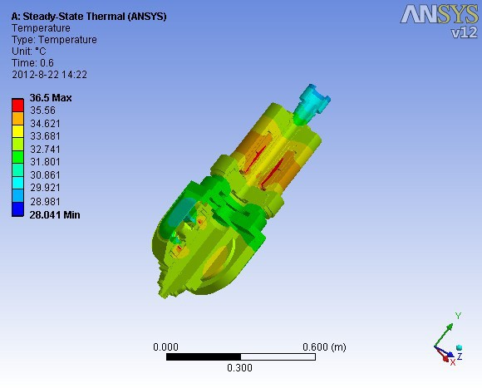 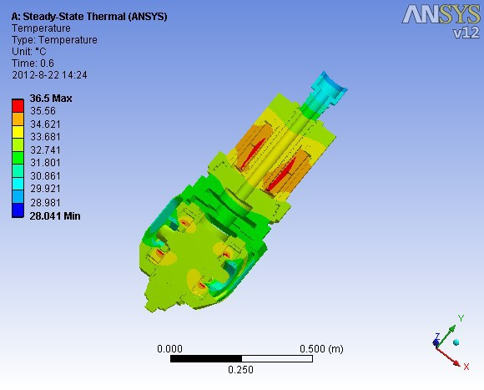

Fig.5 Milling head temperature field distribution Fig. 6 Milling head temperature field distribution (cutaway view)

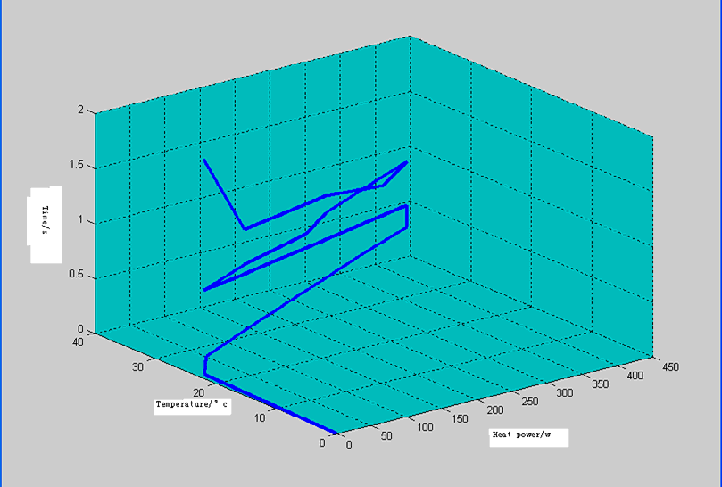

Fig.7 Load - temperature - time distribution curve

## Conclusions

1. From Figure 3, Figure 4 and Figure 7 direct-drive double swing milling head load - temperature - time distribution curves, the Bi-rotary Milling Head temperature rise and power of the Bi-rotary Milling Head direct drive linear relationship, when the Bi-rotary Milling Head power when the temperature rise is also the highest. Cooling system designed to meet the cooling requirements of the maximum power when can well controlled Bi-rotary Milling Head temperature rise.
2. Based solidworks established CAD model of direct-drive Bi-rotary Milling Head the model import ansys platform, analog double swing milling head in the work of engineering, will produce instantaneous power changes of 1:100, the A-axis and C axis respectively applied to the thermal load of the cycle, and thus the thermal characteristics of the direct-drive Bi-rotary Milling Head, double swing milling head load - temperature - time three-dimensional curve. Thermal stress analysis of finite element analysis method of the Bi-rotary Milling Head intuitive, convenient, effective, straight drive the development of the processing technology to lay the theoretical and technical foundation for the structural design of the Bi-rotary Milling Head and high-end CNC machine tools

## References

1. Zhang Zhenpo Tan Xuedong. The Analysis and Design of Structure and Functions of 5-Axis Machine Tool [J]. Equipment Manufacturing Technology,2009,21 10   5-8
2. Fan Hongcai Sheng Bohao. A/C Conversing Boring&Milling Head of Multi-axis Machine Tool [J]. Manufacturing Technology & Machine Tool,2007,26 2   100-102.
3. Xiao Jian Wang Keshe. Topology optimization design of direct-drive double-angle milling head [J].

Journal of Beijing Information Science & Technology University, 2009,24 3   50-53

1. Xue Zhaoyun Kang Min. Design of double swing cutter head based on direct drive motors [J]. Modern Manufacturing Engineering,2007,23 3   107-109.
2. Choi,Chlintae,Tsao Tsu-Chin.Control of linear motor machine tool feed drives for end milling: Robust

MIMO approach[J].Mechatronics,v15,n10,December,2005:1207 1224

1. Liu Lei Yang Qingdong. Study and Analysis of Structure and Precision Preserve for Several Kinds of Multiple Axes Rotary Spindle Heads [J]. Machine Building & Automation,2009,38 3   13-15
2. Lin Jianfeng Yan Ming Zheng Peng. Modal Analysis about Direct-drive A/C Bi-rotary Milling Head [J]. Journal of Mechanical Transmission,2010,4(34)  61-63.
3. Lin Jianfeng Yan Ming Zheng Peng. Finite Element Analysis of Transmission Components of C for Direct-drive Bi-rotary Milling Head [J]. Journal of Mechanical Transmission,2010,5 34   59-61
4. Huo Junzhou Cai Chungang Li Zhen. Thermal Structural Coupled Analysis of Multiple Axes Rotary Spindle Head for CNC Milling Machine [J]. Modular Machine Tool & Automatic Manufacturing Technique,2011, 5   1-4
5. Brandenburg G, Bruckl S, Dormann J. Comparative investigation of rotary and lineear motor feed drive systems for high precision machine tools. International workshop on Advanced Motion Control [J], AMC, 2000: 384-389

**Contact of Corresponding Author: Shiwei Hu/Email:1535825900@qq.com/Tel:15501133133**