[Array 9 (2021) 100050](https://doi.org/10.1016/j.array.2020.100050)

 

Contents lists available at [ScienceDirect](http://www.sciencedirect.com/science/journal/25900056)

Array

journal homepage: [www.elsevier.com/journals/array/2590-0056/open-access-journal](http://www.elsevier.com/journals/array/2590-0056/open-access-journal)

Distribution systems techno-economic performance optimization through renewable energy resources integration

Ahmed S. Hassan a,*, ElSaeed A. Othman b, Fahmy M. Bendary c, Mohamed A. Ebrahim c

a *Ministry of Electricity and Renewable Energy (MOERE), Cairo, Egypt*

b *Department of Electrical Engineering, Faculty of Engineering, Al Azhar University, Cairo, Egypt*

c *Department of Electrical Engineering, Faculty of Engineering at Shoubra, Benha University, Cairo, Egypt*

A R T I C L E I N F O

*Keywords:*

Distributed generation Optimization algorithm Voltage stability index Distribution network Distribution networks

A B S T R A C T

This article presents three new multi-objective optimization methodologies as a solution for enhancing the traditional EDN techno-economic performance through integrating Distributed Generation (DG) of different categories. A combination of four types of DG resources is presented for identifying the optimal mix sizing and positioning through applying the Whale Optimization Algorithm, Sine Cosine Algorithm and Multi-Verse Opti- mization Algorithm. The proposed approaches are constructed and subjected to a multi-objective function to minimize the active power losses, improve the voltage Stability and decrease overall additional costs. While taking into consideration the allowable margin of DG units’ penetration level and their operating power factor in addition to the systems’ voltage profile boundaries. The methodologies have been applied to two IEEE benchmark test systems (33-bus and 118-bus) besides a realistic part of the distribution grid of the Egyptian distribution network which is added as a practical case study. However, the proposed base cases have failed in keeping the voltage magnitudes boundaries at all busbars especially the realistic case, but the proposed algorithms have attained almost the same significant results regarding both of voltage stability and power loss for the medium- sized network IEEE 33-bus system. Furthermore, for both of the two large scale systems (IEEE 118-bus system and the realistic network), the MVO has proved its superiority compared to the proposed algorithms in addressing the optimization problem with higher results’ accuracy. Meanwhile, the MVO has reached the optimal solutions for all cases in less time and iterations number.

1. Introduction

The transition towards sustainable electric power systems is facing many techno-economic and environmental challenges in recent years; this has led researchers to think about finding suitable solutions to these challenges. The national and international vision towards a clean envi- ronment, the increased electricity demand, as well as the fast develop- ment of RERs prices and technologies have played an important role in the progress of the DG resources integration to the Electric Distribution Networks (EDNs) and they are predicted to be commonly used in the near future [1]. DGs are locally supplying the consumers with electricity, as it is connected directly to load centers, and as a result, they reduce the overall expenditure needed for the new centralized power plants and transmission lines infrastructure projects [2]. Modern DG-integrated EDNs performance is affected by several factors, including penetration

level, DGs technologies, operating scenarios and location. Optimized sizing and siting of various forms of DGs due to predefined study based on specific objectives and limitations play a significant role in achieving positive outcomes and eliminating their negative impacts [3]. The EDNs voltage profile and the active power losses are influenced according to the distribution system topology. The voltage stability is used as an important indication to ensure the voltage stability of the entire system. DGs integration planning will require an analysis of several variables, such as DGs’ number, capacities, the best possible locations, and the operating characteristics impact on the system performance such as system loss, voltage profile, economics, stability and reliability issues [4]. Some of the technical key advantages of the DG-integrated EDNs are: improving the voltage profile, reducing the EDNs losses, improving fre- quency, increasing the overall energy efficiency, reducing the pollutants emissions, enhancing the EDNs security and reliability, relieving the

* Corresponding author. Ministry of Electricity and Renewable Energy (MOERE), Minister’s Technical Office, Office Room Number 128, 8 Ramsis Extension St., P.O. Box: 11517, Cairo, Egypt.

*E-mail addresses:* [ahmedsami@moere.gov.eg](mailto:ahmedsami@moere.gov.eg), [eng.asami.moere@gmail.com](mailto:eng.asami.moere@gmail.com) (A.S. Hassan).

<https://doi.org/10.1016/j.array.2020.100050>

Received 21 September 2020; Received in revised form 13 November 2020; Accepted 2 December 2020

Available online 24 December 2020

2590-0056/© 2020 The Authors. Published by Elsevier Inc. This is an open access article under the CC BY-NC-ND license ([http://creativecommons.org/licenses/by-](http://creativecommons.org/licenses/by-nc-nd/4.0/)

[nc-nd/4.0/](http://creativecommons.org/licenses/by-nc-nd/4.0/)).

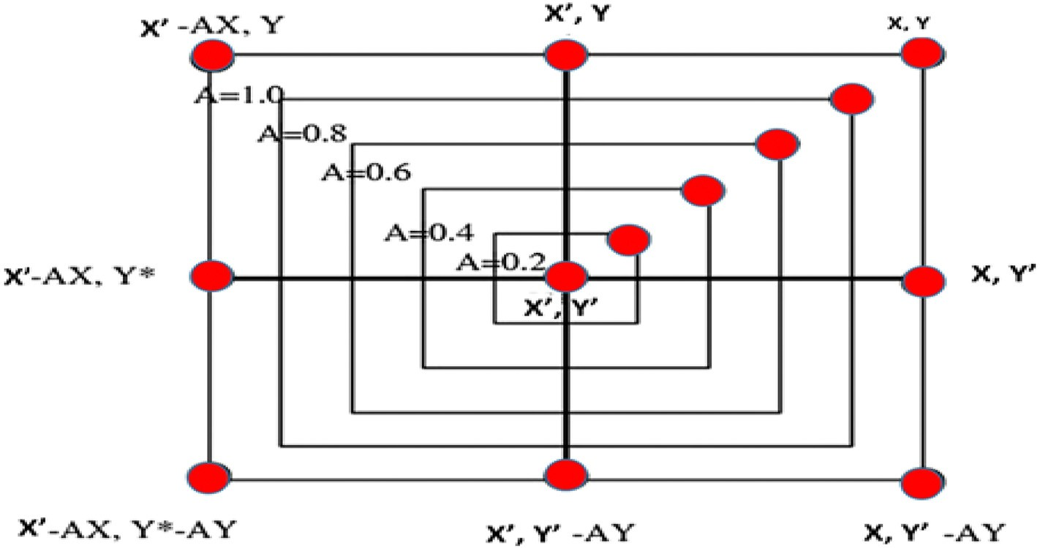

Fig. 1. Bubble net shrinking encircling mechanism.

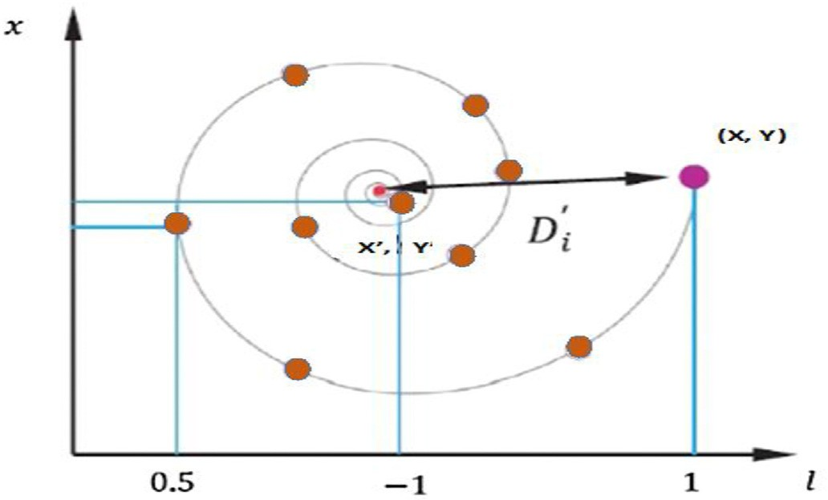

Fig. 2. Bubble net spiral position updating mechanism.

transmission and distribution congestion, and improving the power quality. Some of the other economic advantages are delaying the total investments required for upgrading the facilities, reducing the opera- tional fuel costs, reducing the reserve requirements and the associated costs, and increasing the security for critical loads [5]. The determination of the optimal capacity and placement of DG units in the distribution systems is of great importance for achieving their highest potential positive effects. Researches have demonstrated that an improper selec- tion of the position and size of DG could lead to greater system active power losses and voltage deviations [1]. Therefore, several scientific researches have tried to address the optimal siting and capacity of DG units in EDNs through many different approaches. The techniques may be categorized into four categories: Analytical Expressions (AEs), Meta-heuristic techniques (MMs), Numerical Methods (NMs), and Analytical Expressions Meta-Heuristic Methods (AEMMs) [6,7]. In Ref. [8], the authors presented three multi-objective optimization mechanisms to reduce the active power losses and to improve the voltage profile, within maintaining the framework of the DG cost installation constraints, through determining its optimum placement and size into the distribution networks. Three intelligent optimization techniques Practical Swarm Optimization (PSO), Genetic Algorithms (GA), and Gravitational Search Algorithm (GSA) are introduced to prove their ef- ficiency. A comparative analysis of different optimization techniques, including Moth-Flame Optimization (MFO), Dragonfly Algorithm (DA) and Whale Optimization Algorithm (WOA), was proposed in Ref. [9] to determine the optimum locations and sizes of DGs in radial EDNs to reduce the active power losses. The suggested techniques have been

implemented on IEEE 69-bus and 119-bus under two load power factors. Results showed that MFO gives better findings than WOA and DA algo- rithms. WOA is used to determine the DG units’ sizing and siting opti- mization problem in many researches as follows: In Ref. [10], different DG types are employed through applying the WOA on IEEE 15-bus, 33-bus, 69-bus, 85-bus and 118-bus benchmark test systems. The find- ings of the proposed technique have been compared to various forms of evolutionary algorithms. The attained results from the WOA algorithm proved that it is better when integrating DG type that injects both real and reactive power at 0.9 pf. In addition, a complicated problem of DGs sizing and location is addressed in Ref. [11]. Where, WOA algorithm is tested on IEEE 15, 33, 69 and 85-bus test systems for the active power losses minimizing and improving the voltage profile as the considered objectives. In this study, to improve the performance of the system, four DG types are introduced, but every single type is discussed separately with a fixed power factor value. The WOA proved its capability of finding-high quality solutions for large-scale systems compared to other evolutionary algorithms. Furthermore, a WOA-SCA Hybrid algorithm for improving the bus voltages of the DG-integrated EDNS is explained in Ref. [12] through the allocation of DSTATCOMs and DGs on IEEE33-bus and IEEE-69 bus. The exploration and exploitation steps of the proposed scheme are determined using Sine Cosine Algorithm (SCA) and WOA, respectively, to improve the convergence rate of the WOA. Results proved the enhancement in the voltage profile and reduction of the total systems losses. Moreover, in Ref. [13], WOA is introduced for single DG integration into the IEEE 30-bus radial transmission system. Before the optimization phase, a preconfigured Fast Voltage Stability Index (FVSI) has been used as an indication to identify the location of installing the single DG. The achieved results have been verified with the Firefly al- gorithm (FA) and WOA showed more improvement in voltage stability, the voltage profile and power losses. The Multi-Verse Optimization Al- gorithm (MVO) technique has been proposed in Ref. [14] and applied into two benchmark test systems (IEEE 33-bus and IEEE 69-bus) for the optimal solution of single DG type accommodation in the EDN. A multi-objective function is formulated to improve the performance of EDNs. The objectives considered are decreasing the active power losses, minimizing the voltage deviation and enhancing the VSI. The findings are compared to the results attained by GA, PSO, hybrid GA-PSO, Teaching Learning Based Optimization (TLBO) and Quasi-Oppositional Learning Based Optimization (QOTLBO) algorithms and found to be efficient. SCA has been employed to find the optimum size and location of single and two DGs in radial EDNs in Ref. [15]. The proposed meth- odology is tested on IEEE 15, 33, 69 and 85 radial EDNs. Minimizing the

power loss and improvement of the voltage profile are the main objec-

tives of this research. The findings obtained have demonstrated the

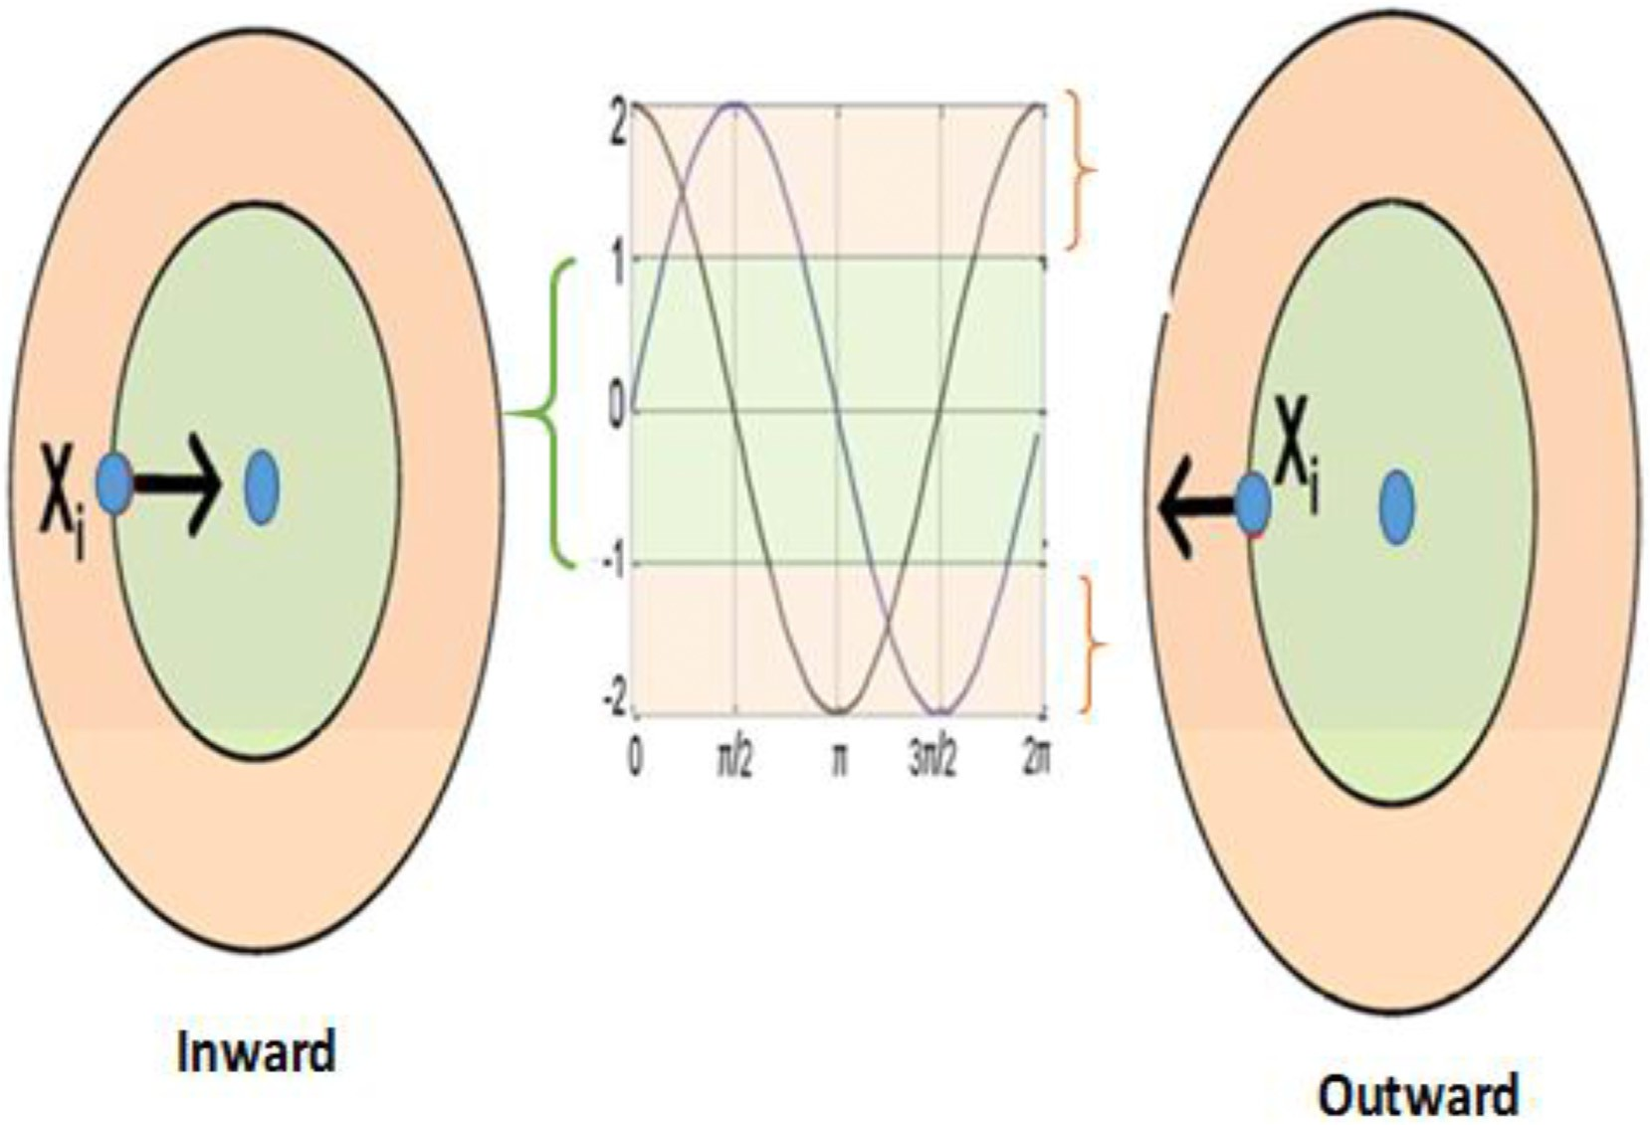

Fig. 3. SCA Inward and outward concept.

validity of the proposed method and its positive effects on the system in terms of power loss reduction and the improvement of the voltage profile and have demonstrated the efficacy and robustness of the proposed method. From the above initial review, it is noticed that, however, many optimization algorithms have been applied to solve the DG location and size problem concerning the different fitness functions, which aims to improve the distribution network’s performance. Most of these re- searches considered the operating power factor of the DG units a fixed value and not an optimization vector variable. In addition, the proposed techniques have been applied to small-scale IEEE test systems and have not been subjected to practical case studies. Also, the DG units’ max capacity ranges have not been set and did not consider the branches’ security constraints. Besides that, the multi-DGs problem of multi-types has not been addressed at the same time to find the optimal mix of DG types. Moreover, the additional required investments are not considered as an optimization objective at the same time to get the optimal solutions with minimum expenditures. The major contributions of the presented article can be summarized as follow: (i) This research proposes three novel algorithms called Whale Optimization Algorithm, Sine Cosine Al- gorithm and Multi-Verse Optimization Algorithm for solving four types of DERs allocation problem. (ii) Formulating a multi objective function to optimize the Voltage Stability, the active power losses and the overall costs is developed. (iii) The system’s operational variables are considered such as the DG units operating power factor in addition to the system’s policies and regulations constraints including (a) the operating power factor limitations, (b) the system’s voltage profile boundaries and (c) DG units’ penetration level range (iv) The proposed approaches are validated by applying them to various IEEE test systems (33 and 118 buses), in addition to a realistic case study. (v) The attained results are compared with other optimization algorithms.

This article’s content is divided into eight sections, as follows: The characteristics of different used DG types are presented in section II. Section III discusses the proposed strategic positioning and sizing algo- rithms. A description of the problem formulation, the objectives and constraints are given below in section IV. Section V describes the IEEE benchmark test cases and the practical distribution system. while, Sec- tion VI presents the problem validation. The findings are analyzed in

detail in section VII. The conclusion of the paper is outlined in section VIII.

1. Characteristics of DG types

Most of the DG benefits’ researches have classified DGs into four different types. In this study, a combination of four DG types is intro- duced for siting and sizing problem to determine the optimal mix of DGs. These types are identified according to the operation criteria as follows [16,17]: In the first type, the active power only is generated. However, reactive power only is produced in the second type. In addition, DG re- sources deliver active and reactive power in the third type. Moreover, in the fourth type, resources can produce active power and consume reac- tive power.

1. Proposed algorithms based methodologies

The following three-optimization algorithms are proposed for the efficient planning of multiple distributed generation resources as follows:

* 1. *Whale Optimization Algorithm*

The WOA is inspired by the special hunting activity of humpback whales, which are intelligent swimming creatures. Normally, they tend to hunt small fishes near to the sea surface. Humpback whales use a specialized hunting process called the bubble net feeding technique. Where, they move around the targets and generate distinctive bubbles across a ring or 9-shaped path [10,18].

To simulate such behavior in WOA, there is a 50% chance of choosing between both the shrinking encircling system and the spiral system to change the whale location, which is represented in this research by the optimization problem vectors, which are DG type, location, size and operating power factor during the optimization. In WOA, the best current potential solution is believed to be the target prey and the other search agents are trying to change their positioning towards it. The numerical simulation of WOA involves three stages as follows: The encircling prey, the spiral bubble-net feeding strategy, and the scan for food sources.

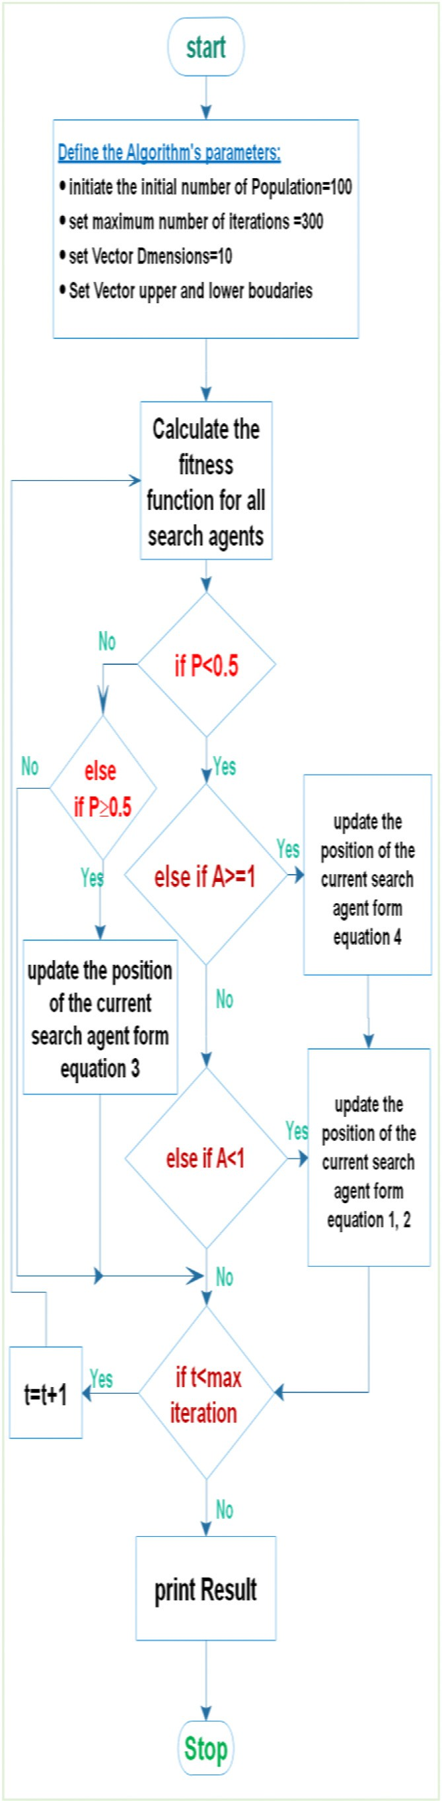 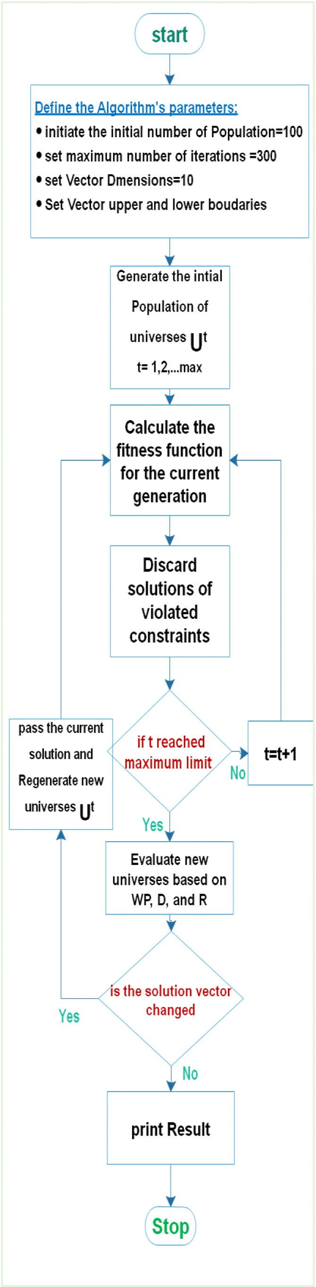

Fig. 4. WOA flowchart. Fig. 5. MVO flowchart.

* + 1. *The encircling prey stage*

The Humpback whales are to identify and encircle the position of the prey, which is represented as the objectives of minimizing total active power losses, enhancing the FVSI and minimizing the new cost of in- vestment. Initially, the WOA considers the target prey (O.F) to be the current best candidate solution, as the location of the optimal solution is not known beforehand; this stage is simulated as shown in equation (1) and (2) and the search candidate will be changed if a better candidate solution is found.

⇀ ⇀ ⇀

→*D* = |*C* * *X*' (*t*)— *X*(*t*)| (1)

⇀ ⇀ ⇀ ⇀

*X*(*t* + 1)= *X*' (*t*)— *A*.*D*

→*A* = 2.→*r*. →*a* — →*a*

→*C* = 2.→*r*

(2)

(3)

(4)

⇀ ⇀ ⇀

Where *t* is the iteration number, *A* and *C* are vectors coefficients, *X* is the

~

position vector, *X*' is the best solution, →*a* is decreasing linearly from 2 to

0. →*r* is a random vector [0,1].

* + 1. *Bubble-net attacking stage*

This is a hunting technique; in it, sharks are doing narrowing encir- cling mechanism through a spiral update process for positioning, which is represented in the current work by operating constraints, which are DGs operating power factor limits, DG capacity penetration levels and voltage

~

profile boundaries. In the shrinking mechanism *A* which is a random position value is setting down between interval [-a, a], the updated po-

~

sition of *A* is determined from equation (3) and its position between the original position and the current best agent position; this mechanism is illustrated in Fig. 1. The space between both the whale and the placement of the prey is evaluated and the helix-shaped motion of the whale is created, as seen in the following spiral equation (5) to mimic the helix- shaped movement, which is illustrated in Fig. 2.

⇀ ⇀ ⇀

*X*(*t* + 1)= *D*' .*ebl*.cos(2π*l*)+ *X*' (*t*) *if p* ≥ 0.5 (5)

Where *D*' is the distance between the whale and the prey, *l* is a random number (—1, 1), *p* is random number [0, 1], and *b* is a constant.

* + 1. *Search for prey stage*

In this stage, whales are randomly searching for prey and changing their location (candidate solutions) based on the current place of other whales. This process completes a search space and is simulated by the given equation (6):

⇀ ⇀ ⇀ ⇀

*X*(*t* + 1)= *Xn* — *A*.*D if P* < 0.5 (6)

Where *Xn* is the vector of random positions, and it is determined by the current population. The major solution steps of the WOA algorithm is explained in a detailed flowchart shown in Fig. 4.

* 1. *Multi-verse optimization algorithm*

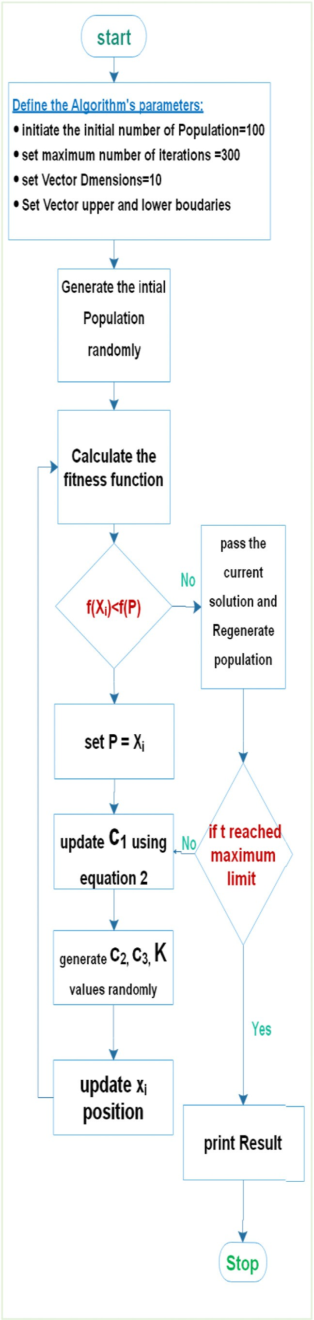

Fig. 6. SCA flowchart.

Seyedali M. et al. developed MVO [19]. The optimization software was created based on the idea of the big bang model and the Multiverse conception. Originally, according to the theory, the Big Bang is simply the cause of the existence of every element in this world. However, the latter concept deals with the presence of some universes. Almost every universe could have various physical rules, which react and collide with each other according to multiverse theory. The numerical model of MVO

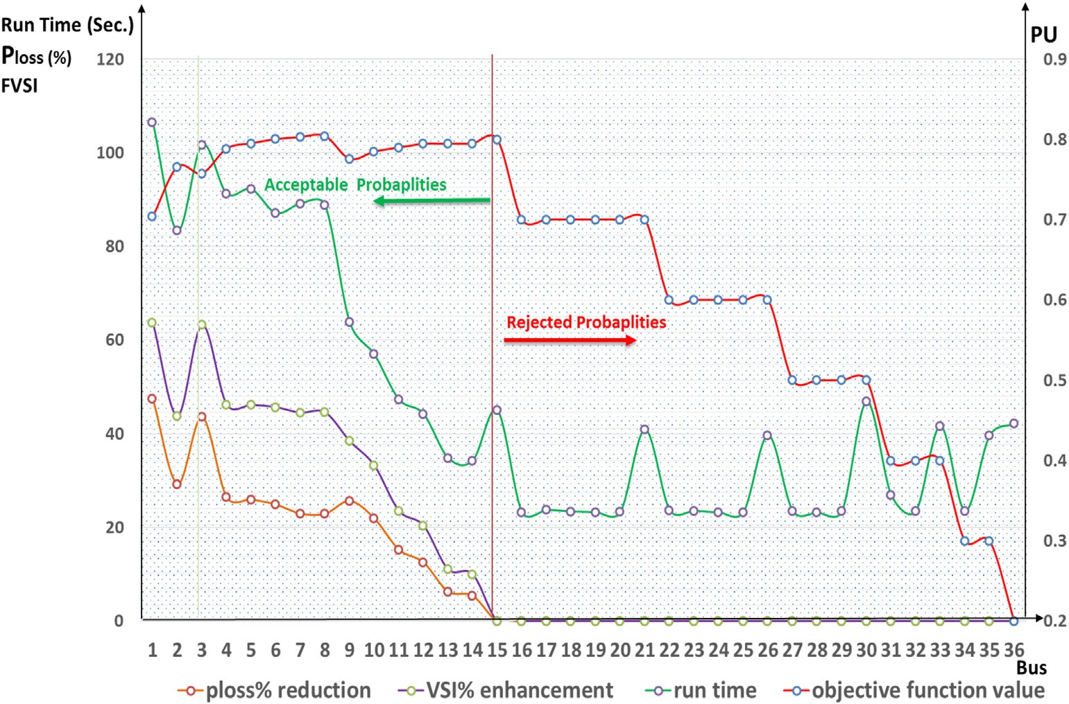

Fig. 7. Weighting coefficients impact on the objective function elements.

is divided into three different stages, which are black holes, white holes, and wormholes [20].

White holes: is a mirror image of big-bang and its theory is used during the exploration step in the optimization process. In this stage, the promising potential solutions that are considered in this work by the DG units’ size, location and operating power factor are determined randomly. Also, the fitness (inflation rate) of each randomly generated population is determined according to upper and lower boundaries, which are the predefined operating constraints of DGs operating power factor limits, DG capacity penetration levels, and voltage profile boundaries from equation (7).

*Uij* = *Lbj* + *R* * *Ubj* — *Lbj* …*i* = 1, 2…..*Popsize*; *j* = 1, 2, ...*Dsize* (7)

( *Ukj if R*1 < *UN*

randomly generated populations, as shown in equations (10) and (11).

If *R*2 < *Wp and R*3 < 0.5 then *Uij* is calculated from the following equation:

*Uij* = *Ub* + *D*\* *Lbj* + *R*4 * *Ubj* — *Lbj* (10)

*j*

If *R*2 < *Wp and R*3 ≥ 0.5 then *Uij* is calculated from the following equation:

*Uij* = *Ub* — *D*\* *Lbj* + *R*4 * *Ubj* — *Lbj* (11)

*j*

*j*

Where *Ub* is the best universe of the j-parameter. *R*2, *R*3 and 4 are random

numbers ranges between [0,1]. *WPmax* and *WPmin* are the maximum and minimum (WP) values. *t* is the current iteration, *tmax* represents the maximum iterations. Besides, *p* is a parametric value, which decides the

universe, shifting on the sides of the best-found universe. Then, the

*Uij* =

*i*

*i*

*Uij if R*1 > *UN*

exploration and exploitation phases are repeated until the convergence is attained. Here, the convergence criterion is made equal to the maximum

Where *Lbj* and *Ubj* are the lower and upper, universe *i* and *k* (are selected

from roulette wheel), *Uij* and *Ukj* are the parameter-j, *UN* is the universe-i normalized inflation rate. *R* , *R*1, *R*2 *R*3 and *R*4 are random numbers ranges between [0, 1].

*i*

Wormholes: it is responsible for exchanging objects between different universes or even between different parts of the same universe, and it is considered as a bridge either for various universes or for separate pieces of the same universe. In this step, the process of roulette wheels is used to construct the entire white/black tunnel at normal inflation levels, which can be used for objects exchanges between universes. The inflation rates are evaluated depending on two parameters, which are; the traveling distance rate (D) and the wormhole existence probability (*Wp*).

iterations/generations set to the optimization algorithm. Also, the above solution steps are explained in a detailed flowchart shown in Fig. 5.

* + 1. *Sine Cosine Algorithm*

SCA is an innovative optimization methodology developed in Refs.

[21] by Mirjalili’s, where its function update depends on cosine and sine function rules. Through the lookup for the optimization problem, the algorithm randomly begins the first population (the optimization prob- lem vectors, which are DG type, location, size and operating power factor during the optimization) with random search agents/solutions. Then, the searching agents are directed to the best position *Pi* in the searching area according to the defined fitness function, which consists of minimizing

total active power losses, enhancing the FVSI and minimizing the new

*WP* = *WPmin*

*t*

*D* 1

*t*1/*p*

= — 1/*p m*

*i*\* *WPmax* — *WPmin* (8)

*tmax*

+

(9)

cost of investment. That assesses and evaluates each search agent. Therefore, the algorithm tracks the P position obtained for each iteration by evaluating all search agents in the population. The SCA algorithm numerical model is based on updating *Xi* search agents [22], as shown in equation (12).

Black holes: its concept is opposite to the white holes. Black holes

( *Xt* + *R*1 sin(*R*2) *R*3*Pt* — *Xt* , *k* < 0.5

*i* = *Xt* + *R* Cos(*R* ) *R Pt* — *Xt* , *k* ≥ 0.5

have a high gravitational force that attracts anything and its concept is

*Xt*+1

*i*

*i*

*i*

(12)

used in the exploration stage. Then the best universe is found from

*i*

1

2

3

*i*

*i*

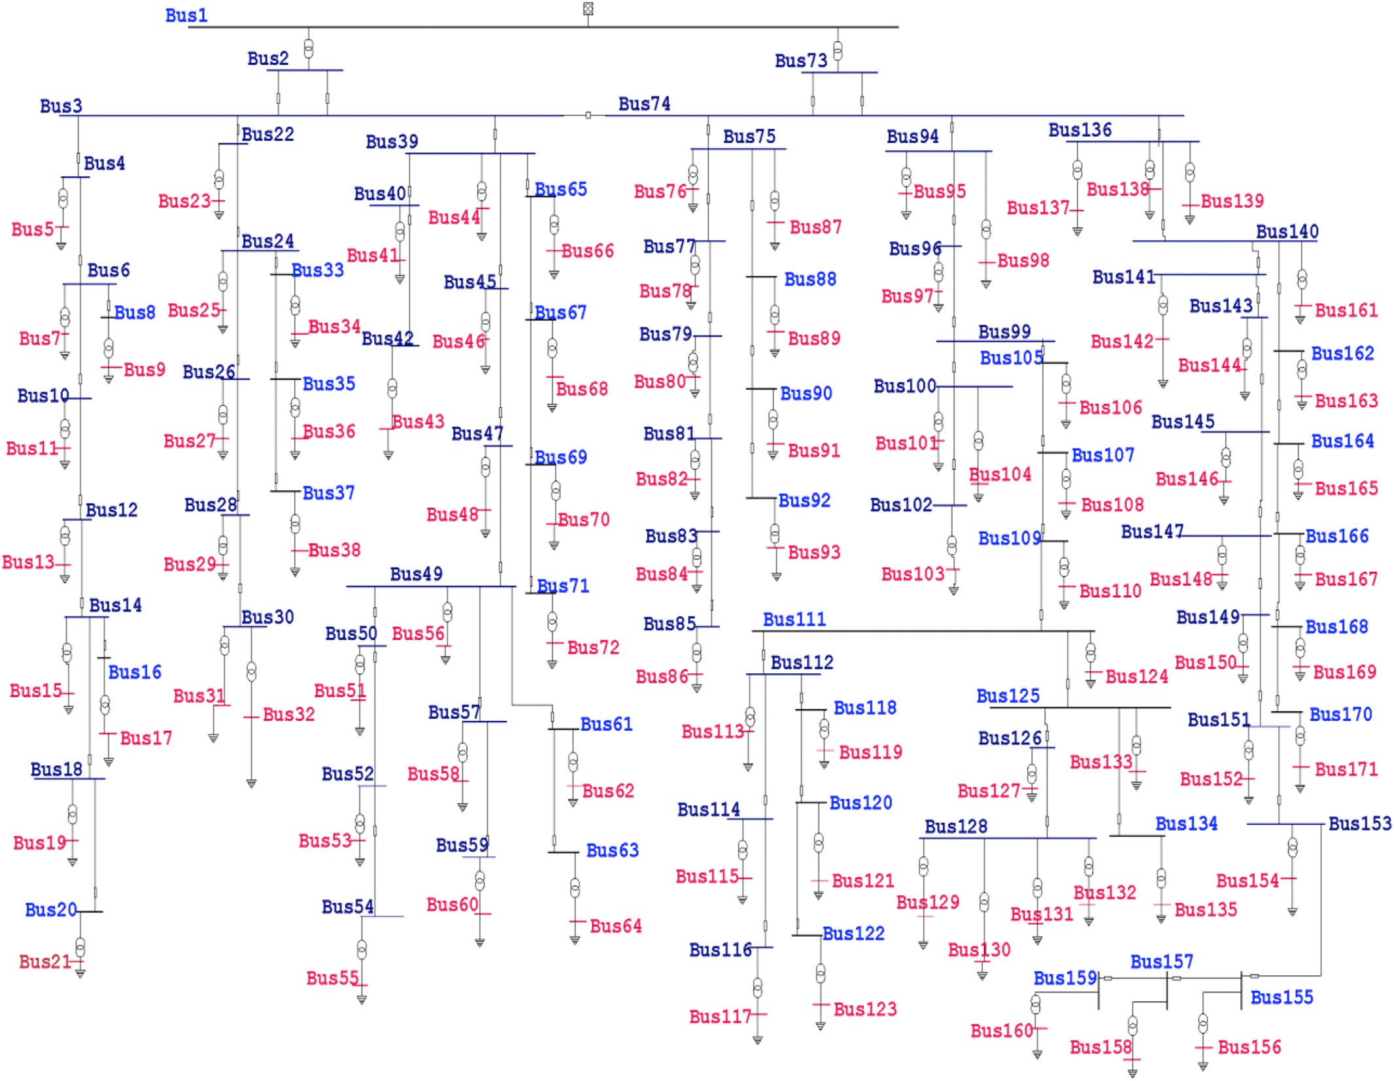

Fig. 8. A realistic part of the Egyptian distribution Grid.

*R*2,*R*3 and *k* are random numbers which are updated randomly, be- sides *R*1 is calculated from the following equation.

*R* = *S* — *t S*

1

*tmax*

*t*, *tmax* are the current iteration, and the maximum iterations number and *S* is a constant.

The SCA pattern illustrated in Fig. 3. It is a circular pattern method-

ology, where the best *P* solution exists in the middle of a circle and the solutions outside it are feasible solutions. The circle search area repre-

space. The major solution steps of the SCA algorithm are explained in a detailed flowchart in Fig. 6.

1. Problem formulation

The optimization problem is given by equation (14) and it is a minimization problem that includes *Ploss*, total investments cost and *FVSI* [23]:

*O*.*F* = *w*1* *ploss* + *w*2* *FVSIm* + *w*3* *costDG* (14)

sents the above-mentioned system’s operational constraints, which are determined by upper and lower boundaries for each variable vector

Where;

*ploss*0

*FVSIm*0

*costDGmax*

(search agent). In addition, this circle is divided into sub-areas that are considered possible discovery areas for *Xi* solution.

*R*1 is a control parameter which determines the *Xi* direction of movement (towards *P* in case its value > 1 and outward if it is < 1). In addition, *R*2 determines the distance of *Xi* movement outward or inward *P* according to *R*1 and *R*2 values which are ranging between 0 to 2π. *R*3 is giving random weights to *P*. *k* is randomly switching between the cosine and sine parts of Equation (12).

When the sine–cosine function range inside the interval of [-1, +1],

space. Nevertheless, when the range out of the interval [-1, +1], then *Xi* then *Xi* movement is towards P and the algorithm is exploiting the search is deviating the P position and the algorithm is exploring the search

O.F: The objective function; *Ploss*0: The total active power losses before installing DG units in (MW); *Ploss*: The total active power losses after installing the DG units in (MW); *costDG*: Total additional cost required for installing DG units in Million United States Dollar (MUS$); *costDGmax*: Maximum DG units cost in MUS$; *FVSIm*0: Maximum *FVSI* before installing DG units; *FVSIm*: Maximum *FVSI* after the installing

DGs; *W*1, *W*2 and *W*3: the weighting factors. In addition, *W*1+*W*2+*W*3

= 1.

In the previous studies, the fitness function weighting coefficient

values were determined according to the researcher ‘s vision. However, in this study, the weighting coefficient values are obtained using an analytical test performed on the benchmark IEEE 33-bus test system to

Table 1

The proposed methodologies outcomes versus existing other researches.

|  |  |  |  |  |  |  |
| --- | --- | --- | --- | --- | --- | --- |
| Type | Methodologya | DG |  |  | Ploss (MW) | Minimum Bus voltage (PU) |
|  |  | capacity (MW) | PF | Location |  |  |
| Base case First type | EVPSO [34] | 0.763 | 1 | 11 | 0.1402 | 0.928 |
|  | PSOPC [34] | 1.0 |  | 15 | 0.1367 | 0.932 |
|  | AEPSO [34] | 1.2 |  | 14 | 0.1314 | 0.935 |
|  | ADPSO [34] | 1.21 |  | 13 | 0.1295 | 0.935 |
|  | DAPSO [34] | 1.21 |  | 8 | 0.1272 | 0.935 |
|  | GA [35] | 2.4 |  | 6 | 0.1326 | – |
|  | WOA [35] | 1.5 |  | 30 | 0.1252 | 0.927 |
|  | VSI [36] | 1.0 |  | 16 | 0.1368 | 0.932 |
|  | EHO [37] | 1.5 |  | 30 | 0.1252 | 0.927 |
|  | PSO [38] | 1.02 |  | 24 | 17870. | – |
|  | DE [38] | 0.646 |  | 24 | 1870. | – |
|  | ALO [34] | 1.0 |  | 18 | 0.1423 | 0.931 |
|  | WOA | 1 |  | 13 | .109 | 0.948 |
|  | SCA | 0.996 |  | 12 | 0.105 | 0.966 |
|  | MVO | 0.994 |  | 12 | 0.104 | 0.967 |
| Third type | BSOA [34] | 2.3 | 0.82 | 8 | 0.083 | 0.955 |
|  | BFOA [39] | 1.1 | – | 30 | 0.144 | 0.924 |
|  | WOA [40] | 1.06 | – | 15 | 0.129 | – |
|  | WOA | 1.5 | .85 | 7 | 0.08 | .955 |
|  | SCA | 1.3 | 0.77 | 30 | .0750 | 0.966 |
|  | MVO | 1.28 | 0.75 | 30 | .0745 | 0.967 |

a particle swarm optimization (PSO), Escape Velocity PSO (EVPSO), PSO with Passive Congregation (PSOPC), Adaptive Dissipative PSO (ADPSO), PSO with Area Extension (AEPSO) and Dynamic Adaptation of PSO (DAPSO), Backtracking Search Optimization Algorithm (BSOA), Genetic Algorithm (GA), Differential Evolution (DE), antlion optimization (ALO), Elephant herding Optimization Algorithm (EHO) and Bacterial Foraging Optimization Algorithm (BFOA).

|  |  |  |  |  |
| --- | --- | --- | --- | --- |
| Table 2  Base cases data. |  |  |  | significant effect is on *Ploss*. It is therefore advised to select the third alternative that ranks the second optimal O.F value, in which the values  of *W*1, *W*2 and *W*3 are 0.6, 0.3, and 0.1 respectively since they have a |
|  | IEEE 33-bus | IEEE 118-bus | Realistic Grid | clear effect on both *Ploss* and *FVSI*. |
| Pg (MW) | 3.716 | 4374.29 | 16.942 |  |
| Pd (MW) | 3.715 | 4242 | 15.68 | *4.1. Objectives* |
| *Ploss*0 (MW) | 0.2029 | 132.79 | 1.2619 |  |

*FVSIm*0 0.0674 0.2355 0.6245

Where; *Pg* : Active power generation(MW), *Pd*: Active power demand(MW); *Ploss*0: Base case active power losses(MW); and *FVSIm*0: Maximum *FVSI* in the base case.

evaluate their most effective values, which will verify the O.F ‘s optimum values. When the possible values of *W*1, *W*2 and *W*3 (36 possibilities) are applied to the test system, the changes in the fitness function components are monitored and recorded. Fig. 7 illustrates the full effects of the changes in the weighting factors values on the fitness function elements namely O. F, *Ploss*, optimization time and *FVSI*. Consequently, possibil- ities from 15 to 36 must be dismissed, as they have no impact on *Ploss* or *FVSI*. Although the first option classification is the best O.F, its

The main objectives of this study are enhancing FVSI, minimizing Ploss as well as minimizing the total additional costs while employing multi DG units mix at a time.

* + 1. *Fast Voltage Stability Index (FVSI)*

Stability is a key factor in the study of distribution systems. This was explored in several publications by multiple methodologies. Due to changes in power generation, the voltage stability of the systems in this study is advised to prevent the collapse of voltage.

The line stability index can be calculated using the fast and accurate formula shown in equation (15) for the determination of *FVSI* [24]. *FVSI* results for all lines ranges between zero and one, where this value must

Table 3

Optimal sizes and locations according to various DG types.

|  |  |  |  |  |  |  |  |  |  |  |  |  |  |
| --- | --- | --- | --- | --- | --- | --- | --- | --- | --- | --- | --- | --- | --- |
| DG |  | IEEE 33-bus |  |  |  | IEEE 118-bus |  |  |  | Realistic Grid |  | | |
|  |  | WOA | SCA | MVO |  | WOA | SCA | MVO |  | WOA | SCA | MVO |  |
| Type 1 | Location | 17 | 18 | 17 |  | 41 | 0 | 0 |  | 144 | 125 | 125 |  |
|  | capacity (MW) | 0.285 | 0.295 | 0.285 |  | 64 | 0 | 0 |  | 0.1 | 0.8 | 0.8 |  |
| Type 2 | Location | – | – | – |  | – | – | – |  | – | – | – |  |
|  | capacity (MVAR) | – | – | – |  | – | – | – |  | – | – | – |  |
| Type 3 | Location | 32 | 32 | 32 |  | 112 | 38 | 38 |  | 158 | 158 | 158 |  |
|  | capacity (MVA) | 0.437 | 0.437 | 0.437 |  | 40 | 128 | 148 |  | 0.3 | 0.3 | 0.3 |  |
|  | PF | 0.61 | 0.59 | 0.61 |  | 0.95 | 0.71 | 0.74 |  | 0.87 | 0.88 | 0.88 |  |
| Type 4 | Location | – | – | – |  | 25 | – | – |  | – | – | – |  |
|  | capacity (MVA) | – | – | – |  | 84 | – | – |  | – | – | – |  |
|  | PF | – | – | – |  | 0.95 | – | – |  | – | – | – |  |
| Objective function | | 0.7561 | 0.7568 | 0.7561 | 0.8540 | | 0.8516 | 0.8500 | 0.8200 | | 0.8080 | 0.8080 | |
| *FVSIm* | | 0.054 | 0.054 | 0.054 | 0.199 | | 0.200 | 0.199 | 0.501 | | 0.492 | 0.492 | |
| *FVSI* Enhancement % | | 19.7 | 19.7 | 19.7 | 15.7 | | 15.3 | 15.4 | 19.8 | | 21.2 | 21.2 | |
| New Ploss (MW) | | 0.115 | 0.114 | 0.115 | 123.68 | | 125.86 | 124.78 | 1.171 | | 1.071 | 1.071 | |
| Ploss Enhancement % | | 43.5 | 43.7 | 43.5 | 6.86 | | 5.22 | 6.03 | 7.2 | | 15.1 | 15.1 | |
| Running time (seconds) | | 134.7 | 121.5 | 111.1 | 1293.8 | | 1288.0 | 1257.8 | 2244.7 | | 2271.3 | 2165.9 | |

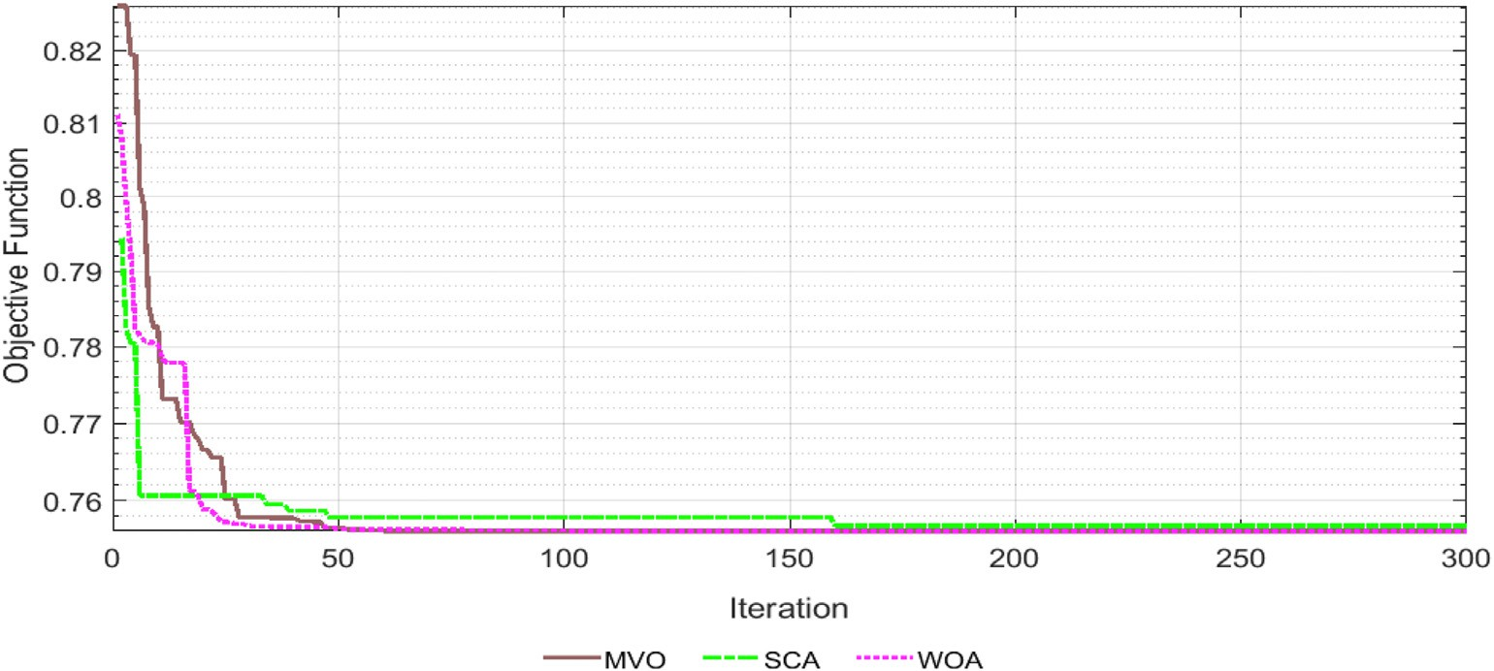

Fig. 9. IEEE 33-bus system convergence curve.

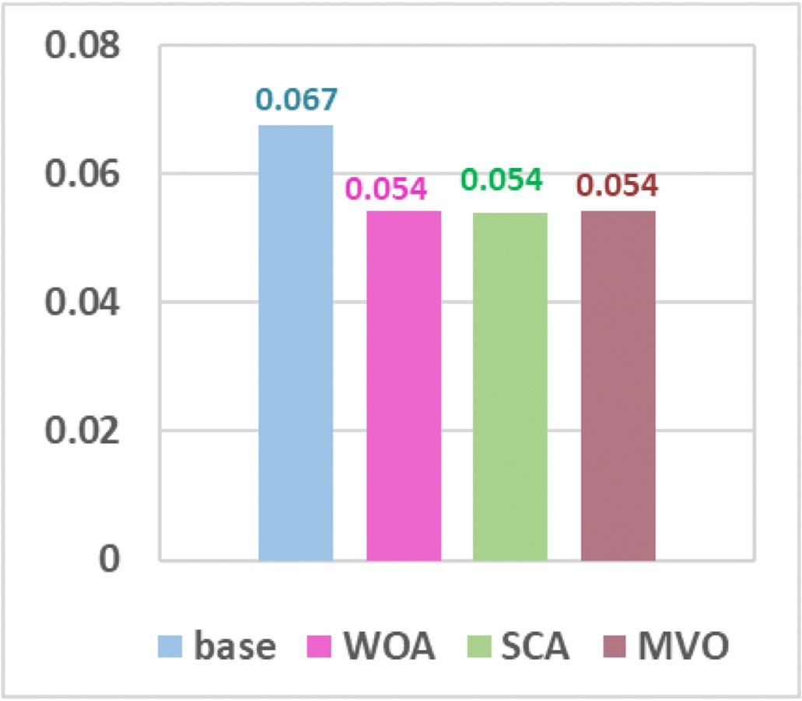

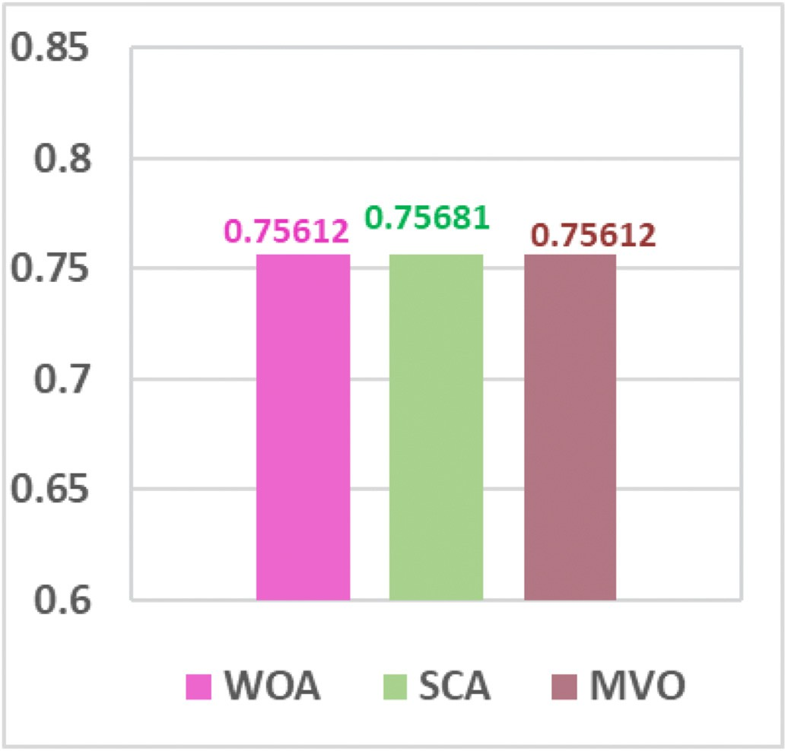Fig. 10. Objective function values.

be below one for stable systems, and while its value is pretty close to one, this means that the system is reaching its stable margin limit.

Fig. 11. Max *FVSI* values.

Where; Vi and Vj are the voltages at bus i and j, Yij is the admittance of the line connecting between bus i and j. The total active power losses in the network can be calculated as follows:

*N*

X

*FVSI*

4*z*2*Qr*

= *v*2 *X* ≤

*s*

1 (15)

*Ploss* = *Plossk* (18)

*k*=1

Where, *Vs*: is the Voltage at sending end in (PU); Z: Line impedance in (PU); X: Reactance of the line in (PU); and *Qr* : Reactive power at receiving end in (MVAR).

* + 1. *Active power losses*

For each branch k, which is connecting between bus i and j, the active power loss is calculated as follows.

Where; N is the total number of lines in the network.

* + 1. *Cost evaluation*

The DG units’ capital cost is different according to their types [25], but generally, it can be defined as shown in the following equation.

*costDGi* = *Ki*\**PDGi* (19)

*Ploss k*

= *I*2*R* (16)

Where Ki is the constant coefficient (US$/kW).

Where; R is the line resistance in ohm and Ii is the line current in ampere, which can be obtained from the following equation.

*i*

* 1. *Constraints*

The fitness function is restricted to the following constraints:

*n n*

*Ii* = *Vi* X *Yij* — X *YijVj* (17)

*j*=0

*j*=1

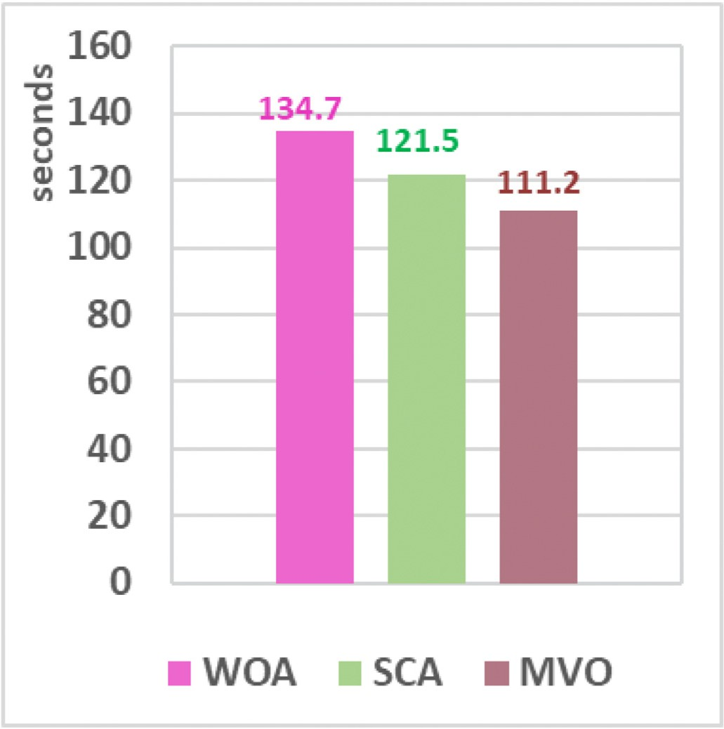

Fig. 12. Running time.

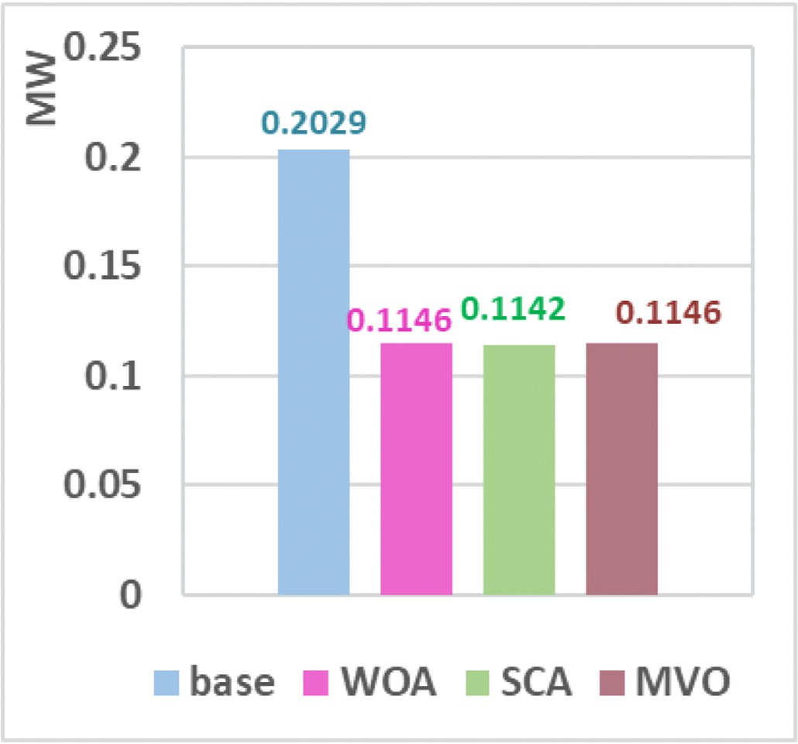

Fig. 13. Active power losses.

* + 1. *Power factor constraints*

In the framework of the multiple types of DGs, the power factor of the DG units (*PFDG*) is defined according to their operating conditions as follows:

1st Type: *PFDG* = 1. 2nd Type: *PFDG* = 0.

3rd and 4th Type: 0.3< *PFDG* <0.95 [26].

* + 1. *Penetration level (%)*

This research suggested that DG’s penetration levels ranges from zero to 30% of the total network demand to preserve the feeders’ ANSI Range protection constraints [27,28].

* + 1. *Bus voltage limitation*

The voltage magnitude at buses must be maintained within pre- determined limits, as shown below.

|*Vmin*|≤ |*V* |≤ |*Vmax*| (20)

0.95 ≤Vi ≤ 1.05.

1. Study cases

The research presents the application of the three proposed algo- rithms to different IEEE benchmark systems (33-bus and 118-bus) as medium and large-scale models to confirm the efficiency of the proposed optimization methodologies in determining the optimal O.F [29–32].

IEEE 33-bus is an RDS consisting of 33-buses, 32 branches, one central generator, one substation, with a total active and reactive load of

3.71 MW and 2.3 MVAR, respectively. Simulation studies are carried out on this widely used distribution system to verify the effectiveness of the proposed optimization techniques in solving the problem of the optimal placement and sizing of DGs. The key driver of selecting this test system arises from the fact that the IEEE 33-bus test system has large losses of power compared to its total capacity, which makes it a suitable selection to prove the capability of DGs for reducing power losses significantly.

IEEE 118-bus is a large scale power system consists of 118-bus, 54 generators and 186 branches with an active and reactive load of 4242 MW and 1438 MVAR, respectively. Therefore, this system is chosen to perform the study cases, to demonstrate the applicability of the proposed techniques to larger systems. This system is conducted in light of the survey, which indicates that few studies are applied to such complex networks and to check the remarkable performance of the algorithms in solving such large-scale systems.

Fig. 8 displays a single line diagram of the realistic part of the Egyptian EDNs from the Canal Electricity Distribution Company (CEDC). It consists of 171-bus, two 66/11 kV main step-down transformers each of a 25 MVA rated capacity, and a number of 87 different ratings step- down transformers (11/0.4 kV) connected directly to loads. The maximum active and reactive loading of the grid is 15.68 MW and 8.63 MVAR, respectively [33].

1. Algorithms’ validation

The proposed methodologies with the pre-mentioned objectives and constraints are validated by installing a single DG test (of the first and the third category), this test is applied on the IEEE 33-bus test system. The obtained outcomes are compared to other existing works. Table 1 sum- marizes the findings for both power loss and voltage magnitudes. Where, it is reported that the single DG of first type achieves an improved per- formance compared to existing approaches. However, it is a DG with minimal capacity that needs fewer additional costs. It is also noticed that promising results are obtained while applying a single DG of the third category for both voltages and power losses with a limited DG’ capacity.

1. Results and discussion

The multi-objective DG siting and sizing algorithms for the four DG mentioned above types are implemented using Hadisaadat and Mat- power load flow toolboxes on many benchmark IEEE test systems (33-bus and 118-bus). Studies are also conducted on a realistic part of the Egyptian EDNs (171-bus). The Optimal DGs sizing and siting effects on the system’s *Ploss*, *FVSI*, voltage profile and the total additional invest- ment cost are summarized in Tables 2 and 3, respectively. Table 2 il- lustrates the base case load flow results, where the attained results are validated by comparing with Hadisaadat, Matpower and ETAP12.6 re- sults for the same test systems under the same operating conditions.

Table 3 describes the results achieved by applying the proposed optimization techniques for each system. The optimal sizes and locations

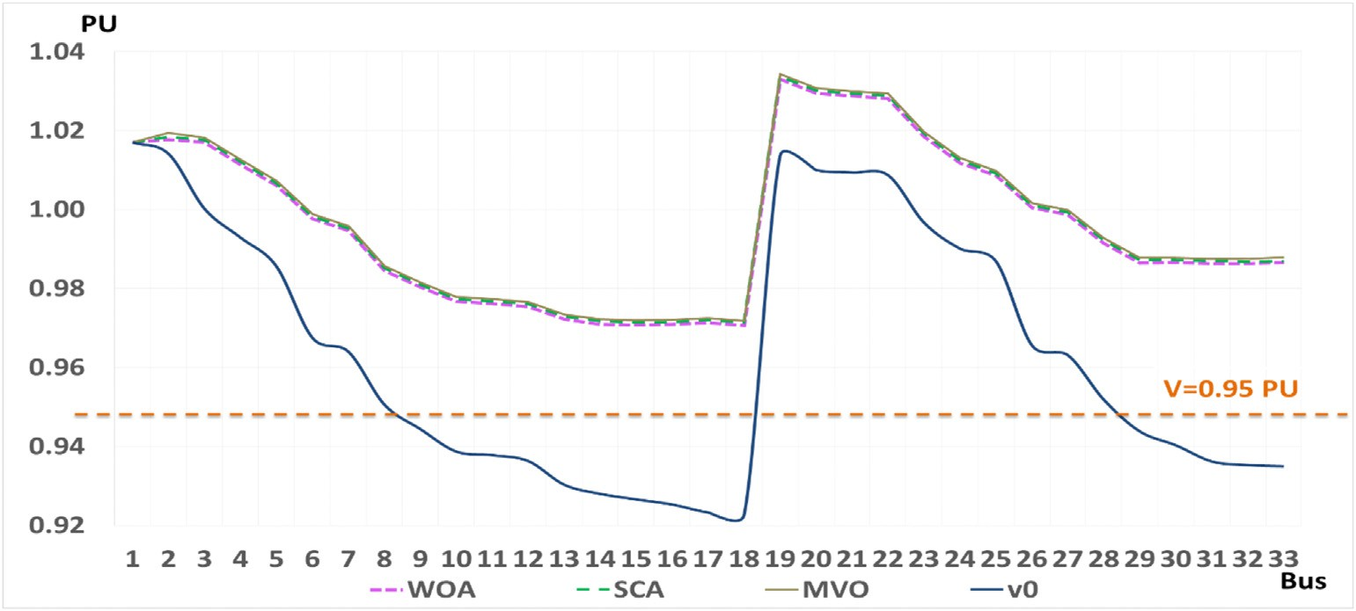

Fig. 14. IEEE 33-bus system voltage profile enhancement.

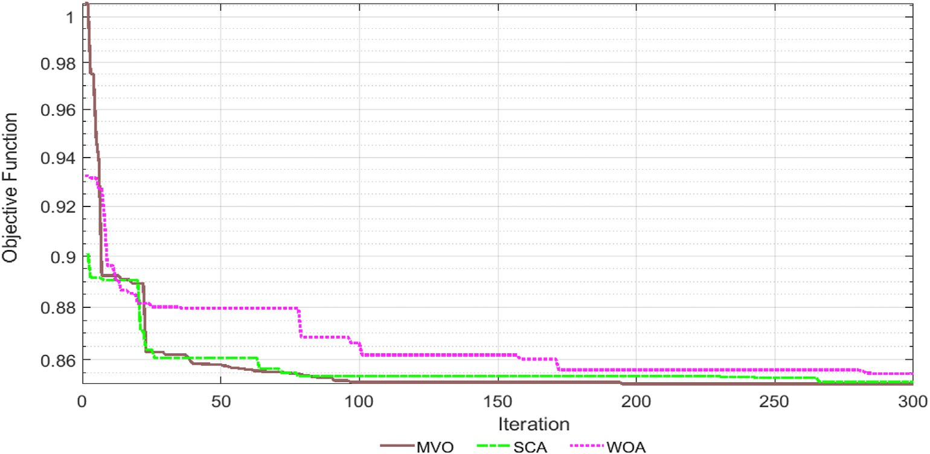

Fig. 15. IEEE 118-bus convergence curve.

of DG types mix are determined for each case study using the three- optimization algorithms. In addition, the third and the fourth DG-type optimal operating power factor is determined. Furthermore, the ob- tained results from WOA, MVO and SCA are compared and summarized. Where it is noticed that MVO scored the optimal results regarding the O.F value for the three introduced networks. However, there is symmetry between the obtained results from MVO and WOA in the case of IEEE 33- bus in addition to another similarity between results of MVO and SCA in the case of the realistic system.

Furthermore, for the IEEE 33-bus system, it is found that the three- optimization techniques almost scored the same system’s enhancement in terms of FVSI and SCA scored the maximum enhancement in terms of Ploss. Moreover, for the IEEE 118-bus system, WOA scored the maximum enhancement in terms of Ploss and FVSI, but unfortunately, it was accompanied by increases in DG type’s number and capacity. In addition, for the realistic case study, it is reported that both MVO and SCA scored the optimal enhancement regarding both FVSI and SCA.

* 1. *For IEEE 33-bus system*

Fig. 9 reflects the convergence curves resulted from applying the three-optimization methodologies into the IEEE 33-bus system. The re- sults demonstrate that with the same iterations number and at the same search agents’ dimension, MVO and WOA converge at almost the same iterations number. However, MVO achieved the best O.F value with a very slight difference compared to WOA.

From Fig. 10, it is concluded that MVO and WOA almost give the optimal O.F value. However, Fig. 18 shows that MVO is converged in less time. Fig. 11 shows that the three-optimization techniques give almost the same enhancement regarding the system’s *FVSI*. However, Fig. 13 illustrates that SCA provides a very slight enhanced result in terms of loss minimization, but this technique is selecting a higher DG capacity of type I to be installed at bus 12, which leads to a higher O.F value (see Fig. 12). Fig. 14 shows a comparison between the voltage magnitudes at base case (without installing any DGs) for each bus (v0) of the IEEE 33-bus test system and the new voltage magnitudes after applying the optimization problem. From Fig. 20, it is noted that WOA, SCA and MVO almost achieved a typical efficient improvement in the overall system’s voltage profile where the maximum voltage improvement ratio reaches about 5.5% at buses 32 and 33, which are the buses at and near to the location

of the installed DG unit from the third type category.

* 1. *For IEEE 118-bus system*

The convergence curves are shown in Fig. 15; results showed that for the same number of iterations (300) and the same number of search agents (100), MVO converged in the minimum iterations number with the best O.F value.

From Fig. 16, it can be noticed that MVO scored the best objective function value, and Fig. 18 illustrates that MVO is also converging at the minimum running time. However, it is concluded from Figs. 17 and 19 that WOA scored the maximum loss reduction (6.86%) and best FVSI

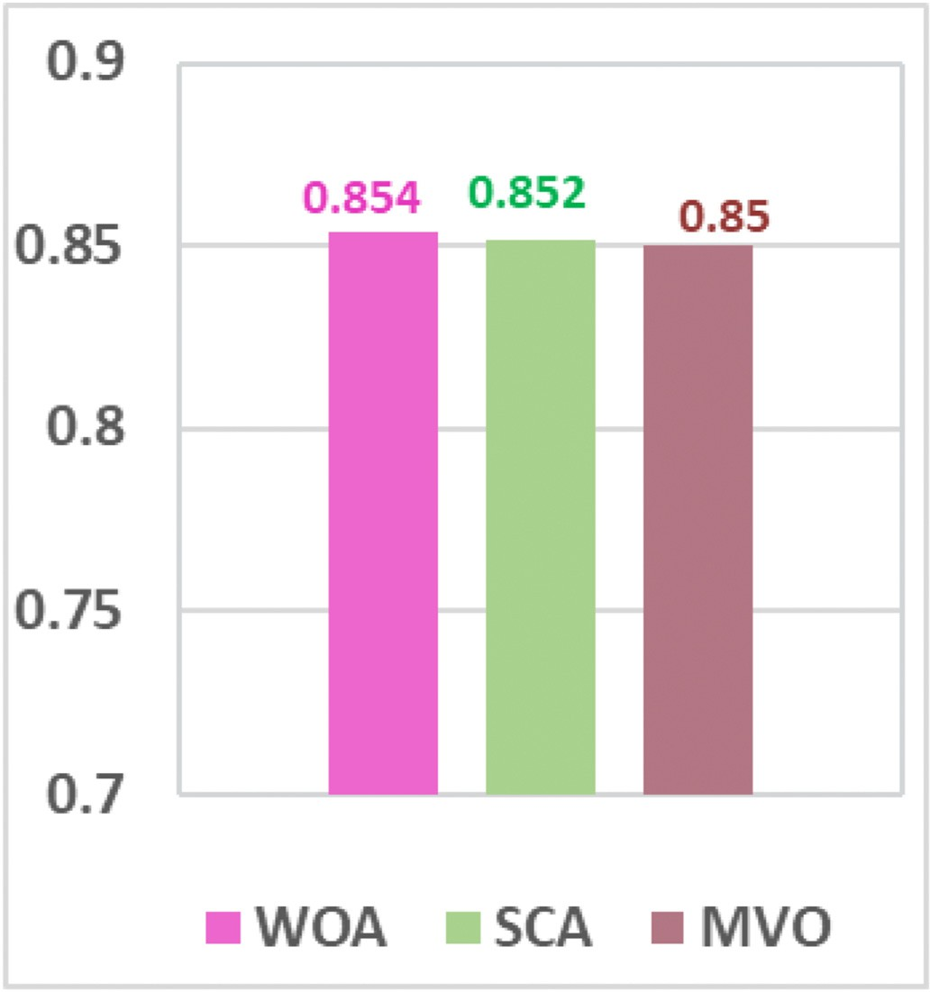 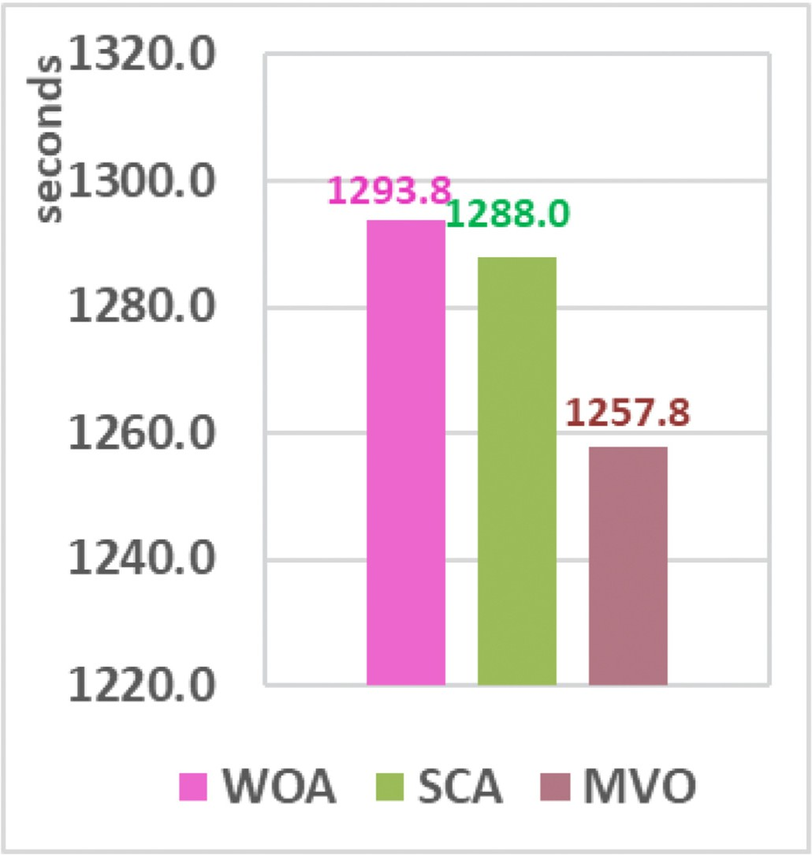

Fig. 16. Objective function values.

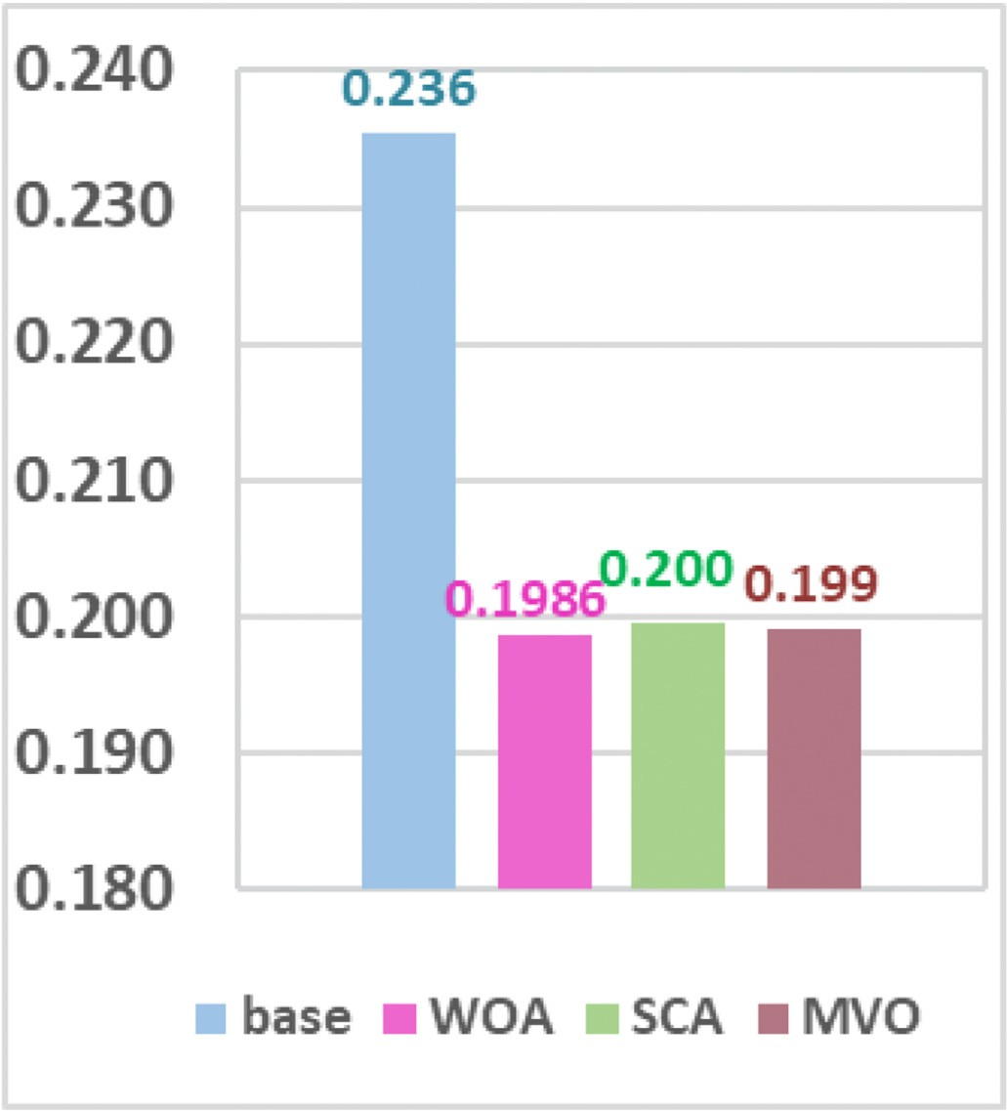

Fig. 17. Max *FVSI* values.

enhancement, but this improvement was combined with the disadvan- tage of increasing the DG types mix and capacities.

Fig. 20 shows the voltage profile enhancement of the IEEE 118-bus system after applying the proposed optimization techniques. The pro- posed techniques resulted in achieving a voltage profile enhancement in certain areas of the system. However, MFO achieved a voltage profile improvement in certain regions of the system, where the maximum

Fig. 18. Running time.

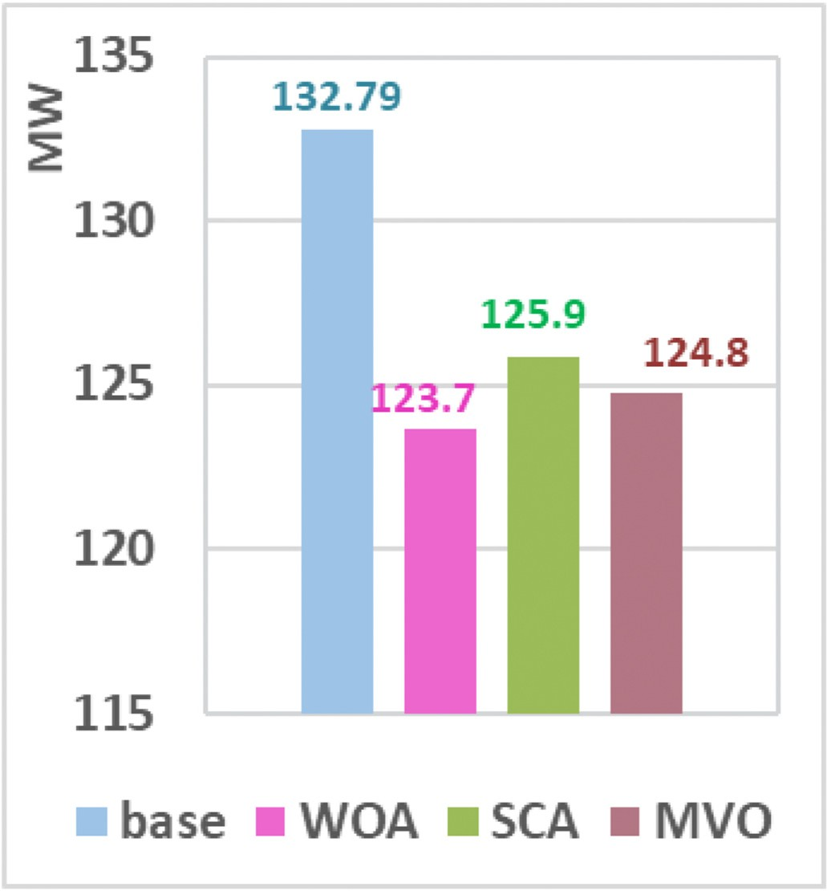

Fig. 19. Active power losses.

improvement ratio of up to 4.8% regarding the base case at bus 88, where the DG of the second type is installed.

* 1. *For the realistic system*

Fig. 21 shows the convergence curves for the realistic system and results show that the MVO and SCA gave the same optimal value of the

O.F. However, MVO converges in the minimum iterations number.

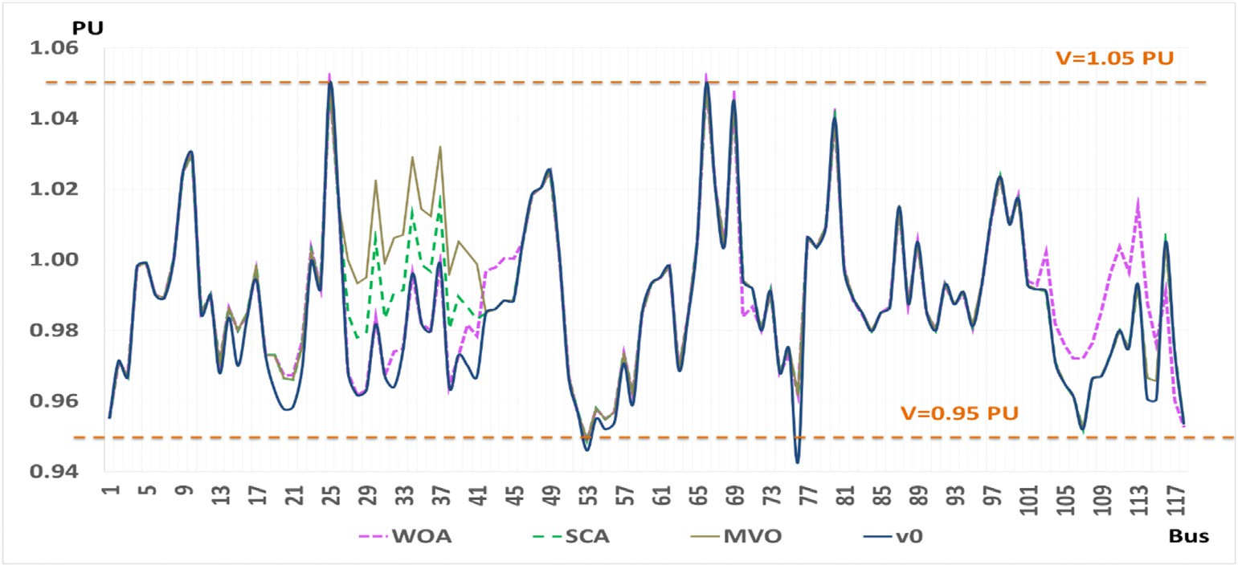

Fig. 20. IEEE 118-bus system voltage profile enhancement.

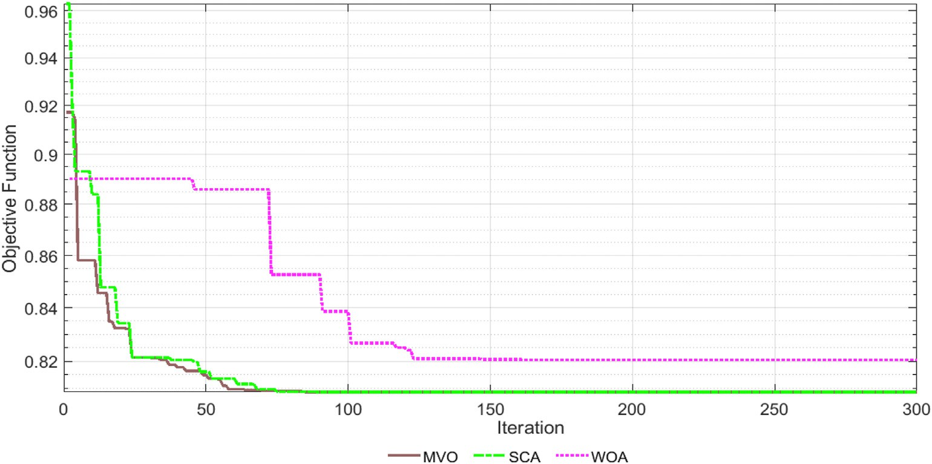

Fig. 21. Realistic grid convergence curve.

From Figs. 22, 23 and 25, it is reported that both MVO and SCA scored almost the same optimal results in terms of O.F, FVSI enhancement and *Ploss* reduction that reached about 15.1%. However, WOA converged in the minimum running time, as shown in Fig. 24.

A promising improvement of the realistic grid voltage profile is shown in Fig. 26. In addition, it is deduced that the MVO technique resulted in the best improvement in voltage magnitudes at the busses or near those to which the third type DG is installed. The maximum voltage improve- ment occurred at busses 158, 161 and 162 with an improved ratio of up to 6.3%.

1. Conclusion

This paper has developed a techno-economic multi-objective opti- mization framework for the multi-distributed generation of different categories siting and sizing. Three modern optimization algorithms which are; Whale Optimization Algorithm, Sine Cosine Algorithm and Multi-Verse Optimization Algorithm are employed to solve objective function which aims at minimizing the power losses, improving the systems’ voltage stability and decreasing overall additional costs. This work considered an allowable margin for the DG units’ penetration level, operating power factor and the systems’ voltages profile boundaries. The

proposed algorithms are applied on two benchmark test systems IEEE (33-bus and 118-bus) in addition to a realistic distribution network (171- bus) in the region of Canal Electricity Distribution Company-Egypt.

The outcomes have proved the effectiveness of the Multi-Verse opti- mization algorithm, Whale optimization algorithm and Sine Cosine al- gorithm in addressing the optimization problem compared to other existing researches. In addition, the proposed algorithms’ have attained almost the same significant results while solving the medium-sized network IEEE 33-bus system; meanwhile, the MVO has reached the optimal solution in less time and iterations number. However, for both of the two large scale systems (IEEE 118-bus system and the realistic network), the MVO has proved its superiority compared to the proposed algorithms in addressing the optimization problem with higher results’ accuracy in less time and iterations number. The attained results appli- cation into the proposed systems (IEEE 33-bus, 118-bus and the realistic system) have demonstrated that the voltage profiles are improved simultaneously as the system’s voltage stability is enhanced by 19.7%, 15.3% and 21.2%, respectively, whereas, the base cases have failed in keeping the voltage values boundaries at all busbars. Furthermore, the active power losses are significantly reduced for the above-mentioned systems by 43.7%, 5.22% and 15.1%, respectively. This work shall be extended to considering the customer’s hourly demand according to the

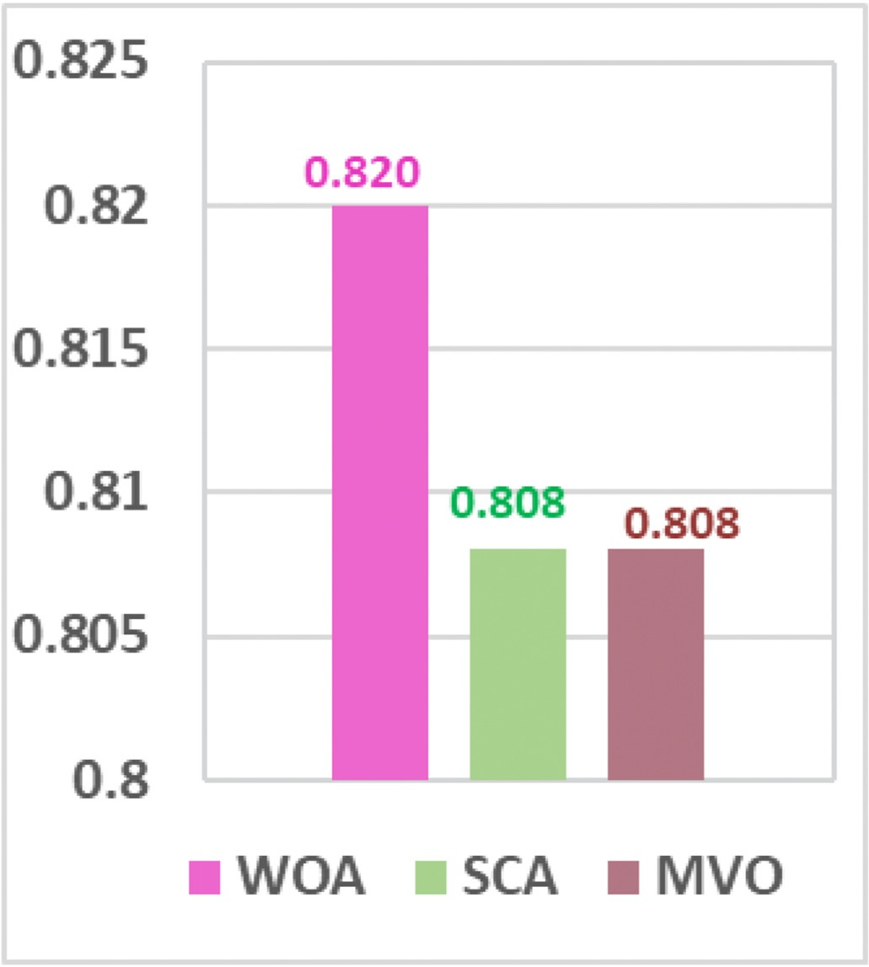 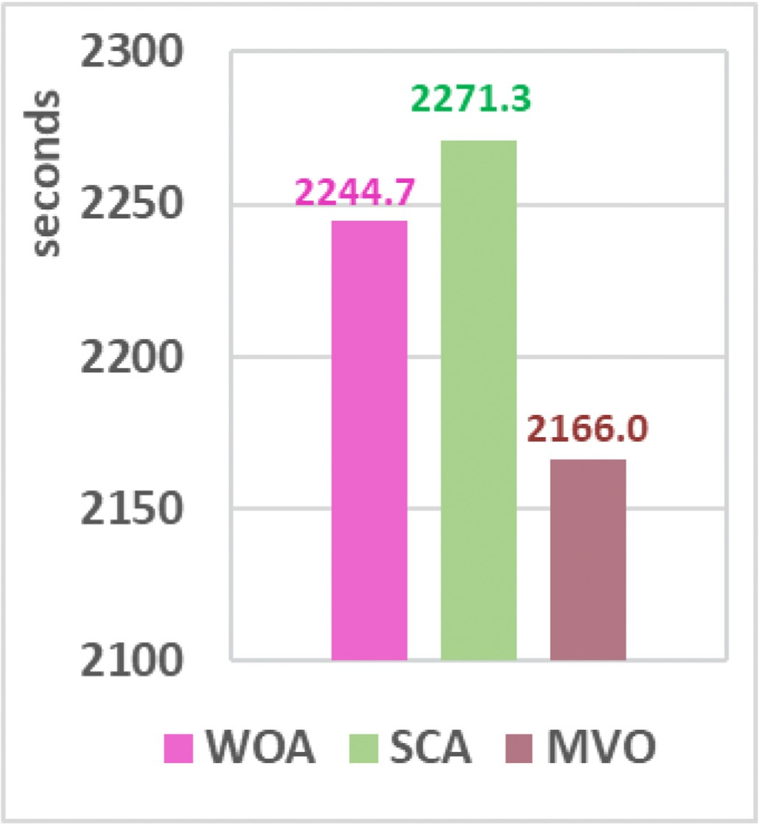

Fig. 22. Objective function values.

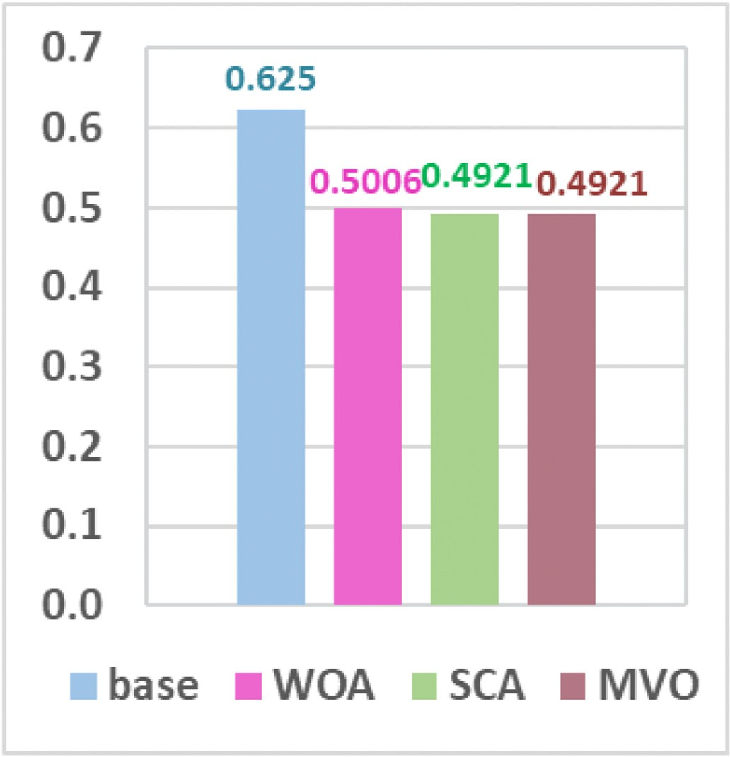

Fig. 23. Max *FVSI* values.

Fig. 24. Running time.

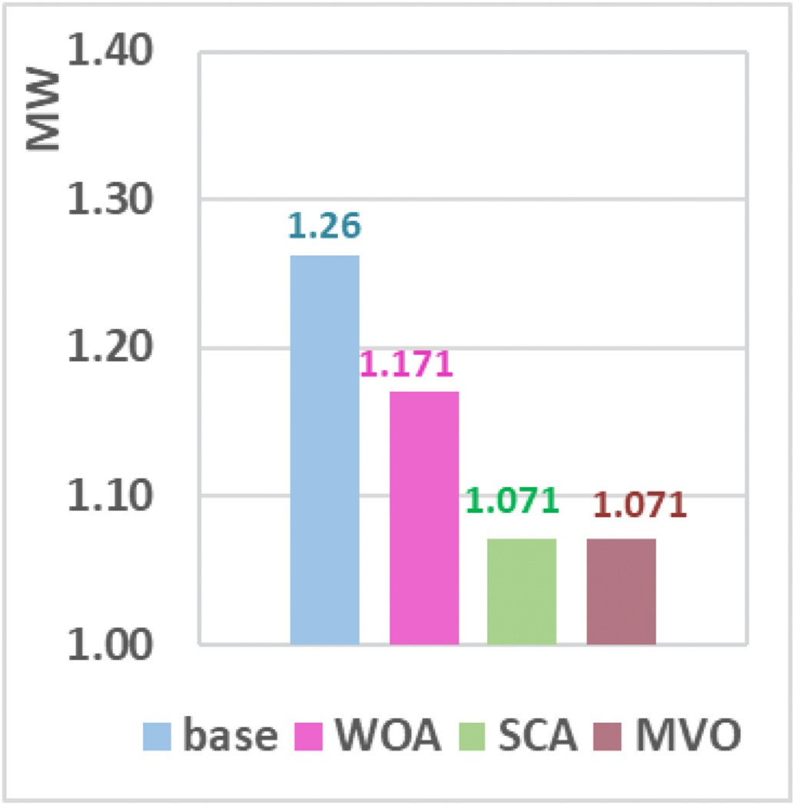

Fig. 25. Active power losses.

consumption type. In addition, it is recommended to investigate the availability and variability of the renewable sources, especially

Photovoltaics to assess their impact on the same systems’ performance with and without compliance with energy storage systems.

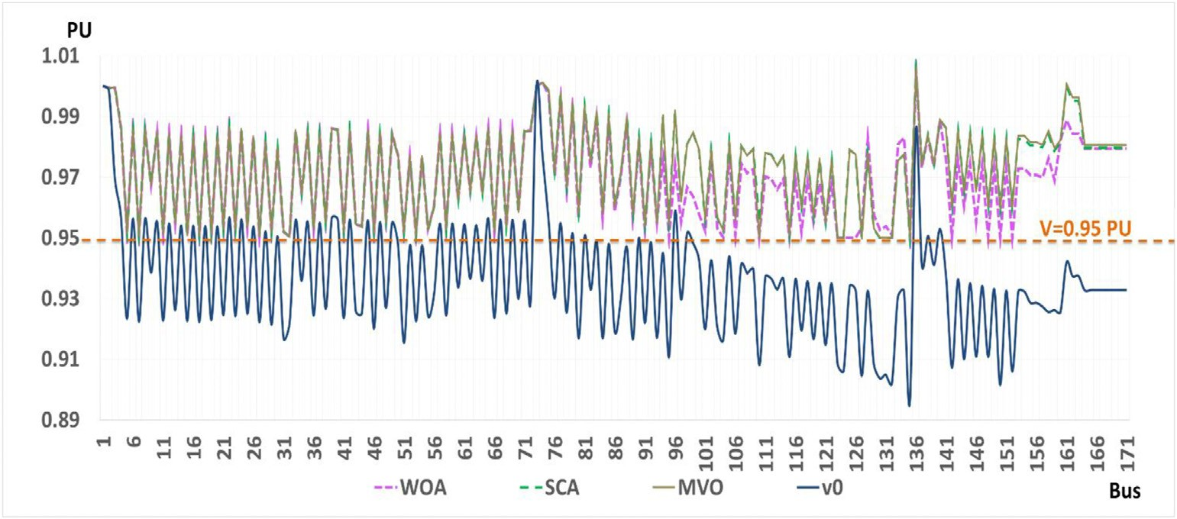

Fig. 26. Realistic system voltage profile.

Credit author statement

A. S. Hassan: Software, Methodology, Formal analysis, Investigation Resources, Writing Original Draft, Visualization, Funding acquisition; M.

A. Ebrahim: Methodology, Validation, Formal analysis, Investigation, Resources, Curation, Writing Original Draft, Visualization; F.M. Bendary: Conceptualization, Validation, Data Curation, Formal analysis, Review & Editing, Project administration; E. A. Othman: Conceptualization, Vali- dation, Review & Editing, Visualization, Supervision, Project administration.

Declaration of competing interest

The authors declare that they have no known competing financial interests or personal relationships that could have appeared to influence the work reported in this paper.

References

1. [Serițan G, Porumb R, Cepișc](http://refhub.elsevier.com/S2590-0056(20)30035-7/sref1)˘a [C, Grigorescu S. Integration of distributed generation](http://refhub.elsevier.com/S2590-0056(20)30035-7/sref1) [for assessment of distribution system reliability considering power loss, voltage](http://refhub.elsevier.com/S2590-0056(20)30035-7/sref1) [stability and voltage deviation. Energy Syst. 2019;10(2):489](http://refhub.elsevier.com/S2590-0056(20)30035-7/sref1)–[515. W. L. Theo,](http://refhub.elsevier.com/S2590-0056(20)30035-7/sref1) [Springer](http://refhub.elsevier.com/S2590-0056(20)30035-7/sref1).
2. [Dkhili N, Eynard J, Thil S, Grieu S. A survey of modelling and smart management](http://refhub.elsevier.com/S2590-0056(20)30035-7/sref2) [tools for power grids with proli](http://refhub.elsevier.com/S2590-0056(20)30035-7/sref2)fi[c distributed generation. Sustain. Energy, Grid](http://refhub.elsevier.com/S2590-0056(20)30035-7/sref2) [Netw. 2020;21:100284. Elsevier](http://refhub.elsevier.com/S2590-0056(20)30035-7/sref2).
3. [Hossain E, Tür MR, Padmanaban S, Ay S, Khan I. Analysis and mitigation of power](http://refhub.elsevier.com/S2590-0056(20)30035-7/sref3) [quality issues in distributed generation systems using custom power devices. IEEE](http://refhub.elsevier.com/S2590-0056(20)30035-7/sref3) [Access 2018;(6):16816](http://refhub.elsevier.com/S2590-0056(20)30035-7/sref3)–[33](http://refhub.elsevier.com/S2590-0056(20)30035-7/sref3).
4. [Lakum A, Mahajan V. Optimal placement and sizing of multiple active power](http://refhub.elsevier.com/S2590-0056(20)30035-7/sref4) fi[lters](http://refhub.elsevier.com/S2590-0056(20)30035-7/sref4) [in radial distribution system using grey wolf optimizer in presence of nonlinear](http://refhub.elsevier.com/S2590-0056(20)30035-7/sref4) [distributed generation. Elec Power Syst Res 2019;173:281](http://refhub.elsevier.com/S2590-0056(20)30035-7/sref4)–[90. Elsevier](http://refhub.elsevier.com/S2590-0056(20)30035-7/sref4).
5. [Bhatt P, Long C, Mehta B, et al. Optimal utilization of reactive power capability of](http://refhub.elsevier.com/S2590-0056(20)30035-7/sref5) [renewable energy based distributed generation for improved performance of](http://refhub.elsevier.com/S2590-0056(20)30035-7/sref5) [distribution network. In: Renewable energy and Climate change; 2020. p. 141](http://refhub.elsevier.com/S2590-0056(20)30035-7/sref5)–[52.](http://refhub.elsevier.com/S2590-0056(20)30035-7/sref5) [Springer](http://refhub.elsevier.com/S2590-0056(20)30035-7/sref5).
6. [Montoya OD, Gil-Gonz´](http://refhub.elsevier.com/S2590-0056(20)30035-7/sref6)a[lez W, et al. An exact MINLP model for optimal location and](http://refhub.elsevier.com/S2590-0056(20)30035-7/sref6)

[sizing of DGs in distribution networks: a general algebraic modeling system](http://refhub.elsevier.com/S2590-0056(20)30035-7/sref6) [approach. Ain Shams Eng. J. 2020;11(2):409](http://refhub.elsevier.com/S2590-0056(20)30035-7/sref6)–[18. Elsevier](http://refhub.elsevier.com/S2590-0056(20)30035-7/sref6).

1. [Babu BK, Maheswarapu S. A solution to multi-objective optimal accommodation of](http://refhub.elsevier.com/S2590-0056(20)30035-7/sref7) [distributed generation problem of power distribution networks: an analytical](http://refhub.elsevier.com/S2590-0056(20)30035-7/sref7) [approach. In: Int Trans Electr Energ Syst. John Wiley](http://refhub.elsevier.com/S2590-0056(20)30035-7/sref7) & [Sons, Ltd.; 2019](http://refhub.elsevier.com/S2590-0056(20)30035-7/sref7).
2. [Alinezhad P, Bakhoda OZ, Menhaj AB. Optimal DG placement and capacity](http://refhub.elsevier.com/S2590-0056(20)30035-7/sref8) [allocation using intelligent algorithms. In: 2015 fourth Iranian Joint Congress on](http://refhub.elsevier.com/S2590-0056(20)30035-7/sref8) [Fuzzy and Intelligent System (CFIS). IEEE; 2015. p. 1](http://refhub.elsevier.com/S2590-0056(20)30035-7/sref8)–[8](http://refhub.elsevier.com/S2590-0056(20)30035-7/sref8).
3. [Saleh AA, Mohamed AAA, et al. Comparison of different optimization techniques](http://refhub.elsevier.com/S2590-0056(20)30035-7/sref9) [for optimal allocation of multiple distribution generation. In: 2018 international](http://refhub.elsevier.com/S2590-0056(20)30035-7/sref9) [Conference on innovative Trends in Computer Engineering (ITCE), IEEE; 2018.](http://refhub.elsevier.com/S2590-0056(20)30035-7/sref9)

[p. 317](http://refhub.elsevier.com/S2590-0056(20)30035-7/sref9)–[23](http://refhub.elsevier.com/S2590-0056(20)30035-7/sref9).

1. [Reddy DP, Veera VC, Manohar TG. Optimal renewable resources placement in](http://refhub.elsevier.com/S2590-0056(20)30035-7/sref10) [distribution networks by combined power loss index and Whale optimization](http://refhub.elsevier.com/S2590-0056(20)30035-7/sref10) [algorithms. J. Electr. Syst. Inf. Technol. 2018;5(2):175](http://refhub.elsevier.com/S2590-0056(20)30035-7/sref10)–[91](http://refhub.elsevier.com/S2590-0056(20)30035-7/sref10).
2. [Dinakara P, Veera VC, Gowri T. Whale optimization algorithm for optimal sizing of](http://refhub.elsevier.com/S2590-0056(20)30035-7/sref11) [renewable resources for loss reduction in distribution systems. Renewables: Wind,](http://refhub.elsevier.com/S2590-0056(20)30035-7/sref11) [Water, and Solar 2017;4(1):3](http://refhub.elsevier.com/S2590-0056(20)30035-7/sref11).
3. [Selim A, Kamel S, Jurado F. Voltage pro](http://refhub.elsevier.com/S2590-0056(20)30035-7/sref12)fi[le improvement in active distribution](http://refhub.elsevier.com/S2590-0056(20)30035-7/sref12) [networks using hybrid WOA-SCA optimization algorithm. In: Twentieth](http://refhub.elsevier.com/S2590-0056(20)30035-7/sref12) [International Middle East Power Systems Conference (MEPCON), IEEE; 2018.](http://refhub.elsevier.com/S2590-0056(20)30035-7/sref12)

[p. 1064](http://refhub.elsevier.com/S2590-0056(20)30035-7/sref12)–[8](http://refhub.elsevier.com/S2590-0056(20)30035-7/sref12).

1. [Morshidi MN, Musirin I, et al. Whale optimization algorithm based technique for](http://refhub.elsevier.com/S2590-0056(20)30035-7/sref13) [distributed generation installation in distribution system. Bull. Electr. Eng. Inf.](http://refhub.elsevier.com/S2590-0056(20)30035-7/sref13) [2018;7(3):442](http://refhub.elsevier.com/S2590-0056(20)30035-7/sref13)–[9](http://refhub.elsevier.com/S2590-0056(20)30035-7/sref13).
2. [Babu BK, Maheswarapu S. An optimal accommodation of distributed generation in](http://refhub.elsevier.com/S2590-0056(20)30035-7/sref14) [power distribution systems. In: 20th National Power Systems Conference (NPSC).](http://refhub.elsevier.com/S2590-0056(20)30035-7/sref14) [IEEE; 2018. p. 1](http://refhub.elsevier.com/S2590-0056(20)30035-7/sref14)–[6](http://refhub.elsevier.com/S2590-0056(20)30035-7/sref14).
3. [Ang S, Leeton U, Chayakulkeeree K, Kulworawanichpong T. Sine cosine algorithm](http://refhub.elsevier.com/S2590-0056(20)30035-7/sref15) [for optimal placement and sizing of distributed generation in radial distribution](http://refhub.elsevier.com/S2590-0056(20)30035-7/sref15) [network. GMSARN Int. J. 2018;12:202](http://refhub.elsevier.com/S2590-0056(20)30035-7/sref15)–[12](http://refhub.elsevier.com/S2590-0056(20)30035-7/sref15).
4. [Sujatha MS, Roja V, Prasad TN. Multiple DG placement and sizing in radial](http://refhub.elsevier.com/S2590-0056(20)30035-7/sref16) [distribution system using Genetic Algorithm and Particle Swarm Optimization.](http://refhub.elsevier.com/S2590-0056(20)30035-7/sref16) [Comput. Intell. Big Data Anal. 2019:21](http://refhub.elsevier.com/S2590-0056(20)30035-7/sref16)–[36. Springer](http://refhub.elsevier.com/S2590-0056(20)30035-7/sref16).
5. [Jaser A, et al. A simpli](http://refhub.elsevier.com/S2590-0056(20)30035-7/sref17)fi[ed analytical approach for optimal planning of distributed](http://refhub.elsevier.com/S2590-0056(20)30035-7/sref17) [generation in electrical distribution networks. Appl Sci 2019;9(24):5446](http://refhub.elsevier.com/S2590-0056(20)30035-7/sref17).
6. [Mirjalili S, Lewis A. The whale optimization algorithm. Adv. Eng. Software 2016;](http://refhub.elsevier.com/S2590-0056(20)30035-7/sref18) [95:51](http://refhub.elsevier.com/S2590-0056(20)30035-7/sref18)–[67. Elsevier](http://refhub.elsevier.com/S2590-0056(20)30035-7/sref18).
7. [Mirjalili S, Mirjalili SM, Hatamlou A. Multi-Verse Optimizer: a nature-inspired](http://refhub.elsevier.com/S2590-0056(20)30035-7/sref19) [algorithm for global optimization. Neural Comput. Appl. 2016;27(2):495](http://refhub.elsevier.com/S2590-0056(20)30035-7/sref19)–[513.](http://refhub.elsevier.com/S2590-0056(20)30035-7/sref19) [Springer](http://refhub.elsevier.com/S2590-0056(20)30035-7/sref19).
8. [Fathy A, Rezk H. Multi-verse optimizer for identifying the optimal parameters of](http://refhub.elsevier.com/S2590-0056(20)30035-7/sref20) [PEMFC model. Energy 2018;143:634](http://refhub.elsevier.com/S2590-0056(20)30035-7/sref20)–[44. Springer](http://refhub.elsevier.com/S2590-0056(20)30035-7/sref20).
9. [Mirjalili S. SCA: a sine cosine algorithm for solving optimization problems.](http://refhub.elsevier.com/S2590-0056(20)30035-7/sref21) [Knowledge-Based Syst. 2016;96:120](http://refhub.elsevier.com/S2590-0056(20)30035-7/sref21)–[33. Elsevier](http://refhub.elsevier.com/S2590-0056(20)30035-7/sref21).
10. [Abdelsalam AA, Mansour HSE. Optimal allocation and hourly scheduling of](http://refhub.elsevier.com/S2590-0056(20)30035-7/sref22) [capacitor banks using sine cosine algorithm for maximizing technical and economic](http://refhub.elsevier.com/S2590-0056(20)30035-7/sref22) [bene](http://refhub.elsevier.com/S2590-0056(20)30035-7/sref22)fi[ts. Elec. Power Compon. Syst. 2019;47:1025](http://refhub.elsevier.com/S2590-0056(20)30035-7/sref22)–[39. Taylor](http://refhub.elsevier.com/S2590-0056(20)30035-7/sref22) & [Francis](http://refhub.elsevier.com/S2590-0056(20)30035-7/sref22).
11. [Yahyazadeh M, Rezaeeye H. Optimal placement and sizing of distributed generation](http://refhub.elsevier.com/S2590-0056(20)30035-7/sref23) [using wale optimization algorithm considering voltage stability and voltage pro](http://refhub.elsevier.com/S2590-0056(20)30035-7/sref23)fi[le](http://refhub.elsevier.com/S2590-0056(20)30035-7/sref23) [improvement, power loss and investment cost reducing. Iran. J. Sci.Technol. Trans.](http://refhub.elsevier.com/S2590-0056(20)30035-7/sref23) [Electr. Eng. 2020;44(1):227](http://refhub.elsevier.com/S2590-0056(20)30035-7/sref23)–[36. Springer](http://refhub.elsevier.com/S2590-0056(20)30035-7/sref23).
12. [Roshan R, Samal P, Sinha P. Optimal placement of FACTS devices in power](http://refhub.elsevier.com/S2590-0056(20)30035-7/sref24) [transmission network using power stability index and fast voltage stability index.](http://refhub.elsevier.com/S2590-0056(20)30035-7/sref24) [Int. Conf. Electr. Electron. Eng. (ICE3) 2020;14:246](http://refhub.elsevier.com/S2590-0056(20)30035-7/sref24)–[51. IEEE](http://refhub.elsevier.com/S2590-0056(20)30035-7/sref24).
13. [Ogunjuyigbe ASO, Ayodele TR, Akinola OO. Impact of distributed generators on the](http://refhub.elsevier.com/S2590-0056(20)30035-7/sref25) [power loss and voltage pro](http://refhub.elsevier.com/S2590-0056(20)30035-7/sref25)fi[le of sub-transmission network. J. Electr. Syst. Inf.](http://refhub.elsevier.com/S2590-0056(20)30035-7/sref25) [Technol. 2016;3(1):94](http://refhub.elsevier.com/S2590-0056(20)30035-7/sref25)–[107. Elsevier](http://refhub.elsevier.com/S2590-0056(20)30035-7/sref25).
14. [Silva VRN, Kuiava R. Loading margin sensitivity in relation to the wind farm](http://refhub.elsevier.com/S2590-0056(20)30035-7/sref26) [generation power factor for voltage preventive control. J. Contr. Autom. Electr.](http://refhub.elsevier.com/S2590-0056(20)30035-7/sref26) [Syst. 2019;30(6):1041](http://refhub.elsevier.com/S2590-0056(20)30035-7/sref26)–[50. Elsevier](http://refhub.elsevier.com/S2590-0056(20)30035-7/sref26).
15. [Ampofo DO, Otchere IK. An investigative study on penetration limits of distributed](http://refhub.elsevier.com/S2590-0056(20)30035-7/sref27) [generation on distribution networks. In: 2017 IEEE PES Power Africa, IEEE; 2017.](http://refhub.elsevier.com/S2590-0056(20)30035-7/sref27)

[p. 573](http://refhub.elsevier.com/S2590-0056(20)30035-7/sref27)–[6](http://refhub.elsevier.com/S2590-0056(20)30035-7/sref27).

1. [Hoke A, Butler R, Hambrick J, et al. Steady-state analysis of maximum photovoltaic](http://refhub.elsevier.com/S2590-0056(20)30035-7/sref28) [penetration levels on typical distribution feeders. IEEE Trans. Sustain. Energy, IEEE](http://refhub.elsevier.com/S2590-0056(20)30035-7/sref28) [2012;4(2):350](http://refhub.elsevier.com/S2590-0056(20)30035-7/sref28)–[7](http://refhub.elsevier.com/S2590-0056(20)30035-7/sref28).
2. [Saadat H. Power system analysis. Boston: McGraw-Hill; 1999](http://refhub.elsevier.com/S2590-0056(20)30035-7/sref29).
3. [Zimmerman RD, Murillo-S](http://refhub.elsevier.com/S2590-0056(20)30035-7/sref30)´[anchez CE, et al. Matpower: a MATLAB power system](http://refhub.elsevier.com/S2590-0056(20)30035-7/sref30) [simulation package. Ithaca NY: Power Systems Engineering Research Center; 1997](http://refhub.elsevier.com/S2590-0056(20)30035-7/sref30).
4. Power system test case archive, University of Washington, available at: <https://www.ece.uw.edu/research/pstca/>, Accessed 10 Oct 2019.
5. MathWorks. <https://www.mathworks.com/>, Accessed 8 Dec 2019.
6. Canal electricity distribution Company (CEDC), Egyptian Electricity Holding Company (EEHC).
7. [Ali ES, Abd Elazim SM, Abdelaziz AY. Ant lion optimization algorithm for optimal](http://refhub.elsevier.com/S2590-0056(20)30035-7/sref34) [location and sizing. Renew Energy 2017;(101):1311](http://refhub.elsevier.com/S2590-0056(20)30035-7/sref34)–[24](http://refhub.elsevier.com/S2590-0056(20)30035-7/sref34).
8. [VC VR. Optimal renewable resources placement in distribution networks by](http://refhub.elsevier.com/S2590-0056(20)30035-7/sref35) [combined power loss index and Whale optimization algorithms. J. Electr. Syst. Inf.](http://refhub.elsevier.com/S2590-0056(20)30035-7/sref35) [Technol. 2018;5(2):175](http://refhub.elsevier.com/S2590-0056(20)30035-7/sref35)–[91](http://refhub.elsevier.com/S2590-0056(20)30035-7/sref35).
9. [Murthy VVSN, Kumar A. Comparison of optimal DG allocation methods in radial](http://refhub.elsevier.com/S2590-0056(20)30035-7/sref36) [distribution systems based on sensitivity approaches. Int J Electr Power Energy Syst](http://refhub.elsevier.com/S2590-0056(20)30035-7/sref36) [2013;53:450](http://refhub.elsevier.com/S2590-0056(20)30035-7/sref36)–[67](http://refhub.elsevier.com/S2590-0056(20)30035-7/sref36).
10. [Prasad CH, Subbaramaiah K, Sujatha P. “Cost](http://refhub.elsevier.com/S2590-0056(20)30035-7/sref37)–[benefit analysis for optimal DG](http://refhub.elsevier.com/S2590-0056(20)30035-7/sref37) [placement in distribution systems by using elephant herding optimization](http://refhub.elsevier.com/S2590-0056(20)30035-7/sref37) [algorithm. Renewables: Wind, Water, and Solar 2019;6(1):2](http://refhub.elsevier.com/S2590-0056(20)30035-7/sref37).
11. [Shanmugapriyan J, Karuppiah N, Muthubalaji S, Tamilselvi S. Optimum placement](http://refhub.elsevier.com/S2590-0056(20)30035-7/sref38) [of multi type DG units for loss reduction in a radial distribution system considering](http://refhub.elsevier.com/S2590-0056(20)30035-7/sref38) [the distributed generation. Bull Pol Acad Sci Tech Sci 2018;66(3)](http://refhub.elsevier.com/S2590-0056(20)30035-7/sref38).
12. [Devabalaji K, Ravi K. Optimal size and siting of multiple DG and DSTATCOM in](http://refhub.elsevier.com/S2590-0056(20)30035-7/sref39) [radial distribution system using bacterial foraging optimization algorithm. Ain](http://refhub.elsevier.com/S2590-0056(20)30035-7/sref39) [Shams Eng J. 2016;7(3):959](http://refhub.elsevier.com/S2590-0056(20)30035-7/sref39)–[71](http://refhub.elsevier.com/S2590-0056(20)30035-7/sref39).
13. [Farh HM, Al-Shaalan AM, Eltamaly AM, Al-Shamma’A AA. A novel crow search](http://refhub.elsevier.com/S2590-0056(20)30035-7/sref40) [algorithm auto-drive PSO for optimal allocation and sizing of renewable distributed](http://refhub.elsevier.com/S2590-0056(20)30035-7/sref40) [generation. IEEE Access 2020;8:27807](http://refhub.elsevier.com/S2590-0056(20)30035-7/sref40)–[20](http://refhub.elsevier.com/S2590-0056(20)30035-7/sref40).