[Artificial Intelligence in Agriculture 6 (2022) 1–9](https://doi.org/10.1016/j.aiia.2021.11.003)

Contents lists available at [ScienceDirect](http://www.sciencedirect.com/science/journal/)

Artificial Intelligence in Agriculture

journal homepage: [http://www.keaipublishing.com/en/journa ls/artificial- intelligence- in-agriculture/](http://www.keaipublishing.com/en/journals/artificial-intelligence-in-agriculture/)

[](http://crossmark.crossref.org/dialog/?doi=10.1016/j.aiia.2021.11.003&domain=pdf)Effect and economic benefit of precision seeding and laser land leveling for winter wheat in the middle of China

Jing Chen a, Chunjiang Zhao b, Glyn Jones c, Hao Yang b, Zhenhong Li d, Guijun Yang b,

Liping Chen b, Yongchang Wu a,⁎

a *Institute of Agricultural Economics and Development, Chinese Academy of Agricultural Sciences, Beijing 100081, China*

b *Beijing Research Center for Information Technology in Agriculture, Beijing Academy of Agriculture and Forestry Sciences, Beijing 100097, China*

c *Fera Science Ltd, Sand Hutton, York YO41 1LZ and Institute for Agri-Food Research and Innovation, Newcastle Univerity, Newcastle Upon Tyne, UK*

d *School of Engineering, Newcastle University, Newcastle Upon Tyne, UK*

# a r t i c l e i n f o

*Article history:*

Received 19 August 2021

Received in revised form 24 November 2021 Accepted 25 November 2021

Available online 27 November 2021

*Keywords:* Precision seeding Laser land leveling Application effect Economic benefit

# a b s t r a c t

Rapid socio-economic changes in China, such as land conversion and urbanization, are creating new scopes for the application of precision agriculture (PA).An experiment to assess the economic benefits of two precision ag- riculture methods was applied for one year – precision seeding and precision seeding with land leveling. Whilst the results for this were positive, of itself it did not provide evidence of longer terms gains. The costs of land level- ing are accrued in a single year but the benefits could carry over into subsequent years. Thus, in this case if the PA method provides carry over benefits to future years, the economic assessment would incorrectly assign all the costs to a single year of benefits i.e.the benefit-cost ratio would be underestimated. To gauge whether there was carry over benefits in future years we looked at NDVI and GUI as proxies for future year benefits. For the sin- gle year experiment, our results showed that: (1) Winter wheat yield was increased 23.2% through the integra- tion of precision seeding and laser leveling technologies.(2) Both the single technology and the integrated technologies significant reduced the concentration of soil ammonium nitrogen at the depths of 60 cm; (3) The benefit/cost ratio's of the treatments exceeded that of the baseline by approximately 10% which translated to an increase of several hundred US$ per hectare. The NDVI analysis showed that the effect of laser land leveling could last to the next two years. When considering the multi-year impact of land leveling, the benefit/cost ratio of PSLL will increase to 23.5% and 22.9% with and without laser land leveling subsidies. Making clear the eco- nomic benefits of using PA technologies will likely promote application of the technologies in the region.

© 2021 The Authors. Publishing services by Elsevier B.V. on behalf of KeAi Communications Co., Ltd. This is an open access article under the CC BY-NC-ND license (<http://creativecommons.org/licenses/by-nc-nd/4.0/>).

1. Introduction

It has become increasingly challenging to produce more food with limited land, water and environmental resources to meet the needs of a rapidly growing population. The purpose of precision agriculture (PA) is to improve the economic and environmental benefits of agricul- ture and to reduce harm to the environment, under the premise of crop yield, quality and food safety (Cassman, 1999; Li, 2008; Gebbers and Adamchuk, 2010; Schieffer and Dillon, 2015). Current technologies of precision agriculture mainly involve the combined application of infor- mation technologies such as Remote Sensing (RS), Geographical infor- mation Systems (GIS), Global Navigation Satellite Systems (GNSS) and sensors placed on agricultural machines for laser land leveling, planting, variable rate fertilizer application, harvesting, and spraying, as well as

* Corresponding author.

*E-mail address:* [wuyongchang@caas.cn](mailto:wuyongchang@caas.cn) (Y. Wu).

water-saving irrigation facilities. However, there are few studies about the evaluation of PA in the field. In China, the potential impacts of PA ap- plication in terms of yield, quality and farm incomes have not yet been fully demonstrated which is likely an important factor constraining its promotion (e.g. Kuehne et al., 2017).

Seeding is the most important part of the crop production process since it directly impacts germination, crop growth and yield, thus affect- ing crop productivity and the ensuing economic benefits (Ansari et al., 2006; Li et al., 2010). Precision seeding is the key to promoting PA, as well as the prerequisite and basis for promoting other precision applica- tions: irrigation, fertilization, and harvesting (Li et al., 2005). Precision seeding technology can not only improve the germination rate, save seeds (Yazgi and Degirmencioglu, 2007; Karayel, 2009), optimize popu- lation density, and increase crop yields (Giannini et al., 1967; Raoufat and Matbooei, 2007; Karayel, 2009), but also reduce labour inputs such as thinning which all lead to improved farm incomes (Zhao et al., 2010). A key determinant affecting seeding success is the quality of land preparation (Ahmed et al., 2014). Laser land leveling machines

<https://doi.org/10.1016/j.aiia.2021.11.003>

2589-7217/© 2021 The Authors. Publishing services by Elsevier B.V. on behalf of KeAi Communications Co., Ltd. This is an open access article under the CC BY-NC-ND license ([http://](http://creativecommons.org/licenses/by-nc-nd/4.0/) [creativecommons.org/licenses/by-nc-nd/4.0/](http://creativecommons.org/licenses/by-nc-nd/4.0/)).

can ensure precise farmland leveling, effectively improving the micro- topographical conditions of farmland, thus laying the foundation for precision seeding (Xu et al., 2007). In general, it can increase crop yields (Rickman et al., 1998; Jat et al., 2006), improve the efficiency of fertilizer and water use (Jat et al., 2006; Choudhary et al., 2000; Ahmed et al., 2014; Ashraf et al., 2017), and thereby increase economic benefits (Jat et al., 2009; Ashraf et al., 2017). There are some concerns that laser land leveling affects the soil salinity and fertility of the soil since during laser land leveling some top soil is removed from the crest and moved to the trough (Walker et al., 2003). Ashraf et al. (2017) indicated that there was no significant difference for available nitrogen, phosphorous, potas- sium and organic matter in level and unlevel fields.

Most previous research focus on the application effects and eco-

nomic benefits of applying one single technology with little research fo- cusing on integrated technologies. No attempt has been made to study the effects on the integrated precision seeding and laser land leveling technologies in China. Therefore, this study aims to evaluate the impacts of precision seeding and its integrated technologies with laser land leveling on the winter wheat yield, residual soil nitrogen and the result- ing economic benefits. Winter wheat is a common crop in the central plains of China. The experiments were conducted in Henan Province in which the total wheat production and per unit yield are both the highest in China. It further aims to study the carry over effect of the land leveling component. That is, the benefits of land leveling are still apparent 2–3 years after the initial cost of leveling.

We report on a one year study of the inputs and outputs from trials of precision seeding (PS), precision seeding with land leveling (PSLL) and compare the results with conventional farming. To capture the carry over effect of land leveling, and to enhance the single year of eco- nomic data, we adopt remote sensing approach to capture its impact in subsequent years. Remote sensing technology can provides various yield-directly related crop parameters for crop condition and yield fore- casting, such as Normalized Difference Vegetation Index (NDVI), which closely related to the vegetation vigor, has been recognized for its ability to monitor crops and as an estimator of crop yields since early 1980s (Bastiaanssen and Ali, 2003; Labus et al., 2002).

1. Materials and methods

The research method is composed of two parts: part one is to carry out a one-year field experiment to obtain the yield, nitrogen residue ap- plication effect, economic benefits of precision sowing, and laser flat + precision sowing; part two is to use the four-year remote sensing data to study the multi-year effect of laser leveling, and finally evaluate the economic benefit obtained from the multi-year cost sharing correction test. See Fig. 1 for specific method flow.

* 1. *Site descriptions*

The experimental work was undertaken at the 2011 National Collab- orative Innovation Pilot for Modern Agriculture (113°58′26″E, 34°12′ 06″N), located in Chang'ge City, Henan Province, China. This area typi- cally deploys a winter wheat-summer maize rotation. The north tem- perate continental monsoon climate dominates, with a mean annual temperature of 14.3 °C, a mean annual rainfall of 711.1 mm, and a mean annual frost-free period of 217 days. The soil is medium textured: topsoil (0–20 cm) organic matter is 18.40 g kg−1, alkali-hydrolyzable ni- trogen is 101.22 mg kg−1, rapidly available phosphorus is 9.83 mg kg−1, rapidly available kalium is 98.44 mg kg−1, and soil pH value is 7.65.

* 1. *Experiment design*

Fig. 2 shows the field layout of the experiment, the treatments and the sampling points. The experiment comprised three land leveling and seeding treatments: precision seeding (PS), integrated precision seeding and laser land leveling (PSLL), and local large-scale conven- tional farming (C). The size of the main plot was 300 m × 150 m with sub-plots of 50 m × 50 m. There were 18 sampling points in each treat- ment. PS equips conventional planters with a wheat seeding moni- toring system and a GPS navigation system developed by the National Engineering Research Center for Agricultural Information Technology (NERCITA) for accurate seeding (Fig. 3). This allows precision control of seeding evenness, and row straightness. The

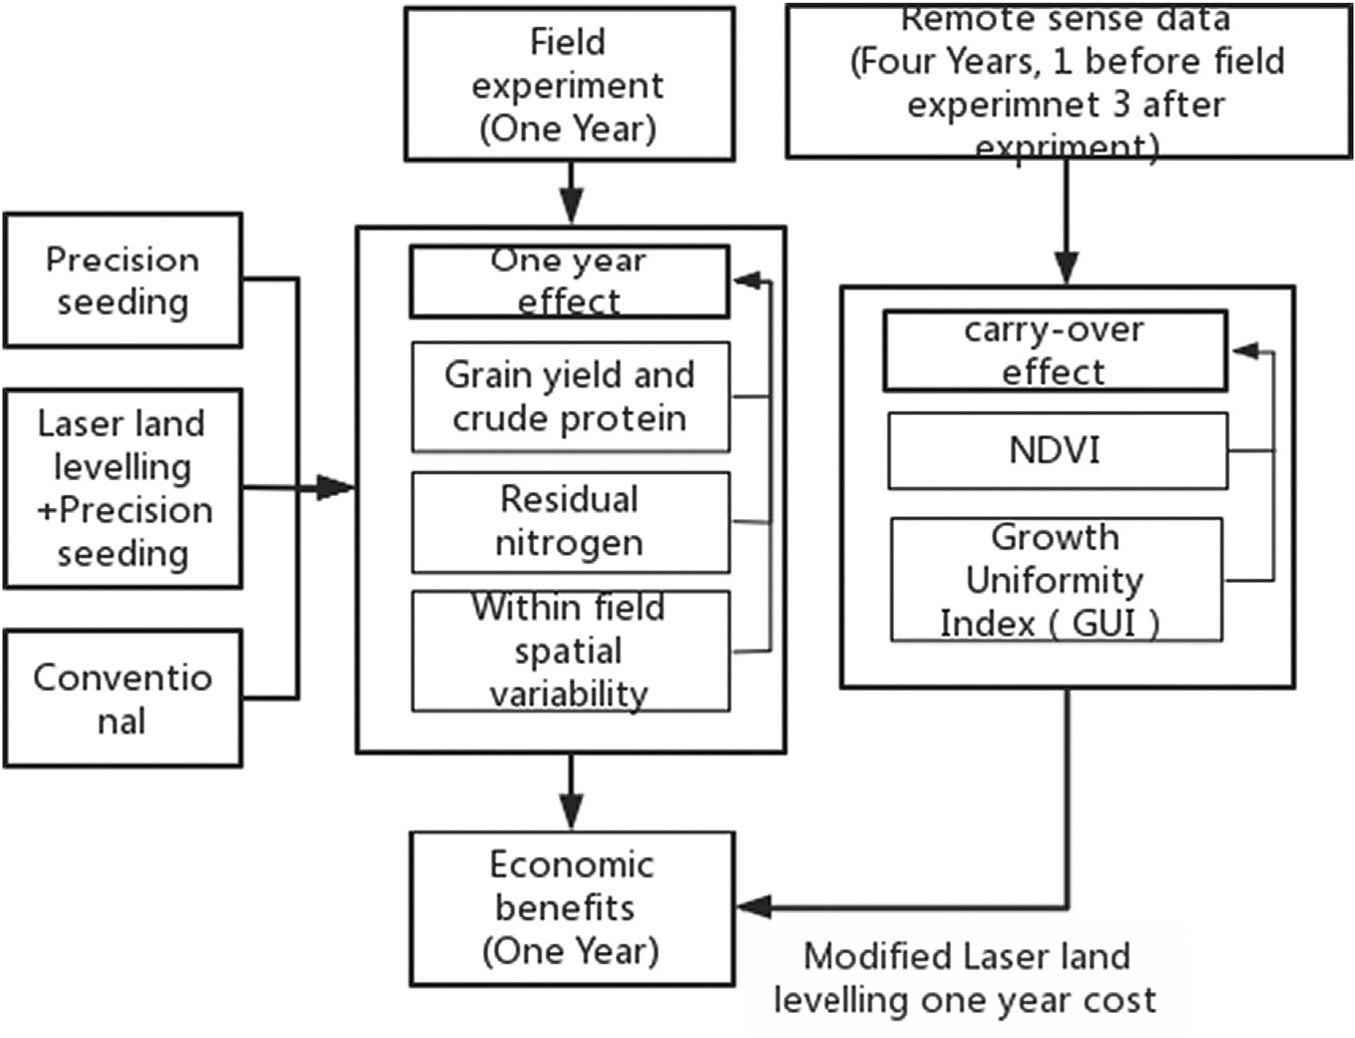

Fig. 1. Flow diagram of this study.

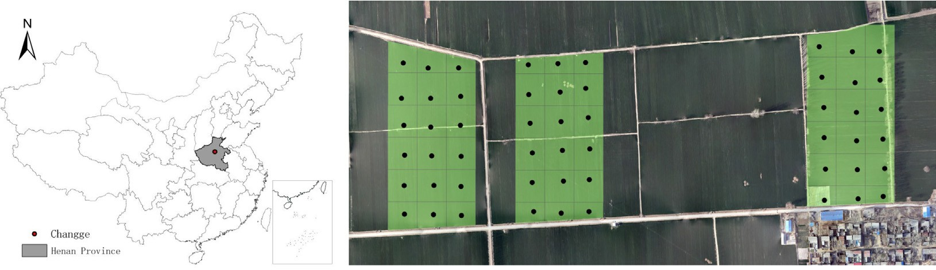

Fig. 2. Experiment design and sampling point distribution.

1PJ-2500 laser land leveling machinery developed by NERCITA was used for non-longitudinal cross slope leveling (Fig. 4), with a width of 2.5 m and a leveling accuracy of 2 cm. Other treatments used con- ventional machines for land leveling.

The winter wheat variety for testing was Xi Nong 979. It was planted on October 5th, 2014. The seeding density of PS and PSLL were 195

kg ha−1, and C was 225 kg ha−1 all with row spacing at 16.5 cm. Base fertilizer was applied at 750 kg ha−1 (N: P: K = 23:16: 6) and another 225 kg ha−1 compound fertilizer was applied in early March 2015 fol- lowing rainfall in the jointing stage. The wheat was irrigated once only during its growth period by local farmers using conventional hose sprin- klers (commonly known as the “little white dragon”) (Sui et al., 2005). The amount and timing of irrigation, fertilization, topdressing, spraying and other management measures of the winter wheat during its grow- ing period were identical for all the three treatments. During October 2014 to July 2017, laser land leveling and precision seeding was applied once in PSLL in October 2014.

* 1. *Sample collection and measurement method*

For each treatment there were 18 sampling points with a spacing of 50 m × 50 m by a handheld GPS (Trimble Juno 3B). At maturity, the wheat was harvested manually at 1m2 around the sampling points.

The grains were threshed using a plot thresher, dried in a batch grain dryer and weighed. Grain yields of wheat was reported at 12% moisture content. Some of the grain was then crushed, mixed, sifted and mea- sured for the Kjeldahl nitrogen content by using the Kjeldahl method (Helrich, 1990), and further converted to crude grain protein content with a conversion factor of 6.25. Concurrently, soil samples were taken from three spots randomly chosen around the sampling points, using an auger with a diameter of 5 cm to collect soil samples at 0–60 cm soil depth (20 cm per layer), placed in a ziplock bag and brought back to the lab. Soil moisture was measured in an oven at 105 °C. Nitrate and ammonium nitrogen were extracted from fresh soil by using 1 mol L−1 KCL solution. Soil nitrate and ammonium concentration were mea-

sured using a flow analyzer (Seal AA3).

* 1. *Economics analysis*

The economic analysis considered all inputs, including the service charge for cultivation, the cost of seed, fertilizer, pesticide (irrigation water in the experimental area was free of charge) and farm manage- ment costs. Land preparation, planting, fertilizer and pesticide applica- tion, irrigation, and harvesting were all undertaken by agricultural machinery cooperatives and farmers' cooperatives. Thus, labour inputs were already included in these paid services. The farm belongs to

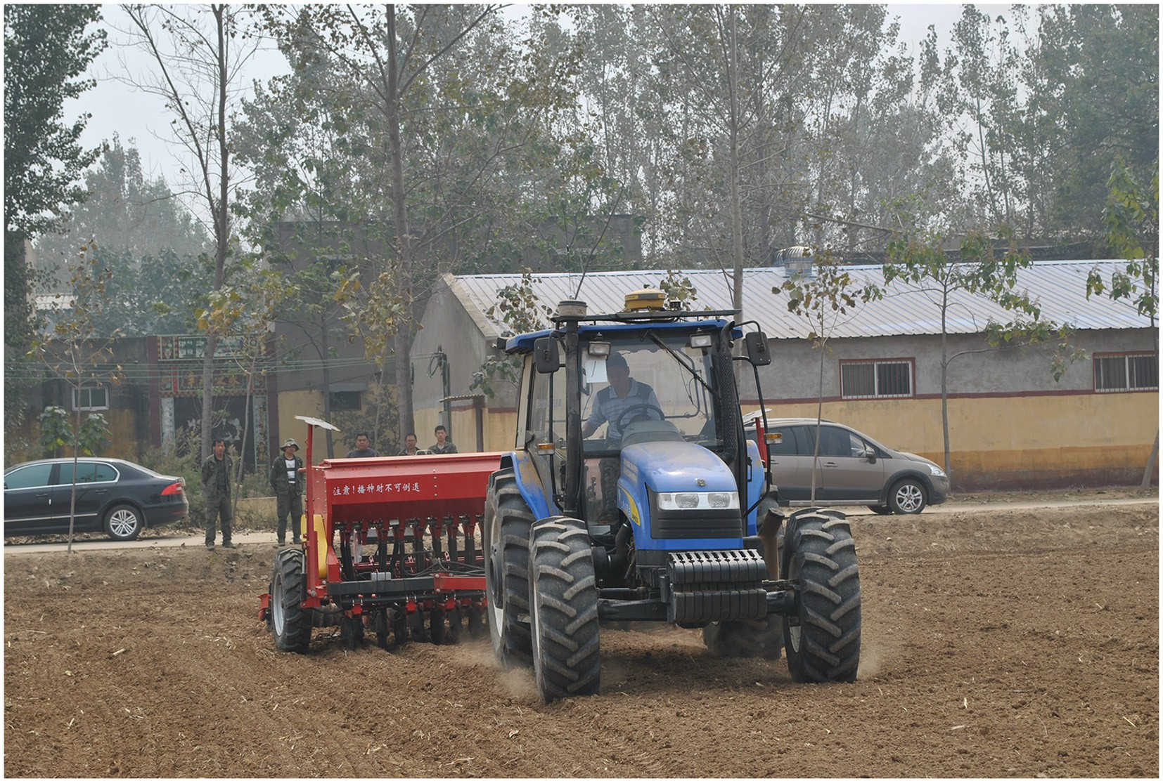

Fig. 3. The accurate seeding machinery.

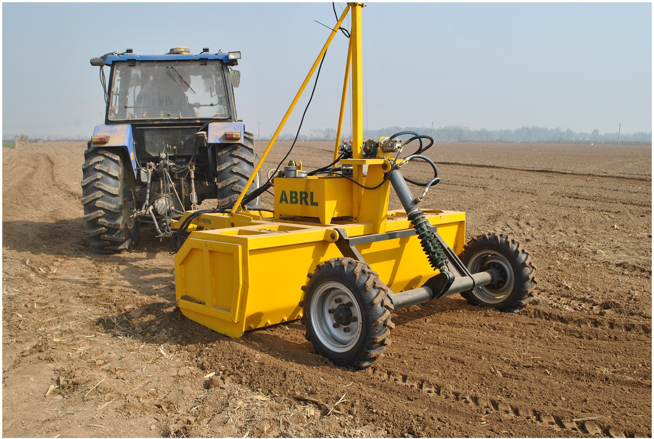

Fig. 4. The laser land leveling machinery.

Henan Food and Oil Group, so management costs refers to wages paid to those management personnel of the Group responsible for land man- agement. The total cost for each treatment was estimated using the fol- lowing equation:

* + 1. *Data collection*

GF-1 satellite images from 2014 to 2017 covering the study area were downloaded from the United States Geological Survey website and Land Observation Satellite Data Service Platform (Table 1).

TCC *C C*

C , *C*

*n* *n* *I*

*I* ∗ *P*

* + 1. *Data processing*

1 With the support of ENVI (The Environment for Visualizing Images),

= 1 +

2 + 3

*i* = ∑ = *i i*=0 *i*

*i* ( )

preprocessing of the GF-1 data included radiance calibration, atmo- spheric correction, RPC orthgraph correction and geometric correction.

Where *TCC* = total cost of cultivation, *C1* = agricultural material cost, *C2* = agro-mechanization service cost, *C3* = managerial pay; *i* = agricultural inputs e.g. seed, fertilizer, pesticide, *Ii* = amount of the *i*th agricultural input, *Pi* = price of the *i*th agricultural input.

Gross returns (GR) were calculated by multiplying grain yield by

minimum support price of wheat (0.4 US$ kg−1) offered by the govern-

For the geometric corrections, high-definition digital images were se- lected as the base map, image to image method was used for correction. The NDVI value for the study area was calculated by the BandMath func- tion of ENVI. The NDVI was calculated from these individual measure- ments as follows:

ρ −ρ

ment of China. Net returns (NR) were calculated as the difference be- tween gross returns and the total cost of cultivation (NR = GR - TCC).

The benefit/cost ratio computed by dividing the GR TCC.

*NDVI* = *NIR R*

ρ*NIR* + ρ*R*

(2)

* 1. *Remote sense data*

NDVI parameters during March to May can provide good estimates of winter wheat condition and yield in the North China Plain (Zhao et al., 2012). Given the aim of PSLL to produce a uniform seeding and growth we consider that PSLL will reduces spatial variability and accel- erates the crops growth than under conventional farming approaches.

This study used a new remote sensing monitoring index-Growth Uni-

Where, NIR is the band 4 of GF-1 image and Red denotes band 3 of GF-1image.

* 1. *Growth uniformity index*

The Growth Uniformity Index (GUI) was calculated as follows. The value of GUI is between 0 and 1, higher values indicate a better and more uniform growth.

formity Index (GUI) (Song Xiaoyu, 2009) developed from NDVI to judge the growth condition levels of the wheat and to assess the carry over effects.

*GUI* = 1− *NDVICV*

*NDVICV* min + *NDVICV* max

(3)

Table 1

The information of GF-1 satellite images of experimental site.

|  |  |  |  |  |  |  |
| --- | --- | --- | --- | --- | --- | --- |
| Satellite | Spatial resolution | Quality Level | Date |  | | |
| GF-1 | 16 M | 1A | 2014.03.14 | 2015.03.13 | 2016.03.11 | 2017.03.16 |

14000

12000

10000

Yield (kg ha-1)

8000

6000

4000

2000

0



PS

PSLL

C

1 2 3 4 5 6 7 8 9 10 11 12 13 14 15 16 17 18

Experimental plot

Fig. 5. Wheat yield at the 18 sampling points in each of the three treatments.

Where, *NDVICV* is the Coefficient of Variance of NDVI; *NDVICV* min is the minimum value of the coefficient of variation of NDVI at the same time phase; *NDVICV* max is the maximum value of the coefficient of variation of NDVI at the same time phase.

* 1. *Data analysis*

The result of grain yield, crude protein and residual nitrogen were shown to obey normal distributions. Data were subjected to analysis of variance (ANOVA) and analyzed using the general linear model pro- cedure of the Statistical Product and Service Solutions (SPSS16.0). Treat- ment mean values were separated by Fischer's protected least significant difference (LSD) test at *P* ≤ 0.05.

1. Results
   1. *Grain yield and crude protein*

A visualization of the experimental plot yields is shown in Fig. 5. Of all the 18 sampling points in each of the three treatments, 33% of PS had a grain yield higher than 8000 kg ha−1 compared to 83% of PSLL and only 22% of C. In terms of average yield, PS increased winter wheat grain yield by 7.8%, but the effect was not remarkably, while PSLL significantly increased by 23.2% (Fig. 6a). Average crude protein content of PS, PSLL and C were 13.6%, 13.6% and 13.7% respectively, the difference was not significant (Fig. 6b).

* 1. *Residual nitrogen*

After the winter wheat harvest, soil residual nitrate nitrogen concen- tration decreased as soil depth increases, under all treatments (Fig. 7a). However, compared with conventional farming, precision agricultural practices tend to have lower soil residual nitrate but this difference was not significant. Compared with C, the soil residual nitrate nitrogen concentration at the depth of 0-60 cm in PS and PSLL was 7.9% and 4.9% lower respectively.

Soil residual ammonium nitrogen concentration at different soil depths was similar in all treatments (Fig. 7b). It was slightly higher in soil at the 20-40 cm depth than other layers. Precision agricultural prac- tices significantly reduced the soil ammonium nitrogen concentration (*P* ≤ 0.05). PSLL was more effective than PS in reducing the soil ammo- nium nitrogen concentration. Soil ammonium nitrogen concentration at the depth of 0-60 cm in PS and PSLL was reduced by 26.3% and 38.2%, respectively, and there were no significant differences under the two treatments.

* 1. *Within field spatial variability*

Table 2 describes the differences between the plot treatments. The coefficient of variation suggests that the within field spatial variability of soil residual nitrate nitrogen and ammonium nitrogen (inorganic ni- trogen) concentration of 0–20 cm layer was much higher than that for protein content or yield. Spatially the inorganic nitrogen concentration

10000

9000

8000

7000

**Yield (kg ha-1)**

6000

5000

4000

3000

2000

1000

0

PS PSLL C

16

14

a

b

b

a

a

a

Crude protein content (%)

12

10

8

6

4

2

0

PS PSLL C

a) b)

Fig. 6. a) Grain yield and b) crude protein content (lowercase letters indicate significant differences).

N03––N concentration(mg kg–1)

9 10 11 12 13 14 1± 16 17 18 19

0

a a a

a a a

a a a

10

20

Depth(cm)

30

40

±0

NH4+–N concentration(mg kg–1)

0 1 2 3 4 ± 6 7 8 9 10

0

b b a

b ab a

b b a

PS PSLL

C

10

20

30

40

±0

60 60

# a) b)

Fig. 7. a) Soil nitrate and b) ammonium nitrogen concentration at the depth of 0–20, 20–40, and 40–60 cm during wheat harvest (a and b in the figure indicate significant differences *P* < 0.05).

has no significant correlation with crop yield and protein content (R2 < 0.3). Spatial variability of winter wheat yield is lower under PS and PSLL, compared with that under C, with the spatial variability of yield being the lowest under PS. PS and PSLL did not reduce the spatial variability of grain protein content and inorganic nitrogen concentration in the surface soil (0–20 cm).

* 1. *Economic benefits*

Estimates of the inputs and their costs are shown in Table 3 and the total costs and benefits of the treatments are shown in Table 4. The total cost of cultivation for C were 1380.3 US$ ha−1 which were lower than those for PS and PSLL. Compared with C, PS and PSLL had additional costs of laser land leveling, seeding monitoring and GPS navigation. For this study, these costs were calculated as service charges, among which the laser land leveling charge was 185.6US$ ha−1, and seeding monitoring and GPS navigation charge was US$23.2 per hectare. The Chinese government currently subsidies laser land leveling. Taking Tianjin for example, the rate of the government subsidy is US$116.0 per hectare (Agricultural Bureau of Tianjin, 2015). Therefore, the fees

of precision agriculture for PS and PSLL were 92.8US$ ha−1 with laser

land leveling subsidies and 208.8US$ ha−1 without laser land leveling subsidies.

As shown in Table 4, the benefit/cost ratio of C is 1.95 (Gross Benifit/ Total Cost of Cultivation). PS increased this by 7.3% to 2.09, while the combined strategy of PSLL increased by 16.7% to 2.27 with laser land

leveling subsidies or 8.1% to 2.11without the subsidies. Compared to C, the net return under PS increased by 15.5% (202.4 US$ ha−1). The in- crease under PSLL was over 40% with subsidies (546.4US$ ha−1) or over 30% (430.4 US$ ha−1) without laser land leveling subsidies.

* 1. *Carry-over effect*

The NDVI results using the GF-1 data are shown in Table 5. The coef- ficient of variation (CV%) value of PSLL is lower than C in 2015 and 2017, are lower than PS in 2015–2017 suggesting a more consistent of the ex- periment results of crop yield, The CV value of PS is lower than C only in 2015. These results are consistent with the GUI value. However, the PS treatment suffered serious pest attack in 2016, with the PSLL treatment also slightly affected, especially on the east side nearest to the PS treat- ment (PSLL is in the west of PS as shown in Fig. 2). Removing the east margin of PSLL affected by pests in 2016 from the analysis, the value of C.V. and GUI of PSLL improved to 4.68% and 0.62 respectively which superior to those for C. Therefore, it can be concluded from the above analysis that applying laser land leveling in year one has positive carry-over effects to at least the third year but that the effect of precision seeding alone is unstable.

Thus, in the case of considering the carry-over effect of laser land leveling, the cost of laser land leveling could shared equally of three years, then the benefit/cost ratio of PSLL will increase by 20.9% to 23.5% and by 21.1% to 22.9% with and without laser land leveling subsidies.

Table 2

Spatial variability of grain yield, protein content and soil inorganic nitrogen concentration at the depth of 0-20 cm under different treatments.

|  |  |  |  |  |  |  |  |
| --- | --- | --- | --- | --- | --- | --- | --- |
| Variables | Treatments | Number of sampling points | Minimum | Mean | Maximum | S.D. | C·V.% |
| Yield (kgha−1) | PS | 18 | 5997.3 | 7805.5 | 10,149.8 | 1173.7 | 15 |
|  | PSLL | 18 | 5969.8 | 8919.6 | 12,015.3 | 1456.2 | 16.3 |
|  | C | 18 | 5196.8 | 7242.8 | 9836.2 | 1293.8 | 17.9 |
| Crude protein content (%) | PS | 18 | 12.8 | 13.6 | 14.6 | 0.6 | 4.8 |
|  | PSLL | 18 | 12.6 | 13.6 | 14.8 | 0.7 | 5 |
|  | C | 18 | 12 | 13.8 | 14.9 | 0.8 | 5.7 |
| Soil inorganic nitrogen concentration | PS | 18 | 10.4 | 18.5 | 33.9 | 5.8 | 31.1 |
| of 0–20 cm layer (mg kg−1) | PSLL | 18 | 12 | 18.7 | 29.9 | 5.9 | 31.8 |
|  | C | 18 | 11.8 | 20.4 | 36.4 | 6.4 | 31.3 |

Inputs and management measures.

|  |  |  |  |  |  |
| --- | --- | --- | --- | --- | --- |
| Management | Input | Unit | PS | PSLL | C |
| Basal dressing (compound fertilizer, N:P:K = 23:16:6) | Amount of fertilizer | Kg ha−1 | 750.0 | 750.0 | 750.0 |
| Land preparation | Service fees for mechanical plowing and returning straw | US$ ha−1 | 185.6 | 185.6 | 185.6 |
|  | Laser land leveling fees (with/without subsidies) | US$ ha−1 | 0.0 | 69.6/185.6 | 0.0 |
| Seeding | Seeds | Kg ha−1 | 195.0 | 195.0 | 225.0 |
|  | Seeder fees | US$ ha−1 | 23.2 | 23.2 | 23.2 |
|  | Seeding monitoring and GPS navigation fees | US$ ha−1 | 23.2 | 23.2 | 0.0 |
| Topdressing (compound fertilizer N:P:K = 23:16:6) | Amount of fertilizers | Kg ha−1 | 225.0 | 225.0 | 225.0 |
|  | Fertilizer distributor fees | US$ ha−1 | 23.2 | 23.2 | 23.2 |
| Irrigation (once during 2014–2015) | Electricity + labor costs | US$ ha−1 | 92.8 | 92.8 | 92.8 |
|  |  | Time−1 |  |  |  |
|  | Pipe costs | US$ ha−1 | 309.3 | 309.3 | 309.3 |
|  |  | Season−1 |  |  |  |
| Spraying | Herbicide (chemicals+ machinery fees) | US$ ha−1 | 16.2 | 16.2 | 16.2 |
|  | Pesticide (chemicals+ machinery fees) | US$ ha−1 | 18.6 | 18.6 | 18.6 |
|  | Prevention of pests, dry hot wind and lodging (chemicals+air spray) | US$ ha−1 | 34.8 | 34.8 | 34.8 |
| Harvesting | Harvester fees | US$ ha−1 | 69.6 | 69.6 | 69.6 |
| Wages of management personnel |  | US$ ha−1 | 13.9 | 13.9 | 13.9 |

Note: Rate of laser land leveling subsidies is 115.8US$ha−1.

1. Discussion
   1. *Grain yield and crude protein*

Our results indicate that precision seeding and integration of preci- sion seeding and laser land leveling technologies could increase grain yield of winter wheat by 7.8% and 23.2%, respectively. These results are in agreement with previous studies that suggest crop yield increases of 5% -40% through the application of precision seeding or laser land leveling technologies, as well as improving the efficiency of water and fer- tilizer usage (Li et al., 1999; Yao, 2004; Li et al., 2005; Jat et al., 2006, 2009; Hashimi et al., 2017). PSLL was more effective than PS in increasing the yield and is attributed to the following aspects. Firstly, laser land leveling improves farmland flatness (Aquino et al., 2015) which makes planting depth even, improves crop germination and its growth environment (Burce et al., 2013; Marlowe et al., 2013), and enhances the effect of pre- cision seeding. Secondly, precision seeding ensures the uniformity of seeding amount and row space (Yazgi and Degirmencioglu, 2007), thus reducing re - seeding rate and lapsus seeding rate, improves germination, optimizes the crop population density, and the better effect of laser land leveling could be achieve. In summary, laser land leveling and precision seeding complement each other are win-win for the crop yield. Crop grain quality depends not only on its genotype, but also on the environ- ment and crop cultivation practices (Souza et al., 2004; Otteson et al., 2008). The results of this study show that PS and PSLL had wheat protein content comparable to that from conventional farming.

* 1. *Residual nitrogen*

Soil nitrate and ammonium nitrogen residues after harvest increase the risk of nitrogen leaching losses (Fang et al., 2006). Previous research has found that PA technologies, by increasing nitrogen utilization effi- ciency, can reduce soil nitrogen residues (Chen, 2003; Diacono et al., 2013). But there are also studies suggesting that PA technologies cannot

reduce soil nitrate nitrogen residues (Ferguson et al., 2002; Link et al., 2006). In this study, PS and PSLL tend to reduce the level of soil nitrate and ammonium nitrogen residues after the winter wheat harvest (Fig. 5). In particular, the two treatments significantly affected the am- monium nitrogen concentration. The main reason is that the two PA treatments significantly increase wheat yields, which absorb more ni- trogen, thereby reducing the nitrogen residues (Hatfield, 2000; Thrikawala et al., 1999). PSLL was less effective than PS in reducing ni- trate nitrogen, mainly because the laser land leveling process compacts the farmland with multiple passes of the machinery, increasing the soil density, slowing down the moisture downward infiltration (Ahmed et al., 2014), and resulting in retention of the nitrate nitrogen that moves easily with water in the surface soil. However, PSLL was more ef- fective than PS in reducing the ammonium nitrogen concentration, mainly because winter wheat grows better under PSLL, more nitrogen is absorbed and unlike nitrate nitrogen, ammonium nitrogen does not move easily with water.

* 1. *Within field spatial variability*

NDVI perceive the temporal and spatial variability of wheat yield (Labus et al., 2002; Zhao et al., 2012; Lopresti and Bella, 2015), the value of the physiological indexes (C·V) of yield (experiments data and NDVI perceive) shows that compared with conventional farming, PS and PSLL could reduce the spatial variability of winter wheat yield in 2015. Precision seeding can improve the uniformity of the seeding (Arzu et al., 2007; Karayel, 2009; Zhao et al., 2014), and laser land level- ing can facilitate more uniform land for seeds, fertilizers, chemicals and other agricultural inputs (Brye et al., 2004; Ashraf et al., 2017). Both technologies contribute to reduce the spatial variability of winter wheat yield. But under laser land leveling, previous sub-surface soil layers may be exposed to the surface, and increase near-surface spatial variability among soil chemical, physical, and biological properties (Brye et al., 2004; Aquino et al., 2015) which may be the reason of

Table 4

Economic benefits of different wheat treatments during 2014–2015.

|  |  |  |  |  |
| --- | --- | --- | --- | --- |
| Economic indicators | PS | PSLL |  | C |
|  |  | With subsidies | Without subsidies |  |
| Conventional agriculture cost (US$ha−1) | 1363.6 | 1363.6 | 1363.6 | 1380.3 |
| Precision agriculture cost (US$ha−1) | 23.2 | 92.8 | 208.8 | 0.0 |
| Total cost of cultivation (US$ha−1) | 1386.8 | 1456.4 | 1572.4 | 1380.3 |
| Gross benefit (US$ha−1) | 2898.0 | 3311.7 | 3311.7 | 2689.1 |
| Net return (US$ha−1) | 1511.2 | 1855.2 | 1739.2 | 1308.8 |
| Benefit/cost ratio | 2.09 | 2.27 | 2.11 | 1.95 |

Note: According to the e-commerce platform Jingdong, compound fertilizer is 0.5US$ kg-1 and seed is 0.6US$ kg-1.

Table 5

NDVI mean and other parameters of winter wheat at reviving stage under different treatments for four years.

|  |  |  |  |  |  |  |  |  |  |  |
| --- | --- | --- | --- | --- | --- | --- | --- | --- | --- | --- |
| Date | Treatments | Number of points | Minimum | Mean | Maximum | S.D. | C.V.% | GUI | C.V.% pest adjusted | GUI pest adjusted |
| 14/03/2014 | C | 432 | 0.71 | 0.75 | 0.79 | 0.03 | 4.11 | 0.50 |  |  |
| 14/03/2014 | C | 432 | 0.61 | 0.75 | 0.78 | 0.03 | 3.49 | – | – | – |
| 13/03/2015 | PS | 144 | 0.56 | 0.58 | 0.60 | 0.01 | 1.29 | 0.65 | – | – |
|  | PSLL | 144 | 0.54 | 0.58 | 0.60 | 0.01 | 1.87 | 0.49 | – | – |
|  | C | 144 | 0.51 | 0.58 | 0.60 | 0.01 | 2.39 | 0.35 | – | – |
| 11/03/2016 | PS | 144 | 0.38 | 0.54 | 0.60 | 0.04 | 7.80 | 0.41 | – | 0.38 |
|  | PSLL | 144 | 0.45 | 0.58 | 0.62 | 0.04 | 6.61 | 0.50 | 4.68 | 0.62 |
|  | C | 144 | 0.39 | 0.57 | 0.61 | 0.03 | 5.41 | 0.59 | – | 0.57 |
| 16/03/2017 | PS | 144 | 0.60 | 0.70 | 0.73 | 0.02 | 2.80 | 0.42 | – | – |
|  | PSLL | 144 | 0.62 | 0.70 | 0.72 | 0.01 | 2.03 | 0.58 | – | – |
|  | C | 144 | 0.62 | 0.70 | 0.72 | 0.02 | 2.43 | 0.50 | – | – |

wheat yield spatial variability under PSLL is higher than under PS. And in 2016 and 2017, the NDVI C.V of PSLL were lower than C, but that of PS were not. Because a one-time application of laser land leveling lasts 3–4 years (Ashraf et al., 2017; Aryal et al., 2015).

* 1. *Economic benefits*

The economic impact of PA technologies on commodity crops with low prices (such an wheat and maize) is generally positive. The net an- nual income, obtained from laser land level fields (two in rice-wheat ro- tation and three in the maize-wheat rotation), was 32% higher, as compared to that from unlevel fields (Ashraf et al., 2017). Experimental results in the rice-wheat rotation field show that the application of laser land leveling technology increases farmers' annual income by $145 ha−1 (Jat et al., 2009). Application of multiple PA technologies can achieve higher earnings than single technology applications (Finck, 1998; Lowenberg-De-Boer, 2000). Walker et al. (2003) and Abdullaev et al. (2007), however, reported that the net income was negative dur- ing the first year mainly because of cost incurred on laser land leveling was recovered in one wheat season only. This study estimates positive benefit/cost ratios and net return of different PA treatments compared to conventional farming.

Actually, it is not imperative to level the fields every year thereby

adding to the cost of production. Ashraf et al. (2017) study shows that there is no need to level the fields at least upto 3 years. Aryal et al. (2015) supposed that a one-time application of laser land leveling lasts at least 4 years. This study use the remote sense image found that the laser land leveling lasts at least 3 years, and than the benefit/ cost ratio of PSLL will increase about 5% percent.

The agricultural policies play a role in farmer's decision (Touza et al., 2008; Barnes et al., 2016), developing policies by the governments that encourage social services such as subsidies for PA technologies can help further promote the popularization and application of PA technologies in China.

1. Conclusions
2. Compared with the local conventional large-scale farming, both precision seeding and integration of precision seeding and laser leveling increased the yield of winter wheat, with the latter being significantly and more effective. They could also reduce spatial variability of yield at the same time. With respect to crop quality, the PA methods had no deleterious impact on the grain protein content of the in-season wheat crops.
3. Precision seeding and integration of precision seeding and laser leveling reduced the soil nitrate and ammonium nitrogen con- centration at 0-60 cm layer after the wheat harvest compared with conventional farming to reduce ammonia volatilization and nitrate nitrogen leaching loss risk.
4. In terms of economic benefits, precision seeding increased the benefit/cost ratio by 7.3%, while integration of precision seeding

and laser leveling increased the benefit/cost ratio by 16.7% with laser land leveling subsidies in place or 8.1% without the subsi- dies. Net return under precision seeding increased by 15.5%

(202.4 US$ ha−1). The increase under precision seeding and laser land leveling was over 30% (430.4 US$ ha−1) without laser land leveling subsidies or over 40% (546.4 US$ ha−1) with subsidies. As a one-time application of laser land leveling lasts for 3 years, after spilt the cost of laser land leveling between 3 years, The benifit increase under PSLL was raised 554.2 US$ ha−1 without subsidies or 592.8 US$ ha−1with subsidies compared to C, both over 40%.

With respect to future research, further studies to evaluate the effec- tiveness and efficiency of different integrated precision agriculture tech- nologies should be undertaken. These should include variable fertilization, variable spraying, variable irrigation and other measures, as well as methods of awareness raising of the higher economic and en- vironmental benefits for dryland farming in the central plains of China.

Declaration of Competing Interest

We declare that we have no financial and personal relationships with other people or organizations that can inappropriately influence our work, there is no professional or other personal interest of any na- ture or kind in any product, service and/or company that could be con- strued as influencing the position presented in the manuscript entitled.

Acknowledgements

This study is funded by the National Key Research and Development Program of China (2017YFE0122500). We greatly appreciate the time, effort, and generosity of Henan Agricultural University and Henan Food & Oil Group who graciously let us use their fields for this study, as well as Ma Xingming, Yang Guijun and An Xiaofei for their continuous sup- port and useful discussion.

References

Abdullaev, I., Hassan, M.U., Jumaboev, K., 2007. [Water saving and economic impacts of](http://refhub.elsevier.com/S2589-7217(21)00034-9/rf0005) [land leveling: the case study of cotton production in Tajikistan. Irrig. Drain. Syst. 21,](http://refhub.elsevier.com/S2589-7217(21)00034-9/rf0005) [251–263](http://refhub.elsevier.com/S2589-7217(21)00034-9/rf0005).

Agricultural Bureau of Tianjin, 2015. Subsoiling and laser land levelling subsidies implementations of Tianjin in 2015. [http://www.tjwq.gov.cn/njj/njgz/201507/](http://www.tjwq.gov.cn/njj/njgz/201507/d541e54d666a4b48ab8a3ad73b19f2d9.shtml) [d541e54d666a4b48ab8a3ad73b19f2d9.shtml](http://www.tjwq.gov.cn/njj/njgz/201507/d541e54d666a4b48ab8a3ad73b19f2d9.shtml) 2015-07-17.(In Chinese).

Ahmed, S., Humphreys, E., Salim, M., et al., 2014. [Optimizing sowing management for](http://refhub.elsevier.com/S2589-7217(21)00034-9/rf0015) [short duration dry seeded aman rice on the High Ganges River Floodplain of](http://refhub.elsevier.com/S2589-7217(21)00034-9/rf0015) [Bangladesh. Field Crop Res. 169, 77–88](http://refhub.elsevier.com/S2589-7217(21)00034-9/rf0015).

Ansari, M., Memon, H., Tunio, S., et al., 2006. [Effect of planting pattern on growth and yield](http://refhub.elsevier.com/S2589-7217(21)00034-9/rf0020) [of wheat. Pakistan J. Agric. Agric. Eng. Vet. Sci. (Pakistan) 22 (2), 6–11](http://refhub.elsevier.com/S2589-7217(21)00034-9/rf0020).

Aquino, L.S., Timm, L.C., Reichardt, K., et al., 2015. [State-space approach to evaluate effects](http://refhub.elsevier.com/S2589-7217(21)00034-9/rf0025) [of land levelling on the spatial relationships of soil properties of a lowland area. Soil](http://refhub.elsevier.com/S2589-7217(21)00034-9/rf0025) [Tillage Res. 145, 135–14](http://refhub.elsevier.com/S2589-7217(21)00034-9/rf0025)7.

Aryal, J.P., Mehrotra, M.B., Jat, M.L., et al., 2015. [Impacts of laser land leveling in rice–](http://refhub.elsevier.com/S2589-7217(21)00034-9/rf0030) [wheat systems of the north–western indo-gangetic plains of India[J]. Food Secur. 7](http://refhub.elsevier.com/S2589-7217(21)00034-9/rf0030) [(3), 725–73](http://refhub.elsevier.com/S2589-7217(21)00034-9/rf0030)8.

Ashraf, M., Ejaz, K., Arshad, M.D., 2017. [Water use efficiency and economic feasibility of](http://refhub.elsevier.com/S2589-7217(21)00034-9/rf0035) [laser land leveling in the fields in the irrigated areas of Pakistan. Science 36 (2),](http://refhub.elsevier.com/S2589-7217(21)00034-9/rf0035) [115–127](http://refhub.elsevier.com/S2589-7217(21)00034-9/rf0035).

Barnes, A., Sutherland, L.A., Toma, L., Matthews, K., Thomson, S., 2016. [The effect of the](http://refhub.elsevier.com/S2589-7217(21)00034-9/rf0045) [common agricultural policy reforms on intentions towards food production: Evi-](http://refhub.elsevier.com/S2589-7217(21)00034-9/rf0045) [dence from livestock farmers. Land Use Policy 50, 548–55](http://refhub.elsevier.com/S2589-7217(21)00034-9/rf0045)8.

Bastiaanssen, W.G.M., Ali, S., 2003. A new crop yield forecusting model based on satellite measurements applied across the Inuds Basin, Pakistan. Agric. Ecosyst. Environ. 94 (3), 321–340. <https://doi.org/10.1016/S0167-8809(02)00034-8>.

Brye, K.R., Slaton, N.A., Mozaffari, M., Savin, M.C., Norman, R.J., Miller, D.M., 2004. [Short-](http://refhub.elsevier.com/S2589-7217(21)00034-9/rf0060) [term effects of land leveling on soil chemical properties and their relationships](http://refhub.elsevier.com/S2589-7217(21)00034-9/rf0060) [with microbial biomass. Soil Sci. Soc. Am. J. 68 (3), 924–93](http://refhub.elsevier.com/S2589-7217(21)00034-9/rf0060)4.

Burce, M.E.C., Kataoka, T., Okamoto, H., 2013. [Seeding depth regulation controlled by in-](http://refhub.elsevier.com/S2589-7217(21)00034-9/rf0065) [dependent furrow openers for zero tillage systems: part 1: appropriate furrow](http://refhub.elsevier.com/S2589-7217(21)00034-9/rf0065) [opener. Eng. Agric. Environ. Food 6 (1), 1–](http://refhub.elsevier.com/S2589-7217(21)00034-9/rf0065)6.

Cassman, K.G., 1999. [Ecological intensification of cereal production systems: yield poten-](http://refhub.elsevier.com/S2589-7217(21)00034-9/rf0070) [tial, soil quality, and precision agriculture. Proc. Natl. Acad. Sci. 96 (11), 5952–5959](http://refhub.elsevier.com/S2589-7217(21)00034-9/rf0070). Chen, L.P., 2003. [Theoretical and Experimental Studies on Variable-Rate Fertilization in](http://refhub.elsevier.com/S2589-7217(21)00034-9/rf0075)

[Precision Farming. China Agricultural University, Beijing (In Chinese)](http://refhub.elsevier.com/S2589-7217(21)00034-9/rf0075).

Choudhary, M., Gill, M.A., Kahlown, M.A., et al., 2000. [Evaluation of resource conservation](http://refhub.elsevier.com/S2589-7217(21)00034-9/rf0080) [technologies in rice-wheat system of Pakistan. Proceedings of the International](http://refhub.elsevier.com/S2589-7217(21)00034-9/rf0080) [Workshop on Developing an Action Program for Farm Level Impact in Rice-Wheat](http://refhub.elsevier.com/S2589-7217(21)00034-9/rf0080) [System of Indo-Gangetic Plains, pp. 25–27](http://refhub.elsevier.com/S2589-7217(21)00034-9/rf0080).

Diacono, M., Rubino, P., Montemurro, F., 2013. [Precision nitrogen management of wheat.](http://refhub.elsevier.com/S2589-7217(21)00034-9/rf0095)

[A review. Agron. Sustain. Dev. 33 (1), 219–24](http://refhub.elsevier.com/S2589-7217(21)00034-9/rf0095)1.

Fang, Q., Yu, Q., Wang, E., et al., 2006. [Soil nitrate accumulation, leaching and crop nitro-](http://refhub.elsevier.com/S2589-7217(21)00034-9/rf0100) [gen use as influenced by fertilization and irrigation in an intensive wheat–maize dou-](http://refhub.elsevier.com/S2589-7217(21)00034-9/rf0100) [ble cropping system in the North China Plain. Plant Soil 284 (1–2), 335–350](http://refhub.elsevier.com/S2589-7217(21)00034-9/rf0100).

Ferguson, R., Hergert, G., Schepers, J., et al., 2002. [Site-specific nitrogen management of](http://refhub.elsevier.com/S2589-7217(21)00034-9/rf0105) [irrigated maize. Soil Sci. Soc. Am. J. 66 (2), 544–55](http://refhub.elsevier.com/S2589-7217(21)00034-9/rf0105)3.

Finck, C., 1998. [Precision can pay its way. Farm J. 122 (2), 10–13](http://refhub.elsevier.com/S2589-7217(21)00034-9/rf0110).

Gebbers, R., Adamchuk, V.I., 2010. [Precision agriculture and food security. Science 327](http://refhub.elsevier.com/S2589-7217(21)00034-9/rf0120) [(5967), 828–83](http://refhub.elsevier.com/S2589-7217(21)00034-9/rf0120)1.

Giannini, G., Chancellor, W., Garrett, R., 1967. [Precision planter using vacuum for seed](http://refhub.elsevier.com/S2589-7217(21)00034-9/rf0125) [pickup. Trans. ASAE 10 (5), 607–0610](http://refhub.elsevier.com/S2589-7217(21)00034-9/rf0125).

Hashimi, S., Ganji, H., Kondo, M., Ito, R., Kajisa, T., 2017. [Laser land leveling for crop yield](http://refhub.elsevier.com/S2589-7217(21)00034-9/rf0135) [and water efficiency in esatern Afghanistan. Int. J. 13 (36), 116–121](http://refhub.elsevier.com/S2589-7217(21)00034-9/rf0135).

Hatfield, J.L., 2000. [Precision Agriculture and Environmental Quality: Challenges for](http://refhub.elsevier.com/S2589-7217(21)00034-9/rf0140) [Research and Education. USDA National Resources Conservation Servic](http://refhub.elsevier.com/S2589-7217(21)00034-9/rf0140)e.

Helrich, K., 1990. [Official Methods of Analysis of the Association of Official Analytical](http://refhub.elsevier.com/S2589-7217(21)00034-9/rf0145) [Chemists. 15th edn. Association of Official Analytical Chemists Inc., Arlington, p. 807](http://refhub.elsevier.com/S2589-7217(21)00034-9/rf0145).

Jat, M., Chandna, P., Gupta, R., et al., 2006. [Laser land leveling: a precursor technology for](http://refhub.elsevier.com/S2589-7217(21)00034-9/rf0150) [resource conservation. Rice-Wheat Consort. Tech. Bull. Ser. 7, 48](http://refhub.elsevier.com/S2589-7217(21)00034-9/rf0150).

Jat, M., Gathala, M., Ladha, J., et al., 2009. [Evaluation of precision land leveling and double](http://refhub.elsevier.com/S2589-7217(21)00034-9/rf0155) [zero-till systems in the rice–wheat rotation: Water use, productivity, profitability and](http://refhub.elsevier.com/S2589-7217(21)00034-9/rf0155) [soil physical properties. Soil Tillage Res. 105 (1), 112–12](http://refhub.elsevier.com/S2589-7217(21)00034-9/rf0155)1.

Karayel, D., 2009. [Performance of a modified precision vacuum seeder for no-till sowing](http://refhub.elsevier.com/S2589-7217(21)00034-9/rf0160) [of maize and soybean. Soil Tillage Res. 104 (1), 121–12](http://refhub.elsevier.com/S2589-7217(21)00034-9/rf0160)5.

Kuehne, G., Llewellyn, R., Pannell, D., Wilkonson, R., Dolling, P., Ouzman, J., Ewing, M., 2017. [Predicting farmer uptake of new agricultural practices: A tool for research,](http://refhub.elsevier.com/S2589-7217(21)00034-9/rf0165) [extension and policy. Agric. Syst. 156, 115–12](http://refhub.elsevier.com/S2589-7217(21)00034-9/rf0165)5.

Labus, M.P., Nielsen, G.A., Lawrence, R.L., et al., 2002. [Wheat yield estimates using multi-](http://refhub.elsevier.com/S2589-7217(21)00034-9/rf0170) [temporal NDVI satellite imagery[J]. Int. J. Remote Sens. 23 (20), 4169–4180](http://refhub.elsevier.com/S2589-7217(21)00034-9/rf0170).

Li, M.Z., 2008. [Characters, current situation and development of precision agriculture.](http://refhub.elsevier.com/S2589-7217(21)00034-9/rf0175)

[Agric. Mach. Market 03, 38–41 (In Chinese)](http://refhub.elsevier.com/S2589-7217(21)00034-9/rf0175).

Li, Y.N., Xu, D., Li, F.X., et al., 1999. [Application and evaluation of laser-controlled land](http://refhub.elsevier.com/S2589-7217(21)00034-9/rf0180) [leveling technology. Trans. CSAE 15 (2), 79–81 (In Chinese](http://refhub.elsevier.com/S2589-7217(21)00034-9/rf0180)).

Li, Q.W., Yang, J.P., Hu, H., et al., 2005. [Application effect of precision seeding of cotton.](http://refhub.elsevier.com/S2589-7217(21)00034-9/rf0185)

[China Cotton 04, 30 (In Chinese)](http://refhub.elsevier.com/S2589-7217(21)00034-9/rf0185).

Li, Q., Zhou, X., Chen, Y., et al., 2010. [Grain yield and quality of winter wheat in different](http://refhub.elsevier.com/S2589-7217(21)00034-9/rf0190) [planting patterns under deficit irrigation regimes. Plant Soil Environ. 56 (10),](http://refhub.elsevier.com/S2589-7217(21)00034-9/rf0190) [482–487](http://refhub.elsevier.com/S2589-7217(21)00034-9/rf0190).

Link, J., Graeff, S., Batchelor, W.D., et al., 2006. [Evaluating the economic and environmental](http://refhub.elsevier.com/S2589-7217(21)00034-9/rf0195) [impact of environmental compensation payment policy under uniform and variable-](http://refhub.elsevier.com/S2589-7217(21)00034-9/rf0195) [rate nitrogen management. Agric. Syst. 91 (1), 135–15](http://refhub.elsevier.com/S2589-7217(21)00034-9/rf0195)3.

Lopresti, M.F., Bella, C.M., 2015. Relationship between MODIS-NDVI data and wheat yield : A case study in Northern Buenos Aires province. Argentina. 2, 73–84. [https://doi.org/](https://doi.org/10.1016/j.inpa.2015.06.001) [10.1016/j.inpa.2015.06.001](https://doi.org/10.1016/j.inpa.2015.06.001).

Lowenberg-De-Boer, J., 2000. [Economic Analysis of Precision Farming. Federal University](http://refhub.elsevier.com/S2589-7217(21)00034-9/rf0205) [of Vicosa, Vicosa, Brazil](http://refhub.elsevier.com/S2589-7217(21)00034-9/rf0205).

Marlowe, E.C.B., Takashi, K., Hiroshi, O., Yoichi, S., 2013. [Seeding Depth Regulation Con-](http://refhub.elsevier.com/S2589-7217(21)00034-9/rf1001) [trolled by Independent Furrow Openers for Zero Tillage Systems. EAEF 6 (1), 13–19](http://refhub.elsevier.com/S2589-7217(21)00034-9/rf1001). Otteson, B.N., Mergoum, M., Ransom, J.K., 2008. [Seeding rate and nitrogen management](http://refhub.elsevier.com/S2589-7217(21)00034-9/rf0210) [on milling and baking quality of hard red spring wheat genotypes. Crop Sci. 48 (2),](http://refhub.elsevier.com/S2589-7217(21)00034-9/rf0210)

[749–755](http://refhub.elsevier.com/S2589-7217(21)00034-9/rf0210).

Raoufat, M., Matbooei, A., 2007. [Row cleaners enhance reduced tillage planting of corn in](http://refhub.elsevier.com/S2589-7217(21)00034-9/rf0215) [Iran. Soil Tillage Res. 93 (1), 152–16](http://refhub.elsevier.com/S2589-7217(21)00034-9/rf0215)1.

Rickman, J.F., Bunna, S., Sinath, P., 1998. [Agricultural engineering. Program Report for](http://refhub.elsevier.com/S2589-7217(21)00034-9/rf0225) [1998. International Rice Research Insititute, Manila, Philippines, p. 142](http://refhub.elsevier.com/S2589-7217(21)00034-9/rf0225).

Schieffer, J., Dillon, C., 2015. [The economic and environmental impacts of precision agri-](http://refhub.elsevier.com/S2589-7217(21)00034-9/rf0230) [culture and interactions with agro-environmental policy. Precis. Agric. 16 (1), 46–61](http://refhub.elsevier.com/S2589-7217(21)00034-9/rf0230). Souza, E., Martin, J., Guttieri, M., et al., 2004. [Influence of genotype, environment, and ni-](http://refhub.elsevier.com/S2589-7217(21)00034-9/rf0245)

[trogen management on spring wheat quality. Crop Sci. 44 (2), 425–43](http://refhub.elsevier.com/S2589-7217(21)00034-9/rf0245)2.

Sui, H.J., Han, G.X., Chen, M.W., 2005. [The usage of “Xiao Bai Long” irrigation method.](http://refhub.elsevier.com/S2589-7217(21)00034-9/rf0250)

[Water Conserv. Sci. Technol. 11 (4), 237–241 (In Chinese)](http://refhub.elsevier.com/S2589-7217(21)00034-9/rf0250).

Thrikawala, S., Weersink, A., Fox, G., et al., 1999. [Economic feasibility of variable-rate tech-](http://refhub.elsevier.com/S2589-7217(21)00034-9/rf0255) [nology for nitrogen on corn. Am. J. Agric. Econ. 81 (4), 914–92](http://refhub.elsevier.com/S2589-7217(21)00034-9/rf0255)7.

Touza, J., Dehnen-Schmutz, K., Jones, G., 2008. [Economic analysis of invasive species pol-](http://refhub.elsevier.com/S2589-7217(21)00034-9/rf0260) [icies. Biological invasions. Springer, Berlin, Heidelberg, pp. 353–36](http://refhub.elsevier.com/S2589-7217(21)00034-9/rf0260)6.

Walker, T.W., Kingery, W.L., Street, J.E., et al., 2003. [Rice yield and soil chemical properties](http://refhub.elsevier.com/S2589-7217(21)00034-9/rf0270) [as affected by precision land leveling in alluvial soils. Agron. J. 95 (6), 1483–1488.](http://refhub.elsevier.com/S2589-7217(21)00034-9/rf0270)

Xiaoyu, Song, 2009. [Winter Wheat Growth Variance Monitoring through Remote Sensing](http://refhub.elsevier.com/S2589-7217(21)00034-9/rf0275) [Image. Doctor ThesisBeijing Normal University, Beijingi, China (In Chinese)](http://refhub.elsevier.com/S2589-7217(21)00034-9/rf0275).

Xu, D., Li, Y.N., Liu, G., 2007. [Research progress on the application system of laser-](http://refhub.elsevier.com/S2589-7217(21)00034-9/rf0280) [controlled precision land leveling technology. Trans. CSAE 23 (3), 267–272](http://refhub.elsevier.com/S2589-7217(21)00034-9/rf0280) [(In Chinese)](http://refhub.elsevier.com/S2589-7217(21)00034-9/rf0280).

Yao, J., 2004. [Preliminary discussion the extension and developing prospect of corn preci-](http://refhub.elsevier.com/S2589-7217(21)00034-9/rf0285) [sion metering technology. J. Maize Sci. 12, 89–91 (in Chinese)](http://refhub.elsevier.com/S2589-7217(21)00034-9/rf0285).

Yazgi, A., Degirmencioglu, A., 2007. [Optimisation of the seed spacing uniformity perfor-](http://refhub.elsevier.com/S2589-7217(21)00034-9/rf0290) [mance of a vacuum-type precision seeder using response surface methodology.](http://refhub.elsevier.com/S2589-7217(21)00034-9/rf0290) [Biosyst. Eng. 97 (3), 347–35](http://refhub.elsevier.com/S2589-7217(21)00034-9/rf0290)6.

Zhao, G.Z., Zhang, H.L., Zhang, J., Liu, Z.J., 2010. [Experiment on the Maize precision sowing.](http://refhub.elsevier.com/S2589-7217(21)00034-9/rf0300)

[Agric. Sci. Technol. Equip. 198 (12), 81–82 (In Chinese)](http://refhub.elsevier.com/S2589-7217(21)00034-9/rf0300).

Zhao, W.L., He, Z., He, J.P., et al., 2012. [Remote sensing estimation for winter wheat yield in](http://refhub.elsevier.com/S2589-7217(21)00034-9/rf0305) [Henan based on the MODIS-NDVI data. Geogr. Res. 31 (12), 2310–2320.](http://refhub.elsevier.com/S2589-7217(21)00034-9/rf0305)

Zhao, J.B., Xia, J.F., Zhou, Y., et al., 2014. [Design and experimental study of the control sys-](http://refhub.elsevier.com/S2589-7217(21)00034-9/rf0310) [tem for precision seed-metering device. Int. J. Agric. Biol. Eng. 7 (3), 13](http://refhub.elsevier.com/S2589-7217(21)00034-9/rf0310).