Available online at [www.sciencedirect.com](http://www.sciencedirect.com/)



AASRI Procedia 1 (2012) 150 – 155

AASRI

Procedia

[www.elsevier.com/locate/procedia](http://www.elsevier.com/locate/procedia)

2012 AASRI Conference on Computational Intelligence and Bioinformatics

# Effect of Spark Condition on Non-Linear Dynamic Characteristics of Natural Gas Engine

Wang Li-yuana, Yang Li-pingb, Jing Hai-guob, Qaisar Hayatb, Liu Guo-dongb

*a College of Sciences, Harbin Engineering University, Harbin,150001, China*

*b College of Power and Energy Engineering, Harbin Engineering University, Harbin, 150001,China*

**Abstract**

In the condition of equivalence ratio α=1 and different spark advance angle (SAA), non-linear dynamic characteristics of combustion process in spark ignition (SI) natural gas engine was studied. The results show that the attractors always have a non-periodic structure within a limited region .When SAA increases indicated mean effective pressure (IMEP) and the scale of attractors increase whereas the coefficients of cyclic variation and the correlation dimension of system decrease. It is observed that the correlation dimension of system is fractal and the largest Lyapunov exponent (LLE) of the system is always greater than zero. Therefore in condition of α = 1, combustion system is of obvious non-linear deterministic nature and the complexity of the system is reduced with the increase of SAA.

© 2012 Published by Elsevier B.V. Open access under [CC BY-NC-ND license.](http://creativecommons.org/licenses/by-nc-nd/3.0/)

Selection and/or peer review under responsibility of American Applied Science Research Institute

*Keywords*: Natural gas engine; combustion; spark condition; chaos

## Introduction

Issues relating to environmental pollution and fuel reservoirs are becoming more and more important. Compressed natural gas (CNG) is a good alternative fuel because of its plentiful resources and clean burning characteristics. Advantages including knock tolerance, less CO2 emission, greater ability to homogenate and reduction of the Non-Methane hydrocarbon emissions have attracted a huge public interest in CNG engines.

* Corresponding author. Tel.:+86 13674608894; fax: 0451-82568316.

*E-mail address:* [yangliping302@tom.com](mailto:yangliping302@tom.com)

2212-6716 © 2012 Published by Elsevier Ltd. Open access under [CC BY-NC-ND license.](http://creativecommons.org/licenses/by-nc-nd/3.0/)

doi:10.1016/j.aasri.2012.06.024

Cyclic combustion variability is also one of the main characteristics of the SI natural gas engines [1]. There will be a 10% increase in the power output of the engine if the cyclic combustion variability is eliminated [2]. The problem of reducing cyclic variability has not been solved up to now. Generation mechanism, source identification and elimination of cyclic combustion variability have therefore become important issues in SI engine technology engineering. J.B. Heywood [3] identified three main factors influencing cyclic combustion variability which include aerodynamics in the cylinder during combustion, a mixture composition near the spark plug and the amount of fuel, air and recycled exhaust gases supplied to the cylinder.

Many people have discussed the dynamic evolution of combustion process in SI engines. C.S.Daw et al proposed a simple nonlinear model to study the dynamical evolution of combustion process in SI engines and they considered that the system can be driven to a chaotic behavior [4]. The research carried out by R.M.Wagner et al showed that there was a nonlinear deterministic structure in the combustion process of SI engine under lean burn condition. Moreover, the cyclic combustion variability of a single-cylinder engine changed from random process to a noisy nonlinear determinism with the decrease of equivalence ratio from stoichiometric to very lean conditions [4]. T.kamin'ski et al evaluated the level of nonlinear dynamics in SI engine[6]. P.L.Curto-Risso et al characterized the fluctuation when the mixture changed from lean mixture to an equivalence ratio mixture using monofractal and multifractal methods[7]. A. K. Sen et al studied the complex dynamics of cycle heat release in SI engine using multifractal and statistical analysis methods[8]. G..Litak et al analyzed the combustion fluctuation of a four-cylinder SI engine using dimensional time series analysis to heat release and constructed recurrence plots for different advance angles of spark ignition [9]. M.Wendeker researched the nonperiodic fluctuation of the SI engine and the results showed that the reconstructed attractor had a characteristic butterfly shape similar to a chaotic attractor of Lorentz type. The recurrence plot showed that the dynamics of the combustion was a nonlinear multidimensional process mediated by stochastic noise [10].We also research the dynamics of combustion system in SI engines in this paper, however we have adopted directly in-cylinder pressure time serial as a research object and performed a quantitative analysis using non-linear chaos theory. Our goal is to understand complex dynamic characteristics of the SI natural gas engine.

## Experimental apparatus and methods

The experiments were conducted on an inline four cylinder natural gas engine with multipoint injection system, turbocharger and intercooler. The engine has a 3.7L displacement, 101.6mm bore, 114.3mm stroke, compression ratio of 11. CNG pressure reduces from 20MPa to 0.25MPa after three decompression stages. Two stage filtration of CNG is carried out to remove tiny impurities in the gas in order to prevent the attrition to engine. First filter is installed in the front of the pressure reducer and achieves preliminary filtration of the gas whereas second filter is installed in the front of the gas rail. Eddy current dynamometer is used to control the engine load. In order to study nonlinear characteristics of engine combustion system other feedback controls were canceled except engine speed. High speed data acquisition system consisting of the piezoelectric sensor, combustion analysis, charge amplifier and computer was used to measure the pressure during combustion inside the combustion chamber. During this measurement engine speed of 1200 r/min and fuel equivalence ratio of 1 were kept constant while angle of throttle valve and advanced ignition angle were modified. The combustion pressure data of 500 cycles were obtained at each operating condition. Experimental apparatus used is listed in Table 1 and the schematic figure is shown in Fig. 1.

Table1 Experimental apparatus

|  |  |  |
| --- | --- | --- |
| Name | Type | Manufacturer |
| Dynamometer | CW-260 | Nan-feng |
| CNG flowmeter | CMF010 | Rosemount |
| Pressure sensor | GU21C | AVL |
| Charge amplifier | 5011B10 | Kistler |
| Combustion analyzer | DS9100 | ONO SOKKI |

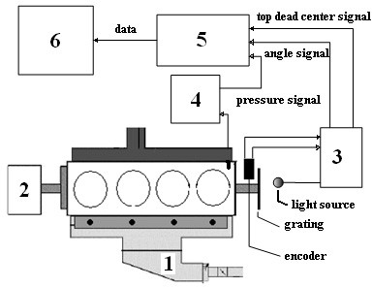

1-engine;2-dynamometer;3-power and signal transducer; 4-charge amplifier;5-combustion analyzer; 6-computer Fig.1 Scheme of the experimental setup

## Chaos analysis of combustion process

* 1. *In-cylinder pressure time series*

Larger ignition timing is required in CNG engines as compared to gasoline engines because of its higher ignition temperatures and slow flame propagation speed. Cylinder pressure was recorded and analyzed at different spark timings (SAA = 30ºCA, 35º CA, 40 ºCA and 45ºCA before top dead center) keeping engine speed, air/fuel ratio and throttle setting constant. Measured pressure data against crank angle is shown in Fig.

2. Graphs show that the cyclic variation decreases and the peak pressure and IMEP increase with the increase of SAA. IMEP increases from 0.798 to 0.854MPa and the coefficient of cyclic variation reduces from 4.4% to 1.2% when SAA increases from 30˚CA to 45 ºCA as shown in Fig.3.

6 6 6 6

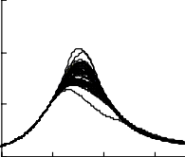

SAA=30ºCA

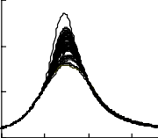

SAA=35ºCA

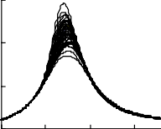

SAA=40ºCA

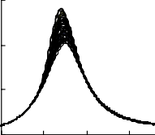

SAA=45ºCA

pressure[MPa]

4

pressure[MPa]

4

4 4

2

2

2 2

0

pressure[MPa]

-60 -10 40 90

crank angle[ºCA]

0

-60 -10 40 90

crank angle[ºCA]

0

-60 -10 40 90

crank angle[ºCA]

0

pressure[MPa]

-60 -10 40 90

crank angle[ºCA]

Fig.2 Time series of in-cylinder pressure

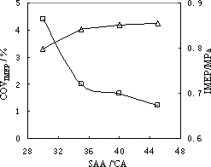

Fig.3 Plot of COVIMEP and IMEP versus spark ignition angle

* 1. *Phase space reconstruction*

Dynamic characteristics of natural gas engine combustion system can not be mathematically represented and it can only be extracted from the pressure time series. Pressure time series contain all traces of the variables therefore we have used the method of phase space reconstruction to illustrate combustion dynamics of CNG engine. On the basis of Takens’ embedding theorem the phase space is constructed from the pressure time series [12]. The time-delayed coordinates used for the construction of the phase space are expressed as

*x*(*i*), *i*  1,2...,*N* '

Make a set of m dimensions vector:

(1)

*X* i  *x*(*i* ** ), *x*(*i*  2** ),...,*x*(*i*  (*m* 1)** ),

*i*  1,2,...,*N*'(*m* 1)**

(2)

Where *N*’ is sampling number, m is embedding dimension and τ is delay time. If delay time is too small the elements of the phase space vectors are strongly correlated. However if delay time is too large the correlation is lost completely. We applied autocorrelation function to determine the suitable delay time. Phase space reconstruction plots obtained from the pressure time series for different SAA are shown in Fig.4. At 30˚CA ignition timing the scale of attractor is smaller and its trajectory is looser. The dynamic behaviour of pressure fluctuations does not exhibit a deterministic nature. With the increase of SAA the scale of attractor increases gradually, the periodicity of the dominant periodic fluctuations becomes prominent, the IMEP increases and the cyclic combustion variability becomes smaller. It only lasts a few milliseconds for a single cycle and combustion will finish in a large combustion chamber volume if the combustion starts too late, thus it leads to partly combustion and chaotic behaviour is observed [5].

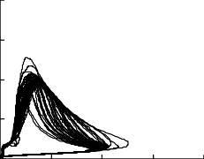8

6

x(i+67)

4

2

0

0 2 4 6 8

x(i)

8

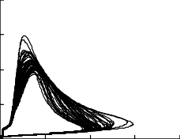6

x(i+64)

4

2

0

0 2 4 6 8

x(i)

8

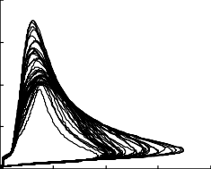6

x(i+60)

4

2

0

0 2 4 6 8

x(i)

8

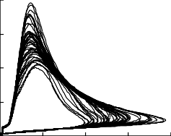6

x(i+56)

4

2

0

0 2 4 6 8

x(i)

Fig.4 The state space reconstruction of the in-cylinder pressure time series

* 1. *Correlation dimension (CD)*

Fig. 5 presents the typical plots of lnC(r) versus lnr calculated for various embedding dimension at different SAA. The scaling region is set in the middle third of the horizontal range of the plot of lnC(r) versus lnr. The scaling region covers the linear portion of curves in Fig. 5. Slope of the scaling region of each curve

was calculated and the results were plotted against the embedding dimension [13]. The saturation value of these slopes was designated as CD for the combustion system. It is clear from Fig. 6 that the CD gradually declines with the increase of SAA. CD of the attractor decreases from 1.76 to 1.59 with the 30˚CA to 45ºCA increases of SAA. This means that the complexity of the attractor declines with the increase of SAA. The continuous cycle of four-stroke engine is isolated by exhaust and intake stroke. If speed is constant, each cycle will cover the same time, so continuous cycle seems to be a deterministic periodic process. However the perturbation brought by air inflow and nonlinear noise effect the dynamics and quantity of air and fuel mixture. This disturbance is amplified during combustion process and results in a chaotic characteristic. Delay in SAA causes pressure drop in expansion stroke and the heat condition becomes worse due to increase of afterburning period. As a result the flame becomes unstable, the engine power output declines and the cyclic combustion variability increases. Consequently the trajectory of attractor deviates and requires more variables to describe the state of the dynamics.

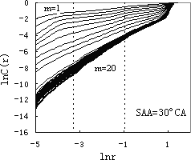 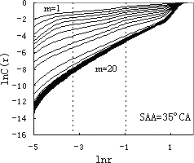 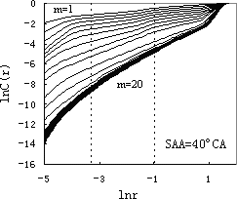 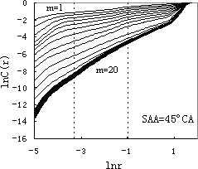

Fig.5 Plots of lnC(r) versus lnr

1.2E-02

1.0E-02

Lyapnov exponent

8.0E-03

6.0E-03

4.0E-03

2.0E-03

0.0E+00



0.01

0.007

0.0045

0.003

30 35 40 45

SAA/ºCA

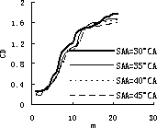Fig.6 Plots of correlation dimension versus embedding dimension Fig7 LLE at the conditions of different SAA

* 1. *Largest lyapunov exponent (LLE)*

Evolution of phase space trajectories can be analyzed by calculating either the spectrum of Lyapunov exponents or the largest Lyapunov exponent. Generally Lyapunov exponents quantify the average exponential rate of divergence of neighboring trajectories in a state space and thus provide a measure of the sensitivity of a combustion system to initial conditions. In general phase trajectories draw together and the dynamical system has an attractor in the form of a fixed point when LLE < 0. Whereas the system tends to get the stable limit cycle when LLE = 0. Moreover at LLE> 0 the phase trajectories move away and such a system may be chaotic or random [14, 15]. Fig. 7 illustrates the LLE for different SAA. Figure shows that LLE is always positive and decreases from 0.1 to 0.04 with the 30ºCA to 45ºCA increase of SAA. This means that sensitivity of a combustion system to initial conditions decreases and combustion process of natural gas engine has an obvious chaotic characteristics.

## 4. Conclusion

In this paper phase space reconstruction and quantitative analysis of combustion process are conducted

under different spark conditions based on chaos theory and nonlinear dynamic data analysis technology. Method of time delay coordinates is applied to phase space reconstruction. Moreover the correlation dimension and the largest Lyapunov exponent are calculated from the pressure time series and are used to quantitatively analyze the chaotic characteristics of the combustion system in natural gas engine. The results show that the peak pressure increases and the coefficient of cyclic variation declines with the increase of SAA. IMEP increases from 0.798 to 0.854MPa and the coefficient of cyclic variation reduces from 4.4% to 1.2% with 30ºCA to 45ºCA increase of SAA. The dimension of combustion system is always fractal and it changes from 1.76 to 1.59, and the largest Lyapunov exponent is positive. This means that the combustion system is of obvious non-linear deterministic nature and the complexity of the system is reduced with the increase of SAA.

## Acknowledgements

This work is supported by China Postdoctoral Science Foundation (20100471021) and Fundamental Research Funds for the Central Universities (GK2030260115, GK2030260110).

## References

1. S. Pischinger and M. Umierski B. Hüchtebrock .New CNG Concepts for Passenger Cars: High Torque Engines with Superior Fuel Consumption. SAE paper 2003-01-2264.
2. Hu.Z.Nonlinear instabilities of combustion processes and cycle-to-cycle variations in spark-ignition engines. SAE Paper 961197.
3. J.B. Heywood, Internal Combustion Engine Fundamentals (McGraw–Hill, New York, 1988)
4. C. S. Daw, C.E.A.Finney,J.B.Green,et al. A simple model for cyclic variations in a spark-ignition engine .SAE Paper 962086.
5. R.M.Wagner, C.S.Daw, B.Johney,et al .Low-Order Map Approximations of Lean Cyclic Dispersion in Premixed Spark Ignition Engine.SAE Paper 2001-01-3559
6. T.Kamiski, M.Wender, K.Urbanowicz . ,et al . Combustion process in a spark ignition engine: Dynamics and noise level estimation .Chaos, 2004, 14(2): 461-466.
7. P.L. Curto-Risso, A. Medina, A. Calvo Hernández, L. Guzmán-Varga.On cycle-to-cycle heat release variations in a simulated spark ignition heat engine . Applied Energy, 2011, 88:1557–1567.
8. A.K.Sen, G.Litak, T. Kaminski, and M. Wendeker. Multifractal and statistical analyses of heat release fluctuations in a spark ignition engine. Chaos ,2008,18: 033115
9. G.Litak,T. Kamin´ski, R.Rusinek, J.Czarnigowski, M. Wendeker. Patterns in the combustion process in a spark ignition engine. Chaos, Solitons and Fractals,2008, 35:578–585.

[10] M. Wendeker , G. Litak , J.Czarnigowski, K. Szabelski. Nonperiodic Oscillations of Pressure in a Spark Ignition Combustion Engine. International Journal of Bifurcation and Chaos, 2004,14(5) :1801-1806.

[11] M.T.Rosenstein, Collins J J and Luca C J A practical method for calculating largest Lyapunov exponents from small data sets.Physica D, 1993, 65 :117–34.

1. Takens F .Detecting strange attractors in turbulence Dynamical Systems and Turbulence[M].Lecture Notes in Mathematics, 1981, 366–81.
2. Henry B, Lovell N and Camacho F 2000 Nonlinear dynamics time series analysis Nonlinear Biomedical Signal Processing: Volume II, Dynamic Analysis and Modeling ed M Akay (New York: IEEE) pp 1–39.

[14] M. T. Rosenstein, C. J. J. and C. J. DeLuca . A practical method for calculating largest Lyapunov exponents from small data sets, Physica D 65,117-134.

[15] D. Ruelle, Ehere can one hope to profitably apply the ideas of chaos?, Physics Today 47, 24-32.