[Array 20 (2023) 100324](https://doi.org/10.1016/j.array.2023.100324)



Contents lists available at [ScienceDirect](https://www.elsevier.com/locate/array)

Array

journal homepage: [www.elsevier.com/locate/array](http://www.elsevier.com/locate/array)

Efficient perturbation techniques for preserving privacy of multivariate sensitive data

Mahbubur Rahman ∗, Mahit Kumar Paul, A.H.M. Sarowar Sattar

*Department of Computer Science & Engineering, Rajshahi University of Engineering & Technology, Rajshahi-6204, Bangladesh*

A R T I C L E I N F O A B S T R A C T

*Keywords:*

Data privacy Information privacy Perturbation

Data utility Sensitive data

Cloud data is increasing significantly recently because of the advancement of technology which can contain individuals’ sensitive information, such as medical diagnostics reports. While deriving knowledge from such sensitive data, different third party can get their hands on this sensitive information. Therefore, privacy preservation of such sensitive data has become a vital issue. Data perturbation is one of the most often used data mining approaches for safeguarding privacy. A significant challenge in data perturbation is balancing the privacy and utility of data. Securing an individual’s privacy often entails the forfeiture of the data utility, and the contrary is true. Though there exist several approaches to deal with the trade-off between privacy and utility, researchers are always looking for new approaches. In order to address this critical issue, this paper proposes two data perturbation approaches namely NOS2R and NOS2R2. The proposed perturbation techniques are experimented with over ten benchmark UCI data set for analyzing privacy protection, information entropy, attack resistance, data utility, and classification error. The proposed approaches are compared with two existing approaches 3DRT and NRoReM. The thorough experimental analysis exhibits that the best-performing approach NOS2R2 offers 15.48% higher entropy and 15.53% more resistance against ICA attack compared to the best existing approach NRoReM. Furthermore, in terms of utility, the accuracy, f1-score, precision and recall of NOS2R2 perturbed data are 42.32%, 31.22%, 30.77% and 16.15% more close to the original data respectively than the NRoReM perturbed data.

# Introduction

Because of the rapid growth of cloud technology and its storage ability, a big volume of data is being used constantly in this era of in- formation technology. A substantial amount of data is transmitted and received on a daily basis via communication channels due to the rapid advancement of data gathering methods [1]. These data may contain many valuable and sensitive information such as commerce [1], edu- cation [2], banking [3], healthcare [3,4], lifestyle, habits and personal preferences [4]. People are often reluctant to give personally identi- fiable information. Such reluctance to provide personal information constrains the accessibility of vital data for knowledge discovery [5,6]. Data mining is the key technique of expertly identifying previously unknown patterns and information from data [7]. Many data mining techniques have made it possible to extract information from massive amounts of data [8]. Many companies and organizations utilize this data to make decisions in order to increase customer contentment [8]. The knowledge that is retrieved is crucial for modeling subsequent business operations. As a result, it is envisaged that during data mining operations, individual privacy should be protected and the data set’s

utility is anticipated to remain quite consistent with that of the actual data. Other big data repositories, such as crimes [9], epidemics [10], medical reports, customer information, and social physics [11] need the data to study human behavior and forecast events that are primarily centered on people. Therefore, protecting individuals’ privacy while conducting analysis chores has become a crucial issue that necessitates forceful answers.

Let us think about the illustration in the Table 1 to highlight the privacy and utility scenario. It contains the customer ID, account num- ber, amount of transaction and current balance of three customers of an organization. The customer ID, account number, amount of transaction and current balance of customers are highly sensitive and private. The organizations typically do not divulge any details about their clients. However, sometimes it may be important to evaluate this data to gain insight into the organization’s and the customers’ condition. The companies must study the customer information provided with a specific level of modification to achieve these goals of utility and

angles *𝜃*1 = 1*.*9◦ and *𝜃*2 = 3*.*3◦ respectively. Since the 2-dimensional privacy. Let us accomplish it by rotating in two dimensions at random

∗ Corresponding author.

*E-mail address:* [durlovrahman32@gmail.com](mailto:durlovrahman32@gmail.com) (M. Rahman).

<https://doi.org/10.1016/j.array.2023.100324>

Received 14 May 2023; Received in revised form 21 September 2023; Accepted 30 September 2023

Available online 6 October 2023

2590-0056/© 2023 The Author(s). Published by Elsevier Inc. This is an open access article under the CC BY-NC-ND license ([http://creativecommons.org/licenses/by-](http://creativecommons.org/licenses/by-nc-nd/4.0/) [nc-nd/4.0/](http://creativecommons.org/licenses/by-nc-nd/4.0/)).

**Table 1**

Customer information.

|  |  |  |  |
| --- | --- | --- | --- |
| Customer ID | Account number | Amount of transaction | Current balance |
| 8317 | 1325 | 8000 | 38211 |
| 9425 | 3026 | 10010 | 50000 |
| 1913 | 6022 | 13210 | 53250 |

**Table 2**

Rotated with smaller angles.

|  |  |  |  |
| --- | --- | --- | --- |
| Customer ID | Account number | Amount of transaction | Current balance |
| 8268.5 | 1600 | 5787.5 | 38 608.1 |
| 9319.5 | 3336.8 | 7115.2 | 50 493.3 |
| 1712.3 | 6082.1 | 10 122.8 | 53 922.1 |

**Table 3**

Rotated with larger angles.

|  |  |  |  |
| --- | --- | --- | --- |
| Customer ID | Account number | Amount of transaction | Current balance |
| 4605.1 | 7051.3 | −26811.2 | 28 377.6 |
| 4089.3 | 9014.7 | −35344.6 | 36 755.2 |
| −3176.1 | 5462.3 | −36187.4 | 41 238.7 |

rotation matrix has a dimension of 2 × 2, we analyzed two attributes at a time to fulfill matrix multiplication rule. So the first attribute pair is formed by customer ID and account number, whereas the second

attribute pair is formed by amount of transaction and current balance.

The 2-Dimensional rotation matrix by counterclockwise direction [12] is denoted by:

( )

*𝑐𝑜𝑠𝜃* −*𝑠𝑖𝑛𝜃*

*𝑅𝜃* =

data set altogether. So, the primary goal of data mining strategies based on PPDM is to develop methodologies that may change the original data while maintaining the privacy of the underlying information during the data mining process [5].

Privacy and data utility are two opposing factors in data mining. It is almost difficult and a huge challenge for any algorithm to be better than all other algorithms in terms of privacy, utility, complexity and so on [15]. Different research initiatives in the subject of PPDM are being examined to deal with this burgeoning challenge. There are different perturbation techniques, such as noise addition [16], conden- sation based approach [17], random projection-based approach [18] and many others. All these approaches have some limitations. The noise addition based perturbation approach generates random noise in the data set’s particular columns [5]. There is another perturbation strategy which is based on randomization. Although this technique is straightforward, attacks based on reconstruction are a threat for this technique. On contrary, in another technique based on condensation, there is a privacy concern because it is highly likely that the perturbed data can be used to deduce the original data [19]. A few of the original data points are projected into a different space than the origi- nal multidimensional space in a random projection-based perturbation strategy [18]. Projection perturbation can preserve graphical fidelity because data set from different spaces can be merged more accurately than those from euclidean space. [20]. Consequently, the protection of sensitive details is mostly concentrated on various phases of a data mining task in other existing systems [5]. Several studies have also focused on the utility of data, such as in [5,21].

In this paper, two approaches namely NOS2R (Normalization, Scal-

ing, Shearing and Reflection) based perturbation and NOS2R2 (Normal-

*𝑠𝑖𝑛𝜃 𝑐𝑜𝑠𝜃*

larger random angles *𝜃*1 = 47*.*8◦ and *𝜃*2 = 55*.*2◦ which result is depicted The Table 2 represents the result after rotation. Then we use two

in Table 3. Analyzing Tables 2 and 3, it is realized that the modified data in Table 2 is sufficiently similar to the original data. As a result, data mining algorithms find it quite simple to bring out information that closely resembles the actual data. However, it is difficult to hide the original data because the perturbed data is almost similar to the original one. On the other hand, it is observed that the revised data are very different from the original data in Table 3. Furthermore, some of them are negative. As a result, data mining algorithms have a great difficulty retrieving information unlike to the original data. However, in this scenario, approximating the information is difficult, which guarantees some privacy. As can be seen from Tables 2 and 3, one transformation fails to protect privacy but preserves the utility, while the other fails to keep up its utility but is able to safeguard privacy. A significant challenge in data mining is the trade-off between privacy and utility.

Privacy-preserving data mining (PPDM) is one of the well-known trends in privacy field. It is motivated by one of the information era’s most important policy issues: the right to privacy. PPDM has been formed as a subject of study in which data mining techniques can be uti- lized to examine private confidential information about persons while protecting their privacy [5]. It is all about improving ‘‘traditional’’ data mining and making it more privacy conscious by employing unique privacy-preserving approaches that will create accurate data mining predictions, show fascinating data patterns, while also safeguarding privacy and data utility [13]. It has been extensively researched in the context of big data. In PPDM, the information that can be extracted from a modified data set by current data mining methods is virtually identical to what can be extracted from the actual data set [5,13]. The main objective of PPDM techniques is to ensure individual pri- vacy while still considering data utility [1,5,6]. PPDM has two major concerns [5,14]. Firstly, the original data can only be accessed by the owner or authorized users [1] and only they can alter confidential raw data in a way that differs from the original database. Thus the privacy is protected. Second, such information ought to be eliminated from the

ization, Scaling, Shearing, Reflection and Rotation) based perturbation have been proposed which maintain data utility and preserve privacy at the same time. Normalization is used to have a standard scale for every data point in the data matrix [5]. In this work, z-score is used as a normalization approach. Scaling is the technique of adjusting data. The coordinate points of the original data change as a result of scaling. It also changes the size of the data. Shearing deals with changing the geometric property along axes. The shape of the object is modified via shearing. In multi-dimensional space, rotation transformation preserves geometric attributes such as length, inner product, shapes such as hyper plane, and hyper curved surfaces. Data utility can be achieved by improving data perturbation parameters for scaling, shearing, reflection and rotation in a systematic way [3]. The privacy of the approach was then assessed in terms of privacy guarantee, attack resistance and an increase in entropy [3].

The remaining portion of this paper is organized as Section 2 summarizes the existing work which are related to this research work. Section 3 represents the overview of perturbation techniques. The metrics used for analyzing privacy and utility are discussed in Section 4. In Section 5, the proposed approaches NOS2R and NOS2R2 are de- scribed. Section 6 represents the experimental analysis and provides a comparative analysis of the performance. In the last section, our research work is concluded.

# Related work

Individuals’ information has become pervasive in today’s world. In case of big data, there are a lot of potential as well as a lot of risk and on the other hand, a slew of security and privacy issues [22]. So, the researchers’ mission of safeguarding privacy has been challenging. Several methodologies have been applied by various studies conducted over the last few years to discover solutions to this problem while maintaining utility and preserving privacy.

In [23], Chamikara et al. offers a perturbation algorithm called DISTPAB to preserve the privacy of horizontally partitioned data in a distributed context. This strategy reduces computational limitations by

dispersing the burden of privacy preservation across a dispersed ecosys- tem with resource-constrained devices and high-performance comput- ers, taking advantage of the asymmetry of resources. But this work has a limitation i.e. it works only for horizontally partitioned data. So when some vertically partitioned data appears, this method cannot maintain the utility and privacy trade-off.

For sensitive data mining, a method called NRoReM is proposed by Paul et al. in [5]. This data perturbation approach consists of four stages. At first normalization, secondly geometric rotation, then linear regression, and finally scalar multiplication was followed. The exploratory study of privacy protection, attack resistance, information entropy analysis, data utility, and error analysis reveals that NRoReM protects individual privacy as well as data utility on a greater level. However, when scalar multiplication is used for better privacy, the size of the data set is altered, which sometimes results in a decrease in utility in some cases.

A method for protecting privacy is represented in [24] which is based on distance matrix. Its aim is to secure common comparable data that is disseminated among many organizations. In circumstances where the amount of data in each organization is limited and the data bias is substantial, the suggested method robustly integrates scattered data that is of the same quality as linked raw data. Furthermore, this proposed method can be used with data that has been corrupted by noise. Even after introducing noise, the statistics of the original data could still be calculated which is a threat and it necessitates a more robust method of privacy protection.

To alter and restore data, a method called RPCM is devised in [25] that leverages reversible data concealment mechanisms. According to the observations, when dealing with perturbed data, RPCM keeps al- most similar knowledge as it does in original data and when the degree of data disruption grows, the risk of privacy leakage does not increase. In [26], a new data perturbation technique is proposed named Range Noise Perturbation (RNP). Data set is perturbed four times in this procedure. In the first step, it analyzes a group of attributes for perturbation; in the second, it selects a range noise value; and in the third step, it figures the range and determines the noise. The perturbed attributes are then used to update the data set. However, there is still a risk of privacy and utility trade-off because this method depends on the range noise value.

The paper [27] introduces a Bayesian-based PPDM approach for classification. This method is a data perturbation method which is algorithm-independent, implying that the perturbed data can be used directly by traditional classification methods. Experiments show that this strategy is effective at securing privacy while maintaining data utility. A semi-supervised privacy-preserving clustering approach is proposed in [28]. The method of this study learns a large margin nearest cluster metric using convex optimization utilizing a limited quantity of supervised data. The method then applies multiplicative perturbation on the original data based on the learned metric, which might change the distribution shape of the original data and therefore protect privacy information while assuring good data usability. Despite that, the inner-site sharing of the LMNC (Large Margin Nearest Cluster) metric within the distributed system, any site that acquires access to the modified data of others is endowed with the capacity to retrieve the corresponding original data.

Torra proposed a new approach microaggregation [29]. This method involves using a clustering algorithm to protect the data set, and then

parameters *𝑚*1 and *𝑚*2 are used for fuzzy partition and membership replacing each of the data with the cluster representative. Here, two

degrees respectively. So erroneous or faulty value of these parameters can still affect the balance between privacy and utility. The k-means technique is utilized in [30] to propose a Reversible Privacy-Preserving k-means Clustering (kRPP) algorithm that protects the clustering in- formation of a data set. When the noise ratio or noise offset ratio is increased, the inserting noises to a cluster with a minimal total distance in the kRPP method has no significant effect on centroids movement.

However, kmeans algorithm is not suitable idea for protecting privacy because this algorithm can worsen the attack resilience.

The authors of [31] suggested a data perturbation approach that follows min–max normalization. The technique starts with choosing the sensitive features and then applying min–max normalization to them. The altered attributes and the actual data are then blended in and some assessment is performed using this data. In this approach, min– max normalization has been used which is not suitable for the full feature data set. The security is jeopardized by the significant changes in the values’ positions in the matrix. The authors of [8] suggested an approach which follows 3D rotation transformation. The technique is accomplished by rotating the attributes of data in a set of triplets. Then the angle of rotation is determined by thresholding to the variance of the attributes [32]. The balance between privacy and utility can be hampered because it uses a mixture of clockwise and anti-clockwise rotation for a better privacy at the expense of utility.

*𝑃* 2*𝑅*0*𝐶𝐴𝑙* is a privacy-preserving technique suggested by the authors

of [4]. For balancing privacy and utility in data sets, this method

makes use of rotation and condensation characteristics. In one version of this method, kmeans was used. This kmeans algorithm delivers better utility, but sometimes privacy suffers and attack resistance declines. A non-reversible perturbation method namely PABIDOT is proposed in [3] that uses optimal geometric transformation for privacy preser- vation of huge data. It uses multidimensional geometrical alternation, reflection, translation, and rotation to disrupt a data set, followed by randomized expansion and random tuple shift out.

For the sake of stream data mining privacy, two data perturbation methodologies are presented in [6] which use random projection, ran- dom translation, and two distinct additive noise structure in a coalition. Independent noise, which is produced for each individual entry, is one of the noise types. The other type of noise accumulates during the course of a stream’s lifetime.

In [33], the authors proposed a new data perturbation algorithm, SEAL (Secure and Efficient data perturbation Algorithm utilizing Lo- cal differential privacy) which relies on Chebyshev interpolation and Laplacian noise. SEAL offers a fair balance of privacy and utility with high efficiency and scalability. In [34], the sensitive information of individuals is perturbed via a fuzzy data transformation technique. The technique uses a fuzzifier to transform linguistic data from crisp values so that the inference engine can compare them to the fuzzy rules which had already been stated. Then using a defuzzifier, perturbed data is then translated from the generated linguistic values to crisp values. In this approach, while perturbing the data, privacy is preserved, but the utility can be neglected.

Another approach namely RG+RP is proposed in [35] which con- sists of two stages. Each individual’s data is perturbed in the first stage by running it through a nonlinear function called repeated Gompertz (RG); in the second stage, a specific random projection (RP) matrix is used to project the perturbed data to a lower dimension in a (almost) distance-preserving manner. Random projection avoids independent component analysis (ICA) attacks and ensures clustering accuracy, while maximum a posteriori (MAP) estimation attacks are mitigated by the nonlinear RG function. The recovery resistance of the proposed two- stage randomization method is evaluated in terms of MAP estimation assaults.

The authors of [36] discussed a method called value swapping. There exists no erroneous information as a result of value swapping. While retaining data set wise properties, methods like value swap- ping [36], condensation [19], random projection [35] and additive noise [6] sacrifice the secrecy of individual records by substituting sensitive information with less sensitive records.

Most of the existing methods still lacks in balancing the privacy and utility. Still a trade-off between utility and privacy has been noticed. In our work, the two proposed approaches follow a combination of normalization and some different transformations. When undergoing these various transformations, normalization aids in maintaining the

Euclidean distance between data points as closely as possible to the original data. And the combination of normalization and the transfor- mations helps to preserve geometric features including length, inner product, hyper-plane forms, and hyper-curved surfaces. As our methods go through several stages of transformations, more data is being dis-

* + 1. *Secrecy*

The variance of actual and altered data values has traditionally been used to characterize the secrecy of a perturbation method [44]. Secrecy is defined as follows:

*𝑉 𝑎𝑟𝑖𝑎𝑛𝑐𝑒*(*𝑥𝑖* − *𝑥*′)

torted. So the privacy of the data is being preserved. Thus our methods

*𝑆𝑒𝑐𝑟𝑒𝑐𝑦* = *𝑖*

*𝑉 𝑎𝑟𝑖𝑎𝑛𝑐𝑒*(*𝑥𝑖*)

(3)

are able to provide significant degree of privacy and keep the utility at the same time.

# Overview of perturbation technique

There are various number of innovative and effective approaches for preserving privacy. Each technique has advantages and disadvantages of its own [37]. For obtaining individual’s privacy, several of the pertur- bation techniques employ many changes to the original data streams. Data privacy can be protected using these perturbation techniques and also the data utility is expected not to be overlooked. However,

where *𝑥𝑖* stands for a single original data attribute, while *𝑥*′ stands

for the perturbed data attribute. This metric, secrecy measures privacy

*𝑖*

by comparing the initial data contents of an altered attribute to those which can be examined.

* + 1. *VD*

VD uses the relative value difference in the Frobenius norm to express changes in original data items [45]. When the initial data values of a data matrix are altered, it is defined as the following equation in Frobenius norm [45].

centralized and distributed scenarios can be initially classified as PPDM

*𝑉 𝐷* = ‖*𝐴*

‖*𝐹*

(4)

approaches [5]. This classification is determined by the position of computing for data mining performance. The perturbation method is well-suited to both centralized and distributed computing applica- tions [38]. Perturbation techniques alter the original data before data mining activities. In most circumstances, individual records cannot be recovered, but aggregate distributions can [5]. All aggregated distri- butions are significant for data mining and analytical jobs. However, adversaries will have a difficult time extracting concealed information about individuals from the skewed published data [39]. There are two types of data perturbation techniques [40] — unidimensional

and multidimensional data perturbation. Random noise addition is the

*𝐴 𝐹*

where Frobenius norm is denoted by the subscript F, A denotes the actual data stream, and A’ stands for the altered data stream.

*𝐴*′

‖ ‖

–

* + 1. *RP*

The ranks of the related data elements are altered when a data matrix is perturbed. The rank-based measure RP can be used to reflect

consider the data set *𝐷𝑚*×*𝑛*, which has n attributes and m instances. mean changes in all attribute-specific ranks [45]. For example, we RP is now defined as Eq. (5), where *𝑅𝑖* represents the rank of the *𝑗*th

*𝑗*

*𝑖*′

element of the original data matrix *𝐴𝑗𝑖* for the *𝑖*th attribute and *𝑅𝑗*

most frequent unidimensional data perturbation technique, which is

represents the *𝑗*th element’s rank of the perturbed data stream *𝐴*′ for

mathematically [41] expressed as Eq. (1).

*𝑥*′ = *𝑥* + *𝑟*

*𝑖*

*𝑖*

*𝑖*

(1)

the *𝑖*th attribute.

∑*𝑛* ∑*𝑚*

*𝑅𝑃* = *𝑖*=1 *𝑗*=1 *𝑗 𝑗*

|*𝑅 𝑅* |

*𝑗𝑖*

where *𝑥𝑖* signifies the initial data value in a one-dimensional situation,

*𝑖* − *𝑖*′

*𝑥*′ represents the equivalent value of the processed data, and *𝑟𝑖* means

*𝑖*

* + 1. *RK*

(5)

*𝑛𝑚*

random noise from a distribution such as the Gaussian distribution. Uni- dimensional data perturbation strategies cannot give accurate mining results because data mining tasks necessitate knowledge from several

Even after being perturbed, some data items can keep their dis- tinct magnitude ranks for each of the attributes. RK can express the percentage of such data components [45]. It is depicted as Eq. (6).

correlated data dimensions [5,42]. On the contrary, multidimensional

(6)

data perturbation approaches retain statistical information. When a value from the original multidimensional data is hidden, this is likewise

∑*𝑛*

∑*𝑚*

*𝑅𝑛𝑖*

true [42]. Multidimensional data perturbation methods change data across all dimensions. Multidimensional data perturbation procedures

Here *𝑅𝑛𝑖* indicates if an element maintains its rank during the data

perturbation process. *𝑅𝑛𝑖* is characterized as the following equation:

*𝑗*

*𝑗*

*𝑅𝐾* = *𝑖*=1 *𝑗*=1 *𝑗*

*𝑛𝑚*

*𝑅𝑛𝑖* =

*𝑗*

*𝑗*

(7)

suffer from less information loss than uni-dimensional data perturba-

tion strategies because a lot of statistical data is stored in various

{1*,* if *𝑅𝑖* = *𝑅𝑖*′

dimensions [5]. Random rotation transformation is described in [43] as Eq. (2).

*𝑔*(*𝑋*) = *𝑅𝑋* (2)

Here R stands for random rotation matrix, X for original data attribute sets, and g(X) for changed attribute sets. The utility is maintained while

*𝑗* 0*,* otherwise

* + 1. *CP*

The rank of the average value of each attribute is predicted to vary following the perturbation of data items. CP [45] can indicate such variations in rank of the average value of attributes as Eq. (8).

( − *𝑅*′

)

*𝐶𝑃* = *𝑖*=1 *𝑖 𝐴𝑉𝑖*

*𝑛*

(8)

the privacy of the user’s data is increased through random rotation

transformation.

∑*𝑛*

| *𝑅𝐴𝑉* |

# Evaluation metrics

where *𝑅𝐴𝑉𝑖* denotes the rank of the mean value of the *𝑖*th attribute in

ascending sequence. On contrary, *𝑅*′

*𝐴𝑉𝑖*

is rank of the mean value of the

Perturbation approaches are commonly evaluated using two types of metrics: privacy metric and data utility metric. The most effective perturbation strategies aim to protect privacy and also maintain data utility. As described below, we have employed different criteria to quantify data utility and privacy in this study.

*𝑖*th perturbed attribute in ascending sequence.

* + 1. *CK*

After data perturbation, CK can reflect the percentage of qualities that can keep their respective ranks of the average value [45]. CK can be depicted as Eq. (9).

* 1. *Privacy of data*

∑*𝑛*

*𝐶𝑛𝑖*

The complexity of estimating the actual data items from the altered

*𝐶𝐾* = *𝑖*=1

*𝑛*

here *𝐶𝑛𝑖* is characterized as the following equation:

(9)

data is referred to as privacy [5]. We evaluated six different metrics to assess data privacy security in this study: Secrecy [5,44], Value

*𝐶𝑛𝑖* =

{1*,* if *𝑅*

*𝐴𝑉𝑖*

*𝑅*′

*𝐴𝑉𝑖*

=

(10)

Difference (VD) [5,45], RP [5,45], RK [5,45], CP [5,45], and CK [5,45].

0*,* otherwise

* 1. *Utility of data*

Utility generally means the amount of important data about a data stream which is necessary for data mining activities [5]. We employed two utility metrics in this study, which are described next.

* + 1. *Accuracy*

It represents how many instances are correctly predicted with re- spect to total observations. The percentage of appropriate results made by data mining algorithms is measured by accuracy [5,46]. Hence, the accuracy is defined as follows:

**Algorithm 1:** NOS2R Perturbation

**Input:** *𝐷𝑚*×*𝑛*

**Output:** *𝐷*8*𝑚*×*𝑛*

**1** *𝐷*1*𝑚*×*𝑛* ← *𝑧𝑠𝑐𝑜𝑟𝑒*(*𝐷𝑚*×*𝑛*) *⊳* Applying normalization;

**2** *𝐷*2*𝑚*×*𝑛* ← *𝑆* × *𝐷*1*𝑚*×*𝑛 ⊳* Applying scaling transformation;

**3** *𝐷*3*𝑚*×*𝑛* ← *𝑆ℎ𝑥* × *𝐷*2*𝑚*×*𝑛 ⊳* Applying shearing transformation along

X axis;

**4** *𝐷*4*𝑚*×*𝑛* ← *𝑆ℎ𝑦* × *𝐷*3*𝑚*×*𝑛 ⊳* Applying shearing transformation along

Y axis;

**5** *𝐷*5*𝑚*×*𝑛* ← *𝑆ℎ𝑧* × *𝐷*4*𝑚*×*𝑛 ⊳* Applying shearing transformation along

*𝐴𝑐𝑐𝑢𝑟𝑎𝑐𝑦* = *𝑇 𝑃* + *𝑇 𝑁*

*𝑇 𝑃* + *𝐹 𝑃* + *𝑇 𝑁* + *𝐹 𝑁*

(11)

Z axis;

**6** *𝐷*6*𝑚*×*𝑛* ← *𝑅𝑓𝑥𝑦* × *𝐷*5*𝑚*×*𝑛 ⊳* Applying reflection transformation

where TP is true positive, TN is true negative, FP is false positive and FN means false negative. The confusion matrix specifies all of these variables [47].

* + 1. *F1-score*

The F1-score combines the precision and recall into a single metric by taking their harmonic mean. A balance between recall and precision can be established by F1-Score [5,46]. If precision P and recall R, then F1-Score can be defined as Eq. (12).

*𝐹* 1 − *𝑆𝑐𝑜𝑟𝑒* = 2 ∗ *𝑃* ∗ *𝑅* (12)

*𝑃* + *𝑅*

along XY plane;

**7** *𝐷*7*𝑚*×*𝑛* ← *𝑅𝑓𝑦𝑧* × *𝐷*6*𝑚*×*𝑛 ⊳* Applying reflection transformation

along YZ plane;

**8** *𝐷*8*𝑚*×*𝑛* ← *𝑅𝑓𝑥𝑧* × *𝐷*7*𝑚*×*𝑛 ⊳* Applying reflection transformation

along XZ plane;

**Table 4**

Normalized data set.

|  |  |  |  |
| --- | --- | --- | --- |
| Customer ID | Account number | Amount of transaction | Current balance |
| 0.4353 | −0.8968 | −0.9159 | −1.1301 |
| 0.7086 | −0.1815 | −0.1510 | 0.3597 |
| −1.1439 | 1.0783 | 1.0669 | 0.7704 |

*𝑃*  *𝑇 𝑃*

where =

*𝑇 𝑃* +*𝐹 𝑃*

*𝑅*  *𝑇 𝑃*

*𝑇 𝑃* +*𝐹 𝑁*

and =

are the precision and recall,

respectively.

* + 1. *Precision*

Precision is the probability that a data is relevant once the algorithm has returned it [48]. A model’s total number of positive predictions divided by the proportion of true positives is known as precision [49]. Precision can be written in regards to true positives and false positives (FP) as follows [49]:

**Table 5**

Data set after scaling.

|  |  |  |  |
| --- | --- | --- | --- |
| Customer ID | Account number | Amount of transaction | Current balance |
| 0.4353 | −0.8968 | −0.9159 | −1.1301 |
| 1.4172 | −0.363 | −0.302 | 0.7194 |
| −3.4317 | 3.2349 | 3.2007 | 2.3112 |

*𝑃 𝑟𝑒𝑐𝑖𝑠𝑖𝑜𝑛* = *𝑇 𝑃*

*𝑇 𝑃* + *𝐹 𝑃*

* + 1. *Recall*

(13)

Then scaling transformation is used to alter the data matrix *𝐷*1*𝑚*×*𝑛*

after normalization. Scaling is one of the fundamental transformations.

Recall can be defined as the likelihood of retrieving a relevant data [48]. Recall is the ratio of true positives to total number of actual positives [49]. Recall can be written as follows [49]:

*𝑅𝑒𝑐𝑎𝑙𝑙* = *𝑇 𝑃* (14)

*𝑇 𝑃* + *𝐹 𝑁*

# Proposed approach

The proposed NOS2R approach consists of normalization, scaling, shearing and reflection. Then the NOS2R2 approach is the combination of NOS2R and 3D rotation transformation. The NOS2R algorithm is shown in Algorithm 1.

The proposed approach starts by using the data matrix *𝐷𝑚*×*𝑛* as

input, where n represents the total number of attributes and m repre-

sents the total number of instances. At first, the data set is normalized

The process of transformation entails changing and moving the current points. Scaling is applied to alter or modify an object’s size. Scaling factors are used to make the shift [12]. The item size will either be increased or decreased depending on the scaling factor [51]. The data size increases if the scaling factor is greater than 1. It is known as magnification [12,51]. The data size is decreased when the scaling factor is less than 1 which is called reduction [12,51]. Thus the data distortion is materialized by the magnification or reduction of the data value. The general form of scaling transformation can be written as Eq. (16) [12]:

*𝑃* ′ = *𝑆.*(*𝑃* ) (16)

For ease of understanding the scaling matrix [12] is given below which we have used for data distortion.

⎢⎣

⎥⎦

0 0

to make it standardized. In NOS2R, The data set *𝐷*

using z-score normalization because it performs better than alternative normalization methods for the full feature data set [50]. Table 1 data set is normalized and the result is shown in Table 4. When rescaling

*𝑆* =

0 *𝑆𝑦* 0

0 0 *𝑆𝑧*

⎤

*𝑚*×*𝑛*

is normalized

⎡⎢ *𝑆𝑥* ⎥

an attribute, z-score normalization helps to re-scale it. For rescaling, the attribute’s mean and standard deviation is used [5]. As a result, it generates a characteristic with a unit variance, zero mean, and good handling of outliers. It can be defined by the following Eq. (15) [50].

Setting *𝑆𝑥*=1, *𝑆𝑦*=2 and *𝑆𝑧*=3, the normalized data matrix *𝐷*1*𝑚*×*𝑛*

data matrix *𝐷*2*𝑚*×*𝑛* looks like Table 5. given in Table 4 is scaled using the scaling matrix S. The transformed

After scaling, the data stream *𝐷*2*𝑚*×*𝑛* is deformed using shearing

*𝑥*′ =

*𝑖*

*𝑥𝑖* − *𝜇𝑖*

*𝜎𝑖*

(15)

transformation. Shearing changes the shape of the object. Shearing can

be done in the three directions as follows [52]:

where the normalized form of the *𝑖*th attribute is represented by *𝑥*′, *𝑥𝑖* is original *𝑖*th attribute. *𝜇𝑖* means the mean and *𝜎𝑖* represents the standard deviation of *𝑖*th attribute.

*𝑖*

* Shearing in X-direction
* Shearing in Y-direction
* Shearing in Z-direction

**Table 6**

Shearing matrices.

Axis of shearing Shearing matrices

1 *𝑆 𝑆*

**Table 8**

Data set after shearing along Y axis.

Customer ID Account number Amount of transaction Current balance

−6.3168 7.9004 7.9312 7.602

⎛⎜ *𝑦 𝑧* ⎞⎟

X *𝑆ℎ𝑥* =

⎜⎝

⎟⎠

0 1 0

0 0 1

1 0 0

⎛⎜

⎞

−21.5115 25.1425 25.1625 22.857

−3.4317 3.2349 3.2007 2.3112

Y *𝑆ℎ𝑦* = *𝑆𝑥* 1 *𝑆𝑧*

0 0 1 ⎟

⎠⎞

**Table 9**

Z *𝑆ℎ𝑧* = ⎝⎛⎜

1 0 0

0 1 0

1 ⎟

Data set after shearing along Z axis.

Customer ID Account number Amount of transaction Current balance

**Table 7**

⎝ *𝑆𝑥 𝑆𝑦* ⎠

−6.3168 7.9004 7.9312 7.602

−21.5115 25.1425 25.1625 22.857

−69.844 81.891 81.969 74.657

Data set after shearing along X axis.

Customer ID Account number Amount of transaction Current balance

−6.3168 7.9004 7.9312 7.602

1.4172 −0.363 −0.302 0.7194

−3.4317 3.2349 3.2007 2.3112

**Table 10**

Reflection matrices.

Reflection plane Reflection matrices

1 0 0

⎛⎜

⎞

XY *𝑅𝑓𝑥𝑦* = 0 1 0

0 0 −1 ⎟

⎝⎛ ⎠⎞

YZ *𝑅𝑓𝑦𝑧* =

⎜

0 1 0

0 0 1 ⎟

In the case of shearing in the X-direction, the coordinate of X remains

unchanged and the coordinate of Y and Z is changed. For shearing

⎛⎝ −1 0 0 ⎞⎠

in the Y-direction, the coordinate of Y remains unchanged while the coordinate of X and Z is changed. Similarly, when shearing is done along the Z direction, the coordinate of Z remains unchanged while the coordinate of X and Y are changed. For the explanation let us see the shearing matrices as shown in Table 6 [52].

The data distortion takes place through shearing along X axis by the following equations [52] when P (x, y, z) is the initial data point and

*𝑃* ′(*𝑥*′*, 𝑦*′*, 𝑧*′) is the altered data point.

*𝑥*′ = *𝑥* (17)

*𝑦*′ = *𝑦* + *𝑆𝑦* ∗ *𝑥* (18)

*𝑧*′ = *𝑧* + *𝑆𝑥* ∗ *𝑥* (19)

Similarly, shearing along Y axis performs the data alteration as follows [52]:

*𝑥*′ = *𝑥* + *𝑆𝑥* ∗ *𝑦* (20)

*𝑦*′ = *𝑦* (21)

*𝑧*′ = *𝑧* + *𝑆𝑧* ∗ *𝑦* (22)

Again, data contortion is transpired through shearing along Z axis by the given equations [52]:

1 0 0

XZ *𝑅𝑓𝑥𝑧* = 0 −1 0

⎜⎝ 0 0 1 ⎟⎠

**Table 11**

After reflection transformation along three planes.

Customer ID Account number Amount of transaction Current balance 6.3168 −7.9004 −7.9312 −7.602

21.5115 −25.1425 −25.1625 −22.857

69.844 −81.891 −81.969 −74.657

be written as Eq. (26) [12]. Thus reflection changes the coordinate points of the original data.

*𝑃* ′ = *𝑅𝑓 .*(*𝑃* ) (26)

The reflection matrices along planes are given in Table 10. The reflec- tion transformation takes place through step 6 to step 8 of algorithm

1. The reflected data matrix of our example is shown in Table 11. This resultant data matrix of reflection transformation is the per-

turbed data set using the NOS2R method. And finally the rotation transformation is applied on the resultant data matrix of Algorithm 1 according to Algorithm 2.

In this study, 3D rotation was accomplished using the double rota- tion matrices shown in Table 12 [8]. Therefore for rotating the data set using geometric multiplication, three attributes of the relevant data set

*𝑥*′ = *𝑥* + *𝑆*

∗ *𝑧* (23)

must be executed simultaneously. As an execution unit, we employed

*𝑥* three sequential attributes (*𝐴𝑖, 𝐴𝑗* , *𝐴𝑘*) ∈ *𝐷*8

*𝑚*×*𝑛*

and termed it a triplet.

*𝑦*′ = *𝑦* + *𝑆𝑦* ∗ *𝑧* (24)

*𝑧*′ = *𝑧* (25)

NOS2R algorithm. At first, *𝐷*2*𝑚*×*𝑛* is transformed using *𝑆ℎ𝑥* and *𝐷*3*𝑚*×*𝑛* is The shearing transformation is done through step 3 to step 5 in the generated. Then *𝐷*3*𝑚*×*𝑛* is transformed using *𝑆ℎ𝑦* and *𝐷*4*𝑚*×*𝑛* is generated. After that, *𝐷*4*𝑚*×*𝑛* is transformed using *𝑆ℎ𝑧* and *𝐷*5*𝑚*×*𝑛* is generated. The

corresponding data matrices after shearing along X, Y and Z axis are

given in Table 7, Table 8 and Table 9 respectively. To do so, let us use

*𝑆𝑥*=2, *𝑆𝑦*=2.5 and *𝑆𝑧*=3.

After shearing, reflection is done. The data value that is reflected

always takes shape on the opposite side of the mirror. As the distance

the reflected point *𝑃* ′ and the mirror, the reflection transformation can between a data point P and the mirror is same as the distance between

Triplet production is simple if the number of attributes is like 3t in total, where t = 1, 2, 3, etc. When there are 3t + 1 number of attributes, the third attribute is combined with the first two to form a triplet. For

example, if the final attribute is n, the attributes of the triplet are [n−2,

n−1, n]. The triplet can be created by combining the attribute n−2 with n−1 and n, if there are a total of 3t+2 attributes. Then the attributes of the triplet are [n−2, n−1, n]. Here, *𝑡*1 = [*Customer ID, Account number, Amount of Transaction*] and *𝑡*2 = [*Account number, Amount of*

*Transaction, Current Balance*] are the triplets used in our example. Due

number and Amount of Transaction are repeated to construct *𝑡*2 with to the fact that Table 11 has 3t + 1 attributes where t = 1, Account

the Current Balance.

created using the sequential first three attributes. By setting *𝜃* = 0.1 Multiple rotation angles are produced once the initial triplet is to 360, a 3D rotation matrix *𝑅𝜃* is produced. In line 6 of Algorithm 2, a rotation is done by the matrix multiplication of (*𝐴𝑖, 𝐴𝑗 , 𝐴𝑘*) and *𝑅𝜃*

**Algorithm 2:** NOS2R2 Perturbation

**Input:** *𝐷*8*𝑚*×*𝑛*

**Output:** *𝐷*9*𝑚*×*𝑛*

⌉

∕3

# Performance analysis

* 1. *Data set*

**1** *𝑘* ← ⌈*𝑛*

**2 for** *each axes pair 𝑞* ∈ *𝑥𝑦, 𝑦𝑧, 𝑥𝑧* **do**

*⊳* n is the number of attributes;

**3** *𝑃𝑘* ← *𝑘* triplets (*𝐴𝑖, 𝐴𝑗 , 𝐴𝑘*) in *𝐷*8*𝑚*×*𝑛* ;

For the purpose of the evaluation, ten UCI data set were used.

**4 for** *different values of 𝜃* **do**

**5 for** *each selected triplet 𝑃𝑘* **do**

′

′

′

Table 14 provides a full summary of the data set that were used. Data sets with multiple dependent variables and characteristics were utilized for analysis activities. Only numerical attributes are included in the

**6** ( data set. The majority of the data set contains confidential information.

**7 end**

*𝐴𝑖 , 𝐴𝑗 , 𝐴𝑘*) ← *𝑅𝜃* × (*𝐴𝑖, 𝐴𝑗 , 𝐴𝑘*)

A fair selection procedure was used.

**8** Variance:

(*𝜈*1 = *𝜈𝑎𝑟*(*𝐴* − *𝐴*′ )*, 𝜈*

= *𝜈𝑎𝑟*(*𝐴* − *𝐴*′ )*, 𝜈*

= *𝜈𝑎𝑟*(*𝐴*

*𝐴* ));

* 1. *Classifiers and experimental set-up*

*𝑖 𝑖* 2

– ′

*𝑗 𝑗* 3

*𝑘 𝑘*

**9** *𝜃𝑘* ← SecurityRange

(*𝜈*1 ≥ *𝛿*1*, 𝜈*2 ≥ *𝛿*2*, 𝜈*3 ≥ *𝛿*3; *𝛿*1*, 𝛿*2*, 𝛿*3 *>* 0);

**10** (*𝐴*′ *,* ′ *,* ′ ) ← *𝑅* × (*𝐴 , 𝐴 , 𝐴* )

*𝑖 𝐴𝑗 𝐴𝑘 𝜃𝑘 𝑖 𝑗 𝑘*

**11 end**

**12** *𝜃𝑚* ← angle giving maximum variance;

**13 end**

**14** *𝐷*9*𝑚*×*𝑛* ← data set with maximum variance;

**Table 12**

3D rotation matrices.

Single rotation Double rotation

Axis of rotation Rotation matrices

Various classification techniques are used by different classifiers [53]. We have used one benchmark classifier named Decision Tree (DT) [54]. A decision tree is a tree-based method where each path leading from the root is characterized by a data separating sequence up until a Boolean result is attained at the leaf node [54]. In these tree structures, the leaves stand in for class labels and the branches signify the combinations of features that result in those class labels [55]

We have used MATLAB R2020a as the implementation platform. The existing methods 3DRT and NRoReM and the proposed methods NOS2R and NOS2R2 are implemented using MATLAB R2020a. We also calculated the privacy metrics using MATLAB. After that,for the classification model, Weka 3.8.5 has been employed to generate data

x *𝑅𝑥* = ⎛⎜0 cos *𝜃* sin *𝜃* ⎞⎟ *𝑅𝑥𝑦* = ⎛⎜

1 0 0

⎜⎝ ⎟⎠

cos *𝜃* 0 − sin *𝜃*

sin2 *𝜃* cos *𝜃* sin *𝜃* cos *𝜃*⎟

⎞

cos2 *𝜃* − sin *𝜃* cos *𝜃* − sin *𝜃*

mining results. The selected measures are Accuracy, F1-score, Precision and recall values. The analysis tasks are carried out using 10-fold

⎜⎝0 − sin *𝜃* cos *𝜃*⎟⎠

cos *𝜃* 0 − sin *𝜃*

⎜⎝sin *𝜃* cos *𝜃* − sin *𝜃* cos2 *𝜃* ⎟⎠

cross-validation. After calculating these utility and privacy metrics, we

y *𝑅𝑦*

⎜⎝ ⎟⎠

= ⎛⎜ 0 1 0

⎞⎟ *𝑅𝑦𝑧*

= ⎛⎜

sin *𝜃*

cos *𝜃*

0 ⎞⎟

plotted those data using Microsoft Excel. The data values were plotted

in different types of graphs such as: line graphs, dot plot and bar charts.

sin *𝜃* 0 cos *𝜃*

cos *𝜃* − sin *𝜃* 0

⎜⎛ ⎞⎟⎟ ⎛⎜⎜ ⎞⎟⎟

sin *𝜃* cos *𝜃* − sin2 *𝜃* cos *𝜃*

cos *𝜃* − sin *𝜃* 0

We used Microsoft Excel to generate all these types of graphs. We

z *𝑅𝑧* = sin *𝜃* cos *𝜃* 0 *𝑅𝑥𝑧* = sin *𝜃* cos *𝜃* cos2 *𝜃* sin *𝜃*

0 0 1 − sin2 *𝜃* sin *𝜃* cos *𝜃* cos *𝜃*

⎝ ⎠ ⎝ ⎠

**Table 13**

Final perturbed data set.

|  |  |  |  |
| --- | --- | --- | --- |
| Customer ID | Account number | Amount of transaction | Current balance |
| −8.266 | 9.2536 | 9.2417 | 8.0817 |
| 59.422 | −69.86 | −69.93 | −63.84 |
| 63.079 | −73.73 | −73.79 | −67.03 |

which results in the triplet like (*𝐴*′*, 𝐴*′ *, 𝐴*′ ). The variances *𝜈* , *𝜈* , and *𝜈*

used a machine with the following specifications: Intel(R) Core(TM) i5- 6200U CPU @ 2.30 GHz 2.40 GHz; RAM: 8.00 GB; system type: 64-bit Operating System, x64-based processor.

* 1. *Analysis of privacy*

We have studied the privacy-preserving performance of NOS2R and NOS2R2 utilizing the metrics which were described in Section 4.1. Again an increase in information entropy and ICA attack analysis [41] was evaluated to measure its privacy-preserving capabilities. The pro- posed NOS2R and NOS2R2 approaches are mostly related to NRoReM

*𝑖 𝑗 𝑘*

1 2 3

[5] and 3-Dimensional Rotation Transformation (3DRT) [8]. That is

are then calculated in line 8 by computing *𝜈𝑎𝑟*(*𝐴𝑖* −*𝐴*′)*, 𝜈𝑎𝑟*(*𝐴𝑗* −*𝐴*′ ) and

why, in this work, NOS2R and NOS2R2 are compared to 3DRT and

*𝑖 𝑗*

*𝜈𝑎𝑟*(*𝐴𝑘* − *𝐴*′ ) respectively. Step 9 of Algorithm 2 compares variances *𝜈*1,

*𝜈*2, and *𝜈*3 to the security thresholds st =[*𝛿*1*, 𝛿*2*, 𝛿*3] where *𝛿*1*, 𝛿*2*, 𝛿*3 *>* 0

*𝑘*

and the inequalities are *𝜈*1 *> 𝛿*1, *𝜈*2 *> 𝛿*2 and *𝜈*3 *> 𝛿*3. We applied

the security thresholds to ensure that the rotated triplet’s attributes

fulfill a minimum variance. For other triplets, these security criteria might be different. Every triplet may differ in variance range because of this. Then the variances and the angles are selected for which the inequalities become true. The covariance matrix of the relevant triplet’s components was then added to the resulting difference matrix’s covariance matrix to calculate the overall variance. Then in line 12 of

Algorithm 2, *𝜃𝑚* is calculated that yields the highest total variance. Then

this *𝜃𝑚* was used to generate the final perturbed data set.

After applying rotation, the resultant data set is the final perturbed data set of NOS2R2 approach. The perturbed data set of our example

is shown in Table 13 where we have used Z axis as rotation axis and *𝜃*

= 38◦ as the angle that provides maximum variance.

The block diagrams representing NOS2R and NOS2R2 are given in Fig. 1 and Fig. 2 respectively.

NRoReM.

* + 1. *Privacy protection*

NOS2R and NOS2R2 both have the potential to protect individuals’ privacy. The secrecy level for NOS2R and NOS2R2 are higher than that of both existing approaches which we have used in this study. Table 15 shows the secrecy level comparison.

The mean Friedman test ranks are provided in the final row of Table 15. A lower FMR value denotes a lower level of secrecy, whereas a higher value denotes a higher level of secrecy. According to the exper-

iment’s test statistics: chi-square *𝜒* 2 value of 28.08 and the probability

value p is less than 0.00001. The *𝑝*-value shows that the variations

in secrecy levels between 3DRT, NRoReM, NOS2R and NOS2R2 are significant. We can conclude from the Friedman Mean Rank (FMR) data that NOS2R offers better secrecy than 3DRT and NRoReM. And NOS2R2 provides the greatest secrecy level. As reported by our study, both NOS2R and NOS2R2 offer better secrecy across all the data set compared to NRoReM and 3DRT. Even NOS2R2 provides higher secrecy than our proposed first method NOS2R. So our proposed both methods

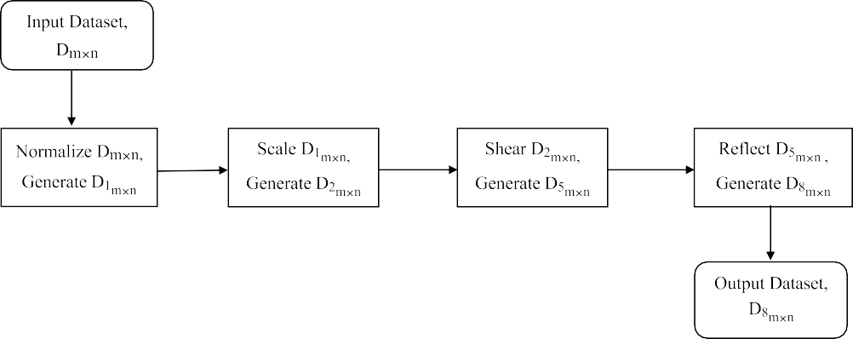

**/ig. 1.** Proposed four stage NOS2R approach.

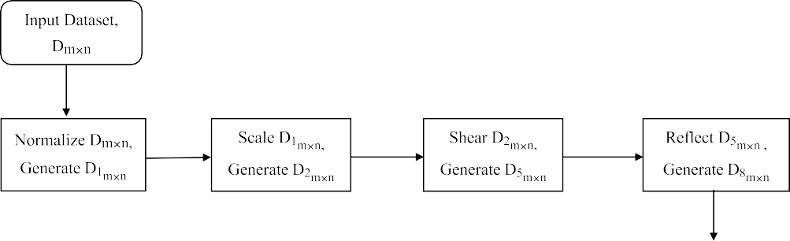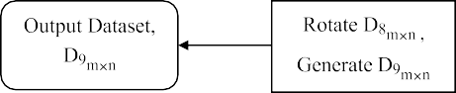

**/ig. 2.** Proposed five stage NOS2R2 approach.

**Table 14**

UCI data set used for Analysis.

|  |  |  |  |  |  |
| --- | --- | --- | --- | --- | --- |
| SI  No. | Original data set name | Names used in this paper | Number of attributes | Attribute type | Number of instances |
| 1 | Haberman’s survival | HBRM | 3+1 | Integer | 306 |
| 2 | Blood Transfusion Service Center | TRNF | 4+1 | Real | 748 |
| 3 | Mammographic mass | MAMO | 5+1 | Integer | 961 |
| 4 | Breast Cancer Wisconsin | WSCN | 10+1 | Integer | 699 |
|  | (Original) |  |  |  |  |
| 5 | Diabetic Retinopathy | DBTC | 19+1 | Integer, Real | 1151 |
| 6 | Breast Cancer Wisconsin | WDBC | 31+1 | Real | 569 |
|  | (Diagnostic) |  |  |  |  |
| 7 | ionosphere | IONS | 34+1 | Integer, Real | 351 |
| 8 | SPECTF Heart | SPTF | 44+1 | Integer | 267 |
| 9 | spambase | SPMB | 57+1 | Integer, Real | 4601 |
| 10 | Connectionist Bench (Sonar, | SNAR | 60+1 | Real | 208 |
|  | Mines vs Rocks) |  |  |  |  |

work well than the existing 3DRT and NRoReM approach. And among all the methods NOS2R2 method is superior.

VD, RP, and CP should have higher values for improved privacy protection; however, the value of CK and RK should be lower [45].

Table 16 shows the value of VD, RP, RK, CP and CK. Here, it is seen that, at least two of the metrics show that the NOS2R strategy protects more privacy compared to 3DRT and NRoReM for 90% the data set and NOS2R2 works better for all the data set. Similarly, in case of

**Table 15**

Comparison of secrecy levels.

**Table 17**

Comparison of ICA attack resistance.

|  |  |  |  |  |  |  |  |  |  |  |
| --- | --- | --- | --- | --- | --- | --- | --- | --- | --- | --- |
| Data set | 3DRT [8] | NRoReM [5] | NOS2R | NOS2R2 |  | Data set | 3DRT [8] | NRoReM [5] | NOS2R | NOS2R2 |
| HBRM | 0.4021 | 0.4801 | 0.7479 | 1.1486 |  | HBRM | 158.2347 | 193.0289 | 216.5618 | 219.9357 |
| TRNF | 0.2277 | 0.2561 | 0.4037 | 0.4409 |  | TRNF | 218.5934 | 218.5935 | 219.4241 | 219.5176 |
| MAMO | 2.4086 | 38.231 | 65.6515 | 171.8649 |  | MAMO | 279.268 | 289.265 | 296.3496 | 313.3135 |
| WSCN | 1.3614 | 23.1025 | 38.7413 | 485.382 |  | WSCN | 45.8631 | 52.6981 | 69.7644 | 73.8404 |
| DBTC | 0.1619 | 2.7813 | 5.2957 | 7.3771 |  | DBTC | 180.815 | 184.2968 | 189.6886 | 190.5094 |
| WDBC | 106.3386 | 689.458 | 4611.768 | 8154.139 |  | WDBC | 156.301 | 156.301 | 156.3017 | 156.3018 |
| IONS | 0.1003 | 3.7854 | 4.1851 | 6.6131 |  | IONS | 43.0971 | 78.5236 | 114.4893 | 135.328 |
| SPTF | 0.0184 | 0.0165 | 0.061 | 1.0957 |  | SPTF | 285.6945 | 293.2979 | 302.2199 | 303.227351 |
| SPMB | 0.0176 | 0.0172 | 0.0178 | 0.0181 |  | SPMB | 531.2711 | 531.8564 | 531.944 | 531.0337 |
| SNAR | 643.8542 | 2178.789 | 30 666.1 | 83 809.57 |  | SNAR | 50.1018 | 68.1669 | 79.2819 | 77.2114 |
| FMR | **1.2** | **1.8** | **3** | **4** |  | FMR | **1.15** | **2.05** | **3.2** | **3.6** |

**Table 16**

Comparison of VD, RP, RK, CP, and CK for privacy protection.

* + 1. *Attack resistance*

There are various sorts of attacks which are addressed against data perturbation methods. One of the attacks is Independent Component Analysis (ICA), which aims to recreate the original data from the altered data [41]. The attack resistance of NOS2R and NOS2R2 is evaluated against an ICA attack because it is based on matrix multiplication. When there is a bigger difference between the altered and actual data, the ICA attack becomes more challenging.

Table 17 shows the values for ICA attack analysis. The values represent the standard deviation of the difference between the ICA- reconstructed data and the initial data. The last row shows the FMR

Here the chi-square *𝜒* 2 value and the probability value, p are 22.35 and values for the comparison of the existing and proposed approaches.

0.000055 respectively, where p demonstrates the significance of the variations in ICA attack resistance among all the methods. According to our analysis, NOS2R offers 33% higher resistance against ICA attack than 3DRT and 11.5% higher resistance than NRoReM. And NOS2R2 is the most resistant method against ICA attack. NOS2R2 is 39.2% more resistant to ICA attack than 3DRT and 15.5% more resistant against ICA attack than NRoReM. So our proposed both methods work better than the existing 3DRT and NRoReM approach. And among all the methods NOS2R2 method is superior in case of attack resistance.

* + 1. *Increase in information entropy*

Information entropy indicates the amount of information contained in an event. The average rate of information production from a random source of data is known as information entropy. Shannon’s entropy can be used to calculate the information entropy of a data set. The formula of Shannon’s entropy is given in Eq. (27) [3].

∑*𝑛*

*𝐻* (*𝑋*) = −

*𝑃* (*𝑥𝑖*) log2 *𝑃* (*𝑥𝑖*) (27)

*𝑖*=1

of X, with X = *< 𝑥*1*, 𝑥*2*,* … *, 𝑥𝑛 >*. *𝑃* (*𝑥𝑖*) represents the probability of where H(X), a discrete random variable which denotes the entropy occurrence of *𝑥𝑖* and denotes the summation over X.

Using Eq. (28) [3], the average information entropy increase are

∑

|  |  |  |  |  |  |
| --- | --- | --- | --- | --- | --- |
| Data set Methods | VD | RP | RK | CP | CK |
| 3DRT [8] | 1.0017 | 116.0958 | 0.0033 | 1.33 | 0.33 |
| NRoReM [5] | 1.0019 | 122.2506 | 0.0033 | 1.35 | 0.1 |
| HBRM NOS2R | 1.0184 | 133.1618 | 0.0033 | 1.38 | 0 |
| NOS2R2 | 1.0238 | 134.4009 | 0.0033 | 1.45 | 0 |
| 3DRT [8] | 0.998 | 151.4586 | 0.2533 | 1 | 0.6 |
| TRNF NRoReM [5] | 0.999 | 207.0529 | 0.0247 | 1 | 0.5 |
| NOS2R | 1.0021 | 347.8389 | 0.000858 | 1 | 0.5 |
| NOS2R2 | 1.0036 | 348.4532 | 0.00066845 | 1 | 0.25 |
| 3DRT [8] | 1.0053 | 320.013 | 0.0012 | 1.4 | 0.2 |
| NRoReM [5] | 1.0254 | 327.248 | 0.003 | 1.7 | 0.2 |
| MAMO NOS2R | 1.0891 | 360.37 | 0.002 | 2.1 | 0.02 |
| NOS2R2 | 1.103 | 369.018 | 0.0002 | 2.2 | 0 |
| 3DRT [8] | 1.0916 | 168.8673 | 0.0035 | 3.2 | 0.2 |
| WSCN NRoReM [5] | 16.602 | 191.214 | 0.0016 | 3.2 | 0.2 |
| NOS2R | 50.7264 | 308.9672 | 0.00087847 | 3.2 | 0.2 |
| NOS2R2 | 54.9648 | 309.5909 | 0.00029283 | 3 | 0.3 |
| 3DRT [8] | 1.0025 | 442.4007 | 0.00686 | 5.3684 | 0.2105 |
| DBTC NRoReM [5] | 1.0012 | 464.5204 | 0.0068 | 6.2045 | 0.1896 |
| NOS2R | 1.0061 | 516.784 | 0.000777356 | 6.8421 | 0.0526 |
| NOS2R2 | 1.1323 | 520.6913 | 0.000274361 | 5.8947 | 0.0526 |
| 3DRT [8] | 1 | 128.0857 | 0.0067 | 9.8064 | 0 |
| WDBC NRoReM [5] | 1 | 194.427 | 0.0028 | 9.7812 | 0 |
| NOS2R | 1 | 267.0425 | 0.0011 | 9.4838 | 0 |
| NOS2R2 | 1 | 268.583 | 0.0009 | 11.8709 | 0 |
| 3DRT [8] | 1.804 | 101.7 | 0.007 | 12.1176 | 0.068 |
| IONS NRoReM [5] | 4.8542 | 119.02 | 0.003 | 10.489 | 0.0314 |
| NOS2R | 10.72 | 152.85 | 0.0015 | 11.82 | 0.33 |
| NOS2R2 | 12.454 | 152.193 | 0.00108 | 14.1705 | 0.0294 |
| 3DRT [8] | 0.9984 | 4.8869 | 0.1173 | 14 | 0 |
| NRoReM [5] | 0.9984 | 6.0892 | 0.0478 | 13.7802 | 0 |
| SPTF NOS2R | 1 | 11.3561 | 0.0016 | 13.6818 | 0.045 |
| NOS2R2 | 1.0257 | 37.1957 | 0.00074 | 13.8182 | 0 |
| 3DRT [8] | 1.006 | 1221.052 | 0.000938 | 20.6316 | 0 |
| SPMB NRoReM [5] | 0.99 | 1203.478 | 0.0025 | 18.4623 | 0 |
| NOS2R | 0.9983 | 1176.32 | 1 | 19.8596 | 0 |
| NOS2R2 | 1.0162 | 1484.6067 | 20.2632 | 13.8182 | 0 |
| 3DRT [8] | 2.4315 | 37.666 | 0.0147 | 20.4667 | 0.0167 |
| NRoReM [5] | 17.2507 | 66.1094 | 0.0088 | 20.0629 | 0.0172 |
| SNAR NOS2R | 23.8662 | 90.67 | 0.0025 | 20.733 | 0.0153 |
| NOS2R2 | 27.8277 | 100.304 | 0.0026 | 16.9 | 0.0333 |

determined.

∑*𝑛*

*𝐴𝐼𝐸* = *𝑖*=1 *𝑖 𝑖*

*𝑛*

(28)

(*𝐻* (*𝑥*′) − *𝐻* (*𝑥*′))

three metrics, for 80% the data set, NOS2R protects more privacy than 3DRT and NRoReM; NOS2R2 offers more privacy for all the data set. Again, using four metrics among those five demonstrate that NOS2R and NOS2R2 provide higher level of privacy for 70% the data set and 90% the data set respectively than both existing approaches which we have used in this study. Moreover, NOS2R2 is compared against 3DRT, NRoReM and NOS2R.

It is seen that, at least two metrics demonstrate the superiority of NOS2R2 than others for all of the data set and that of for 90% of the data set for at least three and four metrics.

Here, *𝐻* (*𝑥𝑖*) is the entropy for every attribute of the original data set. Similarly, *𝐻* (*𝑥*′) stands for every attribute’s entropy of the altered data

set. AIE represents an average increase in information entropy. When the AIE values are greater than 0, it means that the altered data set have more impurities than the original data set. Fig. 3 shows the AIE for 3DRT, NRoReM, NOS2R, and NOS2R2. The bar chart shows that, the entropy level is greater for NOS2R compared to NRoReM and 3DRT for 90% the data set. Also, NOS2R2 provides higher entropy than 3DRT, NRoReM and NOS2R for 90% of the data set. Our experimental analysis says that, NOS2R provides 6.94% higher entropy than 3DRT and 3.44% higher entropy than NRoReM. Furthermore, NOS2R2 provides 17.72% higher entropy than 3DRT and 15.48% higher entropy than NRoReM.

*𝑖*

         



**/ig. 3.** Average increase in information entropy.

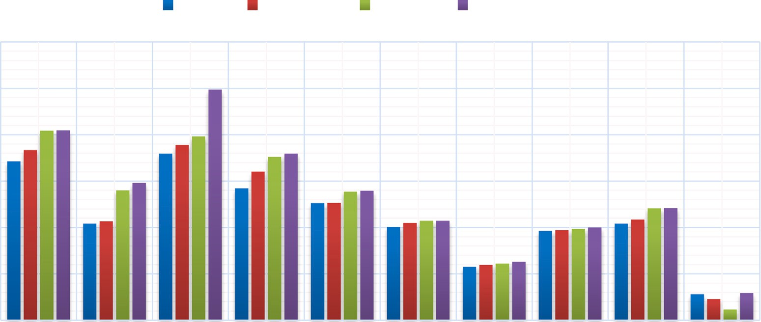

**Table 18**

Accuracy comparison.

|  |  |  |  |  |  |
| --- | --- | --- | --- | --- | --- |
| Data set | Original | 3DRT [8] | NRoReM [5] | NOS2R | NOS2R2 |
| HBRM | 69.23 | 72.12 | 67.26 | 69.68 | 69.26 |
| TRNF | 76.77 | 76.13 | 77.22 | 76.36 | 76.38 |
| MAMO | 83.33 | 79.78 | 80.73 | 82.27 | 82.76 |
| WSCN | 94.36 | 92.55 | 95.75 | 95.68 | 95.65 |
| DBTC | 61.13 | 58.82 | 59.89 | 59.59 | 59.34 |
| WDBC | 90.67 | 94.3 | 94.51 | 93.34 | 93.59 |
| IONS | 88.23 | 89.92 | 87.02 | 90.75 | 88.63 |
| SPTF | 61.36 | 64.07 | 63.48 | 59.52 | 62.97 |
| SPMB | 91.36 | 92.32 | 89.9 | 92.13 | 91.81 |
| SNAR | 73.68 | 74.28 | 72.12 | 71.42 | 72.85 |

**Table 19**

Absolute accuracy differences.

|  |  |  |  |  |
| --- | --- | --- | --- | --- |
| Data set | 3DRT [8] | NRoReM [5] | NOS2R | NOS2R2 |
| HBRM | 2.89 | 1.97 | 0.45 | 0.03 |
| TRNF | 0.64 | 0.45 | 0.41 | 0.39 |
| MAMO | 3.55 | 2.6 | 1.06 | 0.57 |
| WSCN | 1.81 | 1.39 | 1.32 | 1.29 |
| DBTC | 2.31 | 1.24 | 1.54 | 1.79 |
| WDBC | 3.63 | 3.84 | 2.67 | 2.92 |
| IONS | 1.69 | 1.21 | 2.52 | 0.4 |
| SPTF | 2.71 | 2.12 | 1.84 | 1.61 |
| SPMB | 0.96 | 1.46 | 0.77 | 0.45 |
| SNAR | 0.6 | 1.56 | 2.26 | 0.83 |

* 1. *Analysis of utility*

From Table 18, it is seen that the accuracy of NOS2R and NOS2R2 are more similar to that of the original data than NRoReM and 3DRT. For over 70% data set, NOS2R outperforms NRoReM and 3DRT. And for 80% data set, NOS2R2 approach performs on a greater scale.

The absolute differences in classification accuracy shown in Table 19 demonstrate this analysis. Table 19 displays the differences between the accuracy found in the altered data set by 3DRT, NRoReM, NOS2R and NOS2R2 and that of the original data set.

From this accuracy difference, it can be said that the accuracy of NOS2R is 28.62% closer to the original data than 3DRT and 16.81% closer than NRoReM. As well, NOS2R2 is 50.5% closer to the original data than 3DRT and 42.32% closer than NRoReM.

It is also obvious from the analysis of Eq. (29) that the utility of NOS2R and NOS2R2 approach are maintained. The classification accuracy of the original data set, Ro, and the perturbed data set, Rp, are both expressed in Eq. (29). The value of *e* indicates the lowest level

over which the utility of the classifiers can be maintained.

*𝐸* = *𝑅𝑝* − (1 − *𝑒*)*𝑅𝑜* (29)

For this analysis, *e* is set to 0.03068. Then it is observed that the classifier is able to maintain the utility in case of NOS2R and NOS2R2; however fail in case of 3DRT and NRoReM for this lowest value of *e*. That is why *e* is set to 0.03068. In Fig. 4, this is depicted.

*𝐸𝑚𝑖𝑛* values are plotted along the *𝑦*-axis of the graph in Fig. 4 and

are calculated as follows: At first, the minimum error returned for each

is made using the value of minimum error for every method. These *𝐸𝑚𝑖𝑛* strategy is identified. This is carried out for every data set. Next, a plot

that *𝐸𝑚𝑖𝑛* is positive for greater values of *e*. values are displayed against *e* which initializes at 0.1 since Fig. 4 shows

The utilities of the data set that the classifier, decision tree return, are maintained if Eq. (29) shows that the value of error E ≥ 0. As a result, we found that the utility of NOS2R and NOS2R2 can be maintained for *e* = 0.03068 but fail for 3DRT and NRoReM, as shown in Fig. 5. If we further decrease the value of *e* and set at 0.03067, then the utility for NOS2R2 is preserved but fail for 3DRT, NRoReM and NOS2R as well for this value of *e*. This is shown in Fig. 6.

The *𝑦*-axis in Figs. 5 and 6 shows *𝐸𝑚*, the minimum error. It has been

found that NOS2R and NOS2R2 perturbation successfully preserves

the utility of the entire data set for the lowest value of *e* = 0.03068. However, it turns out that 3DRT and NRoReM do not preserve 100% utility for the same value of *e*.

Besides accuracy, f1-score analysis is helpful to evaluate the effec- tiveness of classification algorithms on a larger scale. The bar chart in Fig. 7 shows that where analysis of accuracy compromises, the NOS2R approach provides 43.65% better result than 3DRT and 22% closer f1- score to original data than NRoReM. Again the NOS2R2 perturbation method outperforms all of the 3DRT, NRoReM and NOS2R approaches in terms of f1-score. NOS2R2 results in 50.25% closer f1-score to origi- nal data than 3DRT and 31.22% closer f1-score compared to NRoReM.

Furthermore, Precision is another important metric for utility eval- uation. The bar graph in Fig. 8 demonstrates that, NOS2R algorithm yields precisions that are 48.03% and 21.89% better than 3DRT and NRoReM respectively. Similarly, NOS2R2 approach generates preci- sions which are 53.93% and 30.77% closer to original one in compar- ison to 3DRT and NRoReM respectively.

In addition to the other utility metrics, recall analysis is also of utmost significance. Fig. 9 illustrates the recall values for the existing and proposed methods. From Fig. 9, it can be found that the recall values for NOS2R is 21.4% and 16.15% closer to original one than that of 3DRT and NRoReM methods respectively. All of the 3DRT,



**/ig. 4.** Selecting the value of *e*.

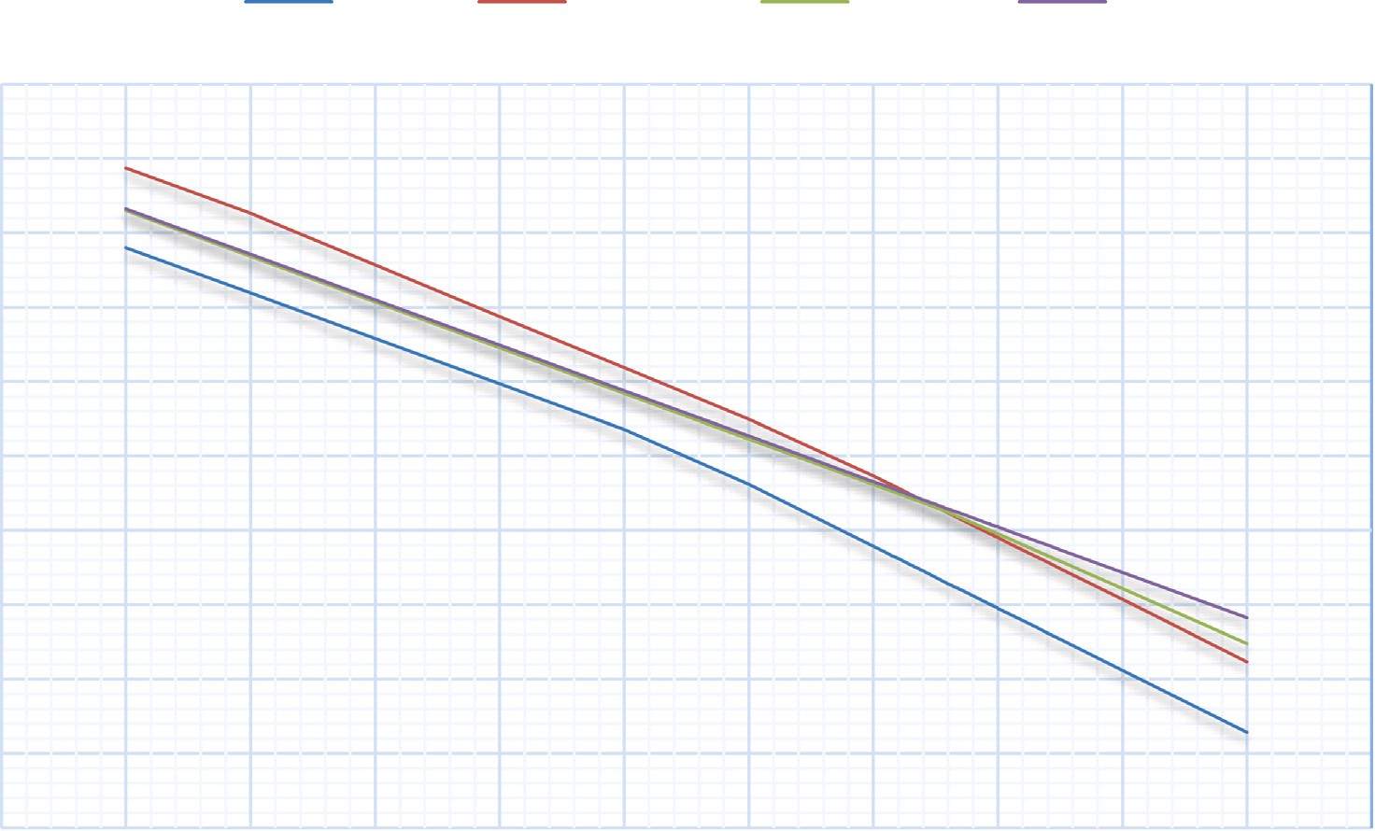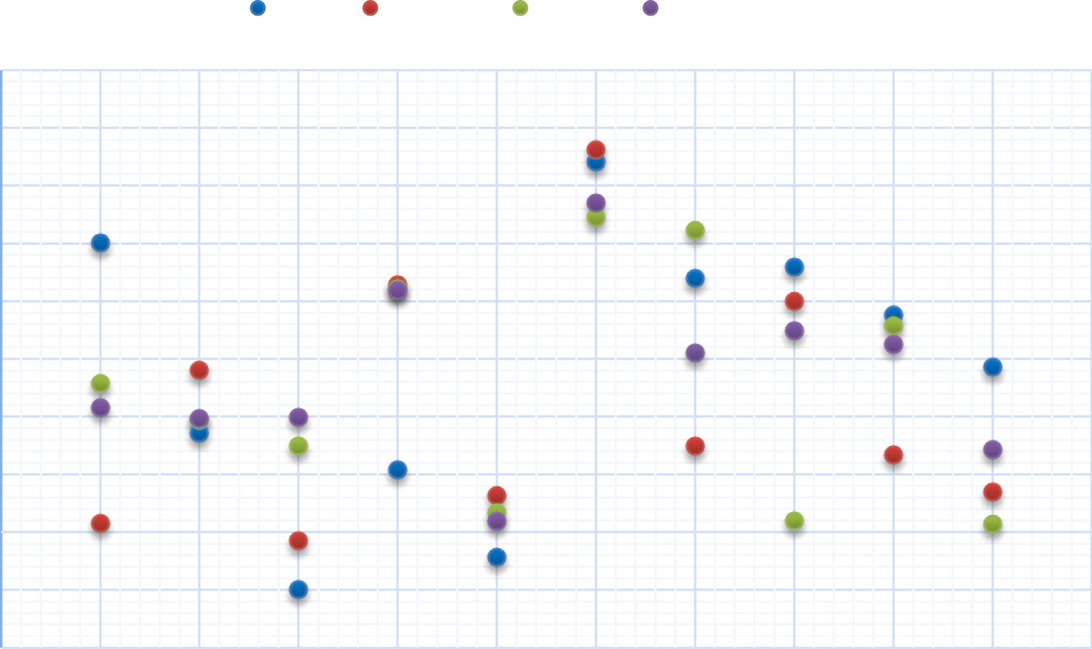



**/ig. 5.** Classification errors for e = 0.03068.

NRoReM, and NOS2R techniques are outperformed by the NOS2R2 perturbation method while evaluating recall values. NOS2R2 algorithm offers 39.85% and 35.82% better recall values than 3DRT and NRoReM respectively.

Hence, we see that the existing approaches are outperformed for the majority of the data set by NOS2R and NOS2R2. A comparative summary has been provided in the Table 20. Thus our methods provide better balance between privacy and utility. Our proposed methods work much better than the existing methods. But in case of big data there is an uncertainty regarding the amount of time these approaches will take.

* 1. *Discussion and shortcomings*

For most of the data set, NOS2R and NOS2R2 surpass 3DRT and NRoReM, but they fall short in a few instances. NOS2R is a four stage

data perturbation technique and NOS2R2 is five stage data perturbation technique. The improved performance is a result of all phases of NOS2R and NOS2R2. Normalization helps to maintain a close rela- tionship of euclidean distances of the data points. Normalization is followed by scaling transformation. Scaling can be used to modify an object’s size. The coordinate values can be multiplied by scaling factors to achieve this. The original coordinate X can be multiplied by a scaling factor to get the modified coordinate X’. Then shearing transformation is done. Shearing also causes a change in object’s shape and the data value and a new shape is appeared. Thus shearing play a vital role in preserving privacy as the data value is changed and a new shape is appeared. Again, geometric reflection and rotation are isometric transformations [56]. NOS2R uses scaling, shearing and reflection transformation. and NOS2R2 uses rotation along with these transformations. Rotation and reflection are strict isometric transforma- tion. Scaling is not isometric transformation, but it still can maintain



**/ig. 6.** Classification errors for e = 0.03067.

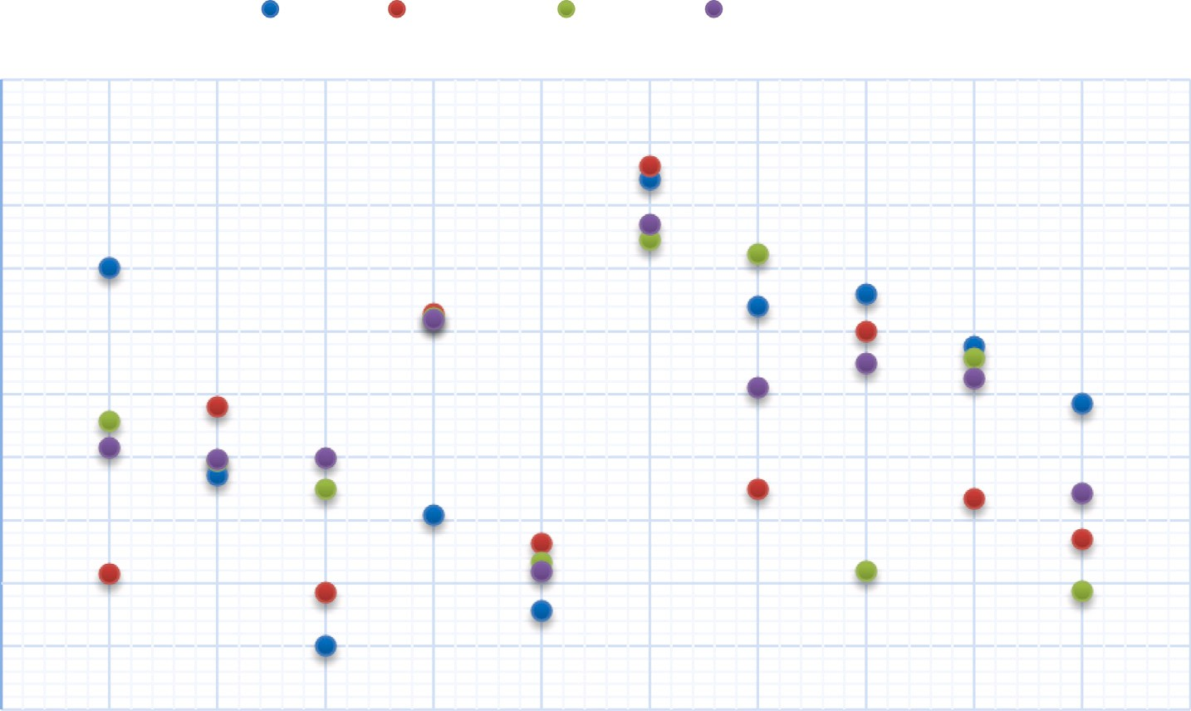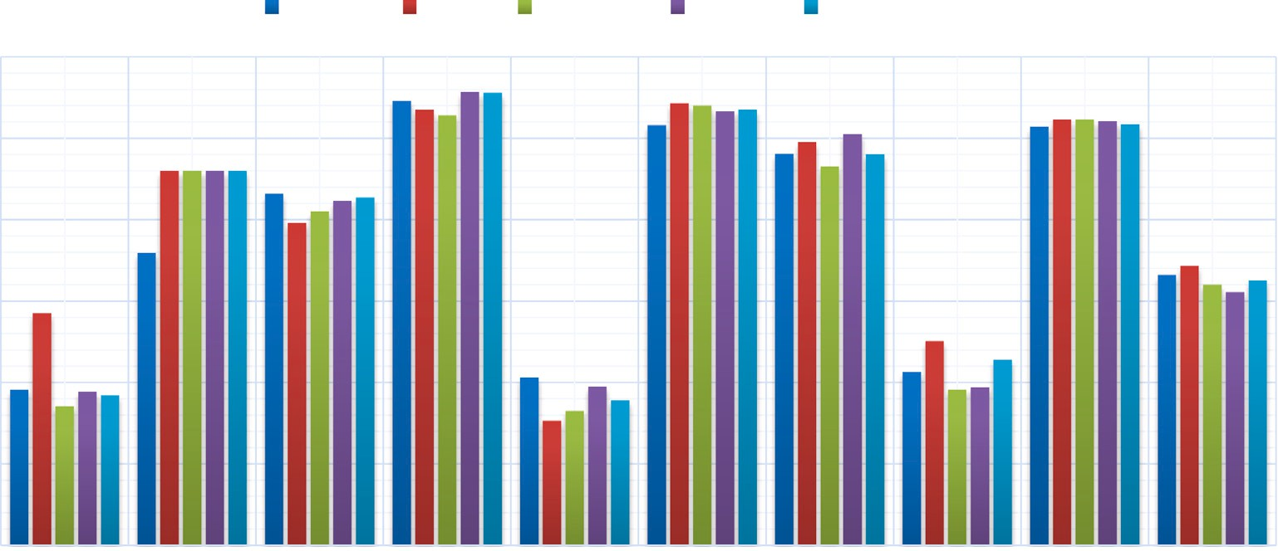



**/ig. 7.** F1-Score analysis.

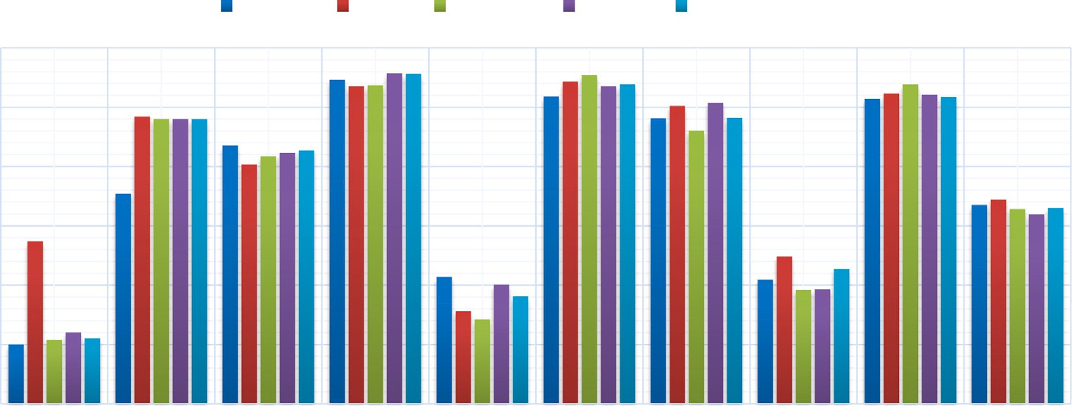



**/ig. 8.** Precision analysis.

         



**/ig. 9.** Recall analysis.

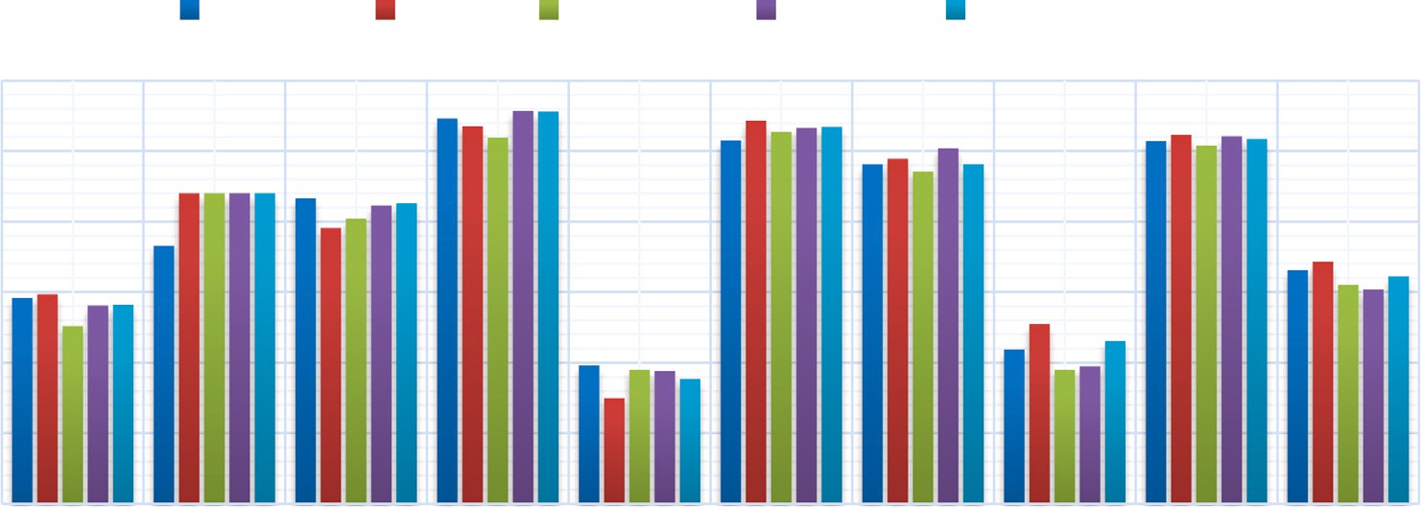

**Table 20**

Summary of comparative analysis of existing methods and proposed methods.

|  |  |  |  |  |
| --- | --- | --- | --- | --- |
| Metric | 3DRT [8] | NRoReM [5] | NOS2R | NOS2R2 |
| Secrecy | FMR = 1.2 | FMR = 1.8 | FMR = 3 | FMR = 4 |
| Entropy | lesser than all | 3.6% higher than | 6.94% higher than | 17.72% higher than |
|  | other methods | 3DRT; | 3DRT | 3DRT |
|  |  | but lesser than | 3.44% higher than | 15.48% higher than |
|  |  | proposed | NRoReM | NRoReM |
|  |  | methods |  | 11.4% higher than |
|  |  |  |  | NOS2R |
| VD, RP, | higher privacy for 40% | greater privacy for 60% | higher for 70% data set | greater for 100% and |
| RK, CP, | of the data set than |  | than existing methods | 90% data |
| CK | NRoReM | and 30% data set | and only greater for | set than the existing |
|  | but lesser privacy for | than 3DRT and NOS2R | 10% | methods |
|  | all | respectively; | data set than NOS2R2 | and NOS2R |
|  | of the other data set | but lower than NOS2R2 |  | respectively. |
| ICA | FMR = 1.15 | FMR = 2.05 | FMR = 3.2 | FMR = 3.6 |
| attack |  |  |  |  |
| Average | 2.08 | 1.78 | 1.48 | 1.03 |
| absolute |  |  |  |  |
| Accuracy |  |  |  |  |
| difference |  |  |  |  |
| Absolute | 0.0394 | 0.0285 | 0.0222 | 0.0196 |
| average |  |  |  |  |
| F1-score |  |  |  |  |
| difference |  |  |  |  |
| Absolute | 0.0508 | 0.0338 | 0.0264 | 0.0234 |
| average |  |  |  |  |
| Precision |  |  |  |  |
| difference |  |  |  |  |
| Absolute | 0.0271 | 0.0254 | 0.0213 | 0.0163 |
| average |  |  |  |  |
| Recall |  |  |  |  |
| difference |  |  |  |  |

the similarity [56]. Thus scaling, rotation and reflection are used to maintain the utility. But in our work, to increase the level of privacy, a 3D rotation matrix with a mixture of clockwise and counterclockwise

directions has been employed (for example, the *𝑧*-axis is counterclock-

wise, the other two axes are clockwise). The rotated data points’ spatial representation therefore varies in a number of ways which conflicts with maintaining utility. Several new study directions have been made possible by this work. To begin with, other transformations or methods can be applied with this work to compare the utility and privacy preservation. The proposed approaches might be used for other data mining tasks, such as regression, clustering, and so on. Currently, we have used numerical data to validate our methods. Adapting these methods to deal with categorical data can be potential avenue for future research. Again, investigating alternative attacks is another crucial topic for future research. ICA attack analysis has been employed in

this work. Further attacks can be put under consideration for a better analysis.

# Conclusion

The main goal of this research work is to perturb the data for preserving privacy along with maintaining the utility at the same time. Data perturbation techniques are applied to multivariate data set in or- der to change the original data items. The recent perturbation methods frequently address the trade-off between privacy and data utility. The proposed NOS2R and NOS2R2 approaches perturb all the features of the data set. The data items are standardized using a normalization process, which is followed by scaling, shearing, reflection and rotation. Thus the data elements are distorted. But the data set’s geometrical shapes remain constant. This property facilitates in maintaining the original data set’s utility and the composite transformation significantly

increases privacy to a significant level. Then the results of the proposed methods are compared with the other existing methods. And the pro- posed two methods provide better results than the existing methods. NOS2R and NOS2R2 perturbation approaches maintain data utility and preserve individual privacy on a larger scale for 90% data set. However, the work proposed in this paper can be well extended with feature reduction in multiparty clustering scenarios.

# CRediT authorship contribution statement

**Mahbubur Rahman:** Conceptualization, Methodology, Software, Validation, Formal analysis, Investigation, Resources, Writing – orig- inal draft, Writing – review & editing, Visualization. **Mahit Kumar Paul:** Supervision, Conceptualization, Methodology, Validation, For- mal analysis, Investigation, Resources, Writing – review & editing, Visualization. **A.H.M. Sarowar Sattar:** Supervision, Formal analysis, Validation, Investigation, Writing – review & editing.

# Declaration of competing interest

The authors declare that they have no known competing finan- cial interests or personal relationships that could have appeared to influence the work reported in this paper.

# Data availability

Data will be made available on request.

# References

1. Afrin A, Paul MK, Sattar AHMS. Privacy preserving data mining using non- negative matrix factorization and singular value decomposition. In: 2019 4th International conference on electrical information and communication technology. 2019, p. 1–6. <http://dx.doi.org/10.1109/EICT48899.2019.9068846>.
2. Askinadze A, Conrad S. Respecting data privacy in educational data mining: An approach to the transparent handling of student data and dealing with the resulting missing value problem. In: 2018 IEEE 27th international conference on enabling technologies: Infrastructure for collaborative enterprises. 2018, p. 160–4. <http://dx.doi.org/10.1109/WETICE.2018.00037>.
3. Chamikara M, Bertok P, Liu D, Camtepe S, Khalil I. Efficient privacy preservation of big data for accurate data mining. Inform Sci 2020;527:420–43. [http://dx.doi.](http://dx.doi.org/10.1016/j.ins.2019.05.053) [org/10.1016/j.ins.2019.05.053](http://dx.doi.org/10.1016/j.ins.2019.05.053).
4. Chamikara M, Bertok P, Liu D, Camtepe S, Khalil I. Efficient data perturbation for privacy preserving and accurate data stream mining. Pervasive Mob Comput 2018;48:1–19. <http://dx.doi.org/10.1016/j.pmcj.2018.05.003>.
5. Paul MK, Islam MR, Sattar AHMS. An efficient perturbation approach for multivariate data in sensitive and reliable data mining. J Inf Secur Appl 2021;62:102954. <http://dx.doi.org/10.1016/j.jisa.2021.102954>.
6. Denham B, Pears R, Naeem MA. Enhancing random projection with independent and cumulative additive noise for privacy-preserving data stream mining. Expert Syst Appl 2020;152:113380. <http://dx.doi.org/10.1016/j.eswa.2020.113380>.
7. Salloum SA, Alshurideh M, Elnagar A, Shaalan K. Mining in educational data: Review and future directions. In: Hassanien A-E, Azar AT, Gaber T, Oliva D, Tolba FM, editors. Proceedings of the international conference on artificial intelligence and computer vision. Cham: Springer International Publishing; 2020,

p. 92–102. <http://dx.doi.org/10.1007/978-3-030-44289-7_9>.

1. Upadhyay S, Sharma C, Sharma P, Bharadwaj P, Seeja K. Privacy preserving data mining with 3-D rotation transformation. J King Saud Univ - Comput Inf Sci 2018;30(4):524–30. <http://dx.doi.org/10.1016/j.jksuci.2016.11.009>.
2. Helbing D, Brockmann D, Chadefaux T, Donnay K, Blanke U, Woolley-Meza O, et al. Saving human lives: What complexity science and information systems can contribute. J Stat Phys 2015;158(3):735–81. [http://dx.doi.org/10.1007/s10955-](http://dx.doi.org/10.1007/s10955-014-1024-9) [014-1024-9](http://dx.doi.org/10.1007/s10955-014-1024-9).
3. Jalili M, Perc M. Information cascades in complex networks. J Complex Netw 2017;5(5):665–93. <http://dx.doi.org/10.1093/comnet/cnx019>.
4. Capraro V, Perc M. Grand challenges in social physics: in pursuit of moral behavior. Front Phys 2018;6:107. <http://dx.doi.org/10.3389/fphy.2018.00107>.
5. [Xiang Z, Plastock RA. Schaum’s outline of computer graphics 2/E. McGraw Hill](http://refhub.elsevier.com/S2590-0056(23)00049-8/sb12) [Professional; 2000.](http://refhub.elsevier.com/S2590-0056(23)00049-8/sb12)
6. Kreso I, Kapo A, Turulja L. Data mining privacy preserving: Research agenda. Wiley Interdiscip Rev Data Min Knowl Discov 2021;11(1):e1392. [http://dx.doi.](http://dx.doi.org/10.1002/widm.1392) [org/10.1002/widm.1392](http://dx.doi.org/10.1002/widm.1392).
7. Verykios VS, Bertino E, Fovino IN, Provenza LP, Saygin Y, Theodoridis Y. State- of-the-art in privacy preserving data mining. ACM Sigmod Rec 2004;33(1):50–7. <http://dx.doi.org/10.1145/974121.974131>.
8. Malik MB, Ghazi MA, Ali R. Privacy preserving data mining techniques: Current scenario and future prospects. In: 2012 Third international conference on computer and communication technology. 2012, p. 26–32. [http://dx.doi.org/10.](http://dx.doi.org/10.1109/ICCCT.2012.15) [1109/ICCCT.2012.15](http://dx.doi.org/10.1109/ICCCT.2012.15).
9. Muralidhar K, Parsa R, Sarathy R. A general additive data perturbation method for database security. Manag Sci 1999;45(10):1399–415. [http://dx.doi.org/10.](http://dx.doi.org/10.1287/mnsc.45.10.1399) [1287/mnsc.45.10.1399](http://dx.doi.org/10.1287/mnsc.45.10.1399).
10. Gerhardt F, Oriti D, Wilson-Ewing E. Separate universe framework in group field theory condensate cosmology. Phys Rev D 2018;98(6):066011. [http://dx.doi.org/](http://dx.doi.org/10.1103/PhysRevD.98.066011) [10.1103/PhysRevD.98.066011](http://dx.doi.org/10.1103/PhysRevD.98.066011).
11. Sun Y, Guo Y, Tropp JA, Udell M. Tensor random projection for low memory dimension reduction. 2021, <http://dx.doi.org/10.48550/arXiv.2105.00105>, arXiv preprint [arXiv:2105.00105](http://arxiv.org/abs/2105.00105).
12. Chen K, Liu L. Geometric data perturbation for privacy preserving outsourced data mining. Knowl Inform Syst 2011;29(3):657–95. [http://dx.doi.org/10.1007/](http://dx.doi.org/10.1007/s10115-010-0362-4) [s10115-010-0362-4](http://dx.doi.org/10.1007/s10115-010-0362-4).
13. Liu K, Kargupta H, Ryan J. Random projection-based multiplicative data pertur- bation for privacy preserving distributed data mining. IEEE Trans Knowl Data Eng 2006;18(1):92–106. <http://dx.doi.org/10.1109/TKDE.2006.14>.
14. Sattar AS, Li J, Liu J, Heatherly R, Malin B. A probabilistic approach to mitigate composition attacks on privacy in non-coordinated environments. Knowl-Based Syst 2014;67:361–72. <http://dx.doi.org/10.1016/j.knosys.2014.04.019>.
15. Fang W, Wen XZ, Zheng Y, Zhou M. A survey of big data security and privacy preserving. IETE Tech Rev 2017;34(5):544–60. [http://dx.doi.org/10.](http://dx.doi.org/10.1080/02564602.2016.1215269) [1080/02564602.2016.1215269](http://dx.doi.org/10.1080/02564602.2016.1215269).
16. Chamikara M, Bertok P, Khalil I, Liu D, Camtepe S. Privacy preserving distributed machine learning with federated learning. Comput Commun 2021;171:112–25. <http://dx.doi.org/10.1016/j.comcom.2021.02.014>.
17. Chang H, Ando H. Privacy-preserving data sharing by integrating perturbed distance matrices. SN Comput Sci 2020;1(3):1–10. [http://dx.doi.org/10.1007/](http://dx.doi.org/10.1007/s42979-020-00127-w) [s42979-020-00127-w](http://dx.doi.org/10.1007/s42979-020-00127-w).
18. Kao Y-H, Lee W-B, Hsu T-Y, Lin C-Y, Tsai H-F, Chen T-S. Data perturbation method based on contrast mapping for reversible privacy-preserving data min- ing. J Med Biol Eng 2015;35(6):789–94. [http://dx.doi.org/10.1007/s40846-015-](http://dx.doi.org/10.1007/s40846-015-0088-6) [0088-6](http://dx.doi.org/10.1007/s40846-015-0088-6).
19. Shan J, Lin Y, Zhu X. A new range noise perturbation method based on privacy preserving data mining. In: 2020 IEEE international conference on artificial intelligence and information systems. 2020, p. 131–6. [http://dx.doi.org/10.1109/](http://dx.doi.org/10.1109/ICAIIS49377.2020.9194850) [ICAIIS49377.2020.9194850](http://dx.doi.org/10.1109/ICAIIS49377.2020.9194850).
20. Li G. A new bayesian-based method for privacy-preserving data mining. In: International conference on intelligent and interactive systems and applications. Springer; 2017, p. 171–7. <http://dx.doi.org/10.1007/978-3-319-69096-4_24>.
21. Huang M, Chen Y, Chen B-W, Liu J, Rho S, Ji W. A semi-supervised privacy-preserving clustering algorithm for healthcare. Peer-to-Peer Netw Appl 2016;9(5):864–75. <http://dx.doi.org/10.1007/s12083-015-0356-9>.
22. Torra V. Fuzzy microaggregation for the transparency principle. J Appl Log 2017;23:70–80. <http://dx.doi.org/10.1016/j.jal.2016.11.007>, SI:Logical Methods in Artificial Intelligence.
23. Lin C-Y. A reversible privacy-preserving clustering technique based on k-means algorithm. Appl Soft Comput 2020;87:105995. [http://dx.doi.org/10.1016/j.asoc.](http://dx.doi.org/10.1016/j.asoc.2019.105995) [2019.105995](http://dx.doi.org/10.1016/j.asoc.2019.105995).
24. Kiran A, Vasumathi D. Data mining: min–max normalization based data perturba- tion technique for privacy preservation. In: Proceedings of the third international conference on computational intelligence and informatics. Springer; 2020, p. 723–34. <http://dx.doi.org/10.1007/978-981-15-1480-7_66>.
25. Oliveira S, Zaiane O. Data perturbation by rotation for privacy-preserving cluster- ing. Technical Report TR04-17, Edmonton, AB, Canada: Department of Computer Science, University of Alberta; 2004, <http://dx.doi.org/10.7939/R3344P>.
26. Chamikara M, Bertok P, Liu D, Camtepe S, Khalil I. An efficient and scalable privacy preserving algorithm for big data and data streams. Comput Secur 2019;87:101570. <http://dx.doi.org/10.1016/j.cose.2019.101570>.
27. Shynu PG, Md. Shayan. H, Chowdhary CL. A fuzzy based data perturbation technique for privacy preserved data mining. In: 2020 International conference on emerging trends in information technology and engineering. 2020, p. 1–4. <http://dx.doi.org/10.1109/ic-ETITE47903.2020.244>.
28. Lyu L, Bezdek JC, Law YW, He X, Palaniswami M. Privacy-preserving collabo- rative fuzzy clustering. Data Knowl Eng 2018;116:21–41. [http://dx.doi.org/10.](http://dx.doi.org/10.1016/j.datak.2018.05.002) [1016/j.datak.2018.05.002](http://dx.doi.org/10.1016/j.datak.2018.05.002).
29. Hasan AT, Jiang Q, Luo J, Li C, Chen L. An effective value swapping method for privacy preserving data publishing. Secur Commun Netw 2016;9(16):3219–28. <http://dx.doi.org/10.1002/sec.1527>.
30. Siang DKK, Othman SH, Radzi RZRM. Comparative study on perturbation techniques in privacy preserving data mining on two numeric data set. Int J Innov Comput 2018;8(1). <http://dx.doi.org/10.11113/ijic.v8n1.161>.
31. Prakash M, Singaravel G. An approach for prevention of privacy breach and in- formation leakage in sensitive data mining. Comput Electr Eng 2015;45:134–40. <http://dx.doi.org/10.1016/j.compeleceng.2015.01.016>.
32. Abitha N, Sarada G, Manikandan G, Sairam N. A cryptographic approach for achieving privacy in data mining. In: 2015 International conference on circuits, power and computing technologies. 2015, p. 1–5. [http://dx.doi.org/10.1109/](http://dx.doi.org/10.1109/ICCPCT.2015.7159300) [ICCPCT.2015.7159300](http://dx.doi.org/10.1109/ICCPCT.2015.7159300).
33. Zhang N, Zhao W. Privacy-preserving data mining systems. Computer 2007;40(4):52–8. <http://dx.doi.org/10.1109/MC.2007.142>.
34. Okkalioglu BD, Okkalioglu M, Koc M, Polat H. A survey: Deriving private information from perturbed data. Artif Intell Rev 2015;44(4):547–69. [http://dx.](http://dx.doi.org/10.1007/s10462-015-9439-5) [doi.org/10.1007/s10462-015-9439-5](http://dx.doi.org/10.1007/s10462-015-9439-5).
35. Li X, Yan Z, Zhang P. A review on privacy-preserving data mining. In: 2014 IEEE International conference on computer and information technology. 2014,

p. 769–74. <http://dx.doi.org/10.1109/CIT.2014.135>.

1. [Chen K, Liu L. A random rotation perturbation approach to privacy pre-](http://refhub.elsevier.com/S2590-0056(23)00049-8/sb43) [serving data classification. Technical Report, Wright State University; 2005,](http://refhub.elsevier.com/S2590-0056(23)00049-8/sb43) [10.1.1.72.6442.](http://refhub.elsevier.com/S2590-0056(23)00049-8/sb43)
2. Oliveira SRM, Zaiane OR. Privacy preserving clustering by data transformation. J Inform Data Manag 2010;1(1):37. <http://dx.doi.org/10.5753/jidm.2010.940>.
3. Xu S, Zhang J, Han D, Wang J. Singular value decomposition based data distortion strategy for privacy protection. Knowl Inf Syst 2006;10(3):383–97. <http://dx.doi.org/10.1007/s10115-006-0001-2>.
4. Tasnim N, Paul MK, Sattar AHMS. Identification of drop out students using educational data mining. In: 2019 International conference on electrical, com- puter and communication engineering. 2019, p. 1–5. [http://dx.doi.org/10.1109/](http://dx.doi.org/10.1109/ECACE.2019.8679385) [ECACE.2019.8679385](http://dx.doi.org/10.1109/ECACE.2019.8679385).
5. Galar M, Fernandez A, Barrenechea E, Bustince H, Herrera F. A review on ensembles for the class imbalance problem: Bagging-, boosting-, and hybrid- based approaches. IEEE Trans Syst Man Cybern C (Appl Rev) 2012;42(4):463–84. <http://dx.doi.org/10.1109/TSMCC.2011.2161285>.
6. Goutte C, Gaussier E. A probabilistic interpretation of precision, recall and F-score, with implication for evaluation. In: Losada DE, Fernández-Luna JM, editors. Advances in information retrieval. Berlin, Heidelberg: Springer Berlin Heidelberg; 2005, p. 345–59. <http://dx.doi.org/10.1007/978-3-540-31865-1_25>.
7. Ting KM. Precision and recall. In: Sammut C, Webb GI, editors. Encyclopedia of machine learning. Boston, MA: Springer US; 2010, p. 781. [http://dx.doi.org/10.](http://dx.doi.org/10.1007/978-0-387-30164-8_652) [1007/978-0-387-30164-8_652](http://dx.doi.org/10.1007/978-0-387-30164-8_652).
8. Singh D, Singh B. Investigating the impact of data normalization on classification performance. Appl Soft Comput 2020;97:105524. [http://dx.doi.org/10.1016/j.](http://dx.doi.org/10.1016/j.asoc.2019.105524) [asoc.2019.105524](http://dx.doi.org/10.1016/j.asoc.2019.105524).
9. Singhal A. Computer graphics. 2019, Gate Vidyalay. [https://www.gatevidyalay.](https://www.gatevidyalay.com/computer-graphics/) [com/computer-graphics/](https://www.gatevidyalay.com/computer-graphics/).
10. Computer Graphics - 3D shearing transformation. 2021, GeeksforGeeks. URL: <https://www.geeksforgeeks.org/computer-graphics-3d-shearing-transformation/>. Online. [Accessed 17 November 2022].
11. Lessmann S, Baesens B, Seow H-V, Thomas LC. Benchmarking state-of-the-art classification algorithms for credit scoring: An update of research. European J Oper Res 2015;247(1):124–36. <http://dx.doi.org/10.1016/j.ejor.2015.05.030>.
12. Charbuty B, Abdulazeez A. Classification based on decision tree algorithm for machine learning. J Appl Sci Technol Trends 2021;2(01):20–8. [http://dx.doi.](http://dx.doi.org/10.38094/jastt20165) [org/10.38094/jastt20165](http://dx.doi.org/10.38094/jastt20165).
13. Yang Y, Farid SS, Thornhill NF. Prediction of biopharmaceutical facility fit issues using decision tree analysis. In: Kraslawski A, Turunen I, editors. 23rd European symposium on computer aided process engineering. Computer aided chemical engineering, vol. 32, Elsevier; 2013, p. 61–6. [http://dx.doi.org/10.1016/B978-0-](http://dx.doi.org/10.1016/B978-0-444-63234-0.50011-7)

[444-63234-0.50011-7](http://dx.doi.org/10.1016/B978-0-444-63234-0.50011-7), URL: [https://www.sciencedirect.com/science/article/pii/](https://www.sciencedirect.com/science/article/pii/B9780444632340500117) [B9780444632340500117](https://www.sciencedirect.com/science/article/pii/B9780444632340500117).

1. Liu J, Xu Y. Privacy preserving clustering by random response method of geometric transformation. In: 2009 Fourth international conference on internet computing for Science and engineering. 2009, p. 181–8. [http://dx.doi.org/10.](http://dx.doi.org/10.1109/ICICSE.2009.31) [1109/ICICSE.2009.31](http://dx.doi.org/10.1109/ICICSE.2009.31).