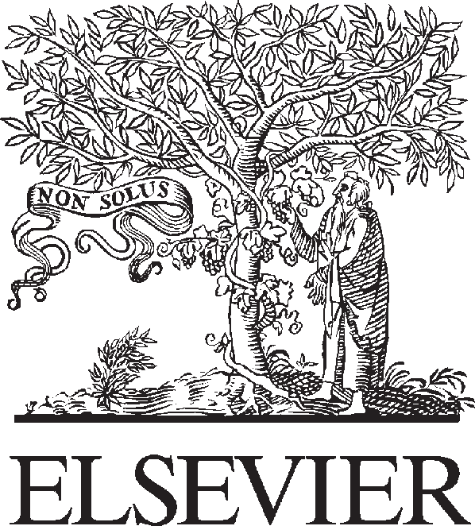Available online at [www.sciencedirect.com](http://www.sciencedirect.com/)



AASRI Procedia 2 (2012) 288 – 292

AASRI

Procedia

[www.elsevier.com/locate/procedia](http://www.elsevier.com/locate/procedia)

2012 AASRI Conference on Power and Energy Systems

# Friction and Wear Behavior of Pantograph Strips Sliding Against Copper Contact Wire with Electric Current

Tao Dinga, b, *, Guang-xiong Chenb, Yu-mei Lia, Qiu-dong Hea; Wen-jing Xuanc*

1. *Hubei engineering University, Xiaogan 432000, China;*
2. *Tribology Research Institute, National Traction Power Laboratory, Southwest Jiaotong University, Chengdu 610031, China;*
3. *College of technology, Hubei engineering university, Xiaogan 432000, China;*

Abstract

An investigation on friction and wear behaviors of carbon strip and contact wire used in the pantograph-cantenary system is presented. The tests are conducted under laboratory conditions and on a pin-on-disc tester under electric current. The results indicate that electric current have a distinct effect on friction properties of carbon strip rubbing against copper. The wear rate of carbon strip increases with increasing of electric intensity due to the heat and arc discharge generated in the current. Worn surfaces of carbon strip are analyzed by scanning electron microscopy equipped with an energy dispersive X-ray spectroscopy. It is found that the thermal wear, arc erosion and abrasive wear are the dominant wear mechanism occurring in the electrical sliding frictional process, accompanying with material transferring.

© 2012 Published by Elsevier B.V. Selection and/or peer review under responsibility of American Applied Science Research Institute

© 2012 Published by Elsevier B.V. Selection and/or peer review under responsibility of American Applied Science Research Institute

© 2012 Published by Elsevier B.V.

Selection and/or peer review under responsibility of American Applied Science Research Institute

Open access under [CC BY-NC-ND license.](http://creativecommons.org/licenses/by-nc-nd/3.0/)

*Keywords:* Friction coefficient; Wear; Electric current; Arc erosion; Wear mechanism;

* Corresponding author. Tel.: +86 712 2345540; fax: +86 712 2345540.

*E-mail address:* [dingtao347@126.com.](mailto:dingtao347@126.com)

2212-6716 © 2012 Published by Elsevier B.V. Selection and/or peer review under responsibility of American Applied Science Research Institute

Open access under [CC BY-NC-ND license.](http://creativecommons.org/licenses/by-nc-nd/3.0/) doi:10.1016/j.aasri.2012.09.048

1. Introduction

In pantograph-catenary system, the electric locomotive obtains electricity power by a carbon strip rubbing against copper contact wire. Therefore the anti-wear of the contact pairs has a direct influence on the service life of pantograph strip and copper contact line materials [1-4]. In order to study the anti-wear of contact couple material, a series of experimental tests were carried on the friction and wear tester under electric current. A large number of investigations were performed to study the tribology performance of carbon strip/copper contact wire under different sliding speed and electric current. In this paper, the friction and wear performance of electrical contact material is investigated. The surface morphology was analyzed by SEM and EDS. The wear mechanism of contact couple is proposed in the electrical sliding process.

The testing machine has been introduced in detail in previous studies [2, 4, 6]. In the test, the normal force *F*n is set to 80, 160 N. The electric current intensity *I* of 0, 10, 30, 50, 70 A are chosen. The sliding speed v is set to 50 km/h and the duration T of each test is set to 1 hour.

1. Results and discussions
   1. *Coefficient friction*

Fig. 1a shows the variation of friction coefficient with and without arc discharge. It can be obviously found that each coefficient of friction varies from a small value to a peak at the beginning stage of sliding, then decreases to an approximate constant value. It is also found that the coefficient of friction with electric current is lower than that without electric current. The sharp rises of friction coefficient may be attributed to uneven contact conditions and the different properties of contact surface at the beginning stage. That suggests that the electric current plays a lubricating role in a sliding process at the steady stage [2, 5, 7-9]. Fig. 1b shows the relation with variation of electric current and friction coefficient with time. It can be found that the variations of friction coefficient and the electric current with time have the same trend, but the time delay existed in the friction process. That may suggest that the coefficient of friction has a close relationship with electric current.

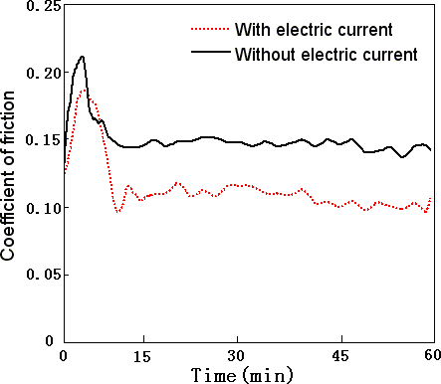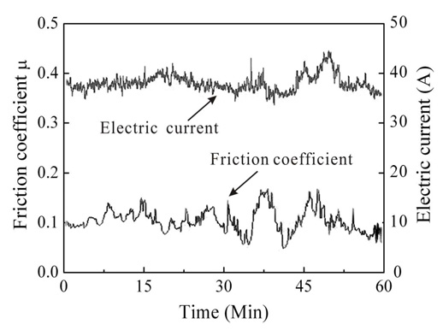

(a) (b)

Fig. 1 Friction coefficient: (a) variation of friction coefficient with and without arc discharge;

(b) relation with variation of electric current and friction coefficient with time;

* 1. *Wear rate of carbon strip materials*

Fig. 2 shows that the wear rate of carbon strip without electric current is much larger than that without electric current. Fig.3a shows that the contact temperatures increase with increasing of electric current. At

the same time, the wear rate with arc discharge is much larger than that without arc discharge, as shown in Fig. 3b. That suggests that the wear of carbon strip is significantly affected by the temperature rise and arc discharge.

0.30

0.25

0.20

Wear rate (g/h)

0.15

0.10

0.05

0.00

0 10 20 30 40 50 60 70

Electric current (A)

Fig. 2 Variation of wear rate of carbon strip with electric current

300



240

Temperature (Oc)

180

0.32

0.28

Without arc discharge With arc discharge (50 A)

0.24

Wear rate (g/h)

120

0.20

60

0

0 10 20 30 40 50 60 70

Electric current (A)

0.16

0.12

160 180 200 220 240 260 280 300

Temperature ( Oc)

(a) (b)

Fig. 3 Effect of temperature rise and arc discharge on wear rate: (a) variation of temperature rise with electric current; (b) comparison of wear rate with and without arc discharge

* 1. *SEM micrograph of worn surface of carbon strip material*

Fig. 4 displays the scanning electron microscope micrographs of a worn surface of carbon strip in different magnifications. Fig.4a shows that there are many furrow, debris and arc ablation pits on the worn surface. Fig. 4b and c are gradually amplified in the zone A in the Fig. 4a. That suggests that thermal wear, arc erosion and abrasive wear occur in the process of electrical sliding friction.

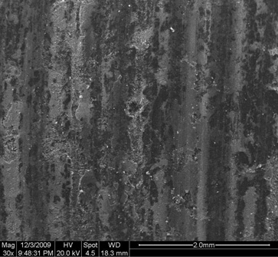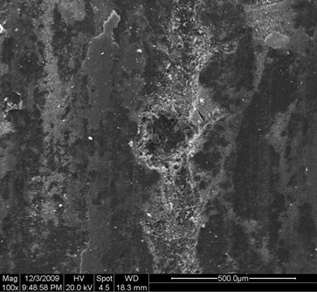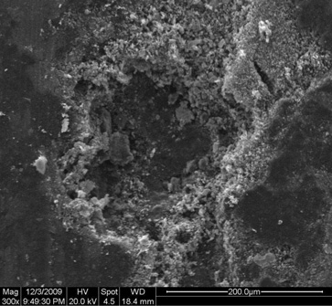

B

C

A

## (b) (c)

Fig. 4 SEM morphology of the worn surface of carbon strip in different magnifications:

(a) 30h; (b) 100h; (c) 300h

* 1. *EDX spectroscopy of worn surface of carbon strip material*

Fig. 5 shows the energy dispersive X-ray spectroscopy of the worn surface of carbon strip. It can be seen black carbon region in zone B of Fig. 4b is mainly compose of carbon element and contains oxygen, copper and sulfur elements, as shown in Fig. 5a. While the carbon strip material is compose of C element and a few S and O elements. That suggests that the material transfer occurs in the process of electrical sliding friction. Fig.5b shows the EDX spectroscopy of arc ablation pit in zone C of Fig. 4c. In comparison with Fig. 5a, the increasing of O and Cu peaks and the reduction of C peak can be clearly observed. That is attributed to serious metal oxidation and deposition of oxide layer on worn surface due to arc discharge and its temperature rise.

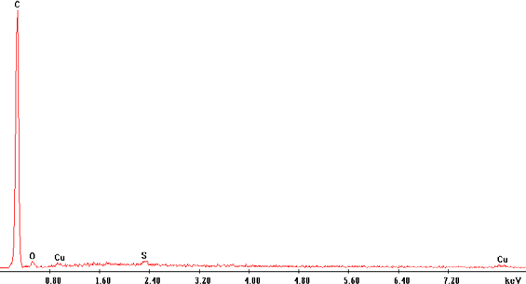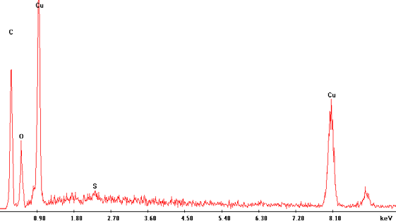

(a) (b)

Fig. 5 EDX spectrum of worn surface of carbon strip in different regions: (a) B zone of Fig. 4b, (b) C zone of Fig. 4c

1. Conclusions:

The coefficient of friction with electric current is smaller than that without electric current. And the variations of the friction coefficient and the electric current with time have the same trend in the process of carbon strip rubbing against copper. The wear rate of carbon strip increases with increasing electric current. The thermal wear, arc erosion and abrasive wear are the dominant wear mechanism occurring in electrical sliding frictional process, and accompanying with material transferring.

## Acknowledgement

It is a project supported by National Science and Technology Support Program (N0. 2009BAG12A01- D06-1).

## Reference

1. D. H. He, Rafael R. Manory, Norm Grady. Wear of railway contact wires against current collector materials [J]. Wear (1998), 215: 146-155.
2. G.X. Chen, F.X. Li, M.H. Zhu, Z.R. Zhou. Friction and wear behavior of stainless steel rubbing against copper-impregnated metalized carbon [J]. Tribology International, vol. 42, 934-939, 2009.
3. S. Kubo, Koji Kato. Effect of arc discharge on wear rate of Cu-impregnated carbon strip in unlubricated sliding against Cu trolley under electric current [J]. Wear (1998), 216: 172-178.
4. T. Ding, G.X. Chen, M.H. Zhu, W.H. Zhang, Z.R. Zhou. Influence of the spring stiffness on friction and wear behaviours of stainless steel/copper-impregnated metallized carbon couple with electrical current, Wear, 267, 1080-1086, 2009.
5. C.R.F. Azevedo, A.Sinatora. Failure analysis of a railway copper contact strip [J]. Engineering failure analysis (2004), 11:829-841.
6. L. Dong, G.X. Chen, et al. Wear mechanism of aluminum-stainless steel composite conductor rail sliding against collector shoe with electric current [J]. Wear (2007), 263: 598-603.
7. R. Elleuch, K. Elleuch, H.B. Abdelounis, H. Zahouani, Surface roughness effect on friction behaviour of elastomeric material[J]. Materials Science and Engineering A (2007), 465: 8-12.
8. A. Bouchoucha, S. Chekroud, D. Paulmier, Influence of the electrical sliding speed on friction and wear processes in an electrical contact copper-stainless steel [J]. Applied Surface Science(2004), 223: 330-342.
9. H. Zhao, G.C. Barber, J. Liu, Friction and wear in high speed sliding with and without electrical current [J]. Wear (2001), 249: 409-414.