[Applied Computing and Informatics 14 (2018) 98–105](http://dx.doi.org/10.1016/j.aci.2017.05.005)



Contents lists available at [ScienceDirect](http://www.sciencedirect.com/science/journal/22108327)

Applied Computing and Informatics

journal homepage: [www.sciencedirect.com](http://www.sciencedirect.com/)

Original Article

Genetic-neuro-fuzzy system for grading depression



Kumar Ashish a, Anish Dasari a, Subhagata Chattopadhyay b, Nirmal Baran Hui a,⇑

a *Department of Mechanical Engineering, National Institute of Technology, Durgapur, West Bengal 713209, India*

b *Sr. Faculty, Indus Training & Research Institute (ITARI), Billapura Cross, Sarjapur, Bangalore 562125, Karnataka, India*

# a r t i c l e i n f o

*Article history:*

Received 11 April 2017

Revised 15 May 2017

Accepted 18 May 2017

Available online 25 May 2017

*Keywords:*

Depression modeling Neuro-fuzzy system Genetic algorithm Automated tuning

Identification of redundant rules

# a b s t r a c t

Main aim of this study is to develop a software prototype tool for grading and diagnosing depression that will help general physicians for first hand applications. Identification of key symptoms responsible for depression is also another important issue considered in this study. It involves collection of data taken from patients through doctors. Due to several reasons, collection of data in Indian scenario is extremely difficult and thus this tool will be very handy and useful for general physicians working at remote loca- tions. Also, it is possible to collect a data pool through this software model. An intelligent Neuro-Fuzzy model is developed for this purpose. Performance of the said model has been optimized through two approaches. In Approach 1, where a back-propagation algorithm has been considered and in Approach 2, Genetic Algorithm has been used. The model is trained with 78 data and validated with 10 data. Approach 2 superseded Approach 1 in terms of diagnostic accuracy. Therefore, it can be said that the soft computing-based diagnostic models could assist the doctors to make informed decisions. Data for train- ing and validation for this purpose has been collected during 2004–2005 from a Government mental hos- pital in India.

© 2017 The Authors. Production and hosting by Elsevier B.V. on behalf of King Saud University. This is an

open access article under the CC BY-NC-ND license (<http://creativecommons.org/licenses/by-nc-nd/4.0/>).

1. Introduction

WHO says ‘‘depression is a common illness worldwide” and it is a growing risk [1–3]. There could be several factors contributing to depression and it is closely related to physical health [1–3]. There exist known and effective treatment procedures, which reach less than half of the sufferers [1,4]. There are several reasons such as lack of trained professionals and lack of resources [1], silent pro- gression [5], social stigma [6] and perception difference among

*Abbreviations:* BP, Back Propagation; DB, Data Base; FS, Feeling Sad; FL, Fuzzy Logic; GP, General Physician; GA, Genetic Algorithm; H, Hypersomnia; IN, Insom- nia; LA, Loss of appetite; LP, Loss of Pleasure; m, Mild; M, Moderate; MSE, Mean Squared Error; NN, Neural Network; PA, Psychomotor Agitation; RBFN, Radial Basis Function Network; RB, Rule Base; s, Severe; SC, Soft Computing; WL, Weight Loss; WHO, World Health Organization.

* Corresponding author.

*E-mail addresses:* [ashish5srivastava@gmail.com](mailto:ashish5srivastava@gmail.com) (K. Ashish), [anish.d47@gmail.](mailto:anish.d47@gmail.com) [com](mailto:anish.d47@gmail.com) (A. Dasari), [subhagata.chattopadhyay@itari.in](mailto:subhagata.chattopadhyay@itari.in) (S. Chattopadhyay), [nirmalhui@](mailto:nirmalhui@gmail.com) [gmail.com](mailto:nirmalhui@gmail.com) (N.B. Hui).

Peer review under responsibility of King Saud University.

**Production and hosting by Elsevier**

doctors leading to ‘under’ or ‘over’ diagnoses [7]. So, diagnosis has to be proper to reduce the disease load [8].

SC techniques are applied for screening and diagnosing the dif- ferent ailments [9,10] in the last couple of decades. Clustering techniques alone are applied for grading of depression [11]. How- ever, Chattopadhyay et al. [12] combined fuzzy logic with cluster- ing for capturing the symptoms psychiatric diseases of human being. They later developed a NN-based toolbox for grading of adult depression [13] and classified it into three categories namely, ‘mild’, ‘moderate’, and ‘severe’ [13]. Tai and Chiu [14] used RBFN to understand the reasons for suicidal tendencies of Taiwanese sol- diers. Chattopadhyay [15] developed a fuzzy-based automated model for grading depression. Later stage, Chattopadhyay et al.

[16] tried to minimize the overlapping among the three different grades of depression. Regression analysis is also used for the sim- ilar purpose by Chattopadhyay and Acharya [17].

It is understood from the literature that grading of depression is a difficult task. It is mainly because of the non-availability of the data. It may of different reasons which are indicated below.

1. social stigma,
2. majority of the patients do not approach to psychiatrists first, they approach to general physicians and when it becomes severe then comes to the psychiatrists,

<http://dx.doi.org/10.1016/j.aci.2017.05.005>

2210-8327/© 2017 The Authors. Production and hosting by Elsevier B.V. on behalf of King Saud University.

This is an open access article under the CC BY-NC-ND license (<http://creativecommons.org/licenses/by-nc-nd/4.0/>).

1. non existence of systems of collecting data by the doctors. For the first time reporting to the doctors, majority of the patients are prescribed medicines. As a result true picture of the patients are not available to the doctors,
2. inferior health management system.

Therefore, basic purpose of our study is to develop a prototype tool which forecasts depression better than the general physicians. In this context, SC-based techniques are found to provide formid- able solutions. However, performance of SC-based techniques depends on its formulation and optimization of the same. Out of different SC-based models, neuro-fuzzy models are finding wide applications in the recent times in different field with high predic- tion accuracies [18,19]. Development of a neuro-fuzzy-based soft- ware prototype model has been made in this study. It has been observed that, the performance of neuro-fuzzy systems depends on its DB and RB [20]. In majority of the case, user defined the same, which in no sense becomes optimal. Some researchers tried to combine different SC-based techniques. Therefore, the main contribution of this work is the development of a neuro-fuzzy- based prototype model for grading depression. Later, performance of the developed approach was made through two optimization methods, namely back-propagation algorithm and genetic algo- rithm. The model will be used by the general physicians for collect- ing more data. After proper validation with large set of data, it will be given for use to the psychiatrists/experts of mental health prob- lems. Presently, the model is validated using data given by the clin- icians. However, the model is evolutionary in nature and thus, it might handles uncertainty, impreciseness present (which are pre- dominant) in the system in much broader way.

The developed neuro-Fuzzy model and its optimization proce- dures using two approaches are described in Section 2 and results have been analyzed in Section 3. Final outcomes of the work are discussed and future directions are mentioned in Section 4.

1. Methodology

Collecting depression data is very difficult. It is because of dif- ferent reasons such as (i) prevailing social stigma, especially in the developing nations, (ii) difficulties in accessing the psychia- trists as they are very few in numbers, (iii) non-existence of system for collecting data by the doctors and so on. Together it leads to

* 1. *Neuro-fuzzy model construction*

A Mamdani-type [21] NN-FL model was developed by Hui et al.

[20] is used in this study for grading depression (refer to Fig. 1). Interested readers may go through the paper of Hui et al. [20,22] for detailed discussion on the development of NN-FL system. In the present study, seven inputs representing the seven different symptoms and one output representing the depression is used. Three different grades of the inputs are considered (*m*, *M* and *s*). The data base of the NN-FL system is shown in Fig. 2. Since there are three possibilities (i.e., mild, moderate and severe) of the load of each of seven inputs, there will be 37 = 2187 numbers of possible input combinations, for which grades of depression would vary as mild, moderate and severe, based on the symptom load. Manually constructed rules are presented in Table 1 and one particular rule (say the first rule of the above table) looks like:

If *FS* is *m* & *LP* is *m* & *WL* is *m* & *IN* is *m* & *H* is *m* & *LA* is *m* & *PA* is

*m* THEN *Depression* is *M*.

For more details related to rule based selection, identification of relevant rules, optimization using GA and gravitational search algorithm, interested readers may go through [23–31].

The performance of the above NN-FL system largely depends on those rules and different weights such as V1, V2, V3, V4, V5, V6, V7 and W1. The NNFL system will have variable structure only when rule base of the FLC is optimized i.e., some rules are deleted. There exist a large number of literatures for developing an optimal NNFL system. In the present study two different approaches have been adopted. Both these two approaches have been explained below in brief.

* 1. *Approach 1: Tuning using a BP algorithm*

In this approach, RB is kept unaltered during its training. Only the weights V1, V2, V3, V4, V5, V6, V7 and W1 are optimized using BP algorithm [32]. It is usually implemented through the mini- mization of Mean Squared Error (E) in prediction, as given below.

*C*

= 1 X( 5*c* — 5*c*) ( )

*E T O* 2 1

2*C c*=1

where *T*5*c* and O5*c* represent the target and model predicted outputs of *cth* training scenario.

The change in W1 that is DW1 is determined as

real a challenge in obtaining the clean data. The basic aim of this study is to build a software toolbox that will be of help for the

@*E*

D*W*1 = —g @*W*1

(2)

GPs, who is the first point of contact to the patients and data will be possible to be collected.

where g indicates the learning rate and @*E* is expressed as follows:

@*E* @*E* @*O*5*c* @*I*5*c*

@*W*1

*2.1. Data collection*

A study is made on 312 patients reported to one of the famous mental hospital in India in the year 2004–2005. Those patients reported to the hospital for the first time and they did not take any medicines before reporting to the hospital. They are then grouped in two. First group belongs to the patients who have sui-

@*W*1 = @*O*5*c* @*I*5*c* @*W*1 (3)

Similarly, the change in V*i* that is DV*i* can be calculated as follows

@*E*

D*Vi* = —g @*Vi* (4)

where @*E* can be calculated as:

@*V*

*i*

cidal ideations and require immediate treatment. However,

@*E* @*E* @*O*5*c* @*I*5*c* @*O*4*P* @*I*4*P*

@*O*3*K*

@*I*3*K* @*O*2*M* @*I*2*M*

patients belonging to the second group (total 88 patients) were further analyzed towards the severity of depression. Therefore, there exist 88 data; out of which 78 has been used for training/

@*Vi* = @*O*5*c* @*I*5*c* @*O*4*P* @*I*4*P* @*O*3*K*

@*I*3*K*

@*O*2*M* @*I*2*M*

@*Vi* (5)

optimizing the neuro-fuzzy architecture and rest 10 have been used for testing the performance of optimized architecture. Seven common symptoms (FS, LP, WL, IN, H, LA, PA) are then observed by three senior psychiatrists. Doctors are then requested to quan- tify the symptoms and severity of depression with which those 88 patients are suffering.

* 1. *Approach 2: Tuning using genetic algorithm*

Approach 1 suffers from the local minima problem. Also, in Approach 1, only the weights are optimized. Therefore, in Approach 2, optimization of both DB and RB is attempted using a GA. GA with 4454-bits long string is used for this purpose. Data

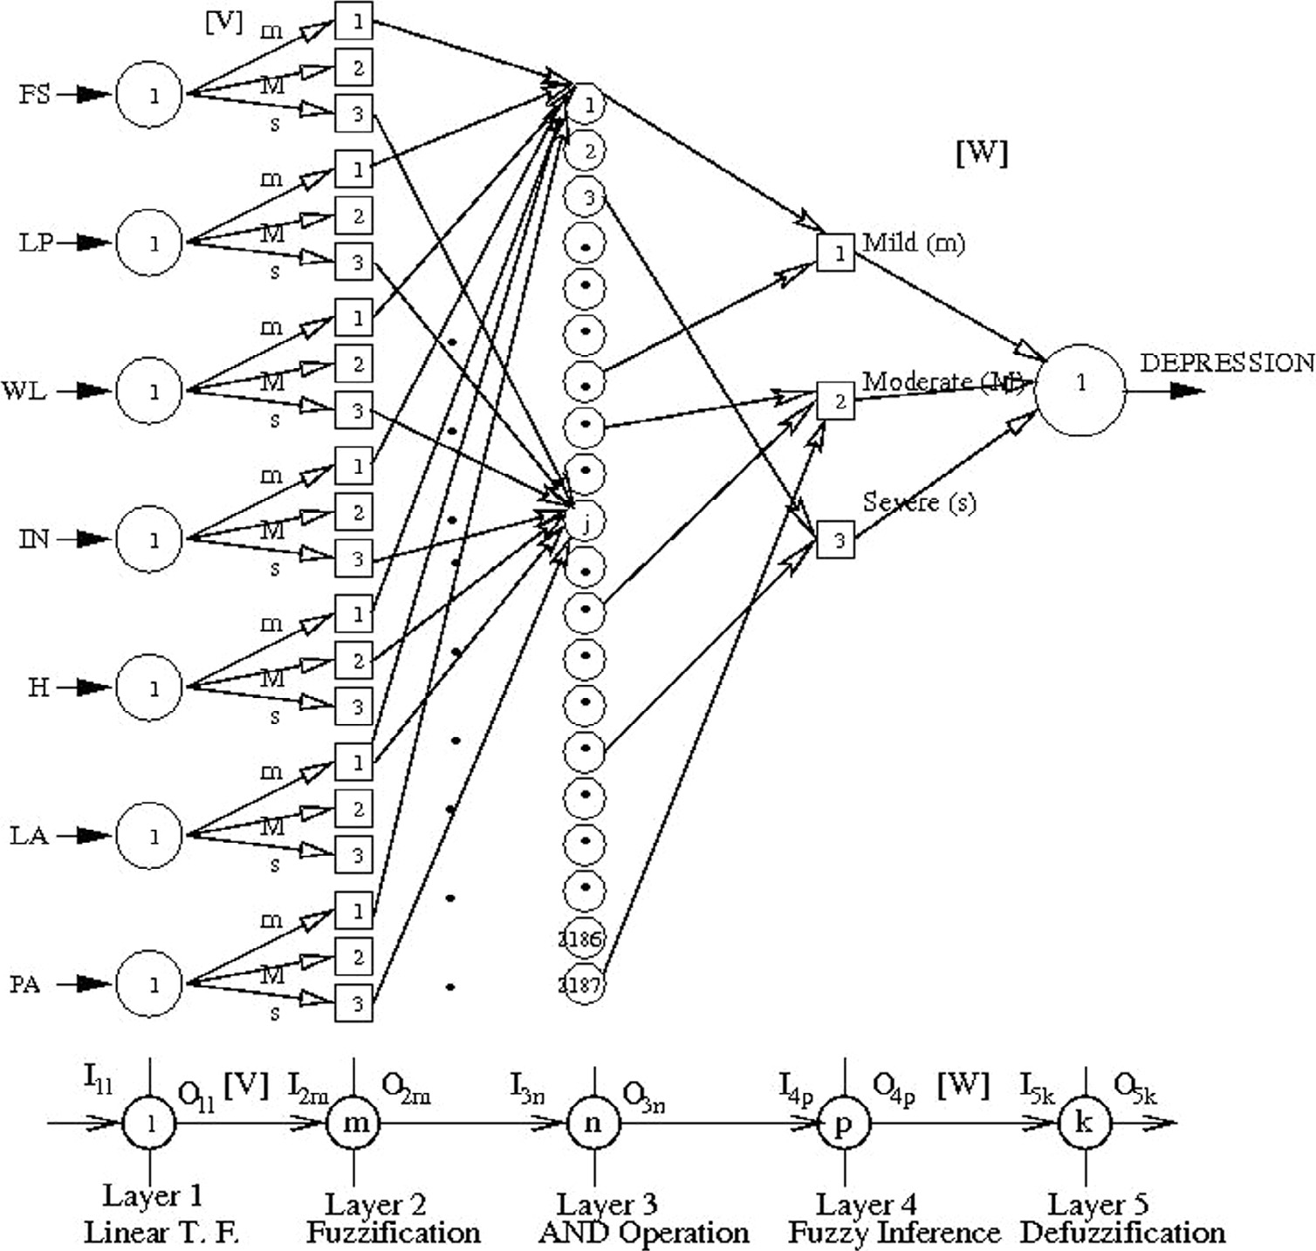

Fig. 1. The proposed NN-FL system.

base is represented by first 80 bits (10 bits for each variable). Rest 4374-bits are used to express the rule base (two bits to represent a rule: 00 for medium, 01 and 10 for moderate and 11 for severe). A string will look like the following.

## 01..1 01..1 01..1 01..1 01..1 01..1 01..1 01..1 00 00

|ﬄﬄ{*V*zﬄ} |ﬄ{*V*zﬄ} |ﬄ{*V*zﬄ} |ﬄﬄ{*V*zﬄ} |ﬄ{*V*zﬄ} |ﬄ{*V*zﬄ} |ﬄﬄ{*V*zﬄ} |ﬄ*W*{zﬄ} |*R*{*ul*z*e*1} |*R*{*ul*z*e*1}

1

2

3

4

5

6

7

1

Let us suppose that nij denotes the number of times that the jth linguistic term (j = 1 for mild, j = 2 for moderate and j = 3 for sev- ere) for the ith input condition (i.e., corresponding to different input values) is fired during training. In this way, total numbers of fired rules are represented by N. Thus, the probability of occurrence of the jth linguistic term for the ith input condition may be given as

## .......... ........... 00 00

follows

*Ru*|*le*{2z1}86 *Ru*|*le*{2z1}87

The detailed working principle of combined GA-NN-FL is avail-

*pij*

*nij*

## = *N* , where i = 1, 2, 3, .. . 2187 and j = 1, 2, 3. (6)

The probability of occurrence of a rule will indicate the neces-

able in [20,22]. Since GA is a population based search and each population is to be assigned a fitness, mean squared error (refer to Eq. (1)) in prediction of degree of depression is considered as the fitness for each population. GA aims at finding that particular solution which gives lowest error in predicting degree of depres- sion. Also, through this approach, it is possible to reduce the num- ber of rules.

* + 1. *Identification of redundant/unimportant rules*

It is very difficult for a doctor to remember a large number of

sity of keeping that rule in the RB. It is then multiplied with the worth of a rule (i.e., contribution of any linguistic term towards the output) to determine the importance factor. We have assumed the worth of any linguistic term for the depression follow a Gaus- sian distribution pattern. The maximum worth is taken to be equal to 1 when error in prediction is zero. Otherwise it decreases with the increase in error.

Let us say that, Cj is the worth of the jth linguistic term

*x* —1 2

1

*j*

rules. Some of the GA-optimized rules may be redundant (are not important) in the context of the problem. Therefore, it will be nicer

*C* 1

2p2

*j* =

*e*—2

,ﬃ2ﬃp

(7)

to eliminate them from the rule base. However, identification of redundant rules is difficult. In this paper, we have planned to iden- tify them using the concept of importance factor. Rules having rel- atively low importance factors are called as redundant and may be deleted from the rule base. It is to be done in such a way so that non-firing of rules does not occur.

where *xj* = 0.005 + (*j* — 1)*W* and *W* denotes the half of the triangu- lar base of the data base and is different for different chromosomes of GA. Thus the average worth over the optimization procedure is taken into account for the determination of importance factor of a rule.

The importance factor of a rule may be determined as follows

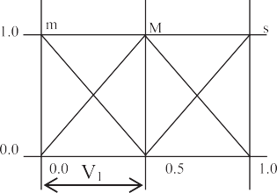

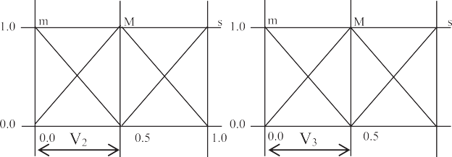

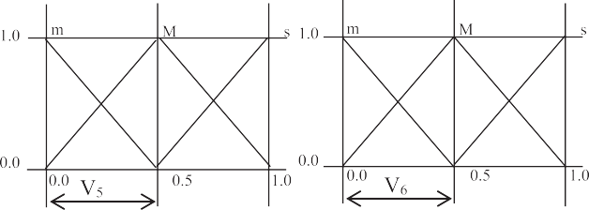

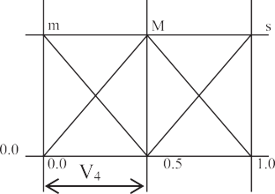





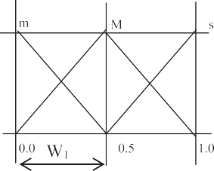Fig. 2. DB of the input and output variables.

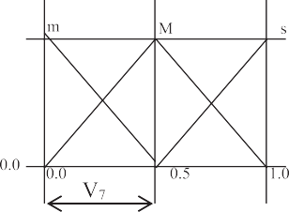

Table 1

Manually constructed RB.

|  |  |  |  |  |  |  |  |  |
| --- | --- | --- | --- | --- | --- | --- | --- | --- |
| Rule No. | FS | LP | WL | IN | H | LA | PA | Depression |
| 1 | m | m | m | m | M | m | m | m |
| 2 | m | m | m | m | M | m | M | m |
| 3 | m | m | m | m | M | m | s | m |
| .. | .. | .. | .. | .. | .. | .. | .. | .. |
| .. | .. | .. | .. | .. | .. | .. | .. | .. |
| 236 | m | m | s | s | S | m | M | s |
| .. | .. | .. | .. | .. | .. | .. | .. | .. |
| .. | .. | .. | .. | .. | .. | .. | .. | .. |
| 2187 | s | s | s | s | S | s | s | s |

1

*I*

*i* = 2 (*Pij* × *Cj*) (8)

A particular rule is considered to be redundant if the impor- tance factor of that rule is very low and can be eliminated only when non-firing does not arise. Let us understand the same through an example. If we consider, S = 0.3, P = 0.3, W1 = 0.3, I1 = 0.3, H = 0.3, A = 0.3 and P1 = 0.3. So, all the inputs can be clas- sified as either mild (m) or moderate (M) (refer to Fig. 2). Therefore, at a time 27 = 128 rules out of existing 2187 rules will be fired. Now, out of those 128 rules, if one such rule is absent in the rule base, there will be a non-firing of such a rule. One training/test sce- nario represents one input set, resulting in possibility of a maxi- mum 128 non-firing situations. Therefore, during training with 78 training cases, there is a possibility of 128 78 = 9984 non- firing situations, if for every case all the fired rules are absent. Moreover, FLC is tuned using GA, therefore, maximum possible

×

non-firing situations = maximum number of generations ×

populations × 9984.

1. Results and discussions

Two approaches as explained in Section 2 are used to train NN- FL system. Out of the 88 data, 78 are used for training and 10 are used for validation. During this process, all the weights are varied

in between 0.1 and 0.45. In Approach 1, learning rate (g) is system-

atically varied in range of 0.01–0.5 and result is noted. Fig. 3 shows the variation of g with MSE and best result is obtained with g = 0.05. This study is done considering the number of iterations

equal to 15. Lowest MSD is found to be equal to 0.0116043 (refer to Fig. 4). Through this process optimal weights are found to be V1 = 0.4161; V2 = 0.4469; V3 = 0.4507; V4 = 0.4469; V5 = 0.4405;

V6 = 0.4232; V7 = 0.4357 and W1 = 0.3425.

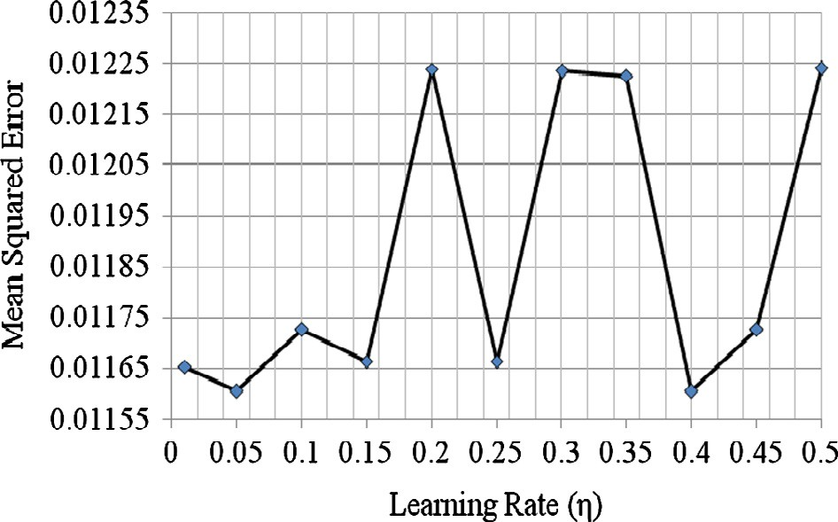

Fig. 3. MSE vs. g.

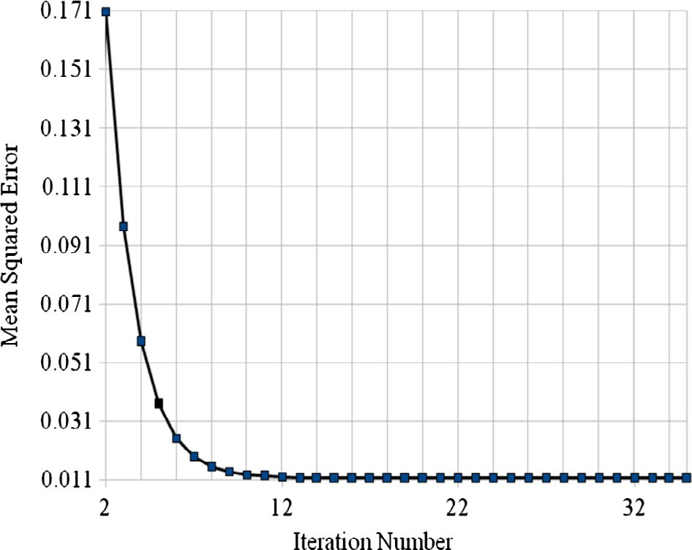

Fig. 4. MSE vs. iteration number with g = 0.05.

Three GA parameters influence the performance of Approach 2. Therefore, GA parametric study is carried out systematically vary- ing other parameters keeping one parameter constant for each run of algorithm. During this process, crossover probability is set at 0.5. The best mutation probability is determined varying it within 0.01–0.1 in a step of 0.01. Similarly, optimal number of GA popula- tion is also obtained. Finally, with the best mutation probability and population size, GA is run for 500 generations and optimal parameters are noted. Figs. 5–7 show the corresponding results.

An attempt has also been made to identify the redundant rules and thereafter those rules have been removed from the rule base. The importance factors thus found for all the rules during the train- ing is presented in Fig. 8. After removing certain number of rules which were found to have lower values of importance factor, the number of non-fired scenarios and the corresponding errors for both the training set (containing 78 data sets) and the test set (con- taining 10 data sets) were calculated and tabulated in Table 2. Zero non-fired scenarios have been observed with the removal of 500 rules out of 2187 during test cases and only 25 non-fired situations happened for the training data-sets. Therefore, final result has been taken removing 500 rules from the rule-base. The reason behind removing 500 rules is – (i) it does not give rise to any non-firing sit- uations of the rule base for the test cases and (ii) no further improvement in error in prediction. It has been observed that there exist three different zones of importance factors. Moreover, nearby rules (say rule no 1819 and 1820) have same large importance fac- tors. It might have happened because of the following reasons: (a)

Mutation Probability x 10 

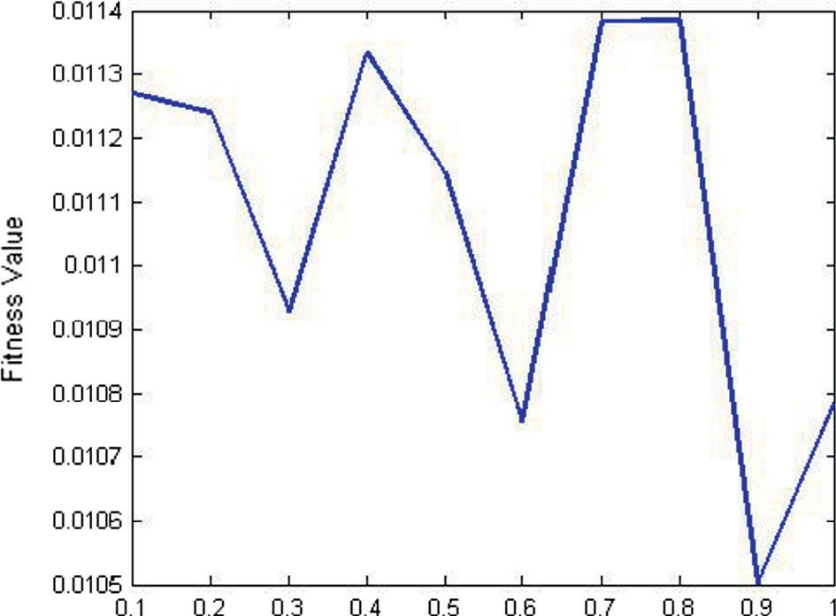Fig. 5. MSE vs. mutation probability.

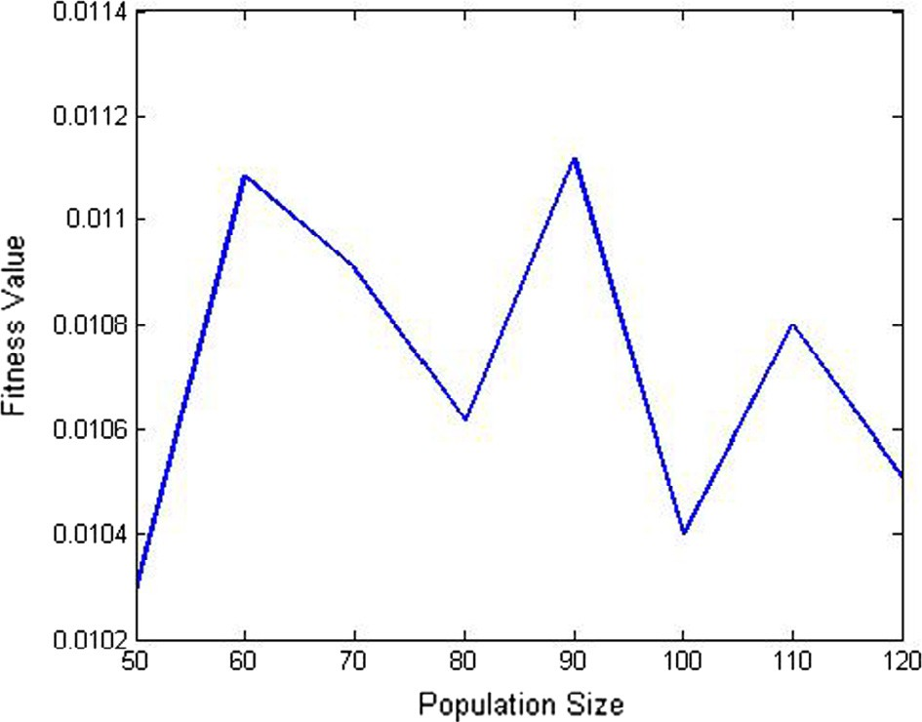

Fig. 6. MSE vs. population size.

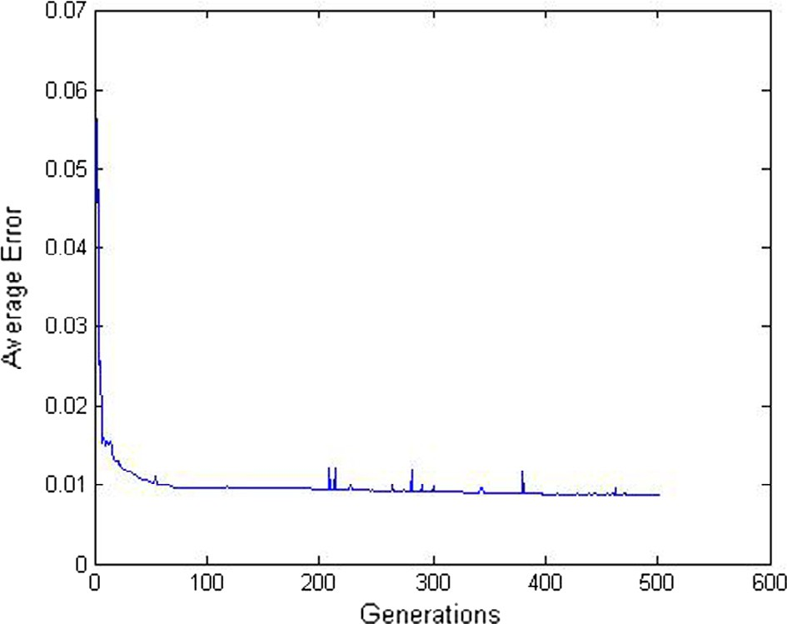

Fig. 7. MSE vs. maximum number of generations.

there are only three linguistic terms representing depression (mild, moderate and severe). Therefore, there could be three different zones of the importance factor. Each zone will have some mean

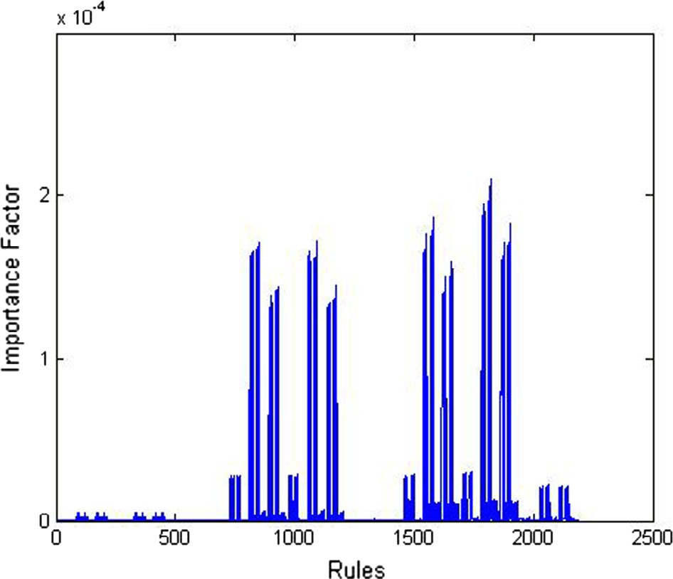

Fig. 8. Importance factor of the rules during training.

and a range, (b) high value of importance factor means more num- ber of firing of such a rule during the process. Since we have con- sidered triangular membership function distributions, which are symmetric in nature, therefore, rules having linguistic terms mild and moderate will have chance of firing at the same time.

Following things have been observed in the rule base.

Type A: 835 rules out of total 2187 rules have not been modified by the GA. It clearly indicates that those are the rules in princi- ple and even their important factor is low, still they can never be omitted from the rule base. For example, Rule nos. 1822 and 1823 are of such a rule (refer to Table 3).

●

Type B: 1106 rules out of total 2187 rules have been modified slightly (i.e., mild to moderate, moderate to severe, moderate to mild, severe to moderate). For example, Rule nos. 1795 and 1796 are of such a rule (refer to Table 3). It indicates that there is a overlapping in the decision making process of the doctors and they often could not clearly defined the rules. Authors have arranged these rules according to their importance factor and deleted those which have low importance factor.

●

Table 2

|  |  |  |  |  |  |  |
| --- | --- | --- | --- | --- | --- | --- |
| Non-fired scenarios vs. no. of rules removed. |  | | | | | |
| Total no. of rules removed out of total | No. of non-firing scenarios |  |  | Error in prediction |  |  |
| 2187 rules present in the rule base | Training cases | Test cases |  | Training cases | Test cases |  |
| 2000 | 3312 | 440 |  | 0.012633359 | 0.01368848 |  |
| 1600 | 1464 | 188 |  | 0.012357538 | 0.01330318 |  |
| 1500 | 1280 | 160 |  | 0.012655688 | 0.01368225 |  |
| 1400 | 1011 | 133 |  | 0.012416698 | 0.01368225 |  |
| 1300 | 862 | 105 |  | 0.012416698 | 0.01368225 |  |
| 1200 | 615 | 80 |  | 0.012416698 | 0.01368225 |  |
| 1100 | 507 | 61 |  | 0.012416698 | 0.01368225 |  |
| 1000 | 315 | 37 |  | 0.012416698 | 0.01368225 |  |
| 500 | 25 | 0 |  | 0.012416698 | 0.01368225 |  |
| 105 | 0 | 0 |  | 0.012416698 | 0.01368225 |  |
| Table 3 |  |  |  |  |  |  |

Some important rules.

Rule No. FS LP WL IN H LA PA Depression Importance factor

Manual Optimized

1 m m m m m m m m s 1.26 × 10—9

9 m M m m m s s s m 2.62 × 10—9 1795 s M M m M M m M s 0.000189

1796 s M M m M M M M m 0.00019

1822 s M M M M M m M M 0.000208

1823 s M M M M M M M M 0.00021

Table 4

Predicted Depression (PD) vs. Target Depression (TD).

No. FS LP WL IN H LA PA *TD PD* %Error

App. 1 App. 2 App. 1 App. 2

1 0.7 0.8 0.5 0.5 0.5 0.6 0.7 0.59 0.6216 0.6182 —5.37 —4.78

2 0.6 0.5 0.5 0.9 0.6 0.9 0.9 0.66 0.6191 0.6161 6.18 6.65

3 0.8 0.6 0.6 0.7 0.7 0.6 0.7 0.57 0.6032 0.5902 —5.83 —3.54

4 0.7 0.4 0.6 0.8 0.6 0.8 0.5 0.60 0.6521 0.6524 —8.69 —8.73

5 0.9 0.5 0.7 0.8 0.6 0.5 0.5 0.60 0.6178 0.6028 —2.97 —0.46

6 0.9 0.6 0.7 0.7 0.8 0.6 0.6 0.68 0.6070 0.6643 10.72 5.24

7 0.6 0.4 0.7 0.6 0.6 0.5 0.8 0.72 0.6557 0.6802 8.91 5.52

8 0.5 0.9 0.4 0.6 0.8 0.7 0.8 0.87 0.6979 0.7659 19.77 11.96

9 0.5 0.6 0.6 0.6 0.9 0.6 0.7 0.70 0.6519 0.6813 6.86 2.67

10 0.6 0.4 0.6 0.5 0.6 0.6 0.6 0.99 0.6509 0.6182 34.24 37.56

Average 0.698 0.6377 0.6489

Standard deviation 0.1351 0.0292 0.0522

Table 5

Predicted depression using Approach 2 and NN-based classifier system.

|  |  |  |  |
| --- | --- | --- | --- |
| Test Case No. | Target depression | Approach 2 | NN-based system |
| 1 | 0.59 | 0.6182 | 0.5263 |
| 2 | 0.66 | 0.6161 | 0.6070 |
| 3 | 0.57 | 0.5902 | 0.4047 |
| 4 | 0.6 | 0.6524 | 0.3870 |
| 5 | 0.6 | 0.6028 | 0.3348 |
| 6 | 0.68 | 0.6643 | 0.5010 |
| 7 | 0.72 | 0.6802 | 0.4019 |
| 8 | 0.87 | 0.7659 | 0.8133 |
| 9 | 0.7 | 0.6813 | 0.6110 |
| 10 | 0.99 | 0.6182 | 0.0741 |
| Average | 0.698 | 0.6489 | 0.4661 |
| Standard deviation | 0.1351 | 0.0522 | 0.1976 |

Type C: 286 rules out of total 2187 rules have been modified lar- gely (i.e., mild to severe and severe to mild, for example rule nos. 1 and 9 of Table 3). These are hypersensitive rules and exis- tence in the rule base causes wrong prediction. Therefore, authors tried to eliminate those rules as a whole and have noticed no change is observed in terms of non-firing scenarios.

●

It is also important to mention that rule no. 1823 is the best rule in terms of importance factor and it is also a rule in principle.

Table 4 shows the predicted depression values corresponding to the ten test cases. Percentage error in prediction is found to be low leaving the tenth case. It indicates that the developed model is a good fit one. Moreover, less percentage error is seen with Approach

2. It may be due to the optimized rule base in the Approach 2. Performance of the best NN-FL system i.e., Approach 2 is com-

pared with a NN-based classifier system. The NN-based system will have a three layered 7-6-1 architecture and the results have been presented in Table 5. It has been observed that the predicted depression by Approach 2 is much closer to the target depression compared to NN-based system. It may be due to the fact that logic-based controller works well in modeling depression of humans.

1. Conclusions and future work

In this study, an attempt has been made to develop a NNFL sys- tem for diagnosing depression based on seven different symptoms. Performance of NNFL-based diagnosing tool is improved through GA-based optimization. Both rule base as well as data base has been optimized using GA. Unfortunately, GA took huge time to evolve the good solution. There are reported works which have brought down the time consumed while running a GA-based opti- mizer in machine automation. However, it is important to note here that diagnosis of depression consumes months to get diag- nosed even by an expert psychiatrist and therefore speed is out of the scope of the paper. Still, to reduce the time the paper attempts to identify the redundant rules and analysis has been made to remove them by identifying the load of individual rules on the morbidity. Finally, performance of the optimized GA- tuned NNFL system is compared with that of back-propagation based NNFL system for ten different cases. It was found that the performance of GA-tuned NNFL system is better compared to the other one. Moreover, it has been observed that GA-tuned NNFL sys- tem has outperformed to a NN-based system. Therefore, Approach 2 can be of great help to the doctors for diagnosing the patients suffering from depression.

Presently forward mapping has been between the symptoms and the disease. However, it will be much more interesting if the reverse mapping is made, where it will be possible to identify the impact of a symptom on the disease. The authors are presently

working with this problem. It is also worth noting while reviewing literature we have come across few works on the said problems.

Acknowledgments

Authors are grateful to the doctors who helped them to collect the data and shared their experience.

References

1. WHO: Depression. <[www.who.int/mediacentre/factsheets/fs369/en/](http://www.who.int/mediacentre/factsheets/fs369/en/)>.
2. [A. Carson, The human illnesses: neuropsychiatric disorders and the nature of](http://refhub.elsevier.com/S2210-8327(17)30124-2/h0010) [human brain, BJPsych 200 (2012), 85–85](http://refhub.elsevier.com/S2210-8327(17)30124-2/h0010).
3. T. Bramesfeld, T. Grobe, F.W. Schwartz, Prevalence of depression diagnosis and prescription of antidepressants in East and West Germany: an analysis of health insurance data, Soc. Psychiat. Psychiatr. Epidemiol. 45 (2010) 329–335 (last accessed on 08/03/2012).
4. O.J. Robinson, C. Overstreet, A. Letkiewicz, C. Grillon, Depressed mood enhances anxiety to unpredictable threat, Psychol. Med. (2011) 1–11 (online first), <http://dx.doi.org/10.1017/S0033291711002583>.
5. [L. Eloul, A. Ambusaidi, S. Al-Adwai, Silent epidemic of depression in women in](http://refhub.elsevier.com/S2210-8327(17)30124-2/h0025) [the Middle East and North Africa region, Sultan Qaboos Univ. Med. J. 9 (2009)](http://refhub.elsevier.com/S2210-8327(17)30124-2/h0025) [5–15](http://refhub.elsevier.com/S2210-8327(17)30124-2/h0025).
6. [A.K. Surbey, Adaptive significance of low levels cooperation in depression,](http://refhub.elsevier.com/S2210-8327(17)30124-2/h0030) [Evol. Hum. Behav. 32 (2011) 29–40](http://refhub.elsevier.com/S2210-8327(17)30124-2/h0030).
7. [S. Titmarsh, I. Goodyer, Psychiatric diagnosis needs a more scientific approach,](http://refhub.elsevier.com/S2210-8327(17)30124-2/h0035) [Prog. Neurol. Psychiat. 15 (2011) 21–22](http://refhub.elsevier.com/S2210-8327(17)30124-2/h0035).
8. [B.M. Kwan, S. Dimidjian, S.L. Rizvi, Treatment preference, engagement, and](http://refhub.elsevier.com/S2210-8327(17)30124-2/h0040) [clinical improvement in pharmacotherapy versus psychotherapy for](http://refhub.elsevier.com/S2210-8327(17)30124-2/h0040) [depression, Behav. Res. Ther. 48 (2010) 799–804](http://refhub.elsevier.com/S2210-8327(17)30124-2/h0040).
9. [S. Chattopadhyay, D.K. Pratihar, S.C. DeSarkar, Fuzzy logic-based screening and](http://refhub.elsevier.com/S2210-8327(17)30124-2/h0045) [prediction of adult psychoses: a novel approach, IEEE Trans. Syst. Man](http://refhub.elsevier.com/S2210-8327(17)30124-2/h0045) [Cybernet. Part-A 39 (2009) 381–387](http://refhub.elsevier.com/S2210-8327(17)30124-2/h0045).
10. S. Chattopadhyay, D.K. Pratihar, Towards developing intelligent autonomous systems in psychiatry: its present state and future possibilities, Intell. Autonom. Syst. Stud. Comput. Intell. 275 (2010) 143–166 (Springer).
11. S.-C. Yu, U.H. Lin, Applications of fuzzy theory on health care: an example of depression disorder classification based on FCM, WSEAS Trans. Inform. Sci. Appl. 5 (2008) 31–36.
12. [S. Chattopadhyay, D.K. Pratihar, S.C. De Sarkar, Some studies on fuzzy](http://refhub.elsevier.com/S2210-8327(17)30124-2/h0060) [clustering of psychoses data, Int. J. Bus. Intell. Data Min. 2 (2007) 143–159](http://refhub.elsevier.com/S2210-8327(17)30124-2/h0060).
13. [S. Chattopadhyay, P. Kaur, F. Rabhi, U.R. Acharya, Neural network approaches](http://refhub.elsevier.com/S2210-8327(17)30124-2/h0065) [to grade adult depression, J. Med. Syst. 36 (5) (2011) 2803–2815](http://refhub.elsevier.com/S2210-8327(17)30124-2/h0065).
14. Y.-M. Tai, H.-W. Chiu, Artificial neural network analysis on suicide and self- harm history of taiwanese soldiers, in: Second International Conference on Innovative Computing, Information and Control (ICICIC’07), 2007, pp. 363– 363.
15. [S. Chattopadhyay, Neurofuzzy models to automate the grading of old-age](http://refhub.elsevier.com/S2210-8327(17)30124-2/h7065) [depression, Expert Syst.: J. Knowl. Eng. 31 (1) (2014) 48–55](http://refhub.elsevier.com/S2210-8327(17)30124-2/h7065).
16. S. Chattopadhyay, S. Banerjee, F.A. Rabhi, R.U. Acharya, A case-based reasoning system for complex medical diagnoses, Expert Syst.: J. Knowl. Eng. 30 (1) (2012) 12–20, <http://dx.doi.org/10.1111/j.1468-0394.2012.00618.x>.
17. [S. Chattopadhyay, U.R. Acharya, A novel mathematical approach to diagnose](http://refhub.elsevier.com/S2210-8327(17)30124-2/h0085) [premenstrual syndrome, J. Med. Syst. 36 (4) (2012) 2177–2186](http://refhub.elsevier.com/S2210-8327(17)30124-2/h0085).
18. Vlastimir Nikolic´, Vojislav V. Mitic´, Ljubiša Kocic´, Dalibor Petkovic´, Wind speed parameters sensitivity analysis based on fractals and neuro-fuzzy selection technique, Knowl. Inform. Syst. (2016) 1–11, [http://dx.doi.org/10.1007/](http://dx.doi.org/10.1007/s10115-016-1006-0) [s10115-016-1006-0](http://dx.doi.org/10.1007/s10115-016-1006-0).
19. Dalibor Petkovic´, Milan Gocic, Slavisa Trajkovic, Miloš Milovancˇevic´, Dragoljub Ševic´, Precipitation concentration index management by adaptive neuro-fuzzy methodology, Clim. Change 141 (4) (2017) 655–669, [http://dx.doi.org/](http://dx.doi.org/10.1007/s10584-017-1907-2) [10.1007/s10584-017-1907-2](http://dx.doi.org/10.1007/s10584-017-1907-2).
20. [N.B. Hui, V. Mahendar, D.K. Pratihar, Time-optimal collision-free navigation of](http://refhub.elsevier.com/S2210-8327(17)30124-2/h0100) [a car-like robot using a neuro-fuzzy approach, Fuzzy Sets Syst. 157 (2006)](http://refhub.elsevier.com/S2210-8327(17)30124-2/h0100) [2171–2204](http://refhub.elsevier.com/S2210-8327(17)30124-2/h0100).
21. [E.H. Mamdani, S. Assilian, An experiment in linguistic synthesis with a fuzzy](http://refhub.elsevier.com/S2210-8327(17)30124-2/h0105) [logic controller, Int. J. Man Mach. Stud. 7 (1975) 1–13](http://refhub.elsevier.com/S2210-8327(17)30124-2/h0105).
22. [S. Chattopadhyay, A neuro-fuzzy approach for the diagnosis of depression,](http://refhub.elsevier.com/S2210-8327(17)30124-2/h0110) [Appl. Comput. Inform. 13 (1) (2017) 10–18](http://refhub.elsevier.com/S2210-8327(17)30124-2/h0110).
23. [D. Pelusi, PID and intelligent controllers for optimal timing performances of](http://refhub.elsevier.com/S2210-8327(17)30124-2/h0115) [industrial actuators, Int. J. Simul. Syst. Sci. Technol. 13 (2) (2012) 65–71](http://refhub.elsevier.com/S2210-8327(17)30124-2/h0115).
24. [D. Pelusi, Designing neural networks to improve timing performances of](http://refhub.elsevier.com/S2210-8327(17)30124-2/h0120) [intelligent controllers, J. Discr. Math. Sci. Cryptogr. 16 (2–3) (2013) 187–193](http://refhub.elsevier.com/S2210-8327(17)30124-2/h0120).
25. [D. Pelusi, R. Mascella, Optimal control algorithms for second order systems, J.](http://refhub.elsevier.com/S2210-8327(17)30124-2/h0125) [Comput. Sci. 9 (2) (2013) 183–197](http://refhub.elsevier.com/S2210-8327(17)30124-2/h0125).
26. D. Pelusi, L. Vazquez, D. Diaz, R. Mascella, Fuzzy algorithm control effectiveness on drum boiler simulated dynamics, in: 36th International Conference on Telecommunications and Signal Processing, TSP, 2013, pp. 272– 276, Art. No. 6613935.
27. D. Pelusi, M. Tivegna, P. Ippoliti, Intelligent algorithms for trading the euro- dollar in the foreign exchange market, Math. Stat. Methods Actuar. Sci. Finan. (2014) 243–252.
28. [D. Pelusi, R. Mascella, L. Tallini, L. Vazquez, D. Diaz, Control of Drum Boiler](http://refhub.elsevier.com/S2210-8327(17)30124-2/h0140) [dynamics via an optimized fuzzy controller, Int. J. Simul.: Syst., Sci. Technol. 17](http://refhub.elsevier.com/S2210-8327(17)30124-2/h0140)

[(33) (2016)](http://refhub.elsevier.com/S2210-8327(17)30124-2/h0140).

1. [D. Pelusi, M. Tivegna, P. Ippoliti, Improving the profitability of Technical](http://refhub.elsevier.com/S2210-8327(17)30124-2/h0145) [Analysis through intelligent algorithms, J. Interdiscip. Math. 16 (2–3) (2013)](http://refhub.elsevier.com/S2210-8327(17)30124-2/h0145) [203–215](http://refhub.elsevier.com/S2210-8327(17)30124-2/h0145).
2. D. Pelusi, M. Tivegna, Optimal trading rules at hourly frequency in the foreign exchange markets, Math. Stat. Methods Actuar. Sci. Finan. (2012) 341–348.
3. D. Pelusi, R. Mascella, L. Tallini, Revised gravitational search algorithms based on evolutionary-fuzzy systems, Algorithms 10 (2) (2017), [http://dx.doi.org/](http://dx.doi.org/10.3390/a10020044)

[10.3390/a10020044](http://dx.doi.org/10.3390/a10020044), 44–44.

1. [D.K. Pratihar, Soft Computing,](http://refhub.elsevier.com/S2210-8327(17)30124-2/h0160) [Narosa Publishers, India, 2008](http://refhub.elsevier.com/S2210-8327(17)30124-2/h0160).