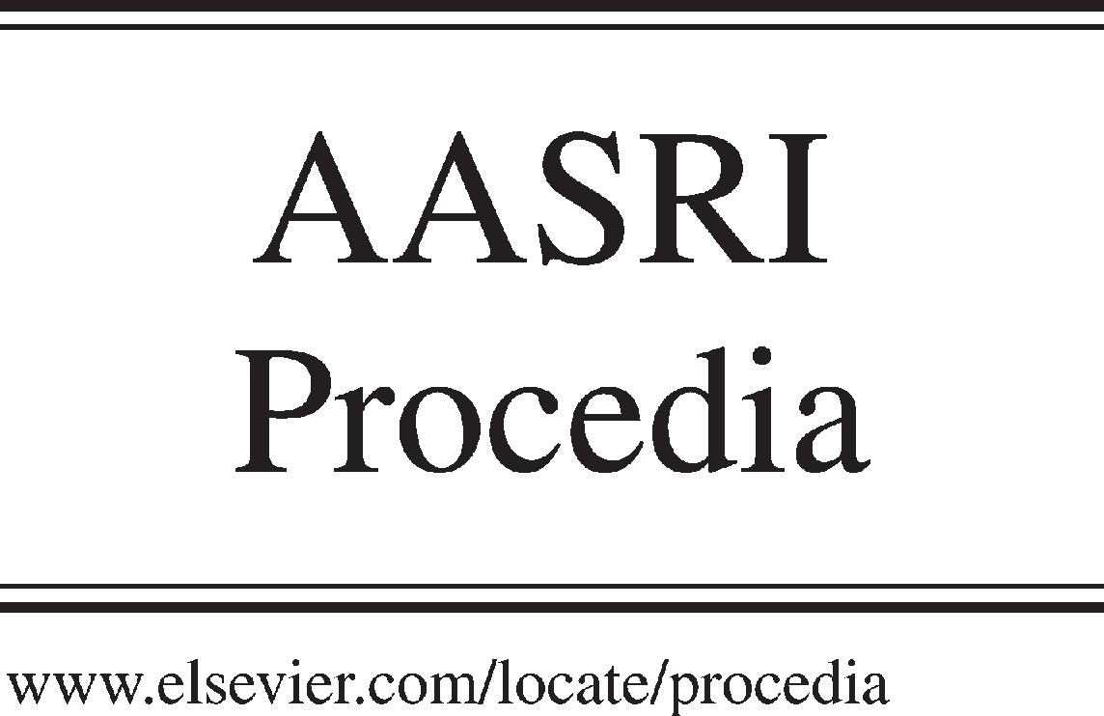Available online at [www.sciencedirect.com](http://www.sciencedirect.com/)



AASRI Procedia 3 (2012) 217 – 223

2012 AASRI Conference on Modelling, Identification and Control

Hydrogen Production from Biomass Pyrolysis in Molten Alkali

# Hongtao Jiang*, Yeru Wu, Hao Fan, Jianbing Ji

College of Chemical Engineering and Materials Science, Zhejiang University of Technology, Hangzhou 310014, China

**Abstract**

Pyrolysis of biomass to hydrogen rich gas in molten alkali media has been conducted in a stainless steel tank reactor. Molten alkali was used as thermal pyrolysis media. Six kinds of biomass were selected as feedstock. The experiments were carried out under atmospheric pressure and 350-550  . The pyrolysis gas was analyzed by gas chromatograph. The effects of the type of biomass, addition of additives and reaction conditions, including temperature and N2 flow rate, on hydrogen content in pyrolysis gas and yield of hydrogen were investigated. This paper reports the feasibility for producing hydrogen rich gas through the pyrolysis of biomass in molten salt media.

© 2012 The Authors. Published by Elsevier B.V. Open access under [CC BY-NC-ND license.](http://creativecommons.org/licenses/by-nc-nd/3.0/)

© 2012 Published by Elsevier B.V. Selection and/or peer rev[iew under responsi](http://creativecommons.org/licenses/by-nc-nd/3.0/)bility of American Applied Science Research Institute

Selection and/or peer review under responsibility of American Applied Science Research Institute

*Keywords:* biomass; pyrolysis; hydrogen; molten salts

## Main text

The inter-related problems of energy and environment are one of biggest challenges facing the world recently, especially for energy sustainability and carbon emissions from the utilization of fossil fuels. Many engineers and scientists agree that the solution to these problems would be to replace the existing fossil system by the hydrogen energy system [1, 2]. There are several established and developing technologies to produce hydrogen from various sources. Hydrogen production can be environmentally friendly only if the resource used to extract hydrogen would be rather biomass than fossil fuel, such as coal, petroleum and natural gas.

* * Corresponding author. Tel.:+86-571-88320598

*E-mail address:* [jht@zjut.edu.cn..](mailto:jht@zjut.edu.cn)

2212-6716 © 2012 The Authors. Published by Elsevier B.V. Open access under [CC BY-NC-ND license.](http://creativecommons.org/licenses/by-nc-nd/3.0/) Selection and/or peer review under responsibility of American Applied Science Research Institute doi:10.1016/j.aasri.2012.11.036

There are two main routes for biomass-based hydrogen production, namely thermo-chemical and bio-chemical. Thermo-chemical routes can produce hydrogen from continuous feed biomass rapidly. Thermo-chemical routes are gasification [3], pyrolysis of bio-oils [4], steam reforming of biomass derived higher alkanes and alcohols [5], and aqueous phase reforming of oxygenated hydrocarbons [6].

Molten alkali is ionic crystals under solid state and will melt into ionic liquid at high temperature. Molten alkali has properties of good electrical conductivity, broad service range of temperature, good thermal stability, low vapour pressure, large heat capacity, large thermal conductivity, good dissolution ability and low viscosity, as well as good chemical stability. Physical properties of molten NaOH and KOH are shown in table 1.

Table 1 Physical Properties of molten NaOH and KOH

Molten alkali

|  |  |  |  |  |
| --- | --- | --- | --- | --- |
|  | (cal/cm·sec·deg) | (cal/deg·mole) | (Cp) | (oC) |
| NaOH | 0.0022(400 oC ) | 19.8(400~900 oC ) | 2.817(400 oC ) | 1390 |
| KOH | 0.0021(400 oC ) | 19.9(320~990 oC ) | 1.292(500 oC ) | 1320 |

Thermal conductivity

Specific heat capacity

Viscosity

Boiling point

In our previous work [7], molten salts (ZnCl2-KCl) were used as media to produce bio-oil from biomass. In this work, pyrolysis of biomass in molten alkali media to produce hydrogen rich gas was carried out. Six kinds of biomass were selected as biomass samples. Molten NaOH was employed as media. The effects of the biomass samples type, reaction conditions, and additives on yield of gas product and content of hydrogen in gas product were investigated.

## Experimental setup

* 1. *Biomass samples*

In this work, agricultural and forestry wasters, including fir sawdust, birch sawdust, redwood sawdust, rice stalk, cole stalk and rice husk were used as biomass feed. The birch sawdust was from Northeast China and other biomass samples were from East China. The element (C, H, O, N and S) content in biomass materials was analyzed by a Vario elemental analyzer. The biomass sample was sieved and the fraction saved for the pyrolysis experiments was 60-100 mesh. The biomass sample was dried at 105  prior to the experiments.

* 1. *Reagents*

Sodium hydroxide, potassium hydroxide, nickel chloride, nickel hydroxide, palladium chloride, sodium chloride, nickel, alumina, and other reagents are from SINOPHARM Chemical Reagent Co. Ltd with purity of more than 99.0%.

* 1. *Test facilities*

The biomass pyrolisys was performed in an atmospheric pressure in molten alkali. The schematic lab-scale configuration is illustrated in Fig. 1. The pyrolysis reactor consisted of a reactor, a biomass screw feeder, a set of heater and a set of cooler. The stainless steel reactor had an inner diameter of 95 mm and a height of 150 mm, equipped with feed inlet, gas outlet, and thermocouple tube. The heating furnace with a programmed temperature controller was self-designed. The temperature was monitored and controlled by K-type thermocouples inside the thermocouple tube. A variable-speed DC motor was employed to adjust the rotational speed of the screw feeder. The gas flow was divided so that one third went through the bottom of

the reactor and the remaining two thirds through the feeder. At the end of feed tube, a cooling jacket was equipped to prevent coking as the biomass sample meets the molten alkali soon. The liquid products (bio-oil + water) were collected by condensing in cold traps maintained at about 0  . The cooler system was made of quartz, in favor of observing condensation condition. The noncondensable gases were collected by gas collector after metered by flow meter.

1

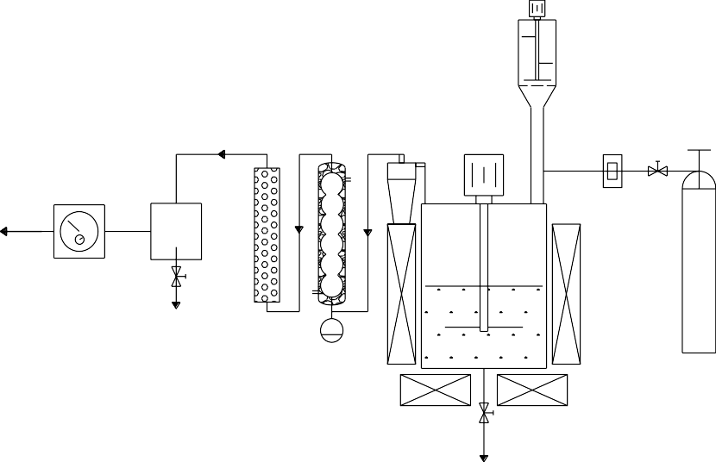

4

8

3 2

12

11

9

6

13

5

Sample

10

7

Fig. 1 Schematic diagram of experimental apparatus. (1-He cylinder, 2-pressure reducing valve, 3-flowmeter, 4-self-designed feeder, 5- oven, 6-reactor, 7-discharge valve, 8-cyclone separator, 9-glass condenser, 10-oil container, 11-water absorber, 12-gas container, 13- flowmeter.)

* 1. *Procedure*

Preliminary, about 700 g molten alkali was put into reactor. When the heating was started, nitrogen gas

-    

temperature reached the reaction temperature, the circulating cooling water system began to work and the pre- treated biomass sample was injected into the reactor through feeding system. The biomass underwent a flash pyrolysis and was converted into hydrogen rich gas, liquid product (bio-oil and water), and bio-coke (only taking up a small amount of total products).

The tests were performed under atmospheric pressure at five different temperatures: 350 °C, 400 °C, 450 °C, 500 °C and 550 °C. The N2 flow rate was kept from 60 to 200 L/h. The gas product was collected into a gas collector and examined by a SHIMADZU GC 17-A gas chromatograph equipped with a TDX-01 packed column. H2 content in gas product was calculated through area correction normalization method. The yield of H2 was calculated as:

***Fgas product***

***H*2 % *MH***

**2**

***Y***

***H***

***m***

**2**

***biomass sample***

**100%**

YH2  H2 yield; Fgas-product  volume flow rate of gas product; H2%  H2 content in hydrogen rich gas; MH2  molecular weight of H2; mbiomass-sample  mass feed rate of biomass sample.

## Results and Discussion

* 1. *Element contents of Biomass samples*

Test results for element contents test are presented in Table 2. C, H and O were found as the three most abundant elements in the biomass samples, regardless of biomass type. The carbon and hydrogen contents of selected biomass samples are in the range of 35.347.0%, w/w and 7.08.51%, w/w. Birch sawdust was proved to be the highest hydrogen content among selected biomass samples.

Table 2 Element contents in the biomass material

|  |  |  |  |  |  |
| --- | --- | --- | --- | --- | --- |
| Biomass | N | C | S | H | O |
| Fir sawdust | 0.444 | 47.007 | 0.524 | 8.500 | 43.525 |
| Birch sawdus | 0.190 | 45.690 | 0.528 | 8.513 | 45.079 |
| Redwood sawdust | 0.241 | 47.440 | 0.571 | 7.789 | 43.962 |
| Rice stalk | 1.174 | 40.790 | 0.486 | 7.664 | 49.886 |
| Rice hus | 0.476 | 39.843 | 0.367 | 7.079 | 52.235 |
| Cole stalk | 1.267 | 35.273 | 0.535 | 7.364 | 55.561 |

* 1. *Effects of biomass sample type*

After detection by GC, it is proved that gas product of biomass pyrolysis in molten NaOH consists of only two compounds, hydrogen and methane. Fig. 2 shows the effect of biomass samples type on yield and content of H2 in gas product obtained through biomass pyrolysis in molten NaOH under condition of 450 °C, 1 atm, 100 L/h N2 flow rate. The biomass type has little influence on H2 content in pyrolysis gas. H2 yields were significantly influenced by biomass samples type. Among selected biomass samples, redwood sawdust gave the highest H2 yield of 65.39 g/Kg biomass, whereas the lowest H2 yield of about 40.0 g/Kg biomass for cole stalk and rice husk.

100



H content in pyrolysis gas (%)

2

H yield (g/Kg biomass)

2

**H Yield (g/Kg biomass) & content in gas (%)**

**2**

80

60

40

20

0

a b c

d e f

**Biomass type**

Fig. 2 H2 content in gas and H2 yield vs. biomass samples type. (a-rice stalk, b-cole stalk, c-rice husk, d-redwood sawdust, e-fir sawdust, f-birch sawdust; 450 °C, 1atm, 100 L/h N2, molten NaOH.)

* 1. *Effects of temperature*

The pyrolysis temperature is crucial for hydrogen production from biomass pyrolysis in molten NaOH. The effects of pyrolysis temperature on H2 yield and H2 content in pyrolysis gas from rice stalk pyrolysis in molten alkali were examined under atmospheric pressure, 100 L/h N2 flow rate. The experimental results were shown in Fig. 3. It can be seen that H2 content in pyrolysis gas are slightly influenced by temperature. Higher temperatures significantly resulted in higher H2 yields. With temperature increasing from 350 to 550 °C, H2 yield yields increased from 30.7 to 66.5 g/Kg-biomass. As has been reported in the literature [8], this result is related to the fact that the H2 yields are linked by the equilibrium of both the pyrolysis reaction and the water gas shift reaction under test conditions.

90

H content in H -rich gas

2 2

H yield (g/Kg biomass)

2

**H Yield (g/Kg biomass) & content in gas (%)**

80

70

60

50

40

30

20

300 350 400 450 500 550 600

**2**

**Temperature (oC)**

Fig.3 H2 content in gas and H2 yield vs. pyrolysis temperature. (1 atm, 100 L/h N2, rice stalk, molten NaOH.)

* 1. *Effects of N2 flow rate*

Inert gas served to provide oxygen free environment, to accelerate mixing of molten salts and biomass particles, and to bring pyrolysis gas out of reactor to prevent secondary cracking reactions of the primary pyrolysis gases. As shown in Fig. 4, the effects of inert gas under atmospheric pressure and 425 °C were investigated. The flow rate of inert gas was varied from 60 L/h to 200L/h. The results show that inert gas flow rate has little influences on H2 yields and H2 contents in pyrolysis gas.

**H Yield (g/Kg biomass) & content in gas (%)**

90

H content in H -rich gas

2

2

H yield (g/Kg biomass)

2

80

70

60

50

40

30

50 100 150 200

**2**

**Flow rate of carrier gas (L/h)**

Fig.4 H2 content in gas and H2 yield vs. N2 flow rate. (425 °C, 1atm, rice stalk, molten NaOH.)

* 1. *Effects of additives addition*

100



H yield (g/Kg biomass)

2

H content in pyrolysis gas (%)

2

**H Yield (g/Kg biomass) & content in gas (%)**

**2**

80

60

40

20

0

a b c d e f

**Molten salts**

Fig.5 H2 content in gas and H2 yield vs. additives type. (450 °C, 1atm, 100 L/h N2, rice stalk)

The effects of adding additives into molten NaOH are shown in Fig. 5(a-NaOH, b-NaOH-5%NiCl2, c- NaOH-1%Ni, d-NaOH-Ni/Al2O3, e-NaOH-5% NaCl, f-NaOH-1% PdCl2). These results indicated that the addition of the additives increased H2 yield for pyrolysis of biomass. Among the additives, NiCl2 increased H2 yield significantly. Compared to 46.33 g/Kg yield of H2 from pyrolysis rice stalk in molten NaOH, the H2 yield increased to 67.34 g/Kg in molten NaOH-NiCl. However, the promotion became weak with adding Ni, NiOH and Ni/Al2O3.

## Conclusions

The following conclusions can be drawn from the experimental results of biomass pyrolysis in molten NaOH to produce hydrogen rich gas. Biomass sample type, reaction temperature, and additive addition have significant influence on the H2 yield. Higher temperature contributes to higher H2 yield. The introduction of additives, especially NiCl, leads to increasing of H2 yield.

## Acknowledgements

The authors gratefully acknowledge the financial support from the National Natural Science Foundation of China (20906084) and graduate student Qi Shen for his help.

## References

1. Abuadala A, Dincer I. A review on biomass-based hydrogen production and potential applications. International Journal of Energy Research 2012; 36:415-455.
2. Lang YZ, Arnepalli RR, Tiwari A. A Review on Hydrogen Production: Methods, Materials and Nanotechnology. Journal of Nanoscience and Nanotechnology 2011; 11:3719-3739.
3. Chang ACC, Chang HF, Lin FJ, Lin KH, Chen CH. Biomass gasification for hydrogen production. International Journal of Hydrogen Energy 2011; 36:14252-14260.
4. Xu QL, Lan P, Zhang BZ, Ren ZZ, Yan YJ. Hydrogen Production via Catalytic Steam Reforming of Fast Pyrolysis Bio-oil in a Fluidized-Bed Reactor. Energy & Fuels 2010; 24:6456-6462.
5. Seyedeyn AF, Salehi E, Abedi J, Harding T. Biomass to hydrogen via catalytic steam reforming of bio-oil over Ni-supported alumina catalysts. Fuel Processing Technology 2011; 92:563-569.
6. Chang ACC, Louh RF, Wong D, Tseng J, Lee YS. Hydrogen production by aqueous-phase biomass reforming over carbon textile supported Pt-Ru bimetallic catalysts. International Journal of Hydrogen Energy 2011: 36:8794-8799.
7. Jiang, HT, Ai N, Wang M, Ji DX, Ji JB. Experimental Study on Thermal Pyrolysis of Biomass in Molten Salt Media. Electrochemistry 2009; 77:730-735.
8. Hu G, Xu SP, Li SG, Xiao XG, Liu SQ. Steam gasification of apricot stones with olivine and dolomite as downstream catalysts. Fuel Processing Technology 2006; 87:375-382.

## Contact of Corresponding Author:

Name: Hongtao Jiang Email: [docjht@126.com](mailto:docjht@126.com)

Mobile Telephone: +86-15967117992