[](Journal%20logo)[Artificial Intelligence in Agriculture 4 (2020) 21–30](https://doi.org/10.1016/j.aiia.2020.01.002)

Contents lists available at [ScienceDirect](http://www.sciencedirect.com/science/journal/25897217)

Artificial Intelligence in Agriculture

journal homepage: [http://www.keaipublishing.com/en/j ournals/artificial- intelligence-in-agriculture/](http://www.keaipublishing.com/en/journals/artificial-intelligence-in-agriculture/)

[](http://crossmark.crossref.org/dialog/?doi=10.1016/j.aiia.2020.01.002&domain=pdf)Image processing based real-time variable-rate chemical spraying system for disease control in paddy crop

V.K. Tewari a, C.M. Pareek a,⁎, Gurdeep Lal a, L.K. Dhruw a, Naseeb Singh b

a *Agricultural and Food Engineering Department, Indian Institute of Technology Kharagpur, West Bengal 721302, India*

b *Division of Agricultural Engineering, ICAR Research Complex for NEH Region, Umiam, Meghalaya 793103, India*

a r t i c l e i n f o

*Article history:*

Received 17 November 2019

Received in revised form 23 January 2020

Accepted 23 January 2020

Available online 16 March 2020

*Keywords:*

Variable-rate chemical application Spraying

Image processing Microcontroller

Plant disease severity

a b s t r a c t

The agrochemical application with conventional sprayers results in wastage of applied chemicals, which not only increases the economic losses but also pollutes the environment. In order to overcome these drawbacks, an image processing based real-time variable-rate chemical spraying system was developed for the precise applica- tion of agrochemicals in diseased paddy crop based on crop disease severity information. The developed system comprised of web cameras for image acquisition, laptop for image processing, microcontroller for controlling the system functioning, and solenoid valve assisted spraying nozzles. The chromatic aberration (CA) based image segmentation method was used to detect the diseased region of paddy plants. The system further calculated the disease severity level of paddy plants, based on which the solenoid valves remained on for a specific time du- ration so that the required amount of agrochemical could be sprayed on the diseased paddy plants. Field perfor- mance of developed sprayer prototype was evaluated in the variable-rate application (VRA) and constant-rate application (CRA) modes. The field testing results showed a minimum 33.88% reduction in applied chemical while operating in the VRA mode as compared with the CRA mode. Hence, the developed system appears prom- ising and could be used extensively to reduce the cost of pest management as well as to control environmental pollution due to such agrochemicals.

© 2020 The Authors. Publishing services by Elsevier B.V. on behalf of KeAi Communications Co. Ltd. This is an open access article under the CC BY-NC-ND license (<http://creativecommons.org/licenses/by-nc-nd/4.0/>).

1. Introduction

Pest management is an essential part of the crop cultivation cycle for better crop yield. The conventional sprayers apply the agrochemicals at a uniform rate, which leads to excessive, injudicious, and less effective utilization of applied chemicals. This uniform spraying results in wast- age of applied chemicals and finally increases the cost of disease control. The extended amount of applied chemicals pollutes the environment and adversely affects the health of agricultural workers and food con- sumers. Besides, it also results in the development of heritable resis- tance in pests against pesticides (Park et al., 2007). The intervention of advanced technologies such as sensors, microcontrollers, and software tools in agriculture, allow the precise use of the applied chemical by reg- ulating the application rate according to the site-specific requirement. This method is called the variable-rate application (VRA), and it can sig- nificantly reduce the amount of applied chemicals and the cost of dis- ease control.

In a variable-rate application system, the application rate of input chemical could be varied using either the map-based approach or sensor-based approach. In the map-based approach, a preset site-

* Corresponding author.

*E-mail address:* [chaitanyapareek@gmail.com](mailto:chaitanyapareek@gmail.com) (C.M. Pareek).

specific map of desired properties is used to control the application rate. While, in the case of a sensor-based approach, the information of desired properties is collected on-the-go using sensors, and the applica- tion rate is regulated according to the processed information. However, the suitability of these approaches mainly depends on the nature and objectives of a particular site-specific farming task. In general, the map-based approach is preferred for the properties that almost remain the same for an extended period or change quite slowly, such as organic matter and soil texture. On the other hand, the sensor-based approach is preferred for the quickly changing soil properties and crop characteris- tics (Ess et al., 2001).

In the case of variable-rate chemical spraying for plant disease con- trol, the map-based approach is not practically appropriate, as the dis- eases spread across the whole field very rapidly. Hence, the accuracy of sample data and the derived disease maps are time-sensitive, which means that the disease distribution may have changed by the time the map is prepared. These maps are also not readily available to make timely decisions on disease control, mainly due to the laborious and time consuming conventional visual plant disease estimation methods (Dammer et al., 2008). Moreover, the operational performance of the map-based variable-rate spraying system is affected by the accuracy of positioning devices, which is not the case with the sensor-based ap- proach. In the sensor-based approach, no additional costs for labor

<https://doi.org/10.1016/j.aiia.2020.01.002>

2589-7217/© 2020 The Authors. Publishing services by Elsevier B.V. on behalf of KeAi Communications Co. Ltd. This is an open access article under the CC BY-NC-ND license ([http://](http://creativecommons.org/licenses/by-nc-nd/4.0/) [creativecommons.org/licenses/by-nc-nd/4.0/](http://creativecommons.org/licenses/by-nc-nd/4.0/)).

and data management are required. Tackenberg et al. (2018) also em- phasized that the detection of crop disease and spraying should be per- formed in one single real-time working cycle, due to the fast- propagating nature of the pathogens. Therefore, the sensor-based variable-rate chemical application is preferred for disease control tasks. So far, very few studies related to the variable-rate chemical applica- tion for plant disease control have been reported. Dammer and Ehlert (2006) developed and tested a real-time variable-rate fungicides spraying system for disease control in cereal crops. They used CROP- Meter (Ehlert et al., 2003) as a target detection sensor. This sensor signal was linearly correlated with the leaf area index; hence, the input chem- ical application rate was adjusted according to the leaf area index values. However, in the decision making for variable-rate chemical ap- plication, the heterogeneous distribution of plant diseases within the field was not taken into consideration, and the applied chemical appli- cation rate was varied according to the leaf area index instead of the dis- ease distribution. Moreover, the Crop-Meter sensor always remained in contact with the crop while spraying, which could be more difficult to operate as compared to the non-contact type on-the-go target detection

sensors.

The image processing technique with the real-time machine vision system is one of the most commonly used on-the-go target detection methods for variable-rate spraying. Its high precision, quick response, and low input cost are made it more popular and widely acceptable in the area of agricultural automation. In the past, this target detection method was extensively used in various real-time variable-rate spraying systems for site-specific pest management, but most studies were focused on the herbicide application for weed control (Tian, 2002; Gerhards and Christensen, 2003; Gerhards and Oebel, 2006; Tangwongkit et al., 2006; Bossu et al., 2008; Tewari et al., 2014; Dammer, 2016; Chandel et al., 2018; Xu et al., 2018; Özlüoymak et al., 2019; Partel et al., 2019; Rehman et al., 2019). The image processing technique was also well-applied in several crop disease detection stud- ies (Tucker and Chakraborty, 1997; Sena Jr et al., 2003; Dammer et al., 2011; Patil and Bodhe, 2011; Barbedo, 2014; Barbedo et al., 2016; Singh and Misra, 2017; Schor et al., 2017), but most of these studies were conducted in laboratory conditions.

In recent years, some studies related to the image processing based precision spraying system for crop disease management have been re- ported. Esau et al. (2014) developed a machine vision-based variable- rate sprayer for spot-application of fungicide in wild blueberry fields. The developed system differentiated the bare spots from foliage (wild blueberry plants and weeds) in real-time using the image processing technique, and the chemical was sprayed only over the foliage portion. Oberti et al. (2016) tested an agricultural robot equipped with precision-spraying end-effector and machine vision-based disease- sensing system for spot spraying over the diseased grapevine canopy area. The testing results showed the reduction in pesticide use from 65% to 85% as compared to conventional homogeneous spraying of the canopy. Tackenberg et al. (2016) developed a camera sensor-based variable-rate fungicide spraying system for the wheat crop. In this study, the disease variability across the field was not taken into consid- eration for variable-rate fungicide spraying; instead, the chemical appli- cation rate was varied according to the sensor measured green coverage level. Berenstein and Edan (2017) designed a human-robot collabora- tive sprayer for site-specific spraying of grape cluster targets. They de- veloped a target detection algorithm based on simple color thresholding and implemented that algorithm using Matlab software for detecting the artificial custom targets for spraying. The test results revealed that the developed spraying system reduced the quantity of sprayed material by 50%. Samseemoung et al. (2017) developed and tested an image processing based variable-rate chemical sprayer assisted with a remote monitoring system for disease and pest- infested coconut plantations. They developed an image processing algo- rithm to estimate disease density, and the corresponding required amount of chemical was applied to the target area.

The above literature reviews show that the image processing tech- nique with necessary electronic hardware and spraying system could be successfully employed for variable-rate spraying of agrochemicals in diseased crops. Therefore, the goal of this study was to develop an image processing technique based real-time variable-rate chemical spraying system for ensuring the precise use of input chemical based on the plant disease severity level. In order to achieve this goal, the pres- ent study was carried out under the following specific objectives (1) To develop an image processing algorithm for real-time estimation of plant disease severity level. (2) To develop a variable-rate spraying system for the precise application of agrochemicals based on plant disease severity.

(3) To evaluate the performance of the developed variable-rate chemi- cal spraying system in field conditions.

1. Materials and methods
   1. *Variable-rate chemical sprayer prototype*

The variable-rate chemical sprayer prototype was designed and de- veloped for agrochemical application in two crop rows simultaneously. The prototype comprised of two web cameras (Logitech Pro 9000) for image acquisition in each row, a Laptop (4GB RAM, Intel Core i5 CPU, and Windows 8 operating system) for image processing; a 5 L plastic tank for chemical storage purpose; a pump; two 12 VDC normally closed solenoid valves; two spray nozzles; two relay switches; a prox- imity sensor; an Arduino Uno microcontroller board; and a battery. All of these components were assembled on a manually operated cart for pesticide application in paddy fields. The developed variable-rate chem- ical sprayer prototype is shown in Fig. 1.

In this prototype, cameras were mounted on the telescopic arrange- ment to adjust their position according to the height of target plants and connected to the laptop through 1.5 m long USB 2.0 cables. The sprayer prototype was equipped with two hollow cone nozzles, one for each row. The cameras were positioned 0.25 m in front of the spray nozzles to compensate the time lag between the image acquisition and the real-time spraying of agrochemicals. A 12 VDC fixed displacement pump was provided to maintain the flow of liquid inside supply tubes. The solenoid valves were placed upstream side of the individual spray nozzle to control the applied amount of input chemical by remaining open for a specific time duration when needed. An Arduino Uno micro- controller board was used to control all sensors and actuators. One 12 VDC relay switch was provided to ON/OFF each solenoid valve according to the control signal received through the microcontroller. A 12 VDC op- erated inductive type proximity sensor was installed on the ground wheel of the developed prototype to sense the traveled distance and triggers the image acquisition units to capture the new images. Power supply to the entire system was provided with the help of a 12 VDC Sealed Lead Acid (SLA) battery.

* 1. *Estimation of paddy plant disease severity using image processing technique*

In the present study, the white-tip disease (*Aphelenchoides besseyi Christie*), which is one of the most common diseases of paddy with visually distinct foliar symptoms, was taken into consid- eration. The characteristic symptoms of white tip disease appear after tillering, and leaf tips become chlorotic or whitened for a length of up to 5 cm (Elazegui and Islam, 2003). The web cameras, provided in each row, captured the RGB images of paddy plants with the image resolution of 640 × 480 pixels. In order to protect the image scenes against direct sunlight and minimize the chromatic color changes during the image acquisition in the field, both the image scene and the image acquisition device were provided with the covering of green cloth. In the past, several researchers applied the similar ap- proach to minimize the effect of varying natural illumination condi- tions in the field during image capturing (Aggelopoulou et al., 2011;

[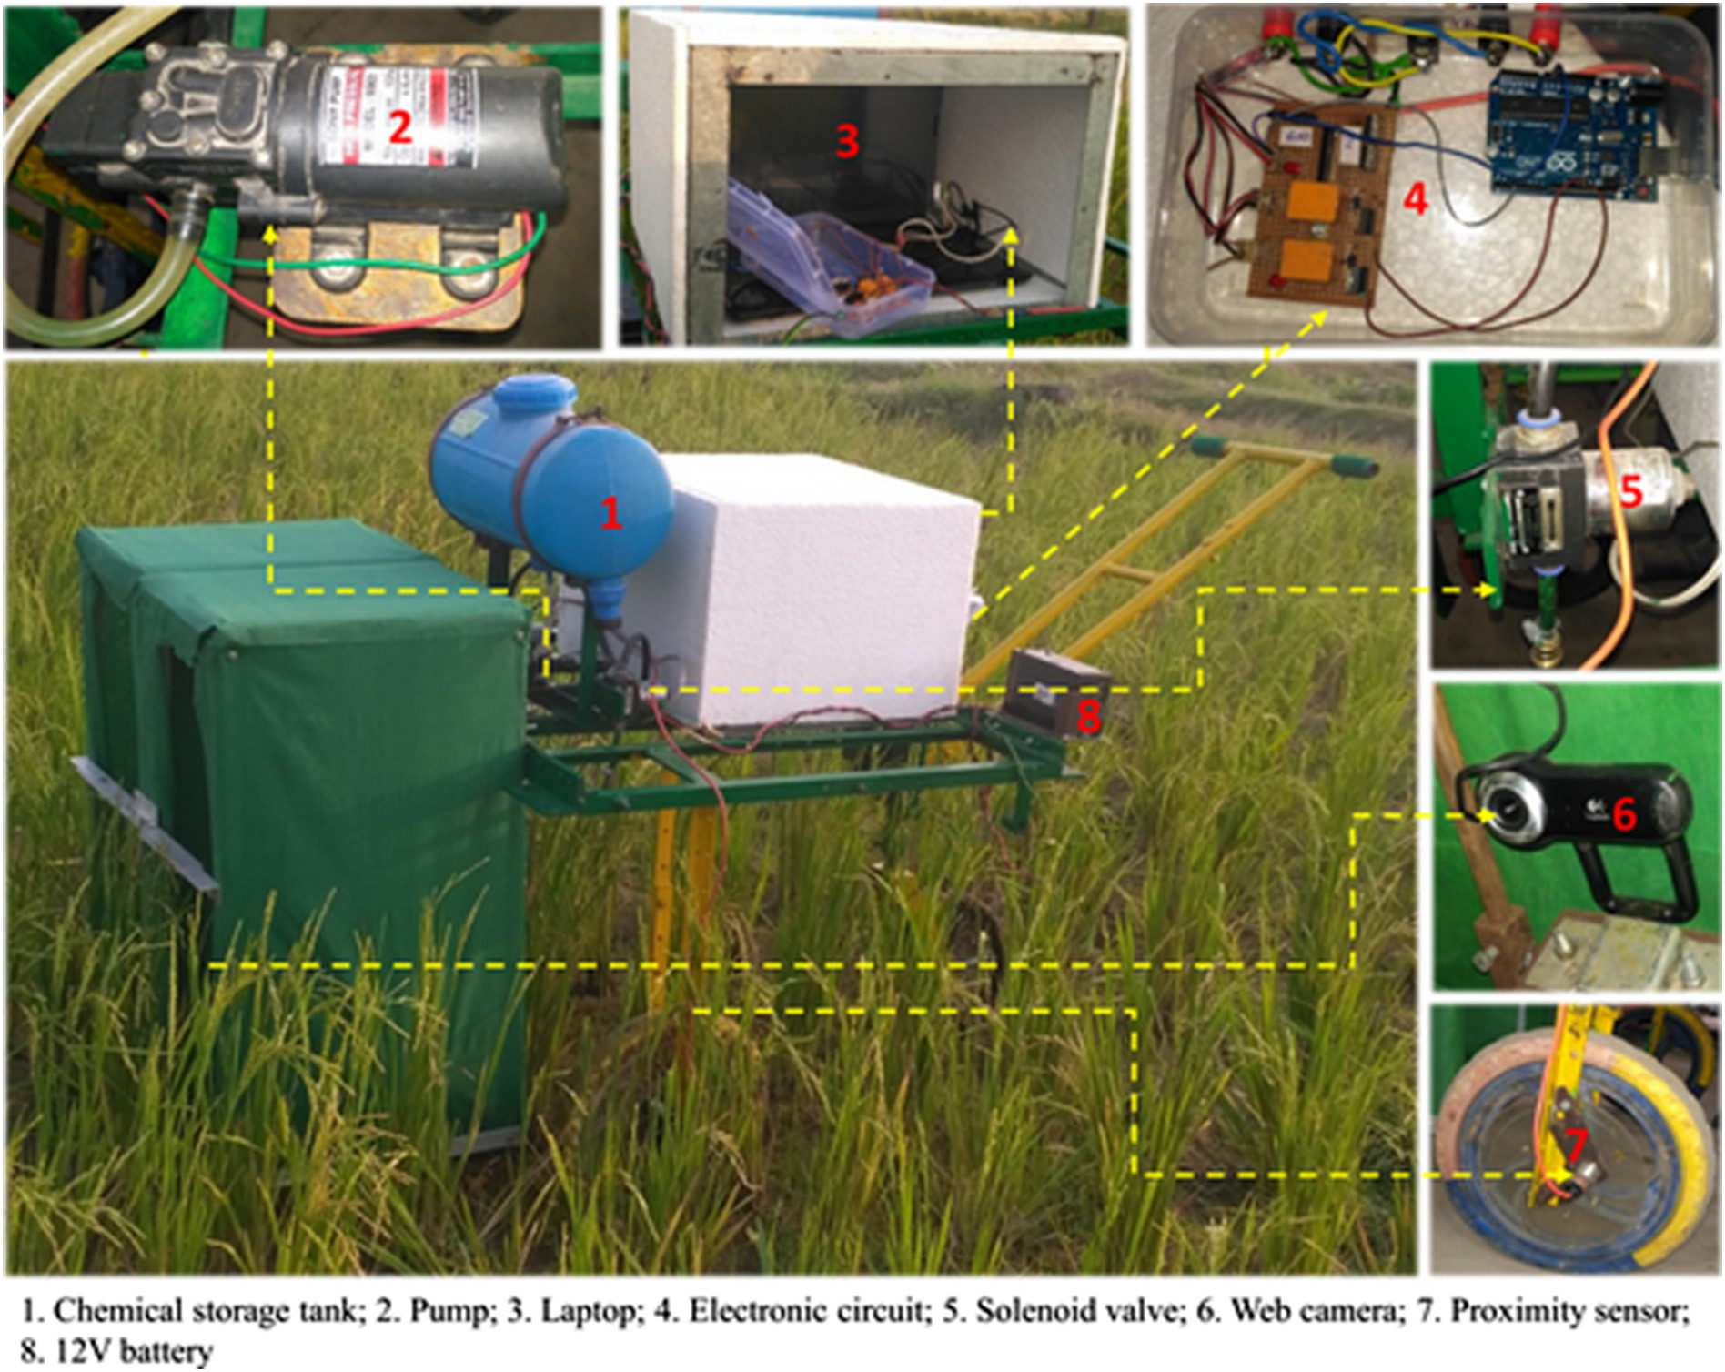](Image%20of%20Fig.%201)

Fig. 1. Variable-rate chemical sprayer prototype.

Ahmed et al., 2012; Haug et al., 2014; Mahmud et al., 2019). The green color background also avoids false detection and minimizes the noises in the image capturing area and allows an accurate seg- mentation of the region of interest. All the images of paddy plants used for algorithm development were captured between 7.30 AM to 10.00 AM on 9th March 2018 in paddy research farm at the agri- cultural and food engineering department, IIT Kharagpur, India. The light illumination values inside the covered area were recorded using a digital lux meter (Metravi 1334, Metravi Instruments Pvt. Ltd., India), which were varied from 270 lx to 400 lx. The captured paddy crop images were subjected to a series of image processing

lesion region are significantly different from that of the healthy re- gion and background. Hence, the RGB color space model can be used for differentiating the diseased region from the healthy region and background.

Selection of characteristic operator: Based on the above information, the various combinations of R, G, and B components were tested to identify the white tip disease of the paddy plants. Finally, a CA equation (Eq. (1)) was found most suitable for differentiating the lesion region from the healthy region and background.

*CA* = *R*− *G* − *B* (1)

steps for plant disease detection and real-time estimation of plant 2 2

disease severity level. The Image Processing Toolbox of MATLAB

R2014b software was utilized for real-time image processing.

* + 1. *Plant diseased area segmentation based on chromatic aberration (CA) method*

In the present study, a chromatic aberration (CA) based color image segmentation algorithm was developed for detecting the diseased re- gion in paddy crop. The proposed image segmentation algorithm consisted of three steps, i.e., color component extraction and analysis, selection of characteristic operator, and thresholding segmentation (Hu et al., 2009).

Color component extraction and analysis: Initially, the red (R), green (G), and blue (B) components of the lesion region, healthy re- gion, and background were extracted from the original captured RGB image and plotted in the form of box-plot, as shown in Fig. 2. From this figure, it can be observed that the R and G pixel values of the

where CA is chromatic aberration value; R denotes red component in RGB color space; G denotes green component in RGB color space; and B denotes blue component in RGB color space.

The CA values of the lesion region, healthy region, and background, which were calculated using Eq. (1), are shown in Fig. 3. From this fig- ure, an apparent deviation of CA values of the lesion region can be ob- served from that of the healthy region and background. Hence, the lesion region could be successfully segmented from the healthy region and background based on its CA values.

Thresholding segmentation: In this step, the captured RGB image was converted into a binary image using the color threshold method by selecting a suitable threshold value (T) of the CA. In order to seg- ment the lesion region from the healthy region and the background, an appropriate threshold value of the CA, i.e., *T* = 0, was chosen from Fig. 3, as the overlapping of CA values of lesion region and healthy

[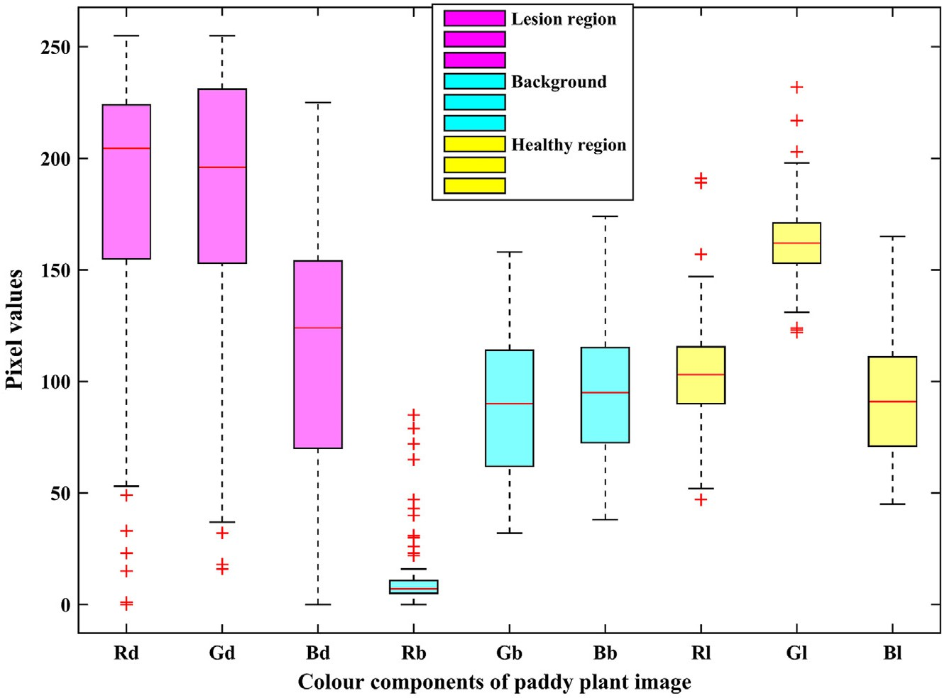](Image%20of%20Fig.%202)

Fig. 2. Distribution of color components of lesion region, healthy region and background in RGB color model.

region of paddy leaves was minimum for CA N 0. The threshold oper- ation based segmentation function is defined as follows:

* + 1. *Plant disease severity estimation*

In order to determine the required amount of input chemical and for making the spraying decisions, the disease severity of the paddy plants

*f* (*x*; *y*) = 8<

:

1 *if CA* ≥*T*

0 *if CA*b*T*

(2)

needs to be observed. The disease severity is defined as the disease in- fected area of a sampling unit (leaf or plant surface) and expressed as a percentage or proportion of the total area (Nutter Jr et al., 1991). Thus, by utilizing the image processing approach, the disease severity of paddy leaves was given by the ratio of total pixels of the diseased region

where, T is the threshold value of chromatic aberration, and *f*(*x,y*) is the value of the pixel (x,y) in the final binary image obtained after implemen- tation of the color thresholding technique. In the binary image, the white

to the total pixels of leaves region and computed using Eq. (3) (Weizheng et al., 2008).

color portion (the pixel value is 1) represents the lesion region, and the black color portion (the pixel value is 0) represents the healthy region and background.

*S*(%) =

*Ad*

*Al* × 100 =

*P* X (*x*;*y*)∈*Rd* 1

*P* X (*x*;*y*)∈*Rl* 1

× 100 =

X (*x*;*y*)∈*Rd* 1

X (*x*;*y*)∈*Rl* 1

× 100 (3)

[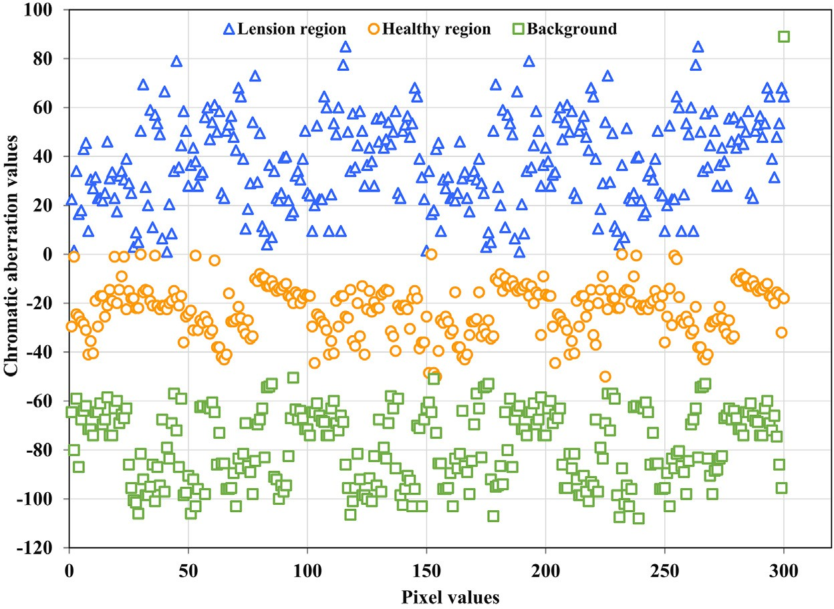](Image%20of%20Fig.%203)

Fig. 3. Distribution of chromatic aberration values of lesion region, healthy region and background.

where S is disease severity, %, S∈[0,100%] ; Ad denotes diseased leaves area; Al represents total plant leaves area; P denotes unit pixel expressed area; Rd is diseased region, and Rl is leaf region.

The flowchart of the developed image processing algorithm for the estimation of plant disease severity is shown in Fig. 4. A sample RGB paddy crop image and corresponding obtained binary image after color thresholding are shown in Fig. 5(a) and (b), respectively. The whole leaf area was determined by altering the contrast value of the RGB image and then segmenting the region of interest, as shown in Fig. 5(c) and (d).

* 1. *Decision-making algorithm for variable-rate chemical application*

In common pest management practices, the agrochemicals are sprayed uniformly throughout the field at the recommended dos- ages (L/ha), mentioned on the product label, for crop disease control. These recommended dosages usually have a high efficacy even if the weather conditions are favorable for disease spread, and the same degree of disease control could be achieved with a lower dosage in

case of low crop disease pressure present at the time of spraying (Dammer and Ehlert, 2006). In the decision-making algorithm ap- plied in this study, the required chemical application rate was de- cided on-the-go according to the measured plant disease severity level. For this purpose, the plant disease severity was classified into three categories, i.e., low, medium, and high, and a reduction coeffi- cient of the recommended application rate was assigned for each cat- egory to determine the reduced application rates of agrochemical for variable-rate spraying. The plant disease severity categorization threshold limits and the corresponding reduction coefficient values are given in Table 1. These values can be reprogrammed by the user for any specific plant disease. In this study (Table 1), 33% of the recommended application rate was selected as the base rate and assigned for the low (0–5%) plant disease severity level. The other two chemical dosages, i.e., 67% and 100% of the recommended application rate, were assigned for the medium (5.1–20%) and high (20.1–100%) plant disease severity levels, respectively.

In variable-rate spraying operation, the required amount of

chemical per hill and the opening time duration of the solenoid

[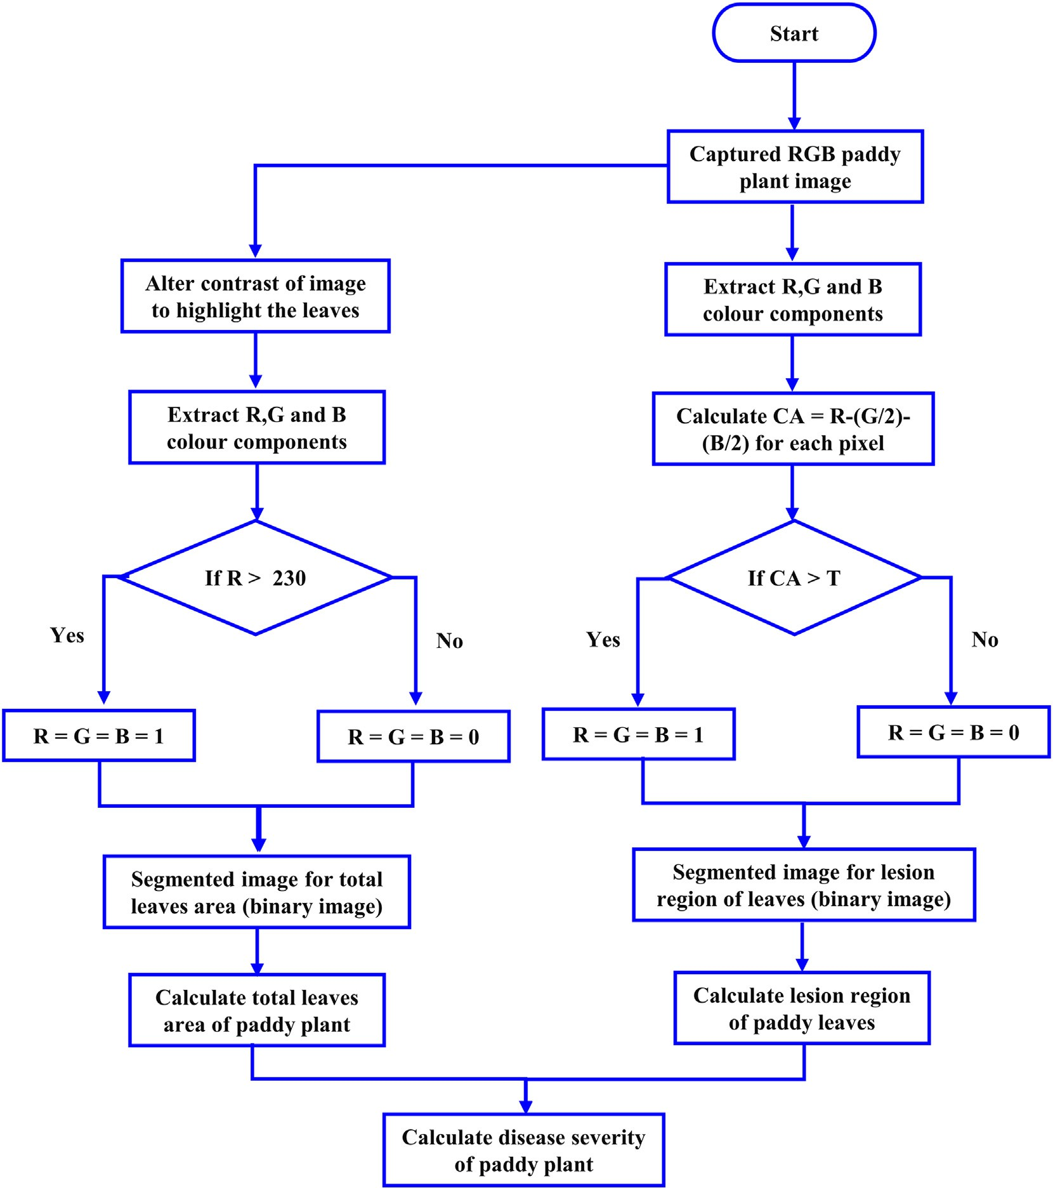](Image%20of%20Fig.%204)

Fig. 4. Flowchart of the image processing algorithm for plant disease severity estimation.

[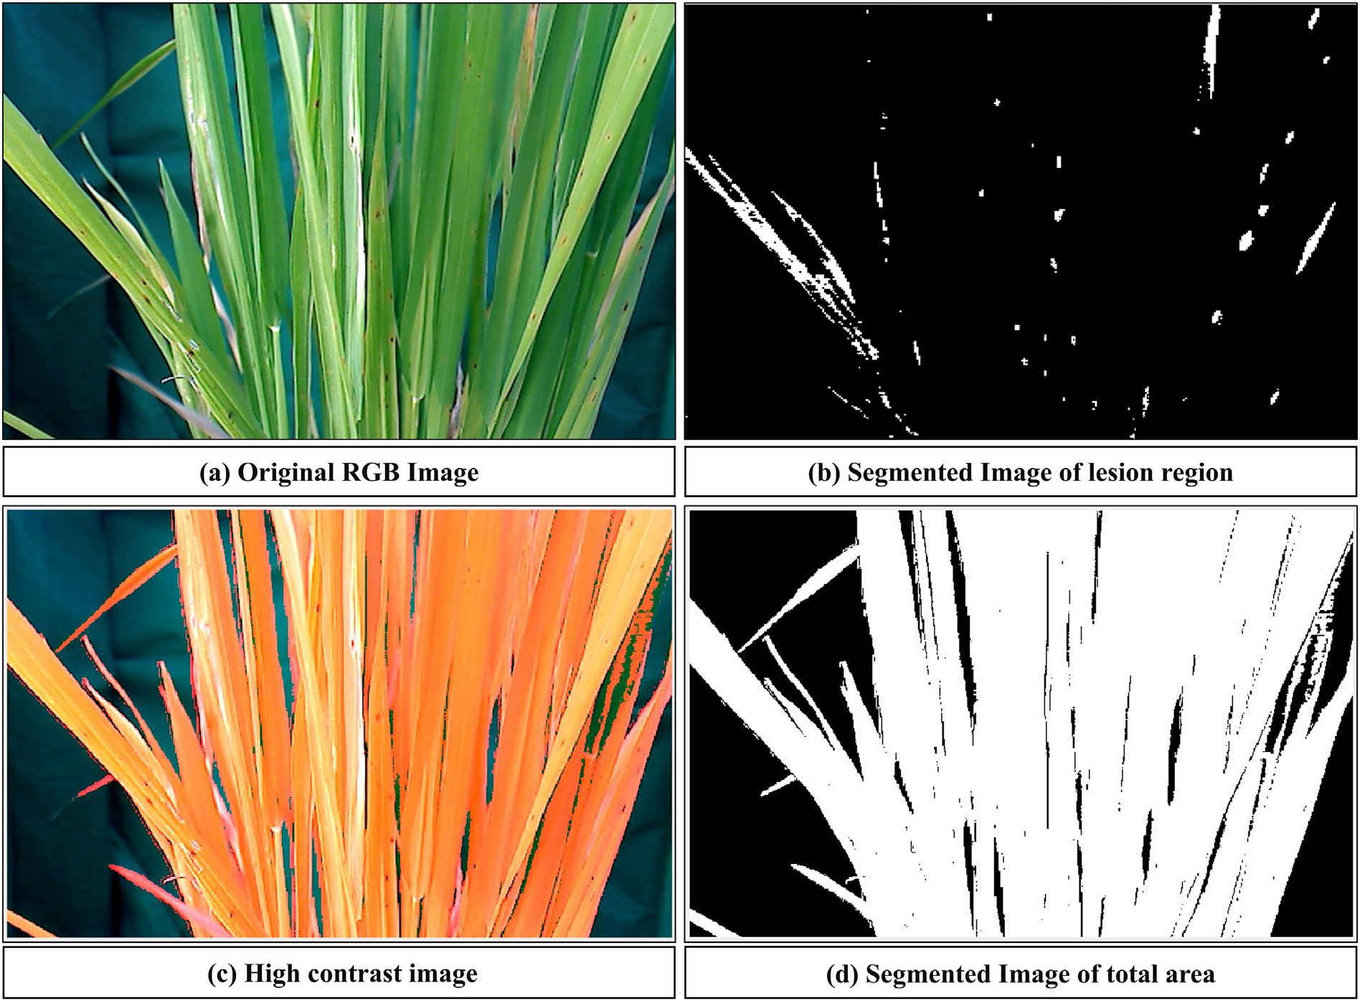](Image%20of%20Fig.%205)

Fig. 5. RGB and binary images of paddy crop.

valve to supply that amount were calculated using Eqs. (4) and (5).

operator can modify the recommended application rate, row to row spacing, and hill to hill spacing, and he also has an option to adjust the

*a* = *C* × *A*

*d* × 10

*ts* = *a*

*Qs*

(4)

(5)

threshold limits for the plant disease severity categorization (Fig. 7). The functional block diagram of the developed variable-rate chemi-

cal spraying system is shown in Fig. 8.

During the variable-rate chemical spraying operation, initially, the web camera captures the paddy plant image and stores it in the laptop, where the lesion region of plant leaves is identified. The processed out-

where *a* denotes the required amount of agrochemical per hill, mL per hill; *C* is the reduction coefficient of the recommended applica- tion rate; *A* represents the recommended application rate of agro- chemicals, L/ha; *d* denotes hill density per square meter area of the field, hills/m2; *ts* represents the opening time duration of solenoid valve, s; *Qs* indicates the flow rate of liquid through solenoid valve, mL/s.

* 1. *Variable-rate chemical spraying system operation cycle*

A Graphical User Interface (GUI) was developed in MATLAB environ- ment for easy monitoring of the developed spraying system by the op- erator, as shown in Fig. 6. This GUI displays the original image as well as the processed image with plant disease severity values and the re- quired amount of input chemical for both rows in real-time. The

Table 1

Plant disease severity categorization and corresponding reduction coefficient values.

|  |  |  |
| --- | --- | --- |
| Category | Plant disease severity (S) | Reduction coefficient (C) |
| I | 0–5% (low) | 0.33 |
| II | 5.1–20% (medium) | 0.67 |
| III | 20.1–100% (high) | 1.00 |

put in terms of disease severity is determined using the developed image processing algorithm. The category of plant disease severity is de- cided according to threshold limits, and this information is then sent to the Arduino microcontroller. The microcontroller assigns the reduction coefficient of the recommended application rate according to the cate- gory of disease severity. Further, it computes the required amount of chemical to be sprayed and the opening time duration for each solenoid valve to supply that amount using Eqs. (4) and (5). After this, the micro- controller then sends a 5 VDC signal to the respective relay switch, which further actuates the associated 12 VDC solenoid valve, and the re- quired amount of input chemical is sprayed on the diseased paddy plants. As the developed prototype moves forward and covers a dis- tance of 200 mm, the proximity switch mounted on the ground wheel sends the signal to the microcontroller, which further triggers the cam- era to capture a new image, and the cycle is repeated.

* 1. *Performance evaluation of developed system*

The operational performance of developed sprayer was evaluated in terms of percentage reduction in applied chemical per unit area during the variable-rate application (VRA) mode as compared with the constant-rate application (CRA) mode. For this purpose, the de- veloped sprayer was operated in both the operational modes, and

[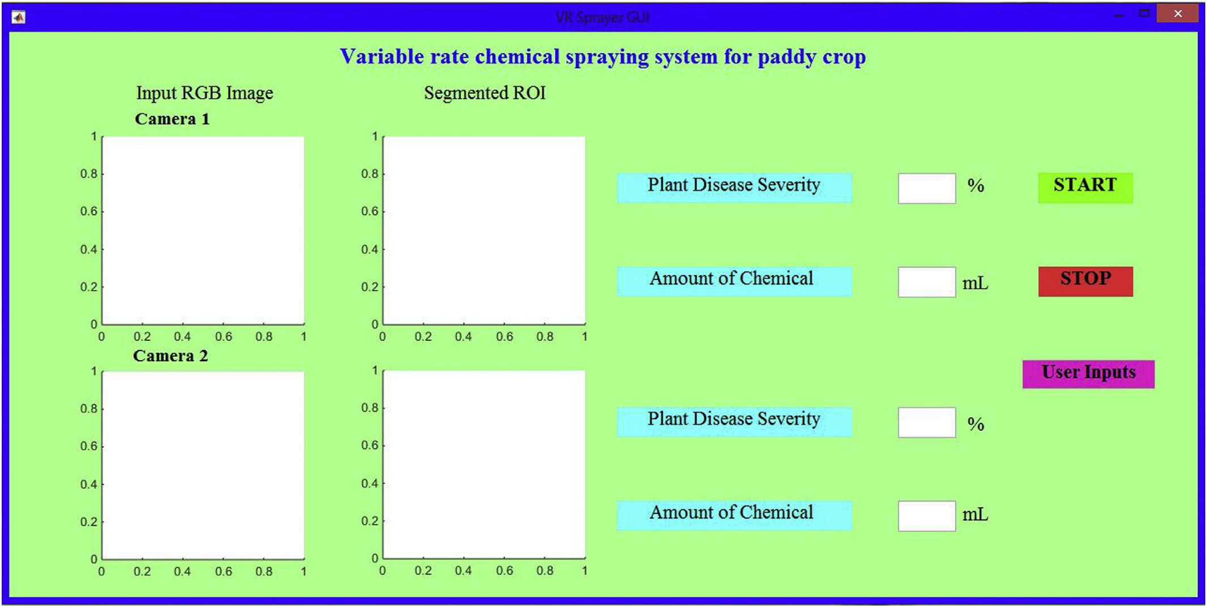](Image%20of%20Fig.%206)

Fig. 6. Main GUI window of variable-rate chemical spraying system.

the corresponding chemical application rates were measured. The agrochemical used in this study was monocrotophos 36 SL. The spray solution was prepared by mixing 60 mL of agrochemical in 30 L of water. The spraying of chemical solution was carried out at the recommended application rate, i.e., 1000 mL/ha (Kumar and Sivakumar, 1998). The experimental field had planting geometry of 20 cm × 20 cm (row to row × hill to hill) and the total area of 300 m2. The whole field area was subdivided into five subplots of 3 m × 20 m each, and the spraying operation was carried out in all of the subplots. Initially, during the CRA mode, the developed

prototype was operated without activation of cameras and other control functions, and both spraying nozzles remained open throughout the spraying operation. Then, the sprayer was operated in the VRA mode by activation of cameras and other control func- tions. In this case, the nozzles were not kept open all the time; in- stead, their opening or closing was controlled by the actuation of respective solenoid valves, and the opening time duration was de- pendent on the plant disease severity level. Before each test, the stor- age tank was filled with spray solution up to a specific mark, and the amount of used chemical was measured by refilling the storage tank

[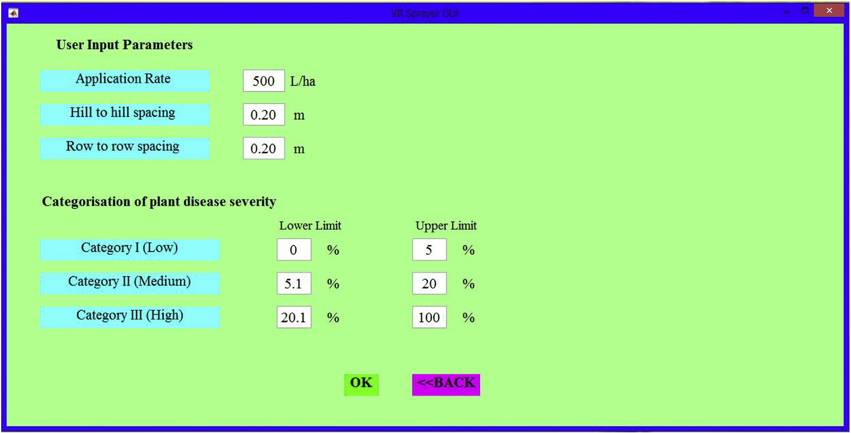](Image%20of%20Fig.%207)

Fig. 7. User input parameters window of variable-rate chemical spraying system.

[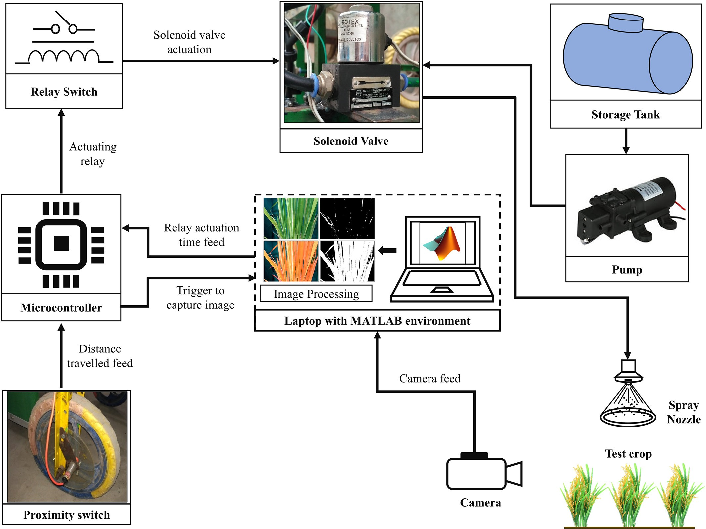](Image%20of%20Fig.%208)

Fig. 8. Functional block diagram of variable-rate chemical spraying system.

up to that particular mark again. The amount of chemical consump- tion was recorded for all five subplots in both the operational modes. The distance between image capturing point and spraying nozzles was 250 mm, and the total time lag between the image acquisition and the spraying was found to be about 800 ms. Hence, the maximum speed of operation was limited to 0.9 km/h. Therefore, the speed of op- eration in both the operational modes was maintained at about 0.9 km/

h. The reduction in applied chemical per unit area in the VRA mode as compared with the CRA mode was calculated using Eq. (6).

Reduction in applied chemical (%) = 1− Av × 100 (6)

Ac

where *Ac* denotes the chemical application rate in CRA mode, L/ha; and

*Av* denotes the chemical application rate in VRA mode, L/ha.

3. Results and discussion

The field tests of the developed prototype were carried out in both the VRA and CRA modes (Fig. 9). Initially, the developed prototype was operated in the CRA mode, during which the average chemical ap- plication rate was observed as 504.17 L/ha with a relative standard de- viation of 1.75%. The developed prototype was then operated in the VRA mode by activation of cameras, during which the chemical application rate was varied from 296.67 L/ha to 338.33 L/ha. The average chemical application rate during the VRA mode was found to be 319.5 L/ha

with a relative standard deviation of 5.11%. The percent reduction in ap- plied chemical per unit area was varied from 33.88% to 40.47% dur- ing VRA mode as compared with the CRA mode, as given in Table 2. Hence, the developed system showed a minimum 33.88% chemical sav- ing as compared with the conventional uniform spraying. The chemical

[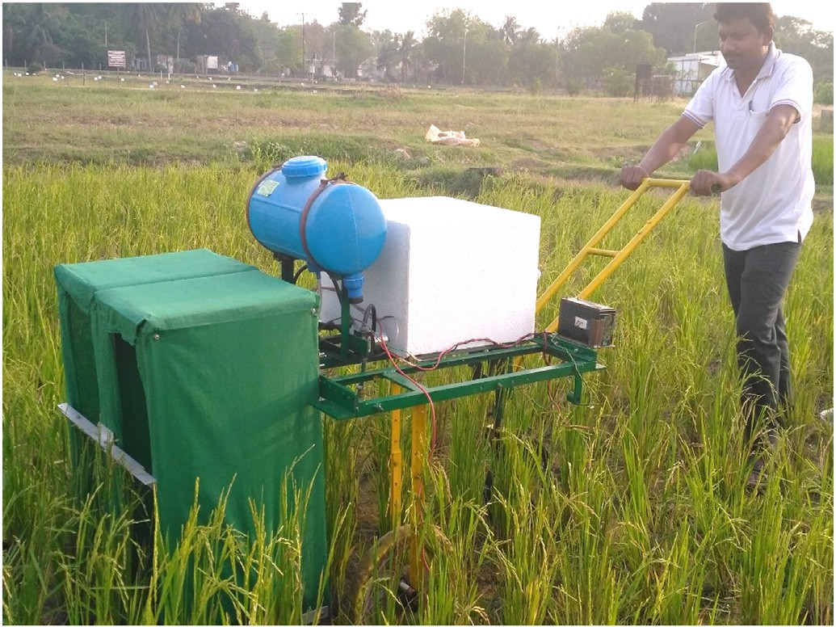](Image%20of%20Fig.%209)

Fig. 9. Performance evaluation of variable-rate chemical sprayer prototype.

Table 2

Performance comparison of variable-rate chemical sprayer prototype in VRA and CRA modes.

showed a minimum 33.88% chemical saving while operating in VRA mode as compared with the CRA mode. Hence, the developed system provides a potential solution to the farmers to avoid wastage of input

S. no. Agrochemical application rate (L/ha)

|  |  |  |  |
| --- | --- | --- | --- |
|  | VRA mode | CRA mode | (%) |
| 1 | 330.00 | 513.33 | 35.71 |
| 2 | 296.67 | 498.33 | 40.47 |
| 3 | 310.83 | 492.5 | 36.89 |
| 4 | 338.33 | 511.67 | 33.88 |
| 5 | 321.67 | 505.00 | 36.30 |

Reduction in applied chemical

chemicals, which could finally increase their profitability as well as re- duce environmental pollution.

saving achieved with the developed prototype could be stochastic and primarily depends on the existing variability in plant disease severity within the field. If the degree of disease severity is high throughout the field, then the chemical saving will be low.

The spraying operation results obtained in VRA mode were also compared with that in the CRA mode using a statistical term, relative deviation (RD), which is defined as follows (Kumar et al., 2017):

CRediT authorship contribution statement

V.K. Tewari: Supervision, Conceptualization, Writing - review & editing. C.M. Pareek: Writing - original draft, Software, Resources. Gurdeep Lal: Methodology, Investigation, Formal analysis. L.K. Dhruw: Software, Investigation. Naseeb Singh: Software, Methodology.

References

Aggelopoulou, A.D., Bochtis, D., Fountas, S., Swain, K.C., Gemtos, T.A., Nanos, G.D., 2011. [Yield prediction in apple orchards based on image processing. Precis. Agric. 12 (3),](http://refhub.elsevier.com/S2589-7217(20)30009-X/rf0005) [448–45](http://refhub.elsevier.com/S2589-7217(20)30009-X/rf0005)6.

Ahmed, F., Al-Mamun, H.A., Bari, A.H., Hossain, E., Kwan, P., 2012. [Classification of crops](http://refhub.elsevier.com/S2589-7217(20)30009-X/rf0010) [and weeds from digital images: a support vector machine approach. Crop Prot. 40,](http://refhub.elsevier.com/S2589-7217(20)30009-X/rf0010)

[98–10](http://refhub.elsevier.com/S2589-7217(20)30009-X/rf0010)4.

1 *N Ac*−*Av*

*RD* X

= ×

*N*

*Ac*

*i*=0

100

(7) Barbedo, J.G.A., 2014. [An automatic method to detect and measure leaf disease symptoms](http://refhub.elsevier.com/S2589-7217(20)30009-X/rf0015)

[using digital image processing. Plant Dis. 98 (12), 1709–1716](http://refhub.elsevier.com/S2589-7217(20)30009-X/rf0015).

Barbedo, J.G.A., Koenigkan, L.V., Santos, T.T., 2016. [Identifying multiple plant diseases](http://refhub.elsevier.com/S2589-7217(20)30009-X/rf0020) [using digital image processing. Biosyst. Eng. 147, 104–11](http://refhub.elsevier.com/S2589-7217(20)30009-X/rf0020)6.

where *Ac* is the chemical application rate in CRA mode, L/ha; *Av* is the

chemical application rate in VRA mode, L/ha; and N is the number of observations.

The relative deviation of the amount of chemical used per unit area between VRA and CRA modes was found to be 36.65%, which showed a significant deviation in the amount of chemical applied during both the operational modes. The two-sample *t*-test was also performed for comparing the means of chemical application rates in both the opera- tional modes. The t-test result indicated that the spraying operation in VRA mode was resulted in significantly less amount of chemical con- sumption as compared with that in the CRA mode (*p* ≤ 0.05). Thus, the developed variable-rate chemical spraying system showed promis- ing results in terms of chemical saving as compared with the conven- tional uniform spraying.

Although, the field testing results indicated that a significant reduc- tion in applied chemicals could be achieved with the developed variable-rate chemical spraying system. However, with the existing po- sition sensing method to trigger the camera for capturing the new image, the plant spacing deviations could lead to errors in spraying op- erations. The developed prototype can be further improved by modify- ing the camera trigger unit using some object detection sensors like the ultrasonic sensor or infrared sensor, which can minimize the errors due to plant spacing deviations. In this study, the performance evaluation of the developed sprayer was primarily concentrated on the percentage reduction in applied chemical during VRA mode as compared with the CRA mode. However, for a detailed analysis of the developed sprayer's performance, the spray deposition tests need to be carried out in future studies. Further research and experimentation are required to analyze the effect of variable-rate chemical spraying on crop yield and disease occurrence.

4. Conclusions

A manually operated real-time variable-rate chemical sprayer was developed to apply the chemical dosages corresponding to the plant disease severity level. The variable-rate chemical sprayer prototype comprised of pump, solenoid valves, spray nozzles, relay switches, web cameras, microcontroller board, Laptop, and 12 VDC battery. The image processing technique was used to identify the diseased region of the paddy plants and also determine their disease severity level. The field performance of developed sprayer prototype was evaluated in terms of percentage reduction in applied agrochemical during the VRA mode as compared with the CRA mode. The field testing results

Berenstein, R., Edan, Y., 2017. [Human-robot collaborative site-specific sprayer. J. Field Ro-](http://refhub.elsevier.com/S2589-7217(20)30009-X/rf0025) [botics. 34 (8), 1519–1530](http://refhub.elsevier.com/S2589-7217(20)30009-X/rf0025).

Bossu, J., Gee, C., Truchetet, F., 2008. [Development of a machine vision system for a real-](http://refhub.elsevier.com/S2589-7217(20)30009-X/rf0035) [time precision sprayer. Electron. Lett. Comput. Vis. Image Anal. 7 (3), 54–66](http://refhub.elsevier.com/S2589-7217(20)30009-X/rf0035).

Chandel, A.K., Tewari, V.K., Kumar, S.P., Nare, B., Agarwal, A., 2018. [On-the-go position](http://refhub.elsevier.com/S2589-7217(20)30009-X/rf0040) [sensing and controller predicated contact-type weed eradicator. Curr. Sci. 114 (7),](http://refhub.elsevier.com/S2589-7217(20)30009-X/rf0040) [1485–1494](http://refhub.elsevier.com/S2589-7217(20)30009-X/rf0040).

Dammer, K.H., 2016. [Real-time variable-rate herbicide application for weed control in](http://refhub.elsevier.com/S2589-7217(20)30009-X/rf0045) [carrots. Weed Res. 56 (3), 237–246](http://refhub.elsevier.com/S2589-7217(20)30009-X/rf0045).

Dammer, K.H., Ehlert, D., 2006. [Variable-rate fungicide spraying in cereals using a plant](http://refhub.elsevier.com/S2589-7217(20)30009-X/rf0050) [cover sensor. Precis. Agric. 7 (2), 137–14](http://refhub.elsevier.com/S2589-7217(20)30009-X/rf0050)8.

Dammer, K.H., Wollny, J., Giebel, A., 2008. [Estimation of the Leaf Area Index in cereal crops](http://refhub.elsevier.com/S2589-7217(20)30009-X/rf0055) [for variable rate fungicide spraying. Eur. J. Agron. 28 (3), 351–360](http://refhub.elsevier.com/S2589-7217(20)30009-X/rf0055).

Dammer, K.H., Möller, B., Rodemann, B., Heppner, D., 2011. [Detection of head blight (Fu-](http://refhub.elsevier.com/S2589-7217(20)30009-X/rf0060) [sarium ssp.) in winter wheat by color and multispectral image analyses. Crop Prot. 30](http://refhub.elsevier.com/S2589-7217(20)30009-X/rf0060) [(4), 420–428](http://refhub.elsevier.com/S2589-7217(20)30009-X/rf0060).

Ehlert, D., Hammen, V., Adamek, R., 2003. On-line sensor pendulum-meter for determina- tion of plant mass. Precis. Agric. 4 (2), 139–148. https://doi.org/10.1023/A: 1024553104963.

Elazegui, F., Islam, Z., 2003. Diagnosis of Common Diseases of Rice. International Rice Re- search Institute, Philippines [http://www.knowledgebank.irri.org/images/docs/diag-](http://www.knowledgebank.irri.org/images/docs/diagnostic-of-common-diseases-of-rice.pdf) [nostic-of-common-diseases-of-rice.pdf](http://www.knowledgebank.irri.org/images/docs/diagnostic-of-common-diseases-of-rice.pdf).

Esau, T.J., Zaman, Q.U., Chang, Y.K., Schumann, A.W., Percival, D.C., Farooque, A.A., 2014. [Spot-application of fungicide for wild blueberry using an automated prototype vari-](http://refhub.elsevier.com/S2589-7217(20)30009-X/rf0070) [able rate sprayer. Precis. Agric. 15 (2), 147–16](http://refhub.elsevier.com/S2589-7217(20)30009-X/rf0070)1.

Ess, D.R., Morgan, M.T., Parson, S.D., 2001. Implementing site-specific management: map- versus sensor-based variable rate application. Pub. No. SSM-2-W, Site-Specific Man- agement Center, Purdue University, West Lafayette, IN. [https://www.extension.](https://www.extension.purdue.edu/extmedia/AE/SSM-2-W.pdf) [purdue.edu/extmedia/AE/SSM-2-W.pdf](https://www.extension.purdue.edu/extmedia/AE/SSM-2-W.pdf).

Gerhards, R., Christensen, S., 2003. [Real-time weed detection, decision making and patch](http://refhub.elsevier.com/S2589-7217(20)30009-X/rf0080) [spraying in maize, sugarbeet, winter wheat and winter barley. Weed Res. 43 (6),](http://refhub.elsevier.com/S2589-7217(20)30009-X/rf0080) [385–39](http://refhub.elsevier.com/S2589-7217(20)30009-X/rf0080)2.

Gerhards, R., Oebel, H., 2006. [Practical experiences with a system for site-specific weed](http://refhub.elsevier.com/S2589-7217(20)30009-X/rf0085) [control in arable crops using real-time image analysis and GPS-controlled patch](http://refhub.elsevier.com/S2589-7217(20)30009-X/rf0085) [spraying. Weed Res. 46 (3), 185–193](http://refhub.elsevier.com/S2589-7217(20)30009-X/rf0085).

Haug, S., Biber, P., Michaels, A., Ostermann, J., 2014. [Plant stem detection and position es-](http://refhub.elsevier.com/S2589-7217(20)30009-X/rf0090) [timation using machine vision. In Workshop Proc. of Conf. on Intelligent Autonomous](http://refhub.elsevier.com/S2589-7217(20)30009-X/rf0090) [Systems. 483–49](http://refhub.elsevier.com/S2589-7217(20)30009-X/rf0090)0.

Hu, M., Zhu, S., Chen, K., 2009. [An effective method for traffic signs segmentation. 2009](http://refhub.elsevier.com/S2589-7217(20)30009-X/rf0095) [International Conference on Intelligent Human-Machine Systems and Cybernetics.](http://refhub.elsevier.com/S2589-7217(20)30009-X/rf0095)

[2. IEEE, pp. 180–18](http://refhub.elsevier.com/S2589-7217(20)30009-X/rf0095)4.

Kumar, S., Sivakumar, C.V., 1998. [Management of rice white tip nematode.](http://refhub.elsevier.com/S2589-7217(20)30009-X/rf0100)

[Aphelenchoides besseyi. Indian J. Nematol. 28, 85–87](http://refhub.elsevier.com/S2589-7217(20)30009-X/rf0100).

Kumar, A.A., Tewari, V.K., Gupta, C., Pareek, C.M., 2017. [A device to measure wheel slip to](http://refhub.elsevier.com/S2589-7217(20)30009-X/rf0105) [improve the fuel efficiency of off road vehicles. J. Terrramech. 70, 1–11](http://refhub.elsevier.com/S2589-7217(20)30009-X/rf0105).

Mahmud, M.S., Zaman, Q.U., Esau, T.J., Price, G.W., Prithiviraj, B., 2019. [Development of an](http://refhub.elsevier.com/S2589-7217(20)30009-X/rf0110) [artificial cloud lighting condition system using machine vision for strawberry pow-](http://refhub.elsevier.com/S2589-7217(20)30009-X/rf0110) [dery mildew disease detection. Comput. Electron. Agr. 158, 219–22](http://refhub.elsevier.com/S2589-7217(20)30009-X/rf0110)5.

Nutter Jr, F.W., Teng, P.S., Shokes, F.M., 1991. [Disease assessment terms and concepts.](http://refhub.elsevier.com/S2589-7217(20)30009-X/rf0115)

[Plant Dis. 75, 1187–1188](http://refhub.elsevier.com/S2589-7217(20)30009-X/rf0115).

Oberti, R., Marchi, M., Tirelli, P., Calcante, A., Iriti, M., Tona, E., Hočevar, M., Baur, J., Pfaff, J., Schütz, C., Ulbrich, H., 2016. [Selective spraying of grapevines for disease control using](http://refhub.elsevier.com/S2589-7217(20)30009-X/rf0120) [a modular agricultural robot. Biosyst. Eng. 146, 203–21](http://refhub.elsevier.com/S2589-7217(20)30009-X/rf0120)5.

Özlüoymak, Ö.B., Bolat, A., Bayat, A., Güzel, E., 2019. [Design, development, and evaluation](http://refhub.elsevier.com/S2589-7217(20)30009-X/rf0125) [of a target oriented weed control system using machine vision. Turk. J. Agric. For. 43](http://refhub.elsevier.com/S2589-7217(20)30009-X/rf0125) [(2), 164–173](http://refhub.elsevier.com/S2589-7217(20)30009-X/rf0125).

Park, Y.L., Krell, R.K., Carroll, M., 2007. [Theory, technology, and practice of site-specific in-](http://refhub.elsevier.com/S2589-7217(20)30009-X/rf0130) [sect pest management. J. Asia Pac. Entomol. 10 (2), 89–10](http://refhub.elsevier.com/S2589-7217(20)30009-X/rf0130)1.

Partel, V., Kakarla, S.C., Ampatzidis, Y., 2019. [Development and evaluation of a low-cost](http://refhub.elsevier.com/S2589-7217(20)30009-X/rf0135) [and smart technology for precision weed management utilizing artificial intelligence.](http://refhub.elsevier.com/S2589-7217(20)30009-X/rf0135) [Comput. Electron. Agr. 157, 339–350](http://refhub.elsevier.com/S2589-7217(20)30009-X/rf0135).

Patil, S.B., Bodhe, S.K., 2011. [Leaf disease severity measurement using image processing.](http://refhub.elsevier.com/S2589-7217(20)30009-X/rf0140)

[Int. J. Eng. Technol. 3 (5), 297–301](http://refhub.elsevier.com/S2589-7217(20)30009-X/rf0140).

Rehman, T.U., Zaman, Q.U., Chang, Y.K., Schumann, A.W., Corscadden, K.W., 2019. [Devel-](http://refhub.elsevier.com/S2589-7217(20)30009-X/rf0145) [opment and field evaluation of a machine vision based in-season weed detection sys-](http://refhub.elsevier.com/S2589-7217(20)30009-X/rf0145) [tem for wild blueberry. Comput. Electron. Agr. 162, 1–13](http://refhub.elsevier.com/S2589-7217(20)30009-X/rf0145).

Samseemoung, G., Soni, P., Suwan, P., 2017. [Development of a variable rate chemical](http://refhub.elsevier.com/S2589-7217(20)30009-X/rf0150) [sprayer for monitoring diseases and pests infestation in coconut plantations. Agricul-](http://refhub.elsevier.com/S2589-7217(20)30009-X/rf0150) [ture 7 (10), 89](http://refhub.elsevier.com/S2589-7217(20)30009-X/rf0150).

Schor, N., Berman, S., Dombrovsky, A., Elad, Y., Ignat, T., Bechar, A., 2017. [Development of a](http://refhub.elsevier.com/S2589-7217(20)30009-X/rf0155) [robotic detection system for greenhouse pepper plant diseases. Precis. Agric. 18 (3),](http://refhub.elsevier.com/S2589-7217(20)30009-X/rf0155) [394–40](http://refhub.elsevier.com/S2589-7217(20)30009-X/rf0155)9.

Sena Jr, D.G., Pinto, F.A.C., Queiroz, D.M., Viana, P.A., 2003. [Fall armyworm damaged maize](http://refhub.elsevier.com/S2589-7217(20)30009-X/rf0160) [plant identification using digital images. Biosyst. Eng. 85 (4), 449–45](http://refhub.elsevier.com/S2589-7217(20)30009-X/rf0160)4.

Singh, V., Misra, A.K., 2017. [Detection of plant leaf diseases using image segmentation and](http://refhub.elsevier.com/S2589-7217(20)30009-X/rf0165) [soft computing techniques. Inf. Process. Agric. 4 (1), 41–49](http://refhub.elsevier.com/S2589-7217(20)30009-X/rf0165).

Tackenberg, M., Volkmar, C., Dammer, K.H., 2016. [Sensor-based variable-rate fungicide](http://refhub.elsevier.com/S2589-7217(20)30009-X/rf0170) [application in winter wheat. Pest Manag. Sci. 72 (10), 1888–1896](http://refhub.elsevier.com/S2589-7217(20)30009-X/rf0170).

Tackenberg, M., Volkmar, C., Schirrmann, M., Giebel, A., Dammer, K.H., 2018. [Impact of](http://refhub.elsevier.com/S2589-7217(20)30009-X/rf0175) [sensor-controlled variable-rate fungicide application on yield, senescence and dis-](http://refhub.elsevier.com/S2589-7217(20)30009-X/rf0175) [ease occurrence in winter wheat fields. Pest Manag. Sci. 74 (6), 1251–1258](http://refhub.elsevier.com/S2589-7217(20)30009-X/rf0175).

Tangwongkit, R., Salokhe, V.M., Jayasuriya, H.W., 2006. [Development of a real-time, vari-](http://refhub.elsevier.com/S2589-7217(20)30009-X/rf0180) [able rate herbicide applicator using machine vision for between-row weeding of sug-](http://refhub.elsevier.com/S2589-7217(20)30009-X/rf0180) [arcane fields. CIGR e-journal. 8, 1–12](http://refhub.elsevier.com/S2589-7217(20)30009-X/rf0180).

Tewari, V.K., Kumar, A.A., Nare, B., Prakash, S., Tyagi, A., 2014. [Microcontroller based roller](http://refhub.elsevier.com/S2589-7217(20)30009-X/rf0185) [contact type herbicide applicator for weed control under row crops. Comput. Elec-](http://refhub.elsevier.com/S2589-7217(20)30009-X/rf0185) [tron. Agric. 104, 40–45](http://refhub.elsevier.com/S2589-7217(20)30009-X/rf0185).

Tian, L., 2002. [Development of a sensor-based precision herbicide application system.](http://refhub.elsevier.com/S2589-7217(20)30009-X/rf0190)

[Comput. Electron. Agr. 36 (2–3), 133–149](http://refhub.elsevier.com/S2589-7217(20)30009-X/rf0190).

Tucker, C.C., Chakraborty, S., 1997. [Quantitative assessment of lesion characteristics and](http://refhub.elsevier.com/S2589-7217(20)30009-X/rf0195) [disease severity using digital image processing. J. Phytopathol. 145 (7), 273–27](http://refhub.elsevier.com/S2589-7217(20)30009-X/rf0195)8.

Weizheng, S., Yachun, W., Zhanliang, C., Hongda, W., 2008. [Grading method of leaf spot](http://refhub.elsevier.com/S2589-7217(20)30009-X/rf1195) [disease basedon image processing. 2008 International Conference on Computer Sci-](http://refhub.elsevier.com/S2589-7217(20)30009-X/rf1195) [ence and Software Engineering. 6. IEEE, pp. 491–49](http://refhub.elsevier.com/S2589-7217(20)30009-X/rf1195)4.

Xu, Y., Gao, Z., Khot, L., Meng, X., Zhang, Q., 2018. [A real-time weed mapping and precision](http://refhub.elsevier.com/S2589-7217(20)30009-X/rf0205) [herbicide spraying system for row crops. Sensors. 18 (12), 4245](http://refhub.elsevier.com/S2589-7217(20)30009-X/rf0205).