Available online at [www.sciencedirect.com](http://www.sciencedirect.com/)



AASRI Procedia 2 (2012) 93 – 105

AASRI

Procedia

[www.elsevier.com/locate/procedia](http://www.elsevier.com/locate/procedia)

# 2012 AASRI Conference on Power and Energy Systems

Inventory-Production Control Systems with Gumbel Distributed Deterioration

Md. Azizul Batena,*, Anton Abdulbasah Kamilb, and Habibah Latehc

*a,*Department of Decision Science, School of Quantitative Sciences, Universiti Utara Malaysia, 06010 UUM Sintok, Darul Aman,*

*Malaysia*

*bMathematics Program, School of Distance Education, Universiti Sains Malaysia, 11800 USM Penang, Malaysia*

*cGeography Program, School of Distance Education, Universiti Sains Malaysia, 11800 USM Penang, Malaysia*

Abstract

This paper is concerned with the optimal control of inventory-production system subject to Gumbel distributed deterioration items with applications to optimal control theory. We successfully formulated the model as a linear optimal control problem and obtained an explicit solution using Pontryagin maximum principle. The optimality conditions are derived in this case. It is then illustrated with the help of examples.

© 2012 Published by Elsevier B.V. Selection and/or peer review under responsibility of American Applied Science Research Institute

© 2012 Published by Elsevier B.V. Selection and/or peer review under responsibility of American Applied Science Research Institute

© 2012 The Authors. Published by Elsevier B.V

Selection and/o[r peer review under](http://creativecommons.org/licenses/by-nc-nd/3.0/) responsibility of American Applied Science Research Institute

Open access under [CC BY-NC-ND license.](http://creativecommons.org/licenses/by-nc-nd/3.0/)

Keywords: Inventory/production: Applications, Perishable items, Planning horizons. Sensitivity analysis

1. Introduction

We are concerned in this paper with inventory-production control problem that can be represented as an optimal control problem with one state variable (inventory level) and one control variable (rate of manufacturing) subject to time of deterioration. In inventory-production models, two factors of the problem have been of growing interest to the researchers, one being the deterioration of items and the other being the variation in the demand rate with time. In the early stage of the study, most of the deterioration rates in the models are constant, such as Padmanabhana and Vratb (1995), Bhunia and Maiti (1999), Al-khedhairi and Tadj (2007) and Baten and Kamil (2009. We are especially interested in the application of optimal control theory to the production planning problem with Gumbel distribution deterioration items. The optimal control theory has been applied to different inventory-production control problems where researchers are involved to analyze the effect of deterioration and the variations in the demand rate with time in logistics. Various authors attacked their research in the application of optimal control theory to the production planning problem. Some

2212-6716 © 2012 Published by Elsevier B.V. Selection and/or peer review under responsibility of American Applied Science Research Institute

Open access under [CC BY-NC-ND license.](http://creativecommons.org/licenses/by-nc-nd/3.0/) doi:10.1016/j.aasri.2012.09.020

of them are: Hedjar et al. (2004, 2007), Bounkhel and Tadj (2005), and Awad El-Gohary et. al., (2009). In this context, Pontryagin maximum principle has been used to determine the optimal production cost control by (Bounkhel and Tadj, 2005; Tadj *et al.,* 2006; Benhadid, Tadj and Bounkhel, 2008). But no attempt has been made to develop the inventory model as an optimal control problem and derive an explicit solution of an inventory model with generalized extreme value distribution (e.g. Gumbel) deterioration using Pontryagin maximum principle. The continuous review policy of optimal control approach is also to be novel in this framework. There seems to be no literature on the optimal control of continuous review manufacturing systems with generalized extreme value i.e. Gumbel distribution deterioration items rate.

In the present paper, we assume that the demand rate is time-dependence and the time of deterioration rate is assumed to follow a Gumbel distribution as well as a non-negative discount rate is considered for the inventory systems. The novelty here is that the time of deterioration is a random variable followed by Gumbel distribution and we consider the problem of controlling the production rate of a continuous review manufacturing system. This paper develops an optimal control models and utilizes Pontryagin maximum principle by Pontryagin et al. (1962) to derive the necessary optimality conditions for inventory systems. The paper also derives explicit optimal policies for the inventory models where items are deteriorating with Gumbel distribution that can be used in the decision making process. The rest of the paper is organized as follows. Following this introduction, section 2 discusses Gumbel distribution with its applications and the associated deterioration rate function. In section 3 we explain the first inventory-production model with necessary assumptions. The similar developments are conducted for the second and third models. Section 4 develops optimal control problems. In section 5 we study the optimal control of the system and derive explicit solution of the models. In section 6 the illustrative examples of the results are given. Finally the last section concludes the paper.

1. Gumbel Distributed Deterioration Rate Function

The probability density function of a generalized extreme value distribution having probability distribution of the form

*ƒ* (*t*)  1 exp*t*  **  / ** ** 1 exp exp*t*  **  / ** ** 1

**

where **  *R* is the location parameter and ** 0,  is the scale parameter and ** ,  is the

shape parameter. The shape parameter ** governs the tail behavior of the distribution. The family defined by

**  0 corresponds to the Gumbel distribution. The probability density function of Gumbel distribution corresponds to a minimum value

**

*ƒ*min

(*t*)  1 exp*t*  **  / ** exp exp*t*  **  / ** ,

*t*  0,

and the cumulative distribution function of Gumbel distribution

*F*min (*t*)  1 expexp*t*  **  / ** ,

*t*  0.

The deterioration rate function defined by

** (*t*) 

*ƒ* (*t*) , 1 *F* (*t*)

*t*  0 is an important quantity characterizing

life phenomena. The instantaneous rate of deterioration of Gumbel distribution corresponds to a minimum value of the on-hand inventory is given by

** (*t*) 

*ƒ*min (*t*)

 1 exp*t*  **  / ** ,

*t*  0.

min

1 *F*min

(*t*) **

The first derivative with respect to *t* is

*d*min (*t*)  1 exp*t*  **  / ** ,

*t*  0.

*dt * 2

Thus, ** (*t*) is an increasing function of *t*.

1. The Model
   1. *Model without Item Deterioration*

We are concerned with the optimal control problem on interval [0,*T* ] to minimize the discounted cost control of production planning in an inventory system

2 

# minimize

*J* *u*, *x*, *u*ˆ  1 *T e* *t* *q* *x*(*t*)  *x*ˆ(*t*)2  *r* *u*(*t*)  *u*ˆ(*t*)2 *dt*

0

# (1)

subject to the dynamics of the inventory level of the state equation which says that the inventory at time t is

increased by the production rate *u*(*t* ) and decreased by the demand rate

*y*(*t* ) can be written as according to

*dx*(*t*)  [*u*(*t*)  *y*(*t*)]*dt*

# (2)

with initial condition *x*(*T* )  0 and the non-negativity constraint *u*(*t*)  0, for all *t* 0,*T*  where the

fixed length of the planning horizon is T,

*x*(*t*) : inventory level function at any instant of time *t* [0,*T* ],

*u*(*t*) : production rate at any instant of time *t* [0,*T* ] and

*y*(*t*) : demand rate at any instant of time

*t* [0,*T* ], *q* : inventory holding cost incurred for the inventory level to deviate from its goal, *r* :

production unit cost incurred for the production rate to deviate from its goal,

*x*ˆ(*t*)

: inventory goal

level, *u*ˆ(*t*) : production goal rate, **  0

: constant non-negative discount rate.

We want to keep the inventory *x*(*t*) as close as possible to its goal *x*ˆ(*t*) , and also keep the production rate

*u*(*t*) as close to its goal level

*u*ˆ(*t*). The quadratic terms

*q*[*x*(*t*)  *x*ˆ(*t*)]2

and

*r*[*u*(*t*)  *u*ˆ(*t*)]2

impose

'penalties' for having either *x* or *u* not being close to its corresponding goal level. The current-value Hamiltonian of the problem is defined as

*H* *t*, *x* *t* , *u* *t* , *u*ˆ *t* ,** *t*      *e t* *q* *x*(*t*)  *x*ˆ(*t*)  *r* *u*(*t*)  *u*ˆ(*t*)  ** *t*  *u* *t*   *y* *t* .

1 *T*  ** 2 2

2 0

(3)

* 1. *Model with Item Deterioration*

Consider a system where items are subject to Gumbel distributed deterioration corresponds to a minimum

value distribution. For *t*  0,

let *h*(*t*)  1 exp*t*  **  / **  be the deterioration rate at the inventory

level

**

*x*(*t*) at time t. Keeping same notation and the same optimal control problem as in the previous section,

the dynamics of the inventory level of the state equation which says that the inventory at time t is increased by

the production rate

*u*(*t* ) and decreased by the demand rate

*y*(*t* ) and the rate of deterioration

1 exp*t*  **  / **  of Gumbel distribution corresponds to a minimum value distribution can be written as according to

**

*dx*(*t*)  [*u*(*t*)  *y*(*t*)  1 exp*t*  **  / **  *x*(*t*)]*dt* with initial condition *x*(*T* )  0 and the non-negativity constraint *u*(*t*)  0, for all *t* 0,*T* . The current-value Hamiltonian of the problem is defined as

**

*H* *t*, *x* *t* , *u* *t* , *u*ˆ *t* ,** *t*  

(4)

−  *e*

*t* *q* *x*(*t*)  *x*ˆ(*t*)  *r* *u*(*t*)  *u*ˆ(*t*)  ** *t*  *u* *t*   *y* *t*   exp*t*  **  / **  *x*(*t*) (5)

1 *T*  **

2 0

2 2  1 

 ** 

* 1. *Assumptions*

We assume that the production deteriorates while in stock and the demand rate varies with time. The firm has set an inventory goal level and production goal rate. Since the constraint *u*(*t*)  *y* *t*   0, for all *t* 0,*T*  with the state equation *x* is non-decreasing. Therefore, shortages are

not allowed in this study. Finally assume that the instantaneous rate of deterioration of the on-hand inventory follows the three parameters generalized extreme value distribution and the production is continuous.

1. Development of the Optimal Control Model

In order to develop the optimal control model, define the variables *z*(*t*), *z*˜(*t*) *and * (*t*) such that

*z*(*t*)  *x*(*t*)  *x*ˆ(*t*), (6)

*z*˜(*t*)  *u*(*t*)  *u*ˆ(*t*), (7)

# and

**(*t*)  *u*ˆ(*t*)  *y*(*t*)  1 exp*t*  **  / **  *x*ˆ(*t*). (8)

Adding and subtracting the last term

**

**

1 exp*t*  **  / **  *x*ˆ(*t*) from the right hand side of equation (8) to

the equation (4) and rearranging the terms we have

*d*  *x*(*t*)  *x*ˆ(*t*)  [ 1 exp*t*  **  / ** (*x*(*t*)  *x*ˆ(*t*))  *u*(*t*)  *y*(*t*)  1 exp*t*  **  / **  *x*ˆ(*t*)]*dt*

** **

Hence by (6)

*dz*(*t*)  [ 1 exp*t*  **  / **  *z*(*t*)  *u*(*t*)  *y*(*t*)  1 exp*t*  **  / **  *x*ˆ(*t*)]*dt*. (9)

** **

Now substituting (7) and (8) in (9) yields

**

The optimal control model (1) becomes

*dz*(*t*)  [ 1 exp*t*  **  / **  *z*(*t*)  *z*˜(*t*) **(*t*)]*dt*. (10)

# minimize

*J*  *z*, *z*˜ 

1 *T*  **

0

2 

*e*

*t* {*q*[*z*(*t*)2 ]  *r*[*z*˜(*t*)2 ]}*dt*

# (11)

subject to an ordinary differential equation (10) and the non-negativity constraint

*z*˜(*t*)  0, for all *t* 0,*T* .

By the virtue of (2) the instantaneous state of the inventory level differential equation

*x*(*t*) at any time t is governed by the

*dx*(*t*)  *u*(*t*)  *y*(*t*), 0  *t*  *T* , *dt*

The boundary conditions with the equation (13) are: at *x*(0)  0, *x* *T*   0

*x*(*T* )  0 (12)

Assuming that

*x*(*t*)  *u*(*t*)  *y* *t*  *t*, for 0  *t*  *T*. (13)

*x*(0)  *x* is known and note that the production goal rate *u*ˆ(*t*) can be computed using the

state equation (12) as

By the virtue of (4) the instantaneous state of the inventory level differential equation

*u*ˆ(*t*)  *y*(*t*) (14)

*x*(*t*) at any time t is governed by the

*dx*(*t*)  1 exp*t*  **  / **  *x*(*t*)  *u*(*t*)  *y*(*t*), 0  *t*  *T* ,

*x*(*T* )  0 (15)

*dt *

This is a linear ordinary differential equation of first order and its integrating factor is

 exp{ 1 exp*t*  **  / ** *dt*}  exp exp*t*  **  / **  .

**

Multiplying both sides of (16) by exp exp*t*  **  / **  and then integrating over [0,*T* ], we have

*T*

*x*(*t*) exp exp*t*  **  / **   *x*(0)  [*y*(*t*)  *u*(*t*)]exp exp*t*  **  / **  *dt*, (16)

0

Substituting this value of *x*(0) in (15), we obtain the instantaneous level of inventory at any time *t* [0,*T* ]

is given by

*t*1 *T*

[ *y*(*t*)  *u*(*t*)]exp exp*t*  **  / **  *dt*  [ *y*(*t*)  *u*(*t*)]exp exp*t*  **  / **  *dt x*(*t*)  0 0 .

  

exp exp *t*  ** / ** 

Solving the differential equation the on-hand inventory at time t is obtained as

*T*

*x*(*t*)  *x* 0exp exp*t*  **  / **   [*y*(*t*)  *u*(*t*)]*dt*

0

# 0  *t*  *T*. (17)

Assuming that

*x*(0)  *x* is known and note that the production goal rate *u*ˆ(*t*) can be computed using the

state equation (15) as

*u*ˆ(*t*)  *y*(*t*)  1 exp*t*  **  / **  *x*ˆ(*t*)

**

# (18)

1. Solution to the Optimal Control Problem

In order to solve the optimal control problem (1) subject to state equation (2) and (4), we derive the necessary optimality conditions using maximum principle of Pontryagin (1962), see also Sethi and Thompson (2000).

* 1. *Solution of the Optimal Control Problem without Item Deterioration*

The optimal control approach consists in determining the optimal control *u*ˆ(*t*) that minimizes the optimal

control problem (1) subject to the state equation (2). By the maximum principle of Pontryagin (1962), there exists adjoint function ** (*t*) such that the Hamiltonian functional form (3) satisfies the control equation

✰ *H t*, *x*(*t*), *u*(*t*), *u*ˆ(*t*),** (*t*)  0, (19)

 

*u*(*t*)

the adjoint equation

✰ *H* *t*, *x*(*t*), *u*(*t*), *u*ˆ(*t*),** (*t*)  *d * (*t*),

** (*T* )  0 (20)

and the state equation

*x*(*t*) *dt*

✰ *H* *t*, *x*(*t*), *u*(*t*), *u*ˆ(*t*),** (*t*)  *d*

*x*(*t*),

# *x*(0)  0. (21)

Then the control equation is equivalent to

The adjoint equation is equivalent to

** (*t*)

*dt*

*u*(*t*)  *u*ˆ(*t*) 

*et r*

** (*t*). (22)

and the state equation is similar to (2).

Substitution expression (22) into the state equation (2) yields

*d * (*t*)  *qe**t*  *x* *t*   *x*ˆ *t*  , (23)

*d t*

*dt*

** (*t*)*e*

*x*(*t*)  *u*ˆ(*t*)   *y*(*t*). (24)

From which we have

## *dt r*

** (*t*)*et*  *d*

*x*(*t*)  *u*ˆ(*t*)  *y*(*t*). (25)

By differentiating (24), we obtain



## *r dt*

*d* 2 *d d*

1  *t d*

*t* 

*dt* 2 *x*(*t*)  *dt u*ˆ(*t*)  *dt y*(*t*)  *r* *e*

And substitution expression (23) into the equation (26) yields

** (*t*)  ** (*t*)*e*

*dt* 

# (26)

*d* 2 *d d q*

** *t*

2 *x*(*t*)  *u*ˆ(*t*)  *y*(*t*)   *x*(*t*)  *x*ˆ(*t*) 

 *e * *t* .

*dt dt dt r r*

# (27)

Finally, substituting expression (25) into (27) to obtain

## *d* 2 *q d d q*

2 *x*(*t*)   *x*(*t*)  *u*ˆ(*t*)  *y*(*t*)   *x*ˆ(*t*)  **  *y*(*t*)  *u*ˆ(*t*).

*dt r dt dt r*

# (28)

Since a closed form solution is not possible, so this boundary value problem can be solved numerically

together with initial condition *x*(0)  0 and the terminal condition ** (*T* )  0.

* 1. *Solution of the Optimal Control Problem with Item Deterioration*

The optimal control approach consists in determining the optimal control *u*ˆ(*t*) that minimizes the optimal

control problem (1) subject to the state equation (4). By the maximum principle of Pontryagin (1962), there exists adjoint function ** (*t*) such that the Hamiltonian functional form (5) satisfies the necessary conditions

(19), (20) and (21). Then here the control equation (19) is equivalent to (22) also. The adjoint equation (21) is equivalent to

*d * (*t*)  *qe**t*  ** *t* exp*t*  **  / **   *qe**t x*ˆ *t* , (29)

*dt*

And the state equation (21) is similar to (4).

Substitution expression (22) into the state equation (4) yields

*d t*

** (*t*)*e*

*x*(*t*)  *u*ˆ(*t*)   *y*(*t*) 

1 exp*t*  **  / **  *x*(*t*), (30)

from which we have

## *dt r* 

** (*t*)*et*  *d*

*x*(*t*)  *u*ˆ(*t*)  *y*(*t*) 

1 exp*t*  **  / **  *x*(*t*). (31)

By differentiating (30), we obtain

*r dt *

*d* 2 *d d*

1  *t d*

*t* 

*dt* 2 *x*(*t*)  *dt u*ˆ(*t*)  *dt y*(*t*)  *r* *e*

** (*t*)  ** (*t*)*e*

## *dt*

  exp*t*  **  / ** *t*  **  / ** .(32)

Substitution expression (29) into the equation (32) yields

*d* 2 *d d q*

2  

1 *t*  

*x*(*t*)  *u*ˆ(*t*)  *y*(*t*)   *x*(*t*)  *x*ˆ(*t*)   *e dt dt dt r r*

− exp*t*  **  / ** *t*  **  / ** .

Finally, substituting expression (31) into (33) to obtain

** *t*  *x* *t* exp*t*  **  / **   ** 

# (33)

*d* 2  *q*

** *t*  *t* 

*dt* 2 *x*(*t*)   *r*  *r e* exp*t*  **  / **   exp*t*  **  / **  *x*(*t*)

 

 *d u*ˆ(*t*)  *d*

*y*(*t*)  *q x*ˆ(*t*)  **  *y*(*t*)  *u*ˆ(*t*).

# (34)

## *dt dt r*

Since a closed form solution is not possible, so this boundary value problem can be solved numerically

together with initial condition *x*(0)  0 and the terminal condition ** (*T* )  0.

1. Illustrative Examples

In this section, we present some numerical examples. Numerical examples are given for four different cases of

demand rates. (a) Demand rate is constant:

1. Demand rate is linear function of time:
2. Demand is sinusoidal function of time:

*y*(*t*)  *y*  20,

y(t)=y1 (*t*) *t*  *y*2 (*t*)  *t* 15,

*y*(*t*)  1  sin *t* .

1. Demand is exponential increasing function of time:

*y*(*t*)  exp*t* .

We use the following parameters where the planning horizon has length T=12 months,

**  0.001, the

inventory holding cost coefficient *q*  5 the production cost coefficient *r*  5. The goal inventory level is considered *x*ˆ(*t*)  1  *t*  sin(*t*), and the location and scale parameters of the Gumbel distribution rate are

considered as **  1 and **  1 respectively. Then the deterioration rate of Gumbel distribution becomes

*h*(*t*)  exp*t* 1,

*t* [0,*T* ]. The inventory level

*x*(*t*) in-terms of the first-order differential equation

from (4) and the second-order differential equation (34) considering the above demand functions are solved numerically using the version 6.5 of the mathematical package MATLAB.

* 1. *Constant Demand Function*

In this subsection, we present the model with constant demand function. Substituting

# constant

*y*1 (*t*)  *y*1  20 instead of

*y*(*t* ) in the controlled system (4) we have

*dx*1 (*t*)  *u* (*t*)  *y* (*t*)  1 exp*t*  **  / **  *x* (*t*), 0  *t*  *T* ,

*x*(*T* )  0

*dt* 1 1 ** 1

from which the production goal rate *u*ˆ(*t*) can be computed (assuming *x*(0)  *x* ) as

*u*ˆ (*t*)  *y* (*t*)  1 exp*t*  **  / **  *x*ˆ (*t*)

1 1 ** 1

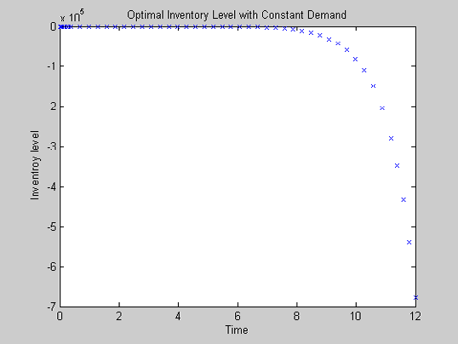 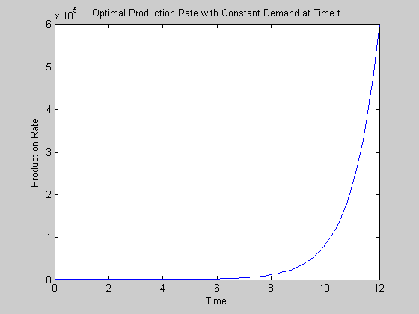

Figure 2: Optimal Production Policy with Constant Demand.

Figure 1: The inventory level *x*(*t* ) in-terms of the first-order differential equation in terms of constant demand. ;

The constant demand rate is assumed to have fixed value 20 units per unit time. Note that here demand and

deterioration decrease the inventory level displayed in Figure 1. From the Figure 2, it is clear that the production rate is not following the constant demand rate but the production rate with constant demand increases over time.

* 1. *Linear Demand Function*

In this subsection, we present the model with linear demand function. Substituting linear y2 (t)= *t* 15

instead of

*y*(*t* ) in the controlled system (4) we have

*dx*2 (*t*)  *u*

(*t*)  *y* (*t*)  1 exp*t*  **  / **  *x* (*t*), 0  *t*  *T* ,

*x*(*T* )  0

*dt* 2 2 ** 2

from which the production goal rate *u*ˆ(*t*) can be computed (assuming *x*(0)  *x* ) as

2

*u*ˆ2 (*t*)  *y*2

(*t*)  1 exp*t*  **  / **  *x*ˆ

(*t*)

In case of linear demand, it is the form

**

# y2 (t)= *t*  15

and the inventory level in-terms of first-order

differential equation decreases over time shown in Figure 3. The result is shown in Figure 4 and it is found that the production rate is not following the linear demand rate. The production rate starts with zero amount and increases over time.

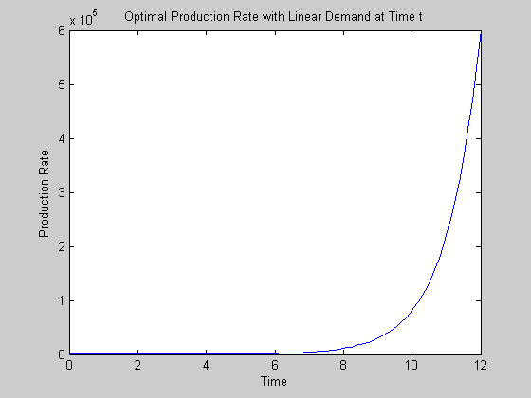

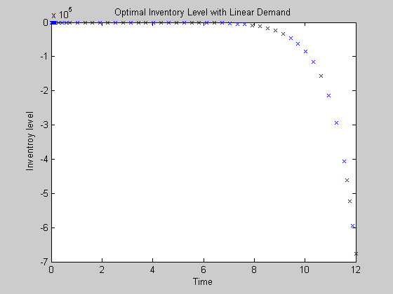Figure 3: The inventory level *x*(*t* ) in-terms of the first-order differential equation in terms of linear demand.

* 1. *Sinusoidal Demand Function*

Figure 4: Optimal Production Policy with Linear Demand.

In this subsection, we present the model with sinusoidal demand function. Substituting

# *y*3 (*t*)  1 sin(*t*)

instead of

*y*(*t*) in the controlled system (4) we have

*dx*3 (*t*)  *u* (*t*)  *y* (*t*)  1 exp*t*  **  / **  *x* (*t*), 0  *t*  *T* ,

*x*(*T* )  0

*dt* 3 3 ** 3

from which the production goal rate *u*ˆ(*t*) can be computed (assuming *x*(0)  *x* ) as

*u*ˆ (*t*)  *y* (*t*)  1 exp*t*  **  / **  *x*ˆ (*t*)

3 3 ** 3

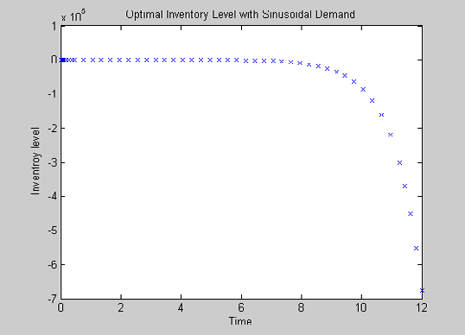

Figure 5: The inventory level *x*(*t* ) in-terms of the first-order differential equation in terms of sinusoidal demand.

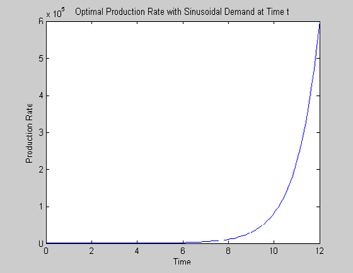

Figure 6: Optimal Production Policy with Sinusoidal Demand.

In Figures 5 to 8 do not show the variations of the inventory and optimal production level with time with changing the shape of the demand functions. In case of sinusoidal and exponential decreasing demand oriented optimal inventory levels over time almost have no variations that support the findings of Baten and Kamil (2009). It is observed that the optimal production rates are not very sensitive to changes in the demand functions in case of Gumbel distribution.

* 1. *Exponential Increasing Demand Function*

In this subsection, we present the model with sinusoidal demand function. Substituting

*y*6 (*t*)  exp*t* 

instead of

*y*(*t*) in the controlled system (4) we have

*dx*6 (*t*)  *u* (*t*)  *y* (*t*)  1 exp*t*  **  / **  *x* (*t*), 0  *t*  *T* ,

*x*(*T* )  0

*dt* 6 6 ** 6

from which the production goal rate *u*ˆ(*t*) can be computed (assuming *x*(0)  *x* ) as

*u*ˆ (*t*)  *y* (*t*)  1 exp*t*  **  / **  *x*ˆ

(*t*)

6 6 ** 6

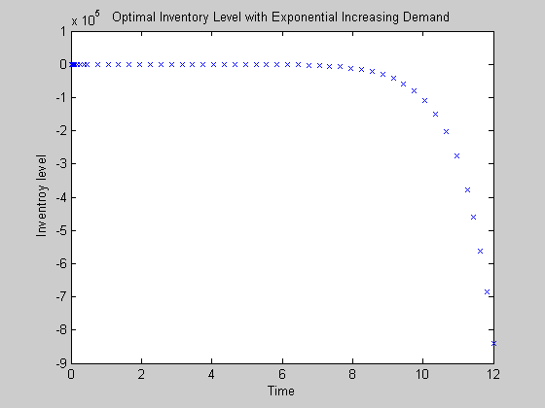

Figure 7: The inventory level *x*(*t* ) in-terms of the first-order differential equation in terms of exponential ncreasing demand.

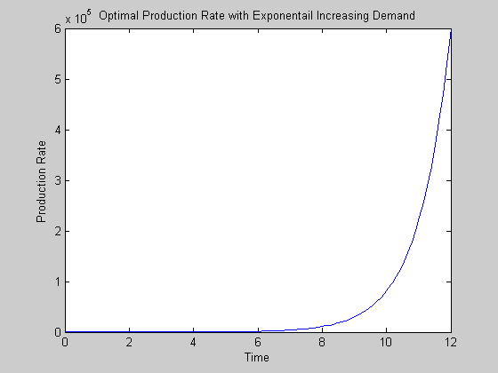

Figure 8: Optimal Production Policy with Exponential Increasing Demand.

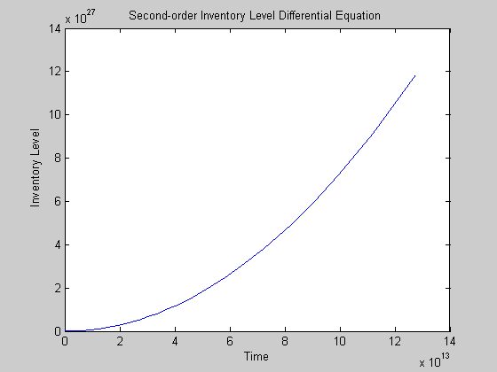

Figure 9: The inventory level *x*(*t* ) in-terms of the second-order differential equation.

The solution of the second-order differential equation is represented by Figure-9 and shows the state of optimal inventory level is increasing. However, in the subsections we present the model to measure the performance using different demand patterns. The production level with time *t* given *u*ˆ(*t*) from the equation

(18) considering the mentioned above different demand rates and we take the inventory goal level is as

*x*ˆ(*t*)  10 keeping all other parameters unchanged.

7 Conclusions

We developed an optimal control model in inventory-production system with generalized Gumbel distribution deteriorating items. This paper derived the explicit solution of the optimal control models of an inventory- production system under a continuous review-policy using Pontryagin maximum principle. However, we gave numerical illustrative examples for this optimal control of a production-inventory system with Gumbel distribution deteriorating items. However, particular emphasis can be made also with extreme value (e.g. Gumbel) distribution for assessing landslides hazards, earthquake hazards. Near-surface groundwater levels can be treated the same extreme-value distribution context as river floods, wind gusts, earthquakes, and other naturally occurring temporal phenomena.

References

1. Abad, P. L. Optimal price and order size for a reseller under partial backordering. *Com. & Opera. Res..*

2001; 28: 53–65.

1. Awad El-Gohary et al., Using optimal control to adjust the production rate of a deteriorating inventory system. *J. of Taliban Uni.for Sci.* 2009; 2: 69-77.
2. Al-khedhairi, A., L. Tadj. 2007. Optimal control of a production inventory system with Weibull distributed deterioration. *Appl. Mathe. Sci.* 2007; 1(35): 1703-1714.
3. Baten, M.A., A. A. Kamil. An optimal control approach to inventory-production systems with Weibull distributed deterioration. *J. of Mathe. and Sta.* 2009; 5(3):206-214.
4. Bhunia, A. K., M. Maiti. An inventory model of deteriorating items with lot-size dependent replenishment cost and a linear trend in demand. *App. Mathe. Model.* 1999; 23: 301–308.
5. Bounkhel, M., L. Tadj. Optimal control of deteriorating production inventory systems. *APPS.* 2005; 7: 30- 45.
6. Benhadid, Y., L. Tadj, M. Bounkhel. Optimal control of production inventory systems with deteriorating items and dynamic costs. *App. Mathe. E-Notes.* 2008; 8: 194-202.
7. Chakrabarty, T., B., C. Giri, K. S. Chaudhuri. An EOQ model for items with weibull distribution deterioration, shortages and trended demand: an extension of philip's model. *Comp. & Ope. Res*. 1998; 25(7– 8): 649–657.
8. Gontg, Z.-J., C.-Q. Wang. A production-inventory arrangement model for deteriorating items in a linear in A Review on Deteriorating Inventory Study increasing market. *Logistics Technology*. 2005; 10: 6–8.
9. Hedjar, R., M. Bounkhel, L.Tadj. Predictive control of periodic-review production inventory systems with deteriorating items. *TOP*, 2004; 12(1): 193-208.
10. Hedjar, R., M. Bounkhel, L.Tadj. Self-tuning optimal control of periodic-review production inventory systems with deteriorating items. *Adv. Model. and Opt*. 2007; 9(1): 91-104.
11. Maity, A. K., K. Maity, S. Mondal, M. Maiti. A chebyshev approximation for solving the optimal production inventory problem of deteriorating multi-item. *Math. and Com. Model*. 2007; 45: 149–161.
12. Padmanabhana, G., P. Vratb. EOQ models for perishable items under stock dependent selling rate.

*European J. of Ope. Res.* 1995; 86(2): 281–292.

1. Pontryagin, L.S., V. G. Boltyanskii, R.V. Gamkrelidge, E.F. Mishchenko. The Mathematical Theory of Optimal Processes, Jhon Wiley and Sons, New York, 1962.
2. Sethi, S. P., G. L. Thompson. Optimal Control Theory, Applications to Management Science and Economics, Second Edition, Springer, 2000.
3. Tadj, L., M. Bounkhel, Y. Benhadid. 2006. Optimal control of production inventory systems with deteriorating items. *Int. J. of Sys. Sci*. 2006; 37(15): 1111-1121.