

[Applied Computing and Informatics (2011) 9, 119–135](http://dx.doi.org/10.1016/j.aci.2011.05.004)

King Saud University

Applied Computing and Informatics

[www.ksu.edu.sa](http://www.ksu.edu.sa/) [www.sciencedirect.com](http://www.sciencedirect.com/science/journal/22108327)

ORIGINAL ARTICLE

Knowledge representation for an eﬃcient re-use of project memory

Smain Bekhti a,*, Nada Matta b,1, Chaker Djaiz c,2

a *College of Computer Science and Information Systems, Imam University, Riyadh 11681,*

*P.O. Box 84880, Saudi Arabia*

b *Tech-CICO, Universite´ de Technologie de Troyes, 12 rue Marie Curie, BP 2060, 10010 Troyes Cedex, France*

c *Cadesis Corp., 142-176 Avenue de Stalingrad, Parc Technologique des fosse´s Jean, Bat 5, 92700 Colombes, France*

Received 21 October 2010; accepted 18 January 2011

Available online 27 May 2011

KEYWORDS

Project memory; Knowledge re-use; Knowledge manage- ment;

Knowledge represen- tation;

Conceptual graphs; Corese

Abstract Knowledge sharing in general and contextual access to knowledge in particular, still represent a key challenge in knowledge management framework. Researchers on semantic web and human machine interface study techniques to enhance this access. For instance, in semantic web, information retrieval is based on domain ontology. In human machine interface, keeping track of user’s activ- ity provides some elements of the context that can guide the access to informa- tion. We suggest an approach based on these two key guidelines, while avoiding some of their weaknesses. The approach permits a representation of both the context and the design rationale of a project for an efficient access to knowledge. In fact, the method consists of an information retrieval environment that, in the one hand, can infer knowledge, modeled as a semantic network, and on the other hand, is based on the context and the objectives of a specific activity (the design). The environment we defined can also be used to gather similar project elements

* Corresponding author. Tel.: +966 55 9104761; fax: +966 1 2591616.

E-mail addresses: [sbekhti@imamu.edu.sa](mailto:sbekhti@imamu.edu.sa) (S. Bekhti), [Nada.Matta@utt.fr](mailto:Nada.Matta@utt.fr) (N. Matta), [cdjaiz@cadesis.com](mailto:cdjaiz@cadesis.com) (C. Djaiz).

1 Tel.: +33 3 25 71 58 65.

2 Tel.: +33 1 56 83 70 00.

2210-8327 ª 2011 King Saud University. Production and hosting by Elsevier B.V. All rights reserved.

Production and hosting by Elsevier

Peer review under responsibility of King Saud University.

doi:[10.1016/j.aci.2011.05.004](http://dx.doi.org/10.1016/j.aci.2011.05.004)

in order to build classifications of tasks, problems, arguments, etc. produced in a company. These classifications can show the evolution of design strategies in the company.

ª 2011 King Saud University. Production and hosting by Elsevier B.V.

All rights reserved.

1. Introduction

Knowledge sharing is still a main problem to deal with in organizations. Although, studies in semantic web and human machine interface provide tech- niques to enable a better access to information, these techniques are not sufficient in terms of allowing a contextual access according to user needs. In fact, in the semantic web framework (Berners-Lee et al., 2001), the information access is guided by the ontology of the user domain. However this type of ontology is built as a consensual concept definition of the domain. Therefore, it can be considered as a reference of the concepts used in a given domain while any user generally has her/his own representation of the domain, which is more or less close to domain ontology. Moreover, the structure of the domain ontology is usually provided by a knowledge engineer who introduces her/his own representation to build this ontology.

In the context of knowledge management within companies, there are numerous challenges in developing effective corporate memories, including problems in asset capture, representation, retrieval, and reuse (Hilbert et al., 2006). Besides, user activity evolves over the time and, subsequently, her/his information requirement changes according to the context of her/his activity. Several works on human machine interface (Jing et al., 2002) study the way to keep track of user activity in order to offer a personalized information retrieval. Studies in ergonomics prove that information about the objectives and the environment of an activity are essen- tial for a better understanding and an accurate representation of that activity.

In our approach, the above important aspects are taken into account. We focus on the designer activity, in which, tasks and activities can provide relevant infor- mation about the objectives of the designer activity. We defined methods and structures for a construction of a memory of design projects focusing, particularly, on the two parts that we consider as essential in such category of projects: the pro- ject context and the design rationale (Bekhti and Matta, 2003). The produced pro- ject memory can be considered as a referential resource in an organization. This resource is structured not only as a domain ontology, providing links to relevant documents, but also as a semantic network accurately linking up concepts consti- tuting the project context and the design rationale. The information retrieval pro- cedure is based on semantic relations between these concepts and can, hence, offer a contextual information access. We used conceptual graphs to represent concepts in a design project as a semantic network structure. We used ‘‘Corese’’ (Corby and Faron-Zucker, 2002) as an information retrieval tool as a semantic search engine.

This tool uses conceptual graphs along with RDF and XML formalisms in order to offer a deep and semantic information retrieval.

The rest of this paper describes, in its second and third sections, the designed structures of project memory and a suggested approach that enables the capture and representation of knowledge used and produced during design project. Section 4 argues the need of contextual information retrieval in design. Section 5 describes how a project memory has been represented using conceptual graphs and RDF formalisms. Information retrieval as carried out with Corese (Section 6) is based on the relation between the constructed conceptual graph and its RDF representation.

1. Project memory

In Dieng-Kuntz-Kuntz et al. (2001) defines knowledge management cycle as being composed of the following stages: clarification, broadcasting and reuse. Many investigations have presented the corporate memory as a significant support for knowledge management. A corporate memory is an ‘‘explicit representation of pertinent knowledge of an organization’’ (Van Heijst et al., 1997). This memory, elucidating the organizational knowledge (also called collective knowledge), may be considered as a knowledge asset of the organization. Such knowledge asset can be specific to a project and so be called project memory. A project memory can be defined as ‘‘a representation of the experience acquired during projects real- ization’’ (Matta et al., 2000). This experience includes knowledge used and pro- duced during the project realization. Beside this, representing project context can be crucial in terms of understanding the circumstances of decision making and problems solving.

Therefore, we consider the structure of project memory as being constituted of the following parts (Fig. 1):

* The project organization: teams, members, tasks, roles, competencies, etc.
* Resources and constraints: rules, methods, directives, time, budget, etc.
* Project realization: problem solving (problem definition, suggestions, and deci- sion), solution evaluation (arguments, criteria), etc.
* Project goals and objectives.

Relations between the above elements must also be represented. These relations have different sorts of influence on the decision making process and may be of great importance for the design rationale understanding.

1. Knowledge acquisition and representation in project memory

We defined an approach that permits the capture and the representation of used and produced knowledge during project realization. This approach consists, on

Evolve

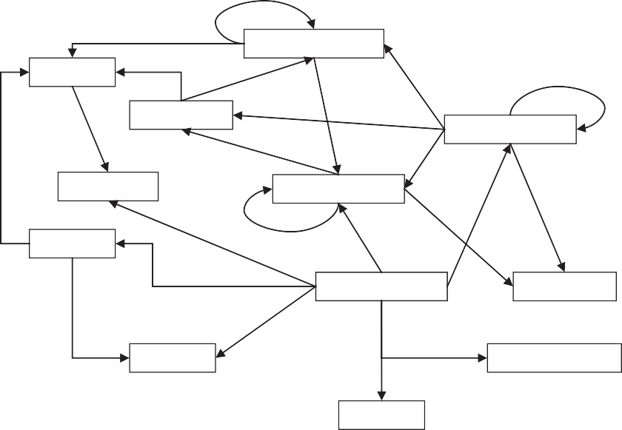

Generate

**Task**

Generate

**Decision**

**Problem/Decision**

Have as solution

Lead to

Discuss

Support/Oppose

Belong to

**Argument**

Consider Lead to

Support/ Oppose

**Constraint Suggestion**

Consider Relate to

Provide

**Role**

Generate

Relate to

Provide

Have

**Project Member**

**Criterion**

Need

Possess

Possess

**Resource**

**Competency/Skill**

Belong to

**Division**

Figure 1 Project memory structure (Bekhti and Matta, 2003).

the one hand, of two main steps: direct transcription and content structuring and, on the other hand, of project context extraction from the tools and the environ- ment of projects (process, organization, etc.).

* 1. *Direct transcription*

The first stage of our approach consists of a form-based transcription. These forms help to record and classify basic elements of a design problem discussion. That is, elements like problems, argumentation and decision. These forms can be used to record, in a structured and prompt way, all the information elements that can be collected during a design problem solving discussion. The goal is to enable a real time structured transcription of the discussion during design meet- ings. The structure of these forms (Fig. 2) permits to distinguish the key elements of the discussed problem and to classify participants’ arguments along with their possible suggestions.

* 1. *Content structuring*

The principal objective of the content structuring is to enable an intelligent access to knowledge represented in the project memory. Our idea is to make possible a flexible access to the project memory according to several viewpoints. This form of access is described in the information retrieval section of this paper. The second stage of our approach consists of a structuring based on a cognitive analysis of the

Trigger

**Decision**

Advocate

* **Hold**
* **Modification**
* **Elimination**
* **Creation**

Lead to a Decision

**New version of the solution**

**Project member**

* **Argument(s)**
* **Suggestion(s)**

**Part of the discussed Problem/Decision**

Figure 2 Structure of the form used for the direct transcription of design discussion.

forms filled out during the direct transcription. We were inspired by the ap- proaches of design rationale representation (Karsenty, 1996; Buckingham, 1997; Klein, 1993) to define a structure of representation, putting ahead elements of influence in a negotiation/discussion, such as arguments, criteria of justification and suggestions (Fig. 3).

Notes are initially grouped by participants (members) who, during the meeting, are identified either by their names or by their visual aspects. In fact, the direct transcription that we propose follows, on the one hand, the traditional methods of notes taking during meetings and permits, on the other hand, a model-based information structuring. This transcription can easily be realized by a meetings secretary. No deep analysis is required in this type of transcription. Note also that a chronological recording of the design rationale is supported by this method of transcription.

The selection of criteria is guided by a classification of common design argu- ments types (Fig. 4). The method we propose can be compared to meetings report- ing where the direct transcription is similar to notes taking and the structuring to summary reporting.

However, in our case, the transcription is guided by model-based forms. The result is richer and reflects a more comprehensive knowledge-oriented memory of the design rationale and the decision-making process.

One of our key suggested ideas is to integrate the traceability procedure in the process of projects realization itself. This implicates a slight change in project structures and organization and permits the capture of knowledge during the pro- ject realization and not afterwards. This aspect is very important as the knowledge that emerges during any project realization is volatile and can hardly be reconsti- tuted after the project is over.

In order to guarantee an accurate representation of knowledge essentially impli- cated in the design rationale, a validation meeting must be held with some project key members who have got a global vision of the project (for example, the project

Discussed Problem/Decision

**ERP and “Autonomy principle”**

|  |  |
| --- | --- |
| **Argument** | **Suggestion** |
|  | **Criterion: Required Resources**  List competences that the company must have in order to perform the evaluation  **(Member3)** |
|  | Contextualization of the  principles according to each company. **(Member6)** |
| **Control ERP:** Companies must remain Masters of the decisions to take to control the risk after the evaluation.  **(Member1)** | Allowing the possibility of having recourse to an external treatment. **(Member1)** |
|  | Nominating an ERP guarantor in the company.  **(Member1)** |

Figure 3 An example of a form used for the design rationale structuring during a project memory definition.



**Decision**

Hold

**Modification of “Autonomy** principle”

Elimination **Creation of “Adaptability**

**Principle”**

**Version 3.0**

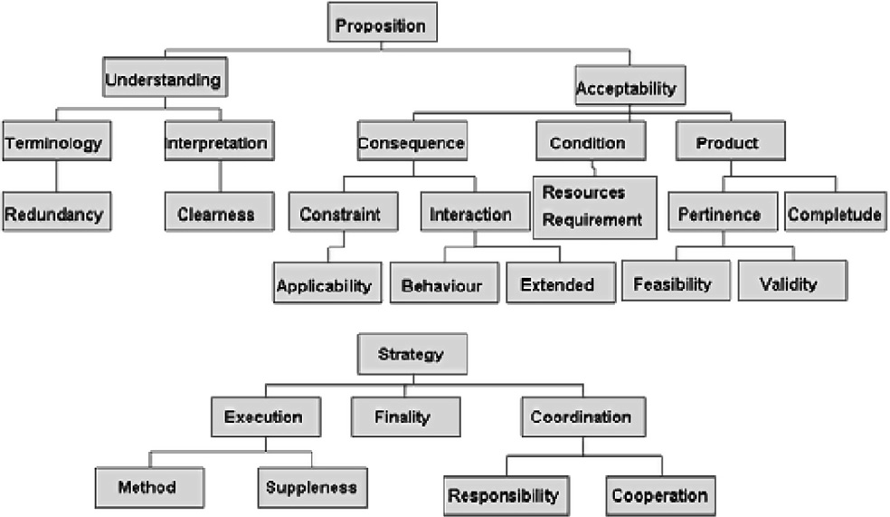

Figure 4 Criteria tree representing a typology of design problems (Matta, 2000).

manager). This kind of meeting can be held after a number of project phases and at the end of the project realization. This makes possible to reformulate the argu- ments, the suggestions and the criteria and to re-examine their classification. The structure of the memory encourages the project members to explicitly express their knowledge, enriching by that the contents of the memory.

* 1. *Logic of the structuring form*

The structure represents the logic of discussion. Participants (project members) discuss each part of the problem by expressing their opinions supported by argu- ments. The participants can also provide suggestions concerning the design prob- lem. The collection of arguments and suggestions allows the team to take a decision concerning a part of a problem. Thus, the part of the problem is either totally solved or will be discussed again in the same manner and will go through the same cycle. This enables to see the evolution of this element during the prob- lem solving process until its final version.

In the structure, the arguments are classified according to their types or natures. Each argument or suggestion is related to the member who emitted it. The fact that the competencies and the role of each member are indicated permits to see the relation that may exist between the contributions (arguments and suggestions) of the participants and their competencies and skills. This is essential for a prob- lem solving context comprehension.

* + 1. *Elements of the structure*
       1. *Problem/decision.* The global problem discussed during design meetings is split into sub-problems or elements of problem. This permits to represent these ele- ments of discussion through the different phases, connect them and elucidate the evolution of each of them during the project completion.
       2. *Arguments.* One of the most significant elements of any negotiation is the argumentation. In our approach the argumentation is an essential element of the representative structure since it is the origin and the cause of the evolution of the discussion of the problem and consequently of the decision-taking.
       3. *Suggestions.* The arguments advanced by the speakers during meetings often lead them to present their own suggestions concerning a given part of the discussed problem; we envisaged in the model a space for suggestions of project members (participants). The suggestions are linked to the arguments and the par- ticipants who emitted them.
       4. *Project members/participants.* The representation of the participants in the structure is important; it permits to bind the arguments and suggestions to their emitters. Each participant is characterized, primarily, by his competencies/skills and his role in the project (see context). This permits to clearly understand the lo- gic and the reasoning of the members and the motives of their opinions.
       5. *Criteria.* Arguments and suggestions are classified according to some de- fined criteria. Theses criteria have been gathered from several previous studies

of classification of common types of design arguments (Matta, 2000; Brown and Berker, 2000).

1. Knowledge re-use and designers needs

Designers need to learn from previous experiences in order to find out how to deal with new problems in their activities. They generally are in a situation of handling designs of new products and need information about similar design situations. Their needs are essentially focused on different elements of past design projects (types of problems, decisions, constraints, arguments, criteria, etc.). The structure defined in Fig. 1 can help in this special form of information retrieval. The infor- mation retrieval process can be guided not only by classifications of problems, projects, etc. but by similarity between project descriptions. Relations between project elements must play an important role in this information retrieval process. For instance, designers may need to know why a given suggestion has not been considered (rejected), who decided that, under which constraints, having which re- sources, competencies, which other suggestion has been approved instead, etc.

For that precise reason, we propose to represent project memory as a semantic network and to use semantic inference engine to conduct the information retrieval process. The resulting memory is not a simple list of documents or parts of doc- uments but a network presenting on the one hand, the relations between project elements and on the other hand, pointing the relevant documents. Designers can therefore have a contextual information retrieval that can be very useful in their design activity.

1. Information retrieval based on semantic relations

Indexing documents can either be simple using metadata and keywords (currently recommended in HTML documents) or complex using semantic networks and ontology (defended by semantic web) (Martin, 1995). Semantic Networks have shown a great ability in terms of information structuring and information retrie- val. (Steyvers and Tenenbaum, 2005) demonstrated that developing search and re- trieval algorithms that exploit the large-scale structures of semantic networks is likely to be a project of great promise, for both cognitive science research and information retrieval applications.

We choose conceptual graphs to represent our semantic network. Conceptual graphs are a formalism that offers a highest structure of the semantic relations be- tween concepts (Chein and Mugnier, 1992). In this formalism, there are a number of inference functions (Sowa, 1984) that helps in information retrieval. We partic- ularly note projection, joint, generalization and specialization functions. This for- malism has been used and validated in numerous applications and its effectiveness is now commonly approved.

Moreover, the structure of conceptual graphs (especially support and graphs) is close to RDF (Resource Framework Description) and RDFs (Resource Frame- work Description Schema). Thus, it can easily be translated to RDF and XML respecting semantic web recommendations (RDFS, 2004). This connection be- tween conceptual graphs, RDF and XML can provide a number of specific func- tions that give more power for information retrieval. The Corese search engine developed at INRIA (Corby et al., 2000) is based on this principle.

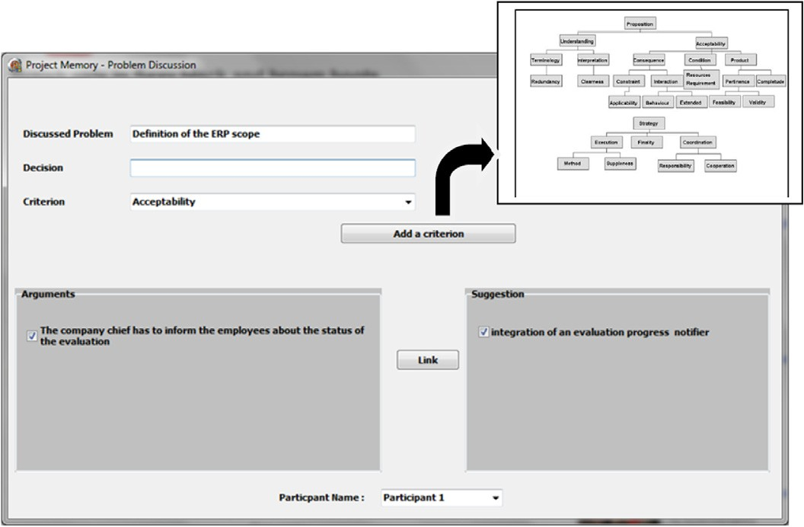

* 1. *Corese: a semantic search engine*

The Corese search engine (Corby and Faron-Zucker, 2002) is dedicated to the que- rying of corporate semantic webs in which documents are described through RDF annotations. Corese interprets RDF metadata in the conceptual graphs model in order to exploit the inference capabilities of this formalism. The RDFS (RDFS, 2004) and conceptual graphs models share many common features and a mapping can easily be established between RDFS and a large subset of the conceptual graphs model. The information retrieval in Corese is based on this mapping. In fact, the Corese query language is RDF with addition of some extra conventions introducing variables and operators. An RDF query statement is interpreted as a conceptual graph query and is processed by a conceptual projection of the query on the annotation graphs. Therefore, Corese enables to process information

Figure 5 DyPKM interface.

retrieval queries on the data (content) as well as on the schema (the structure of the project memory).

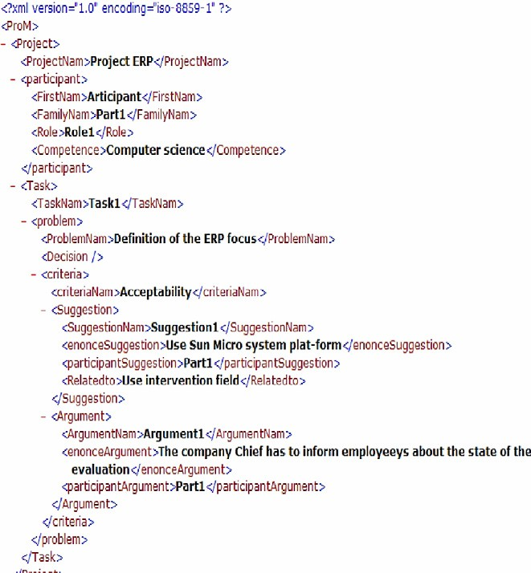

*5.2. Representation of project memory*

Knowledge captured from design projects is structured in XML files. In fact, as we explained in the knowledge acquisition method above, a project secretary, can keep track of the knowledge from the context and the decision meetings of a de- sign project. She/he uses a tool (DyPKM) (Bekhti and Matta, 2003) that generates an XML file. The tool, the secretary uses, helps to classify concepts like sugges- tions, arguments, problems, participants, etc. and to establish semantic relations between these concepts. DyPKM interfaces are designed to clearly display classi- fication trees of design problems. That is, identifying from project members ex- changes: suggestions and arguments concerning a given design problem, related criteria but also grouping arguments, suggestions, tasks, etc. by design decisions (Fig. 5).

Structures and content are transformed to an XML document (Fig. 6). An XSL file is defined in order to generate a related RDF file (Fig. 7). These two files are then integrated in the knowledge base of Corese in order to assure an efficient search process.

Figure 6 The generated XML file.

Knowledge representation for an efficient re-use of project memory 129

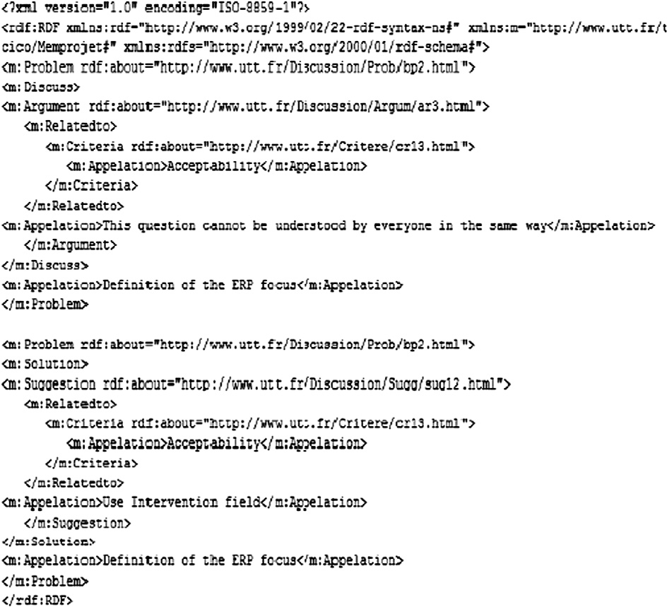

Figure 7 The translated RDF file.

1. Knowledge re-use: project information retrieval using Corese

The structure of the project memory (Fig. 1) is implemented using RDF schema (Fig. 8). Corese inference engine explores this schema in order to retrieve informa- tion from RDF files. These RDF files form a knowledge base of the represented design project. We illustrate in the following two examples the way information retrieval within a project memory is performed.

The first example shows how Corese engine can perform an exploration search and return all the requested concepts. The second example shows how the infer- ence engine can be used to do a deep search and retrieve concepts that are not di- rectly linked.

* 1. *Example of an exploration-like information retrieval*

When a designer deals with a problem, he/she needs to know, for instance, if this problem has been solved in any previous similar projects and how. His request can

130 S. Bekhti et al.

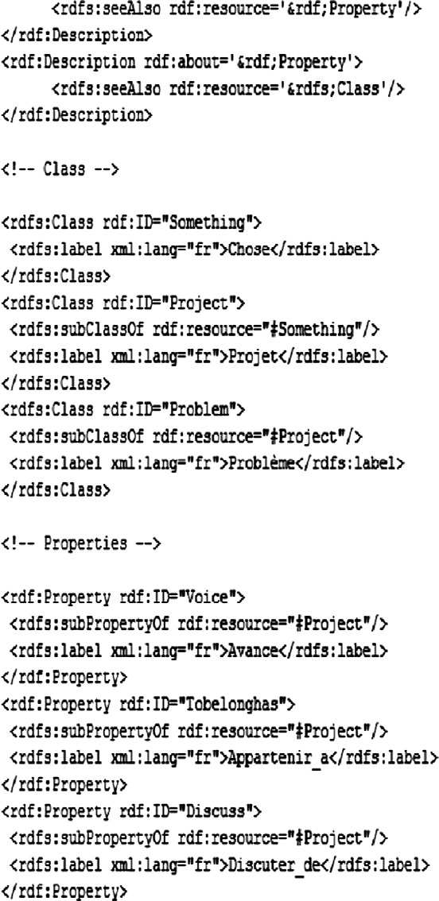

Figure 8 The structure of project memory presented as a RDF schema.

be formulated as follows: ‘‘Which suggestions supported by which arguments were provided to solve a given design problem? And what were the criteria that these arguments and suggestions related to?’’

To start, this query is translated to an RDF request (Fig. 9) according to our RDFS representation. Then, it is projected on a conceptual graph:

RDF → CG → RDF (Fig. 10). This RDF query is then interpreted by the Corese engine as a conceptual graph query. The result is obtained using conceptual graph

generalizations functions and exploiting RDF files. Display of the RDF results is made more user-friendly using an XSLT formatting data sheet (Fig. 11).

Knowledge representation for an efficient re-use of project memory 131

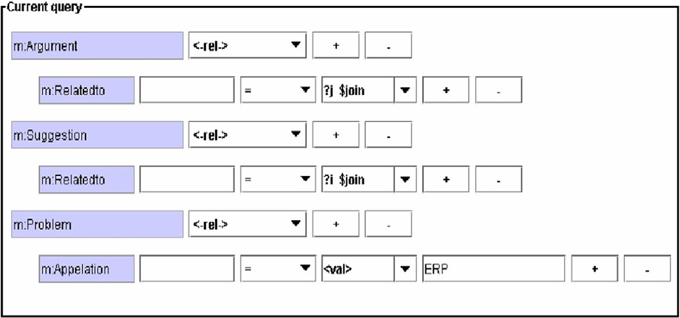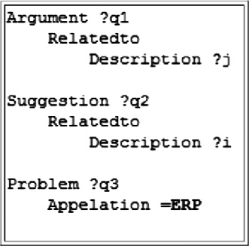

Figure 9 The RDF query.

Figure 10 The request in the conceptual graph formalism.

This exploration search can highlight connected concepts according to certain conceptual relations.

According to the RDF file, the result is:

PB2: ERP focus

Criteria 123: *Terminology*

Argument 342: Evaluation perimeter is not clear.

Argument 10: Evaluation perimeter in paragraph 3 is not in correlation with the text.

Suggestion 11: Use ‘‘intervention field’’ instead of ‘‘evaluation perimeter’’. Criteria 13: *Exhaustiveness*.

Argument 32: The company chief has to inform employees about the state of the evaluation.

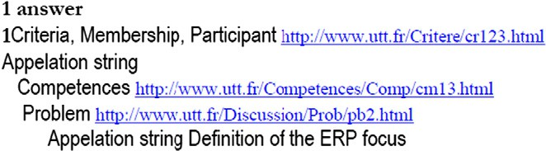

132 S. Bekhti et al.

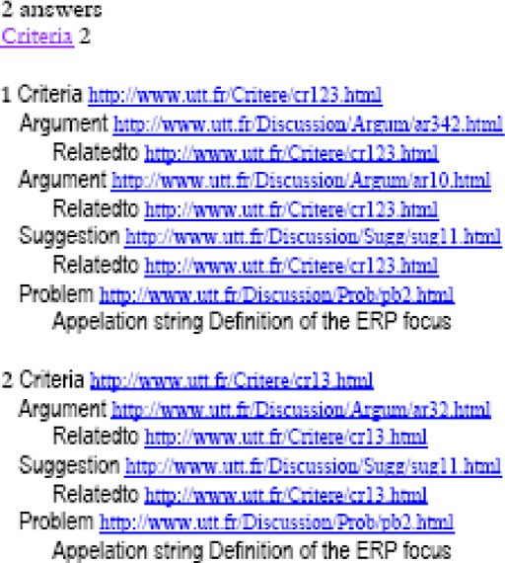

Figure 11 The query result for an exploration search.

Evolve

Have as Solutio

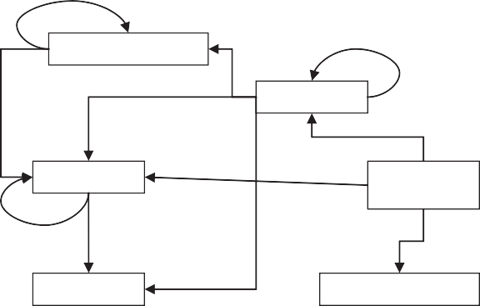

Discuss

Problem/ Decision

Support/Oppose

n

Argument

Provide

Suggestion

Provide

Project Member

Generate

Relate to

Possess

Relate to

Criterion

Competency/Skill

Figure 12 Part of the project memory structure used in the second query example.

Suggestion 11: Emphasis the role of the company chief in the evaluation process.

Figure 13 The query result of a deep information retrieval.

* 1. *Example of a deeply Information retrieval*

A designer may also need to know what are the skills or competencies that contrib- uted to solve a design problem in a previous design project and which argumenta- tion criteria were considered? The particularity of this query is that these concepts (design problems and competencies), are not directly linked in the project memory structure (Fig. 1). In fact, there is a direct relation between a design problem and the related suggestions and arguments. Arguments and suggestions have direct links to corresponding criteria. There is also a link between arguments, suggestions and participants who emitted them. Concepts like skills or competencies of each project member are represented in the structure and linked to the related member (Fig. 12).

Corese engine performs an approximate projection that is based on a joint rela- tion in order to build a meta-relation between the given concepts. Accordingly, Corese engine infers unlinked documents or linked by transitivity documents. The given results are always an RDF file (Fig. 13).

The obtained result is:

PB2: ERP focus

Criteria 123: *Terminology*

Competency 13: *Consulting*

1. Conclusion

Designers need to learn from past design projects in order to deal with new design problems. They want to know, for instance, how similar problems were solved in the past, with which resources, using which solutions and under which conditions. A structured project memory representing influence relations between problems, suggestions, arguments, criteria, project members and their competencies, tasks, etc. provides a useful traceability of knowledge used and produced during the real- ization of design project. These structures also show the relations between the con- text of the project (organizations and environment) and the element of the design rationale. Information retrieval process can use these relations in order to provide a contextual search for required information. This paper shows how this type of conceptual relations can be useful for information retrieval. In fact, we explained how a semantic network (represented as a conceptual graph) can provide a contex- tual and efficient information retrieval. Corese, a semantic search engine tool, has been used to perform the information retrieval process. Corese creates a mapping between RDF and conceptual graphs to offer a deep information retrieval. The search process is based not only on a specialization (as commonly used in ontol- ogy) but also on knowledge representation inference through relations between concepts. The results help designer to understand design problems and in previous

134 S. Bekhti et al.

projects and how they have been solved. This makes project memory very useful in terms of learning from previous experiences.

Examples presented in this paper are extracted from a design project of profes- sional safety evaluation rules (Bekhti and Matta, 2003). DyPKM and Corese have to be validated on other design projects. We also plan to define a graphical inter- face to display results as graphs or trees, clearly illustrating the relations between the elements of design project.

Finally, the environment we defined can also be used to gather elements of sim- ilar design projects in order to build a global classification of tasks, problems, arguments, etc. produced in a company. These classifications can show the evolu- tion of design strategies in the company.

References

Bekhti, S., Matta, N., 2003. Project memory: an approach of modelling and reusing the context and the de design rationale. In: Proceedings of IJCAI’03 (International Joint of Conferences of Artificial Intelligence), Workshop on Knowledge Management and Organisational Memory, Accapulco.

Berners-Lee, T., Hendler, J., Lassila, O., 2001. The semantic web. Scientific American.

Brickley Dan, Guha, R.V. (Eds.), 2004. RDF Vocabulary Description Language 1.0: RDF Schema W3C Recommendation.

Brown, D.C., Berker, I., 2000. Modeling Conflicts Between Agents in A Design Context, Computational Conflicts, Conflicts Modeling for Distributed Intelligent System. Springer, pp. 144–164.

Buckingham, S., 1997. Representing hard-to-formalise, contextualised, multidisciplinary, organisational knowl- edge. In: Proceedings of AAI Spring Symposium on Artificial Intelligence in Knowledge Management, pp. 9– 16.

Chein, M., Mugnier, M.L., 1992. Specialization: Where do the difficulties occur? In: Proceeding of the Seventh Annual Workshop on Conceptual Structures, Las cruces, New Mexico.

Corby, O., Faron-Zucker, C., 2002. Corese: a corporate semantic web engine. In: Workshop on Real World RDF and Semantic Web Applications 11th International World Wide Web Conference, Hawaii.

Corby, O., Dieng, R., Faron-Zucker, C., 2000. Querying the Semantic Web with Corese Search Engine, Prestigious Applications of Intelligent Systems PAIS. ECAI, Valencia.

Dieng-Kuntz-Kuntz, R., Corby, O., Gandon, F., Giboin, A., Golebiowska, J., Matta, N., Ribie` re, M., 2001.

Me´thodes et outils pour la gestion des connaissances, 2eme ed. Dunod e´diteur.

Hilbert, D., Billsus, D., Denoue, L., 2006. Seamless capture and discovery for corporate memory. In: The 15th International World Wide Web Conference (WWW2006).

Jing, Y., Taylor, N., Brown, K., 2002. An intelligent inference approach to user interaction modelling in a generic agent based interface system. In: Proceedings of ECAI2002 (European Conference on Artificial Intelligence), July, Lyon.

Karsenty, L., 1996. An empirical evaluation of design rationale documents. In: Proceedings of the Conference on Human Factors in Computing Systems. Vancouver.

Klein, M., 1993. Capturing design rationale in concurrent engineering teams. IEEE, Computer Support for Concurrent Engineering.

Martin, M., 1995. Links between electronic documents and a knowledge base of conceptual graphs. In: Proceedings of the International Conference on Conceptual Structures of ICCS.

Matta, N., 2000. Conflict management in concurrent engineering: modelling guides. In: Computational Conflicts: Conflict Modeling for Distributed Intelligent Systems, with Contributions by Numerous Experts. Springer.

Matta, N., Ribie` re, M., Corby, O., Lewkowicz, M., Zacklad, M., 2000. Project memory in design. In: Rajkumar Roy, (Ed.), Industrial Knowledge Management – A Micro Level Approach, Springer-Verlag.

Sowa, L., 1984. Conceptual Structures: Information Processing in Mind and Machine. Addison-Wesley, Reading, MA.

Steyvers, M., Tenenbaum, J., 2005. The large-scale structure of semantic networks: statistical analyses and a model of semantic growth. Cognitive Science 29, 41–78.

Van Heijst, G., Schreiber, A., Wielinga, B., 1997. Using explicit ontologies in KBS development. International Journal of Human Computer Studies 46.