[Array 7 (2020) 100036](https://doi.org/10.1016/j.array.2020.100036)

 

Contents lists available at [ScienceDirect](http://www.sciencedirect.com/science/journal/25900056)

Array

journal homepage: [www.elsevier.com/journals/array/2590-0056/open-access-journal](http://www.elsevier.com/journals/array/2590-0056/open-access-journal)

Machine learning based approach for shape memory polymer behavioural characterization

Ritaban Dutta a,*, David Renshaw b, Cherry Chen b, Daniel Liang b

a *DATA 61, CSIRO, Hobart, Australia*

b *Manufacturing, CSIRO, Clayton, Australia*

A R T I C L E I N F O

*Keywords:*

Shape memory polymer Machine learning

Data driven modelling Data science

A B S T R A C T

In this article we aim to combine video data analysis techniques, scalable machine learning, and Shape memory polymers (SMPs) materials to develop a model-based architecture for the advancement of rapid characterization of a novel material. Although artificially intelligent machines, e.g. soft robotics systems, with high flexibility have conquered the production line and other controlled, predictable environments, their use in complex real-world scenarios has to date remained limited. Newly discovered and experimented SMPs are increasingly being used for application solutions in automotive, aerospace, construction and commercial field. But being a nascent field there is little knowledge on the shape recovery behaviour of laminates with a SMP film and there are only methods reported in literature for quantifying the material behaviour. Through various experimental data gathering and predictive modelling it was established that proposed methodology can rapidly characterize novel materials. The proposed modelling workflow showed accuracy of 90% with 92% sensitivity and 94% specificity while predicting recovery behaviour of SMP body, showcasing high potential for data driven rapid characteri- sation of shape memory materials.

1. Problem space

In spite of recent advances in field robots, inspecting complex confined spaces in natural, industrial or areas in natural disasters remains a challenge. Additionally, current robots are limited in their field per- formance by only being operational in a narrow spectrum of environ- mental conditions. To address these challenges, the CSIRO is developing highly flexible machines that can change their body shapes and proper- ties, to adapt to task requirements and environmental conditions. A key scientific challenge in building such a robot is the design, development, and manufacturing of an integrated system that incorporates sensing, actuation, power storage and communication channels that do not restrict, rather augment the mobility of the robot [1–10].

Soft structures are difficult to model and control, so new methods are required to properly model. There are lots of ways to actuate a soft ma- terial but it’s very hard to model. Without modelling, movement of a soft material could not be optimised or controlled. A promising technique that has been proposed and developed in this study, combines computer vision and predictive learning to characterize novel soft materials and subsequent optimisation. Such complex interactions and correlations are

difficult to capture using either analytical modeling or conventional experimental testing due to overlapping of multiple thermal, mechanical, and materials transformation mechanisms.

In this study, a strategy of data-driven modelling, simulation and control is implemented, including the generation of the experimental database on the laminate actuation under electrical stimulus, the explo- ration of supervised machine-learning based modelling, according to the experimental data obtained. The establishment of the predictive model for describing dynamic behaviours of the SMA/SMP laminates and the development of controllers for the locomotion of the morphing robotic system [11–22] were also explored.

Fig. 1 presents a proposed data engineering workflow for this prob- lem space. There are two parts of the data driven system, namely, for the purpose of model of the material and model of the behavioural changes of the material. As in the conventional machine-learning paradigm, training and testing phases are essential for the scalable machine learning too, where rapid prototyping of an evolving model is essential to capture behavioural changes of a novel material [20–28].

* Corresponding author.

*E-mail addresses:* [Ritaban.Dutta@data61.csiro.au](mailto:Ritaban.Dutta@data61.csiro.au) (R. Dutta), [David.Renshaw@csiro.au](mailto:David.Renshaw@csiro.au) (D. Renshaw), [ling.chen@csiro.au](mailto:ling.chen@csiro.au) (C. Chen), [Daniel.Liang@csiro.au](mailto:Daniel.Liang@csiro.au) (D. Liang).

<https://doi.org/10.1016/j.array.2020.100036>

Received 18 December 2019; Received in revised form 5 May 2020; Accepted 23 June 2020

Available online 8 August 2020

2590-0056/© 2020 The Authors. Published by Elsevier Inc. This is an open access article under the CC BY license (<http://creativecommons.org/licenses/by/4.0/>).

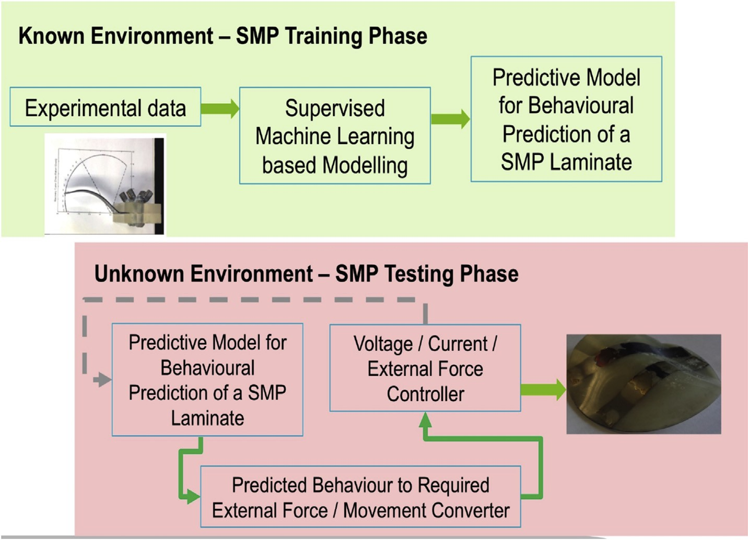

Fig. 1. Proposed experimental set-up for capturing SMP material behavioural changes through heating of the material.

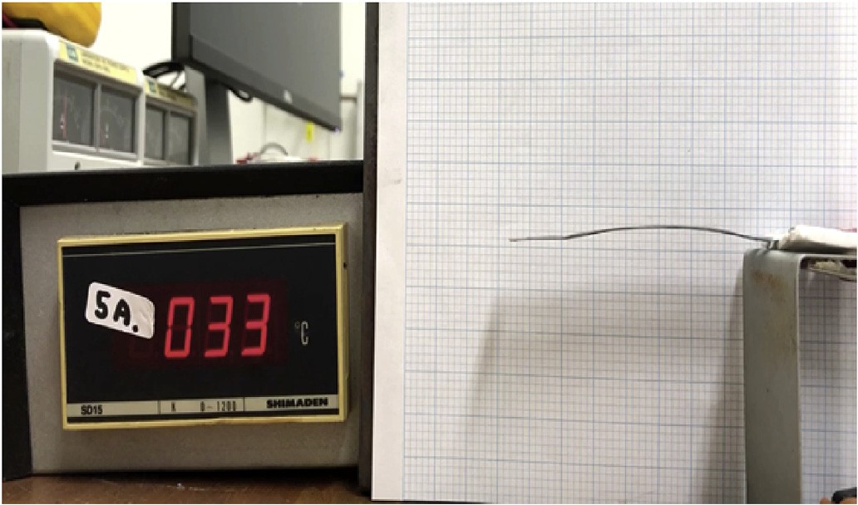

Fig. 2. Experimental set-up for capturing SMP material behavioural changes through heating of the material using current flow.

1. Experimental data gathering

Through various experimental data gathering and analysis, influences of different variables that affect the recovery behaviour of thermoplastic shape memory polyurethanes-based laminates including ambient tem- perature, material modulus, and adhesive strength have been investi- gated to develop a physical model to formulate the recovery behaviour of the material.

It has been identified that a fundamental optimisation problem that needs to be solved is to maximize the final angle recovery ratios and recovery rates of a material to increase the overall efficiency of a targeted SMP material. Fig. 2 shows experimental set-up for capturing SMP ma- terial behavioural changes as ground truth data for predictive modelling. Camera angle didn’t vary during the data gathering as it was a fixed test rig with a thermal camera was used. Quality of the captured video was consistent during all experimentation for this study with no tolerance of error while collecting 200 videos of the moving SMP body. We aim to standardize the experimental protocol so that a high level of data quality can be captured consistently with results being completely reproducible.

1. SMP material selection

The SMP based polyurethane provided was chosen in the study due to its large reversible change in the elastic modulus at a moderate glass transformation (Tg) temperature of about 45 ◦C. This characteristic of a large difference in elastic modulus at T g enables a larger degree and fast actuation under a given force, which is ideal for generating digital database. The moderate Tg does not require an extensive thermal stim- ulation to activate the SMP actuation. Consequently, the heat generated by a thin layer of silver-based conductive paste applied on the SMP surface is sufficient to provide the thermal stimulus required for actu- ating the SMA laminate. In addition, a thin heating layer is essential to main the large degree actuation, as it minimize the resistance to the actuation force.

For this research study mainly focused to prove the utilization of computer vision and machine learning techniques for advanced manufacturing material modelling, we used “DiAPLEX” SMP manufac- tured by SMP Technologies Inc [24]. Rationale behind this selection was also guided by the fact that this material has narrow transition state and drastic change of physical properties at transition state (Fig. 3(a)). The elastic modulus changes largely at the Tg, where setting of Tg can be designed at a desired temperature between 40 ◦C–90 ◦C. At a tempera- ture higher than the Tg, SMP can easily change form by applying low stress. In the heating phase of the SMP foil, increasing the temperature of foil above Tg eliminates the strain resulting in recovery of its original shape (Fig. 3(b)).

A SMP laminate was heated by a constant current of 5A through the body of the foil structure to initiate bending of the SMP material. As shown in the Fig. 3, SMP foil structure changed its shape due to heating while temperature increased from 23 ◦C to 52 ◦C at the connection. In terms of data gathering, a thermal camera and a normal digital camera were used to capture the bending SMP foil as a video file to be analyzed in the modeling phase.

Actual temperatures were also measured and logged as a time series by a separate temperature sensor during the experiments along with the thermal readings by a thermal camera [22–32]. Inputs to the proposed modelling paradigms were, namely, current (heating while temperature increased from 23 ◦C to 52 ◦C at the connection), thermodynamic nature of the SMP (by thermal camera readout). Expected outputs from the

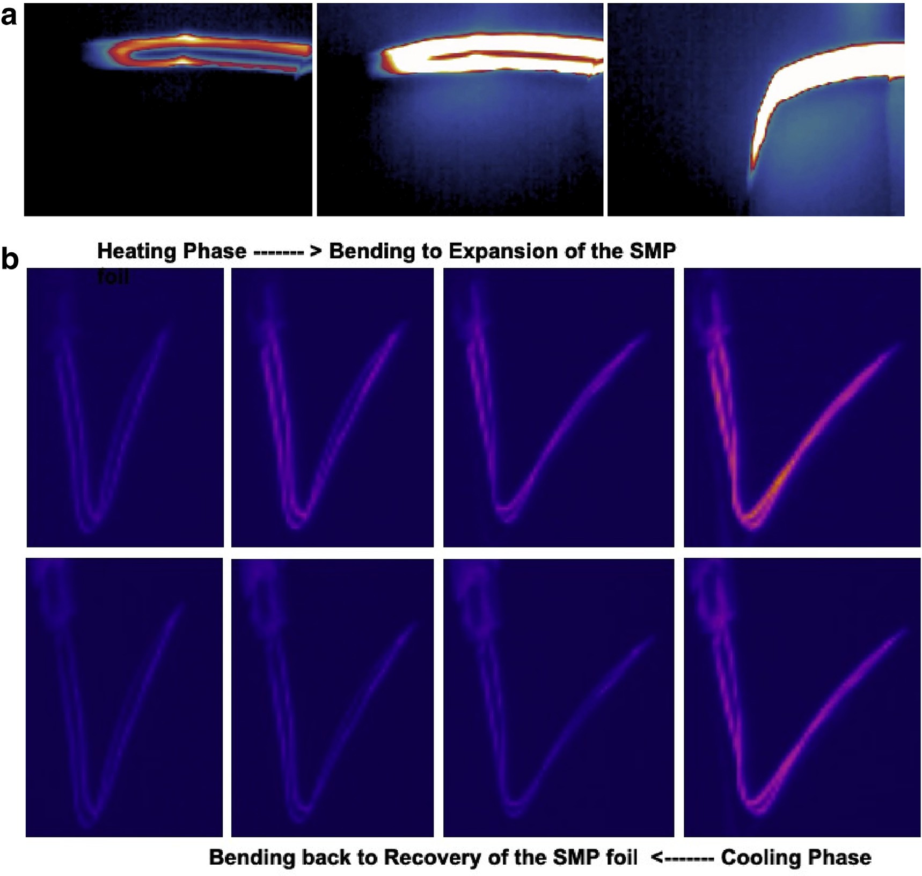

Fig. 3. (a): Snap-shots from the captured thermal video during the experimentation with SMP foil, depicting bending of the body while heating. Fig. 3. (b): Snap-shots from the captured thermal video during the experimentation with SMP foil, depicting two way bending of the body while heating and cooling. Heating phase expanded the SMP foil from its original programmed shape and during the cooling phase SMP body recovered back to its original shape completing the both ways being mechanism of such a material.

predictive trained models were bending angles (angle to pivot and angle to tip) and polynomial to formulate a representation of the holistic structural changes.

1. Rapid vision based modelling of SMP

SMPs are being unique and unknown as materials; property charac- terisation through conventional way was difficult. Thermal imaging technology was used to capture visual recovery related footprint of the material’s recovery phenomenon as direct and rapid mechanism. This method also helped to capture ground truth of the desired behavioural aspects of the SMP of interests. To capture the movement of the SMP foil and quantification of bending angles (defined by two angles, e.g. angle to pivot and angle to tip), video-processing techniques were used to auto- matically extract key features from the captured video.

A multi-scale unsupervised feature selection algorithmic framework has been designed to extract multidimensional features from the captured 300,000 thermal video frames. Consistently 4000 key features were detected from each of the video frames. Based on the detected features, positions of the two key points along the length of the SMP body, namely, tip and bending points were detected dynamically before bending angles were derived against a horizontal line representing the

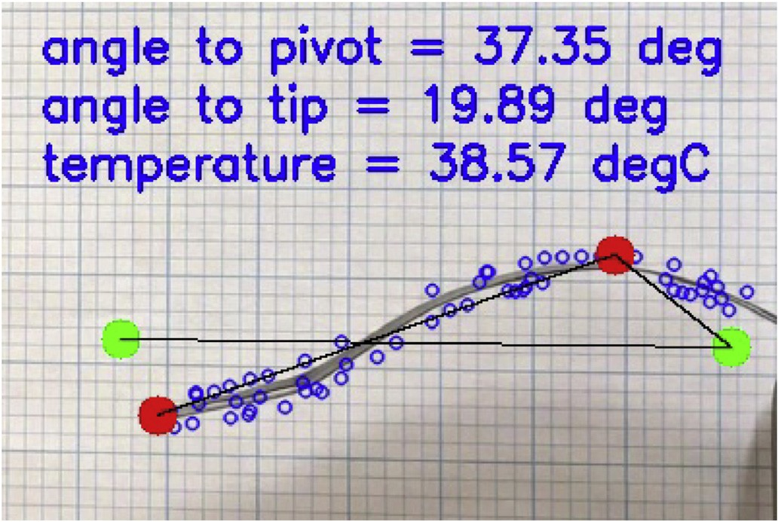

Fig. 4. Multi-scale unsupervised feature selection algorithmic framework has been designed to extract multidimensional features from thermal videos.

original pre-heating shape of the SMP structure. In the Figs. 4 and 5, one example has been shown to describe the overall feature extraction

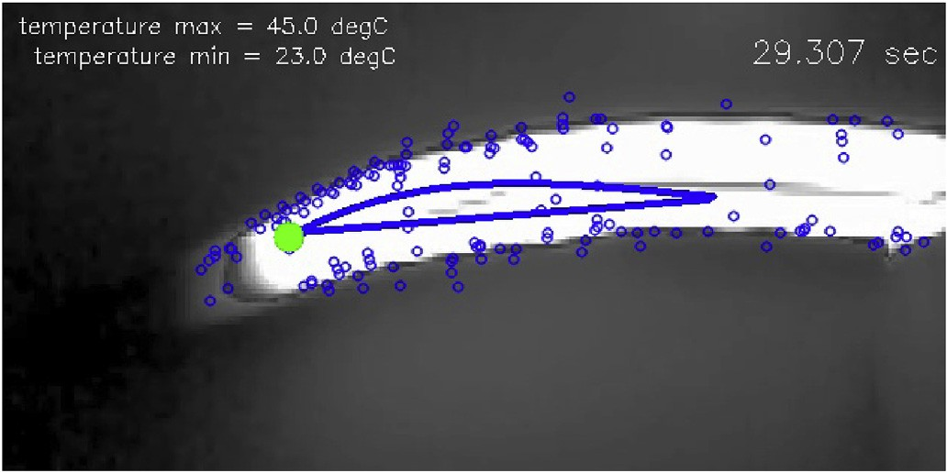

Fig. 5. A polynomial was dynamically fitted through the feature points on each video frame, to represent training targets for the behavioural changes and bending of the SMP.

process and angle estimation dynamically. Derived angles were used to model the bending behavioural change of the SMP foil and its associated polymer material as depicted in Fig. 5.

Based on the detected feature points, a polynomial was dynamically fitted through the feature points on each video frame, to represent training targets for the behavioural changes and bending of the SMP structure. The blue dots in the Figs. 4 and 5 were the features extracted from video frames.

It has been identified that a fundamental optimisation problem that needs to be solved is to maximize the final angle recovery ratios and recovery rates of a material to increase the overall efficiency of a targeted SMP material [30–38]. Hence rapid characterization of a novel material needs to be bench-marked against bending angles for deciding effec- tiveness of the novel material for any suitable targeted application.

1. Architecture for behaviour modelling

A predictive model was developed to predict bending angle of the SMP foil while heated with a constant current flow. Aim of this phase was to achieve a model to take current as input and predict a potential bending angle to mimic the bending behaviour of the physically trained SMP. In the training phase of the data driven experiment, recorded changing profile of the increasing temperature was used to formulate a thermodynamic input to SMP foil structure, whereas measured angles from the video were used as training targets. Fig. 6 showcases the overall approach to this problem phase and its proposed solution.

Similarly, for the thermal video, vision technique-based features were used in the thermodynamic modelling of the SMP foil. Feature points based multi-point temperature detection was applied to capture the thermodynamic nature of the SMP while heated by a constant current. Temperature readings based on position of the extracted feature points gave an overall distribution of thermodynamic changes along the SMP body during heating. This was an unconventional approach to derive

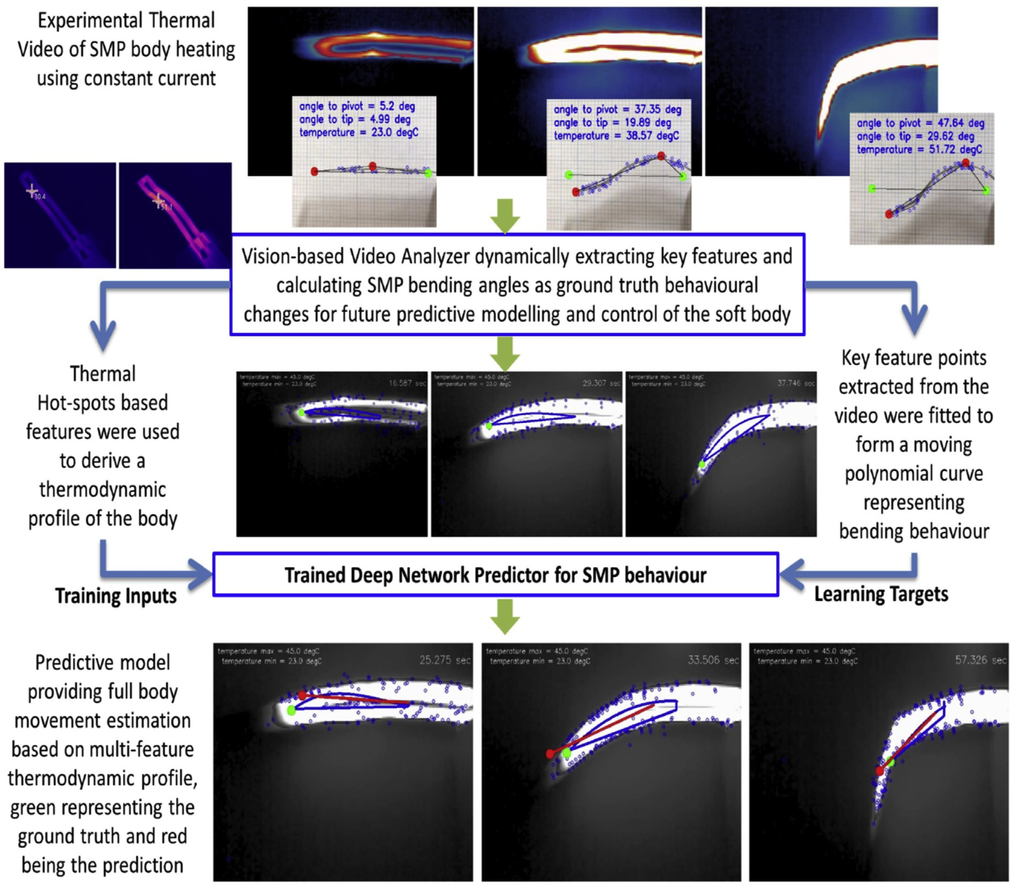

Fig. 6. Data driven predictive work-flow for rapid thermodynamic profiling of shape memory material’s bending behaviour.

Table 1

Comparative accuracy analysis for bending behaviour prediction using 80% Training and 20% Testing paradigm.

|  |  |  |  |
| --- | --- | --- | --- |
| Learner | F1-Accuracy | Sensitivity | Specificity |
| BBR | 77% | 88% | 80% |
| PNN | 82% | 80% | 85% |
| RBFN | 79% | 90% | 92% |
| RFN | 84% | 85% | 90% |
| ELN | 90% | 92% | 94% |

thermodynamics of such a material by using data driven approaches instead of physical experiment and characterisation of a material. The rationale behind this approach was to make the modelling of SMP as generic as possible, hence flexibility and variation of material could be unlimited.

1. Ensemble Learner Network

An ensemble is a supervised learning approach that use multiple models to improve the predictive performance than could be obtained from any of the constituent models. Three different ensemble classifica- tion approaches, bagging, Random Subspace and AdaBoosting were considered to improve the behavioural prediction performance of indi- vidual classifiers. Two different types of learners ‘Linear Discriminant’ and ‘Tree’ were used in the bagging and boosting ensembles of this study, whilst the ‘k-Nearest Neighbour’ learner was used with the Random Subspace ensemble. Bootstrap aggregation, often referred to as bagging, brings a high level of model diversity, by training each model in the ensemble using a randomly drawn subset of behaviour data. The results of each model in the ensemble are aggregated with each model provided with equally. The minimal leaf size for the bagged trees are set to 0.9. Another important parameter is the number of predictors selected at random for every decision split. This random selection is made for every split, and every deep tree involves many splits. AdaBoost is a common boosting-based ensemble approach for multi class binary classification. The algorithm trains learners sequentially. Instead of conventional weighted classification error in boosting, AdaBoosting uses weighted pseudo-loss for N observations and K classes. Random Subspace is an ensemble method similar to bagging, however, it randomly samples from the set of features, in addition to training set instances, in order to construct member learners. This approach was superior in comparison to all other trained predictors that were tested.

1. Results

The model validity is determined by comparing the model prediction of bending behaviour of the material to the actual measured bending

angle during experiments. The data sets were analyzed using five different types of supervised predictive learner, namely the Bayesian Ridge Regression (BRR), Random Forest Network (RFN), Probabilistic Neural Network (PNN), Radial Basis Function Network (RBFN) and Ensemble Learner Network (ELN) paradigms. Training of the neural networks was performed with 80% of the whole data set. The remaining 20% of the whole data were used for testing the neural networks. The process of selecting training and testing data set for development of a machine learning model was completely randomized. These percentages were selected arbitrarily and were applied for all training-testing para- digms. This randomization was done to avoid training overfitting. The aim of this comparative study was to identify the most appropriate ANN paradigm, which can be trained with the best accuracy to predict different levels of bending angles and movement of the material. Table 1 summarizes the prediction results achieved from the neural networks, using same training and testing data sets with 10-fold validation. A significantly high number of supervised learning algorithms to validate the generalisation of this type of application in prediction.

In the next section, some discussion on the proposed ensemble ap- proaches have been summarized which provided best possible overall behavioural prediction and material characterisation.

1. Reasoning of prediction accuracy

From Table 1, we can conclude that there are two main reasons for the superior classification performance of the ELN technique compared to BBR, PNN, RBFN, and RFN. These reasons are:

* + ELNs are able to adapt themselves to the distribution in polynomial feature space. Thus, while ELN was able to classify most of the pat- terns corresponding to bending categories, BBR, PNN, RBFN, and RFN are less able to adapt to the distribution of video analysis based key feature samples.
  + ELN and RFN are able to adjust their scale of generalization to match the morphological variability of the patterns. They were able to achieve a better performance than others in separating different states of the bending movement of the novel material.
  + In the case of the ELN algorithm, when a relatively very good solution has been found, the situation can be further refined by modifying the boundaries where misclassification occur, and also by conducting more experiments with the same material to develop a behavioural feature space.

1. Prediction of behaviour

Based on the multiple point SURF feature points, dynamically a polynomial was fitted through the feature points to represent behav- ioural changes and bending of the SMP foil (as shown in Figs. 6 and 7).

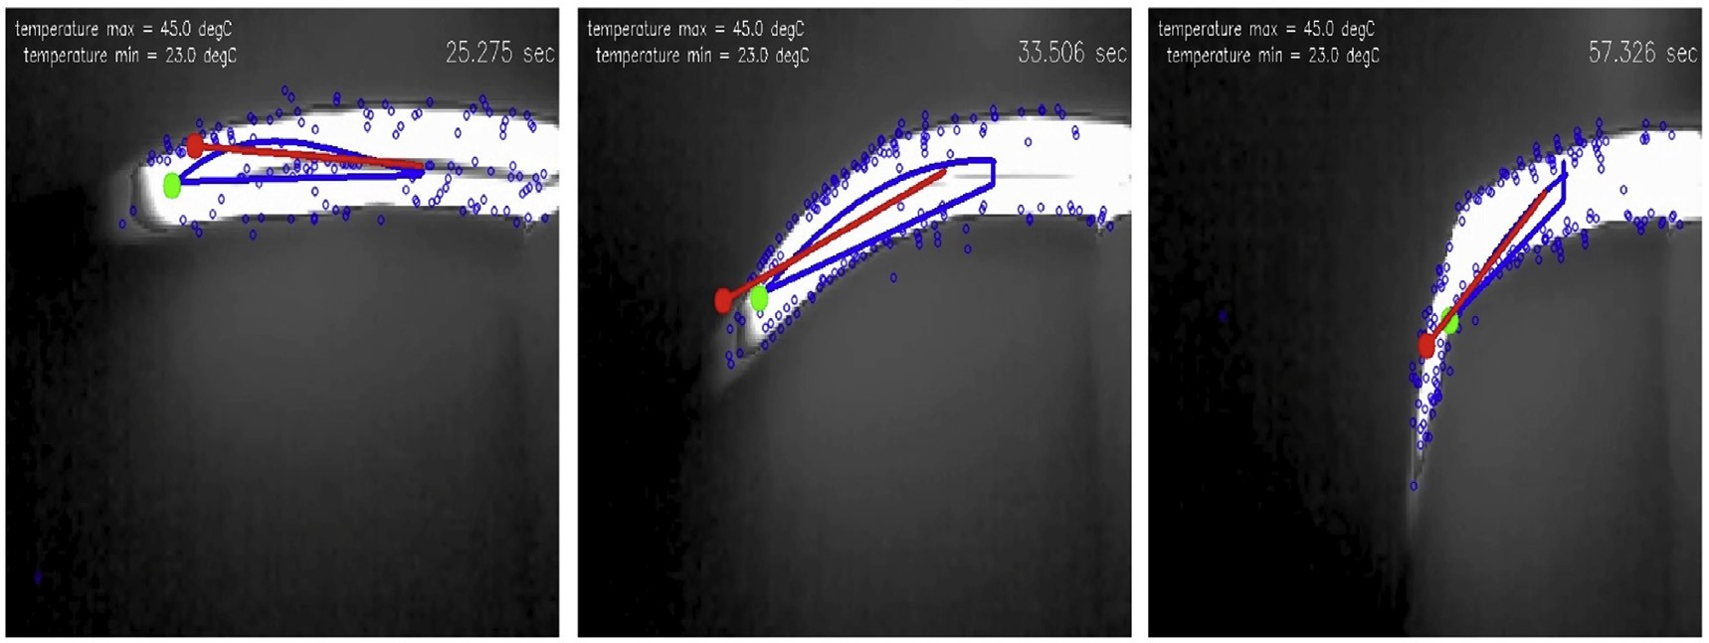

Fig. 7. Dynamic Prediction of moving polynomials to mimic the bending of SMP structure.

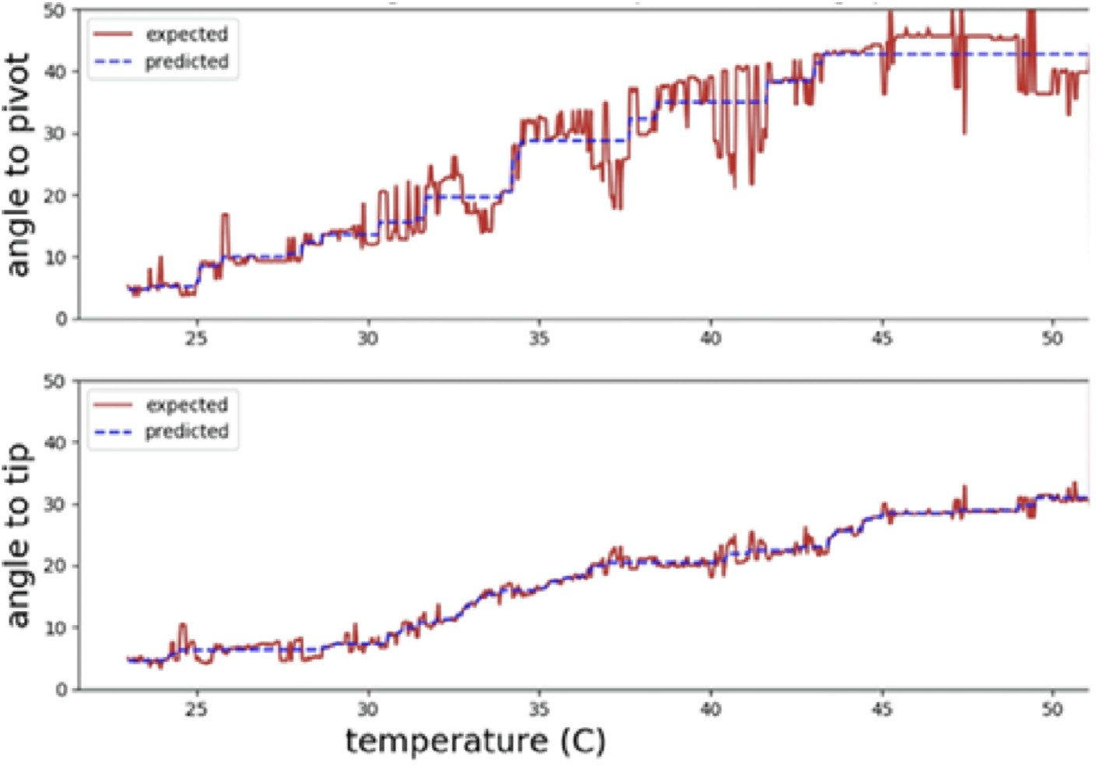

Fig. 8. Actual prediction of bending angles shows performance accuracy of the proposed model.

On the other hand, temperature readings of those key feature points were used as distributed thermodynamic profile across the foil structure to be used for training a model. For this phase of modelling, a simple BRR was used. Training input of this model was the multi-point temperature profile of the SMP foil, whereas training target was the set of polynomials that were captured during the video analysis.

As shown in the Fig. 7, ELN based model was able to predict a suitable polynomial independently, purely based on thermodynamic variation across the foil structure exposed to constant current flow. The red line indicates the predicted polynomial from a trained model, which could be used as an independent predictor for a SMP foil’s behavioural changes while used in conjunction with a controller. This work could be expanded further for refinement of such a predictive model in regards to accurate control of a SMP based foil structure for a Soft-Robotic movement.

Predicted angles were benchmarked against the ground truth mea- surements of angles (to the pivot and to the tip) from thermal video. These angle measurements were done manually using a manufacturing test rig in a laboratory set-up independent of the computer vision based experiments to develop a ground truth data set for machine learning training and testing. The bending angles were categorised into five classes (0–10, 10–20, 20–30, 30–40 and 40–50◦) to formulate a quanti- sation based classification problem. In Fig. 8 shows the model prediction performance of such a model with very high accuracy of 90%

predictability, 92% sensitivity and 94% specificity. Prediction accuracies were not perfect (e.g. near 100%) but they were significantly higher in nature with higher sensitivity and specificity, all remained above 90% with an Ensemble Learner Network. Prediction accuracy was estimated based on the accuracies of the two-way recovery process of the SMP foil (during heating and cooling). Higher temperature towards the moderate glass transformation (Tg) temperature indeed produced higher bending angle, hence quantisation of the prediction targets into five classes hel- ped the machine learning algorithm to learn better. Considering the nature of real world data, video capturing mechanism and the novel SMP material (“DiAPLEX”), it was anticipated that a machine learning algo- rithm would not predict the bending angle continuously, however higher rate of accuracy was very encouraging for applying a machine learning technique for the future modelling of novel materials such as SMP.

1. Model simulation and discussion

As the uptake of robotic technologies by industry increases, the capability-based restrictions of robotic solutions become increasingly exposed. The main challenge is one of embodiment. If robots are com- plex, they will break and require maintenance. If the robot’s body cannot adapt to its environment, control will be more complex and will require human intervention. If the materials reach their functional limits, the

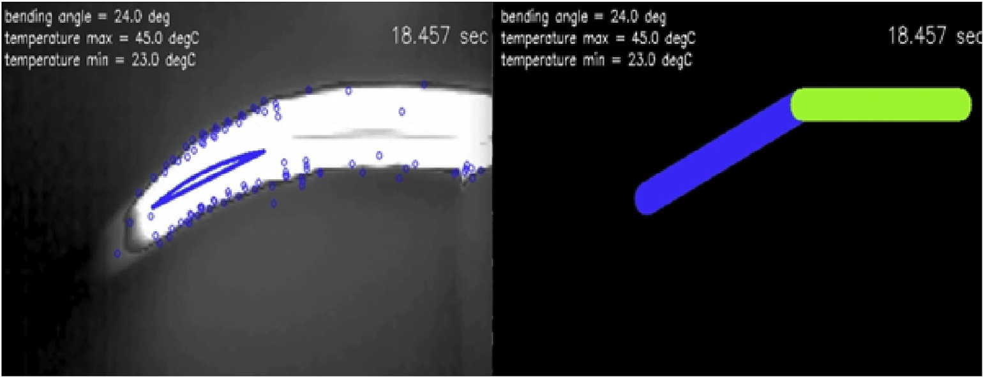

Fig. 9. Simulation of the models to mimic the material and its associated behaviours.

robot will break. So development based on this type of data engineering can only be justified if a system can be realised in the real world. In light of this vision, and based on the outcome of this project so far, a move- ment simulator was developed to encapsulate the data engineering-based models to mimic the movement of the SMP structure or in other words, movement of a soft-robotic part (as in the Fig. 9).

Based on the successful simulation of the SMP material behaviour, two scientific and system aspects were confirmed. Firstly, a rapid mechanism to establish robust characterisation of a novel material using data science, and secondly, the SMP material could be used for soft- robotics body parts, where control of the parts could be driven by a predictive model extracted from the automated video analysis.

Author statement

RD, DR, CC and DL conceived the idea, did experimentation and machine learning modelling. They also contributed to the writing of the manuscript. Research supported by DATA61 Business Unit of CSIRO, Australia and Active Integrated Matter, a Future Science Platform at the CSIRO, Australia, supported this work.

Declaration of competing interest

The authors declare that they have no known competing financial interests or personal relationships that could have appeared to influence the work reported in this paper.

Acknowledgments

Research supported by DATA61 Business Unit of CSIRO, Australia and Active Integrated Matter, a Future Science Platform at the CSIRO, Australia, supported this work.

References

1. [Bauer S, et al. 25th anniversary article: a soft future: from robots and sensor skin to](http://refhub.elsevier.com/S2590-0056(20)30021-7/sref1) [energy harvesters. Adv Mater 2014;26(1):149](http://refhub.elsevier.com/S2590-0056(20)30021-7/sref1)–[62](http://refhub.elsevier.com/S2590-0056(20)30021-7/sref1).
2. [Pfeifer R, Lungarella M, Iida F. The challenges ahead for bio-inspired soft robotics.](http://refhub.elsevier.com/S2590-0056(20)30021-7/sref2) [Commun ACM 2012;55(11):76](http://refhub.elsevier.com/S2590-0056(20)30021-7/sref2)–[87](http://refhub.elsevier.com/S2590-0056(20)30021-7/sref2).
3. [Khaldi A, et al. Smarter actuator design with complementary and synergetic](http://refhub.elsevier.com/S2590-0056(20)30021-7/sref3) [functions. Adv Mater 2015;27(30):4418](http://refhub.elsevier.com/S2590-0056(20)30021-7/sref3)–[22](http://refhub.elsevier.com/S2590-0056(20)30021-7/sref3).
4. [Asada M, et al. Cognitive developmental robotics: a survey. IEEE Trans Aut Ment](http://refhub.elsevier.com/S2590-0056(20)30021-7/sref4) [Devel 2009;1(1):12](http://refhub.elsevier.com/S2590-0056(20)30021-7/sref4)–[34](http://refhub.elsevier.com/S2590-0056(20)30021-7/sref4).
5. [Meyer J, Guillot A. Biologically inspired robots. In: Springer handbook of robotics.](http://refhub.elsevier.com/S2590-0056(20)30021-7/sref5) [Springer Berlin Heidelberg; 2008. p. 1395](http://refhub.elsevier.com/S2590-0056(20)30021-7/sref5)–[422](http://refhub.elsevier.com/S2590-0056(20)30021-7/sref5).
6. [Fv Breugel W Regan, Lipson H. From insects to machines. IEEE Robot Autom Mag](http://refhub.elsevier.com/S2590-0056(20)30021-7/sref6) [2008;15:4](http://refhub.elsevier.com/S2590-0056(20)30021-7/sref6).
7. [Ayers J, Witting J. Biomimetic approaches to the control of underwater walking](http://refhub.elsevier.com/S2590-0056(20)30021-7/sref7) [machines. Phil Trans Roy Soc Lond: Math Phys Eng Sci 2007;365(1850):273](http://refhub.elsevier.com/S2590-0056(20)30021-7/sref7)–[95](http://refhub.elsevier.com/S2590-0056(20)30021-7/sref7).
8. [Kay ER, Leigh DA, Zerbetto F. Synthetic molecular motors and mechanical](http://refhub.elsevier.com/S2590-0056(20)30021-7/sref8) [machines. Angew Chem Int Ed 2007;46(1-2):72](http://refhub.elsevier.com/S2590-0056(20)30021-7/sref8)–[191](http://refhub.elsevier.com/S2590-0056(20)30021-7/sref8).
9. [Liu C, Qin H, Mather PT. Review of progress in shape-memory polymers. J Mater](http://refhub.elsevier.com/S2590-0056(20)30021-7/sref9) [Chem 2007;17(16):1543](http://refhub.elsevier.com/S2590-0056(20)30021-7/sref9)–[58](http://refhub.elsevier.com/S2590-0056(20)30021-7/sref9).
10. [Mayer G, Heckel A. Biologically active molecules with a light switch. Angew Chem](http://refhub.elsevier.com/S2590-0056(20)30021-7/sref10) [Int Ed 2006;45(30):4900](http://refhub.elsevier.com/S2590-0056(20)30021-7/sref10)–[21](http://refhub.elsevier.com/S2590-0056(20)30021-7/sref10).
11. [Brochu P, Pei Q. Advances in dielectric elastomers for actuators and arti](http://refhub.elsevier.com/S2590-0056(20)30021-7/sref11)fi[cial](http://refhub.elsevier.com/S2590-0056(20)30021-7/sref11) [muscles. Macromol Rapid Commun 2010;31(1):10](http://refhub.elsevier.com/S2590-0056(20)30021-7/sref11)–[36](http://refhub.elsevier.com/S2590-0056(20)30021-7/sref11).
12. [Mirfakhrai T, Madden JDW, Baughman RH. Polymer artificial muscles. Mater](http://refhub.elsevier.com/S2590-0056(20)30021-7/sref12) [Today 2007;10(4):30](http://refhub.elsevier.com/S2590-0056(20)30021-7/sref12)–[8](http://refhub.elsevier.com/S2590-0056(20)30021-7/sref12).
13. [Lendlein A, et al. Light-induced shape-memory polymers. Nature 2005;434(7035):](http://refhub.elsevier.com/S2590-0056(20)30021-7/sref13) [879](http://refhub.elsevier.com/S2590-0056(20)30021-7/sref13)–[82](http://refhub.elsevier.com/S2590-0056(20)30021-7/sref13).
14. [Li MH, et al. Light-driven side-on nematic elastomer actuators. Adv Mater 2003;](http://refhub.elsevier.com/S2590-0056(20)30021-7/sref14) [15(7-8):569](http://refhub.elsevier.com/S2590-0056(20)30021-7/sref14)–[72](http://refhub.elsevier.com/S2590-0056(20)30021-7/sref14).
15. [Marshall JE, et al. Anisotropic colloidal micromuscles from liquid crystal](http://refhub.elsevier.com/S2590-0056(20)30021-7/sref15) [elastomers. J Am Chem Soc 2013;136(1):474](http://refhub.elsevier.com/S2590-0056(20)30021-7/sref15)–[9](http://refhub.elsevier.com/S2590-0056(20)30021-7/sref15).
16. [Osada Y, Matsuda A. Shape memory in hydrogels. Nature 1995;376(6537):219](http://refhub.elsevier.com/S2590-0056(20)30021-7/sref16).
17. [Lendlein A, Kelch S. Shape-memory polymers. Angew Chem Int Ed 2002;41(12):](http://refhub.elsevier.com/S2590-0056(20)30021-7/sref17) [2034](http://refhub.elsevier.com/S2590-0056(20)30021-7/sref17)–[57](http://refhub.elsevier.com/S2590-0056(20)30021-7/sref17).
18. [Kim BK, Sang YL, Xu M. Polyurethanes having shape memory effects. Polymer](http://refhub.elsevier.com/S2590-0056(20)30021-7/sref18) [1996;37.26:5781](http://refhub.elsevier.com/S2590-0056(20)30021-7/sref18)–[93](http://refhub.elsevier.com/S2590-0056(20)30021-7/sref18).
19. [Osada Y, Hidenori O, Hori H. A polymer gel with electrically driven motility. Nature](http://refhub.elsevier.com/S2590-0056(20)30021-7/sref19) [1992;355(6357):242](http://refhub.elsevier.com/S2590-0056(20)30021-7/sref19).
20. [Br](http://refhub.elsevier.com/S2590-0056(20)30021-7/sref20)´edas [JL, Chance RR, editors. Conjugated polymeric materials: opportunities in](http://refhub.elsevier.com/S2590-0056(20)30021-7/sref20)

[electronics, optoelectronics, and molecular electronics. vol. 182. Springer Science](http://refhub.elsevier.com/S2590-0056(20)30021-7/sref20) &

[Business Media; 2012](http://refhub.elsevier.com/S2590-0056(20)30021-7/sref20).

1. [Bellan C, Bossis G. Field dependence of viscoelastic properties of MR elastomers. Int](http://refhub.elsevier.com/S2590-0056(20)30021-7/sref21) [J Mod Phys B 2002;16.17n18:2447](http://refhub.elsevier.com/S2590-0056(20)30021-7/sref21)–[53](http://refhub.elsevier.com/S2590-0056(20)30021-7/sref21).
2. [Razzaq MY, et al. Multifunctional hybrid nanocomposites with magnetically](http://refhub.elsevier.com/S2590-0056(20)30021-7/sref22) [controlled reversible shape](http://refhub.elsevier.com/S2590-0056(20)30021-7/sref22)–[memory effect. Adv Mater 2013;25(40):5730](http://refhub.elsevier.com/S2590-0056(20)30021-7/sref22)–[3](http://refhub.elsevier.com/S2590-0056(20)30021-7/sref22).
3. [Pei Q, et al. Electrochromic and highly stable poly (3, 4-ethylenedioxythiophene)](http://refhub.elsevier.com/S2590-0056(20)30021-7/sref23) [switches between opaque blue-black and transparent sky blue. Polymer 1994;35(7):](http://refhub.elsevier.com/S2590-0056(20)30021-7/sref23) [1347](http://refhub.elsevier.com/S2590-0056(20)30021-7/sref23)–[51](http://refhub.elsevier.com/S2590-0056(20)30021-7/sref23).
4. <http://www.smptechno.com/index_en.html>.
5. [Nazeeruddin MK, et al. Conversion of light to electricity by charge-transfer](http://refhub.elsevier.com/S2590-0056(20)30021-7/sref25) [sensitizers on nanocrystalline TiO2 electrodes. J Am Chem Soc 1993;115:6382](http://refhub.elsevier.com/S2590-0056(20)30021-7/sref25)–[90](http://refhub.elsevier.com/S2590-0056(20)30021-7/sref25).
6. [Yu G, et al. Polymer photovoltiac cells: enhanced ef](http://refhub.elsevier.com/S2590-0056(20)30021-7/sref26)fi[ciencies via a network of](http://refhub.elsevier.com/S2590-0056(20)30021-7/sref26) [internal donor-acceptor heterojunctions. Science 1995;270(5243):1789](http://refhub.elsevier.com/S2590-0056(20)30021-7/sref26).
7. [Motornov M, et al. Stimuli-responsive nanoparticles, nanogels and capsules for](http://refhub.elsevier.com/S2590-0056(20)30021-7/sref27) [integrated multifunctional intelligent systems. Prog Polym Sci 2010;35(1):174](http://refhub.elsevier.com/S2590-0056(20)30021-7/sref27)–[211](http://refhub.elsevier.com/S2590-0056(20)30021-7/sref27).
8. [Torchilin VP. Multifunctional nanocarriers. Adv Drug Deliv Rev 2012;64:302](http://refhub.elsevier.com/S2590-0056(20)30021-7/sref28)–[15](http://refhub.elsevier.com/S2590-0056(20)30021-7/sref28).
9. [Khaldi A, et al. Smarter actuator design with complementary and synergetic](http://refhub.elsevier.com/S2590-0056(20)30021-7/sref29) [functions. Adv Mater 2015;27(30):4418](http://refhub.elsevier.com/S2590-0056(20)30021-7/sref29)–[22](http://refhub.elsevier.com/S2590-0056(20)30021-7/sref29).
10. [Goujon LJ, et al. Flexible solid polymer electrolytes based on nitrile butadiene](http://refhub.elsevier.com/S2590-0056(20)30021-7/sref30) [rubber/poly (ethylene oxide) interpenetrating polymer networks containing either](http://refhub.elsevier.com/S2590-0056(20)30021-7/sref30) [LiTFSI or EMITFSI. Macromolecules 2011;44(24):9683](http://refhub.elsevier.com/S2590-0056(20)30021-7/sref30)–[91](http://refhub.elsevier.com/S2590-0056(20)30021-7/sref30).
11. [Maziz A, et al. Demonstrating kHz frequency actuation for conducting polymer](http://refhub.elsevier.com/S2590-0056(20)30021-7/sref31) [microactuators. Adv Funct Mater 2014;24(30):4851](http://refhub.elsevier.com/S2590-0056(20)30021-7/sref31)–[9](http://refhub.elsevier.com/S2590-0056(20)30021-7/sref31).
12. [Billard A, et al. Robot programming by demonstration. In: Springer handbook of](http://refhub.elsevier.com/S2590-0056(20)30021-7/sref32) [robotics. Springer Berlin Heidelberg; 2008. p. 1371](http://refhub.elsevier.com/S2590-0056(20)30021-7/sref32)–[94](http://refhub.elsevier.com/S2590-0056(20)30021-7/sref32).
13. [Conradt J, et al. A pencil balancing robot using a pair of AER dynamic vision](http://refhub.elsevier.com/S2590-0056(20)30021-7/sref33) [sensors. Circuits and Systems. ISCAS 2009. IEEE International Symposium on](http://refhub.elsevier.com/S2590-0056(20)30021-7/sref33) [Circuits and Systems; 2009. 2009](http://refhub.elsevier.com/S2590-0056(20)30021-7/sref33).
14. [Cutkosky MR, Kim S. Design and fabrication of multi-material structures for](http://refhub.elsevier.com/S2590-0056(20)30021-7/sref34) [bioinspired robots. Phil Trans Roy Soc Lond: Math Phys Eng Sci 2009;367(1894):](http://refhub.elsevier.com/S2590-0056(20)30021-7/sref34) [1799](http://refhub.elsevier.com/S2590-0056(20)30021-7/sref34)–[813](http://refhub.elsevier.com/S2590-0056(20)30021-7/sref34).
15. [Dahiya RS, et al. Tactile sensing](http://refhub.elsevier.com/S2590-0056(20)30021-7/sref35)—[from humans to humanoids. IEEE Trans Robot](http://refhub.elsevier.com/S2590-0056(20)30021-7/sref35) [2010;26(1):1](http://refhub.elsevier.com/S2590-0056(20)30021-7/sref35)–[20](http://refhub.elsevier.com/S2590-0056(20)30021-7/sref35).
16. [Hoffmann M, et al. Body schema in robotics: a review. IEEE Trans Aut Ment Devel](http://refhub.elsevier.com/S2590-0056(20)30021-7/sref36) [2010;2(4):304](http://refhub.elsevier.com/S2590-0056(20)30021-7/sref36)–[24](http://refhub.elsevier.com/S2590-0056(20)30021-7/sref36).
17. [Hosoda K, et al. Pneumatic-driven jumping robot with anthropomorphic muscular](http://refhub.elsevier.com/S2590-0056(20)30021-7/sref37) [skeleton structure. Aut Robots 2010;28(3):307](http://refhub.elsevier.com/S2590-0056(20)30021-7/sref37)–[16](http://refhub.elsevier.com/S2590-0056(20)30021-7/sref37).
18. [Iida F. Biologically inspired motor control for underactuated robots](http://refhub.elsevier.com/S2590-0056(20)30021-7/sref38)–[trends and](http://refhub.elsevier.com/S2590-0056(20)30021-7/sref38) [challenges. Robot motion and control. Springer London; 2009. p. 145](http://refhub.elsevier.com/S2590-0056(20)30021-7/sref38)–[54](http://refhub.elsevier.com/S2590-0056(20)30021-7/sref38).