Available online at [www.sciencedirect.com](http://www.sciencedirect.com/)



**ScienceDirect**

AASRI Procedia 6 (2014) 73 – 81

2013 2nd AASRI Conference on Computational Intelligence and Bioinformatics

Method of Noise-free Image Production Based on Video Sequence Handling

Korovin I.S.*, Khisamutdinov M.V.

*Scientific research Institute of multiprocessor computing systems of Southern Federal University (SRI MCS SFEDU)*

**Abstract**

In the paper we suggested a method for video sequence handling with the aim of producing a single noise- free image. An algorithm for the image alignment based on the approaches of dot matches search and the resolution capacity enhancement has been elaborated. A method for multiple images stacking has been proposed to produce a single noise-free picture. The proposed method has been successfully experimentally tested using developed software tools.

© 2014 The Authors. Published by Elsevier B. V. This is an open access article under the CC BY-NC-ND license ([http://creativecommons.org/licenses/by-nc-nd/3.0/).](http://creativecommons.org/licenses/by-nc-nd/3.0/))

© 2013 Korovin I.S., Khisamutdinov M.V. Published by Elsevier B.V.

Selection and/or peer review under responsibility of American Applied Science Research Institute

Peer-review under responsibility of Scientific Committee of American Applied Science Research Institute

*Keywords*: image handling; software; White Gaussian Noise; image alignment;Peak Signal to Noise Ratio (PSNR), image stacking, image recognition

# Introduction

Image enhancement is widely applied in various domains, namely cartography, photogrammetry, medicine, astronomy, etc. This task involves processing of a single or a series of images, aiming to produce a single noise-free picture.

As the research results [1, 2] have revealed that methods and algorithms, aimed at single picture processing slightly enhance the PSNR (for estimating the quality of the noise reduction methods the noise-free pictures

* Corresponding author. Tel.: +7-918-55-65-883; fax: +7-8634-36-03-76.

*E-mail address:* [korovin_yakov@mail.ru.](mailto:korovin_yakov@mail.ru)

2212-6716 © 2014 The Authors. Published by Elsevier B. V. This is an open access article under the CC BY-NC-ND license ([http://creativecommons.org/licenses/by-nc-nd/3.0/).](http://creativecommons.org/licenses/by-nc-nd/3.0/))

Peer-review under responsibility of Scientific Committee of American Applied Science Research Institute doi:10.1016/j.aasri.2014.05.011

are overlapped by White Gaussian Noise, further on the tested filtering algorithm is applied, and the output picture is compared to the original one with PSNR (peak signal-to-noise ratio[3, 4]) assessment), whereas filters based on video sequences reach high values of the given parameter.

So, while elaborating a method of image quality enhancement based on the analysis of image series, received from the same foreshortening, it was decided to implement a method of multiple images stacking.

However one should take into consideration the particularity of receiving images series – certain images of the sequence can be displaced relative to each other. That is why the proposed method of receiving a single noise-free image based on image series handling implies two steps:

* alignment of images series;
* multiple images stacking in order to receive a single noise-free picture

Further on the proposed algorithms of these steps implementation are thoroughly considered.

# An Algorithm of Image Series Alignment Based on Dot Matches Search and the Resolution Capacity Enhancement

Having analyzed the open sources it has been found out that known approaches based on dot matches search possess the high alignment accuracy [5], whereas program implementation of the methods based on resolution power feature the performance are of high rate [6].

This paper suggests a combined algorithm of image alignment based on the dot matches search and the resolution capacity enhancement methods.

The proposed algorithm allows to reach a pixel by pixel accuracy of the image alignment due to approach, based on the dot matches search in the pictures, as well to high rate due to the iterative resolution capacity enhancement based method application. Fig 1 presents the structure of the image alignment combined algorithm.

Let us consider this algorithm functioning in details. Suppose, we have two black and white (monochromic) images, *ImageRef* and *ImageCurrent*. Each image is represented as *H*x*W* elements matrix. It is necessary to find a transformation of *ImageCurrent* matrix into *ImageRef* matrix which would minimize the luminance difference of the images (with minimal luminance difference of the images).

The essential idea of the algorithm is to process consequently the images of the video sequence in order to align the images to the pivotal image *ImageRef*. It is the first image that is chosen to be the pivotal one. Every image *ImageCurrent* undergoes the iterative handling. Under each iteration the picture resolution grows bigger and the dot math search is performed [7, 8]. Further on, from the dot matches found matrix transformation operators are calculated.

Displacement and rotation operators are considered as matrix transformation operators. Rotation transformation similar to that while considering flat geometrical objects, allows to turn the original image’s angle.

The rotation around the centre of the image is performed, with two rotation options being possible:

* image parts that fall outside its limits, are truncated, while the blank parts are filled with pixels with zero luminance;
* ɚ new image size is calculated based on the rotation angle so, that the rotated image fits the new dimensions. The blank parts are also filled with pixels with zero luminance.

In any case the rotation transformation [9] is calculated using the following formula:

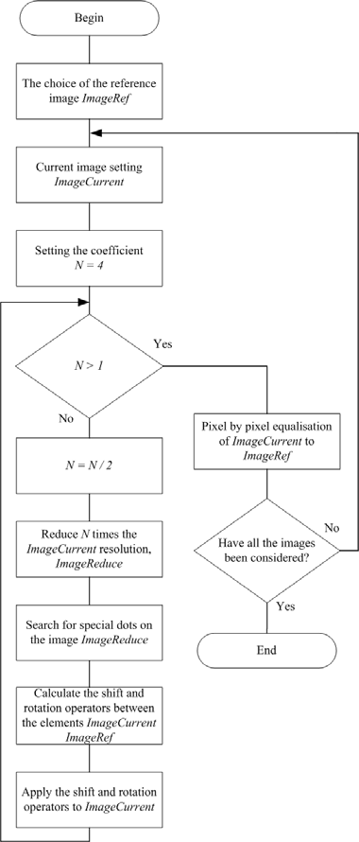

Fig. 1. The scheme of the images alignment combined algorithm

*ɋnew*[*i*][ *j*] 

*Cold* [*a*][*b*], *a* [0, *Hold* 1]☹*b* [0,*Wold* 1]



*C*, *a* [0, *Hold* 1]*Vb* [0,*Wold* 1]

*(1)*

where

*a*  *i* sin()  ;

*Hnew*

2

*b*  *j*  cos()  ;

*Wnew*

2

*i*  0, *Hold*  1;

*j*  0,*Wold* 1;

*C* - is the luminance of the pixels filling the blank parts of the image;

*ĳ* – is the clockwise rotation angle in radians.

The presented formula rounds off the transformed coordinates. However, using a bilinear interpolation is also possible, when the pixel luminance is calculated as weighted sum of the luminance of the four neighboring pixels.

Following this, pixel by pixel image alignment is performed to *ImageCurr* and *ImageRef*. For pixel by pixel image alignment *ImageRef* is compared to 9 variants of the *ImageCurr* (with the original *ImageCurr* being shifted 1 pixel upwards/downwards and 1 pixel in diagonals), and the correlation coefficient (*kor*) being analyzed by formula [1]:

(*ImageRef* (*c*, *r*)  *ImageRefm* )  (*ImageCurr*(*c*, *r*)  *ImageCurrm* )

*kor*   *c r* ,



(*ImageRef* (*c*, *r*)  *ImageRef* )

2

*m*

*c r*

*(2)*

where *ImageRefm -* is a mean of *ImageRef;*

*ImageCurrm* - is a mean of *ImageCurr*.

One of the 9 variants of the shifted image *ImageCurr* featuring the highest value of the correlation coefficient *kor* is chosen as pixel by pixel aligned image to *ImageRef*.

# Algorithm of Multiple Images Stacking for a Single Noise- free Image Production

The submitted algorithm is based on defining the coefficient of the contribution that each image makes to the common sum. The contribution coefficient *k* is the marker of the image noisiness; the higher the noise, the lower is the coefficient, similarly the lower the noise the higher is the contribution coefficient. The possible contribution coefficient value lies within the range of *k* [0,1].

Lets us denote a sequence of original images as ***I***, the total number of images in a sequence as *n*. Let us hold that the images in the sequence are all taken from the same exposure and the same illumination of the

visible object; then the signal intensity ***S*** will be the same in every image

***I****i* , however images of

the ***I****i* sequence have different noise level the electronic equipment).

***N*** *i* caused by various disturbances (for instance by impulse noise of

To estimate the quality of the single image of the sequence let us take the parameter *SNR* (*signal-to-noise ratio,* that is a nondimensional value equal to the ratio of the useful signal power to the noise power [10]), for the *i* image of the sequence the *SNR* parameter is calculated by the formula:

***SNR***  ***S****i*

*i*

*(3)*

***N****i*

As the ***I****i*

images have the same signal level ***S*** but the different noise level

***N*** *i* , it means that their

***SNR****i* correlation is in inverse ratio to ***N*** *i* , while the contribution coefficient *ki* is calculated by the formula:

*k*  ( ***N***1 )2 ,

*i*

*(4)*

***N****i*

where ***N***1 - is the noise level of the least noisy image of the ***I*** sequence, i.e. the image featuring the highest SNR.

In order to search for the least noisy image ***I***1 we use the brightness histogram analysis.

With regard to the found coefficients *ki* for every formula:

***I****i* the total resulting image ***I****sum* is calculated by the

*n*

***I****sum*   ***I****i*  *ki*

*i* 1

*(5)*

As the noise for every image is considered to be random and independent, the noise composition is

performed in second degree. Knowing the value of the ***SNR****i* parameter for every image of the ***I****i*

is possible to calculate the ***SNR****sum* value of the total resulting image ***I****sum* by the formula:

sequence, it

***SNR****sum*



*i* 1

*n*

(***SNR*** )

2

*i*



*(6)*

The submitted algorithm of the image quality enhancement comprises 5 basic steps.

1. *The search for the least noisy image in the I series based on the brightness histogram analysis.*

To select the least noisy image in the series ***I***, the averaged luminance histogram construction based on averaging of all images histograms is carried out. Further search for histogram ***Hist*** closest to ***Hist***med is made, and the image is marked as ***I***1 .

1. *Selecting zones in the image* ***I***1 *, corresponding to the noisy areas* ***N****area.*

It is carried out as follows: the entire image ***I***1 area is assigned to ***N***area, then local areas of singular points ***N***local are excluded, searched according to [11]. From the area ***N***area1 the desired area ***N***area = ***N***area1 – ***N***local, corresponding to the noisy areas in the image ***I***1 , is obtained.

1. *Calculation based on the found areas* ***N****area of the value* ***N****i for each image* ***I****i .*

For each image ***I****i* noise level value ***N****i* . ***N***1  1 is calculated, since the given image is the least noisy in

the series, other values ***N****i* are defined as the standard deviation of pixel brightness of ***N****area* area between the image ***I***1 and image ***I****i* .

1. *Calculating the coefficients ki .*

For each image ***I****i* contribution factor *ki* is calculated by the formula (4).

1. *Median addition of images* ***I****i in the series* ***I*** *with the calculated contribution factor ki , in order to*

*obtain one perspective non-noisy image* ***I****sum .*

At this stage, median addition of images I series taking into account factor *ki* is performed. The essence of the classical median method consists in choosing a new pixel brightness value - the average value of the sorted array of pixel brightness. In this work we propose an approach that takes into account the noisiness of

each image ***I****i* in the series ***I***, in accordance with the contribution factor *ki* . Scheme of image median addition

algorithm, taking into account the contribution factor of each image is shown in Fig. 2.

With a probability, equal to the value of this coefficient *ki* [0,1] , addition of image ***I****i*

pixel brightness

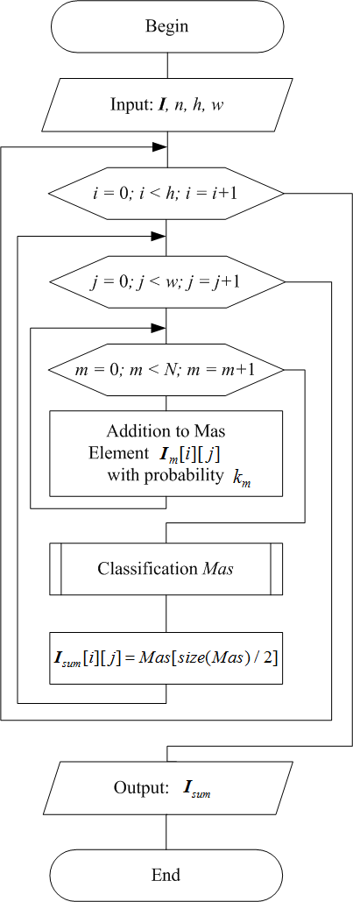value to the array of pixel brightness for the median method of image quality improvement is made. Thus, the most noisy images contribution factor of which *ki*  0 , will not participate in the formation of the final image ***I****sum* . As the result of the algorithm work the final image ***I****sum* is received.

Fig. 2. The scheme of algorithm of image series median composition, taking into account the contribution factor of each image

# 2. Experimental Research and Benefits

On the basis of the proposed method of image quality enhancement software tools has been developed [12] It has been tested on images obtained from standard television camera (TC) of water-cooled power reactor (WCPR) in the process of preventative maintenance (this procedure is performed every year on nuclear power plants in Russian Federation). On the single images, obtained from TC, impulse noise caused by work of common radio and electronic test equipment is found. In Fig. 3 a comparison of a single grayscale series image and of the enhanced image, obtained by stacking image series by the proposed method of image quality improvement, is shown.

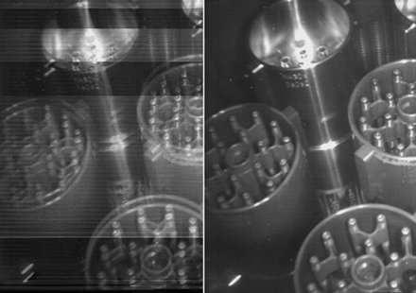

Fig. 3. The result of the image quality enhancement method

Experimental comparison of the proposed image quality enhancement method with well-known image quality improvement methods has been carried out. Experiments have been conducted using grayscale images from the image database USC-SIPI [13].

For the experiment images 5.1.09 - Moon surface ɢ 7.1.03 – Tank have been chosen. Next, two test video sequence have been generated using the mentioned images. White Gaussian noise has been imposed on every single image of video sequences and image quality of received video sequences has been improved applying various methods, in particular, by median composition of images sequence method, by the method, implemented in RegiStax (This program is designed for equalization, addition and image processing in formats BMP, JPEG, FITS, TIFF , or series of AVI frames) [14] and the proposed method of image series stacking taking into consideration the contribution factor of each image. Quality enhancement results are presented in Tables 1 and 2:

Table 1. Comparing the methods of image quality enhancement, video sequence resolution 256x256 pixels (original picture 5.1.09 - Moon surface)

|  |  |  |  |
| --- | --- | --- | --- |
| Number of images in the sequence | PSNR(median composition) (dB) | PSNR (RegiStax) (dB) | PSNR(the proposed method) (dB) |
| 2 | 20.751 | 20.794 | 20.796 |
| 4 | 20.949 | 21.576 | 21.649 |
| 8 | 21.342 | 21.8 | 21.78 |
| 16 | 21.383 | 21.818 | 21.824 |
| 32 | 21.665 | 22.52 | 22.569 |
| 64 | 22.336 | 24.708 | 24.685 |
| 128 | 25.098 | 26.177 | 26.211 |
| 256 | 27.611 | 28.121 | 28.156 |
| 512 | 30.446 | 31.03 | 30.933 |
| 1024 | 33.493 | 33.901 | 33.905 |
| 2048 | 36.32 | 36.684 | 36.59 |
| 4096 | 39.452 | 39.703 | 39.842 |

Table 2. Comparing the methods of image quality enhancement, video sequence resolution 512x512 pixels (original picture 7.1.03 - Tank)

|  |  |  |  |
| --- | --- | --- | --- |
| Number of images in the sequence | PSNR(median composition) (dB) | PSNR (RegiStax) (dB) | PSNR(the proposed method) (dB) |
| 2 | 26.577 | 26.595 | 26.591 |
| 4 | 27.492 | 27.79 | 27.881 |
| 8 | 27.541 | 29.903 | 29.75 |
| 16 | 28.007 | 31.243 | 31.46 |
| 32 | 31.964 | 33.994 | 34.199 |
| 64 | 36.003 | 36.615 | 36.822 |
| 128 | 38.989 | 39.384 | 39.413 |
| 256 | 41.999 | 42.296 | 42.189 |
| 512 | 45.068 | 45.269 | 45.18 |
| 1024 | 48.212 | 48.217 | 48.21 |
| 2048 | 51.239 | 51.352 | 51.298 |
| 4096 | 53.993 | 54.497 | 54.523 |

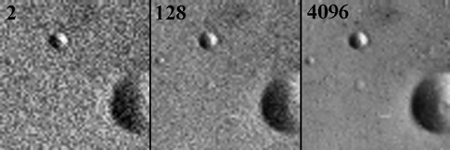

Fig. 4. Image fragment 64x64 pixels obtained after stacking 2,128 and 4,096 noisy images 5.1.09 - Moon surface using the proposed method

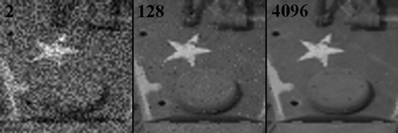

Fig. 5. Image fragment 64x64 pixels obtained after stacking 2,128 and 4,096 noisy images 7.1.03 - Tank using the proposed method

As there can be seen from the tables, the proposed method outgoes the method of median images series addition, and can be compared with the image series addition method, implemented in the program RegiStax; and in determined conditions (discrete number of images in the series) outgoes RegiStax methods in PSNR values.

# Conclusion

While conducting research and development relating to the topic of this paper a method of video sequence processing in order to receive a single non-noisy image has been suggested. The images series alignment algorithm has been developed on the basis of dot matches search and of resolution capacity improvement approaches. The multiple images stacking algorithm has been developed to receive a single non-noisy image.

The proposed method of image quality enhancement is different from the existing ones by using the analysis of each series image contribution factor that minimizes the impact of noisy images on the final result.

It is proved that in comparison with the method of images series median addition the proposed method provides the best PSNR value. It is shown that the proposed method is comparable with the image series addition method, implemented in the program RegiStax, and when a certain number of images in the series it outgoes it in terms of PSNR.

# References

1. Pratt, W.K. Digital image processing / W.K. Pratt. – Wiley Publisher, – 2007. – 807 p.
2. Gonzalez, R.S. Digital Image Processing [Text] / R.S. Gon-zalez, R.E. Woods / New Jersey Prentice Hall, – 2002. – 954 p.
3. Shelukhin O.I. Estimation of quality of stream video trans-mission in telecommunication networks with software and hardware tools application [Text] / O. I. Shelukhin, Yu. A. Ivanov // Electric technical and informational complexes and systems, - 2009.- ʋ4.- p. 48-56.
4. Timbai E.I. Application of correction filter for images quality improvement, compressed by JPEG method. [Text] / E.I. Timbai // Computer optics, – 2011. – Volume 35. – ʋ4. – p. 513-518.
5. Sagues, C. From lines to epipoles through planes in two views [Text] / C. Sagues, A.C. Murillo, F. Escudero and J.J. Guerrero // Pattern Recognition, – 2006. – ʋ3. – P. 384-393.
6. Dowman, I.J. Automating image registration and absolute orientation: solutions and problems [Text] / I.J.Dowman / Photogrammetric Record, –1998. – P. 5-18.
7. Bay, ɇ. Speeded-up robust features (surf) [Text] / ɇ. Bay, A. Ess, T. Tuytelaars, and L. V. Gool. // Computer Vision and Image Understanding. – 2008. –ʋ3. – P. 346-359.
8. Lowe, T. Distinctive image features from scale-invariant keypoints [Text] / T. Lowe , G. David // International Journal of Computer Vision. – 2002. –ʋ2. –P. 91-110.
9. Computer graphics. [web resource]: Polytechnic University of Tomsk, 2005 <http://compgraph.ad.cctpu.edu.ru/Rot.htm>
10. Nikitin, O.R. Development of quality estimation criterions of digital television functioning [Text]. /O.R. Nikitin, E.A. Archipov, V.Sh. Shanazarov // Methods and devices of in-formation transmission and handling,

- 2007.- ʋ8, p. 139 -142.

1. Tretiak, O.J. Surface-based matching using elastic trans-formation [Text] / O.J.Tretiak, M.Gabrani // Pattern Recognition, – 1998. – P. 87-97.
2. Korovin, I.S. Method of fuel assemblies height detection in the task of fuel assemblies television control in the nuclear reactor //Journal of Computer and Information technologies, - 2012. – ʋ12, - p. 3-7.
3. University of Southern California. Signal and Image Processing Institute: The USCSIPI Image Database –University of Southern California, Los Angeles, USA, 2011. – <http://sipi.usc.edu/database/>
4. RegiStax 6: Registax 6 software for alignment/stacking/processing of images – 2011 Cor Berrevoets (The Netherlands). – <http://www.astronomie.be/Registax/>