Available online at [www.sciencedirect.com](http://www.sciencedirect.com/)



AASRI Procedia 2 (2012) 169 – 173

AASRI

Procedia

[www.elsevier.com/locate/procedia](http://www.elsevier.com/locate/procedia)

2012 AASRI Conference on Power and Energy Systems

# Methodology of Establishing Holding Furnace Characteristic for Al-Si Alloys in Pressure Die-casting Process with Application

Marcel Fedaka,*, Pavol Semancoa, Miroslav Rimara

*aFaculty of Manufacturing Technologies with seat in Presov, TUKE, Bayerova 1, Presov 08001, Slovakia*

Abstract

In the paper we propose a conceptual methodology to control liquid state of Al-Si alloys in melting and holding sub- process of the pressure die-casting process. Given that, we determine the characteristic of the holding furnace based on weight percent (wt %) of the certain alloys and their elements. Subsequently the paper introduces an application of methodology of research for establishing characteristic of holding furnace. The application was realized under real conditions in foundry that uses horizontal cold chamber machine CLH 400.1. The chemical analysis was performed by spectrophotometer SPECTROLAB JR.CCD 2000. Finally the last part of the paper lists overall findings with possible future direction to extend this methodology in practice.

© 2012 Published by Elsevier B.V. Selection and/or peer review under responsibility of American Applied Science Research Institute

© 2012 Published by Elsevier B.V. Selection and/or peer review under responsibility of American Applied Science Research Institute

© 2012 The Authors. Published by Elsevier B.V.

Selection and/or peer review under responsibility of American Applied Science Research Institute

Open access under [CC BY-NC-ND license.](http://creativecommons.org/licenses/by-nc-nd/3.0/)

Keywords: die casting; chemical analysis; alloy; weight percent

1. Introduction

The die casting technology is the widest technique for producing castings from aluminum alloys. High cadency of casting production by this technology causes high intensity of melting and replenishment of molten metal into melting holding furnaces. The critical parameters include quality of liquid alloy at input

* Corresponding author. Tel.: +421-517-721-360; fax:+421-517-733-453.

*E-mail address:* [marcel.fedak@tuke.sk](mailto:marcel.fedak@tuke.sk) .

2212-6716 © 2012 Published by Elsevier B.V. Selection and/or peer review under responsibility of American Applied Science Research Institute

Open access under [CC BY-NC-ND license.](http://creativecommons.org/licenses/by-nc-nd/3.0/) doi:10.1016/j.aasri.2012.09.030

side. These parameters impact the final properties of castings produced in pressure die-casting process. In this kind of technology, castings can be produced using cold or hot chamber die-casting machine. The cold chamber die-casting machine employs holding furnace that has important role between melting alloys and

forcing it under high pressure into a mold cavity. The role of holding furnace is to hold molten metal preparatory to casting. The melting and holding process of non-ferrous metals is carried out in the stationary crucible furnaces. Holding furnaces can also be divided into four categories based on power source. They can be supplied by heating gas, oil or electricity [1], [2], and [3]. The extension category includes induction holding furnaces that provide energy-efficient and well-controllable melting and holding process.

The next part of this paper introduces proposed methodology focused on controlling holding phase in die- casting process. Subsequently, in the “Application of methodology of research,” particular methodology is used in the real condition to verify its potential. The last part gives an overall assessment and possible future direction to extend this method in a practical sense.

1. Methodology of research

The objective of the whole paper is to introduce the new method with big potential for melting and holding process control in holding furnace. This method should allow the company measures the process more effective in quality way on the basis of determining the characteristics of the holding furnace.

Our proposed method assesses behavior pattern of the liquid alloy in the melting holding furnace. It also monitors an occurrence of variations in chemical composition of the alloy that result from taking of the load in specific layers. These layers typify decreasing level of the liquid alloy. We analyze chemical elements that exert influence over quality of final casting properties. These elements are as follows: Si, Silicon; Mn, Manganese; Al, Aluminum; and Fe, Ferrite.

Using proposed method we can simply indentify and determine variations that occur, for instance, declining values of monitoring elements can reduce the strength and leakage. In another case, elements, mainly ferrite, can concentrate on the bottom of the furnace. We can also determine the ideal balanced weight percent of given elements in every layer. The application of the method lies in the setting of the optimal furnace utilization.

Nomenclature

n i u q m

k

number of the samples interval between sampling utilization ratio (0.7÷0.9)

maximum capacity of the holding furnace measured wt% of the certain element

trend of the course of the weight percent

The particular steps of the given method are as follows:

1. Ensure degassing and the removal of oxide layers that is emerging at the surface of the liquid alloy.
2. Determine the number of the samples, referred as n, where the first sample is carried out before the casting process. (Recommended *n*=10).
3. Determine the interval between sampling (see Eq. 1), referred as *i,* based on capacity and utilization of the furnace.

*i*  *u*  *q*

*n*  1

*(1)*

1. Carry out sampling from the layer that is in the range of 50 to 70 mm below the surface of the molten metal.
2. Perform the visual control of the samples. If it is found that sample was contaminated by surface layer of the liquid alloy, the sample must be excluded. If there are three or more excluded samples in a row or more than 4 in total, it is necessary to repeat the sampling from the start.
3. Adjust the surface of the sample after solidification by grinding to analyze.
4. Carry out the chemical analysis using spectrophotometer.
5. Process the measured values to determine k (see Eq. 2 and 3), whether the trend in the weight percent of analyzed element is increasing or decreasing.

*k*  *mn*  *m*1

*u*  *q*

*(2)*

where:

*k*   0; increasing tendency of wt%



 0; decreasing tendency of wt%



*(3)*

1. Create charts for each element where x-axis presents number of castings and y-axis stands for weight percent of the certain element. From the charts we can determine the optimal number of cast parts with quality required.
2. Application of methodology

In this part of the paper we used our method to investigate variations of chemical composition in specific layers of liquid alloy vertically during the die casting process. The objective of the study was identified these variations and proposed the counter-measures.

* 1. *Conditions and parameters*

The experiment was carried out on induction crucible holding furnace, P model, at the plant of the company that using the die casting technology. Besides the variations of liquid alloy composition we also investigated a time span of estimated variations of selected elements in alloy based on required amounts that are defined by internal and international standards (En 1706). The holding furnace is an electrical furnace that uses an induction heating with capacity of 150 kg of the liquid alloy. The utilization of the furnace in the specific shop floor is 70 % of the whole volume of liquid alloy. From this utilization we can produce approximately 80 castings. The furnace is use in the manual operation mode of transport a precise amount of molten metal to the cold chamber of the machine CLH 400.1.

We carried out three experiments for three batches of liquid alloy in row to ensure the accurate results. Using the Eq.1, we set the interval *i* for every tenth casting. The chemical analysis was performed for each

sample by spectrophotometer SPECTROLAB JR.CCD 2000. Subsequently, spectrophotometer outputs the weight percent of analyzed sample. The analysis observes volume of Al, Si, Fe, and Mn.

* 1. *Results*

From the measured values we also calculated k for each element except Al using the Eq. 2. The calculated values are as follows: Si, -0.0084; Fe, -0.0011; Mn, -0.0024. Negative values denote decreasing trends of all three elements that point to a gradual deterioration of casting parts. Based on the proposed method in Step 9, the chart for each element is depicted in Fig. 1.

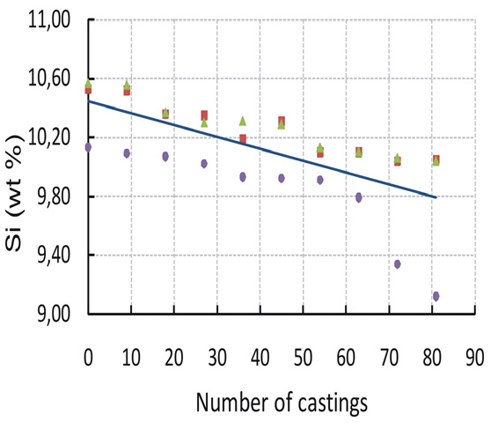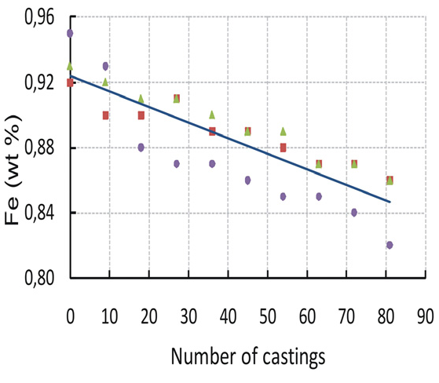

(a) (b)

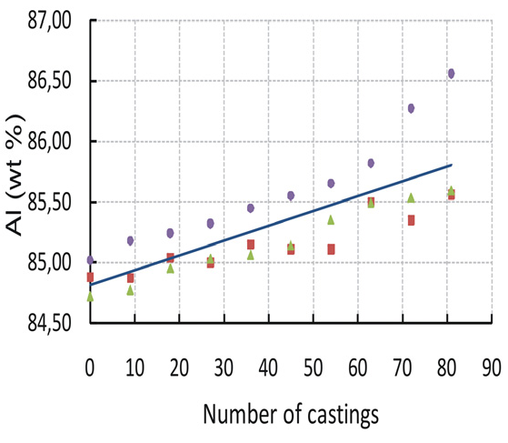 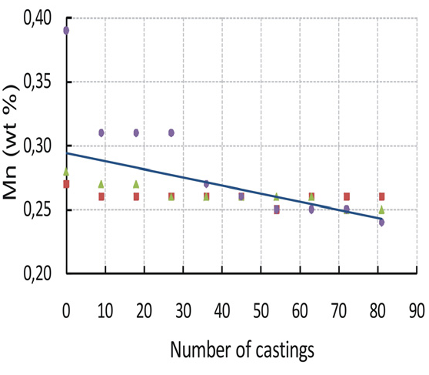

(c) (d)



Fig. 1. Weight percent of: (a) Si ; (b) Fe; (c) Mn; (d) Al in Al-Si alloy depending on the casted parts

From the charts, we can assume decreasing trend of the weight percent for silicon, ferrite, and manganese. The weight loss percentage (WL%) was also calculated for each element. The WL is highest for manganese, about 20.21%, and the minimum WL for aluminum, -1.2%, the negative value denotes an increase in weight percent of aluminum. The weight loss percentage of silicon is 6.46%, and for ferrite is 9.28%.

Progressive air-oxidation of silicon causes its changes in concentration as it is stated in reference [4], [5]. Changes in concentration of ferrite and manganese are caused by electromagnetic field of induction furnace [6], [7] and [8]. Aluminum, iron and manganese form Al3(FeMn) compound [9], [10]. The mentioned decrease of Fe, Mn and Si is prerequisite for the increase in concentration of aluminum.

1. Conclusion and discussion

The important requirement in the die-casting process is to ensure the necessary parameters of the liquid alloy. The proposed method describes a conceptual model of how to determine an optimal amount of each given element depending on number of the casting parts. Proposed method is focused to minimize deviation of the given elements concentration that are set by certain standards. The objective of the method is to minimize the risk of internal defects or reduction of strength and mechanical properties.

The experimental case study demonstrated the application of the method in the company that produces casting parts by die-casting technology. It is recommended to use the proposed method in combination with standards that can lead to an increase in quality of casting parts.

Future research work will be focused on monitoring the impact of the changes for selected mechanical properties such as: permanent deformation, ductility and hardness of the casting. It extends the experimental study on others types of Al-based alloys.

References

1. Zolotorevsky VS, Belov NA, Glazoff MV. Casting aluminum alloys. 1st ed. UK: Elsevier; 2007.
2. Kaufman JG, Roy EL. Aluminium alloy castings. USA: ASM International; 2004.
3. Kaufman JG. Properties of aluminum alloys: tensile, creep, and fatigue data at high and low temperatures. 1st ed. USA: ASM International; 1999.
4. Laudar J. Liatie pod tlakom. Bratislava: SVTL; 1964.
5. Ragan E, et al. Liatie kovov pod tlakom Presov: VMV; 2007.
6. Malik J. Zlievarenske stroje a zariadenia. Kosice: HF TU; 2006.
7. Valecky J et al. Liti kovu pod tlakem. Praha: SNTL; 1963.
8. Malik J et al. Specielne technologie v zlievarenstve. Kosice: HF TU; 2010.
9. Fedak M et al. Quality of die casting in dependence on die casting process and running property in die cavity at pressure die casting technology. ERIN 2009; 1-11.
10. Fedak M., Semanco P. Monitoring of chemical composition of aluminium alloys AlSi in the maintenance furnace. Sci Pap: Oper Diagn Mach Prod Sys Oper Stat 2010; 3: 139-144.