Available online at [www.sciencedirect.com](http://www.sciencedirect.com/)



**ScienceDirect**

AASRI Procedia 6 (2014) 12 – 18

2013 2nd AASRI Conference on Computational Intelligence and Bioinformatics

Modelling of dynamic electrical bioimpedance and measurements safety

Georgios Giannoukos *, Mart Min

*Department of Electronics, Tallinn University of Technology, Estonia*

**Abstract**

This paper is based on mathematical and electrical modelling of living tissues and their electrical bioimpedance. Impedance is complex, dynamic, depends on frequency and changes with time. The equivalent electrical circuit of a tissue in the Fricke-Morse and Debye model as well as the electrical safety checks for medical devices and the standards for medical equipment and how to measure leakage currents are presented in this paper.

© 2014 The Authors. Published by Elsevier B. V. This is an open access article under the CC BY-NC-ND license ([http://creativecommons.org/licenses/by-nc-nd/3.0/).](http://creativecommons.org/licenses/by-nc-nd/3.0/))

© 2013 Published by Elsevier B.V.

Selection and/or peer review under responsibility of American Applied Science Research Institute

Peer-review under responsibility of Scientific Committee of American Applied Science Research Institute

*Keywords:* Bioimpedance; dynamic impedance; biophysical modeling; tissue; frequency; safety standards; leakge currents.

**Nomenclature**

Z

Re Ri C

Ȧ

complex impedance

the resistor which represents the extracellular fluid the resistor which represents the intracellular medium the capacitance of the cell membrane

the angular frequency

\**E-mail address:* [g.giannoukos@gmail.com.](mailto:g.giannoukos@gmail.com)

2212-6716 © 2014 The Authors. Published by Elsevier B. V. This is an open access article under the CC BY-NC-ND license ([http://creativecommons.org/licenses/by-nc-nd/3.0/).](http://creativecommons.org/licenses/by-nc-nd/3.0/))

Peer-review under responsibility of Scientific Committee of American Applied Science Research Institute doi:10.1016/j.aasri.2014.05.003

R0

R

Ĳ Į

the resistance at zero frequency the resistance when f

the characteristic relaxation time constant

a parameter with values between 0 and 1

# Introduction

Electrical bioimpedance describes how a living organism responds to an externally applied electrical current. It can be defined as the impedance of biological specimens. The equivalent electrical circuit of a tissue in the Fricke–Morse model [1] is the following:

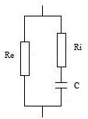

Fig. 1. Fricke–Morse model

The impedance of the above circuit is equal to:

*Z*  *Re* 1 *jRiCω* 

1 *jCω*(*Ri*  *Re* )

*(1)*

The conductivity and the permittivity of tissue are frequency dependent. This phenomenon is called dispersion of which there are four types: Į,ȕ,į and Ȗ [2].

The Fricke-Morse model is not very accurate so the Cole impedance model was proposed for tissue. The Cole empirical equation [3] is expressed by the following equation:

*Z*  *R*

 *R*0  *R*

1 ( *jωτ* )*α*

*(2)*

For example if Į=1 we obtain Fricke-Morse model

In the Fricke-Morse model we substitute the capacitance (Debye model) with the Constant Phase Element (CPE) which is described as an imperfect capacitor which is frequency dependent. The impedance of the CPE is:

*ZCPE*

 1

( *jωC*)*a*

*(3)*

when Į=1 the CPE behaves as an ideal capacitor.

# Electrical safety checks for medical devices

To ensure a safe medical environment and detection - prevention of adverse effects on patients and users, electrical safety checks are probably the most important issue. For this purpose, certain control protocols- standards in accordance with international standards IEC 60601-1 are applied. With these control protocols the medical devices are checked to determine if their operation is safe and if they are within the specified safety limits so that they operate correctly for both the patient and for the user. The standard defines the requirements of the tests for protection against possible hazards including electrical grounding protection, earth leakage currents, patient leakage currents and patient auxiliary currents, which will be analyzed below. Also HEI 95 and DB9801 standards are recommended for the checking of medical devices [4].

For the proper checking of medical devices there are tests for the insulation to check whether there are leakage currents. These tests use AC current and test equipment at certain levels of humidity. The measuring resistance value for class I devices should be greater than 50 Mȍ but may, in some rare cases, be less.

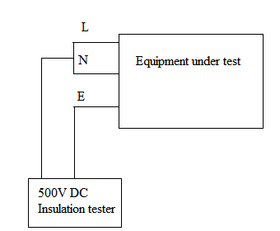

|  |  |
| --- | --- |
| Applicable to: | Class I, all types |
| Limits: | Not less than 50Ȃȍ |
| DB9801  recommended: | Yes |
| HEI 95  recommended: | Yes |

Fig. 2. Insulation resistance measurement for Class I devices

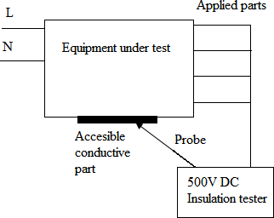

|  |  |
| --- | --- |
| Applicable to | Class II, all types having applied  parts |
| Limits: | Not less than 50Ȃȍ |
| DB9801  recommended: | No |
| HEI 95  recommended: | Yes |

Fig. 3. Insulation resistance measurement devices class II

As regards the devices of Class II, the measuring value of the resistance should not be less than 50 Mȍ [4,5 ].

# Electrical installation standards in medical care facilities

* 1. *Measuring leakage currents*

Measurement circuits have been designed to simulate the average typical electrical characteristics of the human body in order to ensure a traceable simulation of current as if flowing through a human body and these circuits are known as Body Models or Measuring Devices (MD in IEC 60601-1 standard). The diagram below shows the MD.

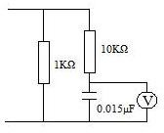

Fig. 4. Measuring device (MD)

* 1. *Enclosure Leakage Current*

The current flowing from the enclosure or other accessible metal parts of the appliance to earth or to another part of the enclosure through another conductive path other than of the protective earth conductor is called Enclosure Leakage Current. Such currents are likely to flow on the housing even when the protective earth conductor presents no discontinuity through another conductive path other than that of the protective earth conductor. The schematic interpretation of the enclosure leakage current measurement is shown in the following figure.

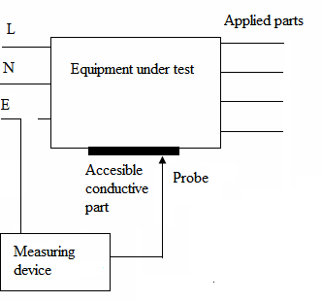

Fig. 5. Test circuit for Enclosure Leakage Current

* 1. *Patient leakage current*

Patient leakage current is the leakage current that flows through a patient connected to an applied part or parts. It can either flow from the applied parts via the patient to earth or from an external source of high potential via the patient and the applied parts to earth. A patient being exposed to external voltage due to an

external voltage source would result in a serious accident and although it is unlikely to occur it is advisable to safeguard against it [6,7].

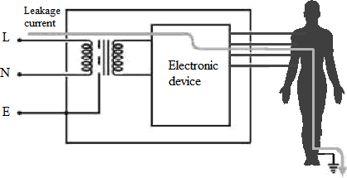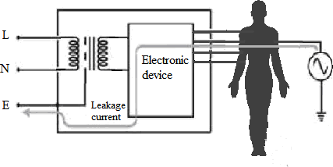

Fig. 6. Patient leakage current from equipment and Patient leakage current to equipment respectively

Checking the patient leakage current is divided into two checks of which the first examines the current flowing through the applied parts and from the device, while the second examines the current that will flow through the parts when a potential difference appears in the patient because of the existence of an external power supply. For the first check, all electrodes are connected together and the measuring device is placed between the protective earth conductor and the connection of the electrodes. In the second check an external voltage is applied to the electrodes through the checking device and a power supply is inserted between the terminals of the measuring device and the protective earth conductor. For internally powered devices with accessible metal parts in particular, the patient leakage current is measured between the electrodes and a point on the housing and the terminals of the measuring device are placed accordingly.

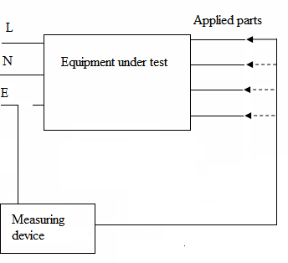The following figure shows the schematic interpretation of the patient leakage current measurement.

Fig. 7. Test circuit for patient leakage current

* 1. *Earth leakage current*

Earth leakage current is the current that escapes from the device to the protective earth conductor leaking from the main parts and is due to capacitive effects. In the event of interruption of the protective earth conductor, current will leak to earth through the patient [6,7].

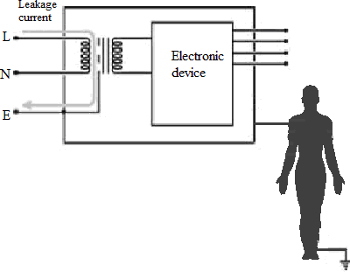 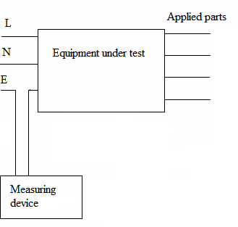

Fig. 8. The route of the leakage current to earth and Test circuit for leakage current to earth respectively

* 1. *Patient protection using grounding system*

Medical facilities are different from ordinary household and industrial premises, because they should combine smooth functioning with some increased security requirements. A typical example is the emergency electrical loads of a hospital (for instance operating theatres, blood refrigerator and intensive care unit) which, in the event of a power failure, are powered by a power generator. All buildings should have a grounding system to eliminate any risk of leaking electricity. For this reason, there should be a distribution network with three lines which are responsible for the insulation. The earth normally encountered is the operating ground and the protective earth. The difference between grounding and earthing protection function is shown below

The grounding function is necessary for the operation of the circuit and the grounding protection is designed to protect people from the leakage current to the metal casing of an electrical device with which they come in contact. The way in which the protective grounding works is shown below, where the resistance of the human consists of two parts: the core (about 500 ȍ) and skin (1 ... 100 Kȍ depending on its humidity) [7].

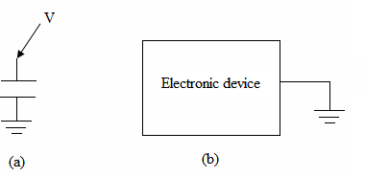 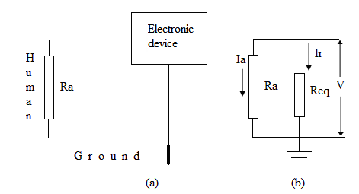

Fig. 9. (a) Operating ground, (b) Protective earth and Explanation of circuit protective earth circuit respectively

The more humid the skin the smaller the resistance. When a person comes into contact with the metal housing of a shielded electrical device, in which a leakage current occurs ((a) in the above figure), then the leakage current is limited (resistance Ra), depending on the value of total resistance of the ground circuit. The equivalent circuit of the above arrangement of the leakage current is shown in (b) of the above figure. From the equivalent circuit above we see that if Req << Ra then Ir >> Ia

Therefore, for the best possible protection we should seek a grounding resistance value, which approaches the theoretical value R = 0. The total value of earth resistance is, in practice, a few ȍ. According to the above, when there is no protective earth installation, or the value of the ground resistance is large (and the resistance of the human body is small) then there are risks to humans who come into contact with the metal casings of the various electrical devices [7].

# Acknowledgements

The authors thank Professor Toomas Rang and Dr. Toomas Parve for support and collaboration.

# References

1. S. Cole, Membranes, Ions and Impulses, Berkeley: University of California Press, 1972.
2. P. Schwan, Electrical properties of tissue and cell suspensions, Adv Biol Med Phys 5, 1957, pp. 147-209.
3. S. Grimmes and Ø Martinsen, Bioimpedance and Bioelectricity Basics, London: Academic, 2000.
4. Health Equipment Information Number 95 (HEI95) August 1981: Code of practice for acceptance testing of medical electrical equipment (withdrawn Dec 1999)
5. MDA Device Bulletin DB9801 Supplement 1: December 1999 - Checks and tests for newly delivered medical devices (replaced November 2006)
6. Geoff Cronshaw, Earthing: Your questions answered, IEE Wiring Matters, 2005
7. Merlin Gerin, Electrical Installation Guide, chap E: Low Voltage distribution: Earthing scheme,2008