Available online at [www.sciencedirect.com](http://www.sciencedirect.com/)

**ScienceDirect**

AASRI Procedia 5 (2013) 85 – 91

2013 AASRI Conference on Parallel and Distributed Computing and Systems

Multi-node Repositioning Technique for Mobile Sensor Network

Muhammad Amir Khana,*, Halabi Hasbullaha, Babar Nazirb

*aComputer and Information Science department, Universiti Teknologi PETRONAS, Tronoh 31750, Malaysia bDepartment of Computer Science, COMSATS Institute of IT, Abbottabad 22010, Pakistan*

**Abstract**

For gathering important information in Mobile sensor network, the inter-sensor connectivity represents a vital role. Nodes within these types of networks examine various aspects of an area of interest. Where failure of a sensor node may results in loss of connectivity and could result in dividing of the system into disjoint portions. Several strategies that follow node move to replace connectivity have been recently proposed. Nevertheless, these strategies often disregard the probable lack of coverage in a few areas, possibly because of the failing itself or because of the connectivity-limited concentration of the recovery. This particular paper fills the space by dealing with both the connectivity and coverage issues in an integral way. A multi-node repositioning algorithm is presented. Each and every neighbor temporarily relocates in order to replacement the particular failed node one particular at the same time and then returns back again the initial area. The algorithm is validated utilizing the efficiency parameter, distance moved and it is significance note that our algorithm handles effectively the escalation in system connectivity.

© 2013 The Authors. Published by Elsevier B.V. Open access under [CC BY-NC-ND license.](http://creativecommons.org/licenses/by-nc-nd/3.0/)

© 2013 The Authors. Published by Elsevier B.V.

Selection and/or peer review under responsibility of American Applied Science Research Institute

Selection and/or peer review under responsibility of American Applied Science Research Institute

Keywords: Wireless Sensor Networks (WSN); node relocation; mobile sensors; network connectivity.

# Introduction

Collectively of extremely considerable technology wireless Sensor Network (WSN), due to its broad effectiveness with completely new arrives becoming a strong research area. Generally a WSN may consist of a substantial amount closely positioned miniature mobile sensor nodes that might have a minimal power as well as economical price tag. Again, it is certainly caused by properly delivered applications for the environment

2212-6716 © 2013 The Authors. Published by Elsevier B.V. Open access under [CC BY-NC-ND license.](http://creativecommons.org/licenses/by-nc-nd/3.0/) Selection and/or peer review under responsibility of American Applied Science Research Institute doi:10.1016/j.aasri.2013.10.062

remark facts processing in addition to transmitting among one another through radio [1, 2]. Not just can certainly WSN reduce the price along with wait around throughout advancement, but in addition it can be applied in to any kind of environment those wherever conventional wired sensor network system tend to be unattainable to become started off just like from the deep oceans, space as well as battle field [3]. Sensor nodes will also be largely utilized in health, home or even military services. For its rapid functionality, self- organization, along with fault tolerance identity, sensor networks used in military services including come to be incredibly well suited for any kind of network permits such as for strong, managing, transmission, surveillance as well as focusing on. Sensor nodes within health about regarding the different aspects allow might be utilized with overseeing patient in addition to assisting handicapped patients. They may furthermore possibly exist appropriate in many commercial issues such as supervision stock, and monitor product quality in addition to disaster places at the same time [4].

For deployment inside tough places and unattended sites a node damage could possibly be undergone due to the exhaustion in on-chip power and perhaps a physically destruction leading to the actual network for being split up straight into several disjoint obstructs. The particular improving loss in a node because failing may well not only affect the particular network coverage but and also have an effect on network connectivity. The recovery process proposed technique is actually originally as much like C3R [5]. As shown in Fig. 1. This paper is focused upon maintaining network connectivity when a simultaneously node failure, even though retaining the actual pre-failure coverage. The demonstrated network topology in Fig. 1a may very well be seen as the subsequent examples. The failure associated with just one single node or perhaps a couple of node could possibly disengage their neighbors from the remaining network and then can certainly placed some sort of hole straight down throughout coverage intended for number different node presenting its sensing range overlapping along with failure node because within Fig. 1b. Nevertheless interchanging failure nodes having still another nodes delivers the connection right back, it in reality just transform the particular coverage starting to an alternative in the internal network area or perhaps at the edge. It may be coped along by means of simply and quickly exchanging the particular failed node with any single or its multiple neighbors [6]. To get it differently once the engaging neighbor nodes failure arise and after which actual node can certainly choose on the basis of some conditions if this become a member of which often neighbor node. The attendant nodes can certainly exchange backward and forward major the network topology and the coverage almost the same as pre-failure status. Our algorithm is simply some sort of distributed algorithm along with requires minimal messaging overhead with accomplishing the recovery.

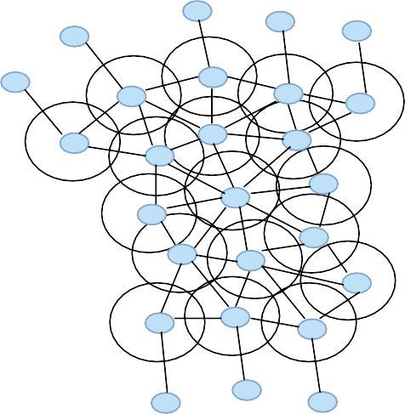

**n21**

**n22**

**n20**

**n23**

**n19**

**n3**

**n2**

**n4**

**n5**

**n7**

**n1**

**n8**

**n6**

**n11**

**n10**

**n9**

**n14**

**n12**

**n13**

**n18**

**n15**

**n16**

**n17**

**n25**

**n24**

**n26**

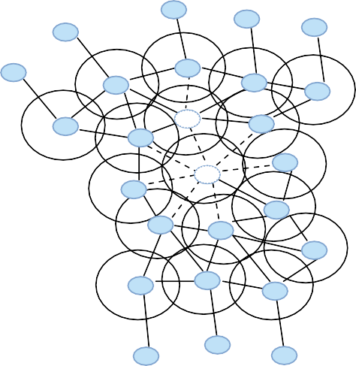

**n21**

**n22**

**n20**

**n23**

**n19**

**n3**

**n2**

**n4**

**n5**

**nn77**

**n1**

**n8**

**n6**

**n11**

**n10**

**n9**

**n14**

**n12**

**n13**

**n18**

**n15**

**n16**

**n17**

**n25**

**n24**

**n26**

(a) Connected mobile nodes network (b) After nodes failure

Fig. 1. A mobile sensor nodes network (a) Every node indicated the communication range (b) Network status after multi-node failure

# Literature Review

Putting in to the most prosperous framework has become the goal of the stated technique. In the beginning associated with application network, effectiveness mainly could be decreased by the node failure, and improvements in requirements demands associated with application might moreover impact on this is regarding effectiveness itself. Nodes regardless are expected to go be able to hold effectiveness of the layout of a network. To be able to a failure node replacement indication. Wang et al [7] proposed the cascaded movement, by alliteratively swapping a node close by with a repetitive node. Furthermore, additional works have regarded connectivity through which as explained in [8]. Another particular method example chooses to keep connectivity of two-degree actually below node or even link failing predicated on moving some sort of the node parts. Even though the thought of the particular nodes motion can be compared to the commonly the main one of previously method, being concerned the requirement for 2-connectivity could possibly contain the specific application-level performance and once again might probably not to be realistic in large-scale communities of node of resource-constrained. In that study, probably the most similar method of RIM present within the literature is DARA [9] requesting every one of nodes to help keep a list of these 2-hop neighbors and selections a failed node neighbor to transfer on the cornerstone of the amount of interaction links.

Younis et al. [10] consequently have suggested RIM (Recovery through Inward Motion) and NN (Nearest Neighbor) algorithms. RIM, some sort of distributed protocol for healing through inward movement action, includes a node F fails, their neighbors might shift inward with their area important them to have the ability to connect each other. It's actually since these neighbors produce reference to the node straight afflicted with the F node, and when to manage to achieve each other again, the network connection could be repaired for their pre-failure position. The process to be able to shift is clearly by recursively controlling any type of failed node for the motion of concerning their neighbors, as an example these types of having currently relocate towards the failure node. Every time a failure occurs in the node, NN for repairing the severed connection about F may keep on with their neighbor, which is FNN, to wherever F is positioned. The specific neighbors related to FNN react their departure since the most effective one may possibly shift and negotiate wherever. FNN was after and thus about NN may possibly halt if it is found no neighbor for a departed node attaining the network along with when all nodes in the network have formerly relocated. Distinctive from RIM applying 1-hop neighbor list, the NN method about yet another area enquire that each node recognizes their 2-hop neighbors. With this particular, the closest neighbor is probably be accepted ahead of the failure of F. Now, equally RIM and NN are not truly associated with in relation to the implication of connected with restoring the specific connection on the network coverage. Where lasting repositioning stops by Coverage Conscious Connectivity Restoration (C3R) method [5]. Through the particular neighbor node with however still another node supplies the connectivity right returning, it actual just improve the particular coverage distance to some other the principal location, periodically within the internal the principal network in addition to with the periphery. Possibly it may be coped alongside through temporarily interchanging the specific failed node as well as one specific even many using their making use of their neighbors simply.

# Methodology

Initially, the incidence of a unneeded node in the natwork involves be a highly effective solution for overage and connectivity in so it can replacement with spare node if a node failure occur. We used the model of Rabinar Heinzelman et al. (2000), and Bhardwaj et al. (2001).

* 1. *Before failure process*

In this study, each node encompass pair of neighbors of 1-hop list this is the information about pre-failure prerequisite by every node indication a HELLO information add itself to their immediate nodes periodically may supply the HEARTBEAT communications using their neighbors, failure node F is lost if their neighbor node, node A does not get a pre-set depend of HEARTBEAT communications from F the neighboring node.

* 1. *Neighbors Synchronization*

Node A detects the failure of the node F, because it might maintain approach for all nodes which have 1- hop number, it's then extremely hard to find out the neighbor nodes. None the less for the smaller range from F, node N the neighbors node is believed to attain initially and will end up a healing coordinator synchronizing and speaking with the remainder of them.

* 1. *Recovery Plan Implementation*

The typical important details for crafting and executing the therapeutic technique are found the following:

 It's possible to concerned node A to compute its overlapped coverage, range to F and power hold prior to going towards F.

 Each node A confirms to neighbors for short-term divorce in preventing to declare problematic that neighbor find other choice or buffer the data before get back of node A.

 The nearest node will be the recovery coordinator if two of the nodes reached at the same time the lees ID node serve as a recovery coordinator.

 Recovery coordinator maintains the set of rank decided by the overlap coverage range protected, and power remains. After that it collection the concern in circular fashion.

The major points for multi-node failure as follows:

 As shown in the Fig. 2a Node 7 failed and to be able to start recovery method the neighbor of the failed node as portrayed in Fig. 2b. Node n2, n3, n4, n6, n8 and n10 will start the recovery method they move towards the failure nodes.

 The whole concerned nodes obtained the ranking list by the recovery coordinator and start the recovery method as per schedule. Throughout the recovery method if the concerned nodes experience its neighbor node failed as portrayed in Fig. 2c failure of node 10 experience by node n6 and n8.

 Node n6 and n8 will determine its overlap coverage and range with the failed nodes, as shown in the Fig.

2d if the overlap coverage calculated is large then both nodes deliver the transfer meaning to productive node which will be in the career of failure node n2.

 After receiving the relocating meaning from nodes n6 and n8, productive node n2 could be the recovery coordinator and broadcast new recovery routine to the concerned nodes.

 Meanwhile nodes n6 and n8 will participate the recovery means of failure node n10.

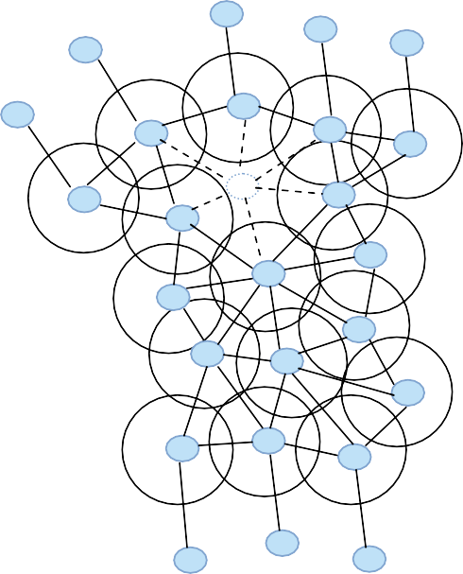

a

**n21**

**n22**

**n20**

**n23**

**n19**

**n3**

**n2**

**n4**

**n5**

**n7**

**n1**

**n8**

**n6**

**n11**

**n10**

**n9**

**n14**

**n12**

**n13**

**n18**

**n15**

**n16**

**n17**

**n25**

**n24**

**n26**

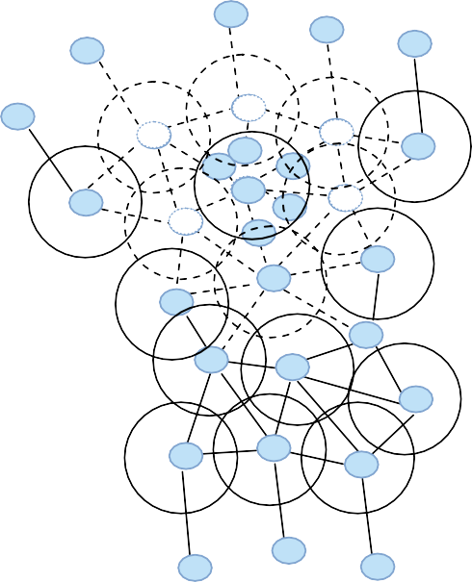

b

**n21**

**n22**

**n20**

**n23**

**n19**

**nn33**

**nn22**

**nn44**

**n3**

**n5**

**n2 n4**

**nn76**

**n1**

**n8**

**nn88**

**nn66**

**n10**

**n11**

**n10**

**n9**

**n14**

**n12**

**n13**

**n18**

**n15**

**n16**

**n17**

**n25**

**n24**

**n26**

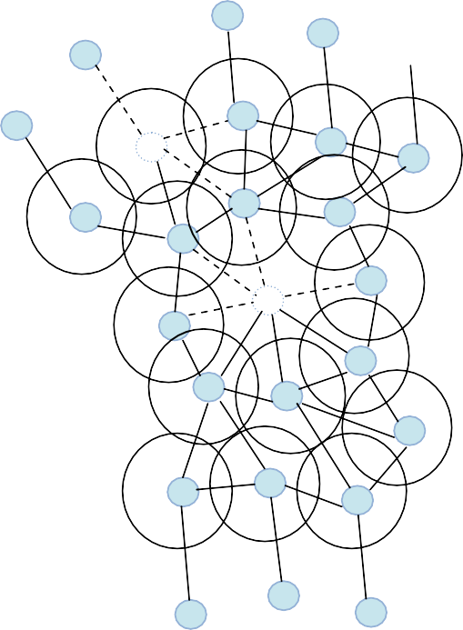

c

**n21**

**n22**

**n20**

**n23**

**n19**

**n3**

**n2**

**n4**

**n5**

**n2**

**n1**

**n8**

**n6**

**n11**

**n10**

**n9**

**n14**

**n12**

**n13**

**n18**

**n15**

**n16**

**n17**

**n25**

**n24**

**n26**

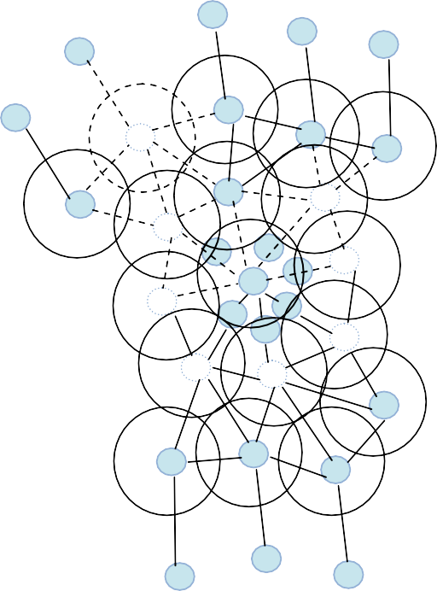

d

**n21**

**n22**

**n20**

**n23**

**n19**

**n3**

**n2**

**n4**

**n5**

**n2**

**n1**

**n8**

**n6**

**n6**

**n8**

**n11**

**n9**

**n11**

**n9**

**n12**

**n14**

**n13**

**n14**

**n12**

**n13**

**n18**

**n15**

**n16**

**n17**

**n25**

**n24**

**n26**

Fig. 2. Proposed technique illustration

# Simulation Results

The experiment results from the include simulation arbitrarily made topology of WSN with various amount of nodes as well as selection of communications. The nodes used in the simulation appears to have been set in order 25, 50, 75, 100 and 125 in an area with sizes 1000×1000 m2. Because RIM as well as NN tend not to support various ranges of communication and sensing, the rc and rs values happen to be held similar for the simulation. The ranges of rc and rs have already been 25, 50, 75, 100, 125m. Every single node carries a preliminary power up to 100J. Fig. 3 the total distance which will nodes jointly needed to travel through the actual recovery because a reason of associated with the connection range. The travel distance of a node will depends upon the connectivity within the nodes range rc. Thus, as rc raises, it will increase the total distance travelled by a node. Because of the permanent relocation both NN and RIM the total distance increases at increasing rate.

**15000**

**10000**

**Total distance travelled**

**5000**

**Our approach RIM**

**NN**

**25 50 75 100 125**

**Communication range(# nodes=125)**

Fig. 3. Nodes total distance travelled

# Conclusion

Maintaining an attached network topology of inter-node is essential within applications of the mobile sensor networks. A node failure could result in the network segmentation and therefore disturb in the network. Unlike the majority of previous work which exploits node separation to be able to recover the connectivity, proposed algorithm deals with the losing of connectivity and coverage both. To overcome this dilemma, proposed algorithm stops everlasting nodes relocation. The recovery task failure of the neighbors just lies with the failed nodes. Most of these neighbors synchronize among on their own and acknowledge their particular location within the recovery. Every single node mixed up in restoration process might have to go to the location with the failed node recover the connectivity and coverage for the reason that area and after which return to their own initial place immediately after serving for a most time. Initially our algorithmis validated using the performance parameter, distance moved and it is well worth observing that our algorithm deals with adequately the actual inside the system connectivity.

# References

1. Hyewon Jun, Wenrui Zhao, Mostafe H. Ammar, Ellen W. Zeguar, Chungki Lee, Trading latency for energy in densely deployed wireless ad hoc networks using message ferrying, Journal of Ad Hoc Networks 2007; 5(4): pp. 444–61.
2. K. Akkaya, M. Younis and M. Bangad, Sink Repositioning for Enhanced Performance in Wireless Sensor Networks, Elsevier Computer Networks, Vol. 49, Feb, 2005, pp. 512-434.
3. Katayoun Sohrabi, Jay Gao, Vishal Ailawadhi, Gregory J. Pottoe, ULCA, Protocols for self-organization of a wireless sensor network, IEEE Personal Communications 7(5), pp. 16–27 (2000).
4. R. Min, M. Bhardwaj, S. Cho, A. Sinha, A. Wang, A. P. Chandrakasan, Low power wireless sensor networks, In: Proceedings of International Conference on VLSI Design, Bangalore, India, January 2001.
5. Neelofer Tamboli, Mohamed Younis, Coverage-aware connectivity restoration in mobile sensor networks, Journal of Network and Computer Applications volume 33 Issue 3, pp. 363–374 (2010).
6. M. Chu, H. Haussecker, F. Zhao, Scalable information driven sensor querying and routing for ad hoc heterogeneous sensor networks, The International Journal of High Performance Computing Applications 16 (3), pp. 293–313 (2002).
7. G. Wang, G. Cao, T. La Porta, and W. Zhang, Sensor Relocation in Mobile Sensor Networks, In the Proceedings of the 24th Annual IEEE Conf. on Computer Communications (INFOCOM’05), Miami, FL, Mar. 2008.
8. A. Abbasi, U. Baraudi, M. Younis, K. Akkaya, C2AM: An Algorithm for Application-Aware Movement- Assisted Recovery in Wireless Sensor and Actor Networks, In the Proceedings of the IEEE International Conference on Wireless Communications and Mobile Computing Leipzig, Germany, June 2009.
9. A. Abbasi, K. Akkaya and M. Younis, A Distributed Connectivity Restoration Algorithm in Wireless Sensor and Actor Networks, In the Proceedings of the 32nd IEEE Conf. on Local Computer Networks (LCN’07), Dublin, Ireland, Oct. 2009.
10. Younis M, Sookyoung Lee, Sheetal Gupta and Kevin Fisher, A localized self-healing algorithm for networks of moveable sensor nodes, In: Proceedings of the IEEE global telecommunications conference (Globecom’08), New Orleans, LA, November 2008.