Available online at [www.sciencedirect.com](http://www.sciencedirect.com/)



**ScienceDirect**

AASRI Procedia 9 (2014) 37 – 43

2014 AASRI Conference on Circuit and Signal Processing (CSP 2014)

Noise Variance Estimation for Spectrum Sensing in Cognitive Radio Networks

Adeel Ahmeda,*, Yim Fun Hua, James M. Norasa

*aFuture Ubiquitous Networks (FUN) Research Group University of Bradford, Bradford BD71DP, United Kingdom*

**Abstract**

Spectrum sensing is used in cognitive radio systems to detect the availability of spectrum holes for secondary usage. The simplest and most famous spectrum sensing techniques are based either on energy detection or eigenspace analysis from Random Matrix Theory (RMT) such as using the Marchenko-Pastur law. These schemes suffer from uncertainty in estimating the noise variance which reduces their performance. In this paper we propose a new method to evaluate the noise variance that can eliminate the limitations of the aforementioned schemes. This method estimates the noise variance from a measurement set of noisy signals or noise-only signals. Extensive simulations show that the proposed method

performs well in

estimating the noise variance. Its performance greatly

improves with increasing

numbers of

measurements and also with increasing numbers of samples taken per measurement.

© 2014 The Authors. Published by Elsevier B. V. This is an open access article under the CC BY-NC-ND license ([http://creativecommons.org/licenses/by-nc-nd/3.0/).](http://creativecommons.org/licenses/by-nc-nd/3.0/))

© 2014The Authors.Published by Elsevier B.V.

Selection and/or peer review under responsibility of American Applied Science Research Institute

Peer-review under responsibility of Scientific Committee of American Applied Science Research Institute

*Keywords*:Noise Estimation and Analysis;Spectrum Sensing; Cognitive Radio Networks; Random Matrix Theory;

# I troduction

Cognitive Radio Systems (CRS) facilitate efficient optimization ofunderutilized radio resource through opportunistic radio spectrum exploitation. CRS require prior knowledge of spectrum utilizationto dynamically

* Corresponding author. Tel.: +044-1274-234093; fax: +44-1274-234124.

*E-mail* [*address:*a.ahmed84@bradford.ac.uk.](mailto:a.ahmed84@bradford.ac.uk)

2212-6716 © 2014 The Authors. Published by Elsevier B. V. This is an open access article under the CC BY-NC-ND license ([http://creativecommons.org/licenses/by-nc-nd/3.0/).](http://creativecommons.org/licenses/by-nc-nd/3.0/))

Peer-review under responsibility of Scientific Committee of American Applied Science Research Institute doi:10.1016/j.aasri.2014.09.008

access the radio spectrum, andspectrum sensing is an active approach used in CRS to locate spectrum holes in underutilized spectrum for opportunistic access. In spectrum sensinganopportunistic useractively measures the radio environment foravailable spectrum holes. There are many different types of spectrum sensing approaches depending on the hardware used for sensing, the sensing entities, sensing dissemination and sensing techniques [1].Reliability of a sensing technique depends whether it can accurately ascertain the presence or absence of a licensed user signals in the band of interest. The sensing techniques can be classified as transmitter detection, interference-based detection and receiver detection [2]. The underlying hypotheses of primary signal detection are as follows [2]:

H0 : x(t) = n(t)

H1 : x(t) = h*s(t) + n(t)

where n(t)is the Additive White Gaussian Noise, h is the channel gain, and

s(t)is the licensed transmitter signal.

H0 represents the null hypothesis, that a primary transmitter *isnot* present, whereas hypothesis H1 states that a primary transmitter *is* present.

# Problem Statement

Commonly used primary user detection techniques include energy detection [3], matched filter detection [4], cyclostationary feature detection [1, 2], self-correlated detection [5], eigenvalue based spectrum sensing [6-8], and multi-taper and filter bank estimation [9]. The RMT based spectrum sensing proposed in [10] suggests acriterion based on the Marchenko-Pastur law [11] which relies on the known variance of noise which suffers the same problem as faced by energy detection.

In this paper we present a techniquefor noise variance estimation that addresses the limitations of current blind spectrum sensing techniques. That is, both energy detection and eigenvaluebased techniques use the noise variance in their hypothesis testing criteria, so both are reliant on the correct estimation of noise variance. Any uncertainty in noise variance estimation will greatly affect theiraccuracy, resulting either in missed detection of spectrum holes or interference to the primary user.Our proposed method for noise variance estimation could be used for setting the decision thresholds for energy detection based spectrum sensing and also for calculating the upper and lower bounds of the eigenvalues using the Marchenko-Pastur law.

The performance of the proposed scheme is tested through extensive simulations and is found to be efficient in terms of estimating the noise variance. In our simulations we have considered various signalswhile evaluating the proposed scheme. In the next section, the performance of the scheme is evaluated through extensive simulations, and the mean error in estimated noise variance has been evaluated by varying the SNR, number of measurements and number of samples per measurement.

# Proposed Noise Estimation Scheme

To address the noise estimation problem, we consider multiple measurement sets, M in number, from the same portion of the radio spectrum, i.e. multiple measurements of the same signal under analysis. We assume N numbers of samples are collected for each measurement set. Let a single measurement set of the signal be represented by **S**M (N)where M represents a separate measurement and N represents the number of samples for the measurement, such that **S1** represents a complete sample set for the first measurement, **S2** represents a complete sample set of second measurement, and so on. **SM** represents the complete sample set for the last measurement, i.e.

**S1 =** ሾݏଵሺͳሻ ݏଵሺʹሻ ݏଵሺ͵ሻ ǥ Sଵሺܰሻሿ

**S2=** ሾݏଶሺͳሻݏଶሺʹሻ ݏଶሺ͵ሻ ǥ ݏଶሺܰሻሿ

…. …. …. ….. … …..

…. … …. ….. … …..

**SM=** ሾݏெሺͳሻ ݏெሺʹሻ ݏெሺ͵ሻ ǥ ݏெሺܰሻሿ,

where S୨ሺkሻ is the kth individual sample for the jth measurement set.So the M×N matrix from M measurements of N samples is represented as

܁૚

܁ ൌ ൦܁૛ ൪

ڭ

ۻ܁

ݏଵሺͳሻ

* ࡿ ൌ ൦ ݏଶሺͳሻ

ݏଵሺʹሻ ݏଶሺʹሻ

ǥ ݏଵሺNሻ

ǥ ݏଶሺNሻ ൪

ڭ ڰ ڭ ڭ

ݏ୑ሺͳሻ ݏ୑ሺʹሻ ڮ ݏ୑ሺNሻ

Let ۱ሺxሻ represent a column of the matrix ܁ such that it represents only the sample ‘x’ from all the measurements, i.e.

ݏଵሺxሻ ۱ ൌ ൦ݏଶሺxሻ ൪

ܠ

ڭ

ݏ୑ሺxሻ

* + ࡿ ൌ ሾ۱૚۱૛۱૜ ǥ ۱ۼሿ

In order to determine the noise variance we propose a new theorem for the calculation of ı2 to be used in hypotheses testing and is given by equation (4), i.e., for M×N matrix S, the ı2 is estimated using:

ൣσࡺ ൣσࡹ

ሼ࢙࢞ሺ࡭ሻିሺ࡯തതത࡭തሻሽ૛൧൧

࣌૛ ൌ

࡭స૚

࢞స૚

ࡺ ሺࡹି૚ሻ

*(1)*

whereCത୅ is the average of C୅Ǥ The above equation (1) is a novel way to estimate the variance of the noise, and has not been proposed earlier in the literature as a noise estimation approach. The performance of the equation (1) is evaluated through multiple simulations. The mean error in estimating ıଶ is calculated in the

next section, where it is clearly shown that the mean error of the estimate is very close to zero for higher numbers of measurements and for higher numbers of samples per measurement. The good estimation performance of the noise variance from equation (1) indicates its suitability to be used with energy detection and for accurate determination of the upper and lower bounds of the Marchenko-Pastur law.

# Simulation and Results

Multiple simulations have been carried out to check the performance of the new method for estimating the noise variance. Each simulation has been repeated 1000 times for each set of numbers of samples, number of measurements and the SNR.The mean error of noise estimation is calculated using equation (2) where Var is the known noise variance and ıଶis our estimation of the noise variance.

**For** loop=1:1000

Error (loop) = {Absolute [Var- ɐଶ ] }

# End

σ૚૙૙૙

ࡱ࢘࢘࢕࢘ሺ࢒࢕࢕࢖ሻ

***Mean error (dB) =***  ࢒࢕࢕࢖స૚

૚૙૙૙

*(2)*

* 1. *Mean Error for Different SNR with Varying Number of Samples:*

Fig.(1) shows the mean error in decibels (dB) of estimating the noise variance using equation (1) for different values of SNR. The mean error greatly reduces with increasing number of samples taken per measurement. The mean error is also low for high SNR values. Fig.(1) also shows that for different values of SNR, the mean error follows the same trend and it decreases with an increase in number of samples per measurement for all values of SNR. Fig.1(a) shows the mean error for noise estimation using two measurements, i.e. M=2. Fig.1 (b) shows the mean error for noise estimation using four measurements. It is clearly evident that Fig.1 (b) follows the same trends for mean error as found in Fig.1 (a) but the mean error reduces with increasing numbers of measurements, M .

* 1. *Mean Error for Different Number of Measurements (M) with Varying SNR:*

Fig.2 shows the mean error in dB of estimating the noise variance using equation (1) for different values of M, i.e. for different numbers of measurements. The mean error greatly reduces with an increase in numbers of measurement sets. The mean error is also low for high SNR values. Fig.2 also shows that for different values of SNR, the mean error follows the same trend and it decreases with increasing SNR for all trends of different numbers of measurements. Fig.2 shows the mean error for 1000 samples per measurement, i.e. N=1000. Fig.3shows the mean error of noise estimation using N=25000. It is clearly evident that Fig.3follows the same trends for mean error as found in Fig.2 but the mean error reduces with increased numbers of samples, N, as also shown in Fig.1.

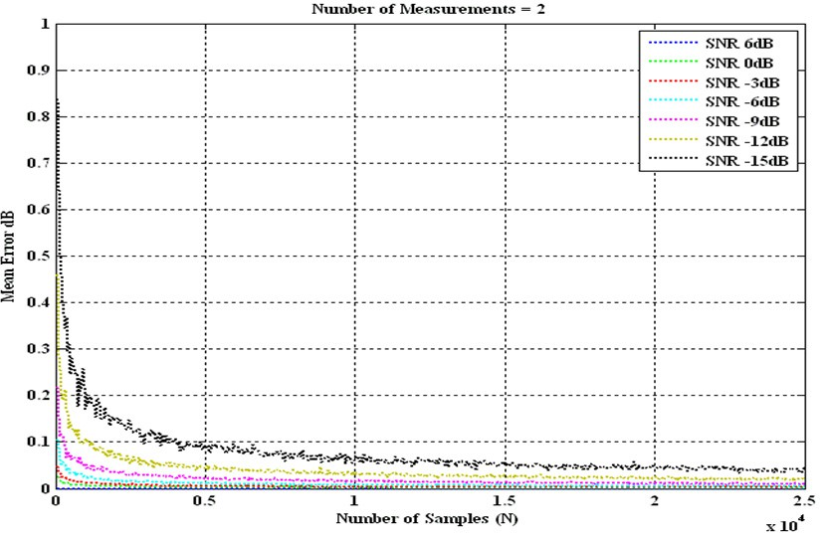

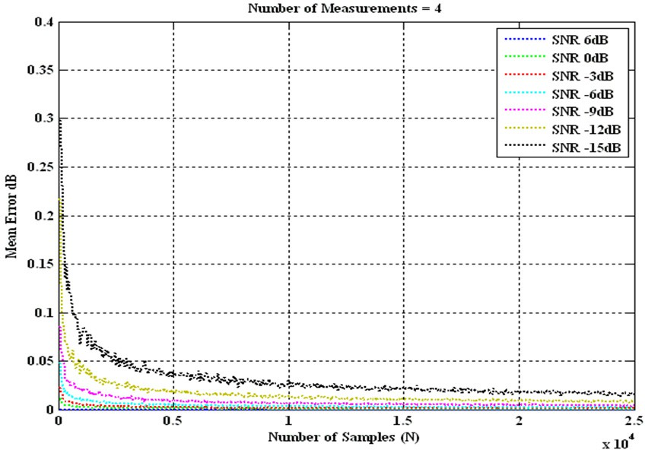

Figure 1:Mean Error in Noise Estimation:(a) for Two Measurements, M=2 (b) for Four Measurements, M=4 (c) for Six Measurements, M=6

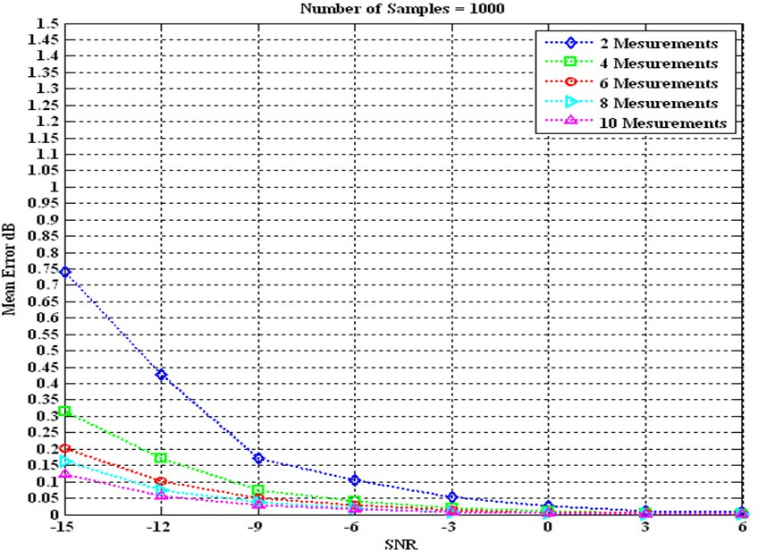

Figure 2: Mean Error in Noise Estimation for Different Number of Measurements (N=1000)

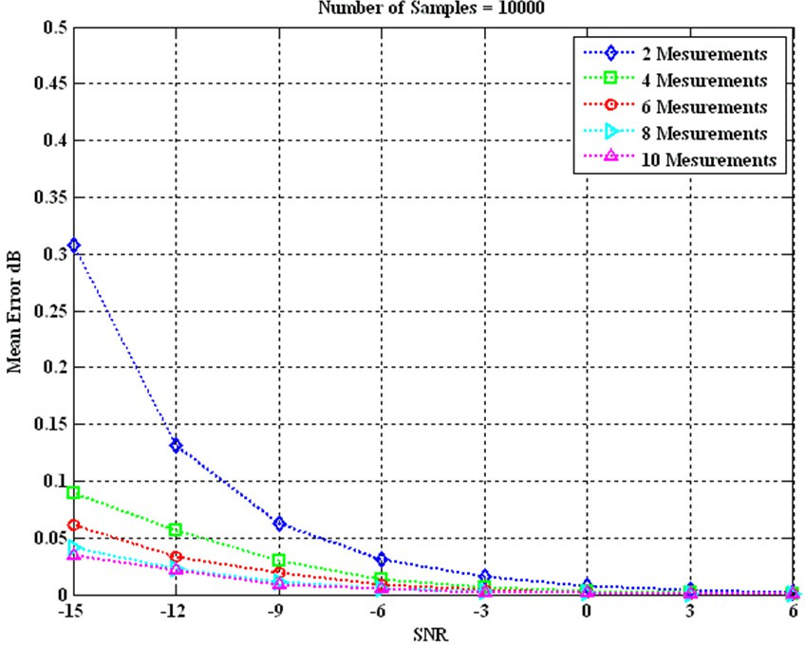

Figure 3: Mean Error in Noise Estimation for Different Number of Measurements (N=10000)

# Conclusion

We have proposed a novel method for estimating the noise variance that can be used in situations where multiple data sets are available. We have also shown that the mean error for estimating the noise variance is very low for higher numbersof measurements, hence making it suitable for energy detection, multi-antenna based spectrum sensing and also for co-operative spectrum sensing. The higher performance of the proposed scheme in estimating the noise variance demonstrates its suitability for establishing the detection thresholds in hypothesis testing in energy detection and Marchenko-Pastur law based spectrum sensing and it is the next milestone for our proposed noise estimation scheme to test its performance for the aforementioned spectrum sensing schemes.

# References

[1] T. Yücek and H. Arslan, "A Survey of Spectrum Sensing Algorithms for Cognitive Radio Applications",

IEEE Communications Surveys and Tutorials, Vol. 11, No.1, 1Q2009, pp. 116-130

[2]I. F. Akyildiz, W.Y.Lee, M.C. Vuran and S. Mohanty. “Next Generation/Dynamic Spectrum Access/Cognitive Radio Wireless Networks: A Survey”, International Journal of Computer and Telecommunications Networking, Vol. 50, No. 13, pp. 2127-59, 2006.

1. H.Wang, G.Noh, D.Kim, S.Kim, S.Kong, “Advanced Sensing Techniques of Energy Detection in Cognitive Radios”, Journal of Communications and Networks, pp.19-27, Feb 2010
2. H. Tang, “Some physical layer issues of wide-band cognitive radio systems,” in Proc. IEEE Int. Symposium on New Frontiers in Dynamic Spectrum Access Networks, Baltimore, Maryland, USA, Nov. 2005, pp. 151–159.
3. Radio Communication Study Group, “ITU-R [LMS-CRS2], Cognitive Radio Systems [CRS Applications] in land mobile services”, Documents 5A/TEMP/348 Annex 9
4. O.Tirkkonen, L.Wei, “Exact and Asymptotic Analysis of Largest Eigen Value Based Spectrum Sensing” in Foundation of Cognitive Radio Sytems,Samuel Cheng, Ed. Croatia, InTech, March 2012
5. Y. Zeng, Y. andY.C. Liang, “Eigenvalue based spectrum sensing algorithms for cognitive radio”. IEEE Transaction on Communications., Vol. 57, no. 6, pp.1784-1793, Jun. 2009.
6. F. Penna, , R. Garello, R., and Spirito, M. A. (2009). “Cooperative spectrum sensing based on the limiting Eigenvalue ratio distribution in Wishart matrices”. IEEE Communication Letters, Vol.13, issue 7, pp. 507-509,

Jul. 2009

1. B. Farhang-Boroujeny, ”Filter Banks Spectrum Sensing for Cognitive Radios”, IEEE Transaction on Signal Processing, Vol.56, pp. 1801-1811, May 2008.
2. L.S. Cardoso, M.Debbah, P.Bianchi, J.Najim,” Cooperative Spectrum Sensing using Random Matrix Theory”, 3rd International Symposium on Wireless Pervasive Computing (ISWPC), 2008,pp.334-338,7-9 May 2008
3. V.A.Marchenko and L.A.Pastur, “Distribution of Eigenvalues for Some Sets of Random Matrices”, Math USSR-Sbornik, 1:457-483, 1967