[Array 15 (2022) 100223](https://doi.org/10.1016/j.array.2022.100223)

Contents lists available at [ScienceDirect](http://www.sciencedirect.com/science/journal/25900056)

Array

journal homepage: [www.sciencedirect.com/journal/array](https://www.sciencedirect.com/journal/array)

Novel group handover mechanism for Cooperative and Coordinated Mobile Femtocells technology in railway environment

Rand Raheem *, Aboubaker Lasebae, Ali Raheem

*Faculty of Science & Technology, Middlesex University, London, United Kingdom*

A R T I C L E I N F O

*Keywords:*

High-speed trains Mobile femto Donor eNB Group handover Signalling

Mobility management Performance analysis Railways environment

A B S T R A C T

Recently, the Mobile Femto (MF) Technology has been debated in many research papers to be a promising so- lution that will dominate future networks. This small cell technology plays a major role in supporting and maintaining network connectivity, enhancing the communication service as well as user experience for pas- sengers in High-Speed Trains (HSTs) environments. Within the railway environment, there are many MF

Technologies placed on HSTs to enhance the train passengers’ internet experience. Those users are more affected by the high penetration loss, path loss, dropped signals, and the unnecessary number of Handovers (HOs).

Therefore, it is more appropriate to serve those mobile users by the in-train femtocell technology than being connected to the outside Access Points (APs) or Base Stations (BSs). Hence, having a series of MFs (called Cooperative and Coordinated MFs -CCMF) installed inside the train carriages has been seen to be a promising solution for train environments and future networks. The CCMF Technologies establish Backhaul (BH) links with the serving mother BS (DeNB). However, one of the main drawbacks in such an environment is the frequent and unnecessary number of HO procedures for the MFs and train passengers. Thus, this paper proposes an efficient Group HO mechanism that will improve signal connection and mitigate the impact of a signal outage when train carriages move from one serving cell to another. Unlike most work that uses Fixed Femtocell (FF) architecture, this work uses MF architecture. The achieved results via Matlab simulator show that the proposed HO scheme has achieved less outage probability of 0.055 when the distance between the MF and mobile users is less than 10 m compared to the signal outage probability of the conventional HO scheme. More results have shown that the dropping calls probability has been reduced when mobile users are connected to the MF compared to the direct transmission from the eNB. That is in turn has have improved the call duration of mobile UEs and reduced the dropping calls probability for mobile users who are connected to the MF compared to eNB direct connection UEs.

# Introduction

Being connected to wireless broadband services has risen signifi- cantly with the high deployment of smartphones, tablets, and other mobile devices. Passengers on public transportation such as buses, trams, and trains make intensive use of these devices and they require to be connected to the internet from anywhere and at any time with any- thing. Studies have shown that mobile broadband users are growing 10% annually and it was 120 million in 2019. On the other hand, forecasts have shown that smartphone users will reach 7.4 billion in 2025 which is 83% of all mobile subscriptions [1].

However, passengers on public transportation especially HST pas- sengers are the most who are suffering from the inadequacy of Quality of Service (QoS). There are so many reasons behind that and one of the

main reasons is the well-shielded structure with coated windows that leads to high penetration loss for in and out signals. Thus, all User Equipments (UEs) who are inside public transportation and connected to the serving eNB via the wireless links are suffering from high Vehicular Penetration Loss (VPL) and signal degradation.

Hence, HSTs are considered to be one of the vital transportation services in which they save time and effort. That is without neglecting the fact that HSTs are used all over the world such as Europe, China, and Japan with speeds exceeds 350 km/h [2]. As mentioned earlier, those well-shield carriages are more exposed to Doppler frequency shift, high VPL up to 40 dB, and low HO success rate. Therefore, many projects and studies have proven that there is a persistent need for seamless wireless connectivity and better QoS to be provided to train passengers in high-speed environments and future networks [3]. Hence,

* Corresponding author.

*E-mail addresses:* [R.H.Raheem@mdx.ac.uk](mailto:R.H.Raheem@mdx.ac.uk) (R. Raheem), [A.Lasebae@mdx.ac.uk](mailto:A.Lasebae@mdx.ac.uk) (A. Lasebae), [aliraheem@outlook.com](mailto:aliraheem@outlook.com) (A. Raheem).

<https://doi.org/10.1016/j.array.2022.100223> Received 22 December 2021; Accepted 3 July 2022

Available online 9 July 2022

2590-0056/Crown Copyright © 2022 Published by Elsevier Inc. This is an open access article under the CC BY-NC-ND license (<http://creativecommons.org/licenses/by-nc-nd/4.0/>).

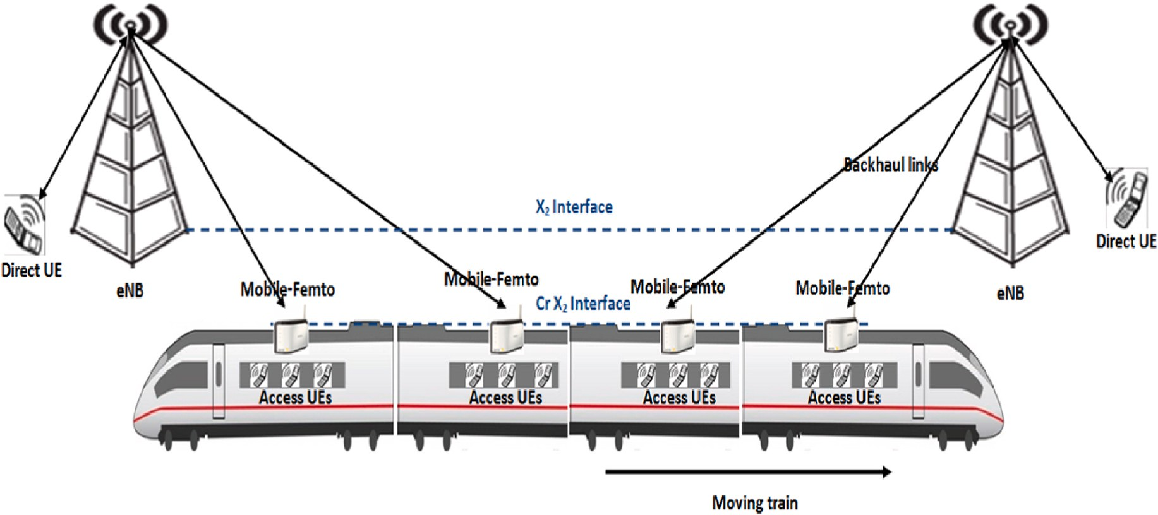

**Fig. 1.** CCMFs scenario in HST environments.

Communication Enablers for Twenty-twenty (2020) Information Society (METIS) is considered to be one of the few projects in which it has considered the deployment of small cells technology inside HST envi- ronments to improve vehicular UEs wireless connectivity.

Therefore, this paper discusses the deployment of the CCMF Tech- nologies inside the HSTs environment to improve train passengers’ signal quality and network connectivity. The CCMFs technology is seen

to be a promising solution to overcome the issue of coverage in the high- speed railway environment. The CCMF technology is installed on trams, trains, and other large-spatial-dimensions vehicles. Hence Fig. 1 shows that the CCMFs themselves are connected with each other via the CrX2 coordination interface. Having such a connection allows the high opti- misation of group HO procedure and BH link connections in which both will be investigated further in this work. That is essential to maintain the data and voice services of mobile users inside the high-speed railway environment.

While the main contribution of this paper is proposing an efficient mobility management scheme in which it improves and supports seamless mobility between the DeNB and other small cells technologies. In this framework, new rules are presented to support the HO procedure and link adaptation that maintain signal strength and quality during UEs’ mobility together with the presented small cells mobility. One of

these rules is the group HO procedure for all train passengers when

handing over the small cell technology from one Macrocell to another. Several challenges will be considered here; the HO process, resource allocation, dropping calls probability, outage probability, and other UEs performance requirements.

# Literature review

There are many studies that tackled the mobile relay HO procedure but very few studies tackled the MF HO procedure. In Ref. [5] the author has discussed the mobile relay HO issue in HSTs environment. The proposed HO scheme relies on the fact that the train travels in fixed paths. The author has shown that the proposed measurement procedure was able to shorten the HO time. However, the proposed solution is limited to the fact that is not capable to survive in crowded train stations where UEs need to quickly be attached and de-attached from the mobile relays after the users get on or get off the train. Other studies have focused on enhancing the HO performance of mobile relay by reducing the HO outage probability in HSTs environment [6]. In addition, the author in Ref. [7] has focused on minimising the HO failure and link

outage probability by proposing a mechanism that reduces the number of unnecessary HOs, HO failure, and link outage probability. The pre- vious solutions have considered the mobile relay which is limited in terms of the served number of UEs as well as the issue of the severe interference between the different mobile relays and Macrocells. Whereas, a HO authentication mechanism has been proposed by Ref. [8] in which it has reduced the HO time delay while providing strong authentication for served mobile users. The previous study provided complex solution that relies on authentication keys to control the number of HOs in HSTs environment. In contrast, the author in Ref. [9] has introduced a new HO scheme by proposing two antennas in order to minimise communication interruption during the HO procedure. In this study, the design and performance analysis of the proposed handover process was relatively based on an ideal model with perfect channel estimation. However, it is well known that accurate channel information is difficult to obtain in broadband wireless systems for HST. Therefore, this study was limited as it did not show how the channel estimation errors affect the performance of handover schemes. Another study has improved the HO scheme based on choosing the appropriate power allocation [10]. The author has shown that the proposed scheme was able to reduce the HO delay at the cost of capacity where the capacity showed slight degradation.

As mentioned earlier, most of the previous work that is concerned

with improving the QoS of UEs inside HSTs was based on using mobile relays in such an environment [11,12], and [13]. Other studies have discussed the challenges the mobile relay face in HSTs environment such as interference and HO-related problems [14,15].

However, in our previous work, the installation of the MF inside public transportation specifically buses has been discussed [16]. It was shown that the deployment of the MF inside buses has greatly improved the vehicular UE experience compared to other solutions. That is because MF works on licensed spectrum, increases network capacity, and shows better load sharing, voice quality and data/multimedia experience. More work has been done to discuss mobility and interfer- ence management for those vehicular cells [17,18]. In terms of mobility management, a group handover procedure has been introduced for all bus passengers when the bus moves from the coverage area of one eNB to another. The proposed solution has discussed the main concept of this HO scheme which is resource allocation. That is because handing over the MF itself from one eNB to another does not only dependent on the MF’s direction, speed, and channels availability but also on the Band-

width (BW) and Physical Resource Blocks (PRBs) availability in the next

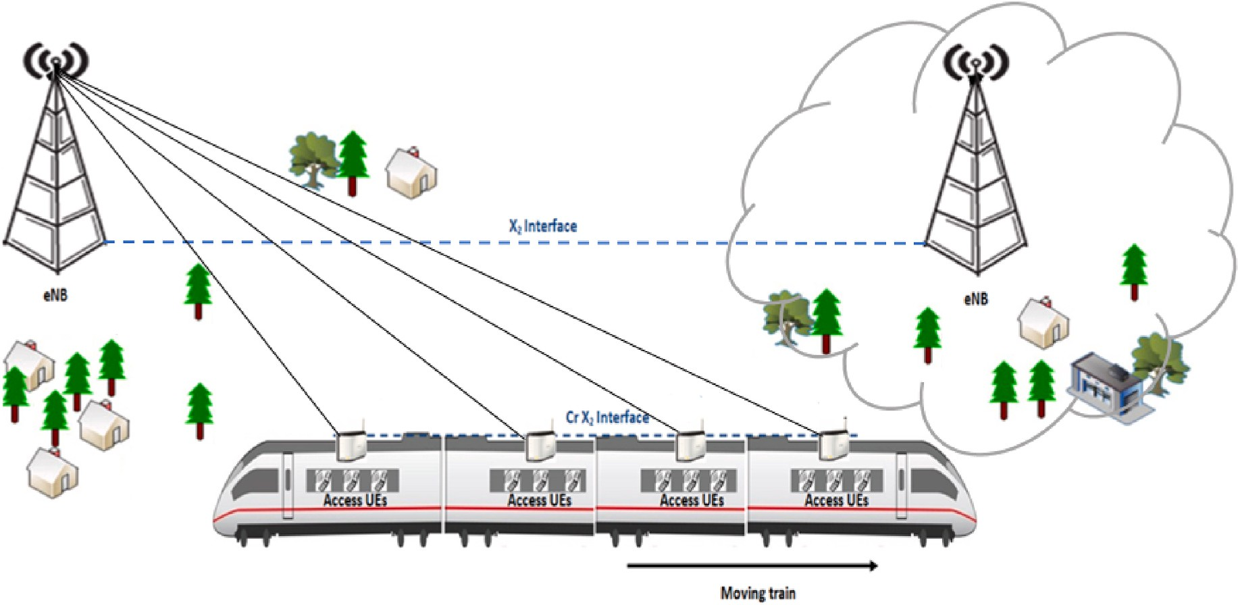

**Fig. 2.** Train movement between different coverage areas.

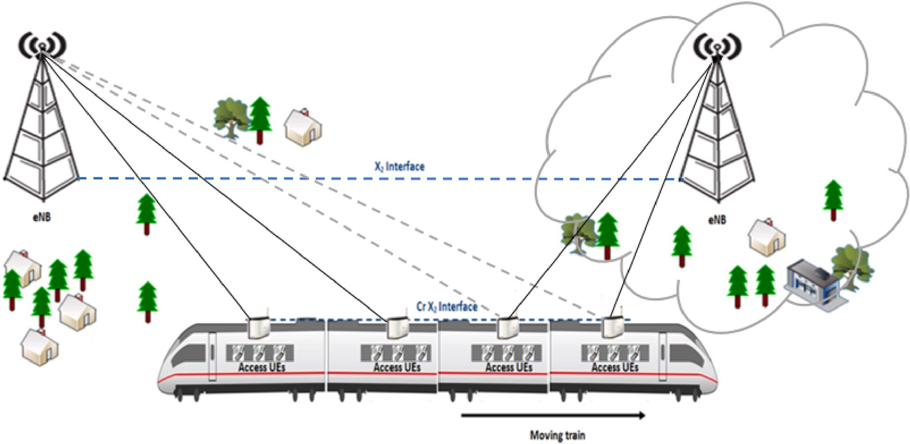

**Fig. 3.** Handing over MF from the S DeNB to the T DeNB.

cell. The proposed solution has shown a significant reduction in the signal outage probability, dropping and blocking calls probability, and improved the throughput of future networks in general. However, the previous studies were limited to the fact that the Doppler shift and speed on bus environment are completely different from the ones on the HSTs environment. The latter is more exposed to signal degradation because of the high speed of trains, which requires sufficient maintenance for

UE’s signal especially when the coverage area changes rapidly in such an

environment. Therefore, installing the MF in HSTs environment will be further discussed in this research paper.

In contrast, in Ref. [4] we have introduced the CCMF technology in which has improved the signal quality and UEs internet experience in- side high-speed railways environment. The achieved results have shown great improvement after deploying the CCMF technology in comparison to other technologies. The CCMFs is implemented on trains and other large-spatial-dimensions vehicles where those CCMFs are connected to

one another through the CrX2 coordination interface. This allows high optimisation for the group HO procedure and BH link connection. In our previous work, the interference issue has been investigated between the Macrocells and the deployed small cells technologies. The proposed interference scheme was based on controlling the eNB and the MF transmission power, controlling the MF location distribution, and using the frequency reuse scheme for the worst-case scenarios. However, the mobility aspect which is the HO process for the CCMF has not been tackled yet. That is why it will be discussed in this research paper. Hence, this work will investigate the Group HO strategy and its impact in maintaining the UEs connectivity when the installed MF moves out of the coverage area of the serving eNB to the target eNB.

# Handover scenario and system model

It has already been mentioned that maintaining connectivity inside

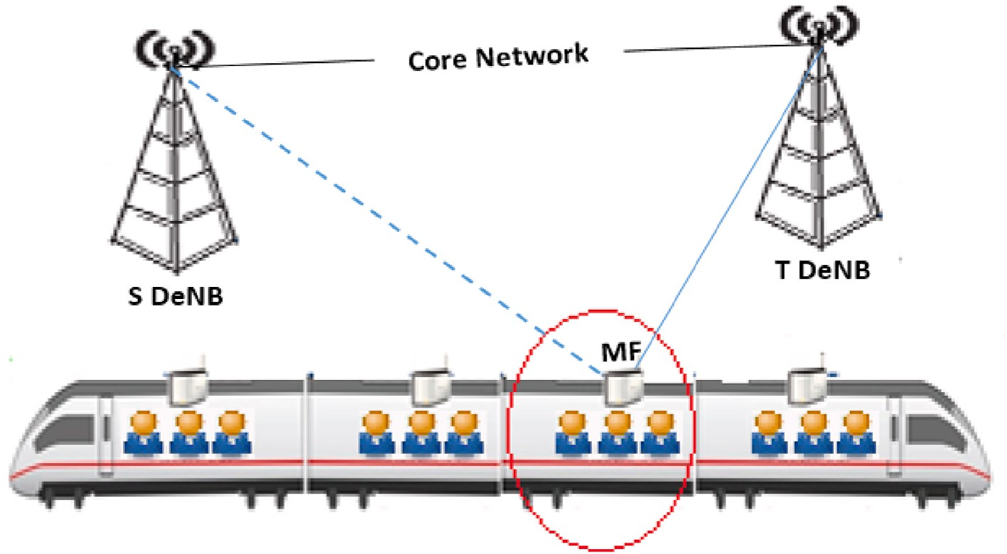

**Fig. 4.** UEs group handover.

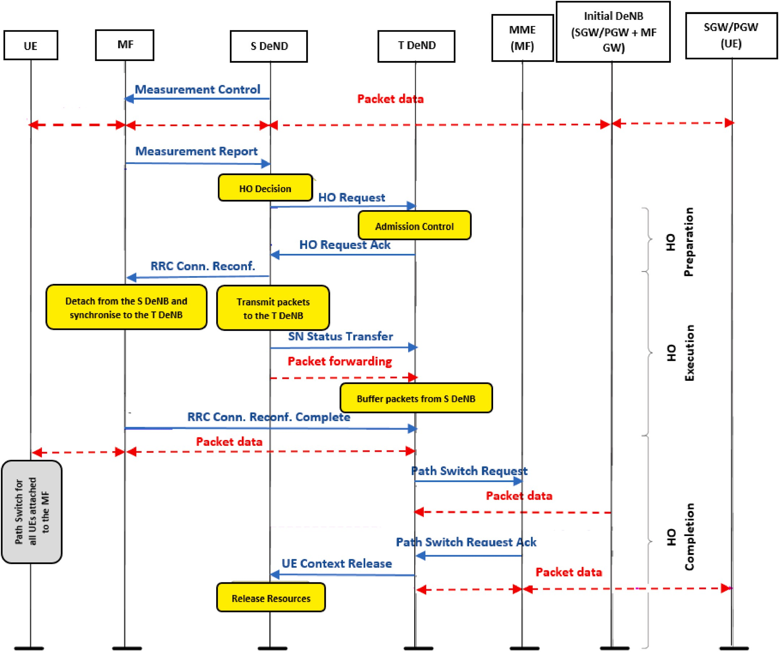

**Fig. 5.** Proposed HO mechanism for MF with its attached UEs.

the HST environment is the most challenging issue especially with the increased demand on using such a transportation system. Thus, pas- sengers can be connected to those small cells technologies to enhance their signal quality and mitigate the number of dropped and blocked connections. However, there is another challenge with this environment which is when this small cell moves out of the coverage area of the serving eNB to another. The issue can be summarised by Fig. 2:

However, to solve the above issue there are a couple of possible so- lutions that can be discussed here. The first solution is by adjusting the transmission power [19]. The approach states that when the train enters the overlapped area between the serving eNB and the target eNB, the serving eNB increases its transmission power to delay the HO process. Using such an approach helps to avoid premature HOs until the train becomes closer to the target eNB. Hence, the target eNB starts increasing its transmission power while in turn, the serving eNB starts decreasing its transmission power in order to let the HO process take its place smoothly.

On the other hand, the efficient coverage planning of the base sta- tions along the railway track is an important aspect in order to improve the HO operation [20]. That can be facilitated by placing the MF on train carriages in their correct locations. Since the available transmission power of the mother BS is assumed to be 46dBm for the inter-BS spacing of 3.8 km [18], studies have proven that the required power to achieve a sufficient QoS by train passengers can exceed the 46dBm especially when the train is near the cell boundary. That is almost halfway between consecutive BSs. Thus, when the coverage planning process takes into account the presence of the MF together with the QoS requirements, this can significantly enhance the signal strength and internet connection for train passengers. That can only be done when the presented MFs are positioned in their right locations which can reduce the power con- sumption at the BS end.

Hence, the CCMF is seen to be a promising solution for the high- speed railway environments and future networks. As a result, it is required to understand the HO mechanism and call maintenance of train passengers when the train moves away from the serving eNB to the target eNB as shown in Fig. 3. Thus, main challenge of offering seamless HO in HST and future networks is data forwarding from the Serving DeNB (S DeNB) to the Target DeNB (T DeNB). As mentioned earlier, Fig. 3 illustrates the fact that when the MF leaves the coverage area of the S DeNB towards the T DeNB the HO process will take a place here to

maintain the vehicular UEs’ connection who are connected to the serving the MF.

However, the HO process, in this case, will not be per UE but it will be per a group of UEs connected to the serving MF as shown in Fig. 4.

The group HO procedure is established when the signal strength –Signal to Interference and Noise Ratio (SINR) between the MF and the S DeNB

drops. The chosen T DeNB depends on the train path which is usually fixed in a known direction. Added to that, the success of the HO pro- cedure depends on a very important factor that cannot be neglected which is the availability of the PRB in the T DeNB. That means, in order to ensure the success of the HO procedure, the required PRB in the T DeNB must satisfy the handed-over MF with all its UEs. If that cannot be met, then the Call Admission Control (CAC) in this case allows the release of some of the BW from the existing direct links of the Macro UEs by degrading their QoS to serve the coming MF. That is because the CAC policy permits the release of the required BW for the coming MF request

where in turn the system allows a maximum (*BWT DeNB* – *BWrequired*) reduction of the BW to complete the HO procedure and meet the coming

MF resource demands. This HO procedure is accompanied by a group HO for all UEs inside the train carriage who are attached to the serving MF.

In contrast, it is worth mentioning if the minimum required BW at the T DeNB is inadequate even after releasing some BW from the direct links of the existing Macro UEs, then the connection of the coming MF

will be dropped, thus, the MF UEs connections will be dropped too. That is clearly due to the lack of a sufficient number of the PRB to accom- modate the coming MF and its UEs. It is to be mentioned that there is always a possibility for the train passengers to be connected individually to the T DeNB via the direct links. Those UEs will be considered as new UEs, thus, they can establish a connection with any close by BS (MF or T DeNB). The CAC in this case checks whether the MF coverage in the same carriage is still available or not. If the MF coverage is available, then the MF is the first choice to connect the UE to; otherwise, T DeNB is the second option to be connected to. However, this connection quality depends on three important factors; the VPL, path loss, and the speed of the train. That means the connection might not last long due to the previous three factors that can be could cause issues.

On the other hand, Fig. 5 illustrates in detail the HO procedure when the MF is handed over from the S DeNB to the T DeNB. That is only when the number of the available PRB at the T DeNB is adequate to accom- modate the coming MF with all its attached UEs. In this case, the HO procedure is going through three main phases as shown below; the preparation phase, the execution phase, and finally the completion phase. Those three main phases themselves include sub-procedures within them in order to ensure the success of the HO procedure in HST environments. Thus, before moving into the first phase, it is to be pointed that the S DeNB configures and triggers the MF Measurements Control where in turn the MF replays with the required Measurements Report to complete the HO procedure successfully.

* 1. *HO preparation phase*

In this phase the S DeNB makes the decision based on the previous measurement reports and whether it is required to perform the HO procedures of the leaving MF towards the T DeNB. The S DeNB sends a HO Request message to the T DeNB. Once the request is received, the T DeNB performs an admission control check to decide whether to accept the coming MF or not. If yes, the T DeNB acknowledges the receipt of the HO Request message after reserving the required resources for the coming MF. This phase does not end up here as the S DeND needs to inform the corresponding MF to hand over by the Radio Resource Control (RRC) connection reconfiguration command.

* 1. *HO execution phase*

Once the RRC connection reconfiguration command is received, all required information for the BH link reconfiguration between the MF and the T DeNB can be applied. At this phase, the MF is detached from the S DeNB and synchronise to the T DeNB. Thus, all packets will be forwarded from the S DeNB to the T DeNB. The RRC connection reconfiguration command between the MF and the T DeNB is completed where the MF notifies the T DeNB about that via a message. This phase cannot be completed unless the required PRBs at the T DeNB are suffi- cient to meet the MF with its UEs needs.

* 1. *HO completion phase*

To end up the HO procedure, the T DeNB sends a path switch request message to the Mobility Management Entity (MME). That is essential because the MME communicates with the Serving Gateway (SGW) of the MF to switch the routing path. Once that is confirmed, the MME of the MF acknowledges the path switch request via a message to the T-DeNB. After receiving the path switch request Ack by the T DeNB, the latest sends a UE context release message to the S DeNB to release all S DeNB resources and make them available for other MFs and UEs. However, it is to be mentioned that the path switch of the MF is accompanied by a path switch of all UEs attached to the corresponding MF. In turn, the SGW forwards all UEs’ packets to the T DeNB which is necessary to maintain

their internet connection and signal quality.

Hence, the MF HO algorithm in HSTs environment has been repre- sented below:

Algorithm. 1. MF HO with UEs Group HO

**1:** *Detect the MF SINR*

**2:** *Request Measurement Report*

**3:** *S DeNB Initiates MF HO Request*

**4:** *T DeNB Receives MF HO Request*

**5:** *If BW available at T DeNB*≥*MF BW required then*

**6:** *Accept MF HO at the T DeNB*

**7:** *T DeNB BW total*= *T DeNB BW total*+ *MF BW required*

**8:** *Forward MF packets to the T DeNB*

**9:** *Path switch of The MF to the T DeNB*

**10:** *Group UE HO of MF served UE to the T DeNB*

**11:** *S DeNB Releases the occupied MF Resources*

**12:** *Else if BW available at T DeNB < MF BW required then*

**13:** *Reject MF HO*

**14:** *MF UEs detect the T DeNB signal*

**15:** *Initiate a HO to the T DeNB*

**16:** *T DeNB Receives UE HO Request*

**17:** *If BW available at T DeNB*≥*UE BW Required then*

**18:** *Accept UE HO at the T DeNB*

**19:** *T DeNB BW total*= *T DeNB BW total*+ *UE BW required*

**20:** *Path switch of The UE to the T DeNB*

**21:** *Else if BW available at T DeNB < UE BW required then*

**22:** *Reject UE HO*

**24:** *If UE signal degrades again then*

**25:** *Drop call*

**26:** *End*

**27:** *End*

**28:** *End*

After the detailed illustration of the MF HO with all its attached UEs (group HO), now it is vital to study and evaluate the impact of the proposed HO scheme on served train passengers. The proposed HO procedure will be evaluated based on the occurrence of the signal outage and dropping calls probabilities in the HSTs environment.

# System level

To create a clear evaluation and comparison between the achieved results, a mathematical model will be presented taking into account the transmission power of both, eNBs and MFs. Thus, there are two main transmission links here; the direct link between the eNB and the train passenger, and the access link between the MF and the train passenger. As mentioned earlier, the HST environment is more exposed to the high path-loss, VPL, fading, and weak SINR at the receiver end that is unable to support the required transmission rate of R bits per sec. Due to the

previously mentioned factors that could severely affect the received SINR, a signal outage in the system could happen which is known as outage probability. Nowadays, systems’ main concern is to reduce the

outage probability and its impact by maintaining the train passengers’

signal connections. Therefore, studying the impact of the proposed HO procedure with the use of the CCMF in HSTs environment is the main target of this section. Fig. 6 illustrates the possible HO scenario of our

proposed approach in which it is required to maintain train passengers’ connection inside train carriages. As it can be shown below, the common

case is to have the train passengers connected to the installed MF inside the train carriages. However, when the MF leaves the coverage area of the S DeNB towards the T DeNB, some worst-case scenarios are to reject the HO if the PRBs at the T DeNB are not adequate to accommodate the coming MF with its attached mobile users. Thus, the attached mobile users to the serving MF as highlighted in Fig. 6 will have the option to be connected individually to the T DeNB to maintain their signal connec- tion and resist the outage probability that could take a place in this case. Hence, it is essential to calculate the outage probability of the pro- posed HO mechanism and understand its impact in maintaining the signal connection of served UEs. There are two main cases here; when a successful Group HO procedure takes a place and when a rejection from the T DeNB takes a place. The outage probability of a single-hop system when there is a direct link between the T DeNB and the train passenger

UE can be given by the following equation:

*Poutage DIrect* = *Preceived* (*SINRRx* ≤ *SINRthreshold DIrect* ) (1) The above case is when there is a HO rejection for the MF with all its

attached UEs due to the inadequacy of the PRBs at the T DeNB. Thus, the UE will try to establish a HO connection with the T DeNB as its required BW is less than the MF required BW. The SINRRx, in this case, is the SINR at the receiver Rx, where the received power at Rx is represented by Preceived. The SINR threshold at the receiver Rx is represented by SINR- threshold_Direct which is required to support a given target rate over the direct link between the T DeNB and the vehicular UE. It is important to set an SINR threshold because it will give a clear indication of when the system will be outage. Hence, the SINR threshold of the direct trans- mission between the T DeNB and the train passenger (UE) can be calculated by the following equation as shown in our previous work [16]:

*SINRthreshold Direct* = *SINRthreshold MF* = 2*R* — 1 (2) R is the required transmission Rate at the UE’s end and it is in bits/

sec. Likewise, the MF in the CCMF system supports the full-duplex transmission mode of the DeNB. As a result, at the Femtocell end, both the BH and the access links are supporting a given end-to-end R

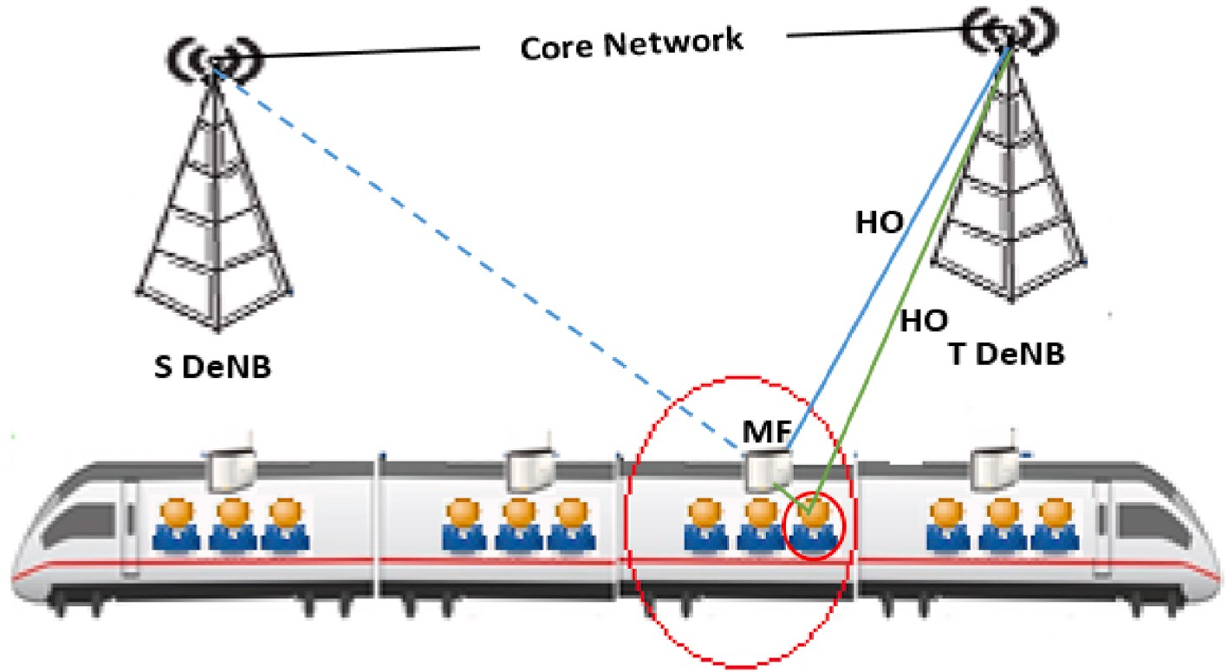

**Fig. 6.** Worst case scenario HO procedure.

bits/sec at the receiver Rx end similar to the direct transmission from the DeNB. Hence, the same SINR threshold will be used for both cases.

*Dropping Call Probability* (*Pmin*

, *L*) = *P*(*Pr*(*L*) < *P*

*min*

) (8)

The transmitter Tx has an average transmission power of Px, likewise, when the receiver Rx is at distance y from the transmitter Tx itself has a received power given by Precieved which can be calculated by [16].

*Precieved*(*y*) = *PxL*(*y*)*ψ*|*G*|2 (3)

The equation terms can be summarised by the following; L(y) is the

path-loss when Rx is at distance y from Tx, whereas the power loss caused by the shadowing is given by *ψ* and G is the channel gain. Nevertheless, it is worth mentioning that both SINR thresholds of direct and access links vary according to the various QoS requirements such as the available rate R bits/sec which can be calculated via the Shannon capacity theorem as follows [16]:

Hence, it can be concluded that that HST UEs are more likely exposed to HO failure and dropping calls probabilities due to their high-speed and continuous movement from one coverage area to another.

# Results and discussion

The following section represents the achieved results of the signal outage and dropping calls probabilities of mobile users inside HSTs’ environment. The results will create a clear comparison between the

signal quality of UEs who are served by either the direct link or the access link transmissions. That is without neglecting the impact of the proposed HO procedure in the simulated environment. A Matlab simu-

*R* = *BWeff*

log

2(1 + *SINR*) (4)

lation tool has been used while Table 1 summarises the main parameters that have been assumed in this work:

Here the BWeff represents the BW efficiency that is offered to the served UEs while the SINR was more appropriate to be used rather than the SNR because of the consideration of the interference aspect in this case. That is actually because of the multiple access methods in which several transmitters can send information simultaneously over a signal communication channel especially when each UE is surrounded by many options to be connected to. This gives UEs the opportunity to share a band of frequencies that can easily cause interferences. However, an interferences mitigation scheme has already been discussed in our pre- vious work [4].

Hence, since the SINR threshold of the direct and access links are equal, they both can be calculated via the following equation:

Fig. 7 represents the SINR value of mobile users inside and outside transceivers over distance. However, the SINR value in both situations is quite small because of the inter-cell interference (ICI) effect. When the mobile user is inside the train carriage, the SINR value is 0.69 due to the short distance which is up to 1 m between the mobile user and the serving MF. On the other hand, the SINR value is 0.89 when the distance between the DeNB and the mobile user inside the train carriage is more than 1 m (outside transceivers).

In contrast, Fig. 8 compares the outage probability of our proposed HO scheme and the conventional HO scheme, taking into account the distance gap between the transmitter and the receiver. In this work, the outage probability of train passengers has been taken into account

where the outage threshold value has been set to 6 dB. The achieved

*SINR*

*threshold Direct*

= *SINR*

*threshold MF*

*R*

= 2*BWeff* — 1 (5)

( )

results show that the outage probability of our proposed HO scheme is very small when the distance is 10 m or less. That indicates the effec- tiveness of the proposed HO scheme in reducing the outage probability

especially when the distance between the mobile user and the serving

Thus, the signal is outage when either the BH link or the access link is

outage. The BH link can be outage when the T DeNB is unable to accommodate the coming MF due to the inadequacy of the required BW and PRBs. On the other hand, the access link can be outage when the MF itself is not attached to any eNB. Both cases can be sum- marised by the following:

*Pout* = *Precieved* (min(*SINRbackhual* , *SINRaccess* ) < *SINRthreshold MF* ) (6) Hence, if the outage probability value is high, then the number of

dropped calls/packets is high too because of the positive correlation between the two. Dropping calls probability is a key performance indi- cator that is used by many service providers to measure the system QoS and the efficiency of the HO procedure. There are many other factors that play important role in increasing the number of dropped calls and these factors can be summarised by the VPL inside train carriages, path- loss, and shadowing. In fact, the shadowing issue is caused by the obstacle between the transmitter and the receiver where this obstacle absorbs the power. That is also known as penetration loss which is common in vehicular and indoor environments. On the other hand, the path-loss issue is caused by the dissipation of power that is radiated by the transmitter together with the effects of the propagation channel. However, the used path-loss model in our HSTs environment scenario is the Microcell non-line-of-sight (NLOS) path-loss model that is given by:

base station is no larger than 10 m.

Whereas, Fig. 9 illustrates the decrease in the outage probabilities of the proposed HO in comparison to the conventional HO schemes ac- cording to the outage threshold variance. The increase in the outage threshold led to a decrease in the outage probability. Hence, the results show that the proposed HO scheme improved the signal connection and reduced the outage probability compared to the conventional HO scheme.

On the other hand, Fig. 10 represents the impact of distance between the served UEs and the serving base stations on dropping calls proba- bility. This comparison has been created to evaluate the advantage of being served by the installed MF inside train carriages and the impact of that on reducing the issue of dropping calls probability. There are many factors influencing the number of dropping calls probability in HSTs environment such as the VPL and the path-loss which has a negative impact on the signal power over distance *d*. That makes the received signal power at *Rx* less than the minimum power threshold *P*min as in

**Table 1**

Simulated parameters.

Used parameters Values

MF Carrier Frequency 1900 MHz

MF Transmission Power 24 dBm

*PL*(*L*) = 34.53 + 38log

10(*L*) (7)

DeNB Transmission Power 46 dBm

MF Height 2 m

SINR Threshold of Outside Transceivers 8 dB

where L is the distance between the transmitter and the receiver. However, in wireless systems, there is a target minimum received level of Pmin, and whatever power below this set power threshold, the per- formance will be unacceptable. Thus, dropping calls probability can be given by:

SINR Threshold of MF 11 dB

No. of DeNBs 2

System BW 10 MHz

Train Speed 300 km/h

VPL 40

Path-loss Model in dB *PL*(*L*) = 34.53 + 38log 10 (*L*)

Minimum Required rate at the UE end 2 bits per sec

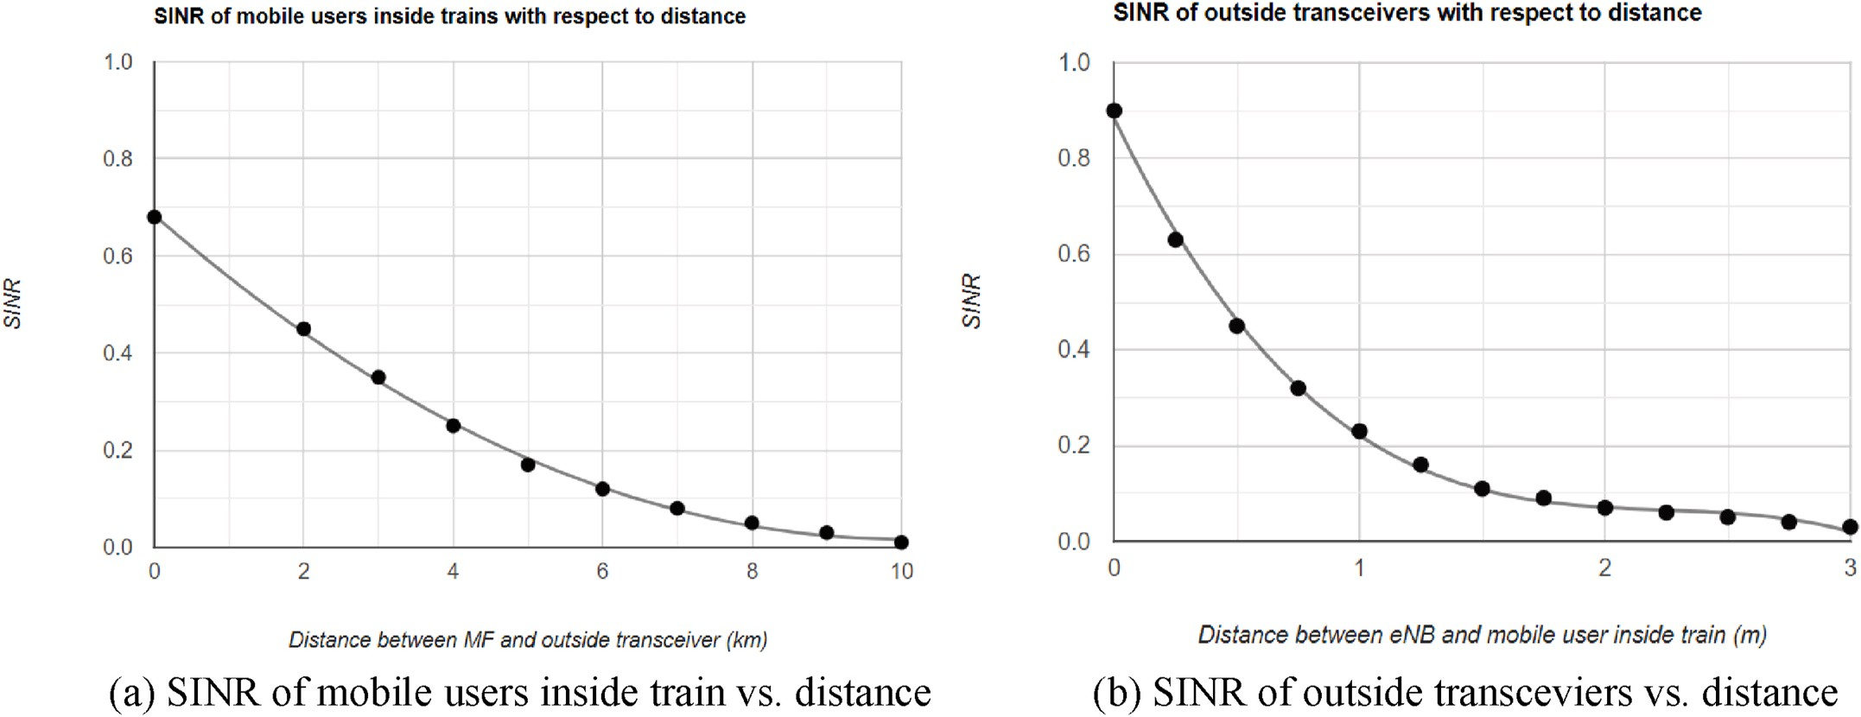

**Fig. 7.** (a) SINR of mobile users inside train vs. distance (b) SINR of outside transceviers vs. distance.

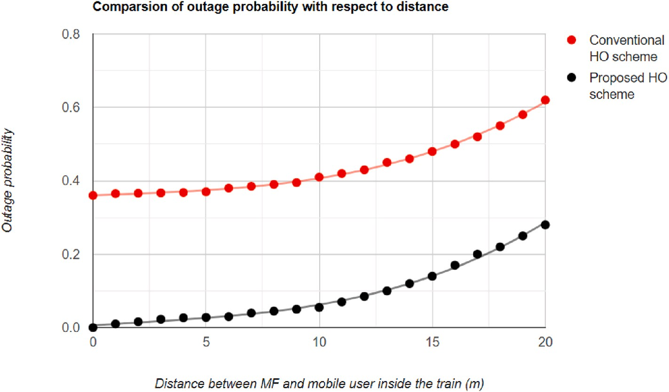

**Fig. 8.** Outage probability vs. distance.

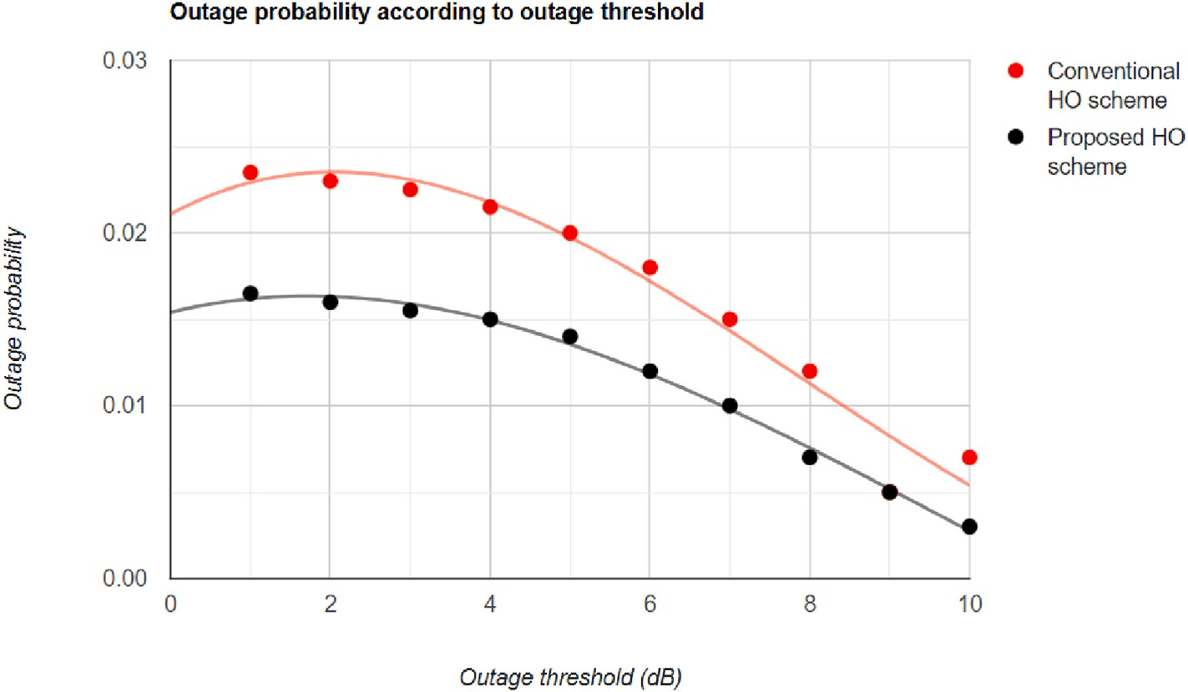

**Fig. 9.** Outage probability vs. outage threshold.

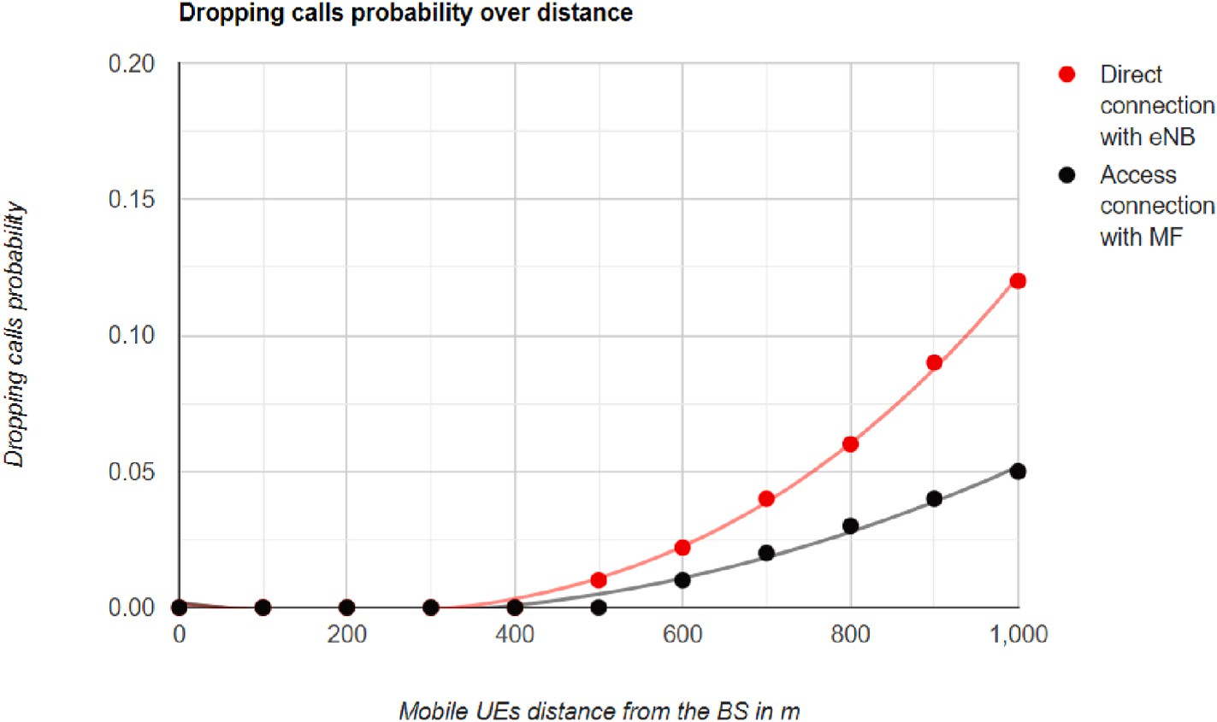

**Fig. 10.** Dropping calls probability vs. distance.

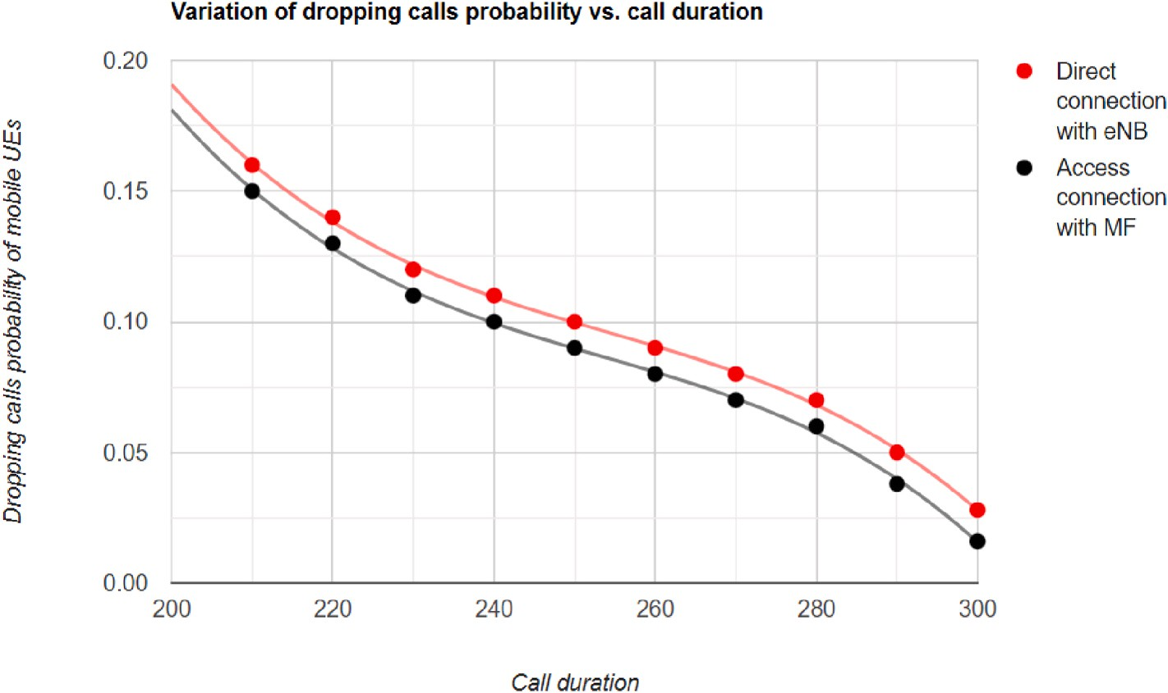

**Fig. 11.** Dropping calls probability vs. call duration.

*(Pr(d)* < *P*min*)*. The results show that the MF achieves less dropping probability when the distance *d* between the mobile user and the serving base station is less than 500 m. That is because of the reasonable short distance between the transmitter and the receiver which makes the

(*Pr*(*d*) > *P*min). However. The dropping calls probability value increases

after the 500 m until it reaches its maximum at 1000 m. That occurs because of the BH link variation when the installed MF inside the HSTs environment moves closer to the edge of the serving macrocell. As a result, the proposed HO scheme takes a place to hand over the MF from the S DeNB to the T DeNB which is accompanied by a UEs group HO in order to main the MF and its UEs connection.

In contrast, Fig. 11 demonstrates the correlation of call duration and dropping calls probability. This correlation shows clearly that call duration has a positive impact on mobile users’ performance and the

which the mobile station consumes to complete a call connection *h* = *A* QoS. Call duration or mean call holding time represents the time in where A is a traffic intensity and *λ* is the call arrival rate. As a result, the

*λ*

call arrival rate varies with call duration the same way it varies with the call dropping probability. That makes a conclusion that calls dropping probability decreases with the positive increase in the call duration. In

fact, calls last longer when the quality of the connection is good because of the strong signal between the mobile user and the serving BS. Hence installing MF inside train carriages has a positive impact in boosting vehicular UEs signal connection, overcoming the path-loss issue, VPL problem, and mitigating the generated interference because of the weak signals.

# Conclusion

Public transportation has dominated people’s life as people always

look for fast and cheap means of transportation. HSTs are considered to be one of the main means of transportation in which they can serve many users and save their money and time. Providing internet connec- tion inside train carriages is the future of public transportation and future networks. Therefore, the vehicular network is seen to be a new type of wireless network that made an appearance along with the development of both wireless technologies and the automotive industry. However, the vehicular network itself comes with implications and de- pendencies like any other technology. Therefore, providing internet connection inside train carriages via the CCMF has been seen to be a promising solution despite the challenges accompany this solution due

to the high-speed railway environment. Consequently, HO is one of the main aspects in HSTs to guarantee the seamless connectivity and communication of served UEs inside train carriages. In fact, in a high- speed moving CCMF environment, HO can occur more frequently, therefore, providing an effective HO procedure to mitigate the outage and dropping calls probabilities were the main target of this work. The proposed HO procedure considered the process of handing over the MF itself from one DeNB to another accompanied by a group UEs HO for all attached UEs to the serving MF. The achieved results showed the reduction in the outage and dropping calls probabilities of the proposed HO scheme compared to the conventional HO scheme.

# Declaration of competing interests

The authors declare that they have no known competing financial interests or personal relationships that could have appeared to influence the work reported in this paper.

# Acknowledgment

The authors would like to thank all those who contributed to accomplish this work. The Faculty of Science and Technology at Mid- dlesex University played an important role in backing up this work until it is completed.

# References

1. Ericsson. Ericsson mobility report. <https://www.ericsson.com/mobility-report>; 2019.
2. Ai B, He R, Zhong Z, Guan K, Chen B, Liu P, et al. Radio wave propagation scene partitioning for high-speed rails. Hindawi, Int. J. Antennas Propag. 2012;2012:1–7. <https://doi.org/10.1155/2012/815232>.
3. Shift2Rail. Rails proejcts. accessed on 03/01/2021, avaliable at: [http://www.shift](http://www.shift2rail.org/) [2rail.org](http://www.shift2rail.org/).
4. [Raheem R, Lasebae A, Petridis M, Raheem A. Cooperative and coordinated mobile](http://refhub.elsevier.com/S2590-0056(22)00064-9/sref4) [femtocells technology in LTE vehicular environment: mobility and interference](http://refhub.elsevier.com/S2590-0056(22)00064-9/sref4) [management, IEEE 35](http://refhub.elsevier.com/S2590-0056(22)00064-9/sref4)th [international conference on advanced information](http://refhub.elsevier.com/S2590-0056(22)00064-9/sref4) [networking and applications (AINA). Toronto, Canada: Ryerson University; 2021](http://refhub.elsevier.com/S2590-0056(22)00064-9/sref4).
5. Pan M, Lin T, Chen W. An enhanced handover scheme for mobile relays in lte- highspeed rail networks. IEEE Trans Veh Technol 2015;64(2):743–56. [https://doi.](https://doi.org/10.1109/TVT.2014.2322374) [org/10.1109/TVT.2014.2322374](https://doi.org/10.1109/TVT.2014.2322374).
6. Qian X, Wu H, Meng J. A dual-antenna and mobile relay station based handover in distributed antenna system for high-speed railway. In: Seventh international conference on innovative mobile and internet services in ubiquitous computing;

2013. p. 585–90. <https://doi.org/10.1109/IMIS.2013.103>. 2013.

1. [Liu Z, Fan P. An effective handover scheme based on antenna selection in](http://refhub.elsevier.com/S2590-0056(22)00064-9/sref7) [ground–train distributed antenna systems. IEEE Trans Veh Technol 2014;63(7):](http://refhub.elsevier.com/S2590-0056(22)00064-9/sref7) [3342–50](http://refhub.elsevier.com/S2590-0056(22)00064-9/sref7).
2. [Cao J, Ma M, Li H, Fu Y, Niu B, Li F. Trajectory prediction-based handover](http://refhub.elsevier.com/S2590-0056(22)00064-9/sref8)

[authentication mechanism for mobile relays in lte-a high-speed rail networks. In:](http://refhub.elsevier.com/S2590-0056(22)00064-9/sref8) [2017 IEEE international conference on communications (ICC); 2017. p. 1–6](http://refhub.elsevier.com/S2590-0056(22)00064-9/sref8).

1. [Tian L, Li J, Huang Y, Shi J, Zhou J. Seamless dual-link handover scheme in](http://refhub.elsevier.com/S2590-0056(22)00064-9/sref9)

[broadband wireless communication systems for high-speed rail. IEEE J Sel Area](http://refhub.elsevier.com/S2590-0056(22)00064-9/sref9) [Commun 2012;30(4):708–18](http://refhub.elsevier.com/S2590-0056(22)00064-9/sref9).

1. Liu Z, Zhou E, Fan P, Hao L. Tradeoff of capacity and handover performance in

high speed railway wireless communications. In: 2016 IEEE 83rd vehicular technology conference. VTC Spring); 2016. p. 1–5. [https://doi.org/10.1109/](https://doi.org/10.1109/VTCSpring.2016.7504508) [VTCSpring.2016.7504508](https://doi.org/10.1109/VTCSpring.2016.7504508).

1. [Van Phan V, Horneman K, Yu L, Vihriala J. Providing enhanced cellular coverage](http://refhub.elsevier.com/S2590-0056(22)00064-9/sref11)

[in public transportation with smart relay systems. In: Proc. Vehicular networking](http://refhub.elsevier.com/S2590-0056(22)00064-9/sref11) [conference; 2010. p. 301–8](http://refhub.elsevier.com/S2590-0056(22)00064-9/sref11).

1. [Li W, Zhang C, Duan X, Jia S, Liu Y, Zhang L. Performance evaluation and analysis](http://refhub.elsevier.com/S2590-0056(22)00064-9/sref12)

[on group mobility of mobile relay for LTE advanced system. Proc. Vehicular](http://refhub.elsevier.com/S2590-0056(22)00064-9/sref12) [Technol. Conf. 2012:1–5](http://refhub.elsevier.com/S2590-0056(22)00064-9/sref12).

1. [Sui Y, Papadogiannis A, Yang W, Svensson T. Performance comparison of fixed and](http://refhub.elsevier.com/S2590-0056(22)00064-9/sref13)

[moving relays under co-channel interference. In: Proc. Globecom workshops. GC](http://refhub.elsevier.com/S2590-0056(22)00064-9/sref13) [Wkshps); 2012. p. 574–9](http://refhub.elsevier.com/S2590-0056(22)00064-9/sref13).

1. [Sui Y, Vihriala J, Papadogiannis A, Sternad M, Yang W, Svensson T. Moving cells: a](http://refhub.elsevier.com/S2590-0056(22)00064-9/sref14)

[promising solution to boost performance for vehicular users. IEEE Commun Mag](http://refhub.elsevier.com/S2590-0056(22)00064-9/sref14) [2013;51:62–8](http://refhub.elsevier.com/S2590-0056(22)00064-9/sref14).

1. [Sui Y, Papadogiannis A, Svensson T. The potential of moving relays-A performance](http://refhub.elsevier.com/S2590-0056(22)00064-9/sref15)

[analysis. In: Proc. IEEE 75th vehicular technology conference. VTC Spring); 2012.](http://refhub.elsevier.com/S2590-0056(22)00064-9/sref15)

[p. 1–5](http://refhub.elsevier.com/S2590-0056(22)00064-9/sref15).

1. [Raheem R, Lasebae A, Aiash M, Loo J, H Colson R. Mobile femtocells utilisation in](http://refhub.elsevier.com/S2590-0056(22)00064-9/sref16) [LTE vehicular environments: vehicular penetration loss elimination and](http://refhub.elsevier.com/S2590-0056(22)00064-9/sref16)

[performance enhancement”. ELSEVIER Journal on Vehicular Communications;](http://refhub.elsevier.com/S2590-0056(22)00064-9/sref16) [2017](http://refhub.elsevier.com/S2590-0056(22)00064-9/sref16).

1. [Raheem R, Lasebae A, Aiash M, Loo J, H Colson R. Interference management and](http://refhub.elsevier.com/S2590-0056(22)00064-9/sref17)

[system optimisation for femtocells technology in LTE and future 4G/5G networks.](http://refhub.elsevier.com/S2590-0056(22)00064-9/sref17) [In: Advances in communications: reviews’ book series. vol. 1. Barcelona, Spain):](http://refhub.elsevier.com/S2590-0056(22)00064-9/sref17) [IFSA Publishing; 2017](http://refhub.elsevier.com/S2590-0056(22)00064-9/sref17).

1. Raheem R, Lasebae A, Aiash M, Loo J. Mobility management for vehicular user Equipments in LTE/mobile femtocell networks. Int J Inf Syst Serv Sect (IJISSS) 2017;9:60–87. <https://doi.org/10.4018/ijisss.2017100105>.
2. Lu Y, Xiong K, Fan P, Zhong Z, Ai B. The effect of power adjustment on handover in high-speed railway communication networks. IEEE Access 2017;5:26237–50. <https://doi.org/10.1109/ACCESS.2017.2775044>.
3. Yaacoub E, Alsharoa A, Ghazzai H, Alouini MS. Seven challenges for communication in modern railway systems. Front. Commun. Netw. 2021. [https://](https://doi.org/10.3389/frcmn.2020.619527) [doi.org/10.3389/frcmn.2020.619527](https://doi.org/10.3389/frcmn.2020.619527).