Available online at [www.sciencedirect.com](http://www.sciencedirect.com/)



AASRI Procedia 3 (2012) 313 – 318

2012 AASRI Conference on Modelling, Identification and Control

Numerical Simulation on the Flow State of Dross Layer in Tundish

LI Chaoxiang*, LIU Biao, ZHU Shengyu

*School of Metallurgy and Resources, Anhui University of Technology, Ma'anshan 243002, China*

**Abstract**

In tundish, the flow state of top dross layer not only influences the oxidation of the molten steel, but also is directly related to the floating and adsorption of inclusions, and is concerned with the entrainment of steel to micro-inclusions. In this study, with the VOF method, the charging and normal casting processes are numerical simulated, two structural models of tundish being created. The results demonstrate that the flow control has significant effect on the stability of dross layer and the probability of dross entrainment. The improved structural model can effectively stabilize the dross layer and reduce the risk of entrainment. It plays an important role on the removal of inclusions, and enhances the cleanliness of molten steel.

© 2012 The Authors. Published by Elsevier B.V. Open access under [CC BY-NC-ND license.](http://creativecommons.org/licenses/by-nc-nd/3.0/)

© 2012 Published by Elsevier B.V.Selection and/or peer rev[iew under responsi](http://creativecommons.org/licenses/by-nc-nd/3.0/)bility of American Applied Science Research Institute

Selection and/or peer review under responsibility of American Applied Science Research Institute

*Keywords:* tundish, protecting dross, flow state, inclusion, numerical simulation

In recent years, on many steel sheets surface, some inclusions are detected, whose composition is the same as the protecting dross in tundish [1]. Some researches [2] have also shown that 60% surface defects in the ultra-low carbon steel are caused by the protecting dross entrainment. It is visible that the slab defects are greatly due to the entrainment. Therefore, in order to improve the purity of steel and optimize the floating process of inclusion, it is necessary to clear about the flow states of molten steel and protecting dross in

*\* * Corresponding author:* Prof. Dr. Chaoxiang LI. Tel.: 13955583866; fax: 0555-2311571 .

*E-mail address:* [chaoxiang@ahut.edu.cn.](mailto:chaoxiang@ahut.edu.cn)

2212-6716 © 2012 The Authors. Published by Elsevier B.V. Open access under [CC BY-NC-ND license.](http://creativecommons.org/licenses/by-nc-nd/3.0/) Selection and/or peer review under responsibility of American Applied Science Research Institute doi:10.1016/j.aasri.2012.11.050

tundish. When casting normally or replacement of a larger tundish, as a result of the strong inertia and impulse of the steel injected from the teeming nozzle, the molten steel reverses violently. The reversal and impact of the molten steel cannot be completely eliminated in vertical direction, despite various kinds of slowing flow and inhibiting flow control devices. For cooling and solidifying on the top, the dross layer seems relatively stable. However, at the interface of steel and dross, there is undercurrent simmering. In fact, the surface flow in tundish is typical non-steady flow with moving interface. The tundish construction and high- temperature surroundings are adverse to observing dynamic characteristics, so the numerical simulation is particularly appropriate.

By numerical simulation, Guo Junyu, Zhang Jieyu et al [3] have researched systematically the influences of the height of dam, the depth of weir and the distance between dam and weir on fluctuation of molten steel in tundish. Yue Lifang et al [4] have studied the changes of the free surface and the velocity field during the emptying and filling of the tundish. In this paper, using the VOF method, the state of top dross layer and the flow of molten steel in tundish are simulated during the charging and continuous casting processes, two structural models of tundish being created. The purpose is to research the distribution and flow state in the interface. This paper provides reference on construction of tundish for the production of high purity steel.

### Governing Equations

The volume of fluid (VOF) method is presented by American scholars Hirt & Nichols et al [5], on the basis of the MAC method. It is a fixed grid technique designed for two or more immiscible fluids. In the VOF model, the volume fraction of each of the fluids in each computational cell is tracked throughout the domain. To facilitate study, the following assumptions are applied: the cooling and solidifying of the dross layer are ignored, and the dross is considered always in the flow state.

The governing equations used in the VOF calculation are as follows: Volume fraction equation:



*aq*

*t*



*Sa*

1

*n*

*q*

*q q p *1

Momentum equation:



*t*

*u*

*aq*

*mpq*

 *mqp*

*(1)*

Realizable k-

# *k*



*t*



*xi*

*kuj*

*div*

*div*

 *t k*



*xi*



*k*

*x j*



*t*

*x j*



# *grad*



*S *

*Gk * *Gb*



 *YM * *Sk*



*(2)*

*(3)*

*u j*



*x j*

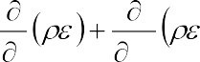

*t*

*x j*

*C*1*S*



 *C*1 *k C*3*Gb*

2

*C*2 *S*



*k*



*(4)*

Where, *mpq* is mass transfer from phase p to phase q, and *mqp* is mass transfer in reverse (i.e. from phase

q to phase p).  is common variable, and can denote an unknown variable u, v, w, etc.  is the generalized diffusion coefficient. S is the generalized source term. Gk represents the generation of turbulent kinetic energy due to the mean velocity gradients. Gb is the generation of kinetic energy due to buoyancy.

*C*1  max

## 0.43,

in which

## 5

*S k* . *C*1

and *C*2 are constants. *k* and  are the turbulent Prandtl

numbers for *k* M represents the contribution of the fluctuating dilatation in compressible turbulence to the overall dissipation. Sk and S are user-defined source terms. In Fluent, these values used by

default are constant, *C*1



1.44 , *C*2

1.9 , *k*

1.0 ,

 1.2 .

### Model Structure

In order to adjust to Fluent software, the Gambit software is used for modeling and meshing. To obtain precise numerical results, Model scale is 1:1. The dimensions of tundish are as follows. At upper side, length is 9036mm, width is 1668mm, and at lower side, length is 8648mm, width is 854mm. The tundish is shown a trough, with 1100mm high. The teeming nozzle diameter is 118mm, and the one of submerged nozzle is 82mm. Due to symmetry of construction and for saving computing resources, half of tundish is as simulation object.

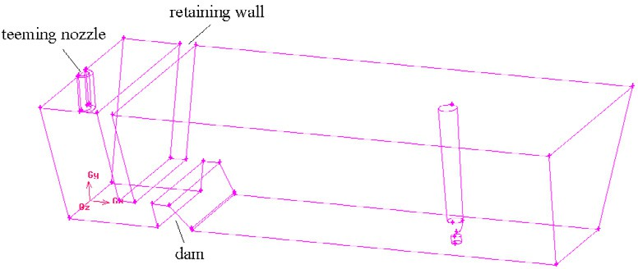Model-1 is shown in Fig. 1. Cartesian coordinate system is set up. Take the intersection of teeming nozzle centerline and bottom of tundish as coordinate origin. Y-axis positive direction is upward, x-axis positive direction is pointing to the right side of the tundish, and z-axis is along the width, pointing to the observer (see Fig.1).

Fig. 1 Schematic view of tundish in Model 1

Model-2 is an improved model. On the basis of the model-1, the dam is removed. Only the retaining wall is left and moved to the side for 300mm distance, and the retaining wall is thickened by 10mm. From the bottom of tundish, a rectangular opening is tapped for diversion in side edge of the wall. The opening size is 80×600mm. It is shown in Fig. 2. Both walls have openings, along diagonal direction.

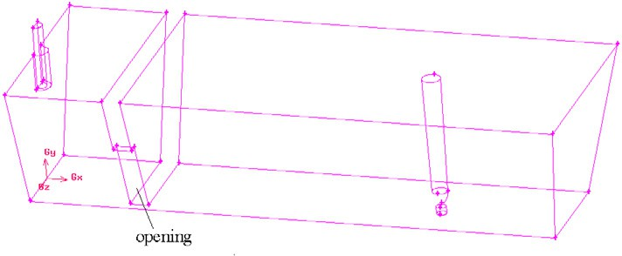

Fig. 2 Schematic view of tundish in Model 2

Solid wall is seen to be no-slip. The near-wall boundary layer uses the standard wall function. The entrance is defined molten steel inlet. Assumed that the velocity is uniform distribution in cross section, the inlet velocity is 1.406m/s at the teeming nozzle, calculated from the casting speed and slab dimensions. At the top of model is set to pressure outlet, and reflux is set as air phase.

The calculation parameters are determined as follows:

* 1. The number of multiphase is set to 3, i.e., molten steel, dross, and air.
  2. Molten steel and dross are both incompressible fluid, and air is compressible fluid.
  3. Molten steel: density is 7004.07kg/m3, and viscosity is 0.004553kg/(m s). Dross: density is 3500kg/m3, and viscosity is 0.035kg/(m s).
  4. The dross thickness is 60mm.

### Simulation and Analysis on Charging Process

For Model-1 and Model-2, during charging process, the location and distribution of dross are recorded, from empty tundish to normal casting level (1100mm), as shown in Fig.3 and 4.

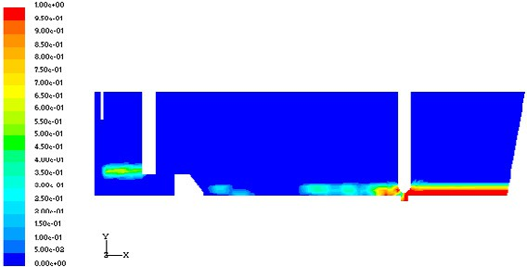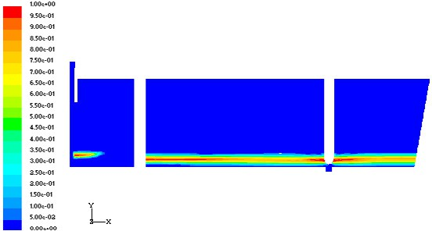It can be seen from Fig. 3, with the process of charging, molten steel level increases, and the dross layer fluctuates often. During the whole process, the concentration distribution varies erratically, particularly near the stopper. It is mainly caused by the lower molten steel impact. Seen from Model-2 in Fig. 4, at initial charging stage, the dross is uniformly distributed on the steel surface, and concentration is also very uniform. Only when close to normal casting level, the dross layer near the retaining wall slightly ripples by strong impact. Near the stopper and other regions, the dross layer is very steady and smooth.

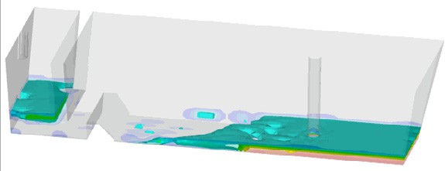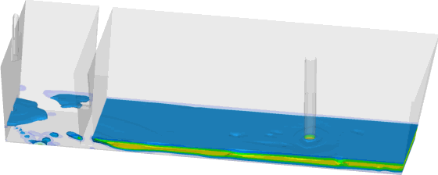a A

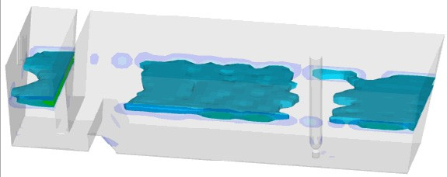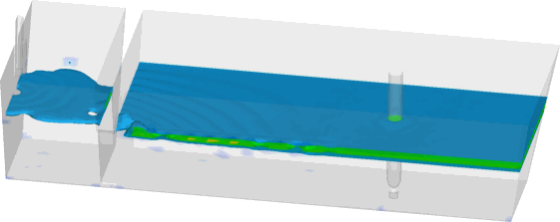b B

c C

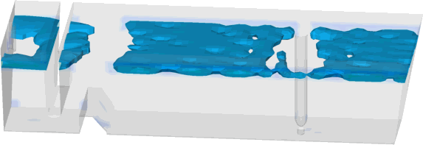d D 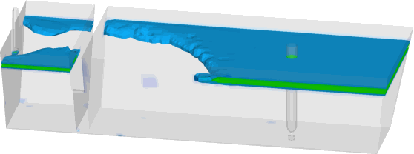

Fig. 3 Flow state and concentration distribution of dross layer in Model 1

Fig. 4 Flow state and concentration distribution of dross layer in Model 2

a,b- Time=35s, c- Time=360.9s, d- Time=572.6s a,b- Time=35s, c- Time=354.7s, d- Time=574.7s

In the case of dross flow state and concentration distribution, in Model-2 they are superior to those in Model-1, and the dross layer is more stable. The dross stability determines the adsorption of floating inclusions. The more stable the dross layer is, the steadier the flow is at the interface, and the better the floating inclusions can be adsorbed. It can also be seen from Model-2, with the height of molten bath increases, the dross near the retaining wall is shocked more seriously, and there may be an ideal bath height.

### Simulation and Analysis on Normal Casting Process

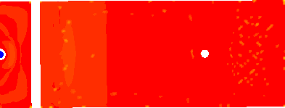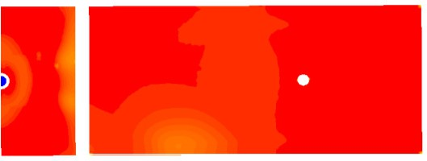In order to further illustrate the stability of the dross layer in the two models, the flow state of protecting dross is simulated in normal casting process. The simulation results are demonstrated in Figs.5 and 6. The location of screenshot is at y=1130mm, selecting the middle of the dross layer in thickness direction.

e E

f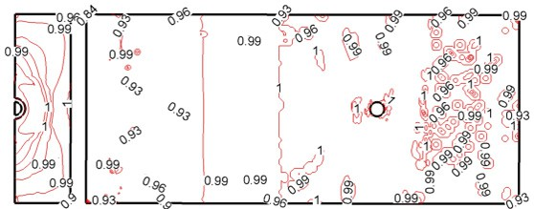 F 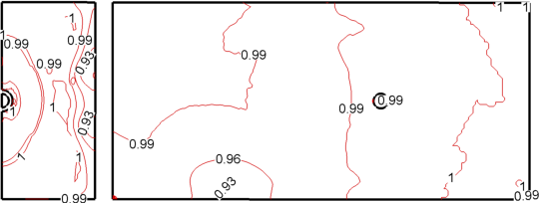

Fig. 5 Volume fraction of dross layer in Model 1 Fig. 6 Volume fraction of dross layer in Model 2 e- Cloud picture, f- Contours e- Cloud picture, f- Contours

Fig. 5 presents that in Model-1, the volume fraction of dross layer is changing from time to time, especially at the end of the tundish. This shows that even in normal continuous casting, the concentration of dross layer changes frequently. It is certain, at the interface the steel flow produces a strong impact to dross, resulting in dramatic variation in the concentration of the dross layer. In Fig. 5, the intensive distribution contours illustrate that under dross layer, there is strong turbulence in molten steel, damaging the adsorption. Because the flow at interface is unstable, floating inclusions are difficult to be adsorbed by dross. Even worse, partial dross is entrained by molten steel and flows to the filling opening.

In contrast, Model-2 adopts flow control technology with side openings. In molten bath, molten steel form a rotational movement in horizontal direction. It can alleviate the impulse in the vertical direction. This follows the rotating separation principle of mechanics, and facilitates the separation of inclusions. As can be seen from Fig. 6, in Model-2 the distribution and concentration of dross layer are very uniform and stable.

n the dross layer is very small. A potential flow core can even be formed, with zero relative velocity between molten steel and dross layer, and becomes gathering center for floating inclusions. The dross layer is very steady, and conducive to the adsorption of inclusions.

### Conclusions

* 1. With VOF method, the multiphase flow model can simulate the flow state of dross in tundish well.
  2. The simulation results indicate in model-1 (commonly used in two-strand slab continuous casting tundish), due to the control flow of retaining wall and dam, in vertical direction a turbulence and its pulse are generated. This brings about a strong impact to the dross. It is unfavorable to the adsorption of the floating inclusions, or even dross is partly entrained along with the filling opening.
  3. In Model 2, the conventional diversion is altered, and the flow forms a rotational motion in horizontal direction. This follows the rotating separation principle of mechanics, and facilitates the separation of inclusions. Meanwhile, the rotational motion will not impact the top dross, maintaining the stability of the dross layer. With zero relative velocity between molten steel and dross layer, it is very conducive for dross to adsorb the floating inclusions. This model is very significant for the production of high purity steel.

### References:

1. ZHU Guosen, YU Huixiang, WANG Wanjun, WANG Xinhua. Study of surface defects of cold-rolled IF steel sheet [J]. Iron and Steel, 2004, 39(4): 54-56.
2. Originally Published by International Iron and Steel Institute, Translated by Chinese Society for Metals. IISI Study on Clean SteelState of the Art and Process Technology in Clean Steelmaking [M]. Beijing: Metallurgical Industry Press, 2006: 11-14.
3. Guo Junyu, Zhang Jieyu, Ren Yanqiu. Study on free surface in tundish [J]. Steelmaking, 2000, 16(4): 34- 36, 46.
4. YUE Lifang, REN Yanqiu. Numerical simulation of the free surface in the process of filling and emptying of the tundish [J]. J. of Inner Mongolia University of Science and Technology, 2007, 26(1): 6-9, 13.
5. C.W. Hirt, B.D. Nichols. Volume of fluid (VOF) method for the dynamics of free boundaries [J]. J. of Computational Physics, 1981, 39: 201-225.