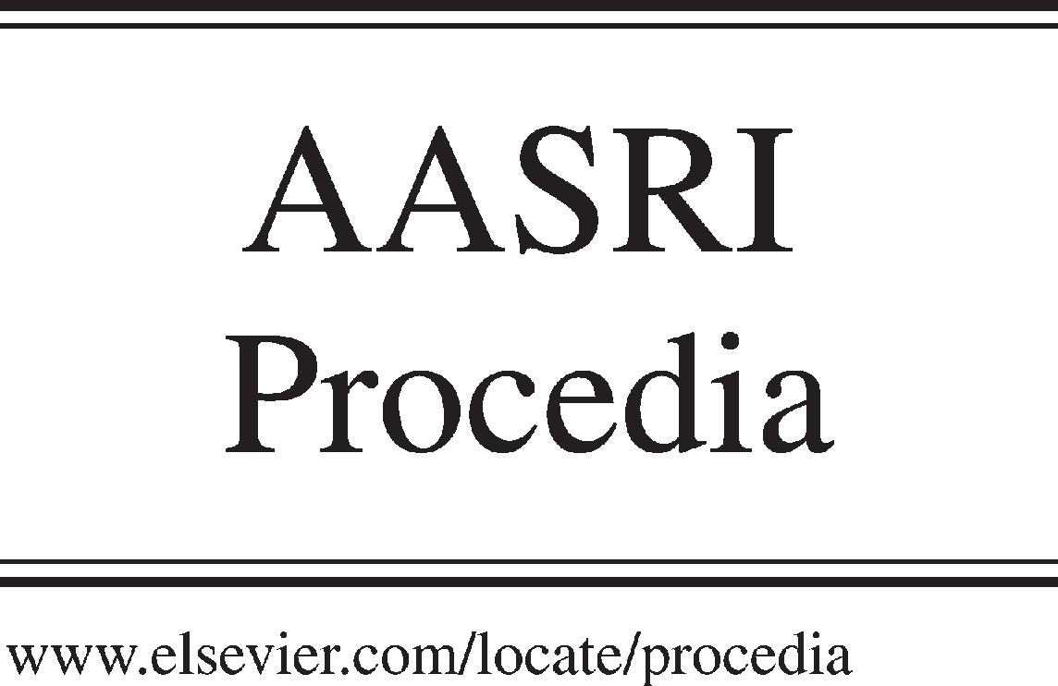Available online at [www.sciencedirect.com](http://www.sciencedirect.com/)



AASRI Procedia 3 (2012) 49 – 53

2012 AASRI Conference on Modeling, Identification and Control

Objective evaluation of engine mounting isolation

Fengyan Yi a*, Meizhi Xie b

a*College of Automotive Engineering* , *transportation Industry Key Laboratory ,Shandong Jiaotong University,5# Jiaoxiao Road,Jinan,250023,China*

*bCollege of Civil Engineering and Architecture Key Laboratory of Disaster Prevention and Structural Safety of the Ministry of Education,Guangxi University,100#Daxue Road, Nanning, 530004,China*

**Abstract**

To evaluate the vibration isolation, with an experimental study on the engine mounting system, vibration isolation performances between hydraulic and rubber mounting system are further analyzed the two mounting systems are objectively evaluated and the results are satisfying.

© 2012 The Authors. Published by Elsevier B.V. Open access under [CC BY-NC-ND license.](http://creativecommons.org/licenses/by-nc-nd/3.0/)

© 2012 Published by Elsevier B.V. Selection and/or peer rev[iew under responsi](http://creativecommons.org/licenses/by-nc-nd/3.0/)bility of American Applied Science Research Institute

Selection and/or peer review under responsibility of American Applied Science Research Institute

*Keywords*: Power train;Hydraulic mount;Vibration isolation;Evaluation

1. **Main text**

Objective evaluation refers to the adoption of instruments and equipment to measure the vibrations of the engine, and then proceed to the analysis and evaluation methods. A real vehicle test is researched on vibration isolation performance of the power train hydraulic suspension system of Transit vehicle.

To expect its test results have a positive effect on the development of the engine mount and damping optimization design of Power train mounting system, subsequently turn hydraulic suspension for the first two points of the power train mounting system also replace the rubber mount. Guarantee prior to its suspension layout and hydraulic suspension system maintain consistent, for acceleration time domain signal collection,

* Fengyan Yi. Tel.: 053180683168; fax:053180687234.

[*E-mail*.yi_fengyan@163.com](mailto:E-mail.yi_fengyan@163.com)

2212-6716 © 2012 The Authors. Published by Elsevier B.V. Open access under [CC BY-NC-ND license.](http://creativecommons.org/licenses/by-nc-nd/3.0/) Selection and/or peer review under responsibility of American Applied Science Research Institute doi:10.1016/j.aasri.2012.11.009

analysis and comparison Isolation effects of two sets of suspension. Finally, make an objective evaluation of their isolation effect.

# Test equipment

Car driving conditions are very complex, typical conditions include: startup, steady state, acceleration, braking and cornering conditions, which steady vibration of different engine speeds and vibration response of startup are research focus of Power train mounting system isolation. Here only vibration response under steady-state conditions is tested.

The Transit power train mounting system is a three-point support. The first two points are the hydraulic suspension and the rear point is rubber mount. Test equipment includes Power train mounting system, acceleration sensors, charge amplifier, and computer for record processing. Its test layout is shown as Fig.1[1].

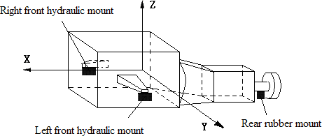

Fig. 1. Layout diagram of the power train mounting system in a real car

Figure 2 is a test structure flowchart of vibration response test. Power train assembly produces vibration during the test. In the flow process shown in Fig.2, acceleration sensors will transform vibrations into signals in the form of (time-domain signals), then by the charge amplifier mounting point vibration response of acceleration of time-domain signal up or down to enlarge, and then enterer into a computer, the computer saves through data acquisition software[2].

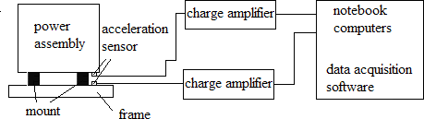

Fig. 2.Test schematic of response test of suspension points up and down vibration

When test, the Transit car parked on level ground and away from the vibration environment, the transmission linked to the neutral, change the engine speed and let it stabilize, collect the acceleration vibration response signal each suspension point up and down .

# The experimental results

By the above test procedure, the results are processed. The process object is acceleration of the time domain data acquisition, and then the acceleration rms values are get, which is shown in Table 1[3].

Table 1.Rms value of Suspension up and down points ( *m* / *s*2 )

|  |  |  |  |  |  |  |  |  |  |  |
| --- | --- | --- | --- | --- | --- | --- | --- | --- | --- | --- |
| speed n(rpm) | 765 | 900 | 1050 | 1200 | 1350 | 1500 | 2000 | 2500 | 3000 | 3500 |
| Left front up hydraulic  mount down | 8.29  0.74 | 8.91  0.81 | 10.1  0.96 | 11.9  1.1 | 14.72  1.23 | 13.88  1.26 | 17.11  1.74 | 35.99  3.43 | 43.6  5.86 | 49.2  6.92 |
| Right front up hydraulic  mount down | 6.87  0.77 | 6.99  0.98 | 8.25  1.66 | 9.35  1.64 | 9.73  1.42 | 9.42  1.58 | 14.15  2.79 | 22.5  3.21 | 36.3  5.13 | 41.6  5.83 |
| Rear rubber up | 7.64 | 7.06 | 8.86 | 10.33 | 11.58 | 12.15 | 15.36 | 19.19 | 31.2 | 36.04 |
| mount down | 0.62 | 0.54 | 0.78 | 0.89 | 1.19 | 1.25 | 1.25 | 2.54 | 6.34 | 7.86 |

In order to facilitate observation, the above data using Excel drawing, represented in picture forms are shown in Fig.3, Fig.4 and Fig.5.

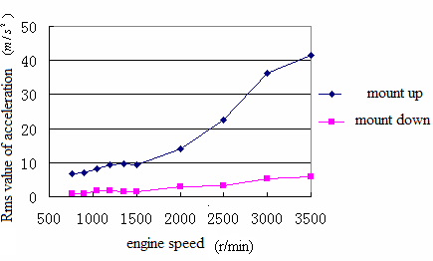

Fig. 3. The acceleration of right front hydraulic mounts up and down

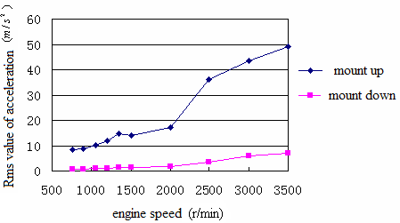

Fig. 4. The acceleration of left front hydraulic mounts up and down

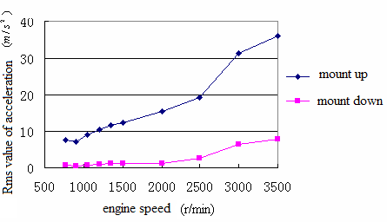

Fig. 5.The acceleration of rear front rubber mounts up and down

Next step, the two hydraulic mount the powertrain mounting system had been replaced by a rubber mount, to ensure that the hydraulic suspension system suspension layout consistent, this time measurement vibration acceleration on the right front rubber mounts, and comparative analysis with the right front hydraulic suspension at the acceleration curve of the upper and lower points in Fig.4, Fig.6 are available[4][5].

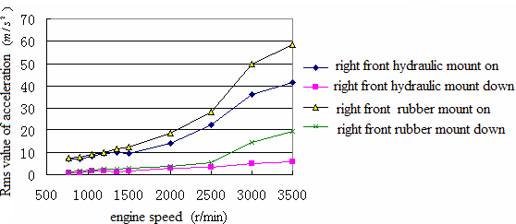

Fig. 6. The acceleration of right front hydraulic mount and right front rubber mount up and down

# Results analysis

Vibration acceleration curves from the suspension point of the system under steady state conditions of engine, it can be seen that, with increasing engine speed, the acceleration of point of each suspension increased significantly, especially in the high speed range of the engine in 2000(r/min) when the trend is obvious. The vibration acceleration of each suspension point, with the engine speed change is not obvious, and its increasing trend is relatively flat and within the measuring range, the vibration rms value is always maintained at the following eight, is not particularly large fluctuations. Left front hydraulic suspension at the vibration response is greater than the right front hydraulic suspension at the vibration response, which is due to the reason of the powertrain left of center of mass; hydraulic mount at the vibration level is greater than rubber mount at the level of vibration. This is because the powertrain system center of mass offset the former hydraulic mount to carry 80% of the mass of the powertrain.

Fig.6 can be compared on the right front hydraulic suspension and right front rubber mount under acceleration curve can be seen below in 2500(r/min), hydraulic mount with rubber mounts, vibration isolation effect difference is not obvious, and then increase as the engine speed, hydraulic mount's isolation effect was significantly superior to the rubber mount, but also due to the severe hardening of the rubber mount high- frequency stiffness, 3000(r/min)above its suspension point vibration intensified significantly, indicating that the hydraulic suspension system has more than rubber suspension system excellent high-frequency vibration isolation performance, and thus the two suspension vibration isolation performance make a satisfactory evaluation.

# Conclusions

The above results show that different conditions (steady state and startup), the power train hydraulic suspension system and rubber suspension system vibration response test to compare the hydraulic mount and rubber mount between the two separated vibration performance of the pros and cons, and start the conditions vibration response spectrum analysis, in-depth study of the vibration isolation performance of the Transit powertrain mounting system. Experiments show that compared with the rubber mounting system, the isolation effect of the hydraulic mount systems has obvious advantages. To meet the comfort of the vehicle on the isolation, it is clear that isolation is better.

# Acknowledgements

The project is supported by Scientific Research Funds of Shandong Jiao Tong University  NO: Z201230  .The authors are grateful to the Shandong Jiao tong university for their financial support of this work.

# References

1. Song Caili.Study on vibration isolation of powertrain mount system[J].Zhenjiang  Jiangsu University.2009
2. Li Hui. The study of hydraulic mounting system features on jiangling quanshun minibuses.Changchun:Jilin University,2002



[3]

[4]

790974

[5] 