Available online at [www.sciencedirect.com](http://www.sciencedirect.com/)



AASRI Procedia 1 (2012) 435 – 440

AASRI

Procedia

[www.elsevier.com/locate/procedia](http://www.elsevier.com/locate/procedia)

2012 AASRI Conference on Computational Intelligence and Bioinformatics

# Obstacle Detection and Classification in Dynamical Background

Lizhuang Liu a,b, Jianzhu Cuib, Jing Lic *

*aSchool of Communication and Information Engineering,Shanghai University, no.99 Shangda Road, Shanghai 200444 ,China bShanghai Advanced Research Institute, Chinese Academy of Sciences, No.99 Haike Road, Shanghai, 201203,China cCollege of Information Technology, Shanghai Ocean University, No.999 huhuanchen Road, Shanghai 201303, China*

**Abstract**

In this work, a new obstacle detection and classification technique in dynamical background is proposed. Obstacle detection is based on inverse perspective mapping and homography. Obstacle classification is based on fuzzy neural network. The estimation of the vanishing point relies on feature extraction strategy. The method exploits the geometrical relations between the elements in the scene so that obstacle can be detected. The estimated homography of the road plane between successive images is used for image alignment. A new fuzzy decision fusion method with fuzzy attribution for obstacle detection and classification application is described.The fuzzy decision function modifies parameters with auto- adapted algorithm to get better classification probability. It is shown that the method can achieve better classification result.

2012 Published by Elsevier B.V. Selection and/or peer review under responsibility of American Applied Science Research Institute Open access under [CC BY-NC-ND license.](http://creativecommons.org/licenses/by-nc-nd/3.0/)

*Keywords:* object detection; image alignment; fuzzy neural network

## Introduction

One of the major challenges of the next generation of road transportation vehicles is to increase the safety of the passengers. A precrash system is an automobile safety system designed to reduce the severity of an

* Corresponding author. Tel.: +86 021 20350822; fax: +86 021 20350822. E-mail address: *liulz@sari.ac.cn,cuijianlou@163.com,*[*j_li@shou.edu.cn*](mailto:j_li@shou.edu.cn)

.

2212-6716 © 2012 Published by Elsevier Ltd. Open access under [CC BY-NC-ND license.](http://creativecommons.org/licenses/by-nc-nd/3.0/)

doi:10.1016/j.aasri.2012.06.068

accident. Also known as forward collision warning systems they use radar and sometimes laser sensors to detect an imminent crash. Depending on the system they may warn the driver, precharge the brakes, inflate seats for extra support, move the passenger seat, position head rests to avoid whip lash, tension seat belts and automatically apply partial or full braking to minimize impact. In 2009 the U.S. National Highway Traffic Safety Administration (NHTSA) began studying whether to make frontal collision warning systems and lane departure warning systems mandatory[1]. In 2011 a question has been submitted to the European Commission regarding stimulation of these "collision mitigation by braking" systems [2]. The mandatory fitting of advanced emergency braking systems in commercial vehicles will be implemented on 1 November 2013 for new vehicle types and on 1 November 2015 for all new vehicles in the European Union [3].

Some vehicles are already fitted with systems which employ sensors to monitor the proximity of the vehicle in front and detect situations where the relative speed and distance between the two vehicles suggest that a collision is imminent. In such a situation, emergency braking can be automatically applied and the effects of the collision are either mitigated or avoided altogether. The capability of such systems could be expanded in the future to cover other types of accident (for example, pedestrian accidents or even head-on collisions). Preliminary studies suggest that such systems could ultimately save around 5000 fatalities and 50,000 serious injuries per year across the EU. It is likely that due to the technical challenges involved, these systems will only be ready for installation on the whole range of new vehicles in a few years time. However, it is already possible to provide estimates of the likely costs and benefits of such systems.

A supplement to the LDW system is the lane change assistant (LCA) system. This assists drivers intending to change lanes. The lane change assistant monitors the adjacent lanes and warns the driver if another vehicle is likely to come within colliding distance during the lane change. This occurs for example, if the other vehicle is located in the LCA equipped vehicle's blind spot. Presently the system would warn the driver of such a problem with e.g. a red flashing side mirror. Later on, a system with feedback in the steering wheel could be introduced. The lane change assistant needs predictive sensors to scan the surrounding vehicles. The sensors might possibly be integrated with the sensors used on a AEBS system.

The full version of the system (Pre-Sense Plus) works in four phases. In the first phase, the system provides warning of impending accident, while the hazard warning lights are activated, the side windows and sunroof are closed and the front seat belts are tensioned. In the second phase, the warning is followed by light braking, strong enough to win the driver's attention. The third phase initiates autonomous partial braking at a rate of 3 m/s². The fourth phase decelerates the car at 5 m/s² followed by automatic deceleration at full braking power, roughly half a second before projected impact. A second system called (Pre-Sense Rear) is designed to reduce consequences of rear end collisions. Sunroof and windows are closed, seat belts prepared for impact. The optional memory seats are moved forward to protect the car occupants. The system uses radar and video sensors[5] and was introduced in 2010 on the 2011 Audi A8.[6] Ford's Collision Warning with Brake Support was introduced in 2009 on the Lincoln MKS and MKT and the Ford Taurus.[4] This system provides a warning through a Head Up Display that visually resembles brake lamps. If the driver does not react, the system pre-charges the brakes and increases the brake assist sensitivity to maximize driver braking performance. Nissan's luxury brand in North America and Europe, Infiniti, offers a laser-based system in the US market, which pre-pressurizes the braking system so maximum force can be applied early. Nissan is reportedly developing a new "magic bumper" system which raises the accelerator pedal if it senses an impending collision. Once the driver lifts off the pedal, the system then automatically applies the brakes.[12] Front Assist on the 2011 Volkswagen Touareg can brake to a stop in case of an emergency and tension the seatbelts as a precautionary measure.[13] Volvo's Collision Warning with Auto Brake (CWAB)[7] developed in cooperation with Mobileye N.V. was introduced on the 2007 Volvo S80. This system is powered by a radar/camera fusion and provides a warning through a Head Up Display that visually resembles brake lamps.

If the driver does not react, the system pre-charges the brakes and increases the brake assist sensitivity to maximize driver braking performance.

Lots of sensors mounted on the vehicle could provide a practical solution to this problem. However, the prices of the traditional systems and their limited performance have prevented such systems from entering the market. In this context, solutions based on video processing have played an important role for the last decade. Obstacle detection becomes the main focus in most Forward Collision Warning (FCW) systems.

## System overview

The complete system overview is shown in Fig 1. The input to the system is a sequence of images captured by the camera installed inside the vehicle. A video camera has been used to acquire the video sequences. The input interface records the images delivered by the camera, and performs the necessary operations to accommodate them to the format expected by the video processing module, i.e., decompresses the image, and rescales it to a 760x320 format.

The system is composed of two blocks, as shown in Fig.1. The contribution of this paper is: we propose a novel obstacle detection and classification system. Obstacle detection is based on inverse perspective mapping and homography. Obstacle classification is based on fuzzy neural network. The rest of the paper is organized as follows: Section 2 gives a brief description of obstacle detection and classification system. Then in Section 3, we describe the algorithm in detail. Section 4 is experiment.

## Obstacle detection and classification







Fig.1. Obstacle classification based on fuzzy neural network

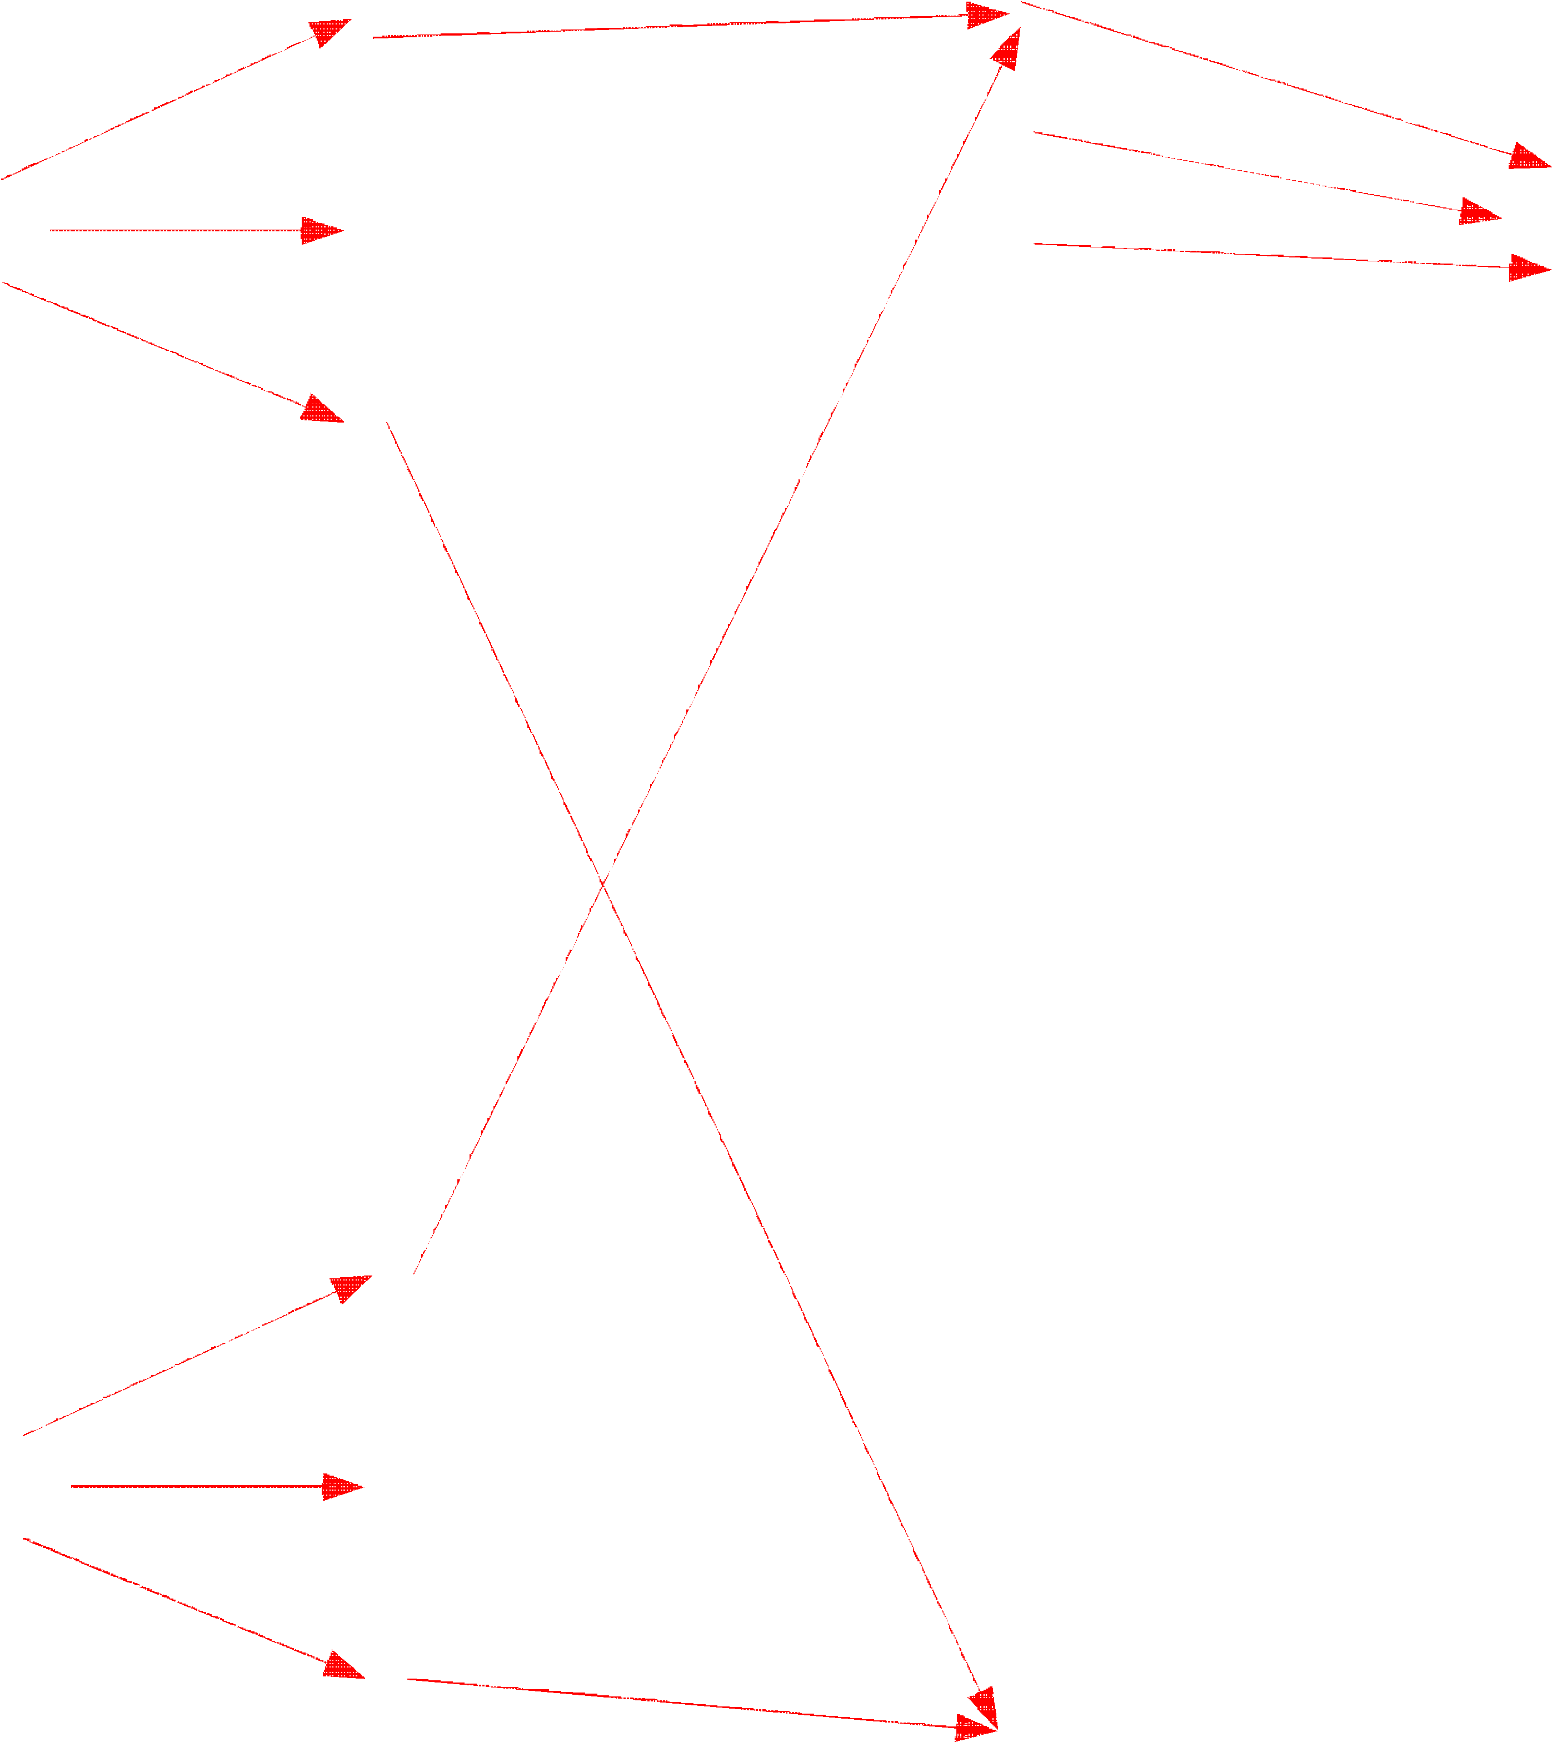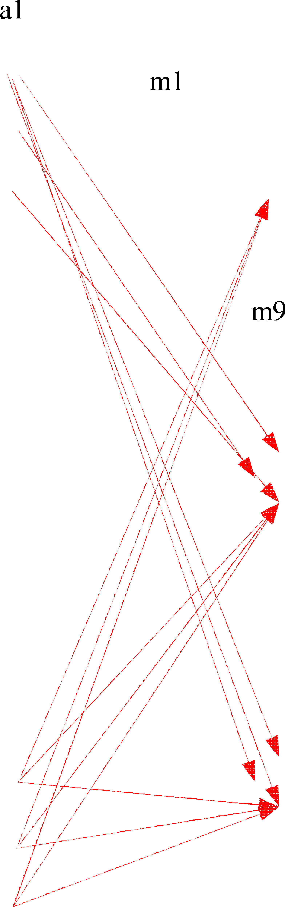

A new Inverse Perspective Mapping (IPM) technique is proposed based on a robust estimation of the vanishing point, which provides bird-view images of the road, so that facilitating the tasks of road modelling and obstacle detection and tracking. This new approach has been design to cope with the instability that cameras mounted on a moving obstacle suffer. The estimation of the vanishing point relies on a novel and efficient feature extraction strategy, which segment the lane markings of the images by combining a histogram-based segmentation with temporal and frequency filtering. Then, the vanishing point of each image is stabilized by means of a temporal filtering along the estimates of previous images. In a last step, the IPM

image is computed based on the stabilized vanishing point. Tests have been carried out on several long video sequences captured from cameras inside an obstacle being driven along highways and local roads, with different illumination and weather conditions, presence of shadows, occluding obstacles, and slope changes. Results have shown a significant improvement in terms of lane width constancy and parallelism between lane markings over non-stabilized IPM algorithms.

⬆*u*

⬇ 

⬆ *X* 

⬇*Y* 

(1)

⬇*v*  ~ *KR* ⬆*I*3 | *C* ✗ ⬇ 

⬇1 ✗

⬇*Z* 

⬇ 

1 ✗

Once the pitch and yaw angle values are obtained from the estimation of the vanishing point, we can build stabilized IPM images by computing the transform matrix. This matrix describes how points of the real world X = (X, Y, Z) are projected into points in the image, with coordinates, in pixels, u = (u, v). Three different coordinate systems will be considered: i) the world coordinate system, assumed to be on the road, ii) the camera coordinate system, and iii) the image coordinate system. A point in the real world, for instance belonging to the road plane, may be expressed as X with respect to the world coordinate system, or x = (x, y, z) with respect to the camera coordinate system. The transform that links these expressions is shown in equation

(1),where R is the rotation matrix. This latter matrix is denominated K, or the camera calibration matrix. The transform between image points and world coordinates is immediately obtained by multiplying the expressions in below, where I3 is the 3×3 identity matrix.

This paper presents a full system for obstacle detection and classification in non-stationary settings based on computer vision. The method proposed for obstacle detection exploits the geometrical relations between the elements in the scene so that obstacles can be detected by analyzing motion parallax. Namely, the homography of the road plane between successive images is computed. The estimated homography is used for image alignment, which in turn allows to detect the obstacles in the image.

 *x* ' 

 *h h h*

  *x* 

 1 

1 1 1 2 1 3 1 

 *x* '  



 

 *h h h*

  *x* 

2 2 1 2 2 2 3 2

   

(2)

 *x* ' 

 *h* 3 1 *h* 3 2 *h* 3 3   *x* 

3 3

X'  *HX*

Xk  *HX k* 1

(3)

(4)

A fuzzy decision fusion method with fuzzy attribution for obstacle detection and classification application is proposed.The fuzzy decision function modifies parameters with auto-adapted algorithm to get better classification probability. It is shown that the method can achieve better classification result.

A new information fusion decision method about fusing two signal based on fuzzy neural network was proposed in this paper.Fuzziness is one of the general characteristics of human thinking and objective things. Fuzzy logic is a form of many-valued logic or probabilistic logic; it deals with reasoning that is approximate rather than fixed and exact. In contrast with traditional logic theory, where binary sets havetwo- valued logic: true or false, fuzzy logic variables may have a truth value that ranges in degree between 0 and 1. Fuzzy logic has been extended to handle the concept of partial truth, where the truth value may range between completely true and completely false.[11] Furthermore, when linguistic variables are used, these degrees may

be managed by specific functions. Fuzzy logic began with the 1965 proposal of fuzzy set theory by Lotfi Zadeh.[8][9] Fuzzy logic has been applied to many fields, from control theory to artificial intelligence. The reasoning in fuzzy logic is similar to human reasoning. It allows for approximate values and inferences as well as incomplete or ambiguous data (fuzzy data) as opposed to only relying on crisp data (binary yes/no choices). Fuzzy logic is able to process incomplete data and provide approximate solutions to problems other methods find difficult to solve. Terminology used in fuzzy logic not used in other methods are: very high, increasing, somewhat decreased, reasonable and very low.[10] An artificial neural network (ANN), usually called neural network (NN), is a mathematical model or computational model that is inspired by the structure and/or functional aspects of biological neural networks. A neural network consists of an interconnected group of artificial neurons, and it processes information using a connectionist approach to computation. In most cases an ANN is an adaptive system that changes its structure based on external or internal information that flows through the network during the learning phase. Modern neural networks are non-linear statistical data modeling tools. They are usually used to model complex relationships between inputs and outputs or to find patterns in data.

The decision function of the fuzzy neural network is :

9

*S*  *mi* * *ai* 

*i*1

(5)

## Experiment

Fig 2 show our algorithm can work in complex environment. Tests have been made on images belonging to video sequences captured from cameras inside a car being driven along different types of road, including highways and local roads. The proposed strategy has been efficiently implemented in a general purpose PC, working in real time for different frame rates according to the size of the images: 15 fps. Overall, an average detection rate of above 92% is obtained for a set of scenarios, including different illumination, weather and traffic conditions.

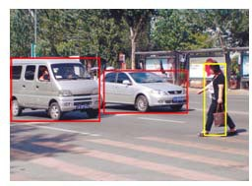

Fig 2 detection result

## References

[1]E. Dagan, O. Mano, G.P. Stein and A. Shashua, “Forward Collision Warning with a Single Camera” IEEE Intelligent vehicles Symposium (IV2004) June 2004, Parma, Italy,p201-205

1. Yong Zhou,Rong Xu,Xiaofeng Hu,Qingtai Ye.A robust lane detection and tracking method based on computer vision. Measurement Science and Technology. 2006,21 (17): p736-745.
2. Y. Wang, E. K. Teoh, D. Shen. Lane detection and tracking using B-snake. Image Vision Compute., 2004,22(1): p269–280.
3. J. C. McCall, M. M. Trivedi. An integrated, robust approach to lane marking detection and lane tracking. In Proceedings of IEEE Intelligent vehicles, Parma, Italy, 2004: 533–537.
4. N. Matthews, P. An, D. Charnley, and C. Harris, “vehicle detection and recognition in greyscale imagery,” Control Engineering Practice, vol. 4, p473–479, 1996.
5. Bo Wu, Nevatia R. Detection of multiple, partially occluded humans in a single image by Bayesian combination of edgelet part detectors[C]. In: Proceedings of IEEE International Conference on Computer Vision, 2005, 1:p90-97.
6. Masoud O, Papanikolopoulos N. A novel method for tracking and counting pedestrians in real-time using a single camera[J]. IEEE Transactions on Vehicular Technology, 2001, 50(5): p1267-1278.
7. <http://www.mobileye.info/en/index.html>
8. C. Goerick, N. Detlev and M.Werner, “Artificial neural networks in real-time vehicle detection and tracking applications,” Pattern Recognition Letters, vol. 17, p335–343, 1996.
9. Z. Sun, R. Miller, G. Bebis and D. Dimeo, “A real-time precrash vehicle detection,” IEEE Intelligent vehicles Symposium 2000. Dearborn, MI, USA.p35–43.

[11]S. Baker and I. Matthews. Lucas-Kanade 20 years on: A unifying framework: Part 1: The quantity approximated, the warp update rule, and the gradient descent approximation. International Journal of Computer Vision, 2003, p38–45.

1. Bertsekas, D.P., Tsitsiklis, J.N. (1996). Neuro-dynamic programming. Athena Scientific.

pp. 512. ISBN 1-886529-10-8

1. DANN:Genetic Wavelets. dANN project. Retrieved 12 July 2010