

Saudi Computer Society, King Saud University

Applied Computing and Informatics

([http://computer.org.sa)](http://computer.org.sa/) [www.ksu.edu.sa](http://www.ksu.edu.sa/) [www.sciencedirect.com](http://www.sciencedirect.com/science/journal/22108327)

ORIGINAL ARTICLE

Online integrity and authentication checking for Quran electronic versions



Izzat Alsmadi a,*, Mohammad Zarour b

a *Computer Information Systems Department, Yarmouk University, Jordan*

b *Prince Sultan University, Saudi Arabia*

Received 24 April 2015; revised 18 July 2015; accepted 10 August 2015

Available online 14 August 2015

Abstract The ability to control data and information through the Internet can be challenging. Pre- liminary analysis showed that some tampering and forgery may occur to some words of the Quran in the electronic versions that span the Internet. Such small modifications may not be noticed by public audience. The holy book of Quran includes a unique feature in that its worldwide copies are all identical. The 114 chapters (Suras) and all their verses and words are preserved in the exact form. As such, we designed and evaluated a model and a tool to evaluate the integrity of the word- ing in the e-versions of the Quran through generating a Meta data related to all words in the Quran preserving the counts and locations. Such Meta data can be used in the same way hash algorithms are used in security to check the integrity of a disk and its data files where any small change in the data will result in a different hash value. We conducted several experiments to evaluate the different parameters and challenges that can impact the automatic authentication process of Quranic verses based on information retrieval and hashing algorithms.

© 2015 The Authors. Production and hosting by Elsevier B.V. on behalf of King Saud University. This is

KEYWORDS

Information retrieval; Security;

Search engines;

Documents’ automatic eval- uation;

Hashing algorithms; Information authentication

an open access article under the CC BY-NC-ND license (<http://creativecommons.org/licenses/by-nc-nd/4.0/>).

1. Introduction

With the huge amount of information uploaded by users all over the world, internet is the central library that all humans in the world are using to exchange information. However, one of the major problems with the current web is that there

* Corresponding author.

E-mail addresses: [ialsmadi@yu.edu.jo](mailto:ialsmadi@yu.edu.jo) (I. Alsmadi), [mzarour@psu.](mailto:mzarour@psu.edu.sa) [edu.sa](mailto:mzarour@psu.edu.sa) (M. Zarour).

Peer review under responsibility of King Saud University.

**Production and hosting by Elsevier**

is no control on the type, nature or details of information uploaded to the web by any user. Accordingly, credibility and accuracy are the foremost concerns when reading informa- tion from the web. Credibility can be linked to the website, hosting the information, author of uploaded data and the type of data or information itself. For example, in social networks or even news websites the same story can be told in exactly opposite versions given by two different websites or authors.

Authenticity and integrity of online documents is increas- ingly getting crucial as many organizations put their docu- ments online. Providing facilities that allow both documents’ owners and viewers to be able to ensure that their documents are authentic and not tampered is extremely important. Currently two major techniques or approaches are used to authenticate documents, or users online: Document control

<http://dx.doi.org/10.1016/j.aci.2015.08.001>

2210-8327 © 2015 The Authors. Production and hosting by Elsevier B.V. on behalf of King Saud University. This is an open access article under the CC BY-NC-ND license (<http://creativecommons.org/licenses/by-nc-nd/4.0/>).

and digital signatures. Document control is related to permis- sions before and after publishing the document online. Docu- ment control then is needed to be dynamically applied in a manner that document can be tracked even after publishing it online. Integrity is about making sure that the document is not altered by any unauthorized person and hence is authenti- cated. In digital signatures, signed documents should be veri- fied by the people who signed it (i.e. non-repudiation).

Nowadays, many multilingual copies of the holy Quran are available online. The holy Quran is originally written in Arabic language. The exact wording and statements in Quran verses are identical for all Arabic versions of the Quran.1 However, one problem with translation is that it may change, intention- ally or unintentionally the meaning of some verses when trans- lated to another language. This is a general problem when dealing with translation. On the other hand, for the same lan- guage, it is possible that the same verse be written in different words due to intentional fraud or due to language translation issues.

Due to the sensitivity and the nature of Quran verses there is a vital need to continuously monitor Quran verses and chap- ters written through the Internet websites and pages to make sure that they are authenticated and not changed or fraud.

Hashing algorithms or checksums are used to verify the integrity of data in files, disks and databases. The hashing algorithms or tools take file or data as inputs and generate a unique decimal or hexadecimal number in a way where any small change that may occur to the data in the file will cause the hashing algorithm to produce a new random number that is different from the previous number that was generated before the modification. The Holy Quran is reserved and inte- grated in all its chapters and verses word by word and letter by letter. Hence using hashing algorithms to check automatically and frequently whether there is any possible modification can be an effective tool to authenticate Quran electronic versions either for the whole Quran version or in parts: chapters or verses. Accordingly, Hashing can be generated for the whole Quran as one unit, chapter by chapter or even verse by verse. Fig. 1 below shows an example for hashing codes using the verse:

Removing one letter from the verse may cause all hash val- ues to be changed to totally new values.

As shown in Fig. 1, different hashing algorithms generate different hashing values for the same verse. Moreover, hashing algorithms do not differentiate between small and large modi- fication. Any tiny modification will change the hash codes just like a large modification.

The identity and integrity of the data must be periodically and systematically verified through mechanisms such as Secure Hash Standard (SHS) and Secure Hash Algorithm (SHA) [1]. Quran verses can be considered plagiarized or unauthenticated even for one letter change. Hence, hash algorithms are good option as such algorithms are very sensitive even for a very small change in data or documents.

In this paper, an online integrity and authentication system for the Quran is proposed. The goal of such system is to con- tinuously traverse and search information and web pages

1 Although different readings have few literal changes, those can impact the integrity checking process and hence we either use one reading or have different integrity datasets for the different readings. Experiments in this papers use ‘‘Hafs” reading.

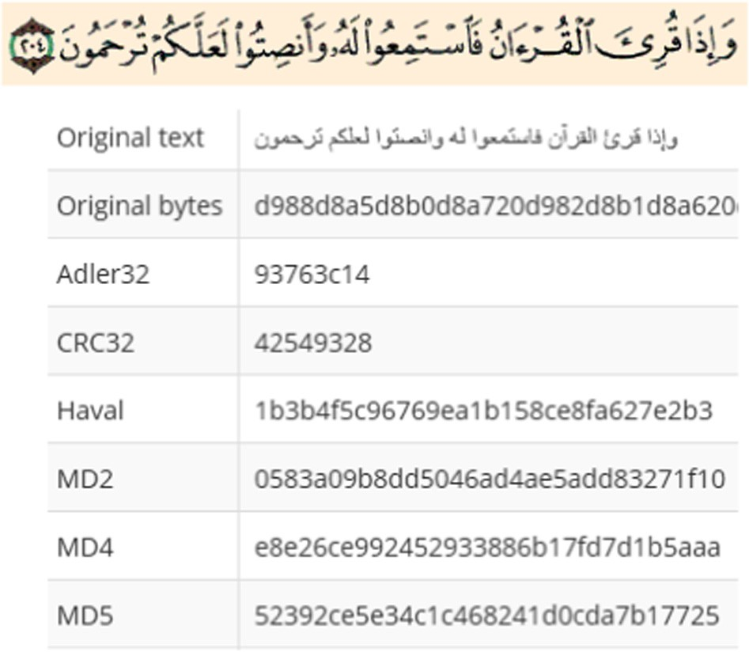

Figure 1 A sample of Quran verses hashing.

throughout the Internet for any possible intentional and unin- tentional Quran verses fraud or change.

It should be mentioned that in this research we are not focusing on encryption but rather integrity checking. The prob- lem is that in our scenario for Quranic documents online, the relation between information providers and readers is not a typical e-commerce one-to-one relation in which typical hash or encryption algorithms can be sent to the known receiver or customer. Accordingly, private keys intended for a particular receiver will not be applicable in our scenario where the tool is expected to check quickly through the Internet that Quranic documents are authentic and do not contain tampering.

The rest of the paper is organized as follows: Section 2 dis- cusses the related work to this research field followed by a dis- cussion of the adopted methodology in Section 3. Section 4 discusses the developed authentication system, while the exper- iments are presented and discussed in Section 5. Section 6 pre- sents the conclusion and future work.

* 1. *Tashkeel, Harakat, or Diacritic marks*

A unique aspect in Arabic is the addition of Diacritic marks or Tashkeel symbols (small ﻭ, small ﺃ, small ﻱ, Tanween: , stress or shaddah). Those are added to letters to give different meanings or ways of spelling letters. They may cause problems to indexing and querying of data in cases whether those Diacritics are added or ignored. We will present few of the proposed solutions to handle Tashkeel in Arabic.

Papers that tried to detect Diacritics proposed morpholog- ical rules to do that. Known patterns and an initial training set are used to match subject word for one of the morphological rules. Hidden Markov Model (HMM) is used where the hid- den states are the possible diacritized selections of the words. In Arabic text, Diacritic marks can be challenging whether they exist or not in the Arabic text. If they exist, the challenge will be to read or parse them correctly especially as they need extra resources in addition to typical letters parsing in all other languages. On the other hand, Diacritic marks are necessary to Arabic words to clarify words and statements from ambiguity.

the characters to verify the fundamental text against the orig- inal Unicode text of the Quran in order to authenticate the fundamental text of the Quranic quotation, and then the posi- tion of diacritics and Tashkeel are verified. A similar study that used unicode centric string matching approach is presented in [8].



|  |  |  |
| --- | --- | --- |
|  | **Selection step:**  Identify and select an authenticated copy of |  |
| **Authentication System Development:**  Choose a hashing algorithm  Code the authenticated Quran copy (with Tashkeel and without Tashkeel versions) using the selected hashing algorithm  Develop similarity check algorithm to retrieve verse that match the verse in question  Develop a searching tool that surfs the web to identify websites that are citing authenticated  /unauthenticated Quran verses. | | |

Figure 2 Research methodology.

Letters in Arabic have different forms based on their loca- tion, accordingly, indexer needs to understand that: (ﺁ,ﺃ ,ﺇ) are all forms of the same letter. Fig. 2 shows a sample of a Sphinx table of Unicode character set that can be used as part of an indexer to guide the indexer for letters of different forms. The goal here is to acknowledge that many Arabic letters have different forms and hence a Unicode character table needs to have equivalent forms of similar letters. As mentioned earlier such issues are solved technically once the right encoding scheme is used.

1. Related work

While the subject of data or information integrity is not new, few research papers are published in the area of web docu- ments integrity verification. This is particularly true if we want to exclude papers discussing encryption approaches.

The removal of online documents’ replication is discussed in [2]. In many cases, the exact document is published in more than one website. This may not be related to plagiarism but to copies replication. This is actually quite common in the Inter- net world. The work presented in [2] used hashing comparison to discover and remove possible replication in web documents. The aim was to improve indexer optimization where one copy of the document will be stored if many documents have the exact same hash value.

The digital Quran verification and authentication is very rare; an algorithm to verify the fundamental text for Quranic quotes is presented in [3]. In order to generate a standard form of Quran verses, the algorithm is stemming some of the special Arabic characters [3] that may make the comparison process difficult. This includes Harakat or Tashkeel that can change the letters’ spelling and the different shapes for some letters as well. While removing such symbols can facilitate the infor- mation retrieval processes, they may cause false alarms where some plagiarism may only occur in those parts which will then be missed or not detected. The work in [3] did not specify any limit or range to consider verses as not authenticated. It used Information retrieval and language processing methods with no utilization of security such as hashing methods.

A system to verify the authenticity of Quranic verses based on Unicode comparison is presented in [4]. The algorithm adopted in this system uses the Unicode representation of

Sbbah and Selamat [9] have developed a framework for Quranic verses authenticity detection in online forum. They used a numerical approach to detect Quran quotes. The numerical approach calculates the diacritical ratio (DR) of each word in the text. Their authentication system depends on defining the weights of Quranic letters and diacritics and calculate the identifiers of distinctive Quranic words.

Yusoff et al. [5] discussed authentication in Hadeeth and used the historical traditional methods used to authenticate Hadeeths in current digital evidence authentication. Writers and collectors of Hadeeths used to follow the sequence or chain of Hadeeths authors and check their authenticity one by one. A deficiency in one member of the chain may weaken the whole chain and the Hadeeth itself.

In order to protect the digital Quran from any distortion or tampering, the work presented in [6] used the meta-codification where an ‘‘atomization structure” and Unicode codification is used on the Quran in terms of the number of verses in each chapter, the number of characters in each verse and so on.

Other research works as in [7] discussed the usage of digital signatures to authenticate information or documents through the web. This can work in e-commerce applications and emails where the typical two ways of communication exists between either sender and receiver or client–server. However, in our case, such architecture does exist and hence such methods can- not be used to check whether the information or the document was tampered or not. In Quran verses verification system, an authenticated copy of content is preserved and web content is surveyed for possible – different copies. It is also important to distinguish some changes related to Tashkeel, fonts, etc. that should not be classified as tampering. In particular we mean that some versions of the Quran include Tashkeel or Dialects and others do not. Hence comparison should take this into consideration.

In another but related domain, speech recognition tech- niques are used to verify Quran recitation as we started seeing many recitation applications which require new techniques to verify the validity of the recitation, see for example [10–12].

In our case, the goal is to use information retrieval tech- niques to look for documents that include unauthenticated Quranic verses. Authentication algorithms are then required to check whether these millions of documents online have the same – literally authenticated versions of the Quran. Of course such algorithms have two possibly contradictory requirements: performance and accuracy. Algorithms should be able to search through the Internet for possible frauds with a high accuracy and quick speed. False alarms may also arise due to issues such as different readings of the Quran where some specific letters or words are different from one reading to another.

1. Methodology

The aim of this research work is to build an authentication sys- tem that can verify any possible ‘‘change” or ‘‘modification” of

Quran verses. Since Quran verses are literally identical, we developed an authentication system that will index verses one by one in its indexer and will frequently search any possi- ble – mutation in the verses. The authentication system will be able to frequently search the Internet for web pages that may include such fraud verses and index them for monitoring, alert, logging and verification.

Similar to the concept of kids safe search that some search engines used to limit or focus kids search on kids related web- sites and eliminate websites that may present or contain harm- ful content to kids, our proposed system should be able to retrieve results for only authenticated versions of Quran verses. Our research methodology consists of three main steps (see

Fig. 2):

1. Selecting a hashing algorithm: MD5 hashing algorithm has been chosen as it is a common and reliable one (see section experiments and discussions).
2. Developing of the authentication system: the authentica- tion system has been developed using C# programming lan- guage, ASP.NET. This can be classified as a customized information retrieval or crawling system.

The details of developing the authentication system are dis- cussed in more detail in Section 4. The goal of this research is to design a search engine or authentication system that is able to retrieve results based on a search query. A customized Quran search engine or information retrieval system should focus on parsing and indexing Quran verses from all over the web. For proposed program search user interface and queries will then represent verses or part of verses.

The proposed Quranic search engine website allows the search through the whole internet and retrieves links where the searched verses are located. The focus in this paper is to propose and design a system that can search for and index cor- rect and incorrect versions of Quranic verses that may exist throughout the Internet.

The algorithm to develop the authentication system is shown in Fig. 3. The authentication system will start by check- ing whether the verse is written with Harakat and Tashkeel or not to decide which version of the Quran to search. Then the algorithm will look for the verses that are similar to the verse in question; some verses or part of them can be replicated in the Quran. The verses that have perfect match (similar- ity = 100%) or verses that are partially match (similar- ity P 70%) are selected to authenticate the verse in question. Then, the hash code for the verse in question is generated and compared to the selected verses. If the hash code of one or more verses is identical to the hash code of the verse in ques- tion then the verse is authenticated, otherwise the verse is tampered.

1. Read Quran Verse (QVsi)
2. QVsi has Tashkeel (Yes or No)
3. Similar verses to QVsi exist? (Yes or No)
4. Generate hash code; HiQVsi of QVsi.
5. Compare HiQVsi with original hash code HoQVsi.
6. If HiQVsi equals HiQVsi, authenticate QVsi.
   * Else, the verse QVsi is unauthenticated

Figure 3 Quran verse authentication algorithm.

1. Quran authentication system development

We have conducted an experiment to evaluate the top websites that are used to search for Quranic verses. This is based on the popular search engine Google. We built a customized crawler to search through Google for Quran verses one by one from the first to the last verse. For each verse, we collected informa- tion related to the approximate number of index pages in Goo- gle for the verse. This represents the approximate number for web or Internet links that include the queried verse. The devel- oped crawler uses Quran verses as search queries. Results are retrieved from embedded information in search web pages. Meta data related to the retrieved web pages are collected and saved in a dataset. Google ranks retrieved results based on its popularity page rank algorithm.

Fig. 4 shows a small sample of the collected data. We col- lected the first 10 links that are retrieved from Google search which indicate the most visited websites for the specific verse. The number of indexed pages in Google is approximate, see Fig. 5, where this can be a direct indicator of the verse popu- larity. Quranic digitally published verses can be indexed as part of the whole Quran in some websites that include the whole Quran chapters and verses. In some other cases, some chapters or verses of the Quran may be indexed or included in some

pages as part of non-Quranic text.

In order to deal with the verses having Harakat and Tash- keel, we have considered two versions of the Quran: one that considers Harakat or Tashkeel and one that does not. Quran indexed in the web can be with or without Tashkeel. In many cases, search engines and their queries can be sensitive to these symbols that are unique in Arabic language; hence a search for verse that does not include Tashkeel in the query may not retrieve results for verses that include Tashkeel symbols.

While there are some authentic websites such as [www.is-](http://www.islamweb.net/) [lamweb.net](http://www.islamweb.net/), [www.alro7.net](http://www.alro7.net/), [www.alhawali.com](http://www.alhawali.com/), many of the popular websites in the first search page or the top 10 pages are either from non-Islamic resources, or from some websites that do not represent the main stream of Islam and that may include inaccurate information, content or interpretation of these verses. We consider that the Internet is now the main source for searching for Quran verses and their interpretation not only for Muslims, but also for non-Muslims. Popular social network websites such as Facebook and YouTube are listed frequently as sources for Quranic verses. It is not clear however why Google is presenting them in the top 10 retrieved results. It is possibly that such high rank is not based on the popularity of the specific Facebook personal page or the speci- fic YouTube video, but rather based on the popularity of the mother website (i.e. YouTube or Facebook).

Fig. 5 shows top 20 verses based on Google indexed pages that are popular. This is accomplished after indexing almost the first half of the Quran. Fig. 5 shows that the number of Quran indexed verses may vary from one verse to another and from one chapter to another. The first most popular verse of the Quran is AlBasmalah (ﺍﻟﺮﺣﻴﻢ ﺍﻟﺮﺣﻤﻦ ﺍﻟﻠﻪ ﺑﺴﻢ). In fact this verse can be used in many contexts not necessary part of citing Quranic verses. People may use it to start a book, a chapter or a process. The verses in the first chapter are also popular for almost the same reasons. Some short verses can get a large number of indexed links as such short verse may be used in non-Quranic contexts (see Fig. 6).

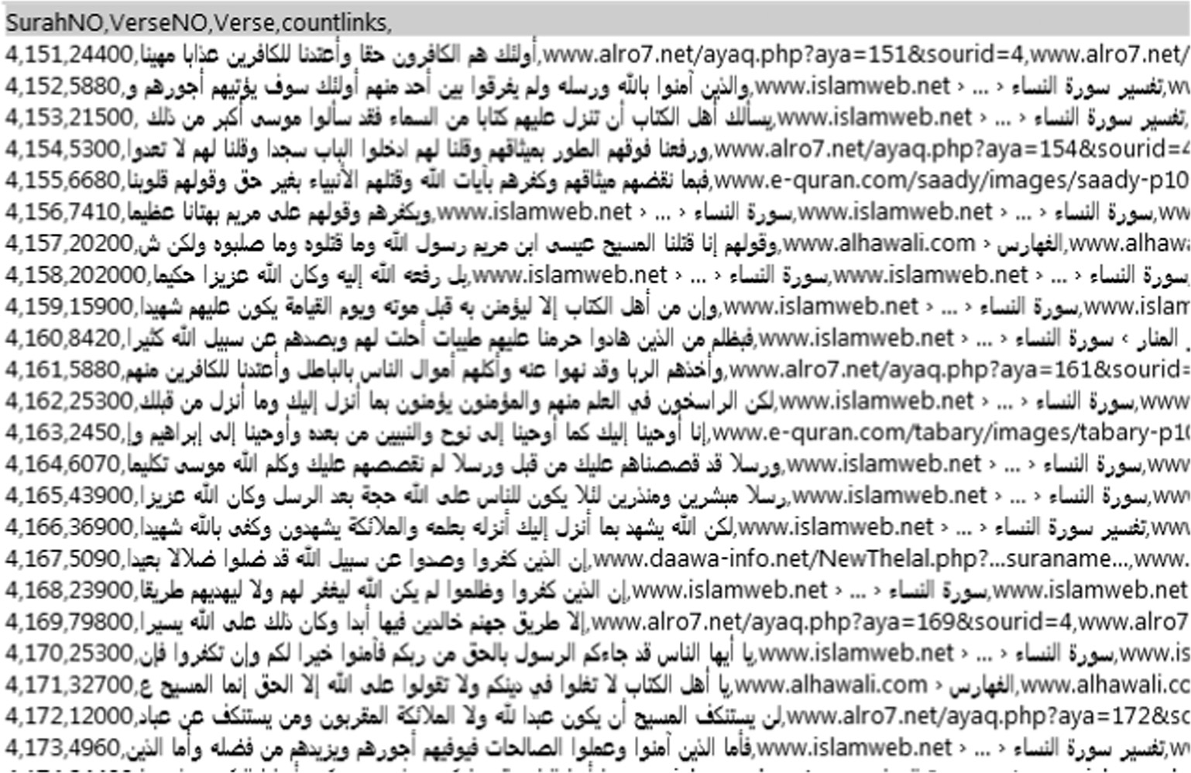

Figure 4 A small sample of Quran search crawler.

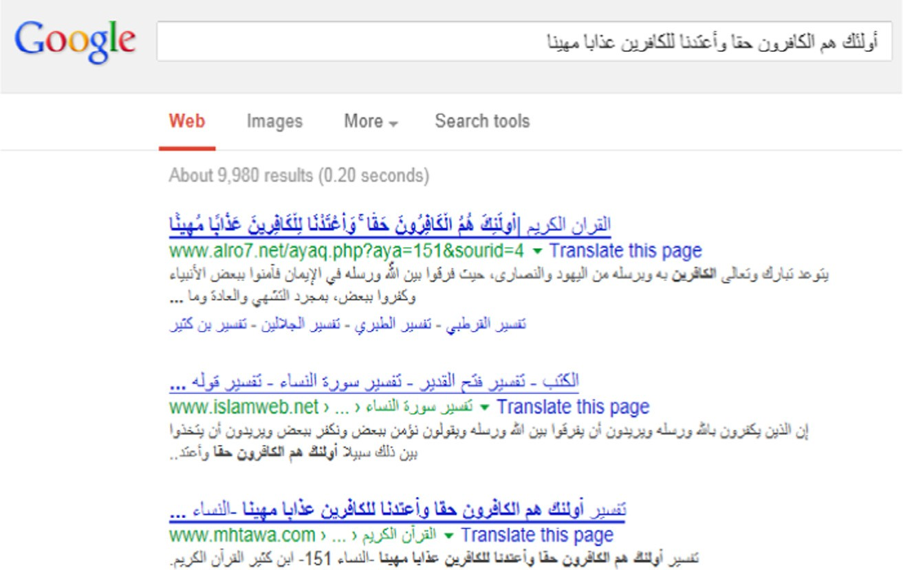

Figure 5 A sample of Google retrieved results.

For the Quran authentication system to work properly, we built an indexer that includes all Quran verses (based on the version available on the Islamweb website) where each line or row in the indexer includes one verse. Information about each verse should include its chapter, sequence number, con- tent and number of characters and MD5 hash value. MD5 hash value is saved as the hash table value besides the verse as a key object, see Fig. 7.

Total hash items are 6236 to represent total Quran verses. Fig. 8 shows a small screenshot from Quran indexer includ-

ing the attributes described earlier.

1. Experiments and discussions

In this section, several experiments are discussed, some of them helped us in making decisions related to the hashing algorithm in developing the authentication system and at the end we have conducted some experiments to test our authentication system. As mentioned earlier, there are several challenges that may face the process of authenticating automatically electronic verses and chapters of the noble Quran. Such challenges are related to different languages, fonts, styles, and Quranic read-

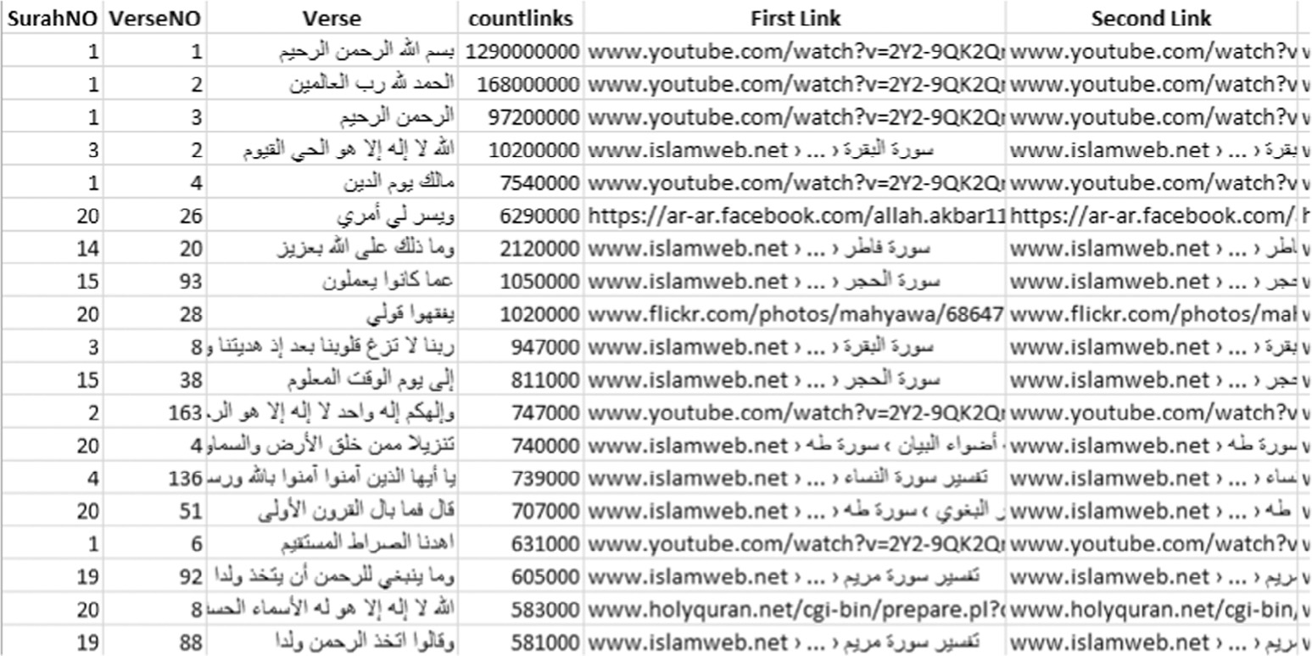

Figure 6 Top 19 verses based on rank.

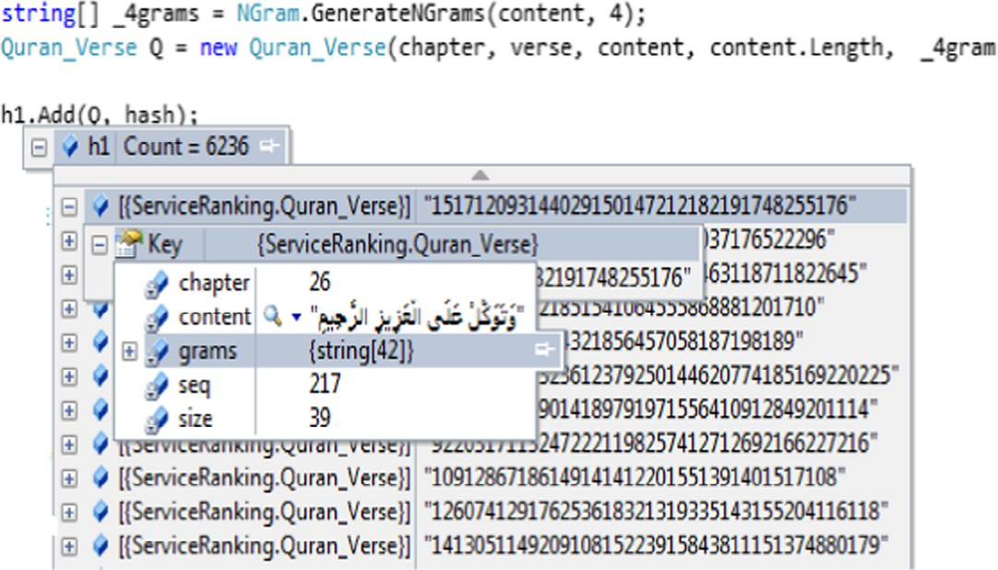

Figure 7 Quran indexer content snapshot.

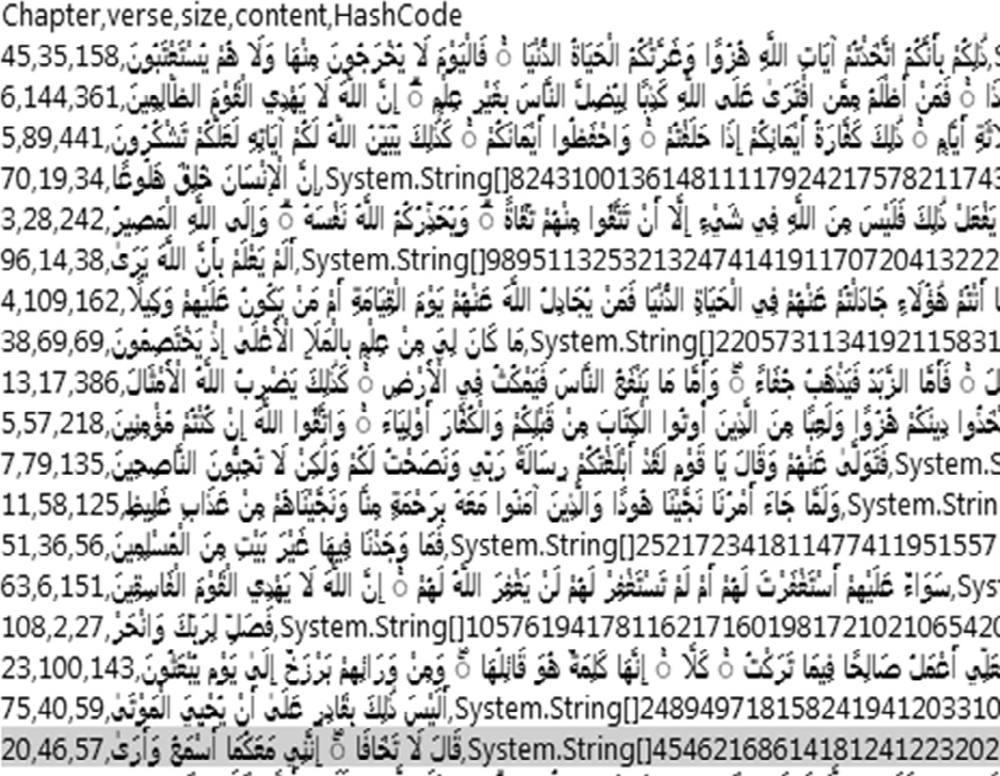

Figure 8 A sample from Quran indexer.

|  |  |
| --- | --- |
|  |  |
| (a) | (b) |

Figure 9 (a) Evaluating hashing values using Tashkeel. (b) Hashing values without Tashkeel.

|  |  |  |  |
| --- | --- | --- | --- |
| Table 1 A sample hash of verses (including Tashkeel). | | | |
| Verse | Hash1 | Hash2 | Hash3 |
| 56:1 | 937dbc692b153fec-d3bcf890121a54ea | 578D50BD96B68D5-A315491A333419D11 | 578d50bd96b68d5a3-15491a333419d11 |
| 3:3 | 3cc96e9210508e78b-3ecae50f5295f63 | C64AC514F615D3E4-3DA500959AFACFED | c64ac514f615d3e4-3da500959afacfed |
| 9:4 | 8709dce3dcf2d41c47-52f76faa1c542a | 17126C6DFA2CDE5344-5F017D079A6378 | 17126c6dfa2cde5344-5f017d079a6378 |
|  |  |  |  |

|  |  |  |  |
| --- | --- | --- | --- |
| Table 2 | Hash of verse (without Tashkeel). |  | |
| Verse | Hash1 | Hash2 | Hash3 |
| 56:1 | a1612dca935376349712c736c71b94b3 | 3EBC3778DB0FE1E6E27BA6C638D2CB55 | 3ebc3778db0fe1e6e27-ba6c638d2cb55 |
| 3:3 | 1cc9e35f76da3988f50c50c13bfec3fc | D2BFE01BFFD05BFFC3AF18139DDD4805 | d2bfe01bffd05bffc3af18139ddd4805 |
| 9:4 | 16f463927f497032dd9b284ac9f20f0c | 6BF0D7336E4203AE294E34CCE0DC5C14 | 6bf0d7336e4203ae294-e34cce0dc5c14 |
|  |  |  |  |

ings. Accordingly, we want first to evaluate whether such dif- ferences can be handled by hashing algorithms or not.

In the first study, we have selected an experimental case study of several different verses, different fonts, colors, and occurrences of small editing or changes and see their hashing values using different hashing algorithms.

We want to see first whether Tashkeels may impact hashing algorithms. Fig. 9(a and b) shows different hash algorithm val- ues for the same small part of Tashkeel

Bytes conversion gave the same value for the part of the verse with and without Tashkeel as Tashkeel values are not recognized by the conversion. This byte value can be then used for verification if Tashkeel is to be ignored. All the evaluated hashing algorithms including the following: Alder32, CRC32, Haval, MD2, MD4, MD5, RipeMD128, RipeMD160, SHA-

1, SHA-256, SHA-384, SHA-512, Tiger, and Whirlpool gave different values for the verses with and without Tashkeels. We repeated the process several times and noticed that all hashing algorithms for all evaluated verses show different hash values comparing with and without Harakat or Tashkeel. We noticed however, that different implementations for the same hashing algorithm may give different hash values for the same text. As such, the system should use the same algorithm imple- mentation for initial and consecutive authentications or verifi- cations. This is what we have done in developing the authentication system where we used the MD5 hashing algo- rithm for hashing purposes.

We also tried some small changes related to using for exam- ple (ﻩ) instead of (ﺓ) and all hashing algorithms showed different values.

This simple experiment showed that if we want to check correctness or authenticity of verses with Tashkeel and exact form, hashing algorithms can be used. However, if we want to stem those parts, hashing algorithms will not be then effec- tive unless those additions are stemmed from all verses. In the second experiment and in order to check whether same hash functions can produce same hash codes, we tried different implementations for the same hashing algorithm and check hash values for several verses. We believe that verse should be the standard unit to measure with. Sizes of smaller or larger than a verse can have several issues and challenges specially related to false alarms.

In this experiment we have fixed the source of Quran text to one website, in this case, ([http://quran.com](http://quran.com/)). First, we evalu- ated using MD5 hashing from three websites: [http://www.file-](http://www.fileformat.info/) [format.info](http://www.fileformat.info/) referred to (Hash1), [http://www.hashemall.com](http://www.hashemall.com/) referred to (Hash2) and [http://www.md5hashgenerator.com](http://www.md5hashgenerator.com/) referred to (Hash3). Table 1 shows results of three samples using verses with Tashkeel.

Results showed inconsistent findings where two algorithms gave exact hash values (ignoring letter cases) unlike the third one.

Table 2 shows same verses and same implementations for the verses but without Tashkeel. All values are different from

|  |  |  |  |
| --- | --- | --- | --- |
| Table 3 Hash of verse with different fonts and font sizes: verse 56:8: MD5 (without Tashkeel). | | | |
| Font-size | Hash1 | Hash2 | Hash3 |
| 1 | c3bc805e0a302bdf11591cf180a5d083 | F1A223ED0DEC063DB88A916EF20405AE | f1a223ed0dec063db88a916ef20405ae |
| 2 | c3bc805e0a302bdf11591cf180a5d083 | F1A223ED0DEC063DB88A916EF20405AE | f1a223ed0dec063db88a916ef20405ae |
| 3 | c3bc805e0a302bdf11591cf180a5d083 | F1A223ED0DEC063DB88A916EF20405AE | f1a223ed0dec063db88a916ef20405ae |
|  |  |  |  |

|  |  |  |  |
| --- | --- | --- | --- |
| Q-verse | Hash MD5 | Correct version | Hash MD5 |
| ِﺇٰﻥَﻟُﻜْﻢِﻓﻴِﻪَﻟَﻤﺎَﻳَﺘَﺨٰﻴُﺮﻭَﻥ | 711522207422 | ِﺇٰﻥَﻟُﻜْﻢِﻓﻴِﻪَﻟَﻤﺎَﺗَﺨٰﻴُﺮﻭَﻥ | 692913921 |
|  | 381951060 |  | 2491711 |
|  | 1321301341 |  | 6387200246 |
|  | 1313059119 |  | 23413536 |

Table 5 Example of verse tampering discovered by the authentication system from another source.

Original ﻦﻳﺪِﺘَﻌْﻤُﻟْﺍ ﺐّﺤِﻳُﻻَﻪَﻠّﻟﺍ ﻥٰﺇِﺍْﻭﺪُﺘَﻌْﺗَﻻَﻭَﻢْﻜُﻧَﻮﻠُﺗِﺎﻘَﻳُﻦَﻳﺬِﻟٰﺍ ﻪِﻠّﻟﺍ ﻞِﻴﺒِﺳَﻲﻓِﺍْﻮﻠُﺗِﺎﻗَﻭَ

MD5 b73a3bde38abdda5f073482de2044787

ﻦَﻳﺪِﺘَﻌْﻤُﻟْﺍ ﺐﺤِﻳُﻻَﻪَﻠّﻟﺍ ﻥٰﺇِﺍْﻭﺪُﺘَﻌْﺗَﻻَﻭَﻢْﻜُﻧَﻮﻠُﺗِﺎﻘَﻳُﻦَﻳﺬِﻟٰﺍ ﻪِﻠّﻟﺍ ﻞِﻴﺒِﺳَﻲﻓِﺍْﻮﻠُﺗِﺎﻗَﻭَ ﺚﺣﺎﺒﻟﺍ

MD5 25dcb1ccfabd68ffcd42556e2a9dd991

those of Table 1 as Tashkeel changed hash values. On the other hand, Hash 2 and 3 gave same values (ignoring letter cases).

This experiment shows that not all hashing functions are identical or should always produce same hash values for same text. Nonetheless, this is not due to reliability issue with hash- ing algorithms. Rather, it has to do with the detail implemen- tation of the hashing algorithm. Hashing values for the same algorithm implementation for the same text should always pro- duce same hash values.

Table 3 shows results of changing text size and font. All three MD5 implementations gave same results and were not impacted with changing verse font type or size.

As a summary of hashing experiments, we found that the authentication systems including the indexer should be devel- oped using the same hash function. This is since values of dif- ferent hashing algorithms for the same exact verse may result or display different hashing values.

We decided to consider MD5 hashing algorithm due to its popularity and reliability. As mentioned earlier, it was impor-

We have used our authentication system to check one of the online copies of the Holy Quran available in one of the Arabic websites that index Arabic books and documents (The compre- hensive library: <http://shamela.ws/>), and we noticed that there are records of some Quranic distortion in some verses. The risk is that such versions may be exposed to non-Muslims or Mus- lims who have little experience of the exact wording of Quran verses.

One popular example of this is a popular program called (Qaloon). At least one version of this program is discovered with examples of incorrect verses’ wording. Following are examples of the incorrect wording of some verses and their correct ones. We also included hashing values for both cases to simply show that an automatic hash based algorithm can easily detect such distortion.

Things to notice in the results:

1. Hash can detect distortion even in dialects or Tashkeels.
2. Hash values are randomly generated. Hence one difference may result in a completely different hash. Hence the idea is not to see how much the text is far from the actual text. The idea is to come up with a Boolean decision: Version is iden- tical relative to the original authenticated copy or not.
3. One of the serious issues through the Internet is that if we search using the incorrect versions that Qaloon program used, you will see thousands of websites indexing these incorrect versions.

Qaloon is not the only program that had such incident.

tant to select only one hashing algorithm as each algorithm

Another program called ‘‘”ﺍﻟﺒﺎﺣﺚ

included some incorrect

produces different hashes in comparison with the others for

Table 4 Comparison of the hash code for some of the Quran verses from Qaloon version using our

authentication system.

ﺍﺪًﻟَﻭَﻭَﻻًﺎﻣَﻚَﻨﻣِﻞٰﻗَﺃَﺎﻧَﺃَﻥِﺮَﺗُﻥﺇِﻪِﻠٰﻟﺎﺑِ

ﺀﺎﺷَﺎﻣَﺖَﻠْﻗُﻚَﺘَﻨٰﺟَﺖَﻠْﺧَﺩَﺫْﺇِﻻَﻮْﻟَﻭَ 137228453917919 ﻻٰﺇِﺓَﻮٰﻗُﻻَﻪُﻠٰﻟﺍ

3691054153

36120220

ﺍﺪًﻟَﻭَﻭَﻻًﺎﻣَﻚَﻨْﻣِﻞٰﻗَﺃَﺎﻧَﺃَﻥِﺮَﺗَﻥْﺇِﻪِﻠٰﻟﺎﺑِ

15774149

ﺀَﺎﺷَﺎﻣَﺖَﻠْﻗُﻚَﺘَﻨٰﺟَﺖَﻠْﺧَﺩَﺫْﺇِﻻَﻮْﻟَﻭَ 109215698 ﻻٰﺇِﺓَﻮٰﻗُﻻَﻪُﻠٰﻟﺍ

162142166

ﺍْﻭﺪُﺘَﻌْﺗَﻻَﻭَﻢْﻜُﻧَﻮﻠُﺗِﺎﻘَﻳُﻦَﻳﺬِﻟٰﺍ ﻪِﻠّﻟﺍ ﻞِﻴﺒِﺳَﻲﻓِﺍْﻮﻠُﺗِﺎﻗَﻭَ 38128941281

ﺐﺤِﻳُﻻَﻪَﻠّﻟﺍ ﻥٰﺇِ 77153692381111 ﻦَﻳﺪِﺘَﻌْﻤُﻟْﺍ

4025172191

70205176

193251

58821615221

42081591148673

ﻪِﻠٰﻟﺍ ﻞِﻴﺒِﺳَﻲﻓِﺍﻮﻠُﺗِﺎﻗَﻭَ 42427067 ﺍﻭﺪُﺘَﻌْﺗَﻻﻭَﻢْﻜُﻧَﻮﻠُﺗِﺎﻘَﻳُﻦَﻳﺬِﻟٰﺍ

ﻦَﻳﺪِﺘَﻌْﻤُﻟْﺍ ﺐّﺤِﻳُﻻ ﻪَﻠٰﻟﺍ ﻥٰﺇِ 351552

3024590161

391672

082015110

the same verses (see Tables 4 and 5).

verses. Results showed that both showed completely different hashes.

1. Conclusion and future work

With the current continuous expansion of Internet information and services, authentication and credibility of users and infor- mation through the web is vital. For the holy Quran book in particular, authentication is very critical. The authenticity and originality of verses in the digital media can be challenging especially as it is required to be accomplished in high agile and quick manners. In this paper, we proposed an approach to implement Quranic authentication system based on informa- tion retrieval techniques and hashing algorithms. We con- ducted several experiments to evaluate the different characteristics that may impact the accuracy of the authentica- tion process. Results showed that hashing verification can be a good candidate for the automatic authentication process with high confidence. Some exceptional cases such as the different Quranic readings are yet to be investigated and evaluated. Combining hashing methods with typical text plagiarism meth- ods can be also another alternative approach for the automatic authentication process. We believe however, that such process is very important as well as applicable. A typical Quran indexer can include one table of verses in rows. Content of the verse, its number, chapter and character size can be the major attributes to include in the table or the Quran indexer.

A customized Quranic crawler is developed to search for Quranic verses through the Internet and index pages and infor- mation about websites that include those verses. We developed a case study to analyze Google top 10 search results for Quranic verses where we retrieved results for the verses one by one for the whole Quran. This was part of an initial assessment to eval- uate the credibility of websites that include Quranic verses and that are most popular according to Google ranking algorithms. Results showed that while some of the most frequently vis- ited websites for verses search are authentic and credible, how- ever, in many other cases, some verses are indexed by less credible websites according to some subjective metrics that we defined or according to the fact that some of those pages are related to personal or social networks that are managed

by individuals without any official entity or establishment.

While we only conducted the current experiments on Quran verses, we believe that same process and tasks can be applied to evaluate Hadeeths as well. The case of Quranic verses can be considered easier as Quranic verses are literally identical even in the different Quran readings (with some few and minor exceptions). However, for the case of Hadeeths, some Hadeeths are mentioned in different wordings where this needs to be considered in the authentication evaluation process.

As a consequence of this study another research work will be conducted in future to rank the websites that cite or docu- ment the Quran verses based on their authenticity and provide the readers with the top most websites that document the authenticated Quran verses.

References

1. [Alfred J. Menezes, Paul Van Oorschot, S.A. Vanstone, Chapter](http://refhub.elsevier.com/S2210-8327(15)00022-8/h0005) [hash functions and data integrity, in: Handbook of Applied](http://refhub.elsevier.com/S2210-8327(15)00022-8/h0005) [Cryptography: The CRC Press Series on Discrete Mathematics](http://refhub.elsevier.com/S2210-8327(15)00022-8/h0005) [and Its Applications, CRC Press, 1997, pp. 321–383](http://refhub.elsevier.com/S2210-8327(15)00022-8/h0005).
2. [P.S. Tomar, M. Shreevastava, The study of detecting replicate](http://refhub.elsevier.com/S2210-8327(15)00022-8/h0010) [documents using MD5 hash function, Int. J. Adv. Comput. Res.](http://refhub.elsevier.com/S2210-8327(15)00022-8/h0010) [1 (2011) 2277–7970](http://refhub.elsevier.com/S2210-8327(15)00022-8/h0010).
3. [A. Alshareef, A.E. Saddik, A Quranic quote verification](http://refhub.elsevier.com/S2210-8327(15)00022-8/h0015) [algorithm for verses authentication, in: International](http://refhub.elsevier.com/S2210-8327(15)00022-8/h0015) [Conference on Innovations in Information Technology (IIT)](http://refhub.elsevier.com/S2210-8327(15)00022-8/h0015) [Abu Dhabi,](http://refhub.elsevier.com/S2210-8327(15)00022-8/h0015) [United Arab Emirates, IEEE, 2012](http://refhub.elsevier.com/S2210-8327(15)00022-8/h0015).
4. [Y. Alginahi, O. Tayan, M. Kabir, Verification of qur’anic](http://refhub.elsevier.com/S2210-8327(15)00022-8/h0020) [quotations embedded in online arabic and islamic websites, Int.](http://refhub.elsevier.com/S2210-8327(15)00022-8/h0020)

[J. Islamic Appl. Comput. Sci. Technol. 1 (2013) 10–16](http://refhub.elsevier.com/S2210-8327(15)00022-8/h0020).

1. [Y. Yusoff, R. Ismail, Z. Hassan, Adopting hadith verification](http://refhub.elsevier.com/S2210-8327(15)00022-8/h0025) [techniques in to digital evidence authentication, J. Comput. Sci.](http://refhub.elsevier.com/S2210-8327(15)00022-8/h0025) [6 (2010) 613–618](http://refhub.elsevier.com/S2210-8327(15)00022-8/h0025).
2. A.F. Shamsudin, A. Farooq, AI natural language in metasynthetics of Al-Qur’an, in: 2000 TENCON Proceedings: Intelligent Systems and Technologies for the New Millennium, Kuala Lumpur, Malaysia, 2000, pp. 464–467.
3. M. Warasart, P. Kuacharoen, Paper-based document authentication using digital signature and QR code, in: 4th International Conference on Computer Engineering and Technology (ICCET 2012) Bangkok, Thailand, 2012.
4. Kamsin, Amirrudin, Abdullah Gani, Ishak Suliaman, Salinah Jaafar, Rohana Mahmud, Md Sabri, Aznul Qalid et al., Developing the novel Quran and Hadith authentication system, in: Information and Communication Technology for The Muslim World (ICT4M), 2014 The 5th International Conference on, IEEE, 2014, pp. 1–5.
5. Sabbah, Thabit, Ali Selamat, A framework for Quranic verses authenticity detection in online forum, in: Taibah University International Conference on Advances in Information Technology for the Holy Quran and Its Sciences, 2013.
6. [Noor Jamaliah Ibrahim, Zaidi Razak, Zulkifli Mohd Yusoff,](http://refhub.elsevier.com/S2210-8327(15)00022-8/h0050) [Mohd Yamani Idna Idris, Emran Mohd Tamil, Noorzaily](http://refhub.elsevier.com/S2210-8327(15)00022-8/h0050) [Mohamed Noor, Abdul Rahman, Noor Naemah, Quranic Verse](http://refhub.elsevier.com/S2210-8327(15)00022-8/h0050) [recitation recognition module for support in J-QAF learning: a](http://refhub.elsevier.com/S2210-8327(15)00022-8/h0050) [review, Int. J. Comput. Sci. Netw. Secur. (IJCSNS) 8 (8) (2008)](http://refhub.elsevier.com/S2210-8327(15)00022-8/h0050) [207–216](http://refhub.elsevier.com/S2210-8327(15)00022-8/h0050).
7. Razak, Zaidi, Noor Jamaliah Ibrahim, Zulkifli Mohd Yusoff, Mohd Yamani Idna Idris, Emran Mohd Tamil, Quranic verse recitation feature extraction using mel-frequency cepstral coefficient (MFCC), in: 4th International Colloquium on Signal Processing and its Applications (CSPA 2008), 2008.
8. [Mohammed Ammar, Mohd Shahrizal Sunar, Md Sah Hj Salam,](http://refhub.elsevier.com/S2210-8327(15)00022-8/h0060) [Quranic verses verification using speech recognition techniques,](http://refhub.elsevier.com/S2210-8327(15)00022-8/h0060) [Jurnal Teknologi 73 (2) (2015)](http://refhub.elsevier.com/S2210-8327(15)00022-8/h0060).