[Array 19 (2023) 100307](https://doi.org/10.1016/j.array.2023.100307)

Contents lists available at [ScienceDirect](http://www.sciencedirect.com/science/journal/25900056)

Array

journal homepage: [www.sciencedirect.com/journal/array](https://www.sciencedirect.com/journal/array)

Optimal inventory system for deteriorated goods with time-varying demand rate function and advertisement cost

Palanivelu Saranya *, Ekambaram Chandrasekaran

*Department of Mathematics, Vel Tech Rangarajan Dr.Sagunthala R&D Institute of Science and Technology, Chennai, 600062, India*

A R T I C L E I N F O

*Keywords:* Inventory Ramp-rate type Replenishment

Economic order quantity Deterioration

Cycle length Shortage Backlog

A B S T R A C T

This research work presents a depleted demand inventory model with constant deterioration. The rate of change of demand is assumed to be a time-dependent function. Initial non-zero demand occurs due to advertisements. Advertisement cost is assumed to be constant. Two types of models are considered for two replenishment stra- tegies viz., without shortages and with shortages. This study aims to obtain a suitable policy for replenishment for minimizing the total inventory cost. Four examples about the alterations made in the optimal solutions due to different values of independent parameters used in the models are considered and discussed. Sensitivity analysis is done and numerical illustrations are provided for validating the approach presented.

# Introduction

To achieve organisational goals, it is desirable to know the norms and specifics of resources such as labour, goods, finances, etc. These aspects enable decision-makers to frame their objectives for getting maximum profit via utilising limited services and resources. One of their objectives is inventory. Literature on inventory theory has been continuously modified to reflect the most practical characteristics of existing inventory systems.

Two important factors play a major role in inventory. Firstly, the supply chain of almost every company faces the problem of holding stocks of obsolete or deteriorating goods. For, some goods gradually lose their potential usefulness over time; some deteriorate directly as they are stored; some experience physical depletion over time through desertion; and some deteriorate through direct spoilage. Therefore, the best inventory management strategy for this class of products is to minimise the loss caused by deterioration. Secondly, the change in de- mand rates affects their inventory policy.

In this paper, the demand function has two distinct phases: The de- mand rate is a function of time that initially increases, and after some time, begins to stabilise or becomes constant. This demand rate function is referred to as the ramp-type demand function. When a new consumer product brand enters the market, retailers initially invest heavily in transmitters. And when customers are happy with the item’s price and

quality and service rendered by the company, sales volume gradually

increases over a duration, and then, becomes constant. Therefore, the ramp type-demand function must have a minimum of one broken point between the two-time intervals in which it is non-differentiable [1].

Most of the literature available today is on an inventory model with a ramped demand rate, accounting for backorders, stockouts, and dete- rioration. A negative, exponentially deteriorating inventory model was presented by Ghare and Schrader [2]. Covert and Philip [3] replaced the negative exponential with two-parameter Weibull distributions for deterioration rate. Misra [4] and Chakrabarty [5] came up with eco- nomic order quantity models that concentrated on the above type of commodity. Mandal and Pal [6] introduced ramped demand rate for items with constant expiration rate inventory. Wu and Ouyang [7] gave the most suitable solution for the inventory system introduced by Mandal and Pal [6]. Also, they discussed two possible shortage models with ramp-type demand rate functions [1].

Manna and Chaudhuri [8] developed a model in which the deteri- oration rate of the ramped demand goods was time-dependent and the finite production rate is proportional to the demand rate. Panda, Sen- apati, and Basu [9] discussed a single-level inventory model for a seasonal item since the demand rate of seasonal products corresponds to the characteristics of a ramped demand rate. Skouri, Konstantaras, Papachristos, and Ganas [10] developed the model introduced by Covert and Philip, with the ramped demand rate and the Weibull dis- tribution deterioration rate, partial backlog. Skouri, Manna, Kon- stantaras, and Chaudhuri [11] supplemented the work discussed in

* Corresponding author.

*E-mail addresses:* [psaranya@veltech.edu.in](mailto:psaranya@veltech.edu.in) (P. Saranya), [drchandrasekarane@veltech.edu.in](mailto:drchandrasekarane@veltech.edu.in) (E. Chandrasekaran).

<https://doi.org/10.1016/j.array.2023.100307>

Received 10 April 2023; Received in revised form 12 June 2023; Accepted 12 July 2023

Available online 13 July 2023

2590-0056/© 2023 The Authors. Published by Elsevier Inc. This is an open access article under the CC BY-NC-ND license ([http://creativecommons.org/licenses/by-](http://creativecommons.org/licenses/by-nc-nd/4.0/) [nc-nd/4.0/](http://creativecommons.org/licenses/by-nc-nd/4.0/)).

Ref. [8] by taking into account the demand rate without bottlenecks, which stabilizes after the production stop time; and the demand rate with bottlenecks, which stabilizes after the production stop time. Moreover, they further modified their model by considering the de- mand rate as a time function [1].

Recently, in contrast to the work above, Ahmed, Al-Khamis, and Benkherouf [12], for the first time, considered a general deterioration rate. Sanni and Chukwu [13] developed an EOQ inventory model for items with a three-parameter Weibull distribution of deterioration [1]. Amutha and Chandrasekaran [14] advanced the EOQ model with quadratic demand and time-dependent carrying cost of inventory. Sri- vastava and Singh [15] built on the inventory model with linear demand by varying the deterioration rates and partial backlogs.

Singh, Mishra, and Pattanayak [16] presented a model with a linear function of deterioration and a “ramp-type demand function. Uthaya- kumar and Karruppasamy [17] provided a model with time-varying

demand for healthcare industries. Shaikh, A.A., and others [18] described an inventory model with addition facility for deteriorating goods with a ramp-type demand and a trade credit policy. Sharma and Kaushik [19] studied the inventory with ramp-type demand and offers with delayed payments. Palanivelu and Chandrasekaran [20] delivered the replenishment strategy for Giffen goods with time-dependent de- mand. Supakar, P., and Mahato, S. K. [21], developed the deteriorating inventory models with and without an advanced payment scheme, and they considered the ramp-type function for the demand rate.

It can be observed that until now, most of the researchers in this

ramp-type demand rate have completely ignored the initial demand or

* Model I does not allow stock outs.
* Stock outs are allowed in Model II.
  1. *Notations*
* *A*1- The ordering cost/order
* *AC-*Advertisement cost/cycle
* ***D***(***t***)-Deterministic demand**,**
* *γ* – the constant rate of deterioration
* *q*1- The economic order quantity (EOQ)
* h - holding cost per unit item per time
* *I*1(*t*), *I*2(*t*)- the inventory at the time duration t;
* *OC*1, *OC*2 - Ordering cost per cycle
* *AC*1, *AC*2 – Advertisement cost per cycle
* *HC*1, *HC*2-carrying cost per cycle
* *DC*1, *DC*2-Total deterioration cost/cycle;
* *TIC*1, *TIC*2-Total Inventory Cost/unit time
* *T*1, *T*2 - Replenishment period of cycle time.

At the beginning of each period, it is supposed that *I* is the total

inventory level to slowly decrease during the duration (0, *T*1) and eventually move to zero at *t* = *T*1. Due to the backlog, shortages occur amount of inventory, and market demand and deterioration induce the during the time interval *T*1 ≤ *t* ≤ *T*. Therefore, the differential equation governing the inventory *I*(*t*) has two phases of the cycle time T, which are as follows:

considered a zero demand for starting the inventory cycle. In some

*dI*(*t*) = { —*γI*(*t*) — *D*(*t*)0 ≤ *t* < *T*1

(1)

particular situations or products, non-zero initial demand will exist. In a *dt*

real-life situation, there is an initial demand for newly launched items

—*D*(*t*)*T*1 ≤ *t* ≤ *T*

such as mobile phones, computers, software, automobiles, etc., before they enter into the market because of the advertisement or canvassing. It moves upward with time when these items are launched, and after some time, it begins to stabilise.

In the healthcare industries too, newly introduced medicines have an initial demand before they are available in the market. Nonzero initial demand is also possible due to pre-booking or reserving of that product [22–24]. This paper contributes to that type of demand and takes into

consideration the constant deterioration rate and constant holding cost.

A ramp-type demand rate function is assumed here. The model is first discussed under the assumption that there is no inventory shortage, and then, extended to account for the shortage [25,26].

Here is how the rest of the article is structured: The assumptions and symbols as well as the description and formulation of Model-I, both without the shortage and with the shortage are presented in Section 2. It also includes some numerical examples to provide further insights. Section 3 presents a sensitivity analysis for the model parameters. The results thereof are presented in Section 4. Section 5 finally draws a conclusion of the study.

# Materials and methods

This part of the paper presents the assumptions made, symbols used, and the formulation of the model used in this study.

* 1. *Assumptions*
     + Inventory system considers only one item.
     + Demand rate is characterized by a time-dependent function of the ramp type.
     + Time horizon is infinite.
     + There is a constant holding cost.
     + There is an unbounded replacement rate.
     + There has been no lead time.
     + There is a constant deterioration rate, and no replacement is required during the cycle.
  2. *Mathematical model*
     1. *Model 1 - deterministic model without shortage*

As mentioned earlier, demand for these types follows a ramp-type demand rate function. Let us consider this function as-

***D***(***t***) = ***a*** + ***bt*** + ***b***(***μ*** — ***t***)***H***(***t*** — ***μ***), where **a** and b are non — negative (2) Where ***H***(***t*** —***μ***) is a piecewise continuous ‘Unit Heaviside function’,

*H*(*t* — *μ*) = { 1, *μ* ≤ *t*

0, *μ* > *t*

The shortages can be avoided if the stock is replenished instantly when stock levels become sufficiently low or reach zero (see Fig. 1). There are no shortages in Model I, but this assumption is relaxed in

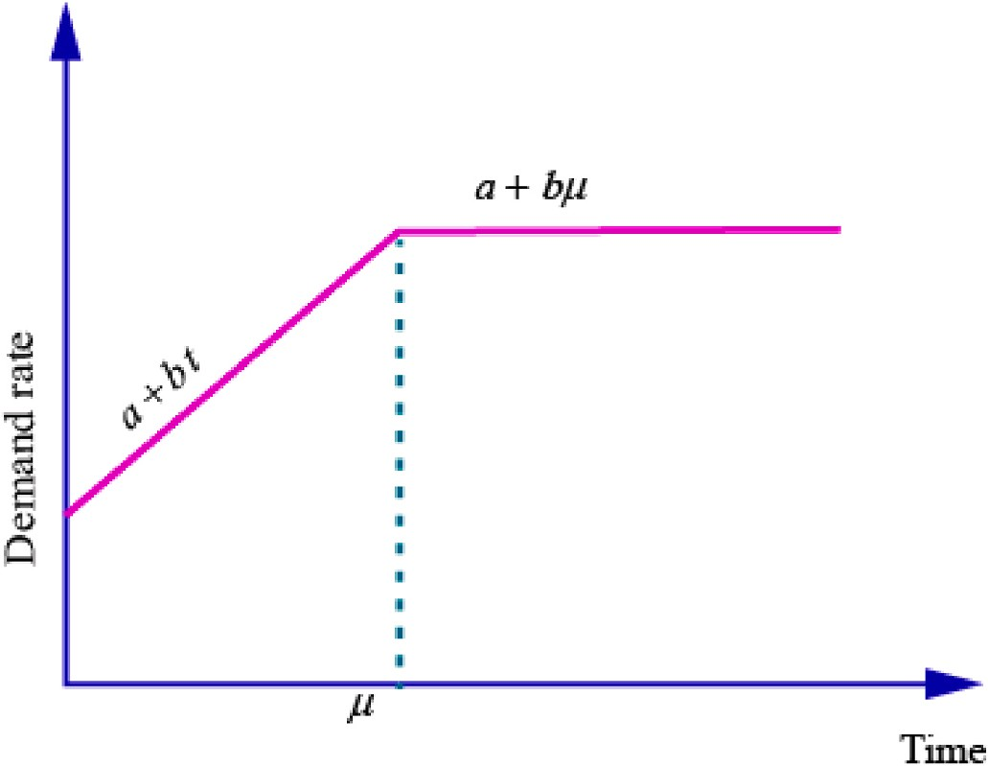

**Fig. 1.** Ramp Type Demand rate curve.

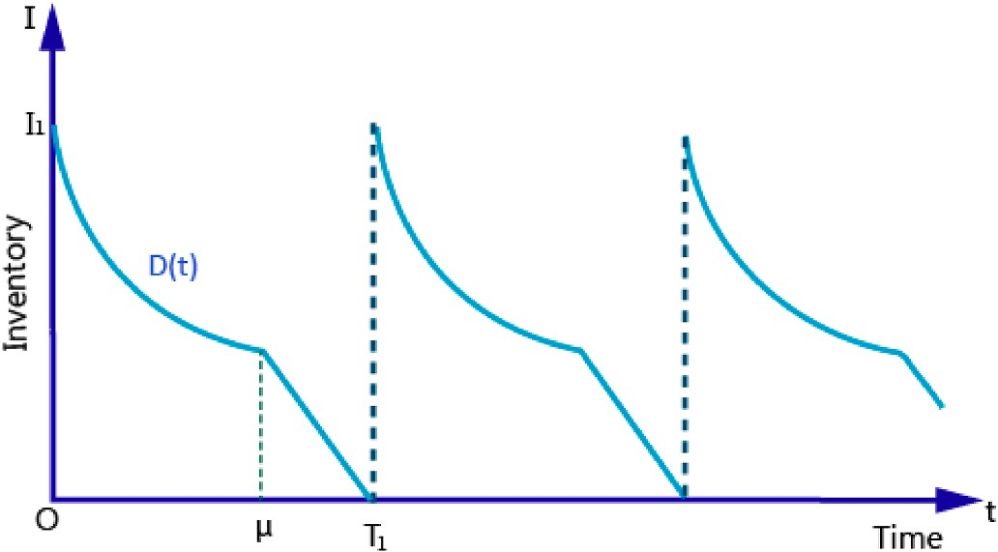⎡∫***μ*** (

## *a b* ) *a bt b*

∫ ( ***a***

***T*1**

***bμ***)

***a bμ*** ⎤

= ***h***⎢⎣

**0**

***e***—***γt***

***q*1** + ***γ*** — ***γ*2**

— ***γ*** — ***γ*** + ***γ*2 *dt*** +

***μ***

***q*1** + ***γ*** + ***γ***

***e***—***γt*** — ***γ*** — ***γ dt***⎥⎦

[( ***b***

= ***h***

***γ*2** — ***γ***

***a***)(

***e***—***γμ*** )

***bμ*2**

***qe***—***γμ***]

[(***e***—***γT*1** — ***e***—***γμ***)

***μ*** +

***γ***

—

***γ*** —

***γ***

— ***qh***

***γ***

—

***γ***

***γ*** + ***T*1** — ***μ***

(12)

(***a*** + ***bμ***)(***e***—***γT*** — ***e***—***γμ*** )]

Deterioration cost

**Fig. 2.** The inventory model that excludes shortage.

***DC*1** = ***d***⎡⎣***q*1** —

***T*1**

***D***(***t***)***dt***

∫

⎤

⎦

**0**

⎤

Model- II. A batch of *I*1 units is ordered at time 0 to raise the initial in-

= ***d***⎢⎡***q*** — ∫ (***a*** + ***bt***)***dt*** —

***T*1**

(***a*** + ***bμ***)***dt***⎥

∫

⎦

ventory level from 0 to *I*1. This process is repeated each time the in- ventory level falls back to 0. This can be seen in Fig. 2.

The governing differential equation (1) when the shortage is not allowed is given by-

***dI*1**(***t***)

**1**

**0**

⎣

***μ***

= ***d***{***q*1** — (***aμ***

***bμ*2**

+ **2**

***μ***

— (***a*** + ***bμ***)(***T*1** — ***μ***)}

)

(13)

***dt*** + ***γI*1**(***t***) + ***D***(***t***) = **0** (3)

Substituting the ramp-type rate demand function (2) in (3), the

Total inventory cost

***TIC*** = (***OC*1** + ***HC*1** + ***DC*1**)

following equations are obtained.

+ ***γI*** (***t***) + (***a*** + ***bt***) = **0**, **0** ≤ ***t*** ≤ ***μ*** (4)

***dI*1**(***t***)

***dt***

**1**

(5)

— *q*1

**1**

1 [

=

*T*1

*A*1 + *A*3 + *h*

*γ*

—

***T*1**

[{( *b*

*γ*2

*a*)(

—

*γ*

*μ* +

*e*—*γμ*)

—

*γ*

*γ* + *T*1 — *μ*

*bμ*2

*γ*

—

*γ*

*γ*

*q*1 *e*—*γμ* }

## *dI t*

**1** ( ) + ***γI*** (***t***) + (***a*** + ***bμ***) = **0**, ***μ*** ≤ ***t*** ≤ ***T***

(14)

(*e*—*γT*1 — *e*—*γμ* )

(*a* + *bμ*)(*e*—*γT*1 — *e*—*γμ* )]

***dt* 1 1**

+ *d*

*q*1 —

*aμ* +

2

with initial and boundary conditions,

{ ( *bμ*2 ) }]

***I*1**(**0**) = ***q*1**, ***I*1**(***T*1**) = **0**

Total Inventory Cost function ***TIC*1** is given by-

***TIC*** = (***OC*1** + ***AC*1** + ***HC*1** + ***DC*1**)

***T***

**1**

**1**

(6)

* + 1. *Model II* – *inventory model with shortage*

A company policy restricts the shortages of any of their products. Shortage costs occur when the required quantity of the good (demand) exceeds the available inventory. The company that has a supply shortage with its customers has to bear the shortage cost. This can be interpreted

+ (*a* + *bμ*)(*μ* — *T*1)

on solving equations (2) and (3),

as the loss of goodwill with customers and the resulting unwillingness to

do business with the company. That is, it includes the cost of belated

***I*1**(***t***) = ***e***—***γt***(***q***

***a b*** ) ***a***

+ , **0** ≤ ***t*** ≤ ***μ***, (7)

revenue, and the additional administrative expenditure involved. A

**1** + ***γ*** — ***γ*2** — ***γ*** — ***γ γ*2**

***bt b***

***bμ***

producer experiencing a shortage of materials needed to meet the de- mand for it has to spend an additional amount to delay the completion of

***I*1**(***t***) = (***q***

**1** + ***γ*** + ***γ***

***a bμ***)***e***—***γt a***

, ***μ*** ≤ ***t*** ≤ ***T*1**, (8)

the production process. When there is additional demand over available

inventory, the company won’t wait for the next shipment to meet this

By using the boundary conditions, one can obtain the initial order quantity by using the following equation:

— ***γ*** — ***γ***

**1** — **1** —

***γ*2** , **0** ≤

≤

,

additional demand. This is shown in Fig. 3. The governing equation corresponding to shortages is given below-

***q*** (***a***

**1** =

***γ*** — ***γ*2**

***b*** ) ***e***—***γT***

) ***beγT*1 *t μ***

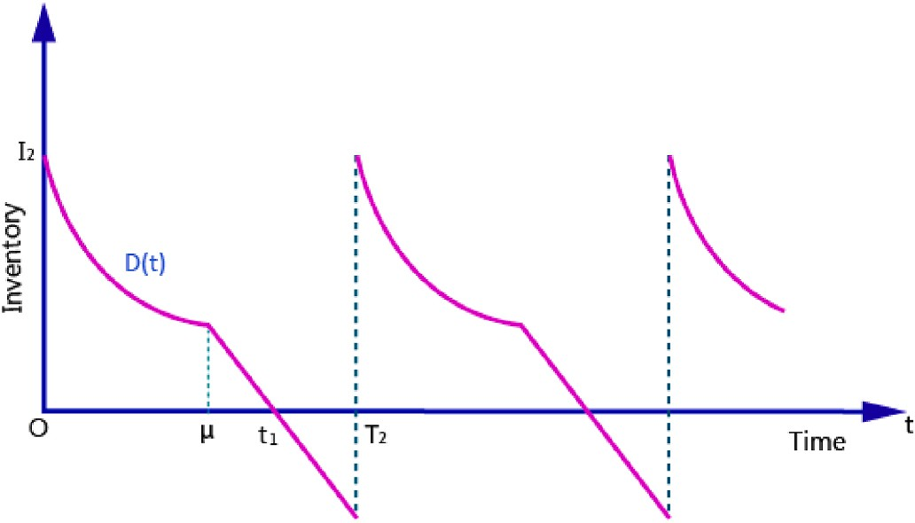(9)

***q*** = (***a*** + ***bμ***) ***eγT*1** — **1**), ***μ*** ≤ ***t*** ≤ ***T***

(10)

**1 *γ* 1**

Ordering cost

***OC*1** = ***A*1** (11)

Carrying cost

***T*1**

***HC*1** =

∫

**0**

***hI*1**(***t***)***dt***

**Fig. 3.** The inventory model that includes shortage.

*dI*2(*t*) = { —(*γI*(*t*) + *D*(*t*))0 ≤ *t* ≤ *t*1

(15)

***A*2** + ***A*3** + ***h***

***q*2** +

(***e***—***γμ*** — **1**) — ***γ***

***aμ*** + —

**2**

the following is obtained

*dt* —*D*(*t*)*t*1 < *t* ≤ *T*2

with the same ramped demand is

**2**

***γ*2**

— (***e***—***γt*1** — ***e***—***γμ***)(***q*** + ***a*** + ***bμ***) — (***a*** + ***bμ***)(***t*** — ***μ***)}

**1** [ {( ***aγ*** — ***b***)

**1** ( ***bμ*2**

***bμ***)

***γ***

***dt*** + ***γI*2**(***t***) + (***a*** + ***bt***) = **0**, **0** ≤ ***t*** ≤ ***μ*** (16)

***dI*2**(***t***)

***TIC*2** = ***T***

**2 *γ*2**

{ ***bμ*2**

***γ* 1**

} ( (***T***

— ***t*** )**2**)]

***dI*2**(***t***) ***dt***

***dI*2**(***t***)

+ ***γI*2**(***t***) + (***a*** + ***bμ***) = **0**, ***μ*** ≤ ***t*** ≤ ***t*1**

(17)

+ ***d q*2** — ***aμ*** — **2**

— (***a*** + ***bμ***)(***t*1** — ***μ***)

+ ***s*** (***a*** + ***bμ***) **2 1**

# 2

(28)

***dt*** + (***a*** + ***bμ***) = **0**, ***t*1** ≤ ***t*** ≤ ***T*2** (18)

with initial and boundary conditions

* 1. *Methodology*

To attain the minimum total cost *C*1

, the function *TIC*1

given by (12)

***I*2**(**0**) = ***q*2**, ***I*2**(***t*1**) = **0** (19)

By solving equations (16)–(18), the following equations are

obtained.

necessary condition *dTIC*1 = 0 is solved. This helps in obtaining a tran- is differentiated with respect to *T*1 and the equation given by the

1

*dT*

scendental equation in *T*1. MATLAB software is used to perform the

sensitivity for the inventory function on the minimum total cost *TIC*1,

—

—

, **0** ≤

≤

, (20)

1

## *I t q e γt*

**2**( ) =

—

**2**

+

(***aγ*** — ***b*2**)***e γt***

(***a*** + ***bt***

***b*** ) ***t μ***

and optimal ordering quantity *(q *)* caused by any incremental changes

in the parameter.

***I*** (***t***) = ***q e***—***γt*** + (***a*** + ***bμ***)(***e***—***γt*** — **1**), ***μ*** ≤ ***t*** ≤ ***t*** , (21)

***γ*2**

***γ*** — ***γ*2**

**2**

**2**

***γ***

**1**

The following necessary requirement for TIC2 is applied.

∂***T*2** ∂***t*1**

∂***TIC*2** = **0**, ∂***TIC*2** = **0** (29)

***I*2**(***t***) = (***t*** — ***t*1**)(***a*** + ***bμ***), ***t*1** ≤ ***t*** ≤ ***T*2**. (22)

And by using equation (19)

By differentiating equation (28) with respect to *t*1and*T*2 and applying

the necessary condition (29), the simultaneous equations in transcen- dental function of *t*1and*T*2 are obtained. MATLAB software is used to

***q*** = (***a*** + ***bt*1** — ***b*** )***eγt*1 *a***

***b*** , **0** ≤ ***t*** ≤ ***μ***, (23)

calculate the effects of the decision variables by variations given to the

**2 *γ γ*2**

— ***γ*** + ***γ*2**

system parameters of the inventory model function such as *a, b, , h* and *s.*

Tables 1 and 2 present the results thereof (see Table 3).

***q*** = **1** (***a*** + ***bμ***)(***eγt*1** — **1**), ***μ*** ≤ ***t*** ≤ ***t***

(24)

**2 *γ* 1**

Carrying cost

***t*1**

***HC*2** = ***h I*2**(***t***)***dt***

∫

**0**

* + 1. *Numerical example*

To utilize and to check the above models, four cases are discussed with various parameter values.

* + 1. *Model I- without shortage*

Example 1.

Setting the values of parameters in (13) as *a* = 150, *b* = 2, *A*1 = 500/

⎧⎨ ∫***μ***

= ***h***

**0**

⎩ ⎭

***q e***—***γt*** +

(***a*** + ***bμ***

)(***e***—***γt*** — **1**)***dt*** +

***t*1**

(***t*** — ***t*** )(***a*** + ***bμ***)***dt***

∫

⎫⎬

**1**

(25)

order, *A*3 = 500/cycle, *d* = 50/unit, *μ* = 1.5, *h* = 2 and *γ* = 0.01, the

optimal point *T*∗ = 2.1257 is obtained. This optimal point *T*∗ is

1

1

1

1

***μ***

substituted in equations (12) and (7) to obtain the optimal cost *TIC*∗ =

**2**

***γ***

Deterioration cost

887.41 and *q*∗ = 327.

***DC*2** = ***d***

⎧

⎨

⎧⎨***q*2** —

***μ***

⎩

∫

***t*1**

***D***(***t***)***dt***

∫

⎬

⎫

⎭

**0**

***t*** ⎫

∫

⎬

**Table 1**

The corresponding alterations in other parameters for model I.

|  |  |  |  |  |
| --- | --- | --- | --- | --- |
| Parameter Values *T*∗ *TIC*∗ | | | | *q*∗  1 |
| a | 120 | 2.3052 | 804 | 285 |
|  | 135 | 2.2101 | 846 | 307 |
|  | 150 | 2.1257 | 887.41 | 327 |
|  | 165 | 2.0501 | 927 | 346 |
|  | 180 | 1.9820 | 965 | 364 |
| b | 1 | 2.1987 | 879 | 336 |
|  | 2 | 2.1257 | 887.41 | 327 |
|  | 3 | 2.0666 | 894.73 | 320 |
|  | 4 | 2.0178 | 901.26 | 314 |
|  | 5 | 1.9767 | 907.16 | 309 |
| *γ* | 0.005 | 2.2199 | 844.23 | 340 |
|  | 0.01 | 2.1257 | 887.41 | 327 |
|  | 0.015 | 2.0420 | 929.02 | 315 |
|  | 0.02 | 1.9670 | 969.21 | 305 |
|  | 0.025 | 1.8993 | 1008 | 296 |
| h | 1.0 | 2.5618 | 708.90 | 396 |
|  | 1.5 | 2.3125 | 802.41 | 356 |
|  | 2.0 | 2.1257 | 887.41 | 327 |
|  | 2.5 | 1.9787 | 965.92 | 304 |
|  | 3 | 1.8592 | 1039 | 285 |

1 1

= ***d q*2** — (***a*** + ***bt***)***dt*** —

⎩

**0**

**1**

(***a*** + ***bμ***)***dt***

***μ*** ⎭

(26)

Shortage Cost

***T*2**

***SC*** = ***s***(***a*** + ***bμ***)

∫

***t*1**

(***t*** — ***t*1**)***dt***

( (***T*** — ***t*** )**2**)

= ***s***

(***a*** + ***bμ***)

**2**

**2**

**1**

Substituting all the above information in the following total in- ventory cost equation

## *TIC*

**1**

**2** =  ( **2** + **2** + **2** + **2** + ) (27)

***T OC AC HC DC SC***

**2**

**Table 2**

The corresponding changes in other parameters for model II.

# Sensitivity analysis

Parameter Values t1* *T*∗

2

2

|  |  |  |  |  |  |  |
| --- | --- | --- | --- | --- | --- | --- |
| a | 140  165 | 1.4613  1.3876 | 3.8745  3.6491 | 517.63  552.94 | 208  226 | A sensitivity analysis is taken for the values as given in Example 1. It |
|  | 180 | 1.3235 | 3.4594 | 586.30 | 242 | is observed that the changes in the values of *T*∗, *TIC*∗ and*q*∗ bring about  1 1 1 |
|  | 200 | 1.2671 | 3.2967 | 618.01 | 257 | corresponding changes in other parameters. This is shown in Table 1. |
|  | 220 | 1.2170 | 3.1551 | 648.30 | 271 |  |
| b | 1 | 1.3059 | 3.4505 | 583.89 | 238 |  |
|  | 2 | 1.3235 | 3.4594 | 586.30 | 242 | *3.2. Sensitivity analysis for model II* |
|  | 3 | 1.3379 | 3.4649 | 588.66 | 245 |  |
|  | 4 | 1.3498 | 3.4680 | 590.98 | 248 |  |
|  | 5 | 1.3598 | 3.4693 | 593.28 | 251 | Similarly, a sensitivity analysis is conducted for the values as given in |
| *γ* | 0.005 | 1.4198 | 3.5100 | 573.73 | 259 | Example 3. It is evident that alterations in the values of t∗ , *T*∗, *TIC*∗ , *q*∗ ,  1 2 2 2 |
|  | 0.01  0.015  0.02 | 1.3235  1.2395  1.1656 | 3.4594  3.4159  3.3782 | 586.30  597.44  607.38 | 242  227  214 | bring corresponding changes in other parameters. This is shown in Table 2. |
|  | 0.025 | 1.1000 | 3.3453 | 616.31 | 202 |  |
| h | 1.0 | 1.7939 | 3.7091 | 525.73 | 329 | **4. Results and discussion** |
|  | 1.5 | 1.5215 | 3.5618 | 560.06 | 278 |  |

*TIC*∗

∗ *3.1. Sensitivity analysis for model I*

2

*q*

*4.1. Model-I’s effect on T*∗*, TIC*∗ *and q*∗ *caused by a, b, γ, and hare*

|  |  |  |  |  |
| --- | --- | --- | --- | --- |
| 2.0 | 1.3235 | 3.4594 | 586.30 | 242 |
| 2.5 | 1.1724 | 3.3840 | 607.06 | 214 |

3 1.0530 3.3260 623.95 192

s 1.0 1.1941 3.9965 512.84 218

1.25 1.2653 3.6837 553.21 231

1 1 1

* An increase in *a, b, γ*, and *h* in Model-1 will cause ***TIC***∗ to be increased.

**1**

|  |  |  |  |  |  |  |
| --- | --- | --- | --- | --- | --- | --- |
| 1.5  1.75 | 1.3235  1.3723 | 3.4594  3.2897 | 586.30  614.06 | 242  251 | * It is clear that the variations of ***TIC***∗ and *q*∗ are in the same direction   **1** 1 | |
| 2.0 | 1.4139 | 3.1564 | 637.77 | 258 | as ‘*a*’. |  |

* + *T*∗, ***TIC***∗ and *q*∗ are perceptive towards the alterations in the scale

1 **1** 1

parameter ‘*b*’.

* + *T*∗, ***TIC***∗ and *q*∗ are discreetly penetrative with an increase in the

1 **1** 1

**Table 3**

parameter *γ*.

The change of direction in *T*∗, *TIC*∗ , *q*∗ through the parameter. ∗ ∗ ∗

1 1 1

Change of direction in Parameter Effects on *T*∗ , ***TIC***∗, *q*∗

* *T*1 and *q*1 sensibly change with alterations in the parameter h. *T*1 and

*q*∗ drop when the carrying cost per unit h increases, but ***TIC***∗ upturns

1 **1** 1

∗ ***TIC***∗ ∗

*T*

**1**

*q*

1

1

↑ in *a* ↓ ↑ ↑

↑ in *b* ↓ ↑ ↓

↑ in *γ* ↓ ↑ ↓

↑ in *h* ↓ ↑ ↓

Example 2.

2.5, *a* = 150, *b* = 2, *A* = 1000 per order, d = 50 per unit, *h* = 2, and *γ* = Considering the change in demand at the breakthrough point μ as 0.01, the values *T*∗ = 2.3259, ***TIC***∗ = 880 and *q*∗ = 359 are obtained.

1 **1** 1

* + 1. *Model II- without shortage*

Example 3.

With the parameter values *a* = 180, *A*2 = 500 per order, *A*4 = 500/ cycle, b = 2, *γ* = 0.01,*d* = 50, *s* = 1.5, *h* = 2, and *μ* = 1.5, the optimum

values *t*∗ = 1.3235, *T*∗ = 3.4594 , *TIC*∗ = 586.30 and *q*∗ = 242 are

1 **1**

when ‘*h*’ rises.

The sensitivity analysis for Model-I is depicted in the following Figs. 4–7.

From Fig. 4, it clear that the cycle length is inversely proportional to

the parameter ‘a’ while the total cost and the economic order quantities are directly proportional.

From Fig. 5, it is seen that the cycle length and economic order quantities decrease as the parameter ‘b’ increases. However, there is an increase in the total cost.

From Fig. 6, it can be seen that with an increase in the deterioration rate, the cycle length and the economic order quantities decrease. However, the total cost increases.

From Fig. 7, it is evident that an increase in the holding cost will lead to the increase of total cost. The cycle length and the economic order quantities decrease.

The vital role of the shortages on the impacts of the change in pa-

1 2 2

obtained.

2

rameters *a, b, c*, and *h* on *t*∗, *T*∗, *TIC*∗ , *q*∗ .are analyzed for Model II. This is

Example 4.

For identical parameter values like that in example 3, except *μ*,

shown in Table 4.

1 2 2 2

which is considered as 2.5, the model gives the optimum values as *t*∗ = • The changes in *TIC*∗ and *q*∗ are in the same direction as changes in all

1 2 2

1.5463, *T*∗ = 3.7348, *TIC*∗ = 607.31 and *q*∗ = 283. parameters, excluding shape parameter *‘a*’

2 2 2

It is observed from examples 1, 2, 3, and 4 that when the break-

through point μ is greater than the cycle length, a stock-out condition

* As *b* increases, there is an increase in the values of *t*∗, *T*∗, *TIC*∗ , *q*∗ .
* *T*∗, *TIC*∗ , and *q*∗ are reasonably sensitive with ɤ.

1 2 2 2

2 2 2

occurs. The inventory cost and the initial order quantity of Model-I are

* *t*∗, *T*∗ and *q*∗ move in the opposite direction as the carrying cost per

1 2 2

greater than those of Model II to avoid a stock-out situation. The shortage in Model II ushers in the chance of losing the customer’s goodwill.

unit *h* rises. *TIC*∗ alone does not abide by this condition.

* *t*∗, *T*∗, *TIC*∗ and *q*∗ are highly perceptive with the changes in the

2

1 2 2 2

parameters.

In model II, the sensitivity analysis shows that the shortage cost plays a vital role on order quantity and total inventory cost.

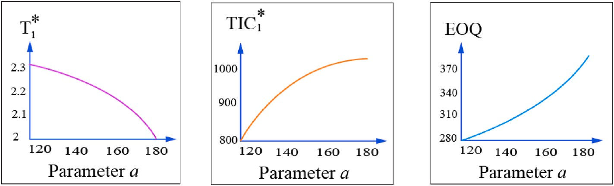**Fig. 4.** The influence of parameter ‘a’ on *T*∗, *TIC*∗ and *q*∗ .

1 1 1

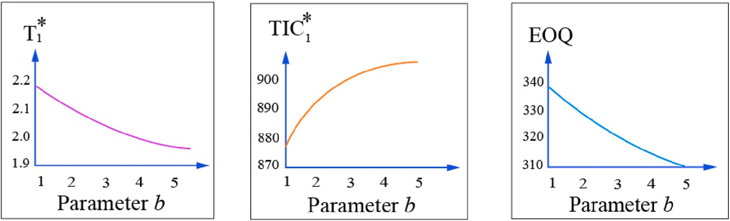**Fig. 5.** The influence of parameter ‘b’ with *T*∗, *TIC*∗ and *q*∗ .

1 1 1

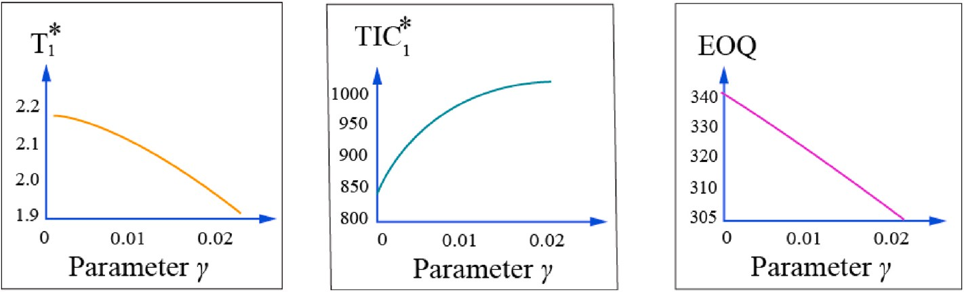**Fig. 6.** Influence of parameter ‘ɤ’ with *T*∗, *TIC*∗ and *q*∗ .

1 1 1

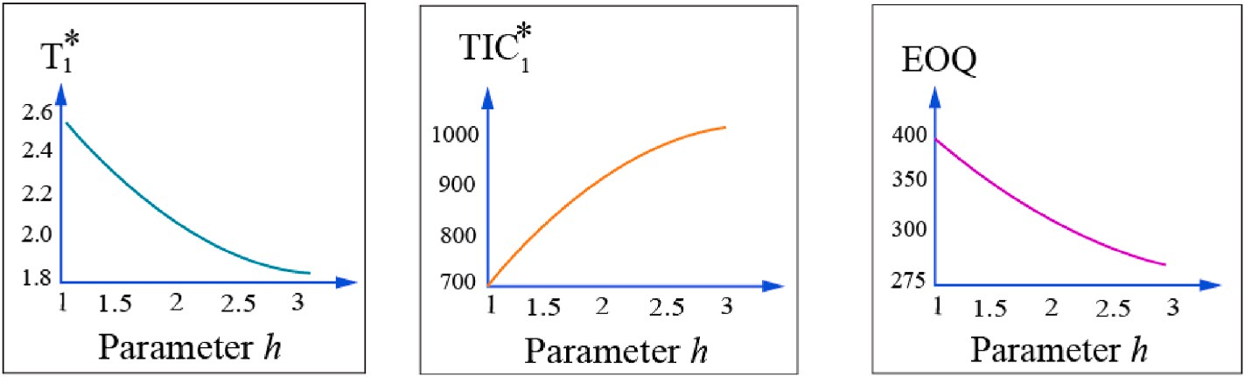**Fig. 7.** The influence of parameter ‘h’ with *T*∗, *TIC*∗ and *q*∗ .

1 1 1

**Table 4**

Change in the direction of ***t***∗, ***T***∗, ***TIC***∗, ***q***∗ for different parameters.

**1 2 2 2**

Change of direction in Parameter Effect on *t*∗ , *T*∗ , *TIC*∗ , *q*∗

1 2 2 2

1 2 2

The graphs in Figs. 8–12 clarify the significance of the sensitivity analysis for.

Model II.

Fig. 8 clarifies that the change of direction is the same for the total cost and the economic order quantity as it is for the direction of

|  |  |  |  |  |  |
| --- | --- | --- | --- | --- | --- |
|  | *t*∗ | *T*∗ | *TIC*∗ | *q*∗ |  |
| ↑ in a | ↓ | ↓ | ↑ | ↑ |  |
| ↑ in b | ↑ | ↑ | ↑ | ↑ |  |
| ↑ in ɤ | ↓ | ↓ | ↑ | ↓ |  |
| ↑ in h | ↓ | ↓ | ↑ | ↓ |  |
| ↑ in s | ↑ | ↓ | ↑ | ↑ |  |

2

parameter ‘a’. But the cycle length reflects the opposite direction.

From Fig. 9, it is observed that the change of the parameter ‘b’ is

directly proportional to the economic order quantity, total cost, and cycle length.

From Fig. 12, it is clear that to avoid the stock out situation, the economic order quantities should be increased. When stock-out situa- tion occurs, the increase in the total inventory cost cannot be avoided due to the shortage cost.

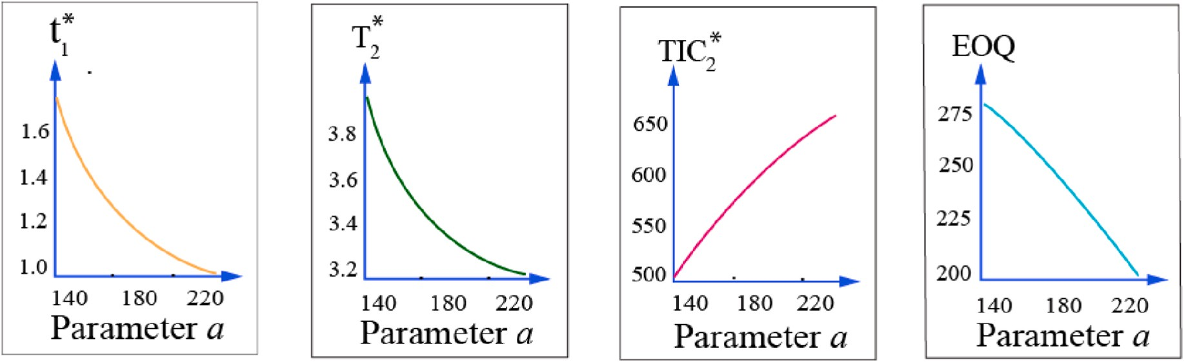**Fig. 8.** The influence of parameter ‘a’ on *t*∗, *T*∗, *TIC*∗ and *q*∗ .

1 2 2 2

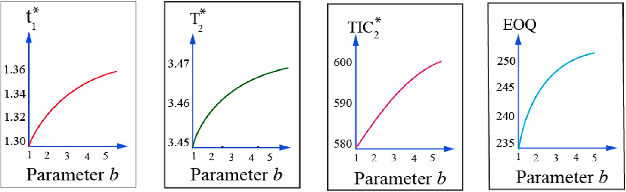**Fig. 9.** The influence of parameter ‘b’ on *t*∗, *T*∗, *TIC*∗ and *q*∗ .

1 2 2 2

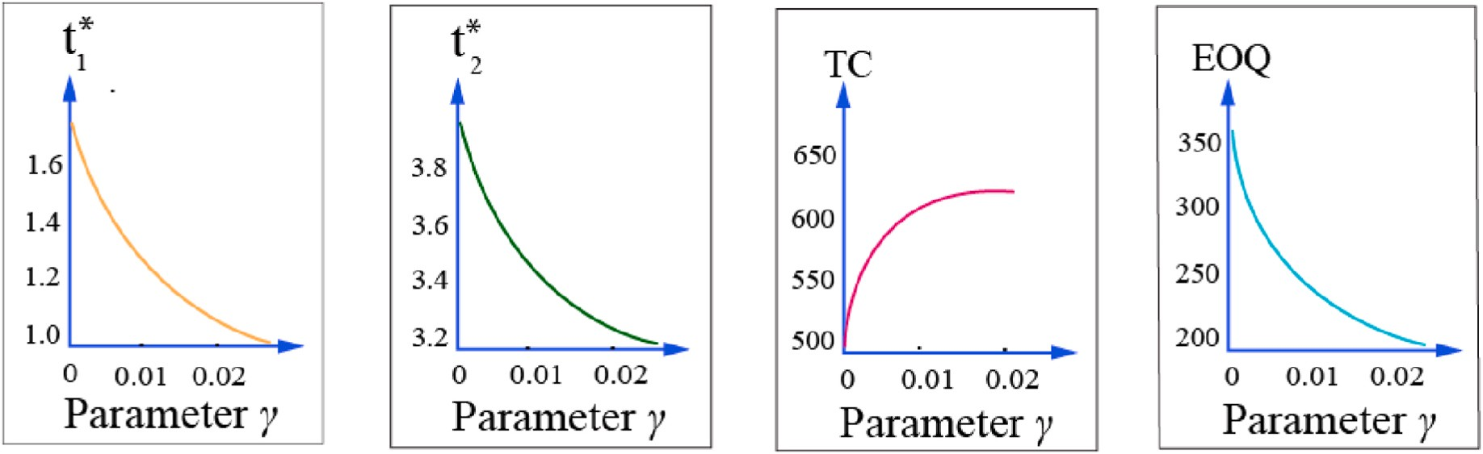**Fig. 10.** The Influence of Parameter ‘ɤ’ on *t*∗, *T*∗, *TIC*∗ and *q*∗ It is clear from Fig. 10 that the deterioration parameter plays a vital role in the inventory cost and the

1 2 2 2

economic order quantities. The cycle length cannot be longer if the deterioration rate increases.

# 5. Conclusion

This paper has proposed an inflated model for a time-dependent demand of the ramp type with a constant holding cost, constant advertisement cost, and expiration rate, taking into consideration two conditions viz., with and without shortage. The model provides an overall solution for reducing inventory holding costs is provided. So, it is also quite feasible for the latest technologies used for goods inventory and healthcare industry products under time-dependent demand. This

approach’s sensitivity was verified by considering the different param- eters of the system. This replenishment policy can be used for com-

modities such as fashion items, healthcare products, and milk products whose expiry rates increase with time. This can help policymakers in successfully and effectively managing practical problems. There are

numerous opportunities to expand the future model. Partial backlogs, lost sales, shortage substitution, allowable withholding of payments, nonlinear ramped function rates of demand, fuzzy demand rates, etc. are some factors to be considered.

# Credit author statement

Palanivelu Saranya: Conceptualization, Methodology / Study design, Software, Validation, Formal analysis, Resources, Data curation, Writing – original draft, Visualization, Ekambaram Chandrasekaran: Validation,

Formal analysis, Investigation, Data curation, Writing – review and

editing, Visualization, Supervision, Project administration

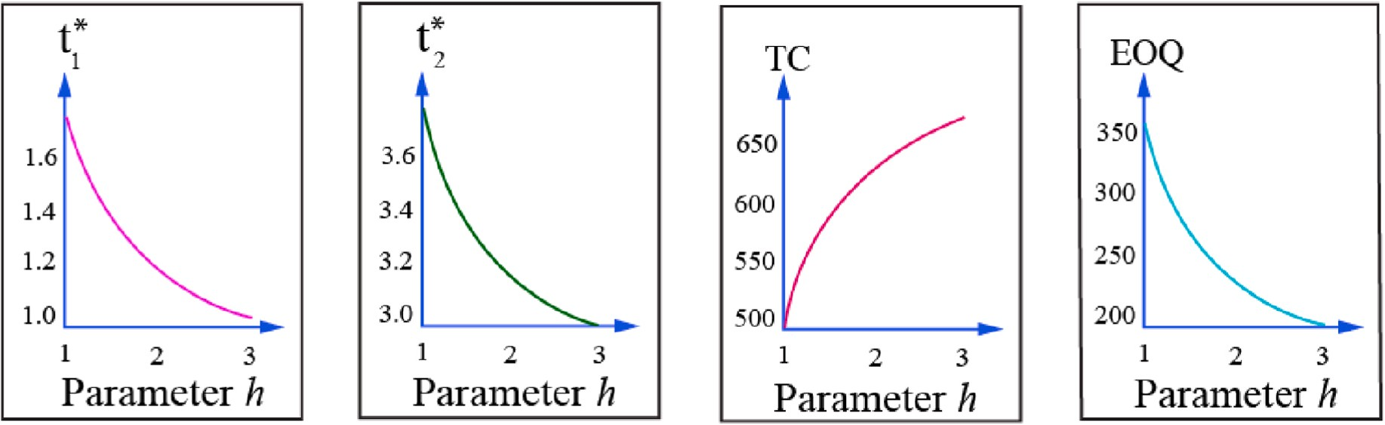**Fig. 11.** The Influence of Parameter ‘h’ on *t*∗, *T*∗, *TIC*∗ and *q*∗ It is observed from Fig. 11, with an increase in the holding cost of the inventory, the total inventory cost

1 2 2 2

increases. So, the goods cannot be held for a long time.

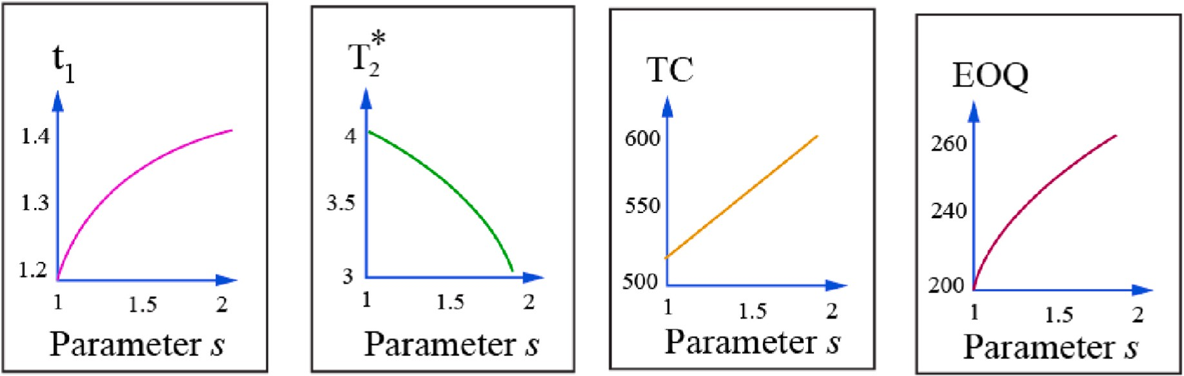**Fig. 12.** The Influence of parameter’s’ with *t*∗, *T*∗, *TIC*∗ and *q*∗ .

1 2 2 2

# Author contributions statement

**Palanivelu Saranya** and **Ekambaram Chandrasekaran** have contributed equally to the manuscript, **Palanivelu Saranya** and **Ekambaram Chandrasekaran** conducted the experiment(s), **Palani- velu Saranya** and **Ekambaram Chandrasekaran** analyzed the results. All authors have written and reviewed the manuscript.

# Declaration of competing interest

The authors declare that they have no known competing financial interests or personal relationships that could have appeared to influence the work reported in this paper.

# Data availability

No data was used for the research described in the article.

# References

1. Shi Y, Zhang Z, Zhou F, Shi Y. Optimal ordering policies for a single deteriorating item with ramp-type demand rate under permissible delay in payments. J Oper Res

Soc 2019;70(10):1848–68. <https://doi.org/10.1080/01605682.2018.1468865>.

1. [Ghare PM, Schrader GF. An inventory model for exponentially deteriorating items.](http://refhub.elsevier.com/S2590-0056(23)00032-2/sref2) [J Ind Eng 1963;14(2):238–43](http://refhub.elsevier.com/S2590-0056(23)00032-2/sref2).
2. Covert RP, Philip GC. An EOQ model for items with Weibull distribution

deterioration. AIIE Trans 1973;5(4):323–6. [https://doi.org/10.1080/](https://doi.org/10.1080/05695557308974918) [05695557308974918](https://doi.org/10.1080/05695557308974918).

1. Misra RB. Optimum production lot size model for a system with deteriorating inventory. Int J Prod Res 1975;13:495⋅505. [https://doi.org/10.1080/](https://doi.org/10.1080/00207547508943019) [00207547508943019](https://doi.org/10.1080/00207547508943019).
2. Chakrabarty T, Giri BC, Chaudhuri KS. An EOQ model for items Weibull distribution deterioration shortages and trended demand—an extension of Philips model. Comput Oper Res 1998;25(7/8):649–57. [https://doi.org/10.1016/S0305-](https://doi.org/10.1016/S0305-0548(97)00081-6)

[0548(97)00081-6](https://doi.org/10.1016/S0305-0548(97)00081-6).

1. Mandal B, Pal AK. Order level inventory system with ramp type demand rate for deteriorating items. J Interdiscipl Math 1998;1:49–66. [https://doi.org/10.1080/](https://doi.org/10.1080/09720502.1998.10700243) [09720502.1998.10700243](https://doi.org/10.1080/09720502.1998.10700243).
2. [Wu KS, Ouyang LY. A replenishment policy for deteriorating items with ramp type](http://refhub.elsevier.com/S2590-0056(23)00032-2/sref7) [demand rate. Proc. Nat. Sci. Council ROC(A) 2000;24:279–86](http://refhub.elsevier.com/S2590-0056(23)00032-2/sref7).
3. Manna SK, Chaudhuri KS. An EOQ model with ramp type demand rate, time

dependent deterioration rate, unit production cost and shortages. Eur J Oper Res 2006;171:557–66. <https://doi.org/10.1016/j.ejor.2004.08.041>.

1. Panda S, Senapati S, Basu M. Optimal replenishment policy for perishable seasonal

products in a season with ramp-type time dependent demand. Comput Ind Eng 2008;54:301–14. <https://doi.org/10.1016/j.cie.2007.07.011>.

1. Skouri K, Konstantaras I, Papachristos S, Ganas I. Inventory models with ramp type

demand rate, partial backlogging and Weibull deterioration rate. Eur J Oper Res 2009;192:79–92. <https://doi.org/10.1016/j.ejor.2007.09.003>.

1. Skouri K, Konstantaras I, Manna SK, Chaudhuri KS. Inventory models with ramp

type demand rate, time dependent deterioration rate, unit production cost and shortages. Ann Oper Res 2011;191:73–95. [https://doi.org/10.1007/s10479-011-](https://doi.org/10.1007/s10479-011-0984-2) [0984-2](https://doi.org/10.1007/s10479-011-0984-2).

1. Ahmed MA, Al-Khamis TA, Benkherouf L. Inventory models with ramp type demand rate, partial backlogging and general deterioration rate. Appl Math

Comput 2013;219(9):4288–307. <https://doi.org/10.1016/j.amc.2012.09.068>.

1. Sanni SS, Chukwu WIE. An economic order quantity model for Items with three-

parameter Weibull distribution deterioration, ramp-type demand and shortages. Appl Math Model 2013;37:9698–706. [https://doi.org/10.1016/j.](https://doi.org/10.1016/j.apm.2013.05.017) [apm.2013.05.017](https://doi.org/10.1016/j.apm.2013.05.017).

1. [Amutha R, Chandrasekaran E. An EOQ model for deteriorating items with](http://refhub.elsevier.com/S2590-0056(23)00032-2/sref14) [quadratic demand and tie dependent holding cost. Int J Emerg Sci Eng 2013;1(5):](http://refhub.elsevier.com/S2590-0056(23)00032-2/sref14)

[5–6](http://refhub.elsevier.com/S2590-0056(23)00032-2/sref14).

1. Srivastava S, Singh H. Deterministic inventory model for items with linear demand,

variable deterioration and partial backlogging. Int J Inventory Res 2017;4(4): 333–49. <https://doi.org/10.1504/IJIR.2017.090378>.

1. Singh T, Mishra PJ, Pattanayak H. An EOQ inventory model for deteriorating items

with time-dependent deterioration rate, ramp-type demand rate and shortages. Int J Math Oper Res 2018;12(4):423–37. [https://doi.org/10.1504/](https://doi.org/10.1504/IJMOR.2018.092103) [IJMOR.2018.092103](https://doi.org/10.1504/IJMOR.2018.092103).

1. Uthayakumar R, Karuppasamy SK. An EOQ model for deteriorating items with different types of time-varying demand in healthcare industries. J Anal 2019;27(1): 3–18. <https://doi.org/10.1007/s41478-018-0100-y>.
2. Shaikh AA, Panda GC, Khan MAA, Mashud AHM, Biswas A. An inventory model for deteriorating items with preservation facility of ramp type demand and trade

credit. Int J Math Oper Res 2020;17(4):514–51. [https://doi.org/10.1504/](https://doi.org/10.1504/IJMOR.2020.110895) [IJMOR.2020.110895](https://doi.org/10.1504/IJMOR.2020.110895).

1. Sharma A, Kaushik J. Inventory model for deteriorating items with ramp type

demand under permissible delay in payment. Int J Procure Manag 2021;14(5): 578–95. <https://doi.org/10.1504/IJPM.2021.117292>.

1. Palanivelu S, Chandrasekaran E. A deterministic replenishment policy for constant

deteriorating giffen goods with time-dependent demand. In: Proceedings of 2nd international conference on mathematical modeling and computational science.

Singapore: Springer; 2021. p. 29–30. [https://doi.org/10.1007/978-981-19-0182-](https://doi.org/10.1007/978-981-19-0182-9_28) [9_28](https://doi.org/10.1007/978-981-19-0182-9_28).

1. Supakar P, Mahato SK. An EPQ model with time proportion deterioration and ramp

type demand under different payment schemes with fuzzy uncertainties. Int J Syst Sci: Operations & Logistics 2022;9(1):96–110. [https://doi.org/10.1080/](https://doi.org/10.1080/23302674.2020.1826594) [23302674.2020.1826594](https://doi.org/10.1080/23302674.2020.1826594).

1. Fattahi Parviz, Hajipour Vahid, Hajiloo Sara. A multi-objective parameter-tuned soft computing based algorithm to optimize competitive congested location-pricing problem within multi-type service. Array 2021;10:100062. [https://doi.org/](https://doi.org/10.1016/j.array.2021.100062) [10.1016/j.array.2021.100062](https://doi.org/10.1016/j.array.2021.100062). ISSN 2590-0056.
2. Zhao Jing, Wang Lisha. Pricing and retail service decisions in fuzzy uncertainty environments. Appl Math Comput 2015;250. [https://doi.org/10.1016/j.](https://doi.org/10.1016/j.amc.2014.11.005) [amc.2014.11.005](https://doi.org/10.1016/j.amc.2014.11.005). ISSN 0096-3003.
3. Pinto Rui, Gil Gonçalves. Application of artificial immune systems in advanced manufacturing. Array 2022;15:100238. [https://doi.org/10.1016/j.](https://doi.org/10.1016/j.array.2022.100238) [array.2022.100238](https://doi.org/10.1016/j.array.2022.100238). ISSN 2590-0056.
4. Abosaif Aghabi N, Hamza Haitham S. Quality of service-aware service selection algorithms for the internet of things environment: a review paper. Array 2020;8. <https://doi.org/10.1016/j.array.2020.100041>. ISSN 2590-0056.
5. Zambrano Valentina, Mueller-Roemer Johannes, Sandberg Michael, Prasad Talasila, Zanin Davide, , Peter Gorm Larsen, Loeschner Elke,

Thronicke Wolfgang, Pietraroia Dario, Landolfi Giuseppe, Fontana Alessandro, Laspalas Manuel, Antony Jibinraj, Poser Valerie, Kiss Tamas, Bergweiler Simon, Pena Serna Sebastian, Izquierdo Salvador, Viejo Ismael, Juan Asier,

Serrano Francisco, Stork Andr´e. Industrial digitalization in the industry 4.0 era: classification, reuse and authoring of digital models on Digital Twin platforms. Array 2022;14:100176. <https://doi.org/10.1016/j.array.2022.100176>. ISSN 2590-

0056.