Available online at [www.sciencedirect.com](http://www.sciencedirect.com/)

**ScienceDirect**

AASRI Procedia 4 (2013) 160 – 166

2013 AASRI Conference on Intelligent Systems and Control

Optimization of Semi-Active Suspension System Using Particle Swarm Optimization Algorithm

Abroon Jamal Qazia,*, Umar A. Farooquib, Afzal Khana, M. Tahir Khana, Farrukh Mazharb, Ali Fiaza

*aDepartment of Mechanical Engineering, University of Engineering and Technology, Peshawar, Pakistan*

*bNational University of Science and Technology, Islamabad, Pakistan*

**Abstract**

The paper involves modeling of quarter car models of passive and various semi-active suspension systems. Semi-active suspension is better than the passive and active suspensions based on optimum performance within the constraints of weight and operational cost. Fuzzy logic controllers are incorporated in the design scheme of semi-active models. Fuzzy logic based systems can handle non-linearities through heuristic rules. Particle swarm optimization technique is applied in order to determine the optimized scaling factors keeping the normalized ranges of inputs and output of fuzzy logic controller. The performance of resulting optimized system is compared with different systems based on various control algorithms (including passive system). The models are compared for attributes of road handling and ride comfort. The results clearly manifest supremacy of fuzzy logic based particle swarm optimized semi-active suspension system in relation to all other systems. The research presents an innovative approach of utilizing relative displacement and relative velocity as the input parameters resulting in no overshoot of the suspension displacement.

© 2013 The Authors. Published by Elsevier B.V. Open access under [CC BY-NC-ND license.](http://creativecommons.org/licenses/by-nc-nd/3.0/)

© 2013 Published by Elsevier B.V.

Selection and/or peer review under responsibility of American Applied Science Research Institute

Selection and/or peer review under responsibility of American Applied Science Research Institute

*Keywords:* semi-active suspension; fuzzy logic controller; heuristic rules; particle swarm optimization

* Corresponding author. Tel.: +923455420132.

*E-mail address:* [abroon_qazi@hotmail.com.](mailto:abroon_qazi@hotmail.com)

2212-6716 © 2013 The Authors. Published by Elsevier B.V. Open access under [CC BY-NC-ND license.](http://creativecommons.org/licenses/by-nc-nd/3.0/) Selection and/or peer review under responsibility of American Applied Science Research Institute doi:10.1016/j.aasri.2013.10.025

# Introduction

The main function of a suspension system is to provide the shock absorption in automobiles. Besides carrying the weight of the vehicle, it attempts to minimize or eliminate vibrations that may be induced by a variety of sources including road surface irregularities, aerodynamics forces and non-uniformity of the tire/wheel assembly [1]. The development of electrorheological (ER) and magnetorheological (MR) fluids has materialized the manufacturing of controllable dampers. The use of active and semi-active suspensions has increased because the passive suspension systems cannot meet the conflicting requirements [2].

During the last decades, fuzzy logic has implemented very fast since the first paper in fuzzy set theory, which is now considered to be the seminal paper of the subject, was written by Zadeh [3], who is considered the founding father of the field. Mamdani [4] developed Zadeh`s work and demonstrated the application of Fuzzy Logic Control (FLC) for a small model steam engine. It is difficult to control the parameters of the fuzzy logic control system through manual procedure. Therefore, important scaling factors are tuned by means of an appropriate optimization technique. Particle swarm optimization (PSO) method performs better in terms of convergence and computation time. This technique has been widely used in engineering problems [5].

This paper presents quarter car passive and semi-active suspension systems modeled in Simulink. The inputs and output of optimized fuzzy logic controller are normalized and gain factors are incorporated in the system. The gain factors are evaluated by performing off-line tuning method using PSO technique. Based on the optimized parameters, the maximum output of the damper is selected. Various models are designed on the basis of various control algorithms. All the models are compared for road handling and ride comfort. Section 2 describes modeling of the systems along with the implementation of PSO technique. Section 3 discusses the simulation results while Section 4 presents the conclusion.

# Modeling of Systems

This section explains the modeling of systems. The block diagram of PSO tuned fuzzy logic control system is described in Fig. 1.

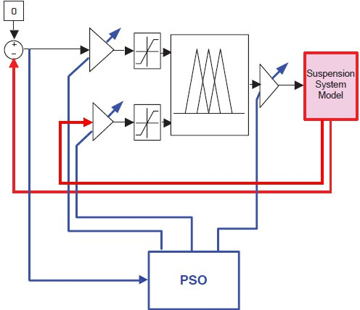

A

Controller

Scaling Factor

C

F

Scaling

B Normalized Factor

Scaling Factor

Fig. 1. Block diagram of PSO tuned fuzzy logic control system

* 1. *Quarter Car Parameters and Road Profile*

The quarter car model has two degrees of freedom. In order to simulate the systems, quarter car parameters have been taken from reference data [6]. Road disturbance profile comprising a pulse is modeled for carrying out a comparison between passive and fuzzy logic based suspension systems as shown in Fig. 2.

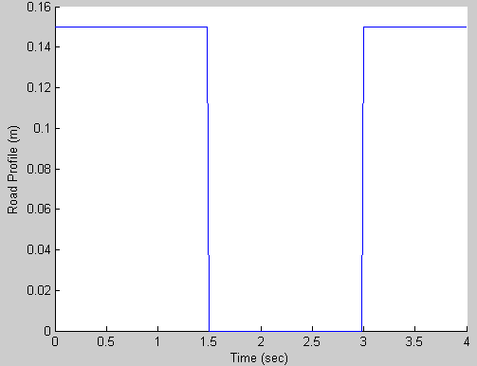

Fig. 2. Road disturbance profile

* 1. *Optimized Fuzzy Logic Controller*

For a semi-active suspension model, the damping coefficient needs to be varied. In order to incorporate the modulation of damping coefficient, a fuzzy logic controller is incorporated in the design scheme. Fuzzification interface, fuzzy rule base, decision making logic and defuzzification interface are the main blocks of a fuzzy logic system..

Fuzzification involves transformation of crisp values into linguistic variables that are further manipulated by fuzzy rule base and decision making process. Defuzzification transforms the linguistic variables back to crisp values that are fed into the plant again. In current research, the proposed fuzzy logic controller takes two inputs; relative displacement and relative velocity, while output of the controller is desired damping coefficient. Each of the inputs comprises three membership functions; N (triangular), Z (singleton) and P (triangular), while the output variable consists of three membership functions; S (triangular), M (Gaussian) and L (triangular).

Based on the three membership functions of each input variable, a total of nine rules are formulated. All the input and output variables have been normalized having ranges of [-1,1] and [0,1] respectively. Mamdani inference system is selected employing centroid defuzzification method.

* 1. *Particle Swarm Optimization (PSO)*

PSO is a bio-inspired technique based on the behavior exhibited by swarms of birds and schools of fish. The algorithm searches through an n-dimensional problem in order to optimize an objective function. The

strength of this technique is attributed to its relative simplicity and better convergence to reasonable solutions with avoidance of local minima. The swarm comprises a fixed number of particles that develop a collaborative search of an optimal solution.

Each particle optimizes a set of three scaling factors; A, B and C. *Libest* indicates the best known position for each particle while *Gbest* denotes the corresponding best known position for the complete swarm. The position of each particle (*pi*) is updated by velocity (*vi*) in the *k+1* iteration, as given by (1) and (2).

*vi* (*k *1)

*w * *vi* (*k*)  *c*1

 *r*1 (*k* )

 (*Libest*

*pi* (*k* ))  *c*2

 *r*2 (*k*)

 (*Gbest*

*pi* (*k* ))

*(1)*

*pi* (*k *1)

*pi* (*k*)

 *vi* (*k* )

*(2)*

where *c1* and *c2* indicate cognitive and social accelerations for the local best and global best positions respectively, w is the inertial weight constant and *r1(k)* and *r2(k)* denote random numbers generated in the uniform distribution domain of [0,1].

# Simulation Results and Discussion

This section describes the simulation results followed by a detailed discussion. The fuzzy logic controller is designed in Matlab Fuzzy Tool Box while simulations are performed in Simulink. The PSO algorithm is programmed in Matlab and executed to determine the three optimized gain factors. Parameters used for PSO algorithm are described in Table 1.

Table 1. PSO algorithm parameters

**Parameter Symbol**

Swarm Size 30

Number of Iterations 30

Unknown Variables 3

Cognitive Acceleration 1.5

Social Acceleration 1.8

Inertial Weight 0.6

Optimized scaling factors obtained through PSO algorithm for the optimized fuzzy based semi-active suspension system are A = 24.39, B = 15.46, and C = 3954.3.

* 1. *Systems based on Various Control Algorithms*

In order to evaluate the performance of the fuzzy logic based semi-active suspension systems, fuzzy based skyhook, groundhook and hybrid systems have been developed and simulated. The skyhook system is based on the strategy of minimizing the vibrations of suspension, groundhook system controls the vibrations experienced by the tire and the hybrid system is designed on the combined strategies of both the systems.

Fig. 3 and Fig. 4 depict the performance results of various systems based on control algorithms in response to pulse road disturbance. Tire displacement is a good indicator of road handling while suspension displacement is a measure of ride comfort.

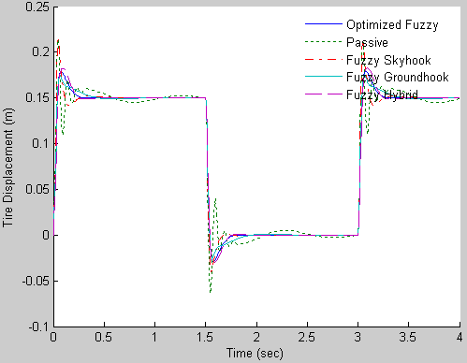

Fig. 3. Tire displacement for various control algorithms

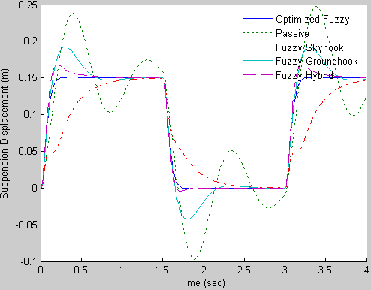

Fig. 4. Suspension displacement for various control algorithms

Values of important performance parameters of various control algorithms have been tabulated in Table 2 in relation to pulse road disturbance. The shaded values indicate percent overshoot while the non-shaded values indicate the stabilizing time expressed in seconds. Furthermore, top two values in each grid relate to the initial disturbance and the bottom ones correspond to the second part of the disturbance.

Table 2. Performance comparison of various control techniques for pulse road profile

|  |  |  |  |  |  |  |  |  |  |  |
| --- | --- | --- | --- | --- | --- | --- | --- | --- | --- | --- |
| **Parameters** | **Control Algorithms** | | | | | | | | | |
| ***Optimized Fuzzy Passive Fuzzy Skyhook Fuzzy Groundhook Fuzzy Hybrid*** | | | | | | | | | |
| ***Tire Displacement*** | 20 | 0.25 | 40 | - | 20 | 0.5 | 16.7 | 0.4 | 21.3 | 0.3 |
| -2.9 | 1.75 | -6.4 | - | -4 | 1.8 | -2.5 | 2 | -3 | 1.8 |
| ***Suspension Displacement*** | 0 | 0.25 | 60 | - | 0 | 1.25 | 28 | 1.25 | 13.3 | 1 |
| 0 | 1.75 | -10 | - | 0 | 2.75 | -4.3 | 2.75 | -0.4 | 1.8 |

Shaded cells indicate percentage overshoot Unshaded cells indicate stabilizing time in seconds

The optimized fuzzy system outperforms all other systems in the domain of suspension displacement. There is no overshoot and the system gets stabilized rapidly in relation to other systems in comparison. Therefore, the optimized fuzzy system gives the best ride comfort among all the control algorithms. Passive system does not stabilize at all in case of suspension displacement. Fuzzy hybrid combines the strategies of skyhook and groundhook control algorithms. In terms of tire displacement, the best stabilizing time periods are depicted by the optimized fuzzy logic system while groundhook offers the minimum percent overshoot. However, optimized fuzzy system is still comparable with the groundhook system in vehicle handling.

# Conclusion

The paper has demonstrated successful application of hybrid artificial intelligence techniques in designing a semi-active suspension system. Both passive and semi-active suspension systems have been modeled in Simulink. The input and output membership functions of optimized fuzzy system have been normalized because of the incorporation of scaling factors. The performance of optimized fuzzy logic controlled system is much better in comparison with the passive system and other control schemes in terms of road handling and ride comfort.

# References

1. Anil Shirahatt, Pravin Panzade and Kulkarni M M. Optimal design of passenger car suspension for ride and road holding . Journal of Brazilian Society of Mechanical Science & Engineering, 2008, 30(1): 66-76.
2. Martins I, Esteves M, Pina da Silva F, Verdelho P. Electromagnetic hybrid active-passive vehicle suspension system. 49th IEEE Vehicular Technology Conference, Houston, USA, 1999, 3: 2273-2277.
3. Zadeh L A. Fuzzy sets. Information and Control, 1965, 8(3): 338-353.
4. Mamdani E and Assilian S. An experiment in linguistic synthesis with a fuzzy logic controller. International Journal of Man-Machine Studies, 1975, 7(1): 1-13.
5. Rini D P, Shamsuddin S M, and Yuhaniz S S. Particle swarm optimization: Technique, system and challenges. International Journal of Computer Applications, 2011, 14(1): 19–26.
6. Abu-Khudhair A, Muresan R and Yang S X. Fuzzy control of semi-active automotive suspensions. IEEE International Conference on Mechatronics and Automation, Changchun, China, Aug 2009, 2118-2122.