[Artificial Intelligence in Agriculture 5 (2021) 1–12](https://doi.org/10.1016/j.aiia.2020.11.002)

Contents lists available at [ScienceDirect](http://www.sciencedirect.com/science/journal/)

Artificial Intelligence in Agriculture

journal homepage: [http://www.keaipublishing.com/en/journa ls/artificial- intelligence- in-agriculture/](http://www.keaipublishing.com/en/journals/artificial-intelligence-in-agriculture/)

[](http://crossmark.crossref.org/dialog/?doi=10.1016/j.aiia.2020.11.002&domain=pdf)Optimizing the seed-cell filling performance of an inclined plate seed metering device using integrated ANN-PSO approach

C.M. Pareek a,⁎, V.K. Tewari a, Rajendra Machavaram a, Brajesh Nare b

a *Agricultural and Food Engineering Department, Indian Institute of Technology Kharagpur, West Bengal 721302, India*

b *Indian Council of Agricultural Research-Central Potato Research Station, Jalandhar, Punjab 144026, India*

a r t i c l e i n f o

*Article history:*

Received 30 May 2020

Received in revised form 19 November 2020 Accepted 24 November 2020

Available online 27 November 2020

*Keywords:*

Precision planter

Inclined plate seed metering device Cell fill percentage

ANN PSO

a b s t r a c t

Uniform seed distribution within the row is the prime objective of precision planters for better crop growth and yield. Inclined plate planters are generally used for sowing bold seeds like maize, groundnut, chickpea, and their operating parameters like the forward speed of operation, the seed metering plate inclination, and the seed level in the hopper affect the cell fill and subsequently the uniform seed distribution. Therefore, to achieve precise seed distribution, these parameters need to be optimized. In the present study, out of the different optimization tech- niques, a new intelligent optimization technique based on the integrated ANN-PSO approach has been used to achieve the set goal. A 3–5-1 artificial neural network (ANN) model was developed for predicting the cell fill of inclined plate seed metering device, and the particle swarm optimization (PSO) algorithm was applied to obtain the optimum values of the operating parameters corresponding to 100% cell fill. The most appropriate optimal values of the forward speed of operation, the seed metering plate inclination, and the seed level in the hopper for achieving 100% cell fill were found to be 3 km/h, 50-degree, and 75% of total height, respectively. The pro- posed integrated ANN-PSO approach was capable of predicting the optimal values of operating parameters with a maximum deviation of 2% compared to the experimental results, thus confirmed the reliability of the pro- posed optimization technique.

© 2020 The Authors. Publishing services by Elsevier B.V. on behalf of KeAi Communications Co. Ltd. This is an open access article under the CC BY-NC-ND license (<http://creativecommons.org/licenses/by-nc-nd/4.0/>).

1. Introduction

In the Indian agriculture scenario, the inclined plate planters are popularly used for bold seeds like maize, groundnut, soybean, chickpea, cotton, gram, and sunflower as these planters provide better seeding performance with lower seed damage as compared to the horizontal and vertical plate planters. In these planters, the seed metering device consists of a metering plate with cells around its periphery and rotates in an inclined plane. During the seed metering process, the metering plate passes through a seed hopper, lifts the seeds to the top of the plate travel, and drops them into the seed delivery tube (Kepner et al*.,*1978). In the ideal condition, each cell of the seed metering plate should occupy one seed and meter it into the seed tube, which means there should be 100% cell fill, which is the prerequisite for achieving the uni- form seed distribution within the row. The accomplishment of the uni- form seed distribution is a highly desirable phenomenon in the precision planting operation, as it results in better germination and emergence and increases the crop yield by allowing more efficient use of soil moisture, nutrients, and light (Donald, 1963). However, under ac- tual field conditions, missing and multiple seed drop are inevitable and

* Corresponding author.

*E-mail address:* [chaitanyapareek@gmail.com](mailto:chaitanyapareek@gmail.com) (C.M. Pareek).

eventually lead to the non-uniform seed distribution. In the case of an inclined plate seed metering device, the uniform seed distribution is sig- nificantly affected by the forward speed of operation, the seed metering plate inclination, and the seed level in the hopper (Chhinnan et al., 1975; Chauhan et al., 1999; Yadachi et al., 2013; Sharma et al., 2013). Kepner et al. (1978) also reported that, in cell-type seed metering de- vices, the most uniform seed distribution is usually obtained with cell speed that gives about 100% average cell fill. This cell speed directly de- pends on the forward speed of operation for the given overall gear ratio between the drive wheel and the seed metering plate. Thus, it is be- lieved that a significant reduction in the non-uniformity of seed distri- bution could be achieved by selecting the best optimal operating parameters corresponding to 100% cell fill under laboratory conditions before going to the field. For this purpose, first, the seed-cell filling per- formance of an inclined plate metering device needs to be modeled, and the developed model is then linked with an appropriate optimization technique to obtain the best optimal operating parameter settings cor- responding to 100% cell fill.

In this study, among the various modeling techniques, the artificial

neural network (ANN) modeling approach was adopted for predicting the cell fill corresponding to the different operating parameters of an in- clined plate seed metering device. The ANN is a data-driven computa- tional modeling tool inspired by the functioning of the human brain.

<https://doi.org/10.1016/j.aiia.2020.11.002>

2589-7217/© 2020 The Authors. Publishing services by Elsevier B.V. on behalf of KeAi Communications Co. Ltd. This is an open access article under the CC BY-NC-ND license ([http://](http://creativecommons.org/licenses/by-nc-nd/4.0/) [creativecommons.org/licenses/by-nc-nd/4.0/](http://creativecommons.org/licenses/by-nc-nd/4.0/)).

Its high learning ability and information processing potentiality make it suitable for complex nonlinear modeling without prior knowledge about the input-output relationships, which is difficult to handle with the statistical approach. In the past, this modeling approach was suc- cessfully applied for the modeling of different agricultural machines' op- erations (Kumar et al., 2009; Anantachar et al., 2010; Chandel et al., 2019; Gundoshmian et al., 2019; Zhang et al., 2019; Nádai et al., 2020), and these methods exhibit better modeling capabilities com- pared to the statistical techniques (Kumar et al., 2009; Anantachar et al., 2010).

So far, in order to enhance the precision of agricultural machines' op- erations, several optimization techniques were utilized to find out the best optimal operating parameter settings. In these studies, most of the researchers applied statistical optimization techniques like the Taguchi method (TM) and the response surface methodology (RSM) for optimizing the agricultural machines' design and operating parame- ters (Yazgi and Degirmencioglu, 2007; Singh et al., 2008; Hosseini and Shamsi, 2012; Ozturk et al., 2012); but in recent years, for such optimi- zation studies, the interest towards the evolutionary algorithms (EAs) like the genetic algorithm (GA) and the differential evolution (DE) algo- rithm (Kumar et al., 2009; Yuan et al., 2010; Golpira and Golpîra, 2017; Xu et al., 2017; Li et al., 2019; Zhang et al., 2019) has been increased as these approaches are comparatively less time consuming and more eco- nomical. In this study, a relatively new optimization technique, i.e., the particle swarm optimization (PSO) (Kennedy and Eberhart, 1995; Eberhart and Kennedy, 1995), was used to optimize the operating pa- rameters of an inclined plate seed metering device. This technique has been successfully applied in various optimization studies (Eberhart and Shi, 2001), including constrained parameter optimization problems (Hu and Eberhart, 2002). Moreover, it is relatively easy to implement and has fewer parameters to adjust as compared to GA. Furthermore, it also has the features of genetic algorithms (GAs) and evolution strat- egies (ESs) (Zŭperl et al., 2007).

So, based on the above literature reviews, it is clearly evident that the ANN modeling approach integrated with the PSO algorithm could be used for modeling and optimization of the seed-cell filling perfor- mance of an inclined plate seed metering device. Therefore, the present study aims to apply a new integrated ANN-PSO-based intelligent opti- mization approach for determining the optimal operating parameters of an inclined plate seed metering device corresponding to 100% cell fill. With this aim, an artificial neural network model for predicting the cell fill was developed with the experimental data. The developed ANN model was then coupled with a particle swarm optimizer to re- trieve the optimal operating parameters for achieving 100% cell fill. The confirmation tests were also carried out to verify the reliability of the proposed optimization approach.

1. Materials and methods
2. *Experimental setup*

This research was carried out at the farm machinery workshop of the agricultural and food engineering department, IIT Kharagpur, India. The test setup consisted of an inclined plate seed metering device coupled to a DC motor via a chain drive, as shown in Fig. 1. A DC motor controller was used to synchronize the motor speed corresponding to the forward speed of operation, and a proximity sensor was provided at the motor's output shaft to measure the motor's running speed. An Infrared (IR) sensor was employed at the bottom end of the seed delivery tube to de- tect and count the number of seeds. An Arduino UNO microcontroller for synchronizing the sensor signals and a laptop for collecting the data were also used in the test setup. The schematic diagram of the lab- oratory test setup is shown in Fig. 2.

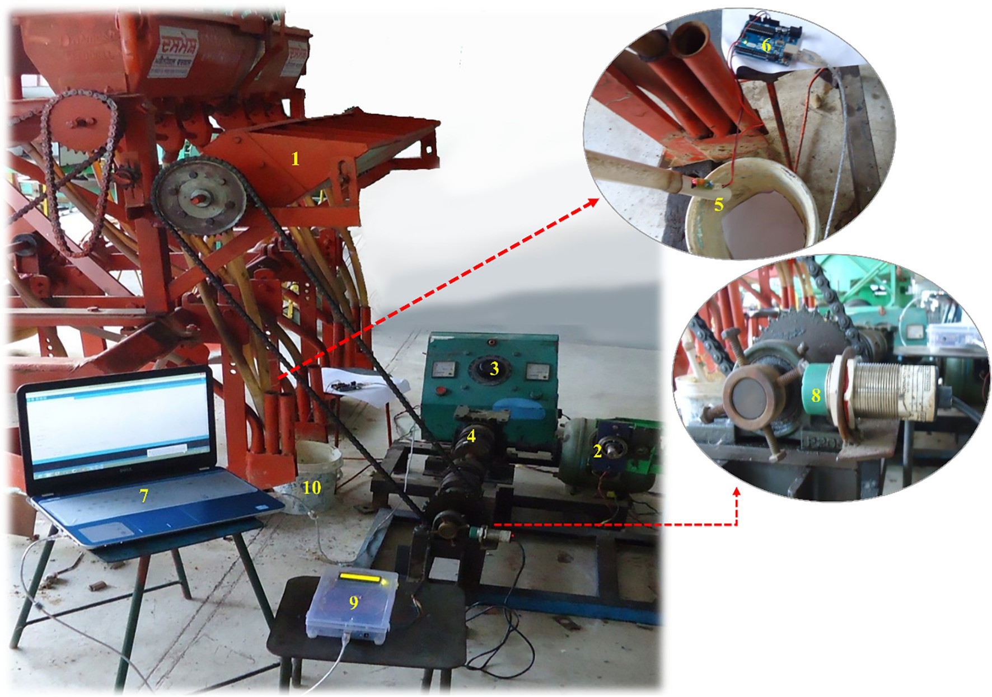

Fig. 1. Laboratory test setup for measuring the cell fill. 1. Inclined plate seed metering device; 2. Electric motor; 3. Motor controller; 4. Gear reduction unit; 5. Infrared sensor; 6. Arduino microcontroller; 7. Laptop; 8. Proximity sensor; 9. LCD Display unit for motor speed; 10. Collecting pan.

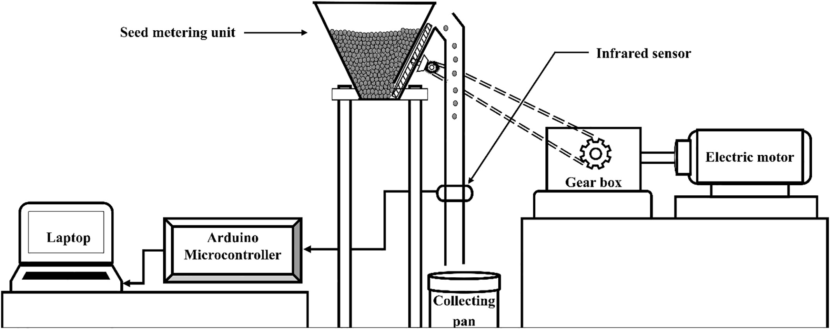

Fig. 2. Schematic diagram of test setup for measuring the cell fill.

1. *Data collection*

In this study, the forward speed of operation, the seed metering plate inclination, and the seed level in the hopper were selected as inde- pendent parameters, and the cell fill of inclined plate seed metering de- vice was considered as the dependent parameter. The seed metering plate inclination is defined as the angle of the metering plate measured from the horizontal axis, and it can be varied by tilting the seed hopper upward or downward with respect to the hopper mounting frame with the help of a nut-bolt arrangement. The cell fill of an inclined plate seed metering device is defined as the total number of seeds discharged by the metering mechanism in a specific number of the metering plate's revolutions divided by the total number of cells passed through the dis- charge point in that revolutions. It is determined using Eq. (1).

N × 100

respectively, based on 20 cm seed spacing and the given overall gear ratio between the drive wheel and the seed metering plate. The seeds passing through the seed delivery tube were detected by the IR sensor interfaced with the Arduino microcontroller, and the counted seed numbers were recorded in the laptop with the help of a serial monitor app during the experiment. Initially, the test was conducted by varying the forward speed of operation while keeping other parameters con- stant. Similarly, other observations were taken by varying all indepen- dent parameters one by one while keeping the rest parameters constant. The test setup was run for ten revolutions of the seed metering plate corresponding to each set of independent parameters. The system counted the metered seeds in 10 revolutions, and cell fill was deter- mined. Three replications were taken for each set of conditions, and the corresponding average cell fill was computed. These data were fur- ther utilized to develop the ANN model for predicting the cell fill.

Fc = s

Nc

(1)

Where, FC denotes the cell fill (%), and Ns and Nc represent the total number of metered seeds and the total number of cells passing through the discharge point, respectively.

In this study, hybrid maize seeds (Suvarna NMH-589) were used. The physical properties of the trial seeds are given in Table 1. The labo- ratory tests were carried out at three levels of the seed metering plate inclination, four levels of the forward speed of operation, and three levels of the seed level in the hopper of the inclined plate seed metering device. The levels of these variables are given in Table 2. The random- ized block experimental design was adopted, and a total of 36 sets of tests were conducted in the laboratory. During the experiments, the seed spacing was not directly measured; instead, the total number of delivered seeds was counted, and the corresponding cell fill value was computed. The DC motor was set to run at 26, 40, 52, and 65 rpm for re- sembling the forward speed of operation at 2, 3, 4, and 5 km/h,

1. *Neural network modeling for prediction of the cell fill*

In this study, among different ANN models, a multilayer feed- forward ANN, which is very popular and widely used for solving complex problems due to its remarkable universal approximation capa- bilities, was employed for predicting the underlying relationship be- tween the cell fill and the operating parameters of an inclined plate seed metering device. This neural network consisted of three layers of neurons, i.e., the input layer, the hidden layers, and the output layer. The network output can be computed by applying hidden and outer layer activation functions, i.e., *fh*(.) and *fo*(.), to the weighted sum of the previous layer's inputs. The mathematical expression for the kth output is given using Eq. (2).

Table 1

Physical properties of maize seeds.

|  |  |  |
| --- | --- | --- |
| Physical property | Mean | Standard error |
| Length (l), mm | 10.52 | 0.15 |
| Width (w), mm | 9.27 | 0.13 |
| Thickness (t), mm | 4.31 | 0.09 |
| Sphericity (a), % | 71.20 | – |
| Thousand seed mass, g | 293.85 | – |

1

a calculated as a = (lwt)3 × 100%

l

Table 2

Experimental plan for laboratory test.

|  |  |  |  |
| --- | --- | --- | --- |
| S. No. | Variables | Levels | |
| A. | Independent variables |  | |
| 1. Seed metering plate inclination (θ) | | 3 | 40°, 50° and 60° |
| 2. Forward speed of operation (V) | | 4 | 2, 3, 4 and 5 km/h |
| 3. Seed level in hopper (L) | | 3 | 25%, 50% and 75% |

1. Dependent variable
   1. Cell fill (FC) in %

*y f* " *Nh W*

*f* *Ni W x*

*b* ! *b* #

function and given by Eqs. (4) and (5), respectively. The topology of de-

2 veloped ANN is shown in Fig. 3.

*k* = *o* ∑

*j*=1

*jk*. *h* ∑

*i*=1

*ij i* + ( *h* )*j*

+ ( *o*)*k*

( )

*f x* 1

*h* ( ) =

(1 + *e*−*x* )

,0 ≤ *f h* (*x*) ≤ 1 (4)

Where *yk* is the kth output variable; *xi* is the ith input variable; *fh* and *fo* are the activation functions in the hidden and the output layer, re- spectively. *i*, *j*, and k denote the input layer neuron, hidden layer neuron and output layer neuron, respectively, and given as *i* = 1,2 …*Ni*; *j* = 1,2…*Nh* and k = 1,2…*No*. *Wij* represents the connection weight between the ith input neuron and the jth hidden neuron. *Wjk* represents the con- nection weight between the jth hidden neuron and the kth output neu- ron. (*bh*)*j* denotes the bias for the jth neuron in the hidden layer, and (*bo*)*k* is the bias for the kth neuron in the output layer.

In this study, the MATLAB R2014b package was used for neural net- work modeling. The forward speed of operation (km/h), the seed metering plate inclination, and the seed level in the hopper (%) were considered as the model inputs, and the cell fill of the inclined plate seed metering device was taken as the model response. The number of neurons in the input and the output layers of the network were deter- mined by the number of input and output parameters, respectively (Lek and Guegan, 1999). Thus, the input and output layers had three and one neurons, respectively. The number of neurons in the hidden layer was selected by the trial and error method. The upper limit of the number of neurons in the hidden layer was determined using Eq. (3) (Armaghani et al., 2018) and computed as seven. Therefore, the number of neurons in the hidden layer was varied from one to seven, and the op- timum number of neurons was selected based on the minimum MSE

value of the network. The optimal value for hidden layer neurons was

(*k*+1)

*k*

*k k*

*k k*

*f o* (*x*) = *x*, −∞ ≤ *f o* (*x*) ≤ + ∞ (5)

Among various developed neural network training algorithms, the error backpropagation (EBP) training algorithm (Rumelhart et al., 1986) is most frequently used to train a neural network model. How- ever, this algorithm may get stuck in local minima and faces difficulty in finding out the global optimal solution, as it uses the gradient- descent search method; hence, it suffers from the problem of slow con- vergence. In order to avoid these drawbacks, the Levenberg–Marquardt backpropagation learning algorithm (Levenberg, 1944; Marquardt, 1963) was used in this study for training purpose, as this algorithm pro- duces better results than the other training methods for moderate-sized neural networks (Hagan and Menhaj, 1994; Kişi and Uncuoğlu, 2005; Kişi, 2007; Adamowski and Karapataki, 2010). This algorithm is a com- bination of the steepest descent and the Gauss-Newton algorithms. It possesses the speed advantage of the Gauss-Newton algorithm and the stability of the steepest descent method; hence, it exhibits fast and stable convergence.

During the Levenberg–Marquardt algorithm based training process, the connection weights and biases were adjusted iteratively using Eq. (6) for minimizing the error function, i.e., the mean squared error (MSE) between the target and the model-predicted cell fill values.

obtained as five. Thus, the hidden layer comprised of five neurons was *w*

incorporated between the neural network's input and output layers.

= *w* − *JT J*

+ *μI* −1*J e*

(6)

*Nh* ≤ 2*Ni* + 1 (3)

Where *Nh* denotes the maximum number of neurons in the hidden layer and *Ni* denotes the total number of neurons in the input layer.

The log-sigmoid transfer function (logsig) and linear transfer func- tion (purelin) were used in the hidden and outer layers as the activation

Where J denotes the Jacobian matrix, ek is the error in the network; I is the identity matrix, and μ is Levenberg's damping factor; *wk* and *w*(*k*+1) represent the current and the updated weights, respectively.

This algorithm's nature shifts between Gauss-Newton and steepest descent methods during the training process, depending upon the Levenberg's damping factor (μ). When μ is very small, this algorithm's behavior is similar to that of the Gauss-Newton method, whereas if μ

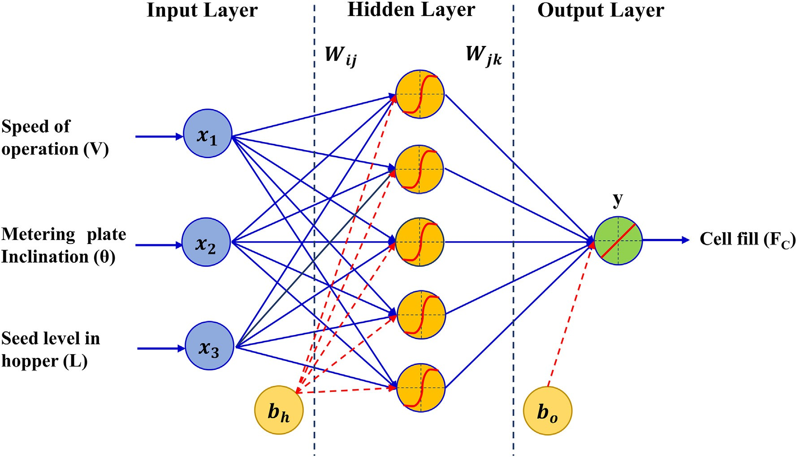

Fig. 3. Topology of developed neural network model (*x*1, *x*2 and *x*3 are input variables, and *y* is estimated output; *bh* and *bo* are the bias for the hidden layer and the output layer, respectively; *W*ij and *W*jk are the connection weights of input- hidden layer and hidden-output layer, respectively).

is very large, this algorithm acts like the steepest descent method (Yu and Wilamowski, 2011).

A major concern during the ANN training process is the overfitting phenomenon, which occurs because of memorizing the training data's trends by the network instead of establishing the underlying relation- ship between input and output datasets, and consequently, the devel- oped neural network exhibit minimal training error but large test error (i.e., error with unseen dataset), which indicated the poor gener- alization performance. Hence, in this study, the early stopping tech- nique (Prechelt, 1998; Tian et al., 2010) was adopted in the training process to avoid the overfitting issue and thus improve the generaliza- tion ability of the trained network. In this technique, the training dataset is randomly divided into three subsets, i.e., training set (70%), testing set (15%), and validation set (15%). The training set is utilized for comput- ing the gradient and adjusting the network weights and bias values to optimize network performance; the validation set is used to estimate network performance by monitoring the validation error during the training process and determine the training stopping point to avoid the overfitting. During the training process, initially, the training error

0.001, and the maximum validation checks before terminating the training process, which represents the number of successive iterations for which the validation performance fails to decrease, was taken as 6. The model was adaptively trained by the trial and error method, and the network connection weights were adjusted to minimize the mean squared error (MSE) between the target and model-predicted cell fill values.

The developed ANN model's predictive performance was evaluated using two statistical parameters, i.e., the coefficient of determination (R2) and the mean square error (MSE). The coefficient of determination (R2) is a goodness-of-fit measure that represents the robustness of the developed ANN model, and the mean square error (MSE) is a model error measure that estimates the accuracy of the predictive model. The higher R2 value and lower MSE value represent the better predictive performance of the developed ANN model. The coefficient of determi- nation (R2) and mean square error (MSE) were calculated using the fol- lowing equations:

*n*   2

∑ *Ya*−*Ya*

*YP* −*YP*

and the validation error drop rapidly with the number of iterations, as

the network is learning the underlying input-output relationship by *n n*

*R*2 = *i*=1

(8)

∑ *Ya*−*Ya* 2 ∑ *YP* −*YP* 2

modifying the network weights and bias values, and after that, the val- idation error begins to increase, as the network starts to memorize the

training examples. If the validation error repeatedly increases for a spec-

MSE

*i*=1

1 *n*

*i*=1

2

ified number of iterations, then the network training is terminated to avoid overfitting, and the network weights and bias values at the itera-

= ∑ (*Ya*−*YP* )

*i*=1

*n*

(9)

tion corresponding to the minimum validation error are stored as the final weights and bias for the trained network. The testing dataset is used to measure the generalization ability of the trained network via ex- perimental data, which were not being used in the training process.

In this study, 36 sets of samples obtained from the laboratory exper- iments were used for ANN modeling. The entire experimental dataset was randomly divided into two parts, i.e., the training set and the testing set. The training dataset consisted of approximately 70% (i.e., 25 sam- ples) of the total data and was used for calibrating and designing the ANN model. The testing dataset consisted of the remaining approxi- mately 30% (i.e., 11 samples) data and was used to assess the predictive performance of the developed ANN model. As the early stopping method was utilized during the network training process to avoid the overfitting issue, therefore the available training dataset was further di- vided into three subsets, i.e., training set (approximately 70% data; 17 samples), testing set (approximately 15% data; four samples), and vali- dation set (approximately 15% data; four samples). This partition of available training data was done within the Levemberg–Marquardt back-propagation algorithm during the network training process.

Before being utilized for ANN training, the experimental data need to

Where *Ya* and *YP* represent the experimental and model-predicted cell fill values, respectively; *Ya* and *YP* are the averages of experimental and model-predicted cell fill values, respectively; and n represents the total number of datasets.

1. *Sensitivity analysis*

Sensitivity analysis was carried out to evaluate each operating parameter's relative significance on the model-predicted cell fill values. The sensitivity analysis was conducted by using the Garson's algorithm (Garson, 1991). In this method, the relative importance of each input parameter is calculated using the absolute values of the connection weights of the developed ANN model. Therefore, it does not give any idea about the direction of the relationship between the independent and dependent variables of the ANN model. The relative importance (RI) of each input parameter of the well trained and tested ANN model is calculated using Eq. (10).

∑Nh Wij /∑Ni Wij × Wjk

RI(%)

j=1

i=1

× 100 (10)

ik ∑Ni n∑Nh W /∑Ni W × W o

=

be normalized in a range that commensurates with the limits of the ap- plied transfer functions to accelerate the training process and provide

i=1

j=1

ij

i=1

ij

jk

equal importance to all the variables during the network training. Al- though the sigmoid transfer function outputs are between 0 and 1, the data should be normalized in the range of 0.1 and 0.9 instead of between 0 and 1 to avoid sigmoid function's saturation, which hinders the learn- ing process. Therefore, in this study, the input variables were normal- ized within the interval [0.1, 0.9] using a linear transformation as given in Eq. (7) (Basheer and Hajmeer, 2000; Maier and Dandy, 2000).

*x* 0 1 0 8 *xo* −*xmin* 7

*n* = . + . ( )

*xmax* −*xmin*

Where *xn* and *xo* are the normalized and the original values of the in- put parameters, respectively; and *xmax* and *xmin* are the maximum and the minimum values of the input parameters, respectively.

In the training phase, the network's final weights and biases were se- lected using the training dataset. During the training process, the max- imum number of epochs and the minimum performance gradient were set as 1000 and 10–7, respectively. The damping factor (μ) was set to

Where: *RIik* is the relative importance of input variable *xi* on the out- put *yk*. *Ni* and *Nh* are the number of input and hidden neurons, respec- tively. *Wij* and *Wjk* represent the connection weights of input- hidden layer and hidden-output layer, respectively.

1. *Optimization of operating parameters using integrated ANN-PSO algorithm*
   1. *Basic particle swarm optimization (PSO) algorithm*

Particle swarm optimization (PSO) is a bio-inspired population- based metaheuristic algorithm. Its working mechanism imitates the so- cial behavior of the bird flocking. In this algorithm, each member of a given swarm, also called a particle, represents a potential solution to the given optimization problem. Each particle is allowed to move in the problem space with associated random position and velocity. At each iteration, the best position of each particle achieved so far among all iterations (i.e., personal best) and the best position of any particle achieved so far among all the particles (i.e., global best) are selected

by evaluating the objective function value for each particle. Each particle is accelerated towards its personal best and global best positions in each iteration with the initialization of weighted acceleration randomly by modifying its velocity and position.

Considering a D-dimensional search space, where *Xi* = (*xi*, 1, *xi*, 2…*xi*, *D*) and *Vi* = (*vi*, 1, *vi*, 2…*vi*,*D*) represent the position and velocity of the ith par- ticle, respectively. The position and velocity of the particles are updated by the following equations

*v*i,d(t + 1) = *wv*i,d(t) + c1r1 pi,d(t)−*x*i,d(t) + c2r2 p*g*,*d*(t)−*xi*,*d*(t) (11)

*Xi*,*d*(t + 1) = *Xi*,*d*(t) + *Vi*,*d*(t + 1) (12)

In which, *i* = 1,2, …..,n; n is the swarm size; d represents the dimen- sion index, d = 1,2, …D; t denotes the number of iteration. C1 and C2 are the acceleration coefficients, 0 < C1, C2 < 2; r1 and r2 are the random numbers, uniformly distributed between [0,1]; pi,d(t) denotes the personal best position of the ith particle in the given iteration *t*; p*g*,*d*(t) refers the global best position in the given iteration correspond- ing to the given swarm size, and w denotes the inertia weight factor. A large inertia weight helps to explore a large search space and facili- tates the PSO as a global search algorithm, while with a small inertia weight, PSO works like a local search algorithm. For any population- based optimization algorithm, generally, it is better to possess more global search ability at the starting phase and more local search ability during the ending phase of a simulation run. In PSO, this phenomenon can be achieved by decreasing the inertia weight linearly from a rela- tively large value to a small value throughout the PSO simulation run. This PSO variant with linearly varying inertia weight is called modified PSO, and it showed a significant improvement in the convergence per- formance of the PSO algorithm (Shi and Eberhart, 1998). The linearly varying inertia weight is determined by the following equation

25% ≤ X3 ≤ 75%

The working flowchart of the integrated ANN-PSO approach is shown in Fig. 4. Initially, the objective function and the constraints were defined; the PSO parameters, i.e., inertia weight, acceleration coefficients, swarm size, and maximum number of iterations were specified, and the particle swarm was initialized with random position and velocity. The cell fill was predicted using the developed ANN model, which was further utilized for calculating the objective function value for each particle. The particle with a lower objective function value was considered better than others, as the given optimization problem was a minimization problem. At each iteration, first, the personal best (pBest) and the global best (gBest) posi- tions were selected by evaluating the objective function values for each particle, and then each particle moved towards its pBest and the gBest po- sitions by updating its velocity and position. These steps were repeated until the convergence criteria, i.e., the maximum number of iterations was reached. The input parameters were optimized by PSO within the maximum number of iterations, and the particle's dimensions corre- sponding to the gBest at final iteration were taken as the optimal solution. The results obtained from the integrated ANN-PSO approach were veri- fied for its authentication. For that purpose, the confirmation tests were carried out using optimal parameter settings, and the experimental and the model-predicted cell fill values were compared for evaluating the ad- equacy of the proposed optimization technique.

1. Results and discussion
   1. *Effect of operating parameters on cell fill of seed metering device*

The laboratory tests were conducted for a total of 36 sets of condi- tions, considering the three levels of the seed metering plate inclination, four levels of the forward speed of operation, and three levels of seed

level in the hopper of inclined plate seed metering device. The data, col-

w(t) = w*max*− (t−1)[Wmax−Wmin]

−

T 1

(13)

lected from laboratory tests, were analyzed with respective each vari- able and graphically presented in Fig. 5.

Where W*max* and Wmin are the maximum and the minimum values of inertia weight, respectively; t is iteration number, and T is maximum number of iterations.

* 1. *Optimal operating parameters selection*

This optimization study aims to obtain the optimal values of inclined plate seed metering device's operating parameters, which results in achieving 100% cell fill. The underlying relationship between these oper- ating parameters and the cell fill was established using the ANN model- ing approach in the previous section. In order to determine the optimal operating parameters, the developed ANN model for predicting the cell fill was integrated with the PSO algorithm. The optimization was carried out by considering this design problem as a minimization problem hav- ing three design variables, i.e., the seed metering plate inclination (θ), the forward speed of operation (V), and the seed level in the hopper (L), which are denoted as *X1, X2, and X3*, respectively. The mathematical expression of this optimization problem can be given as follows:

*min* (*F*(*Xd*)) = *min* {|100−*Fc*|} (14)

Where *Xd* = [*X*1, *X*2, *X*3]*T* denotes the design variable vector, *F*(*Xd*) is the objective function of this optimization problem, and *Fc* is the cell fill pre- dicted using the developed ANN model. The goal of this optimization problem was to determine a set of design variables that minimized the objective function *F*(*Xd*) under the given constraints. The minimization of the objective function *F*(*Xd*) actually maximized the cell fill (*Fc*) to 100%.

The following variable bounds were used: 2 km/h ≤ X1 ≤ 5 km/h

40o ≤ X2 ≤ 60ο

From Fig. 5, it can be observed that the cell fill is reduced with an in- crease in the inclination angle of the seed metering plate from 40° to 60° in all the cases of the forward speed of operation and the seed level in the hopper, as the seed metering plate's lower inclination angle leads to more multiple seed drops. In contrast, the frequency of skips is more at a higher inclination angle of the seed metering plate. Similar re- sults were reported by Sharma et al. (2013) and Yadachi et al. (2013). It can also be observed that the cell fill is increased with an increase in the seed level in the hopper. It may be due to fewer chances of seeds to oc- cupy the cells, as the seed level in the hopper goes down. This result is in good agreement with the findings reported by Chhinnan et al. (1975) and Sharma et al. (2013). It is also indicated that the cell fill is negatively affected by the forward speed of operation. At a higher speed of opera- tion, the exposure time of cells for picking up the seeds is less, and the seeds also tend to fall back into the hopper due to high vibration. Both the events contribute to high skips and finally lower down the cell fill. The high cell fill at a slower speed is due to the high frequency of mul- tiple seed drops because of the more exposure time of cells. This result is supported by the finding of Chauhan et al. (1999) and Reddy et al. (2012). All the three operating parameters do not have the same effect on cell fill, which is evident from Fig. 5; therefore, it becomes necessary to optimize these operating parameters to achieve 100% cell fill and as- sure the uniform seed distribution.

* 1. *Performance evaluation of developed ANN model*

In this study, a 3–5-1 ANN model was developed to predict the cell fill of the inclined plate seed metering device using three independent variables, i.e., the forward speed of operation, the seed metering plate inclination, and the seed level in the hopper. The Levenberg– Marquardt backpropagation learning algorithm was adopted for the

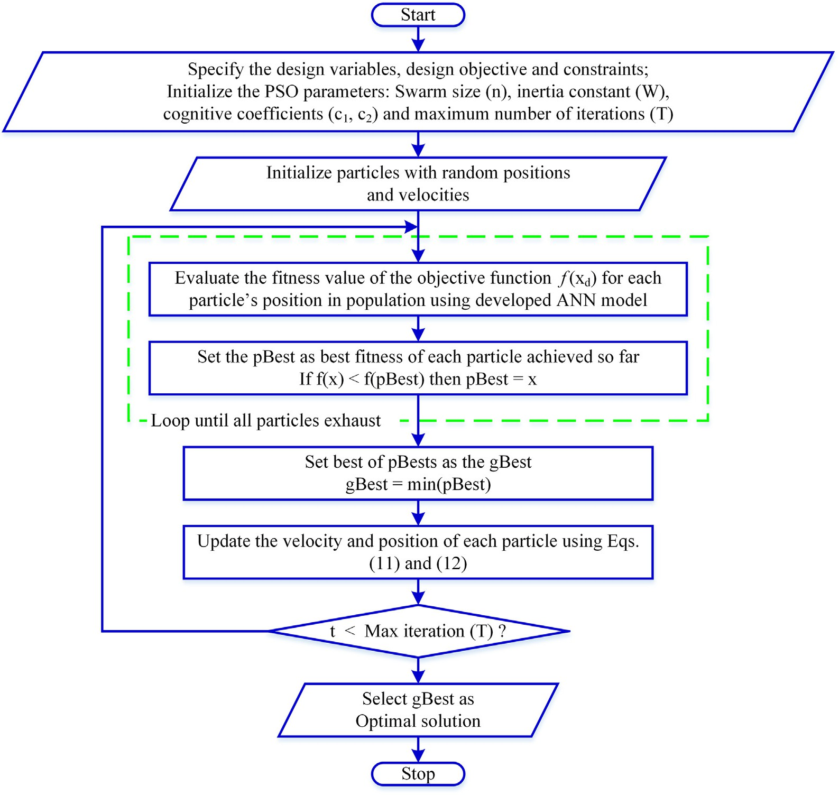

Fig. 4. Flowchart of the integrated ANN-PSO algorithm.

ANN training. The ANN model was adaptively trained by trial and error method until the convergence criteria, i.e., minimum mean squared error (MSE) between the target and model-predicted cell fill values,

was achieved. The developed ANN model's performance plot, demon- strating the variation in training, validation, and testing errors with the number of training epochs to assess the possibility of overfitting

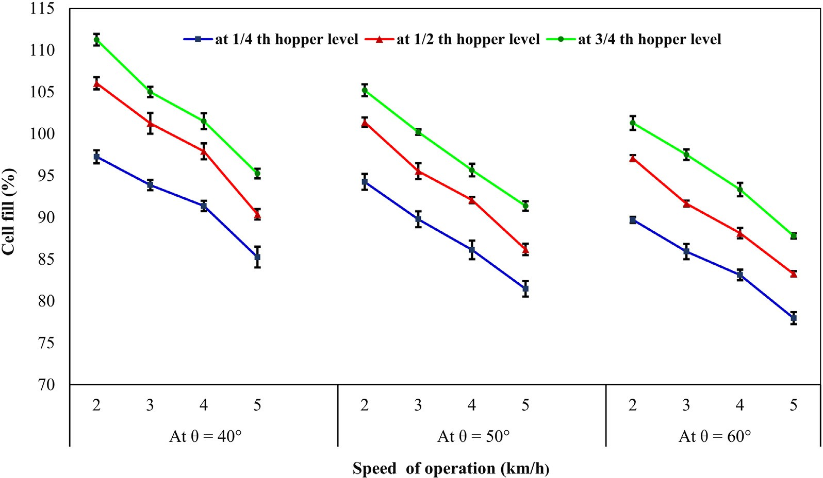

Fig. 5. Cell fill corresponding to various operating parameters (error bars represent standard deviation of triplicate measurements).

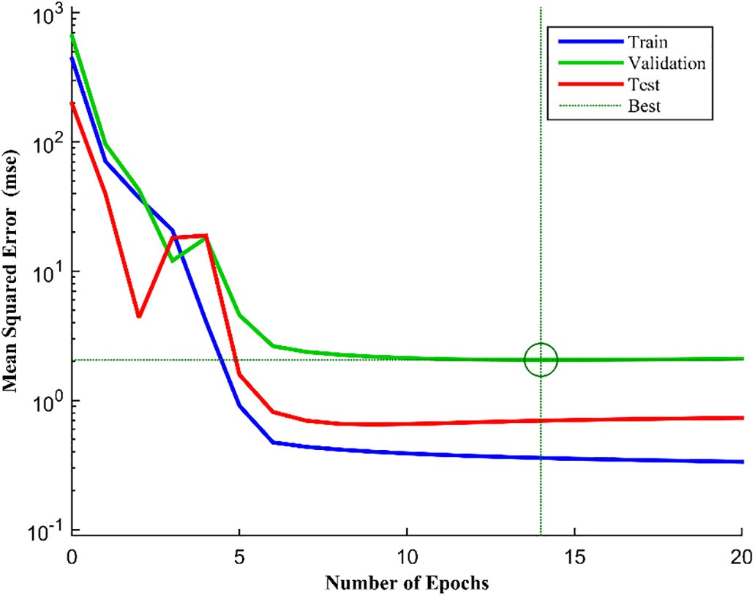

Fig. 6. Performance plot of developed ANN model during training process (best validation performance is 2.0563 at the 14th training epoch).

during the training process, is presented in Fig. 6. In this figure, the circle indicates the best validation performance, i.e., the lowest validation error (MSE = 2.0563), which was obtained at the 14th epoch, and the associated network weights and biases were selected as the final model weights and biases. The network training continued as long as the validation error decreased and terminated at the 20th epoch when the validation error increased for six consecutive iterations after the best validation performance (epoch 14). There may be a possibility of overfitting if the test error increases significantly before the increase in the validation error, but the current training performance plot does

not indicate any major problem with the training process, as the test and validation performance curves are showing very similar trends.

The training state plot of the developed ANN model, demonstrating the variation in performance gradient, Levenberg's damping factor (mu), and validation checks, is shown in Fig. 7. It can be seen that the gradient value was reduced to 0.18741 at the 20th epoch, and the value of the mu factor was 0.1 at that epoch. Moreover, the network training was terminated at the 20th epoch considering the six validation checks after the best validation performance (epoch 14) for avoiding any possible overfitting.

The neural network regression plots between ANN model-predicted and target cell fill values for the training set, validation set, test set, and the total experimental set with the Levenberg–Marquardt algorithm are shown in Fig. 8. The correlation coefficients (R) for training, testing, val- idation, and all dataset using the ANN model were 0.99654, 0.97809, 0.98846, and 0.99364, respectively. High R-values (more than 0.97) in the different phases indicate a good correlation between experimental and model-predicted cell fill values, which implies that the developed ANN model can predict the cell fill values with a higher accuracy.

The scatter plots comparing the experimental and model-predicted cell fill values for training and testing datasets are shown in Fig. 9 and Fig. 10, respectively. A high degree of regression (R2 = 0.9873) with a low MSE (0.6841) value for the training dataset indicates the excellent agreement between experimental and model-predicted cell fill values. Moreover, the R2 (0.9873) value for the training dataset implies that the developed ANN model can explain at least 98% of the variability in the measured cell fill values for the training phase.

Similarly, an excellent agreement can be observed between experi- mental and model-predicted cell fill values for the testing dataset as in- dicated by a high R2 (0.9825) value and low MSE (0.734) value, which also confirms the excellent generalization ability of the developed ANN model for predicting the cell fill. Furthermore, the R2 (0.9825) value for the testing dataset indicates that the developed ANN model

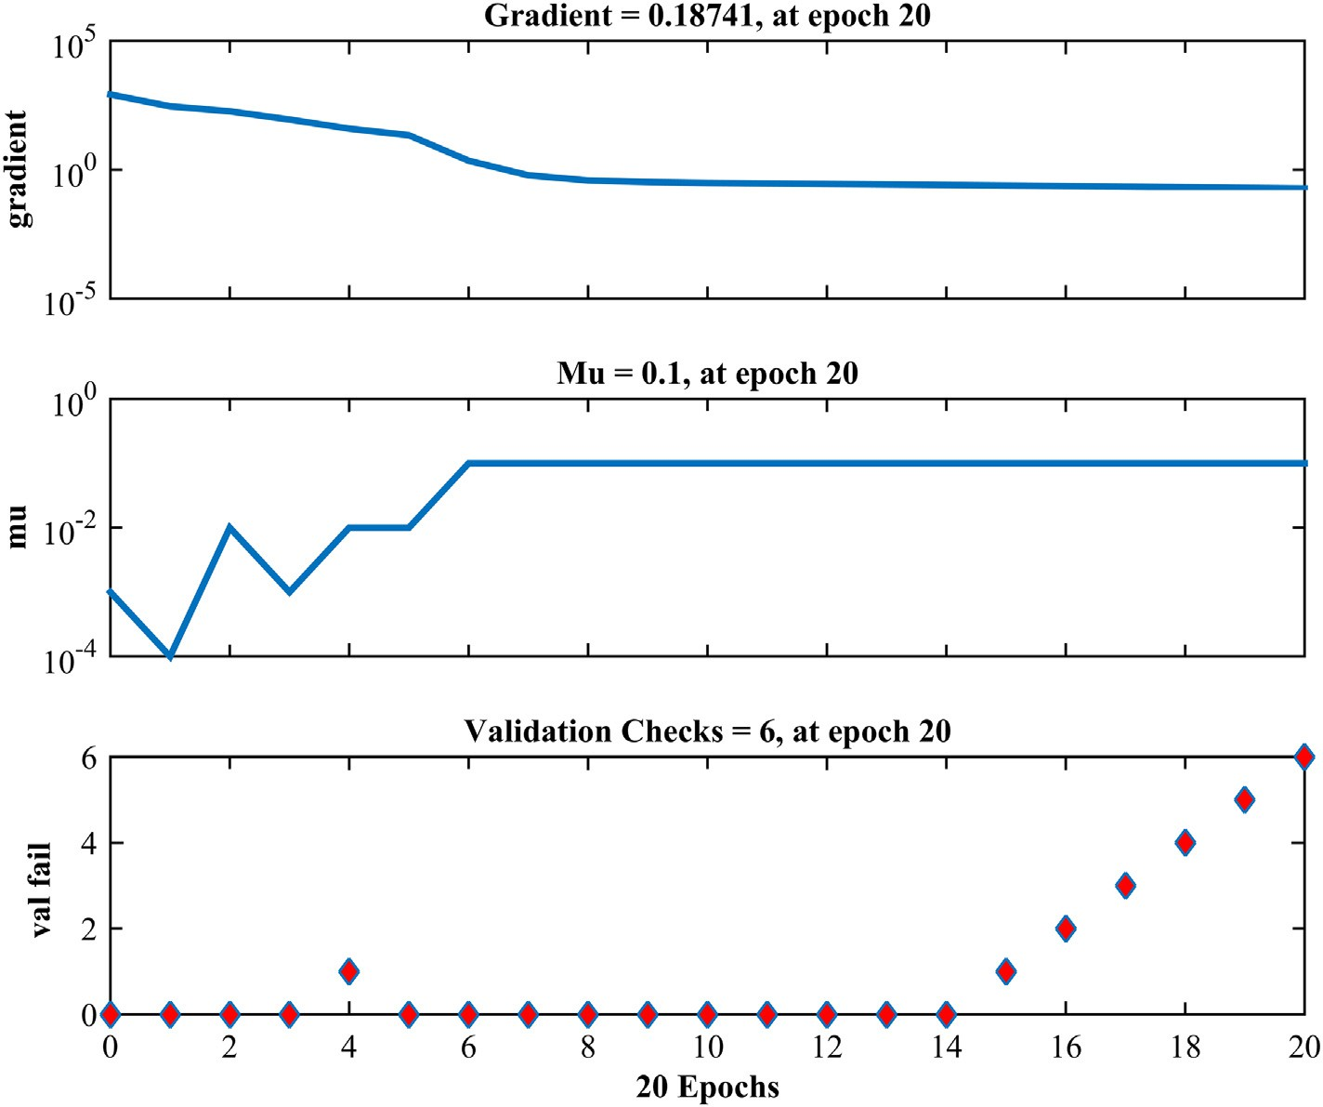

Fig. 7. Training state of developed ANN model.

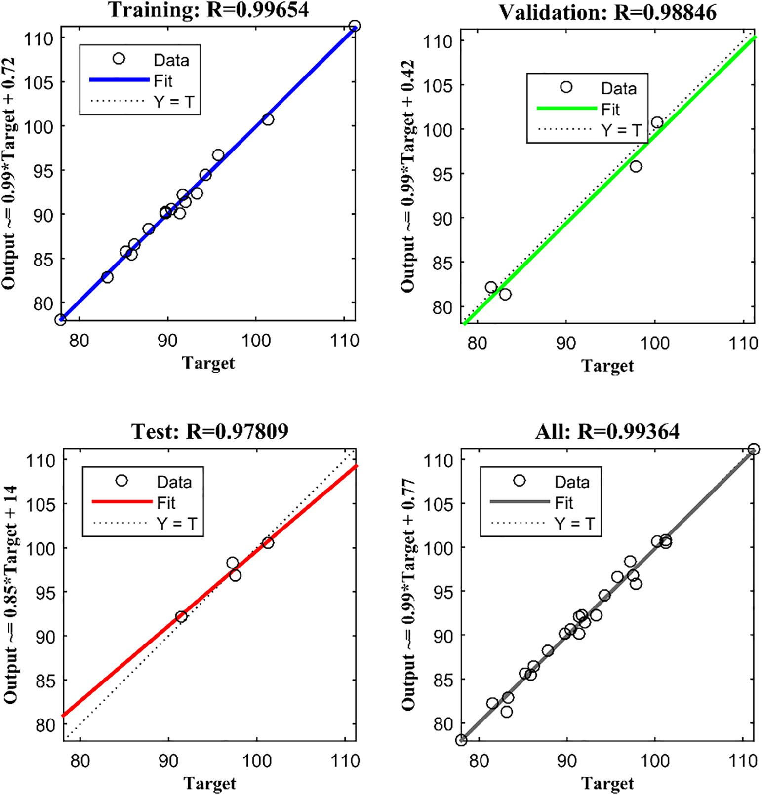

Fig. 8. Regression plots of the developed ANN model for different phases.

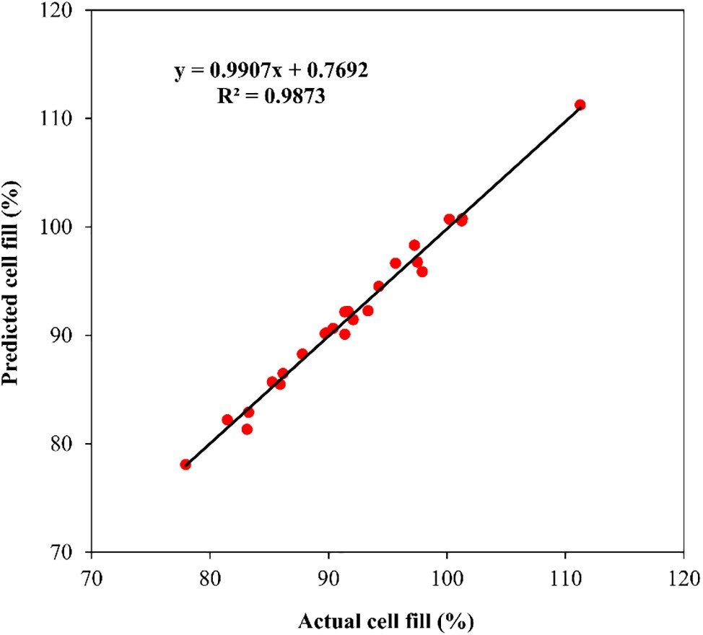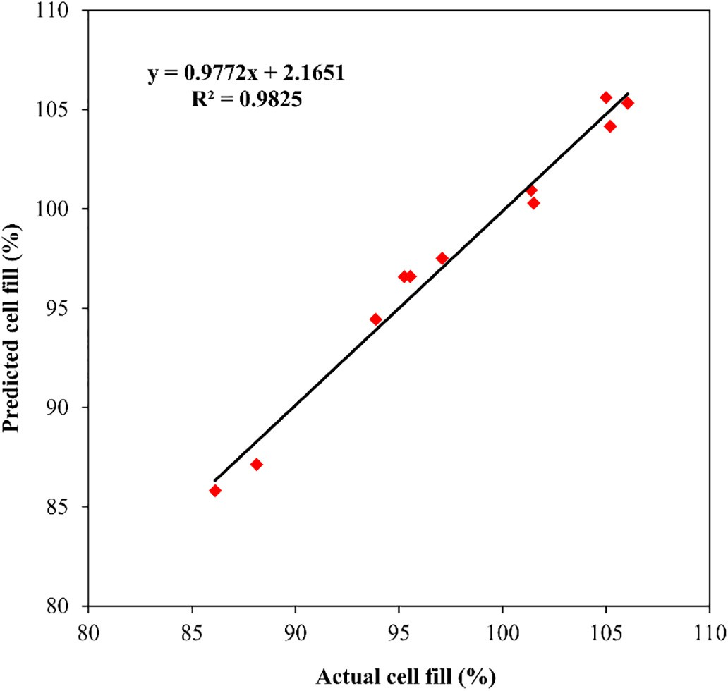

Fig. 9. Actual cell fill variation with predicted cell fill for the training dataset. Fig. 10. Actual cell fill variation with predicted cell fill for the testing dataset.

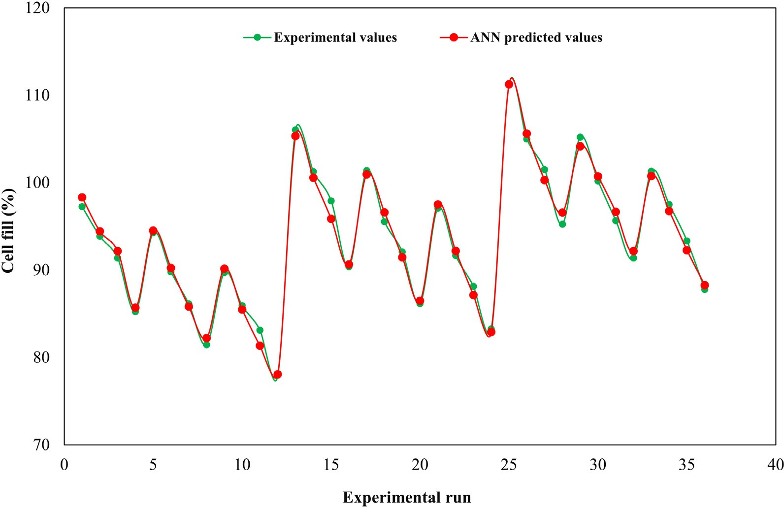

Fig. 11. Comparison of experimental values and ANN predicted values of cell fill.

Table 3

Connection weights of developed ANN model and relative importance of input parameters.

could explain at least 98% of the variability in the measured cell fill values with a new unseen dataset.

The comparison between experimental and model-predicted cell fill

Hidden

|  |  |  |  |  |
| --- | --- | --- | --- | --- |
| Neuron number | Seed metering plate  inclination | Forward speed  of operation | seed level in the  hopper |  |
| 1 | −1.43249 | 1.568 | 1.9446 | 0.16109 |
| 2 | −4.3003 | −2.394 | 1.9583 | 0.005177 |
| 3 | 0.060749 | 0.35606 | −0.16875 | −1.9683 |
| 4 | 2.6562 | −1.4428 | −0.07316 | −0.084708 |
| 5 | −2.7462 | −1.6353 | 0.31212 | 0.11938 |
| Relative Importance | 16.13 | 56.45 | 27.42 | – |

(%)

*Wij Wjk*

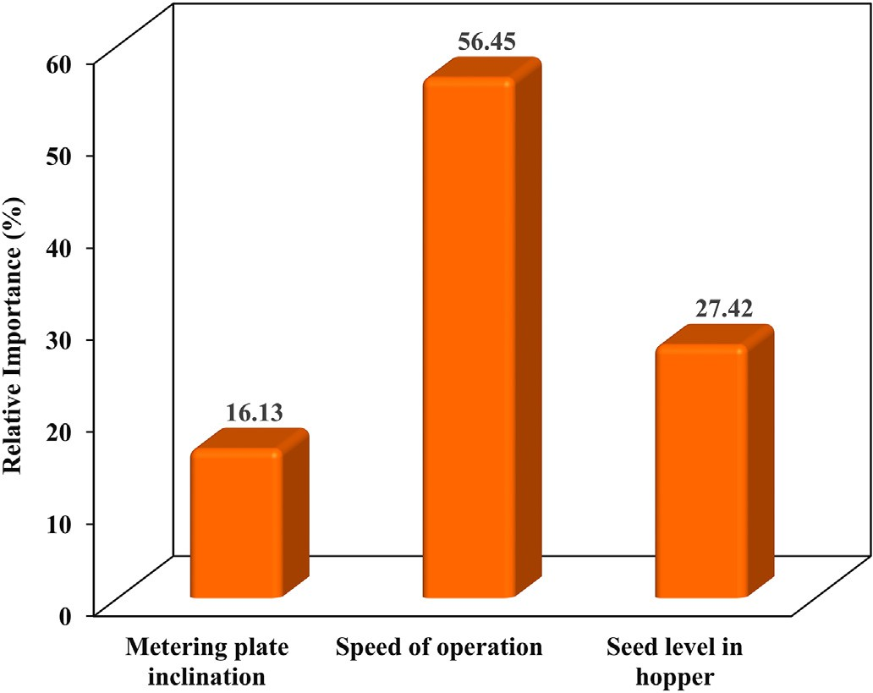Fig. 12. Relative importance of different operating parameters.

values for each experimental run is shown in Fig. 11. From this figure, it can be observed that the ANN model-predicted cell fill value lies very close to the experimental cell fill value in each run, which confirms the excellent approximation capability of the developed ANN model.

The connection weights between input-hidden layer and hidden- output layer of the well trained and tested ANN model are given in Table 3.

The relative importance of different operating parameters is pre- sented in Fig. 12. It indicates that the forward speed of operation (56.45%) has maximum influence on the cell fill of inclined plate seed metering device, followed by the seed level in the hopper (27.42%) and the seed metering plate inclination (16.13%), respectively.

* 1. *ANN-PSO simulation results and experimental validation*

In this study, the PSO simulation was carried out in MATLAB 2014b environment using a laptop with an Intel Core i5-3337U CPU at

1.80 GHz and 8 GB of RAM. The developed ANN model's output was fed into particle swarm optimizer for optimizing the input parameters corresponding to 100% cell fill. In all optimization runs, the inertia weight parameter was linearly decreased from 0.9 to 0.4 for encourag- ing the global exploration in the starting phase of the run and achieving a more refined solution near the end of the simulation run. The acceler- ation coefficients (c1 and c2) were chosen as 2.8 and 1.3, respectively. The swarm size and the maximum number of iterations were selected as 30 and 50, respectively. These PSO parameters were selected based on the previous research works (Shi and Eberhart, 1999; Eberhart and Shi, 2000; Carlisle and Dozier, 2001), as these parameters setting yielded better simulation performance. Using this integrated ANN-PSO optimization approach, the inclined plate seed metering device's oper- ating parameters were optimized to get the minimum fitness value within the maximum number of iterations, i.e., gBest, and the particle's dimensions corresponding to the gBest at the final iteration were taken as the optimal solution. The convergence curve of PSO, demonstrating the global best and the mean best fitness values of all particles over

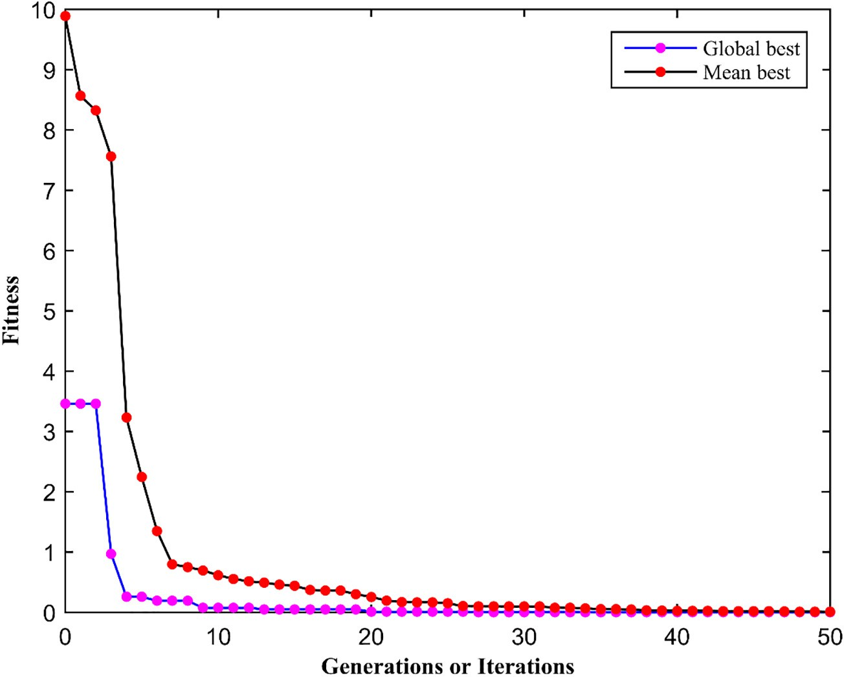

Fig. 13. Convergence curve of PSO.

the entire particle population at each iteration, is shown in Fig. 13. From this figure, it can be observed that the mean fitness value approached the global best fitness value after 43 iterations; it indicates that all par- ticles of the swarm converged to approximately the same optimum so- lution. The global best and the mean best fitness functions converged to their minimum value after 20 and 43 iterations, respectively, and remained constant within the maximum number of iterations.

In this optimization study, the integrated ANN-PSO approach pre- dicted the two sets of optimal operating parameters corresponding to 100% cell fill. These optimization results were further validated in the laboratory using the nearest feasible values of the obtained optimal op- erating parameters to verify their reliability. Three replications were taken, and the corresponding average cell fill value was computed at each optimal parameter setting. The optimal parameters obtained from the integrated ANN-PSO approach and their validation test results are given in Table 4.

The validation test results showed that the proposed integrated ANN-PSO approach provides the best approximation of optimal values of operating parameters at 100% cell fill with a maximum deviation of 2% between the model-predicted and experimentally observed cell fill values, and thus confirm the reliability of the proposed optimization technique for determining the optimal operating parameters of an in- clined plate seed metering device. The optimization results indicated that, for achieving near about 100% cell fill, the inclination of the seed metering plate should be set around 50°, the planter should be operated at a low speed (2 to 3 km/h) and approximately 75% level of seeds in the hopper. However, these experimental results also need to be verified under actual field conditions. This study provides an effective and

promising tool for optimizing the cell filling performance of an inclined plate seed metering device, which is crucial for improving the seeding performance and achieving the uniform seed distribution within the row.

1. Conclusions

This study aimed to improve the seeding uniformity of an inclined plate seed metering device by optimizing its seed-cell filling perfor- mance. In this study, the ANN modeling approach, coupled with the PSO technique, was applied to obtain the inclined plate seed metering device's best optimal operating parameter settings corresponding to 100% cell fill. The forward speed of operation, the seed metering plate inclination, and the seed level in the hopper were chosen as indepen- dent variables, and the cell fill of inclined plate seed metering device was considered as the model response. A multilayer feed-forward backpropagation neural network model with 3-5-1 configuration was found capable of predicting the cell fill of the inclined plate seed metering device, as indicated by high R2 (0.9849) and low MSE (0.709) values. The sensitivity analysis of the developed ANN model re- vealed that the forward speed of operation (56.45%) had the greatest in- fluence on the cell fill, followed by the seed level in the hopper (27.42%) and the seed metering plate inclination (16.13%), respectively. Using the integrated ANN-PSO approach, the most appropriate optimal values of the forward speed of operation, the seed metering plate inclination, and the seed level in the hopper were found to be 3 km/h, 50-degree, and 75% of total height, respectively. The cross-validation results showed that the proposed integrated ANN-PSO approach provides the

Table 4

Optimized parameters by integrated ANN-PSO algorithm.

|  |  |  |  |  |  |  |  |
| --- | --- | --- | --- | --- | --- | --- | --- |
| S. No. | Seed metering plate inclination (degree) | Forward speed of operation (km/h) | Seed level in hopper (%) | Cell fill (%) |  | | |
|  |  |  |  | Predicted | Observed | Deviation (%) |  |
| 1 | 47.907 | 2.0 | 66.894 | 100 | 98.0 | 2.0 |  |
| 2 | 50.066 | 3.1 | 75 | 100 | 98.8 | 1.2 |  |

best approximation of optimal values of operating parameters at 100% cell fill with a maximum deviation of 2% between the model-predicted and experimentally observed cell fill values. These experimental valida- tion results indicate that the proposed optimization technique is feasi- ble to determine the optimal operating parameters of an inclined plate seed metering device. However, these results need to be verified under actual field conditions.

This study, thus, proposed a new intelligent optimization technique based on the integrated ANN-PSO approach for optimizing the seed-cell filling performance of an inclined plate seed metering device. The ex- perimental results of this study suggested that the proposed optimiza- tion technique could also be effectively applied to determine the optimal operating parameters of other agricultural machines. Moreover, this study also provides a reference basis for future research on process parameters optimization and precision seeding technology.

Declaration of Competing Interest

The authors do not have any type of conflict of interest.

References

Adamowski, J., Karapataki, C., 2010. [Comparison of multivariate regression and artificial](http://refhub.elsevier.com/S2589-7217(20)30033-7/rf0005) [neural networks for peak urban water-demand forecasting: evaluation of different](http://refhub.elsevier.com/S2589-7217(20)30033-7/rf0005) [ANN learning algorithms. J. Hydrol. Eng. 15 (10), 729–74](http://refhub.elsevier.com/S2589-7217(20)30033-7/rf0005)3.

Anantachar, M., Kumar, P.G.V., Guruswamy, T., 2010. [Neural network prediction of perfor-](http://refhub.elsevier.com/S2589-7217(20)30033-7/rf0010) [mance parameters of an inclined plate seed metering device and its reverse mapping](http://refhub.elsevier.com/S2589-7217(20)30033-7/rf0010) [for the determination of optimum design and operational parameters. Comput. Elec-](http://refhub.elsevier.com/S2589-7217(20)30033-7/rf0010) [tron. Agric. 72, 87–98](http://refhub.elsevier.com/S2589-7217(20)30033-7/rf0010).

Armaghani, D.J., Hasanipanah, M., Mahdiyar, A., Abd Majid, M.Z., Amnieh, H.B., Tahir, M.M., 2018. [Airblast prediction through a hybrid genetic algorithm-ANN model. Neu-](http://refhub.elsevier.com/S2589-7217(20)30033-7/rf0015) [ral Comput. & Applic. 29 (9), 619–629](http://refhub.elsevier.com/S2589-7217(20)30033-7/rf0015).

Basheer, I.A., Hajmeer, M., 2000. [Artificial neural networks: fundamentals, computing,](http://refhub.elsevier.com/S2589-7217(20)30033-7/rf0020) [design, and application. J. Microbiol. Methods 43, 3–31](http://refhub.elsevier.com/S2589-7217(20)30033-7/rf0020).

Carlisle, A., Dozier, G., 2001. [An off-the-shelf PSO. Proceedings of the Workshop on Parti-](http://refhub.elsevier.com/S2589-7217(20)30033-7/rf0025) [cle Swarm Optimization. Purdue School of Engineering and Technology, Indianapolis,](http://refhub.elsevier.com/S2589-7217(20)30033-7/rf0025) [USA, pp. 1–](http://refhub.elsevier.com/S2589-7217(20)30033-7/rf0025)6.

Chandel, N.S., Tewari, V.K., Mehta, C.R., 2019. [ANN model for predicting operating param-](http://refhub.elsevier.com/S2589-7217(20)30033-7/rf0030) [eters of a variable rate applicator. Eng. Agric. Environ. Food 12 (3), 341–35](http://refhub.elsevier.com/S2589-7217(20)30033-7/rf0030)0.

Chauhan, A.M., Dhingra, H.S., Bhatia, B.S., 1999. [Seed placement behaviour of sunflower.](http://refhub.elsevier.com/S2589-7217(20)30033-7/rf0035)

[Ama-Agr Mech. Asia Af. 30 (4), 9–11](http://refhub.elsevier.com/S2589-7217(20)30033-7/rf0035).

Chhinnan, M.S., Young, J.H., Rohrbach, R.P., 1975. [Accuracy of seed spacing in peanut](http://refhub.elsevier.com/S2589-7217(20)30033-7/rf0040) [planting. Trans. ASAE 18, 828–83](http://refhub.elsevier.com/S2589-7217(20)30033-7/rf0040)1.

Donald, C.M., 1963. [Competition among crop and pasture plants. Adv. Agron. 15, 1–11](http://refhub.elsevier.com/S2589-7217(20)30033-7/rf0045)8. Eberhart, R.C., Kennedy, J., 1995. [A new optimizer using particle swarm theory. Proceed-](http://refhub.elsevier.com/S2589-7217(20)30033-7/rf0050) [ings of the Sixth International Symposium on Micro Machine and Human Science,](http://refhub.elsevier.com/S2589-7217(20)30033-7/rf0050)

[IEEE, pp. 39–43](http://refhub.elsevier.com/S2589-7217(20)30033-7/rf0050).

Eberhart, R.C., Shi, Y., 2000. [Comparing inertia weights and constriction factors in particle](http://refhub.elsevier.com/S2589-7217(20)30033-7/rf0055) [swarm optimization. Proceedings of the 2000 Congress on Evolutionary Computa-](http://refhub.elsevier.com/S2589-7217(20)30033-7/rf0055) [tion. vol. 1. IEEE, pp. 84–88](http://refhub.elsevier.com/S2589-7217(20)30033-7/rf0055).

Eberhart, R.C., Shi, Y., 2001. [Particle swarm optimization: Developments, applications and](http://refhub.elsevier.com/S2589-7217(20)30033-7/rf0060) [resource. In Proceedings of the 2001 Congress on Evolutionary Computation. 1. IEEE,](http://refhub.elsevier.com/S2589-7217(20)30033-7/rf0060)

[pp. 81–86](http://refhub.elsevier.com/S2589-7217(20)30033-7/rf0060).

Garson, G.D., 1991. [Interpreting neural network connection weights. AI Expert. 6, 46–51](http://refhub.elsevier.com/S2589-7217(20)30033-7/rf0065).

Golpira, H., Golpîra, H., 2017. [Soft simulator for redesigning of a chickpea harvester](http://refhub.elsevier.com/S2589-7217(20)30033-7/rf0070) [header. Comput. Electron. Agric. 135, 252–25](http://refhub.elsevier.com/S2589-7217(20)30033-7/rf0070)9.

Gundoshmian, T.M., Ardabili, S., Mosavi, A., Várkonyi-Kóczy, A.R., 2019. [Prediction of com-](http://refhub.elsevier.com/S2589-7217(20)30033-7/rf0075) [bine harvester performance using hybrid machine learning modeling and response](http://refhub.elsevier.com/S2589-7217(20)30033-7/rf0075) [surface methodology. International Conference on Global Research and Education.](http://refhub.elsevier.com/S2589-7217(20)30033-7/rf0075) [Springer, pp. 345–360](http://refhub.elsevier.com/S2589-7217(20)30033-7/rf0075).

Hagan, M.T., Menhaj, M.B., 1994. [Training feedforward networks with the Marquardt al-](http://refhub.elsevier.com/S2589-7217(20)30033-7/rf0080) [gorithm. IEEE Trans. Neu. Net. 5 (6), 989–99](http://refhub.elsevier.com/S2589-7217(20)30033-7/rf0080)3.

Hosseini, S.S., Shamsi, M., 2012. [Performance optimization of a rotary mower using](http://refhub.elsevier.com/S2589-7217(20)30033-7/rf0085) [Taguchi method. Agron. Res. 10 (1), 49–54](http://refhub.elsevier.com/S2589-7217(20)30033-7/rf0085).

Hu, X., Eberhart, R.C., 2002. [Solving constrained nonlinear optimization problems with](http://refhub.elsevier.com/S2589-7217(20)30033-7/rf0090) [particle swarm optimization. Proceedings of the Sixth World Multiconference on Sys-](http://refhub.elsevier.com/S2589-7217(20)30033-7/rf0090) [temics, Cybernetics and Informatics. 5, pp. 203–20](http://refhub.elsevier.com/S2589-7217(20)30033-7/rf0090)6.

Kennedy, J., Eberhart, R., 1995. [Particle swarm optimization. Proceedings of](http://refhub.elsevier.com/S2589-7217(20)30033-7/rf0095) [ICNN’95-International Conference on Neural Networks. vol. 4. IEEE, pp. 1942–1948.](http://refhub.elsevier.com/S2589-7217(20)30033-7/rf0095) Kepner, R.A., Bainer, R., Barger, B.L., 1978. [Crop planting. Principles of Farm Machinery,](http://refhub.elsevier.com/S2589-7217(20)30033-7/rf0100)

[Third edition CBS Publishers and Distributors India, pp. 209–23](http://refhub.elsevier.com/S2589-7217(20)30033-7/rf0100)6.

Kişi, Ö., 2007. [Streamflow forecasting using different artificial neural network algorithms.](http://refhub.elsevier.com/S2589-7217(20)30033-7/rf0105)

[J. Hydrol. Eng. 12 (5), 532–53](http://refhub.elsevier.com/S2589-7217(20)30033-7/rf0105)9.

Kişi, Ö., Uncuoğlu, E., 2005. [Comparison of the three backpropagation training algorithms](http://refhub.elsevier.com/S2589-7217(20)30033-7/rf0110) [for two case studies. Indian J. Eng. Mater. Sci. 12 (5), 434–442](http://refhub.elsevier.com/S2589-7217(20)30033-7/rf0110).

Kumar, G., Srivastava, B., Nagesh, D., 2009. [Modeling and optimization of parameters of](http://refhub.elsevier.com/S2589-7217(20)30033-7/rf0115) [flow rate of paddy rice grains through the horizontal rotating cylindrical drum of](http://refhub.elsevier.com/S2589-7217(20)30033-7/rf0115) [drum seeder. Comput. Electron. Agric. 65 (1), 26–35](http://refhub.elsevier.com/S2589-7217(20)30033-7/rf0115).

Lek, S., Guegan, J.F., 1999. [Artificial neural networks as a tool in ecological modelling, an](http://refhub.elsevier.com/S2589-7217(20)30033-7/rf0120) [introduction. Ecol. Model. 120 (2–3), 65–73](http://refhub.elsevier.com/S2589-7217(20)30033-7/rf0120).

Levenberg, K., 1944. [A method for the solution of certain non-linear problems in least](http://refhub.elsevier.com/S2589-7217(20)30033-7/rf0125) [squares. Q. Appl. Math. 2 (2), 164–16](http://refhub.elsevier.com/S2589-7217(20)30033-7/rf0125)8.

Li, Y., Yuan, J., Liu, X., Niu, Z., Chen, B., Liu, X., 2019. [Spraying strategy optimization with](http://refhub.elsevier.com/S2589-7217(20)30033-7/rf0130) [genetic algorithm for autonomous air-assisted sprayer in Chinese heliogreenhouses.](http://refhub.elsevier.com/S2589-7217(20)30033-7/rf0130) [Comput. Electron. Agric. 156, 84–95](http://refhub.elsevier.com/S2589-7217(20)30033-7/rf0130).

Maier, H.R., Dandy, G.C., 2000. [Neural networks for the prediction and forecasting of](http://refhub.elsevier.com/S2589-7217(20)30033-7/rf0135) [water resources variables: a review of modelling issues and applications. Environ.](http://refhub.elsevier.com/S2589-7217(20)30033-7/rf0135) [Model. Softw. 15 (1), 101–124](http://refhub.elsevier.com/S2589-7217(20)30033-7/rf0135).

Marquardt, D.W., 1963. [An algorithm for least-squares estimation of nonlinear parame-](http://refhub.elsevier.com/S2589-7217(20)30033-7/rf0140) [ters. J. Soc. Ind. Appl. Math. 11 (2), 431–441](http://refhub.elsevier.com/S2589-7217(20)30033-7/rf0140).

Nádai, L., Imre, F., Ardabili, S., Gundoshmian, T.M., Gergo, P., Mosavi, A., 2020. Performance Analysis of Combine Harvester using Hybrid Model of Artificial Neural Networks Par- ticle Swarm Optimization. arXiv preprint. [arXiv:2002.11041](https://arxiv.org/abs/2002.11041).

Ozturk, I., Yildirim, Y., Hinislioglu, S., Demirl, B., Kus, E., 2012. [Optimization of seed flow](http://refhub.elsevier.com/S2589-7217(20)30033-7/rf0150) [evenness of fluted rolls used in seed drills by Taguchi method. Sci. Res. Essays 7](http://refhub.elsevier.com/S2589-7217(20)30033-7/rf0150) [(1), 78–85](http://refhub.elsevier.com/S2589-7217(20)30033-7/rf0150).

Prechelt, L., 1998. [Early stopping-but when? Neural Networks: Tricks of the Trade.](http://refhub.elsevier.com/S2589-7217(20)30033-7/rf0155)

[Springer, Berlin, Heidelberg, pp. 55–69](http://refhub.elsevier.com/S2589-7217(20)30033-7/rf0155)

Reddy, B.S., Satyanarayana, Adake, R.V., Anantachar, M., 2012. [Performance of seed](http://refhub.elsevier.com/S2589-7217(20)30033-7/rf0160) [planter metering mechanisms under simulated conditions. Indian J. Dryland Agric.](http://refhub.elsevier.com/S2589-7217(20)30033-7/rf0160) [Res. Dev. 27 (2), 36–42](http://refhub.elsevier.com/S2589-7217(20)30033-7/rf0160).

Rumelhart, D.E., Hinton, G.E., Williams, R.J., 1986. [Learning representations by back prop-](http://refhub.elsevier.com/S2589-7217(20)30033-7/rf0165) [agating errors. Nature 323, 533–53](http://refhub.elsevier.com/S2589-7217(20)30033-7/rf0165)6.

Sharma, V.K., Sharma, D.N., Kumar, D., 2013. [Development and evaluation of tractor](http://refhub.elsevier.com/S2589-7217(20)30033-7/rf0170) [drawn inclined cell plate type Bt cotton planter. Int. J. Agric. Eng. 6 (2), 329–33](http://refhub.elsevier.com/S2589-7217(20)30033-7/rf0170)4.

Shi, Y., Eberhart, R.C., 1998. [A modified particle swarm optimizer. Proceedings of the IEEE](http://refhub.elsevier.com/S2589-7217(20)30033-7/rf0175) [International Conference on Evolutionary Computation. IEEE, pp. 69–73](http://refhub.elsevier.com/S2589-7217(20)30033-7/rf0175).

Shi, Y., Eberhart, R.C., 1999. [Empirical study of particle swarm optimization. Proceedings](http://refhub.elsevier.com/S2589-7217(20)30033-7/rf0180) [of the 1999 Congress on Evolutionary Computation. vol. 3. IEEE, pp. 1945–1950](http://refhub.elsevier.com/S2589-7217(20)30033-7/rf0180).

Singh, K.P., Pardeshi, I.L., Kumar, M., Srinivas, K., Srivastva, A.K., 2008. [Optimization of ma-](http://refhub.elsevier.com/S2589-7217(20)30033-7/rf0185) [chine parameters of pedal operated VL paddy thresher for better threshing capacity](http://refhub.elsevier.com/S2589-7217(20)30033-7/rf0185) [and efficiency. Biosyst. Eng. 100, 591–600](http://refhub.elsevier.com/S2589-7217(20)30033-7/rf0185).

Tian, Z., Wong, L., Safaei, N., 2010. [A neural network approach for remaining useful life](http://refhub.elsevier.com/S2589-7217(20)30033-7/rf0190) [prediction utilizing both failure and suspension histories. Mech. Syst. Signal Process.](http://refhub.elsevier.com/S2589-7217(20)30033-7/rf0190) [24 (5), 1542–1555.](http://refhub.elsevier.com/S2589-7217(20)30033-7/rf0190)

Xu, Y.L., Wang, Q., Zhu, L.T., Huang, D.Y., 2017. [Numerical simulation and optimization for](http://refhub.elsevier.com/S2589-7217(20)30033-7/rf0195) [the vibration of the seed metering device based on a novel ML-IGA method.](http://refhub.elsevier.com/S2589-7217(20)30033-7/rf0195)

[J. Vibroeng. 19 (5), 3151–3168](http://refhub.elsevier.com/S2589-7217(20)30033-7/rf0195).

Yadachi, S., Mani, I., Kalra, M.S., Kumar, A., Sahoo, P.K., 2013. [Development and evaluation](http://refhub.elsevier.com/S2589-7217(20)30033-7/rf0200) [of inclined plate metering mechanism for carrot seed. Agr. Eng. Today 35 (1), 10–16](http://refhub.elsevier.com/S2589-7217(20)30033-7/rf0200). Yazgi, A., Degirmencioglu, A., 2007. [Optimization of the seed spacing uniformity perfor-](http://refhub.elsevier.com/S2589-7217(20)30033-7/rf0205) [mance of a vacuum- type precision seeder using response surface methodology.](http://refhub.elsevier.com/S2589-7217(20)30033-7/rf0205)

[Biosyst. Eng. 97 (3), 347–35](http://refhub.elsevier.com/S2589-7217(20)30033-7/rf0205)6.

Yu, H., Wilamowski, B.M., 2011. [Levenberg-marquardt training. Industrial Electronics](http://refhub.elsevier.com/S2589-7217(20)30033-7/rf0210) [Handbook, Second edition 5(12). CRC Press, Boca Raton, pp. 1–16](http://refhub.elsevier.com/S2589-7217(20)30033-7/rf0210).

Yuan, J., Cheng, L.L., Yan, M.L., Qingbing, Z., Xuan, F.Z., 2010. [Gaussian processes based bi-](http://refhub.elsevier.com/S2589-7217(20)30033-7/rf0215) [variate control parameters optimization of variable-rate granular fertilizer applicator.](http://refhub.elsevier.com/S2589-7217(20)30033-7/rf0215) [Comput. Electron. Agric. 70, 33–41](http://refhub.elsevier.com/S2589-7217(20)30033-7/rf0215).

Zhang, J., Liu, G., Luo, C., Hu, H., Huang, J., 2019. [MOEA/D-DE based bivariate control se-](http://refhub.elsevier.com/S2589-7217(20)30033-7/rf0220) [quence optimization of a variable-rate fertilizer applicator. Comput. Electron. Agric.](http://refhub.elsevier.com/S2589-7217(20)30033-7/rf0220) [167, 105063](http://refhub.elsevier.com/S2589-7217(20)30033-7/rf0220).

Zŭperl, U., Cŭs, F., Gecevska, V., 2007. [Optimization of the characteristic parameters in](http://refhub.elsevier.com/S2589-7217(20)30033-7/rf0225) [milling using the PSO evolution technique. Aust. J. Mech. Eng. 6, 354–36](http://refhub.elsevier.com/S2589-7217(20)30033-7/rf0225)8.