[Array 13 (2022) 100110](https://doi.org/10.1016/j.array.2021.100110)

Contents lists available at [ScienceDirect](http://www.sciencedirect.com/science/journal/25900056)

Array

journal homepage: [www.sciencedirect.com/journal/array](https://www.sciencedirect.com/journal/array)

Physics-informed neural network method for solving one-dimensional advection equation using PyTorch

Shashank Reddy Vadyala a,*, Sai Nethra Betgeri a, Naga Parameshwari Betgeri, Ph.D b

a *Department of Computational Analysis and Modeling, Louisiana Tech University, Ruston, LA, United States*

b *Department of Business and Administration, Dr. B.V.Raju Institute of Technology, Narsapur, Medak, Telangana, India*

A R T I C L E I N F O

*Keywords:*

Data-driven scientific computing Partial differential equations Physics

Machine learning Finite element method

A B S T R A C T

Numerical solutions to the equation for advection are determined using different finite-difference approxima- tions and physics-informed neural networks (PINNs) under conditions that allow an analytical solution. Their accuracy is examined by comparing them to the analytical solution. We used a machine learning framework like PyTorch to implement PINNs. PINNs approach allows training neural networks while respecting the Partially differential equations (PDEs) as a strong constraint in the optimization as apposed to making them part of the loss function. In standard small-scale circulation simulations, it is shown that the conventional approach incorporates a pseudo diffusive effect that is almost as large as the effect of the turbulent diffusion model; hence the numerical solution is rendered inconsistent with the PDEs. This oscillation causes inaccuracy and computational uncer- tainty. Of all the schemes tested, only the PINNs approximation accurately predicted the outcome. We assume that the PINNs approach can transform the physics simulation area by allowing real-time physics simulation and geometry optimization without costly and time-consuming simulations on large supercomputers.

# Introductions

PDEs, whose states exist in infinite-dimensional spaces, often model physical science and engineering processes [1]. Due to the lack of computational methods in most situations, finite-dimensional approxi- mations are used instead, based on conventional numerical techniques developed and improved over the years. Traditional numerical solvers, on the other hand, frequently necessitate considerable computational effort, particularly for complex systems with multiscale/multiphysics features, and may not be feasible in real-time or many-query applica- tions, such as optimization, inverse problem, and uncertainty quantifi- cation (UQ), which necessitate many repeated simulations [2]. Solving PDE structures for the best possible combination between precision and reliability [3]. Some data-driven approaches to solve PDEs with deep neural networks (DNNs) exist nowadays. The benefits of using DNNs to approximate PDE solutions [4]. DNNs can Identify nonlinear in- teractions, which are confirmed mathematically by universal approxi- mation theorems.

Forward assessments of trained DNNs are quick, which is ideal for real-time or multiple-query applications. Furthermore, DNN models are analytically differentiable; derivative information can be easily derived

for optimization and control problems using automatic differentiation [5]. Recently, researchers have attempted to use DNNs in numerous sectors, including education [6], media [7], power [8], and healthcare [9]. However, there are several problems in various fields for which there is no analytical approach. Since certain constants are believed to be fixed, even problems with analytical solutions have them. The

analytical solution to a simplistic dilemma, on the other hand, teaches us a lot about the system’s actions. On the other hand, numerical methods can rapidly investigate problems if no analytical solution approach is

available. However, extreme caution must be exercised to ensure that a converged solution is achieved. This means we need to figure out if the step sizes are minimal enough to discover the solutions to the equations we are trying to understand. For example, the numerical method FEM is an excellent tool for solving complicated geometrical shapes with a boundary and load condition that is difficult to describe with available analytical expressions. There are generally three approaches by which scientific problems/equations are solved: Analytical, Numerical, and Experimental. However, we cannot perform the experimental method every time because of cost and time constraints. The traditional ap- proaches for solving problems are analytical methods. However, we cannot solve equations analytically due to limitations imposed by

* Corresponding author.

*E-mail address:* [vadyala.shashankreddy@gmail.com](mailto:vadyala.shashankreddy@gmail.com) (S.R. Vadyala).

<https://doi.org/10.1016/j.array.2021.100110>

Received 17 May 2021; Received in revised form 21 September 2021; Accepted 19 November 2021

Available online 2 December 2021

2590-0056/© 2021 The Authors. Published by Elsevier Inc. This is an open access article under the CC BY license (<http://creativecommons.org/licenses/by/4.0/>).

complex geometry, boundary conditions, and other factors.

Consequently, we have been pushing towards numerical methods for several years because they can produce almost reliable results in addi- tion to analytical methods, and they can do so in a much shorter and

easier period. For example, the famous Navier-Stoke equation has never

Most of the time is spent attempting to decide if the process succeeds. Since numerical wave propagation has its own set of complexities, we will start with one of the most basic mathematical equations for generating moving waves [12]. The advection equation is written as

been solved analytically, but it can be solved quickly using Numerical Schemes. On the other hand, the disadvantages of traditional Numerical

∂*u*/∂*t*

+ *a* ∂*u*/∂*x*

= 0, *for*{ —∞ < *x* < ∞

(2)

Schemes are they are challenging in representing irregular boundaries, not optimized for unstructured meshes, and momentum, energy, and mass are not conserved [10]. Lastly, they are not well suited for turbu- lent flow slow for significant problems, and they tend to be biased to- wards edges and one-dimensional physics.

0 < *t*

To solve the drawbacks of traditional methods, we investigate the use of PINNs as a solution approximation for PDEs in this paper. PINNs trained to solve supervised learning tasks while respecting any given physics law described by general nonlinear PDEs Fig. 1 and Eq. (1) summarizes the PINNs [11]. We will talk about PyTorch as a Python implementation for PINNs. We assume these PINNs would affect real-world applications where reduced-order physics models are possible and widely used. The numerical efficiency of reduced-order models usually comes at the expense of physical consistency. We illus- trate how PINNs can be used in reduced-order models to reduce epistemic (model-form) ambiguity for the advection equation. PINNs architectures can help close the distance between forecasts and observable results. Our method begins with an abstract formulation and then moves to numerical integration methods before implementing a neural network.

PINNs = Data + Neural Networks + Physical Laws (1)

The rest of the paper is structured in the following way. First, section

2, the background of the advection equation, section 3.1 specifies the implementation choices in language, libraries, and public repositories (needed for replicating results). Then, section 3.2 presents the formu- lation and implementation for integrating the first-order ordinary dif- ferential equation with the simple Euler’s forward method. Next, section

4 presents results, and section 5 closes conclusions and future work.

Finally, Appendix summarizes concepts about neural networks used in this paper.

# Background

Whether it is waves on a lake, sound waves, or an earthquake, everybody has seen traveling waves. Writing down a reasonable-looking finite difference approximation to a wave equation is not complicated.

The convenient feature of model Eq. (2) is that it has an analytical solution in Eq. (3):

*u* = *u*0*f* (*x* — *at*) (3)

Which represents a wave propagating with a constant velocity with

an unchanged shape. When a>0, the wave propagating in the positive x- direction, whereas for *a<0*, the wave propagates in the negative x-di- rection. Eq. (2) is significant in various applications should not be overlooked due to its mathematical simplicity. The momentum equation for gas motion, for example, is an inhomogeneous version of Eq. (2) that is dependent on u. Therefore, a nonlinear version of the advection equation occurs in the physical model of interstellar gas and its motion due to the solar wind [13]. Another application is in analyzing traffic flow along a highway [14]. The density of cars along the road is rep- resented by *u (x, t)*. Their speed is represented by a. Eq. (2) may serve as a model-equation for a compressible fluid, e.g., if u denote pressure, it represents a pressure wave propagating. The advection equation is often used to model pressure or flow transmission in a compliant pipe, such as a blood vessel. The [applications of fractional advection-dispersion equa](https://www.x-mol.com/paperRedirect/1260044655500918784)

The generalization of equation ∂*u*/∂*t* + ∂*F*/∂*x* = 0, where for the linear [tions for anomalous solute transport in surface and subsurface water](https://www.x-mol.com/paperRedirect/1260044655500918784). advection equation *F(u)* = *au*.

PDEs are equations that contain unknown multivariate functions and

their partial derivatives in Eq. (4).

∅*t* + ∇ ⋅ (*u* ⋅ ∅ ) = ∇⋅(Γ∇ ∅ ) (4)

Where ∅ is the dependent variable, ∅*t* = ∂∅/∂*t* is the derivative of ∅*t* concerning time, *t,* ∇ = (∂∅/∂*t*, ∂∅/∂*t*, ∂∅) is the nabla operator, *u* = (*u*, *v*, *w*) is the velocity, and Γ is the diffusivity. The independent vari- ables are space, *x* = (*x*, *y*, *z*) and time, *t*. Eq. (4) is known as the

∂*t*

convection-diffusion equation. Diffusion and convection are two

mechanisms that explain how particles, electricity, and other physical quantities are transported within a physical structure. Concerning

diffusion ∇⋅(*Γ*∇ ∅), The concentration of a chemical can be assumed by

∅. As concentration is minimal in one region relative to the surrounding

areas (e.g., a local minimum of concentration), the substance diffuses

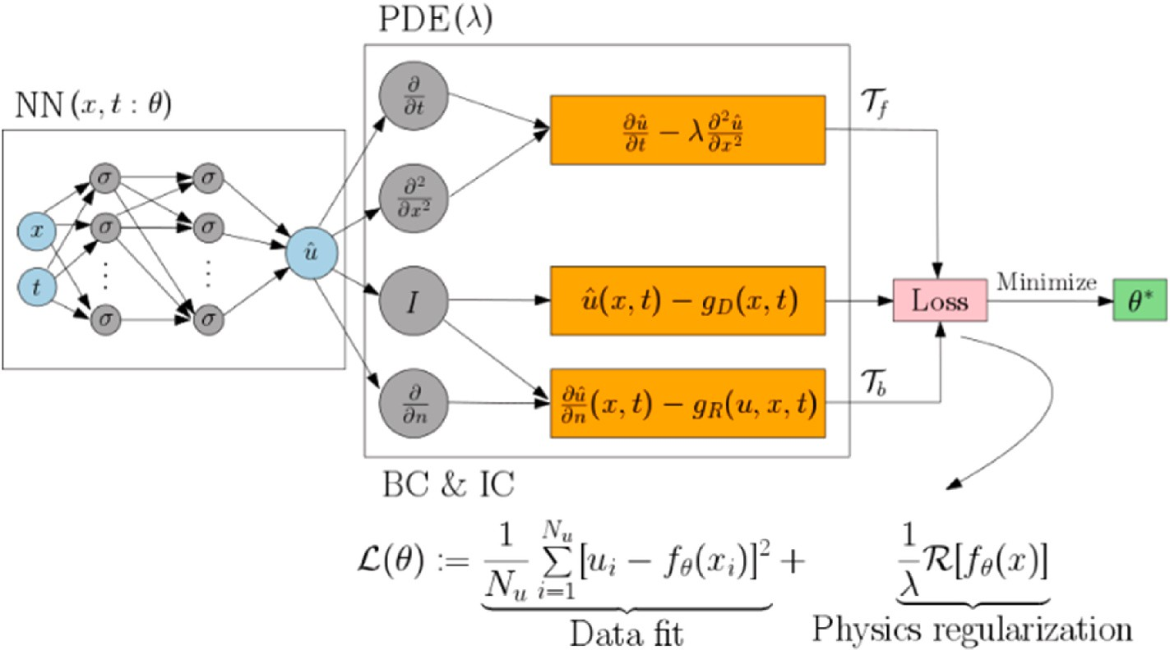

**Fig. 1.** Schematic of a PINNs for solving the diffusion equation (∂*u*/∂*t*

∂*t*

= ⋏∂2*u*/

2).

from the surrounding areas, increasing concentration. The net diffusion is proportional to the Laplacian (or second derivative) of concentration.

If the diffusivity *Γ* is a constant, *Γ*∇2∅. On the other hand, concerning convection, ∇⋅(*u* ⋅ ∅), Assume the chemical is being carried down a canal, and we are calculating the concentration of the water per second.

Then, someone spills a barrel of the chemical into the river upstream. The concentration will suddenly rise and fall as the field with the elevated chemicals passes. The problems presented in this study as ex-

amples will consist of finding the function ∅(*x*, *t*) that, for a given ge-

ometry, original, and boundary conditions, satisfies the PDE. In a typical

approach such as finite volume, we divide the statistical domain into small regions and consider the average volume size ∅ at a given moment Eq. (5).

∅*n* = 1 ∫ ∅(*x*, *tn*) (5)

there are no derivable piecewise alternatives. Furthermore, since we use time-marching algorithms, new computations are needed once the free parameters, current, or boundary conditions are changed.

This study presents a strategy to combine physics-based modeling with data-driven ML to solve 1D advection equation. The equation of 1D advection is directly encoded into the PINNs to guide its training and prediction. The presented case studies show that encoding physics can significantly improve the generalization ability of the PINNs for struc- tural response prediction and reduce its reliance on the quality and quantity of the training data. The PINNs model can effectively reduce the computational costs compared with the numerical method of the same order, making it a good candidate for surrogate modeling of structural, dynamical systems.

# Methods

*i Vi*

*Vi*

Where *Vi* denotes the volume of the i*th* discretized element in the computational domain. The global solution can then be obtained by combining the different solutions for all volumes Eq. (6).

* 1. *Implementation*

This part will teach you how to solve Eq. (2) using a neural network. Python is being used to solve the PDEs. Python, a programming lan-

∅*n* = ∑∅*n*

(6)

guage, has grown in popularity in recent years. For the following rea-

*V i* sons: Since there is no need for an explicit declaration of variables or a separate compilation period, it is quick and simple to code and use for

*i*

This function is piecewise constant and cannot be deduced, demon-

strating one of the first drawbacks of conventional numerical methods. Many applications need derivable PDE solutions. Specific exciting ef- fects, such as heat fluxes and mass transfer, are computed with de- rivatives; a derivable solution would be more reliable than a derivatives approximation using piecewise functions. We discretize the various operators in equation one and use a time integration scheme to change the time. In its most basic form, the first-order Euler algorithm Eq. (7).

small “prototyping” tasks. It is available for free on most computing

systems and has a vast repository of packages covering a wide range of applications. Python also has features that make developing and doc- umenting massive, well-structured program structures easier. Python is not appropriate for running extended computational computations since it is an interpreted language. However, calls to precompiled library routines are often used in the code for such computations. Many of these routines are available directly from Python using the PyTorch [15],

∅*n*+1 = ∅*n* — *Δt* ∑*F A*

*f f*

(7)

NumPy [16], and SciPy [17] packages. Most operating systems (OS),

*i i Vi f*

*i*

where *Δt* is the time step, *Ff* is the flux ∅ across the face f of the volume

*Vi* and *Af* is the area of the face. Additional computational schemes to calculate these unknown values are used to calculate the fluxes at the faces. Some popular choices are central difference or upwind methods. Two more aspects are required to complete the problem: the original and boundary conditions. To begin, keep in mind that an initial state is simply a time-dimensional boundary condition. This is important because initial and boundary conditions are typically considered inde-

dition sets the value for ∅(*x*, *t* = 0) and functions as the first values to pendently, but our approach will treat them similarly. The initial con- rithm. Boundary conditions set the value for ∅(*x* ∈ *D*, *t* > 0) where *D* is start the computation in the previously described time-marching algo- the total number of points on the domain’s boundaries. We must specify

a specific set of rules to change these points, not to see values outside the scope. There are many boundary conditions, but the ones used in our examples are as follows:

* Periodic: The domain folds itself to bind boundaries when periodic conditions are assumed.
* Dirichlet: For this type of boundary condition, we will fix ∅ it at boundaries.
* Newmann: For this type of boundary condition, we will fix ∇∅ at boundaries.

For the treatment of walls, inflows, and outflows, specific boundaries may be needed. For example, in the temporal dimension, an initial state is a Dirichlet boundary condition. The approach used for other con- ventional approaches such as finite difference or finite elements differs slightly. However, the basic principle remains the same: discretize the computational domain into small regions where the solution is assumed and bring them back together to retrieve the global solution. Therefore,

including Linux, OSX, and MSWindows, have these kits available for free.

The aim is to achieve a trained multilayer perceptron (MLP) that can give the output *φ(x, t),* where *x* and *t* are set as inputs that satisfy Eq. (1). The basic principle is that a forward transfer on the network using the independent variables as PINNs inputs gives one the evaluated depen- dent variables. Since PINNs are derivable, we can compute the depen- dent variables (outputs). The dependent variables (inputs) to calculate the different derivatives that appear in the original PDEs. We create a loss function that fits the PDEs with this derivative throughout the training phase. We will assume that our PINNs solve the PDEs if the loss function approaches a near-zero value. The teaching is done in an un- supervised setting. Thus, there are continuous and derivable solutions that can be applied throughout the whole domain. PINNs also have the advantage of allowing one to use the PDEs-free parameters in the solu- tion. Therefore, a solution trained for various values of these parameters will generalize to different conditions rather than a single scenario, eliminating the need for new calculations any time a parameter is modified. This property is of particular interest in optimization studies. In more depth, we describe a collection of points within our domain the same way as standard approaches would. These points are divided into two categories: preparation and validation after training. We also differentiate between internal and external points. This will be dealt with in compliance with the boundary conditions that have been established. Then, we define the MLP architecture: several layers and a number of hidden units in each layer. The number of inputs would be the same as the number of independent variables in the PDEs with any free parameters we want to add. The number of outputs would be the same as the number of unknowns that need to be solved. Table 1 summarizes the PINNs algorithm. Once we have training data and the PINNs defined, follows the steps:

* We compute the network’s outputs at all points, ∅(*x*, *t*) and the de- rivatives concerning the inputs: ∅*t*, ∅*x*, ∅*xx*.

**Table 1**

PINNs algorithm.

PINNS Algorithm

**Input:** dynamics parameters ∅, start time *t*0 , stop time *t*1 , final state z (*t*1 ).

* Specify the two training sets *Tf* and

*Tb* for the equation and boundary/initial conditions.

* Define dynamics on the augmented state.
* Specify a loss function for the PDE equation and boundary condition.
* Train the PINNs to find the best parameters ∅ by minimizing the loss function.
* We use a loss function that fits our PDE for internal points. This is the role we’d like to improve: ∅*t* + ∇⋅(*u* ⋅ ∅) — ∇⋅(*Γ*∇ ∅) = 0
* We can create an MSE loss function to fulfill the given condition for

boundary points since we fix values.

* Update the parameters of the PINNs for each loss function.
  1. *Solving one-dimensional advection equation using PINNs*

associated with it. When t = 0, the initial condition will use a Mean Square Error (MSE) loss function, which will equate the known initial

condition with the PINNs output. For the spatial boundary condition, we

function at *x* = *0* and *x* = *L* for any t and forces them to be equal. As seen use a periodic condition that compares the solutions using an MSE loss in Fig. 3, we characterize our solution as an MLP with two inputs

(number of independent variables), hidden layers, and one output. Fig. 3 shows a general scheme’s flowchart for converting PDEs into the PINNs structure.

The training steps are as follows:

* + - Compute the network outputs for the internal points:

∅(0 < *x* < *L*; *t* > 0).

* + - Compute the gradients of the outputs concerning the inputs: ∅*x*, ∅*t*.
    - Create the internal point loss function: L1 = MSE *(*∅*x* + ∅*t)*
    - Calculate boundary state outputs: ∅(0 < *x* < *L*; *t* = 0),

∅(*x* = 0; *t*) and ∅(*x* = *L*, *t*).

* + - Establish a failure function to account for boundary conditions: L2 =

— 2

0.4

MSE ( 0 x

We aim to create a qualified multilayer perceptron (MLP) that can

∅(

<

<

L t 0

*exp*(

1(*x*—*at*)2)/*L* , L3

MSE

output *(x, t)* when given *x* and *t* as inputs and satisfy Eq. (2). Consider the one-dimensional advection Eq. (8), which is a simplification of Eq.

;

=

) —

=

(1) for a 1D,

∅*t* + *u*∅*x* = 0 (8)

Where ∅(*x*, *t*) is the unknown function, *x* and *t* are the independent variables, *u* is a constant parameter and ∅*t* and ∅*x* are the derivatives of

which is ∅(*x*,*t*) = ∅(*x*,*x* — *ut*). We may assume that the initial condition ∅ concerning *t* and *x*, respectively. This PDE has an analytical solution,

was physical ∅(*x*, *t* = 0) moves in x at speed u. In the case that ∅ (*x*, *t* =

*(*∅(*x* = 0; *t*)— *(* ∅(*x* = *L*; *t*))

* Update the PINNs parameters for the other losses.

MLP with two inputs, *x* and *t*, one output ∅(*x*, *t*), sigmoid activation Moreover, we here assume that *t* is a function of ∅(*x*, *t*), the first de- rivative of ∅(*x*, *t*) concerning the set of inputs and physical parameters, function, and five hidden layers with 32 neurons shown in Fig. 4.

sponding domains. {*xn*,*i*,*un*,*i*} corresponding to data at *tn and* Euler *θ*. The training points are randomly uniformly drawn from their corre- scheme Eq. (7) allows us to infer the latent solution *u(t, x)* in a sequential

0) =

— 2 —

—

—

0.4

2 0.4

*exp*(

1( *x at*)2)/*L* the solution is

∅(*x*,*t*) =

*exp*(

1( *x at*)2 )/ *L*

method. Starting from initial data {*xn*,*i*,*un*,*i*} at time *tn* and data at the domain boundaries x = 0 and x = 2 shown in Fig. 5, we can use the loss

as illustrated in Fig. 2. To solve the equation, we define a set of points for training.

Discretized equation: *un*+1 = *un* — *a Δt* *un* — *un* ) (9) Defining a *Δx* and *Δt* allows us to build a uniform grid of points in the

*i i Δx i i*—1

entire domain used in the discretized Eq. (9). We describe internal and boundary points, each of which would have a separate loss function

function to train the networks and predict the solution at the time *tn*+1.

An Euler time-stepping scheme would then use this prediction as initial

data for the next step and proceed to train again and predict. We use an optimization algorithm to perform well in applying the PINNs method for parameter estimation. The Adam optimizer with a learning rate of

0.001 is used until the optimization problem’s solution converges with the prescribed tolerance. We set the maximum number of Adam’s epoch

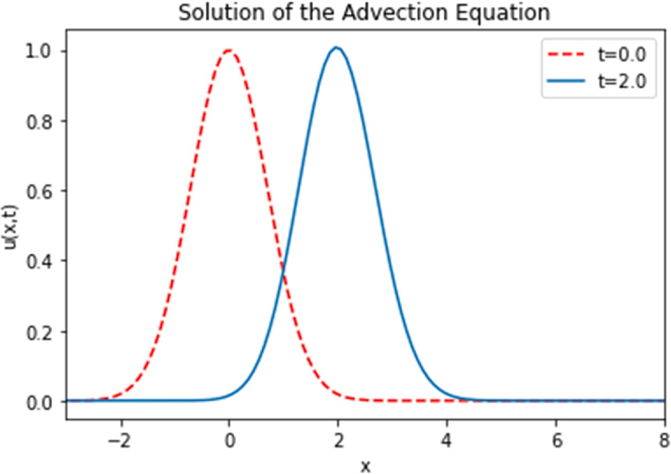

**Fig. 2.** Example of the solution to the 1D advection equation with the initial condition.*exp*(

— 2

0.4

1(*x*—*at*)2)

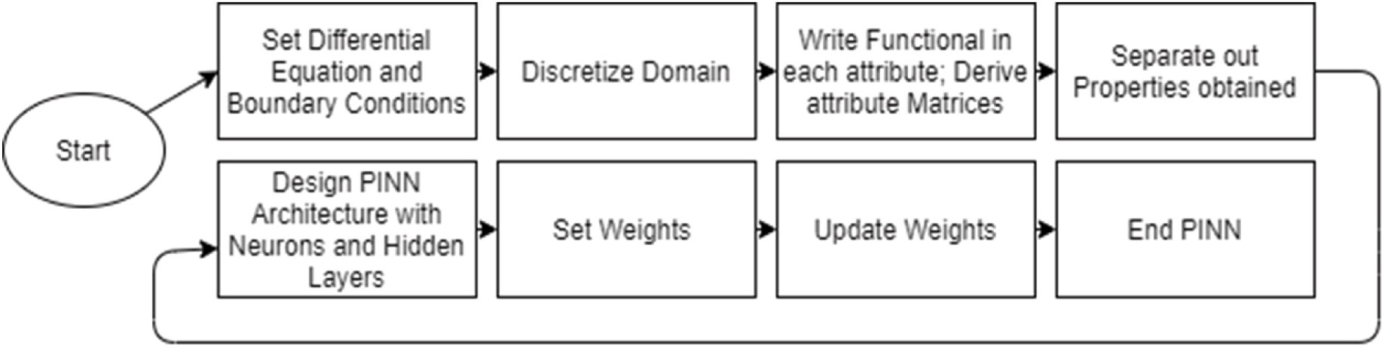

**Fig. 3.** Flowchart for designing the PINNs for a general PDE.

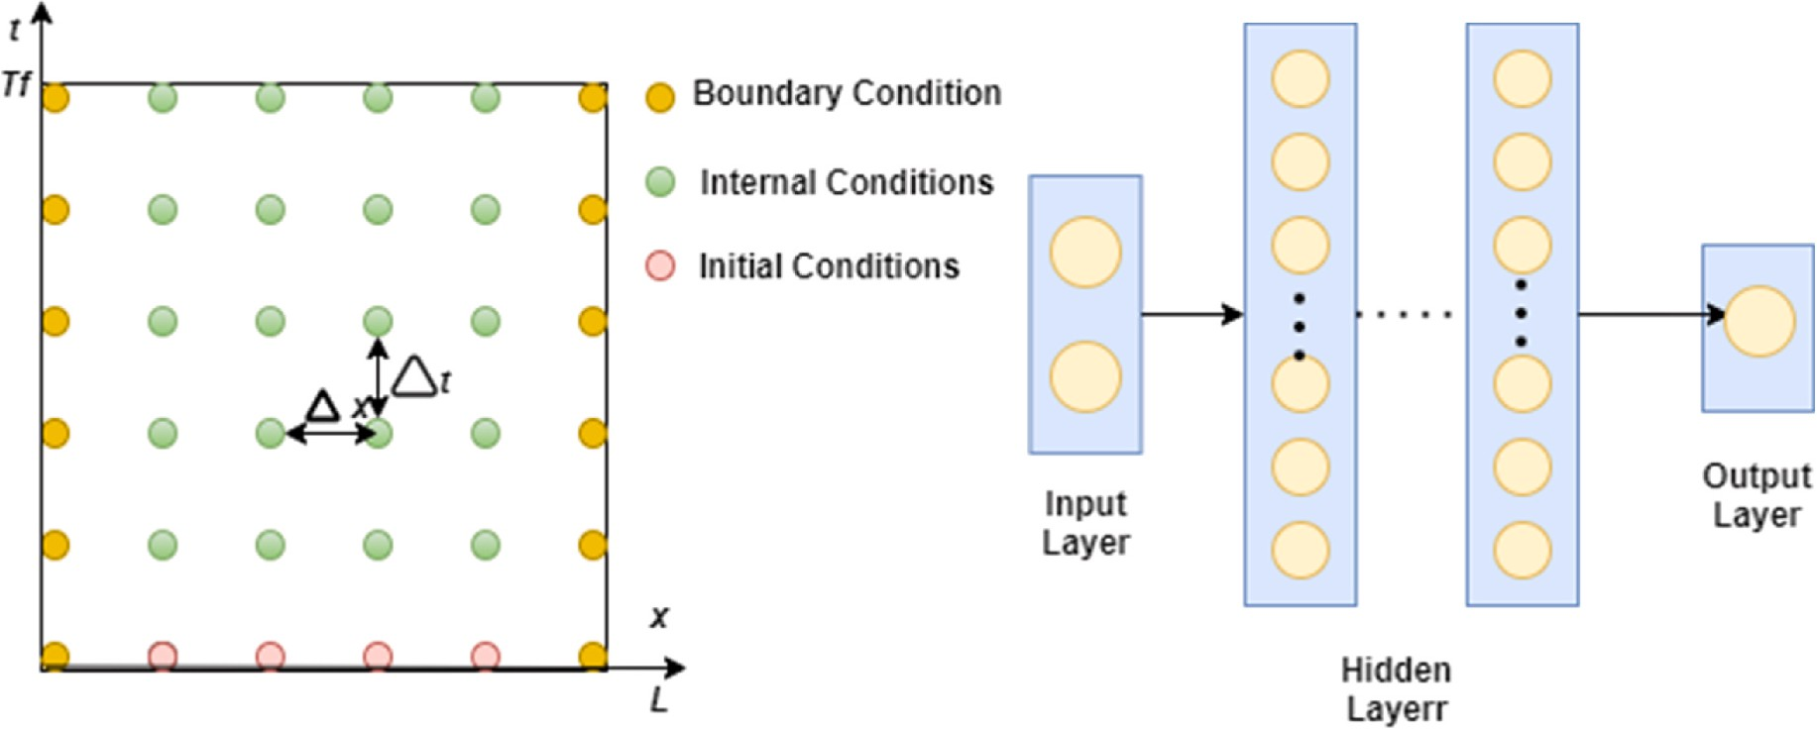

**Fig. 4.** Two distributions of training points of PINNs for one-dimensional advection equation (Left). PINNs Multilayer perceptrons (Right).

to be 10,000 and use the mini-batch training; the PINNs weights are randomly initialized using the Xavier scheme [18].

These steps are usually small in the classical numerical analysis due to stability constraints for explicit schemes or computational complexity constraints for implicit formulations. If the number of Euler scheme stages increases, these restrictions become more serious. Thousands to millions of such measures are needed for most realistic interest problems before the solution is resolved up to a desired final period. We can use an implicit Euler scheme with an infinitely large number of stages at no added expense compared to conventional approaches. This helps one overcome the entire Spatio-temporal solution in a single step while ensuring consistency and high predictive precision. Table 2 shows the parameters and constants used implementation of PINNs and different hyperbolic schemes.

# Results

A one-dimensional advection equation is solved to understand the main process of solving a PDE with PINNs. Compared PINNs with a traditional FTBS [19], Lax Wendroff [20], and Lax Friedrich [21] all time-integrated with an Euler scheme. Our trained PINNs, unlike the FVM solution, are continuous and derivable over the entire domain.

Since physical effects do not limit PINNs, our experiments demonstrate that a much larger mesh will provide better results in this specific case. In comparison to conventional methods, we find that PINNs are capable of minimizing error. Our findings are summarized in Table 3 below.

The computing time needed to integrate the problem in a small grid of points is a few seconds. Still, if the domain’s discretization contains about 10,000 points for each variable, the computing time of the 10,000

Euler method is not like that of the PINNs training. However, the computing time requirement of the PINNs method is not comparable with traditional numerical methods. Any numerical method gives solu- tion points over a selected grid. The computing time, in this case, in- creases as the number of grid points increases. So, computing the solution for an infinite number of points will need infinite time. On the other hand, the PINNs find a continuous solution over the real domain in a finite time.

The PINNs were tested with points that did not participate in the training. Fig. 5 shows the MSE of the trained network as a function of the number of testing points. It can be observed that the averaged error is stable for an increasing number of testing points, which indicates that the solution found is a good approximation of the real solution not only for the training points but also over the whole domain of the problem.

**Table 2**

Constants and parameters.

Constants and parameters Values

a (Wave Speed) 1.0

*tmin* , *tmax* (start and stop time of simulation) 0.0,2.0

*Nx* (N umber of spatial points) 80

C (Courant number, need C ≤ 1 for stability) 0.9

**Table 3**

MSE reported. MSE between the predicted ∅(*x*, *t*)

and the exact solution *u(x, y)* for the different

methods and PINNs.

Methods MSE

FTBS 3.87e-03

Lax Wendroff 4.32e-03

Lax Fredrich 4.78e-03

PINNs 1.65e-03

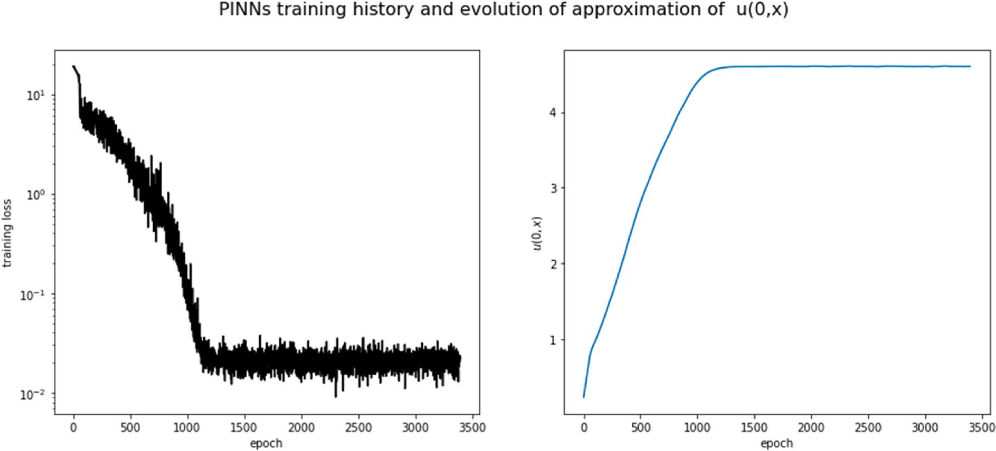

**Fig. 5.** MSE of the trained PINNs vs the number of testing points into the integration domain.

Fig. 6 shows the errors in the resulting PINNs solution ∅ (*x*, *t*) for the reference one-dimensional advection equation *u(x, t)* field with the

maximum point errors provided in Table 4 for the prediction in *0 < t <*

*2*. The FTBS, Lax Wendroff, and Lax Friedrich approximation produced a less accurate solution and had more intense oscillation than PINNs. As can be seen, training the PINNs requires optimization concerning many

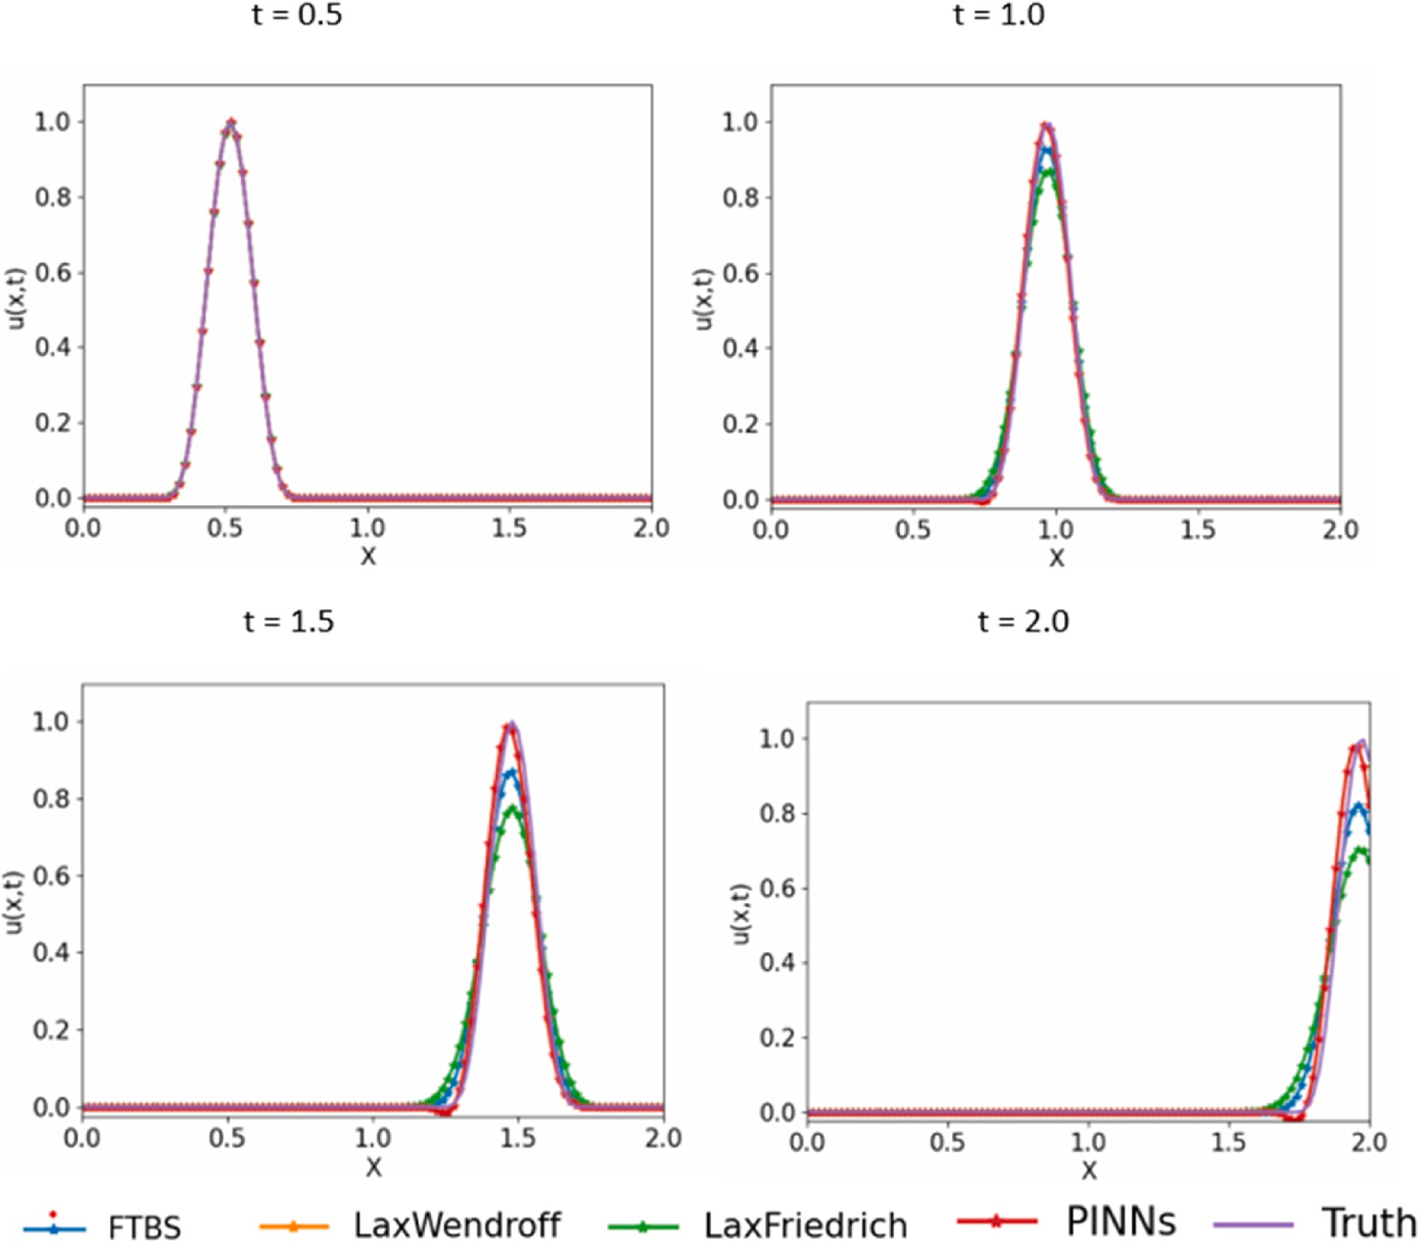**Fig. 6.** A range of hyperbolic schemes are implemented 1D advection equation with the initial condition *exp*( 1(*x*—*at*)2). The colored lines with the marker "*"

denote different hyperbolic schemes. The solid black line denotes the exact solution.

— 2 0.4

**Table 4**

for different hyperbolic schemes. Here, the time-step size to t = 0.5. 1D advection equation: Relative final prediction error measure in the L2 norm

|  |  |  |  |  |  |
| --- | --- | --- | --- | --- | --- |
| Model | *t* = 0 min | *t* = *0.5* | *t* = *1* | *t* = *1.5* | *t* = *2* |
| FTBS | 2.33e-04 | 5.29e-04 | 5.46e-03 | 6.01e-03 | 7.12e-03 |
| Lax Wendroff | 2.03e-04 | 4.90e-04 | 5.26e-03 | 6.71e-03 | 8.92e-03 |
| Lax Friedrich | 2.53e-04 | 5.80e-04 | 6.56e-03 | 7.21e-03 | 9.32e-03 |
| PINNs | 1.03e-02 | 1.10e-3 | 1.26e-03 | 1.65e-03 | 2.12e-03 |

loss functions (as many as PDEs and different boundary conditions), challenging complex problems. We see that PINNs more sharply resolve discontinuities at the cost of adding oscillations, which leads to a net reduction in error. We can use this result to hypothesize that PINNs will improve the solution when the discontinuity is more significant. We verify our hypothesis by plotting the error ratio against discontinuity width in *0 < t < 2* and demonstrating that more significant disconti- nuities lead to lower error ratios. In the solutions obtained with Lax Friedrich, FTBS, and Lax Wendroff, an anomalous oscillation is present

when the grid spacing is too large to follow the quantity’s variations advected closely. Lax Friedrich, FTBS, and Lax Wendroff’s results converge faster and produce more significant predictive errors than

PINNs at almost all training data points. The accuracy of the predictions Lax Friedrich, FTBS, and Lax Wendroff is very good at the initial con-

ditions *t* = *0,* and the boundary conditions are controlled or well known, but they struggle at *t* = *2*. MSE indicates that the PINNs loss can effi- ciently approximate the solution (*0 < t < 2*) without explicit

regularization.

Even in the presence of partially unknown physics, the PINNs approach can reliably anticipate the reaction of a one-dimensional advection equation and has high generalization capacity. The perfor- mance comparison of the PINNs and the Deep Residual Recurrent Neural Networks (DR-RNN) [2] using the parameters as shown in Table .5. Fig. 7 and Fig. 8 show that incorporating physics into the design of ML models may considerably enhance prediction performance, particularly for extrapolation, while also lowering training costs. The PINNs approach may efficiently decrease computing costs by employing a more significant time step than an explicit integration method of the same

order while retaining high prediction accuracy; the PINNs method’s resilience is proven by training the PINNs with noisy/noisy/limited

data, as shown in Table .6. Furthermore, it is found that the quantity and

quality of the training data do not significantly influence the prediction performance. The prediction accuracy of the PINNs method does not vary significantly with the prediction time length.

# Conclusions

By comparing numerical solutions of advection equation with known analytic solutions and PINNs have been demonstrated. The FTBS, Lax

led to a large error in *t* = *2* and would make accurate turbulent diffusion Wendroff, and Lax Friedrich introduced a pseudo diffusion effect that modeling impossible. In those cases where the value of the property

being advected varied rapidly in the space of a few grid intervals, var- iations which seem to be typical in many models, the Lax Friedrich, FTBS, and Lax Wendroff introduced an anomalous oscillation into the

distribution of the quality being advected at *t* = *2*. The oscillations grew

steadily with time and could easily introduce instability into a numerical

model. Of the methods investigated, Only the PINNs approximation moved the advected field correctly at *0 < t < 2*. Traditional numerical methods to find a consistent solution with more straightforward and faster methods led to inaccurate results. Only the PINNs method pro- duces an accurate and consistent approximation with the PDEs. Tradi- tional numerical methods also require a large amount of computer core storage. PINNs approach can transform the physics simulation area by allowing real-time physics simulation and geometry optimization without costly and time-consuming simulations on large supercomputers.

# Credit author statement

**Shashank Reddy Vadyala**: Conceptualization, Methodology, Data curation, Writing – original draft preparation. **Dr B. Naga Para- meshwari**: Writing- Reviewing, Editing and Supervision. **Sai Nethra**

**Betgeri**: Visualization,Validation.

# Declaration of competing interest

The authors declare that they have no known competing financial interests or personal relationships that could have appeared to influence the work reported in this paper.

# Appendix. PINNs method

PINNs are a simple multilayer feed-forward neural network with depth D that contains an input layer, D — 1 hidden layers, and output layer. output *xd*—1 *ε RNd*—1 of the previous layers as its input, and the specific affine transformation is of the form shown in Eq. (A.1): Without loss of generalization, we assume that there are *Nd* neurons in the *dth* hidden layer. Then, the *dth* hidden layer receives the post-activation

*ρd* *Xd*—1)  *ΔWdxd*—1 + *bd* (A.1)

≡

where the network weight *Wd* ε *RNd*—1 and the bias term *bd* ∈ *RNd* be learned are initialized using some special strategies, such as Xavier initialization or initialization. The nonlinear activation function σ(⋅) is applied component-wise to the affine output *ρd* of the present layer. This nonlinear activation is

not used in the output layer for specific regression issues, or we may assume that the identity activation is used in the output layer. As a result, the

neural network can be denoted as *q*(*x*, *Θ*) = (*ρd* ◦ σ ◦ *ρd* 1 ◦ ⋅ ⋅ ⋅ ◦ σ ◦ *ρ*1) (x). Where the operator " ◦ " is the composition operator, Θ = {*Wd*, *bd*}*D* ε P

—

**Table 5**

Parameters used in PINNs and DR-RNN.

Parameter Value

Activation Adam

Hidden Layers 5

Neurons 300

Batch Size 64

Learning Rate 5e-4

Epochs 4000

network, and P is the parameter space, q, and *x*0 = x is the output and represents the learnable parameters to be optimized later in the input of the network, respectively. The residual networks *fu* (x, t): = *ut* + *Nu* (u, *ux*, *uxx*, *uxxx*, ⋅ ⋅ ⋅), and *fv* (x, t): = *vt* + *Nv* (v, *vx*, *vxx*, *vxxx*, ⋅ ⋅ ⋅). Then the solution q (x, t) will be trained to satisfy these two physical

constraint conditions. Which play a vital role in regularization and have

loss function *lossΘ* = *lossu* + *lossv* + *lossfu* + *lossfv* been embedded into the mean-squared objective function, that is, the

# Appendix. Multilayer perceptrons (MLP) shown in Fig. A.1

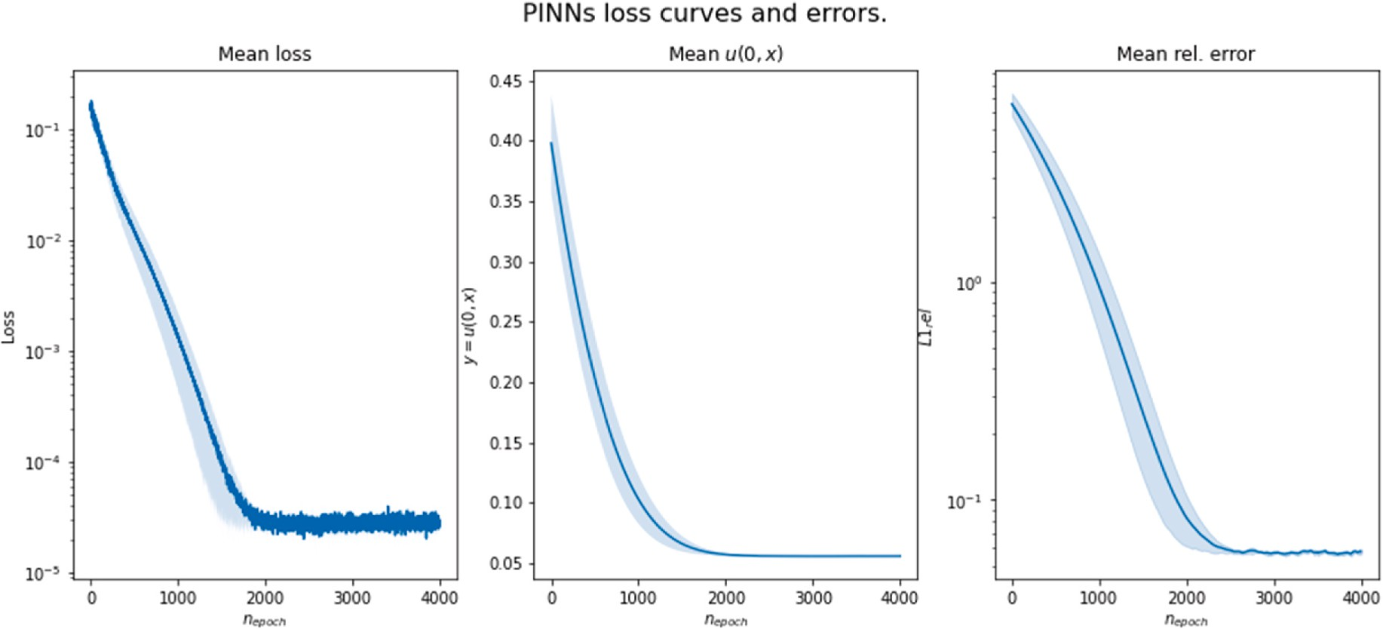

**Fig. 7.** Performance of PINNs.

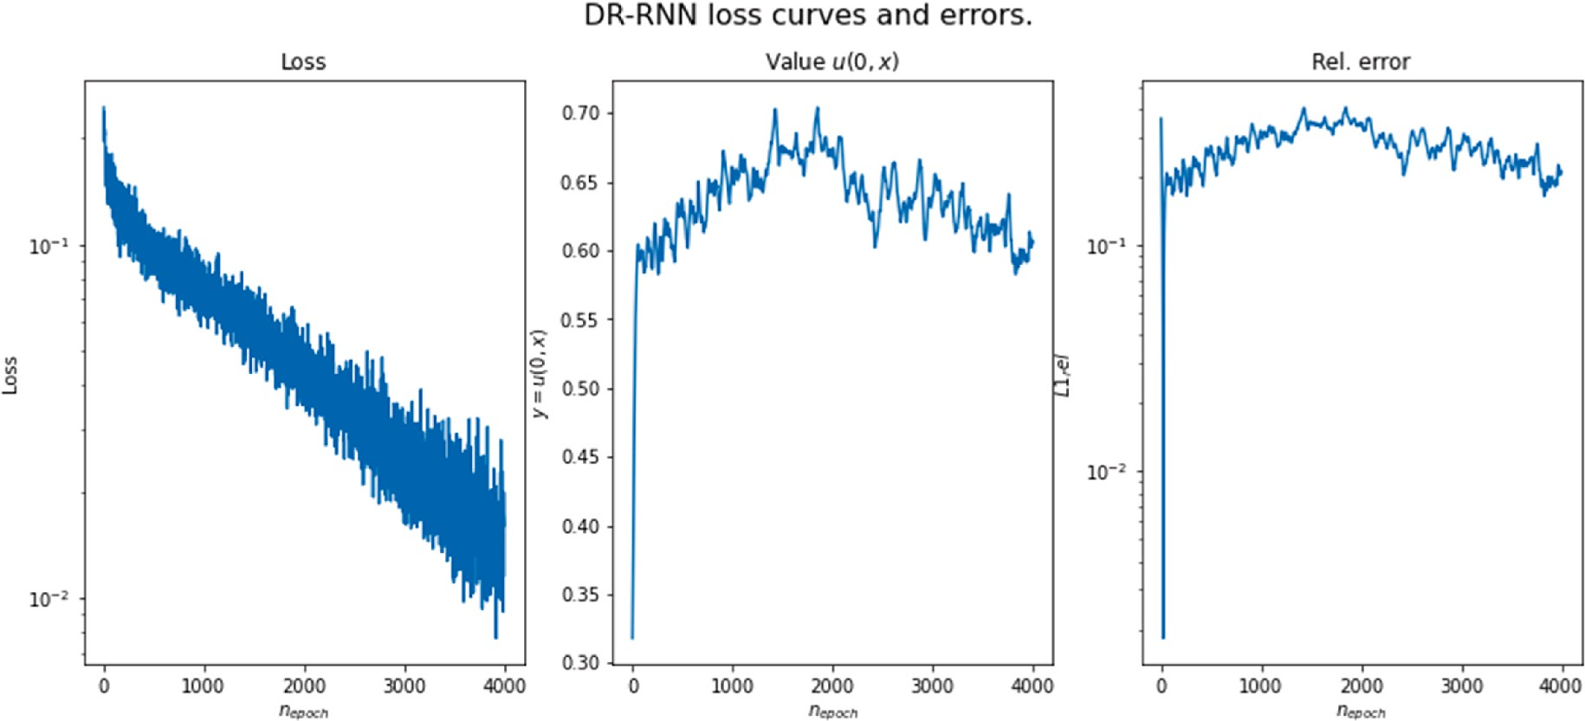

**Fig. 8.** Performance of DR-RNN.

**Table 6**

Comparison of computation time and MSE between the DR-RNN and the PINNs model.

|  |  |  |
| --- | --- | --- |
|  | PINNs | DR-RNN |
| **Computation time (s)** | 25.4 | 134.7 |
| **MSE** | 2.12e-04 | 4.03e-04 |

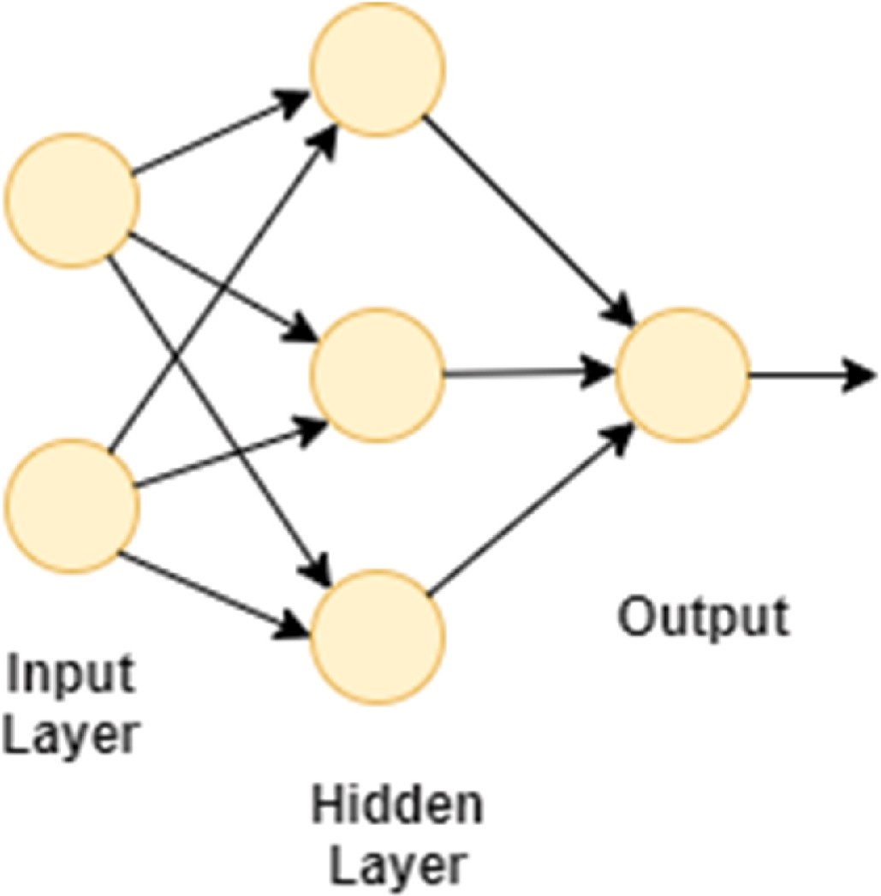

**Fig. A.1.** illustrates the popular MLP.

Each layer can have one or more perceptrons (nodes in the graph). A perceptron applies a linear combination to the input variables followed by an activation function.

*v* = *f* (*z*) and *z* = *WT u* + *b*

where *v* is the perceptron output, u is the inputs; w and b are the perceptron hyperparameters, and *f* (.) is the activation function. Throughout this

paper, we used the hyperbolic tangent (tanh), sigmoid, and the exponential linear unit (elu) activation functions (although others could also be used, such as the rectified exponential linear unit):

tanh(*z*) =

*ez* — *e*—*z*

*ez* + *e*—*z* , sigmoid(*z*) =

1

and elu( ) =

*z*

1 +

*e*—*z*

*z when z* > 0

*ez* — 1

{

1. Alblawi, A.S. and A.A. Alhamed. Big data and learning analytics in higher education: Demystifying variety, acquisition, storage, NLP and analytics. In 2017 IEEE Conference on Big Data and Analytics (ICBDA). 2017. IEEE.
2. Kani, J.N. and A.H. Elsheikh, DR-RNN: A deep residual recurrent neural network for model reduction. arXiv preprint arXiv:1709.00939, 2017.

# References

1. Sirignano J, Spiliopoulos K. DGM: a deep learning algorithm for solving partial differential equations. J. Comput. Phys. 2018;375:1339–64. [https://doi.org/](https://doi.org/10.1016/j.jcp.2018.08.029) [10.1016/j.jcp.2018.08.029](https://doi.org/10.1016/j.jcp.2018.08.029). Dec.
2. Rüde U, Willcox K, McInnes LC, Sterck HD. Research and education in computational science and engineering. SIAM Rev. 2018;60(3):707–54. [https://](https://doi.org/10.1137/16M1096840) [doi.org/10.1137/16M1096840](https://doi.org/10.1137/16M1096840). Jan.
3. Gunzburger M. Finite element solution of boundary value problems—theory and computation (O. Axelsson and V. A. Barker). SIAM Rev. 1988;30(1):143–4. [https://](https://doi.org/10.1137/1030025) [doi.org/10.1137/1030025](https://doi.org/10.1137/1030025). Mar.
4. Mahmoudabadbozchelou M, Caggioni M, Shahsavari S, Hartt WH, Em Karniadakis G, Jamali S. Data-driven physics-informed constitutive metamodeling of complex fluids: a multifidelity neural network (MFNN) framework,. J. Rheol.

2021;65(2):179–98. <https://doi.org/10.1122/8.0000138>. Feb.

1. Xu J, Tao Q, Li Z, Xi X, Suykens JAK, Wang S. Efficient hinging hyperplanes neural network and its application in nonlinear system identification. ArXiv190506518 Cs, Nov. 2019, Mar. 14,, <http://arxiv.org/abs/1905.06518>; 2021 [Online]. Available.
2. [Albalowi A, Alhamed A. Big data and learning analytics in higher education:](http://refhub.elsevier.com/S2590-0056(21)00051-5/sref6) [Demystifying variety, acquisition, storage. NLP and analytics 2017](http://refhub.elsevier.com/S2590-0056(21)00051-5/sref6).
3. [Denecke K. Extracting medical concepts from medical social media with clinical](http://refhub.elsevier.com/S2590-0056(21)00051-5/sref7) [NLP tools : a qualitative study. 2014. /paper/Extracting-Medical-Concepts-from-](http://refhub.elsevier.com/S2590-0056(21)00051-5/sref7) [Medical-Social-NLP-Denecke/8ed7609f41aa772a93c4a46f5ae7a9266559376e, .](http://refhub.elsevier.com/S2590-0056(21)00051-5/sref7) [[Accessed 14 March 2021]](http://refhub.elsevier.com/S2590-0056(21)00051-5/sref7).
4. Strubell E, Ganesh A, McCallum A. Energy and policy considerations for deep learning in NLP. ArXiv190602243 Cs, Jun. 2019, Mar. 14, [http://arxiv.org/abs/1](http://arxiv.org/abs/1906.02243) [906.02243](http://arxiv.org/abs/1906.02243); 2021 [Online]. Available.
5. Vadyala SR, Betgeri SN, Sherer EA, Amritphale A. Prediction of the number of COVID-19 confirmed cases based on K-Means-LSTM. ArXiv 200614752 phys Q-Bio 2021. Jun. 2020, Accessed: Mar. 14,, [Online]. Available: [http://arxiv.org/abs/2](http://arxiv.org/abs/2006.14752)

[006.14752](http://arxiv.org/abs/2006.14752).

1. Loredo C, Banks D, Roquen˜í N. Evaluation of analytical models for heat transfer in mine tunnels. Geothermics 2017;69:153–64. [https://doi.org/10.1016/j.](https://doi.org/10.1016/j.geothermics.2017.06.001) [geothermics.2017.06.001](https://doi.org/10.1016/j.geothermics.2017.06.001). Sep.
2. Raissi M, Perdikaris P, Karniadakis GE. Physics-informed neural networks: a deep

learning framework for solving forward and inverse problems involving nonlinear partial differential equations. J. Comput. Phys. 2019;378:686–707. [https://doi.](https://doi.org/10.1016/j.jcp.2018.10.045) [org/10.1016/j.jcp.2018.10.045](https://doi.org/10.1016/j.jcp.2018.10.045). Feb.

1. [Dutykh D, Dias F. Water waves generated by a moving bottom. In: Kundu A, editor.](http://refhub.elsevier.com/S2590-0056(21)00051-5/sref12) [Tsunami and nonlinear waves. Berlin, Heidelberg: Springer; 2007. p. 65–95](http://refhub.elsevier.com/S2590-0056(21)00051-5/sref12).
2. Bruno R, Carbone V. The solar wind as a turbulence laboratory. Living Rev. Sol.

Phys. 2013;10(1):2. <https://doi.org/10.12942/lrsp-2013-2>. May.

1. L. Romero and F. G. Benitez, "Outline OF diffusion-advection IN traffic flow modelling," p. 17.
2. [Stevens E, Antiga L, Viehmann T, Chintala S. Deep learning with PyTorch 2020](http://refhub.elsevier.com/S2590-0056(21)00051-5/sref15).
3. [Oliphant T. Guide to NumPy 2006](http://refhub.elsevier.com/S2590-0056(21)00051-5/sref16).
4. FJ Blanco-Silva"Learning SciPy for numerical and scientific computing," Packt. [https://www.packtpub.com/product/learning-scipy-for-numerical-and-scientific-](http://www.packtpub.com/product/learning-scipy-for-numerical-and-scientific-) computing/9781782161622 (accessed Mar. 14, 2021).
5. Kumar SK. On weight initialization in deep neural networks," ArXiv 170408863 Cs. May 2017, Mar. 14,, <http://arxiv.org/abs/1704.08863>; 2021 [Online]. Available.
6. Long W, Kirby J, Shao Z. A numerical scheme for morphological bed level calculations. Coast. Eng Times 2008;55:167–80. [https://doi.org/10.1016/j.](https://doi.org/10.1016/j.coastaleng.2007.09.009) [coastaleng.2007.09.009](https://doi.org/10.1016/j.coastaleng.2007.09.009). Feb.
7. [Roe PL. Generalized formulation of TVD lax-wendroff schemes. Nat Aeronau Space](http://refhub.elsevier.com/S2590-0056(21)00051-5/sref20) [Admin Langlry Res Center 1984](http://refhub.elsevier.com/S2590-0056(21)00051-5/sref20).
8. Chen G. Convergence of the LAX–FRIEDRICHS scheme for isentropic gas dynamics

(III). Acta math. Sci. 1986;6(1):75–120. [https://doi.org/10.1016/S0252-9602(18)](https://doi.org/10.1016/S0252-9602(18)30535-6) [30535-6](https://doi.org/10.1016/S0252-9602(18)30535-6). Jan.