[](Journal%20logo)[Artificial Intelligence in Agriculture 4 (2020) 127–139](https://doi.org/10.1016/j.aiia.2020.07.001)

Contents lists available at [ScienceDirect](http://www.sciencedirect.com/science/journal/)

Artificial Intelligence in Agriculture

journal homepage: [http://www.keaipublishing.com/en/j ournals/artificial- intelligence-in-agriculture/](http://www.keaipublishing.com/en/journals/artificial-intelligence-in-agriculture/)

[](http://crossmark.crossref.org/dialog/?doi=10.1016/j.aiia.2020.07.001&domain=pdf)Principles, developments and applications of laser-induced breakdown spectroscopy in agriculture: A review

Keqiang Yu a,b,c,⁎, Jie Ren a, Yanru Zhao a,b,c

a *College of Mechanical and Electronic Engineering, Northwest A&F University, 22 Xinong Road, Yangling, Shaanxi 712100, PR China*

b *Key Laboratory of Agricultural Internet of Things, Ministry of Agriculture and Rural Affairs, Yangling, Shaanxi 712100, PR China*

c *Shaanxi Key Laboratory of Agricultural Information Perception and Intelligent Service, Yangling, Shaanxi 712100, PR China*

a r t i c l e i n f o

*Article history:*

Received 17 June 2020

Received in revised form 17 July 2020

Accepted 17 July 2020

Available online 22 July 2020

*Keywords:*

Laser-induced breakdown spectroscopy Soil elements

Plants

Detection methods Agriculture

a b s t r a c t

Considering the diversity of soil contents, quality and usability, a systematic scientific study on the elemental and chemical composition (major and minor nutrients elements, trace elements, heavy metals, etc.) of soil is very im- portant. Rapid and accurate detection and prevention of soil contamination (mainly in pollutants of heavy metals) is deemed to be a concerned and serious central issue in modern agriculture and agricultural sustainable development. In order to study the chemical composition of soil, laser induced breakdown spectroscopy (LIBS) has been applied recently. LIBS technology, a kind of atomic emission spectroscopy, is regarded as a future “Su- perstar” in the field of chemical analysis and green analytical techniques. In this work, the research achievements and trends of soil elements detection based on LIBS technology were reviewed. The structural composition and operating principle of LIBS system was briefly introduced. The paper offered a review of LIBS applications, includ- ing detection and analysis of major element, minor nutrient element and heavy metal element. Simultaneously, LIBS applications to analysis of the soil related materials, plants-related issues (nutrients, pesticide residues, and plants disease) were briefly summarized. The research tendency and developing prospects of LIBS in agriculture were presented at last.

© 2020 The Authors. Publishing services by Elsevier B.V. on behalf of KeAi Communications Co. Ltd. This is an open access article under the CC BY-NC-ND license (<http://creativecommons.org/licenses/by-nc-nd/4.0/>).

Contents

1. Introduction 127
2. Synopsis of LIBS technology 129
   1. Systematic structure of LIBS 129
   2. Analytical methods of LIBS 129
3. Applications of LIBS for revealing soil elements 129
   1. Detection of major, micro nutritional elements 129
   2. Traceability of heavy metal elements in soil 130
   3. LIBS combined with new methods and techniques for soil detection 133
4. LIBS applications to soil related materials and plants-related issues 135
   1. LIBS for detecting the soil related materials 135
   2. LIBS detection in plant materials 135
   3. LIBS for plant diseases diagnosis 136
5. Conclusions and future perspectives 136

Acknowledgements 136

References 136

* Corresponding author at: College of Mechanical and Electronic Engineering, Northwest A&F University, 22 Xinong Road, Yangling, Shaanxi 712100, PR China.

*E-mail address:* [keqiang_yu@163.com](mailto:keqiang_yu@163.com) (K. Yu).

<https://doi.org/10.1016/j.aiia.2020.07.001>

2589-7217/© 2020 The Authors. Publishing services by Elsevier B.V. on behalf of KeAi Communications Co. Ltd. This is an open access article under the CC BY-NC-ND license ([http://](http://creativecommons.org/licenses/by-nc-nd/4.0/) [creativecommons.org/licenses/by-nc-nd/4.0/](http://creativecommons.org/licenses/by-nc-nd/4.0/)).

1. Introduction

Soil is a synthesis with extremely complex chemical and elemental composition, as it mainly contains minerals, air water, living organisms, organic matters, fossils, and so on. Meanwhile, soils are an important component in the biogeochemical cycle of carbon, storing about four times more carbon than biomass plants and nearly three times more than the atmosphere. In fact, the carbon content in soil is directly related on the capacity of water retention, fertility, among other properties. Thus, soil carbon quantification in field conditions is an important chal- lenge related to carbon cycle and global climatic changes. Major nutri- ent elements (N, P, K, Si, Ca, Mg, S, etc.) and microelements (Fe, Cu, Mn, Zn, B, Mo, Ni, etc.) are essential material for plant growth and phys- iological activities (Pieruschka and Schurr, 2019). Recently, with the rapid development of the economy and technology, a lot of man- made pollution materials, especially heavy metals (Cu, Pb, Cd, Cr, etc.), are entered into the soil, water and ecosystem within the different form (Nicolodelli et al., 2019; Mowry et al., 2017). Heavy metals in soil are particularly dangerous pollutants, which can be easily trans- ferred to the food chain through absorption by plants and the pollution of ground water. Heavy toxic metals in the soil can accumulate in the human body through the food chain and threaten health eventually. The monitoring of concentration of elements such as heavy toxic metals, nutrient elements and microelements in soil is of great importance to environmental research, agriculture, and public health.

For the determination of soil elements, a variety of chemical analyt- ical techniques are employed (Kim et al., 2013), such as atomic fluores- cence spectrometry (AFS), inductively coupled plasma-optical emission spectrometry (ICP-OES), X-ray fluorescence spectrometry (XRFS),

inductively coupled plasma-mass spectrometry (ICP-MS), flame atomic absorption spectrometry (FAAS), and gas chromatography–mass spec- trometry (GC–MS), etc. However, those methods are time consuming, complicated, and normally need a chemical laboratory for quantitative results and expensive equipment (Lee et al., 2004). Therefore, the anal- ysis of many samples is usually expensive and last for a long time.

Laser-induced breakdown spectroscopy (LIBS), also sometimes called laser-induced plasma spectroscopy (LIPS) or laser spark spectros- copy (LSS) has developed rapidly as an analytical technique over the past several decades. LIBS technology is a rapid, in situ, less- destructive, cost-effective and reliable technique suitable for the simul- taneous qualitative and quantitative analysis of major and trace ele- ments in the solid, liquid, or gas samples (Cremers and Chinni, 2009; Cremers and Radziemski, 2013; Fortes et al., 2013; Miziolek et al., 2006; Noll, 2012). In LIBS technology, a laser pulse is focused precisely onto the surface of a target sample, ablating a certain amount of sample to create plasma. The spectrum is collected by plotting intensity versus wavelength from light emissions generated from atomic, ionic, and mo- lecular fragments. The detected LIBS spectrum contains two kinds of in- formation about the composition and content of the sample, the wavelength of the characteristic spectrum corresponds to the type of the element, and the relative strength of the characteristic spectrum corresponds to the concentration of the element. Due to the instrumen- tal features of LIBS, the advanced analysis can be achieved and the lim- itations of chemical analytical techniques are overcome, including non- preparative or little sample treatment, real-time analysis, in situ field application, and remote detection of hazardous materials (Cremers and Chinni, 2009; Hahn and Lunden, 2000; Hahn and Omenetto, 2012). Based on these unique abilities, LIBS has been widely used in

[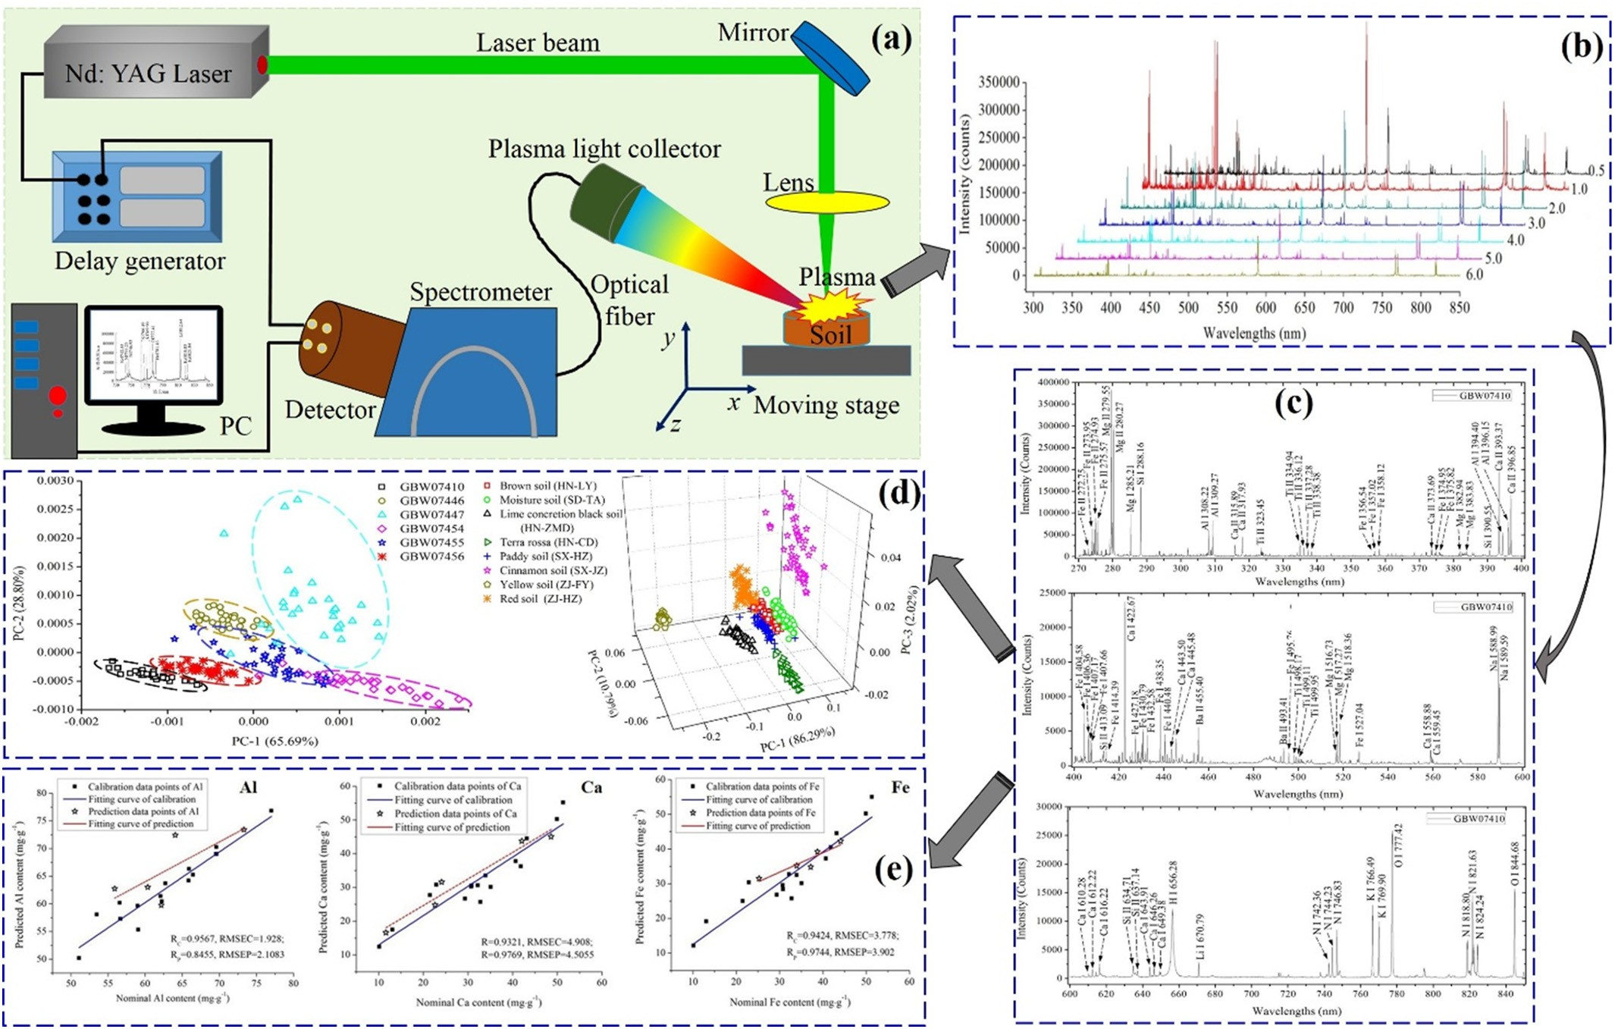](Image%20of%20Fig.%201)

Fig. 1. The process of LIBS for determining the soil types and measuring the content of several elements (such as Al, Ca, Fe) in soil. (a) The schematic diagram of a representative LIBS system; (b) the collected LIBS data of soil; (c) the characteristic emission lines of several elements in soil located in LIBS curve; (d) classification of the soil types using PCA;

(e) prediction of Al, Ca, Fe content in soil using PLSR (Yu et al., 2016).

industry, environmental monitoring, biological medicine, archaeology, identification of antique, aerospace, agricultural and food, etc. Only in agriculture, LIBS could be used in many aspects, like soil, soil pollution, plant nutrients, cereals and seeds, fruits and vegetables, agri-foods, plant stressed by heavy metals, pesticide residues, etc. At present, sev- eral excellent reviews of LIBS theory and various applications were pro- vided by Nicolodelli et al. (2019), Fortes et al. (2013), Fantoni et al. (2006), Gehl and Rice (2007), Santos et al. (2012), Singh and Rai (2011), Tognoni et al. (2002); Wallin et al. (2009), Miziolek (2012), and El Haddad et al. (2014). Meanwhile, readers were encouraged to read some books and monographs edited by Noll (2012), Miziolek et al. (2006), Musazzi and Umberto (2014), Cremers and Radziemski (2013), etc. Those books provided extensive coverage of LIBS funda- mental principles, experimental parameters, plasma dynamics, the modeling of plasma emission, LIBS achievements in variety fields, com- bination of tutorial discussions ranging from basic principles to more advanced descriptions of equipment, methods, and techniques.

The objectives of this paper were to present the applications and rel- evant developments of LIBS in soil detection, and to provide the working principle of LIBS instruments, relevant techniques with regard to soil application. Simultaneously, some studies on soil related materials and potential applications were briefly stated. The future trends and focuses of LIBS are summarized at last. The review mainly focused on research over the past 10–15 years.

1. Synopsis of LIBS technology
   1. *Systematic structure of LIBS*

Fig. 1(a) shows the schematic of the LIBS system employed in many studies. The most commonly used LIBS system includes these parts: the pulsed laser, the detection device composed of a spectrometer and a de- tector, the optical system composed of mirror, focusing lens and optical fiber, the personal computer (PC) used to control parameters of instru- ments and analyse data, some additional devices such as delay genera- tor, sample holder, etc.

The LIBS technique is a laser based surface analytical technique that determines the elemental composition of sample. A pulsed Neodymium-doped Yttrium Aluminium Garnet (Nd: YAG) laser with sufficient energy is focused through a focusing lens to generate a spark on the surface of the tested sample, the surface of the sample is heated and melted due to the absorption of laser energy. When the out- ermost electrons in the sample absorb enough energy, they can get rid of the bondage and form free electrons, so the sample is ionized. The ac- celerated free electrons collide with each other and bombard atoms, resulting in avalanche ionization of a large number of atoms. Many kinds of particles, such as free electrons, ions and atoms et al., combine to form a high-temperature laser plasma, which contains about 1% high- speed free electrons, ions and a large number of high-energy atoms. With the end of laser action, a large number of excited atoms and ions will gradually transition to the low-energy or ground state and generate spectral lines of specific wavelength corresponding to the element com- position (Ciucci, 1997; Harmon et al., 2005; Hahn and Omenetto, 2010). In other words, LIBS can induce the vaporization of a small volume of sample with sufficient energy for optical excitation of the elemental species in the resultant sample plume. The vaporized species then un- dergo de-excitation and optical emission on a microsecond time scales, and time-dependent spectroscopy fingerprints the elements associated with the spectral peaks (Miziolek et al., 2006; Musazzi and Umberto, 2014; Noll, 2012). In LIBS system, the high-temperature laser plasma emits light that is collected by an optical fiber which is delivered to a spectrometer. The spectrometer separates out the white light of the plasma into different wavelengths and is made incident on an intensi- fied charge coupled device (ICCD) detector which converts the optical signal into an electronic signal. Then, the computer software is used to

present a spectrum (intensity of wavelengths) which represents the el- ement composition and content of the sample under test.

* 1. *Analytical methods of LIBS*

For analyzing LIBS data, the soil samples were first simply processed (air-dried, impurity separated, grinded, sieved, etc.) to form powder, which was made into a round tablet with uniform thickness by using a tablet presser. After obtaining the LIBS data of the tested sample, qual- itative and quantitative analysis were conducted to finish further study. For qualitative analysis, when no line was detected in the LIBS spec- trum for a given element, it meant that the element is absent from the sample's composition. Identification of each spectral line was helpful to strictly know each individual line and chemical element of the tested samples. The most popular atomic database is the one of the National In- stitute of Standards and Technology (NIST), and some complementary data, like Kurucz database etc., could be noticed. Sometimes, for enhanc- ing the confidence of classification, chemometric methods, machine learning methods, or artificial intelligence algorithms were employed to determine the substance's elemental composition, type, level, or se- quence, such as principal component analysis (PCA), independent com- ponent analysis (ICA), K-Means, partial least square-discriminant analysis (PLS-DA), support vector machine (SVM), least-squares sup- port vector machine (LS-SVM), hierarchical cluster analysis (HCA),

soft independent modeling of class analogy (SIMCA).

On the other hand, quantitative analysis with LIBS was defined here as the determination of concentrations of chemical elements in a spec- imen. Calibration curve and calibration free LIBS approaches were stud- ied to complete a quantitative measurement. In order to improve the accuracy and repeatability of the measurement, the chemometric methods, machine learning methods, or artificial intelligence algo- rithms had become the latest hotspot in the quantitative analysis of LIBS, such as partial least squares regression (PLSR), artificial neural net- works (ANN), logistic regression (LR), multivariate linear regression (MLR), Extreme Learning Machine (ELM), random forest (RF), deep learning. Those algorithms were widely used in the analysis and calcu- lation of the measured substance content. Fig. 1 illustrates the analytical process of determining the soil types and measuring Al, Ca, Fe content in soil using LIBS technology.

1. Applications of LIBS for revealing soil elements
   1. *Detection of major, micro nutritional elements*

The mass nutritional elements in soil mainly include carbon (C), ni- trogen (N), phosphorus (P), potassium (K), silicon (Si), sulfur (S), cal- cium (Ca), magnesium (Mg), and so on. To a large extent, those elements can reflect the soil fertility, and they are also considered as the basic elements for guaranteeing the plants growth and maintaining normal physiological activities (de Carvalho et al., 2014).

Rühlmann et al. (2018) calculated the Ca mass fractions in 60 soils from different testing grounds in Germany with univariate and multi- variate approaches. The multivariate approach consisted of a principal component analysis (PCA) of adequately pre-treated data for classifica- tion and identification of outliers, followed by partial least squares re- gression (PLSR) for quantification. For validation, the soils were also characterized with inductively coupled plasma optical emission spec- troscopy (ICP-OES) and X-ray fluorescence (XRF) analysis. The experi- ment find that the LIBS results obtained with multivariate data analysis are in better agreement with ICP OES than the results obtained with univariate data analysis.

Glumac et al. (2010) analyzed 6 dried and pelletized soil samples containing from 0.5% to 3% of organic C (OC) by LIBS. A strategy based on the optimized combination of high dispersion and appropriate time gating parameters was developed to minimize the interference of atomic and ionic Fe I and Fe II lines adjacent to the C I line at

247.8 nm. A high correlation (r2 = 0.94) was obtained between the in- tensity of the C I line at 247.8 nm and the OC content measured by dry combustion. Thus, the research would represent an important result for the development of low-power portable LIBS instruments for field, on-site analysis of soil C.

Nicolodelli et al. (2016) evaluated macronutrients (Ca, Mg, K, P), micronutrients (Cu, Fe, Na, Mn, Zn) and in soil fertilizer using LIBS in sin- gle pulse (SPLIBS) and double pulse (DPLIBS) configurations. The limit of detection (LOD) values obtained by DPLIBS increased up to seven times as compared to SPLIBS. The results presented in this study show the promising potential of the DP LIBS technique for a qualitative anal- ysis in soil fertilizers about nutritional elements, without requiring sam- ple preparation with chemical reagents.

Hussain et al. (2007) determined appropriate spectral signatures of vital nutrients. From the calibration curves, the concentrations of im- portant nutrients such as Ca, K, P, Mg, Fe, S, Ni and Ba in the soil were predicted. The measurements proved that the LIBS method rapidly and efficiently measures soil nutrients with excellent detection limits of 12, 9, 7, 9, 7, 10, 8 and 12 mg∙kg−1 for Ca, K, P, Mg, Fe, S, Ni and Ba re- spectively with a precision about 2%. The unique features of LIBS for rapid sample analysis demonstrated by this study suggested that this method offers promise for precision measurements of soil nutrients as compared to conventional methods in short span of time.

Erler et al. (2020) used a commercially available handheld LIBS spec- trometer for a spatially resolve determination of nutrients and various soil parameters in two agricultural fields. Most measurements were conducted in the laboratory. Three different multivariate regression methods (PLSR, Lasso, GPR) were characterized and compared for mea- suring soil parameters. Lasso and GPR yielded better regression results than PLSR. Several nutrients, such as Ca, Mg, K and Fe, could be deter- mined with good accuracy. Other nutrients, such as Mn and P, could only be determined qualitatively with the handheld instrument.

He et al. (2018) compared the detection ability of single-pulse (SP) and collinear double-pulse (DP) laser-induced breakdown spectroscopy (LIBS) for soil nutrient elements. 63 soil samples were collected for SP and collinear DP signal acquisition, respectively. Macro-nutrients (K, Ca, Mg) and micro-nutrients (Fe, Mn, Na) were analyzed. The results in- dicated that the DP-LIBS technique coupled with PLSR could be an accu- rate and reliable method in the quantitative determination of soil nutrient elements.

For carbon detection, Bricklemyer et al. (2011) evaluated the accu- racy of LIBS in measuring soil profile C for field-moist, intact soil cores by interrogating 78 intact soil cores from three Montana agricultural fields. Samples were analyzed in the laboratory for total C (TC), inor- ganic C (IC), and soil organic C (SOC). PLS methods were applied to de- rive and validate the samples and best LIBS validation predictions for IC (R2 = 0.66, standard error of prediction SEP = 5.3 g∙kg−1, ratio product differential RPD = 1.7), TC (R2 = 0.63, SEP =6.0 g∙kg−1, RPD = 1.6),

and SOC (R2 = 0.22, SEP = 3.2 g∙kg−1, RPD = 1.1) were obtained.

Bricklemyer et al. (2018) reported the first rigorous integration of visible-near infrared diffuse reflectance spectroscopy (vis–NIRS) and LIBS, evaluating the precision of vis–NIRS, LIBS, and combined vis– NIRS-LIBS spectra for simulated in situ soil profile total C (TC), inorganic C (IC) and SOC measurement. The highest soil C prediction accuracies were observed using multivariate regression with covariance estima- tion (MRCE). Inorganic C was best predicted by LIBS, vis–NIRS pro- vided better SOC predictions, and TC was best predicted using combined vis–NIRS-LIBS data. Soil C prediction accuracy wasn't consistently in- creased by combined vis–NIRS-LIBS.

Nicolodelli et al. (2014) developed a method for separating the Al interference from the C emission line in LIBS measurements. 43 sam- ples from two typical forest Brazilian soils rich in Al were collected and analyzed using a low-resolution LIBS apparatus to measure the intensities of C lines. As a result, two C lines at 193.03 and

247.86 nm were evaluated due to the strong interference of Fe, Si. Using the developed method, a strong correlation (*R* N 0.91) was

found between the C content measured by LIBS and elemental anal- ysis in a set of forest soils.

Martin et al. (2010) discussed that how LIBS spectra collected on dif- ferent types of soil varied according to laser wavelength (532 and 1064 nm) and excitation energy (45, 90, and 135 mJ), and then multi- variate approaches were used to explore whether calibration models could be developed for LIBS that were independent of the soil chemical and physical properties. Finally, a set of operational parameters and sta- tistical analysis techniques were located, which would produce a robust calibration model or models for predicting the C concentration in soils by LIBS.

Additionally, Martin et al. (2013) used LIBS combined with multivar- iate analysis to differentiate between the total carbon (C), inorganic C, and organic C in a set of 58 different soils from 5 soil orders. The results were compared to the laboratory standard technique (e.g. combustion on a LECO-CN analyzer) to determine the true values for total C, inor- ganic C, and organic C concentrations.

da Silva et al. (2008) calibrated a portable LIBS system to carry out quantitative measures of carbon in six soil samples from the Brazilian Cerrado region (Argisoil). Using methods of statistical analysis as a sim- ple linear regression, multivariate linear regression and cross validation were possible to obtain correlation coefficients higher than 0.91.

Knadel et al. (2017) used LIBS technology to determine the content of organic carbon, clay, silt and sand in Danish agricultural soil, and compared it with vis NIRS method. The results showed that LIBS model was similar to vis NIRS model in all soil properties, but the differ- ence was not significant (*p* N 0.05), except for the prediction ability of sand (*p* = 0.0305). Therefore, using LIBS can get lower prediction error of soil properties.

Belkov et al. (2009) compared two advanced laser-induced break- down spectroscopy (LIBS) techniques to determine the total carbon

(C) content in soils. The calibration curves in both modes have a nonlin- ear trend in the actual range of carbon contents and present a good R2 value (0.97).

Izaurralde et al. (2013) employed three advanced technologies to measure soil carbon (C) density and the results compared against those obtained by the dry combustion (DC) method. The advanced methods are Laser Induced Breakdown Spectroscopy (LIBS), Diffuse Re- flectance Fourier Transform Infrared Spectroscopy (DRIFTS), and Inelas- tic Neutron Scattering (INS).

Glumac et al. (2010) examined the 247.8 nm line of atomic C (C I) in detail to assess the effect of potential elemental interferences. A combi- nation of high dispersion and appropriate time gating of the LIBS signal was found to generate very high signal/noise ratio spectra using low laser powers and therefore, allowed accurate determination of the C content down to the sub-percent level in the presence of Fe interfer- ences. A strong correlation of the LIBS C signal with measurements made by the thermal oxidation, dry combustion method was observed. The total nitrogen (TN) and total phosphorus (TP) in soil were deter- mined by Laser-induced breakdown spectroscopy (LIBS) technique (Lu et al., 2013). The relationship between line intensity of analyte element and its concentration was established and conducted to obtain calibra- tion model. Then, the strong linear correlations (0.981 for N and 0.868

for P) were acquired from calibration curves.

From those studies above, most of studies based on LIBS technique were conducted in laboratory conditions, only a few of works were fin- ished using the developed portable and field-able LIBS instrument for completing the farmland soil in situ rapid analysis and detection.

* 1. *Traceability of heavy metal elements in soil*

Heavy metal refers to the element that its proportion or density is greater than 5 or 4.5 g∙cm−3. The trace heavy metal elements in soil mainly include cadmium (Cd), lead (Pb), chromium (Cr), copper (Cu), zinc (Zn), nickel (Ni), mercury (Hg) and arsenic (As), etc. As we all known, the moderate content of metal elements is useful to living

things. However, along with enrichment of the food chain and the un- able biodegradation, heavy metal content was gradually accumulated in soil, which could cause biotoxication of living things when the con- tent of heavy metal reached to a certain degree.

Gu et al. (2018) applied LIBS to analyse the spatial concentration dis- tribution of toxic heavy metals in soils around a smelter. The spectral lines of copper (Cu), lead (Pb) and chromium (Cr) were used to directly analyse the concentration distribution in soils around the smelter (Fig. 2). The calibration-free LIBS (CF-LIBS) method combined with Saha equation was used to improve the analysis accuracy, because the relevance between the spectral line intensities of Cr and the total con- centrations detected by inductively coupled plasma optical emission spectrometry (ICP-OES) was poor. Compared with the preliminary anal- ysis result of spectral line intensities, the concentration ratios of Cr/Si obtained from CF-LIBS showed a good correlation with the total concentrations.

Wang et al. (2018) studied practical use of LIBS for rapid quantifica- tion of 4 (Cu, Ni, Cr, Pb) heavy metal elements in 169 agricultural soil samples. The objective is to conclude an appropriate method to reduce the interference of matrix effect in soils within the scope of data analy- sis, by comparing several univariate and multivariate methods of LIBS data interpretation (full spectrum and emission lines). The proposed multivariate methods (Fig. 3), such as the least absolute shrinkage and selection operator and principal components regression were found to be effective in reducing the matrix interference and the predictive per- formance was stable in our experiment, approaching normalized root mean squared error of 6.84%, 8.87%, 9.71%, and 10.76% for Cu, Ni, Cr, and Pb, respectively. Meanwhile, the performance of univariate analysis suffered from such effect.

Meng et al. (2017) employed two working methods: a mobile labora- tory mode and a handheld mode of LIBS system to finish in situ analysis of heavy metals in soil samples. For the mobile laboratory mode, simple sample pretreatment was needed and the whole testing time for a sam- ple was within 10 min. It was able to achieve semi-quantitative measure- ment by the traditional calibration curve method. The LODs of Pb, Cu, and Zn were all below 10 mg∙kg−1, which can satisfy the need for rapid screening of soil heavy-metal pollution. However, by using the internal standard method, the stability of LIBS data was improved significantly to around 6%. For soil samples with serious heavy-metal pollution, the measurement errors were less than 12%, which indicates that handheld LIBS is effective to monitor the heavy-metal pollution in soil.

Ding et al. (2019) proposed LIBS technique combined with interval partial least squares (iPLS) to determine Cu, Zn, Cr and Ni in oily soil samples. The full spectrum was divided into 10, 20, 30, 40, 50, 60, 70, 80, and 90 subintervals for iPLS model optimization. Compared to the PLS model using the full spectrum, the iPLS model with the 30th

subinterval from the 80-interval case as the input variable has higher R2 and lower RMSE for Cu, Zn, Cr, and Ni. The R2 improved from 0.96 to 0.99, and the RMSE reduced from 0.03 to 0.01. The calculation speed increased about 5 times.

Zhao et al. (2019) used the method of combining principal compo- nent analysis and deep learning to classify the LIBS data of soil samples with different levels of lead added to two to four weeks of tobacco plant- ing. The robustness of the method was verified through a comparison with the results of a support vector machine and partial least squares discriminant analysis. A confusion matrix of the different algorithms showed that the DBN achieved satisfactory classification performance on all samples of contaminated soil.

Senesi et al. (2009) demonstrated that new developments in LIBS technique were able to provide reliable qualitative and quantitative an- alytical evaluation of several heavy metals in soils, with special focus on the element chromium (Cr), and with reference to the concentrations measured by conventional inductively coupled plasma (ICP) method. The preliminary qualitative LIBS analysis of five soil samples and one sewage sludge sample had allowed. The quantitative analysis was also possible for the elements Cr, Cu, Pb, V, and Zn by the proportionality be- tween the intensity of the LIBS emission peaks and the concentration of each heavy metal in the sample measured by ICP. In particular, a triplet of emission lines for Cr could be used for its quantitative measurement. Barbafieri et al. (2011) explored a transportable and on-site remedi- ation system based on the LIBS for rapid on-site measurement of heavy metal concentrations. Pb concentrations in soil and plant samples from contaminated areas were measured using the portable LIBS analyzer.

Results obtained from LIBS showed an excellent correlation with data compared with atomic absorption spectrometry (AAS).

Capitelli et al. (2002) employed LIBS technique to detect total con- tents of the heavy metals Cr, Cu, Fe, Mn, Ni, Pb, and Zn in a number of reference soil samples. The conventional ICP method was used to vali- date the LIBS technique. The results suggested that detection limits of Cr, Cu, Fe, Mn, Ni, Pb, and Zn concentrations were 30, 30, 500, 100, 30, 50, and 30 mg∙kg−1, which were similar within 6% to the corresponding data obtained by ICP.

Essington et al. (2009) evaluated the capabilities of LIBS for deter- mining the qualitative and quantitative elemental content of soil. Srungaram et al. (2013) compared two potential spectroscopic methods LIBS and spark induced breakdown spectroscopy (SIBS) at their opti- mum experimental conditions for mercury monitoring. The limits of de- tection (LODs) of Hg in soil were calculated from the Hg calibration curves. The LOD for mercury in soil calculated using LIBS and SIBS were 483 ppm and 20 ppm, respectively. LIBS analysis offered better re- sults at higher concentrations, while SIBS was more suitable at lower concentrations.

[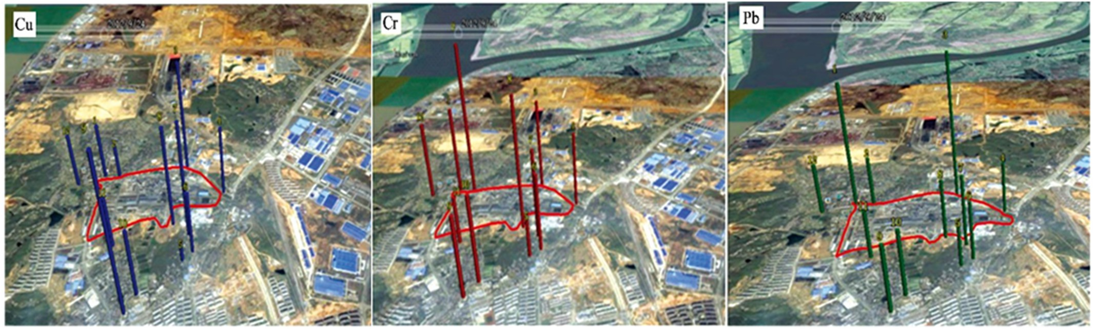](Image%20of%20Fig.%202)

Fig. 2. The map of the spatial concentration ratio distribution of Cu, Cr/Si and Pb superposed on the aerial view of the locations around the smelter (Gu et al., 2018).

[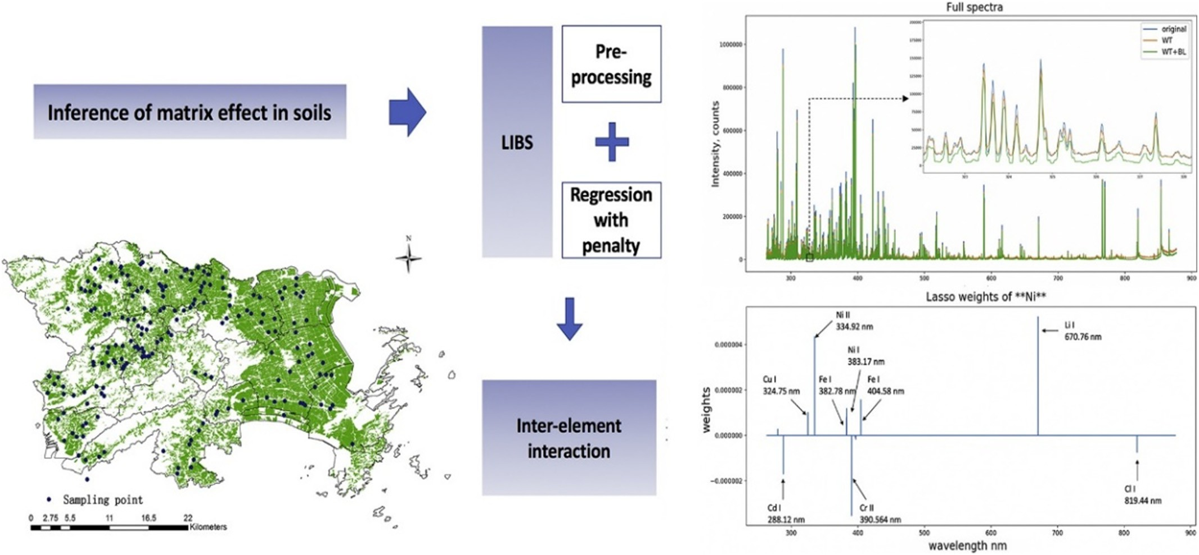](Image%20of%20Fig.%203)

Fig. 3. Multi-element analysis of heavy metal content in soils using LIBS in eastern China (Wang et al., 2018).

Lu et al. (2011) analyzed the content of element Cr in the national standard soil samples using LIBS. The calibration curve of element Cr is measured by studying the characteristics of laser-induced breakdown spectroscopy of element Cr in soil under optimal conditions. The exper- imental results demonstrate that the element content (60–400) × 10−6 and the spectral line intensity are in good linear relation, and the rela- tive standard deviation of element analysis of concentration measure- ment from the standard value is 7.89%. The relative deviation of the quantitative analytic result from the standard value is 5.3%, and the de- tection limit of Cr in soil is 16.3 × 10−6. The relative deviation by the in- ternal standard method is 2.7%, which indicates that the internal standard method can improve the accuracy of the measurement.

Yuan et al. (2016) measured the elemental concentration of Cr contained in soil with laser induced breakdown spectroscopy (LIBS). The laser wavelength was 1064 nm, pulse width is 8 ns, repetition fre- quency was 10 Hz, and the analysis line of LIRS was 4 nm. The results showed that the relative standard deviation (RSD) of the detected con- tent of Cr was 12.1% at the delay time of 4.78 us and the soil sample sur- face 1 mm behind lens focal point. The limit of detection (LOD) of LIBS is

2.01 ppm. The measured relative deviation between the measured value and the nature value is 5.15%.

Khan et al. (2013) reported the use of LIBS to determine the chro- mium contamination of soil due to effluents from leather tanning indus- try in Pakistan. Calibration curves were constructed by indigenously prepared standard sample and fitting of curves by linear regression. The limit of detection (LOD) was found to be 23.71 mg∙kg−1. The con- centration of chromium in the soil is up to 839 mg∙kg−1 in vicinity of ef- fluent drain and 1829 mg∙kg−1 in the area of old stagnant pool.

Gondal et al. (2009) used LIBS technique to monitor the remediation process of soil contaminated with chromium metal. Evaluating optimal experimental conditions, the LIBS system offered the minimum detec- tion limit of chromium (2 mg∙kg−1) in soil matrix. Meanwhile, the po- tential and capabilities of LIBS as a rapid tool for remediation process of contaminated sites is discussed in detail.

Ferreira et al. (2008) used artificial neural network (ANN) as calibra- tion strategy for LIBS, aiming Cu determination in soil samples. Two strategies of simple linear regression (SLR) and wrapper approach were employed to select a set of wavelengths for ANN learning.

[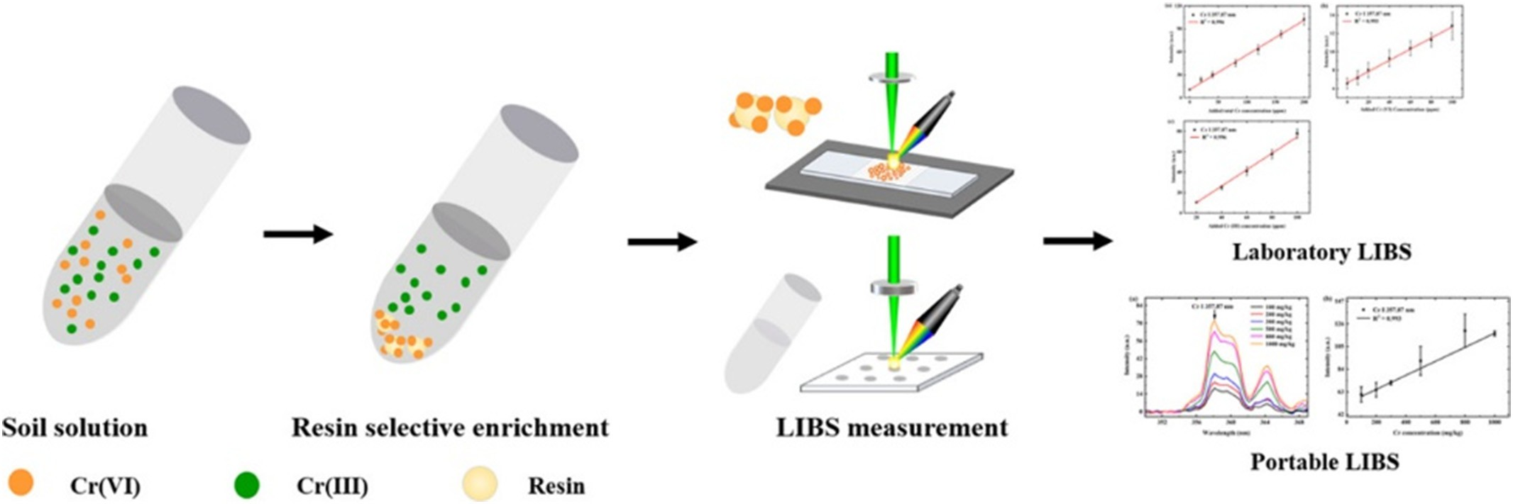](Image%20of%20Fig.%204)

Fig. 4. The processing flow for determining Cr in different valence states using LIBS (Fu et al., 2020).

Following ANN training, cross validation was applied for verification of prediction accuracy. The ANN showed good efficiency for Cu predictions although the features of portable instrumentation employed. The pro- posed method presented a limit of detection (LOD) of 2.3 mg∙dm−3 of Cu and a mean squared error (MSE) of 0.5 for the predictions.

Ambushe et al. (2015) applied the LIBS technique for quantification of total Cr in soil samples collected from polluted areas of Brits, North West Province, South Africa. The concentrations of Cr in soil samples varied from 111 to 3180 mg∙kg−1. In order to test the validity of the LIBS results, inductively coupled plasma-mass spectrometry (ICP-MS) was also employed for determination of Cr.

Fu et al. (2020) proposed a new method for rapid determination of Cr in different valence states (total Cr, Hexavalent chromium (Cr(VI)), trivalent chromium (Cr(III))) in soil by LIBS, and the experimental steps were revealed in Fig. 4. The regression coefficients for the total Cr, Cr(III), and Cr(VI) calibration curves were all over 0.99. The total Cr and Cr(VI) limits of detection were 19.34 and 35.18 mg∙kg−1, respec- tively. The total Cr and Cr(VI) relative standard deviations for repeat analyses were 7.69% and 12.98%, respectively. A portable laser- induced breakdown spectrometric method was developed for the de- termination of chromium in soil. The regression coefficient of total chro- mium concentration in soil was 0.993.

Lu et al. (2013) employed LIBS for detection of Pb in slurry samples for developing an in-situ sensor for monitoring heavy metal. From the LIBS data of slurry samples, the signals at Pb I 405.78 nm and Mn I

403.07 nm were investigated. The intensity ratio of I (Pb)/ I (Mn) in- creased as a linear function of the concentration of Pb with correlation coefficient R2 of 0.9949.

Motto-Ros et al. (2008) presented an artificial neural network (ANN)-based advanced analytical method for automated identification of elements and measurements of seven elements (Fe, Mg, Si, Mn, Al, Ca, and Ti) concentrations in rocks and soils, as well as its experimental validation. Results demonstrated that the ANN method worked success- fully for all major elements of the tested natural rock and soil samples. Dell'Aglio et al. (2011) analyzed soil samples of various origins by LIBS using the calibration curve method. The total concentrations of Cr, Cu, Pb, V, and Zn were determined, and compared with those ob- tained by ICP-OES. Furthermore, an anthropogenic index (AI) was eval- uated for Cr (AICr) and Zn (AIZn), and proposed as a simple and fast

indicator of soil pollution by heavy metals.

Huang et al. (2009) reported a LIBS system for soil analysis and pre- sented optimum experimental conditions for quantitatively measure- ment of Sr and other heavy metals in soil. Calibration curve for quantitative measurement of Sr has been built and limits of detection (LOD) of Sr in soil were determined to be 15.0 μg∙g−1.

* 1. *LIBS combined with new methods and techniques for soil detection*

In order to improve the detection precision of the elements and limit of detection of LIBS instrument, the researchers used the LIBS technique combined with new data analysis methods or new physical and chem- ical techniques to enhance the performance of the technologies.

Pareja et al. (2013) compared the performances of LIBS and laser ab- lation LIBS (LA-LIBS) by quantifying the total elemental concentration of potassium in highly heterogeneous solid samples, namely soils. The LA- LIBS approach (Fig. 5) produced a superior linear response different than the traditional LIBS scheme. The analytical response of LA-LIBS was tested with a large set of different soil samples for the quantifica- tion of the total concentration of Fe, Mn, Mg, Ca, Na, and K. Results showed an acceptable linear response for Ca, Fe, Mg, and K while poor signal responses were found for Na and Mn.

Yi et al. (2017) applied LIBS-assisted by laser-induced fluorescence (LIES-LIP) to selectively enhance the spectral intensities of the inter- fered lines. The determination coefficient (R2) of calibration curve (Pb concentration range = 14–94 ppm), the relative standard deviation (RSD) of spectral intensities, and the limit of detection (LOD) for Pb

element were improved from 0.6235 to 0.9802, 10.18% to 4.77%, and

24 ppm to 0.6 ppm using LIBS-LIF, respectively.

Du et al. (2013) analyzed the heavy metal elements (Mn, Cr, Cu, and Pb) in contained soil samples by using the orthogonal dual laser pulses induced breakdown spectroscopy (DP-LIBS).

Liu et al. (2012) used microwave-assisted LIBS (MA-LIBS) to mea- sure the copper content in soil samples showing a 23-fold improvement of the sensitivity compared with the conventional LIBS. The signal en- hancement obtained with MA-LIBS allowed for the detection of spectral lines related to concentration values as low as 30 mg•kg−1 for copper and 23.3 mg∙kg−1 for silver.

Li et al. (2010) demonstrated a significant signal increment of soil sample using laser ablation-spark induced breakdown spectroscopy (LA-SIBS) technique over using single pulse (SP) LIBS (Fig. 6).

Also in same research team, Li et al. (2012) developed a laser abla- tion fast pulse discharge plasma spectroscopy (LA-FPDPS) technique for analysis of Pb, Mg and Sn in soil. LA-FPDPS employed a periodical os- cillating discharge plasma generation method on samples instead of the second laser beam in DP-LIBS. Based on the calibration curves, the Pb, Mg and Sn contents in soil were derived and the limits of detection were 1.5 μg∙g−1, 34 μg∙g−1, and 0.16 μg∙g−1, respectively.

Idris et al. (2007) conducted direct analysis of soil samples utilizing a special advantage of transversely excited atmospheric (TEA) CO2 laser- induced plasma generated at atmospheric pressure on a metal target. A new method using micromoles structured intentionally on a metal sub- target was developed. A linear calibration curve was obtained with a de- tection limit of approximately 50 mg∙kg−1. Preliminary quantitative studies were carried out for a quartz sand sample containing Cr and Hg, resulting in linear calibration curves with detection limits of approx- imately 25 mg∙kg−1 and 10 mg∙kg−1, respectively.

Nicolodellia et al. (2015) have used dual-pulse excitation setup in order to improve LIBS's sensitivity. The key parameters as excitation wavelength, delay time and inter pulse, that influence the double pulse (DP) LIBS technique in the collinear beam geometry were opti- mized when applied to the analysis at atmospheric air pressure of soil samples of different origin and texture from extreme regions of Brazil. The collinear DP LIBS system improved the analytical performances of the technique by enhancing the intensity of emission lines of some ele- ments up to about 5 times, when compared with conventional SP-LIBS, and reduced the continuum emission.

Kim et al. (2013) employed LIBS technique coupled with the chemo- metric method (PCA and PLS-DA) to discriminate between soils con- taminated with heavy metals or oils and clean soils. Meanwhile, the effects of the water contents and grain sizes of soil samples on LIBS emissions were also investigated. The LIBS emission lines decreased by 59%–75% when the water content increased from 1.2% to 7.8%, and soil samples with a grain size of 75 μm displayed higher LIBS emission lines with lower relative standard deviations than those with a 2 mm grain size.

Chatterjee et al. (2019) collected a total of 20 soil samples both from near the thermal discharges as well as away from the thermal manifes- tations in the Manuguru geothermal area. LIBS spectra were recorded for all the collected soil samples and principal component analysis (PCA) was applied to easily identify the emission lines majorly respon- sible for variety classification of the soil samples.

Akhtar et al. (2018) has used a combination of magnetic field and LIBS to improve the detection limit of heavy elements in different Soil samples. The emission intensity enhancement factor up to about 8 has been observed and the limit of detection (LOD) of Cr has been improved from 18.2 mg/kg-7.7 mg/kg in the presence of magnetic field. A modi- fied PCA was developed which is based on the spectral truncation method to reduce the huge number of spectral data obtained from LIBS. The PCA bi-plot on the LIBS data reveals the presence of two differ- ent clusters.

Ma et al. (2011) applied LIBS to quantitative analysis of heavy metal pollution elements in soil. A new algorithm using weight iteration in the

[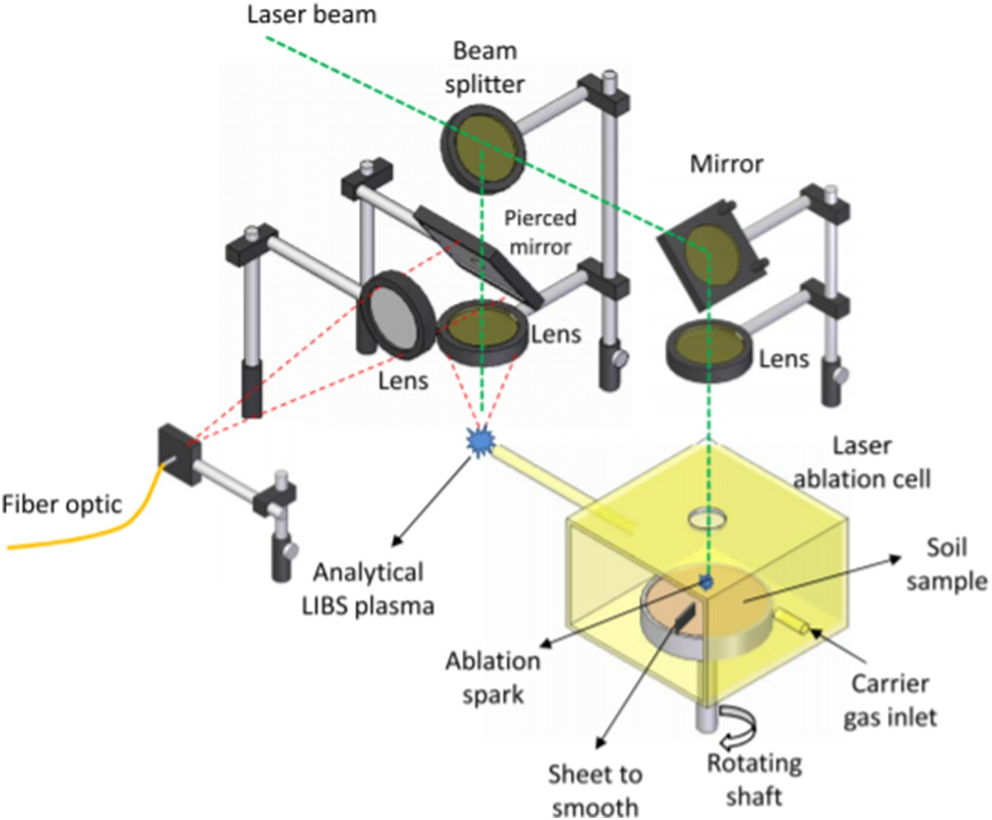](Image%20of%20Fig.%205)

Fig. 5. Experimental setup for modified LA-LIBS approach (Pareja et al., 2013).

[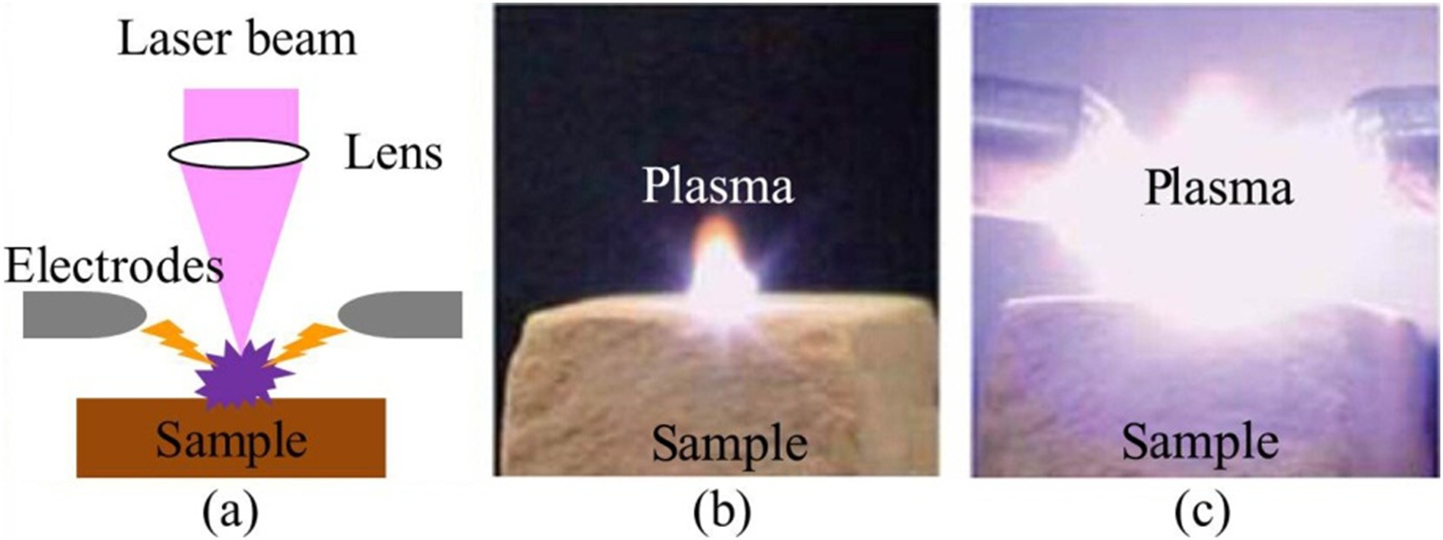](Image%20of%20Fig.%206)

Fig. 6. (a) The interface between the sample, laser beam and the electrodes, (b) plasma from SP-LIBS, (c) plasma from LA-SIBS (Li et al., 2010).

artificial neural network was developed, which decreased the training epochs remarkably. Based on the new method, the LODs for several el- ements Cu and Cd in soil were determined to be 42 and 5 ppm, respectively.

Chen et al. (2012) investigated the quantitative analysis of trace Cd in polluted soil with LIBS technique by calibration. Radial Basis Function (RBF) neural network and Lorentz function were intro- duced to optimize the LIBS spectral data for improving the detection sensitivity and limit of detection (LOD). The calibration curve of Cd in soil was obtained, its linear correlation is 0.9998, and the LOD of Cd in soil is 16.5 mg∙kg−1.

Bousquet et al. (2007) used the LIBS (Nd: YAG laser delivering 10-ns pulses at 1064 nm, 20 mJ laser pulse, and 10 Hz repetition rate) tech- nique to conduct a quantitative analysis of chromium (Cr) in soil sam- ples and proposed a method for classifying soils by applying principal components analyses (PCA) to LIBS data. To reduce the dataset's dimen- sionality, relevant spectral lines related to major elements were selected.

Bricklemyer et al. (2013) tested for soil C predictions and the identi- fication of wavelengths important for soil C prediction by two regres- sion shrinkage and variable selection approaches, the least absolute shrinkage and selection operator (LASSO) and sparse multivariate re- gression with covariance estimation (MRCE). Predictive multi- response partial least squares (PLS2) models using full and reduced spectrum LIES were compared for directly determining soil total C (TC), IC, and SOC. The result showed that complete spectrum LIES is su- perior to UV spectrum LIES for predicting soil C for intact soil cores with- out pre-treatment; LASSO and MRCE approaches provide improved calibration prediction accuracy over PLS2 but require additional testing with increased soil and target analyte diversity.

Kim et al. (2014) used LIBS to determine Zn concentrations in vari- ous types of soil samples. For enhancing the performance of the LIBS analysis and minimizing the factors affecting LIBS results, the data pro- cessing methods of discarding and Kriging interpolation methods were combined. The discarding method decreased the precision of pulse-to- pulse variation and the interpolation methods improved the sample-

to-sample precision and accuracy of Zn concentration compared to ICP- OES analysis. It is expected that the suggested data analysis method with high performance and convenience could be applied in the envi- ronmental monitoring field for the determination of hazardous ele- ments in soil.

Fu et al. (2018) developed a new method for the determination of cadmium in soils using LIBS. The heavy metals were enriched by the cat- ion exchange resins. And then, the LIBS signal levels were further en- hanced by a sample container with spatial confinement. During this process, the soil only needs to be treated with water to achieve slurry status, rather than any complex pre-treatments. The detection limit for cadmium in soils is 0.132 mg/ kg by using this method.

El Haddad et al. (2013) exploited a transportable LIBS system for on- site LIBS measurements of soil samples. Quantitative analysis was achieved by artificial neural network (ANN) to overcome the matrix ef- fects and the nonlinear behaviour of the calibration. Results demon- strated that the relative error of prediction (REP) was found to be below 20% for matrix elements like Ca and Fe, for major element like Al (in the % range) and also for trace element like Cu (in the mg∙kg−1 range).

Mukhono et al. (2013) employed the multivariate chemometric methods to deal with the LIBS spectra of soils and rocks samples from a geothermal field lying in a high background radiation area (HBRA). Multivariate calibration strategies (PLS and ANN) were developed and applied for prediction of the trace elements. Then, principal components analysis (PCA) and soft independent modeling of class analogy (SIMCA) were utilized to classify and identify the HBRA geothermal samples, HBRA non geothermal sources and NBRA geothermal samples.

As mentioned above, the soil in different types, sources and compo- sitions, a large number of exploratory studies have been achieved. Re- searchers should focus on developing the more novel techniques to obtain the more robust models and results. It can provide a theoretical guidance for detecting and controlling heavy metal pollution.

1. LIBS applications to soil related materials and plants-related issues
   1. *LIBS for detecting the soil related materials*

Besides these studies above, some researchers used LIBS technology to detect soil related materials (ore, soil on other planets, chemical, coal, and agricultural products, etc.). The fruitful results were achieved, which also revealed the powerful ability of LIBS technology in chemical analysis field.

Deng et al. (2020) used LIBS to test the coal quality. The PLS model was established based on the adaptive reweighted sampling (CARS) and the successive projections algorithm (SPA). The results show that LIBS combined with spa-pls technology has a good prospect in the de- tection of N and S content in coal.

Ma et al. (2020) adopted the technology of indirect laser-induced breakdown spectroscopy (ID-LIBS) to improve the detection sensitivity of Cl and S elements in water. The method detected Cl in water by indi- rectly detecting the excess silver (Ag) after the precipitation reaction of Ag and chloride,and detected S in water by detecting the excess barium (Ba) after the precipitation reaction of Ba and sulfate. The results showed that the technique of indirect LIBS can achieve the sensitive de- tection of Cl and S in water.

Li et al. (2020) proposed LIBScombined with laser-induced fluores- cence (LIF) technology to enhance the spectral intensity of uranium in ores and eliminate spectral interference. The study demonstrates that LIBS-LIF has excellent potential in the exploration of uranium resources. Judge et al. (2013) used LIBS to analyse depleted uranium (U) and thorium (Th) oxide powders and uranium ore sample as both pressed pellets and powders. The acquired results proved that LIBS as a potential rapid in situ analysis technique can be widely used in nuclear

production facilities, environmental sampling, and in-field forensic applications.

Schroder et al. (2013) used LIBS technology and the multivariate analysis methods to detect and identify the eight different salts (CaCl2, CaSO4, KCl, K2SO4, MgCl2, MgSO4, NaCl, Na2SO4), pure and frozen salt so- lutions under Mars soil. PCA, SIMCA and PLS-DA models were built, tested and optimized for both, the pure salts and the frozen salt solu- tions. Gottfried et al. (2009) employed both single- and double-pulse LIBS technology combined with PCA and PLS-DA algorithm to distin- guish the natural carbonate, fluorite and silicate geological materials.

* 1. *LIBS detection in plant materials*

In addition, many researchers employed LIBS technology to analyse to agricultural goods (Yao et al., 2013), plants (Kumar et al., 2014; Pouzar et al., 2009; Santos et al., 2012; Trevizan et al., 2009; Yao et al., 2010), wood (Uhl et al., 2001; Solo-Gabriele et al., 2004; Martin et al., 2005), food (Schroder et al., 2013), etc. and fruitful academic achieve- ments are made.

In detail, Arantes de Carvalho et al. (2015) used for the first time a femtosecond (fs)-LIBS system in a systematic study aiming to deter- mine quantitatively the macronutrients Ca, Mg and P and the micronutrients Cu, Fe, Mn and Zn in pelletized leaves of 31 different crop plants of economic value covering a wide range of matrices.

Kim et al. (2012) proposed the use of LIBS combined with PLS-DA to quantify the nutrients Mg, Ca, Na and K and discriminate between non- contaminated and pesticide-contaminated spinach leaves.

Han et al. (2012) employed CF-LIBS to investigate the trace elements Fe, Ca, Al, Cu, K, Li, Mg, Mn, Na, Sr, Ti, and Zn in cigarette tobacco leaves and ashes.

Nicolodelli et al. (2017) provided a further advance in nutrient anal- ysis of plants by applying to soybean leaves double pulse (DP)-LIBS at the wave-lengths of 532 and 1064 nm in orthogonal beam geometry usinga reheating configuration.

Peng et al. (2017a, 2017b) investigated the effects of moisture af- fected dramatically the intensity and stability of LIBS signals of heavy metals, especially Cr, in rice leaves. To reduce the moisture, a simple and efficient approach was proposed based on a preliminary fast drying of samples followed by the application of an exponential model to cor- rect the actual element concentration in the analyte and the PLSR model to compensate the prediction deviations. By using this approach, the calibration performance was greatly improved yielding a correlation co- efficient r2 = 0.967 and a RMSE of 4.75 mg∙kg−1 for the prediction set. Rehan et al. (2016) identified by CF-LIBS in ambient air at atmo- spheric pressure the presence of 11 elements, i.e. C, Ca, Cl, Fe, H, K, Li, Mg, N, Na and O, in the flesh of red skin potato, whereas white skin po-

tato contained the same elements except Li and Cl.

Tripathi et al. (2016) used LIBS and biochemical analysis to evaluate the effect of Si on Pb toxicity in roots and shoots of wheat seedlings by comparing the Pb content both in original samples treated with Si and in samples added with both Pb and Si.

Ferreira et al. (2010) proposed the use of LIBS as an efficient tool for assessing the nutrient distribution in commercial breakfast cereals. The Ca content declared by the manufacturers in 16 cereals samples was verified by ICP-OES analysis.

Liu et al. (2018) evaluated quantitatively by LIBS the elemental nu- trients content and the level of Cu contamination in 270 samples of three kinds of rice. The contents of the nutrient elements C, K and Mg in the various kinds of rice as resulting from PCA analysis of LIBS data showed the feasibility of LIBS for classifying rice types and evaluating their quality.

Ma and Dong (2014) explored the potential of LIBS for the fast, real- time, on site measurement of P, S and Cl spectral lines of the pesticide chlorpyrifos residues on apple surfaces. The results of PCA highlighted significant spectral differences between untreated apples and apples sprayed with chlorpyrifos at various concentrations. In the same team,

Du et al. (2015) explored further the LIBS performance in analyzing the pesticide chlorpyrifos and omethoate residues on apple and pear surfaces.

* 1. *LIBS for plant diseases diagnosis*

Besides above, LIBS could be employed to conduct an early diagnosis of plant diseases, especially for citrus, soybean and tobacco. Sankaran et al. (2015) applied LIBS to citrus leaves for analysis of various anoma- lies, including diseases, such as the *Huanglongbing* (HLB) bacterial de- structive disease and citrus cancer, and nutrient deficiencies from Fe, Mn, Mg, and Zn. First, pre-processing methods including baseline cor- rection, WT multivariate de-noising and normalization were employed to deal with the LIBS spectra. And then, the spectral features were ex- tracted by PCA and quadratic discriminant analysis (QDA) and SVM were used to distinguish the healthy and infected samples. As a result, a high average classification accuracy (97.5%) was obtained.

Ranulfi et al. (2017) used LIBS to citrus leaves as an alternative to conventional methods to discover the possible presence of the HLB dis- ease by identifying the nutritional elemental composition profile related to the citrus health state. In this research, citrus leaves collected from adult citrus trees were separated into 3 groups, named healthy, HLB- symptomatic and HLB-asymptomatic samples. From the LIBS spectra, the largest variations among the 3 groups were measured for Ca, Mg and K, which were considered the most relevant elements for HLB diag- nosis. Then, a PLS-DA model was developed, which offered an accuracy of 73% in distinguishing the 3 groups of leaves. Thus, LIBS analyses of fresh citrus leaves confirmed the visual symptomology and appeared to be a fast and reproducible tool for the early diagnosis of HLB in citrus. Rao et al. (2018) explored a diagnostic method based on LIBS to dis- tinguish between healthy and HLB-infected navel oranges originated from China. The LIBS spectra (200 nm–1050 nm) of the epidermis of the fruit were pre-processed by smoothing and multiple scattering cor- rection (MSC). A random forest (RF) based on the wavelet transform (CWT) and PCA was employed to identify and discriminate HLB- infected samples from healthy ones. As a result, both the training set

and the validation set provided an average accuracy higher than 96%.

Ponce et al. (2018) employed LIBS combined with PCA to classify 6 citrus varieties (Macrophylla, Valencia orange, Sugar Belle, Ray Ruby grapefruit, Meyer lemon and honey Murcott). Here, a multi-pulse laser setup coupled with a microscope was employed to collect the LIBS spec- tra of the plant phloem. And those LIBS spectra revealed the emission lines of the elements Ca, Na, N, H and Fe and the molecules CN and C2. The results of PCA on LIBS data allowed to discriminate healthy from HLB-infected samples with a high level of accuracy (about 90%). The re- search indicated that LIBS combined with chemometric methods was considered to be a rapid, low-cost and efficient tool to discriminate be- tween healthy and HLB-infected citrus plants.

Peng et al. (2017a, 2017b) investigated an approach based on LIBS to classify tobacco leaves infected by the mosaic virus (TMV) from healthy leaves. The moisture content (MC) in fresh leaves apparently affected the stability of analysis resulting in a detrimental result on classification. The PLS-DA model established using LIBS spectral data of fresh and dried pelletized leaves provided a good classification (Fig. 7). Mean- while, SVM approach was used and provided an oppositely result. The negative effect of MC was reduced and the classification results were improved.

1. Conclusions and future perspectives

At present, LIBS technology is undergoing a rapid technical develop- ment for using laboratorial, man-portable, robotic-based, and standoff methods in chemical analysis field.

Further research could focus on several aspects as follows: (1) novel techniques (data processing or signal enhancement) should be devel- oped to enhance LIBS signal and improve the reliability, accuracy and

repeatability of LIBS analytical results; (2) LIBS technology should be combined with other analytical techniques (Raman, fluorescence, etc.) to reinforce the analytical ability of laser spectrometer and extend the applicability of the chemical apparatus; (3) portable and customised LIBS instrument should be developed to cope with the in situ, online de- tection in emergencies, environmental monitoring, history cultural her- itage, and so on; (4) LIBS core parts must be researched and developed, contributing to the rapid development of the LIBS industry.

Acknowledgements

This work was supported by the National Natural Science Founda- tion of China (Program No: 61705188), China Postdoctoral Science Foundation (2017M613218), Shaanxi Province Postdoctoral Science Foundation (2017BSHYDZZ61), the Fundamental Research Funds for the Central Universities (2452017125), and the Key Laboratory of Agri- cultural Internet of Things, Ministry of Agriculture and Rural Affairs of the People's Republic of China.

References

Akhtar, M., Jabbar, A., Mehmood, S., Ahmed, N., Ahmed, R., Baig, M.A., 2018. [Magnetic field](http://refhub.elsevier.com/S2589-7217(20)30020-9/rf0005) [enhanced detection of heavy metals in soil using laser induced breakdown spectros-](http://refhub.elsevier.com/S2589-7217(20)30020-9/rf0005) [copy. Spectrochim. Acta Part B. 148, 143–15](http://refhub.elsevier.com/S2589-7217(20)30020-9/rf0005)1.

Ambushe, A.A., du Plessis, A., McCrindle, R.I., 2015. [Laser-induced breakdown spectros-](http://refhub.elsevier.com/S2589-7217(20)30020-9/rf0010) [copy and inductively coupled plasma-mass spectrometry for determination of Cr in](http://refhub.elsevier.com/S2589-7217(20)30020-9/rf0010) [soils from Brits District. South Africa. B. Chem. Soc. Ethiopia. 29 (3), 357–36](http://refhub.elsevier.com/S2589-7217(20)30020-9/rf0010)6.

Arantes de Carvalho, G.G., Moros, J., Santos Jr., D., Krug, F.J., Laserna, J.J., 2015. [Direct deter-](http://refhub.elsevier.com/S2589-7217(20)30020-9/rf0015) [mination of the nutrient profile in plant materials by femtosecond laser-induced](http://refhub.elsevier.com/S2589-7217(20)30020-9/rf0015) [breakdown spectroscopy. Anal. Chim. Acta 876, 26–38](http://refhub.elsevier.com/S2589-7217(20)30020-9/rf0015).

Barbafieri, M., Pini, R., Ciucci, A., Tassi, E., 2011. [Field assessment of Pb in contaminated](http://refhub.elsevier.com/S2589-7217(20)30020-9/rf0020) [soils and in leaf mustard (Brassica juncea): the LIBS technique. Chem. Ecol. 27,](http://refhub.elsevier.com/S2589-7217(20)30020-9/rf0020) [161–16](http://refhub.elsevier.com/S2589-7217(20)30020-9/rf0020)9.

Belkov, M.V., Burakov, V.S., De Giacomo, A., Kiris, V.V., Raikov, S.N., Tarasenko, N.V., 2009. [Comparison of two laser-induced breakdown spectroscopy techniques for total car-](http://refhub.elsevier.com/S2589-7217(20)30020-9/rf0025) [bon measurement in soils. Spectrochim. Acta Part B 64, 899–90](http://refhub.elsevier.com/S2589-7217(20)30020-9/rf0025)4.

Bousquet, B., Sirven, J.B., Canioni, L., 2007. [Towards quantitative laser-induced breakdown](http://refhub.elsevier.com/S2589-7217(20)30020-9/rf0030) [spectroscopy analysis of soil samples. Spectrochim. Acta Part B. 62, 1582–1589.](http://refhub.elsevier.com/S2589-7217(20)30020-9/rf0030)

Bricklemyer, R.S., Brown, D.J., Barefield, J.E., Clegg, S.M., 2011. [Intact soil core total, inor-](http://refhub.elsevier.com/S2589-7217(20)30020-9/rf0035) [ganic, and organic carbon measurement using laser-induced breakdown spectros-](http://refhub.elsevier.com/S2589-7217(20)30020-9/rf0035) [copy. Soil Sci. Soc. Am. J. 75, 1006–1018](http://refhub.elsevier.com/S2589-7217(20)30020-9/rf0035).

Bricklemyer, R.S., Brown, D.J., Turk, P.J., Clegg, S.M., 2013. [Improved intact soil-core carbon](http://refhub.elsevier.com/S2589-7217(20)30020-9/rf0040) [determination applying regression shrinkage and variable selection techniques to](http://refhub.elsevier.com/S2589-7217(20)30020-9/rf0040) [complete spectrum laser-induced breakdown spectroscopy (LIBS). Appl. Spectrosc.](http://refhub.elsevier.com/S2589-7217(20)30020-9/rf0040) [67 (10), 1185–1199](http://refhub.elsevier.com/S2589-7217(20)30020-9/rf0040).

Bricklemyer, R.S., Brown, D.J., Turk, P.J., Clegg, S., 2018. [Comparing vis–NIRS, LIBS and](http://refhub.elsevier.com/S2589-7217(20)30020-9/rf0045) [combined vis-NIRS-LIBS for intact soil core soil carbon measurement. Soil Sci. Soc.](http://refhub.elsevier.com/S2589-7217(20)30020-9/rf0045) [Am. J. 82 (6), 1482–1496](http://refhub.elsevier.com/S2589-7217(20)30020-9/rf0045).

Capitelli, F., Colao, F., Provenzano, M.R., Fantoni, R., Brunetti, G., Senesi, N., 2002. [Determi-](http://refhub.elsevier.com/S2589-7217(20)30020-9/rf0055) [nation of heavy metals in soils by laser induced breakdown spectroscopy. Geoderma.](http://refhub.elsevier.com/S2589-7217(20)30020-9/rf0055) [106, 45–62](http://refhub.elsevier.com/S2589-7217(20)30020-9/rf0055).

Chatterjee, S., Singh, M., Biswal, B.P., Sinha, U.K., Patbhaje,S., Sarkar, A., 2019. Application of laser-induced breakdown spectroscopy (LIBS) coupled with PCA for rapid classifi- cation of soil samples in geothermal areas. Anal. Bioanal. Chem. 411(13), 2855–2866. Chen, S.Q., Ma, X.H., Zhao, H.F., Lv, H., 2012. [Research of laser induced breakdown spec-](http://refhub.elsevier.com/S2589-7217(20)30020-9/rf0060) [troscopy for detection of trace Cd in polluted soil, in: Liao, Y., Jin, W., Sampson,](http://refhub.elsevier.com/S2589-7217(20)30020-9/rf0060) [D.D., Yamauchi, R., Chung, Y., Nakamura, K., Rao, Y. (Eds.), 22nd International Confer-](http://refhub.elsevier.com/S2589-7217(20)30020-9/rf0060)

[ence on Optical Fiber Sensors, pp. 1–](http://refhub.elsevier.com/S2589-7217(20)30020-9/rf0060)4.

Ciucci, A., 1997. [LIBS Technique for Environmental Measurements. In Spectroscopy and](http://refhub.elsevier.com/S2589-7217(20)30020-9/rf5000) [Dynamics of Collective Excitations in Solids. Springer US](http://refhub.elsevier.com/S2589-7217(20)30020-9/rf5000).

Cremers, D.A., Chinni, R.C., 2009. [Laser-induced breakdown spectroscopy - capabilities](http://refhub.elsevier.com/S2589-7217(20)30020-9/rf0065) [and limitations. Appl. Spectrosc. Rev. 44, 457–50](http://refhub.elsevier.com/S2589-7217(20)30020-9/rf0065)6.

Cremers, D.A., Radziemski, L.J., 2013. [Handbook of Laser-induced Breakdown Spectros-](http://refhub.elsevier.com/S2589-7217(20)30020-9/rf0070) [copy. Second edition. John Wiley & Sons, Lt](http://refhub.elsevier.com/S2589-7217(20)30020-9/rf0070)d.

da Silva, R.M., Milori, D., Ferreira, E.C., Ferreira, E.J., Krug, F.J., Martin-Neto, L., 2008. [Total](http://refhub.elsevier.com/S2589-7217(20)30020-9/rf0075) [carbon measurement in whole tropical soil sample. Spectrochim. Acta Part B. 63,](http://refhub.elsevier.com/S2589-7217(20)30020-9/rf0075) [1221–1224](http://refhub.elsevier.com/S2589-7217(20)30020-9/rf0075).

de Carvalho, G.G.A., Santos Jr., D., da Silva Gomes, M., Nunes, L.C., Guerra, M.B.B., Krug, F.J., 2014. [Influence of particle size distribution on the analysis of pellets of plant mate-](http://refhub.elsevier.com/S2589-7217(20)30020-9/rf0080) [rials by laser-induced breakdown spectroscopy. Spectrochim. Acta Part B. 105,](http://refhub.elsevier.com/S2589-7217(20)30020-9/rf0080) [130–13](http://refhub.elsevier.com/S2589-7217(20)30020-9/rf0080)5.

Dell'Aglio, M., Gaudiuso, R., Senesi, G.S., De Giacomo, A., Zaccone, C., Miano, T.M., De Pascale, O., 2011. [Monitoring of Cr, Cu, Pb, V and Zn in polluted soils by laser induced](http://refhub.elsevier.com/S2589-7217(20)30020-9/rf0085) [breakdown spectroscopy (LIBS). J. of Environ. Monitor. 13, 1422–1426](http://refhub.elsevier.com/S2589-7217(20)30020-9/rf0085).

Deng, F., Ding, Y., Chen, Y.J., Zhu, S.N., 2020. [Quantitative analysis of the content of nitro-](http://refhub.elsevier.com/S2589-7217(20)30020-9/rf0090) [gen and sulfur in coal based on laser-induced breakdown spectroscopy: effects of](http://refhub.elsevier.com/S2589-7217(20)30020-9/rf0090) [variable selection. Plasma Sci. Technol. 22 (7), 074005](http://refhub.elsevier.com/S2589-7217(20)30020-9/rf0090).

Ding, Y., Xia, G.Y., Ji, H.W., Xiong, X., 2019. [Accurate quantitative determination of heavy](http://refhub.elsevier.com/S2589-7217(20)30020-9/rf0095) [metals in oily soil by laser induced breakdown spectroscopy (LIBS) combined with](http://refhub.elsevier.com/S2589-7217(20)30020-9/rf0095) [interval partial least squares (IPLS). Anal. Methods-UK. 11 (29), 3657–3664](http://refhub.elsevier.com/S2589-7217(20)30020-9/rf0095).

[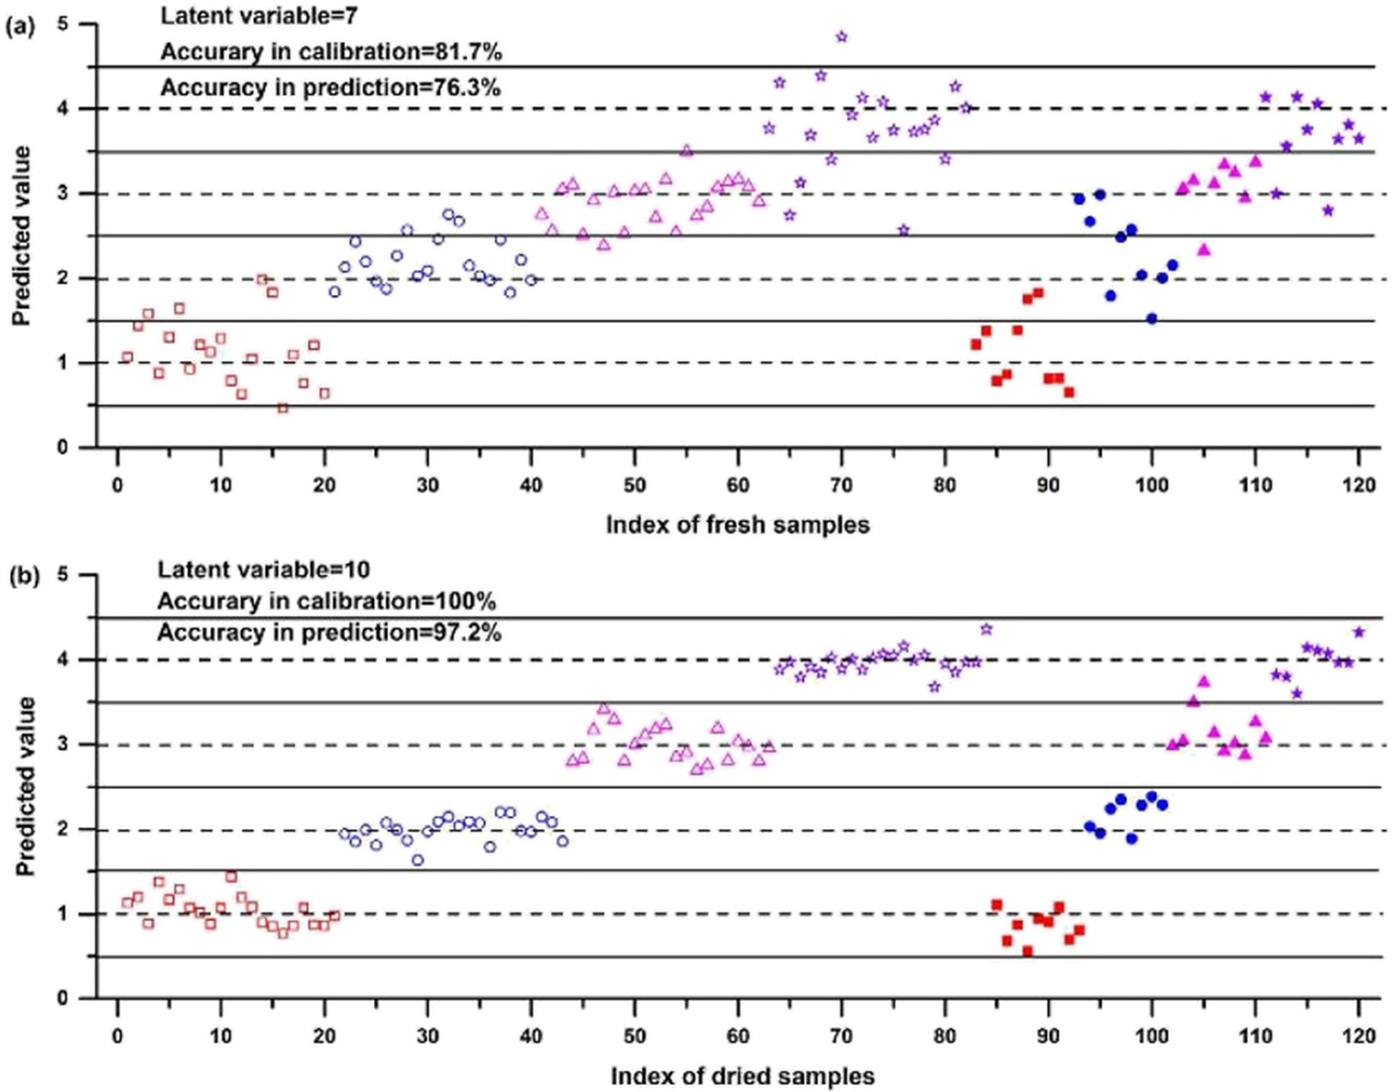](Image%20of%20Fig.%207)

Fig. 7. Predicted values plot for PLS-DA classification of different symptoms of the infected plants based on LIBS spectra of (a) fresh samples and (b) dried samples (Peng et al., 2017a, 2017b).

Du, C., Gao, X., Shao, Y., Song, X.W., Zhao, Z.M., Hao, Z.Q., Lin, J.Q., 2013. [Analyses of heavy](http://refhub.elsevier.com/S2589-7217(20)30020-9/rf0100) [metals by soil using dual-pulsed laser induced breakdown spectroscopy. Acta Phys.](http://refhub.elsevier.com/S2589-7217(20)30020-9/rf0100) [Sin-Ch Ed 62 045202-1-045202-6](http://refhub.elsevier.com/S2589-7217(20)30020-9/rf0100).

Du, X., Dong, D., Zhao, X., Jiao, L., Han, P., Lang, Y., 2015. [Detection of pesticide residues on](http://refhub.elsevier.com/S2589-7217(20)30020-9/rf0105) [fruit surfaces using laser induced breakdown spectroscopy. RSC Adv. 5,](http://refhub.elsevier.com/S2589-7217(20)30020-9/rf0105) [79956–79963](http://refhub.elsevier.com/S2589-7217(20)30020-9/rf0105).

El Haddad, J., Villot-Kadri, M., Ismael, A., Gallou, G., Michel, K., Bruyere, D., Laperche, V., Canioni, L., Bousquet, B., 2013. [Artificial neural network for on-site quantitative anal-](http://refhub.elsevier.com/S2589-7217(20)30020-9/rf0110) [ysis of soils using laser induced breakdown spectroscopy. Spectrochim. Acta Part B.](http://refhub.elsevier.com/S2589-7217(20)30020-9/rf0110) [79–80, 51–57](http://refhub.elsevier.com/S2589-7217(20)30020-9/rf0110).

El Haddad, J., Canioni, L., Bousquet, B., 2014. [Good practices in LIBS analysis: review and](http://refhub.elsevier.com/S2589-7217(20)30020-9/rf0115) [advices. Spectrochim. Acta Part B. 101, 171–18](http://refhub.elsevier.com/S2589-7217(20)30020-9/rf0115)2.

Erler, A., Riebe, D., Beitz, T., Lohmannsroben, H.G., Gebbers, R., 2020. [Soil nutrient detec-](http://refhub.elsevier.com/S2589-7217(20)30020-9/rf0120) [tion for precision agriculture using handheld laser-induced breakdown spectroscopy](http://refhub.elsevier.com/S2589-7217(20)30020-9/rf0120) [(LIBS) and multivariate regression methods (PLSR, Lasso and GPR). Sensors-Basel. 20](http://refhub.elsevier.com/S2589-7217(20)30020-9/rf0120) [(2), 418–434](http://refhub.elsevier.com/S2589-7217(20)30020-9/rf0120).

Essington, M.E., Melnichenko, G.V., Stewart, M.A., Hull, R.A., 2009. [Soil metals analysis](http://refhub.elsevier.com/S2589-7217(20)30020-9/rf0125) [using laser-induced breakdown spectroscopy (LIBS). Soil Sc. Soc. Am. J. 73,](http://refhub.elsevier.com/S2589-7217(20)30020-9/rf0125) [1469–1478](http://refhub.elsevier.com/S2589-7217(20)30020-9/rf0125).

Fantoni, R., Caneve, L., Colao, F., Fornarini, L., Lazic, V., Spizzichino, V., 2006. [Laser induced](http://refhub.elsevier.com/S2589-7217(20)30020-9/rf0130) [breakdown spectroscopy (LIBS)—the process, applications to artwork and environ-](http://refhub.elsevier.com/S2589-7217(20)30020-9/rf0130) [ment. In: Bartolo, B.D., Forte, O. (Eds.), Advances in Spectroscopy for Lasers and Sens-](http://refhub.elsevier.com/S2589-7217(20)30020-9/rf0130) [ing, pp. 229–25](http://refhub.elsevier.com/S2589-7217(20)30020-9/rf0130)4.

Ferreira, E.C., Milori, D., Ferreira, E.J., Da Silva, R.M., Martin-Neto, L., 2008. [Artificial neural](http://refhub.elsevier.com/S2589-7217(20)30020-9/rf0135) [network for Cu quantitative determination in soil using a portable laser induced](http://refhub.elsevier.com/S2589-7217(20)30020-9/rf0135) [breakdown spectroscopy system. Spectrochim Acta Part B. 63, 1216–1220.](http://refhub.elsevier.com/S2589-7217(20)30020-9/rf0135)

Ferreira, E.C., Menezes, E.A., Matos, W.O., Milori, D.M.B.P., Nogueira, A.R.A., Martin-Neto, L., 2010. [Determination of Ca in breakfast cereals by laser induced breakdown spec-](http://refhub.elsevier.com/S2589-7217(20)30020-9/rf0140) [troscopy. Food Control 21, 1327–1330](http://refhub.elsevier.com/S2589-7217(20)30020-9/rf0140).

Fortes, F.J., Moros, J., Lucena, P., Cabalin, L.M., Laserna, J.J., 2013. [Laser-induced breakdown](http://refhub.elsevier.com/S2589-7217(20)30020-9/rf0145) [spectroscopy. Anal. Chem. 85, 640–669](http://refhub.elsevier.com/S2589-7217(20)30020-9/rf0145).

Fu, X.L., Li, G.L., Tian, H.W., Dong, D.M., 2018. [Detection of cadmium in soils using laser-](http://refhub.elsevier.com/S2589-7217(20)30020-9/rf0150) [induced breakdown spectroscopy combined with spatial confinement and resin en-](http://refhub.elsevier.com/S2589-7217(20)30020-9/rf0150) [richment. RSC Adv. 8 (69), 39635–39640](http://refhub.elsevier.com/S2589-7217(20)30020-9/rf0150).

Fu, X.L., Ma, S.X., Li, G.L., Guo, L.B., Dong, D.M., 2020. [Rapid detection of chromium in dif-](http://refhub.elsevier.com/S2589-7217(20)30020-9/rf0155) [ferent valence states in soil using resin selective enrichment coupled with laser-](http://refhub.elsevier.com/S2589-7217(20)30020-9/rf0155)

[induced breakdown spectroscopy: from laboratory test to portable instruments.](http://refhub.elsevier.com/S2589-7217(20)30020-9/rf0155) [Spectrochim. Acta Part B. 167, 105817](http://refhub.elsevier.com/S2589-7217(20)30020-9/rf0155).

Gehl, R.J., Rice, C.W., 2007. [Emerging technologies for in situ measurement of soil carbon.](http://refhub.elsevier.com/S2589-7217(20)30020-9/rf5005)

[Climatic Change. 80 (1-2), 43–54](http://refhub.elsevier.com/S2589-7217(20)30020-9/rf5005).

Glumac, N.G., Dong, W.K., Jarrell, W.M., 2010. [Quantitative analysis of soil organic carbon](http://refhub.elsevier.com/S2589-7217(20)30020-9/rf0160) [using laser-induced breakdown spectroscopy: an improved method. Soil Sci. Soc. Am.](http://refhub.elsevier.com/S2589-7217(20)30020-9/rf0160)

[J. 74 (6), 1922–1928](http://refhub.elsevier.com/S2589-7217(20)30020-9/rf0160).

Gondal, M.A., Hussain, T., Yamani, Z.H., Baig, M.A., 2009. [On-line monitoring of remedia-](http://refhub.elsevier.com/S2589-7217(20)30020-9/rf0165) [tion process of chromium polluted soil using LIBS. J. Hazard. Mater. 163, 1265–1271](http://refhub.elsevier.com/S2589-7217(20)30020-9/rf0165). Gottfried, J.L., Harmon, R.S., De Lucia, F.C., Miziolek, A.W., 2009. [Multivariate analysis of](http://refhub.elsevier.com/S2589-7217(20)30020-9/rf0175) [laser-induced breakdown spectroscopy chemical signatures for geomaterial classifi-](http://refhub.elsevier.com/S2589-7217(20)30020-9/rf0175)

[cation. Spectrochim. Acta Part B. 64, 1009–1019](http://refhub.elsevier.com/S2589-7217(20)30020-9/rf0175).

Gu, Y.H., Zhao, N.J., Ma, M.J., Meng, D.S., Jia, Y., Fang, L., Liu, J.G., Liu, W.Q., 2018. [Mapping](http://refhub.elsevier.com/S2589-7217(20)30020-9/rf0180)

[analysis of heavy metal elements in polluted soils using laser-induced breakdown](http://refhub.elsevier.com/S2589-7217(20)30020-9/rf0180) [spectroscopy. Spectrosc. Spectr. Anal. 38 (03), 982–98](http://refhub.elsevier.com/S2589-7217(20)30020-9/rf0180)9.

Hahn, D.W., Lunden, M.M., 2000. [Detection and analysis of aerosol particles by laser-](http://refhub.elsevier.com/S2589-7217(20)30020-9/rf0185) [induced breakdown spectroscopy. Aerosol Sci. Technol. 33, 30–48](http://refhub.elsevier.com/S2589-7217(20)30020-9/rf0185).

Hahn, D.W., Omenetto, N., 2010. [Laser-induced breakdown spectroscopy (LIBS), part I: re-](http://refhub.elsevier.com/S2589-7217(20)30020-9/rf5010) [view of basic diagnostics and plasma-particle interactions: still-challenging issues](http://refhub.elsevier.com/S2589-7217(20)30020-9/rf5010) [within the analytical plasma community. Appl. Spectrosc. 74, 335A–366A](http://refhub.elsevier.com/S2589-7217(20)30020-9/rf5010).

Hahn, D.W., Omenetto, N., 2012. [Laser-induced breakdown spectroscopy (LIBS), part II:](http://refhub.elsevier.com/S2589-7217(20)30020-9/rf0190) [review of instrumental and methodological approaches to material analysis and ap-](http://refhub.elsevier.com/S2589-7217(20)30020-9/rf0190) [plications to different fields. Appl. Spectrosc. 66, 347–419](http://refhub.elsevier.com/S2589-7217(20)30020-9/rf0190).

Han, J., Sun, D., Su, M., Peng, L., Dong, C., 2012. [Quantitative analysis of metallic elements](http://refhub.elsevier.com/S2589-7217(20)30020-9/rf0195) [in tobacco and tobacco ash by calibration free laser-induced breakdown spectros-](http://refhub.elsevier.com/S2589-7217(20)30020-9/rf0195) [copy. Anal. Lett. 45, 1936–1945](http://refhub.elsevier.com/S2589-7217(20)30020-9/rf0195).

Harmon, R.S., Delucia, F.C., Lapointe, A., 2005. [Discrimination and identification of plastic](http://refhub.elsevier.com/S2589-7217(20)30020-9/rf5015) [landmine casings by single-shot broadband LIBS. Proc. SPIE Int. Soc. Opt. Eng. 5794](http://refhub.elsevier.com/S2589-7217(20)30020-9/rf5015) [(1), 92–10](http://refhub.elsevier.com/S2589-7217(20)30020-9/rf5015)1.

He, Y., Liu, X.D., Lv, Y.Y., Liu, F., Peng, J.Y., Shen, T.L., Zhao, Y., Tang, Y., Luo, S.M., 2018.

[Quantitative analysis of nutrient elements in soil using single and double-pulse](http://refhub.elsevier.com/S2589-7217(20)30020-9/rf0200) [laser-induced breakdown spectroscopy. Sensors-Basel. 18 (5), 1526–1541](http://refhub.elsevier.com/S2589-7217(20)30020-9/rf0200).

Huang, J., Zhou, W., Ying, C., Chen, Q., 2009. [Quantitative determination of toxic metals in](http://refhub.elsevier.com/S2589-7217(20)30020-9/rf0205) [soil by laser induced breakdown spectroscopy. Proc. of SPIE-International Conference](http://refhub.elsevier.com/S2589-7217(20)30020-9/rf0205) [on Optical Instruments and Technology: Optoelectronic Measurement Technology](http://refhub.elsevier.com/S2589-7217(20)30020-9/rf0205) [and Applications, 7160, pp. 1–](http://refhub.elsevier.com/S2589-7217(20)30020-9/rf0205)8.

Hussain, T., Gondal, M.A., Yamani, Z.H., Baig, M.A., 2007. [Measurement of nutrients in](http://refhub.elsevier.com/S2589-7217(20)30020-9/rf0210) [green house soil with laser induced breakdown spectroscopy. Environ. Monit. Assess.](http://refhub.elsevier.com/S2589-7217(20)30020-9/rf0210) [124 (1–3), 131–13](http://refhub.elsevier.com/S2589-7217(20)30020-9/rf0210)9.

Idris, N., Kagawa, K., Sakan, F., Tsuyuki, K., Miura, S., 2007. [Analysis of heavy metal pollu-](http://refhub.elsevier.com/S2589-7217(20)30020-9/rf0215) [tion in soil using transversely excited atmospheric CO2](http://refhub.elsevier.com/S2589-7217(20)30020-9/rf0215) [laser-induced plasma by trap-](http://refhub.elsevier.com/S2589-7217(20)30020-9/rf0215) [ping the soil in microstructured holes on metal subtargets. Appl. Spectrosc. 61,](http://refhub.elsevier.com/S2589-7217(20)30020-9/rf0215) [1344–1351](http://refhub.elsevier.com/S2589-7217(20)30020-9/rf0215).

Izaurralde, R.C., Rice, C.W., Wielopolski, L., Ebinger, M.H., Reeves, J.B., Thomson, A.M., Harris, R., Francis, B., Mitra, S., Rappaport, A.G., Etchevers, J.D., Sayre, K.D., Govaerts, B., McCarty, G.W., 2013. [Evaluation of three field-based methods for quantifying](http://refhub.elsevier.com/S2589-7217(20)30020-9/rf0220) [soil carbon. PLoS One 8,](http://refhub.elsevier.com/S2589-7217(20)30020-9/rf0220) 1.

Judge, E.J., Barefield, J.E., Berg, J.M., Clegg, S.M., Havrilla, G.J., Montoya, V.M., Le, L.A., Lopez, L.N., 2013. [Laser-induced breakdown spectroscopy measurements of uranium and](http://refhub.elsevier.com/S2589-7217(20)30020-9/rf0225) [thorium powders and uranium ore. Spectrochim. Acta Part B. 83–84, 28–36](http://refhub.elsevier.com/S2589-7217(20)30020-9/rf0225).

Khan, S.A., Ibrahim, M., Jamil, Y., Islam, M.S., Abbas, F., 2013. Spectrochemical analysis of soil around leather tanning industry using laser induced breakdown spectroscopy.

J. Chem. <https://doi.org/10.1155/2013/894020>.

Kim, G., Kwak, J., Choi, J., Park, K., 2012. [Detection of nutrient elements and contamination](http://refhub.elsevier.com/S2589-7217(20)30020-9/rf0235) [by pesticides in spinach and rice samples using laser-induced breakdown spectros-](http://refhub.elsevier.com/S2589-7217(20)30020-9/rf0235) [copy (LIBS). J. Agric. Food Chem. 60, 718–72](http://refhub.elsevier.com/S2589-7217(20)30020-9/rf0235)4.

Kim, G., Kwak, J., Kim, K.R., Lee, H., Kim, K.W., Yang, H., Park, K., 2013. [Rapid detection of](http://refhub.elsevier.com/S2589-7217(20)30020-9/rf0240) [soils contaminated with heavy metals and oils. By laser induced breakdown spectros-](http://refhub.elsevier.com/S2589-7217(20)30020-9/rf0240) [copy (LIBS). J. Hazard. Mater. 263, 754–76](http://refhub.elsevier.com/S2589-7217(20)30020-9/rf0240)0.

Kim, K.R., Kim, G., Kim, J.Y., Park, K., Kim, K.W., 2014. [Kriging interpolation method for](http://refhub.elsevier.com/S2589-7217(20)30020-9/rf0245) [laser induced breakdown spectroscopy (LIBS) analysis of Zn in various soils. J. Anal.](http://refhub.elsevier.com/S2589-7217(20)30020-9/rf0245) [Atom. Spectrom. 29, 76–84](http://refhub.elsevier.com/S2589-7217(20)30020-9/rf0245).

Knadel, M., Gislum, R., Hermansen, C., Peng, Y., Moldrup, P., de Jonge, L.W., Greve, M.H., 2017. [Comparing predictive ability of laser-induced breakdown spectroscopy to visi-](http://refhub.elsevier.com/S2589-7217(20)30020-9/rf0250) [ble near-infrared spectroscopy for soil property determination. Biosyst. Eng. 156,](http://refhub.elsevier.com/S2589-7217(20)30020-9/rf0250) [157–17](http://refhub.elsevier.com/S2589-7217(20)30020-9/rf0250)2.

Kumar, R., Tripathi, D.K., Devanathan, A., Chauhan, D.K., Rai, A.K., 2014. [In-situ monitoring](http://refhub.elsevier.com/S2589-7217(20)30020-9/rf0255) [of chromium uptake in different parts of the wheat seedling (Triticum aestivum)](http://refhub.elsevier.com/S2589-7217(20)30020-9/rf0255) [using laser-induced breakdown spectroscopy. Spectrosc. Lett. 47, 554–56](http://refhub.elsevier.com/S2589-7217(20)30020-9/rf0255)3.

Lee, W.B., Wu, J., Lee, Y.I., Sneddon, J., 2004. [Recent applications of laser-induced break-](http://refhub.elsevier.com/S2589-7217(20)30020-9/rf0260) [down spectrometry: a review of material approaches. Appl. Spectrosc. Rev. 39, 27–97](http://refhub.elsevier.com/S2589-7217(20)30020-9/rf0260).

Li, K.X., Zhou, W.D., Shen, Q.M., Ren, Z.J., Peng, B.J., 2010. [Laser ablation assisted spark in-](http://refhub.elsevier.com/S2589-7217(20)30020-9/rf0265) [duced breakdown spectroscopy on soil samples. J. Anal. Atom. Spectrom. 25,](http://refhub.elsevier.com/S2589-7217(20)30020-9/rf0265) [1475–1481](http://refhub.elsevier.com/S2589-7217(20)30020-9/rf0265).

Li, X.F., Zhou, W.D., Li, K.X., Qian, H.G., Ren, Z.J., 2012. [Laser ablation fast pulse discharge](http://refhub.elsevier.com/S2589-7217(20)30020-9/rf0270) [plasma spectroscopy analysis of Pb, Mg and Sn in soil. Opt. Commun. 285, 54–58](http://refhub.elsevier.com/S2589-7217(20)30020-9/rf0270).

Li, Q.Z., Zhang, W., Tang, Z.Y., Zhou, R., Yan, J.L., Zhu, C.W., Liu, K., Li, X.Y., Zeng, X.Y., 2020.

[Determination of uranium in ores using laser-induced breakdown spectroscopy com-](http://refhub.elsevier.com/S2589-7217(20)30020-9/rf0275) [bined with laser-induced fluorescence. J. Anal. Atom. Spectrom. 35 (3), 626–63](http://refhub.elsevier.com/S2589-7217(20)30020-9/rf0275)1.

Liu, Y., Bousquet, B., Baudelet, M., Richardson, M., 2012. [Improvement of the sensitivity for](http://refhub.elsevier.com/S2589-7217(20)30020-9/rf0280) [the measurement of copper concentrations in soil by microwave-assisted laser-](http://refhub.elsevier.com/S2589-7217(20)30020-9/rf0280) [induced breakdown spectroscopy. Spectrochim. Acta Part B. 73, 89–92](http://refhub.elsevier.com/S2589-7217(20)30020-9/rf0280).

Liu, F., Ye, L., Peng, J., Song, K., Shen, T., Zhang, C., He, Y., 2018. [Fast detection of copper](http://refhub.elsevier.com/S2589-7217(20)30020-9/rf0285) [content in rice by laser-induced breakdown spectroscopy with uni- and multivariate](http://refhub.elsevier.com/S2589-7217(20)30020-9/rf0285) [analysis. Sensors 18, 705](http://refhub.elsevier.com/S2589-7217(20)30020-9/rf0285).

Lu, C.P., Liu, W.Q., Zhao, N.J., Liu, L.T., Chen, D., Zhang, Y.J., Liu, J.G., 2011. Quantitative anal- ysis of chrome in soil samples using laser-induced breakdown spectroscopy. Acta Phys. Sin-Ch Ed., 60 <https://doi.org/10.1007/s11630-011-0439-8>.

Lu, C.P., Wang, L.S., Hu, H.Y., Zhuang, Z., Wang, Y., Wang, R.J., Song, L.T., 2013. [Analysis of](http://refhub.elsevier.com/S2589-7217(20)30020-9/rf0295) [total nitrogen and total phosphorus in soil using laser-induced breakdown spectros-](http://refhub.elsevier.com/S2589-7217(20)30020-9/rf0295) [copy. Chin. Opt. Lett. 11, 053004–053007](http://refhub.elsevier.com/S2589-7217(20)30020-9/rf0295).

Ma, F., Dong, D., 2014. [Measurement method on pesticide residues of apple surface based](http://refhub.elsevier.com/S2589-7217(20)30020-9/rf0300) [on laser-induced breakdown spectroscopy. Food Anal. Method. 7, 1858–1865](http://refhub.elsevier.com/S2589-7217(20)30020-9/rf0300).

Ma, X.H., Zheng, Z.K., Zhao, H.F., Zhang, M., Liao, Y.B., 2011. [Laser induced breakdown](http://refhub.elsevier.com/S2589-7217(20)30020-9/rf0305) [spectroscopy algorithm using weights iteration artificial neural network. 21st Inter-](http://refhub.elsevier.com/S2589-7217(20)30020-9/rf0305) [national Conference on Optical Fiber Sensors. 7753, pp. 77532k1–77532k](http://refhub.elsevier.com/S2589-7217(20)30020-9/rf0305)4.

Ma, S.X., Tang, Y., Zhang, S.Y., Ma, Y.Y., Sheng, Z.Q., Wang, Z., Guo, L.B., Yao, J., Lu, Y.F., 2020.

[Chlorine and sulfur determination in water using indirect laser-induced breakdown](http://refhub.elsevier.com/S2589-7217(20)30020-9/rf0310) [spectroscopy. Talanta 214, 120849](http://refhub.elsevier.com/S2589-7217(20)30020-9/rf0310).

Martin, M.Z., Labbé, N., Rials, T.G., Wullschleger, S.D., 2005. [Analysis of preservative](http://refhub.elsevier.com/S2589-7217(20)30020-9/rf0320) [treated wood by multivariate analysis of laser-induced breakdown spectroscopy](http://refhub.elsevier.com/S2589-7217(20)30020-9/rf0320) [spectra. Spectrochim. Acta Part B. 60, 1179–1185.](http://refhub.elsevier.com/S2589-7217(20)30020-9/rf0320)

Martin, M.Z., Nicole, L., André, N., Wullschleger, S.D., Harris, R.D., Ebinger, M.H., 2010. [Novel multivariate analysis for soil carbon measurements using laser-induced break-](http://refhub.elsevier.com/S2589-7217(20)30020-9/rf2020) [down spectroscopy. Soil Sci. Soc. Am. J. 74 (1), 87–93](http://refhub.elsevier.com/S2589-7217(20)30020-9/rf2020).

Martin, M.Z., Mayes, M.A., Heal, K.R., Brice, D.J., Wullschleger, S.D., 2013. [Investigation of](http://refhub.elsevier.com/S2589-7217(20)30020-9/rf0325) [laser-induced breakdown spectroscopy and multivariate analysis for differentiating](http://refhub.elsevier.com/S2589-7217(20)30020-9/rf0325) [inorganic and organic C in a variety of soils. Spectrochim. Acta Part B. 87, 100–10](http://refhub.elsevier.com/S2589-7217(20)30020-9/rf0325)7.

Meng, D., Zhao, N., Ma, M., Gu, Y., Yu, Y., Fang, L., Wang, Y., Jia, Y., Liu, W., Liu, J., 2017.

[Rapid soil classification with laser induced breakdown spectroscopy. Spectrosc.](http://refhub.elsevier.com/S2589-7217(20)30020-9/rf5025) [Spect. Anal. 37 (1), 241–246](http://refhub.elsevier.com/S2589-7217(20)30020-9/rf5025).

Miziolek, A.W., 2012. [Progress in fieldable laser-induced breakdown spectroscopy (LIBS).](http://refhub.elsevier.com/S2589-7217(20)30020-9/rf0335)

[Proc. of SPIE Next-Generation Spectroscopic Technologies. 8374 (02), 1–13](http://refhub.elsevier.com/S2589-7217(20)30020-9/rf0335).

Miziolek, A.W., Palleschi, V., Schechter, I., 2006. [Laser-induced Breakdown Spectroscopy-](http://refhub.elsevier.com/S2589-7217(20)30020-9/rf0340) [fundamentals and Applications. Cambridge University Press](http://refhub.elsevier.com/S2589-7217(20)30020-9/rf0340).

Motto-Ros, V., Koujelev, A.S., Osinski, G.R., Dudelzak, A.E., 2008. [Quantitative multi-](http://refhub.elsevier.com/S2589-7217(20)30020-9/rf0345) [elemental laser-induced breakdown spectroscopy using artificial neural networks.](http://refhub.elsevier.com/S2589-7217(20)30020-9/rf0345) [Journal of the European Optical Society-Rapid Publications 3, 08011-1–08011-](http://refhub.elsevier.com/S2589-7217(20)30020-9/rf0345)5.

Mowry, C., Milofsky, R., Collins, W., Pimentel, A.S., 2017. [Laser-induced breakdown spec-](http://refhub.elsevier.com/S2589-7217(20)30020-9/rf5030) [troscopy for qualitative analysis of metals in simulated martian soils. J. Chem. Educ.](http://refhub.elsevier.com/S2589-7217(20)30020-9/rf5030) [94, 1507–1511](http://refhub.elsevier.com/S2589-7217(20)30020-9/rf5030).

Mukhono, P.M., Angeyo, K.H., Dehayem-Kamadjeu, A., Kaduki, K.A., 2013. [Laser induced](http://refhub.elsevier.com/S2589-7217(20)30020-9/rf0350) [breakdown spectroscopy and characterization of environmental matrices utilizing](http://refhub.elsevier.com/S2589-7217(20)30020-9/rf0350) [multivariate chemometrics. Spectrochim. Acta Part B. 87, 81–85](http://refhub.elsevier.com/S2589-7217(20)30020-9/rf0350).

Musazzi, S., Umberto, P., 2014. [Laser-induced Breakdown Spectroscopy-Theory and Ap-](http://refhub.elsevier.com/S2589-7217(20)30020-9/rf0355) [plications. Springer-Verlag, Berlin Heidelber](http://refhub.elsevier.com/S2589-7217(20)30020-9/rf0355)g.

Nicolodelli, G., Marangoni, B.S., Cabral, J.S., Villas-Boas, P.R., Senesi, G.S., dos Santos, C.H., Romano, R.A., Segnini, A., Lucas, Y., Montes, C.R., Milori, D.M.B.P., 2014. [Quantification](http://refhub.elsevier.com/S2589-7217(20)30020-9/rf0360) [of total carbon in soil using laser-induced breakdown spectroscopy: a method to cor-](http://refhub.elsevier.com/S2589-7217(20)30020-9/rf0360) [rect interference lines. Appl. Opt. 53, 2170–2176](http://refhub.elsevier.com/S2589-7217(20)30020-9/rf0360).

Nicolodelli, G., Senesi, G.S., Perazzoli, I.L.D., Marangoni, B.S., Benites, V.D., Milori, D.M.B.P., 2016. [Double pulse laser induced breakdown spectroscopy: a potential tool for the](http://refhub.elsevier.com/S2589-7217(20)30020-9/rf0365) [analysis of contaminants and macro/micronutrients in organic mineral fertilizers.](http://refhub.elsevier.com/S2589-7217(20)30020-9/rf0365) [Sci. Total Environ. 565 (15), 1116–1123](http://refhub.elsevier.com/S2589-7217(20)30020-9/rf0365).

Nicolodelli, G., Senesi, G.S., Ranulfi, A.C., Marangoni, B.S., Watanabe, A., de Melo Benites, V., de Oliveira, P.P.A., Villas-Boas, P., Milori, D.M.B.P., 2017. [Double-pulse laser induced](http://refhub.elsevier.com/S2589-7217(20)30020-9/rf0370) [breakdown spectroscopy in orthogonal beam geometry to enhance line emission in-](http://refhub.elsevier.com/S2589-7217(20)30020-9/rf0370) [tensity from agricultural samples. Microchem. J. 133, 272–27](http://refhub.elsevier.com/S2589-7217(20)30020-9/rf0370)8.

Nicolodelli, G., Cabral, J., Menegatti, C.R., Marangoni, B., Senesi, G.S., 2019. [Recent advances](http://refhub.elsevier.com/S2589-7217(20)30020-9/rf0375) [and future trends in libs applications to agricultural materials and their food deriva-](http://refhub.elsevier.com/S2589-7217(20)30020-9/rf0375) [tives: an overview of developments in the last decade (2010–2019). Part I. Soils and](http://refhub.elsevier.com/S2589-7217(20)30020-9/rf0375) [fertilizers. Trac-Trend Anal. Chem. 115, 70–82](http://refhub.elsevier.com/S2589-7217(20)30020-9/rf0375).

Nicolodellia, G., Senesib, G.S., Romano, R.A., Perazzoli, I.L.D., Milori, D.M.B.P., 2015. [Signal](http://refhub.elsevier.com/S2589-7217(20)30020-9/rf0380) [enhancement in collinear double-pulse laser-induced breakdown spectroscopy ap-](http://refhub.elsevier.com/S2589-7217(20)30020-9/rf0380) [plied to different soils. Spectrochim. Acta Part B. 111, 23–29](http://refhub.elsevier.com/S2589-7217(20)30020-9/rf0380).

Noll, R., 2012. [Laser-induced Breakdown Spectroscopy Fundamentals and Applications.](http://refhub.elsevier.com/S2589-7217(20)30020-9/rf0385)

[Springer-Verlag, Berlin Heidelberg](http://refhub.elsevier.com/S2589-7217(20)30020-9/rf0385).

Pareja, J., Lopez, S., Jaramillo, D., Hahn, D.W., Molina, A., 2013. [Laser ablation-laser induced](http://refhub.elsevier.com/S2589-7217(20)30020-9/rf0390) [breakdown spectroscopy for the measurement of total elemental concentration in](http://refhub.elsevier.com/S2589-7217(20)30020-9/rf0390) [soils. Appl. Opt. 52 (11), 2470–2477](http://refhub.elsevier.com/S2589-7217(20)30020-9/rf0390).

Peng, J., He, Y., Ye, L., Shen, T., Liu, F., Kong, W., Liu, X., Zhao, Y., 2017a. [Moisture influence](http://refhub.elsevier.com/S2589-7217(20)30020-9/rf0395) [reducing method for heavy metals detection in plant materials using laser-induced](http://refhub.elsevier.com/S2589-7217(20)30020-9/rf0395) [breakdown spectroscopy: a case study for chromium content detection in rice leaves.](http://refhub.elsevier.com/S2589-7217(20)30020-9/rf0395) [Anal. Chem. 89, 7593–7600](http://refhub.elsevier.com/S2589-7217(20)30020-9/rf0395).

Peng, J., Song, K., Zhu, H., Kong, W., Liu, F., Shen, T., He, Y., 2017b. [Fast detection of tobacco](http://refhub.elsevier.com/S2589-7217(20)30020-9/rf0400) [mosaic virus infected tobacco using laser-induced breakdown spectroscopy. Sci. Rep.](http://refhub.elsevier.com/S2589-7217(20)30020-9/rf0400) [7, 4455](http://refhub.elsevier.com/S2589-7217(20)30020-9/rf0400)1.

Pieruschka, R., Schurr, U., 2019. Plant Phenotyping: Past, Present, and Future. Plant Phenomics. <https://doi.org/10.34133/2019/7507131>.

Ponce, L., Etxeberria, E., Gonzalez, P., Ponce, A., Flores, T., 2018. [Rapid identification of](http://refhub.elsevier.com/S2589-7217(20)30020-9/rf0405) [Huanlongbing-infected citrus plants using laser-induced breakdown spectroscopy](http://refhub.elsevier.com/S2589-7217(20)30020-9/rf0405) [of phloem samples. Appl. Opt. 57, 8841–8844](http://refhub.elsevier.com/S2589-7217(20)30020-9/rf0405).

Pouzar, M., Černohorský, T., Průšová, M., Prokopčáková, P., Krejčová, A., 2009. [LIBS analy-](http://refhub.elsevier.com/S2589-7217(20)30020-9/rf0410) [sis of crop plants. J. Anal. Atom. Spectrom. 24, 953–95](http://refhub.elsevier.com/S2589-7217(20)30020-9/rf0410)7.

Ranulfi, A.C., Romano, R.A., Magalhães, A.B., Ferreira, E.J., Villas-Boas, P.R., Milori, D.M.B.P., 2017. [Evaluation of the nutritional changes caused by Huanglongbing (HLB) to citrus](http://refhub.elsevier.com/S2589-7217(20)30020-9/rf0415) [plants using laser-induced breakdown spectroscopy. Appl. Spectrosc. 71, 1471–1480](http://refhub.elsevier.com/S2589-7217(20)30020-9/rf0415). Rao, G., Huang, L., Liu, M., Chen, T., Chen, J., Luo, Z., Xu, F., Xu, X., Yao, M., 2018. [Identifica-](http://refhub.elsevier.com/S2589-7217(20)30020-9/rf0420) [tion of Huanglongbing-infected navel oranges based on laser-induced breakdown](http://refhub.elsevier.com/S2589-7217(20)30020-9/rf0420) [spectroscopy combined with different chemometric methods. Appl. Opt. 57,](http://refhub.elsevier.com/S2589-7217(20)30020-9/rf0420)

[8738–8742](http://refhub.elsevier.com/S2589-7217(20)30020-9/rf0420).

Rehan, I., Rehan, K., Sultana, S., Oun ul Haq, M., Zubair Khan Niazi, M., Muhammad, R., 2016. [Spatial characterization of red and white skin potatoes using nano-second](http://refhub.elsevier.com/S2589-7217(20)30020-9/rf0425) [laser induced breakdown in air. Eur. Phys. J. Appl. Phys. 73, 10701](http://refhub.elsevier.com/S2589-7217(20)30020-9/rf0425).

Rühlmann, M., Büchele, D., Ostermann, M., Bald, I., Schmid, T., 2018. [Challenges in the](http://refhub.elsevier.com/S2589-7217(20)30020-9/rf5040) [quantification of nutrients in soils using laser-induced breakdown spectroscopy – A](http://refhub.elsevier.com/S2589-7217(20)30020-9/rf5040) [case study with calcium. Spectroc. Acta Part B. 146, 115–12](http://refhub.elsevier.com/S2589-7217(20)30020-9/rf5040)1.

Sankaran, S., Ehsani, R., Morgan, K.T., 2015. [Detection of anomalies in citrus leaves using](http://refhub.elsevier.com/S2589-7217(20)30020-9/rf0430) [laser-induced breakdown spectroscopy (LIBS). Appl. Spectrosc. 69, 913–91](http://refhub.elsevier.com/S2589-7217(20)30020-9/rf0430)9.

Santos, D., Nunes, L.C., de Carvalho, G.G.A., Gomes, M.d.S., de Souza, P.F., Leme, F.d.O., dos Santos, L.G.C., Krug, F.J., 2012. [Laser-induced breakdown spectroscopy for analysis of](http://refhub.elsevier.com/S2589-7217(20)30020-9/rf0435) [plant materials: a review. Spectrochim. Acta Part B. 71–72, 3–13](http://refhub.elsevier.com/S2589-7217(20)30020-9/rf0435).

Schroder, S., Pavlov, S.G., Rauschenbach, I., Jessberger, E.K., Hubers, H.W., 2013. [Detection](http://refhub.elsevier.com/S2589-7217(20)30020-9/rf0440) [and identification of salts and frozen salt solutions combining laser-induced break-](http://refhub.elsevier.com/S2589-7217(20)30020-9/rf0440) [down spectroscopy and multivariate analysis methods: a study for future martian ex-](http://refhub.elsevier.com/S2589-7217(20)30020-9/rf0440) [ploration. Icarus 223, 61–73](http://refhub.elsevier.com/S2589-7217(20)30020-9/rf0440).

Senesi, G.S., Dell'Aglio, M., Gaudiuso, R., De Giacomo, A., Zaccone, C., De Pascale, O., Miano, T.M., Capitelli, M., 2009. [Heavy metal concentrations in soils as determined by laser-](http://refhub.elsevier.com/S2589-7217(20)30020-9/rf0445) [induced breakdown spectroscopy (LIBS), with special emphasis on chromium. Envi-](http://refhub.elsevier.com/S2589-7217(20)30020-9/rf0445) [ron. Res. 109 (4), 413–420](http://refhub.elsevier.com/S2589-7217(20)30020-9/rf0445).

Singh, V.K., Rai, A.K., 2011. [Prospects for laser-induced breakdown spectroscopy for bio-](http://refhub.elsevier.com/S2589-7217(20)30020-9/rf0450) [medical applications: a review. Lasers Med. Sci. 26, 673–68](http://refhub.elsevier.com/S2589-7217(20)30020-9/rf0450)7.

Solo-Gabriele, H.M., Townsend, T.G., Hahn, D.W., Moskal, T.M., Hosein, N., Jambeck, J., Jacobi, G., 2004. [Evaluation of XRF and LIBS technologies for on-line sorting of CCA-](http://refhub.elsevier.com/S2589-7217(20)30020-9/rf0455) [treated wood waste. Waste Manag. 24, 413–42](http://refhub.elsevier.com/S2589-7217(20)30020-9/rf0455)4.

Srungaram, P.K., Ayyalasomayajula, K.K., Yu-Yueh, F., Singh, J.P., 2013. [Comparison of laser](http://refhub.elsevier.com/S2589-7217(20)30020-9/rf0460) [induced breakdown spectroscopy and spark induced breakdown spectroscopy for](http://refhub.elsevier.com/S2589-7217(20)30020-9/rf0460) [determination of mercury in soils. Spectrochim. Acta Part B. 87, 108–113](http://refhub.elsevier.com/S2589-7217(20)30020-9/rf0460).

Tognoni, E., Palleschi, V., Corsi, M., Cristoforetti, G., 2002. [Quantitative micro-analysis by](http://refhub.elsevier.com/S2589-7217(20)30020-9/rf0465) [laser-induced breakdown spectroscopy: a review of the experimental approaches.](http://refhub.elsevier.com/S2589-7217(20)30020-9/rf0465) [Spectrochim. Acta Part B. 57, 1115–1130](http://refhub.elsevier.com/S2589-7217(20)30020-9/rf0465).

Trevizan, L.C., Santos, D., Samad, R.E., Vieira, N.D., Nunes, L.C., Rufini, I.A., Krug, F.J., 2009. [Evaluation of laser induced breakdown spectroscopy for the determination of](http://refhub.elsevier.com/S2589-7217(20)30020-9/rf0470) [micronutrients in plant materials. Spectrochim. Acta Part B. 64, 369–37](http://refhub.elsevier.com/S2589-7217(20)30020-9/rf0470)7.

Tripathi, D.K., Singh, V.P., Prasad, S.M., Dubey, N.K., Chauhan, D.K., Rai, A.K., 2016. [LIB spec-](http://refhub.elsevier.com/S2589-7217(20)30020-9/rf0475) [troscopic and biochemical analysis to characterize lead toxicity alleviative nature of](http://refhub.elsevier.com/S2589-7217(20)30020-9/rf0475)

[silicon in wheat (*Triticum aestivum L*.) seedlings. J. Photochem. Photobiol. B Biol. 154,](http://refhub.elsevier.com/S2589-7217(20)30020-9/rf0475) [89–98](http://refhub.elsevier.com/S2589-7217(20)30020-9/rf0475).

Uhl, A., Loebe, K., Kreuchwig, L., 2001. [Fast analysis of wood preservers using laser in-](http://refhub.elsevier.com/S2589-7217(20)30020-9/rf0480) [duced breakdown spectroscopy. Spectrochim. Acta Part B. 56, 795–806](http://refhub.elsevier.com/S2589-7217(20)30020-9/rf0480).

Wallin, S., Pettersson, A., Ostmark, H., Hobro, A., 2009. [Laser-based standoff detection of](http://refhub.elsevier.com/S2589-7217(20)30020-9/rf0485) [explosives: a critical review. Anal. Bioanal. Chem. 395, 259–27](http://refhub.elsevier.com/S2589-7217(20)30020-9/rf0485)4.

Wang, T., He, M.J., Shen, T.T., Liu, F., He, Y., Liu, X.M., Qiu, Z.J., 2018. [Multi-element analysis](http://refhub.elsevier.com/S2589-7217(20)30020-9/rf0490) [of heavy metal content in soils using laser-induced breakdown spectroscopy: a case](http://refhub.elsevier.com/S2589-7217(20)30020-9/rf0490) [study in eastern China. Spectrochim. Acta Part B. 149, 300–31](http://refhub.elsevier.com/S2589-7217(20)30020-9/rf0490)2.

Yao, M., Liu, M., Zhao, J., Huang, L., 2010. [Identification of nutrition elements in orange](http://refhub.elsevier.com/S2589-7217(20)30020-9/rf0495) [leaves by laser induced breakdown spectroscopy. Third International Symposium](http://refhub.elsevier.com/S2589-7217(20)30020-9/rf0495) [on Intelligent Information Technology and Security Informatics, pp. 398–40](http://refhub.elsevier.com/S2589-7217(20)30020-9/rf0495)1.

Yao, M., Huang, L., Zheng, J., Fan, S., Liu, M., 2013. [Assessment of feasibility in determining](http://refhub.elsevier.com/S2589-7217(20)30020-9/rf0500) [of Cr in Gannan Navel Orange treated in controlled conditions by laser induced](http://refhub.elsevier.com/S2589-7217(20)30020-9/rf0500) [breakdown spectroscopy. Opt. Laser Technol. 52, 70–74](http://refhub.elsevier.com/S2589-7217(20)30020-9/rf0500).

Yi, R.X., Li, J.M., Yang, X.Y., Zhou, R., Yu, H.W., Hao, Z.Q., Guo, L.B., Li, X.Y., Zeng, X.Y., Lu, Y.F.,

2017. [Spectral interference elimination in soil analysis using laser-induced break-](http://refhub.elsevier.com/S2589-7217(20)30020-9/rf0505) [down spectroscopy assisted by laser-induced fluorescence. Anal. Chem. 89 (4),](http://refhub.elsevier.com/S2589-7217(20)30020-9/rf0505) [2334–2337](http://refhub.elsevier.com/S2589-7217(20)30020-9/rf0505).

Yu, K., Zhao, Y., Liu, F., He, Y., 2016. Laser-induced breakdown spectroscopy coupled with multivariate chemometrics for variety discrimination of soil. Sci. Re-UK. 6, 27574. <https://doi.org/10.1038/srep27574>.

Yuan, D., Gao, X., Yao, S., 2016. [The detection of heavy metals in soil with laser induced](http://refhub.elsevier.com/S2589-7217(20)30020-9/rf5050) [breakdown spectroscopy. Spectrosc. Spect. Anal. 36 (8), 2617–2620](http://refhub.elsevier.com/S2589-7217(20)30020-9/rf5050).

Zhao, Y., Guindo, M.L., Xu, X., Sun, M., Peng, J.Y., Liu, F., He, Y., 2019. [Deep learning associ-](http://refhub.elsevier.com/S2589-7217(20)30020-9/rf0515) [ated with laser-induced breakdown spectroscopy (LIBS) for the prediction of lead in](http://refhub.elsevier.com/S2589-7217(20)30020-9/rf0515) [soil. Appl. Spectrosc. 73 (5), 565–573](http://refhub.elsevier.com/S2589-7217(20)30020-9/rf0515).