[Artificial Intelligence in Agriculture 1 (2019) 35–47](https://doi.org/10.1016/j.aiia.2019.05.001)

Contents lists available at [ScienceDirect](http://www.sciencedirect.com/science/journal/)

Artificial Intelligence in Agriculture

journal homepage: [http://www.keaipublishing.com/en/j ournals/artificial- intelligence-in-agriculture/](http://www.keaipublishing.com/en/journals/artificial-intelligence-in-agriculture/)

[](http://crossmark.crossref.org/dialog/?doi=10.1016/j.aiia.2019.05.001&domain=pdf)Recent advances in emerging techniques for non-destructive detection of seed viability: A review

Yu Xia a,b,e, Yunfei Xu a, Jiangbo Li a,b,c,d, Chi Zhang a,b,c,d, Shuxiang Fan a,b,c,d,⁎

a *Beijing Research Center of Intelligent Equipment for Agriculture, Beijing 100097, China*

b *National Research Center of Intelligent Equipment for Agriculture, Beijing 100097, China*

c *Key Laboratory of Agri-informatics, Ministry of Agriculture, Beijing 100097, China*

d *Beijing Key Laboratory of Intelligent Equipment Technology for Agriculture, Beijing 100097, China*

e *College of Mechanical and Electronic Engineering, Northwest A&F University, Yangling, Shaanxi 712100, China*

a r t i c l e i n f o

*Article history:*

Received 17 April 2019

Received in revised form 10 May 2019

Accepted 10 May 2019

Available online 15 May 2019

*Keywords:*

Seed viability NIR

Hyperspectral imaging Raman spectroscopy Infrared thermography Soft X-ray imaging

Contents

a b s t r a c t

Over the past decades, imaging and spectroscopy techniques have been developed rapidly with widespread ap- plications in non-destructive agro-food quality determination. Seeds are one of the most fundamental elements of agriculture and forestry. Seed viability is of great significance in seed quality characteristics reflecting potential seed germination, and there is a great need for a quick and effective method to determine the germination con- dition and viability of seeds prior to cultivate, sale and plant. Some researches based on spectra and/or image pro- cessing and analysis have been explored in terms of the external and internal quality of a variety of seeds. Many attempts have been made in image segmentation and spectra correction methods to predict seed quality using various traditional and novel methods. This review focuses on the comparative introduction, development and applications of emerging techniques in the analysis of seed viability, in particular, near infrared spectroscopy, hyperspectral and multispectral imaging, Raman spectroscopy, infrared thermography, and soft X-ray imaging methods. The basic theories, principle components, relative chemometric processing, analytical methods and prediction accuracies are reported and compared. Additionally, on the foundation of the observed applications, the technical challenges and future outlook for these emerging techniques are also discussed.

© 2019 The Authors. Publishing services by Elsevier B.V. on behalf of KeAi Communications Co. Ltd. This is an open access article under the CC BY-NC-ND license (<http://creativecommons.org/licenses/by-nc-nd/4.0/>).

1. Introduction 35
2. Emerging technologies 36
   1. Near infrared spectroscopy 36
   2. Hyperspectral and multispectral imaging 37
   3. Raman spectroscopy 41
   4. Infrared thermography 42
   5. X-ray imaging 44
3. Technical challenges and trends 46
4. Conclusions 46

Acknowledgements 46

References 46

1. Introduction

* Corresponding author at: Beijing Research Center of Intelligent Equipment for Agriculture, Beijing 100097, China.

*E-mail address:* [fanshuxiang@outlook.com](mailto:fanshuxiang@outlook.com) (S. Fan).

Seeds are one of the most fundamental elements of agriculture and forestry as field establishment of grain, vegetable, fruit, forage crops and economic forest crops, which are usually performed with the direct or indirect use of seeds. Seed quality has a profound effect on the unifor- mity of development, yield and quality of the harvested product.

<https://doi.org/10.1016/j.aiia.2019.05.001>

2589-7217/© 2019 The Authors. Publishing services by Elsevier B.V. on behalf of KeAi Communications Co. Ltd. This is an open access article under the CC BY-NC-ND license ([http://](http://creativecommons.org/licenses/by-nc-nd/4.0/) [creativecommons.org/licenses/by-nc-nd/4.0/](http://creativecommons.org/licenses/by-nc-nd/4.0/)).

Moreover, the safety and quality of seeds and their products directly af- fect human health (Huang et al., 2015; Rahman and Cho, 2016). Seed vigor is more promising in seed quality characteristic reflecting poten- tial seed germination, field emergence, resistance to biotic and abiotic stress, and seed storage ability under different conditions than standard germination (Sun et al., 2007). Moreover, it is well known that seeds with preferable viability would be profitable to seed industries by obtaining considerable yield for cultivators and reducing crop variabil- ity. At the same time, seed dealers or companies could benefit from seeds with promoted viability via a series of higher quality products. In- ternational Seed Testing Association (ISTA) defined seed vigor as: “seed vigor is the sum of those properties that determine the activity and per- formance of seed lots of acceptable germination in a wide range of envi- ronments; a vigorous seed lot is one that is potentially able to perform well under environmental conditions which are not optimal for the spe- cies”. The high-vigor seeds germinate uniformly, rapidly and grow more resistant seedlings, then better field performance and higher yield are reasonably hopeful (Marcos Filho, 2015). Currently, conventional methods including standard germination test, electrical conductivity test, seedling growth test, accelerated aging test, cold test and tetrazo- lium have been proposed and applied for the evaluation of seed vigor. However, those methods are usually non-automated, time-consuming, destructive and/or require specialized training and experience. Thus, they are not suitable for large-scale application or compatible with en- dangered species conservation. Therefore, non-invasive and high- throughput screening methods are urgently needed for seed industry to provide high-vigor seeds for farmers before sowing.

In the recent decades, great advances in computer, material and elec- tronic technologies have led to the remarkable improvement of optical- based and image-based systems available of evaluating qualities indexes rapidly and accurately on the static and dynamic or online grading equip- ment with less labor force (Gowen et al., 2007). Optical-based and image- based detection systems are of great indispensability in the agro-food quality determination coupled with satisfied reliability and accuracy by removing the instability and inconsistency via human intervention (Du and Sun, 2004; Elmasry et al., 2012). Specifically, optical-based or image-based techniques, including computer vision, spectral imaging, near-infrared spectroscopy and other relatively emerging techniques, have been well trained and widely utilized towards fruits and vegetables sorting equipment for non-destructive quality assessment and grading (Elmasry et al., 2012; Huang et al., 2008; Hussain et al., 2018; Lorente et al., 2012; ElMasry and Nakauchi, 2016; Nicolaï et al., 2007; Xia et al., 2019; Zhang et al., 2018a). However, studies and applications towards seeds are correspondingly few using techniques stated above. Although some emerging techniques are utilized for feasibility exploration, there is an obvious trend that more emerging techniques are also applied focus- ing on the determination quality indexes of seeds, such as Raman spec- troscopy, infrared thermography, X-ray imaging.

In fact, seed vigor is an interaction of characteristics and many fac- tors are involved in the composition and manifestation of seed vigor, such as genetic constitution, environment during seed development, and storage (Rahman and Cho, 2016), hindering the establishment of a precise definition of seed vigor (Sun et al., 2007). Therefore, most re- searchers focused on the detection of seed viability instead of seed vigor based on emerging non-destructive techniques, such as near infra- red (NIR) spectroscopy, hyperspectral imaging (HSI) or multispectral imaging (MSI), Raman spectroscopy (RS), infrared thermography (IRT), and soft X-ray imaging. Hence, the applications and trends of these techniques in seed viability detection were reviewed in this paper.

1. Emerging technologies
   1. *Near infrared spectroscopy*

Near infrared (NIR) spectroscopy is based on the absorption of elec- tromagnetic radiation at wavelengths in the range of 780–2500 nm

(Huang et al., 2008; Nicolaï et al., 2007). While the radiation penetrates agricultural and forest products, their spectral characteristics change through wavelength dependent scattering and absorption processes. The tissue structures of products made up of the cells and intra/extracel- lular environments are responsible for the scattering. The absorption is mainly caused by C\\H, O\\H, and N\\H bonds of the main compounds (water, sugars, chlorophylls, carotenoids, etc.). NIR spectra comprise broad wave bands arising from overlapping absorptions corresponding mainly to overtones and combinations of these chemical bonds, making it feasible to detect organic and biological materials.

Radiation interacting with a sample may be absorbed, transmitted or reflected. Specular reflection is caused by a smooth surface, while dif- fuse reflection is due to a rough surface. Both reflection ways provide only information about the surface of samples. Scattering depends on the size, shape and microstructure of the particles, affecting the inten- sity level of the reflected spectrum, while the absorption process affects the shape of the reflected spectrum. Thus, there are different NIR spec- troscopy measurement modes fitting different applications (Nicolaï et al., 2007). The common modes are diffuse reflectance and transmit- tance for seed quality measurement (Fig. 1). In reflectance mode, light source and detector are mounted under a specific angle to avoid specu- lar reflection. The structure of this mode is relatively simple and easy to establish. However, it can generally obtain the superficial spectral infor- mation (about 1–2 cm thickness) of samples and is easily affected by stray light. In transmittance mode the light source is positioned oppo- site to the detector. In the wavelength range of 1100–2500 nm, the amount of scattering makes the path length so high that the transmit- tance of most samples passing through about 1 cm thickness which can be negligible (Huang et al., 2008). This mode can easily acquire the internal spectral information with penetration light through sam- ples, but the requirement of sensitivity in charge coupled devices (CCD) in spectrometers is pretty high and light sources with higher power are also demanded (Xia et al., 2018).

However, the fundamental vibrations of these bonds yield absorp- tion peaks in the visible and near infrared (Vis/NIR) regions that are broad and overlapping, making the Vis/NIR spectra with complex mix- tures hard to interpret. In addition, NIR spectra are 10 to 100 times weaker than their corresponding fundamental mid-infrared absorption bands (Fu and Ying, 2016). Therefore, the analytical information contained in NIR spectra is hard to explain and select because of its mul- tivariate nature, and it is impossible to distinguish the very slight spec- tral differences between samples. In order to extract useful information from vast amounts of spectral data speedily and efficiently, advanced chemometric algorithms are needed to extract information by not only data preprocessing but also quantitative or qualitative analysis as expected.

It is necessary to preprocess the spectral data to remove any irrele- vant information and improve calibration model performance. Spectral pretreatment methods such as spectral filtering, smoothing, normaliza- tion, mean centering, auto scaling, baseline offset correction (BOC), first and second derivative, Fourier transform (FT), wavelet transform (WT), orthogonal signal correction (OSC), standard normal variate (SNV), and multiplicative scatter correction (MSC) are commonly utilized. The pre- treatment methods based on spectra are an art and can be found in pre- vious studies (Engel et al., 2013; Nicolaï et al., 2007).

Multivariate regression techniques (quantitative analysis) aim at es- tablishing a relationship between the observed response values and spectral data (Nicolaï et al., 2007). Multiple linear regression (MLR) is the simplest regression analysis technique, in which the response is ap- proximated by a linear combination of the spectral values at each single wavelength. However, it might work badly if there are more variables than samples. In addition, MLR models typically perform worse due to the high co-linearity of spectra, which might easily lead to over-fitting and loss of robustness of calibration models (Saranwong et al., 2001). Principal component analysis (PCA) regression uses a small number of principal components (PCs) instead of the original variables as

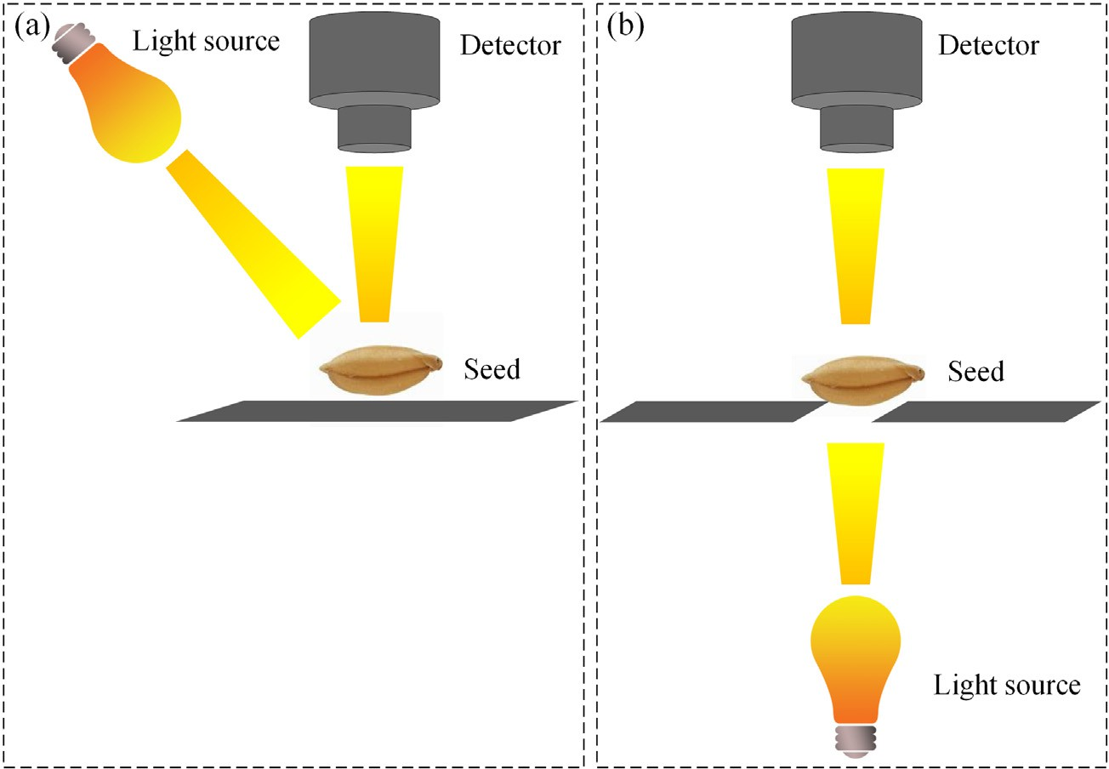

Fig. 1. Setup for the acquisition of NIR reflectance (a) and transmittance (b) spectra of seeds.

predictors to fit a MLR model (Naes et al., 2002). Partial least squares (PLS) regression is the most widely used regression method compared to other multivariate methods. Unlike MLR, PLS can be used to analyze data with strongly collinear (correlated), noisy and redundant variables (Cozzolino et al., 2009). As one of the nonlinear regression techniques, support vectors regression (SVR) has been demonstrated with a very good performance mainly due to its great immunity to the presence of outliers and tolerance to spectral noise in NIR data sets. Artificial neural networks (ANN), least squares-support vector machines (LS-SVM) can be also employed to deal with non-linear relationships between vari- ables. Regarding the development of classification and identification methods based on NIR spectroscopy, spectral data have been mostly processed by many well-known qualitative multivariate methods, such as K-nearest neighbor (KNN), linear discriminant analysis (LDA), soft independent modeling of class analogy (SIMCA), partial least squares-discriminant analysis (PLS-DA), support vector machine (SVM), etc.

Modern spectrometers usually possess high resolution with hun- dreds or thousands of spectral variables including collinearity, redun- dancies, and noise, thus, this situation increases the complexity of calibration model built with full range of spectra, and hinders the com- puting speed (Fan et al., 2019). The models built using full spectra are not suitable for on-line or real-time detection in a rapid and non- destructive manner due to the fact that the calibration process is time- consuming with heavy pressure in computing and data transmission. In addition, the irrelevant information within spectra would negatively affect the accuracy and robustness of model (Li et al., 2014). Therefore, a large number of variable selection methods have been proposed during the last decades, such as competitive adaptive reweighted sampling (CARS), interval random frog (iRF), Monte Carlo-uninformative variable elimination (MC-UVE), etc. Infromative variable selection or wave- length selection plays an important role in the quantitative analysis of spectral data. The details of variable selection methods can be found in previous studies (Mehmood et al., 2012; Yun et al., 2019).

NIR spectroscopy has been successfully employed in the quality evaluation of natural resources, such as fruits, vegetables, crops, trees and their seeds (Pasquini, 2018). In recent years, it has been widely ex- plored to detect seed viability (Table 1) and the diffuse reflection is the most commonly used mode. The viability of soybean seeds were deter- mined using Fourier transform near-infrared (FT-NIR) spectroscopy (Kusumaningrum et al., 2018). A total of 200 soybean seeds were artifi- cially aged (non-viable) by vacuuming intact seeds in plastic bags and

aging by incubation for 9 days in a water bath maintained at 42 °C with about 100% relative humidity. The other 200 seeds were set as nor- mal seeds (viable). The reflectance spectrum of each seed was acquired with illumination focused directly on the germ point using a specific sample holder with a hole in the center (Fig. 2a). The sample holder was designed with suitable size and shape for soybean seeds (Fig. 2b). There were some major spectral differences between viable and non- viable seeds in 1000–1900 nm (Fig. 2d), in which the spectra for viable soybean seeds had a lower reflectance than those of non-viable ones. A classification model based on PLS-DA method was built to classify viable and non-viable seeds. The variable importance in projection (VIP) method for variable selection combined with PLS-DA was employed. Fi- nally, 146 optimal variables out of full set with 1557 variables were se- lected. The results demonstrated that FT-NIR spectral analysis with PLS- DA method based on all variables or the selected variables showed a good performance with an accuracy of nearly 100%. FT-NIR was testified to be a stable and potential method for measuring soybean seed viability rapidly.

FT-NIR spectroscopy with a PLS-DA classification method could also correctly classify viable and non-viable corn seeds with a high accuracy of 100% (Ambrose et al., 2016b), and pepper seeds with accuracy of 90.5% for validation set (Seo et al., 2016). A supervised classification method called extended canonical variates analysis (ECVA) was ex- plored to predict seeds viability by NIR spectroscopy. The effect of the number of seeds in a training sample set on the ability to predict the vi- ability of cabbage or radish seeds was discussed (Shetty et al., 2011). The results showed that 200 seeds were optimal in a calibration set for both cabbage and radish data. This conclusion was similar to the mis- classification rate obtained using all seeds in calibration set and effec- tively enhanced the cost-effectiveness of NIR spectral analysis. The misclassification rates at optimal sample size were 6% for cabbage and 2% for radish, respectively. NIR spectroscopy with proper classification method had also been studied to identify tomato (Shrestha et al., 2017) and *Juniperus polycarpos* (Daneshvar et al., 2015) with accuracies of more than 90%.

* 1. *Hyperspectral and multispectral imaging*

Hyperspectral imaging (HSI) system, integrates both spectroscopic and imaging techniques into one system to get a set of monochromatic images at almost continuous hundreds of wavelengths. This integrated system combines NIR spectroscopy and digital imaging to give

Table 1

Overview of applications using emerging technologies to detect seed viability.

|  |  |  |  |  |  |
| --- | --- | --- | --- | --- | --- |
| No. | Seed(s) | Method(s) | Classifier(s) | Result(s) | Reference |
| 1 | Corn | FT-NIR | PLS-DA | 100% | Ambrose et al. (2016b) |
| 2 | Soybean | FT-NIR | PLS-DA | 100% | Kusumaningrum et al. (2018) |
| 3 | Pepper | FT-NIR | PLS-DA | 90.5% | Seo et al. (2016) |
| 4 | Cabbage | NIR | ECVA | 94% | Shetty et al. (2011) |
| 5 | Radish | NIR | ECVA | 98% | Shetty et al. (2011) |
| 6 | *Juniperus polycarpos* | NIR | PLS-DA | 98% | Daneshvar et al. (2015) |
| 7 | Tomato | NIR | iPLS-DA | 93.71% | Shrestha et al. (2017) |
| 8 | Barley/wheat/sorghum | NIR HSI | PLS-DA | – | McGoverin et al. (2011) |
| 9 | Corn | NIR HSI | PLS-DA | 100% | Wakholi et al. (2018) |
| 10 | Muskmelon | NIR HSI | PLS-DA | 94.6% | Kandpal et al. (2016) |
| 11 | Pepper | Vis/NIR HSI | PLS-DA | 100% | Mo et al. (2014) |
| 12 | Wheat | Vis/NIR HSI | SVM, PLS-DA | 88.1%, 89.5% | Zhang et al. (2018b) |
| 13 | Castor | MSI | Normalized canonical DA | 96% | Olesen et al. (2015) |
| 14 | Spinach | Vis/NIR MSI | PLS-DA | 60%–76% | Shetty et al. (2012) |
| 15 | Norway spruce | Vis/NIR, NIR HSI | SVM | 83%, N93.3% | Dumont et al. (2015) |
| 16 | Corn | Vis/NIR, NIR HSI | PLS-DA | 74.4–95.6%, | Ambrose et al. (2016b) |
| 17 | Soybean | NIR HSI | PLS-DA | 82.2–95.60%  N95% | Baek et al. (2019) |
| 18 | Tomato | Vis/NIR HSI | PLS-DA | 90.48% | Peng et al. (2018) |
| 19 | Pepper | RS | PLS-DA | 94.4% | Seo et al. (2016) |
| 20 | Corn | RS | PCA, PLS-DA | 93–100% | Ambrose et al. (2016b) |
| 21 | Pea | IRT | SVM | 95%, 91.67% | Men et al. (2017) |
| 22 | Garden pea/wheat/rape | IRT | NetLogo | – | Kranner et al. (2010) |
| 23 | Lettuce | IRT | – | – | Kim et al. (2013) |
| 24 | Pepper | IRT | Pixel-based regression analysis | – | Kim et al. (2014) |
| 25 | Muskmelon | Soft X-ray imaging | LDA | 98.9% | Ahmed et al. (2018) |

information about the spatial distribution of compounds. Therefore, HSI system creates three-dimensional (3D) “hypercube” datasets composed of two spatial dimensions and a single spectral dimension. In general, point scanning, line scanning and area scanning approaches are three commonly used modes to acquire hyperspectral image (Zhang et al., 2014). As the most widespread application type, hyperspectral reflec- tance imaging is carried out in Vis/NIR (400–1000 nm) or NIR (1000–2500 nm) range to detect defects, contaminants, and quality at- tributes of fruits, vegetables and seeds (Nicolaï et al., 2014).

HSI experiments usually involve three different modules: (I) image acquisition and image pre-processing, (II) data extraction and data treatment, (III) data modeling and image post-processing. These typical modules are illustrated in the flowchart of Fig. 3 (ElMasry and Nakauchi, 2016).

The first step in this module is the acquisition of a high-quality hyperspectral image by utilizing ideal acquisition parameters, including motor speed, exposure time, and object distance. Due to the differences in camera quantum efficiency, the uncorrected radiance may not be the same, even when HSI system is imaging the same target under the same condition. Thus, original hyperspectral images need to be corrected to eliminate the influence (Gowen et al., 2007). Under the same system parameters as the sample image acquisition, the white reference (*Rwhite*) is captured by a standard whiteboard with a reflectance of ap- proximately 99.9%, and then the dark reference image (*Rdark*) is ob- tained with the lamps turned off and optical lens completely covered by its cap (Yu et al., 2014). The corrected images (*R*) are calculated ac- cording to Eq. (1):

employed method of segmentation is the thresholding by selecting a proper threshold value. Spectral information of the imaged sample that represents its physicochemical properties could be extracted di- rectly from ROIs. In the most circumstances, the extracted spectral data contain some noise and variability, if the extracted data show some problems owing to low signal-to-noise ratio, the data could be preprocessed to reduce noise using preprocessing methods stated above, followed by the quantitative or qualitative multivariate analysis. The long acquisition time, required to collect high-dimensional hyperspectral images, leads to considerable challenges to real-time in- spections. This limits the HSI technology to commercialized packing lines which require a fast speed. As a result, HSI is always applied to off-line applications to select optimal wavelengths performed to form multispectral images. A multispectral imaging (MSI) system aims at ac- quiring spatial and spectral information that is directly useful for a spe- cific application. It only captures images at the selected wavelengths (usually about 10 discrete wavelengths), thus this extensively reduces the total data volume and improves the processing speed and efficiency. Rather than using optical fiber probes to obtain average concentrations of sundry quality attributes at local regions of agricultural samples, hyperspectral or multispectral imaging systems have the capability to obtain the classification map or visualize the distribution of these attri- butes across the whole sample. The application of HSI or MSI has been

reported in the identification of viable seed in the decades.

Viability of grains including barley, wheat and sorghum was investi- gated by McGoverin et al. (2011) with near-infrared hyperspectral im- aging technique. The prediction of viable and non-viable proportions using PLS-DA may not be accurate but correlated well with the viable

*R* = *Rraw*−*Rdark*

*Rwhite* −*Rdark*

(1)

proportion proved using the tetrazolium test. The classification of corn seeds based on their viabilities using HSI was explored by Wakholi et al. (2018). In this study, 600 corn samples were selected, and half of

where *Rraw* represents the original hyperspectral image and *R* repre- sents the calibrated image. The calibrated image can be then used for further data processing and analyzing.

In order to obtain regions of interest (ROIs), which represent differ- ent quality features in the corrected image, segmentation is essentially conducted to identify different clustered objects in the image for appro- priate selection of ROIs, classifying objects in the image or building image masks for subsequent analyses on each. The most commonly

them were treated using microwave heat treatment while the rest sam- ples were kept as the control group. HSI data of all the samples were then collected using a NIR HSI system with a range of 1000–2500 nm (Fig. 4). During data collection, the samples were placed on the con- veyor belt, irrespective of whether the germinal or the opposite side of each kernel was facing the camera. The reflectance spectra of the seeds in the treated group were generally higher than those of non- treated corn samples, this was because that the chemical composition

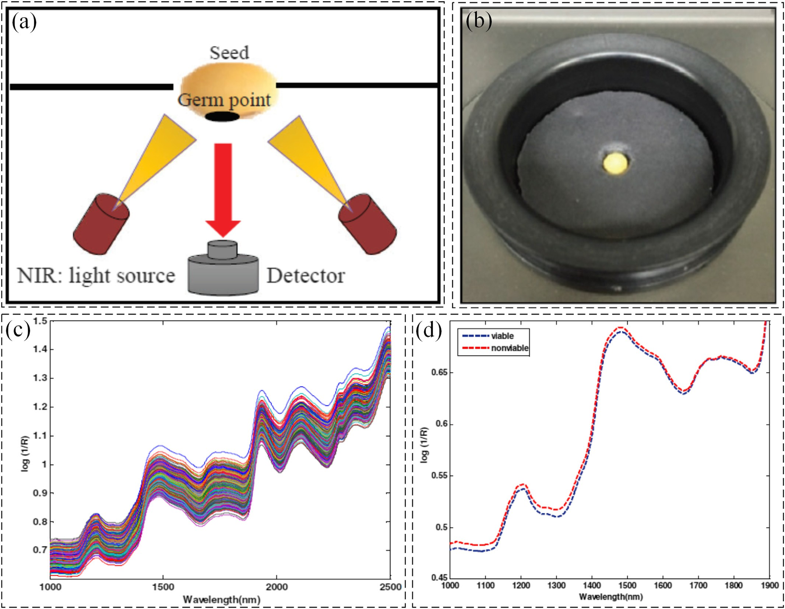

Fig. 2. Schematic of FT-NIR spectroscopy (a), single seed holder (b), raw spectra of soybean seeds (c) and average spectra of viable and non-viable seeds in spectral range of 1000–1900 nm

(d) (Kusumaningrum et al., 2018).

of corn seeds was altered during heat treatment process (denaturization of proteins, gelatinization of starch, lipid saturation, moisture reduction, etc.). Therefore, the less light was absorbed which meant that more re- flectance was exhibited. Three classification methods, LDA, PLS-DA, and SVM, coupled with some preprocessing methods were tested to deter- mine the most suitable method among them. The SVM model exhibited the highest accuracies among all models with 100%, 100%, and 98% for white, purple, and yellow corn seeds, respectively. The model also pro- duced flawless classification images, suggesting that hyperspectral im- aging can be used to classify corn based on viability accurately.

A viability evaluation method for pepper seeds based on Vis/NIR was proposed by Mo et al. (2014). The application of images based on PLS- DA model with first-order derivative of a 31.5 nm gap for red LED illumi- nation (600–700 nm) yielded 100% discrimination accuracy for both vi- able and non-viable seeds. An algorithm of image acquisition and characteristic identification and classification of tomato seeds was pro- posed based on HSI and image processing technology. The characteristic wavelengths, including 535, 577, 595, 654, 684, 713, 744, 768, 809 and 840 nm for tomato seed viability were acquired by SPA. The images under above characteristic wavelengths were preprocessed to gain the seed eigen values including area, circularity and average grey. The clas- sification thresholds were calculated according to eigen values and vi- tality results of calibration set based on statistical regularity.

Classification accuracy of calibration and validation sets was above 85% in eight characteristics wavelengths. 713 nm grey scale image gave the best result with calibration and validation set accuracy of 93.75% and 90.48%, respectively (Peng et al., 2018). Viable and non- viable soybean seeds were distinguished using a NIR HSI technique and a PLS-DA classification model built based on seven optimal wavebands selected by VIP with the accuracy of over 95% (Baek et al., 2019). Vis/NIR (400–1000 nm) and NIR HSI (1000–2500 nm) tech-

niques were compared to identify the seed viability of Norway spruce (Dumont et al., 2015) and corn (Ambrose et al., 2016a). The results in- dicated that the Vis/NIR range was not as informative as NIR range with respect to seed viability sorting.

Although the application of MSI technique is carried out in seed via- bility determination, there are much fewer studies reported than HSI. The ultimate purpose of using HSI systems is to establish a MSI system as an essential part of a computer-integrated machine vision system for different on-line applications (Sendin et al., 2018). As MSI system is equipped with fewer spectral channels, this means shorter acquisition and processing time than HSI system. In general, fewer characteristic wavelengths make great efforts to faster sensor systems and shorter col- lection time (ElMasry et al., 2019). The viability prediction of castor seeds was explored using MSI technique (Olesen et al., 2015). The spec- tral imaging system was a VideometerLab instrument, which consisted

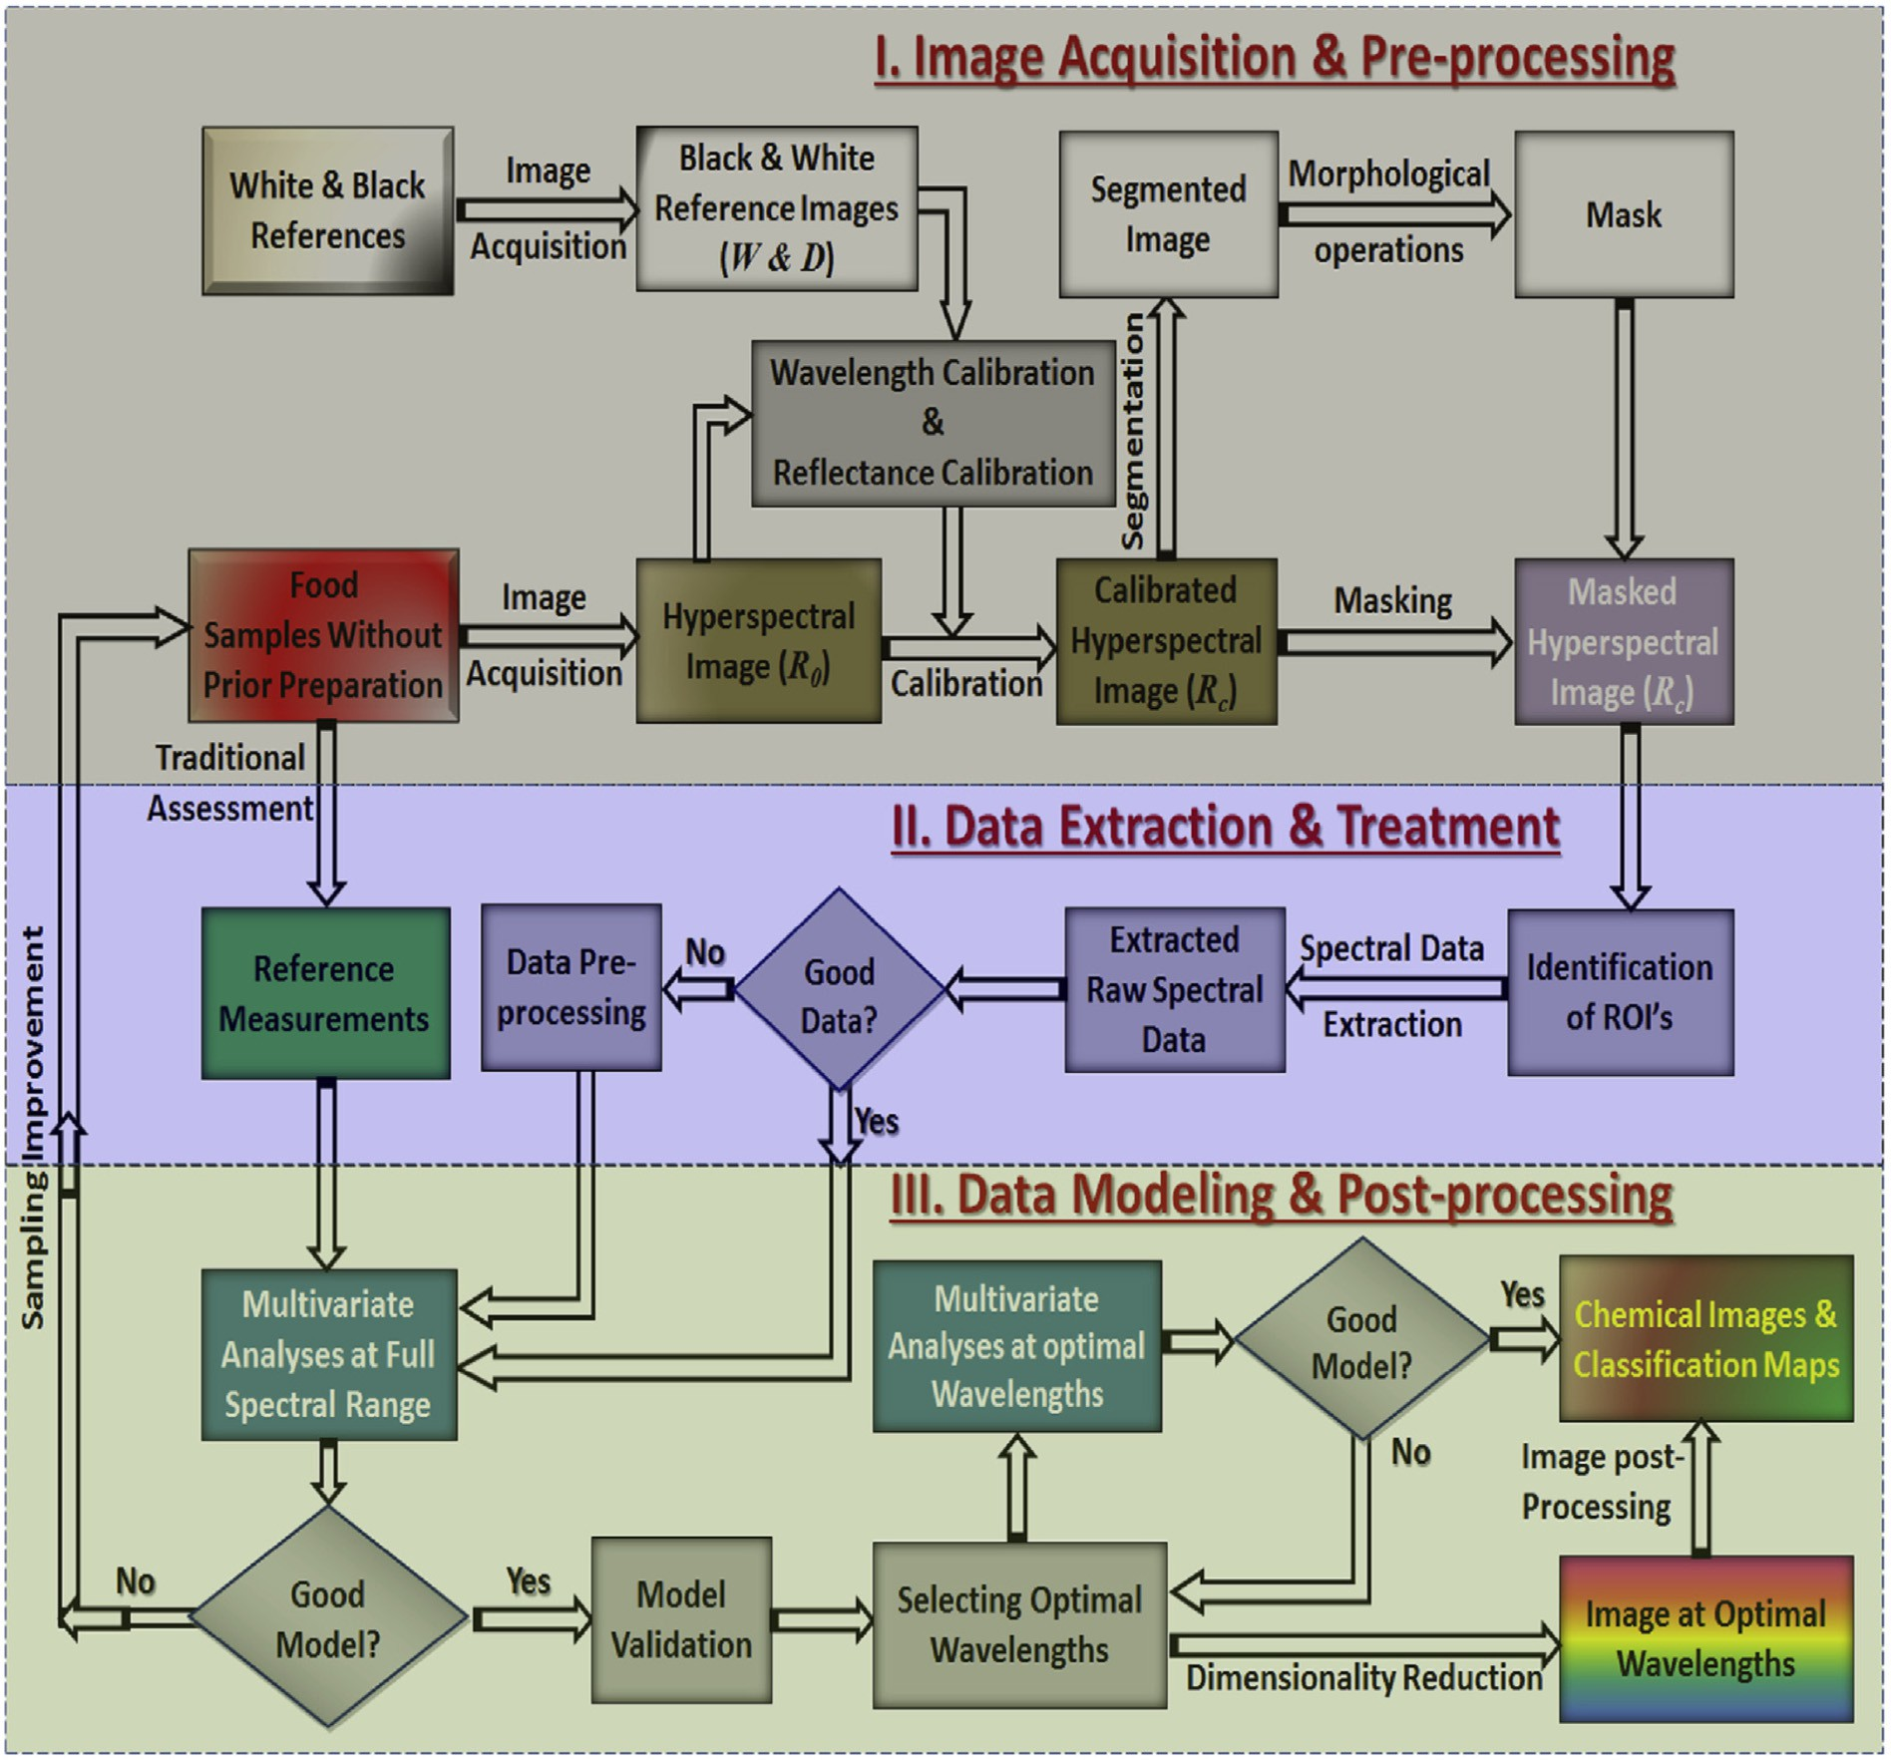

Fig. 3. Modules involved in acquiring, processing and analyzing hyperspectral images and spectral data (ElMasry and Nakauchi, 2016).

of a 5-mega pixel charge-coupled device (CCD) camera, mounted inside the top of an integrating sphere and coated with highly white and dif- fusing paint. The illumination set was consisted of 19 narrowband

high-power LEDs ranging from 375 to 970 nm placed at the rim to en- sure a uniform and diffuse illumination of the sample at the bottom port of sphere reflection (Fig. 5). In order to minimize the distance to

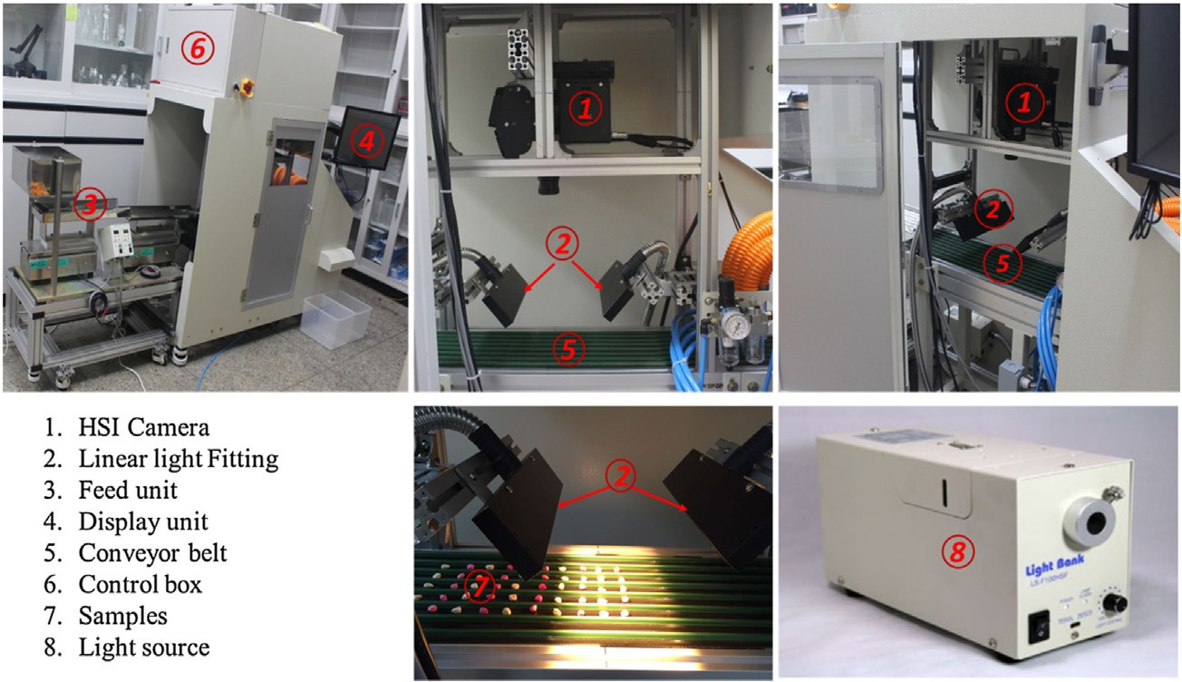

Fig. 4. The NIR HSI prototype used for corn seeds viability inspection (Wakholi et al., 2018).

achieve observations within the seed color classes and maximize the differences between classes, the multispectral images were transformed using normalized canonical discriminant analysis (nCDA). A specified feature (Region MSI mean) combined with nCDA, which can calculate a trimmed mean of MSI transformed pixel values within each single seed, was employed and viable seeds were distinguished from dead seeds with accuracy of 92%. This model resulted in 96% correct classifi- cation of seeds for validation set.

Moreover, a HSI or MSI system was also utilized to try to predict seed vigor in terms of germination periods or germ length. Kandpal et al. (2016) reported the vigor determination of muskmelon seeds using NIR HSI. The samples were artificially aged to obtain seeds with differ- ent viability and vigor. The spectra of seeds with 3 and 5 germination days and non-geminate seeds were used for development of a PLS-DA classification model. The model yielded the highest classification accu- racy of 94.6% for a validation set based on 18 wavelengths selected by selectivity ratio (SR). The possibility of using PLS-DA on feature extrac- tion from multispectral images of spinach seeds to detect seed vigor in terms of germ length was investigated (Shetty et al., 2012). Images of 300 seeds including small, medium, and large seeds were studied, and the seeds were examined for germ length. The results indicated that larger seeds had both a significantly higher germination potential and germ length compared with smaller ones. The classification accuracies of validation set for seed vigor according to germ length were 60%, 76%, and 68% for the small, medium, and large seeds, respectively. The results indicated that larger spinach seeds had not only higher germina- tion potential, but also bigger germ length compared with smaller seeds.

* 1. *Raman spectroscopy*

Raman spectroscopy (RS) is a form of analytical spectroscopy based on Raman scattering, which was discovered by C.V. Raman in 1928. Ac- cording to the principle that vibrational frequencies are specific to molecule's chemical bonds and symmetry, Raman peaks are typically obvious in most cases, which provide fingerprints to identify molecules and make the analysis of chemical compositions more precise (Yang et al., 2018). However, due to the fact that technologies for detecting Raman scattering effects and strong light sources were not developed sufficiently, there were few applications of RS initially. Fortunately, RS was found to be widely applied with the development of relative tech- nologies in the recent decade (Li-Chan et al., 1994). RS can achieve ex- tremely high detection sensitivity in various applications, such as quality evaluation of meat and fish (Herrero, 2008), detection of bacte- ria (Lee et al., 2017; Lu et al., 2011), ingredients prediction of agricul- tural products (Kizil et al., 2002; Lee et al., 2013), classification of oil and fat (Baeten et al., 1998), viability evaluation of seed (Ambrose et al., 2016b; Seo et al., 2016), etc. The advantages of RS techniques over conventional methods in detecting seed viability include rapidity, robustness, high accuracy and non-invasiveness.

Fig. 6a shows a RS system used to capture and analyze the scattering

signals of pepper (*Capsicum annuum* L.) seeds for viability assessment (Seo et al., 2016). The Raman spectrometer (Raman workstation™, Kai- ser Optical Systems Inc., Ann Arbor, MI, USA) consisted of a diode laser and a CCD detector with a resolution of 0.3 cm−1. The diode laser wave- length was 785 nm, and the CCD had a holographic transmission grating that enabled the scanning of a plate with 96 square wells. The laser

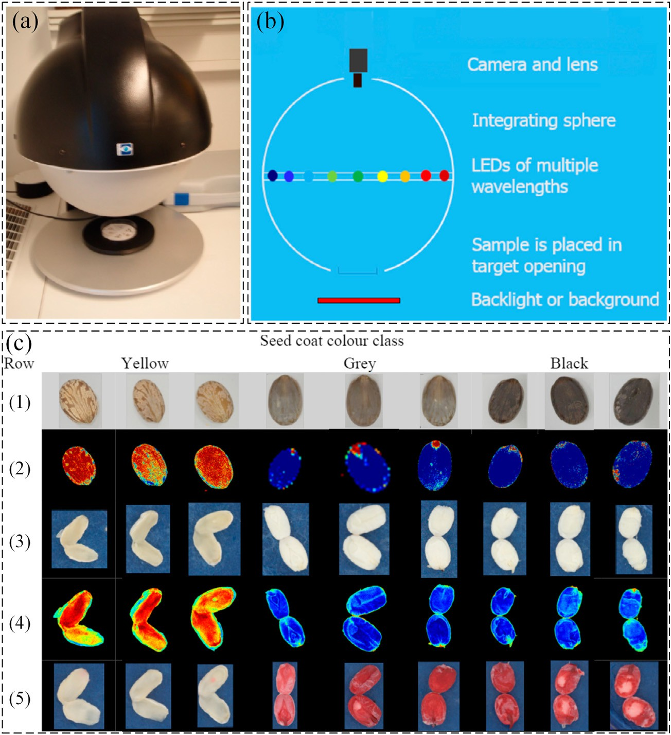

Fig. 5. Picture of the VideometerLab instrument (a) and its schematic diagram (b), and overview of seeds of three classes based on visual color of seed coat: yellow, grey and black (c). Row

(1) shows RGB images of the intact seeds; (2) is images transformed by nCDA to divide dead and viable seeds (intact seeds); (3) is RGB images of cut seeds; (4) is images transformed by nCDA to divide dead and viable seeds (based on cut seeds) and (5) is RGB images taken after the cut seeds has been immersed in tetrazolium (Olesen et al., 2015).

apparatus had a power of 100 mW, a spot size of 3 mm, and an exposure time of 0.5 s. The spectral range was 150–1800 cm−1 and each plate was scanned 32 times (Fig. 6).

In this study, the pepper seeds initiated germination in 4 days and achieved germination in 168 h. Out of 144 untreated seeds, 141 seeds were germinated and showed a seed viability of 97.9%, and 288 seeds (141 viable and 147 non-viable seeds) were used for analysis in the ger- mination test. Fig. 6d shows the mean plots of Raman spectra for viable and non-viable seeds. Characteristic peaks associated with the basic constituents of pepper seeds could be observed around 1520 cm−1 (C=C), 1440 cm−1 (=CH2), 1263 cm−1 (=CH), 1154 cm−1 (C\\C),

and 1090 cm−1 (C\\O) (Baranski et al., 2006; Reitzenstein et al.,

2007). A classification model was developed using PLS-DA with RS data in 1800–970 cm−1. A series of preprocessing methods were also proposed to reduce the noise of spectra and compare the classification results. The results showed that RS with raw data (none-preprocessed data) achieved the best classification accuracy of 96.4%. Therefore, RS was shown to be a reliable spectroscopic method to determine seed quality.

In seed viability detection with RS, researches could also be found to- wards corn seeds. The comparison between FT-NIR and RS methods to- wards the classification of viable and non-viable hybrid corn kernels (*Zea mays* L.) could be diagnosed. It was observed that some specific wavelengths at which the energy absorption was different between the aged and normal seed groups. The major changes were observed in the range of 1580–1640 cm−1. The variation in intensity at this region was thought to be caused by the germination ability of seeds. The PLS- DA results with various preprocessing methods on Raman spectral data were analyzed, and the classification model presented recognition and prediction ability of 93–100% of three groups (white, yellow, and purple corns). Especially, the mean normalization, MSC, and first

derivative preprocessing methods showed the highest accuracy (100%) in the calibration model, but a significant number of seeds were overlapping when using PCA (Ambrose et al., 2016b). In a word, RS is useful and promising to be utilized for classification of viable and non-viable seeds instead of the traditional invasive seed quality detec- tion and evaluation methods.

* 1. *Infrared thermography*

Infrared thermography (IRT) is a relatively young discipline with its origin traced back to the 17th century when thermometers were devel- oped (Ring, 2010). The discovery of infrared radiation by Sir William Herschel in 1800 was closely followed by the recording of first thermal image by his son John Herschel (Ring, 2007). In 1934, Hardy established the diagnostic significance of temperature measurement by infrared technique which made contribution to the application of IRT in medical sciences (Hardy, 1934). However, the first use was reported in 1960 due to the non-availability of quality equipment and technical know-how (Ring, 2010). Recently, IRT as one of the fast, non-contact and non- destructive diagnosis methods has been used in various fields including medical tests, fault diagnosis, remote sensing, plant diseases and insect pest detection, fruit quality, seed viability evaluation, etc. (Fernández- Cuevas et al., 2015; Picazo-Ródenas et al., 2013; Usha and Singh, 2013). Compared with hyperspectral imaging and Fourier transform near-infrared methods, IRT shows the advantages of relatively low cost and high assessment throughput. IRT also provides two- dimensional (2D) thermal images, which makes a comparison between areas of target possible (Usamentiaga et al., 2014). Infrared radiation is the energy radiated by the surface of an object whose temperature is above absolute zero (Meola, 2012). The fractions of the total radiant en- ergy that are associated with each of these modes of dissipation are

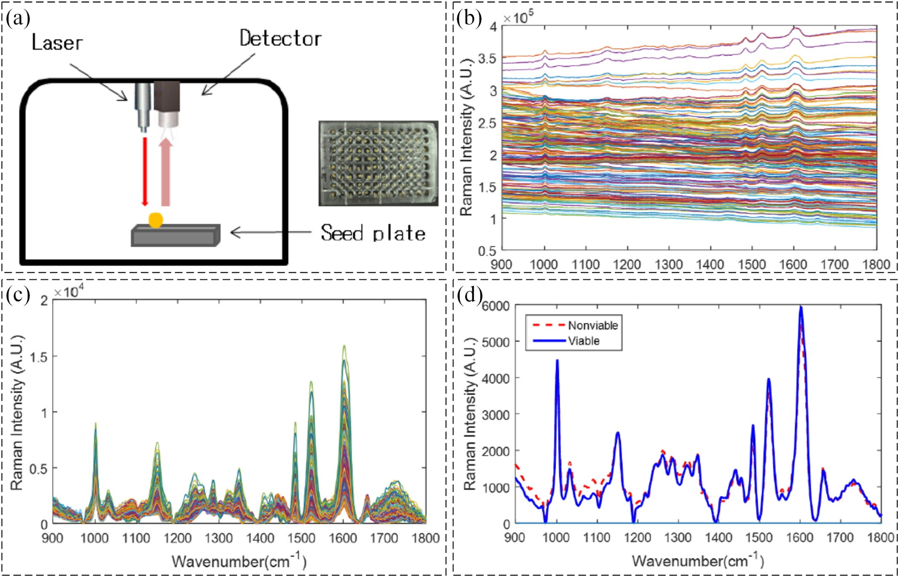

Fig. 6. Schematic of Raman spectrometer used to capture and analyze scattering signals of seeds (a), Raman spectra without removed fluorescence background signal (b), Raman spectra with removed fluorescence background signal (c), and mean spectra of viable and non-viable pepper seeds (d) (Seo et al., 2016).

referred to as the absorptivity, transmissivity and reflectivity of the ob- jects (Howell et al., 2010). Three parameters are used to describe these phenomena: the spectral absorptance *αλ*, which is the ratio of the spec- tral radiant power absorbed by the object, the spectral reflectance *ρλ*, which is the ratio of the spectral radiant power reflected by the object, and the spectral transmittance *τλ*, which is the ratio of the spectral radi- ant power transmitted by the object. These three parameters are wave- length dependent (Usamentiaga et al., 2014). The sum of these three parameters must be one at any wavelength, as in Eq. (2):

*αλ* + *ρλ* + *τλ* = 1 (2)

Fig. 7c shows the configuration of a typical IRT system used to cap- ture and analyze the thermal and visible images of *Pisum sativum* L. seeds for viability assessment. As shown in Fig. 7c, an infrared thermog- raphy system generally consists of an infrared thermal camera, a digital color CCD camera, a directional light source, a constant temperature in- cubator, a thermostatic water bath, and a computer. Thermal images (320 × 240 pixels) were obtained by the infrared thermal camera Ti55 (Fluke, Everett, WA, USA) with a sensitivity of 0.02 °C and initially proc- essed with the Smartview software (Fluke Systems). Visible images (900 × 600 pixels) captured from the CCD were digitized to 8-bit (256 grey levels) data and stored. Thermal and visible images were simulta- neously stored every 5 min and could be exported in time sequence. Then, image processing, data analysis and numerical modeling were ap- plied using MATLAB (MathWorks, Natick, MA, USA). As seen in Fig. 7d, the temperature variations (relative seed temperature *rT*) of the three categories of seeds mainly occurred in the first 3 h (Men et al., 2017).

In this study, a total of 120 seeds were divided into two groups for different aging process. The root length of each sample was measured to evaluate the viability. Each individual seed area in the visible images was segmented with an edge detection method, image fusion

technology was adopted to extract seed regions in the thermal images with the disk areas in the visible images, and the average temperature of the corresponding area in the infrared images was calculated as the representative temperature for this seed at that time (Fig. 8). Thirteen characteristic parameters extracted from the temperature curve were analyzed to show the difference of the temperature fluctuations be- tween the seeds with different viability. Support vector machine (SVM) was used to classify the seed samples into viable, aged and dead according to the root length with 95% classification rate. With the temperature data of first 3 h during the germination, another SVM model was calculated with classification rate of 91.67%. According to these experimental results, it can be observed that there were obvious differences between the parameters carried out for characterizing the temperature variations of seeds depended on seed viability. Apparently, infrared thermography can be applied for the prediction of seed viability based on the SVM algorithm.

In seed viability detection with IRT, other applications could also be

found. The developmental stage of a geminating garden pea (*Pisum sativum*) could be diagnosed using IRT by Kranner et al. They proved the concept that IRT was applicable to other seed types such as wheat (*Triticum aestivum*) and rape (*Brassica napus*) seeds. IRT was testified to link biochemical and biophysical parameters with developmental changes and visualize them noninvasively. Moreover, they developed a computer model of “virtual pea seeds” that uses Monte Carlo simula- tion, based on the heart production of major seed storage compounds to unravel physic-chemical processes of thermogenesis by NetLogo. They also found that IRT could visualize in real time of the earliest physic-chemical events in pea seed germination and diagnose seed via- bility long before radical emergence (Kranner et al., 2010). And the con- clusion that non-viable seeds failed to degrade starch upon germination was demonstrated (Kranner, 2013). Similarly, the lettuce (*Lactuca sativa* L.) seed viability was evaluated using infrared lifetime thermal imaging

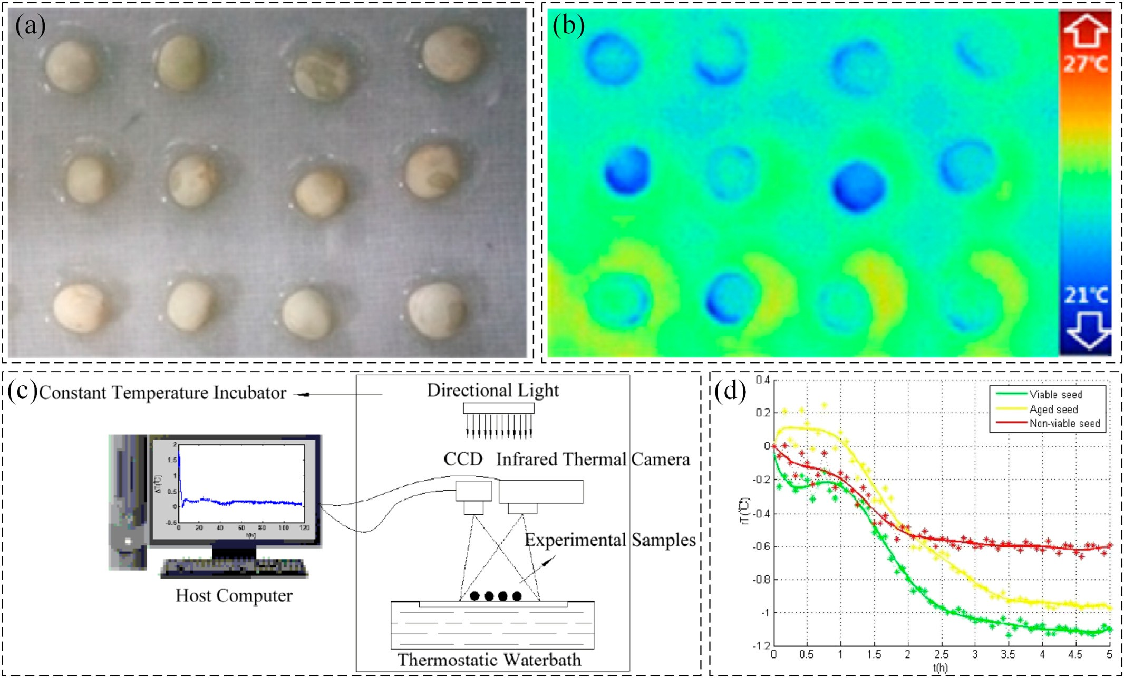

Fig. 7. Visible (a) and thermal images (b) of the experimental samples, schematic diagram of IRT system used to capture and analyze thermal profiles (c), and heat production during the

first 5 h in the experiment (d) (Men et al., 2017).

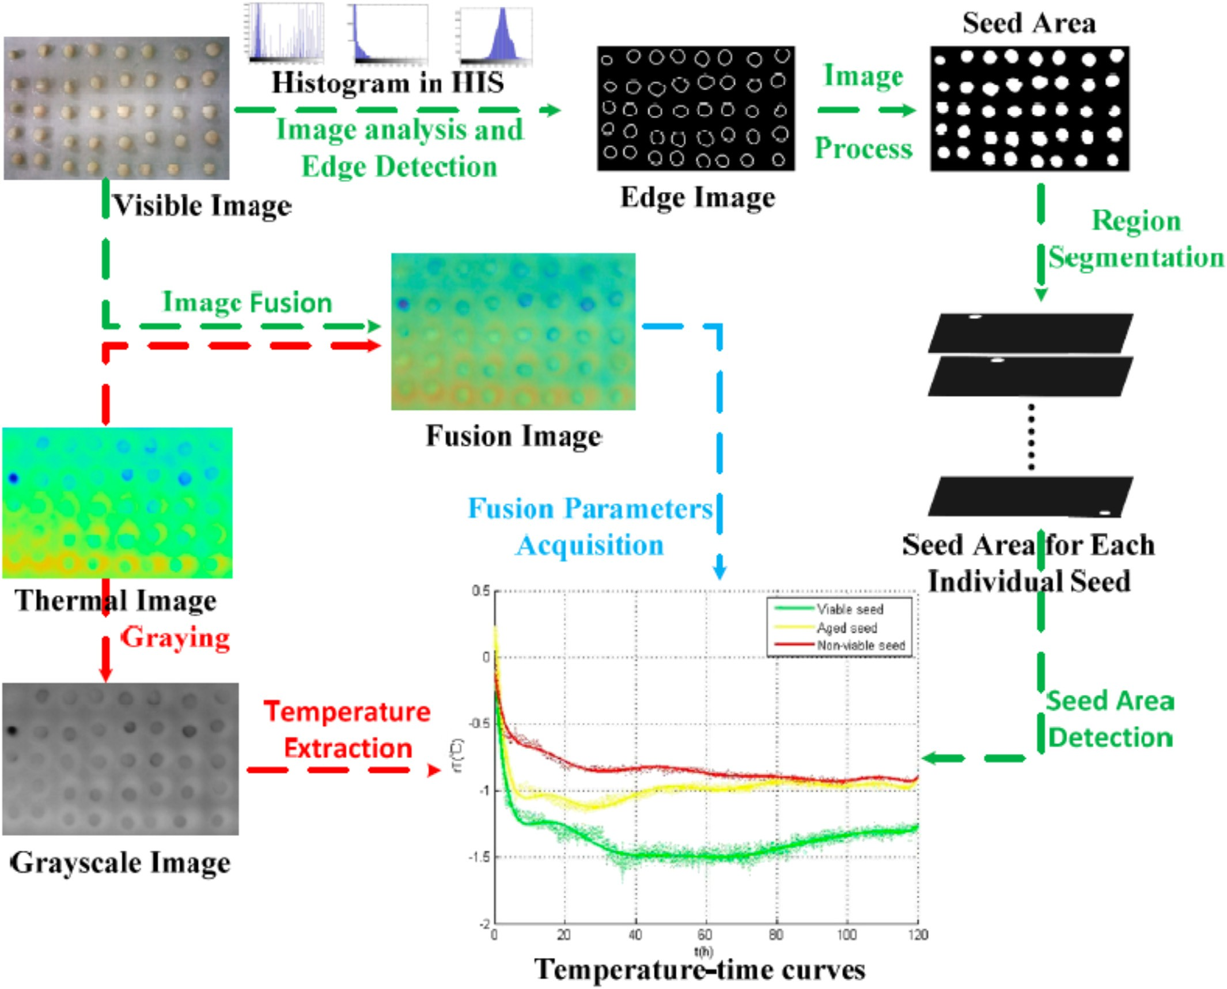

Fig. 8. Flowchart of a series of steps for analyzing thermal and visible images data. Visible images are used to acquire the edge regions information (green arrow). Thermal images are used to extract the temperature information (red arrow). Fusion parameters are acquired from fusion image of viable image and thermography image (Men et al., 2017).

technique, the results showed that the time-dependent thermal signal decay characteristics, along with the decay amplitude and delay time images, could be used to distinguish aged lettuce seeds from normal seeds easily (Kim et al., 2013). The viability of pepper (*Capsicum annuum*) seeds was also estimated using IRT and photothermal signal and image reconstruction techniques, pixel-based regression analysis was used to investigate the photothermal signal from seed and seed groups was distinguished by the reconstructed images of regression co- efficients. Results showed that time-resolved photothermal characteris- tic, along with the regression coefficient images, can be used to discriminate the aged or dead pepper seeds from the healthy ones (Kim et al., 2014). Therefore, IRT can definitely be one of the promising methods in the existing destructive and labor-intensive seed-sorting situations.

* 1. *X-ray imaging*

X-ray computed tomography (CT), is electromagnetic radiation with the wavelength range of 0.01–10 nm. The photon energy of an X-ray is in the range of 0.1–120 keV, which leads to a strong penetrability. X-ray, similar to other electromagnetic waves, can show the following phe- nomena: reflection, refraction, scattering, interference, diffraction, po- larization and absorption. X-ray CT evaluates the internal structure of

a sample by means of an X-ray source and a detector in order to obtain information from a projected slice. The X-ray imaging inspection sys- tem, mainly comprises a computer-controlled X-ray generator (i.e. X- ray source tube), a line-scanning sensor for X-ray detection (i.e. an X- ray CCD camera in which an enlarged radiograph (projection) can be produced), conveying belt, stepping motor, image-acquisition card, and computer (Chen et al., 2013). The differences in attenuation are at- tributable to density and compositional differences within a sample. During image acquisition, an X-ray beam, which is collimated, is di- rected towards a sample, the detector measures the remnant attenuated radiation and the response is transferred to a computer, resulting in a 2D image whose contrast is produced by variations in the X-ray attenu- ation that includes absorption and scattering (Fig. 9). When a sample is rotated on a translation stage while illuminated with X-ray, the X-rays pass through the object in many different directions and along with dif- ferent pathways to create an image illustrating variation in density at numerous points in a 2D slice, acquiring a series of 2D radiographs or projection images (Baker et al., 2012). Mathematical principles can then be used to reconstruct the series of 2D radiographs into a 3D digital image, which can be presented as virtual slices at various depths and in multiple directions or the sample can be viewed as a whole. Image pro- cessing and analysis is followed to visualize CT data and extract suitable information from the image. In a word, the basic principles of X-ray CT

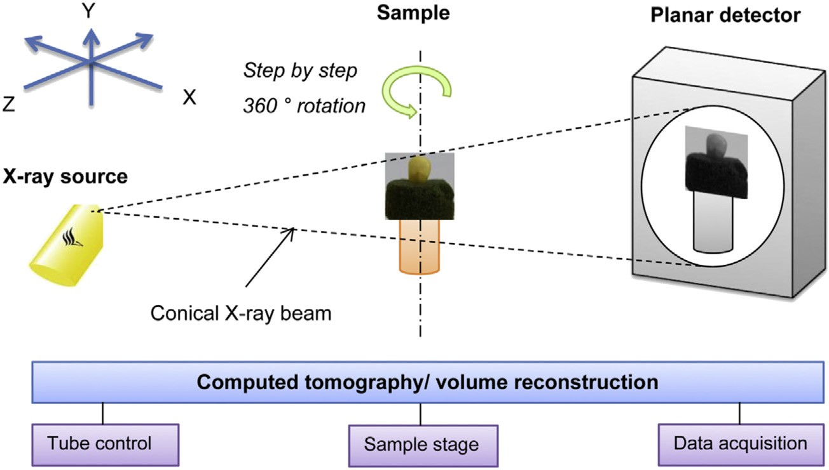

Fig. 9. Schematic illustration of the measurement principle of X-ray CT. An object is exposed to collimated X-rays, generated by the X-ray tube and the detector converts the X-rays into digital radiographs (Schoeman et al., 2016).

imaging are absorption physics (related to 2D projection images) and reconstruction mathematics (relevant to the generation of a 3D volume from a series of 2D images) (Schoeman et al., 2016). Nevertheless, char- acterization analysis of seed morphology based on an X-ray CT system is very limited.

A recent study reported the application of X-ray technology in the evaluation of muskmelon seed viability by analyzing the morphological characteristics of naturally aged seeds (Ahmed et al., 2018). The proce- dure for developing the pattern classification algorithm for muskmelon seeds based on their internal structures (morphology) as determined using CT imaging in connection with viability, is illustrated in Fig. 10.

The seeds were five years old (2012–2017) and were kept in storage at ambient temperature. A total of 100 seeds were randomly selected for scanning using X-ray CT image. After the preprocessing by re- slicing, contrast enhancement, noise reduction, and segmentations, fif- teen preprocessed images were nominated from each sample, and fea- tures of interest (i.e. local binary pattern, Gabor, local fast Fourier transform (FFT), texture, contrast and Haralick textural features) were extracted. Then, the sequential forward selection (SFS) method was ap- plied as a search strategy to determine the most relevant features for seed viability classification from the features extracted above. A germi- nation test was performed to evaluate the seed viability and the

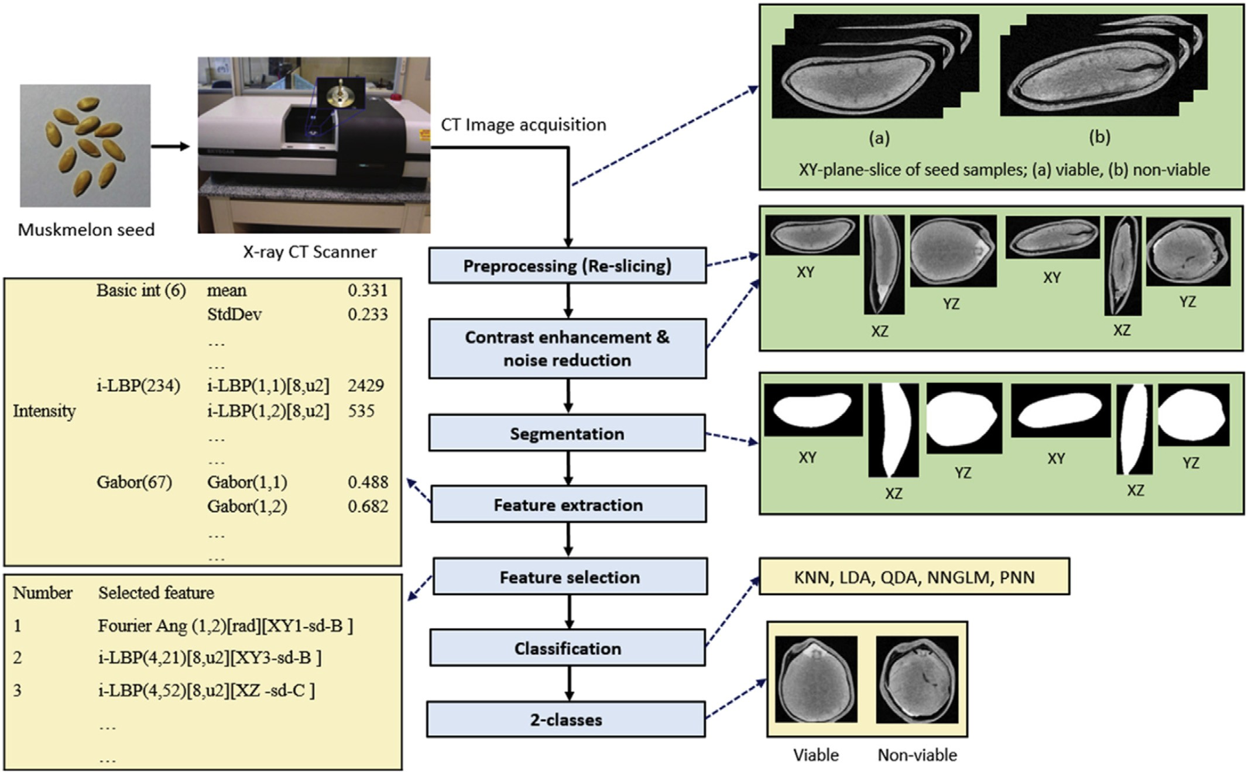

Fig. 10. The methodology applied to develop the pattern classification algorithm to identify viable and non-viable muskmelon seeds using X-ray CT images (Ahmed et al., 2018).

information was used to construct the training and validation data set. After that, the LDA classifier could result in more promising results, with the accuracy of 98.9% for 10-fold cross-validation using eighteen selected features. The findings indicate that CT imaging is a potential tool for the classification of seeds based on the characterization of inter- nal morphologically.

1. Technical challenges and trends

As a relatively mature technology, numerous NIR spectroscopy in- struments are commercially available for research, laboratory and industrial purposes, making the technique enjoy considerable advan- tages in terms of use cost over other optical sensing techniques. With the development of tumbling or spinning aid in calibration, scanning seeds tends to obtain higher precision and overcome any other differ- ences between instruments gradually (Agelet and Hurburgh, 2014). The chemical composition information of seeds, such as lipids, proteins, and carbohydrates, can be captured by NIR, however, it might be easily affected by the uniformity with different sample distributions due to the fact that only one a single spot of samples is applied (Ji et al., 2015). HSI has been shown to be an effective tool for seed viability detection, allowing a rapid and high-throughput analysis at single kernel basis. One of the main advantages is that HSI provides both spatial and spec- tral information and is suitable for both external quality classification and internal chemical composition prediction. However, a drawback of NIR spectroscopy and HSI/MSI is that a new calibration model is re- quired for each seed species and cultivar, and the calibration models should be based on large datasets incorporating different orchards, sea- sons, cultivation systems, etc. Furthermore, the prediction accuracy also depends on temperature, spectrometer, noise and some other external conditions which are hard to control by operators according to their subjective wills. Optimization and customization of optical components and sampling systems are required to ensure the success of an applica- tion on a specific commodity. Owing to the growing interests from both academia and industry, the Raman spectroscopy technology has been evolved quickly during past decades. Challenges still exist for practical applications of RS techniques for evaluating seed viability, such as high fluorescence interference from plant materials, poor repeatability of SERS techniques, etc. (Qin et al., 2019). X-ray, which does not scale to large operation, can only exhibit the structural integrity of seeds. Di- rectly identifying whether seeds are dead or not can hardly be achieved (Chelladurai et al., 2014). The application of thermal imaging and soft X- ray imaging in seed quality assessment is very limited due to the high use cost. In addition, the detection efficiency restricts the application of those two techniques in practical detection requirement. The combi- nation (fusion) of outputs of different instrumental techniques has emerged as a means of promoting the reliability of classification or pre- diction of foodstuff specifications compared with using an analytical technique separately (Borràs et al., 2015). Given that more non- destructive methods have been successfully applied in seed viability de- tection, it would be an interesting task to explore seed viability detec- tion by fusing these different technologies based on data fusion strategies. With the development in computer hardware with low cost and high speed, and artificial intelligence, some of the mentioned emerging techniques would be more commonly inexpensive, attractive and realizable for promising applications in quality control and auto- matic detection of seeds.

1. Conclusions

Optical-based and/or image-based non-destructive evaluation sys- tems have been gradually investigated and employed in the external and internal quality inspecting of seeds in recent years. Seed viability is of great importance in seed quality characteristics reflecting potential seed germination. This review summarizes emerging technologies and their major applications in seed viability detection. These noninvasive

techniques are rapid, accurate, reliable and simple tools for evaluating seed viability. The reasons why they might encounter problems in prac- tical application are discussed. On the basis of the observed trends, the technical challenges and potential future trends for these emerging techniques are also presented.

Acknowledgements

This work was financially supported by the National Natural Science Foundation of China (31801262 and 31871523) and National Key Re- search and Development Program of China (2018YFD0101004).

References

Agelet, L.E., Hurburgh, C.R., 2014. [Limitations and current applications of near infrared](http://refhub.elsevier.com/S2589-7217(19)30005-4/rf0005) [spectroscopy for single seed analysis. Talanta 121, 288–29](http://refhub.elsevier.com/S2589-7217(19)30005-4/rf0005)9.

Ahmed, M.R., Yasmin, J., Collins, W., et al., 2018. [X-ray CT image analysis for morphology](http://refhub.elsevier.com/S2589-7217(19)30005-4/rf0010) [of muskmelon seed in relation to germination. Biosyst. Eng. 175, 183–19](http://refhub.elsevier.com/S2589-7217(19)30005-4/rf0010)3.

Ambrose, A., Kandpal, L.M., Kim, M.S., et al., 2016a. [High speed measurement of corn seed](http://refhub.elsevier.com/S2589-7217(19)30005-4/rf0015) [viability using hyperspectral imaging. Infrared Phys. Technol. 75, 173–179](http://refhub.elsevier.com/S2589-7217(19)30005-4/rf0015).

Ambrose, A., Lohumi, S., Lee, W.H., et al., 2016b. [Comparative nondestructive measure-](http://refhub.elsevier.com/S2589-7217(19)30005-4/rf0020) [ment of corn seed viability using Fourier transform near-infrared (FT-NIR) and](http://refhub.elsevier.com/S2589-7217(19)30005-4/rf0020) [Raman spectroscopy. Sens. Actuator B-Chem. 224, 500–50](http://refhub.elsevier.com/S2589-7217(19)30005-4/rf0020)6.

Baek, I., Kusumaningrum, D., Kandpal, L.M., et al., 2019. [Rapid measurement of soy-](http://refhub.elsevier.com/S2589-7217(19)30005-4/rf0025) [bean seed viability using kernel-based multispectral image analysis. Sensors 19](http://refhub.elsevier.com/S2589-7217(19)30005-4/rf0025) [(2), 271.](http://refhub.elsevier.com/S2589-7217(19)30005-4/rf0025)

Baeten, V., Hourant, P., Morales, M.T., et al., 1998. [Oil and fat classification by FT-Raman](http://refhub.elsevier.com/S2589-7217(19)30005-4/rf0030) [spectroscopy. J. Agric. Food Chem. 46 (7), 2638–2646](http://refhub.elsevier.com/S2589-7217(19)30005-4/rf0030).

Baker, D.R., Mancini, L., Polacci, M., et al., 2012. [An introduction to the application of X-ray](http://refhub.elsevier.com/S2589-7217(19)30005-4/rf0035) [microtomography to the three-dimensional study of igneous rocks. Lithos 148,](http://refhub.elsevier.com/S2589-7217(19)30005-4/rf0035) [262–27](http://refhub.elsevier.com/S2589-7217(19)30005-4/rf0035)6.

Baranski, R., Baranska, M., Schulz, H., et al., 2006. [Single seed Raman measurements allow](http://refhub.elsevier.com/S2589-7217(19)30005-4/rf0040) [taxonomical discrimination of Apiaceae accessions collected in gene banks. Biopoly-](http://refhub.elsevier.com/S2589-7217(19)30005-4/rf0040) [mers 81 (6), 497–50](http://refhub.elsevier.com/S2589-7217(19)30005-4/rf0040)5.

Borràs, E., Ferré, J., Boqué, R., et al., 2015. [Data fusion methodologies for food and beverage](http://refhub.elsevier.com/S2589-7217(19)30005-4/rf0045) [authentication and quality assessment – a review. Anal. Chim. Acta 891, 1–14](http://refhub.elsevier.com/S2589-7217(19)30005-4/rf0045).

Chelladurai, V., Karuppiah, K., Jayas, D.S., et al., 2014. [Detection of Callosobruchus](http://refhub.elsevier.com/S2589-7217(19)30005-4/rf0050) [maculatus (F.) infestation in soybean using soft X-ray and NIR hyperspectral imaging](http://refhub.elsevier.com/S2589-7217(19)30005-4/rf0050) [techniques. J. Stored Prod. Res. 57, 43–48](http://refhub.elsevier.com/S2589-7217(19)30005-4/rf0050).

Chen, Q., Zhang, C., Zhao, J., et al., 2013. [Recent advances in emerging imaging techniques](http://refhub.elsevier.com/S2589-7217(19)30005-4/rf0055) [for non-destructive detection of food quality and safety. TrAC Trends Anal. Chem. 52,](http://refhub.elsevier.com/S2589-7217(19)30005-4/rf0055) [261–27](http://refhub.elsevier.com/S2589-7217(19)30005-4/rf0055)4.

Cozzolino, D., Chree, A., Murray, I., et al., 2009. [Usefulness of near infrared spectroscopy to](http://refhub.elsevier.com/S2589-7217(19)30005-4/rf5010) [monitor the extent of heat treatment in fish meal. Int. J. Food Sci. Technol. 44 (8),](http://refhub.elsevier.com/S2589-7217(19)30005-4/rf5010) [1579–1584](http://refhub.elsevier.com/S2589-7217(19)30005-4/rf5010).

Daneshvar, A., Tigabu, M., Karimidoost, A., et al., 2015. [Single seed near infrared spectros-](http://refhub.elsevier.com/S2589-7217(19)30005-4/rf0060) [copy discriminates viable and non-viable seeds of Juniperus polycarpos. Silva Fennica](http://refhub.elsevier.com/S2589-7217(19)30005-4/rf0060) [49 (5](http://refhub.elsevier.com/S2589-7217(19)30005-4/rf0060)).

Du, C.J., Sun, D.W., 2004. [Recent developments in the applications of image processing](http://refhub.elsevier.com/S2589-7217(19)30005-4/rf0065) [techniques for food quality evaluation. Trends Food Sci. Technol. 15 (5), 230–24](http://refhub.elsevier.com/S2589-7217(19)30005-4/rf0065)9.

Dumont, J., Hirvonen, T., Heikkinen, V., et al., 2015. [Thermal and hyperspectral imaging for](http://refhub.elsevier.com/S2589-7217(19)30005-4/rf0070) [Norway spruce (Picea abies) seeds screening. Comput. Electron. Agric. 116, 118–124](http://refhub.elsevier.com/S2589-7217(19)30005-4/rf0070). ElMasry, M.G., Nakauchi, S., 2016. [Image analysis operations applied to hyperspectral im-](http://refhub.elsevier.com/S2589-7217(19)30005-4/rf0075) [ages for non-invasive sensing of food quality – a comprehensive review. Biosys. Eng.](http://refhub.elsevier.com/S2589-7217(19)30005-4/rf0075)

[142, 53–82](http://refhub.elsevier.com/S2589-7217(19)30005-4/rf0075).

Elmasry, G., Kamruzzaman, M., Sun, D.W., et al., 2012. [Principles and applications of](http://refhub.elsevier.com/S2589-7217(19)30005-4/rf0080) [hyperspectral imaging in quality evaluation of agro-food products: a review. Crit.](http://refhub.elsevier.com/S2589-7217(19)30005-4/rf0080) [Rev. Food Sci. Nutr. 52 (11), 999–1023](http://refhub.elsevier.com/S2589-7217(19)30005-4/rf0080).

ElMasry, G., Mandour, N., Al-Rejaie, S., et al., 2019. [Recent applications of multispectral](http://refhub.elsevier.com/S2589-7217(19)30005-4/rf0085) [imaging in seed phenotyping and quality monitoring – an overview. Sensors 19](http://refhub.elsevier.com/S2589-7217(19)30005-4/rf0085) [(5), 32](http://refhub.elsevier.com/S2589-7217(19)30005-4/rf0085).

Engel, J., Gerretzen, J., Szymańska, E., et al., 2013. [Breaking with trends in pre-processing?](http://refhub.elsevier.com/S2589-7217(19)30005-4/rf0090)

[TrAC Trends Anal. Chem. 50, 96–106](http://refhub.elsevier.com/S2589-7217(19)30005-4/rf0090).

Fan, S., Li, J., Xia, Y., et al., 2019. [Long-term evaluation of soluble solids content of apples](http://refhub.elsevier.com/S2589-7217(19)30005-4/rf0095) [with biological variability by using near-infrared spectroscopy and calibration trans-](http://refhub.elsevier.com/S2589-7217(19)30005-4/rf0095) [fer method. Postharvest Biol. Technol. 151, 79–87](http://refhub.elsevier.com/S2589-7217(19)30005-4/rf0095).

Fernández-Cuevas, I., Bouzas Marins, J.C., Arnáiz Lastras, J., et al., 2015. [Classification of](http://refhub.elsevier.com/S2589-7217(19)30005-4/rf0100) [factors influencing the use of infrared thermography in humans: a review. Infrared](http://refhub.elsevier.com/S2589-7217(19)30005-4/rf0100) [Phys. Technol. 71, 28–55](http://refhub.elsevier.com/S2589-7217(19)30005-4/rf0100).

Fu, X., Ying, Y., 2016. [Food safety evaluation based on near infrared spectroscopy and im-](http://refhub.elsevier.com/S2589-7217(19)30005-4/rf0105) [aging: a review. Crit. Rev. Food Sci. Nutr. 56 (11), 1913–1924](http://refhub.elsevier.com/S2589-7217(19)30005-4/rf0105).

Gowen, A.A., O'Donnell, C.P., Cullen, P.J., et al., 2007. [Hyperspectral imaging – an emerging](http://refhub.elsevier.com/S2589-7217(19)30005-4/rf0110) [process analytical tool for food quality and safety control. Trends Food Sci. Technol.](http://refhub.elsevier.com/S2589-7217(19)30005-4/rf0110) [18 (12), 590–598](http://refhub.elsevier.com/S2589-7217(19)30005-4/rf0110).

Hardy, J.D., 1934. [The radiation of heat from the human body. 2. A comparison of some](http://refhub.elsevier.com/S2589-7217(19)30005-4/rf0115) [methods of measurement. J. Clin. Invest. 13 (4), 605–61](http://refhub.elsevier.com/S2589-7217(19)30005-4/rf0115)4.

Herrero, A.M., 2008. [Raman spectroscopy a promising technique for quality assessment of](http://refhub.elsevier.com/S2589-7217(19)30005-4/rf0120) [meat and fish: a review. Food Chem. 107 (4), 1642–1651](http://refhub.elsevier.com/S2589-7217(19)30005-4/rf0120).

Howell, J., Siegel, R., Mengüç, M.P., 2010. [Thermal Radiation Heat Transfer](http://refhub.elsevier.com/S2589-7217(19)30005-4/rf0125).

Huang, H., Yu, H., Xu, H., et al., 2008. [Near infrared spectroscopy for on/in-line monitoring](http://refhub.elsevier.com/S2589-7217(19)30005-4/rf0130) [of quality in foods and beverages: a review. J. Food Eng. 87 (3), 303–31](http://refhub.elsevier.com/S2589-7217(19)30005-4/rf0130)3.

Huang, M., Wang, Q.G., Zhu, Q.B., et al., 2015. [Review of seed quality and safety tests using](http://refhub.elsevier.com/S2589-7217(19)30005-4/rf0135) [optical sensing technologies. Seed Sci. Technol. 43 (3), 337–36](http://refhub.elsevier.com/S2589-7217(19)30005-4/rf0135)6.

Hussain, A., Pu, H., Sun, D.W., 2018. [Innovative nondestructive imaging techniques for rip-](http://refhub.elsevier.com/S2589-7217(19)30005-4/rf0140) [ening and maturity of fruits – a review of recent applications. Trends Food Sci.](http://refhub.elsevier.com/S2589-7217(19)30005-4/rf0140) [Technol. 72, 144–15](http://refhub.elsevier.com/S2589-7217(19)30005-4/rf0140)2.

Ji, G., Huang, G., Yang, Z., et al., 2015. [Using consensus interval partial least square in near](http://refhub.elsevier.com/S2589-7217(19)30005-4/rf0145) [infrared spectra analysis. Chemometr. Intell. Lab. 144, 56–62](http://refhub.elsevier.com/S2589-7217(19)30005-4/rf0145).

Kandpal, L.M., Lohumi, S., Kim, M.S., et al., 2016. [Near-infrared hyperspectral imaging sys-](http://refhub.elsevier.com/S2589-7217(19)30005-4/rf0150) [tem coupled with multivariate methods to predict viability and vigor in muskmelon](http://refhub.elsevier.com/S2589-7217(19)30005-4/rf0150) [seeds. Sens. Actuator B-Chem. 229, 534–544](http://refhub.elsevier.com/S2589-7217(19)30005-4/rf0150).

Kim, G., Kim, G.H., Ahn, C.K., et al., 2013. [Mid-infrared lifetime imaging for viability eval-](http://refhub.elsevier.com/S2589-7217(19)30005-4/rf0155) [uation of lettuce seeds based on time-dependent thermal decay characterization.](http://refhub.elsevier.com/S2589-7217(19)30005-4/rf0155) [Sensors 13 (3), 2986–2996](http://refhub.elsevier.com/S2589-7217(19)30005-4/rf0155).

Kim, G., Kim, G.H., Lohumi, S., et al., 2014. [Viability estimation of pepper seeds using time-](http://refhub.elsevier.com/S2589-7217(19)30005-4/rf0160) [resolved photothermal signal characterization. Infrared Phys. Technol. 67, 214–221](http://refhub.elsevier.com/S2589-7217(19)30005-4/rf0160).

Kizil, R., Irudayaraj, J.M.K., Seetharaman, K., 2002. [Characterization of irradiated starches](http://refhub.elsevier.com/S2589-7217(19)30005-4/rf0165) [by using FT-Raman and FTIR spectroscopy. J. Agric. Food Chem. 50 (14), 3912–3918.](http://refhub.elsevier.com/S2589-7217(19)30005-4/rf0165)

Kranner, I., 2013. [Mechanisms of seed ageing. S. Afr. J. Bot. 86 (3), 140](http://refhub.elsevier.com/S2589-7217(19)30005-4/rf0170). Kranner, I., Kastberger, G., Hartbauer, M., et al., 2010. [Noninvasive diagnosis of seed viabil-](http://refhub.elsevier.com/S2589-7217(19)30005-4/rf0175)

[ity using infrared thermography. Proc. Natl. Acad. Sci. U. S. A. 107 (8), 3912–3917](http://refhub.elsevier.com/S2589-7217(19)30005-4/rf0175). Kusumaningrum, D., Lee, H., Lohumi, S., et al., 2018. [Nondestructive technique for deter-](http://refhub.elsevier.com/S2589-7217(19)30005-4/rf0180)

[mining the viability of soybean (Glycine max) seeds using FT-NIR spectroscopy. J. Sci.](http://refhub.elsevier.com/S2589-7217(19)30005-4/rf0180) [Food Agric. 98 (5), 1734–1742](http://refhub.elsevier.com/S2589-7217(19)30005-4/rf0180).

Lee, H., Cho, B., Kim, M.S., et al., 2013. [Prediction of crude protein and oil content of soy-](http://refhub.elsevier.com/S2589-7217(19)30005-4/rf0185) [beans using Raman spectroscopy. Sens. Actuator B-Chem. 185, 694–70](http://refhub.elsevier.com/S2589-7217(19)30005-4/rf0185)0.

Lee, H., Kim, M.S., Qin, J.W., et al., 2017. [Raman hyperspectral imaging for detection of wa-](http://refhub.elsevier.com/S2589-7217(19)30005-4/rf0190) [termelon seeds infected with Acidovorax citrulli. Sensors 17 (10), 11](http://refhub.elsevier.com/S2589-7217(19)30005-4/rf0190).

Li, J., Huang, W., Chen, L., et al., 2014. [Variable selection in visible and near-infrared spec-](http://refhub.elsevier.com/S2589-7217(19)30005-4/rf0195) [tral analysis for noninvasive determination of soluble solids content of ‘Ya’ pear. Food](http://refhub.elsevier.com/S2589-7217(19)30005-4/rf0195) [Anal. Methods 7 (9), 1891–1902](http://refhub.elsevier.com/S2589-7217(19)30005-4/rf0195).

Li-Chan, E., Nakai, S., Hirotsuka, M., 1994. [Raman Spectroscopy as a Probe of Protein Struc-](http://refhub.elsevier.com/S2589-7217(19)30005-4/rf0200) [ture in Food System](http://refhub.elsevier.com/S2589-7217(19)30005-4/rf0200)s.

Lorente, D., Aleixos, N., Gómez-Sanchis, J., et al., 2012. [Recent advances and applications of](http://refhub.elsevier.com/S2589-7217(19)30005-4/rf0205) [hyperspectral imaging for fruit and vegetable quality assessment. Food. Bioprocess.](http://refhub.elsevier.com/S2589-7217(19)30005-4/rf0205) [Tech. 5 (4), 1121–1142](http://refhub.elsevier.com/S2589-7217(19)30005-4/rf0205).

Lu, X., Alqadiri, H.M., Lin, M., et al., 2011. [Application of mid-infrared and Raman spectros-](http://refhub.elsevier.com/S2589-7217(19)30005-4/rf0210) [copy to the study of bacteria. Food. Bioprocess. Tech. 4 (6), 919–935](http://refhub.elsevier.com/S2589-7217(19)30005-4/rf0210).

Marcos Filho, J., 2015. [Seed vigor testing: an overview of the past, present and future per-](http://refhub.elsevier.com/S2589-7217(19)30005-4/rf0215) [spective. Sci. Agric. 72 (4), 363–37](http://refhub.elsevier.com/S2589-7217(19)30005-4/rf0215)4.

McGoverin, C.M., Engelbrecht, P., Geladi, P., et al., 2011. [Characterisation of non-viable](http://refhub.elsevier.com/S2589-7217(19)30005-4/rf0220) [whole barley, wheat and sorghum grains using near-infrared hyperspectral data](http://refhub.elsevier.com/S2589-7217(19)30005-4/rf0220) [and chemometrics. Anal. Bioanal. Chem. 401 (7), 2283–2289](http://refhub.elsevier.com/S2589-7217(19)30005-4/rf0220).

Mehmood, T., Liland, K.H., Snipen, L., et al., 2012. [A review of variable selection methods](http://refhub.elsevier.com/S2589-7217(19)30005-4/rf0225) [in partial least squares regression. Chemometr. Intell. Lab. 118, 62–69](http://refhub.elsevier.com/S2589-7217(19)30005-4/rf0225).

Men, S., Yan, L., Liu, J.X., et al., 2017. [A classification method for seed viability assessment](http://refhub.elsevier.com/S2589-7217(19)30005-4/rf0230) [with infrared thermography. Sensors 17 (4), 14](http://refhub.elsevier.com/S2589-7217(19)30005-4/rf0230).

Meola, C., 2012. [Origin and Theory of Infrared Thermography](http://refhub.elsevier.com/S2589-7217(19)30005-4/rf0235).

Mo, C., Kim, G., Lee, K., et al., 2014. [Non-destructive quality evaluation of pepper (Capsi-](http://refhub.elsevier.com/S2589-7217(19)30005-4/rf0240) [cum annuum L.) seeds using LED-induced hyperspectral reflectance imaging. Sensors](http://refhub.elsevier.com/S2589-7217(19)30005-4/rf0240) [14 (4), 7489–7504](http://refhub.elsevier.com/S2589-7217(19)30005-4/rf0240).

Naes, T., Isaksson, T., Fearn, T., et al., 2002. [A User Friendly Guide to Multivariate Calibra-](http://refhub.elsevier.com/S2589-7217(19)30005-4/rf5005) [tion and Classification](http://refhub.elsevier.com/S2589-7217(19)30005-4/rf5005).

Nicolaï, B.M., Beullens, K., Bobelyn, E., et al., 2007. [Nondestructive measurement of fruit](http://refhub.elsevier.com/S2589-7217(19)30005-4/rf0245) [and vegetable quality by means of NIR spectroscopy: a review. Postharvest Biol.](http://refhub.elsevier.com/S2589-7217(19)30005-4/rf0245) [Technol. 46 (2), 99–11](http://refhub.elsevier.com/S2589-7217(19)30005-4/rf0245)8.

Nicolaï, B.M., Defraeye, T., Ketelaere, B.D., et al., 2014. [Nondestructive measurement of](http://refhub.elsevier.com/S2589-7217(19)30005-4/rf0250) [fruit and vegetable quality. Annu. Rev. Food Sci. Technol. 5 (1), 285–31](http://refhub.elsevier.com/S2589-7217(19)30005-4/rf0250)2.

Olesen, M.H., Nikneshan, P., Shrestha, S., et al., 2015. [Viability prediction of Ricinus](http://refhub.elsevier.com/S2589-7217(19)30005-4/rf0255) [cummunis L. seeds using multispectral imaging. Sensors 15 (2), 4592–4604](http://refhub.elsevier.com/S2589-7217(19)30005-4/rf0255).

Pasquini, C., 2018. [Near infrared spectroscopy: a mature analytical technique with new](http://refhub.elsevier.com/S2589-7217(19)30005-4/rf0260) [perspectives – a review. Anal. Chim. Acta 1026, 8–36](http://refhub.elsevier.com/S2589-7217(19)30005-4/rf0260).

Peng, Y., Zhao, F., Bai, J., et al., 2018. [Classification of tomato seed vitality based on image](http://refhub.elsevier.com/S2589-7217(19)30005-4/rf0265) [processing. Transactions of the Chinese Society for Agricultural Machinery 49 (2),](http://refhub.elsevier.com/S2589-7217(19)30005-4/rf0265) [327–33](http://refhub.elsevier.com/S2589-7217(19)30005-4/rf0265)3.

Picazo-Ródenas, M.J., Royo, R., Antonino-Daviu, J., et al., 2013. [Use of the infrared data for](http://refhub.elsevier.com/S2589-7217(19)30005-4/rf0270) [heating curve computation in induction motors: application to fault diagnosis. Eng.](http://refhub.elsevier.com/S2589-7217(19)30005-4/rf0270) [Failure Anal. 35, 178–19](http://refhub.elsevier.com/S2589-7217(19)30005-4/rf0270)2.

Qin, J., Kim, M.S., Chao, K., et al., 2019. [Advances in Raman spectroscopy and imaging tech-](http://refhub.elsevier.com/S2589-7217(19)30005-4/rf0275) [niques for quality and safety inspection of horticultural products. Postharvest Biol.](http://refhub.elsevier.com/S2589-7217(19)30005-4/rf0275) [Technol. 149, 101–11](http://refhub.elsevier.com/S2589-7217(19)30005-4/rf0275)7.

Rahman, A., Cho, B.K., 2016. [Assessment of seed quality using non-destructive measure-](http://refhub.elsevier.com/S2589-7217(19)30005-4/rf0280) [ment techniques: a review. Seed Sci. Res. 26 (04), 285–305](http://refhub.elsevier.com/S2589-7217(19)30005-4/rf0280).

Reitzenstein, S., Rosch, P., Strehle, M., et al., 2007. [Nondestructive analysis of single rape-](http://refhub.elsevier.com/S2589-7217(19)30005-4/rf0285) [seeds by means of Raman spectroscopy. J. Raman Spectrosc. 38 (3), 301–30](http://refhub.elsevier.com/S2589-7217(19)30005-4/rf0285)8.

Ring, E.F.J., 2007. [The historical development of temperature measurement in medicine.](http://refhub.elsevier.com/S2589-7217(19)30005-4/rf0290)

[Infrared Phys. Technol. 49 (3), 297–30](http://refhub.elsevier.com/S2589-7217(19)30005-4/rf0290)1.

Ring, F., 2010. [Thermal imaging today and its relevance to diabetes. J. Diabetes Sci.](http://refhub.elsevier.com/S2589-7217(19)30005-4/rf0295)

[Technol. 4 (4), 857](http://refhub.elsevier.com/S2589-7217(19)30005-4/rf0295).

Saranwong, S., Sornsrivichai, J., Kawano, S., 2001. [Improvement of PLS calibration for Brix](http://refhub.elsevier.com/S2589-7217(19)30005-4/rf5000) [value and dry matter of mango using information from MLR calibration. J. Near Infra-](http://refhub.elsevier.com/S2589-7217(19)30005-4/rf5000) [red Spectrosc. 9 (1), 287–29](http://refhub.elsevier.com/S2589-7217(19)30005-4/rf5000)5.

Schoeman, L., Williams, P., du Plessis, A., et al., 2016. [X-ray micro-computed tomography](http://refhub.elsevier.com/S2589-7217(19)30005-4/rf0300) [(μCT) for non-destructive characterisation of food microstructure. Trends Food Sci.](http://refhub.elsevier.com/S2589-7217(19)30005-4/rf0300) [Technol. 47, 10–24](http://refhub.elsevier.com/S2589-7217(19)30005-4/rf0300).

Sendin, K., Manley, M., Williams, P.J., 2018. [Classification of white maize defects with mul-](http://refhub.elsevier.com/S2589-7217(19)30005-4/rf0305) [tispectral imaging. Food Chem. 243, 311–318](http://refhub.elsevier.com/S2589-7217(19)30005-4/rf0305).

Seo, Y.W., Ahn, C.K., Lee, H., et al., 2016. [Non-destructive sorting techniques for viable](http://refhub.elsevier.com/S2589-7217(19)30005-4/rf0310) [pepper (Capsicum annuum L.) seeds using Fourier transform near-infrared and](http://refhub.elsevier.com/S2589-7217(19)30005-4/rf0310) [Raman spectroscopy. J. Biosyst. Eng. 41 (1), 51–59](http://refhub.elsevier.com/S2589-7217(19)30005-4/rf0310).

Shetty, N., Min, T.G., Gislum, R., et al., 2011. [Optimal sample size for predicting viability of](http://refhub.elsevier.com/S2589-7217(19)30005-4/rf0315) [cabbage and radish seeds based on near infrared spectra of single seeds. J. Near Infra-](http://refhub.elsevier.com/S2589-7217(19)30005-4/rf0315) [red Spectrosc. 19 (6), 451–46](http://refhub.elsevier.com/S2589-7217(19)30005-4/rf0315)1.

Shetty, N., Olesen, M.H., Gislum, R., et al., 2012. [Use of partial least squares discriminant](http://refhub.elsevier.com/S2589-7217(19)30005-4/rf0320) [analysis on visible-near infrared multispectral image data to examine germination](http://refhub.elsevier.com/S2589-7217(19)30005-4/rf0320) [ability and germ length in spinach seeds. J. Chemom. 26 (8–9), 462–466](http://refhub.elsevier.com/S2589-7217(19)30005-4/rf0320).

Shrestha, S., Deleuran, L., Gislum, R., et al., 2017. [Separation of viable and non-viable to-](http://refhub.elsevier.com/S2589-7217(19)30005-4/rf0325) [mato (Solanum lycopersicum L.) seeds using single seed near-infrared spectroscopy.](http://refhub.elsevier.com/S2589-7217(19)30005-4/rf0325) [Comput. Electron. Agric. 142, 348–355 Part A](http://refhub.elsevier.com/S2589-7217(19)30005-4/rf0325).

Sun, Q., Wang, J.H., Sun, B.Q., 2007. [Advances on seed vigor physiological and genetic](http://refhub.elsevier.com/S2589-7217(19)30005-4/rf0330) [mechanisms. Agric. Sci. China 6 (9), 1060–1066](http://refhub.elsevier.com/S2589-7217(19)30005-4/rf0330).

Usamentiaga, R., Venegas, P., Guerediaga, J., et al., 2014. [Infrared thermography for tem-](http://refhub.elsevier.com/S2589-7217(19)30005-4/rf0335) [perature measurement and non-destructive testing. Sensors 14 (7), 12305–12348](http://refhub.elsevier.com/S2589-7217(19)30005-4/rf0335).

Usha, K., Singh, B., 2013. [Potential applications of remote sensing in horticulture – a re-](http://refhub.elsevier.com/S2589-7217(19)30005-4/rf0340) [view. Sci. Hortic. 153, 71–83](http://refhub.elsevier.com/S2589-7217(19)30005-4/rf0340).

Wakholi, C., Kandpal, L.M., Lee, H., et al., 2018. [Rapid assessment of corn seed viability](http://refhub.elsevier.com/S2589-7217(19)30005-4/rf0345) [using short wave infrared line-scan hyperspectral imaging and chemometrics. Sens.](http://refhub.elsevier.com/S2589-7217(19)30005-4/rf0345) [Actuator B-Chem. 255, 498–50](http://refhub.elsevier.com/S2589-7217(19)30005-4/rf0345)7.

Xia, Y., Huang, W., Fan, S., et al., 2018. [Effect of fruit moving speed on online prediction of](http://refhub.elsevier.com/S2589-7217(19)30005-4/rf0350) [soluble solids content of apple using Vis/NIR diffuse transmission. J. Food Process Eng.](http://refhub.elsevier.com/S2589-7217(19)30005-4/rf0350) [41 (8), e12915](http://refhub.elsevier.com/S2589-7217(19)30005-4/rf0350).

Xia, Y., Huang, W., Fan, S., et al., 2019. [Effect of spectral measurement orientation on on-](http://refhub.elsevier.com/S2589-7217(19)30005-4/rf0355) [line prediction of soluble solids content of apple using Vis/NIR diffuse reflectance. In-](http://refhub.elsevier.com/S2589-7217(19)30005-4/rf0355) [frared Phys. Technol. 97, 467–47](http://refhub.elsevier.com/S2589-7217(19)30005-4/rf0355)7.

Yang, G.Y., Wang, Q.Y., Liu, C., et al., 2018. [Rapid and visual detection of the main chemical](http://refhub.elsevier.com/S2589-7217(19)30005-4/rf0360) [compositions in maize seeds based on Raman hyperspectral imaging. Spectroc. Acta](http://refhub.elsevier.com/S2589-7217(19)30005-4/rf0360) [Pt. A-Molec. Biomolec. Spectr. 200, 186–19](http://refhub.elsevier.com/S2589-7217(19)30005-4/rf0360)4.

Yu, K., Zhao, Y., Li, X., et al., 2014. [Identification of crack features in fresh jujube using Vis/](http://refhub.elsevier.com/S2589-7217(19)30005-4/rf0365) [NIR hyperspectral imaging combined with image processing. Comput. Electron. Agric.](http://refhub.elsevier.com/S2589-7217(19)30005-4/rf0365) [103, 1–10](http://refhub.elsevier.com/S2589-7217(19)30005-4/rf0365).

Yun, Y.H., Li, H.D., Deng, B.C., et al., 2019. [An overview of variable selection methods in](http://refhub.elsevier.com/S2589-7217(19)30005-4/rf0370) [multivariate analysis of near-infrared spectra. Trac-Trends Anal. Chem. 113, 102–115](http://refhub.elsevier.com/S2589-7217(19)30005-4/rf0370). Zhang, B., Huang, W., Li, J., et al., 2014. [Principles, developments and applications of com-](http://refhub.elsevier.com/S2589-7217(19)30005-4/rf0375) [puter vision for external quality inspection of fruits and vegetables: a review. Food](http://refhub.elsevier.com/S2589-7217(19)30005-4/rf0375)

[Res. Int. 62, 326–34](http://refhub.elsevier.com/S2589-7217(19)30005-4/rf0375)3.

Zhang, B., Gu, B., Tian, G., et al., 2018a. [Challenges and solutions of optical-based nonde-](http://refhub.elsevier.com/S2589-7217(19)30005-4/rf0380) [structive quality inspection for robotic fruit and vegetable grading systems: a techni-](http://refhub.elsevier.com/S2589-7217(19)30005-4/rf0380) [cal review. Trends Food Sci. Technol. 81, 213–231](http://refhub.elsevier.com/S2589-7217(19)30005-4/rf0380).

Zhang, T., Wei, W., Zhao, B., et al., 2018b. [A reliable methodology for determining seed vi-](http://refhub.elsevier.com/S2589-7217(19)30005-4/rf0385) [ability by using hyperspectral data from two sides of wheat seeds. Sensors 18 (3),](http://refhub.elsevier.com/S2589-7217(19)30005-4/rf0385) [81](http://refhub.elsevier.com/S2589-7217(19)30005-4/rf0385)3.