[Artificial Intelligence in Agriculture 5 (2021) 196–207](https://doi.org/10.1016/j.aiia.2021.09.001)

Contents lists available at [ScienceDirect](http://www.sciencedirect.com/science/journal/)

Artificial Intelligence in Agriculture

journal homepage: [http://www.keaipublishing.com/en/journa ls/artificial- intelligence- in-agriculture/](http://www.keaipublishing.com/en/journals/artificial-intelligence-in-agriculture/)

[](http://crossmark.crossref.org/dialog/?doi=10.1016/j.aiia.2021.09.001&domain=pdf)Reducing deep learning network structure through variable reduction methods in crop modeling

Babak Saravi a, A. Pouyan Nejadhashemi a,b,⁎, Prakash Jha b,c, Bo Tang d

a *Department of Biosystems and Agricultural Engineering, Michigan State University, East Lansing, MI 48824, USA*

b *Department of Plant, Soil and Microbial Sciences Michigan State University, East Lansing, MI 48824, USA*

c *Feed the Future Innovation Lab for Collaborative Research on Sustainable Intensification, Kansas State University, Manhattan, KS 66506, USA*

d *Department of Electrical and Computer Engineering, Mississippi State University, MS 39762, USA*

a r t i c l e i n f o

*Article history:*

Received 23 March 2021

Received in revised form 30 September 2021 Accepted 30 September 2021

Available online 2 October 2021

*Keywords:*

Deep learning Artificial intelligent Variable reduction Crop modeling Yield prediction Irrigation

a b s t r a c t

Crop models are widely used to predict plant growth, water input requirements, and yield. However, existing models are very complex and require hundreds of variables to perform accurately. Due to these shortcomings, large-scale applications of crop models are limited. In order to address these limitations, reliable crop models were developed using a deep neural network (DNN) – a new approach for predicting crop yields. In addition, the number of required input variables was reduced using three common variable selection techniques: namely Bayesian variable selection, Spearman's rank correlation, and Principal Component Analysis Feature Extraction. The reduced-variable DNN models were capable of estimating future crop yields for 10,000,000 different weather and irrigation scenarios while maintaining comparable accuracy levels to the original model that used all input variables. To establish clear superiority of the methodology, the results were also compared with a very recent feature selection algorithm called min-redundancy max-relevance (mRMR). The results of this study showed that the Bayesian variable selection was the best method for achieving the aforementioned goals. Specifically, the final Bayesian-based DNN model with a structure of 10 neurons in 5 layers performed very similarly (78.6% accuracy) to the original DNN crop model with 400 neurons in 10 layers, even though the size of the neu- ral network was reduced by 80-fold. This effort can help promote sustainable agricultural intensifications through the large-scale application of crop models.

© 2021 The Authors. Publishing services by Elsevier B.V. on behalf of KeAi Communications Co., Ltd. This is an open access article under the CC BY-NC-ND license (<http://creativecommons.org/licenses/by-nc-nd/4.0/>).

1. Introduction

A major challenge in the twenty-first century is meeting the needs of the fast-growing human population that burgeons demand on food, water, and energy (triple nexuses) (Slavin, 2016). The world's popula- tion has grown exponentially in the past 100 years and is expected to reach 10 billion by 2055 (Kitzes et al., 2008). The Food and Agriculture Organization of the United Nations predicts that this growth will de- mand 50% more food, equating to a 70% increase in food production (FAO, 2017). Given that most of the world's agricultural land is already in production (Bruinsma, 2003), management efficiency must improve to match the demand. As a result, new techniques are emerging, which take both resource and climate limitations into account (Gebbers and Adamchuk, 2010).

Increases in crop productivity have been largely attributed (50–60%)

to breeding and the development of hybrid cultivars, followed by

* Corresponding author at: Department of Biosystems and Agricultural Engineering, Michigan State University, East Lansing, MI 48824, USA.

*E-mail address:* [pouyan@msu.edu](mailto:pouyan@msu.edu) (A.P. Nejadhashemi).

improved management practices (Connor et al., 2011; Sacks and Kucharik, 2011). Technological advancements have helped fine-tune management with increased adaptation of yield simulation (Ali and Deo, 2020; Ali et al., 2018a), field monitoring (Rao and Sridhar, 2018), and other data-driven practices (Pathak et al., 2018). Most recently, pre- cision in resource management has been continuously fine-tuned through crop models and use of satellite navigation systems (Abbasi et al., 2014; Basso et al., 2001; Lobell and Burke, 2010).

Digitized agriculture, or smart farming, has made a significant contribution to improving productivity, ensuring food security, and protecting the environment (Tyagi, 2016). Wide-scale employment of smart agriculture is necessary for meeting the coming challenges of food security and water deficiency; applying inputs in the right amount, time, and place are the basis of efficient crop management systems (Gebbers and Adamchuk, 2010). External influences can make it difficult to operate at optimal efficiency, since many factors such as climate, pests, and disease can adversely influence crop man- agement plans. Smart agriculture can help modify management sys- tems to maximize crop yield while minimizing input requirements given current conditions.

<https://doi.org/10.1016/j.aiia.2021.09.001>

2589-7217/© 2021 The Authors. Publishing services by Elsevier B.V. on behalf of KeAi Communications Co., Ltd. This is an open access article under the CC BY-NC-ND license ([http://](http://creativecommons.org/licenses/by-nc-nd/4.0/) [creativecommons.org/licenses/by-nc-nd/4.0/](http://creativecommons.org/licenses/by-nc-nd/4.0/)).

* 1. *Crop modeling*

The complexity of agricultural systems demands exploratory re- search to discover and validate system factors' interactions and influ- ences on each other. At the systems level, biotic and abiotic factors interact nonlinearly and are very difficult to study in isolation. Mean- while, crop simulation models can help researchers go around resource constraints by mimicking the physiological process in connection with relevant physical conditions (soil and weather). Crop models help syn- thesize complex systems through a reductionist approach, i.e., reducing the number of inputs to only include the components that significantly influence crop growth and development (De Wit and De Vries, 1983). System behavior and processes can be hypothesized through proper analysis of crop models. Historically, crop models have been used for yield gap analysis, understanding weather impacts, studying crop phe- nology and physiology, and developing management strategies (Jha et al., 2018). Most of the dynamic crop models produced to date have been developed from equations representing growth processes and the influence of abiotic factors like soil and weather (Hoogenboom et al., 2015).

Deterministic crop models can be categorized into three main

groups: statistical models (Lobell and Asseng, 2017; Schlenker et al., 2006), mechanistic models (Arnold et al., 2012), and functional models (Arnold et al., 2012; Ballesteros et al., 2016). However, these determin- istic models could not capture spatial and temporal variability in inputs (soil, climate, and other factors). Therefore, input uncertainty could lead to biases in model outputs that must be validated. Biophysical models (De Wit, 1965) and their continuous evolution (Bouman et al., 1996) have led to significant advancements in crop biomass/yield estimation with less risk of bias and uncertainty. Basic crop growth simulation models include Elementary CROp growth Simulator-ELCROS (Bouman et al., 1996), BAsic CROp growth Simulator-BACROS (De Vries, 1973; De, 1978; Goudriaan, 1977; van Keulen, 1975), Simple and Universal Crop growth Simulator-SUCROS (Spitters et al., 1989), WOrld FOod Studies-WOFOST (Van Diepen et al., 1989), Modules for Annual CRop Simulation-MACROS (Penning de Vries, 1989), rice crop model-ORYZA (Kropff, 1994), and PAPRAN (Seligman and Van Keulen, 1981; Van Keulen, 1982). These basic models were the precursors of the modern crop simulation models: Agricultural Production Systems sIMulator- APSIM (McCown et al., 1996), Decision Support System for Agrotechnology Transfer-DSSAT (Jones et al., 2003a, 2003b), Cropping Systems simulation model-CropSyst (Stöckle et al., 2003), InfoCrop (Aggarwal et al., 2006), and other dynamic models that assess biophys- ical impacts on crops.

Crop models play a significant role in interpreting field experiment results, assisting in a timely decision-making process for input manage- ment (Jha et al., 2018) and for climate change's impact on crop yield (Lobell and Asseng, 2017). Biophysical crop models estimate the pro- cesses and factor influence through parameterized equations (Wallach et al., 2018). Parameter estimation can be performed through sensitivity analysis and model calibration (Sehgal et al., 2017) as long as uncer- tainty is accounted for (Ahuja and Ma, 2011; He et al., 2009). For in- stance, many environmental variables, like precipitation, temperature, solar radiation, irrigation, and fertilizer applications, can directly impact crop growth and yield. Not only the quantity, but also the timing of en- vironmental variables play a significant role in determining overall out- comes. The large number of variables and nonlinear system responses limit the techniques and algorithms that can be used to model biophys- ical systems.

* 1. *Artificial intelligence application in crop modeling*

A systematic approach to analyzing the complex and unpredictable behavior of agriculture can be used to meet smart farming requirements (Chi et al., 2016; Hashem et al., 2015). Heterogeneous data collection, processing, and analysis produce a vast network requiring real-time

data synthesis and reclassification (Kempenaar et al., 2016). The appli- cation of new artificial intelligence (AI) techniques in agricultural fields is desirable, given their ability to analyze and use big data. Additionally, these techniques can be used for model development without extensive knowledge of the specific area of application (Angermueller et al., 2016; Latha and Mohana, 2016; Menger et al., 2018). One of the most popular AI techniques is Deep Learning (DL). DL is a large structure (multiple layers) of an Artificial Neural Network (ANN), which has been around since the seventies. Using DL techniques for modeling has only recently become possible through the advancements made in computer hard- ware technologies, such as high-performance computer clusters (HPCC), multicore computer processing units (CPUs), and powerful graphic processing units (GPUs). However, most agriculture-related DL experiments conducted thus far have employed Convolutional Neu- ral Network (CNN) architectures, which vary in learning rates and effi- ciency (Amara et al., 2017; Prasad et al., 2020).

In principle, DL is similar to ANN, with higher performance capabil-

ities and more than three layers. Both of these techniques are widely used (Chen et al., 2014; LeCun et al., 2015; Schmidhuber, 2015). How- ever, a comparative study among these techniques showed the superi- ority of the DL-based model to ANN to estimate biochemical oxygen demand and total phosphorus loads at watershed scales (Song et al., 2016). In another study by Khaki and Wang (2019), a deep neural net- work (DNN) model was designed for predicting crop yield, and the re- sults were compared against a shallow neural networks (SNN) model. Overall, the predictive model based on DNN outperformed the SNN model.

DL allows multiple levels of abstraction by hierarchical data process- ing. In agriculture, DL is a new but promising approach with immense potential, uncovering different areas and dimensions through image vi- sualization and analysis. The most explored areas of DL application in agriculture are classification of land use and land cover, crop type, rec- ognition or identification of plant type in weed management, counting of final produce (fruits/vegetables), and recognizing diseases in plants. Algorithms based on DL have even more potential to predict future farm parameters, such as soil moisture (Song et al., 2016) and weather (Sehgal et al., 2017). Variations in available data help to generate further training in DL models, which offers the ability to differentiate between characteristics and achieving greater accuracy in classification (Kamilaris and Prenafeta-Boldú, 2018). However, differentiation based on data is difficult to identify when assessing crop type (Dyrmann et al., 2017; Ienco et al., 2017; Kussul et al., 2017; Rebetez et al., 2016), crop stages (Chen et al., 2017; Minh et al., 2017; Namin et al., 2018; Yalcin, 2017), and crop conditions (Amara et al., 2017; Prasanna et al., 2016; Rahnemoonfar and Sheppard, 2017; Sladojevic et al., 2016). Com- plexities in layered structures which change gradually with phenology create a complex network of data, increasing the size of the dataset (Einheuser et al., 2012). As a result, the computational capability to de- velop and train the model is compromised by the number of variables and training performance is reduced.

In order to address the problems associated with the high number of

input variables necessary to model environmental and agricultural sys- tems, many techniques have been used such as the Bayesian variable se- lection (O'Hara and Sillanpää, 2009; Woznicki et al., 2015), the Spearman's rank correlation (Einheuser et al., 2012; Einheuser et al., 2013; Maret et al., 2010; Waite et al., 2010), and the Principle Compo- nent Analysis Feature Extraction methods (Khalid et al., 2014; Pearson, 1901). Other popular machine-learning-based variable reduc- tion techniques have been applied to model portions of the biophysical system: the ant colony optimization (Dorigo and Di Caro, 1999) was used for selecting the best intrinsic mode functions in forecasting monthly solar radiation (Prasad et al., 2019), the bio-inspired Bat algo- rithm was used to improve features estimated for forecasting monthly rainfall (Ali et al., 2018b), the Simulated Annealing algorithm (FAO, 2017) was used in the development of a drought model (Ali et al., 2019), the singular value decomposition algorithm (Bretherton et al.,

1992) was used to develop a model for forecasting weekly solar radia- tion (Prasad et al., 2020), and the non-dominated sorting genetic algo- rithm (Deb et al., 2002) was used in the development of a long-term precipitation model (Ali et al., 2020).

In summary, crop models are widely used to predict plant growth, water input requirements, and yield. However, the existing models are very complex and require hundreds of variables to perform accu- rately. Due to these shortcomings, the large-scale applications of crop models are limited. Machine learning techniques, such as DL, can be used to address some of these limitations; however, their applications are currently limited to qualitative assessments, such as computer vi- sion and speech recognition (Liu et al., 2017). Here, we tried to address the existing problems with crop models by not only developing a DL model for predicting yield and water requirements, but also by reducing the number of input variables from hundreds to only a few. This way, the DL crop models can be used for real-time and large-scale applica- tions, which are not currently possible. In this study, we evaluated the reliability of the DL crop model using about 10 million tested scenarios, which to the best of our knowledge has not been attempted before. This effort will mainstream crop model applications for predicting yield and water use at the regional and national scale. Crop models can help guide policymakers toward achieving sustainable water and food security in the 21st century.

The paper is organized as follows: In section 2, first, the input vari- ables (e.g., precipitation) and output variables (e.g., crop yield) for the development of DL crop models were described. Next, the architecture for the DL model, along with training and testing procedures, were ex- plained. Due to the high number of the input variables, three different techniques were tested for variable reduction efficiency without compromising the model accuracy. Finally, the best DL models devel- oped by the variable reduction techniques were compared with a newer feature selection method. Under section 3, a DL crop model was developed using all input variables (800). This model was used as a reference to examine the performance of variable reduction tech- niques. Systematically, the number of variables was reduced until the model accuracy was compromised. The smallest structure for crop DL models with comparable accuracy to the reference model were then identified and the performance of the variable reduction method was evaluated against other commonly used methods. Finally, under section 4, the results of the analysis were synthesized to identify the best ap- proach for the development of accurate and reliable DL crop models.

1. Materials and methods
   1. *Overview of methodology*

Fig. 1 presents an overview of this study. First, 100 weather scenarios were combined with 100,000 random irrigation applications to create 10,000,000 scenarios in which crop production could be examined using a crop model. Next, a DL model was trained and tested based on these 10 million scenarios. Eight hundred input variables were intro- duced within the DL model, including four varying environmental vari- ables during a 200-day crop growing season. Three commonly used variable reduction techniques were then used to develop additional deep learning models based on the reduced number of input parame- ters and smaller structures. These models were tested and compared with the original deep learning model to identify the best new models with the lowest number of input variables. The impact of variable reduc- tion methods on the performance of DNN models with various architec- tures were discussed at length. In each round of the experiment, the number of input variables was reduced (400, 200, 100, 50, 40, 30, 20, and 10 variables), and the model's DNN structure was downsized (com- binations of 600, 400, 200, 100, 50, 40, 30, 20, 10, 8, 6, and 4 neurons by 50, 40, 30, 20, 10, 9, 8, 7, 6, 5, 4, 3, 2, and 1 layers). The process was iter- ated until a minimum number of architectures with comparable accu- racy to the original model was identified. Each computed model was

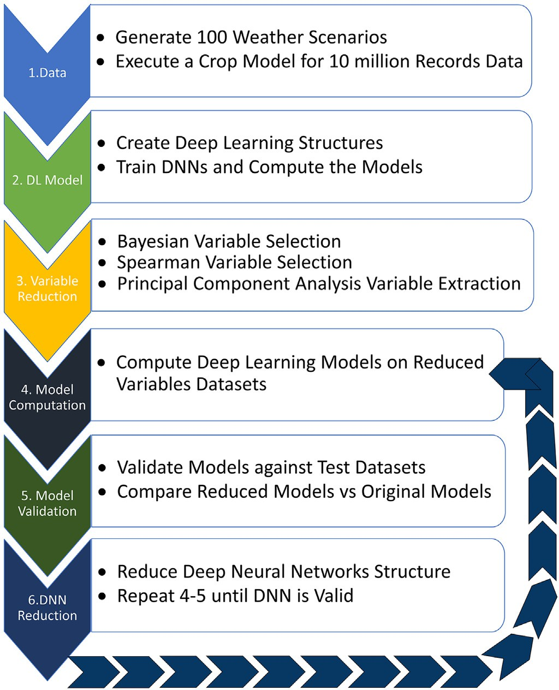

Fig. 1. Overview of the procedures for generating reduced deep neural network structures for crop yield estimations.

identified by three numbers in the form of Inputs-Neurons-Layers. For example, model 50–40-6 indicates a DNN with 50 input variables, 40 neurons per layer, and 6 layers. Finally, the best DNN model was com- pared against a new DNN model developed using a recent feature selec- tion method.

* 1. *Model input variables*

In this study, several environmental input variables were consid- ered, including precipitation and irrigation, maximum temperature, minimum temperature, and solar radiation. 800 variables were intro- duced for a 200-day growing season. Irrigation was added in combina- tion with precipitation to generate the total water applied in mm per day. To generate the model's training data, 100 different climate scenar- ios were considered. These climate scenarios were combined with 100,000 random irrigation scenarios and applied to a crop model, which generated 10,000,000 records of maize yields. Data related to cli- mate variabilities were produced by weather generators as described below.

* + 1. *Generating weather data*

Providing daily precipitation, temperature, and solar radiation in ad- dition to irrigation amounts, is essential for assuring the accuracy of crop model outputs. One-year field weather data was collected and used to generate different weather realization scenarios. The monthly temperature, solar radiation, and precipitation were collected from the nearest weather station to the study site (PRISM, 2011). A weather sto- chastic disaggregation tool was used to generate daily weather informa- tion from the environmental variables' monthly historical records (Hansen and Ines, 2005). This tool generated daily weather information by disaggregating average monthly data from historical records. To ac- curately simulate weather in the study area, 30 years of data were

used in the weather generator. The weather generator uses stochastic approaches to generate daily information for the locations of interest. In regards to precipitation, three conditions above the average, the aver- age, and below the average levels of precipitation are considered. Pre- cipitation occurrence is modeled by the Markov chain and the amount is sampled from hyperexponential distribution or probability density function of the random variable *x* (precipitation occurrence) given by Eq. (1).

and Melbourne, 2002). Less than 30% of the annual rainfall occurs from February through May, which is the main growing season (Fig. 2). The 30-year minimum and maximum temperatures of the loca- tion were 14.3 °C and 26.7 °C, respectively. On average, the highest tem- perature ranged from 32.7 °C in July to a low of 19 °C in January. Millhopper fine sand was the major soil type found in this region, known to drain moderately well.

* 1. *Crop modeling*

*f* (*x*) = *α*

exp − *x*

*β*1

*β*1

+ (1−*α*)

exp − *x*

*β*2

*β*2

(1)

The crop model selected for this study is the Decision Support Sys- tem for Agrotechnology Transfer (DSSAT). This model is designed to dy-

where: *α* is the mixing probability of hyperexponential distribution, and *β*1, *β*2 are means of the *i*th component of a hyperexponential rainfall intensity distribution.

In addition, maximum and minimum temperatures are sampled from a Gaussian distribution function conditioned on the occurrence of precipitation. To generate solar radiation, the weather generator used the *logit* function transformations of daily clearness rescaled be- tween upper and lower limits of field solar radiation Eq. (2):

*logit*(*p*) = ln (p/(1−*p*)) (2)

where, *p* is a probability of daily clearness.

To consider statistical behavior of daily sequences, the amount was shifted to match monthly average values of solar radiation and temper- atures from historical records.

* + 1. *Data preparation*

After removing duplicate data from the 10,000,000 generated re- cords, 8,970,685 unique maize production data remained (Table 1). These data were used for further developing the DL model. Despite the fact that two computers were used in the study, a 24 core of Intel® Xeon® CPU E5-2680 v3 @ 2.50GHz with Quadro M6000 GPU and an Intel® Core™ i7-4770 CPU @ 3.40GHz with GeForce GTX 1080 GPU, the GPU memory did not allow for all available records to be used in training the DNN. To reduce the number of records and maintain diversity, the data were categorized by maize yield into 12 categories, each 1000 kg apart, then sampled to create 10 similar population distri- bution datasets. Table 1 shows the number of data records in each dataset.

* 1. *Study area*

Irrigation Research Park in Gainesville, Florida, was selected as the study area for analyzing the effect of irrigation on maize yield. The Irri- gation Research Park is located at the experimental station of the Uni- versity of Florida (29° 37′ 8″ N, 82° 22′ 22″ W). The humid subtropical climate with abundant rainfall after the growing season makes this loca- tion suitable for quantitative studies of water management (Lascody

namically model over 40 different crops and has been widely used in the past 30 years by researchers and academic institutes worldwide (Hoogenboom et al., 2015; Jones et al., 2003a, 2003b; Nurudeen, 2011). According to the DSSAT website (Hoogenboom et al., 2019), the model has been used by more than 14,000 researchers, educators, consultants, extension agents, growers, and policy/decision-makers in over 150 countries. DSSAT's software application package includes soil, weather, crop management tools, and experimental data. DSSAT simulates and models crop growth, development, and yield as a func- tion of the soil, weather, and plant dynamics.

To obtain data for the purposes of DNN model training, a maize irri- gation experiment was setup in DSSAT and calibrated based on the re- sults from the experimental study site at the Irrigation Research Park. The growing season comprises 200 days (Hoogenboom et al., 2015). The DSSAT input files were setup using maize cultivar (McCurdy 84aa) with planting and harvesting dates of February 16 and May 7, re- spectively. Ten irrigation applications were selected to generate random scenarios within the growing season to further train the DNN model ir- rigation applications. Irrigations occurred within the growing season, with amounts ranging from 10 mm to 250 mm of water per day.

* 1. *Deep learning architecture for crop modeling*

Extensive knowledge of climate, geology, and agricultural manage- ment practices is needed to accurately operate typical crop models. In addition, the application of these types of models on a large-scale is lim- ited by model complexity. To address these limitations, this study was aimed to show the potential for applying DL techniques to crop models. The DL architecture that was used in this study was a DNN with a Multi Layers Perceptron (MLP) architecture (Fig. 3). MLP is a feed-forward DNN and was selected for this study, since it has been shown to success- fully generate solutions for classification problems (Deng and Yu, 2014). In this large-scale analysis, we were interested in estimating the pro- duction class rather than the actual yield due to the high level of uncer- tainty for individual fields. To make the production estimation more reliable, the maize production level was grouped into 12 classes (ranges from 0 to 12,000 kg/ha), with each class of input representing a range of 1000 kg/ha yield. For example, class 0 represents 0 to 1000 kg/ha, and

Table 1

Nonduplicated maize yield datasets for different climatological and irrigation scheduling that were used for deep learning crop model development.

|  |  |  |  |  |  |  |  |  |  |  |
| --- | --- | --- | --- | --- | --- | --- | --- | --- | --- | --- |
| Yield class | Data set 1 | Data set 2 | Data set 3 | Data set 4 | Data set 5 | Data set 6 | Data set 7 | Data set 8 | Data set 9 | Data set 10 |
| 0–1000 | 46,872 | 46,919 | 47,131 | 46,985 | 46,664 | 46,718 | 46,680 | 46,861 | 46,707 | 44,936 |
| 1000–2000 | 99,136 | 99,251 | 99,783 | 100,049 | 99,829 | 99,882 | 99,719 | 99,821 | 100,204 | 96,568 |
| 2000–3000 | 102,770 | 102,178 | 102,101 | 102,235 | 102,288 | 102,187 | 102,320 | 102,286 | 101,961 | 99,032 |
| 3000–4000 | 167,257 | 168,053 | 167,320 | 167,595 | 167,256 | 167,508 | 167,786 | 166,691 | 167,349 | 161,942 |
| 4000–5000 | 114,608 | 114,090 | 114,052 | 113,762 | 114,278 | 114,607 | 113,753 | 114,485 | 114,531 | 110,320 |
| 5000–6000 | 85,792 | 86,493 | 86,807 | 86,388 | 86,571 | 86,460 | 86,144 | 86,361 | 86,183 | 83,332 |
| 6000–7000 | 99,090 | 99,033 | 99,108 | 99,439 | 99,650 | 98,712 | 99,751 | 99,675 | 99,294 | 96,510 |
| 7000–8000 | 62,626 | 62,559 | 61,742 | 62,081 | 61,887 | 62,443 | 62,292 | 62,502 | 62,201 | 60,065 |
| 8000–9000 | 61,518 | 60,911 | 61,190 | 61,082 | 60,970 | 60,798 | 61,037 | 60,995 | 61,254 | 59,276 |
| 9000–10,000 | 24,199 | 24,258 | 24,296 | 24,222 | 24,551 | 24,302 | 24,178 | 24,181 | 24,305 | 23,421 |
| 10,000–11,000 | 30,280 | 30,394 | 30,753 | 30,377 | 30,232 | 30,574 | 30,539 | 30,385 | 30,303 | 29,622 |
| 11,000–12,000 | 5852 | 5861 | 5717 | 5785 | 5824 | 5809 | 5801 | 5757 | 5708 | 5661 |
| Total | 900,000 | 900,000 | 900,000 | 900,000 | 900,000 | 900,000 | 900,000 | 900,000 | 900,000 | 870,685 |

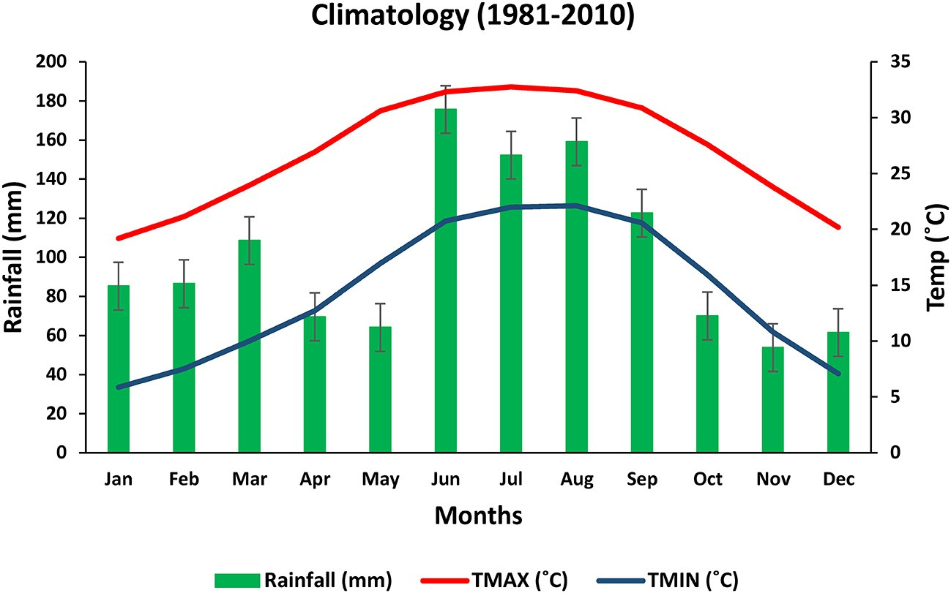

Fig. 2. The 30-year (1981–2010) average weather conditions at Gainesville, Florida.

class 1 represent 1000 to 2000 kg/ha. Different combinations of hidden layers with neurons (computation nodes) within each layer were used in the DNN to form the crop models. Activation functions of the same type were assigned for all neurons. The TanH (tangent hyperbolic) acti- vation function was used for all hidden layers and the SoftMax (normal- ization constraint on the total output probability function) activation function was used for the output layer (Costa, 1996). Once the DNN structure was created, training is necessary and was performed as detailed in the next section.

* 1. *Training and validation of the models*

All models were trained using the first dataset of 900,000 records and 10% of the dataset (90,000 records) were used for validation throughout the training process. The backpropagation (Liu et al., 2017) method and the gradient descent (Baldi, 1995) algorithm were also used to train the network by minimizing a defined cost (Baldi, 1995). In this study, the negative log-likelihood equation Eq. (3) was used as a cost function (Friedman, 2002). The learning rate was fixed at 0.01, and the mini-batch size was 1000 records in all training runs. After reaching the lowest validation error, training was continued for 100 epochs to ensure that it was not trapped in the local minimum.

reducing the number of layers and the number of neurons per layer, the training process became faster.

* 1. *Variable reduction*

To improve training performance and reduce the computational power required for developing the DL models. Among the numerous variable reduction techniques, some of the most commonly used tech- niques in environmental and agricultural studies were applied (Woznicki et al., 2015). The following three variables reduction methods were evaluated for preprocessing the data.

* + 1. Bayesian Variable Selection (O'Hara and Sillanpää, 2009)

In theory, a Bayesian model explains a response variable (output) with a (large) number of explanatory variables (inputs). The Bayes- ian Variable Selection method selects a small subset of variables that can be inferred and used to explain a large fraction of the variation present in the response. In many cases, the variable selection is done by specifying the variables; the variable selection task is to es- timate the marginal posterior probability of whether the variable should be included in the model or not (O'Hara and Sillanpää, 2009). Several Bayesian Variable Selection software tools are currently available, such as BayesFactor, BayesVarSel, and BMS (Forte et al.,

*Cost*  1

= +

*nbz*

X

*k*=0

*n*

*log* *P*(*Y* = *yk* | cos

*nπx*

*L* + *bn* sin

*nπx L*

(3)

2018); however, none of them is suitable to work with a large dataset. As a result, we identified the Bayesian Generalized Linear Regression (BGLR) software (Pérez and de los Campos, 2014) that

where, *n*bz is the mini-batch size, *n* is the number of output classes (12 in this case), and *P* is a function of likelihood probability calculated by Softmax (normalization constraint on the total output probability func- tion) (Costa, 1996).

To compute the required time for each epoch in the DNN structure with *l* layers and *n* neurons per layer, it was assumed the total calcula- tion time of each layer in parallel for the feed-forward and feed- backward process on the GPU is *T*l second. To feed the next layer, the neuron's output between GPU memory and machine main memory was transferred in *T*n second. Considering the training process, Eq. (4) calculated the time consumption for one epoch.

can work with big data. The BGLR is an R-based statistical package based on the Gibbs sampler technique with scalar updates to reduce the number of input variables (Casella and George, 1992).

* + 1. Spearman Variable Selection (Zwillinger and Kokoska, 1999)

Spearman Rank Correlation method calculates the ranking cor- relation between each variable and the output (Eq. (5)). In this method, it was assumed that the variables with higher cor- relations would have a greater impact on outputs and should be considered first in the model.

*SSuv*

*rs* = ,*S*ﬃﬃﬃ*S*ﬃﬃﬃﬃﬃﬃﬃﬃ×ﬃﬃﬃﬃ*S*ﬃﬃﬃ*S*ﬃﬃﬃﬃﬃﬃ

(5)

*Tepoch* = *l* × *T* + *n* × *l* × *Tn* (4)

Eq. (4) demonstrated that training time had a direct relationship with the number of layers and the number of neurons per layer. By

*uu* *vv*

where, *r*s presents the Spearman Rank Correlation coefficient, *SS*uv is the covariance of the input and the output variables, respectively, *SS*uu and *SS*vv are standard deviations of input and output variables.

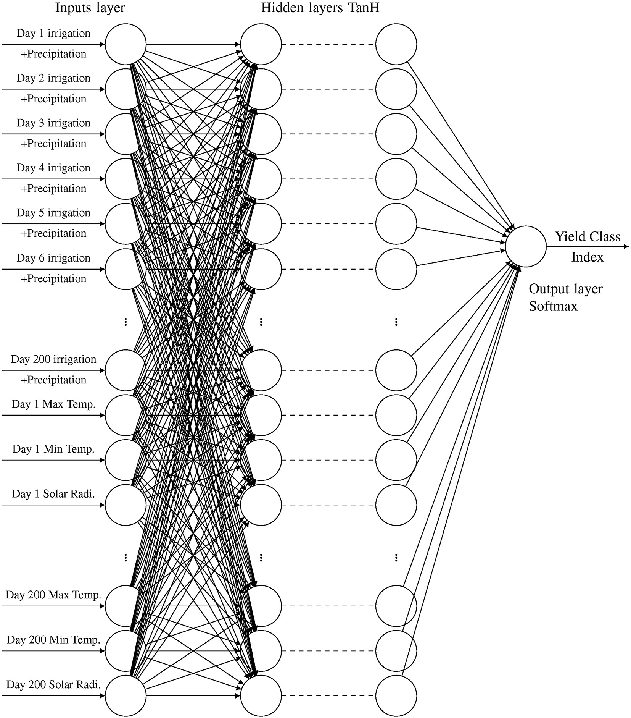

Fig. 3. Schematic representation of the deep neural network with multi-layer perceptron architecture that was used for crop yield estimations.

A python library from [scipy.org](http://scipy.org/) (scipy.stats.spearmanr) was used to calculate the Spearman Rank Correlation coefficient (Zwillinger and Kokoska, 1999) between inputs and outputs for variable selection purposes.

* + 1. Principal Component Analysis Feature Extraction (Khalid et al., 2014)

Principal Component Analysis (PCA) feature extraction is an orthog- onal transformation for converting correlated variables to a smaller set of uncorrelated variables. PCA feature extraction method uses ei- genvalues of *XT X* to calculate linear transformations between these two sets. This method is called feature/variable extraction (Khalid et al., 2014).

In this study, a python library (sklearn.decomposition.PCA) was used to perform this analysis. This library used the LAPACK imple- mentation of the full Singular Value Decomposition (SVD) or a ran- domized truncated SVD, a method introduced by Halko et al. (2011).

* 1. *Feature (variable) selection base on max-relevance and min- redundancy*

Min-redundancy and max-relevance (mRMR) (Menger et al., 2018) is a novel and popular method that was initially introduced by Peng et al. (2005) and then improved by Bugata and Drotar (2020). The mRMR algorithm selects a set of explanatory variables with the highest relevancy and the lowest redundancy level to describe the output vari- able. Consequently, the most dependent variables are identified in a large set of variables, which ultimately results in better classification. Through reduced input variable redundancy, a smaller model with equal or better performance can be obtained.

Research by Bugata and Drotar (2020) showed that the max- redundancy is not always equivalent to max-dependency as was assumed by Peng et al. (2005). Therefore, Bugata and Drotar (2020) suggested that by adding an objective to the algorithm to maximize de- pendency, the overall performance of the mRMR algorithm can be im- proved. In fact, applying the revised mRMR algorithm resulted in

better feature selection under a real-world scenario (Bugata and Drotar, 2020).

1. Results of discussion
   1. *Deep neural network structure analysis*
      1. *Evaluation of the original deep learning model's accuracy with 800 input variables*

The original DL model was trained and tested using 800 inputs. The inputs consisted of four environmental variables varying over a 200-day crop growing season and all models were trained on the first 900,000 recordsets. Fig. 4 and Table S1 (Supplementary Materials) present the accuracy of the original DL models with different structures. The predic- tion accuracy results are shown in the “Training Set” columns and the average accuracy rates from the nine test sets are shown in the “Test Sets” columns. The results showed that in smaller DNN structures (50 to 100 neurons per layer), more layers resulted in lower model accu- racy. This behavior was previously observed by Schmidhuber (2015), who noticed decreasing accuracy from exploding/vanishing gradients. The accuracy rates in the DNNs with small structures were significantly lower (30% to 70%) than those with larger structures (400 to 1000 neu- rons per layer) (75% to 80%), which can be seen in Fig. 4. This behavior shows that a DL model based on a large dataset with 800 inputs vari- ables needs a large structure to perform reasonably well.

In this study, the accuracy reduced at a lower rate in DNNs with more than 400 neurons per layer compared to smaller DNNs with an in- creasing number of layers. However, larger structures require more computational time and more powerful hardware to perform at an ac- ceptable level. It should be noted that accuracy rates in training sets and test sets were identical, indicating that the models were not overfitted.

* + 1. *The number of input variables for deep learning models was reduced to 400*

Table S2 and Fig. 5 show the accuracy training and test sets of the DNN model predictions with 400 input variables. Evidently, the result with the Bayesian and Spearman Rank Correlation methods in the train- ing set and the average of the nine test sets were almost identical. The similarity indicated that the models were not overfitted. Furthermore, the PCA feature extraction method displayed greater accuracy with the training set but poor performance with the test sets. As an unsuper- vised feature extraction method, PCA identifies and extracts the least correlated features from the input dataset (Calesella et al., 2021). Mean- while, the developed DL models based on this extraction method were overfitted during the training process.

Additionally, Fig. 5 shows that the 400 neuron DNN with many layers had a lower accuracy with the Bayesian Variable Selection method. Similar results were observed with the Spearman Rank Corre- lation, but the Bayesian Variable Selection method showed a decrease in accuracy when the number of layers increased, while the Spearman Rank Correlation method did not. This indicated that the Spearman Rank Correlation method was less affected by the vanishing/exploding gradients issue. The PCA feature extraction method showed almost no sensitivity to an increasing number of layers. Although it reached a sig- nificant prediction accuracy (more than 97%) with the training set, poor performance on test sets showed the model was highly overfitted. Bayesian Variable Selection and Spearman Rank Correlation methods had the same prediction accuracy on both training and test sets of DNNs with 600 neurons per layer. For the PCA feature extraction method, the prediction accuracy on training sets were increased on 600 neurons per layer, demonstrating how the method became less reliable due to overfitting with larger DNN structures.

* + 1. *The numbers of input variables for deep learning models were reduced to 200,100 and 50 number*

Table S3 and Fig. S1 (Supplementary Materials) presented the DNN models' accuracy with 200 input variables. Table S4 and Fig. S2 pre- sented the DNN models' accuracy with 100 input variables. Almost identical behaviors to 400 input variables were observed with 200 and 100 variables. One hundred input variables (Fig. S2) indicated a flat ac- curacy amount for all DNN structures because the number of neurons was twice that of the number of inputs. As a result, the DNN was more flexible and compensated for vanishing/exploding gradient issues. The results from the Bayesian Variable Selection and the Spearman Rank Correlation methods showed comparable accuracy levels for the DNN models with similar architectures (79%). Meanwhile, the DNN models using the PCA feature extraction method had the highest accuracy for the training set (over 98%) and significantly lower accuracy for the test sets (less than 39%). This finding indicated the model was overfitted.

Fig. S1 shows a decrease in accuracy in relation to an increase in the

number of layers in the DNN with 200 neurons per layer. However, for 400 and 600 neurons per layer, the accuracy rate remained almost con- stant for all three variable reduction methods. It can be observed in Fig. S2 that 100 input variables' accuracy rates were constant for all the different DNN structures except for the PCA feature extraction method, which had a comparable accuracy rate to the 400 inputs models. This illustrates that improvements in accuracy were established by increasing the number of layers in the training set without improving test set performance.

To study the effect of additional input variable reductions, some new models with only 50 input variables were computed. Table S5 and

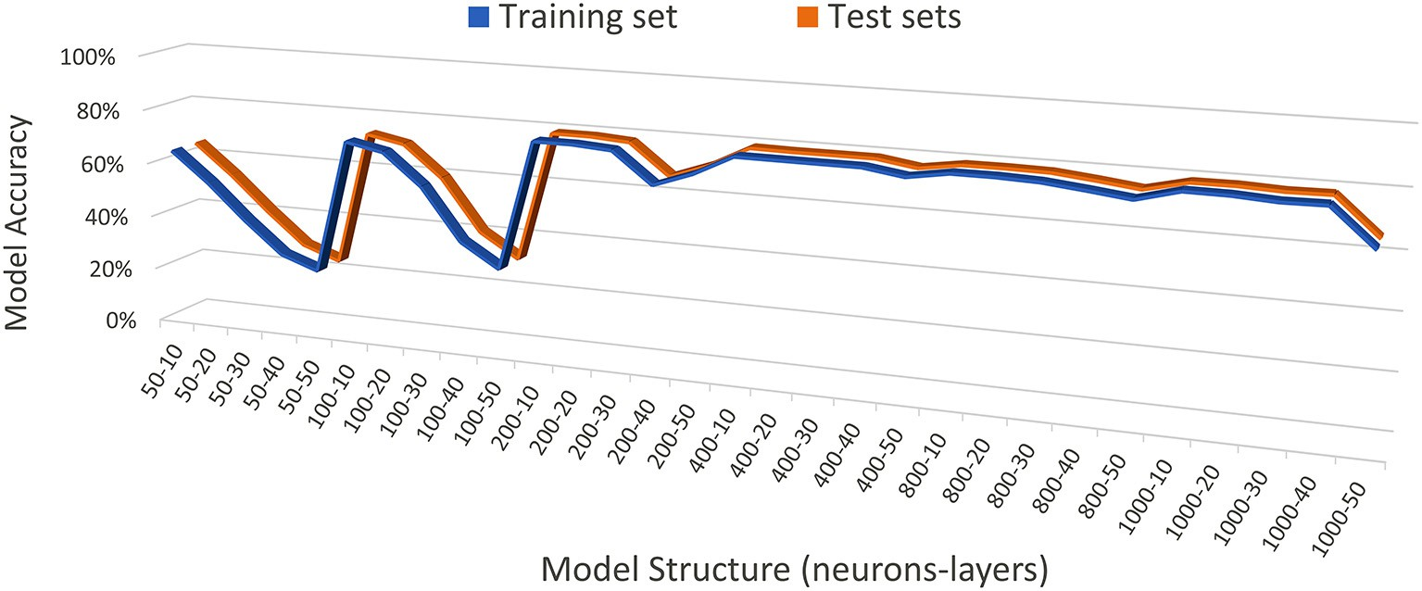

Fig. 4. Deep neural network original models' accuracy with 800 input variables under different model structures.

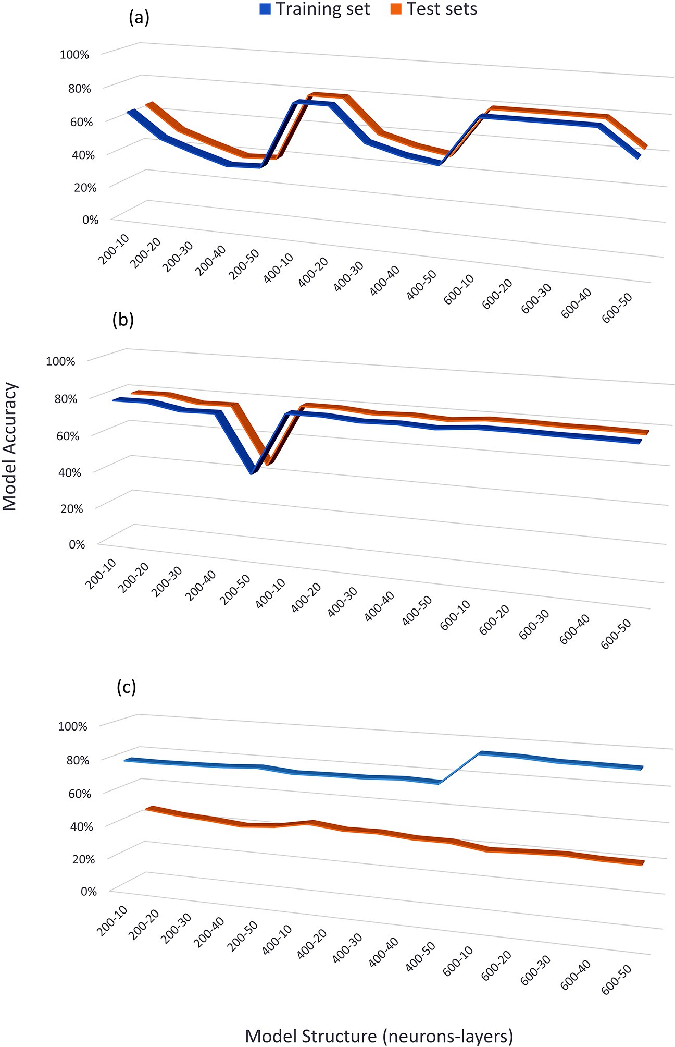

Fig. 5. Deep neural network models' accuracy with 400 input variables (a) Bayesian (b) Spearman (c) PCA.

Fig. S3 show the accuracy validation result for these models on the train- ing sets and test sets with 50 input variables, which turned out to be identical to the results of 100 input variables. This result shows that the three variable reduction methods successfully reduced input vari- ables and can be expected to produce models with small DNN structures at acceptable prediction accuracy levels. In the next step, the DNN struc- ture was reduced in order to find out if these methods would work with smaller DNN structures.

* + 1. *Evaluating the performance of deep learning models with limited layers*

To understand the impact of the number of hidden layers and vari- able reductions on the DNN model's accuracy, the number of layers was limited to less than 10 (1 to 9) for three different sets of neurons (i.e., 200, 400, and 600) and 200 input variables (Table S6).

Fig. S4 indicates that with 200 inputs and the proper number of neu- rons per layer, the accuracy with 1 hidden layer is almost the same as the large DNN structures with several layers. This shows the robustness of all three chosen variable reduction methods on the system. In other words, a shallow DNN (with less than 10 layers) with a higher number of neurons per layer (200, 400, and 600) performed as well as a deep DNN (with more than 10 layers) with several hidden layers (10, 20, 30, 50 hidden layers). However, similar to previous results, the models developed based on the PCA feature extraction method had excellent accuracy on the training sets and poor performance on the test sets.

* + 1. *Evaluate the impact of the number of neurons and layers on deep learning model accuracy*

In this stage, the performance of several models was computed with a small number of neurons per layer. Table S7 and Fig. S5 show the ac- curacy result for the DNN models with 50 input variables. The number

of neurons per layer in these models was 4, 6, 8, and 10, while the num- ber of layers was 1 through 9. In general, the overall accuracy of the DNN models with a low number of neurons (e.g., ten neurons in Fig. S5) was lower than the accuracy of the models with more neurons (e.g., 200 neurons in Fig. S4). Meanwhile, the DL models' accuracy fluctuated when the number of layers increased for the same number of neurons. However, when the data was rearranged (Fig. S6), the fluctuation pat- terns became more apparent in which the accuracy increased as the number of neurons increased for the same number of layers.

Meanwhile, DL models based on the Bayesian and Spearman vari- able reductions methods are more consistent in performance between testing and training sets, while the DL models developed using the PCA variable reduction method are less robust. For example, in section C of Fig. S5 the test set shows a considerable drop in accuracy compared to the training set.

Finally, regardless of the variable reduction methods and the num- ber of layers, the accuracy of the DL model is higher as the number of neurons increases (Fig. S5).

* 1. *Identifying the smallest DNN model with good accuracy*

Large DNN structures require significant time for training their net- work (Sun et al., 2019). Therefore, the goal of this section was to identify the minimum number of input variables that can be used to develop a DL model with similar accuracy as the original model, with 800 input variables. Here we considered four models with 10, 20, 30, and 40 var- iables. Table 2 shows models by 10 to 40 inputs and 1 to 9 layers predic- tion accuracy results. The highest accuracy for all three variable reduction methods was obtained using the DNN with 10 neurons per layer, as highlighted in Table 2. Among these three methods, only the

DL model based on the Bayesian variable reduction method was suc- cessful in producing reliable data comparable to the original model, with 800 input variables.

The model with 30 inputs, 10 neurons, and 5 layers (50 computa- tional units) created by the Bayesian Variable Selection method had the same accuracy as a model with 800 inputs, 400 neurons, and 10 layers (Table S1 with 4000 computational units). This suggests that the DNN structure developed using the Bayesian Variable Selection method, which was 80 times smaller, with 1/27 the number of input variables, could have the same accuracy as the larger model. However, it took three weeks to calculate the posterior probability vector using 900,000 simulated crop yield datasets. This hurdle makes the Bayesian Variable Selection method less useful for fast applications.

The Spearman variable selection method, with more than 200 input variables, was acceptable with larger DNN structures since they had the same accuracy as the Bayesian Variable Selection model with 200 neu- rons per layer. However, the Spearman produced model reduced the prediction accuracy when the number of neurons per layer was re- duced. This method was found to work well with larger input variables and DNN structures compared to the Bayesian Variable Selection method. In addition, the processing time for variable selection was much faster (~10 min) than the Bayesian Variable Selection method.

The PCA model consistently had the best results on the training set and poor performance on test sets with larger DNN structures showed inferior performance on training sets and test sets with small DNN structures. The accuracy of the smallest model's DNN structure for each method of variable reduction compared to the original 800 input variable models can be seen in Table 3.

One of the main benefits of variable reduction is minimizing the structure of DNN and, as a result, reducing prediction run time. To

Table 2

Deep neural network models' architectures and accuracy for the training and test sets.

|  |  |  |  |  |  |  |  |  |  |  |  |
| --- | --- | --- | --- | --- | --- | --- | --- | --- | --- | --- | --- |
| Inputs | Neurons | Layers | Bayesian |  |  | Spearman |  |  | PCA |  |  |
|  |  |  | Training Set | Test Sets |  | Training Set | Test Sets |  | Training Set | Test Sets |
| 10 | 10 | 1 | 53.73% | 53.72% |  | 65.82% | 65.88% |  | 27.54% | 22.41% |  |
| 20 | 10 | 1 | 71.86% | 71.83% |  | 69.15% | 69.11% |  | 32.31% | 18.34% |  |
| 30 | 10 | 1 | 77.84% | 77.85% |  | 54.28% | 54.32% |  | 35.63% | 21.18% |  |
| 40 | 10 | 1 | 78.52% | 78.52% |  | 71.02% | 70.94% |  | 38.64% | 16.81% |  |
| 10 | 10 | 2 | 68.89% | 68.86% |  | 60.08% | 60.12% |  | 29.61% | 23.20% |  |
| 20 | 10 | 2 | 76.88% | 76.87% |  | 56.80% | 56.82% |  | 35.45% | 18.92% |  |
| 30 | 10 | 2 | 78.53% | 78.52% |  | 61.18% | 61.18% |  | 36.88% | 20.64% |  |
| 40 | 10 | 2 | 78.55% | 78.54% |  | 69.46% | 69.40% |  | 39.54% | 17.21% |  |
| 10 | 10 | 3 | 68.95% | 68.91% |  | 59.19% | 59.28% |  | 31.24% | 23.83% |  |
| 20 | 10 | 3 | 76.81% | 76.80% |  | 54.05% | 54.02% |  | 35.75% | 19.60% |  |
| 30 | 10 | 3 | 78.57% | 78.56% |  | 54.24% | 54.16% |  | 37.54% | 21.04% |  |
| 40 | 10 | 3 | 78.57% | 78.56% |  | 52.14% | 52.08% |  | 40.70% | 17.16% |  |
| 10 | 10 | 4 | 69.20% | 69.18% |  | 61.28% | 61.33% |  | 32.44% | 24.79% |  |
| 20 | 10 | 4 | 77.03% | 77.01% |  | 56.49% | 56.55% |  | 36.28% | 19.95% |  |
| 30 | 10 | 4 | 78.58% | 78.57% |  | 54.11% | 54.15% |  | 38.96% | 20.67% |  |
| 40 | 10 | 4 | 78.57% | 78.57% |  | 56.78% | 56.74% |  | 40.35% | 17.77% |  |
| 10 | 10 | 5 | 69.93% | 69.91% |  | 48.66% | 48.65% |  | 33.21% | 25.41% |  |
| 20 | 10 | 5 | 76.94% | 76.92% |  | 51.80% | 51.76% |  | 37.44% | 19.67% |  |
| 30 | 10 | 5 | 78.59% | 78.58% |  | 45.41% | 45.43% |  | 39.61% | 20.99% |  |
| 40 | 10 | 5 | 78.57% | 78.57% |  | 50.89% | 50.82% |  | 41.34% | 17.07% |  |
| 10 | 10 | 6 | 67.81% | 67.84% |  | 50.39% | 50.41% |  | 33.44% | 24.93% |  |
| 20 | 10 | 6 | 77.11% | 77.10% |  | 55.79% | 55.76% |  | 37.42% | 19.32% |  |
| 30 | 10 | 6 | 78.57% | 78.56% |  | 41.60% | 41.69% |  | 39.83% | 21.10% |  |
| 40 | 10 | 6 | 78.56% | 78.55% |  | 48.09% | 48.08% |  | 41.11% | 18.24% |  |
| 10 | 10 | 7 | 67.00% | 66.95% |  | 42.95% | 42.96% |  | 33.77% | 26.10% |  |
| 20 | 10 | 7 | 77.02% | 76.98% |  | 47.74% | 47.75% |  | 37.56% | 19.85% |  |
| 30 | 10 | 7 | 78.57% | 78.57% |  | 50.02% | 49.96% |  | 39.64% | 20.68% |  |
| 40 | 10 | 7 | 78.57% | 78.56% |  | 48.63% | 48.60% |  | 41.91% | 16.88% |  |
| 10 | 10 | 8 | 67.02% | 67.03% |  | 45.74% | 45.80% |  | 33.98% | 26.14% |  |
| 20 | 10 | 8 | 77.03% | 77.01% |  | 49.00% | 48.96% |  | 38.26% | 20.14% |  |
| 30 | 10 | 8 | 78.58% | 78.57% |  | 43.69% | 43.70% |  | 40.12% | 21.12% |  |
| 40 | 10 | 8 | 78.54% | 78.54% |  | 51.99% | 52.00% |  | 41.38% | 17.57% |  |
| 10 | 10 | 9 | 67.27% | 67.24% |  | 45.49% | 45.61% |  | 34.05% | 25.69% |  |
| 20 | 10 | 9 | 76.96% | 76.94% |  | 39.34% | 39.34% |  | 38.38% | 19.46% |  |
| 30 | 10 | 9 | 78.58% | 78.57% |  | 37.95% | 37.97% |  | 40.09% | 21.54% |  |
| 40 | 10 | 9 | 77.70% | 77.70% |  | 55.71% | 55.70% |  | 42.21% | 16.98% |  |

Table 3

The accuracy of the smallest deep neural network structure for the three variable reduc- tion methods compare to the original model with 800 inputs.

DNN structure Maximum accuracy

0.86 s, which is 193 times faster. A decrease in the overall runtime of the DNN crop model can help with the application of these types of models at the large scale that is necessary for policymakers to make an informed decision at the national and international levels.

|  |  |  |  |  |  |  |  |  |  |
| --- | --- | --- | --- | --- | --- | --- | --- | --- | --- |
|  | Models | Inputs | Neurons |  | Layers | Training Set | Test Sets |  |  |
|  | 800 inputs | 800 | 400 |  | 10 | 78.58% | 78.54% |  |
|  | Bayesian | 30 | 10 |  | 5 | 78.59% | 78.58% |  |
|  | Spearman | 40 | 10 |  | 1 | 71.02% | 70.94% |  | *3.3. Comparing by mRMR* |
|  | PCA | 40 | 10 |  | 9 | 42.21% | 26.14% |  |  |
|  |  |  |  |  |  |  |  |  | In this section, the mRMR method was used to identify a set of vari- |

measure this benefit, the original model (800 inputs, 400 neurons, 10 layers) and the smallest DNN model (30 inputs, 10 neurons, and 5 layers) that show the same level of accuracy have been run on 90,000 records on the same CPU platform to measure their execution time. As a result, the original model with 800 inputs took 166 s to run and the small model based on the Bayesian Variable Selection method took

ables from the 800 inputs to develop the DNN models comparable with the most accurate model developed by the Bayesian variable selection method. Fig. 6 shows the comparison between these two methods. The DL models computed by mRMR are usually around 10% less accu- rate than the similar models developed based on the Bayesian variable selection method. The lower accuracy established a clear superiority of the Bayesian variable selection methodology to the mRMR.

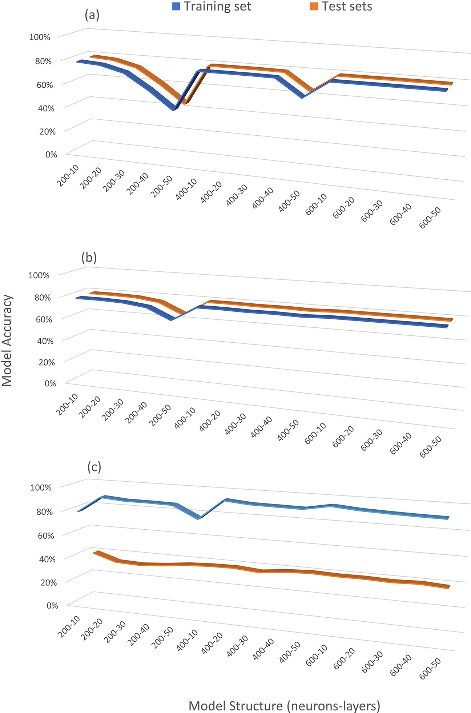

Fig. 6. Comparison between min-redundancy max-relevance and Bayesian model accuracy.

1. Conclusion

A cropping system modeled by DL with many input variables pro- duces a large DNN structure, which is very computationally intensive. Additionally, the training process required for large DNNs can be very time-consuming. This shortcoming has limited their usage for large- scale applications. However, the utilization of an efficient deep learning crop model can be a game-changer. For example, a regional-scale irriga- tion scheduling system can be developed using a hybrid system com- prised of DL-based crop models, a weather forecasting system, and an optimization algorithm.

In this study, we examined the possibility of developing a simpler deep learning model with comparable accuracy through the application of different variable reduction methods (i.e., Bayesian Variable Selec- tion, Spearman Rank Correlation, and PCA variable extraction method). The Bayesian Variable Selection method was identified as the most robust method of the three evaluated in this study. However, calculating the posterior probability for each variable is very time-consuming. The Spearman Rank Correlation was ranked the second best with similar ac- curacy to the Bayesian Variable Selection method. The performance of these models were also examined against the recently improved mRMR technique. In general, the models based on the mRMR technique are less accurate than the ones based on the Bayesian and the Spearman Rank Correlation techniques. Finally, the DNN models that were devel- oped based on the PCA feature extraction method had the highest accu- racy during the training tests, but the lowest levels during testing.

Unfortunately, almost all DNN models developed by this technique were overfitted.

Even though the Bayesian Variable Selection method was selected as the best for this study; however, future studies are necessary for analyz- ing the robustness of this method and reduce uncertainty by utilizing ensembles of crop simulation models under different irrigation schemes, climatological conditions, and crop management strategies. Ultimately, the results of this work can then be compared to determine the best selection method for a wide variety of crops/regions.

Declaration of Competing Interest

The authors declare that they have no conflict of interest.

Acknowledgments

The authors would like to thank Ms. Anna Raschke for her review and constructive feedback. This work was supported by the USDA Na- tional Institute of Food and Agriculture, Hatch project 1019654.

Appendix A. Supplementary data

Supplementary data to this article can be found online at [https://doi.](https://doi.org/10.1016/j.aiia.2021.09.001) [org/10.1016/j.aiia.2021.09.001](https://doi.org/10.1016/j.aiia.2021.09.001).

References

Abbasi, A.Z., Islam, N., Shaikh, Z.A., 2014. [A review of wireless sensors and networks’ ap-](http://refhub.elsevier.com/S2589-7217(21)00027-1/rf0005) [plications in agriculture. Comput. Stand. Inter. 36 (2), 263–27](http://refhub.elsevier.com/S2589-7217(21)00027-1/rf0005)0.

Aggarwal, P.K., Kalra, N., Chander, S., Pathak, H., 2006. [Infocrop: a dynamic simulation](http://refhub.elsevier.com/S2589-7217(21)00027-1/rf0010) [model for the assessment of crop yields, losses due to pests, and environmental im-](http://refhub.elsevier.com/S2589-7217(21)00027-1/rf0010) [pact of agro-ecosystems in tropical environments. i. Model description. Agric. Syst.](http://refhub.elsevier.com/S2589-7217(21)00027-1/rf0010) [89 (1), 1–25](http://refhub.elsevier.com/S2589-7217(21)00027-1/rf0010).

Ahuja, L., Ma, L., 2011. [A synthesis of current parameterization approaches and needs for](http://refhub.elsevier.com/S2589-7217(21)00027-1/rf0015) [further improvements. Methods of Introducing System Models into Agricultural](http://refhub.elsevier.com/S2589-7217(21)00027-1/rf0015) [Research. 2, pp. 427–44](http://refhub.elsevier.com/S2589-7217(21)00027-1/rf0015)0.

Ali, M., Deo, R.C., 2020. [Modeling wheat yield with data-intelligent algorithms: artificial](http://refhub.elsevier.com/S2589-7217(21)00027-1/rf0020) [neural network versus genetic programming and minimax probability machine](http://refhub.elsevier.com/S2589-7217(21)00027-1/rf0020) [regression. Handbook of Probabilistic Models. Butterworth-Heinemann, pp. 37–87](http://refhub.elsevier.com/S2589-7217(21)00027-1/rf0020).

Ali, M., Deo, R.C., Downs, N.J., Maraseni, T., 2018a. [Cotton yield prediction with Markov](http://refhub.elsevier.com/S2589-7217(21)00027-1/rf0025) [Chain Monte Carlo-based simulation model integrated with genetic programing algo-](http://refhub.elsevier.com/S2589-7217(21)00027-1/rf0025) [rithm: a new hybrid copula-driven approach. Agric. For. Meteorol. 263, 428–44](http://refhub.elsevier.com/S2589-7217(21)00027-1/rf0025)8.

Ali, M., Deo, R.C., Downs, N.J., Maraseni, T., 2018b. [Multi-stage hybridized online sequen-](http://refhub.elsevier.com/S2589-7217(21)00027-1/rf0030) [tial extreme learning machine integrated with Markov Chain Monte Carlo copula-Bat](http://refhub.elsevier.com/S2589-7217(21)00027-1/rf0030) [algorithm for rainfall forecasting. Atmos. Res. 213, 450–46](http://refhub.elsevier.com/S2589-7217(21)00027-1/rf0030)4.

Ali, M., Deo, R.C., Maraseni, T., Downs, N.J., 2019. [Improving SPI-derived drought forecasts](http://refhub.elsevier.com/S2589-7217(21)00027-1/rf0035) [incorporating synoptic-scale climate indices in multi-phase multivariate empirical](http://refhub.elsevier.com/S2589-7217(21)00027-1/rf0035) [mode decomposition model hybridized with simulated annealing and kernel ridge](http://refhub.elsevier.com/S2589-7217(21)00027-1/rf0035) [regression algorithms. J. Hydrol. 576, 164–184](http://refhub.elsevier.com/S2589-7217(21)00027-1/rf0035).

Ali, M., Deo, R.C., Xiang, Y., Li, Y., Yaseen, Z.M., 2020. [Forecasting long-term precipitation](http://refhub.elsevier.com/S2589-7217(21)00027-1/rf0040) [for water resource management: a new multi-step data-intelligent modelling](http://refhub.elsevier.com/S2589-7217(21)00027-1/rf0040) [approach. Hydrol. Sci. J. 65 (16), 2693–2708](http://refhub.elsevier.com/S2589-7217(21)00027-1/rf0040).

Amara, J., Bouaziz, B., Algergawy, A., 2017. [A deep learning-based approach for banana](http://refhub.elsevier.com/S2589-7217(21)00027-1/rf0045) [leaf diseases classification. Datenbanksysteme für Business, Technologie und Web](http://refhub.elsevier.com/S2589-7217(21)00027-1/rf0045) [(BTW 2017)-Workshopband, pp. 79–88](http://refhub.elsevier.com/S2589-7217(21)00027-1/rf0045).

Angermueller, C., Pärnamaa, T., Parts, L., Stegle, O., 2016. [Deep learning for computational](http://refhub.elsevier.com/S2589-7217(21)00027-1/rf0050) [biology. Mol. Syst. Biol. 12 (7), 878](http://refhub.elsevier.com/S2589-7217(21)00027-1/rf0050).

Arnold, J.G., Moriasi, D.N., Gassman, P.W., Abbaspour, K.C., White, M.J., Srinivasan, R., Santhi, C., Harmel, R., Van Griensven, A., Van Liew, M.W., Kannan, N., 2012. [SWAT:](http://refhub.elsevier.com/S2589-7217(21)00027-1/rf0055) [model use, calibration, and validation. T. ASABE 55 (4), 1491–1508](http://refhub.elsevier.com/S2589-7217(21)00027-1/rf0055).

Baldi, P., 1995. [Gradient descent learning algorithm overview: a general dynamical sys-](http://refhub.elsevier.com/S2589-7217(21)00027-1/rf0060) [tems perspective. IEEE Trans. Neural Netw. 6 (1), 182–19](http://refhub.elsevier.com/S2589-7217(21)00027-1/rf0060)5.

Ballesteros, R., Ortega, J.F., Moreno, M.Á., 2016. [FORETo: new software for reference](http://refhub.elsevier.com/S2589-7217(21)00027-1/rf0065) [evapotranspiration forecasting. J. Arid Environ. 124, 128–14](http://refhub.elsevier.com/S2589-7217(21)00027-1/rf0065)1.

Basso, B., Ritchie, J., Pierce, F., Braga, R., Jones, J., 2001. [Spatial validation of crop models for](http://refhub.elsevier.com/S2589-7217(21)00027-1/rf0070) [precision agriculture. Agric. Syst. 68 (2), 97–11](http://refhub.elsevier.com/S2589-7217(21)00027-1/rf0070)2.

Bouman, B., Van Keulen, H., Van Laar, H., Rabbinge, R., 1996. [The ‘school of de wit’ crop](http://refhub.elsevier.com/S2589-7217(21)00027-1/rf0075) [growth simulation models: a pedigree and historical overview. Agric. Syst. 52](http://refhub.elsevier.com/S2589-7217(21)00027-1/rf0075) [(2–3), 171–198](http://refhub.elsevier.com/S2589-7217(21)00027-1/rf0075).

Bretherton, C.S., Smith, C., Wallace, J.M., 1992. [An intercomparison of methods for finding](http://refhub.elsevier.com/S2589-7217(21)00027-1/rf0080) [coupled patterns in climate data. J. Clim. 5 (6), 541e560](http://refhub.elsevier.com/S2589-7217(21)00027-1/rf0080).

World agriculture: towards 2015/2030: an FAO perspective. In: Bruinsma, J. (Ed.), Earthscan. <http://www.fao.org/3/y4252e/y4252e00.htm> (Accessed 12 January 2021). Bugata, P., Drotar, P., 2020. [On some aspects of minimum redundancy maximum rele-](http://refhub.elsevier.com/S2589-7217(21)00027-1/rf0090)

[vance feature selection. Sci. China Inf. Sci. 63 (1), 1–15](http://refhub.elsevier.com/S2589-7217(21)00027-1/rf0090).

Calesella, F., Testolin, A., De Grazia, M.D.F., Zorzi, M., 2021. [A comparison of feature extrac-](http://refhub.elsevier.com/S2589-7217(21)00027-1/rf0095) [tion methods for prediction of neuropsychological scores from functional connectiv-](http://refhub.elsevier.com/S2589-7217(21)00027-1/rf0095) [ity data of stroke patients. Brain Inform. 8 (1), 1–13](http://refhub.elsevier.com/S2589-7217(21)00027-1/rf0095).

Casella, G., George, E.I., 1992. [Explaining the GIBBS sampler. Am. Stat. 46 (3), 167–17](http://refhub.elsevier.com/S2589-7217(21)00027-1/rf0100)4.

Chen, Y., Lin, Z., Zhao, X., Wang, G., Gu, Y., 2014. [Deep learning-based classification of](http://refhub.elsevier.com/S2589-7217(21)00027-1/rf0105) [hyperspectral data. IEEE J. Sel. Top. Appl. Earth Obs. Remote Sens. 7 (6), 2094–2107](http://refhub.elsevier.com/S2589-7217(21)00027-1/rf0105). Chen, S.W., Shivakumar, S.S., Dcunha, S., Das, J., Okon, E., Qu, C., Taylor, C.J., Kumar, V., 2017. [Counting apples and oranges with deep learning: a data-driven approach.](http://refhub.elsevier.com/S2589-7217(21)00027-1/rf0110)

[IEEE Robot Autom. Lett. 2 (2), 781–78](http://refhub.elsevier.com/S2589-7217(21)00027-1/rf0110)8.

Chi, M., Plaza, A., Benediktsson, J.A., Sun, Z., Shen, J., Zhu, Y., 2016. [Big data for remote](http://refhub.elsevier.com/S2589-7217(21)00027-1/rf0115) [sensing: challenges and opportunities. Proc. IEEE 104 (11), 2207–2219](http://refhub.elsevier.com/S2589-7217(21)00027-1/rf0115).

Connor, D.J., Loomis, R.S., Cassman, K.G., 2011. [Crop Ecology: Productivity and Manage-](http://refhub.elsevier.com/S2589-7217(21)00027-1/rf0120) [ment in Agricultural Systems. Cambridge University Press](http://refhub.elsevier.com/S2589-7217(21)00027-1/rf0120).

Costa, M., 1996. [Probabilistic interpretation of feedforward network outputs, with rela-](http://refhub.elsevier.com/S2589-7217(21)00027-1/rf0125) [tionships to statistical prediction of ordinal quantities. Int. J. Neural Syst. 7 (5),](http://refhub.elsevier.com/S2589-7217(21)00027-1/rf0125) [627–637](http://refhub.elsevier.com/S2589-7217(21)00027-1/rf0125).

De, W., 1978. [Simulation of assimilation, respiration and transpiration of crops. Simula-](http://refhub.elsevier.com/S2589-7217(21)00027-1/rf0130) [tion Monographs. PUDOC, Wageninge](http://refhub.elsevier.com/S2589-7217(21)00027-1/rf0130)n.

De Vries, F.P., 1973. [Substrate Utilization and Respiration in Relation to Growth and Main-](http://refhub.elsevier.com/S2589-7217(21)00027-1/rf0135) [tenance in Higher Plants. Ph.D. dissertationWageningen Universit](http://refhub.elsevier.com/S2589-7217(21)00027-1/rf0135)y.

De Wit, C., 1965. [Photosynthesis of leaf canopies. Agricultural Research Report no 663.](http://refhub.elsevier.com/S2589-7217(21)00027-1/rf0140) [Center for Agricultural Publication and Documentation, Wagenin-gen, The](http://refhub.elsevier.com/S2589-7217(21)00027-1/rf0140) [Netherlands](http://refhub.elsevier.com/S2589-7217(21)00027-1/rf0140).

De Wit, C., De Vries, F.P., 1983. [Crop growth models without hormones. Neth. J. Agri. Sci.](http://refhub.elsevier.com/S2589-7217(21)00027-1/rf0145)

[31, 313–323](http://refhub.elsevier.com/S2589-7217(21)00027-1/rf0145).

Deb, K., Pratap, A., Agarwal, S., Meyarivan, T.A., 2002. [A fast and elitist multiobjective](http://refhub.elsevier.com/S2589-7217(21)00027-1/rf0150) [genetic algorithm: NSGA-II. IEEE Trans. Evol. Comput. 6 (2), 182–197](http://refhub.elsevier.com/S2589-7217(21)00027-1/rf0150).

Deng, L., Yu, D., 2014. [Deep learning: methods and applications. Found. Trend Signal](http://refhub.elsevier.com/S2589-7217(21)00027-1/rf0155) [Process. 7 (3–4), 197–387](http://refhub.elsevier.com/S2589-7217(21)00027-1/rf0155).

Dorigo, M., Di Caro, G., 1999. [Ant colony optimization: a new meta-heuristic. Proceedings](http://refhub.elsevier.com/S2589-7217(21)00027-1/rf0160) [of the 1999 Congress on Evolutionary Computation-CEC99 (Cat. No. 99TH8406). Vol.](http://refhub.elsevier.com/S2589-7217(21)00027-1/rf0160)

[2. IEEE, pp. 1470–1477](http://refhub.elsevier.com/S2589-7217(21)00027-1/rf0160).

Dyrmann, M., Jørgensen, R.N., Midtiby, H.S., 2017. [RoboWeedSupport - detection of weed](http://refhub.elsevier.com/S2589-7217(21)00027-1/rf0165) [locations in leaf occluded cereal crops using a fully convolutional neural network.](http://refhub.elsevier.com/S2589-7217(21)00027-1/rf0165) [Adv. Anim. Biosci. 8 (2), 842–84](http://refhub.elsevier.com/S2589-7217(21)00027-1/rf0165)7.

Einheuser, M.D., Nejadhashemi, A.P., Sowa, S.P., Wang, L., Hamaamin, Y.A., Woznicki, S.A., 2012. [Modeling the effects of conservation practices on stream health. Sci. Total](http://refhub.elsevier.com/S2589-7217(21)00027-1/rf0170) [Environ. 435, 380–39](http://refhub.elsevier.com/S2589-7217(21)00027-1/rf0170)1.

Einheuser, M.D., Nejadhashemi, A.P., Wang, L., Sowa, S.P., Woznicki, S.A., 2013. [Linking](http://refhub.elsevier.com/S2589-7217(21)00027-1/rf0175) [biological integrity and watershed models to assess the impacts of historical land](http://refhub.elsevier.com/S2589-7217(21)00027-1/rf0175) [use and climate changes on stream health. Environ. Manag. 51 (6), 1147–1163.](http://refhub.elsevier.com/S2589-7217(21)00027-1/rf0175)

FAO, Food and Agriculture Organization of the United Nations, 2017. [The State of Food](http://refhub.elsevier.com/S2589-7217(21)00027-1/rf0185) [and Agriculture: Leveraging Food Systems for Inclusive Rural Transformation. Food](http://refhub.elsevier.com/S2589-7217(21)00027-1/rf0185) [and Agriculture Organization of the United Nations](http://refhub.elsevier.com/S2589-7217(21)00027-1/rf0185).

Forte, A., Garcia-Donato, G., Steel, M., 2018. [Methods and tools for bayesian variable selec-](http://refhub.elsevier.com/S2589-7217(21)00027-1/rf0190) [tion and model averaging in normal linear regression. Int. Stat. Rev. 86 (2), 237–25](http://refhub.elsevier.com/S2589-7217(21)00027-1/rf0190)8. Friedman, J.H., 2002. [Stochastic gradient boosting. Comput. Stat. Data Anal. 38 (4),](http://refhub.elsevier.com/S2589-7217(21)00027-1/rf0195)

[367–378](http://refhub.elsevier.com/S2589-7217(21)00027-1/rf0195).

Gebbers, R., Adamchuk, V.I., 2010. [Precision agriculture and food security. Science 327](http://refhub.elsevier.com/S2589-7217(21)00027-1/rf0200) [(5967), 828–831 1](http://refhub.elsevier.com/S2589-7217(21)00027-1/rf0200)2.

Goudriaan, J., 1977. [Crop Micrometeorology: A Simulation Study. Doctoral](http://refhub.elsevier.com/S2589-7217(21)00027-1/rf0205) [dissertationPudoc. Wageningen University](http://refhub.elsevier.com/S2589-7217(21)00027-1/rf0205).

Halko, N., Martinsson, P.G., Tropp, J.A., 2011. [Finding structure with randomness: proba-](http://refhub.elsevier.com/S2589-7217(21)00027-1/rf0210) [bilistic algorithms for constructing approximate matrix decompositions. SIAM Rev.](http://refhub.elsevier.com/S2589-7217(21)00027-1/rf0210) [53 (2), 217–28](http://refhub.elsevier.com/S2589-7217(21)00027-1/rf0210)8.

Hansen, J.W., Ines, A.V., 2005. [Stochastic disaggregation of monthly rainfall data for crop](http://refhub.elsevier.com/S2589-7217(21)00027-1/rf0215) [simulation studies. Agric. For. Meteorol. 131 (3–4), 233–246](http://refhub.elsevier.com/S2589-7217(21)00027-1/rf0215).

Hashem, I.A.T., Yaqoob, I., Anuar, N.B., Mokhtar, S., Gani, A., Khan, S.U., 2015. [The rise of](http://refhub.elsevier.com/S2589-7217(21)00027-1/rf0220)

[“big data” on cloud computing: review and open research issues. Inf. Syst. 47, 98–11](http://refhub.elsevier.com/S2589-7217(21)00027-1/rf0220)5. He, J., Dukes, M., Jones, J., Graham, W., Judge, J., 2009. [Applying glue for estimating ceres-](http://refhub.elsevier.com/S2589-7217(21)00027-1/rf0225) [maize genetic and soil parameters for sweet corn production. T. ASABE 52 (6),](http://refhub.elsevier.com/S2589-7217(21)00027-1/rf0225)

[1907–1921](http://refhub.elsevier.com/S2589-7217(21)00027-1/rf0225).

Hoogenboom, G., Jones, J., Wilkens, P., Porter, C., Boote, K., Hunt, L., Singh, U., Lizaso, J., White, J., Uryasev, O., 2015. [Decision Support System for Agrotechnology Transfer](http://refhub.elsevier.com/S2589-7217(21)00027-1/rf0230) [(Dssat) Version 4.6. Dssat Foundation, Prosser, Washington](http://refhub.elsevier.com/S2589-7217(21)00027-1/rf0230).

Hoogenboom, G., Porter, C.H., Boote, K.J., Shelia, V., Wilkens, P.W., Singh, U., White, J.W., Asseng, S., Lizaso, J.I., Moreno, L.P., Pavan, W., 2019. [The DSSAT crop modeling ecosys-](http://refhub.elsevier.com/S2589-7217(21)00027-1/rf0240) [tem. Adv. Crop. Model. Sustain. Agri. 173–21](http://refhub.elsevier.com/S2589-7217(21)00027-1/rf0240)6.

Ienco, D., Gaetano, R., Dupaquier, C., Maurel, P., 2017. [Land cover classification via](http://refhub.elsevier.com/S2589-7217(21)00027-1/rf0245) [multitemporal spatial data by deep recurrent neural networks. IEEE Geosci. Remote](http://refhub.elsevier.com/S2589-7217(21)00027-1/rf0245) [Sens. Lett. 14 (10), 1685–1689](http://refhub.elsevier.com/S2589-7217(21)00027-1/rf0245).

Jha, P.K., Kumar, S.N., Ines, A.V., 2018. [Responses of soybean to water stress and supple-](http://refhub.elsevier.com/S2589-7217(21)00027-1/rf0250) [mental irrigation in upper indo-gangetic plain: field experiment and modeling](http://refhub.elsevier.com/S2589-7217(21)00027-1/rf0250) [approach. Field Crops Res. 219, 76–86](http://refhub.elsevier.com/S2589-7217(21)00027-1/rf0250).

Jones, J.W., Hoogenboom, G., Porter, C.H., Boote, K.J., Batchelor, W.D., Hunt, L., Wilkens, P.W., Singh, U., Gijsman, A.J., Ritchie, J.T., 2003a. [The DSSAT cropping system model.](http://refhub.elsevier.com/S2589-7217(21)00027-1/rf0260) [Eur. J. Agron. 18 (3–4), 235–26](http://refhub.elsevier.com/S2589-7217(21)00027-1/rf0260)5.

Jones, J.W., Hoogenboom, G., Porter, C.H., Boote, K.J., Batchelor, W.D., Hunt, L.A., Wilkens, P.W., Singh, U., Gijsman, A.J., Ritchie, J.T., 2003b. [The DSSAT cropping system model.](http://refhub.elsevier.com/S2589-7217(21)00027-1/rf0265) [Eur. J. Agron. 18 (3–4), 235–26](http://refhub.elsevier.com/S2589-7217(21)00027-1/rf0265)5.

Kamilaris, A., Prenafeta-Boldú, F.X., 2018. [Deep learning in agriculture: a survey. Comput.](http://refhub.elsevier.com/S2589-7217(21)00027-1/rf0270)

[Electron. Agric. 147, 70–90](http://refhub.elsevier.com/S2589-7217(21)00027-1/rf0270).

Kempenaar, C., Lokhorst, C., Bleumer, E., Veerkamp, R., Been, T., van Evert, F., Boogaardt, M., Ge, L., Wolfert, J., Verdouw, C., 2016. [Big Data Analysis for Smart Farming: Results](http://refhub.elsevier.com/S2589-7217(21)00027-1/rf0275) [of Two Project in Theme Food Security. Tech. Rep.Wageningen University & Research](http://refhub.elsevier.com/S2589-7217(21)00027-1/rf0275). Khaki, S., Wang, L., 2019. [Crop yield prediction using deep neural networks. Front. Plant](http://refhub.elsevier.com/S2589-7217(21)00027-1/rf0280)

[Sci. 10, 621](http://refhub.elsevier.com/S2589-7217(21)00027-1/rf0280).

Khalid, S., Khalil, T., Nasreen, S., 2014. [A survey of feature selection and feature extraction](http://refhub.elsevier.com/S2589-7217(21)00027-1/rf0285) [techniques in machine learning. Proceedings of 2014 Science and Information Con-](http://refhub.elsevier.com/S2589-7217(21)00027-1/rf0285) [ference. 2014. SAI, pp. 372–37](http://refhub.elsevier.com/S2589-7217(21)00027-1/rf0285)8.

Kitzes, J., Wackernagel, M., Loh, J., Peller, A., Goldfinger, S., Cheng, D., Tea, K., 2008. [Shrink](http://refhub.elsevier.com/S2589-7217(21)00027-1/rf0290) [and share: humanity’s present and future ecological footprint. Philos. Trans. R. Soc.](http://refhub.elsevier.com/S2589-7217(21)00027-1/rf0290) [Lond. Ser. B Biol. Sci. 363, 467–47](http://refhub.elsevier.com/S2589-7217(21)00027-1/rf0290)5.

Kropff, M.J., 1994. [Oryza1-an ecophysiological model for irrigated rice production. SARP](http://refhub.elsevier.com/S2589-7217(21)00027-1/rf0295) [Research Proceedings. DLO-Research Institute for Agrobiology and Soil Fertilit](http://refhub.elsevier.com/S2589-7217(21)00027-1/rf0295)y.

Kussul, N., Lavreniuk, M., Skakun, S., Shelestov, A., 2017. [Deep learning classification of](http://refhub.elsevier.com/S2589-7217(21)00027-1/rf0300) [land cover and crop types using remote sensing data. IEEE Geosci. Remote Sens.](http://refhub.elsevier.com/S2589-7217(21)00027-1/rf0300) [Lett. 14 (5), 778–78](http://refhub.elsevier.com/S2589-7217(21)00027-1/rf0300)2.

Lascody, R., Melbourne, N., 2002. [The Onset of the Wet and Dry Seasons in East Central](http://refhub.elsevier.com/S2589-7217(21)00027-1/rf0305) [Florida, a Subtropical Wet-dry Climate. National Weather Service Weather Forecast](http://refhub.elsevier.com/S2589-7217(21)00027-1/rf0305) [Office Melbourne, FL](http://refhub.elsevier.com/S2589-7217(21)00027-1/rf0305).

Latha, C.P., Mohana, P., 2016. [A review on deep learning algorithms for speech and facial](http://refhub.elsevier.com/S2589-7217(21)00027-1/rf0310) [emotion recognition. Aptikom 1 (3), 88–10](http://refhub.elsevier.com/S2589-7217(21)00027-1/rf0310)4.

LeCun, Y., Bengio, Y., Hinton, G., 2015. [Deep learning. Nature 521 (7553), 436–44](http://refhub.elsevier.com/S2589-7217(21)00027-1/rf0315)4.

Liu, W., Wang, Z., Liu, X., Zeng, N., Liu, Y., Alsaadi, F.E., 2017. [A survey of deep neural net-](http://refhub.elsevier.com/S2589-7217(21)00027-1/rf0320) [work architectures and their applications. Neurocomputing 234, 11–26](http://refhub.elsevier.com/S2589-7217(21)00027-1/rf0320).

Lobell, D.B., Asseng, S., 2017. [Comparing estimates of climate change impacts from](http://refhub.elsevier.com/S2589-7217(21)00027-1/rf0325) [process-based and statistical crop models. Environ. Res. Lett. 12 (1), 015001](http://refhub.elsevier.com/S2589-7217(21)00027-1/rf0325).

Lobell, D.B., Burke, M.B., 2010. [On the use of statistical models to predict crop yield](http://refhub.elsevier.com/S2589-7217(21)00027-1/rf0330) [responses to climate change. Agric. For. Meteorol. 150 (11), 1443–1452](http://refhub.elsevier.com/S2589-7217(21)00027-1/rf0330).

Maret, T., Konrad, C., Tranmer, A., 2010. [Influence of environmental factors on biotic](http://refhub.elsevier.com/S2589-7217(21)00027-1/rf0335) [responses to nutrient enrichment in agricultural streams. J. Am. Water Resour.](http://refhub.elsevier.com/S2589-7217(21)00027-1/rf0335) [Assoc. 46 (3), 498–51](http://refhub.elsevier.com/S2589-7217(21)00027-1/rf0335)3.

McCown, R.L., Hammer, G.L., Hargreaves, J.N.G., Holzworth, D.P., Freebairn, D.M., 1996. [APSIM: a novel software system for model development, model testing and simula-](http://refhub.elsevier.com/S2589-7217(21)00027-1/rf0340) [tion in agricultural systems research. Agric. Syst. 50 (3), 255–27](http://refhub.elsevier.com/S2589-7217(21)00027-1/rf0340)1.

Menger, V., Scheepers, F., Spruit, M., 2018. [Comparing deep learning and classical machine](http://refhub.elsevier.com/S2589-7217(21)00027-1/rf0345) [learning approaches for predicting inpatient violence incidents from clinical text.](http://refhub.elsevier.com/S2589-7217(21)00027-1/rf0345) [Appl. Sci. 8 (6), 981](http://refhub.elsevier.com/S2589-7217(21)00027-1/rf0345).

Minh, D.H.T., Ienco, D., Gaetano, R., Lalande, N., Ndikumana, E., Osman, F., Maurel, P., 2017. [Deep Recurrent Neural Networks for Mapping Winter Vegetation Quality Coverage](http://refhub.elsevier.com/S2589-7217(21)00027-1/rf0350) [Via Multi-temporal Sar Sentinel-1 arXiv preprint arXiv,1708.03694](http://refhub.elsevier.com/S2589-7217(21)00027-1/rf0350).

Namin, S.T., Esmaeilzadeh, M., Najafi, M., Brown, T.B., Borevitz, J.O., 2018. [Deep phenotyp-](http://refhub.elsevier.com/S2589-7217(21)00027-1/rf0355) [ing: deep learning for temporal phenotype/genotype classification. Plant Meth. 14](http://refhub.elsevier.com/S2589-7217(21)00027-1/rf0355) [(1), 66](http://refhub.elsevier.com/S2589-7217(21)00027-1/rf0355).

Nurudeen, A.R., 2011. [Decision Support System for Agro-technology Transfer (DSSAT)](http://refhub.elsevier.com/S2589-7217(21)00027-1/rf0365) [Model Simulation of Maize Growth and Yield Response to NPK Fertilizer Application](http://refhub.elsevier.com/S2589-7217(21)00027-1/rf0365) [on a Benchmark Soil of Sudan Savanna Agro-ecological Zone of Ghana (Doctoral Dis-](http://refhub.elsevier.com/S2589-7217(21)00027-1/rf0365) [sertation). Kwame Nkrumah University of Science and Technology Kumas](http://refhub.elsevier.com/S2589-7217(21)00027-1/rf0365)i.

O'Hara, R.B., Sillanpää, M.J., 2009. [A review of Bayesian variable selection methods: what,](http://refhub.elsevier.com/S2589-7217(21)00027-1/rf0370) [how and which. Bayesian Anal. 4 (1), 85–11](http://refhub.elsevier.com/S2589-7217(21)00027-1/rf0370)7.

Pathak, R., Barzin, R., Bora, G.C., 2018. [Data-driven precision agricultural applications](http://refhub.elsevier.com/S2589-7217(21)00027-1/rf0375) [using field sensors and Unmanned Aerial Vehicle. IJPAA 1 (1)](http://refhub.elsevier.com/S2589-7217(21)00027-1/rf0375).

Pearson, K., 1901. [On lines and planes of closest fit to systems of points in space. Lond.](http://refhub.elsevier.com/S2589-7217(21)00027-1/rf0380)

[Edinb. Dublin. Philos. Mag. J. Sci. 2 (11), 559–57](http://refhub.elsevier.com/S2589-7217(21)00027-1/rf0380)2.

Peng, H., Long, F., Ding, C., 2005. [Feature selection based on mutual information criteria of](http://refhub.elsevier.com/S2589-7217(21)00027-1/rf0385) [maxdependency, max-relevance, and min-redundancy. IEEE Trans. Pattern Anal.](http://refhub.elsevier.com/S2589-7217(21)00027-1/rf0385) [Mach. Intell. 27 (8), 1226–1238](http://refhub.elsevier.com/S2589-7217(21)00027-1/rf0385).

Penning de Vries, F.W.T., 1989. [Simulation of ecophysiological processes of growth in sev-](http://refhub.elsevier.com/S2589-7217(21)00027-1/rf0390) [eral annual crops. Int. Rice Res. Inst. 29](http://refhub.elsevier.com/S2589-7217(21)00027-1/rf0390).

Pérez, P., de los Campos, G., 2014. [BGLR: a statistical package for whole genome regres-](http://refhub.elsevier.com/S2589-7217(21)00027-1/rf0395) [sion and prediction. Genetics 198 (2), 483–49](http://refhub.elsevier.com/S2589-7217(21)00027-1/rf0395)5.

Prasad, R., Ali, M., Kwan, P., Khan, H., 2019. [Designing a multi-stage multivariate empirical](http://refhub.elsevier.com/S2589-7217(21)00027-1/rf0400) [mode decomposition coupled with ant colony optimization and random forest model](http://refhub.elsevier.com/S2589-7217(21)00027-1/rf0400) [to forecast monthly solar radiation. Appl. Energy 236, 778–79](http://refhub.elsevier.com/S2589-7217(21)00027-1/rf0400)2.

Prasad, R., Ali, M., Xiang, Y., Khan, H., 2020. [A double decomposition-based modelling](http://refhub.elsevier.com/S2589-7217(21)00027-1/rf0405) [approach to forecast weekly solar radiation. Renew. Energy 152, 9–22](http://refhub.elsevier.com/S2589-7217(21)00027-1/rf0405).

Prasanna, Mohanty, S., Hughes, D., Salathe, M., 2016. [Using Deep Learning for Image-](http://refhub.elsevier.com/S2589-7217(21)00027-1/rf0410) [based Plant Disease Detection (arXiv e-prints)](http://refhub.elsevier.com/S2589-7217(21)00027-1/rf0410).

PRISM, 2011. Prism Climate Data. <http://prism.oregonstate.edu/> (Accessed 12 January 2021).

Rahnemoonfar, M., Sheppard, C., 2017. [Deep count: fruit counting based on deep simu-](http://refhub.elsevier.com/S2589-7217(21)00027-1/rf0420) [lated learning. Sensors 17 (4), 905](http://refhub.elsevier.com/S2589-7217(21)00027-1/rf0420).

Rao, R.N., Sridhar, B., 2018. [IoT based smart crop-field monitoring and automation irriga-](http://refhub.elsevier.com/S2589-7217(21)00027-1/rf0425) [tion system. 2018 2nd International Conference on Inventive Systems and Control](http://refhub.elsevier.com/S2589-7217(21)00027-1/rf0425) [(ICISC). IEEE, pp. 478–48](http://refhub.elsevier.com/S2589-7217(21)00027-1/rf0425)3.

Rebetez, J., Satizábal, H.F., Mota, M., Noll, D., Büchi, L., Wendling, M., Cannelle, B., Pérez- Uribe, A., Burgos, S., 2016. [Augmenting a Convolutional Neural Network With Local](http://refhub.elsevier.com/S2589-7217(21)00027-1/rf0430) [Histograms-A Case Study in Crop Classification From High-resolution UAV Imagery.](http://refhub.elsevier.com/S2589-7217(21)00027-1/rf0430) [InESANN](http://refhub.elsevier.com/S2589-7217(21)00027-1/rf0430).

Sacks, W.J., Kucharik, C.J., 2011. [Crop management and phenology trends in the us corn](http://refhub.elsevier.com/S2589-7217(21)00027-1/rf0440) [belt: impacts on yields, evapotranspiration and energy balance. Agric. For. Meteorol.](http://refhub.elsevier.com/S2589-7217(21)00027-1/rf0440) [151 (7), 882–89](http://refhub.elsevier.com/S2589-7217(21)00027-1/rf0440)4.

Schlenker, W., Hanemann, W.M., Fisher, A.C., 2006. [The impact of global warming on us](http://refhub.elsevier.com/S2589-7217(21)00027-1/rf0445) [agriculture: an econometric analysis of optimal growing conditions. Rev. Econ. Stat.](http://refhub.elsevier.com/S2589-7217(21)00027-1/rf0445) [88 (1), 113–12](http://refhub.elsevier.com/S2589-7217(21)00027-1/rf0445)5.

Schmidhuber, J., 2015. [Deep learning in neural networks: an overview. Neural Netw. 61,](http://refhub.elsevier.com/S2589-7217(21)00027-1/rf0450) [85–11](http://refhub.elsevier.com/S2589-7217(21)00027-1/rf0450)7.

Sehgal, G., Gupta, B., Paneri, K., Singh, K., Sharma, G., Shroff, G., 2017. [Crop planning using](http://refhub.elsevier.com/S2589-7217(21)00027-1/rf0455) [stochastic visual optimization. 2017 IEEE Visualization in Data Science (VDS). IEEE,](http://refhub.elsevier.com/S2589-7217(21)00027-1/rf0455)

[pp. 47–51](http://refhub.elsevier.com/S2589-7217(21)00027-1/rf0455).

Seligman, N., Van Keulen, H., 1981. [Papran: a simulation model of annual pasture produc-](http://refhub.elsevier.com/S2589-7217(21)00027-1/rf0465) [tion limited by rainfall and nitrogen, simulation of nitrogen behavior of soil-plant sys-](http://refhub.elsevier.com/S2589-7217(21)00027-1/rf0465) [tems: papers of a workshop. Models for the Behavior of Nitrogen in Soil and Uptake](http://refhub.elsevier.com/S2589-7217(21)00027-1/rf0465) [by Plant, Comparison Between Different Approaches, Wageningen, the Netherlands,](http://refhub.elsevier.com/S2589-7217(21)00027-1/rf0465) [January 28–February 1, 1980. Centre for Agricultural Publishing and Documentation,](http://refhub.elsevier.com/S2589-7217(21)00027-1/rf0465) [Wageningen, Netherlands, p. 1981](http://refhub.elsevier.com/S2589-7217(21)00027-1/rf0465).

Sladojevic, S., Arsenovic, M., Anderla, A., Culibrk, D., Stefanovic, D., 2016. [Deep neural net-](http://refhub.elsevier.com/S2589-7217(21)00027-1/rf0470) [works based recognition of plant diseases by leaf image classification. Comput. Intell.](http://refhub.elsevier.com/S2589-7217(21)00027-1/rf0470) [Neurosci. 1–11 3289801](http://refhub.elsevier.com/S2589-7217(21)00027-1/rf0470).

Slavin, P., 2016. [Climate and famines: a historical reassessment. Wiley Interdiscip. Rev. 7](http://refhub.elsevier.com/S2589-7217(21)00027-1/rf0475) [(3), 433–44](http://refhub.elsevier.com/S2589-7217(21)00027-1/rf0475)7.

Song, X., Zhang, G., Liu, F., Li, D., Zhao, Y., Yang, J., 2016. [Modeling spatio-temporal distri-](http://refhub.elsevier.com/S2589-7217(21)00027-1/rf0480) [bution of soil moisture by deep learning-based cellular automata model. J. Arid Land.](http://refhub.elsevier.com/S2589-7217(21)00027-1/rf0480) [8 (5), 734–748](http://refhub.elsevier.com/S2589-7217(21)00027-1/rf0480).

Spitters, C., Van Keulen, H., Van Kraalingen, D., 1989. [A simple and universal crop growth](http://refhub.elsevier.com/S2589-7217(21)00027-1/rf0485) [simulator: Sucros87. Simulation and Systems Management in Crop Protection. Pudoc,](http://refhub.elsevier.com/S2589-7217(21)00027-1/rf0485)

[pp. 147–18](http://refhub.elsevier.com/S2589-7217(21)00027-1/rf0485)1.

Stöckle, C.O., Donatelli, M., Nelson, R., 2003. [Cropsyst, a cropping systems simulation](http://refhub.elsevier.com/S2589-7217(21)00027-1/rf0490) [model. Eur. J. Agron. 18 (3–4), 289–307](http://refhub.elsevier.com/S2589-7217(21)00027-1/rf0490).

Sun, P., Wen, Y., Han, R., Feng, W., Yan, S., 2019. [Gradientflow: Optimizing Network Per-](http://refhub.elsevier.com/S2589-7217(21)00027-1/rf0495) [formance for Large-Scale Distributed DNN Training. IEEE Trans. Big Data](http://refhub.elsevier.com/S2589-7217(21)00027-1/rf0495).

Tyagi, A.C., 2016. [Towards a second green revolution. Irrig. Drain. 65 (4), 388–38](http://refhub.elsevier.com/S2589-7217(21)00027-1/rf0500)9.

Van Diepen, C.V., Wolf, J., Van Keulen, H., Rappoldt, C., 1989. [Wofost: a simulation model](http://refhub.elsevier.com/S2589-7217(21)00027-1/rf0505) [of crop production. Soil Use Manag. 5 (1), 16–24](http://refhub.elsevier.com/S2589-7217(21)00027-1/rf0505).

van Keulen, H., 1975. [Simulation of Water Use and Herbage Growth in Arid Regions.](http://refhub.elsevier.com/S2589-7217(21)00027-1/rf0510)

[Pudoc, Wageningen University](http://refhub.elsevier.com/S2589-7217(21)00027-1/rf0510).

Van Keulen, H., 1982. [Crop production under semi-arid conditions, as determined by ni-](http://refhub.elsevier.com/S2589-7217(21)00027-1/rf0515) [trogen and moisture availability. Simulation of Plant Growth and Crop Production.](http://refhub.elsevier.com/S2589-7217(21)00027-1/rf0515) [Pudoc, pp. 234–24](http://refhub.elsevier.com/S2589-7217(21)00027-1/rf0515)9.

Waite, I., Brown, L., Kennen, J., May, J., Cuffney, T., Orlando, J., Jones, K., 2010. [Comparison](http://refhub.elsevier.com/S2589-7217(21)00027-1/rf0520) [of watershed disturbance predictive models for stream benthic macroinvertebrates](http://refhub.elsevier.com/S2589-7217(21)00027-1/rf0520) [for three distinct ecoregions in western US. Ecol. Indic. 10 (6), 1125–1136.](http://refhub.elsevier.com/S2589-7217(21)00027-1/rf0520)

Wallach, D., Makowski, D., Jones, J.W., Brun, F., 2018. [Working with Dynamic Crop](http://refhub.elsevier.com/S2589-7217(21)00027-1/rf0525) [Models: Methods, Tools and Examples for Agriculture and Environment. Academic](http://refhub.elsevier.com/S2589-7217(21)00027-1/rf0525) [Pres](http://refhub.elsevier.com/S2589-7217(21)00027-1/rf0525)s.

Woznicki, S.A., Nejadhashemi, A.P., Ross, D.M., Zhang, Z., Wang, L., Esfahanian, A.H., 2015. [Ecohydrological model parameter selection for stream health evaluation. Sci. Total](http://refhub.elsevier.com/S2589-7217(21)00027-1/rf0530) [Environ. 511, 341–35](http://refhub.elsevier.com/S2589-7217(21)00027-1/rf0530)3.

Yalcin, H., 2017. [Plant phenology recognition using deep learning: deep-pheno. 6th Inter-](http://refhub.elsevier.com/S2589-7217(21)00027-1/rf0535) [national Conference on Agro-geoinformatics. IEEE, pp. 1–](http://refhub.elsevier.com/S2589-7217(21)00027-1/rf0535)5.

Zwillinger, D., Kokoska, S., 1999. [CRC Standard Probability and Statistics Tables and For-](http://refhub.elsevier.com/S2589-7217(21)00027-1/rf0540) [mulae. Crc Press](http://refhub.elsevier.com/S2589-7217(21)00027-1/rf0540).