Available online at [www.sciencedirect.com](http://www.sciencedirect.com/)



AASRI Procedia 2 (2012) 106 – 111

AASRI

Procedia

[www.elsevier.com/locate/procedia](http://www.elsevier.com/locate/procedia)

2012 AASRI Conference on Power and Energy Systems

# Research of Experimental Simulation on Aerodynamic Character for Typed Iced Conductor

Li Xinmin*, Zhu Kuanjun, Liu Bin

*China Electric Power Research Institute,Beijing 102401, PR China*

Abstract

The dynamics force of iced-conductor is the driving force of conductor galloping; its variation is depended on the aerodynamic character of iced conductor. The aerodynamic character of iced conductor is the key factor of galloping of iced-conductor, but the result of theoretically analysis and numerical simulation has the certain limited, and it isn't suited for the requirement of transmission line anti-galloping project. In the paper, basing on the development, research status and the theoretically analysis of iced-conductor aerodynamic character, the simulation tests in wind tunnel of typed iced conductor is stetted up and put into practice for typical shapes, namely, crescent-shaped and D-shaped, under different wind speeds and with different ice thicknesses, and the systemic study is carried into execution. The result of research indicated that the experimental result can not only provide the original date for the galloping analysis, but also validate the affectivity of numerical simulation, support the research of mechanism and control of galloping.

© 2012 Published by Elsevier B.V. Selection and/or peer review under responsibility of American Applied Science Research Institute

© 2012 Published by Elsevier B.V. Selection and/or peer review under responsibility of American Applied Science Research Institute

© 2012 LI xinmin, ZHU Kuanjun, LIU Bin. Published by Elsevier B.V.

Selection and/or peer review under responsibility of American Applied Science Research Institute

Open access under [CC BY-NC-ND license.](http://creativecommons.org/licenses/by-nc-nd/3.0/)

Keywords:Typed Iced Conductor; Simulation Tests in Wind Tunnel; Aerodynamic Parameter Character; Coefficient of lift, drag and torsion

1. Introduction

Galloping of overhead transmission line is the instability status because the conductor's cross- section characteristic is variable for the eccentric Icing under wind excitation. In the meteorological disasters in China, galloping has the high frequency in occurrence, the wide range in affecting, and the large losses in resulting. It is a serious threat for the security and stability of the power grid.

From the 1930s, the mechanism and prevention of galloping is researched. Combined dynamic instability with the aerodynamic parameters of cross-section, Den Hartog established the Den Hartog galloping

* Corresponding author. Tel.: +0086-10-58387131; fax: +0086-10-89358143.

*E-mail address:* [lixm@epri.sgcc.com.cn.](mailto:lixm@epri.sgcc.com.cn)

2212-6716 © 2012 Published by Elsevier B.V. Selection and/or peer review under responsibility of American Applied Science Research Institute

Open access under [CC BY-NC-ND license.](http://creativecommons.org/licenses/by-nc-nd/3.0/) doi:10.1016/j.aasri.2012.09.021

excitation mechanism [1]: When the damping of transverse vibration equation is less than 0, that the system of "negative damping", the wire vertical self-excited vibration will occurs. In 1970s, Nigol [2-4] proposed the theory of reverse excitation mode: when the damping term of torsion vibration equation is less than 0, the system will produce to reverse the self-excited vibration, lateral vibration of a wide range of excitation by coupling, the galloping is occurs. In addition, the angle of attack is changes for the wire eccentric inertia, and the positive feedback is formed between the corresponding lift and the transverse vibration. With the gradual accumulation of transverse energy, the galloping is occur, that is galloping inertia coupling mechanism. So, it is essential to grasp the iced-conductor's aerodynamic parameters for the research, prevention and treatment of galloping. At home and abroad, relevant experimental and calculated data is relatively lack, it is

necessary to research the aerodynamic coefficients for the iced cross-section conductor around flow.

In the search of aerodynamic calculation and experimental problem for flow around structure, make using a discrete vortex method, Walther studied the two-dimensional bluff body flow around a high Reynolds number[5]; Li Wanping Carried out the aerodynamic testing to the three-bundled conductors in the crescent- shaped and fan-shaped iced conductor[6]; Chabart conducted the wind tunnel experiments for single conductor with a spindle-shaped cross-section, and different angle of attack aerodynamic coefficients is obtained[7]; Using of the stream function-vortices method, Yao Yucheng simulated the variety of vortex and aerodynamic parameter when the flow field around the crescent-shaped cross-section in two-dimensional space[8]; Gu Ming concluded the aerodynamic characteristics and stability through the wind tunnel experiments for the quasi- oval-shaped and fan-shaped typical iced conductor[9]; Ma Wenyong carried out the experimental studies for the quasi-oval iced conductor, and it's aerodynamic characteristics is obtained[10]. However, for the aerodynamic coefficient of the iced conductor, more comprehensive experimental and numerical analysis is lacking for different ice shape, as well as in different wind loads.

In order to systematically master the typical shaped iced conductor's aerodynamic parameters characteristic, an in-depth theoretical analysis is carried out. Making use of test in wind tunnel, the dynamics characteristics of iced conductor is researched with different iced thickness and wind speed. For the different conditions of iced conductor's aerodynamics research, the systematic analysis result of parameters characteristic is given.

1. Aerodynamic test model of iced conductor

For the flow around a bluff body, the calculated pressure drag can be obtained by integrating the pressure component, and lift and torsion coefficients of the fluid can be obtained through integrating the computational fluid surface pressure difference. Making use of the equation (3), the cross-section of the fluid drag, lift and moment coefficients can be obtained.

*CD*  *D*

*F*

2

** *U*

*CL*  *L*

*U* 2

*F*

*CM* 

*MZ*

*U* 2 2

*(1)*

*air* 2 *D*

*air* 2 *D*

*air* 2 *D*

Where U is flow speed, D is diameter of conductor, FD, FL and MZ are drag, lift and torsion force in the per unit length respectively.

* 1. *Test equipment and devices*

The test is carrying out in the lower wind tunnel of 1.4X1.4m, it is Open-type closed test section wind tunnel, and the test wind speed is 10m/s-65m/s. The force measuring device is three-component balance of FGC03A/FGC3B, the data acquisition system is PXI, and the data of attack angle, speed pressure is controlled by industrial control computer.

* 1. *Test conditions and research objectives*

According to the research of the climatic conditions in transmission line galloping condition, the test wind speed is decided as 10,20, and 30m/s, iced-shape is crescent and D-shaped, its thickness has 6,12, 15,23 and 33mm et al., the type of conductor is LGJ400/35, the conductor and typical iced-shape schematic diagram is showed in figure 1.

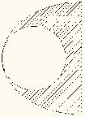 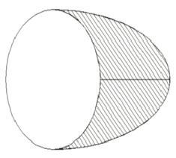 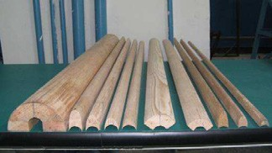

* + 1. D-shaped (b) Crescent-Shaped (C) ice schematic diagram

Figure 1 Typed-shape iced conductor and test ice schematic diagram

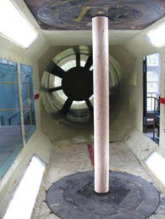The attack angle is 0-180°, interval is 5°, The direction of initial angle, 0°, Corresponds to the direction of iced. Attack angle and the direction of load are showed as figure 2(a), and the equipment and devices is showed as figure 2(b):

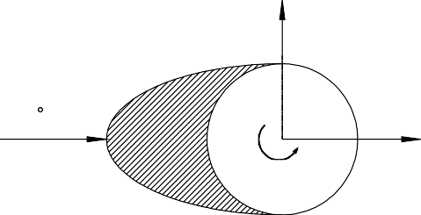

FL

0

FD

MZ

Fig.2 attack angle, equipment and devices in wind tunnel schematic diagram

1. Experiment simulation and analysis of iced conductor aerodynamics parameter
   1. *The experimental result of crescent-shaped iced conductor*

The numerical and experiment value of drag, lift and torsion coefficient for crescent-shaped iced conductor is shown in figure2,figure 3 and figure 4, the thickness of iced is 15,23 and 33mm, the test wind speed is 10,20 and 30m/s. As compare, the partly numerical value is given.

2.5

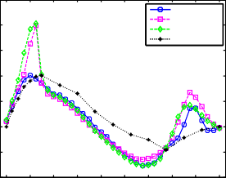

10m/s 20m/s 30m/s

Numerical value

2

1.5

Lift coefficient

1

3

2.5

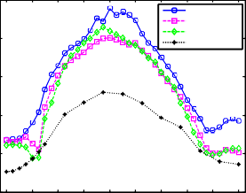

10m/s 20m/s 30m/s

Numerical value

2

Drag coefficient

1

0.8

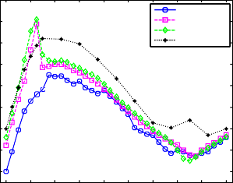

10m/s 20m/s 30m/s

Numerical value

Torsional coefficient

0.6

0.4

0.5

0

-0.5

-1

0 20 40 60 80 100 120 140 160 180

Attack angle

1.5

1

0.5

0 20 40 60 80 100 120 140 160 180

Attack angle

0.2

0

-0.2

-0.4

0 20 40 60 80 100 120 140 160 180

Attack angle

Fig. 3 numerical and test value of drag, lift and torsion coefficient at different wind speed (15mm iced thickness)

2.5

2

1.5

1

Lift coefficient

0.5

0

-0.5

-1

-1.5

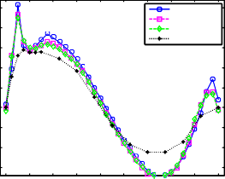

10m/s 20m/s 30m/s

Numerical value

0 20 40 60 80 100 120 140 160 180

Attack angle

4

3.5

3

Drag coefficient

2.5

2

1.5

1

0.5

0 20 40 60 80 100 120 140 160 180

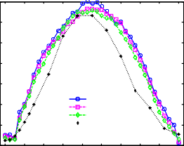

10m/s 20m/s 30m/s

Numerical value

Attack angle

3

2.5

2

Torsional coefficient

1.5

1

0.5

0

-0.5

-1

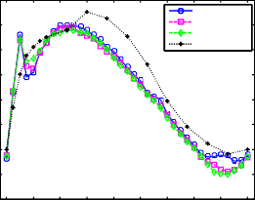

10m/s 20m/s 30m/s

Numerical value

0 20 40 60 80 100 120 140 160 180

Attack angle

Fig. 4 numerical and test value of drag, lift and torsion coefficient at different wind speed (23mm iced thickness)

3

2.5

2

1.5

1

Lift coefficient

0.5

0

-0.5

-1

-1.5

-2

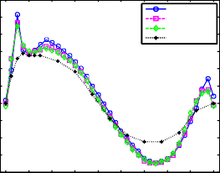

10m/s 20m/s 30m/s

Numerical value

0 20 40 60 80 100 120 140 160 180

Attack angle

4

3.5

3

Drag coefficient

2.5

2

1.5

1

0.5

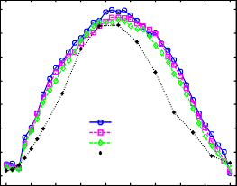

10m/s 20m/s 30m/s

Numerical value

0 20 40 60 80 100 120 140 160 180

Attack angle

2.5

2

Torsional coefficient

1.5

1

0.5

0

-0.5

-1

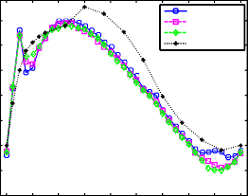

10m/s 20m/s 30m/s

Numerical value

0 20 40 60 80 100 120 140 160 180

Attack angle

Figure 5 numerical and test value of drag, lift and torsion coefficient at different wind speed (33mm iced thickness)

From the figure, the lift, drag and torsion coefficient have the less relevant with the wind speed values, except for the individual peak point. As the lift and torsion coefficient, the wind is larger; the peak point is more obviously near 20 ° angle of attack. Contrast the calculations with experimental values, it is closely of the result between the numerical with experiment. The whole calculation of the simulated curves in the 30 ° angle of attack is obviously skewed to the right, but the overall calculation of the trend is similar. The value of the drag coefficient of calculates has the similar trend with test, but the value is significantly less, and there is a maximum deviation at 90 °attack angle.

3

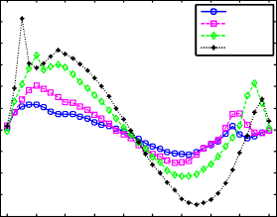

10mm iced 15mm iced 23mm iced 33mm iced

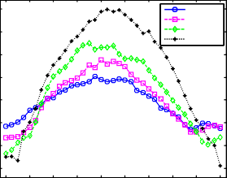

10mm iced 15mm iced 23mm iced 33mm iced

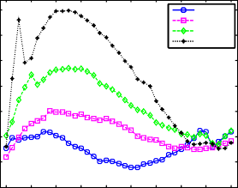

10mm iced 15mm iced 23mm iced 33mm iced

2.5

2

1.5

Lift coefficient

1

0.5

0

-0.5

-1

-1.5

-2

0 20 40 60 80 100 120 140 160 180

Attack angle

4

3.5

3

Drag coefficient

2.5

2

1.5

1

0.5

0 20 40 60 80 100 120 140 160 180

Attack angle

2.5

2

1.5

Torsional coefficient

1

0.5

0

-0.5

-1

0 20 40 60 80 100 120 140 160 180

Attack angle

Figure 6 test value of drag, lift and torsion coefficient at different iced thickness (10m/s wind speed)

From the figure it is can be seen that lift, drag and torsion coefficient has the better consistency in trend with the increase of iced thickness: The greater the thickness of the iced, the greater the drag and torsion coefficients, and the absolute value of lift coefficient. Therefore, the approximate aerodynamic parameter value is obtained with different thickness of the iced conductor by interpolation calculation.

* 1. *The experimental result of other D-shaped iced conductor*

The experiment value of drag, lift and torsion coefficient is shown in figure7 and figure 8, the thickness of iced is 6 and 12mm, the test wind speed is 10, 20 and 30m/s.

1.5

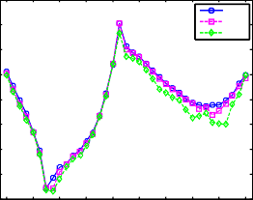

10m/s 20m/s 30m/s

1

0.5

0

Lift coefficient

-0.5

-1

3.5

3

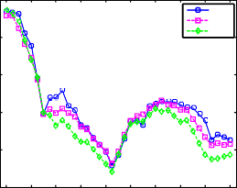

10m/s 20m/s 30m/s

2.5

Drag coefficient

2

0.6

0.4

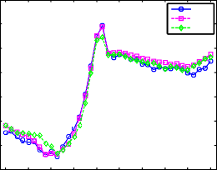

10m/s

20m/s 30m/s

0.2

Torsional coefficient

0

-0.2

-1.5

-2

-2.5

0 20 40 60 80 100 120 140 160 180

Attack angle

1.5

1

0 20 40 60 80 100 120 140 160 180

Attack angle

-0.4

-0.6

-0.8

0 20 40 60 80 100 120 140 160 180

Attack angle

Figure 7 test value of drag, lift and torsion coefficient at different wind speed (6mm iced thickness)

3.5

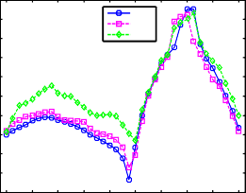

10m/s

20m/s 30m/s

3

2.5

2

1.5

lift coefficient

1

0.5

0

-0.5

-1

5

4.5

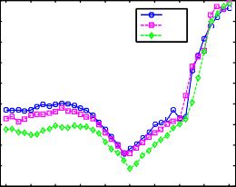

10m/s 20m/s 30m/s

4

3.5

Drag coefficient

3

2.5

2

1.5

1

1.5

1

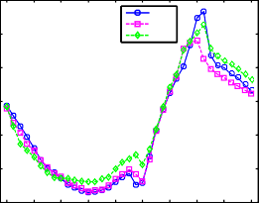

10m/s 20m/s 30m/s

0.5

Torsional coefficient

0

-0.5

-1

-1.5

0 20 40 60 80 100 120 140 160 180

Attack angle

0.5

0 20 40 60 80 100 120 140 160 180

Attack angle

-1.5

0 20 40 60 80 100 120 140 160 180

Attack angle

Figure 8 test value of drag, lift and torsion coefficient at different wind speed (12 mm iced thickness)

From the figure 7 and 8, it is can be seen that the lift, drag and torsion coefficient also have the less relevant with the wind speed values. With the increase of iced thickness, the coefficient value is increscent, so the dimensionality of aerodynamics force is also increase.

For the different thickness of iced, the numerical and experiment value of drag, lift and torsion coefficient is shown as in figure11, and the thickness of iced is 6 and 12mm, the wind speed is 20m/s.

1.5

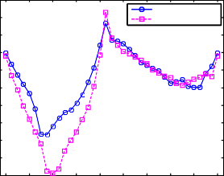

6mm thickness iced 12mm thickness iced

1

0.5

0

Lift coefficient

-0.5

-1

-1.5

-2

-2.5

-3

5.5

5

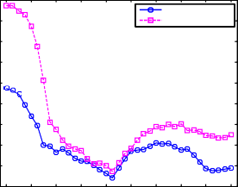

6mm thickness iced 12mm thickness iced

4.5

4

Drag coefficient

3.5

3

2.5

2

1.5

0.8

0.6

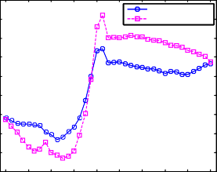

6mm thickness iced 12mm thickness iced

0.4

Torsional coefficient

0.2

0

-0.2

-0.4

-0.6

-0.8

-3.5

0 20 40 60 80 100 120 140 160 180

Attack angle

1

0 20 40 60 80 100 120 140 160 180

Attack angle

-1

0 20 40 60 80 100 120 140 160 180

Attack angle

Figure 9 test value of drag, lift and torsion coefficient at the different thickness and same wind speed

From the figure 9, the lift coefficient is increased with the increase of iced thickness when the attack angle range is 0 to 90, otherwise, when the attack angle rage is 90 to 180, there is little relativity between the lift coefficient and iced thickness. For the drag and torsion coefficient, the value of parameter is increased with the increase of iced thickness in the all attack angle range. Therefore, the approximate aerodynamic parameter value is obtained with different thickness of the iced conductor by interpolation calculation.

1. Conclusions

Making use the experimental simulation in wind tunnel, the coupling model of flow over the crescent and D-Shaped iced conductor had been set up. In the final, the dynamical parameter character of iced conductor

had been given. By compare the result of numerical simulation with experimental simulation, the conclusion is given as follows:

1. By the wind tunnel tests, it is indicated that lift coefficients, drag coefficients and moment coefficients of iced conductor have little relativity with the wind speed. The parameter value is confirmed by the type of conductor, the thickness and type of ice, and the attack angle.
2. With the increase of ice thickness, the aerodynamic coefficient values increased is significantly, especially in the extreme point, the rate of change for the aerodynamic coefficient is also increase. Especially, the negative slope of aerodynamics curve is become sudden steeper, it is indicated that the galloping is easy occur when the ice thickness is larger.
3. The dynamical parameter character curve is gained by experimental simulation for iced conductor, it is can not only provide the basic data for the analysis of galloping, but also validate the availability of the result of numerical simulation, and supply the support for the mechanism and prevention of transmission line conductor galloping.

Acknowledgements

The project supported by National Natural Science Foundation of China (NSFC) (50908218).

References

1. Hartog JPD. Transmission Line Vibration Due to Sleet [J]. AIEE, 1932, 51(4):1074-1076
2. Nigol PGB. Torsional Stability of Bundle Conductors[J]. IEEE Transactions on Power Apparatus and Systems, Vol. PAS-96, no. 5, September/October 1977,1666-1674
3. Nigol PGB. Conductor Galloping, Part I: Den Hartog Mechanisim[J]. IEEE Transactions on Power Apparatus and Systems, Vol. PAS-100, No. 2, February 1981Vancouver, Canada, 1981.699-707
4. Nigol PGB. Conductor Galloping, Part II: Torsional Mechanism [J]. EEE Transactions on Power Apparatus and Systems, Vol. PAS-100, No. 2, February 1981Vancouver, Canada, 1981.708-720
5. J H Walther. Discrete vortex method for two-dimensional flow past bodies of arbitrary shape undergoing prescribed rotary and translation motion. (1994) Doctoral Dissertation, Technical University of Denmark, DK-2800, Lyngby Denmark.
6. Li Wanping, Yang Xinxiang, Zhang Lizhi. Static Aerodynamic Characters of the Galloping of Bundled Iced Power Transmission Lines. [J]. ACTA Aerodynamica Sinica,1995,13(4): 427-434 (in Chinese)
7. Charbart, J L Lilien. Galloping of electrical lines in wind tunnel facilities [J]. Journal of Wind Engineering, 1998:967—976
8. Yao YuCheng, Li Wanping, Li Liangjun. Numerical Simulation of Flow over a Bluff Body in High Reynolds Number [J]. Journal of Huazhong University of Science and Technology (Nature Science). 2003,31(2): 106-108 (in Chinese)
9. Gu Ming, Ma Wenyong, Quan Yong etc.al. Aerodynamic Force Characters and Stability of Two Typical Iced Conductors. [J]. Journal of Tongji University (Nature Science). 2009. 37(10): 1328-1332 (in Chinese)
10. Ma Wenyong, Gu Ming, Quan Yong etc.al. Testing Study on Aerodynamic Force Characters of Quasi- oval Shaped Iced Conductor. [J]. Journal of Tongji University (Nature Science). 2010.38(10):1409- 1413(in Chinese)
11. Li Wanping, Huang He. Aerodynamic Characters of Heavily Iced Conductor [J]. Journal of Huazhong University of Science and Technology(Nature Science). 2001.29(8):84-86(in Chinese)
12. Teng Erpu, Duan Zhongdong, Zhang Xiuhua. Numerical Simulation on Aerodynamic Characters of Crescent-Shaped Iced Conductor. [J]. Low Temperature Architecture Technology. 2008,121(1): 86—88 (in Chinese)